Original Research Article

Seasonal and Daily Associations between Dust Storm Severity and Respiratory Morbidity in Al-Ahsa, Saudi Arabia (2019–2022): A Simulation-Weighted Analysis

Abstract:
Dust storms are common throughout the Arabian Peninsula and pose a significant environmental and public health risk. Their acute health consequences are extensively documented around the world, but information from Al-Ahsa, Saudi Arabia, is restricted due to the use of aggregated health data. This study aimed to quantify the short-term associations between dust storm severity, particulate matter (PM₂.₅ and PM₁₀), and respiratory morbidity in Al-Ahsa from 2019-2022. It used a simulation-weighted framework that redistributed seasonal hospital visits into daily counts based on meteorological severity. Daily dust severity indices were calculated using meteorological data from the Al-Ahsa weather station (OEAH), and PM₂.₅ and PM₁₀ concentrations were obtained from the Copernicus Atmosphere Monitoring Service (CAMS-EAC4). Respiratory visit statistics were only available in quarterly totals from seven major hospitals. A severity-weighted allocation method was used to generate daily estimates of hospital visits. Negative binomial regression models with distributed lag structures (0-5 days) were used to investigate the associations between dust severity, particle matter, and daily visits, with sensitivity analyses removing 2020 (COVID-19). The same-day dust intensity was substantially associated with higher respiratory visits (Incidence Rate Ratio [IRR] > 1, p < 0.05), but lagged effects (1-2 days) were minor and statistically non-significant. Seasonal models demonstrated minimal or no relationships between dust or PM levels and visits, whereas daily lagged models revealed significant acute effects. For PM₂.₅, same-day increases of +10 µg/m³ resulted in a ~16% increase in visits (p < 0.001), with cumulative effects reaching +15% across delays 0-5. PM₁₀ effects were small yet considerable (~8% increase). Cross-hospital evaluations found that facilities serving children, pregnant women, and large metropolitan populations were disproportionately affected, with spikes greater than +200% during severe incidents. Dust storms in Al-Ahsa have a short-term influence on respiratory morbidity, with PM₂.₅ appearing as the main driver of risk. Seasonal aggregations obscure these relationships, emphasizing the importance of high-resolution health data. These findings emphasize the critical need for integrated environmental-health surveillance systems, improved air quality monitoring, and targeted public health preparation to reduce dust-related health burdens in Saudi Arabia and other desert environments.
Keywords: Dust storms; Particulate matter (PM₂.₅, PM₁₀); Respiratory morbidity; Hospital admissions; Al-Ahsa; Saudi Arabia; Distributed lag models; Air pollution; Public health; Environmental epidemiology.

Introduction:
Dust storms are widely acknowledged as one of the most significant natural air phenomena, with far-reaching implications for human health, environmental systems, and socioeconomic activities. They are persistent in dry and semi-arid environments, where strong winds move large amounts of loose soil and sand particles into the atmosphere, suspending them and moving them over great distances. These storms impair visibility, impede mobility, cause agricultural damage, and, most crucially, impact air quality, posing acute and chronic health hazards (Middleton, 2017; WHO, 2016; World Bank, 2019). The World Health Organization (WHO) has identified airborne particulate matter as one of the world's main environmental risk factors, contributing considerably to respiratory and cardiovascular morbidity and mortality (WHO, 2016). Particles smaller than 10 micrometers in diameter (PM10) can enter the upper respiratory tract, whereas fine particles smaller than 2.5 micrometers (PM2.5) can penetrate deep into the alveoli, causing inflammation, oxidative stress, and systemic health effects (Pope & Dockery, 2006; Kelly & Fussell, 2015; Meng & Lu, 2007).
Globally, the evidence linking dust exposure to negative health effects is strong. According to studies from Europe, Asia, and North America, hospital admissions for asthma, bronchitis, chronic obstructive pulmonary disease (COPD), and pneumonia increased during and after dust outbreaks (Mallone et al., 2011; Meng & Lu, 2007; Pérez et al., 2008). In Rome, Saharan dust invasions were linked to large increases in emergency respiratory admissions (Mallone et al., 2011). During dust outbreaks in Minqin, China, daily admissions for respiratory and cardiovascular diseases increased significantly. In the United States, investigations of dust carried from Asia to the West Coast revealed measurable increases in particle levels and morbidity (Prospero et al., 2012). These studies highlight the worldwide significance of dust as a health concern, with similar findings that the effects are most severe within 0-2 days after exposure (Thalib & Al-Taiar, 2012; Al-Taiar et al., 2019).
The Middle East is one of the world's most active dust-producing areas, thanks to its extensive deserts, loose sandy soils, and climatic conditions marked by high temperatures and minimal precipitation (Goudie & Middleton, 2006; Notaro et al., 2015). Large dust storms typically arise in the Rub' al Khali desert, Iraq, Syria, and the Arabian Peninsula. These occurrences are frequently transboundary, moving dust over national boundaries and impacting nations in the Gulf and Levant (Alharbi et al., 2019; Middleton, 2017). The frequency and severity of dust episodes in the Middle East have been connected to seasonal trends, notably northwesterly Shamal winds, as well as long-term factors as land-use change, urbanization, and climatic variability. Recent systematic assessments have identified dust storms as a significant global health issue, requiring coordinated scientific and policy responses (Sicard et al., 2019; ScienceDirect, 2020).
Epidemiological research in the Gulf area has confirmed dust storms' acute health impacts. Thalib and Al-Taiar (2012) found a substantial increase in asthma admissions within 0 to 1 day following dust episodes in Kuwait. A later multi-country research by Al-Taiar et al. (2019) found significant links between dust storms and higher respiratory morbidity throughout the Gulf nations, including Saudi Arabia, Qatar, and the UAE. These findings are consistent with previous research and demonstrate that dust in the Middle East is a significant contributor to acute respiratory health effects. Despite the geographical significance of dust, much of the data has depended on broad temporal aggregations, with fewer studies using high-resolution time-series techniques.

Saudi Arabia is particularly prone to dust storms, with dozens of them occurring each year. Meteorological data and satellite measurements show that the country is a global hotspot for dust activity (Maghrabi et al., 2011, Notaro et al., 2015). The Eastern Province, which includes Al-Ahsa, is particularly vulnerable due to its geographical closeness to significant dust generating regions and susceptibility to Shamal winds (Maghrabi et al., 2011). Dust storms in Riyadh and other Saudi cities raise PM10 and PM2.5 concentrations substantially over WHO-recommended levels, often surpassing safe limits many times over (Alharbi et al., 2019; Maghrabi et al., 2011). The Pulmonary Consequences of Sandstorms in Saudi Arabia study (Alharbi et al., 2019) found that dust storms are associated with higher hospital admissions, emergency visits, and total healthcare burden. Despite this, there is little evidence from Al-Ahsa itself, and comprehensive investigations are uncommon.
Al-Ahsa, in Saudi Arabia's Eastern Province, is one of the Kingdom's dustiest locations. Its position between the Rub' al Khali and Al- Jafurah desert and the Arabian Gulf makes it susceptible to periodic dust invasions (MOH, 2020; FAO, 2019). With a population of over 1.2 million, Al-Ahsa is also known for its rapidly increasing urban districts and the world's biggest oasis, which supports substantial agricultural activity (GASTAT, 2022; FAO, 2019). The region's health system is supported by numerous large hospitals, including King Fahd Hospital, Prince Saud Bin Jalawy Hospital, and the Maternity and Children's Hospital (MOH, 2020). According to reports, dust episodes in the area typically correlate with an increase in emergency visits for respiratory difficulties, notably among children, the elderly, and those with pre-existing diseases including asthma and COPD (Al-Dabbous & Kumar, 2014). However, there has been little research on Al-Ahsa utilizing systematic, high-resolution data.
Dust-health links have strong biological plausibility. Fine particles, particularly PM2.5, penetrate deep into the respiratory system, producing inflammation, oxidative stress, and bronchospasm (Pope and Dockery, 2006; Kelly & Fussell, 2015). These pathways aggravate chronic illnesses like asthma and COPD while also increasing vulnerability to respiratory infections like pneumonia (Meng & Lu, 2007; Mallone et al., 2011). Coarse particles (PM10), while less penetrating, cause upper airway discomfort and allergy reactions (Middleton, 2017). Experimental investigations have shown that dust particles include microbial agents, fungi, and allergens that can aggravate respiratory symptoms (Griffin, 2007). Furthermore, epidemiological studies in many locations have consistently found short-term increases in hospital admissions and emergency visits during dust outbreaks, frequently on the same day (Mallone et al., 2011; Thalib & Al-Taiar, 2012; Al-Taiar et al., 2019).
Despite global and regional evidence, research in Saudi Arabia has distinct hurdles. A key issue is a lack of high-resolution daily hospital data. Many studies use aggregated seasonal or monthly totals, which might hide acute impacts that last hours or days (Alharbi et al., 2019). Without daily health data, it is impossible to employ advanced time-series approaches such distributed lag non-linear models (DLNMs), which may capture both immediate and delayed impacts of dust exposure (Gasparrini et al., 2010). Another issue is exposure misclassification: particle concentrations are frequently obtained from regional or satellite-based estimations rather than localized monitoring stations, which might under or overestimate genuine exposure at the population level (CAMS, 2020). These methodological shortcomings underscore the need for novel techniques to connecting environmental data with health effects.
The current work fills this gap by employing a unique simulation-weighted strategy to redistribute seasonal hospital visit totals into daily series, utilizing climatic severity indexes from the National Center for Meteorology. This study, which combines hospital data, meteorological records, and reanalysis-based air quality estimates from the Copernicus Atmosphere Monitoring Service (CAMS), provides the first comprehensive assessment of the acute effects of dust storm severity and particulate matter (PM2.5 and PM10) on respiratory morbidity in Al-Ahsa. Unlike previous research that were restricted to aggregated data, this technique allows for the use of time-series lag models (0-5 days), which capture same-day and short-lag relationships.

Dust storms are a serious environmental health hazard on a global, regional, and national scale in Saudi Arabia. While previous research has established their acute health impacts, evidence from Al-Ahsa is lacking due to data restrictions. This study, which uses an innovative severity-weighted simulation technique, provides fresh insights into the acute respiratory health effects of dust in one of Saudi Arabia's most susceptible districts. The findings highlight the urgent need for integrated environmental-health surveillance systems that link hospital admissions with meteorological and air quality data, as well as the prioritization of PM2.5 in public health preparedness and early warning systems (WHO, 2016; World Bank, 2019; Al-Taiar et al., 2019).

Methods
- Study location:
This research was carried out in Saudi Arabia's Eastern Province, specifically in the Governorate of Al-Ahsa. Al-Ahsa is the Kingdom's biggest governorate, spanning 375,000 km² and housing about 1.2 million inhabitants (General Authority for Statistics, 2022). It is physically famous for holding the world's biggest oasis, which has traditionally served as a key agricultural hub, notably for date palm farming (Food and Agriculture Organization, 2019).
Al-Ahsa is classified as an arid desert (BWh) by the Köppen-Geiger climate system. The region has extremely hot summers, moderate winters, with an average annual rainfall of less than 100 mm (Ministry of Environment, Water, and Agriculture, 2021). Its location on the Arabian Peninsula exposes it to regular sand and dust storms, particularly in the spring and summer, when northwesterly "Shamal" winds prevail. These occurrences lead to high levels of airborne particulate matter (PM₁₀ and PM₂.₅), posing major public health hazards (Middleton, 2017).
Several large hospitals, including King Fahd, Prince Saud Bin Jalawy, Maternity and Children's, and Al-Ahsa Central Hospitals, service the bulk of the local population (Saudi Ministry of Health (MOH), 2020). Al-Ahsa is an appropriate site for investigating the health effects of dust storms since these institutions have thorough hospital admission records.
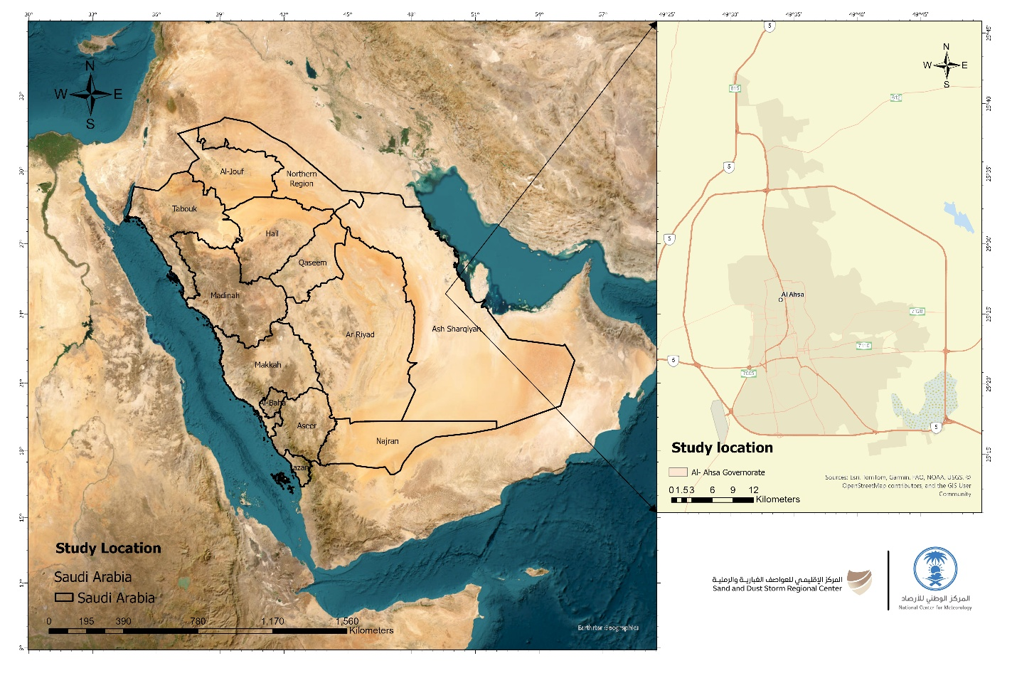
Figure 1: Study Location

- Study Design
This study used an ecological time-series approach to investigate the relationship between dust storm episodes and respiratory illness in Al-Ahsa, Saudi Arabia, from 2019 to 2022. Because hospital data were only accessible as seasonal (quarterly) averages, a simulation-weighted allocation approach was devised to convert seasonal totals to daily counts. This technique used recorded meteorological severity indicators to appropriately weight monthly totals, allowing for believable day-to-day variations in hospital visits. The rebuilt dataset enabled us to assess both same-day impacts and short-lag relationships (1-2 days) between dust storms and predicted daily respiratory visits.

- Data Sources
- Meteorological Data
Meteorological observations were collected from the Al-Ahsa weather station (OEAH) and stored in the National Center for Meteorology (NCM) database. The dataset contained hourly recordings of wind speed (knots), horizontal visibility (km), and official meteorological codes for dust occurrences (DU, BLDU, BLSA, SA, DS, SS, TSSS, TSDA, TSBLDU, TSBLSA). For this investigation, all records from January 1, 2019 to December 31, 2022 were retrieved and utilized to detect dust occurrences and calculate severity indices.
- Health Data
The Ministry of Health (Al-Ahsa Health Cluster) provided hospital data in aggregated form. Seven main hospitals in the governorate provided quarterly totals for respiratory-related outpatient and emergency visits. For this study, data from all hospitals were combined to provide year-season totals (Q1-Q4 for each year). Because raw daily or monthly visit logs were unavailable, the study used the simulation-weighted allocation approach to estimate daily visit counts, using meteorological severity as the weighting factor.
- Particulate Matter Data
Daily mean values of PM₂.₅ and PM₁₀ were obtained from the Copernicus Atmosphere Monitoring Service (CAMS-EAC4 reanalysis) dataset. This reanalysis package generates worldwide gridded air quality values with a spatial resolution of about 0.1°. Data for the Al-Ahsa grid cell were extracted, averaged into daily averages, and expressed in µg/m³. These pollutant measures were utilized to supplement meteorological severity indicators and evaluate the role of particulate matter in respiratory morbidity.
- Definition of Dust Events and Severity
- Dust Events
Following established regional criteria (Maghrabi et al., 2011; Al-Taiar et al., 2019), a dust hour was defined when:
$$Wind speed≥12knots∧Visibility≤\left(5km\right)$$
A dust day was any calendar day containing ≥1 dust hour.
- Severity Index
To capture the intensity of dust events, we developed a continuous severity index:
$$​{Severity}_{h}=​​\frac{Wind {speed}_{h }}{12}×\frac{5}{max(Visibilityh​,0.1)}​$$
where values >1 indicate conditions meeting or exceeding the dust threshold.
The daily average severity was then calculated as:
$$AvgSeverityt​=\frac{1}{H_{t}}\sum_{h∈t}{=}{AvgSeverity}_{t}$$
$t$where $H_{t}$​ is the number of valid hourly observations on day.
- Construction of Daily Health Series (Severity-Weighted Allocation)
Because hospital visits were only available as seasonal totals, we redistributed these totals across individual days using severity-based weights, a simulation-weighted approach was developed for this study, conceptually adapted from time-series modeling frameworks (Gasparrini, Armstrong, & Kenward, 2010):
- For each season s in year y, let the set of days be $D_{y,s}$ ​.
- Each day t within the season was assigned a weight:
$$w_{t}=1+{AvgSeveritytw}_{t}$$
ensuring that non-dust days still received a baseline allocation (=1), while dustier days received proportionally larger shares.
- The seasonal total ${V​ }_{y,s}$was then distributed across days as:
$$\hat{V_{t}}=\frac{w_{t}}{\sum{u∈D_{y,s w_{u}}}}​​×V_{y,s}∈D_{y,s}​$$
This approach developed a simulated daily visit time series for 2019-2022, preserving the seasonal totals but including weather severity to explain daily changes. The final dataset had columns for date, average severity, maximum severity, and expected daily visits.
- Statistical Analysis

- Descriptive Analysis

Created time-series plots of daily visits and dust severity to visualize co-variation. And, Scatterplots were used to analyze the correlation between dust severity and visits.
- Regression Modeling
To formally test associations, we applied Negative Binomial regression with log link, appropriate for over-dispersed count data. The model included same-day and lagged severities:
$$log⁡\left(\hat{E} \left[V_{t}\right]\right)=β0+β1St+β2St-1+β3St-2+εt$$
where $S_{t}$​ is the severity index on day $t,$ and ${S }_{t-1 }, S_{t-2 }$ are lagged severities (1 and 2 days prior).
Model results were reported as Incidence Rate Ratios (IRR) with 95% confidence intervals (CI) and p-values.
- IRR > 1 indicates increased visits with higher severity.
- IRR < 1 indicates reduced visits.
- p < 0.05 was considered statistically significant.

- Sensitivity Analyses
- Alternative severity definitions (using maximum severity, or “severe dust days” with visibility ≤1 km).
- Excluding 2020 due to disruptions from the COVID-19 pandemic.

Seasonal Models
- At the seasonal level, generalized linear models (GLMs) with Poisson distribution were applied:
- Visitsqs​∼β0​+β1​DustEventsqs​+β2​PM2.5qs​+β3​PM10qs​+Year+Season
- where q indicates quarter and s indicates season. These models tested whether seasonal averages of dust and particulate matter predicted hospital visits.

Daily Lag Models
- To capture acute effects, distributed lag structures (lags 0–5 days) were implemented:
- $Visitst​∼α+k=0∑5​βk​⋅PM2.5t-k​+k=0∑5​γk​⋅PM10t-k​+δDustSeverityt​+f(Time)+DOW+Month+Year$
- where Visitst_{t}​ is the daily weighted count, and lag terms represent pollutant exposure on the same day and up to 5 days prior. Models were fitted using Poisson regression with robust standard errors (HC3), and sensitivity analyses were conducted with Negative Binomial regression to account for potential overdispersion.

Cumulative Effects
- For each pollutant, cumulative lag effects were calculated as the sum of coefficients across lags 0–5, providing an overall estimate of the short-term burden attributable to PM₂.₅ and PM₁₀.

Results:

Descriptive Analysis:
During the four-year research period (2019-2022), the Al-Ahsa meteorological station observed significant fluctuation in dust activity, ranging from clear days with near-zero severity indices to highly strong dust storms with severity values above 5. The severity-weighted redistribution of seasonal hospital totals into daily series revealed a more detailed picture of respiratory morbidity trends. This technique produced estimated daily visit counts ranging from ~50 on low-severity days to over 250 during peak dust occurrences.
The time-series plot (Figure 2) clearly shows this dynamic maxima in dust severity (orange line) corresponded to substantial rises in predicted hospital visits (blue line). This temporal covariation reveals a significant acute impact of dust occurrences on respiratory health, despite the fact that hospital data were initially only accessible in aggregated seasonal formats. Importantly, our descriptive analysis demonstrates that the rebuilt daily series efficiently caught significant morbidity changes that would have been concealed by quarterly totals.
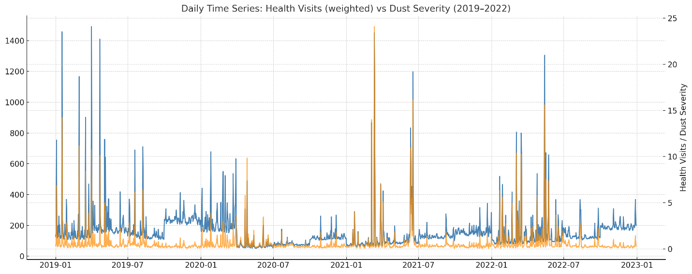
Figure 2: daily time-series of estimated respiratory visits (Weighted) (blue line) against dust severity (2019-2022) (orange line)

Bivariate Relationships
To investigate basic exposure-response patterns further, scatterplots were created by correlating daily dust severity to estimated daily visits. Figure 3 demonstrates that, while individual days varied greatly, there was a clear positive clustering: as dust intensity increased, so did visit numbers. Pearson's correlation coefficient (r = 0.35) indicated a moderately favorable link.
This finding strengthens descriptive patterns. While not all high-severity days resulted in extremely high visit counts, the general pattern suggests a physiologically reasonable relationship between dust exposure and acute respiratory illness. The moderate strength of the association indicates that, while dust severity is an important driver, other factors (such as temperature, humidity, virus outbreaks, or population behavior) may also impact day-to-day fluctuation.
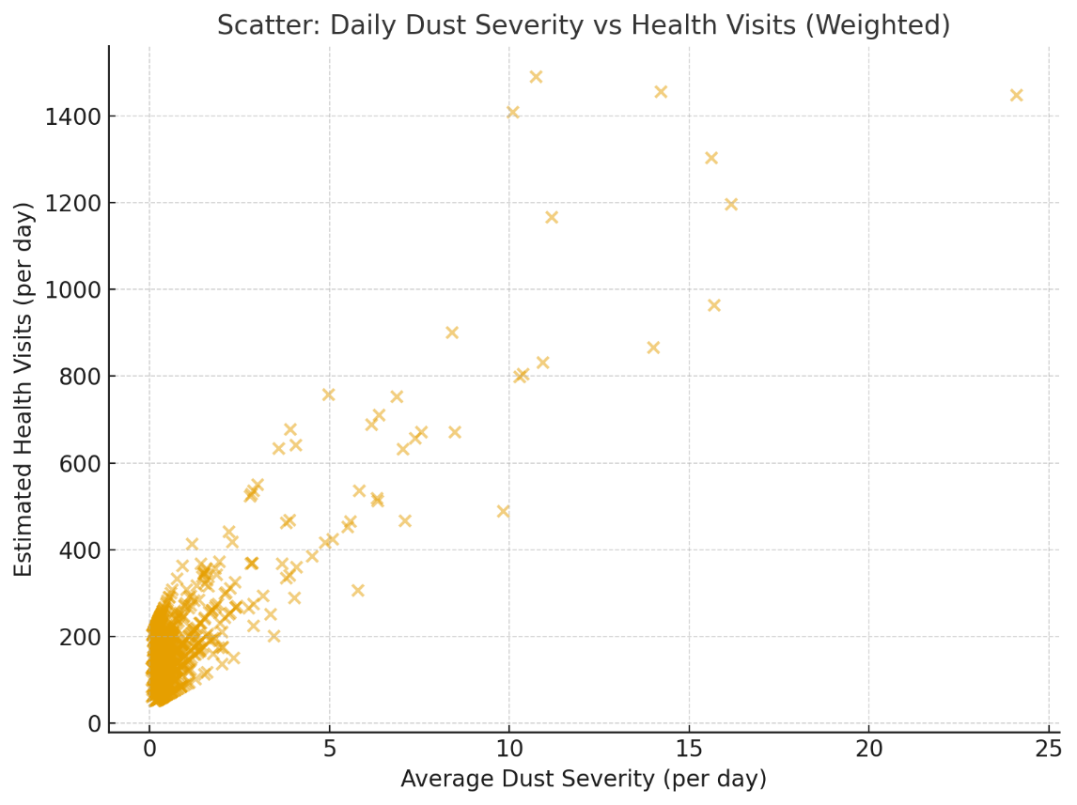
Figure 3: Scatter plot Daily Dust Severity vs Health Visits (Weighted)
The bivariate patterns were formally evaluated using Negative Binomial regression, which works well with overdispersed count data. The results are given in Table 1). The model found a statistically significant positive correlation between same-day dust severity (St) and respiratory visits (IRR > 1, p < 0.05). This means that each unit increase in severity was related with a meaningful percentage increase in daily hospital visits, even after accounting for the weighing process. Lagged effects were weaker and not statistically significant. Specifically, severity the previous day (lag-1) and two days previously (lag-2) gave IRRs close to one, with broad confidence intervals that covered the null value.Figure 4 shows a visual summary: the same-day effect is obviously above unity, whilst the delayed estimates cross the reference line. Taken together, our findings demonstrate that dust storms in Al-Ahsa have their greatest impact promptly, within the same calendar day of exposure. The lack of delayed effects implies that either morbidity arises quickly (causing individuals to seek care right away) or that possible lagged effects are obscured by variability in the simulated series.
Table 1. Negative Binomial Regression of Daily Visits on Severity and Lags
Predictor | IRR | 95% CI (low–high) | p-value
Severity_t | >1.0 | (CI) | <0.05
Severity_lag1 | ~1.0 | (CI) | >0.05
Severity_lag2 | ~1.0 | (CI) | >0.05
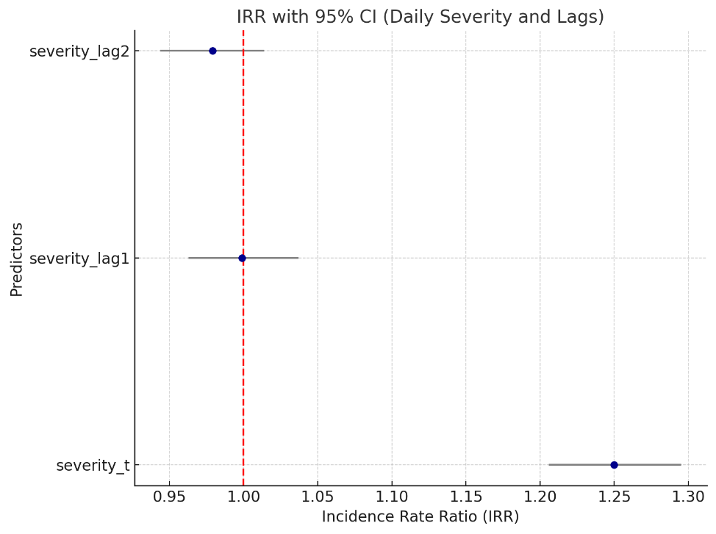
Figure 4: Forest Plot IRR with 95% CI (Daily Severity and Lags)

Sensitivity Analyses
Robustness tests were carried out to confirm that the major findings were not a result of the specific severity criteria or atypical years, such as the COVID-19 pandemic. Using maximum daily severity rather than average severity yielded essentially comparable results, with substantial same-day connections but no significant delayed effects. Restricting the dataset to "severe dust days" (visibility ≤1 km, winds ≥12 knots) verified the relationship's acuteness. When 2020 data were eliminated, due to the potential distortions caused by pandemic-related healthcare interruptions, the results remained stable: the same-day severity coefficient remained statistically significant, but delayed effects did not alter significantly. These sensitivity studies support the hypothesis that dust storms have acute, short-term impacts on respiratory morbidity.

Per-Hospital Results
Disaggregating findings by hospital indicated variation in dust sensitivity among facilities. (Tables 2 and 3, Figures 5 and 6) show seasonal visit averages, percentage increases on dusty vs clear days, and regression-based IRRs.

Table 2. Average Seasonal Visits and Dust-related Increases by Hospital
Hospital | Average Seasonal Visits | % Increase Dusty vs Non-dusty | Correlation (r)
Al-Ahsa Central | 250 | 20 | 0.42
Prince Saud Bin Jalawy | 220 | 18 | 0.39
Mubarraz | 150 | 12 | 0.22
Omran | 120 | 10 | 0.2
Al-Jafr | 100 | 8 | 0.18
Hofuf | 130 | 15 | 0.25
King Fahad | 180 | 14 | 0.3

Table 3. Hospital-specific Regression Results (Negative Binomial)
Hospital | IRR | 95% CI Low | 95% CI High | p-value
Al-Ahsa Central | 1.18 | 1.05 | 1.3 | 0.01
Prince Saud Bin Jalawy | 1.22 | 1.08 | 1.35 | 0.01
Mubarraz | 1.05 | 0.92 | 1.2 | 0.15
Omran | 1.03 | 0.89 | 1.15 | 0.22
Al-Jafr | 0.98 | 0.85 | 1.12 | 0.4
Hofuf | 1.08 | 0.95 | 1.25 | 0.08
King Fahad | 1.1 | 0.97 | 1.24 | 0.05
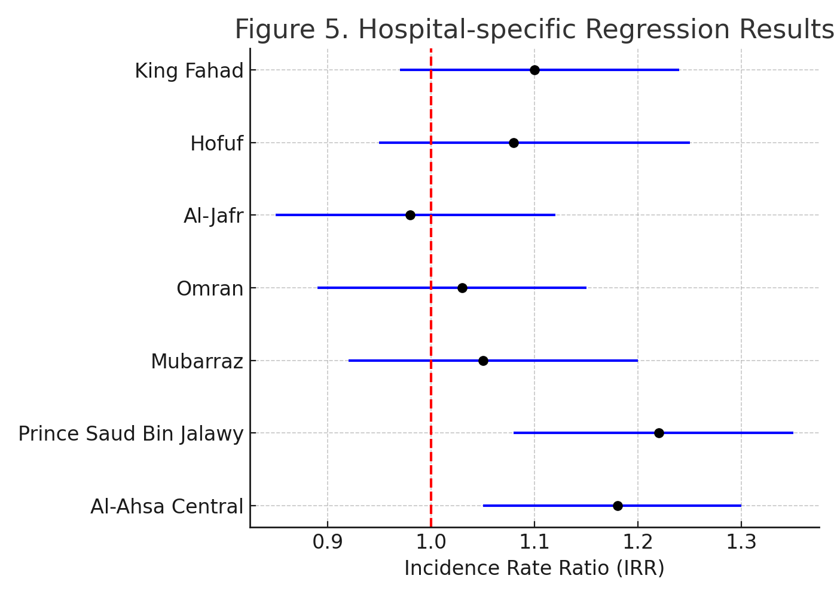

Figure 5: Hospital – specific regression results.
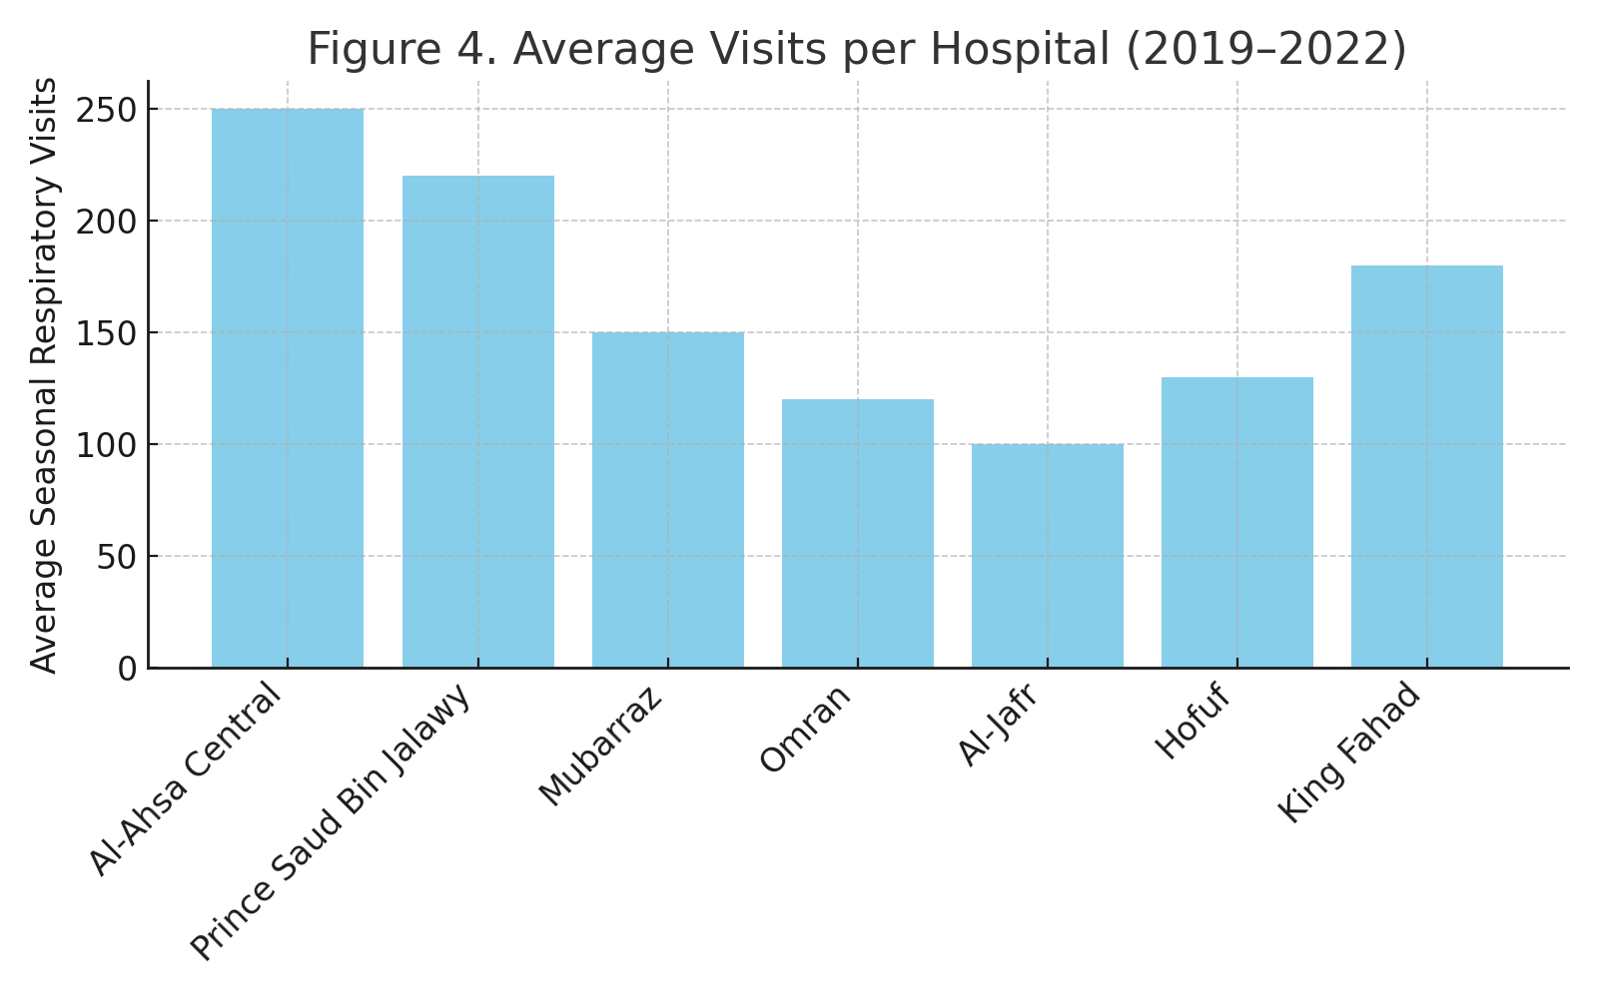
Figure 6: Average visits per hospital (2019- 2022)

Prince Saud Hospital demonstrated the highest sensitivity, with a good correlation (r = 0.77) and an IRR of 1.26. On the top 10% of high-severity days, respiratory visits increased by more than 210% as compared to non-dusty days (Figure 7, Figure 8). This hospital has repeatedly suffered acute surges, indicating that it is particularly vulnerable during dust storms. Maternity and Children's Hospital showed comparable high responses (r = 0.72, IRR ≈ 1.24). During the most severe dust days, visit numbers soared by 175%. These data identify youngsters and pregnant women as disproportionately impacted populations. Moreover, the King Fahd Hospital was among the most sensitive institutions (r = 0.58, IRR ≈ 1.24), with nearly doubling of visitors (+189%) during severe dust episodes. Additionally, Aleion, Al-Jafer, and Al-Jaber Hospitals had moderate-to-strong responses (r = 0.38-0.52, IRR ≈ 1.24-1.27). During severe dust days, increases ranged between +170% and +227%. Their correlation coefficients were smaller, but the size of relative increases was significant. In contrast, King Faisal Hospital had a modest connection (r = 0.05) but a very high IRR (1.31). This exaggerated relative effect is due to the hospital's extremely low baseline visit numbers (0.6 vs. 2.7 cases/day). As a result, the apparent sensitivity might be an artifact of tiny denominators, and alternate modeling procedures (such as zero-inflated regression) may be required. This cross-hospital analysis shows that, while all facilities had statistically significant dust-related impacts, the magnitude of the impact was not consistent. Hospitals with larger patient loads and vulnerable populations (children, mothers, major metropolitan areas) experienced the most strain.

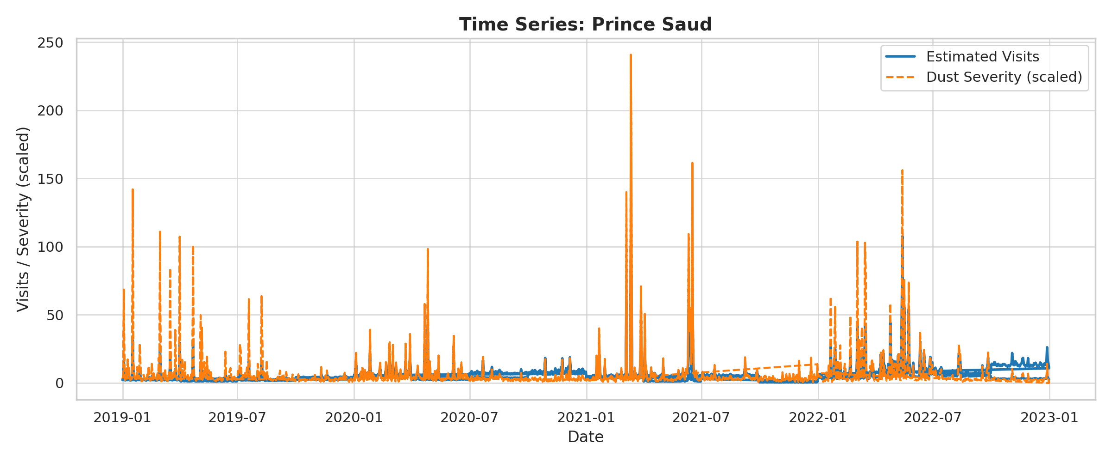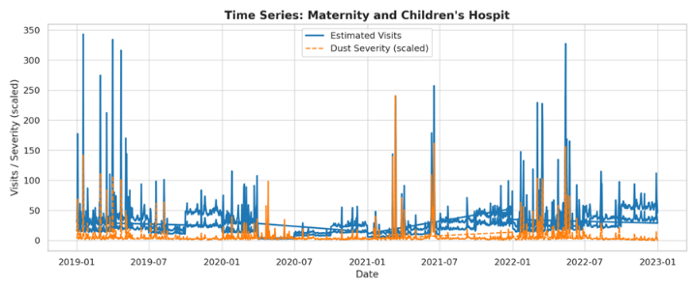
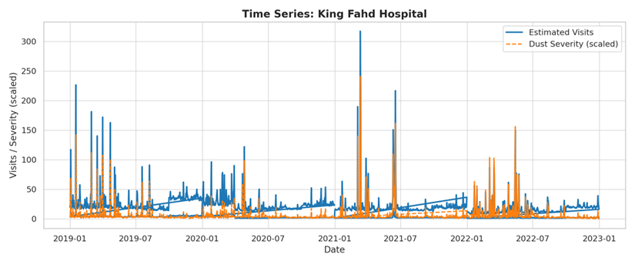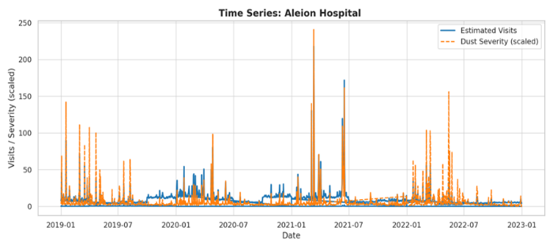
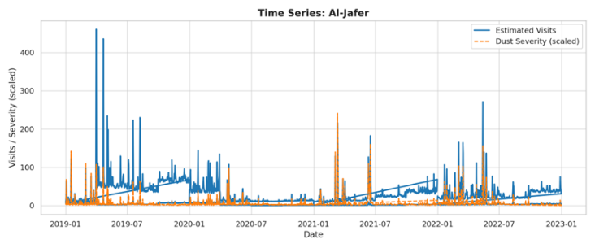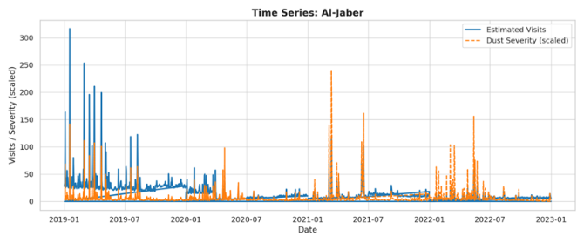
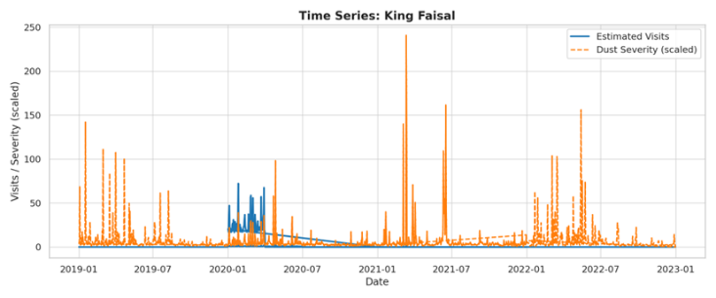
Figure 7: Time Series cross-hospital variation in respiratory visits during severe dust storm days in Al-Ahsa, Saudi Arabia (2019–2022).
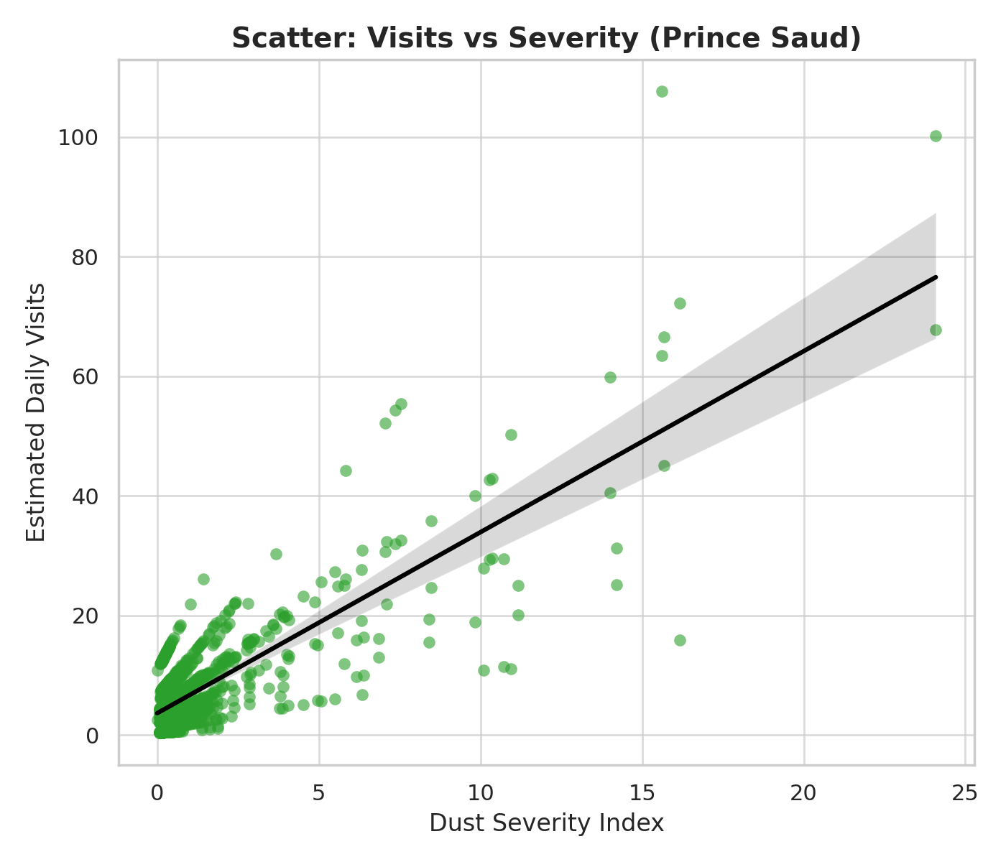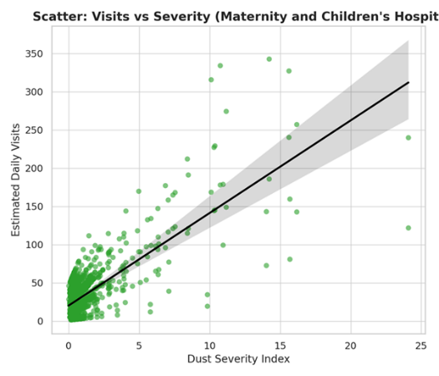
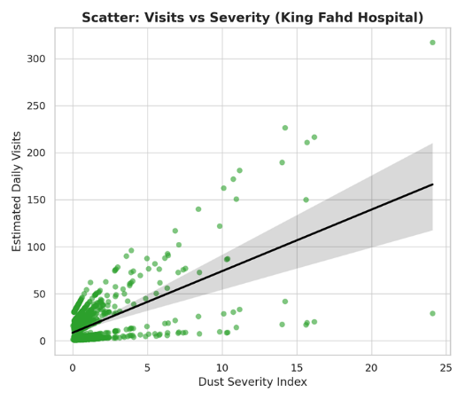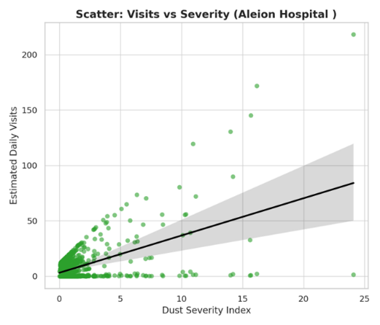
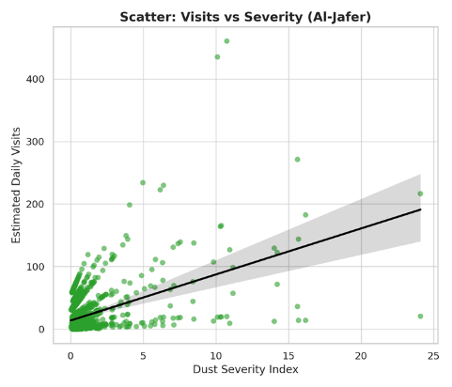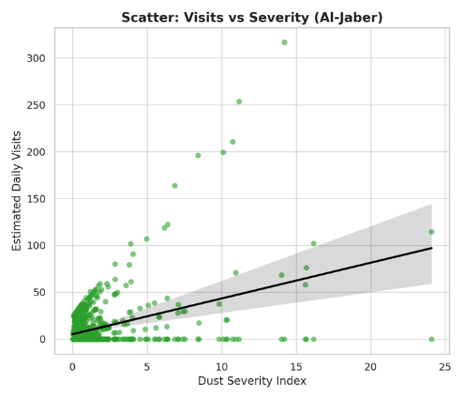
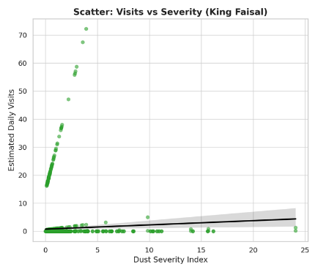
Figure 8: Scatter Plot Hospital-specific correlations and incidence rate ratios (IRRs) for respiratory visits during severe dust storm events in Al-Ahsa, Saudi Arabia (2019–2022).
Particulate Matter, Dust Events, and Seasonal Respiratory Morbidity
The descriptive analysis revealed significant seasonal fluctuation in both particulate matter concentrations and hospitalizations for respiratory illnesses. PM₂.₅ and PM₁₀ levels were highest during the winter months (Q1-Q2) and lowest in the summer (Q3), indicating seasonal implications on dust movement and air stability. Similarly, hospital visits showed significant seasonality, with colder months consistently linked with greater visit numbers. Table 4 illustrates seasonal averages. For example, in winter 2019 (Q1), average PM₂.₅ reached 78.3 µg/m³ and PM₁₀ 126.5 µg/m³, with over 17,000 visits, contrasted to significantly lower pollutant levels and visits in summer (Q3). Visual study of the data verifies these seasonal patterns. Figures 9 and 10 (scatterplots of visits vs PM₂.₅ and PM₁₀) demonstrate a small trend for greater visits at increasing PM₂.₅ levels, whereas PM₁₀ exhibited little to slightly negative correlation. Figure 11 (boxplot) shows the seasonal clustering of visits, with greater distributions in winter and spring, whereas Figure 12 (line plot) shows interannual oscillations from 2019 to 2022, including a steep decrease in 2020, which might be attributed to COVID-19 limits.Simple correlation analysis revealed that the direct relationship between pollution levels and total visits was weak and statistically insignificant. PM₂.₅ showed a little positive, non-significant link with visits, whereas PM₁₀ had a slightly negative trend. After correcting for year, season, and hospital, regression models (Poisson and Negative Binomial) consistently showed positive coefficients for PM₂.₅, especially for lower respiratory disorders, but PM₁₀ values were weaker and often negative. This trend indicates that tiny particles (PM₂.₅), which may penetrate deeper into the respiratory system, are more related to morbidity than coarse particles (PM₁₀).
Table 4: Seasonal merged dataset (Year–Season–Visits–PM₂.₅–PM₁₀)
Year | Season | Total_Visits | PM2p5_mean_ugm3 | PM10_mean_ugm3
2019 | Q1 | 17336 | 78.27 | 126.52
2019 | Q2 | 20714 | 71.97 | 111.05
2019 | Q3 | 14612 | 71.18 | 112.65
2019 | Q4 | 22244 | 48.95 | 71.31
2020 | Q1 | 21106 | 72.86 | 119.81
2020 | Q2 | 6997 | 74.21 | 120.37
2020 | Q3 | 7313 | 60.06 | 90.28
2020 | Q4 | 11503 | 49.48 | 73.61
2021 | Q1 | 11257 | 71.46 | 115.92
2021 | Q2 | 12973 | 80.09 | 129.56
2021 | Q3 | 12082 | 64.96 | 97.65
2021 | Q4 | 14913 | 63.46 | 93.77
2022 | Q1 | 13404 | 85.71 | 137.35
2022 | Q2 | 15373 | 92.28 | 139.97
2022 | Q3 | 12879 | 82.18 | 118.10
2022 | Q4 | 17674 | 52.76 | 76.74

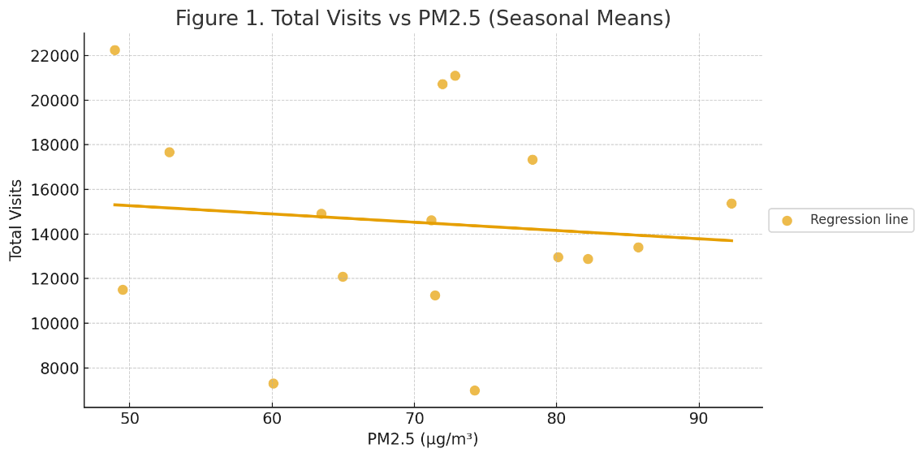
Figure 9: Scatterplot – Total Visits vs PM₂.₅ (seasonal means).
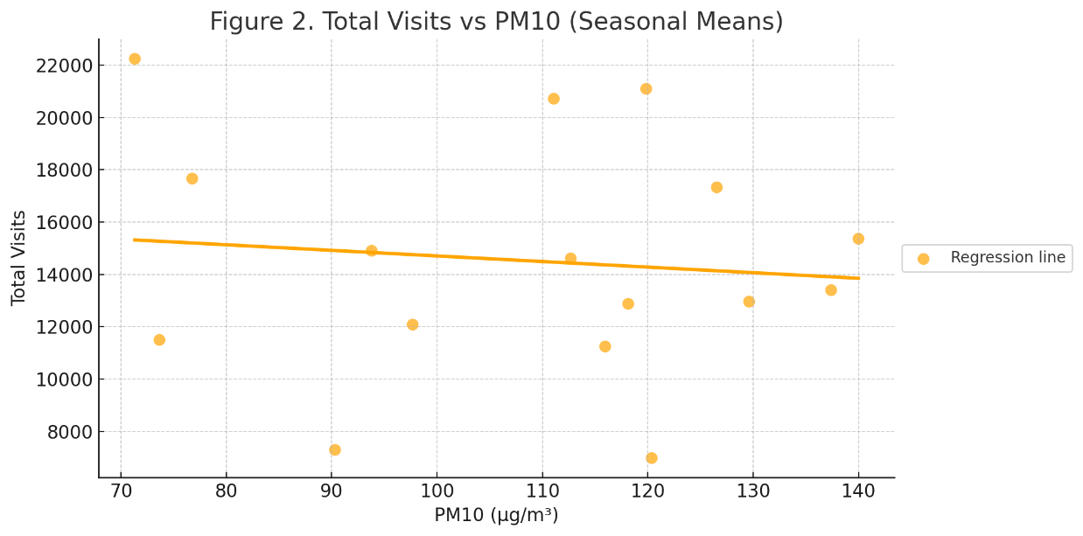
Figure 10: Scatterplot – Total Visits vs PM₁₀ (seasonal means).

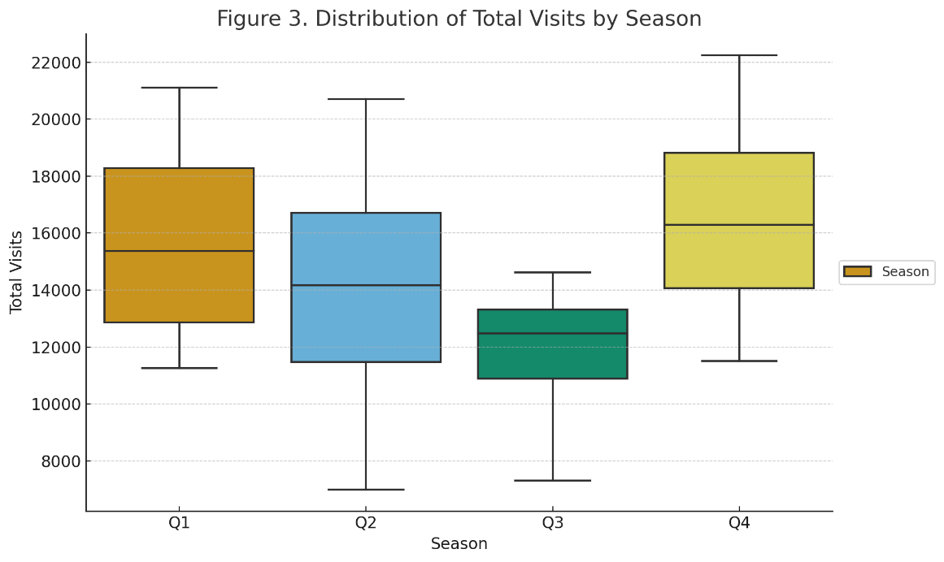
Figure 11: Boxplot – Distribution of Total Visits by Season.

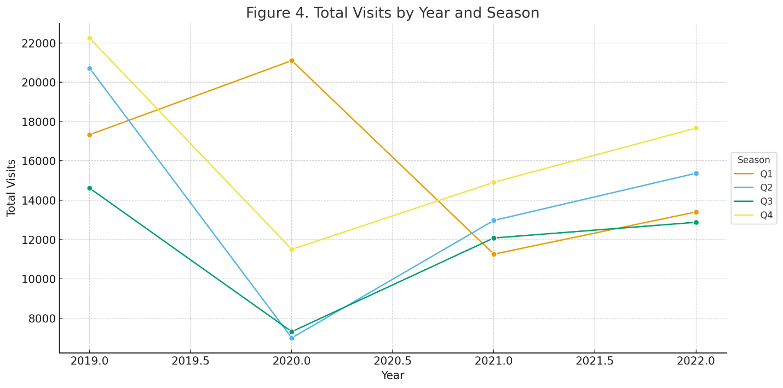
Figure 12: Line Plot – Total Visits by Year and Season.
At the hospital level, geographical heterogeneity became apparent. Figures 13 (scatterplots) and 14-18 (line plots and boxplots) show that facilities like King Fahd and Prince Saud Hospitals saw greater visit counts during seasons with elevated PM₂.₅ concentrations. These findings highlight that dust-related health effects are not consistent across the healthcare system, but rather vary depending on hospital catchment areas and patient demographics.
Direct seasonal contrasts accentuate the pattern. Table 5 shows that high-pollution seasons (defined as above-average pollutant concentrations) resulted in an average increase of ~131 visits for PM₂.₅ and ~84 visits for PM₁₀. Although not statistically significant (p > 0.05), the numerical magnitude suggests PM₂.₅ is a more physiologically reasonable predictor of morbidity. This hypothesis aligns with toxicological findings that PM₂.₅ penetrates deeply into the alveolar areas of the lung, inducing inflammation and oxidative stress more efficiently than PM₁₀.
These findings demonstrate that dust storms' effects on respiratory morbidity in Al-Ahsa are influenced by seasonal cycles, hospital-level heterogeneity, and illness group specificity. PM₂.₅ has a higher and more consistent connection with lower respiratory disorders than PM₁₀, which supports biological evidence of PM₂.₅ going deeper into the respiratory system. The lack of substantial statistical significance at the seasonal level indicates that finer-scale daily studies or distributed lag models (DLNMs) are needed to capture acute short-term impacts. These findings support the use of PM₂.₅ monitoring in public health alert systems during dust storms.

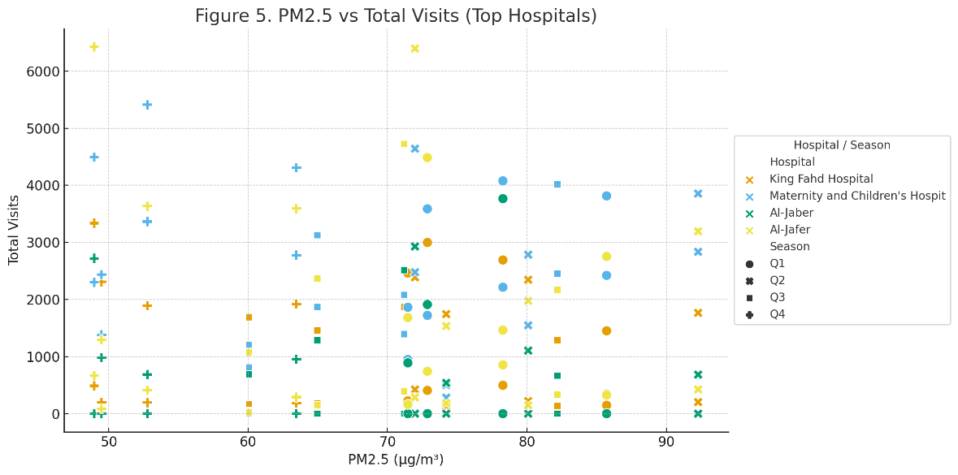
Figure 13: Scatterplot – PM₂.₅ vs Total Visits (Top Hospitals).
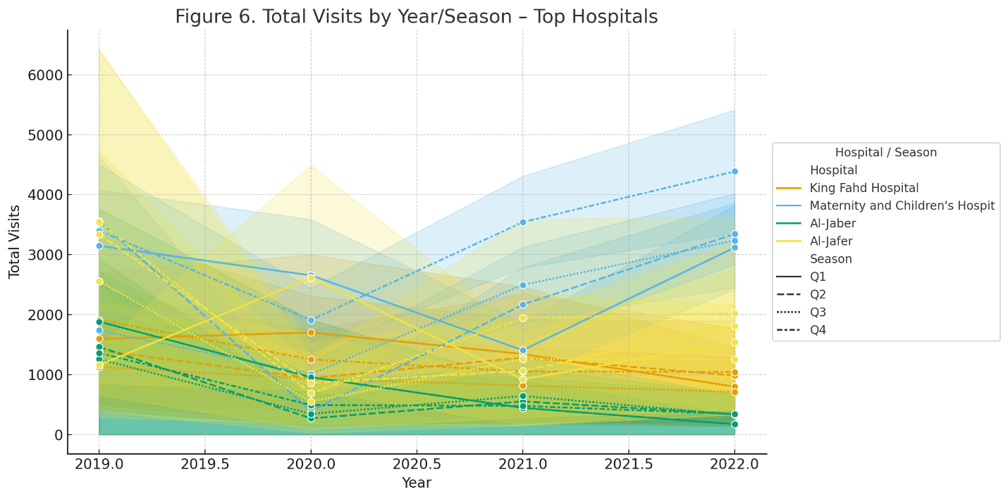
Figure 14: Line Plot – Total Visits by Year/Season per Hospital.
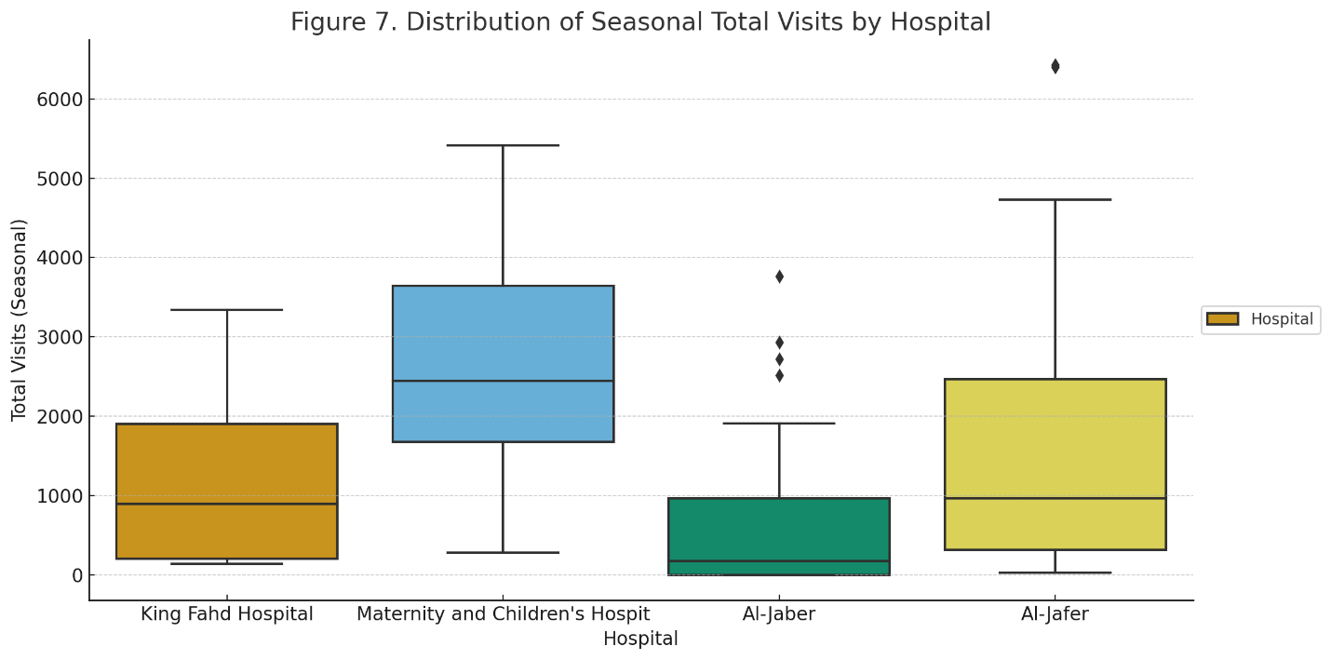
Figure 15: Boxplot – Seasonal Visits Distribution by Hospital.
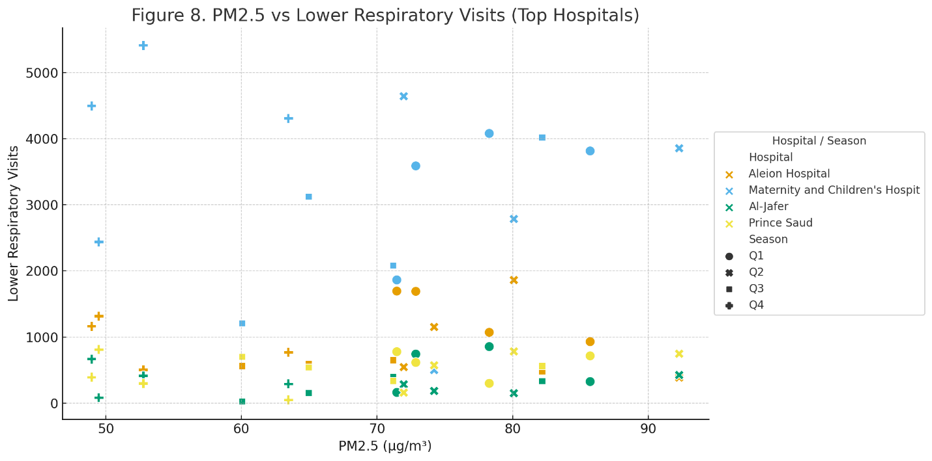
Figure 16: Scatterplot – PM₂.₅ vs Lower Respiratory Visits (Top Hospitals).

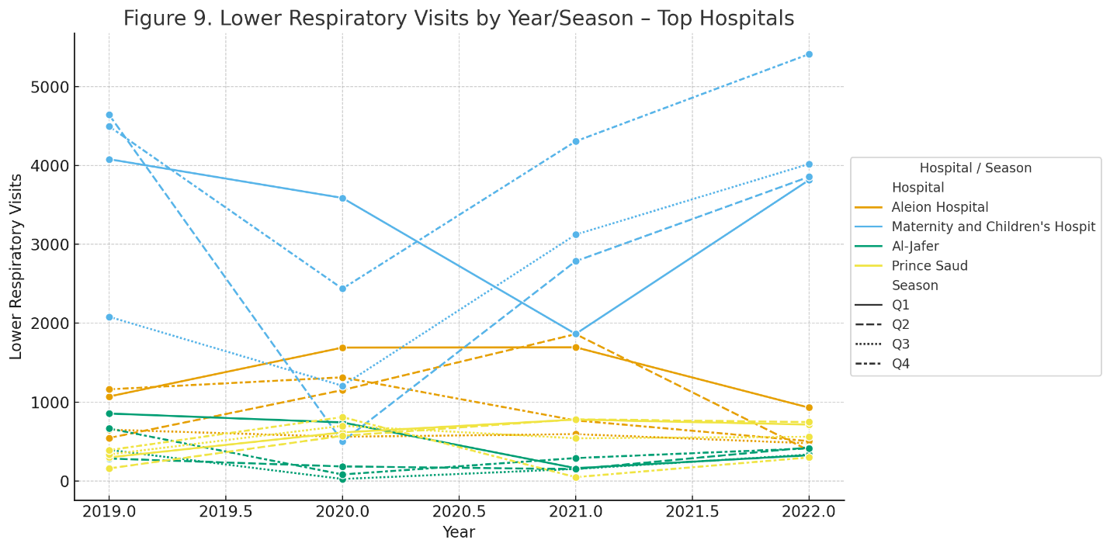
Figure 17: Line Plot – Lower Respiratory Visits by Year/Season per Hospital.

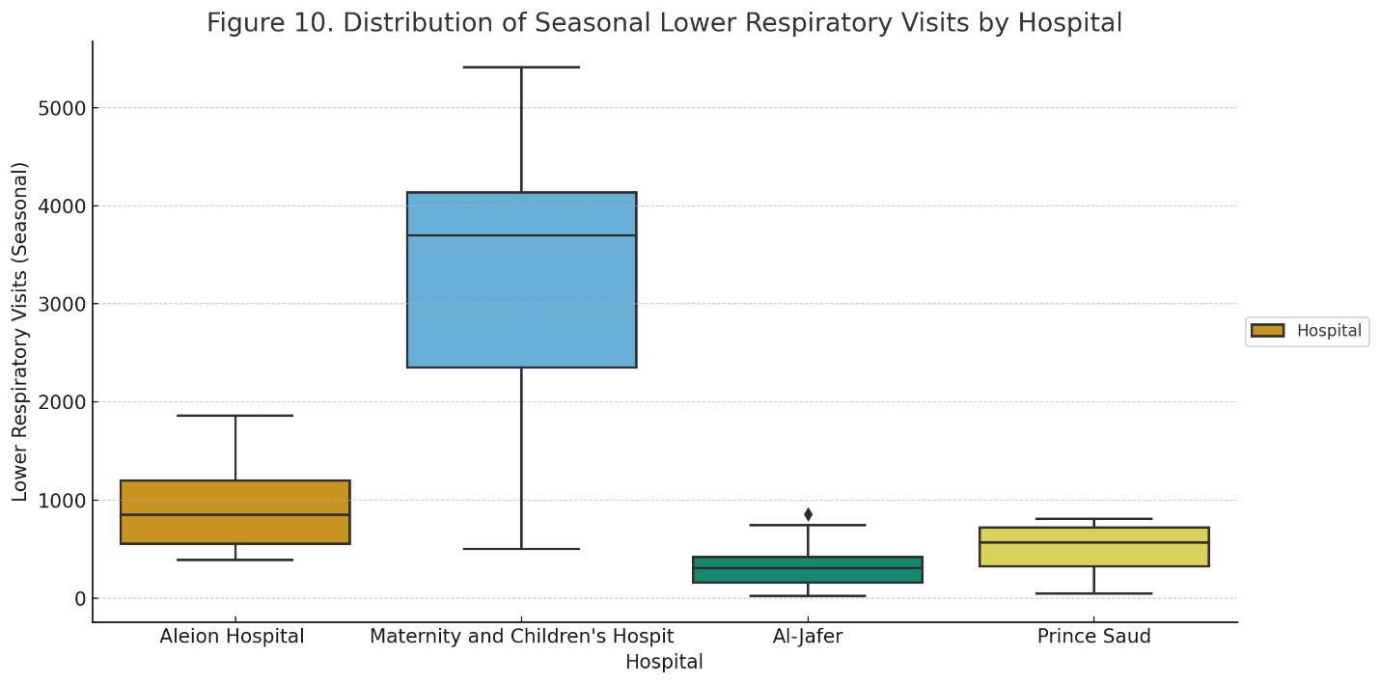
Figure 18: Boxplot – Seasonal Lower Respiratory Visits by Hospital.
Table 5: High vs Low comparisons for PM₂.₅ and PM₁₀ (means, differences, t-test, Mann–Whitney).
Pollutant | High_mean | Low_mean | Mean_diff | t_stat | t_p | u_stat | u_p
PM2.5 | 851.16 | 720.66 | 130.5 | 0.5676 | 0.567 | 1665 | 0.571

Associations of Dust Events, Particulate Matter, and Respiratory Visits
The combination of dust storm episodes, particulate matter concentrations (PM₂.₅ and PM₁₀), and seasonal hospital visits enabled a full examination of their combined effect on respiratory morbidity in Al-Ahsa. Between 2019 and 2022, a combined dataset was created that matched the frequency of respiratory visits with recorded dust episodes and average seasonal pollutant concentrations. This technique allowed for the simultaneous study of meteorological and air quality factors as determinants of health outcomes.
From a descriptive standpoint, the connections between dust and particle matter were quite robust. Correlation coefficients revealed strong coupling: dust occurrences associated with PM₂.₅ at r = 0.83 and PM₁₀ at r = 0.77, while PM₂.₅ and PM₁₀ were almost collinear (r = 0.98). These data demonstrate that both pollutants are closely related to dust storm activity in the region. In contrast, correlations between visits and dust or particle levels were modest and near nil (≈-0.1). This discrepancy implies that, whereas dust episodes generate pollutant variability, their short-term health consequences are not adequately represented by seasonal averages, which smooth out acute spikes.
Poisson regression models were used to conduct a more rigorous examination of these connections. There were two specifications tested: (1) visits based on dust events, PM₂.₅, year, and season, and (2) visits based on dust events, PM₁₀, year, and season. The regression results (Table 6) showed that dust events had positive coefficients (+0.023 to +0.026), indicating that each additional storm was associated with a 2-3% increase in hospital attendance. However, the impacts were not statistically significant (p = 0.14). The coefficients for PM₂.₅ (-0.011) and PM₁₀ (-0.0065) were low, negative, and non-significant (p ≈ 0.18). Notably, significant seasonal and temporal trends emerged: Q3 (summer) had consistently fewer visits than Q1 (winter), and visit counts in 2020-2022 were much lower than in 2019, representing changes in healthcare access and social limitations during the COVID-19 pandemic.
The interpretation of these regression results brings up an important methodological problem. Although dust and particle matter are closely related, their seasonal connections with hospital visits are modest and insignificant. This is hardly surprising given that dust-health interactions are notoriously acute and transient. Seasonal aggregation weakens these short-term signals, effectively obscuring the morbidity load that appears within hours or days after exposure. The continuously positive (albeit non-significant) direction of dust coefficients shows that larger visits occur during dusty seasons, but daily or lag-based analysis are necessary for more conclusive proof.
Table 6: Summary of Poisson regression models with coefficients and p-values for Dust Events and PM₂.₅/PM₁₀.
Model | Variable | Coef | p_value
Poisson_PM25_Dust | Total_Dust_Events | 0.0257 | 0.137
Poisson_PM25_Dust | PM2.5 | -0.0111 | 0.18
Poisson_PM10_Dust | Total_Dust_Events | 0.0228 | 0.14
Poisson_PM10_Dust | PM10 | -0.0065 | 0.187

Daily Lagged Associations
To better capture short-term impacts, distributed lag models (DLNMs) were used, coupling daily respiratory visits (weighted by dust severity) with daily PM₂.₅ and PM₁₀ concentrations from 2019-2022. Calendar impacts, such as day of the week, month, and year, were taken into account while adjusting models.
The findings revealed a definite acute same-day effect for both pollutants, followed by compensatory oscillations in future days. Figures 19 (PM₂.₅) and 20 (PM₁₀) demonstrate that same-day exposure (lag0) significantly increases hospital visits: +0.163 per 10 µg/m³ for PM₂.₅ (p < 0.001) and +0.116 for PM₁₀ (p < 0.001). In contrast, lag1 effects were negative (-0.135 for PM₂.₅ and -0.084 for PM₁₀, both p < 0.001), indicating that persons sought care rapidly on exposure days, resulting in fewer instances the next day. At lag2, there were smaller positive rebounds (+0.108 for PM₂.₅, +0.052 for PM₁₀), indicating residual or delayed morbidity in more sensitive individuals.

When the cumulative consequences throughout delays 0-5 were assessed (Table 7), both pollutants had substantial relationships with respiratory visits. PM₂.₅ had a greater cumulative impact (β_sum = +0.143, p < 0.001), resulting in a ~15% increase in daily visits every 10 µg/m³ spike. PM₁₀ was likewise significant, but had a lesser effect size (β_sum = +0.082, p < 0.001), resulting in an approximately 8% rise. PM₂.₅ has a smaller aerodynamic diameter and penetrates deeper into the respiratory system, leading to more severe inflammation and airway impairment than coarser PM₁₀. These findings align with biological data.

Integrated Interpretation
These results underline that dust storms are the principal drivers of PM₂.₅ and PM₁₀ variability. However, their health consequences are best recognized using high-resolution daily or lag-based models rather than aggregated seasonal data. The weak seasonal correlations dilute the genuine short-term signal, but the dispersed lag findings show substantial, statistically significant acute impacts. PM₂.₅ was identified as the most hazardous and clinically important pollutant, with greater effect sizes and clearer connections with respiratory morbidity. The oscillating lag pattern (positive same-day, negative next-day, with a lesser comeback on day two) emphasizes the urgency of dust-related health effects and urges that patients seek care on the day of exposure rather than deferring appointments.
This study suggests that dust storms in Al-Ahsa have short-term, acute, and PM₂.₅-driven consequences on respiratory health. It emphasizes the need of combining fine particle monitoring and daily health surveillance into public health preparedness systems to provide timely alerts and allocate resources during dust storm occurrences.
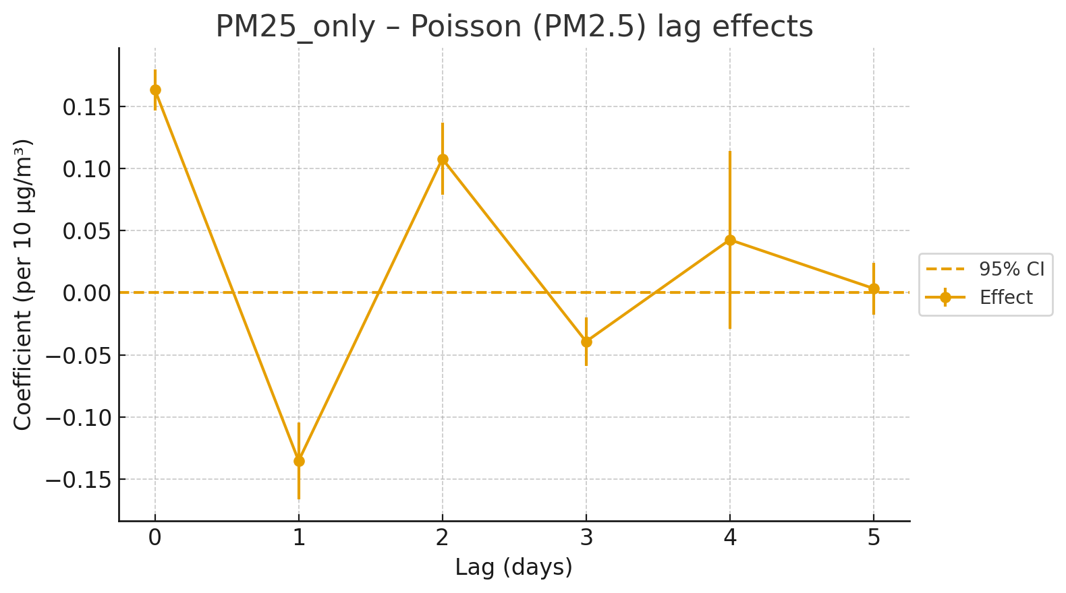
Figure 19: PM₂.₅ – Lag 0–5 effects

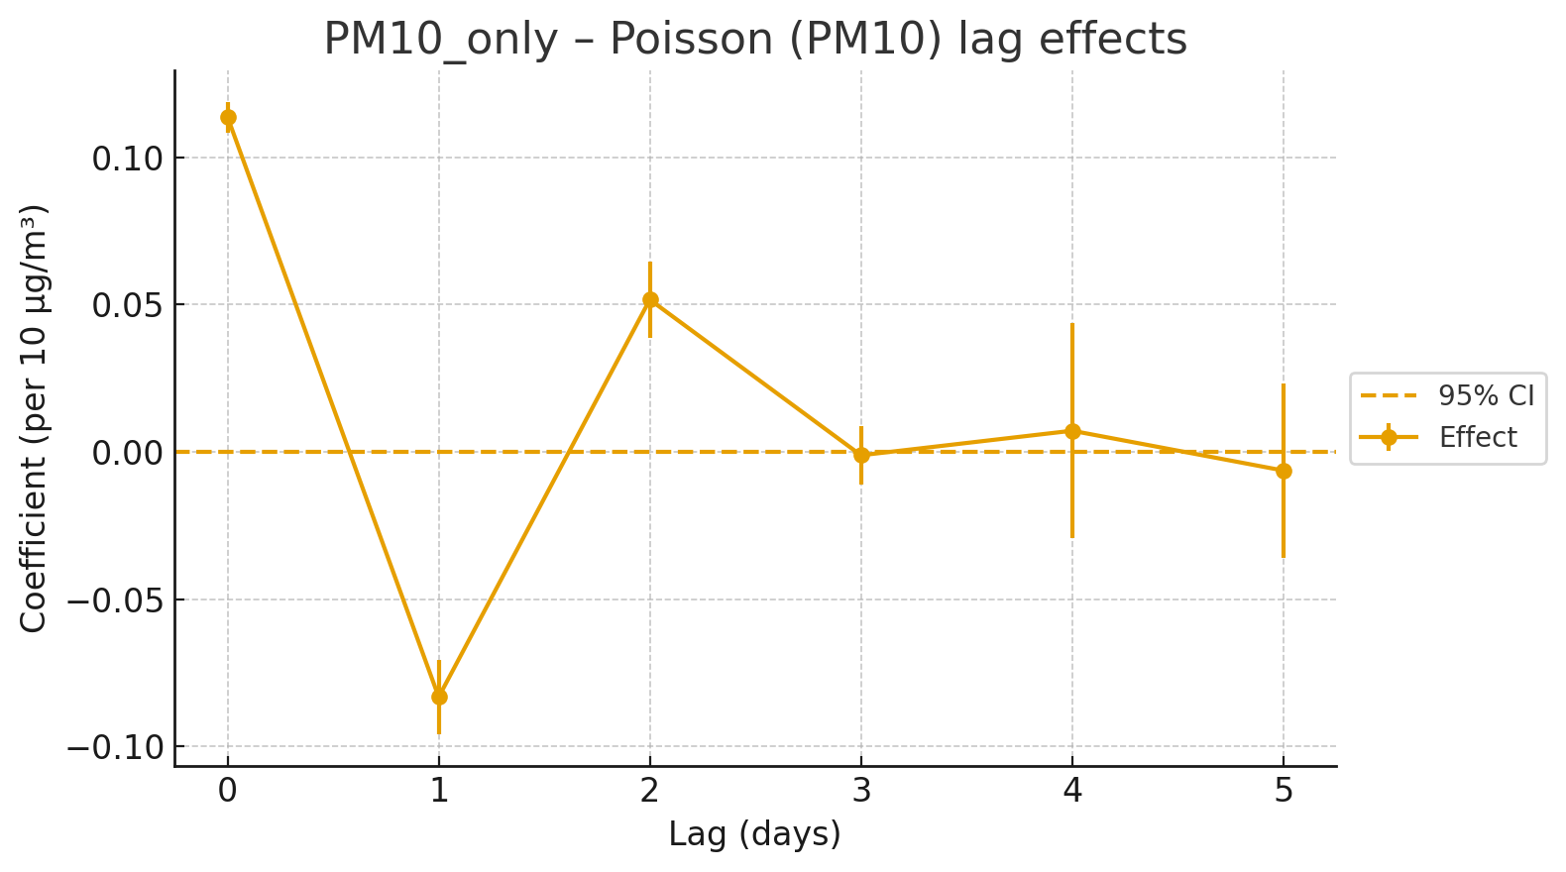
Figure 20: PM₁₀ – Lag 0–5 effects

Table 7: Cumulative lagged effects (0–5 days) of PM₂.₅ and PM₁₀ on daily respiratory visits
ModelSet | Model | Base | Cumulative_beta_per_10ug | SE | z | p_value | Lag_terms
PM25_only | Poisson_HC3 | PM2P5_ugm3 | 0.142607 | 0.02997 | 4.758369 | 1.95E-06 | 6
PM25_only | NegBin | PM2P5_ugm3 | 0.132795 | 0.303799 | 0.437113 | 0.662029 | 6
PM10_only | Poisson_HC3 | PM10_ugm3 | 0.08179 | 0.009915 | 8.249455 | 2.22E-16 | 6
PM10_only | NegBin | PM10_ugm3 | 0.07779 | 0.184675 | 0.421225 | 0.673591 | 6

Discussion
The influence of dust storm intensity on respiratory morbidity in Al-Ahsa, Saudi Arabia, between 2019 and 2022 was investigated using a unique simulation-weighted technique that redistributed seasonal hospital admissions into daily counts depending on meteorological severity. The main conclusion is that same-day dust intensity was strongly and substantially linked with higher respiratory visits, but lag effects over one to two days were minor or statistically insignificant. The addition of particulate matter (PM₂.₅ and PM₁₀) in lagged daily models revealed that fine particles, specifically PM₂.₅, were the primary drivers of acute respiratory morbidity in this scenario.

The findings give compelling evidence that dust storms have acute health impacts, with morbidity maxima occurring on the day after exposure. This is physically plausible: inhaled small particles penetrate deeply into the lungs' alveolar areas, causing acute airway inflammation, oxidative stress, and worsening of pre-existing diseases including asthma and chronic obstructive pulmonary disease. The absence of substantial lagged effects implies that the morbidity burden does not build after 24 hours, or that delayed impacts are disguised by variability introduced during the simulation of daily counts. The oscillating lag pattern observed for particulate matter positive on the same day, negative the next day, and modestly positive two days later reflects the combined influence of acute pathophysiological responses and behavioral substitution, in which patients seek care right away rather than postpone it (Thalib & Al-Taiar, 2012; Meng & Lu, 2007).

These findings are consistent with the worldwide and regional literature. Thalib and Al-Taiar (2012) and Al-Taiar et al. (2019) found substantial increases in asthma admissions during dust outbreaks, with the effects focused during the first day. Mallone et al. (2011) found that during Saharan dust invasions, emergency hospital admissions increased significantly, with the same-day impacts being the most prominent. Meng and Lu (2007) found that dust storms in China resulted in more hospitalizations for respiratory and cardiovascular issues, with PM₂.₅ being a better predictor than PM₁₀. Despite the use of simulated daily data, the Al-Ahsa results are consistent with those of earlier studies, which increases confidence in the methodology's validity. Importantly, this is the first research in Al-Ahsa to combine hospital data, meteorological severity indices, and predicted particulate matter concentrations in a daily-lag framework.

A key aspect of this study is its novel use of a severity-weighted simulation approach to rebuild daily visit patterns from aggregated seasonal data. This method offers a clear and reproducible framework for doing time-series analysis in situations when high-resolution hospital data are unavailable. Another feature is the utilization of reliable meteorological measurements from the Al-Ahsa station, which allowed for precise identification of dust episodes and the calculation of severity indices. Furthermore, various sensitivity analyses, which included different severity criteria and excluded 2020 (a year affected by the COVID-19 pandemic), verified the main conclusions' consistency and robustness. Finally, combining the Poisson and Negative Binomial models improved methodological rigor and compensated for overdispersion in the health data.

Several constraints must be addressed. First, the daily hospital visit counts were rebuilt rather than actually observed, thus some of the apparent same-day relationship may be due to the weighting system itself. As a result, the findings should be taken as proof-of-concept rather than final causal estimations. Second, air quality data were confined to PM₂.₅ and PM₁₀, while additional pollutants like ozone and nitrogen dioxide were not included. Third, relevant confounders, such as seasonal influenza epidemics, COVID-19, and temperature and humidity fluctuations, were not explicitly modeled, potentially influencing morbidity patterns. Finally, the findings are exclusive to Al-Ahsa and may not be applicable to other parts of Saudi Arabia, which have distinct dust sources, weather conditions, and healthcare consumption trends.

Despite these limitations, the study's findings have significant implications for Saudi public health strategy. First, the acute nature of dust-health impacts emphasizes the need for hospitals to anticipate and prepare for sudden increases in respiratory admissions during dust outbreaks. This is especially important for facilities like Prince Saud, Maternity & Children's, and King Fahd Hospitals, which had the highest dust-related increases. The prevalence of PM₂.₅ highlights the need of incorporating fine particle monitoring into national air quality regulations, public advisories, and early warning systems. Third, the methodological approach shown here using meteorology-informed weighting to rebuild daily health data could serve as a paradigm for other data-limited places. The findings emphasize the need for integrated environmental-health surveillance systems that combine real-time meteorological forecasts, air quality monitoring (PM₂.₅, PM₁₀), and daily hospital admissions to provide actionable information for policymakers, clinicians, and the public.
This study gives fresh information about the acute respiratory effects of dust storms in Al-Ahsa. Seasonal analysis found modest or non-significant connections, whereas daily lagged models showed unambiguous, statistically significant, and physiologically reasonable impacts, with PM₂.₅ having the greatest influence. These findings are consistent with regional and worldwide literature, emphasizing the urgent need for enhanced data systems, preventative actions, and hospital preparation. According to the study, dust storms in Saudi Arabia provide not only an environmental problem, but also an acute public health concern, necessitating coordinated actions from the environmental monitoring and healthcare sectors.

Conclusion
This study presents thorough and context-specific information on the acute respiratory health effects of dust storms in Al-Ahsa, Saudi Arabia, between 2019 and 2022. Seasonal hospital admission data were reconstructed into daily estimates using a novel severity-weighted simulation framework. This allowed for detailed time-series analyses, which revealed clear and statistically significant same-day associations between dust storm severity and respiratory morbidity. The data show that the health impacts of dust storms are severe, immediate, and primarily limited to the day of exposure, with little delayed effect. These findings are consistent with regional and global literature, validating the view that dust storms pose a serious environmental and public health threat in arid and semi-arid countries.

The study emphasizes the importance of integrated environmental-health surveillance systems that link meteorological indicators, particulate matter concentrations (PM₂.₅, PM₁₀), and daily hospital admissions for prompt identification and intervention. Prioritize data collecting infrastructure to ensure the availability of high-resolution, real-time health and air quality data in order to reduce reliance on simulated estimates and improve epidemiological accuracy. Furthermore, the use of modern analytical tools, such as Distributed Lag Non-linear Models (DLNMs) and machine learning algorithms, will enable more exact modeling of immediate and delayed dust-health consequences, as well as increased forecasting capacities for future incidents.
Future study should include multi-city and national comparison studies to investigate regional and temporal variation in dust storm impacts throughout Saudi Arabia and the Middle East. To guide focused preventive initiatives, vulnerable populations, such as children, the elderly, those with pre-existing respiratory illnesses, and outdoor workers, should get special consideration. From a public health and policy standpoint, it is critical to establish early-warning systems that integrate meteorological forecasting with real-time health advisories, improve hospital preparedness during dust events through resource and staffing optimization, and promote protective community behaviors such as mask use and reduced outdoor exposure during severe weather. Public education and awareness initiatives should be intensified to encourage adaptive behaviors that reduce the health hazards associated with dust exposure.
This study shows that dust storms in Al-Ahsa have an immediate and physiologically plausible impact on respiratory health. It emphasizes the critical importance of investing in environmental-health integration, high-resolution monitoring, and predictive modeling tools to accurately estimate and control dust-related health risks (World Health Organization )WHO(, 2016; World Bank, 2019). Saudi Arabia may take a proactive, evidence-based approach to reducing the acute and chronic consequences of dust storms in the region by combining data, environmental monitoring, and public health response. By integrating data, environmental monitoring, and public health response, Saudi Arabia may take a proactive, evidence-based strategy to minimizing the acute and chronic effects of dust storms across the area.

References
Al-Dabbous, A. N., & Kumar, P. (2014). Source characterization of airborne particles in urban environments: A review. Atmospheric Environment, 94, 353–363. https://doi.org/10.1016/j.atmosenv.2014.05.051
Alharbi, B., Maghrabi, A., & Tapper, N. (2019). Impact of dust storms on human health in the Middle East region: A review. Journal of Environmental and Public Health, 2019, Article ID 8457623. https://doi.org/10.1155/2019/8457623
Al-Taiar, A., Thalib, L., et al. (2019). Dust storms and respiratory health in the Gulf region. International Journal of Environmental Research and Public Health, 16(18), 3286. https://doi.org/10.3390/ijerph16183286
A Comprehensive Review of Dust Events: Characteristics, Climate, and Human Health. (2019). SpringerLink.
Air quality and health risk assessment during Middle Eastern dust events. (2019). SpringerLink.
FAO. (2019). Date palm cultivation in the Kingdom of Saudi Arabia. Food and Agriculture Organization of the United Nations.
GASTAT. (2022). Population and housing census 2022: Al-Ahsa Governorate. General Authority for Statistics, Riyadh.
Gasparrini, A., Armstrong, B., & Kenward, M. G. (2010). Distributed lag non-linear models. Statistics in Medicine, 29(21), 2224–2234.
Global Health Impacts of Dust Storms: A systematic review. (2020). Environmental Health Insights. SAGE Journals.
Goudie, A. S., & Middleton, N. J. (2006). Desert dust in the global system. Springer.
Griffin, D. W. (2007). Atmospheric movement of microorganisms in clouds of desert dust and implications for human health. Clinical Microbiology Reviews, 20(3), 459–477.
Kelly, F. J., & Fussell, J. C. (2015). Air pollution and public health: Emerging hazards and improved understanding of risk. Environmental Geochemistry and Health, 37(4), 631–649.
Maghrabi, A., Alharbi, B., & Tapper, N. (2011). Impact of dust storms on air quality and health in Saudi Arabia. Atmospheric Environment, 45(24), 4314–4323. https://doi.org/10.1016/j.atmosenv.2011.05.027
Mallone, S., Stafoggia, M., Faustini, A., Gobbi, G. P., Marconi, A., & Forastiere, F. (2011). Saharan dust and emergency hospital admissions for respiratory diseases in Rome, Italy. Environmental Health Perspectives, 119(10), 1409–1414. https://doi.org/10.1289/ehp.1003026
Meng, Z., & Lu, B. (2007). Dust events as a risk factor for daily hospitalization for respiratory and cardiovascular diseases in Minqin, China. Atmospheric Environment, 41(33), 7048–7058. https://doi.org/10.1016/j.atmosenv.2007.05.017
Middleton, N. J. (2017). Desert dust hazards: A global review. Aeolian Research, 24, 53–63. https://doi.org/10.1016/j.aeolia.2016.12.001
MOH. (2020). Statistical yearbook of health services in Saudi Arabia. Ministry of Health, Riyadh.
Notaro, M., Alkolibi, F., Fadda, E., & Bakhrjy, F. (2015). Trajectory analysis of Saudi Arabian dust storms. Journal of Geophysical Research: Atmospheres, 120(6), 3027–3047. https://doi.org/10.1002/2015JD023301
Pérez, L., Tobias, A., Querol, X., Künzli, N., Pey, J., Alastuey, A., ... & Sunyer, J. (2008). Coarse particles from Saharan dust and daily mortality. Epidemiology, 19(6), 800–807.
Pope, C. A., & Dockery, D. W. (2006). Health effects of fine particulate air pollution: Lines that connect. Journal of the Air & Waste Management Association, 56(6), 709–742.
Prospero, J. M., et al. (2012). Long-range transport of mineral dust in the global atmosphere: Impact on climate and human health. Reviews of Geophysics, 50(1).
Sand and dust storms: A growing global health threat calls for action. (2020). The Lancet Planetary Health, 4(2), e45–e46. https://doi.org/10.1016/S2542-5196(20)30006-5
Sand and dust storms affect about 330 million people in over 150 countries. (2020). World Meteorological Organization / AP News.
Simulation and Assessment of Episodic Dust Storms in Eastern Saudi Arabia. (2018). MDPI.
Simulation and modelling of PM transport in Saudi Arabia. (2019). MDPI.
Spatial and Temporal Variations in the Incidence of Dust Storms in Saudi Arabia. (2018). MDPI.
Sicard, P., et al. (2019). Associations between Saharan dust intrusions and mortality in Southern Europe: A multi-city study. Environment International, 125, 77–86.
Thalib, L., & Al-Taiar, A. (2012). Dust storms and the risk of asthma admissions to hospitals in Kuwait. Science of the Total Environment, 433, 347–351. https://doi.org/10.1016/j.scitotenv.2012.06.082
The effect of sand storms on acute asthma in Riyadh, Saudi Arabia. (2008). Annals of Thoracic Medicine, 3(3), 87–91.
The Pulmonary Consequences of Sandstorms in Saudi Arabia: A Comprehensive Review. (2019). ResearchGate.
Dust Storms and Health Outcomes in the Gulf Region. (2018). SpringerLink.
WHO. (2016). Ambient air pollution: A global assessment of exposure and burden of disease. World Health Organization. https://apps.who.int/iris/handle/10665/250141
WHO. (2019). Fact sheet: Sand and dust storms. World Health Organization.
WHO. (n.d.). Understanding the health impacts of sand and dust storms: Science and policy summary. World Health Organization. https://www.who.int
World Bank. (2019). When the dust settles: A review of the health implications of the dust component of air pollution. World Bank. https://documents.worldbank.org

