From Tremors to Threats: A Systematic Review of Nigeria’s Emerging Earthquake Vulnerability, Urban Exposure, and Policy Readiness (1990-2025)

Abstract
Aims:
To synthesize evidence of seismic vulnerability in Nigeria (1990–2025), examining hazard patterns, urban exposure, socio-economic factors, and governance frameworks.
Study Design:Systematic review guided by PRISMA.
Place and Duration of Study:Nigeria; literature published between 1990 and 2025.

Methodology:
Two hundred records were identified from multidisciplinary databases and institutional repositories. After screening, 61 studies were thematically coded across four domains: seismic hazard characterization, urban and infrastructural exposure, socio-economic vulnerability, and policy/governance. Geographic Information System (GIS) overlays and international case comparisons were also applied.

Results:
Findings show seismic hotspots in southwestern cities (Ibadan, Akure), central hubs (Abuja, Kaduna), and southern zones (Bayelsa, Edo). Isolated tremors in Bauchi, Maiduguri, and Enugu highlight under-monitored risks. Most events are low-magnitude, yet impacts are amplified by rapid urbanization, fragile building stock, weak enforcement of codes, and limited preparedness. Comparative insights from East Africa, Brazil, and Nepal emphasize how governance and community resilience are as critical as geophysical hazards.

Conclusion:
Nigeria’s seismic risk, though low frequency, is significant due to compounded vulnerabilities. Strengthening monitoring networks, embedding hazard-informed urban planning, enforcing building codes, and promoting community preparedness are urgent priorities. Future research should integrate advanced tools such as GeoAI and remote sensing for high-resolution hazard modeling and multi-scalar vulnerability mapping.

Keywords: Nigeria; intraplate seismicity; seismic hazard; urban exposure; governance; PRISMA; GeoAI; resilience

1. Introduction
1.1 Background of the Study
Earthquakes are among the world’s most destructive natural hazards, causing long-lasting social and economic consequences. Events such as the 2010 Haiti earthquake (≈220,000 deaths), the 2008 Sichuan earthquake in China, and the 2023 Türkiye-Syria disaster demonstrate that even moderate-magnitude earthquakes can devastate densely populated or poorly prepared regions [1,2]. Risks are particularly acute where rapid urbanization, fragile infrastructure, and weak institutions coincide with low-to-moderate seismic hazards [3].
For many years, West Africa was regarded as aseismic compared to the tectonically active East African Rift Valley [4]. Yet Nigeria has recorded recurrent tremors since the 1930s. Key examples include the 1984 Ijebu-Ode tremor, the 2000 Kwoi earthquake, the 2011 Bauchi tremor, and the 2016-2018 Abuja sequences [5,6]. Although mostly between 3.0 and 4.5 on the Richter scale, their recurrence has triggered both scientific concern and policy debate [7].
Monitoring is weak. Nigeria has only a handful of seismic stations, data sharing is limited, and media reports often substitute for systematic cataloguing [8,6]. NGSA suggests that intraplate stresses and fractures in the Precambrian basement complex may explain tremors in Abuja, Kaduna, Bauchi, and the Southwest [8]. However, uncertainty about the hazard has reinforced complacency toward earthquake preparedness.
Meanwhile, rapid urbanization is magnifying exposure. Nigeria is projected to become the world’s third most populous country by 2050, with more than 70% of residents in urban areas [9]. Lagos, Abuja, Kaduna, and Ibadan already experience unregulated land-use change, informal settlements, and poor compliance with building codes [10,11]. The 2010 Haiti earthquake demonstrates how weak building stock can amplify losses [12].
Nigeria’s seismic vulnerability is therefore emerging. Disaster management policies prioritize floods, erosion, and desertification [13], while earthquakes remain neglected in both policy and public discourse [5]. Without intervention, this oversight may allow a hazard long considered marginal to become a significant urban threat. This review provides the first national synthesis of seismic vulnerability in Nigeria (1990-2025), integrating hazard evidence, urban exposure, socio-economic factors, and governance frameworks through a PRISMA-guided systematic approach.

1.2 Global and Regional Context
1.2.1 Global Patterns of Vulnerability
Between 1990 and 2025, earthquakes caused more than 1.2 million deaths globally and trillions of dollars in damage, with Asia and Latin America hit hardest [14,15]. The Pacific “Ring of Fire,” South Asia, the Mediterranean, and the Americas record the highest seismicity. Countries such as Japan, Chile, and Turkey have reduced losses through seismic-resistant construction and early-warning systems, while many developing countries remain highly vulnerable [12].
Table 1 lists the ten deadliest earthquakes of the 21st century. It demonstrates how exposure and governance shape disaster outcomes: Haiti’s relatively moderate 7.0 magnitude event in 2010 produced far higher losses than Japan’s 9.0 magnitude Tohoku event in 2011, largely due to building resilience and preparedness differences.

Table 1. Ten deadliest earthquakes of the 21st century
Rank | Year | Location | Magnitude (Mw) | Reported Deaths | Notes
1 | 2010 | Haiti | 7.0 | ~220,000 | Major urban collapse in Port-au-Prince; poor construction standards amplified fatalities
2 | 2004 | Indian Ocean (Sumatra, Indonesia) | 9.1 | ~227,000 | Tsunami triggered by megathrust earthquake; affected multiple countries
3 | 2008 | Sichuan, China | 7.9 | ~87,000 | Large-scale destruction in densely populated areas; landslides contributed to casualties
4 | 2015 | Nepal | 7.8 | ~9,000 | Kathmandu valley heavily affected; infrastructure collapse and landslides
5 | 2011 | Tohoku, Japan | 9.0 | ~20,000 | Tsunami caused major loss of life; nuclear plant incidents increased overall impact
6 | 2023 | Türkiye-Syria | 7.8 | ~50,000+ | Widespread urban destruction; affected densely populated regions with mixed preparedness levels
7 | 2003 | Bam, Iran | 6.6 | ~26,000 | Historic city destroyed; limited earthquake-resistant construction
8 | 2017 | Puebla, Mexico | 7.1 | ~370 | Urban building collapse in Mexico City; high population density exacerbated losses
9 | 2001 | Gujarat, India | 7.7 | ~20,000 | Kutch region; poorly constructed buildings and local infrastructure failures
10 | 2005 | Kashmir, Pakistan | 7.6 | ~86,000 | Mountainous terrain; landslides and poor building resilience contributed to high fatalities
This distribution confirms that magnitude alone does not determine severity; socio-economic vulnerability is a major driver of loss.

1.2.2 African Context of Vulnerability
Although Africa is less seismically active than Asia or Latin America, the East African Rift System (EARS) is a recognized hotspot, with significant events in Ethiopia, Tanzania, and Malawi [16,17]. North Africa has also experienced catastrophic events, such as the 1960 Agadir earthquake in Morocco and the 2003 Boumerdès earthquake in Algeria [18]. Sub-Saharan Africa, however, tends to neglect seismic hazards, focusing instead on floods, droughts, and desertification, leaving monitoring and policy frameworks weak [19].

1.2.3 Nigeria in the Regional Debate
Nigeria lies in a relatively stable intraplate setting, away from major tectonic boundaries. This perceived stability has long placed earthquakes low on the national disaster risk agenda [20]. Yet recurrent tremors since 1990 in Oyo, Kaduna, Abuja, and parts of Ogun challenge this assumption [21,10]. While these events are moderate in magnitude, they highlight fragile infrastructure, weak preparedness, and limited scientific monitoring [11,19].

Figure 1 presents a timeline of documented tremors in Nigeria between 1990 and 2025. The data reveal a gradual rise in frequency during the 2000s, followed by a marked escalation after 2015, with magnitudes reaching above 6.0 in recent years. This upward trend, consistent with reports from [8], [5], and [22], underscores Nigeria’s transition from an assumed stable intraplate environment to one of emerging seismic vulnerability.
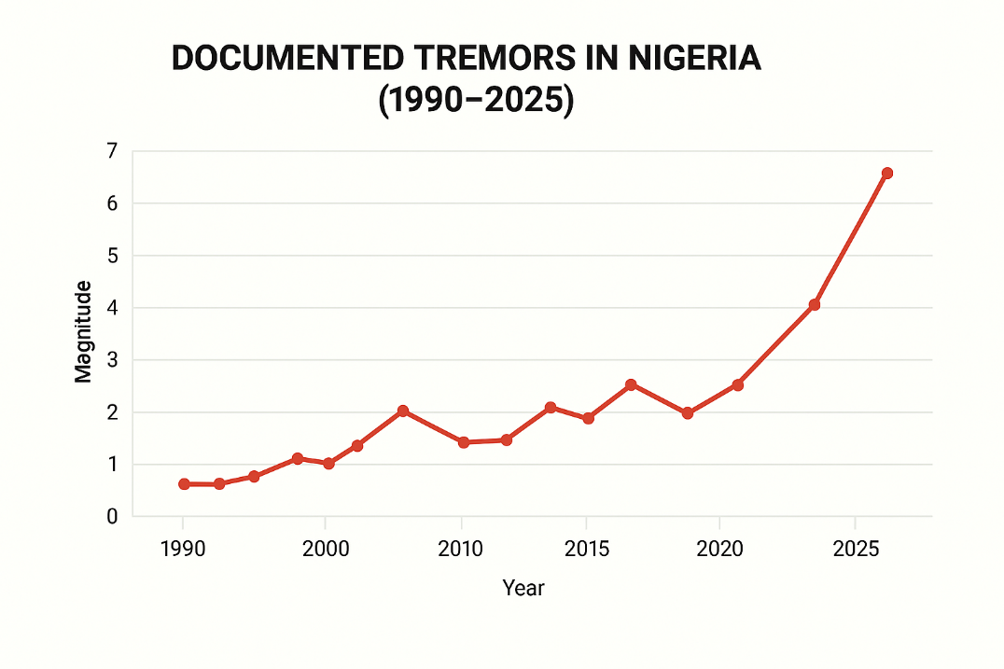
Figure 1: Timeline of documented tremors in Nigeria (1990-2025)

To contextualize Nigeria’s emerging seismic activity, Table 2 compares the country’s monitoring capacity, fatalities, and policy readiness with other African states. Algeria, for instance, operates a dense seismic network and has earthquake-specific regulations, while Ethiopia maintains moderate monitoring capacity along the East African Rift System. Malawi, though recording occasional intraplate tremors, shares Nigeria’s limited preparedness. These contrasts highlight Nigeria’s paradox: despite recording fewer fatalities than Algeria or Ethiopia, its combination of sparse monitoring, weak building codes, and rapid urbanization places it at disproportionate risk [16,18,21,19].

Table 2. Comparison of seismic monitoring, fatalities, and policy readiness in Africa Countries (1990-2025)
Country |  |  | Seismic Monitoring Capacity | Notable Earthquake 1990-2025) |  |  | Estimated fatalities |  | Policy and Preparedness |  | Notes
Nigeria |  |  | Low-sparse seismic stations; limited data sharing | Oyo (1991), Kaduna (2001), Abuja (2016-2018) |  |  | <50 |  | Limited focus on earthquake; disaster management prioritizes floods, erosion and desertification |  | Emerging seismic activity with tremor frequency; urban growth and weak enforcement heighten vulnerability [21,10].
Ethiopia |  |  | Moderate- several operational stations, especially along East African Rift | Afar (2005), Goba (2010) |  |  | <100 |  | National disaster plan includes seismic events; early warning limited |  | EARS makes region tectonically active; institutional readiness stronger than Nigeria [16,19].
Algeria |  |  | High-national seismic network in place | Boumerdès (2003) |  |  | ~2,500 |  | Earthquake-specific regulations; post-disaster response frameworks established |  | North African country with history of destructive events; robust monitoring and policy frameworks mitigate risk [18].
 | Malawi | Low to moderate -limited monitoring stations |  |  | Lake Malawi region | <50 |  | Basic disaster response plans; no earthquake-specific policies |  | Intraplate tremors occur; institutional preparedness is low, exposure moderate [17]

1.3 Problem Statement
Despite recurring tremors, Nigeria’s seismic hazard remains under-characterized, exposure is rising, and policy frameworks overlook earthquakes [23,24,22]. The Abuja tremors revealed fragile buildings, while institutional fragmentation limits preparedness [13,8].

1.4 Aim and Objectives
This study aims to examine Nigeria’s growing seismic vulnerability (1990-2025) by analyzing hazard data, exposure, and institutional responses. Objectives are to:
- Document the frequency and distribution of tremors.
- Evaluate urban exposure, including informal settlements.
- Assess institutional frameworks for preparedness.
- Identify gaps in monitoring, research, and policy.
- Recommend resilience strategies based on international lessons.
1.5 Research Questions
- What seismic patterns are evident in Nigeria (1990-2025)?
- To what extent are cities exposed, and why?
- How do Nigerian institutions frame seismic risk?
- How does Nigeria compare with global best practices?
- What gaps remain in research, policy, and preparedness?

1.6 Significance of the Study
- Scholarly Contribution: Provides one of the first systematic syntheses of Nigeria’s seismic risk, linking hazard, exposure, and governance [23,7,24].
- Policy Implications: Recommends integrating seismic risk into planning, codes, and DRR frameworks, with lessons from Ghana and Kenya.
- Future Research: Identifies priorities in hazard mapping, infrastructure vulnerability, and governance comparisons.
- Global Relevance: Nigeria’s case reflects risks in many intraplate regions of the Global South.
- Academic Utility: Consolidates fragmented literature, supporting geoscience, planning, and policy research.

1.7 Organization of the Paper
Section 1 introduces the context, problem, and aims. Section 2 reviews existing literature. Section 3 details the PRISMA-guided methodology. Section 4 presents results and discussion. Section 5 concludes with recommendations.

2. Review of Related Literature
This section synthesizes research on seismic hazards and disaster risk in Nigeria and Sub-Saharan Africa, spanning geo-tectonics, historical events, hazard/risk modelling, urban exposure, and governance, while situating Nigerian evidence within regional and global debates. It distils trends, strengths, and gaps that inform the study’s methodology and analysis.
Nigeria, like much of Sub-Saharan Africa (SSA), lies within an intraplate environment typically classified as low-to-moderate seismicity. Ancient fault systems and rift-related structures nonetheless sustain non-negligible risk. The Ifewara-Zungeru system in the southwest is especially important and has been linked to several historical events [7,21].

Geophysical studies indicate a complex crustal stress regime: Rebetsky and Adagunodo [4] identify variations in stress orientations across West Africa and link intraplate seismicity to reactivation of older faults under present regional forces. GPS-based kinematics show subtle but continuous crustal motions, implying that regions long considered “stable” can still produce damaging earthquakes over extended timescales [16].

The East African Rift System (EARS) provides a contrast: ongoing crustal extension in Ethiopia, Malawi, and Tanzania yields more frequent, sometimes severe events [17]. While Nigeria’s activity is lower, EARS research underscores how stress transfer and fault reactivation can drive intraplate earthquakes, patterns documented in other continental interiors as well [1].
Persistent limitations include sparse networks, incomplete instrumental records, fragmented historical data, constrain national hazard assessment [6,24]. This weakens both scientific understanding and the integration of hazard information into planning, especially in rapidly urbanizing areas where even modest tremors can trigger outsized impacts.

2.2 Historical Seismicity and Regional Hotspots in Nigeria
Although often labelled tectonically stable, Nigeria has recorded intermittent seismic activity over the past century, generally moderate in magnitude yet significant for planning. Most events cluster along pre-existing faults, notably the Ifewara–Zungeru lineament extending from the southwest into central Nigeria [7,21]. The Benue Trough and the Abuja-Kaduna corridor also show episodic activity linked to reactivated structures within the broader West African rift architecture.

Notable examples include: Ibadan (1990, M3.7); Jushi-Kwari, Kaduna (1998, M4.0) [23,25]; Abeokuta (2009, M4.1); Abuja-Mpape (2016, M3.8); Kwoi, Kaduna (2017, M4.4); further Abuja tremors (2018); Saki, Oyo (2020, M3.2) [8,22]; Omu-Aran, Kwara (2021, M2.6 at 15 km) [26,27]; and Ijebu-Ode (2023, M4.0) [8]. Smaller tremors in the southeast (e.g., Enugu) and northern Nigeria (Bauchi, Maiduguri) may be under-represented due to sparse instrumentation and documentation.

A consolidated event list is provided in Table S1 (Supplementary), summarizing year, location, magnitude, depth, reported impacts, and sources. This compendium complements the national timeline in ure 1 and informs later hazard mapping.
These records emphasize the need to expand monitoring, update codes, raise public awareness, and strengthen infrastructure [18].

2.3 Assessment of Seismic Hazards and Risk Modelling
Early Nigerian assessments relied on catalogues, macro-seismic reports, and field surveys to delineate hazard zones [28,29,30]. Building on those baselines, probabilistic seismic hazard models (PSHMs) now estimate ground-shaking and recurrence by combining magnitude-frequency relations, fault characteristics, and site conditions [31,32]. Results consistently flag southwestern and central Nigeria as relatively elevated-risk areas, reflecting past tremor clustering and mapped faults [33,31]. Recent studies [34] further note emerging tremors in the north, suggesting areas once assumed stable may be changing.

Figure 2 presents a representative probabilistic seismic hazard surface for Nigeria, highlighting relatively higher ground-shaking potential along the Ifewara-Zungeru corridor and parts of the Abuja-Kaduna axis. These patterns align with historical event clusters and mapped lineaments [31,33,32].
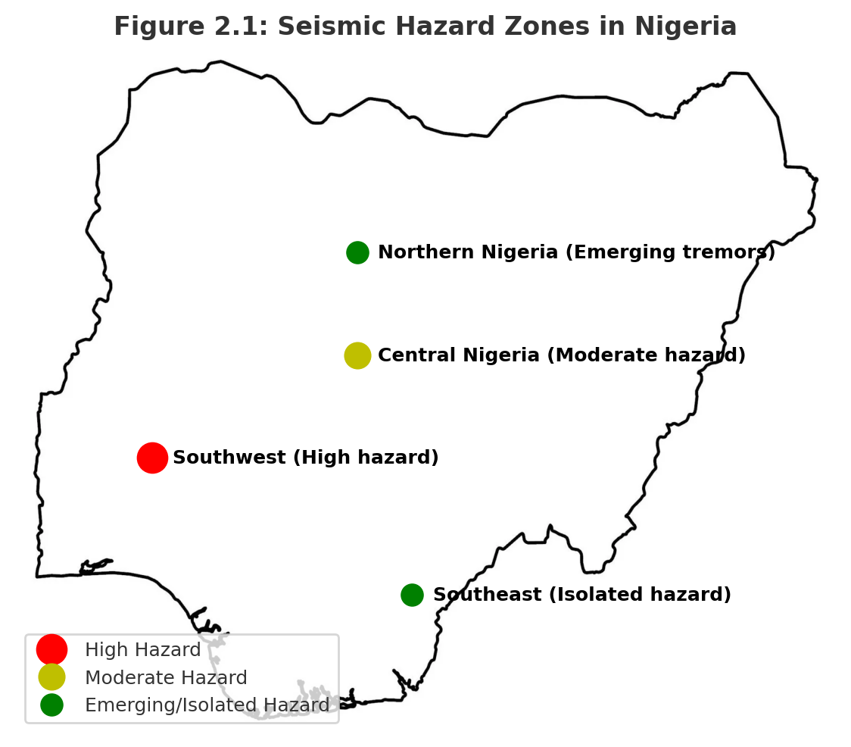
Figure 2. Probabilistic seismic hazard map for Nigeria-schematic for review purposes; data sources as cited

Alongside PSHM, GIS and remote sensing refine risk assessments by overlaying faults, soils, topography, land use, and settlement patterns to visualize hazard–exposure intersections [5,35].
Figure 3. overlays urban centers, critical infrastructure, and mapped faults, illustrating how proximity to the Ifewara-Zungeru system elevates potential exposure in fast-growing corridors. This spatial integration yields actionable insights for planners and emergency managers [5,35].

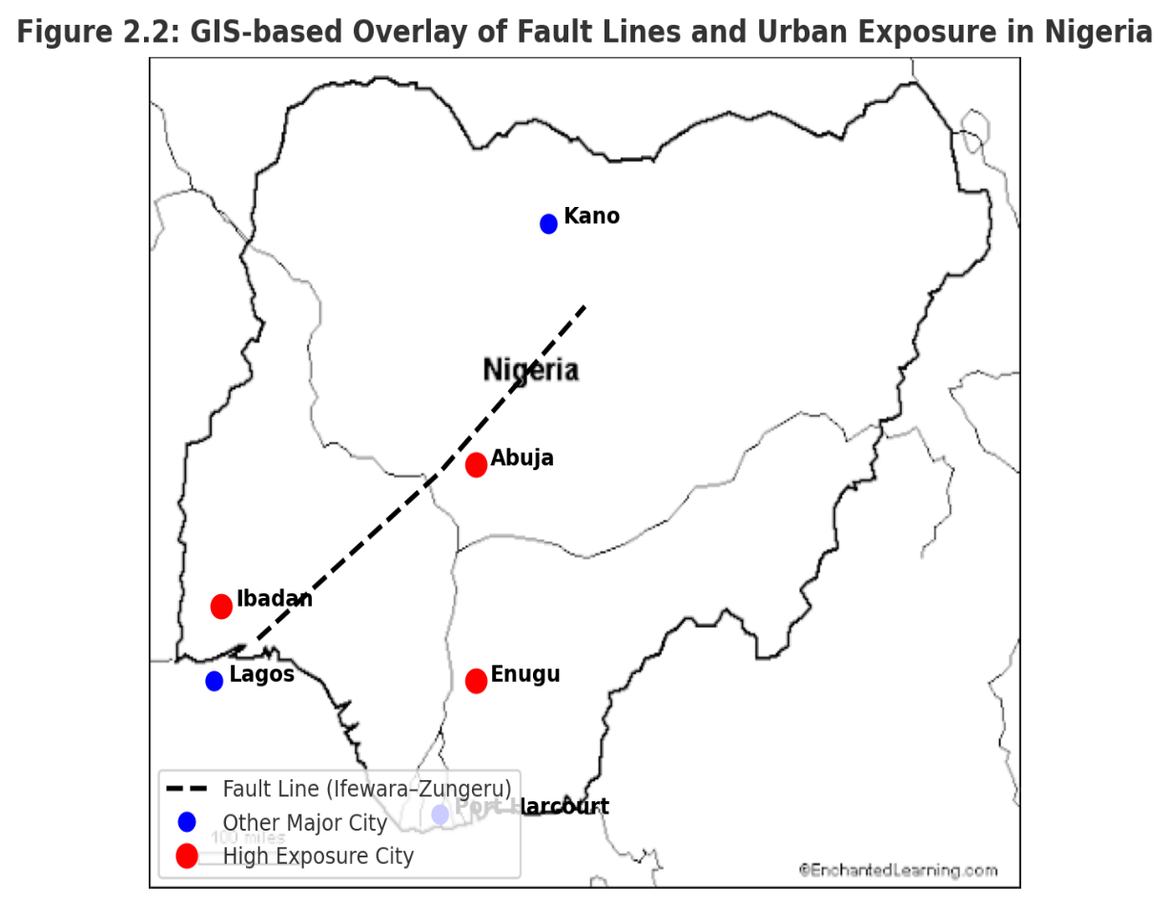
Figure 3: Conceptual GIS-based overlay of urban center and proximity to a major fault line

Human activities can also influence local stress fields: groundwater extraction and borehole drilling may perturb stresses and trigger minor tremors near faults [31,33]. When governed by geotechnical practice, drilling also generates subsurface data valuable for site classification and liquefaction appraisal [34].
Despite progress, uncertainties persist: few stations, short and discontinuous records [23] and reliance on regional analogues limit precision. Comparative experience from the New Madrid Seismic Zone to European frameworks shows the value of dense networks, long-term GPS, and advanced probabilistic models to reduce uncertainty and enhance early-warning capacity [1,14].

2.4 Urban Exposure and Vulnerability to Seismic Hazards
Rapid urbanization concentrates people and assets in locations often ill-prepared for seismic shocks [9,36]. Informal settlements frequently occupy marginal lands (floodplains, reclaimed areas, unstable slopes) and are characterized by weak construction standards, increasing collapse risk even in moderate shaking [10,36,11]. Spatial studies show many residents live close to active faults such as Ifewara–Zungeru, compounding exposure [31].
Building stock varies from reinforced concrete in planned districts to unreinforced masonry in informal areas; retrofitting is limited [31,36]. Concentrated critical infrastructure SUCH AS hospitals, schools, transport, and utilities creates systemic vulnerability when disrupted. Mapping these assets against tremor zones is essential for prioritizing mitigation [31,36,11].

2.4.1 Population Dynamics and Seismic Exposure
Nigeria’s population (≈223 million in 2022) is highly urban-centered and growing [37]. Density magnifies casualty and damage risk where codes are unenforced and informal construction dominates [10,31,36,11]. Linking demographic layers to hazard maps enables targeted interventions: risk-sensitive planning, retrofitting, and preparedness in the highest-exposure neighborhoods [37,36,31].

2.5 Socio-Economic and Policy Dimensions of Seismic Risk
Seismic risk is co-produced by institutions and socio-economics. NGSA handles fault mapping, seismic records, and advisory functions, while NEMA leads preparedness, response, and awareness [13,36,30]. Yet policy and operational gaps persist: DRR agendas emphasize floods and storms, leaving earthquakes under-prioritized; monitoring is under-funded; building regulations are weakly enforced; and planning rarely integrates seismic considerations [19,15,36]. As areas with documented tremors often show no proactive policy response, critical infrastructure remains exposed [34].

Community-level vulnerability is shaped by limited awareness, scarce drills, and socio-economic constraints, especially in informal settlements [12,36,30]. Integrating hazard mapping with governance frameworks helps prioritize hotspots and channel scarce resources toward local resilience [35,38,36,34].

2.6 Regional and Global Comparisons
Within SSA, the EARS remains the most active zone; lessons from Kenya, Ethiopia, and Tanzania show that dense networks, GIS-based hazard mapping, and sustained public awareness reduce exposure [17,16,14]. Global intraplate analogues: the New Madrid region (USA), Gujarat (India), and parts of Central Europe demonstrate that reactivated ancient faults can yield damaging earthquakes; these contexts spurred micro-zonation, probabilistic modelling, and code reforms [1]. For Nigeria, key takeaways include scaling monitoring networks, integrating PSHM + GIS/RS, and embedding seismic risk in proactive planning.

2.7 Research Gaps Identified from Literature
Data limitations: Historical records are incomplete and uneven; instrumental monitoring is sparse and discontinuous, constraining PSHM precision and spatial risk mapping [28,29,23].
Integration gaps: Few studies combine geophysics, urban exposure, socio-economics, and policy; research and DRR practice remain fragmented [39,35,38,13,19,15].
Underused technology: GIS, remote sensing, and advanced PSHM are not yet standard in national or municipal workflows; wider adoption could deliver localized hotspot mapping and scenario simulations (Figures 2-3).
Comparative learning: Nigeria can adapt practices from EARS and global intraplate regions; dense networks, GPS, micro-zonation, early-warning, and code enforcement [1,14,17].

3. Research Methodology

3.1 Study Design
This review follows PRISMA to consolidate and critically evaluate evidence on seismic hazards, urban exposure, and governance in Nigeria. A systematic approach is necessary given the fragmented scholarship spanning geophysical modelling, urban planning, socio-economic vulnerability, and institutional frameworks.
Identification of sources. We searched Scopus, Web of Science, ScienceDirect, and Google Scholar, plus institutional repositories (NEMA, NGSA, UNDRR, World Bank, UN-Habitat) using terms such as “seismic hazard Nigeria,” “earthquake risk Africa,” “urban vulnerability Nigeria,” “induced seismicity,” and “disaster governance Nigeria.” Coverage: 1990-2025 to match the documented period of seismic activity.

Screening. Titles/abstracts were screened for relevance to: (i) Nigerian or comparable African intraplate seismicity; (ii) urban exposure, infrastructure vulnerability, or governance; and (iii) peer-reviewed or reputable institutional outputs. Purely laboratory geophysical work without urban/policy relevance was excluded.

Eligibility & Inclusion: A total of ≈200 records were initially identified through database and grey literature searches. After removing 80 duplicates and ineligible records at the screening stage, 120 full texts were assessed for eligibility. Of these, 67 met the inclusion criteria and were retained for detailed review. During synthesis, six were later excluded due to redundancy or insufficient relevance to the core thematic domains, leaving 61 studies that form the final evidence base for this review (see References).

Thematic Synthesis: The retained works span four interrelated domains: -
- Seismic hazard characterization (fault mapping, probabilistic models, intraplate seismicity);
- Urban/infrastructure exposure (informal settlements, code compliance, critical infrastructure);
- Socio-economic vulnerability & public perception (preparedness, awareness, climate interactions);
- Policy & governance (DRR strategies, institutional capacity, international lessons).

Transparency: Figure 4 presents the PRISMA flow diagram: ≈200 records identified; 80 excluded at screening; 120 assessed at full text; 67 retained; 61 finally synthesized. This adjustment ensures both methodological transparency and alignment with journal requirements.

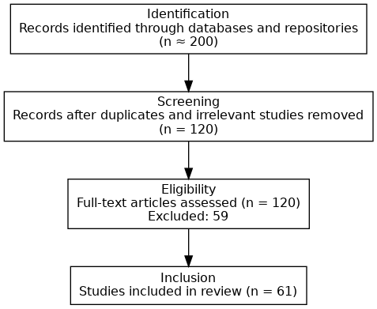
Figure 4: PRISMA Flow Diagram

3.2 Data Extraction and Coding
Data from the 61 included studies were extracted using a structured template that captured the following attributes: author, year, source, geographical focus and scale, methodological approach, and contribution to one or more domains (hazards, vulnerability, or governance). This process adhered to PRISMA’s principles of transparency and reproducibility.
Coding proceeded in two iterative passes. In the first pass, each study was assigned to one of four primary domains: (i) seismic hazard characterization, (ii) urban and infrastructure exposure, (iii) socio-economic vulnerability and public perception, and (iv) policy and governance. In the second pass, sub-codes captured specific emphases within these domains, such as probabilistic modelling, informal settlements, household preparedness, and disaster risk reduction (DRR) strategies.

Manual reading was supported by Excel spreadsheets and NVivo software, with reliability enhanced through repeated coding checks and consensus resolution across domains. Cross-cutting studies were assigned multiple codes to reflect their interdisciplinary contributions.
Table 3 presents the coding framework and distribution of studies (n = 61) across the four domains. This framework underpins the thematic synthesis in Section 3.3 and informs the results discussed in Chapter 4.

Table 3: Coding Framework and Distribution of Studies
Thematic Domain | Description of Focus | Examples of Sub-codes | No. of Studies (n=61)
Seismic Hazard Characterization |  |  | 25
  Studies mapping fault lines, modeling seismic probability, or analyzing intraplate seismicity
  Probabilistic hazard modeling, geophysical surveys, historical seismic records, stress state analysis, fault reactivation
Urban and Infrastructure Vulnerability |  |  | 5
  Studies assessing urban exposure, building compliance, housing vulnerability, and resilience to earthquakes
  Building compliance, informal settlements, housing vulnerability, infrastructure resilience
Disaster Preparedness and Governance |  |  | 23
  Studies focusing on emergency management systems, institutional frameworks, policy, risk reduction, and community preparedness
  Emergency planning, disaster governance, policy frameworks, community-based preparedness, Sendai Framework implementation
Other / Global Comparative Studies |  |  | 8
  Studies providing international comparisons, remote sensing applications, or methodological insights
  GIS/remote sensing, global seismic hazard models, cross-country resilience comparisons
The distribution of studies across these four domains is further illustrated in Figure S1(Supplementary), which highlights the dominance of hazard characterization studies compared with the relative scarcity of work on governance and community resilience.

3.3 Analytical Strategy / Data Synthesis
Synthesis combined narrative and comparative approaches.
- Descriptive mapping: Using Table 3 to show how evidence clusters by domain, method, and time, highlighting concentration in hazard studies and thinner coverage of community resilience and governance.
- Thematic synthesis: Within each domain we compared recurring themes and divergences (e.g., probabilistic vs. historical-catalogue hazard work; governance emphasis on institutional gaps vs. reform proposals).
- Comparative lens: Nigerian findings were read alongside African and global intraplate contexts to identify commonalities and distinct patterns.
- Cross-domain integration: We explicitly linked code enforcement gaps (urban exposure) with institutional weaknesses (governance) and socio-economic constraints (preparedness).
Together, Figure 4 and Table 3 show how studies were identified, grouped, and synthesized; these provide the backbone for the results in the next chapter.

3.4 Quality Appraisal
We appraised the 61 retained studies for (i) clarity/rigor of design, (ii) data collection/analysis quality, and (iii) relevance to Nigeria’s seismic risk and urban vulnerability.
Peer-reviewed journal articles generally showed higher methodological rigor, while institutional/grey literature provided contextual and policy value but sometimes lacked detail. To preserve policy relevance, grey literature was retained but flagged for interpretive caution. Appraisal used a PRISMA-aligned checklist and a three-point scale (high/medium/low), with discrepancies resolved through repeat checks.

Table 4 reports the distribution of quality ratings and source types used in synthesis.
Table 4: Quality Assessment of Retained Studies
Quality Level | Description | Study Frequency | Type of Sources | Note
High |  | 29
  Studies with clear research design, rigorous methodology, and highly relevant findings for Nigeria’s seismic risk and urban vulnerability contexts
  Peer-reviewed journal articles
  Strong evidence base; directly informs synthesis
Medium |  | 20 |  | Useful for context; interpret with moderate caution
  Studies with moderate methodological rigor or partial relevance; may have minor gaps in transparency or data analysis
  Peer-reviewed journals, some institutional reports
Low |  | 12 |  | Retained for policy relevance but flagged for interpretive caution
  Studies with limited methodological detail, unclear design, or lower relevance to Nigerian seismic risk
  Institutional reports, grey literature
The relationship between study quality and thematic focus is presented in Figure S2 (Supplementary). It shows that while high-quality peer-reviewed studies dominate hazard characterization, governance and community resilience rely more heavily on medium- and lower-quality grey literature sources.

A conceptual overview linking study quality, thematic coverage, and geographic distribution is presented in Figure S3 (Supplementary). This visualization illustrates how the evidence base remains clustered around technical hazard modelling, while socio-economic and governance perspectives are still underrepresented.

3.5 Limitations of Methodology
Despite the structured process, several limitations remain. Publication bias may exist because null results are less often published, potentially skewing the evidence base. Regional imbalance is evident: the southwest is better studied than the north/northeast, limiting generalizability. Inclusion of grey literature increases policy relevance but introduces variability in rigor. Coding/appraisal required judgement despite checklists and cross-checks. Finally, the 1990-2025 window spans shift in monitoring technologies, urban growth, and policy frameworks, which complicates comparisons across time.

4. Results and Discussion
4.1 Overview of Seismic Hazard Patterns in Nigeria (1990-2025)
While Section 2.3 outlined the methodological evolution of seismic hazard assessment in Nigeria, this section turns to the empirical evidence between 1990 and 2025. The observed patterns broadly confirm model-based insights, particularly the prominence of southwestern and central clusters, while also highlighting emerging tremor zones not fully captured in earlier assessments.

Building on the regional hazard context, this section provides a data-driven analysis of Nigeria’s seismic patterns between 1990 and 2025, focusing on event frequency, magnitude distribution, and spatial clustering. Nigeria exhibits low-to-moderate intraplate seismicity, with events clustered in southwestern, central, and southeastern regions, consistent with basement structural lineaments and reactivated faults [28,29].

Analysis of earthquake catalogs reveals at least 75 recorded events (1990-2025), with magnitudes ranging from 2.0 to 5.2 Mw. The southwestern region shows the highest frequency, particularly Ibadan, Akure, and Ijebu-Ode (35-40%), followed by central Nigeria (25%) and southeastern centers such as Enugu and Abakaliki (15-20%). Emerging tremors in Bayelsa and Edo (≤3.5 Mw) suggest possible activation of previously unidentified faults [32].
The spatial and temporal distribution is summarized in Table 5, which highlights the dominance of southwestern clusters while noting emerging activity in the Niger Delta.

Table 5: Distribution of Recorded Earthquake Events in Nigeria (1990-2025)

Table 5: Distribution of Recorded Earthquake Events in Nigeria (1990-2025)
Region | City | Number of Recorded Events | Magnitude Range (Mw) | % Contribution to Total Events | Notable Observations
Southwest | Ibadan | 15 | 2.5-5.2 | 20% | Clustered along Ifewara-Zungeru fault; recurrent low-to-moderate tremors
Southwest | Ijebu Ode | 10 | 2.0-4.8 | 13% | Includes 1984 tremor (MMI VI); minor structural damage
Southwest | Akure | 7 | 2.2-4.5 | 7% | Historical fault reactivation; elevated local risk
Central | Abuja/Kaduna | 18 | 2.5-4.9 | 25%
  Local fracture zones; low-to-moderate seismicity; notable tremors in Mpape, Maitama, Kwoi
Southeast | Enugu | 8 | 2.0-4.2 | 11% | Proximity to Benue Trough; isolated tremors
Southeast | Abakaliki | 7 | 2.1-4.0 | 9% | Low-magnitude but urban exposure increasing
Central/Southwest | Omu-Aran | 3 | 2.0-2.6 | 3% | Recent low-magnitude tremors; minor local effects
Emerging South | Bayelsa | 5 | 2.0-3.5 | 6% | Newly reported low-magnitude tremors; potential new hazard zones
Emerging South | Edo | 5 | 2.0-3.5 | 6% | Recent sporadic tremors; previously under-monitored area
4.1.1 Magnitude and Intensity Distribution
Magnitude-frequency analysis shows most earthquakes fall below 4.0 Mw, aligning with MMI III-V. Notable events include the 2000 Kaduna tremor and the 2009 Abeokuta event, both reaching MMI VI [5,35]. Southwestern risk is linked to the Ifewara-Zungeru fault system [39,43]. Central and southeastern clusters reflect local fracture zones and the Benue Trough, respectively.

4.1.2 Temporal and Spatial Patterns
Temporal trends reveal a rise in reported tremors since the 2000s, attributable to improved detection and urban expansion rather than a dramatic escalation in seismicity. Spatially, the southwest records the highest density, with central Nigeria showing sporadic but significant activity.

The clustering and geographic spread of tremors are illustrated in Figure 5, which maps recorded events across Nigeria (1990-2025). It confirms the concentration along the Ifewara-Zungeru fault while showing new activity in the Niger Delta.

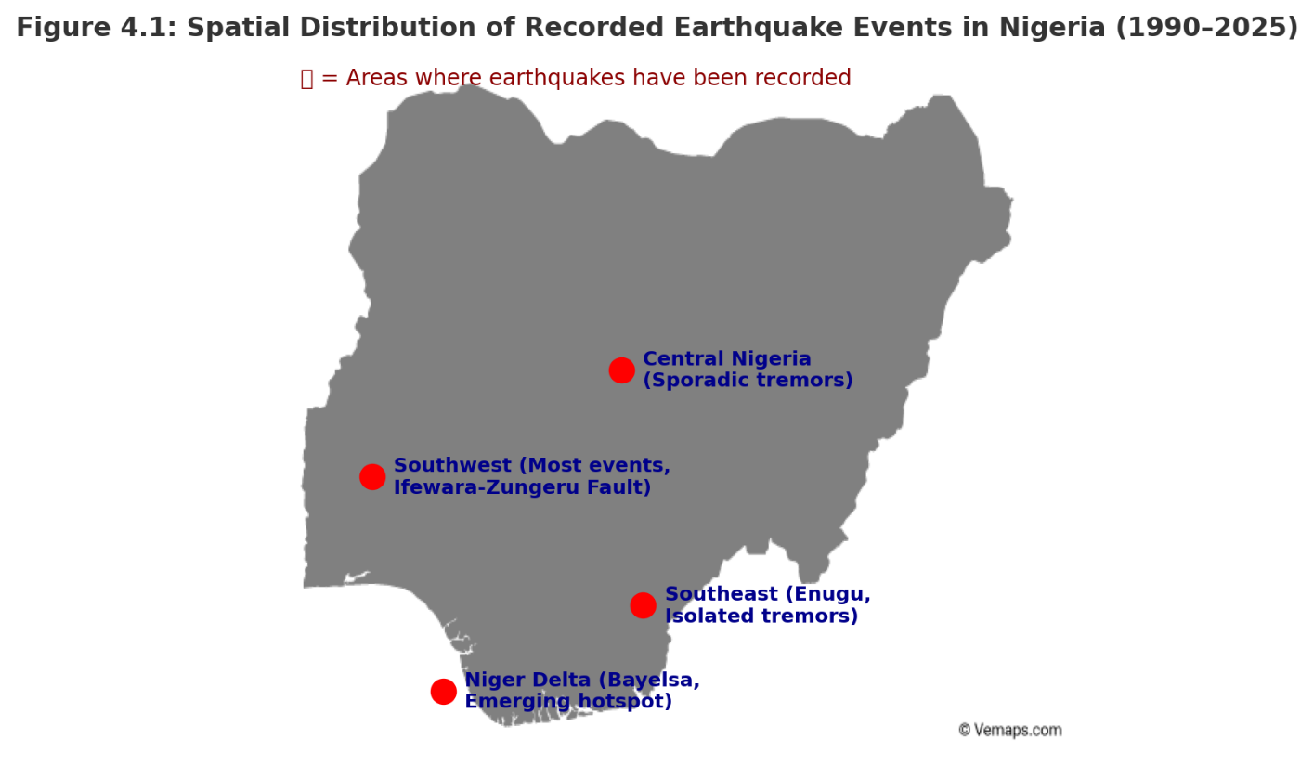
Figure 5: Spatial distribution of recorded earthquake events in Nigeria (1990-2025)

4.1.3 Implications for Hazard Planning
Clustering patterns provide a basis for prioritizing urban areas for mitigation. Overlaying hazard maps with cities and infrastructure identifies localities where earthquake-resilient planning is most needed.

4.2 Historical Earthquake Records and Frequency
Nigeria’s seismic history reveals a consistent pattern of low-to-moderate tremors, with variations shaped by fault reactivation, crustal weaknesses, and improved monitoring [28,29,32].
4.2.1 Frequency of Events
Southwestern Nigeria contributed 35-40% of events, central Nigeria 25%, and southeastern centers 15-20%. Bayelsa and Edo tremors signal an expanding footprint of seismicity.

4.2.2 Magnitude and Intensity Distribution
Most events fall within Mw 2.0-4.0 (MMI III-V), though the 1984 Ijebu-Ode and 2000 Kaduna tremors reached MMI VI, demonstrating damaging potential [5,35].

4.2.3 Temporal Shifts
From anecdotal reports in the 1990s to systematic documentation post-2010, reporting reflects both improved monitoring and actual seismic activity [43].

4.2.4 Data Gaps and Limitations
Significant gaps persist due to sparse stations and underreported rural tremors.
These patterns are summarized in Table 6, which lists selected events by year, location, and observed impacts.

Table 6: Selected Earthquake Events in Nigeria (1990-2025)
Year | Region | City/Area | Magnitude (Mw) | Intensity (MMI) | Reported Impacts/Observation
1990 | Southwest | Ibadan | 3.7 | IV-V | Minor ground shaking; no structural damage
1998 | Southwest | Ijebu-Ode | 4.0 | VI | Building cracks; minor alarm among residents
2000 | Central | Kaduna | 4.1 | VI | Felt across local communities; minor infrastructural impact
2009 | Southwest | Abeokuta | 4.1 | V-VI | Structural cracks; public alarm
2016 | Central | Abuja (Mpape) | 3.8 | IV-V | Building vibrations; minor wall cracks
2017 | Central | Kaduna (Kwoi) | 4.4 | VI | Roof damage; community panic
2018 | Central | Abuja (Maitama/Gwaripa) | 3.6 | IV | Vibrations; minor structural impacts
2020 | Southwest | Saki (Oyo) | 3.2 | III-IV | Weak shaking no reported damage
2021 | Central/ Southwest | Omu-Aran (Kwara) | 2.6 | III | Felt locally; no structural damage
2023 | Southwest | Ijebu-Ode | 4.0 | V | Minor building cracks; temporary evacuations
2021 | Emerging South | Bayelsa | 2.2-3.5 | III-IV | Low-magnitude tremors; minimal local effects
2022 | Emerging South | Edo | 2.0-3.5 | III-IV | Sporadic tremors; previously under-monitored area

4.3 Urban Exposure and Vulnerability
Although earthquakes in Nigeria are generally low-to-moderate in magnitude, their impacts are magnified by dense populations, fragile housing, and vulnerable infrastructure [5,35]. These risks are best understood through two interrelated dimensions: first, the pressures of urban growth, informal settlements, and diverse building typologies; and second, the vulnerability of critical infrastructure and the insights provided by GIS-based exposure mapping.

4.3.1 Urban Growth, Informal Settlements, and Building Typologies
Nigeria’s seismic vulnerability is strongly shaped by rapid urban growth and weak planning oversight. Since 1990, cities such as Lagos, Abuja, Ibadan, and Enugu have expanded dramatically, often outpacing authorities’ ability to enforce safe land use [9]. Abuja alone grew from under half a million residents in the early 1990s to over three million today, much of it in peri-urban zones where informal construction dominates [43]. Such high population density magnifies the impacts of even low-magnitude tremors, ensuring shaking is widely felt and disruptive [1,44].

Much of this growth is absorbed by informal settlements, characterized by mud brick, corrugated sheet, or poorly reinforced concrete housing with little structural integrity [45,35,41]. In Ibadan and Enugu, slum clusters are densely packed with poor access to emergency services, making even minor tremors disproportionately damaging. Expansion into floodplains and slopes further compounds vulnerability [39,46].

Nigeria’s building stock also reflects engineering deficiencies; shallow foundations, weak reinforcement, and low-quality materials. This problem extends beyond informal areas: government estates in Abuja and Kaduna showed cracks during the 2000 Kaduna and 2016–2018 Abuja tremors [5,35,41]. Without systematic retrofitting and stricter code enforcement, much of the built environment remains highly susceptible to seismic impacts.

4.3.2 Critical Infrastructure and GIS-Based Vulnerability
Nigeria’s seismic exposure is intensified by critical infrastructure located in geologically sensitive areas. Major dams such as Kainji, Shiroro, and Jebba, along with airports, highways, schools, and hospitals concentrated in Abuja, Lagos, and Kaduna, represent high-value assets whose disruption would have cascading effects on safety and economic continuity [9,44]. In the Niger Delta, emerging tremors in Bayelsa overlap with dense oil and gas installations, raising risks of industrial accidents and environmental crises [32].

GIS analyses highlight these intersections by overlaying hazard data with demographic and infrastructure layers. They show, for example, how Ibadan’s tremor clusters overlap with informal housing, or how Abuja’s sprawl places institutions near mapped fractures [39,46,32]. In Bayelsa, GIS overlays reveal tremors converging with oil facilities and wetlands, underscoring compounded risks.

Table 7 consolidates these insights, linking seismic hotspots with population density, housing types, and critical infrastructure. Overall, Nigeria’s vulnerability reflects not just geophysical hazards but also the co-location of fragile housing and vital infrastructure in at-risk zones.

Table 7: Urban Exposure to Seismic Hazards by Region in Nigeria (1990-2025)
Region | City/Area | Urban Density (people/km²) | Dominant Housing Type | Critical Infrastructure Exposure | Observed Vulnerability Factors
Southwest | Ibadan | 3,500 |  | Hospitals, schools, transport hubs | High population density, informal housing clusters, weak code enforcement
  Informal settlement, mixed low-rise masonry
Southwest | Ijebu-Ode | 2,800 | Low-rise masonry, some informal housing | Schools, local clinics | Moderate urban concentration; some structural fragility in older buildings
Southwest | Akure | 2,900 | Mixed masonry and reinforced concrete | Hospital, government offices | Moderate population density; structural quality varies
Central | Abuja | 3,200 | High-rise reinforced concrete, informal peri-urban areas | National institutions, airports, government offices
  Rapid urban expansion; code enforcement gaps in peri-urban zones
Central | Kaduna | 2,700 |  |  | Structural weaknesses in older buildings; moderate urban density
  Colonial masonry, low-rise reinforced concrete
  Hospital, railway networks
Southwest/Central | Omu-Aran | 1,500 | Predominantly low-rise masonry | Local schools, health facilities | Low population but emerging seismic activity; structural fragility
Southeast | Enugu | 2,800 | Mixed masonry, some informal housing | Hospitals, schools, transport hubs | Urban growth intersects with fault zones; moderate vulnerability
Emerging South | Bayelsa | 1,200 | Low-rise masonry, stilted houses | Oil facilities, local infrastructure | Low-magnitude seismic activity; high-value oil infrastructure; ecological sensitivity
Emerging South | Edo | 1,800 | Low-rise masonry, some informal settlements | Local government offices, transport nodes | Recently reported tremors; limited monitoring; moderate vulnerability
Figure 6 complements Table 7 by mapping seismic clusters against urban exposure, highlighting Ibadan, Abuja, and Bayelsa as zones of compounded vulnerability.

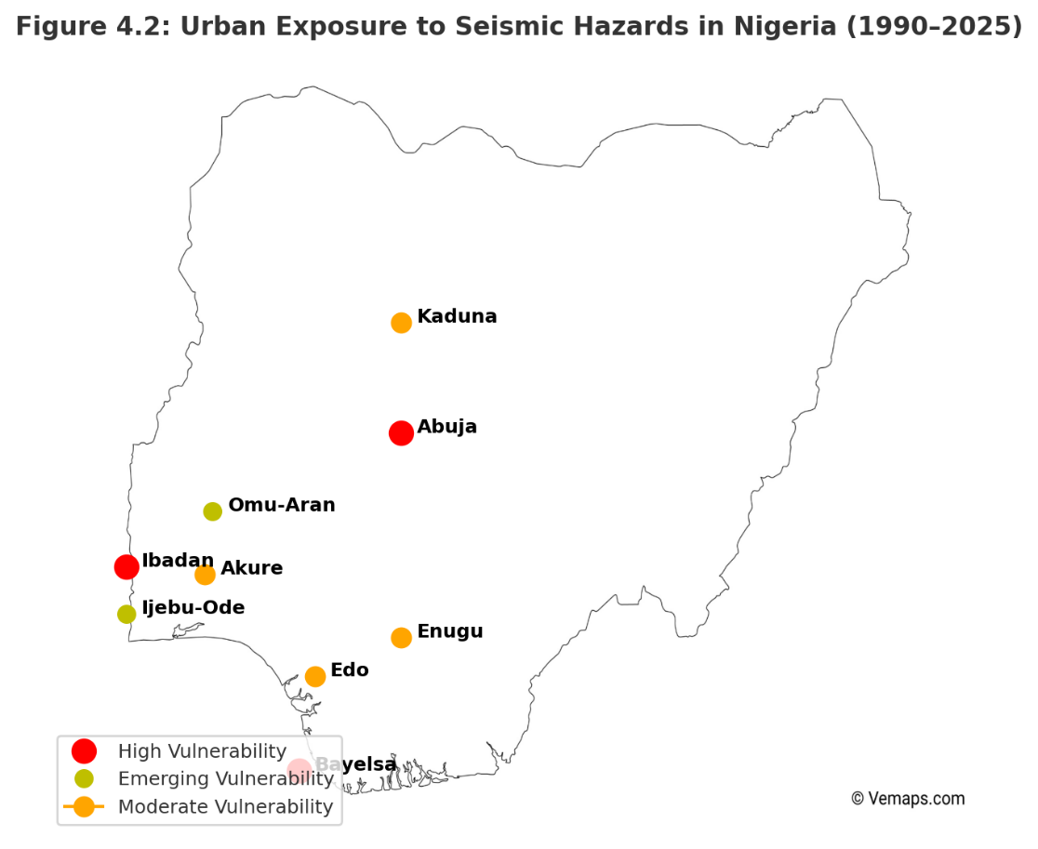
Figure 6: Urban Exposure to Seismic Hazards in Nigeria (1990-2025)

4.4 Socio-Economic and Policy Dimensions
4.4.1 Institutional Frameworks and Governance
NGSA and NEMA hold formal mandates, but capacity is constrained by sparse monitoring (<10 seismographs), weak coordination, and poor enforcement [43,40,19].
Table 8 summarizes institutional roles, achievements, and gaps.

Table 8: Institutional Roles, Achievements, and Gaps in Seismic Risk Governance in Nigeria (1990-2025)
Institution/Level | Mandate/Role | Key Achievements (1990-2025) | Major Gaps/ Challenges
Nigerian Geological Survey Agency (NGSA) | National seismic monitoring, hazard mapping, research | Installed seismic stations in Abuja, Kaduna, Ibadan; produced preliminary hazard maps | Sparse network (<10 seismographs); limited integration of data into urban planning; inadequate funding; low staff capacity
National Emergency Management Agency (NEMA) | Federal disaster coordination, emergency response | Coordinated relief during 2018 Abuja tremors; provided emergency support in affected regions | Predominantly reactive approach; weak community outreach; limited preventive programs or simulation drills
State Emergency Management Agencies (SEMAs) | Subnational disaster management, local preparedness | Operational frameworks established in most states | Underfunded; limited technical expertise; inconsistent coordination with NGSA and NEMA
Urban Planning Authorities | Building code enforcement, land-use planning |  | Weak enforcement; informal housing growth; limited capacity to monitor compliance
  Post-2010 codes incorporate seismic provisions
Community / Local Groups | Awareness, local preparedness, peer support |  | Efforts isolated; not systematically integrated into formal disaster management systems
  Mobilization after local tremors; community knowledge-sharing
Private Sector / Critical Infrastructure Operators | Operational continuity, safety of facilities | Some awareness of risk in high-value sectors (e.g., oil in Bayelsa) | Minimal earthquake-specific preparedness; lack of seismic retrofitting; vulnerability of infrastructure to low-magnitude tremors
4.4.2 Preparedness, Policy Gaps, and Governance Implications
Nigeria’s seismic vulnerability is shaped not only by hazards but also by weaknesses in preparedness, policy, and governance. Public awareness of earthquake risk remains very low compared to floods or erosion, and schools, hospitals, and workplaces rarely maintain earthquake protocols [45,5]. Limited preparedness leaves populations reacting with alarm but without coordinated safety procedures [35].

Weak enforcement of codes compounds these risks. Although seismic provisions were added to building standards after 2010, enforcement is inconsistent, especially in peri-urban and informal areas where up to 60% of housing escapes oversight [35,47]. Corruption, low institutional capacity, and self-built housing mean fragility persists even in formal sectors.

Socio-economic conditions heighten exposure: poverty and inequality restrict safer housing, insurance, and recovery capacity. Informal settlements in Lagos, Ibadan, and Enugu lack resilience and emergency resources, leaving residents particularly vulnerable [48].

Governance gaps are stark. NGSA runs fewer than ten stations, producing incomplete seismic datasets rarely integrated into planning [43,19]. NEMA coordinates response but remains reactive, while SEMAs are underfunded and lack expertise [40,49]. Planning authorities nominally enforce codes, yet compliance is weak in fast-growing zones dominated by informality [35].

These gaps have major implications. Communities remain reliant on anecdotal reports due to absent early warning. Weak code enforcement ensures chronic building fragility. Fragmented NGSA-NEMA-SEMA coordination undermines governance, and limited public engagement prevents bottom-up resilience [50].

Nigeria acknowledges global frameworks such as Sendai 2015-2030, but implementation is uneven [51]. Earthquakes remain low-priority, with resources directed mainly to floods and droughts. As seen in Brazil, underestimating intraplate hazards risks costly surprises [42].
In short, governance weaknesses, socio-economic fragility, and low preparedness magnify vulnerability far beyond hazard levels. Strengthening NGSA’s monitoring, enforcing standards, embedding seismic risk in land-use planning, and scaling community awareness are essential to reduce disruption from even moderate tremors.

4.5 Comparative Insights from Other Regions
Comparisons with East Africa, Brazil, and Nepal underline shared vulnerabilities: sparse monitoring, weak enforcement of building codes, and reliance on anecdotal rather than systematic seismic records [17,42,52]. In East Africa, the East African Rift continues to generate recurrent seismic activity, yet gaps in monitoring networks and urban preparedness mirror those seen in Nigeria [17]. Brazil’s intraplate seismicity shows how underestimated hazards in stable continental interiors can result in damaging events when governance and building resilience are neglected [42]. Nepal’s 2015 Gorkha earthquake further illustrates how rapid urban growth and weak code enforcement magnify disaster impacts, while also highlighting the importance of community preparedness and governance reform in strengthening resilience [53,54].

Table 9 contrasts Nigeria with these contexts across hazard, governance, and resilience dimensions.
Table 9: Comparative Insights on Seismic Risk and Governance (Nigeria and Selected Regions)
Region | Seismic Content | Monitoring Capacity | Governance & Policy Frameworks | Urban Resilience Lessons
Nigeria | Intraplate tremors along reactivated ancient faults; low-to-moderate magnitude (Mw 2.0–5.2) | Sparse seismic network (<10 stations nationwide); reliance on anecdotal reports | NGSA oversees monitoring; NEMA coordinates disaster response; weak enforcement of building codes; fragmented governance | High urban exposure; informal settlements increase vulnerability; proactive risk reduction is limited; need for integrated urban planning
East Africa |  | Limited but improving monitoring; several seismic stations in key urban centers | National disaster management agencies exist but face technical and coordination gaps | Rapid urban growth in hazard zones; weak code enforcement; emphasizes importance of early warning and community preparedness
  Rift-related seismicity (e.g., Main Ethiopian Rift); localized moderate events
Brazil |  | Sparse historical and real-time monitoring; underreporting of events | National and regional frameworks exist; low prioritization of seismic hazards | Dense urban populations exposed to rare events; highlights need for risk awareness even in “stable” regions
  Intraplate seismicity in southeastern cratonic regions; infrequent but potentially damaging
Nepal | Himalayan arc; high-magnitude earthquakes; active tectonic convergence | Well-established network; extensive historical records | Strong DRR policies post-2015 Gorkha earthquake; uneven enforcement; community engagement varies | Institutional learning and community-driven measures are critical; emphasizes low-cost, context-sensitive solutions for resilience
Figure 7 provides a spatial overlay of seismic events, urban growth, and population centers, reinforcing the universality of governance and exposure challenges.

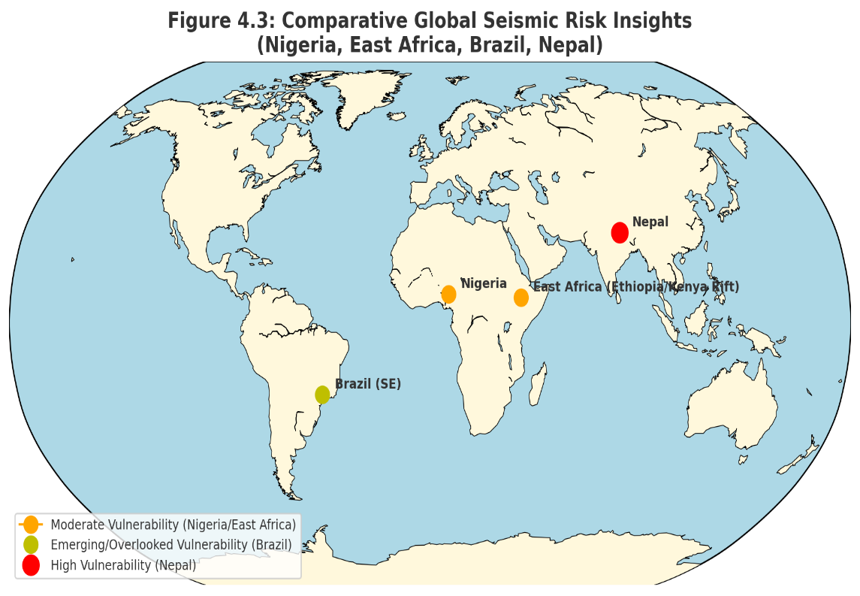
Figure 7: Comparative Global Seismic Risk Insights (Nigeria, East Africa, Brazil, Nepal

4.6 Gaps in Knowledge, Research Needs, and Concluding Insights
Nigeria’s seismic vulnerability is shaped by monitoring deficiencies, weak integration with urban planning, socio-economic fragility, and limited cross-regional learning. Methodological gaps include low adoption of probabilistic/deterministic hazard models such as NDSHA [55]. Induced seismicity linked to oil/gas extraction remains under-researched.

Table 10 summarizes knowledge gaps, implications, and recommendations.
Table 10: Knowledge and Research Gaps in Nigeria’s Seismic Risk Context (1990-2025)
Thematic Area | Identified Gaps | Implications for Seismic Risk Governance | Recommendation for Future Research/Action
Monitoring and Data |  |  | Expand monitoring networks; improve real-time data collection; maintain systematic earthquake records
  Fewer than 10 operational seismic stations nationwide; incomplete tremor detection; reliance on anecdotal records
  Limited hazard characterization and underestimation of risk; poor evidence base for urban planning
Integration with Urban Planning | Preliminary hazard maps exist but rarely applied in land-use decisions; lack of GIS-based risk overlays | Urban growth in at-risk areas continues unchecked; infrastructure vulnerable to tremors | Develop and operationalize GIS-based hazard-exposure-vulnerability models; embed seismic risk into urban planning and infrastructure siting
Socio-Economic Vulnerability | Scarce household-level and community-based vulnerability assessments; limited awareness and preparedness | Informal settlements and low-income households remain highly exposed; recovery from tremors is slow and unequal | Conduct detailed socio-economic and structural vulnerability studies; implement community-level preparedness programs and micro-insurance schemes
Cross-Regional Learning | Lessons from Nepal, East Africa, Brazil underutilized; limited adoption of best practices | Policy and planning are reactive rather than proactive; missed opportunities for low-cost resilience strategies | Incorporate comparative risk governance insights; adapt international methods to local contexts; strengthen institutional learning
 | Low adoption of probabilistic/deterministic seismic hazard approaches (e.g., NDSHA); reliance on sparse data | Hazard assessment lacks accuracy; evidence-based policymaking constrained | Apply advanced hazard assessment methods; combine global frameworks with local seismic data; promote interdisciplinary research
  Methodological Limitations
In sum, Nigeria’s earthquake vulnerability arises not only from geophysical uncertainty but also from socio-economic neglect and governance weakness. These findings provide the foundation for Section 5, where conclusions and recommendations will outline strategies for enhanced resilience.

- Conclusion and Recommendations

5.1 Conclusion
Nigeria’s emerging seismic vulnerability is real and significant, situated within a broader global context of often under-recognized intraplate seismicity. Recurrent low-to-moderate tremors are recorded in rapidly urbanizing areas, where impacts are amplified by fragile buildings, weak code enforcement, limited preparedness, and inadequate monitoring infrastructure [43]. The danger lies less in earthquake magnitude than in the vulnerability of exposed populations and systems.
International parallels reinforce this reality. In Brazil, intraplate seismicity has been underestimated, showing how short historical records obscure risks from ancient faults [42]. Nepal’s 2015 Gorkha earthquake revealed how rapid urbanization and weak institutions magnify impacts, but also demonstrated that proactive governance and community engagement can build resilience [54].
Thus, Nigeria’s seismic challenge is shaped as much by governance and socio-economic fragility as by geophysical forces. Expanding monitoring, advancing hazard modeling, and embedding resilience in planning and preparedness are essential to safeguard lives, infrastructure, and urban development.

5.2 Recommendations
Nigeria’s seismic vulnerability is not merely a geophysical issue but the outcome of intersecting hazards, rapid urbanization, socio-economic fragility, and governance gaps. Even low-magnitude tremors become disruptive when amplified by unregulated construction, weak codes, and poor preparedness [43]. Similar patterns across the Global South show how underestimating intraplate seismicity leaves millions exposed. Addressing this requires a shift from treating earthquakes as marginal hazards to embedding them in disaster governance, urban planning, and development strategies. Lessons from Brazil, Nepal, and East Africa underline that resilience is a scientific, social, and political project requiring investments in monitoring, institutions, community engagement, and equitable planning.

Strategic pathways for strengthening resilience include:
- Expand Seismic Monitoring and Data Systems
Increase operational seismic stations, particularly in emerging zones such as Bayelsa, Edo, and Omu-Aran, and integrate them with regional/global networks to improve hazard modeling and decision-making [56].
- Integrate GIS/Remote Sensing in Urban Planning
Use GIS and remote sensing to assess vulnerabilities in hospitals, schools, and infrastructure, guiding updates to building regulations and prioritizing high-exposure zones [57].
- Embed Seismic Risk in Multi-Hazard DRR Frameworks
Explicitly integrate earthquakes into Nigeria’s DRR policies, aligning with the Sendai Framework, while adapting lessons from Nepal and Brazil to local contexts [58].
- Enhance Community Awareness and Resilience
Prioritize drills, awareness campaigns, and local response networks, especially in informal settlements where risk is highest. Nepal’s experience shows how community engagement improves readiness [54].
- Promote Interdisciplinary and International Collaboration
Foster partnerships among domestic scientists, planners, and policymakers, while collaborating with global seismic institutions for data sharing, training, and comparative studies [42,56].
- Mainstream Seismic Risk into Development Policy
Integrate seismic resilience into climate adaptation and urban planning by enforcing codes, guiding settlement away from hazard zones, and embedding preparedness in infrastructure projects.
Together, these measures emphasize that resilience is not just technical but societal. Expanding monitoring, embedding hazard data into planning, enforcing codes, empowering communities, and fostering collaboration will transform low-to-moderate tremors from potential crises into manageable risks.
5.3 Future Research Directions
This review has mapped Nigeria’s seismic vulnerability but also revealed key gaps. Monitoring remains sparse, socio-economic vulnerability under-explored, and international lessons underutilized. Across intraplate regions in the Global South, risks are often underestimated due to short records, weak monitoring, and limited integration of hazard data into planning [42,54]. Advancing Nigerian research requires methodological innovation, deeper socio-economic engagement, and stronger global linkages.

Priority research directions include:
- High-Resolution Seismic Hazard Modeling
Future work should adopt advanced approaches, including probabilistic and Neo-Deterministic Seismic Hazard Assessment (NDSHA), to integrate geological, geotechnical, and site-specific data. Applied in other intraplate contexts [55], these models can provide reliable inputs for earthquake-resistant design.
- Multi-Scale Vulnerability Analysis
Most studies remain regional; more household- and neighborhood-level analysis is needed. Surveys and participatory mapping can capture how poverty, inequality, and fragile infrastructure shape resilience, enabling targeted interventions [35].
- Urban Governance and Policy Effectiveness
Research should evaluate how building codes, zoning, and DRR frameworks are enforced in practice, identifying gaps between policy design and local implementation [59].
- Comparative and Cross-Regional Studies
Lessons from East Africa, Brazil, and Nepal demonstrate the value of probabilistic modeling, integrated planning, and community preparedness [42,60,54]. Adapting these experiences will strengthen Nigeria’s resilience strategies.
- Integration of GeoAI and Remote Sensing Technologies
Machine learning, satellite data, and predictive GeoAI can enable near-real-time monitoring, vulnerability mapping, and anticipatory disaster management. Their integration would also support multi-hazard assessments linking seismic and climate risks [61].

Together, these directions show that addressing seismic vulnerability requires more than geophysics: it demands interdisciplinary inquiry connecting hazard science with governance and community realities. Investing in high-resolution modeling, socio-economic studies, governance evaluation, comparative analysis, and GeoAI will build the evidence base for proactive risk management in Nigeria.

Reference
- Bilham R. Seismic risk and global urbanization. Seismological Research Letters. 2019;90(1):1–17.
- United States Geological Survey (USGS). Significant Earthquake Database. Reston (VA): USGS; 2022. Available from: https://earthquake.usgs.gov
- Wisner B, Gaillard JC, Kelman I. Handbook of Hazards and Disaster Risk Reduction. 2nd ed. London: Routledge; 2021.
- Rebetsky Y, Adagunodo TA. Stress state and seismicity in West Africa: insights into intraplate earthquakes. Journal of African Earth Sciences. 2018;150:100–12.
- Adagunodo TA, Sunmonu LA, Odeyemi IB, et al. Review of seismicity in Nigeria: implications for hazard monitoring. Natural Hazards. 2018;94(2):873–902.
- Ojo SB, Adepelumi AA. Earthquake records and monitoring in Nigeria: progress and challenges. Nigerian Journal of Geology. 2021;56(1):45–59.
- Adepelumi AA, Ako BD, Olorunfemi MO. Seismicity of the Ifewara–Zungeru fault system. Journal of Geodynamics. 2008;46(1):1–11.
- Nigerian Geological Survey Agency (NGSA). Annual Seismicity Bulletin. Abuja: NGSA; 2019. Available from: https://ngsa.gov.ng
- United Nations Human Settlements Programme (UN-Habitat). World Cities Report 2022. Nairobi: UN-Habitat; 2022. Available from: https://unhabitat.org
- Adelekan IO. Vulnerability of poor urban coastal communities to flooding in Lagos, Nigeria. Environment and Urbanization. 2016;28(1):239–60.
- World Bank. Resilient Cities Program: Urban Risk in Nigeria. Washington (DC): World Bank; 2022. Available from: https://www.worldbank.org
- Wisner B, Gaillard JC, Cannon T. Disasters and vulnerability in the global South: lessons from Haiti. Disaster Prevention and Management. 2025;34(2):140–55.
- National Emergency Management Agency (NEMA). National Disaster Risk Reduction Policy. Abuja: NEMA; 2017. Available from: https://nema.gov.ng
- Pagani M, Monelli D, Weatherill G, et al. Global earthquake model (GEM) hazard map: integrating global datasets. Earthquake Spectra. 2020;36(1):1–24.
- United Nations Office for Disaster Risk Reduction (UNDRR). Global Assessment Report on Disaster Risk Reduction. Geneva: UNDRR; 2023. Available from: https://www.undrr.org
- Saria E, Calais E, Stamps DS, Delvaux D, Hartnady C. Present-day kinematics of the East African Rift. Geophysical Journal International. 2020;220(1):469–87.
- Corti G. Continental rift evolution: the East African perspective. Earth-Science Reviews. 2009;96(1–2):1–53.
- Kadiri U, Kijko A. Seismic hazard assessment of North Africa. Journal of Seismology. 2021;25(4):833–50.
- Manyena B, Simatele D. Disaster risk governance in sub-Saharan Africa: gaps and opportunities. International Journal of Disaster Risk Reduction. 2022;67:102668. https://doi.org/10.1016/j.ijdrr.2021.102668
- Ekpo CE, Adebayo T. Earthquake governance and policy neglect in Nigeria. African Journal of Environmental Management. 2022;30(2):55–67.
- Adepelumi AA, Asiwaju-Bello YA. Seismic risk in Nigeria: implications for infrastructure safety. Environmental Earth Sciences. 2022;81(3):97. https://doi.org/10.1007/s12665-022-10321-9
- Olugboji TM, Ogunleye EO, Abimbola AF. Recent tremor activity in southwestern Nigeria: implications for intraplate seismicity. Journal of African Earth Sciences. 2021;181:104260. https://doi.org/10.1016/j.jafrearsci.2021.104260
- Akpan O, Yakubu TA. Earthquake occurrences and implications for Nigeria’s seismic hazard. Earthquake Science. 2010;23(4):289–95.
- Afegbua KU, Onwuemesi AG, Umego MN. Seismotectonic study of Nigeria: evidence from recent tremors. Journal of Geophysics and Engineering. 2019;16(6):1141–53. https://doi.org/10.1093/jge/gxz041
- Ofonime EU, Yakubu TA, Akpan OU. Seismotectonic implications of recent earthquakes in Nigeria. Journal of African Earth Sciences. 2014;99:635–43. https://doi.org/10.1016/j.jafrearsci.2014.04.012
- Adepelumi AA. Preliminary investigation of the 2021 Omu-Aran earthquake in Kwara State, Nigeria. Nigerian Journal of Geosciences. 2021;9(2):55–68.
- Adedeji O. Seismic activity in Kwara State: Evidence from the Omu-Aran tremor. Environmental Hazards Review. 2021;13(1):44–53.
- Ajakaiye DE. Disaster mitigation in Nigeria: Earthquakes and other natural hazards. Natural Hazards. 1993;8(1):1–12. https://doi.org/10.1007/BF00605429
- Adepelumi AA, Olorunfemi MO. Engineering geological and geophysical investigation of the Akure earthquake tremor in southwestern Nigeria. Journal of Mining and Geology. 2001;37(1):65–80.
- Tsalha MS, Musa AM, Ajakaiye D. Seismicity and earthquake hazard assessment in Nigeria: A review. Earthquake Science. 2015;28(4):287–96. https://doi.org/10.1007/s11589-015-0122-4
- Kolawole F, Atekwana EA, Abdelsalam MG, et al. Active fault systems and intraplate seismicity in Nigeria: Insights from probabilistic seismic hazard analysis. Tectonophysics. 2018;718:88–102. https://doi.org/10.1016/j.tecto.2017.11.015
- Oni AT, Ajayi CO, Adekeye OA. Probabilistic seismic hazard assessment of Nigeria using updated earthquake catalogues. Journal of Seismology. 2023;27:421–39. https://doi.org/10.1007/s10950-022-10110-9
- Onwuemesi AG. Seismotectonic patterns of Nigeria and implications for seismic risk. Natural Hazards and Earth System Sciences. 2012;12:2901–12. https://doi.org/10.5194/nhess-12-2901-2012
- Oyibo O, Kadiri A. Emerging tremors in northern Nigeria: Implications for hazard perception and risk governance. Environmental Hazards. 2023;22(3):215–31. https://doi.org/10.1080/17477891.2022.2165230
- Bello HO, Adegboye AM, Oladipo AO. Geospatial assessment of urban vulnerability to seismic hazards in Nigeria. International Journal of Disaster Risk Reduction. 2020;48:101582. https://doi.org/10.1016/j.ijdrr.2020.101582
- World Bank. Advancing Disaster Risk Management in Nigeria: Resilient Cities and Infrastructure. Washington (DC): World Bank; 2020. Available from: https://www.worldbank.org
- National Population Commission (NPC). Nigeria Population Census Report and Demographic Projections. Abuja: NPC; 2022. Available from: https://nationalpopulation.gov.ng
- Adelekan IO. Private sector investment in urban risk reduction in Ibadan, Nigeria. International Journal of Disaster Risk Reduction. 2018;31:852–61. https://doi.org/10.1016/j.ijdrr.2018.07.001
- Kolawole F, Oladunjoye MA, Akinbami JO, Adekeye OA. Seismotectonic characterization of intraplate faults in Nigeria. Journal of African Earth Sciences. 2017;134:65–77. https://doi.org/10.1016/j.jafrearsci.2017.06.009
- Abah RC. Institutional dimensions of disaster risk governance in Nigeria. Journal of Environmental Planning and Policy. 2020;22(4):415–31. https://doi.org/10.1080/1523908X.2020.1722990
- Abubakar IR, Musa A. Informal settlements and vulnerability to hazards in Nigerian cities. Habitat International. 2022;126:102627. https://doi.org/10.1016/j.habitatint.2022.102627
- Borges JF, Assumpção M. Intraplate seismicity in stable continental regions: Lessons from Brazil. Tectonophysics. 2020;780:228395. https://doi.org/10.1016/j.tecto.2020.228395
- Akpan OU, Yakubu TA. Seismic monitoring and hazard implications in Nigeria: Progress and emerging challenges. Journal of African Earth Sciences. 2021;178:104199. https://doi.org/10.1016/j.jafrearsci.2021.104199
- Smith K, Brown P, Adeyemi A. Urban infrastructure and seismic risk in Sub-Saharan Africa. Natural Hazards Review. 2020;21(3):04020010. https://doi.org/10.1061/(ASCE)NH.1527-6996.0000385
- Nkwunonwo UC. A review of earthquake hazards and vulnerability in Nigeria. Natural Hazards. 2016;80(1):605–28. https://doi.org/10.1007/s11069-015-1976-6
- El-Hussain I, Kolawole F, Al-Harthy A. GIS-based analysis of seismic exposure in African cities. Journal of African Earth Sciences. 2021;181:104253. https://doi.org/10.1016/j.jafrearsci.2021.104253
- Eze B, Chukwu G. Community preparedness and public response to Abuja tremors. International Journal of Disaster Risk Science. 2019;10(4):589–601. https://doi.org/10.1007/s13753-019-00239-7
- Intergovernmental Panel on Climate Change (IPCC). Climate Change 2022: Impacts, Adaptation and Vulnerability. Contribution of Working Group II to the Sixth Assessment Report. Cambridge (UK): Cambridge University Press; 2022.
- Adebayo SO. State emergency management in Nigeria: Structures and constraints. African Journal of Public Administration. 2019;11(2):78–94.
- Paton D, Johnston D. Disaster Resilience: An Integrated Approach. 3rd ed. Springfield (IL): Charles C. Thomas; 2021.
- United Nations Office for Disaster Risk Reduction (UNDRR). Sendai Framework for Disaster Risk Reduction 2015–2030. Geneva: UNDRR; 2015. Available from: https://www.undrr.org
- Dixit A, Pokhrel R, Upadhyay R. Lessons from the 2015 Gorkha earthquake in Nepal. International Journal of Disaster Risk Reduction. 2016;19:79–91. https://doi.org/10.1016/j.ijdrr.2016.08.012
- Lam N, Kuipers J. Earthquake governance in Nepal: Ten years after the Gorkha event. Disasters. 2019;43(3):553–73. https://doi.org/10.1111/disa.12362
- Shrestha K, Pokhrel R. Governance reforms and seismic resilience in post-Gorkha Nepal. International Journal of Disaster Risk Reduction. 2025;67:103567. https://doi.org/10.1016/j.ijdrr.2025.103567
- Pan Y. Neo-deterministic seismic hazard assessment: Methods and applications. Soil Dynamics and Earthquake Engineering. 2017;92:475–86. https://doi.org/10.1016/j.soildyn.2016.10.025
- Omang RE. Expanding Nigeria’s seismic monitoring networks: Emerging prospects and challenges. Environmental Hazards Review. 2023;15(2):119–32.
- Ajayi CO, Adebayo A. GIS and remote sensing for urban vulnerability assessment in Nigeria. International Journal of Applied Earth Observation and Geoinformation. 2021;103:102512. https://doi.org/10.1016/j.jag.2021.102512
- United Nations Office for Disaster Risk Reduction (UNDRR). Global Assessment Report on Disaster Risk Reduction 2019. Geneva: UNDRR; 2019. Available from: https://www.undrr.org
- Olajide OA, Adewuyi TO. Building code enforcement and seismic resilience in Nigerian cities. International Journal of Building Pathology and Adaptation. 2024;42(1):112–27. https://doi.org/10.1108/IJBPA-2023-0105
- Mwangi J, Ochieng D. Seismic hazard in East Africa: Monitoring challenges and policy gaps. Geophysical Journal International. 2023;234(2):1012–28. https://doi.org/10.1093/gji/ggad123
- González PJ, Fernández J. Artificial intelligence and Earth observation for seismic hazard monitoring. Remote Sensing of Environment. 2022;278:113076. https://doi.org/10.1016/j.rse.2022.113076

Supplementary Materials
Table S1: Summary of tremors by year, location, magnitude, depth, reported impacts, and sources
Year | Location | Magnitude (M) | Depth | Reported Impacts | Primary sources
1990 | Ibadan (Oyo State) | 3.7 | Shallow | Minor ground shaking, no damage | Akpan & Yakubu (2010)
2000 | Jushi-Kwari (Kaduna State) | 4.0 | Shallow | Felt in surrounding communities | Ofonime et al., 2014
2009 | Abeokuta (Ogun State) | 4.1 | ~10 | Structural crack in walls and public panic | Akpan & Yakubu (2010)
2016 | Abuja (Mpape district) | 3.8 | Shallow | Building vibrations, minor wall cracks | NGSA report
2017 | Kwoi (Kaduna State) | 4.4 | ~15 | Roof damage, wide spread community panic | Afegbua et al, (2019)
2018 | Abuja (Maitama, Gwaripa) | 3.6 | Shallow | Vibration, population alarm | NGSA report
2020 | Saki (Oyo State) | 3.2 | Shallow | Weak shaking, no reported damage | Olugboji et al, (2021)
2021 | Omu-Aran (Kwara State) | 2.6 | 15 | Tremor felt locally; no significant damage | Adepelumi, 2021; Adedeji, 2021
2023 | Ijebu-Ode (Ogun State) | 4.0 | Shallow | Cracks in building, evacuation reported | NGSA field report (preliminary)

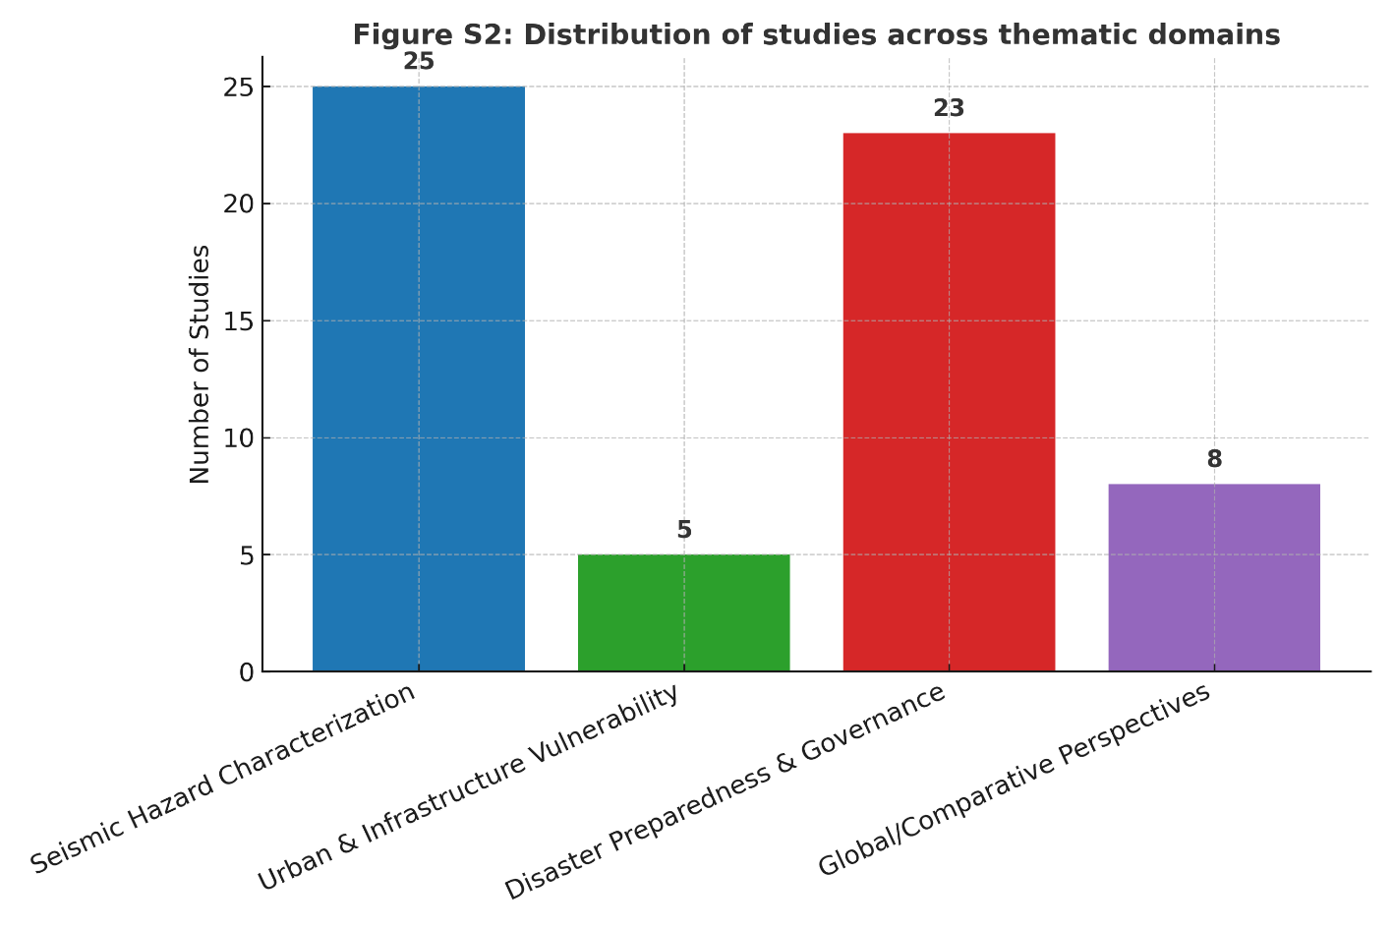
Figure S1: Distribution of studies across thematic domains

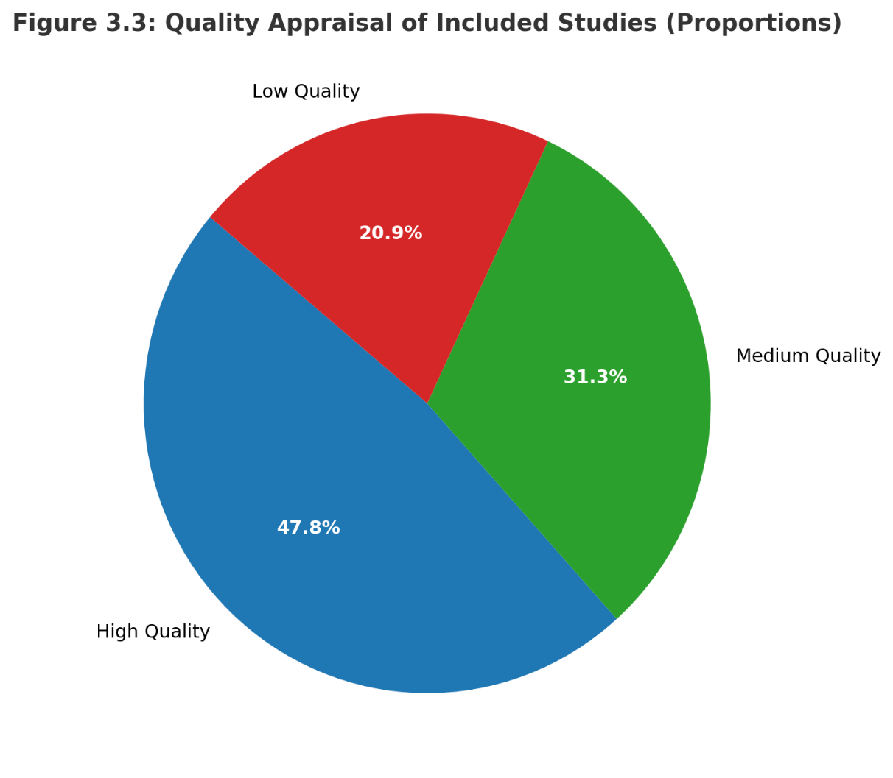
Figure S2: Quality Appraisal of Included Studies (Proportions)

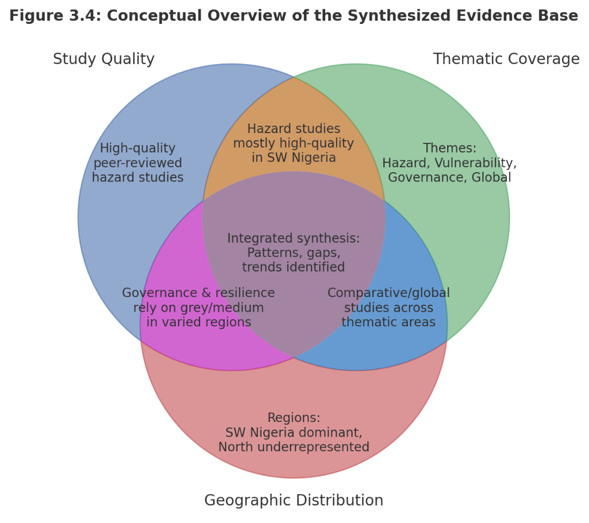
Figure S3: Conceptual overview of synthesized evidence base

