Emerging Trends and Innovative Approaches in Periodontal Therapy

Abstract
Optical Coherent Tomography (OCT), Ultrasonography (USG) and MRI are ionizing radiations to detect furcation involvement, measure gingival height and crestal bone level, quantifies soft-tissue inflammation and periodontal bone loss. Incorporating fluorescent, metallic, magnetic and electrochemical nanoparticles in periodontal screening aids in optimum diagnosis along with delivering antibacterial effect in the dysbiotic environment. The success of regeneration in GBR depends on the lack of micro motion of the membrane placed which would result in stability of the blood clot promoting the formation of alveolar bone. The membrane fixation techniques have been highlighted in the literature of which a novel suture technique “Nasal Spine Suture' was advised since it is safe, effective and prevents displacement of the graft placed beneath the membrane. In this modern era, utilizing the recent technologies especially in the form of digitalized approach has faded away the conventional approach. We the periodontists are in a situation to welcome these modern approaches without compromising the conventional modalities to deliver a personalized and successful periodontal care to fulfill the patient’s expectation.
Keywords: inflammatory disease, Periodontitis, Nasal Spine Suture, Optical Coherent Tomography

1. INTRODUCTION:
Periodontitis is an inflammatory disease which occurs as a result of host bacterial interaction resulting in attachment loss and bone loss affecting the quality of life of the individual.The optimal diagnosis and treatment planning areessential for the management of periodontitis.
The field of periodontics has seen an exponential growth both in the diagnosis and management of periodontitis. The proper understanding and application of these recent advances in the field of periodontics is essential to provide the quality dental care to the patients. This essay would highlight the recent advances in the diagnostic and therapeutic 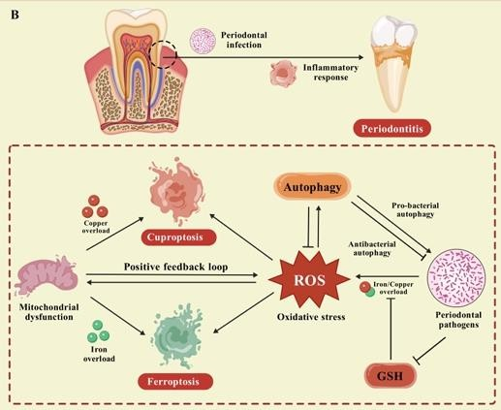periodontology and can be the eye opener to the budding as well as the pioneered dentists / periodontists.
FIG 1: PROGRAMMED CELL DEATH IN PERIODONTAL PATHOGENESIS

2. PERIODONTAL PATHOGENESIS:
2.1 Role of Viruses:
The synergistic interaction between bacteria and viruses such as cytomegalovirus or herpes virus plays a major role in the pathogenesis of juvenile / aggressive periodontitis. It alter host susceptibility, by suppressing protective response of macrophages, releases pro inflammatory cytokines, allowing the up growth of microorganisms leading to periodontal destruction in aburst likeepisodicpattern. Thus, systemic/ topical antiviral therapy may also be needed in the management of periodontitis (1).
2.2 Programmed Cell Death:
Ferroptosis is a new unveils which is dependent upon iron concentration; occur due to oxidative imbalance in the intracellular environment mediating the generation of reactive oxygen species resulting in periodontal damage (2). Cuproptosis is as similar find related to ferroptosis which depends upon copper concentration. Thus, it acts as a bidirectional sword and channeled focus would result in proper diagnosis and aid in tailoring periodontal therapy.
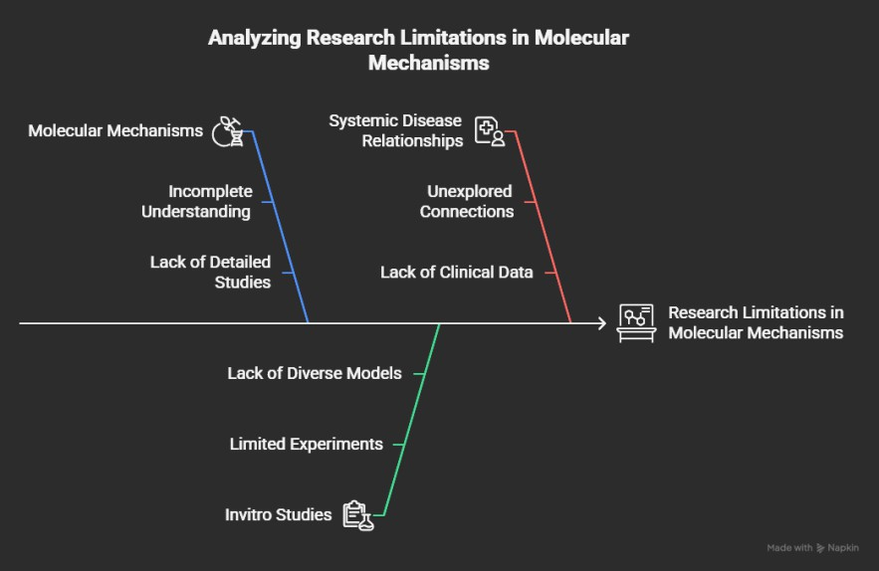

FIG 2: LIMITATIONS OF AUTOPHAGY IN PERIODONTAL PATHOGENESIS

3. CLASSIFICATION OF PERIODONTITIS:
Periodontitis is the major global health concern and management requires a classification with profound case definitions for optimal stratification of patients to aid in diagnosis and management which was given byAAP and EFP in 2018.
Westetal.found this classification as novel, improved compared tool dersystems and has mild and limited diagnostic accuracy due to heterogenic factors, low prediction rate of tooth loss and its unclear role in epidemiological studies. Moreover it has advised SPT for periodontitis patients every 3-12 months and applying this is difficult even in richestcountries like Norway where 72% of population are periodontitis patients. Thus, the clinical application of this classification is still difficult and has to be re-evaluated. (3)

4. PERIODONTAL DIAGNOSIS:
The 20thWorkshop by EFP, on “Periodontal diagnosis” found conventional periodontal probing as the standard reference method. Similarly, Stodle et al. compared the accuracy of manual probing vs pressure sensitive or electronic probes and found manual probes still remains the standard and no additional benefit from contemporary tools (4,5).
4.1 Recent advances in Imaging:
Optical Coherent Tomography (OCT), Ultrasonography (USG) and MRI are ionizing radiations to detect furcation involvement, measure gingival height and crestal bone level, quantifies soft-tissue inflammation and periodontal bone loss. However limitations such as poor penetration associated with OCT, cost factor of MRI and limited studies associated with periim plant bone loss has to be elucidated by future clinical trials to optimize periodontal diagnosis.
As periodontal pocket formation is a soft tissue condition, radiographic assessment was not possible in earlier days. Now with the incorporation of radio-opaque contrast agents, pockets can be assessed by imaging technologies. Biocompatible micro particle fillers and gold, silver nanoparticles Zno, Zirconia are commonly used along with CBCT (6)
OCT uses infrared light with 1325nm wavelength which show improved efficacy due to deeper penetration (7) Apart from pocket imaging, gingival thickness and biological width can also be evaluated.
Fiber optic endoscopes principle combined with capillaroscopy can assess the blood circulation in the periodontium providing pocket images (8)
Photoacoustic imaging is the combination of optical and ultrasonic imaging which show better resolution images due to deeper penetration and low scattering of ultrasonic waves. (8)

4.2 BIOSENSORS:
Point of care testing is one of the simple, cost effective and chair side diagnostic methods, predicting periodontitis using biosensors especially by integrating nanoparticles is a new trend (10)
4.2.1 Nanoparticle Biosensors:
Incorporating fluorescent, metallic, magnetic and electrochemical nanoparticles in periodontal screening aids in optimum diagnosis along with delivering antibacterial effect in the dysbiotic environment (11) The ideal prerequisite is the need of immobilization methods to maintain bio receptor in its place (12).
Virulence agents such as proteases (gingipains) are commonly detected by the Nano sensors. Researchers have found the limit of detection (LOD) for gingipains as 1ng/mLideal to detect periodontitis (13).
Apart from gingipains, human neutrophil elastase and cathepsin G are also gaining popularity which detects the proteolytic activity using protease probes. The LOD for human neutrophil elastase and cathepsin G are 1pg/mL and 100fg/mL respectively. (14)
4.2.2 SWATH:
Sequential Window Acquisition of all Theoretical – Mass Spectra is a new biomarker analytic technique using saliva. 377 proteins were identified out of which 8 salivary biomarkers such as beta 2 microglobulin, lysozyme C, protein S100-A8, neutrophil defensin 1, resistin, plastin 2, MMP-9, keratin, type II cytoskeletal 1 are associated with periodontitis. (15)
Even though many biomarkers are widely used in the early detection of periodontitis, following five host derived biomarkers such as MMP-8, HB, MIP-1Alpha, MIP-1 Gamma,Il-Beta has been highlighted in meta-analysis (16). Rakic et al. found MMP-8 as commonly addressed bone marker in saliva and show improved accuracy compared to cytokine markers and MMP -8. (17)

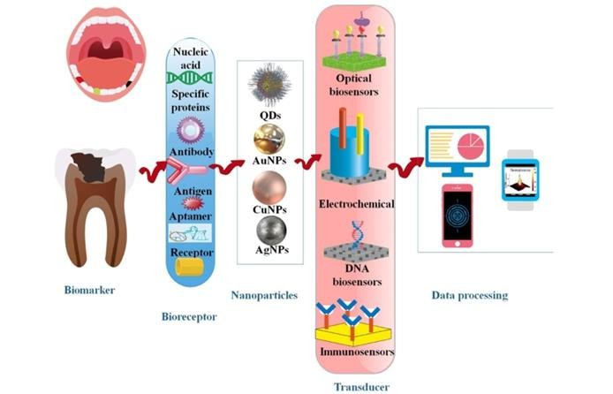

FIG 3: NANO BIOSENSORS
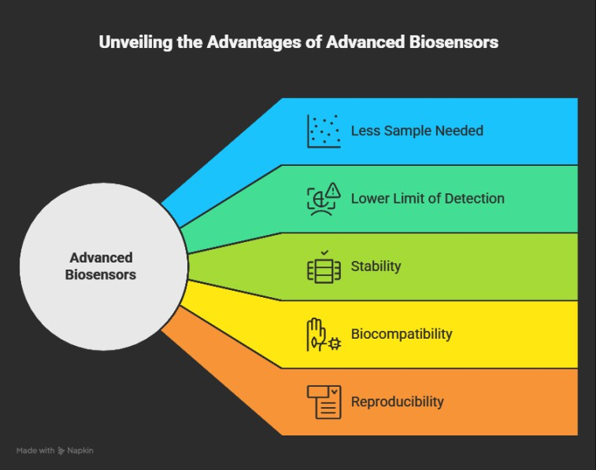

FIG 3A: ADVANTAGES OFNANOBIOSENSORS
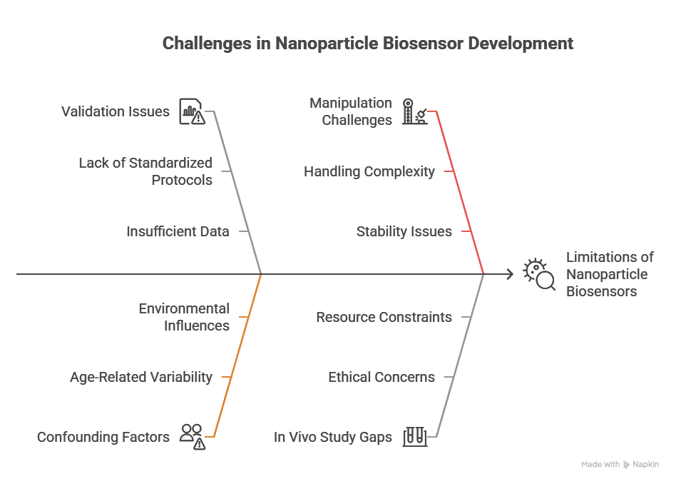

FIG 3B: CHALLENGES OF NANO BIOSENSORS

5. ROLE OF ARTIFICIAL INTELLIGENCE:
5.1 Intraoral Photographs/ Imaging:
It helps in biofilm detection, screening of automatic gingivitis, monitoring intervention in periodontitis patients, bone loss in periodontitis and also in surgical planning by providing segmentation of anatomical structures (18).
Fig. 4. Unveiling the advantages of advanced bisensors
Various models such as CNN, Faster R-CNN, U-Net EfficientNet b0 and DenseNet are commonly used in periodontal diagnosis of which R CNN possess high sensitivity score of 90.ViT Base model is used to classify bone loss in periodontitis using periapical radiographs. (19)
5.2 Cellular Techniques:
AI assisted cellular analysis of PMNs by segmentation and classification methods can be done using DNN methods non-invasively of which You look Only Once provides rapid and real time detection of periodontitis (20).
5.3 Risk Assessment:
Few software systems have been approved by the FDA such as,Videa Perio Assist(VPA), Overjet Dental Assist etc. VPA& Overjet Dental Assist measures bone levels associated with each tooth automatically, provides a high sensitive and specificity compared to expert dentists. (21,22)
5.4 Smart Phones:
Patient can utilize AI-based apps in their smartphones to take images of their mouth after periodontal treatment to check their periodontal status periodically. It can also deliver reminders and steps to follow proper plaque control measures to maintainoral hygiene and to improve clinical outcomes (23). Shen KL (24) found AI assisted counselling along with human counselling showed improved treatment outcomes compared to control group after non-surgical periodontal therapy.

6. EXOSOMES IN PERIODONTAL DIAGNOSIS AND TREATMENT:
It contains micro RNAs (miRNAs) which are secreted by every cell and acts as a communication between cells and play a major role in periodontal diagnosis and treatment. Plasma derived miRNAs, snoRs and programmed death ligand 1 in saliva are commonly expressed in periodontitis patients. Similarly, CD81 and CD9 exosomes are found be low in periodontitis patients compared to periodontally healthy patients (25, 26).
Exosomes derived from mesenchymal stemcells can maintain the Th17/Treg cell balance, facilitate conversion of macrophages from proinflammatory phenotype to anti-inflammatory, reduce apoptosis and increase phagocytic action of neutrophils, promote osteogenic differentiation, regulate osteoclastogenesis. Thus, it can modulate the host inflammatory response by specifically targeting each cell providing a customized periodontal therapy (27,28,29). miR-1246, miR-1260 band miR-378a show promising results in animal models (30). This method of treatment is found to be novel, ethical, effective and provide excellent results in immune regulation.
6.1 Plant Derived Exosomes:
Plant derived exosome like nanoparticles (PELN) were introduced by Halperin et el. in 1967. PELN derived from ginger, grapes, orange, cabbage, mulberry and blue berries possesses anti-inflammatory property, microbial modulation by inhibiting P. gingivalis and promoting the growth of probiotics (31), immunomodulatory and tissue regenerative properties by promoting osteogenesis and tissue angiogenesis (32).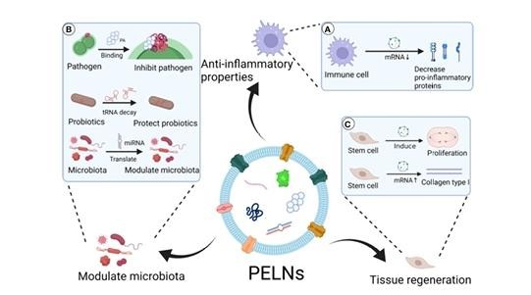

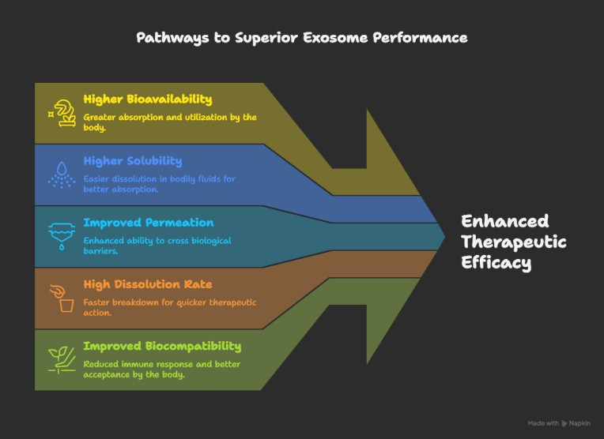

FIG 5A and 5B: PLANT DERIVED EXOSOMES LIKE NANOPARTICLES AND PERIODONTITIS
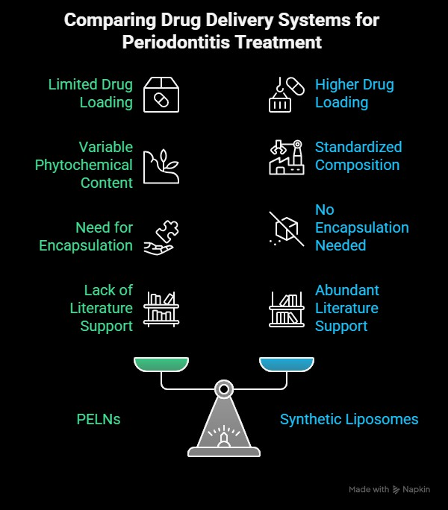

FIG5C: COMPARISON OF PLANT DERIVED EXOSOMES LIKE NANOPARTICLES AND SYNTHETIC LYSOSOMES

7. PERIODONTALVACCINATION:
Mucosal vaccines are found to be the current trend which shows improved results than systemic vaccines, however studies have been conducted only in rodents (32,33) rather than non-human primates such as dogs, mini pigs etc.
Other common routes of administration using whole cell vaccine, sub unit vaccine and DNA vaccine in the literature are found to be intranasal and oral, targeting antigens of periodontal pathogens such as P. gingivalis,A. actinomycetemcomitans and F. nucleatum.
Efficacy of period on tal vaccines depend sup on the delivery systems,of which bacterial,viral carriers and liposomes are commonly used. A breakthrough in the delivery system are, mucoadhesive patches and microneedles which showed improved drug release compared to liposomes (34)

8. RECENT INNOVATIONS IN ORAL HYGIENE TOOLS:
8.1 Modifications in Manual Tooth Brushes:
The most common modification of bristle shapes is crisscross type which showedhighest reduction of plaque and gingival inflammation in orthodontic patients and periodontal maintenance patients (34). Bristles infused with charcoal are also available which showed significant results in plaque removal along with less wear compared to nylon bristles. (35)
8.2 Customized Tooth Brushes:
Tooth brushes customized to the children with special health care needs and adults affected with cerebral palsy are widely becoming popular to ensure maintenance of oral hygiene. (36,37)
8.3 Modifications In Powered Tooth Brushes:
Powered tooth brushes with different modes are available which include gum line and interdental modes and showed effective plaque removal compared to conventional powered brushes (38). Apart from the modes, the heads of tooth brushes are also available as double heads providing effective plaque removal (39).
8.4 Modifications In Dental Floss:
Apart from waxed, unwaxed and flavored dental flosses, knotted floss was introduced to initiate the habit of flossing in beginners. Knotted dental floss provides significant plaque removal compared to conventional floss in plaque removal (40). Different types of knots are available of which ellipsoidal knots showed improved efficacy in plaque removal.Apart from this, dental health education using cartoons, tooth brushing assisted by smart apps especially with artificial intelligence and antimicrobial chewing gums (41) are recent trends to improve oral health. These modifications will promote periodontal health especially in orthodontic and prosthodontic patients.

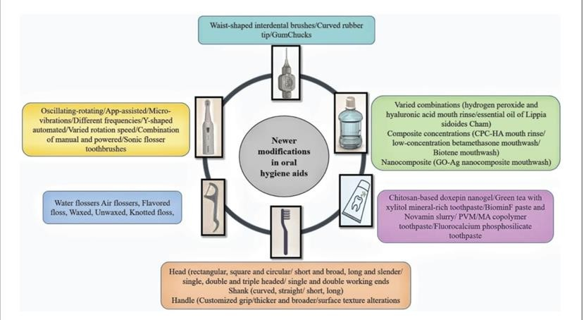

FIG 6: MODICATIONS IN ORAL HYGIENE TOOLS
9. PERIODONTALREGENERATION:
9.1 Advances in bonegrafts:
Regeneration of alveolar bone defects in the absence of bony walls along with simultaneousim plant placement is quite question able. Hence,abone graft should beself-contained and stable in such cases to promote regeneration.
Here comes the role of novel bone graft Poly Lactide Co Glycolic Acid coated biphasic calcium phosphate material which can turn into a porous and stable hard tissue scaffold on exposure to body fluids which overcome the limitation of the conventional bone grafts (42).
9.2 Mesenchymal Cells- Conditioned Medium:
Cell free approaches have overcome challenges associated with stem cells in promoting regeneration. Mesenchymal stem cell - conditioned medium is the indirect treatment approach with potential immunomodulation and regeneration effect.
Conditioned medium from mesenchymal stem cells contain a mixture of cytokines, growth factors and enzymes. It is simple, more economical and can be produced in large numbers and stored effectively (43).
9.3 PlateletRich Fibrin:
Miron et al. concluded that PRF still proves to be ideal for periodontal regeneration in intrabony defects compared to open flap debridement alone or in combination with bone grafts, enamel matrix derivative, PRP (44).
Horizontal centrifugation:
It is found to provide improved clinical outcomes due to higher concentration of the cells because of unrestricted movement of cells, more uniform distribution of the cells in the tube with increased release of growth factors ideal for the preparation of C-PRF and E-PRF.
9.3.1 Extended PRF:
To overcome the shorter resorption period of PRF, extended PRF uses bio heat technology which focuses on the degradation rate rather than release of growth factors. This was given by Kawase et al who heated PRF membrane to extend the resorption period (45). This resulted in the idea of heating the platelet poor plasma layer which is rich in albumin to extend the degradation time of PRF (46). Since it can be left unexposed with out suturing,it can be use das bio filler in the extraction socket as a socket preservation, lateral sinus lift procedures, guided tissue regeneration and guided bone regeneration and in the reconstruction of papilla. Thus, it can be considered as an alternative to collagen membrane.

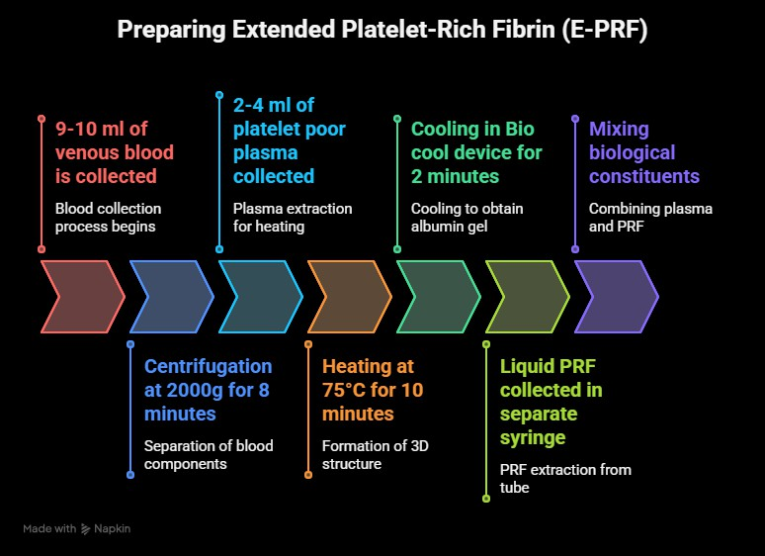
Fig. 7. Preparing extended platelet-rich fibrin

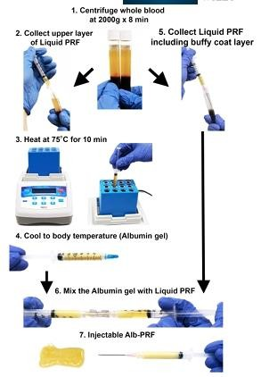FIG 8 & 9. STEPS IN THE PREPARATION OF E-PRF
9.4 Personalized scaffolds:
Electrospinning and 3D printing are commonly addressed technologies for thefabrication of personalized scaffolds.
Ferreira et al.(47) fabricated a scaffold (electrospinning) loaded with tetracycline in the management of three-walled osseous defects in rats and found significant new bone formation. 3D bio printing is also a novel approach that involves incorporation of cells and signaling molecules to ensure optimum regeneration of the defects.

10. ADVANCES IN PERIODONTAL SURGERIES:
10.1 Sinus Lift Procedure:
Lateral wall access is commonly used sinuslift procedure which is an invasive procedure. The novel technique (MOVE - Modified Osseo densification Visco-Elastic) to lift the sinus along with the implant placement in posterior maxilla was introduced by Neiva et al. 2019. (48). It involves two steps, Elevation of Schneiderian membrane by osseodensification drills followed by the use of Viscoelastic putty to deliver the forces uniformly on the membrane.
10.2 AdvancesInMIST:
One of the novel techniques in MIST is, Triangle Papilla Access Approach by Iharaet al. in which the defect is accessed using surgical microscope by placing incisions only on the buccal side in a triangular fashion. It allows proper debridement of the defect facilitating accurate positioning of the flap without compromising blood supply (49).
10.3 Nasal Spine Suture:
The success of regeneration in GBR depends on the lack of micro motion of the membrane placed which would result in stability of the blood clot promoting the formation of alveolar bone. The membrane fixation techniques have been highlighted in the literature of which a novel suture technique “Nasal Spine Suture' was advised since it is safe, effective and prevents displacement of the graft placed beneath the membrane (50).

11. CONCLUSION:
Periodontics is one of the older branches in dentistry, yet it has seen greater revolutionary changes in diagnosis and treatment including non-surgical and surgical approaches. Surgical techniques in periodontal therapy especially in the management of gingival recession have been modified by various authors to improve the percentage of root coverage.
In this modern era, utilizing the recent technologies especially in the form of digitalized approach has faded away the conventional approach. We the periodontists are in a situation to welcome these modern approaches without compromising the conventional modalities to deliver a personalized and successful periodontal care to fulfill the patient’s expectation.

12

REFERENCE:
1. Slots J, Rams TE. Herpesvirus-Bacteria pathogenic interaction in juvenile (aggressive) periodontitis. A novel etiologic concept of the disease. Periodontol 2000. 2024 Feb;94(1):532-538.
2. Mukherjee S. The role of crevicular fluid iron in periodontal disease. J Periodontol. (1985) 56:22–7.
3. Raittio E, Grytten J, Lopez R, Blich CC, Vettore MV, Baelum V. Applying current European periodontitis clinical practice guidelines is not feasible even for the richest countries in the world. Community Dent Oral Epidemiol. 2025 Feb;53(1):1-6.
4. Stødle IH, Imber JC, Shanbhag SV, Salvi GE, Verket A, Stähli A. Methods for Clinical Assessment in Periodontal Diagnostics: A Systematic Review. J Clin Periodontol. 2025 Mar 17.
5. Trindade D, et al. Prevalence of periodontitis in dentate people between 2011 and 2020: a systematic review and meta-analysis of epidemiological studies. J Clin Periodontol. 2023;50(5):604–26.
6. Velea O-A, Sinescu C, Zeicu C, et al. Evaluation of periodontal pockets using different
biomaterials. A preliminary study. Rev Chim. 2014;65:1063‐1066.
7. Mota CC, Fernandes LO, Cimoes R, Gomes AS. Non-invasive periodontal probing through Fourierdomain optical coherence tomography. J Periodontol. 2015;86:1087‐1094.
8. Townsend D, D’aiuto F, Deanfield J. Preliminary study of video imaging of blood vessels in tissues lining the gingival sulcus in periodontally healthy individuals. J Periodontal Res. 2014;49:670‐679.
9. Lin CY, Chen F, Hariri A, et al. Photoacoustic imaging for noninvasive periodontal probing depth measurements. J Dent Res. 2018;97:23‐30.
10. Gorgzadeh A, et al. A state-of-the-art review of the recent advances in exosome isolation and detection methods in viral infection. Virology Journal. 2024;21(1):34.
11. Ostadhossein F, et al. Dual purpose hafnium oxide nanoparticles offer imaging Streptococcus mutans dental biofilm and fight it in vivo via a drug free approach. Biomaterials. 2018;181:252–67.
12. Malik P, et al. Nanobiosensors: concepts and variations. Int Sch Res Not. 2013;2013:327–435.
13. Palomar Q, et al. Detection of gingipain activity using solid state nanop ore sensors. Sens Actuators, B Chem. 2022;368:132209.
14. Wignarajah S, et al. Colorimetric assay for the detection of typical bio markers for periodontitis using a magnetic nanoparticle biosensor. Anal Chem. 2015;87(24):12161–8.
15. Blanco-Pintos T, Regueira-Iglesias A, Relvas M, Alonso-Sampedro M, Bravo SB, Balsa-Castro C, Tomás I. Diagnostic Accuracy of Novel Protein Biomarkers in Saliva to Detect Periodontitis Using Untargeted 'SWATH' Mass Spectrometry. J Clin Periodontol. 2025 Feb;52(2):199-214.
16. Cafiero C, Spagnuolo G. Predictive Periodontitis: The Most Promising Salivary Biomarkers for Early Diagnosis of Periodontitis. J Clin Med. 2021;10(7):1488.
17. Rakic M, Calciolari E, Grant MM, Radovanovic S, Bostanci N, Preshaw PM. Host Markers of Periodontal Diseases: Meta-Analysis of Diagnostic Accuracy Studies. J Clin Periodontol. 2025 Apr 19.
18. Wu, C.-Z.; Yuan, Y.-H.; Liu, H.-H.; Li, S.-S.; Zhang, B.-W.; Chen, W.; An, Z.-J.; Chen, S.-Y.; Wu, Y.-Z.; Han, B. Epidemiologic relationship between periodontitis and type 2 diabetes mellitus. BMC Oral Health 2020, 20, 204.
19. You, W.; Hao, A.; Li, S.; Wang, Y.; Xia, B. Deep learning-based dental plaque detection on primary teeth: A comparison with clinical assessments. BMC Oral Health 2020, 20, 141.
20. Alam,M.M.; Islam, M.T. Machine learning approach of automatic identification and counting of blood cells. Healthc. Technol. Lett. 2019, 6, 103–108.
21. Khan, A.; Khan, K.J.; Ghaza, M.A.; Dave, T.; Shahnoor, S.; Khan, A.M.; Oduoye, M.O.; Nafula, W.P.; Ubechu, S.C. Celebrating breakthrough in dental diagnostics: FDA approval of an AI model for diagnosis of periodontal diseases: A correspondence. Health Sci. Rep. 2023, 6, e1573.
22. Hajishengallis, E.; Hajishengallis, G. Neutrophil homeostasis and periodontal health in children and adults. J. Dent. Res. 2014, 93, 231–237.
23. Jönsson B, Öhrn K, Oscarson N, Lindberg P. The effectiveness of an individually tailored oral health educational programme on oral hygiene behaviour in patients with periodontal disease: a blindedrandomized‐controlled clinical trial (one‐year follow‐up). Journal of clinical periodontology. 2009 Dec;36(12):1025-34.
24. Shen KL, Huang CL, Lin YC, Du JK, Chen FL, Kabasawa Y, Chen CC, Huang HL. Effects of artificial intelligence‐assisted dental monitoring intervention in patients with periodontitis: a randomized controlled trial. Journal of Clinical Periodontology. 2022 Oct;49(10):988-98.
25. Tobon-Arroyave SI, Celis-Mejia N, Cordoba-Hidalgo MP, Isaza-Guzman DM. Decreased salivary concentration of CD9 and CD81 exosome-related tetraspanins may be associated with the periodontal clinical status. J Clin Periodontol. 2019;46(4):470–480.
26. Zhang Y, Chen J, Fu H, Kuang S, He F, Zhang M, et al. Exosomes derived from 3D-cultured MSCs improve therapeutic effects in periodontitis and experimental colitis and restore the Th17 cell/Treg balance in inflamed periodontium. Int J Oral Sci. 2021;13(1):43.
27. Shen Z, Kuang S, Zhang Y, Yang M, Qin W, Shi X, et al. Chitosan hydrogel incorporated with dental pulp stem cell-derived exosomes alleviates periodontitis in mice via a macrophage-dependent mechanism. Bioact Mater. 2020;5(4):1113–1126.
28. Shimizu Y, Takeda-Kawaguchi T, Kuroda I, Hotta Y, Kawasaki H, Hariyama T, et al. Exosomes from dental pulp cells attenuate bone loss in mouse experimental periodontitis. J Periodontal Res. 2022;57(1):162–172.
29. Sundaram K, Miller DP, Kumar A, Teng Y, Sayed M, Mu J, et al. Plant Derived Exosomal Nanoparticles Inhibit Pathogenicity of Porphyromonas Gingivalis. iScience (2019) 21:308–27.
30. Halperin W, Jensen WA. Ultrastructural Changes During Growth and Embryogenesis in Carrot Cell Cultures. J Ultrastruct Res (1967) 18(3):428 43.
31. Peters JL, DeMars PL, Collins LM, Stoner JA, Matsumoto H, Komori N, et al. Effects of Immunization With Natural and Recombinant Lysine Decarboxylase on Canine Gingivitis Development. Vaccine (2012) 30 (47):6706–12.
32. Shimizu Y, Iwasaki T, Tajima T, Yuba E, Kono K, Watarai S. Induction of Antibody Response in the Oral Cavity of Dogs Following Intraocular (Eye Drop) Immunization With Porphyromonas Gingivalis Cell Lysate Incorporated in pH-Sensitive Fusogenic Polymer-Modified Liposomes. J Vet Med Sci (2017) 79(2):290–8.
33. Russell MW, Mestecky J. Mucosal Vaccines: An Overview. In: Mucosal Immunology, 4th ed. Amsterdam: Elsevier Inc (2015). p. 1039–46.
34. Naik SP, Punathil S, Shetty P, Jayanti I, Jalaluddin M, Avijeeta A. Effectiveness of different bristle designs of toothbrushes and periodontal status among fixed orthodontic patients: a double-blind crossover design. J Contemp Dent Pract. (2018) 19(2):150–5.
35. Kini V, Yadav S, Rijhwani JA, Farooqui A, Joshi AA, Phad SG. Comparison of plaque removal and wear between charcoal infused bristle and nylon bristle toothbrushes: a randomized clinical crossover study. J Contemp Dent Pract. (2019) 20(3):377–84.
36. Rai T, Ym K, Rao A, Anupama Nayak P, Natarajan S, Joseph RM. Evaluation of the effectiveness of a custommade toothbrush in maintaining oral hygiene and gingival health in cerebral palsy patients. Spec Care Dentist. (2018) 38(6):367–72.
37. Soncini JA, Tsamtsouris A. Individually modified toothbrushes and improvement of oral hygiene and gingival health in cerebral palsy children. J Pedod. (1989) 13(4):331–4.
38. Mancinelli-Lyle D, Qaqish JG, Goyal CR, Schuller R. Effectiveness of a sonic f losser toothbrush with different size brush heads and manual toothbrush plus dental floss on plaque, gingival bleeding and inflammation in adults with naturally occurring gingivitis: a 4-week randomized controlled trial. Int J Dent Hyg. (2023) 21(3):624–33.
39. Wang M, Zhao J, Zhang R, Li L, Shao J, Zheng Y, et al. Plaque removal efficacy of a compacted dual-head power toothbrush: a split-mouth randomized clinical trial. Am J Dent. (2022) 35(2):146–51.
40. Roa López A, Moreu Burgos G, Aguilar Salvatierra A, Fernández Delgado J, Bravo M, González Jaranay M. Efficacy of dental floss with ellipsoidal knots vs conventional dental floss for plaque removal: a split-mouth
41. Weber J, Scholz KJ, Schenke IM, Pfab F, Cieplik F, Hiller KA, et al. Randomized controlled clinical trial on the efficacy of a novel antimicrobial chewing gum in reducing plaque and gingivitis in adolescent orthodontic patients. Clin Oral Investig. (2024) 28(5):272.
42. Levin L, Clark-Perry D. Use of a Novel In Situ Hardening Biphasic Alloplastic Bone Grafting Material for Guided Bone Regeneration Around Dental Implants: A Prospective Case Series. Clin Adv Periodontics. 2022 Mar;12(1):12-16.
43. Lin H, Chen H, Zhao X, Chen Z, Zhang P, Tian Y, Wang Y, Ding T, Wang L, Shen Y. Advances in mesenchymal stem cell conditioned medium-mediated periodontal tissue regeneration. J Transl Med. 2021 Nov 4;19(1):456.
44. Miron RJ, Moraschini V, Estrin N, Shibli JA, Cosgarea R, Jepsen K, JervøeStorm PM, Wang HL, Sculean A, Jepsen S. Autogenous platelet concentrates for treatment of intrabony defects-A systematic review with meta-analysis. Periodontol 2000. 2025 Feb;97(1):153-190.
45. Kawase T, Kamiya M, Kobayashi M, et al. The heat-compression technique for the conversion of platelet-rich fibrin preparation to a barrier membrane with a reduced rate of biodegradation. J Biomed Mater Res B Appl Biomater. 2015;103(4):825-831.
46. Fujioka-Kobayashi M, Schaller B, Mourão C, Zhang Y, Sculean A, Miron RJ. Biological characterization of an injectable platelet-rich fibrin mixture consisting of autologous albumin gel and liquid plate let-rich fibrin (Alb-PRF). Platelets. 2021;32(1):74-81.
47. Ferreira JA, Kantorski KZ, Dubey N, Daghrery A, Fenno JC, Mishina Y, Chan HL, Mendonça G, Bottino MC. Personalized and defect-specific antibiotic-laden scaffolds for periodontal infection ablation. ACS Applied Materials & Interfaces. 2021 Oct 12;13(42):49642-57.
48. Puterman I, Weinstein B, Walton P, Fien M. The Modified Osseodensification Visco-Elastic (MOVE) Sinus Protocol: A Case Series to Illustrate the Combination of Osseodensification with Viscoelastic Bone Replacement Material. Clin Adv Periodontics. 2022 Sep;12(3):180-185.
49. Ihara Y, Shibazaki S, Morikawa S, Nakagawa T. Novel triangle papilla access approach for interdental bone defect regeneration: A case study. Clin Adv Periodontics. 2025 Jan 15.
50. Bane WE, Blyleven GM, Lincicum AR, Stancoven BW, Inouye KA, Johnson TM. The nasal spine suture: A novel approach for membrane stabilization. Clin Adv Periodontics. 2024 Dec;14(4):300-309.randomized trial. Int J Dent Hyg. (2021) 19(2):209–14.

