Case report
Tooth-Supported Maxillary Single Complete Overdenture with Complete Mandibular Rehabilitation: A Case Report

Abstract
Introduction: Overdentures provide a viable treatment option for patients with limited remaining teeth, offering improved retention, stability, and preservation of alveolar bone. This case report describes the rehabilitation of a patient with a maxillary tooth-supported single complete overdenture and a complete mandibular denture.
Case Presentation: A 43 -year-old female presented with a severely resorbed maxillary arch and retained mandibular teeth. The maxillary arch was restored with a tooth-supported overdenture using two remaining central incisors, while the mandibular arch was completely rehabilitated with post and core, implant supported fixed prosthesis and fixed crowns.
Discussion: The treatment improved masticatory efficiency, speech, and esthetics while preserving residual ridge integrity. Tooth-supported overdentures offer advantages over conventional complete dentures, including better stability and proprioception.
Conclusion: This case highlights the effectiveness of a tooth-supported maxillary overdenture combined with mandibular complete denture rehabilitation in improving oral function and patient satisfaction.
Keywords – overdenture, prosthesis, implants,esthetics
Introduction
The transition from natural dentition to complete edentulism presents significant functional and aesthetic challenges for patients [1]. While conventional complete dentures remain a common solution, they often lack optimal stability and retention, particularly in atrophic ridges [2]. Overdentures, which utilize remaining teeth or implants for support, have emerged as a superior treatment modality that provides enhanced retention while preserving alveolar bone [3].
Maxillary tooth-supported overdentures represent a particularly valuable yet underutilized treatment option [4]. Though implant-supported overdentures have gained prominence in recent years, tooth-supported variants offer a cost-effective alternative with comparable functional benefits [5]. This case report details the successful rehabilitation of a patient with a maxillary tooth-supported overdenture opposing a complete mandibular denture, demonstrating the clinical viability of this treatment approach.

Case Presentation
Patient History
A 43 -year-old female presented with complaints of inadequate masticatory function and poor denture stability. The patient's dental history revealed gradual tooth loss over 15 years, with previous attempts at removable partial denture therapy proving unsatisfactory [6]. Medical history was non-contributory, with no contraindications to dental treatment.
Clinical Examination
Intraoral examination revealed:
- Maxillary arch: only grossly decayed two central incisors (11, 21) and caries with peri-apical abcess in canine- 23 is present.
- Mandibular arch: grossly decayed lower anteriors and premolars 35 45 46
- Oral mucosa appeared healthy with no signs of pathology
- Loss of vertical dimension noted
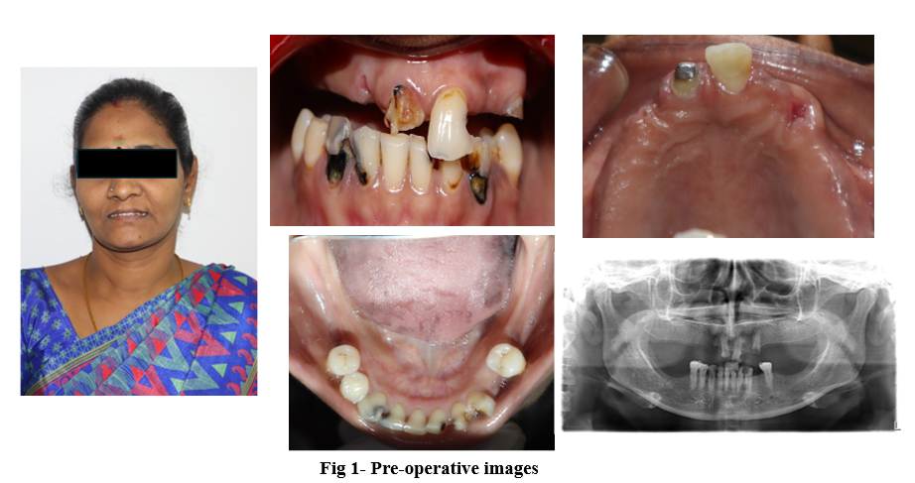

Treatment Plan
After considering various treatment options, the following plan was formulated [10]:
- Maxillary Arch:
  - Endodontic treatment of remaining central incisors and extraction of grossly decayed canine - 23
  - Preparation of abutments with custom cast copings
- Transferring to Hanau articulator
  - Face-bow transfer done
  - Vertical dimension raised after raising vertical rod in hanau articulator by 2mm.
  - Fabrication of maxillary complete overdenture with attachments.
- Mandibular Arch:
- Lower anteriors rehabilitated after completion of root canal treatment.
- Implant placement followed by screw retained prosthesis in partially edentulous posterior areas 34 36 46.

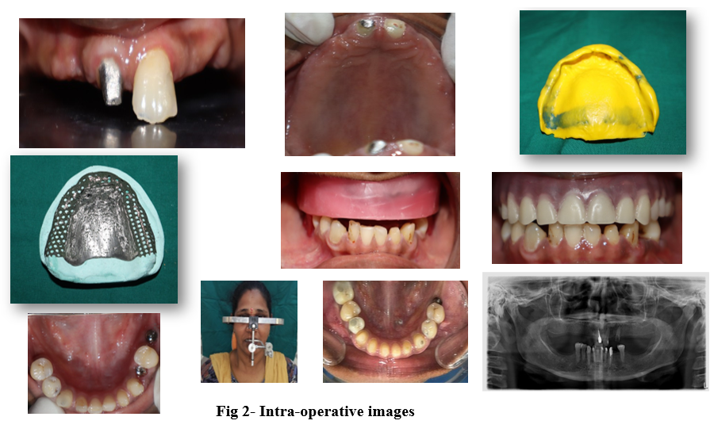
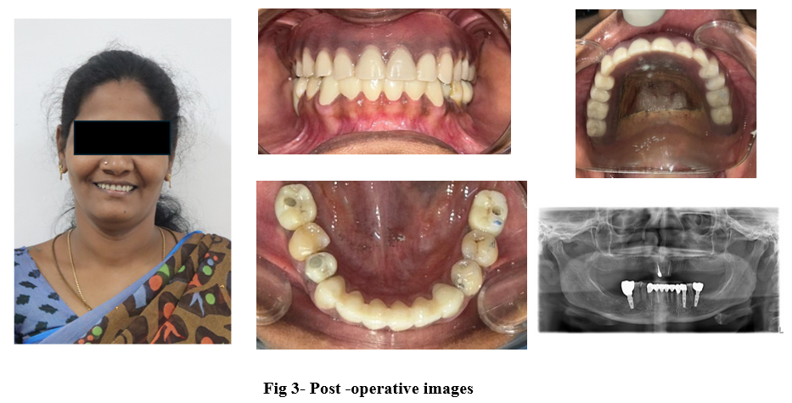
Patient was recalled at regular intervals and evaluated the comfort, stability, retention and oral hygiene. After 3 years of follow up, patient was satisfied with the results and the prosthesis showed excellent stability and comfort.
Discussion
The rehabilitation of edentulous patients with overdentures has been well-documented as a superior alternative to conventional complete dentures, particularly in terms of stability, retention, and preservation of residual alveolar bone (1). This case report demonstrates the successful use of a tooth-supported maxillary overdenture in conjunction with a complete mandibular rehabilitation, highlighting the clinical benefits of retaining natural tooth roots for prosthetic support.
One of the most significant advantages of overdentures is the reduction in residual ridge resorption. When teeth are extracted, the alveolar bone undergoes progressive atrophy due to the loss of periodontal ligament stimulation (2). By retaining strategic roots, as in this case (maxillary canines), the mechanical loading is transferred more physiologically, slowing bone loss (3). Studies by Tallgren (1972) and Crum & Loiselle (1972) have shown that patients with overdentures exhibit significantly less ridge resorption compared to those with conventional complete dentures (4,5).
The incorporation of attachments (e.g., ball, bar, or telescopic copings) enhances denture retention, reducing displacement during function (6). In this case, custom cast copings were used, which provided both retention and proprioceptive feedback—a critical factor in patient adaptation (7). Feine et al. (2002) emphasized in the McGill Consensus Statement that even two implant or tooth-supported abutments can dramatically improve overdenture stability (8).
Patients with overdentures demonstrate better chewing ability than those with conventional dentures (9). Kapur et al. (1999) conducted a randomized trial comparing implant-supported overdentures to conventional dentures and found that overdenture wearers had significantly improved masticatory performance (10). Although this case used tooth-supported rather than implant-supported abutments, similar benefits were observed, with the patient reporting improved comfort and function.
Several studies, including Burns et al. (1995) and Walton & MacEntee (1994), have compared tooth-supported and implant-supported overdentures (17,18). While implants offer greater long-term predictability, tooth-supported overdentures remain a viable option when abutment teeth have good prognosis (adequate bone support, no mobility).
Challenges and Considerations
1. Risk of Caries and Periodontal Disease in Abutment Teeth
A major concern with tooth-supported overdentures is the long-term survival of abutment teeth. Proper endodontic treatment, ferrule design, and oral hygiene maintenance are crucial (11). Langer & Langer (2000) reported that telescopic crown-retained overdentures have a high success rate when abutments are well-maintained (12). In this case, the patient was placed on a strict recall schedule to monitor periodontal health.
2. Occlusal Considerations in Complete Denture Rehabilitation
The mandibular complete denture opposing a maxillary overdenture requires careful occlusal balancing to avoid excessive forces on the remaining abutments (13). Zarb & Bolender (2004) recommend using lingualized occlusion to distribute forces evenly and minimize lateral displacement (14).
3. Cost-Effectiveness Compared to Implant Overdentures
While implant-supported overdentures are considered the gold standard for edentulous patients, they may not be feasible for all individuals due to financial constraints or medical contraindications (15). Brewer & Morrow (1980) highlighted that tooth-supported overdentures provide a cost-effective alternative with comparable functional benefits (16).
Conclusion
This case reinforces the viability of tooth-supported overdentures as a practical, cost-effective, and biomechanically favorable treatment for partially edentulous patients. By preserving natural tooth roots, clinicians can enhance denture stability, reduce bone resorption, and improve patient satisfaction. Future research should focus on long-term survival rates of tooth-supported overdentures compared to implant-retained ones.
References
- Carlsson GE. Clinical morbidity and sequelae of treatment with complete dentures. J Prosthet Dent. 1998;79(1):17-23.
- Crum RJ, Loiselle RJ. Oral perception and proprioception: a review. J Prosthet Dent. 1972;28(2):215-230.
- Brewer AA, Morrow RM. Overdentures. 2nd ed. St. Louis: CV Mosby; 1980.
- Lord JL, Teel S. The overdenture: patient selection. J Prosthet Dent. 1974;32(1):41-51.
- Rissin L, et al. Clinical comparison of masticatory performance. J Prosthet Dent. 1978;39(5):508-511.
- Feine JS, et al. The McGill consensus statement. Int J Prosthodont. 2002;15(4):413-414.
- Kapur KK, et al. Randomized clinical trial. J Prosthet Dent. 1999;81(6):705-710.
- Langer Y, Langer A. Tooth-supported telescopic prostheses. J Prosthet Dent. 2000;84(2):129-132.
- Zarb GA, Bolender CL. Prosthodontic Treatment. 12th ed. Mosby; 2004.
- Tallgren A. The continuing reduction. J Prosthet Dent. 1972;28(2):120-132.
- Burns DR, et al. Prospective clinical evaluation. J Prosthet Dent. 1995;73(4):354-363.
- Walton JN, MacEntee MI. Problems with prostheses. J Prosthet Dent. 1994;71(3):283-288.
- DeVan MM. The nature of the partial denture foundation. J Prosthet Dent. 1952;2(2):210-218.
- Misch CE. Dental Implant Prosthetics. 2nd ed. Elsevier; 2015.
- Atwood DA. Reduction of residual ridges. J Prosthet Dent. 1971;26(3):266-279.
- Preiskel HW. Precision Attachments in Prosthodontics. Quintessence; 1985.

