Case report
Prosthetic mitral valve obstruction: pannus, thrombus, or both?

Abstract:

The prosthetic valve obstruction is a frequent yet severe complication of the mechanical valve replacement. This constitution is the result of thrombus or pannus formation or the coexistence of both. Although this latter entity is poorly reported in current literature, the burden of its morbidity and mortality imposes a rapid diagnosis, yet its recognition can be challenging taking account of the paucity of performant imaging modalities and the necessity of surgical confirmation.
We present a case of a mechanical mitral valve obstruction in a 42 year old patient in whom the diagnosis of pannus and thrombus was suspected on the basis of clinical biological and imaging data, confirmed by surgery.

- Keywords: Prosthetic valve obstruction, Mechanical valve dysfunction, Thrombus, Pannus, cardiac surgery

Introduction:

Valvular heart disease affects more than 100 million persons worldwide and is associated with significant morbidity and mortality (1). Surgical valve replacement is one of the main treatments of severe valvular heart disease in patients at low and intermediate risk for surgery (1). Mecanichal prosthetic valve (MPV) replacement exposes to various complications such as thromboembolism, prosthetic mismatch, endocarditis, microangiopathic hemolytic anemia, valve dehiscence, and valve dysfunction (pannus, dehiscence, valvular, or paravalvular regurgitation) (2) , resulting in a reduction of the leaflet motion or impaired leaflet coaptation, leaflet thickening , reduce or increased effective orifice area, this in turn leads to increased transvalvular gradient or transvalvular regurgitation, with or without valve-related symptoms.

Displaying both issues, valve dysfunction may be the result of thrombus formation which is the most common complication or fibrous tissue ingrowth (3). Both entities might occur simultaneously rendering the diagnosis and the management challenging.
The determination of the main etiology MPV dysfunction is challenging yet crucial task requiring multimodal imaging including fluoroscopy, transthoracic, transesophageal echocardiogram, CT scan.

Case presentation:
We present the case of Mrs A.H, 43 years old, with no cardiovascular risk factors, with a history of mechanical mitral valve replacement [St Jude Medical (SJM) valve, N°27)] 10 years ago for severe rheumatic mitral stenosis, was admitted to the cardiology department for exertional dyspnea. At admission, physical examination found the patient to be in good general condition, apyretic with a heart rate of 68 beats per minute, eupneic with a respiratory rate of 16 cycles per minute and a blood pressure of 97/72 mmHg. There were no signs of heart failure. Cardiac auscultation shows a mildly muffled prosthetic valve sound, pulmonary and arterial auscultation were unremarkable. The examination of the other systems, notably the neurological, pleuropulmonary and digestive systems, were normal. She was taking acenocoumarol previously with international normalized ratio of 1.98 at the admission.
- Transthoracic echocardiography (TTE) revealed an unchanged ejection fraction and a fixed closed mitral valve leaflet with a trans-valvular mean gradient of 10 mmHg. The calculated MV area was 1.1 cm² (via continuity equation), maximum mitral prosthetic valve E wave velocity of 2.13 m/s(video 1)
-Fluoroscopy showed a bi-leaflet mechanical mitral valve with absence of mobility of one mitral leaflet, and normal motion of the other leaflet. (video 2)
TEE was performed using adequate equipment. Two- and three-dimensional images were acquired and analyzed. This showed a reduced mobility of the leaflet, a circular fibrotic tissue ingrowth from the atrial view and a small element appending to the leaflet suggestive of a thrombus (video 3).
The TEE doppler analysis showed a mean trans-valvular gradient of 12 mmHg.
It should be noted that prior post-surgery follow-up echocardiograms showed trans-mitral valvular gradients increasing progressively from 6 to 8 to 10 mmHg.
Given this information, and the poor anticoagulation, the coexistence of pannus and thrombus seemed the most likely etiology of valve obstruction.
The patient underwent redo-mitral valve replacement after a trail treatment with heparin and aspirin. Surgical view showed that the prosthetic valve was covered with circumferential pannus involving both atrial and ventricular sides and a thrombus formation (Figure 1).

Discussion:
The overall incidence of prosthetic valve obstruction (PVO) ranges from 0.5%-6.0% annually with the difference in rates depending on the type and location of prosthetic valve replacement (4) .
There are two main etiologies, prosthetic valve thrombosis (PVT) and pannus formation.
In PVT, the thrombogenic metallic surface of the mechanical valve activates coagulation factors, leading to fibrin formation, demonstrating the requirement for systematic lifelong oral anticoagulation post-surgery. PVT is thus commonly associated with suboptimal anticoagulation and tend to appear in a shorter time after surgery and requires urgent thrombolytic therapy in case of refractory symptoms.
In pannus formation, the prosthetic material triggers an inflammatory response, leading to an excessive growth of fibroelastic and collagen tissues, followed by the infiltration of endothelial cells, myofibroblasts, and chronic inflammatory cells. This process, which is not fully understood, leads to the formation of fibrinous ingrowth around the annulus of the prosthetic valve. It usually occurs years after the valve replacement (5).
It should be noted that combined pannus and thrombus formation were identified in mechanical valve obstructions suggesting that pannus serves as a nidus for thrombus, with pannus formation being the underlying cause, the coexistence of both has been reported to be between 12%-75% of all PVO (6) .
In our case the non-optimal anticoagulation treatment is more in favor of a thrombotic etiology although the coexistence of a pannus should be evoked considering the delayed and progressive appearance of valve dysfunction with little to no clinical findings, with slightly elevated mean trans-valvular gradient (at 12mmHg)
The 2D TTE is recommended as first-line imaging once PVO is suspected. It evaluates prosthetic valve hemodynamics and valve motion but is limited for morphological characterization of the etiology of PV dysfunction due to acoustic shadowing caused by the prosthesis or the characteristics of the patient.
The cine-fluoroscopy is the gold standard for detecting mechanical valve dysfunction, but it lacks the capacity for depicting the underlying etiology as in our case (6,7).
TEE is the preferred method for the diagnosis of PVO (8). It can determine the etiology of PVO as well as identifying candidates for thrombolytic therapy vs surgical intervention. An additional benefit of using 3D TEE is visualizing and evaluating the anatomy of prosthetic valves. As compared to standard 2D TEE echo, 3D TEE allows a more detailed and accurate assessment of valve leaflets, prosthetic ring, and struts. Additionally, 3D TEE has been shown to have a high correlation with surgical findings, especially regarding MV pathology (9).
Furthermore, although the above-mentioned imaging modalities can be sufficient in characterization of PVO, there are other imaging techniques such as CT scan and CMR which may be used when etiology remains unclear, or TEE is not feasible (10).
Treatment options of prosthetic valve obstruction encompass both medical and surgical strategies. Medical treatment is preferred as an initial therapy in PVT (based on the level of obstruction, ejection fraction and symptomatic burden), as the mortality of repeat valve surgery can be extremely high. However, pannus, due to its highly fibrotic makeup does not respond to medical therapy, surgery remains the optimal treatment furthermore when both mechanisms are associated (as in our case )or in cases on PVT not responding to medical therapy.
Conclusion:
PVO is a feared complication of mechanical valve replacement. Careful clinical and multiple non-invasive imaging modalities are necessary in evaluation of these patient, since the diagnosis can be challenging specially when both thrombotic mechanism and pannus coexist.

References:

- Bernard Iung et Alec Vahanian, « Epidemiology of Valvular Heart Disease in the Adult », Nature Reviews Cardiology 8, no 3 (mars 2011): 162-72, https://doi.org/10.1038/nrcardio.2010.202.
- Rick A. Nishimura et al., « 2014 AHA/ACC Guideline for the Management of Patients With Valvular Heart Disease », Journal of the American College of Cardiology 63, no 22 (juin 2014): e57-185, https://doi.org/10.1016/j.jacc.2014.02.536.
- Jeanne M. Vesey et Catherine M. Otto, « Complications of Prosthetic Heart Valves », Current Cardiology Reports 6, no 2 (mars 2004): 106-11, https://doi.org/10.1007/s11886-004-0007-x.
- George D. Dangas et al., « Prosthetic Heart Valve Thrombosis », Journal of the American College of Cardiology 68, no 24 (décembre 2016): 2670-89, https://doi.org/10.1016/j.jacc.2016.09.958.
- Jason Salamon et al., « Mechanical valve obstruction: Review of diagnostic and treatment strategies », World Journal of Cardiology 7, no 12 (26 décembre 2015): 875-81, https://doi.org/10.4330/wjc.v7.i12.875.
- Patrizio Lancellotti et al., « Recommendations for the Imaging Assessment of Prosthetic Heart Valves: A Report from the European Association of Cardiovascular Imaging Endorsed by the Chinese Society of Echocardiography, the Inter-American Society of Echocardiography, and the Brazilian Department of Cardiovascular Imaging », European Heart Journal – Cardiovascular Imaging 17, no 6 (juin 2016): 589-90, https://doi.org/10.1093/ehjci/jew025.
- Macit Kalçık et al., « Identification of Mechanical Prosthetic Heart Valves Based on Distinctive Cinefluoroscopic and Echocardiographic Markers », The International Journal of Artificial Organs 42, no 11 (novembre 2019): 603-10, https://doi.org/10.1177/0391398819860845.
- Paul A. Grayburn, « Multimodality Imaging of Suspected Mechanical Prosthetic Valve Obstruction », JACC: Cardiovascular Imaging 12, no 11 (novembre 2019): 2193-95, https://doi.org/10.1016/j.jcmg.2018.12.025.
- Lissa Sugeng et al., « Real-Time Three-Dimensional Transesophageal Echocardiography in Valve Disease: Comparison With Surgical Findings and Evaluation of Prosthetic Valves », Journal of the American Society of Echocardiography 21, no 12 (décembre 2008): 1347-54, https://doi.org/10.1016/j.echo.2008.09.006.
- Jesse Habets et al., « Imaging of Prosthetic Heart Valve Dysfunction », JACC: Cardiovascular Imaging 5, no 9 (septembre 2012): 956-61, https://doi.org/10.1016/j.jcmg.2012.03.018.

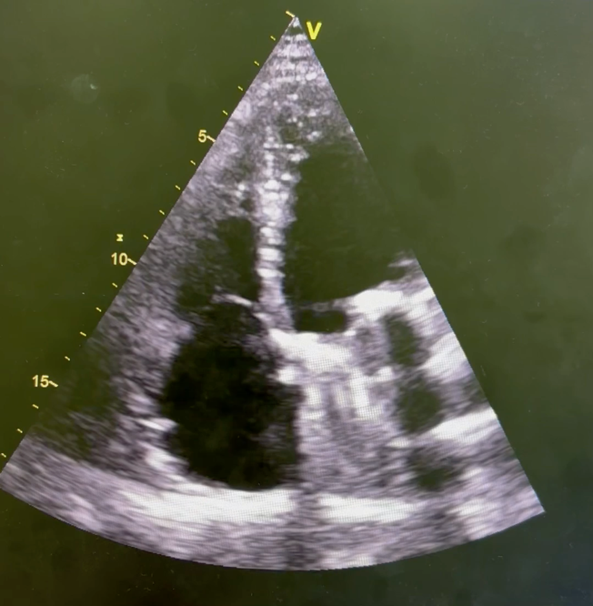
Picture 1: Transthoracic echocardiography (TTE) showing an unchanged ejection fraction and a fixed closed mitral valve leaflet
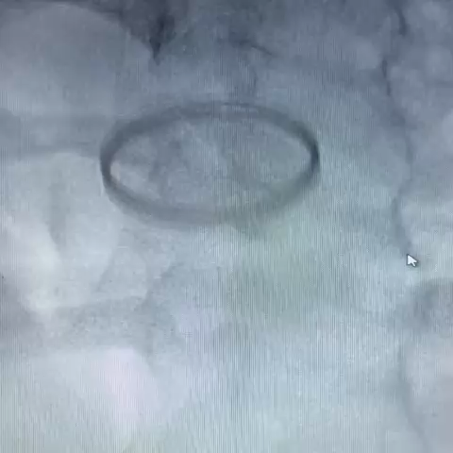
Picture 2: cine-Fluoroscopy showing a bi-leaflet mechanical mitral valve with absence of mobility of one mitral leaflet, and normal motion of the other one.

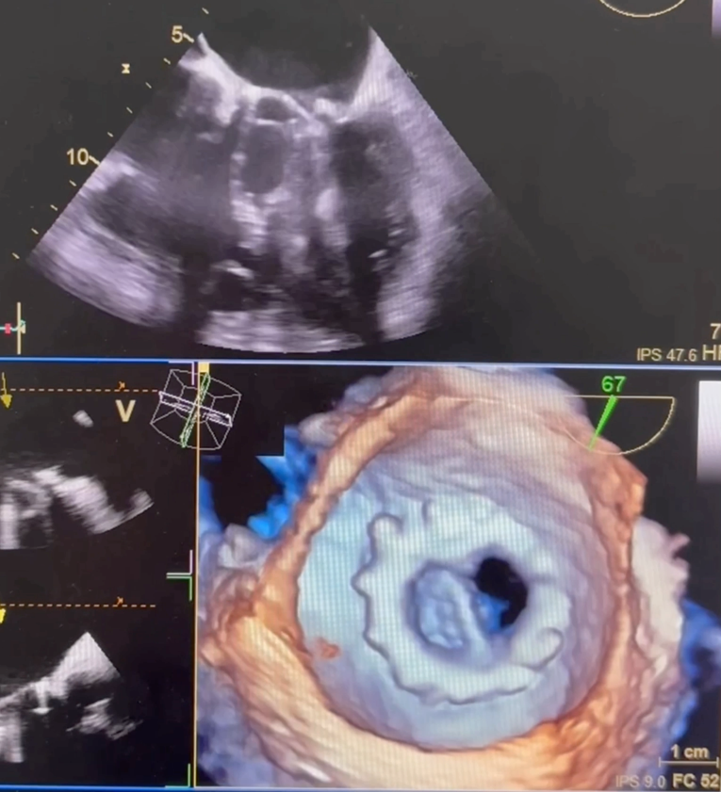

Picture 3: TEE: Two- and three-dimensional showing a reduced mobility of the leaflet, a circular fibrotic tissue ingrowth from the atrial view and a small element appending to the leaflet suggestive of a thrombus.

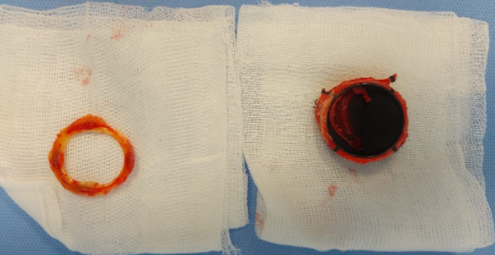
Figure 1: Surgical view showing the excised pannus (left) and the explanted mechanical mitral valve prosthesis with adherent thrombus (right).

