Case report
Unraveling Dual Cardiomyopathy : Ischemic Etiology Complicated by Cardiac Amyloidosis - Case Report

.
ABSTRACT

Aims: Dual cardiomyopathy, characterized by the coexistence of two distinct cardiac dysfunctions, poses significant diagnostic and therapeutic challenges. This case report highlights a unique instance of a patient diagnosed with both ischemic cardiomyopathy and cardiac amyloidosis.
Presentation of Case: A 56-year-old male with a history of heart failure underwent catheterization, previously on the last two years had stent implanted of the right coronary artery (RCA) and left anterior descending artery (LAD). He presented with worsening dyspnea and signs of pulmonary congestion. The patient was admitted to the cardiac intensive care unit (CVCU) and treated for fluid decongestion, achieving a negative fluid balance of -5000 cc over 48 hours. While his dyspnea initially improved, it recurred upon transfer to a general ward. Echocardiography revealed an ejection fraction of 56%, E/e' ratio of 12, and left ventricular concentric hypertrophy. Subsequent coronary angiography this admission confirmed patent stents. Cardiac magnetic resonance imaging (CMR) was performed to assess myocardial viability, revealing infiltrative disease consistent with cardiac amyloidosis, characterized by hypertrophied myocardium (LVMI 101 g/m²; normal range 38-67 g/m²) and poor nulling of myocardium signal on T1 look locker and diffuse fibrosis late gadolinium enhancement (LGE) images. Analysis of free light chains indicated elevated kappa chains and normal lambda chains, maintaining a normal kappa/lambda ratio was rulling out AL type cardiac amyloidosis. The patient was diagnosed with ischemic cardiomyopathy and non-ischemic cardiomyopathy due to transthyretin amyloidosis (ATTR). The recommended management for this dual cardiomyopathy includes heart failure therapy targeting ischemic cardiomyopathy with SGLT2 inhibitors and specific treatment for ATTR amyloidosis using tafamidis.
Discussion and Conclusion: Worsening dyspnea in heart failure patients is often attributed to exacerbations of heart failure. In patients with coronary artery disease, it is frequently associated with ischemic cardiomyopathy. This highlights the importance of cardiac magnetic resonance imaging to assess myocardial viability and to investigate potential non-ischemic causes, thereby facilitating the development of appropriate treatment strategies.

Keywords: Dual Cardiomyopathy, Cardiac Amyloidosis, Ischemic Cardiomyopathy, Cardiac Magnetic Resonance, Heart Failure

1. INTRODUCTION

Heart failure (HF) is a major global health concern, defined by a complex clinical condition arising from structural and functional cardiac abnormalities (Bawaskar et al., 2024; McDonagh et al., 2021). Ischemic cardiomyopathy (ICM), associated with coronary artery disease (CAD), is among the most prevalent causes, particularly in populations with a significant incidence of cardiovascular risk factors. The diagnosis of heart failure (HF) is extensive, encompassing non-ischemic cardiomyopathies that may resemble or coexist with ischemic cardiomyopathy (ICM) (Kittleson et al., 2023).
Cardiac amyloidosis (CA) is an increasingly recognized, albeit historically underdiagnosed, cause of infiltrative cardiomyopathy, often leading to restrictive physiology and HF, particularly HF with preserved ejection fraction (HFpEF) (Ruberg et al., 2019). CA results from the extracellular deposition of misfolded protein fibrils within the myocardium. The two most common forms affecting the heart are immunoglobulin light-chain (AL) amyloidosis, a plasma cell dyscrasia requiring urgent hematologic treatment, and transthyretin amyloidosis (ATTR), caused by deposition of either wild-type or variant (hereditary) transthyretin protein (Kittleson et al., 2023; Ruberg et al., 2019).
The presence of multiple cardiomyopathies presents diagnostic and therapeutic challenges. In patients with established coronary artery disease, heart failure symptoms are often attributed solely to ischemia (Bawaskar et al., 2024; Siagh et al., 2025). This assumption can lead to delays in diagnosis if a coexisting non-ischemic process is present, impacting prognosis and delaying therapy. Early diagnosis of other cardiomyopathies is crucial, particularly for ATTR-type amyloidosis, for which targeted therapies are now available (Elliott et al., 2022; Garcia-Pavia et al., 2021).
Cardiac magnetic resonance imaging (CMR) is an accurate noninvasive examination for comprehensive myocardial function assessment, particularly for detailed anatomical evaluation and tissue characterization. Its ability to detect myocardial edema, scarring, fibrosis, and infiltration makes it highly accurate in differentiating ischemic from non-ischemic cardiomyopathy and identifying specific conditions such as CA (Smiseth et al., 2022). This examination can simultaneously identify cases of ICM and ATTR-CA in patients with refractory heart failure despite optimal heart failure therapy and evaluation of patent coronary stents. The use of CMR and immunoserology examinations in patients with ischemic cardiomyopathy can reveal other cardiomyopathies caused by CA (Kittleson et al., 2023).

2. Presentation of Case

The patient is a 56-year-old male, a former smoker, who is experiencing worsening dyspnea and showing signs of pulmonary congestion. His notable medical history comprised three-vessel coronary artery disease (CAD), requiring several intricate percutaneous coronary procedures (PCIs) utilizing drug-eluting stents (DES). He has a history of percutaneous coronary intervention (PCI) using two overlapping drug-eluting stents (DES) in the proximal-mid left anterior descending artery (LAD), one DES in the proximal right coronary artery (RCA), and one overlapping DES in the mid RCA, performed in February 2021. Subsequent operations comprised one drug-eluting stent (DES) placed in the ostial right coronary artery (RCA) and another DES in the distal RCA in May 2022. Patients often attend the polyclinic for treatment involving antiplatelet medication, statins, and Sodium-Glucose Cotransporter-2 Inhibitors (SGLT2i). The vital signs remained constant. The electrocardiogram (ECG) revealed a sinus rhythm at 99 beats per minute with pathological Q waves in leads V1–V4 and T wave inversions in leads I, aVL, and V1–V6. These findings were considered indicative of extensive anterior myocardial ischemia, in accordance with his established history of coronary artery disease (CAD). Laboratory studies indicated an elevated cardiac troponin I level, rising from 42 ng/L to 105 ng/L (local reference range upper limit normally < 20-30 ng/L), implying persistent myocardial damage. Transthoracic echocardiography (TTE) revealed a preserved left ventricular ejection fraction (LVEF) of 56%. Significant abnormalities were seen, including severe diastolic dysfunction as evidenced by an increased E/e' ratio (medial e') of 21. Significant concentric left ventricular hypertrophy (LVH) was observed, characterized by a relative wall thickness (RWT) of 0.56 and a markedly raised left ventricular mass index (LVMI) of 193 g/m². These findings pointed towards a stiff, non-compliant ventricle despite seemingly preserved systolic function.
The clinical symptoms, elevated troponin levels, and signs of congestion led to an initial diagnosis of Non-ST Elevation Myocardial Infarction (NSTEMI) Killip Class II, superimposed on chronic Heart Failure with preserved Ejection Fraction (HFpEF), New York Heart Association (NYHA) Class III. The patient performed an invasive procedure, and angiography revealed that the existing stents in the LAD and RCA were patent. The patient was admitted to the Cardiac Vascular Care Unit (CVCU) for intensive care. Intravenous loop diuretics (furosemide) were provided, resulting in a negative fluid balance of roughly 5000 ml over 48 hours, which facilitated notable symptomatic relief. He was subsequently relocated to the ward. Medical therapy was optimized according to standards, incorporating dual antiplatelet therapy (DAPT), a high-intensity statin, and a sodium-glucose cotransporter 2 (SGLT2) inhibitor, in alignment with the current European Society of Cardiology (ESC) guidelines for HFpEF treatment.
Despite achieving euvolemia and receiving optimized medical therapy, including medications for both coronary artery disease and heart failure with preserved ejection fraction, the patient experienced recurrent episodes of dyspnea in the ward. The ongoing presence of symptoms, especially in relation to confirmed patent coronary stents from angiographic findings, suggests the possibility of an alternative or additional underlying cardiac condition beyond epicardial coronary stenosis. This necessitated additional examination utilizing advanced cardiac imaging techniques.
Cardiac Magnetic Resonance (CMR) was conducted to facilitate comprehensive myocardial tissue characterization. The research demonstrated notable left ventricular hypertrophy, indicated by an interventricular septal thickness of 17.3 mm and a posterior wall thickness of 15.2 mm at end-diastole. The LVMI determined by CMR was 101 g/m². This value, although lower than the TTE-derived measurement, remained significantly elevated, confirming severe hypertrophy. CMR indicated moderate systolic dysfunction, with a calculated LVEF of 44%, placing the patient in the heart failure with mid-range ejection fraction (HFmrEF) category. This discrepancy in relation to the initial TTE LVEF underscores the potential limitations of TTE in specific pathologies or the possibility of functional decline.
CMR exhibited characteristics strongly indicative of infiltrative cardiomyopathy. T1 mapping sequences demonstrated abnormal myocardial nulling following gadolinium administration, suggesting diffuse interstitial expansion. Additionally, late gadolinium enhancement (LGE) imaging revealed a diffuse, non-coronary distribution pattern, affecting extensive regions of the myocardium, indicative of myocardial infiltration rather than ischemic scar, which typically presents as a subendocardial or transmural pattern localized to specific coronary territories.
Due to the CMR findings indicative of infiltrative disease, particularly amyloidosis, additional investigations were conducted to determine the specific type of amyloid. Analysis of serum free light chains (FLC) indicated an elevated free kappa light chain level of 26.5 mg/L, exceeding the normal range of up to 19.4 mg/L, while the free lambda light chain level was normal at 24.5 mg/L, within the normal range of up to 26.3 mg/L. The calculated kappa/lambda FLC ratio was 1.08, which is within the normal range of 0.26 to 1.65. The lack of an abnormal free light chain ratio, along with presumed negative serum and urine protein electrophoresis and immunofixation for monoclonal proteins—standard procedures in the evaluation of amyloidosis—adequately excluded AL amyloidosis. The serological pattern, along with the CMR findings of severe LVH and infiltration, strongly indicated a diagnosis of ATTR amyloidosis.
By integrating the clinical history of established coronary artery disease, recurrent heart failure symptoms despite patent stents, and advanced imaging and laboratory findings, a final diagnosis of dual cardiomyopathy was established. This included ischemic cardiomyopathy resulting from extensive three-vessel coronary artery disease, following multiple percutaneous coronary interventions, and non-ischemic cardiomyopathy attributed to transthyretin cardiac amyloidosis. After DAPT therapy, high-intensity statins, and SGLT2 inhibitors for heart failure, patients received tafamidis therapy for ATTR amyloidosis. Post-therapy, the patient exhibited symptom improvement.

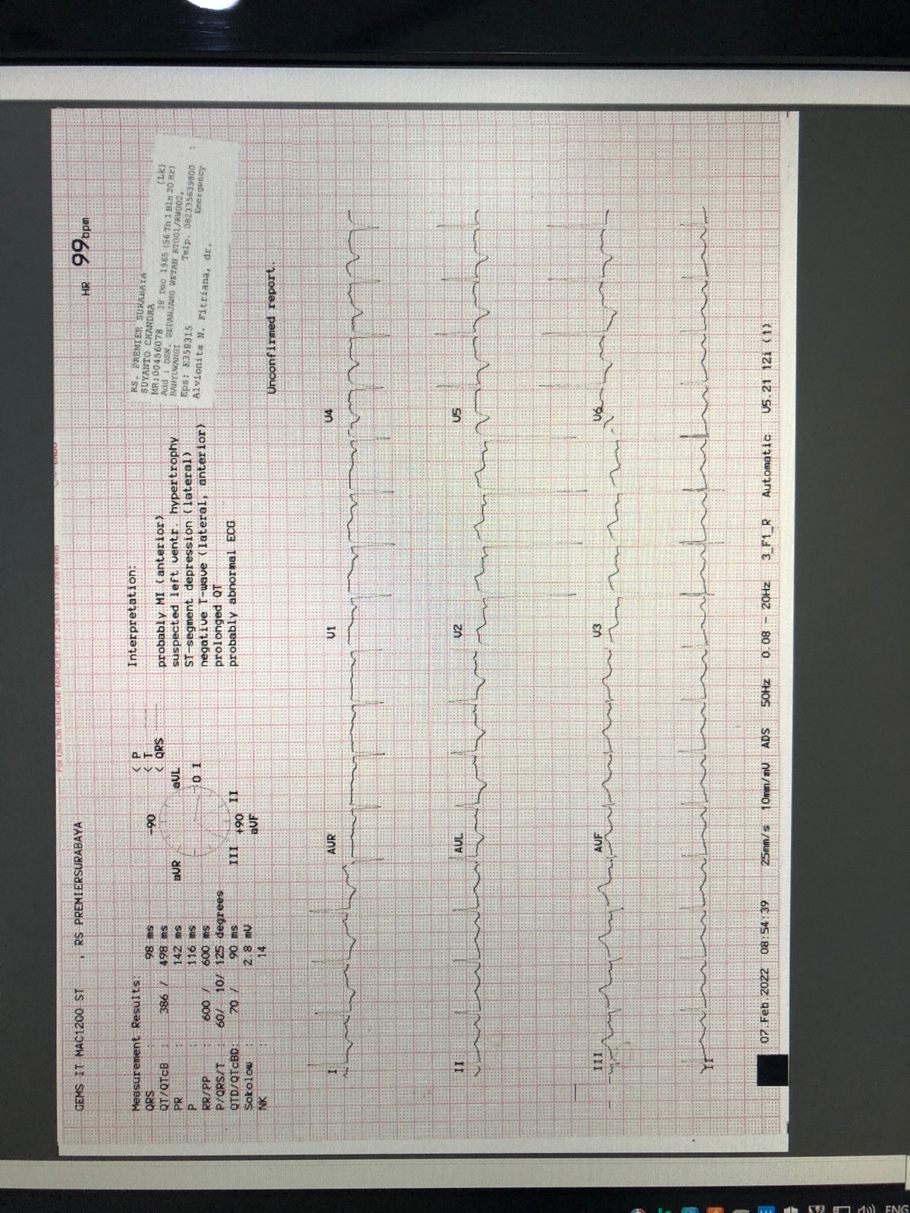
Figure 1: Electrocardiogram on admission showing sinus rhythm, Q waves in leads V1-V4, and T wave inversions in leads I, aVL, V1-V6, consistent with prior anterior extensive ischemia.

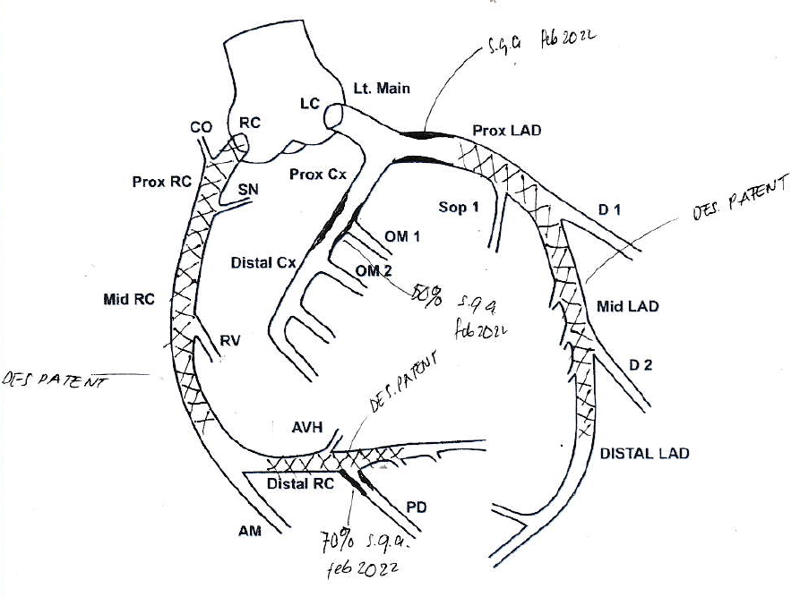
Figure 2: Angiography evaluation revealed that the existing stents in the LAD and RCA were patent. Previous PCI was performed that involved placing two drug-eluting stents (DES) in the proximal-mid left anterior descending artery (LAD), one DES in the proximal right coronary artery (RCA), and one overlapping DES in the mid RCA. Additionally, one DES was implanted in the ostial right coronary artery (RCA) and one DES in the distal RCA.

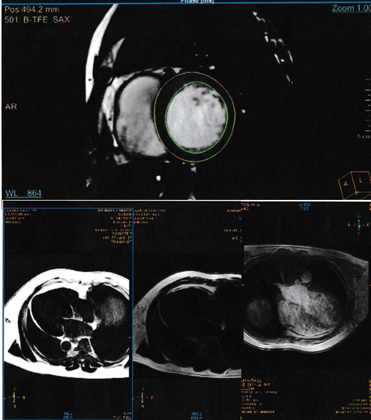
Figure 3: Cardiac magnetic resonance T1 mapping demonstrating diffusely abnormal myocardial T1 values (image or map representation), indicative of interstitial expansion.

3. discussion

This case highlights the importance of looking for other causes of heart failure in patients with ischemic cardiomyopathy who still have symptoms. Symptoms of shortness of breath and persistent and recurrent congestion in patients, even though angiography results show a patent stent, are indicators that underlying CAD may not be the only cause of their clinical symptoms. This case emphasizes the need to consider differential diagnoses or other comorbidities when heart failure symptoms persist after receiving optimal therapy and evidence of ischemia remains (Bawaskar et al., 2024).
CMR is one of the diagnostic modalities used to determine the cause of heart failure after initial echocardiography, which is non-invasive and feasible. Echocardiography can accurately identify left ventricular hypertrophy (LVH) and diastolic dysfunction, but with a Left Ventricular Ejection Fraction (LVEF) result that is still better, indicating adequate heart pump function (Kittleson et al., 2023). CMR examination can better describe myocardial tissue characteristics, calculate a more accurate LVEF, and detect the presence of infiltrative processes. A significant increase in LVMI, a diffuse LGE pattern that does not correspond to the coronary region, and the absence of abnormal myocardium in the T1 mapping sequence are strong characteristics that point to cardiac amyloidosis. This pattern contrasts sharply with typical ischemic LGE, which is usually subendocardial or transmural and localized to areas supplied by occluded coronary arteries(Smiseth et al., 2022).
Elevated troponin levels can be caused by several factors, most commonly acute coronary obstruction. In this case, angiographic evaluation was performed and no coronary obstruction was found, so the cause of troponin elevation due to supply and demand imbalance was categorized as type 2 myocardial infarction. Supply-demand imbalance in the context of a hypertrophied, stiff, and poorly relaxed ventricle due to amyloidosis, exacerbated by congestive stress, can increase troponin. Other causes may include toxicity or direct myocyte injury due to amyloid fibril deposition itself, which can contribute to troponin release. This highlights that increased troponin levels in heart failure patients necessitate critical interpretation, rather than an immediate presumption of abrupt plaque rupture (McDonagh et al., 2021).
Immunoserology confirmed the amyloid subtype. It is important to find that there are more free kappa light chains than normal lambda chains and, most importantly, that the kappa/lambda ratio is normal. This pattern effectively excludes AL amyloidosis, a condition requiring prompt intervention. FLC tests are mostly used to find the monoclonal protein that shows AL amyloidosis, which causes a very strange ratio. However, small increases in one FLC type with a normal ratio can also happen in other disorders, like inflammation or kidney disease. Given that CMR findings strongly suggest amyloidosis, this serological profile clearly points to ATTR-CA. A comprehensive assessment typically includes serum and urine protein electrophoresis with immunofixation to definitively rule out a monoclonal gammopathy (Ruberg et al., 2019). Further validation and subtyping (wild-type versus hereditary) may require technetium-99m pyrophosphate (Tc-PYP) scintigraphy (which shows significant myocardial uptake in ATTR-CA) or genetic testing; however, a non-biopsy diagnosis based on unique imaging and the exclusion of AL amyloidosis is now widely accepted (Gillmore et al., 2016).
The diagnosis of dual cardiomyopathy necessitates a multifaceted management approach. Guideline-directed medical therapy for the ischemic component (DAPT, statin) and heart failure (diuretics for congestion, SGLT2 inhibitors) remains essential. SGLT2 inhibitors are particularly relevant given their established benefits in HFpEF and HFmrEF, and emerging data suggesting potential benefits in CA (McDonagh et al., 2021). However, caution is advised with certain HF medications in ATTR-CA; beta-blockers may be poorly tolerated due to fixed stroke volume and reliance on heart rate for cardiac output, and non-dihydropyridine calcium channel blockers are generally contraindicated due to potential negative inotropic effects and binding to amyloid fibrils (Arbelo et al., 2023). The cornerstone of ATTR-CA management is targeted therapy aimed at stabilizing the TTR protein. Tafamidis is an approved oral medication demonstrated to reduce mortality and cardiovascular hospitalizations in patients with ATTR cardiomyopathy . Consideration of Tafamidis therapy was appropriate for this patient following the diagnosis (Elliott et al., 2022).
The prognosis for individuals with dual cardiomyopathy is probably less favorable compared to those with a single condition. However, the early detection of ATTR-CA enables the beginning of targeted disease-modifying therapy, which may decelerate disease progression and enhance outcomes. This case emphasizes the necessity of a systematic approach, employing advanced diagnostic techniques such as CMR and suitable laboratory assessments, to identify intricate underlying pathologies in patients with heart failure.. Appropriate treatment according to the cause of heart failure can reduce morbidity and improve patients' quality of life (Arbelo et al., 2023).

4. Conclusion

This report describes a case of dual cardiomyopathy involving both ischemic heart disease and transthyretin cardiac amyloidosis in a patient presenting with refractory heart failure despite patent coronary stents. It highlights the critical importance of maintaining a high index of suspicion for alternative or coexisting cardiac pathologies in patients with known CAD whose clinical course is atypical or refractory to standard therapy. Cardiac magnetic resonance imaging proved indispensable for non-invasive myocardial tissue characterization, identifying the infiltrative process suggestive of amyloidosis. Subsequent immunoserology was essential for differentiating ATTR from AL amyloidosis, guiding appropriate management strategies. Early and accurate diagnosis of dual cardiomyopathy, facilitated by advanced imaging and laboratory techniques, allows for the implementation of targeted therapies, potentially improving the prognosis for this complex patient population.

Consent (where ever applicable)

All authors declare that ‘written informed consent was obtained from the patient (or other approved parties) for publication of this case report and accompanying images. A copy of the written consent is available for review by the Editorial office/Chief Editor/Editorial Board members of this journal

Ethical approval

It is not applicable.

References

Arbelo, E., Protonotarios, A., Gimeno, J. R., Arbustini, E., Barriales-Villa, R., Basso, C., Bezzina, C. R., Biagini, E., Blom, N. A., De Boer, R. A., De Winter, T., Elliott, P. M., Flather, M., Garcia-Pavia, P., Haugaa, K. H., Ingles, J., Jurcut, R. O., Klaassen, S., Limongelli, G., … Witkowski, A. (2023). 2023 ESC Guidelines for the management of cardiomyopathies: Developed by the task force on the management of cardiomyopathies of the European Society of Cardiology (ESC). European Heart Journal, 44(37), 3503–3626. https://doi.org/10.1093/eurheartj/ehad194
Bawaskar, P., Thomas, N., Ismail, K., Guo, Y., Chhikara, S., Athwal, P. S. S., Ranum, A., Jadhav, A., Mendez, A. H., Nadkarni, I., Frerichs, D., Velangi, P., Ergando, T., Akram, H., Kanda, A., & Shenoy, C. (2024). Nonischemic or Dual Cardiomyopathy in Patients With Coronary Artery Disease. Circulation, 149(11), 807–821. https://doi.org/10.1161/CIRCULATIONAHA.123.067032
Elliott, P., Drachman, B. M., Gottlieb, S. S., Hoffman, J. E., Hummel, S. L., Lenihan, D. J., Ebede, B., Gundapaneni, B., Li, B., Sultan, M. B., & Shah, S. J. (2022). Long-term survival with tafamidis in patients with transthyretin amyloid cardiomyopathy. Circulation: Heart Failure, 15(1), E008193. https://doi.org/10.1161/CIRCHEARTFAILURE.120.008193
Garcia-Pavia, P., Rapezzi, C., Adler, Y., Arad, M., Basso, C., Brucato, A., Burazor, I., Caforio, A. L. P., Damy, T., Eriksson, U., Fontana, M., Gillmore, J. D., Gonzalez-Lopez, E., Grogan, M., Heymans, S., Imazio, M., Kindermann, I., Kristen, A. V., Maurer, M. S., … Linhart, A. (2021). Diagnosis and treatment of cardiac amyloidosis: A position statement of the ESC Working Group on Myocardial and Pericardial Diseases. European Heart Journal, 42(16), 1554–1568. https://doi.org/10.1093/eurheartj/ehab072
Gillmore, J. D., Maurer, M. S., Falk, R. H., Merlini, G., Damy, T., Dispenzieri, A., Wechalekar, A. D., Berk, J. L., Quarta, C. C., Grogan, M., Lachmann, H. J., Bokhari, S., Castano, A., Dorbala, S., Johnson, G. B., Glaudemans, A. W. J. M., Rezk, T., Fontana, M., Palladini, G., … Hawkins, P. N. (2016). Nonbiopsy diagnosis of cardiac transthyretin amyloidosis. Circulation, 133(24), 2404–2412. https://doi.org/10.1161/CIRCULATIONAHA.116.021612
Kittleson, M. M., Panjrath, G. S., Amancherla, K., Davis, L. L., Deswal, A., Dixon, D. L., Januzzi, J. L., & Yancy, C. W. (2023). 2023 ACC Expert Consensus Decision Pathway on Management of Heart Failure With Preserved Ejection Fraction: A Report of the American College of Cardiology Solution Set Oversight Committee. Journal of the American College of Cardiology, 81(18), 1835–1878. https://doi.org/10.1016/j.jacc.2023.03.393
McDonagh, T. A., Metra, M., Adamo, M., Baumbach, A., Böhm, M., Burri, H., Čelutkiene, J., Chioncel, O., Cleland, J. G. F., Coats, A. J. S., Crespo-Leiro, M. G., Farmakis, D., Gardner, R. S., Gilard, M., Heymans, S., Hoes, A. W., Jaarsma, T., Jankowska, E. A., Lainscak, M., … Koskinas, K. C. (2021). 2021 ESC Guidelines for the diagnosis and treatment of acute and chronic heart failure. In European Heart Journal (Vol. 42, Issue 36, pp. 3599–3726). Oxford University Press. https://doi.org/10.1093/eurheartj/ehab368
Ruberg, F. L., Grogan, M., Hanna, M., Kelly, J. W., & Maurer, M. S. (2019). Transthyretin Amyloid Cardiomyopathy: JACC State-of-the-Art Review. In Journal of the American College of Cardiology (Vol. 73, Issue 22, pp. 2872–2891). Elsevier USA. https://doi.org/10.1016/j.jacc.2019.04.003
Siagh, S., Hibatouallah, H., Amrani, M., & Cherti, M. (2025). A Case Report and Literature Review of Cardiac Amyloidosis: The Great Pretender Masquerading As Acute Coronary Syndrome. Cureus. https://doi.org/10.7759/cureus.81567
Smiseth, O. A., Morris, D. A., Cardim, N., Cikes, M., Delgado, V., Donal, E., Flachskampf, F. A., Galderisi, M., Gerber, B. L., Gimelli, A., Klein, A. L., Knuuti, J., Lancellotti, P., Mascherbauer, J., Milicic, D., Seferovic, P., Solomon, S., Edvardsen, T., Popescu, B. A., … Cosyns, B. (2022). Multimodality imaging in patients with heart failure and preserved ejection fraction: An expert consensus document of the European Association of Cardiovascular Imaging. European Heart Journal Cardiovascular Imaging, 23(2), E34–E61. https://doi.org/10.1093/ehjci/jeab154

