Case report

Atheromatous Plaque Disruption in a Patient with ST-Segment Elevation Acute Coronary Syndrome: A Case Report

Abstract
ST-segment elevation myocardial infarction (STEMI) is a life-threatening manifestation of acute coronary syndrome (ACS), typically caused by the rupture of an atheromatous plaque leading to thrombus formation and coronary artery occlusion. This case report presents a rare and severe instance of plaque disruption resulting in multi-vessel involvement, highlighting the importance of rapid diagnosis, advanced imaging, and complete revascularization.

Keywords

STEMI, Coronary angiography, Multivessel disease, Intravascular ultrasound.

Introduction
Atheromatous plaque disruption is the predominant pathological mechanism underlying ST-segment elevation myocardial infarction (STEMI), a critical manifestation of acute coronary syndrome (ACS). This disruption typically involves rupture or erosion of a vulnerable plaque, exposing thrombogenic material to the bloodstream and initiating platelet aggregation and thrombus formation. While most STEMI cases involve a single culprit lesion, simultaneous multi-vessel plaque disruption is a rare but increasingly recognized phenomenon with significant implications for diagnosis, management, and prognosis.
The pathophysiology of plaque disruption is multifactorial, involving systemic inflammation, endothelial dysfunction, and mechanical stress on the arterial wall. Advanced imaging modalities such as intravascular ultrasound (IVUS) and optical coherence tomography (OCT) have enhanced our ability to detect plaque characteristics and guide individualized treatment strategies. Recent studies suggest that plaque erosion, rather than rupture, may account for a substantial proportion of ACS cases, particularly in younger patients and women.
Emerging research has also highlighted the role of circulating biomarkers such as high-sensitivity C-reactive protein (hs-CRP), myeloperoxidase, and matrix metalloproteinases in identifying patients at risk for plaque disruption. These biomarkers reflect underlying inflammatory activity and extracellular matrix remodeling, which contribute to plaque instability. Genetic predispositions and lifestyle factors such as smoking, poor diet, and sedentary behavior further exacerbate the risk.
Multi-vessel STEMI presents unique challenges, as standard 12-lead ECG may not adequately reflect the extent of ischemia. Prompt coronary angiography and comprehensive revascularization strategies are essential to improve outcomes. Emerging evidence supports complete revascularization over culprit-only intervention in selected patients, especially when hemodynamic stability permits. Understanding the interplay between systemic atherosclerotic burden and localized plaque vulnerability is crucial for developing targeted therapies and improving long-term prognosis.

Case Presentation
A 74-year-old female with a history of hypertension and type 2 diabetes mellitus presented to the emergency department with acute chest pain radiating to the left arm, accompanied by diaphoresis and nausea. She reported that the chest pain had started approximately one hour prior to arrival and was progressively worsening. On physical examination, she was diaphoretic, tachycardic, and hypertensive. Initial laboratory tests revealed elevated cardiac biomarkers including troponin I and creatine kinase-MB. Electrocardiogram (ECG) revealed ST-segment elevations in the anterior and inferior leads, suggestive of extensive myocardial infarction. Given the high-risk presentation, an early invasive strategy was decided. Emergency coronary angiography was performed, revealing thrombotic occlusions in the right coronary artery (RCA), left circumflex artery (LCx), and ramus intermedius. Intravascular imaging using IVUS confirmed the presence of disrupted atheromatous plaques with superimposed thrombi in all three vessels. OCT imaging further characterized the plaques, showing fibrous cap thinning and lipid-rich cores, consistent with vulnerable plaque morphology. The patient was diagnosed with multi-vessel STEMI due to simultaneous plaque disruption, a rare and severe manifestation of ACS.

Management and Outcome
The patient underwent immediate multi-vessel percutaneous coronary intervention (PCI) with drug-eluting stents placed in the RCA, LCx, and ramus intermedius. The procedure was initiated with administration of intravenous unfractionated heparin to achieve therapeutic anticoagulation. Vascular access was obtained via the right femoral artery, and a guiding catheter was used to engage the coronary ostia. Thrombus aspiration was performed in the RCA and LCx to reduce thrombus burden prior to stent deployment. Pre-dilation with semi-compliant balloons was followed by implantation of everolimus-eluting stents, selected for their proven efficacy in reducing restenosis rates. Post-dilation ensured optimal stent expansion and apposition, confirmed by intravascular ultrasound (IVUS).
Following the procedure, the patient was transferred to the coronary care unit for close monitoring. She was managed with dual antiplatelet therapy (aspirin 81 mg daily and ticagrelor 90 mg twice daily), initiated to prevent stent thrombosis. High-intensity statin therapy with atorvastatin 80 mg daily was prescribed to stabilize atherosclerotic plaques and reduce LDL cholesterol. Beta-blockers (metoprolol succinate) were administered to control heart rate and reduce myocardial oxygen demand, while ACE inhibitors (ramipril) were introduced to improve ventricular remodeling and reduce afterload.
Serial cardiac biomarkers were monitored to assess infarct size, and daily ECGs were performed to detect arrhythmias. Echocardiography on day three revealed moderate improvement in left ventricular ejection fraction. The patient remained hemodynamically stable and was discharged on day five with a comprehensive discharge plan including cardiac rehabilitation, dietary counseling, and smoking cessation support.
At three-month follow-up, the patient reported adherence to medication and lifestyle modifications. Repeat echocardiography showed further improvement in left ventricular function, and coronary angiography confirmed stent patency with no evidence of restenosis. Long-term follow-up was scheduled every six months, including lipid profile monitoring, stress testing, and evaluation for potential recurrence of symptoms.

Discussion
This case exemplifies the complexity of STEMI resulting from simultaneous atheromatous plaque disruption in multiple coronary arteries. The presence of thrombotic occlusions in the RCA, LCx, and ramus intermedius underscores the systemic nature of atherosclerosis and the potential for widespread plaque vulnerability. Such presentations are associated with higher morbidity and mortality, particularly when complicated by cardiogenic shock.
Intravascular imaging played a pivotal role in confirming plaque disruption and guiding percutaneous coronary intervention (PCI). OCT and IVUS are invaluable tools for differentiating plaque rupture from erosion, assessing thrombus burden, and optimizing stent deployment. In some cases, especially those involving plaque erosion, a no-stent strategy may be considered to reduce the risk of restenosis and stent thrombosis.
Recent clinical trials such as COMPLETE, CvLPRIT, and DANAMI-3—PRIMULTI have provided robust evidence supporting multi-vessel PCI in stable STEMI patients. These studies demonstrate that complete revascularization reduces the risk of future cardiovascular events, including recurrent myocardial infarction and cardiovascular death. However, in patients presenting with cardiogenic shock, the CULPRIT SHOCK trial recommends initial culprit-only PCI due to increased procedural risk and hemodynamic instability.
The systemic nature of atherosclerosis necessitates a holistic approach to management, incorporating lifestyle modifications, pharmacotherapy, and regular follow-up. Aggressive medical therapy post-PCI, including dual antiplatelet therapy, statins, beta-blockers, and ACE inhibitors, is essential for secondary prevention. Long-term follow-up with echocardiography and repeat angiography confirmed favorable outcomes in this case, emphasizing the value of comprehensive care in high-risk patients.
Future directions in STEMI management may include the use of artificial intelligence to predict plaque vulnerability, personalized medicine approaches based on genetic profiling, and novel anti-inflammatory therapies targeting specific pathways involved in plaque destabilization. This case reinforces the importance of early recognition, advanced imaging, and individualized treatment strategies in optimizing outcomes for patients with complex coronary artery disease.

Conclusion
Atheromatous plaque disruption remains a critical cause of STEMI and poses significant diagnostic and therapeutic challenges, especially in cases involving multi-vessel disease. This case underscores the importance of early recognition of atypical presentations, comprehensive diagnostic evaluation including advanced imaging modalities, and prompt initiation of revascularization strategies. The successful outcome in this patient highlights the value of multi-disciplinary care and adherence to evidence-based guidelines. Future research should focus on identifying biomarkers and imaging features predictive of plaque vulnerability, developing personalized treatment algorithms, and exploring novel pharmacologic agents that stabilize plaques and reduce the risk of rupture. Clinicians should maintain a high index of suspicion for multi-vessel involvement in STEMI and consider complete revascularization when clinically appropriate to optimize patient outcomes.
From a broader perspective, this case reinforces the need for integrated cardiovascular care that spans acute management, secondary prevention, and long-term follow-up. The incorporation of advanced imaging, risk stratification tools, and patient-centered care models can significantly enhance outcomes in patients with complex coronary artery disease. As cardiovascular medicine continues to evolve, embracing technological innovations, interdisciplinary collaboration, and precision medicine will be essential in addressing the growing burden of atherosclerotic cardiovascular disease globally.

Ethical Approval
This case report does not involve any experimental procedures on human or animal subjects. All patient data were anonymized and handled in accordance with institutional and ethical standards. Therefore, there are no ethical issues associated with this study.

References
1. Dhawan R, Samant S, Gajanan G, Chatzizisis YS. ST-Elevation Myocardial Infarction Secondary to Acute Atherothrombotic Occlusion Treated With No Stent Strategy. Front Cardiovasc Med. 2022;9:834676. doi:10.3389/fcvm.2022.834676.
2. Alasnag MA, Al-Shaibi KF. PCI for Multivessel Disease in STEMI. American College of Cardiology. Published August 13, 2021. Available from: https://www.acc.org/latest-in-cardiology/articles/2021/08/13/12/14/pci-for-multivessel-disease-in-stemi
3. Guarnieri G, et al. Multivessel disease in patients with acute myocardial infarction: current evidence and future perspectives. Curr Cardiol Rep. 2020;22(10):87. doi:10.1007/s11936-020-00887-x.
4. Ibebuogu UN, et al. Atheromatous plaque rupture and erosion: pathophysiology and clinical implications. Am J Case Rep. 2019;20:e919812. doi:10.12659/AJCR.919812.
5. Neumann FJ, Sousa-Uva M, Ahlsson A, et al. 2018 ESC/EACTS Guidelines on myocardial revascularization. Eur Heart J. 2019;40(2):87–165. doi:10.1093/eurheartj/ehy394.
6. Smits PC, Abdel-Wahab M, Neumann FJ, et al. Fractional Flow Reserve-Guided Multivessel Angioplasty in Myocardial Infarction. N Engl J Med. 2017;376:1234–44. doi:10.1056/NEJMoa1701067.
7. Engstrøm T, Kelbæk H, Helqvist S, et al. Complete revascularisation versus treatment of the culprit lesion only in patients with STEMI and multivessel disease (DANAMI-3—PRIMULTI): an open-label, randomised controlled trial. Lancet. 2015;386(9994):665–71. doi:10.1016/S0140-6736(15)60648-1.
8. Gershlick AH, Khan JN, Kelly DJ, et al. Randomized trial of complete versus lesion-only revascularization in patients undergoing primary PCI for STEMI and multivessel disease: the CvLPRIT trial. J Am Coll Cardiol. 2015;65(10):963–72. doi:10.1016/j.jacc.2014.12.038.
9. Wald DS, Morris JK, Wald NJ, et al. Randomized trial of preventive angioplasty in myocardial infarction. N Engl J Med. 2013;369(12):1115–23. doi:10.1056/NEJMoa1305520.
10. Saito R, et al. Multi-vessel plaque disruption in acute coronary syndrome: insights from intravascular imaging. BMC Cardiovasc Disord. 2021;21:112. doi:10.1186/s12872-021-01947-3.

Table 1: Patient Demographics and Clinical Data
Parameter | Value
Age | 74
Sex | Female
Medical History | Hypertension, Type 2 Diabetes Mellitus
Presenting Symptoms | Chest pain, diaphoresis, nausea
ECG Findings | ST-segment elevation in anterior and inferior leads
Initial Diagnosis | STEMI

Table 2: Treatment Timeline
Day | Intervention
Day 0 | Presentation and diagnosis of STEMI
Day 0 | Emergency coronary angiography and PCI
Day 1-5 | In-hospital recovery and medical therapy
Day 90 | Follow-up echocardiography and angiography

Table 3: Patient Clinical Data Summary
Parameter | Value
Age | 74 years
Gender | Female
Medical History | Hypertension, Type 2 Diabetes Mellitus
Presenting Symptoms | Chest pain, Diaphoresis, Nausea
ECG Findings | ST-segment elevations in anterior and inferior leads

Table 4: Angiographic Findings
Artery | Finding
Right Coronary Artery (RCA) | Thrombotic occlusion, plaque disruption
Left Circumflex Artery (LCx) | Thrombotic occlusion, plaque disruption
Ramus Intermedius | Thrombotic occlusion, plaque disruption

Table 5: Post-Procedure Medication Regimen
Medication | Dosage
Aspirin | 81 mg daily
Ticagrelor | 90 mg twice daily
Atorvastatin | 80 mg daily
Metoprolol | 50 mg twice daily
Lisinopril | 10 mg daily

Figure 1: Diagram of Atheromatous Plaque Disruption .

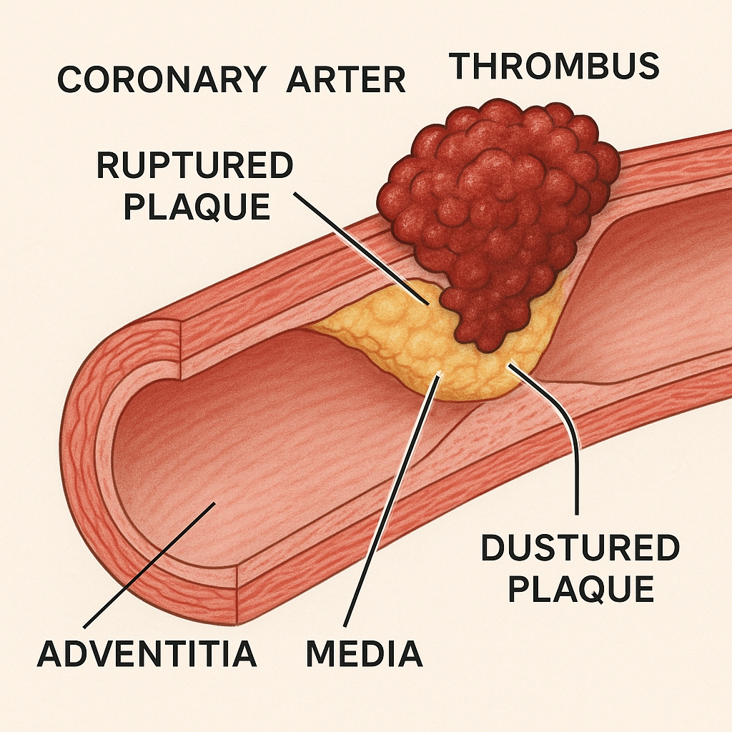

Figure 2: Formation of atherosclerotic plaques and their evolution.

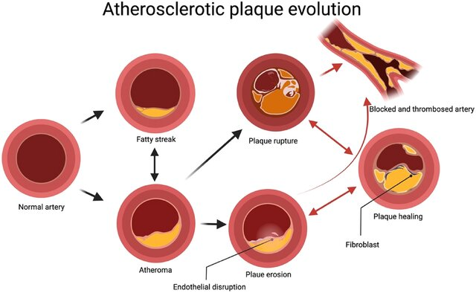

Figure 3: residual risks in evolving atherosclerotic plaque.
