Case report
Challange and success in PM implantation via PRSVC in Situs Inversus Dextrocardia: A Case Report

Abstract
Situs inversus dextrocardia is a rare congenital anomaly that can complicate medical procedures, including the implantation of a dual-chamber pacemaker (PM). This case report describes the challenges encountered during pacemaker implantation in a patient with situs inversus dextrocardia and a complex venous anatomy, including a persistent right superior vena cava (RSVC) draining directly into the coronary sinus (CS) and a left-sided venous drainage with multiple turbulences. Despite the anatomical challenges, the procedure was successful, with pacemaker leads successfully placed in the left-sided right ventricle. This case highlights the importance of thorough preoperative assessment and understanding of venous variations in patients with situs inversus dextrocardia.
Keywords : Situs inversus dextrocardia, Persistent right superior vena cava, Atrioventricular block, Pacemaker implantation, Heterotaxy syndrome, Polysplenia

Introduction
Situs inversus dextrocardia is a rare congenital condition, estimated at 1 in 10,000–12,000 live births, where the heart is located in the right hemithorax with a mirror-image arrangement of its chambers and great vessels [1]. Although many patients remain asymptomatic, situs inversus is frequently associated with additional cardiovascular malformations and venous drainage anomalies, particularly persistent superior vena cava (SVC) variants [2].
Cardiac rhythm disturbances in this setting are uncommon, and high-grade atrioventricular (AV) block requiring pacing is exceptionally rare [1, 3]. Implantation of a permanent pacemaker in such patients can be technically challenging, especially when venous anomalies such as persistent SVC draining into the coronary sinus are present. Potential difficulties include prolonged procedure time, tortuous venous access, lead instability, and increased risk of complications [2, 4].
We present the case of a young adult with situs inversus dextrocardia, systemic venous anomaly, and complete AV block, who underwent successful dual-chamber pacemaker implantation.

Case presentation
A 34-year-old male with no prior history of toxic habits, metabolic disorders, or comorbidities presented with recurrent syncopal episodes and symptomatic bradycardia. Physical examination was unremarkable. Serial electrocardiographic recordings confirmed severe bradyarrhythmia with different manifestations, including bradycardia-dependent ventricular ectopy, marked sinus bradycardia at 37 bpm, and a paroxysmal high-grade atrioventricular block (Figure 1).
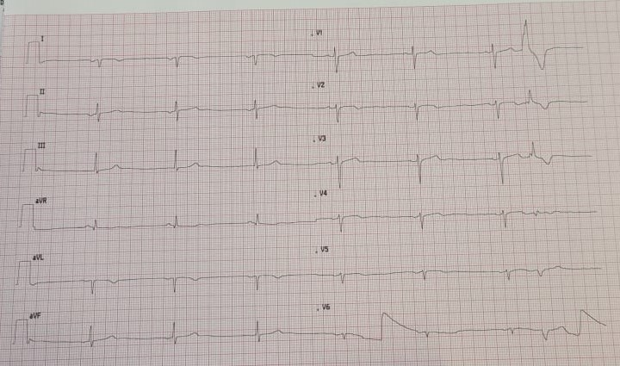
Figure 1a) Surface ECG showing severe bradycardia with bradycardia-dependent premature ventricular contractions
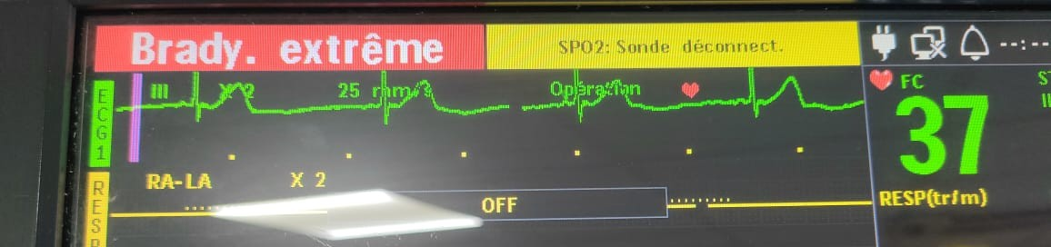Figure 1b ) Telemetry recording from cardiac monitoring demonstrating severe bradycardia at 37 bpm 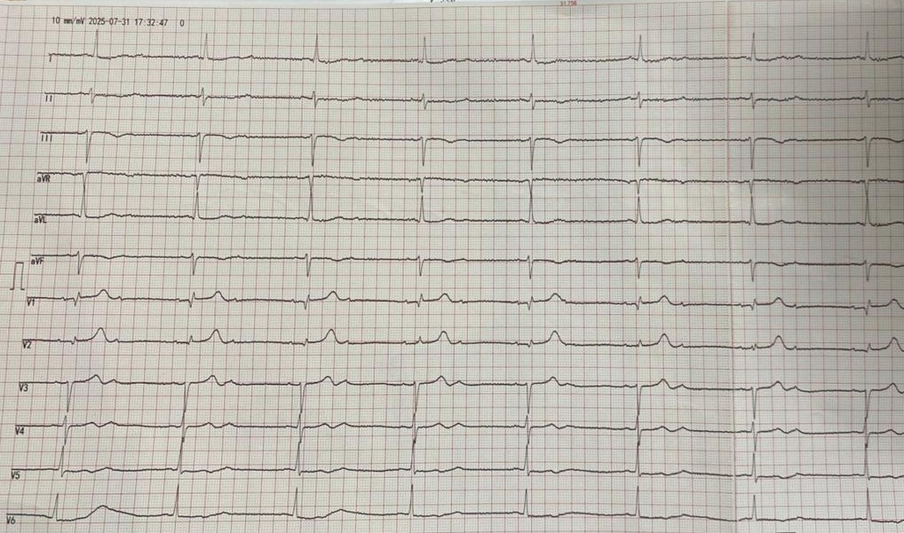 Figure 1c) Twelve-lead ECG documenting a paroxysmal high-grade (2:1) atrioventricular block with narrow QRS complexes
Figure 1. Electrocardiographic findings in the patient with severe bradycardia. (a) Surface ECG showing severe bradycardia with bradycardia-dependent premature ventricular contractions. (b) Telemetry recording from cardiac monitoring demonstrating severe bradycardia at 37 bpm. (c) Twelve-lead ECG documenting a paroxysmal high-grade (2:1) atrioventricular block with narrow QRS complexes
Echocardiography and fluoroscopy revealed situs inversus dextrocardia with a persistent right superior vena cava (RSVC) draining into the coronary sinus (CS) (Figure 2). To further investigate, a thoraco-abdomino-pelvic CT angiography was performed. It demonstrated an abnormal systemic venous return, with the RSVC receiving the azygos vein and draining into the CS. In addition, abdominal malrotation with polysplenia was identified. Although these CT images were not available for publication, the findings were carefully documented and incorporated into procedural planning.
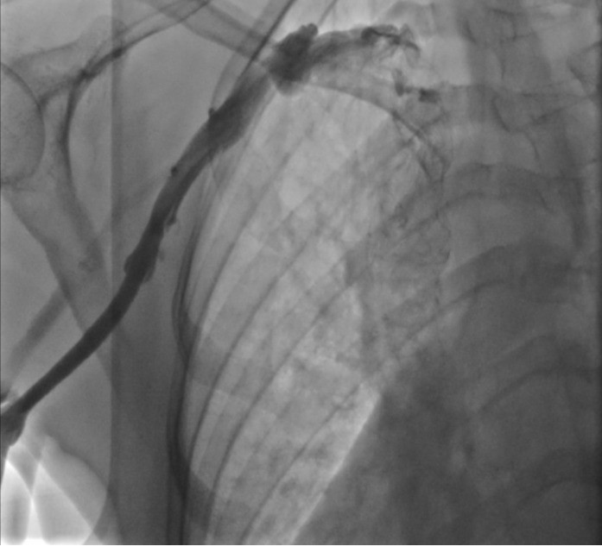
Figure 2. Contrast venography demonstrating the venous drainage pattern. The superior right vena cava drains anomalously into the coronary sinus before reaching the right atrium.”
Pacemaker implantation was attempted through the right subclavian vein. Despite the elongated and tortuous course of the RSVC, venous access was achieved. A guidewire was advanced into the morphological right ventricle located on the left side, and the leads were positioned under fluoroscopic guidance. Intraoperative venography confirmed venous drainage into the coronary sinus. The procedure was completed without complication, and final fluoroscopy and chest radiography confirmed stable dual-chamber pacemaker placement (Figures 3 and 4).
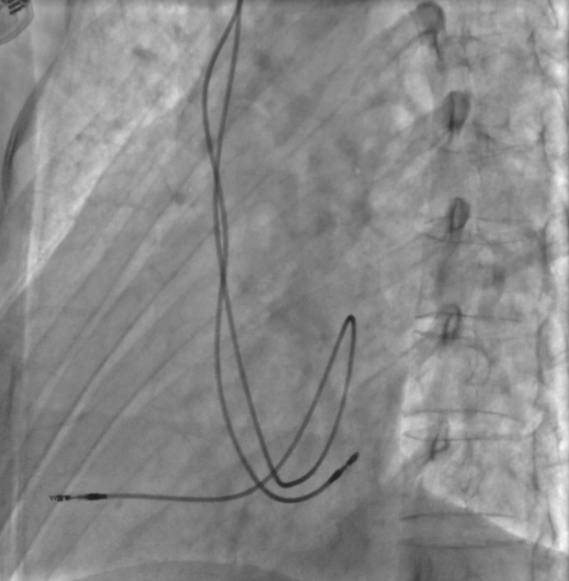 Figure 3 : Fluoroscopy during the procedure confirmed appropriate positioning of both the ventricular and atrial leads
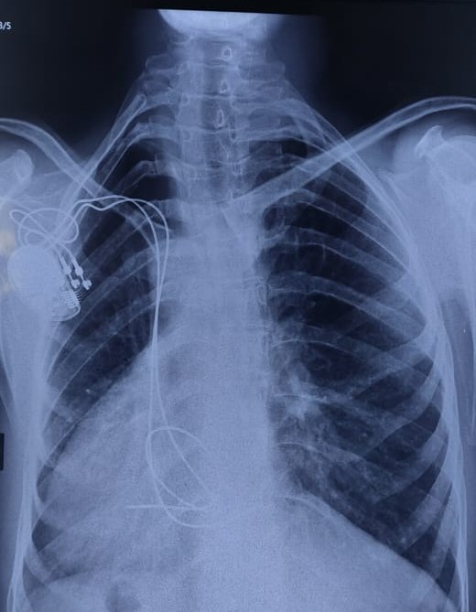
Figure 4 : Postoperative chest X-ray further demonstrated correct lead placement and stability

The patient recovered uneventfully, was discharged in stable condition, and follow-up showed normal device function without evidence of lead dislodgement or venous obstruction, the postoperative electrocardiogram demonstrated an atrially paced rhythm with preserved spontaneous ventricular activity, consistent with the pacemaker programming in AAI-DDDR mode
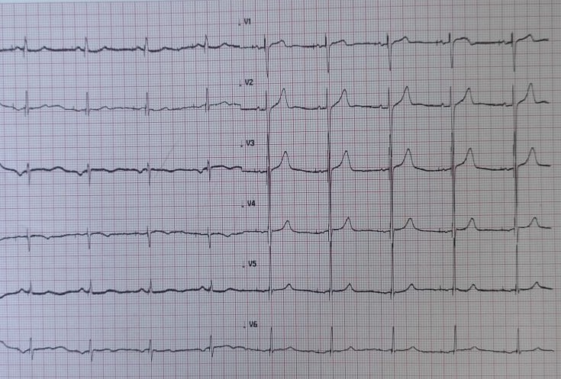
Figure 5. Postoperative electrocardiogram showing atrial pacing with spontaneous ventricular rhythm. The pacemaker was programmed in AAI-DDDR mode

Discussion
This case illustrates the rare association of situs inversus dextrocardia, systemic venous anomaly, and complete AV block. The coexistence of high-grade AV block in dextrocardia is unusual, as most patients requiring pacing in this setting present with sick sinus syndrome rather than AV conduction disorders [1,5].
Systemic venous anomalies are frequent in heterotaxy spectrum syndromes. Persistent SVC, whether left- or right-sided, is found in <0.5% of the general population but is more frequent in situs anomalies [2]. In our patient, the RSVC drained into the coronary sinus and received the azygos vein, complicating venous return. Abdominal malrotation and polysplenia confirmed a broader heterotaxy syndrome, a constellation that is rarely documented in the context of pacemaker implantation.
Venous anomalies can complicate device implantation due to unusual entry sites, tortuous trajectories, and risks of complications such as coronary sinus thrombosis, lead dislodgement, and arrhythmias [2,4]. In our case, despite the tortuous RSVC, venous access was achieved, and successful dual-chamber pacing was performed under fluoroscopic guidance.
This case emphasizes the importance of comprehensive imaging—ranging from echocardiography to CT angiography and intraoperative venography—to delineate complex anatomy, guide safe procedural strategy, and prevent complications [3,4].
Our experience adds to the limited body of literature and highlights that, even in complex heterotaxy spectrum anomalies, permanent pacemaker implantation can be successfully achieved with careful planning and intraoperative imaging.

Conclusion
Pacemaker implantation in patients with situs inversus dextrocardia is feasible with proper preoperative planning and understanding of the altered anatomy. This case emphasizes the importance of thorough imaging and procedural adaptability to ensure successful outcomes, even in the presence of complex venous and anatomical variations
In every case, it is necessary to perform an angiographic investigation to make implant more safe and easy, and to prevent eventual complications. We advise to effect a bi-dimensional echocardiography before the discharge of the patient, in order to verify the real location of the electrode in right ventricle.

Consent for publication:
Written informed consent was obtained from the patient for publication of this case report and accompanying images. A copy of the written consent is available for review by the Editor-in-Chief of this journal on request.

References
- Shenthar J, Rai MK, Walia R, Ghanta S, Sreekumar P, Reddy SS. Transvenous permanent pacemaker implantation in dextrocardia: technique, challenges, outcome, and a brief review of literature. Europace. 2014;16(9):1327-1333.
- Karumbaiah K, Bhat P, Bhat A, et al. Persistent right superior vena cava in a patient with dextrocardia and situs inversus. BMJ Case Rep. 2014;2014:bcr2014204490.
- Kato S, Matsumoto Y, Sugano Y, et al. Catheter ablation and pacemaker implantation in a patient with dextrocardia, persistent right superior vena cava, and IVC occlusion: a case report. HeartRhythm Case Rep. 2025;11(5):401-405.
- Guo G, Sun J, Dong J, Ma C. Implantation of a permanent VVI pacemaker in a patient with dextrocardia and persistent left superior vena cava. J Thorac Dis. 2017;9(2):E166-E169.
- Maharani E, Yuniadi Y. Permanent pacemaker implantation through persistent left superior vena cava: safe for normal heart position and dextrocardia. Indones J Cardiol. 2013;34(3):197-201.

