Case report

Global Heart Failure Decompensation Revealing Fabry Disease: A Case Report

Abstract
Background: Fabry disease is a rare X-linked lysosomal storage disorder caused by mutations in the GLA gene, leading to deficiency of α-galactosidase A and progressive accumulation of globotriaosylceramide (Gb3) in multiple tissues. Cardiac involvement may mimic hypertrophic cardiomyopathy or amyloidosis, often leading to delayed diagnosis.
Case Presentation: We report the case of a 67-year-old man with a history of complete atrioventricular block requiring pacemaker implantation and type 2 diabetes, admitted for global heart failure decompensation. Echocardiography showed concentric left ventricular hypertrophy and reduced ejection fraction. Coronary angiography was normal, and an extensive workup for amyloidosis was negative. Enzymatic assay confirmed markedly decreased α-galactosidase A activity, establishing the diagnosis of Fabry disease. Genetic testing and cardiac magnetic resonance imaging are ongoing.
Conclusion: This case underlines the importance of considering Fabry disease in the differential diagnosis of unexplained hypertrophic cardiomyopathy with heart failure, especially when amyloidosis has been excluded. Early recognition is essential as specific therapies are available that can alter the natural course of the disease.

Introduction
Fabry disease is an X-linked lysosomal storage disorder caused by deficient activity of the enzyme α-galactosidase A. This enzymatic deficiency results in progressive lysosomal accumulation of glycosphingolipids, particularly globotriaosylceramide (Gb3), in a wide variety of tissues including the cardiovascular, renal, nervous, and integumentary systems. The clinical spectrum is heterogeneous, ranging from the classic early-onset form with systemic involvement to late-onset variants with organ-specific manifestations, particularly cardiac or renal disease.
From a cardiology perspective, Fabry disease is increasingly recognized as an important cause of otherwise unexplained left ventricular hypertrophy (LVH), often mimicking sarcomeric hypertrophic cardiomyopathy (HCM) or infiltrative diseases such as cardiac amyloidosis. Cardiac manifestations include concentric LVH, conduction abnormalities, arrhythmias, valvular dysfunction, and eventually heart failure. With disease progression, systolic dysfunction may develop, further complicating the clinical course.
Despite these characteristic features, diagnosis is frequently delayed because Fabry disease is rare, and its phenotypic overlap with more common cardiac disorders complicates recognition. In particular, distinguishing Fabry disease from amyloidosis and sarcomeric HCM is challenging without dedicated biochemical and genetic testing. Moreover, awareness among cardiologists is still limited, leading to underdiagnosis or misdiagnosis.
In this case report, we describe a 67-year-old man admitted with global heart failure decompensation, in whom enzymatic assay ultimately confirmed Fabry disease after exclusion of amyloidosis. This case highlights the importance of considering Fabry disease in elderly patients with unexplained LVH and heart failure, and it illustrates the diagnostic approach and therapeutic implications of this rare but treatable condition.

Case Presentation
A 67-year-old man was admitted to our hospital in March 2025 for evaluation and treatment of global decompensated heart failure. His medical history was notable for complete atrioventricular block diagnosed in 2013, for which he underwent dual-chamber pacemaker implantation. He had also been diagnosed with type 2 diabetes mellitus one month prior to admission. His past surgical history included appendectomy and cholecystectomy. He had no known family history of cardiomyopathy or sudden cardiac death.
The patient presented with progressive exertional dyspnea, peripheral edema, and occasional presyncopal episodes over the preceding months. On admission, vital signs included a blood pressure of 118/63 mmHg, a heart rate of 50 beats/min (paced), and oxygen saturation of 99% on room air. Physical examination revealed bilateral lower limb edema and mild jugular venous distension, consistent with fluid overload. Lung auscultation was unremarkable.
Electrocardiography (ECG) demonstrated a ventricular paced rhythm with a rate of 54–65 bpm, consistent with underlying atrioventricular block. Transthoracic echocardiography showed concentric left ventricular hypertrophy with an interventricular septal thickness of 18 mm, global hypokinesia, a moderately reduced left ventricular ejection fraction (LVEF 39–45%), and biatrial dilation. Right ventricular size and function were preserved.
Laboratory studies revealed elevated N-terminal pro-brain natriuretic peptide (NT-proBNP) of 908 pg/mL and a mildly increased high-sensitivity troponin of 54 ng/L. Renal and liver function were within normal limits. Coronary angiography revealed angiographically normal coronary arteries. Given the echocardiographic findings of LVH with diastolic dysfunction and conduction disease, cardiac amyloidosis was suspected.
An extensive workup for amyloidosis was performed, including serum and urine protein electrophoresis, immunofixation, free light chain assays, and bone scintigraphy. All results were negative, excluding light chain (AL) and transthyretin (ATTR) amyloidosis. Given the persistent diagnostic uncertainty, enzymatic assay for α-galactosidase A activity was obtained and revealed markedly reduced levels, confirming the diagnosis of Fabry disease. Genetic testing of the GLA gene and cardiac magnetic resonance imaging (CMR) were scheduled for further characterization.
During hospitalization, the patient was treated with diuretics and initiated on guideline-directed medical therapy for heart failure, including eplerenone, dapagliflozin, metformin, and rosuvastatin. His symptoms improved with diuresis, and he was discharged in stable condition. He was referred to a specialized metabolic disease center for evaluation of enzyme replacement therapy (ERT) or chaperone therapy, depending on his genetic results.

Figures
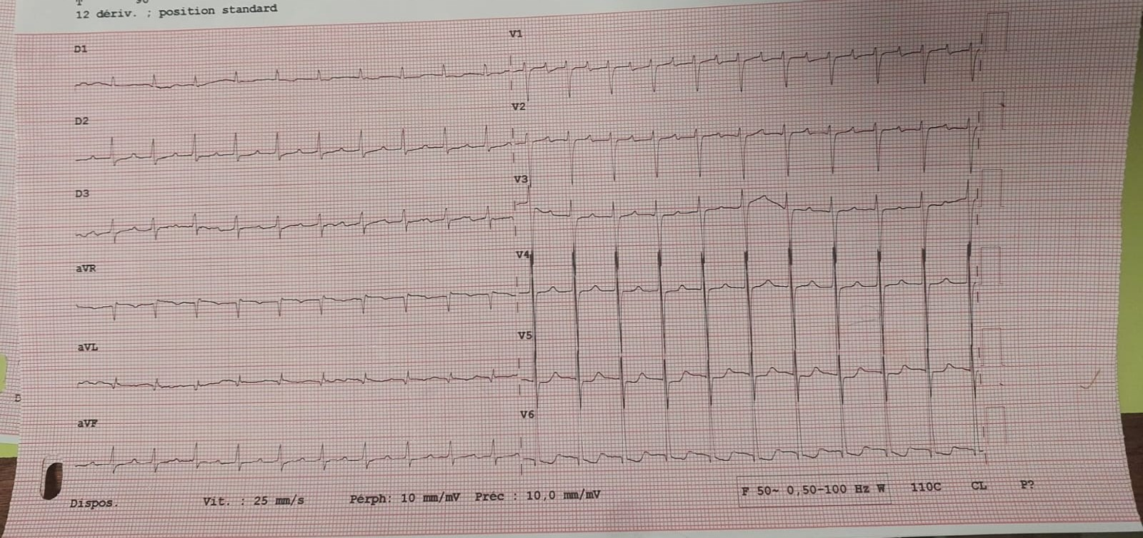
Figure 1. Electrocardiogram (ECG): Paced ventricular rhythm at 60 bpm with underlying complete atrioventricular block.
→ [Insert ECG image here]
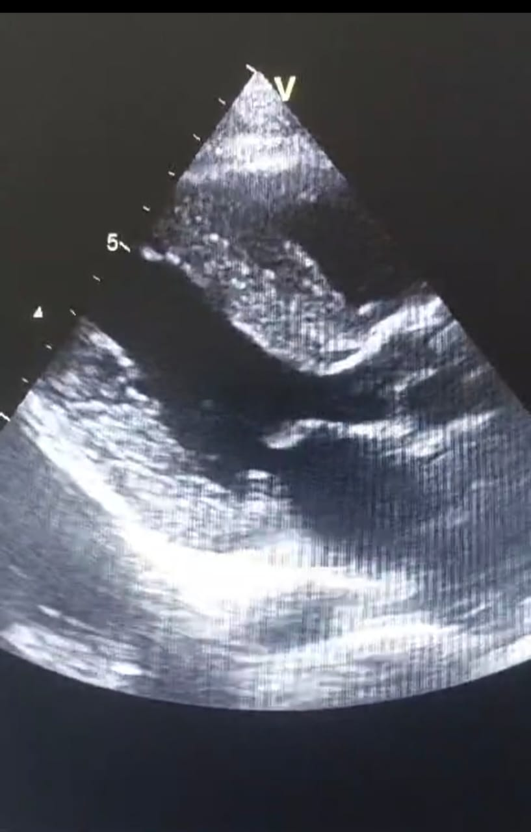
Figure 2. Transthoracic Echocardiography (TTE): Parasternal long-axis view showing concentric left ventricular hypertrophy (interventricular septum thickness 18 mm) and reduced ejection fraction (39–45%).
→ [Insert Echocardiography image here]

Discussion
This case illustrates the diagnostic challenge of Fabry disease presenting with global decompensated heart failure in an elderly patient. Cardiac involvement in Fabry disease often manifests as concentric LVH, conduction system abnormalities, arrhythmias, and eventually systolic dysfunction. In our patient, the presence of conduction disease requiring pacemaker implantation, along with LVH and biatrial dilation, initially raised strong suspicion for amyloidosis. However, the negative amyloidosis workup redirected attention to Fabry disease, which was subsequently confirmed by enzymatic testing.
The pathophysiology of Fabry cardiomyopathy is driven by lysosomal accumulation of Gb3 within cardiomyocytes, vascular endothelial cells, and conduction tissue. Over time, this leads to hypertrophy, fibrosis, arrhythmogenesis, and progressive myocardial dysfunction. Unlike sarcomeric HCM, which is characterized by asymmetric hypertrophy, Fabry disease typically causes concentric LVH with relatively preserved cavity size. Infiltrative diseases such as amyloidosis may produce similar findings but often present with low-voltage ECG, which was not observed in our patient due to pacing.
Imaging modalities play a central role in differentiating Fabry disease from other causes of LVH. Echocardiography is often the first-line tool, but findings are nonspecific. Cardiac magnetic resonance imaging (CMR) provides greater diagnostic specificity by identifying late gadolinium enhancement (LGE) in the basal inferolateral wall, a hallmark of Fabry cardiomyopathy. T1 mapping has also emerged as a sensitive biomarker for early detection of myocardial sphingolipid accumulation. Although CMR was pending in our case, its findings will further refine the extent of cardiac involvement.
Therapeutic strategies for Fabry disease have advanced significantly in recent years. Enzyme replacement therapy (ERT) with agalsidase-α or agalsidase-β is the standard of care and has been shown to reduce Gb3 accumulation, stabilize or reverse LVH, and improve long-term outcomes, particularly when initiated early. Pharmacological chaperone therapy with migalastat is an alternative for patients with amenable mutations, offering the advantage of oral administration. Supportive therapies for heart failure, arrhythmia management, and anticoagulation remain essential.
The prognosis of Fabry disease largely depends on the timing of diagnosis and initiation of therapy. Delayed recognition often results in irreversible myocardial fibrosis and advanced heart failure. In our patient, diagnosis was established at age 67, which may limit the potential for cardiac remodeling with therapy. Nonetheless, initiating ERT or chaperone therapy can still provide symptomatic benefit and slow disease progression.
An equally important aspect of Fabry disease management is family screening. Given its X-linked inheritance, male relatives are at high risk for severe disease, while female carriers may present with variable symptoms due to lyonization. Early identification of affected family members enables timely initiation of therapy and comprehensive genetic counseling.
This case underscores the need for heightened clinical suspicion of Fabry disease in patients with unexplained LVH, especially when amyloidosis is excluded. Increasing awareness among cardiologists and internists is crucial to reduce diagnostic delays. Furthermore, advancements in imaging and biomarker-based screening hold promise for earlier recognition, which is essential for optimizing outcomes.

Conclusion
We present the case of a 67-year-old man admitted for global decompensated heart failure, in whom enzymatic assay confirmed Fabry disease after exclusion of amyloidosis. This case highlights the diagnostic complexity of Fabry cardiomyopathy and reinforces the importance of considering this rare but treatable condition in the differential diagnosis of unexplained LVH and heart failure. Early recognition and timely initiation of specific therapy, together with family screening, are key to improving outcomes and reducing disease burden.

References
1. Pande S, et al. Fabry disease cardiomyopathy: a state‑of‑the‑art review. Prog Cardiovasc Dis. 2025.
2. Hung CL, et al. 2024 Update of the TSOC Expert Consensus of Fabry disease. Acta Cardiol Sin. 2024.
3. Pieroni M, et al. Cardiac involvement in Fabry disease: recent advances. Eur Heart J Suppl. 2025.
4. Duro G, et al. Early diagnosis of cardiac involvement in Anderson‑Fabry disease. Expert Rev Cardiovasc Ther. 2025.
5. Jovanovic A, et al. Clinical efficacy and real‑world effectiveness of Fabry disease treatments: a systematic review. J Clin Med. 2025;14(14):5131.
6. Dougherty S, et al. Cardiac manifestations of Fabry disease. Nat Rev Cardiol. 2025.
7. Oudit GY, et al. Cardiac and cerebrovascular outcomes of agalsidase beta treatment: systematic review. Front Cardiovasc Med. 2025.
8. Senlis J, et al. Cardiac magnetic resonance imaging in Fabry disease follow‑up. Int J Cardiol Imaging. 2025.
9. Figliozzi S, et al. Enzyme replacement therapy and cardiac MRI in Fabry disease. Orphanet J Rare Dis. 2024.
10. Lenders M, et al. Progress and challenges in the treatment of Fabry disease. Drugs. 2025.
11. Kallish S, et al. Long‑term efficacy of migalastat in females with Fabry disease. J Med Genet. 2025.
12. Tognola C, et al. Anderson–Fabry disease: current approaches and arrhythmic risk. Diagnostics (Basel). 2025;15(2):139.
13. Giliberti M, et al. Current and future therapeutic strategies for Fabry disease. J Transl Genet Genom. 2024.
14. Ricci F, et al. Prognostic significance of late gadolinium enhancement in Fabry disease. Am J Cardiol. 2023.
15. Averbuch T, et al. Anderson‑Fabry cardiomyopathy: recognition, diagnostics, management. Front Cardiovasc Med. 2023.
16. Giugliani R, et al. Diagnosis, therapy and follow‑up of Fabry disease: expert review. Mol Genet Metab. 2025.

