Dilemma of diagnosis of right hypochondrium sinus tract -unusual presentation of spontaneous Cholecysto-cutaneous fistula

Abstract
Cholecysto-cutaneous fistula is an abnormal communication between the gallbladder and the skin. It is not very common and may be the result of complications of acute cholecystitis, gallbladder malignancy, post-operative ie iatrogenic injury. A 74-year-old male presented to us with the complaint of discharging sinus ian the right hypochondrium quadrant of the abdomen with a history of pain and swelling 5 months ago. Patient had a history of drainage of swelling in the some hospital and is now having continuous seropurulent discharge from the incision site. Biliary discharge is confirmatory of biliary fistula, but serous discharge without any inflammatory sign gives a dilemma about diagnosis. Subcostal right-sided fistulous opening with serosanguinous discharge is a diagnostic dilemma, and cholecysto-cutaneous fistulas are one of them. One should always be aware and treat such cases after proper diagnostic evaluation and full consideration of appropriate treatment.
Keywords: cholecysto-cutaneous fistulas, Biliary discharge, hypochondrium, gall bladder

Introduction
Right hypochondrial fistulous opening gives diagnostic dilemma as it may be a Chronic granulomatous lesion, discharging tuberculoma, enterocutaneous fistula, chronic osteomyelitis of ribs with sequestrum and metastatic carcinoma or communication with the biliary system. (1) Cholecysto-cutaneous fistula is an abnormal communication between the gallbladder and the skin. It is not very common and may be the result of complications of acute cholecystitis, gallbladder malignancy, post-operative ie iatrogenic injury. (2) Spontaneous fistula formation is again very rare. (3)
Here we are presenting a rare case of a 74-year-old male with a discharging wound in the right hypochondrium, which finally comes out to be cholecysto-cutaneous fistula.

Case report
A 74-year-old male presented to us with the complaint of discharging sinus ian the right hypochondrium quadrant of the abdomen with a history of pain and swelling 5 months ago. Patient had a history of drainage of swelling in the some hospital and is now having continuous seropurulent discharge from the incision site. (Figure-1) No other significant history was present, and all laboratory investigations were within normal limits. The patient had a small lesion in the right subcostal area in the mid-axillary line. Mild seropurulent discharge was present, and no surrounding inflammatory signs were present. Ultrasonography of the abdomen revealed a contracted gall bladder with a normal biliary tree and a sinus tract in the subcutaneous space of the abdominal wall. Sinogram reveals a sinus tract in the parietal wall. We explored the patient with the intention of excising the sinus tract. While dissecting the sinus tract, we found that this tract had communication with the gall bladder. We extended the Incision and did the open cholecystectomy with sinus tract excision in toto.(Figure - 2) The postoperative period was uneventful.

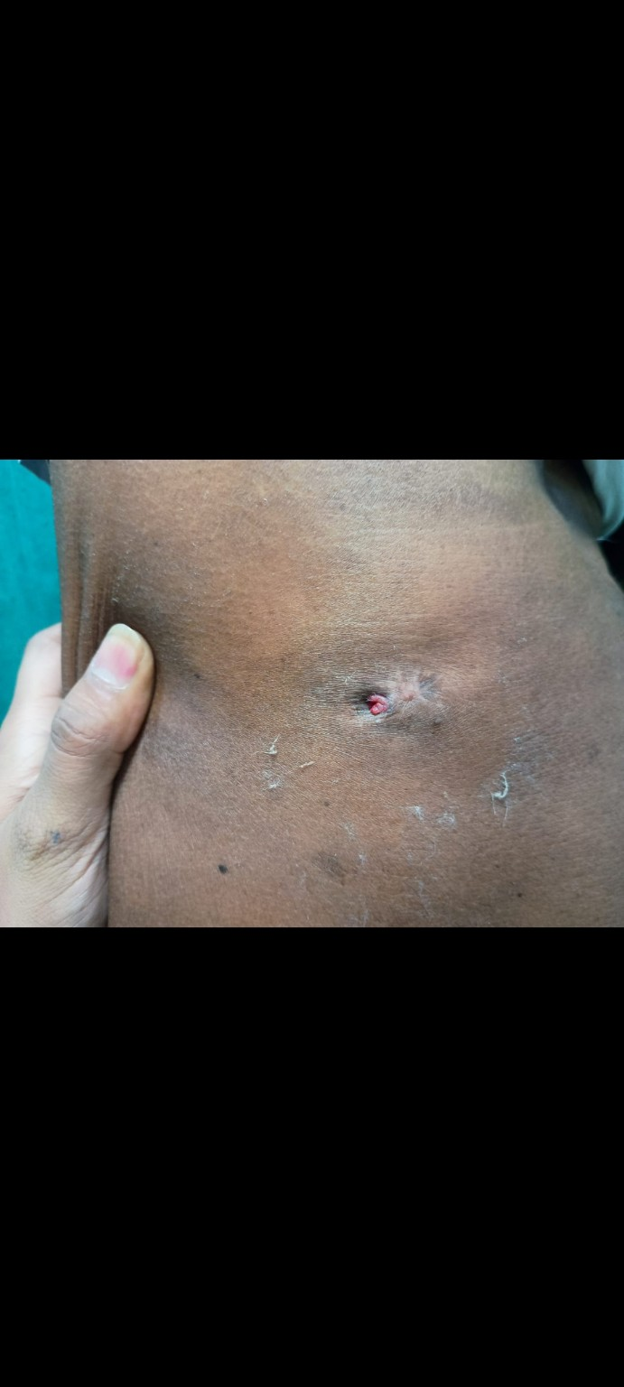
Figure 1 External appearance of fistula

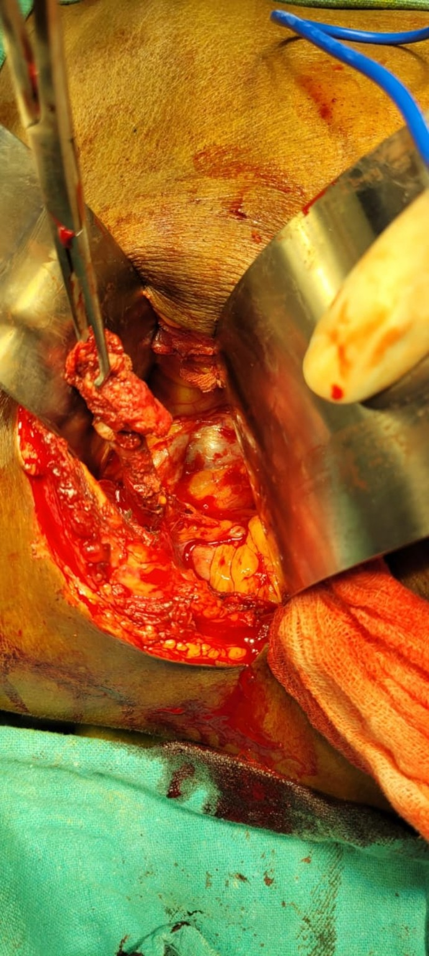
Figure 2 Intraoperative image showing cholecystocutaneous fistula

Discussion-
Spontaneous cholecysto-cutaneous fistulas are very rare. It can occur in cholecystitis, gall bladder malignancy, postoperatively and iatrogenic injury. (3,4) It was reported as the first sign of malignancy. (5)
The first description of cholecysto-cutaneous fistulas was found in 1670. (6) . Commonly these fistulas are found in the right hypochondrium. (7,8) with more propensity in elderly females. (9)
10% of patients with acute cholecystitis can develop spontaneous perforation of the gall bladder but formation of cutaneous biliary fistula is very rare.(8) Gall bladder inflammation may end up in subcutaneous abscess in the right hypochondrium, and after drainage or rupture of these abscess,(10,11) fistula formation occurs.(12) Barima Alsaman et al, in their review of 48 reports of external biliary fistulas, mentioned that many of them presented as either a mass or an abscess in the right hypochondrium. Sixteen cases had spontaneous cutaneous communication. (9) These fistulas can present externally through postoperative scar sinus, from appendectomy scar, (13) or Umbilicus (14)
One case reported of drainage of breast abscess present with bile. (15) Spilled stone during cholecystectomy (16) or migrated from perforated gall bladder perforation (17) are also responsible for cholecysto-cutaneous fistulas.
Biliary discharge is confirmatory of biliary fistula, but serous discharge without any inflammatory sign gives a dilemma about diagnosis. (5) Sero-sanguinous discharge from fistulous opening may confuse it as tubercular sinus, which is still widespread in India (1) as we also thought in our case.
There is no standard way is established to diagnose the SCCF. Ultrasonography despite being primary modality of imaging has no practical use in diagnosis of CCF. (14) It is mandatory to keep mind open for presence of CCF in cases with openings or abscess in right hypochondrium (9)
These fistulas can be managed nicely by open cholecystectomy with excision of fistulous tract. The laparoscopic approach is also safe and can be recommended in these patients.(8) ss
Subcostal right-sided fistulous opening with serosanguinous discharge is a diagnostic dilemma, and cholecysto-cutaneous fistulas are one of them. One should always be aware and treat such cases after proper diagnostic evaluation and full consideration of appropriate treatment.
References

- Pol MM, Vyas S, Singh P, et al. BMJ Case Rep 2019;12:e228138.doi:10.1136/bcr-2018- 228138
- Chan, Anson. (2023). Cholecystocutaneous fistula. 10.53347/rID-160169.
- Crespi M, Montecamozzo G, Foschi D. Diagnosis and Treatment of Biliary Fistulas in the Laparoscopic Era. Gastroenterol Res Pract. 2016;2016:6293538. doi: 10.1155/2016/6293538. Epub 2015 Dec 24. PMID: 26819608; PMCID: PMC4706943.
- Sodhi K, Athar M, Kumar V, Sharma ID, Husain N. Spontaneous cholecysto-cutaneous fistula complicating carcinoma of the gall bladder: a case report. Indian J Surg. 2012 Apr;74(2):191-3. doi: 10.1007/s12262-011-0280-z. Epub 2011 Aug 16. PMID: 23542313; PMCID: PMC3309093.
- Ugalde Serrano P, Solar Garcı´a L, Miyar de Leo´n A, Gonza´lez-Pinto Arrillaga I, Gonza´ lez Gonza´ lez J. Fı´stula colecistocuta´nea como forma de presentacio´n del adenocarcinoma de vesı´cula biliar. Cir Esp. 2013;91:396–397.
- Rinzivillo NMA, Danna R, Leanza V et al. Case Report: Spontaneous cholecystocutaneous fistula, a rare cholethiasis complication [version 1; referees: 3 approved] F1000Research 2017, 6:1768 (doi: 10.12688/f1000research.12235.1)
- Sulakshane, S., Thakare, V., & Dumbre, R. (2018). Consequences of gallbladder inflammation: spontaneous cholecystocutaneous fistula: a case report. International Surgery Journal, 5(5), 1974–1977. https://doi.org/10.18203/2349-2902.isj20181623
- Arshad H Malik+*, M Nadeem,* Jonathan Ockrim. Complete laparoscopic management of cholecystocutaneous fistula. Ulster Med J 2007; 76 (3) 166-167
- Shams C, Cannon M, Bortman J, Hakim S. Stone-Induced Purulent Choledocoduodenal Fistula Presenting with Ascending Cholangitis. ACG Case Rep J. 2018;5:e60.
- Schippers HJW, Toorenvliet BR. [A late complication of cholecystitis]. Ned Tijdschr Geneeskd. 2018 Jun 22;162
- Wang YF, Chen HQ. Hepatobiliary and Pancreatic: Spontaneous cholecystocutaneous fistula. J Gastroenterol Hepatol. 2019 Jan;34(1):11
- Gerrard A, Date R. Delayed Spontaneous Passage of Gallstones via Cholecystocutaneous Fistula. ACG Case Rep J. 2017;4:e102

