Case report
OCCULT CERVICAL CARCINOMA PRESENTING AS PSOAS ABSCESS- DIAGNOSTIC INSIGHTS
ABSTRACT

Psoas abscess as a presentation of cervical squamous cell carcinoma is an uncommon clinical scenario. While this manifestation has been recognized as an AIDS-defining condition in HIV-positive individuals, its occurrence in HIV-negative women is exceedingly rare, with only a few documented cases. This rarity often leads to diagnostic delays, as initial imaging findings may mimic infectious psoas abscesses, resulting in misdirected therapeutic interventions. Our case highlights the critical importance of a high index of suspicion and the need for a multidisciplinary approach involving gynecologists, radiologists and pathologists. Comprehensive evaluation including advanced imaging, biopsy, and histopathological analysis is essential for accurate diagnosis. Clinicians must be aware that malignancies, including metastatic cervical cancer, can mimic benign inflammatory conditions, and failure to consider such differentials may adversely impact outcomes. This case serves as a reminder that atypical presentations require broadened diagnostic perspectives to ensure timely and effective care.

Keywords: Cervical carcinoma, psoas abscess, occult, flank pain

1. INTRODUCTION

A Psoas abscess is a localized collection of pus in the iliopsoas muscle and is uncommon nowadays and can be either primary or secondary. Primary psoas abscess is believed to arise from hematogenous spread from hidden infectious sources within the body. In contrast, secondary Psoas abscess typically results from the direct spread of infections, such as spinal osteomyelitis, Crohn’s disease, diverticulitis, peri-appendicular abscess and cecal carcinoma ⁽¹⁾. Metastatic carcinoma of the cervix masquerading as a psoas abscess is an uncommon presentation. Cervical carcinoma tends to spread locally and metastasizes later to lymph nodes and adjacent areas ⁽¹⁾. In HIV-positive females, cervical carcinoma tends to exhibit more aggressive behavior, sometimes leading to the unusual clinical presentation as psoas abscess formation ⁽²⁾. As emphasized in our case, psoas abscess-like metastasis in HIV-negative females with cervical carcinoma is uncommon. Without a high index of suspicion such cases may be misdiagnosed resulting in delay in appropriate treatment.

2. presentation of case

A woman in her 60s arrived at the emergency department after an inadvertent removal of her pigtail catheter, which had been inserted in an outside hospital two months ago, given her diagnosis of a Left Psoas Abscess. At present, she complained of abdominal pain localized to the left lower quadrant, which began gradually, had a throbbing quality, worsened after the catheter removal and was relieved by medication. Additionally, she reported a ten-day history of intermittent fever that responded to medication, along with one day of copious purulent foul-smelling discharge from the catheter site associated with back pain. There was no history of any bowel or bladder issues, weight loss, or other swellings. She had a six-year history of type 2 diabetes, managed with oral hypoglycemic drugs, and had undergone tubectomy and attained menopause 25 and 18 years ago, respectively.

During the general examination, the patient appeared moderately built and was oriented to time, place, and person, with normal vital signs. Examination of the abdomen revealed a purulent discharging sinus in the left lower quadrant, emitting a copious foul-smelling discharge. No visible masses, engorged veins, pulsations, or fullness of flanks were observed, and the external genitalia appeared normal. Laboratory investigations revealed anemia (Hb-7.3 g/dl) with normal total and platelet counts. Liver and kidney function tests were within normal limits. Pus samples were negative for the Ziehl Nelson stain, but gram staining revealed gram-negative bacilli and pus cells.

Ultrasound examination of the abdomen and pelvis revealed a well-defined, heterogeneously hypoechoic collection in the subcutaneous plane of the left iliac region, suggestive of an organized abscess. Following this, the patient was initiated on broad-spectrum antibiotics. Subsequent contrast-enhanced CECT and MRI scans showed a relatively well-defined soft tissue collection with necrotic areas in the left iliac region and erosions of the iliac bone and lumbar vertebrae (Fig 1), indicating a potentially infective collection. Differential diagnoses included osteomyelitis with abscess collection, lymphoma, and retroperitoneal soft tissue sarcoma with bone erosion. Following imaging studies, Ultrasound-guided fine-needle aspiration cytology (FNAC) was performed, yielding 2.5 ml pus-like material. Microscopic examination revealed suppurative inflammation (Fig 2), while a cell block preparation showed few atypical squamous cells.

The patient subsequently underwent incision and drainage of the left psoas abscess along with tissue biopsy (Fig 3). Histopathological examination revealed multilayered epithelium, showing loss of polarity and pleomorphic cells, along with squamous differentiation and areas of necrosis and brisk mitosis (Fig 4,5). Differentials included squamous cell carcinoma with an unknown primary and transitional cell carcinoma with squamous differentiation. Blocks were sent for immunohistochemistry panel analysis to evaluate carcinoma of unknown primary (CUP).

After comprehensive research to evaluate the primary cause, referral to obstetrics and gynecology (OBG) for a PAP smear and cervical biopsy. Per speculum examination revealed minimal cervical erosion, pulled-up cervix, absence of vaginal rugae, minimal cystocele, and anteverted uterus with free bilateral fornices.
PAP smear showed a High-grade squamous intraepithelial lesion (HSIL) with suspected invasion, while cervical biopsy confirmed squamous cell carcinoma – Not otherwise specified (Fig 6). In due time, IHC results demonstrated that tumor cells showed diffuse immunopositivity for p40 (Fig 7), CK 5, and CK 6, supporting the diagnosis of Invasive squamous carcinoma, keratinizing, and moderately differentiated.

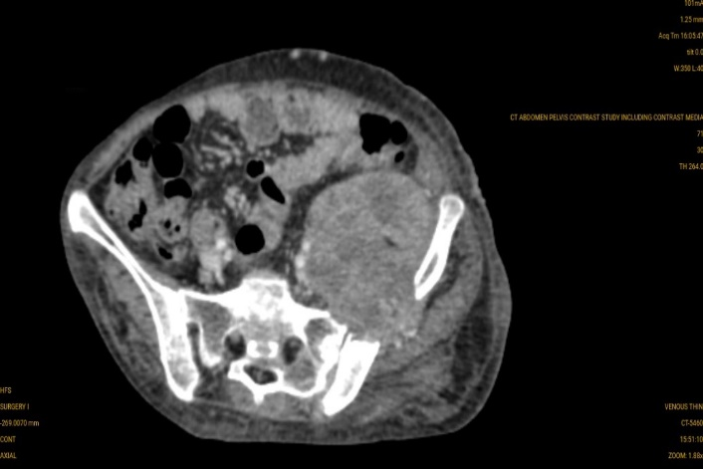

Fig 1, – CT showing a well-defined hypodense collection with air foci in the upper part of the left psoas muscle extending from L1 – L3 vertebral body level along with erosion of iliac bone and lumbar vertebrae.
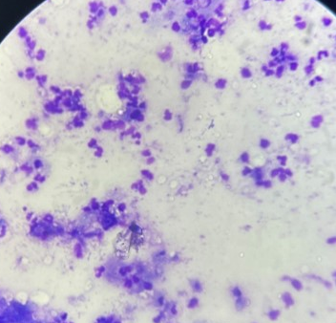
Fig 2 – Photomicrograph (20X, Giemsa) showing mature and degenerated neutrophils, few lymphocytes and histiocytes suggestive of suppurative inflammation.

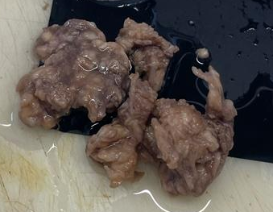
Fig 3 – Excised tissue from left iliac fossa sent for histopathology.
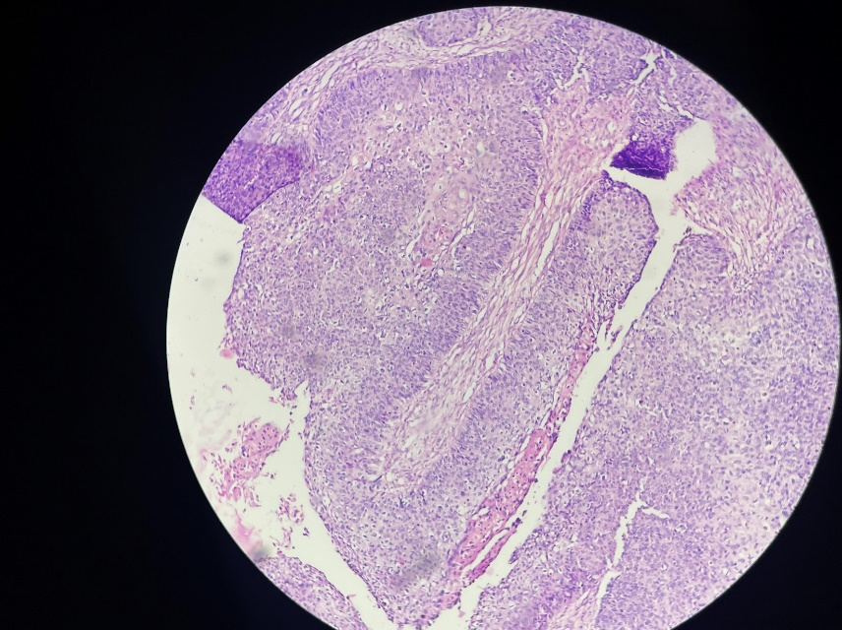
Fig 4 – Photomicrograph (20X, H&E) section showing multilayered epithelium, arranged in papillae with fibrovascular core and nests.

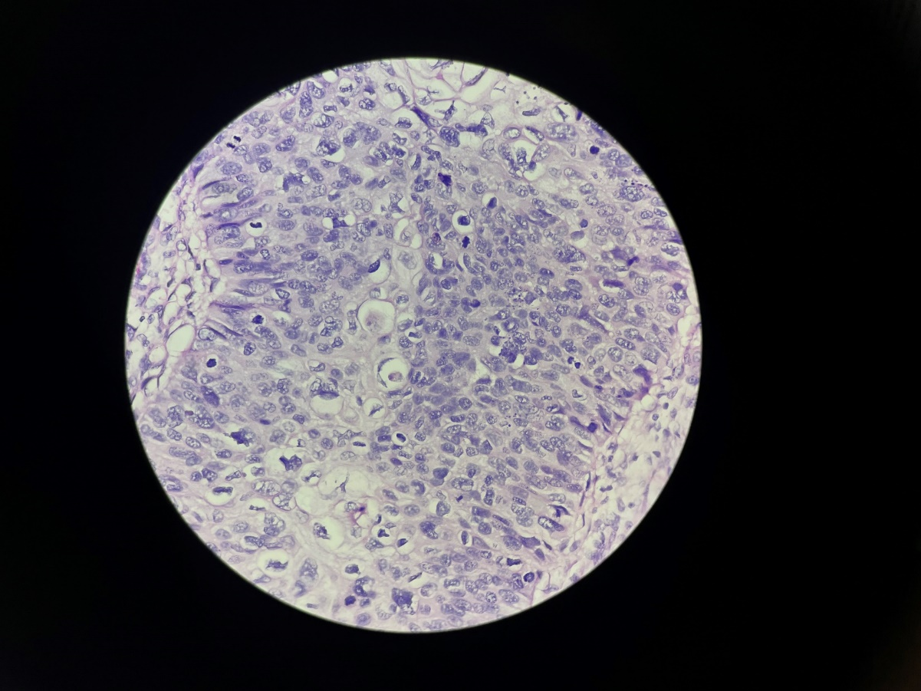
Fig 5 - Photomicrograph (40X, H&E) section showing pleomorphic cells, along with squamous differentiation and brisk mitosis.
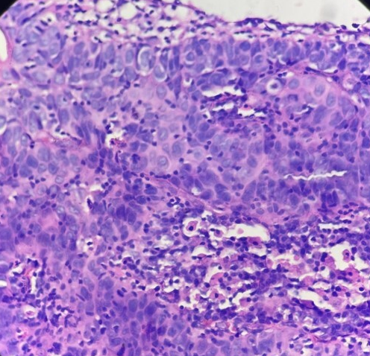
Fig 6- Photomicrograph (40X, H&E) of cervical biopsy showing dysplastic tumor cells with invasion and stromal reaction.

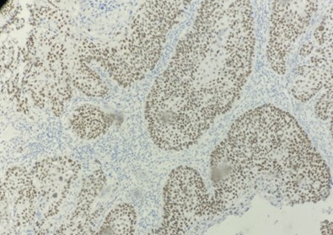

Fig 7 – Photomicrograph (20X) immunohistochemical study of p40 showing positive nuclear staining in tumor cells.

3. discussion

Cervical carcinoma is the second most common cancer in women worldwide and encompasses a range of mild to severe epithelial neoplastic changes⁽¹⁾. Cervical cancer primarily spreads through the lymphatic system and by direct extension, while hematogenous spread is relatively rare^{(1,3)}. HIV-induced immunosuppression increases the likelihood of atypical presentations in cases of invasive cervical carcinoma. Therefore, cervical cancer in HIV-positive women typically progresses aggressively and peculiarly ⁽⁴⁾. The occurrence of skeletal metastasis in the context of cervical carcinoma suggests an advanced stage of the disease where the tumor has breached the adjacent structures. However, there are only a limited number of documented cases of psoas abscess-like bony metastases from cervical cancer in HIV-negative women, rendering it an uncommon condition.

Primary psoas abscess most likely arises from the hematogenous spread of infection, most commonly caused by Staphylococcus aureus, from an unidentified source within the body⁽⁵⁾. Usually, the direct transmission of infection from adjacent structures results in secondary psoas abscess. Secondary Psoas Abscess has been linked to several conditions, including septic arthritis, gastrointestinal tract disorders (like diverticulitis, Crohn’s disease, and infections), genitourinary tract disorders (like cancers, infections, and treatments), and tuberculous spondylitis. The leading cause of secondary psoas abscess with dorsolumbar spine involvement in India is tuberculosis ^{(5,6)}.

Patients with a psoas abscess may exhibit nonspecific symptoms like fever, flank pain, lower back pain, and difficulty with hip movement ⁽⁶⁾. When associated with cervical carcinoma, these symptoms might be initially misleading, especially if the primary tumor is asymptomatic or minimally symptomatic ^{(7,8)}.

Devendra and Tay et al.⁽⁷⁾ reported a case of cervical carcinoma presenting as a psoas abscess without any bone involvement. In contrast, Chatzis and Daniilidis et al.⁽³⁾ described a case of metastatic cervical carcinoma manifesting as a psoas abscess following a radical total hysterectomy.

Kalra et al.⁽⁴⁾ highlighted a case where metastatic cervical carcinoma mimicked a psoas abscess on imaging, with lytic lesions in the L2 and L3 vertebrae and cortical destruction. Similarly, Sharma et al.⁽¹⁾ discussed a case of well-differentiated keratinizing squamous cell carcinoma of the cervix with skeletal metastasis.
Our case stands out for several reasons, namely, the metastasis occurred in an unusual, solitary site with no prior history of a primary lesion. The diagnosis of cervical carcinoma was made in retrospect during the search for the primary malignancy, with the cancer confined to the cervix and showing no regional spread. Diagnosing skeletal muscle metastasis is particularly challenging when there is no past history of any malignancy or clinical signs of a primary tumor, as in our case.
The initial presentation as a psoas abscess, combined with the absence of a primary lesion and the high prevalence of tuberculosis in India, led to an early assumption of an infective etiology⁽⁹⁾. Therefore, this case emphasizes the necessity of considering broad differential diagnoses for atypical abscess-like masses.
4. Conclusion

Cervical carcinoma can present as a psoas abscess even in HIV-negative individuals; Clinicians should consider malignancy in atypical abscess-like presentation to avoid delayed diagnosis. Diagnostic Approach and Management: A comprehensive diagnostic workup including imaging studies, FNAC with cell block analysis, histopathology, and immunohistochemistry is essential for identifying the primary tumour in cases presenting as carcinoma of unknown primary and multidisciplinary management involving both abscess management (drainage and antibiotics) and oncological therapy (surgery, radiotherapy, chemotherapy). Therefore, early recognition and intervention are crucial for a better prognosis. In regions where infections like tuberculosis are common, clinicians should remain vigilant for possible malignancies when evaluating abscess-like lesions to avoid misdiagnosis.

Consent

All authors declare that ‘written informed consent was obtained from the patient (or other approved parties) for publication of this case report and accompanying images.

Ethical approval (where ever applicable)

As per international standards or university standards written ethical approval has been collected and preserved by the authors.

References

Sharma A, Dey A, Gupta M. Metastatic cervical carcinoma masquerading as iliopsoas abscess in an HIV negative woman-diagnosed on fine-needle aspiration cytology: A case report. Journal of Cytology. 2015 Oct 1;32(4):275-7.
Zhao X, Chen R, Zhou Q. Skin metastasis in squamous cell cancer of cervix: A case report. Precision Radiation Oncology. 2023 Jun;7(2):142-6.
Chatzis P, Daniilidis A, Papathanasiou N, Lathouras K, Loufopoulos PD, Vrachnis N. Metastatic cervical carcinoma presenting as psoas abscess, after a radical total hysterectomy. Journal of Obstetrics and Gynaecology. 2014 Jan 1;34(1):101-2.
Kalra N, Aiyappan S, Nijhawan R, Sharma SC, Khandelwal N. Metastatic carcinoma of cervix mimicking psoas abscess on imaging: a case report. Journal of Gynecologic Oncology. 2009 Jun 1;20(2):129-31.
Van den Berge M, de Marie S, Kuipers T, Jansz AR, Bravenboer B. Psoas abscess: report of a series and review of the literature. The Netherlands journal of medicine. 2005 Jan 1;63(10):413-6.
Mehdorn M, Petersen TO, Bartels M, Jansen-Winkeln B, Kassahun WT. Psoas abscess secondary to retroperitoneal distant metastases from squamous cell carcinoma of the cervix with thrombosis of the inferior vena cava and duodenal infiltration treated by Whipple procedure: a case report and review of the literature. BMC surgery. 2016 Dec;16:1-6.
Devendra K, Tay SK. Metastatic carcinoma of the cervix presenting as a psoas abscess in an HIV-negative woman. Singapore Medical Journal. 2003 Jun 1;44(6):302-5.
Afrose R, Akram M, Khalid S, Ahmad SS, Siddiqui SA. Psoas abscess: a rare metastatic presentation of asymptomatic carcinoma of the cervix. Southern African Journal of Gynaecological Oncology. 2015 Jan 2;7(1):37-9.
Askin A, Bayram KB, Demirdal US, Korkmaz MB, Gurgan AD, Inci MF. An easily overlooked presentation of malignant psoas abscess: hip pain. Case Reports in Orthopedics; 2015(1)

