Case report
A Rare Bite: Esophageal Obstruction by a Mango Seed in the Elderly

Abstract
Aims: To report a rare case of esophageal obstruction in an elderly male due to ingestion of a mango seed.
Presentation of Case: A 75-year-old male presented five days after swallowing a mango seed, with progressive dysphagia and regurgitation of food. Imaging revealed a mid-sized filling defect with proximal esophageal dilatation. Endoscopic removal failed, necessitating surgical extraction via left thoracotomy.
Discussion: While foreign body ingestion is more common in children and mentally challenged individuals, it can occur in elderly patients due to impaired sensation or swallowing difficulties. Large and irregular foreign bodies such as mango seeds are rare and may require surgical removal if endoscopy fails. Early diagnosis and timely management are crucial to prevent complications such as perforation and mediastinitis.
Conclusion: Foreign body ingestion should be considered in elderly patients presenting with sudden dysphagia. Prompt imaging and appropriate intervention, including surgery when necessary, can ensure good outcomes.

Keywords
Foreign body ingestion, Esophageal obstruction, Elderly, Mango seed, Thoracotomy

Introduction
Foreign body ingestion is an uncommon but potentially serious clinical problem that can lead to severe complications. It is defined as the ingestion of any object—intentionally or accidentally—or materials consumed during eating or medication intake, which may cause complications such as impaction under specific circumstances (1).
High-risk populations include prisoners, individuals with intellectual disabilities, drug users, alcoholics, and the elderly with reduced oral tactile sensation. A wide variety of esophageal foreign bodies are encountered in clinical practice. Coins are the most commonly ingested objects overall and represent the most frequent type in children, whereas bones account for the majority of cases in adults. Other commonly ingested objects include meat, cartilage, dentures, bezoars, fruit stones, toys, batteries, and buttons.
Some foreign bodies may be aspirated, but when lodged in the esophagus, they typically become impacted at the level of the cricopharyngeus muscle in children, and at the lower esophageal sphincter or at sites of pre-existing esophageal pathology in adults (2).
Large or irregularly shaped foreign bodies can cause edema, ischemia, and erosion due to pressure effects. Esophageal perforation, though rare, is a serious complication most commonly associated with bone ingestion or the presence of sharp foreign bodies (3).
We report a rare case of esophageal foreign body (mango seed) ingestion in an elderly male who presented five days after the incident.

Case Presentation
A 75-year-old male arrived at the emergency department at a tertiary care centre in Central India complaining of difficulty swallowing solid foods for the past five days. He was able to consume oral liquids. The patient mentioned experiencing pain while swallowing and noticed food coming back up after eating. He had a documented history of high blood pressure and was consistently taking medication to manage it. The patient had no prior history of mental health conditions, neurological disorders, or gastrointestinal problems. The patient shared a detailed account of accidentally swallowing a mango seed five days before experiencing symptoms.
On overall assessment, the patient's state was typical. His vital signs remained steady: pulse rate of 88 beats per minute, blood pressure of 138/88 mmhg, and oxygen saturation (SPO₂) of 95% in the presence of room air. He showed no signs of breathing difficulties when he arrived at the hospital.
The initial x-rays of the chest and abdomen (CXR and AXR) did not reveal any signs of obstruction or perforation. The barium swallow study showed a mid-sized (56 × 38 mm) filling defect in the middle and lower third of the oesophagus, leading to substantial luminal obstruction with proximal dilation. The barium contrast stayed in the dilated oesophagus for up to 10 minutes after the imaging, indicating the possibility of a retained foreign object or a space-occupying lesion.

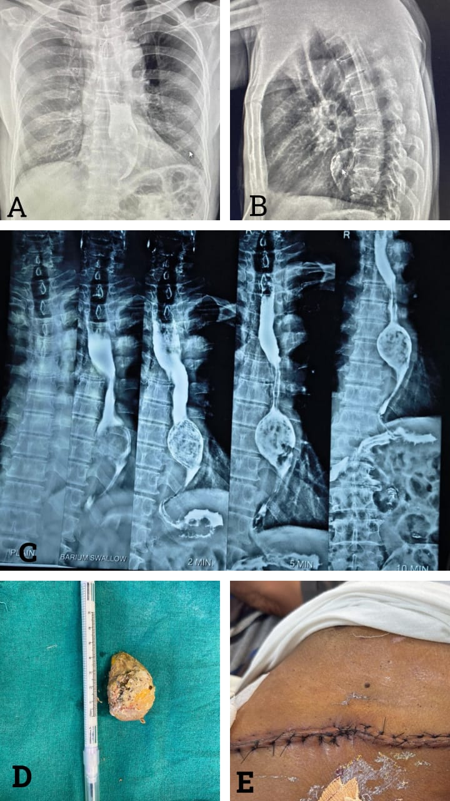

Figure 1
A,B,C: Pre operative contrast study
D: Excised specimen of foreign body(Mango Seed)
E: Post operative wound

An attempt was made to retrieve the object through endoscopy at an external facility, but it was unsuccessful. Considering the size and location of the foreign object, the patient was scheduled for surgical extraction.
A surgical procedure was carried out on the left side of the chest(Left Anterolateral Thoracotomy). The lung was pulled up above to reveal the oesophagus. A noticeable bulge was observed in the lower-middle third of the oesophagus, leading to the decision to perform an esophagectomy at that specific location. The mango seed—a foreign object—was successfully extracted. The incision in the oesophagus was stitched together in a single layer, and a drainage tube was inserted on the left side of the chest.
After the surgery, the patient was placed on positive pressure ventilation until postoperative day 1. Ryle's tube feeding was started on pod 3. Oral sips were initiated on pod 5, with careful observation for any indications of leakage or respiratory issues. On pod 7, a gentle diet was implemented, and the chest tube was taken out on pod 9. The patient remained in good health and was released from the hospital in a satisfactory state.

Discussion
Foreign body ingestion is more frequently observed in children and individuals with mental health conditions, but it can also occur in older adults due to factors like diminished sensory perception, dental issues, or difficulties with swallowing. In adults, bones are the most commonly swallowed foreign objects, while ingesting large plant-based materials like mango seeds is extremely rare and not well-documented in the literature (4).
In this particular situation, a 75-year-old male came in five days after consuming a mango seed, experiencing worsening difficulty swallowing, pain while swallowing, and the regurgitation of food. The postponed presentation resulted in a substantial oesophageal obstruction, which was clearly visible on the radiograph as a mid-sized filling defect with dilated proximal segments. In most cases, oesophageal foreign bodies can pass on their own or be removed through endoscopy. However, when dealing with large, irregularly shaped objects that have been stuck for a long time, surgical intervention becomes necessary. In this situation, the sizable mango seed (56 x 38 mm) could not be extracted using endoscopy, necessitating a left thoracotomy for a successful removal.
In adults, FB impaction is commonly found in the upper oesophageal sphincter, lower oesophageal sphincter, and areas with pathological narrowing like strictures or tumours. The shape and size of the mango seed, along with the possibility of causing damage to the mucosa due to prolonged compression, heighten the likelihood of complications like pressure necrosis, perforation, or mediastinitis if not treated promptly (5). Fortunately, in this patient, no complications were observed, and he had a smooth recovery after surgery.
Early imaging is of utmost importance in the diagnosis and treatment planning process. In this case, the barium swallow proved to be effective, providing a clear depiction of the obstruction and guiding subsequent management decisions. Surgical removal is the preferred treatment option when endoscopic retrieval fails or when there is a significant risk of complications.

Conclusion
This case emphasizes the significance of being vigilant for foreign body ingestion in elderly patients who experience sudden difficulty swallowing. While endoscopy is typically the initial method for diagnosis and removal, surgical intervention becomes necessary when non-operative approaches are ineffective. Timely diagnosis, accurate imaging, and collaborative management among healthcare professionals can prevent severe complications and achieve positive outcomes, even in cases where treatment is delayed.

Consent
Written informed consent was obtained from the patient for publication of this case and accompanying images.

Ethical Approval
All procedures were conducted in accordance with institutional ethical standards and the Declaration of Helsinki.

References
1. Alturkmani OG, Al-Badawi MM, Alturkmani SG, Al-Midani MH, Attar SA. A Case Report of Non-intentional Foreign Body Ingestion in an Elderly Patient. Cureus. 2023;15(4):e37684. doi:10.7759/cureus.37684.
2. Ashraf O. Foreign body in the esophagus: a review. Sao Paulo Med J. 2006;124(6):346-9. doi:10.1590/s1516-31802006000600010.
3. Al-Faham FS, Al-Hakkak SM. The largest esophageal foreign body in adults: A case report. Ann Med Surg. 2020;54:82-84. doi:10.1016/j.amsu.2020.04.039.
4. Ambe P, Weber SA, Schauer M, Knoefel WT. Swallowed foreign bodies in adults. Dtsch Arztebl Int. 2012;109(50):869-75. doi:10.3238/arztebl.2012.0869.
5. Webb WA. Management of foreign bodies of the upper gastrointestinal tract: update. Gastrointest Endosc. 1995;41(1):39-51.

