Case report
Rare location of pleomorphic adenoma in the oral cavity - Gingivobuccal sulcus-Case report and review of literature

ABSTRACT:
Background: Minor salivary gland tumors account for 22% of all salivary gland neoplasms . Only eighteen percent of them are benign; the majority of them are malignant .In about 8% of cases, pleomorphic adenomas affect minor salivary glands., with rare occurrences in the upper gingivobuccal sulcus (GBS).
Case Presentation: We report the case of a 31-year-old male with a pleomorphic adenoma located in the right upper GBS, presenting as a swelling measuring 3x2x2 cm. The lesion was surgically excised, and the postoperative biopsy confirmed the diagnosis of pleomorphic adenoma with clear margins.
Conclusions: This case emphasizes the importance of considering pleomorphic adenoma in the differential diagnosis of oral lesions, even in atypical locations, and highlights the value of surgical excision for treatment and definitive diagnosis.
Keywords: Minor salivary gland, Pleomorphic adenoma, Gingivobuccal sulcus(GBS)

INTRODUCTION:
Salivary gland tumors account for 3% of the head and neck tumors ⁽¹⁾. Pleomorphic adenoma represents the most frequent benign neoplasm of major and minor salivary glands, accounting for about 40%-70% of lesions ⁽²⁾. The annual incidence is 2-3.5 cases per 100,000 population with a female preponderance ⁽³⁾. The condition is most commonly seen in the fifth to seventh decades of life ^{(4).} Twenty-two percent of all salivary gland neoplasms are from minor salivary gland tumors ⁽⁵⁾. The overwhelming majority of them are malignant, with only 18% being benign ⁽⁶⁾.Approximately 8% of pleomorphic adenomas affect minor salivary glands ⁽⁷⁾.
Palatal salivary glands account for up to 60% of minor salivary gland tumor involvement, and other reported locations include the upper lip (10.1%), cheek (5.5%), throat (2.5%), retromolar region (0.7%), floor of the mouth, tongue, upper gingival sulcus, nasal cavity, and paranasal sinuses, which are very rare ⁽⁸⁾ ⁽⁹⁾. Here, we report a case of pleomorphic adenoma of the right upper gingivobuccal sulcus region in a 31-year-old male patient.

CASE PRESENTATION:
A 31-year-old male patient presented with progressively increasing swelling on the right side of the buccal mucosa and pain for the past one year. A clinical examination swelling of 3x2x2 cm size was noted over the right buccal mucosa, extending from the upper right 2nd molar tooth to the retromolar trigone region, and minimal mucosal tethering due to biopsy (Figure 1).
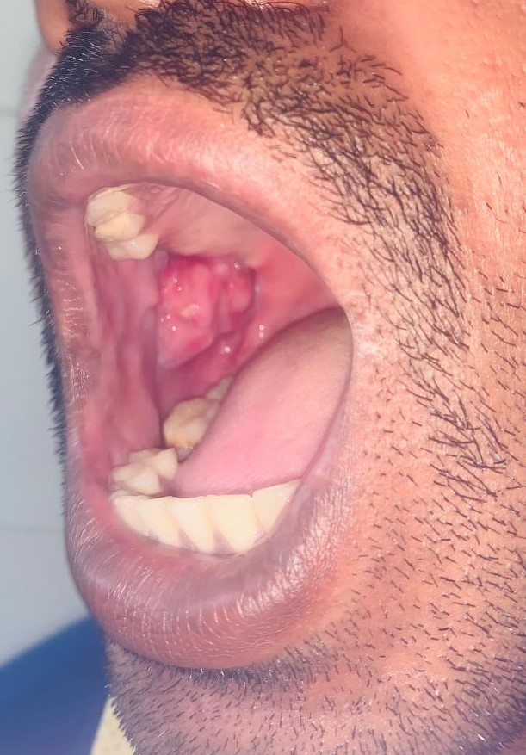
Figure1: Intraoral clinical picture showing swelling in the right upper gingivobuccal sulcus region extending to the retromolar trigone region.
Histopathological examination of the excision biopsy from the right upper buccal mucosa revealed pleomorphic adenoma. Buccal mucosa lined by hyperplastic stratified squamous epithelium with an encapsulated neoplasm composed of triphasic elements. The epithelial component is arranged in tubules, cords and sheets surrounded by myoepithelial cells with spindle, plasmacytoid, and clear cell morphology. The stroma is fibrillary to chondromyxoid. Focally, the cellularity is increased with epithelial and myoepithelial cells arranged in sheets exhibiting mild nuclear atypia with intervening hyaline stromal matrix. The individual cells have scant to moderate cytoplasm with vesicular nuclei and prominent nucleoli. The capsule is focally deficient beneath the mucosa with pseudopodia formation. Also noted is a focus suspicious of invasion (2 mm) with surrounding dense fibroblastic stroma and lymphocytic infiltration (Figure 2a,2b,2c)
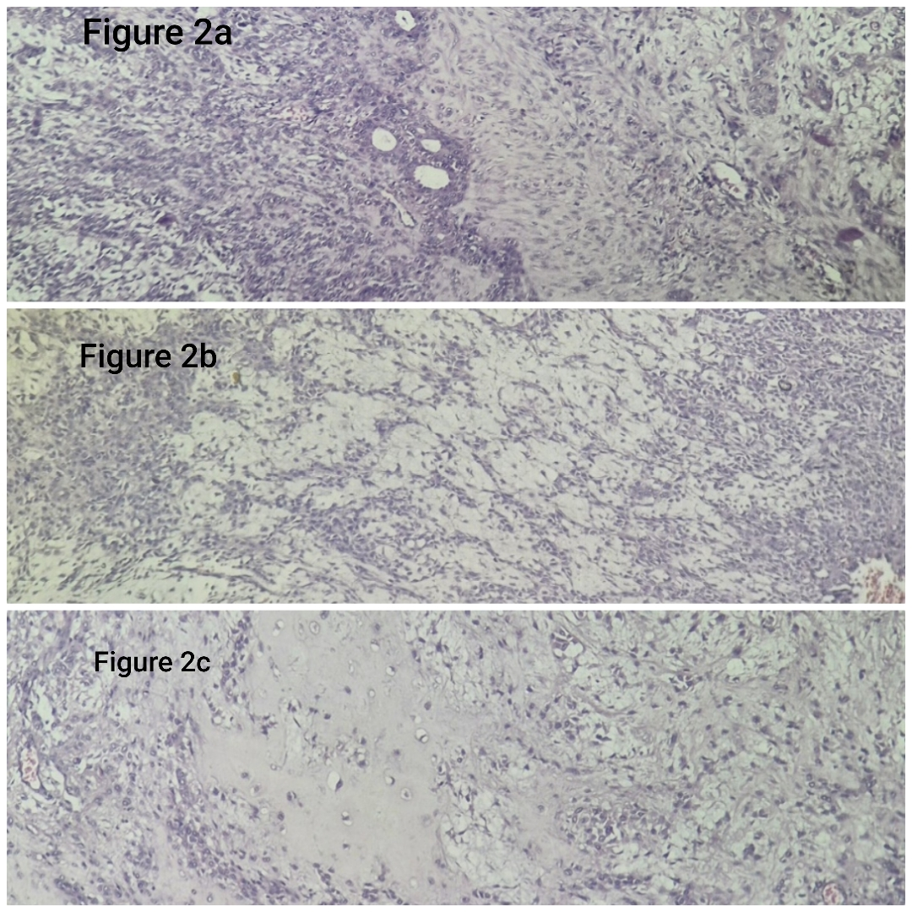

Figure 2a,2b,2c: Focus suspicious of invasion (2 mm) with surrounding dense fibroblastic stroma and lymphocytic infiltration (2a: Epithelial component), (2b: Myxoid area),(2c: chondroid area)
Further imaging evaluation with an MRI-Face revealed a well-defined lobulated heterogeneously enhancing T1 iso to hypointense and T2 heterogeneously hyperintense lesion measuring 4.3cm (CC) x 3.3 cm (AP) x 3.1 cm(TR) from the oral cavity extending to the right masticator space (Figure 3a,3b,3c).
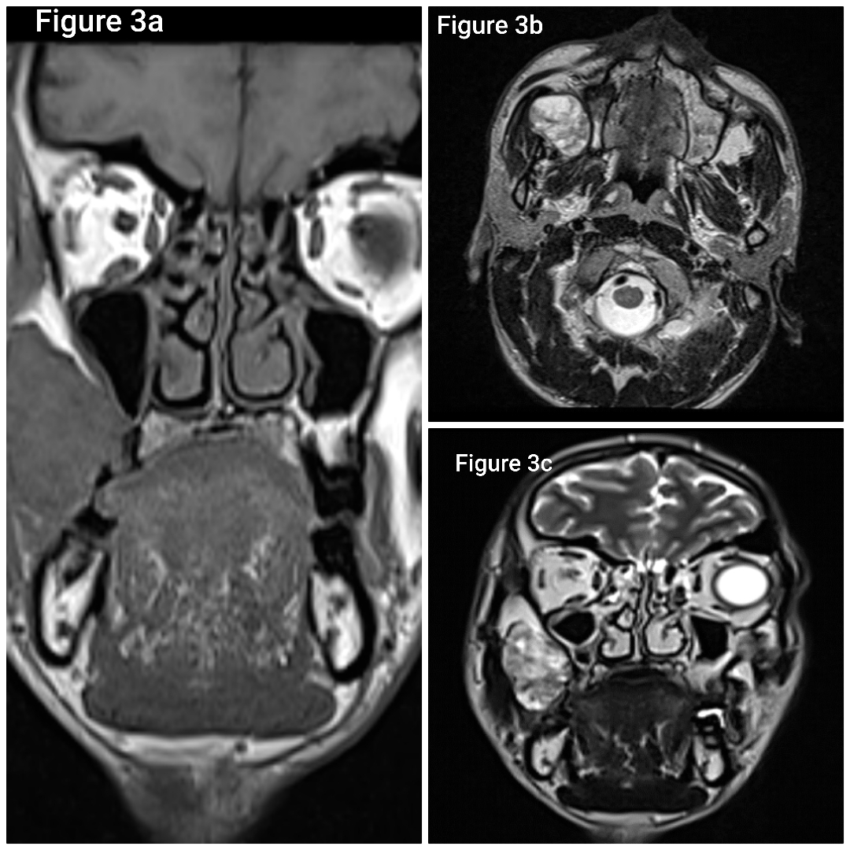

Figure 3a,3b,3c: MRI (a) – T1-weighted coronal image, MRI (b) T2-weighted axial image, and MRI (c) T2–weighted coronal images, showing well-defined lobulated heterogeneously enhancing lesions in the right masticator space.
Based on clinical evaluation, a diagnosis of pleomorphic adenoma of the minor salivary gland was made, and the patient underwent intraoral tumor excision with buccal mucosa excision and buccal pad fat cover for the mucosal defect
Intra operative findings shows a 5x4 cm tumor in the right buccal mucosa extending in the masticator space involving mucosa possibly due to previous biopsy (Figure 4 ).
Fig 4 : Intraoperative view of oral surgery
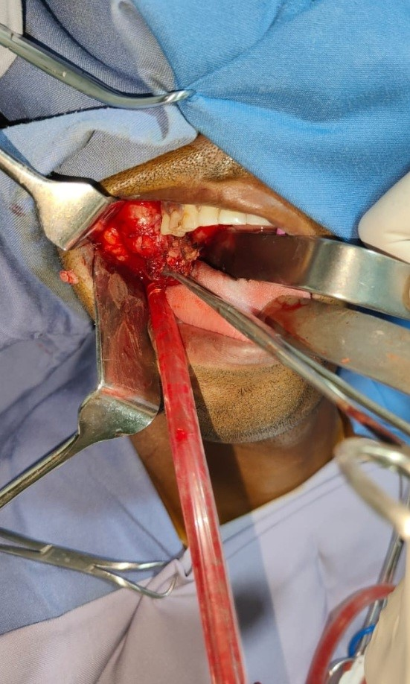

Intraoral mucosal excision made around the tumor, the mass was carefully dissected out of the buccal pad of fat, upper alveolus and pterygoid muscles the tumour was excised along with buccal mucosa and buccal pad of fat was used to cover the defect. Post-operative biopsy was suggestive of pleomorphic adenoma and margins were negative.
DISCUSSION:
Salivary glands begin to develop between 6 and 8 weeks of gestation. This process starts when the epithelial tissue interacts with the nearby mesenchyme, causing the oral ectoderm to thicken⁽¹⁰⁾. Minor salivary gland tissue consists approximately 800-1000 tiny salivary glands⁽¹¹⁾. Different sites show notable variances in the percentage of cancerous growth and the frequency of different types of tumors⁽¹²⁾.
‘Pleomorphic adenoma’ is a term coined by Willis due to its distinctive histological characteristics⁽¹³⁾. It is characterized by epithelial origin and is associated with genetic alterations at 8q12 and 12q15^{(14).} Pleomorphic adenoma usually presents as a slow-growing, painless mass ⁽¹⁵⁾. Patients with minor salivary gland tumors can present with other symptoms such as dysphagia, dyspnea, hoarseness, difficulty in chewing and epistaxis ⁽⁵⁾. From a clinical perspective, it is impossible to distinguish between malignant and benign tumors of the minor salivary glands⁽¹⁶⁾.
The preferred diagnostic method for determining the basic nature of the lesion is fine needle aspiration cytology⁽¹⁷⁾. The size, extent and impact of the lesion on the surrounding tissues are determined by ultrasonography, CT scans and MRI⁽¹⁸⁾.
From a histological perspective, it shows considerable variability. It is considered biphasic, defined by a combination of polygonal epithelial cells and sphindle-shaped myoepithelial components set against a diverse stroma, which can be mucoid, myxoid, cartilaginous, or hyaline in nature .Among the differential diagnosis pleomorphic adenoma of buccal mucosa are lipoma, neurofibroma, dermoid cyst, sebaceous cyst, buccal abscess, mucoepidermoid carcinoma and low-grade polymorphous adenocarcinoma. These neoplasms, although slow-growing, can exhibit significant growth if not treated and may undergo a rare malignant transformation into carcinoma ex pleomorphic adenoma⁽¹⁹⁾.
Wide local excision with removal of the periosteum or bone, if involved, is the preferred treatment for pleomorphic adenoma in minor salivary glands. Because of their rare potential to develop into more aggressive cancers like adenoid cystic or mucoepidermoid carcinoma as well as their elevated risk of recurrence (approximately 13 percent), minor salivary gland neoplasm need to be regularly monitored⁽²⁰⁾.
CONCLUSION:
Pleomorphic adenoma can occur in unusual sites like buccal mucosa, and the clinical suspicion with histopathological diagnosis excluding malignancy plays a vital role in deciding the surgical approach, which can vary between the benign and malignant cases. A firm clinical and pathological impression is mandatory in approaching the tumor in these unusual sites.
DECLARATIONS:

Competing interests
All authors certify that they have no affiliations with or involvement in any organization or entity with any financial interest or non-financial interest in the subject matter or materials discussed in this manuscript.

Ethics approval
This is a case report. The Institutional Ethics Committee (IEC) has confirmed that no ethical approval is required.

Consent to participate
Written informed consent was obtained from the patient and bystanders.

Consent to publish
The authors certify that they have obtained all appropriate patient consent forms. In the form, the patient has given the consent for his images and other clinical information to be reported in the journal. The patient understands that his names and initials will not be published and due efforts will be made to conceal their identity, but anonymity cannot be guaranteed.

REFERENCES:
1. Eveson JW, Cawson RA. Tumours of the minor (oropharyngeal) salivary glands: a demographic study of 336 cases. J Oral Pathol. 1985 Jul;14(6):500–9.
2. Periasamy S, Manoharan A, Garg H, Kumar SP. Pleomorphic Adenoma of the Cheek: A Case Report. Cureus. 2019 Aug 3;11(8):e5312.
3. Sood A, Chung S, Datiashvili RO. An Incidental Finding of Pleomorphic Adenoma of the Minor Salivary Glands in the Skin Area of the Lower Lip. 14.
4. Urs AB, Augustine J, Negi D, Kumar RD, Ghosh S. Pleomorphic adenoma: a rare presentation in buccal salivary gland with extensive squamous and mucous metaplasia. Pan Afr Med J. 2019;33:147.
5. Khan MN, Raza SS, Hussain Zaidi SA, Haq IU, Hussain AK, Nadeem MD, et al. Pleomorphic Adenoma Of Minor Salivary Glands. J Ayub Med Coll Abbottabad JAMC. 2016;28(3):620–2.
6. Shah P, Gada A. Pleomorphic Adenoma of Lower Lip: A Rare Anomaly. Guident. 2014 Mar;7(4):70–2.
7. Spiro RH, Huvos AG, Berk R, Strong EW. Mucoepidermoid carcinoma of salivary gland origin. A clinicopathologic study of 367 cases. Am J Surg. 1978 Oct;136(4):461–8.
8. Kaul D, Rajput A, Ahmed Z, Umadiya P. Pleomorphic adenoma in the cheek a rare finding. J Int Clin Dent Res Organ [Internet]. 2017 Dec [cited 2024 Dec 12];9(2). Available from: https://www.proquest.com/docview/1980918331/abstract/11AA6F7A82EB4693PQ/1
9. Cohen MA. Pleomorphic adenoma of the cheek. Int J Oral Maxillofac Surg. 1986 Dec;15(6):777–9.
10. Ghannam MG, Singh P. Anatomy, Head and Neck, Salivary Glands. In: StatPearls [Internet]. Treasure Island (FL): StatPearls Publishing; 2024 [cited 2024 Dec 31]. Available from: http://www.ncbi.nlm.nih.gov/books/NBK538325/
11. Kessler AT, Bhatt AA. Review of the Major and Minor Salivary Glands, Part 1: Anatomy, Infectious, and Inflammatory Processes. J Clin Imaging Sci. 2018 Nov 15;8:47.
12. Malignant tumors of the minor salivary glands in northern Pakistan: a clinicopathological study - PubMed [Internet]. [cited 2025 Feb 23]. Available from: https://pubmed.ncbi.nlm.nih.gov/20063536/
13. Pramod Krishna B. Pleomorphic Adenoma of Minor Salivary Gland in a 14 year Old Child. J Maxillofac Oral Surg. 2013 Jun;12(2):228–31.
14. Sharma A, Deshmukh S, Shaikh A, Dabholkar J. Pleomorphic adenoma of the minor salivary gland of the cheek. Singapore Med J. 2013 Sep;54(9):e183-184.
15. Samia M, Amin K, Rihab O, Afifa C. Case Series: Pleomorphic adenoma in minor salivary gland. F1000Research. 2024;13:243.
16. Minor intraoral salivary gland tumors: a clinical-pathological study - PubMed [Internet]. [cited 2025 Feb 23]. Available from: https://pubmed.ncbi.nlm.nih.gov/28076598/
17. Bisla S, Gupta A, Singh H, Narwal A, Shukla S. Pleomorphic adenoma of the minor salivary gland in buccal mucosa: A case report. J Oral Med Oral Surg Oral Pathol Oral Radiol. 7(2):142–5.
18. Pleomorphic adenoma of the buccal mucosa: a rare entity. J Cancer Prev Curr Res [Internet]. 2019 Nov 19 [cited 2025 Jan 27];Volume 10(Issue 6). Available from: https://medcraveonline.com/JCPCR/JCPCR-10-00408.pdf

19. Lee H, Senehi N, Sedghizadeh P. Diagnosis and treatment of mixed salivary gland tumor previously diagnosed as cutaneous chondroid syringoma proximal to the oral commissure: A case report. Clin Case Rep [Internet]. 2024 Apr [cited 2025 Jan 2];12(4). Available from: https://www.proquest.com/docview/3046632323/abstract/29C4FBF547FF454DPQ/18
20. Samia M, Amin K, Rihab O, Afifa C. Case Series: Pleomorphic adenoma in minor salivary gland. F1000Research. 2024 Jun 28;13:243.

.

