Case report

Instable splenic injury, no time for CT-imagery!

.
ABSTRACT

Aims:
To highlight the importance of early surgical intervention in splenic trauma following blunt abdominal impact, particularly in the setting of hemodynamic instability after motor vehicle accidents (MVAs).
Presentation of Case:
A 28-year-old male with no prior medical history presented in haemorrhagic shock following an MVA. Initial vitals indicated hypotension and tachycardia, and FAST ultrasound revealed significant intra-abdominal free fluid. Hemoglobin levels dropped from 14.4 g/dL to 8 g/dL. Due to hemodynamic deterioration, an urgent exploratory laparotomy was performed, revealing a ruptured spleen with active bleeding. A hemostatic splenectomy was conducted. The patient had an uneventful recovery and was discharged on postoperative day six.
Discussion:
While non-operative management (NOM), including splenic artery embolization, is effective in hemodynamically stable patients, it is contraindicated in unstable cases. Clinical signs of ongoing bleeding—particularly persistent hypotension—require immediate surgical intervention. FAST is valuable for rapid assessment but should not delay operative care when instability is evident.
Conclusion:
In blunt abdominal trauma with shock, early surgical decision-making is critical. Timely intervention based on clinical evaluation rather than imaging can significantly reduce morbidity and mortality. Splenectomy, though associated with long-term immune considerations, remains a life-saving procedure in unstable trauma patients.

Keywords: Emergent laparotomy, splenic trauma, surgery

1. INTRODUCTION

Common in abdominal trauma, splenic injury mainly concerns multiple trauma patients. The spleen is exposed to a significant risk of hemorrhage which can be life-threatening, mainly due to its high vascularization. The evolution of recent techniques, such as embolization, has favored the preservation of the organ in stable cases. However, in certain cases, the hemodynamic instability of the patient imposes exploratory laparotomy. Appropriate care helps limit morbidity and mortality while preserving splenic immune function. In surgery, management is based on clinical and radiological evaluation, guiding towards a conservative approach or splenectomy. [1]
Blunt splenic injuries represent a growing challenge due to the increased reliance on non-operative strategies and the changing epidemiology of trauma. Advances in road safety and the widespread use of seatbelts have somewhat shifted the pattern of splenic trauma, with more isolated injuries and less association with polytrauma now being observed. This evolution influences diagnostic and management approaches, highlighting the need for precise injury grading and early identification of patients likely to fail conservative measures.[2]

Moreover, the spleen plays a critical role in immune surveillance and host defense, particularly against encapsulated organisms. Therefore, avoiding splenectomy when feasible is not merely a surgical preference but a strategy aimed at preserving long-term immune function, especially in young patients. Postsplenectomy infectious complications such as overwhelming post-splenectomy infection (OPSI) underscore the importance of spleen-preserving approaches.[3]

2. PRESENTATION OF CASE

We present the case of a 28-year-old male, with no medical history, who was victim of a Motor Vehicle Accident (MVA). The impact site was abdominal patient and the patient was admitted in the ICU of our hospital. Physical examination revealed a pale patient, tachycardic at 130 bpm, blood pressure 100/60 mmHg, Spao2 at 94%. Abdomen showed generalized guarding.

We performed biological tests, that showed Hemoglobin initial levels a 14.4 g/dL and white blood cells at 21,000 /mm³. Rest of biological exams were within the normal range.

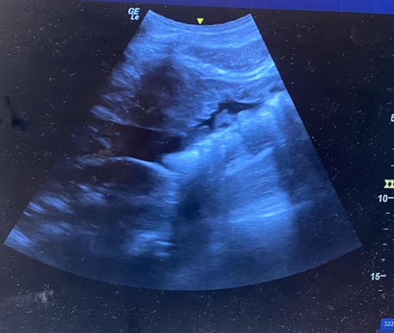
Patient underwent a fast-ultrasound revealing a large amount of free fluid (significant effusion) [Fig.1]
C
B
A
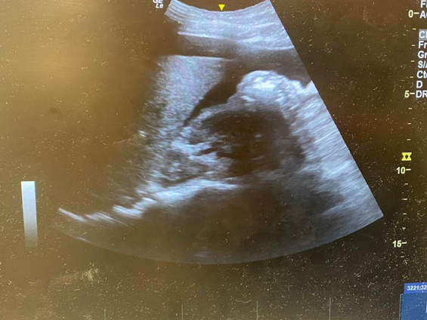
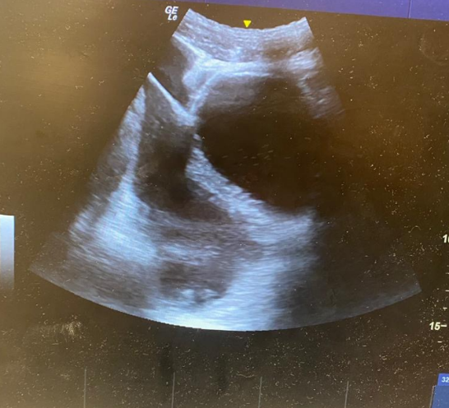
Fig. 1: FAST-Ultrasound finding significant effusion in Douglas’ Pouch (A), hepato-renal recess (B), spleno-renal recess (C)
Patient dropped the BP to 80/50 mm/Hg and blood gas analysis was realized finding a hemoglobin level at 8 g/dl
Due to the hemodynamic deterioration of the patient and the installation of a hemodynamic shock, urgent exploratory surgery was indicated.
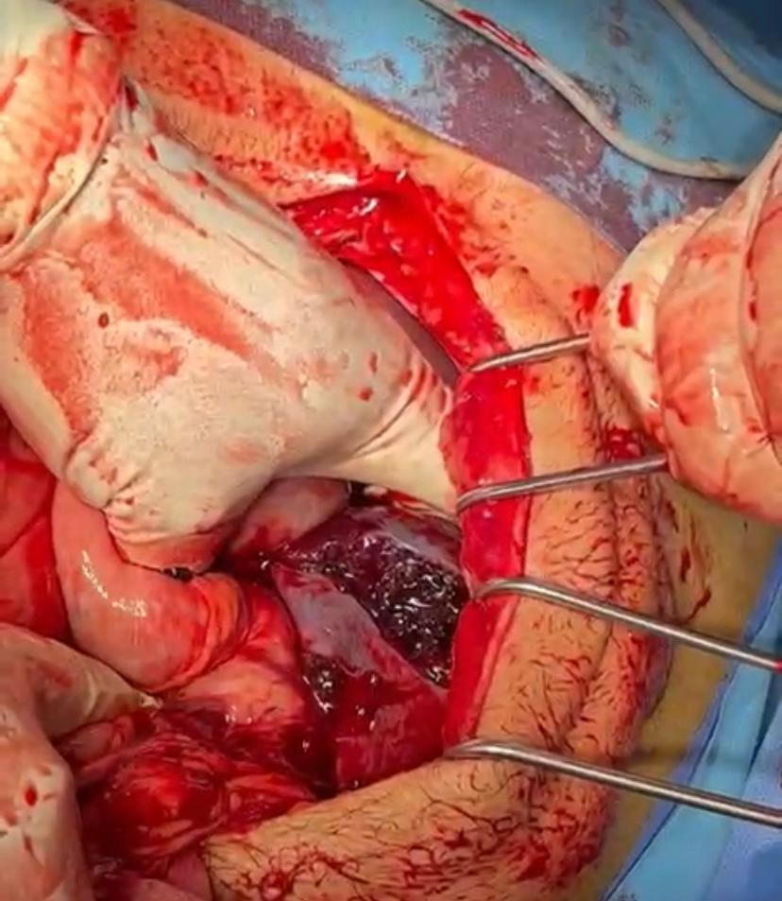
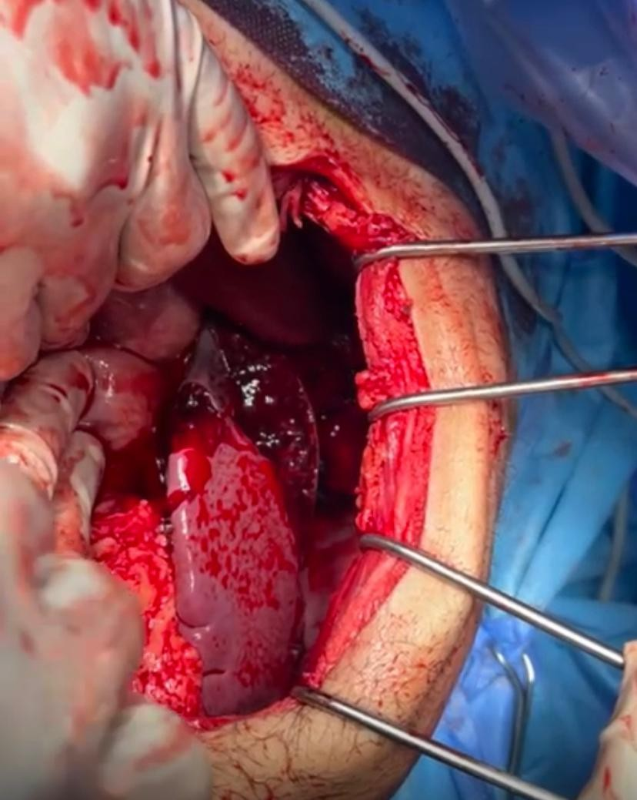

B
A

Vascular blush
D
C

Fig. 2: per-operative view of the injured spleen

Exploratory laparotomy identified a massive hemoperitoneum. The spleen was found to be fractured (Fig. 1) with an active source of hemorrhage. No other intra-abdominal injuries were observed. A hemostatic splenectomy was performed. (Fig.2) The abdominal cavity was irrigated and drains were placed.

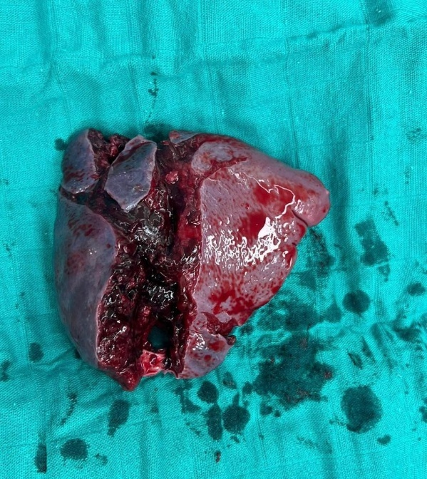

Fig. 3: Macroscopic view of the resected specimen showing a fractured spleen

The patient was discharged on the sixth day post-operatively with no further complications.

3. DISCUSSION
Motor vehicle accidents (MVAs) are a prominent origin of blunt abdominal trauma, specifically in fast-paced collisions or in events of seat belt injury. The spleen and liver are the most frequently harmed solid organs. For hemodynamically stable patients, management (NOM) has become the usual technique for addressing such injuries, with success ratios surpassing 90% when suitable monitoring and imaging methods (e.g. FAST or CT scans) are available. [4]
Recent American data (2017–2021) demonstrates that in hemodynamically stable adults with high-grade (IV–V) blunt splenic injuries, splenic artery embolization (SAE) is associated with substantially lower in-hospital mortality (OR 0.28), shorter intensive care unit stays (median 7 days vs 9 days), and reduced early transfusion needs compared to splenectomy.[5]
Meta-analysis encompassing over 25,000 blunt splenic injury cases report a low overall failure rate of SAE (~5.3%). Major complications include rebleeding (~4.8%), infarction (~4.6%), and abscess formation (~4%), while minor complications such as fever (18.4%) and pleural effusion (13.1%) are more frequent. Spleen-related mortality after SAE remains exceedingly low (~0.08%).[6]
However, in patients with hemodynamic instability, prompt surgical intervention is often life-saving. Ongoing hypotension despite sufficient fluid resuscitation greatly implies active intra-abdominal bleeding, even if imaging is not yet accessible. In such scenarios, early laparotomy is indicated to achieve hemorrhage control. The usage of Focused Assessment with Sonography in Trauma (FAST) might help identify intra-peritoneal fluid rapidly, but should not postpone surgery if clinical signals towards ongoing bleeding. [7-9]
Studies have demonstrated that unstable patients with severe injuries (e.g., AAST grade IV–V) are more likely to require immediate surgery. Prolonging surgical treatment in these instances elevates the rate of mortality and complications [8]
To summarize, while NOM is efficient and fitting for stable patients, surgical management remains necessary for trauma patients who are haemodynamically unstable. In acute scenarios, clinical assessment sustained by vital signs and physical investigation must take precedence over imaging to circumvent delays in life-saving interventions. [9]
4. CONCLUSION
In blunt abdominal trauma, hemodynamic instability must be recognized as a surgical emergency. While non-operative strategies, including embolization, have revolutionized the management of stable splenic injuries, they are not appropriate when the patient is unstable.
Clinical deterioration, persistent hypotension, and signs of peritoneal irritation should immediately trigger operative intervention. In such scenarios, the priority shifts from organ preservation to life-saving hemorrhage control. Splenectomy, though associated with long-term immunologic consequences, remains a justified and often necessary procedure in trauma surgery.
The timing of intervention is critical: early surgical decision-making based on clinical assessment significantly reduces morbidity and mortality, especially when diagnostic tools are limited or delayed. [10]

Consent

As per international standard or university standard, patient written consent has been collected and preserved by the authors.

Ethical approval

As per international standard or university standard written ethical approval has been collected and preserved by the authors.
Author(s) hereby declare that Large Language Models (GPT-4.1 mini) have been used during the writing or editing of this manuscript. Main usage has been in order to properly translate medical terminology from author’s original scientific language (French) into English.

References

- Koide Y, Okada T, Yamaguchi M, Sugimoto K, Murakami T. The Management of Splenic Injuries. Interv Radiol (Higashimatsuyama). 2023 Aug 11;9(3):149-155. doi: 10.22575/interventionalradiology.2022-0003. PMID: 39559801; PMCID: PMC11570251.
- Oelhaf RC, Wang CF, King KC. Splenic Trauma. 2025 Jun 2. In: StatPearls [Internet]. Treasure Island (FL): StatPearls Publishing; 2025 Jan–. PMID: 28613670.
- Taniguchi LU, Correia MD, Zampieri FG. Overwhelming post-splenectomy infection: narrative review of the literature. Surg Infect (Larchmt). 2014 Dec;15(6):686-93. doi: 10.1089/sur.2013.051. PMID: 25318011.
- Goedecke, Maximilian, Kühn, Florian, Stratos, Ioannis, Vasan, Robin, Pertschy, Annette and Klar, Ernst. "No need for surgery? Patterns and outcomes of blunt abdominal trauma" Innovative Surgical Sciences, vol. 4, no. 3, 2019, pp. 100-107. https://doi.org/10.1515/iss-2018-0004
- Breeding T, Nasef H, Patel H, Bundschu N, Chin B, Hersperger SG, Havron WS, Elkbuli A. Clinical Outcomes of Splenic Artery Embolization Versus Splenectomy in the Management of Hemodynamically Stable High-Grade Blunt Splenic Injuries: A National Analysis. J Surg Res. 2024 Aug;300:221-230. doi: 10.1016/j.jss.2024.05.012. Epub 2024 Jun 1. PMID: 38824852.
- Alomar Z, Alomar Y, Mahmood I, Alomar A, El-Menyar A, Asim M, Rizoli S, Al-Thani H. Complications and failure rate of splenic artery angioembolization following blunt splenic trauma: A systematic review. Injury. 2024 Oct;55(10):111753. doi: 10.1016/j.injury.2024.111753. Epub 2024 Jul 26. PMID: 39111269.
- Leenen LP. Abdominal trauma: from operative to nonoperative management. Injury. 2009 Nov;40 Suppl 4:S62-8. doi: 10.1016/j.injury.2009.10.038. PMID: 19895955.
- Werner NL, Zarzaur BL. Contemporary management of adult splenic injuries: What you need to know. J Trauma Acute Care Surg. 2025 Jun 1;98(6):840-849. doi: 10.1097/TA.0000000000004570. Epub 2025 Mar 25. PMID: 40128168.
- Coccolini, F., Montori, G., Catena, F. et al. Splenic trauma: WSES classification and guidelines for adult and pediatric patients. World J Emerg Surg 12, 40 (2017). https://doi.org/10.1186/s13017-017-0151-4
- Podda M, De Simone B, Ceresoli M, Virdis F, Favi F, Wiik Larsen J, Coccolini F, Sartelli M, Pararas N, Beka SG, Bonavina L, Bova R, Pisanu A, Abu-Zidan F, Balogh Z, Chiara O, Wani I, Stahel P, Di Saverio S, Scalea T, Soreide K, Sakakushev B, Amico F, Martino C, Hecker A, de'Angelis N, Chirica M, Galante J, Kirkpatrick A, Pikoulis E, Kluger Y, Bensard D, Ansaloni L, Fraga G, Civil I, Tebala GD, Di Carlo I, Cui Y, Coimbra R, Agnoletti V, Sall I, Tan E, Picetti E, Litvin A, Damaskos D, Inaba K, Leung J, Maier R, Biffl W, Leppaniemi A, Moore E, Gurusamy K, Catena F. Follow-up strategies for patients with splenic trauma managed non-operatively: the 2022 World Society of Emergency Surgery consensus document. World J Emerg Surg. 2022 Oct 12;17(1):52. doi: 10.1186/s13017-022-00457-5. PMID: 36224617; PMCID: PMC9560023.

