Original Research Article
DEVELOPMENT OF LARGE MOLECULETHERAPEUTICS FOR HEPATO-CELLULAR CARCINOMA BY INSILICO APPROACHES

1. ABSTRACT

Aims: To design, validate, and partially express a novel large molecule therapeutic construct targeting MYC and CTNNB1, key oncogenes implicated in hepatocellular carcinoma (HCC), using in silico computational approaches.

Study design: In Silico Studies using Computational tools in bioinformatics.

Place and Duration of Study: Amplikon Biosystems and Aurora’s Degree&PG College, Hyderabad, Telangana, India; April–June 2025.

Methodology: The methodology involved retrieving MYC and β-catenin protein sequences from UniProt, followed by prediction and prioritization of B- and T-cell epitopes using IEDB and NetMHCpan. Selected epitopes were linked with suitable adjuvants and modeled into a 3D structure using SWISS-MODEL, with validation through Ramachandran plot analysis. Codon optimization was carried out for expression in E. coli using the pET-28a vector. The designed construct was then assessed for allergenicity, toxicity, aggregation, and physicochemical properties, while molecular docking with ClusPro confirmed binding interactions with the target oncogenic proteins.

Results: The designed large molecule therapeutic construct showed promising characteristics in silico. Structural validation through the Ramachandran plot confirmed that most residues occupied favorable regions, indicating reliable folding and stereochemical quality. Safety assessments revealed the protein to be non-toxic, non-allergenic, and soluble, suggesting suitability for therapeutic use. Physicochemical evaluation predicted reasonable stability with an acceptable half-life across biological systems. Immunogenicity analysis classified the construct as a probable antigen, supporting its potential to elicit an immune response. Furthermore, molecular docking demonstrated strong and stable interactions with MYC and β-catenin, confirming the intended binding efficacy. Collectively, these results highlight the construct’s potential as a candidate therapeutic for hepatocellular carcinoma, warranting further in vitro validation.

Conclusion: This study successfully designed a novel large molecule therapeutic construct targeting MYC and β-catenin, two critical oncogenic drivers of hepatocellular carcinoma, using in silico approaches. The construct demonstrated favorable properties, including proper structural stability, non-toxicity, non-allergenicity, and strong immunogenic potential. Docking studies further confirmed its ability to form stable interactions with the target proteins, supporting its therapeutic relevance. While experimental validation in HCC cell lines remains the next step, the computational findings provide a strong proof-of-concept and establish a reliable workflow for rational design of targeted biologics against complex cancer pathways.

Keywords: Hepatocellular carcinoma (HCC); Large molecule therapeutics; In silico drug design; MYC oncogene; β-catenin (CTNNB1); Molecular docking; Codon optimization
2. INTRODUCTION

Hepatocellular carcinoma (HCC) is one of the most common primary liver cancers and ranks among the leading causes of cancer-related deaths worldwide (McGlynn et al., 2021). Its incidence is particularly high in regions with endemic hepatitis B virus (HBV) and hepatitis C virus (HCV) infections, though lifestyle-related factors such as alcohol consumption, obesity, and diabetes also contribute significantly to disease progression (West et al., 2017; Baffy et al., 2012). The majority of HCC cases arise in the background of chronic liver disease and cirrhosis, which compromise hepatic function and increase the risk of malignant transformation (Garrido & Djouder, 2021). Globally, more than 750,000 new cases are reported annually, with Asia, especially China, carrying nearly half of the disease burden (Ozakyol, 2017). In India, the incidence is comparatively lower but remains a growing health concern with a male-to-female ratio of nearly 4:1 (Acharya, 2014).
The molecular pathogenesis of HCC is highly complex, involving both genetic and epigenetic alterations such as mutations, chromosomal changes, and deregulated signaling pathways (DWH et al., 2016; Shibata & Aburatani, 2014). Among these, the Wnt/β-catenin pathway is one of the most frequently activated, promoting unchecked proliferation and survival of malignant cells (Clevers & Nusse, 2012). β-catenin functions as a central mediator of this pathway, translocating into the nucleus where it regulates transcription of downstream oncogenes, including MYC. The MYC oncogene, known as a master regulator of cellular growth and metabolism, is often overexpressed in HCC and is strongly associated with poor clinical outcomes (Higgs et al., 2013). Together, β-catenin and MYC form a pathological axis that drives tumor initiation, progression, and therapy resistance (Vilchez et al., 2016).
Traditional treatment strategies, including surgical resection, chemotherapy, and radiotherapy, often provide limited success due to tumor heterogeneity, therapy resistance, and high recurrence rates (Ikeda et al., 2000). Therefore, there is an urgent need for novel targeted therapeutic approaches that can improve prognosis. However, oncogenic proteins such as MYC and β-catenin are considered “undruggable” because of their lack of well-defined ligand-binding pockets, making them difficult to inhibit with conventional small-molecule drugs (Ghosh et al., 2022). This limitation has prompted a shift towards large molecule therapeutics, such as peptides, engineered proteins, and antibody fragments, which provide higher specificity and stronger binding potential (Llovet et al., 2016).
Recent advancements in computational biology and bioinformatics have opened new opportunities to rationally design and optimize such large molecules. In silico methods, including epitope prediction, molecular docking, and structural validation, enable rapid screening of therapeutic candidates, allowing researchers to evaluate immunogenicity, stability, and target specificity before moving to laboratory testing (Dhanda et al., 2019; Comeau et al., 2004). These computational strategies accelerate drug discovery while reducing experimental costs and failure rates.
The present study utilizes these tools to design a novel large molecule therapeutic construct targeting MYC and β-catenin. By integrating sequence retrieval, epitope mapping, structural modeling, codon optimization, and docking validation, the study aims to provide a rationally designed therapeutic with potential efficacy against hepatocellular carcinoma. This approach not only strengthens the pipeline for targeted biologics but also demonstrates the power of in silico methods in cancer therapeutic development (Schulze et al., 2015).

3. MATERIALS AND METHODS
3.1. Retrieval of target protein sequences & tertiary structure from Uniprot: -
The MYC and β-catenin Uniprot accession number were taken to obtain the protein sequences in FASTA format from the Uniprot. Along with the protein sequence tertiary structures were obtained from the same tool.
3.1.1. Epitope prediction – IEDB analysis resource
The sequences which are copied from uniport are directly pasted in the IEDB (Immune Epitope Database Analysis Resource) on specific site.
- Prediction of B Cell Epitopes:
Linear B cell epitopes were predicted using BepiPred for hydrophilicity and surface accessibility.
- Prediction of T cell Epitopes:
T cell epitopes for MHC class I and II were predicted by NetMHCpan and IEDB tools respectively.
3.2. Epitope Prioritization:
Epitopes were prioritized using binding level, pan-allele coverage and threshold values.
The peptide sequence was selected based on the allele number and peptide score.
3.3. Making the peptide sequence and by adding Linkers & Adjuvants
3.3.1. Linker Conjugation:
Flexible linkers were conjugated at the distal sides of each junction to reduce structural stiffness and minimize junctional immunogenicity.
3.3.2. Addition of Adjuvant:
β-defensins and PADRE peptide were added as adjuvants.
3.3.3. Pan HLA-DR:
HLA-DR is a type of MHC class II molecule, which is involved in presenting antigens to T helper cells. "Pan HLA-DR" indicates that the peptide can bind to a wide variety of HLA-DR molecules, making it broadly applicable.
3.4. SWISS MODELLING
The SWISS-MODEL Repository (SMR) is a free, web-based resource that provides automatically generated 3D protein structure models based on the technique of comparative (homology) modelling.
The sequence that we have prepared was submitted in the Swiss Model Repository after validating the sequence the 3d model was generated. Nearly Eight templates of different structures were generated by SMR. Structure was selected according to the GMQE (Global Model Quality Estimate) and QMEAN score and biologically relevant structure was taken.
QMEAN (Qualitative Model Energy Analysis) is a model quality estimation score used in the SWISS-MODEL Repository to assess the reliability and accuracy of predicted 3D protein structures. It helps us to evaluate how close a predicted model is to a real, experimentally determined protein structure.
3.5. Predicted 3d structure validation through RAMPLOT
The Ramachandran plot was visualized using a 3D frequency map of φ (phi) and ψ (psi) backbone dihedral angles. Residue angle distributions were extracted from the predicted PDB model and rendered in 3D to observe frequency of conformational clustering. This helped in evaluating the folding quality and overall stereochemical stability of the therapeutic model.

3.6. Conversion of Amino acid sequence to Nucleotide sequence
The amino acid sequence that we have prepared needs to be converted in to the Nucleotide sequence. To proceed for the further processes.
3.7. Codon Optimization
Codon Optimization is the process of modifying the DNA sequence of a gene to improve the expression of a protein in a specific host organism, without changing the amino acid sequence of the resulting protein. The protein sequence that we have prepared is submitted in the tool.
3.8. Cloneing of Optimized Gene into pET-28a(+) Vector
After codon optimization, the modified gene sequence was successfully inserted into the pET-28a(+) expression vector between the Eco RI and Bam HI restriction enzyme sites to facilitate expression in the chosen host system.
Why Pet-28a(+)?
The pET-28a (+) vector is widely used in recombinant protein production, including in the early stages of large molecule therapeutic development for hepatocellular carcinoma (HCC). While pET-28a itself is not specific to HCC, it provides several key advantages for producing, screening, and purifying therapeutic candidates, especially when using E. coli as an expression host. It has multiple cloning sites. Because of High-Level Protein Expression, pET-28a contains a T7 promoter, which drives strong transcription when induced by IPTG in E. coli strains like BL21(DE3). This allows for high-yield production of therapeutic proteins (e.g., MYC/β-catenin inhibitors or binding peptides relevant to HCC).
3.9. Safety Assessment Tests using In Silico Tools
3.9.1. Allergenicity Prediction
- Tool: AllergenFP V1.1
This test is mainly to classify that our protein is allergic or nonallergic. The Protein sequence was provided to the tool within next few seconds it will give the results by checking the allergencity.
3.9.2. Toxicity Prediction
- Tool: ToxinPred
When we provide the protein sequence to this tool it identifies the toxic motifs and predicts the toxicity score. It interprets as, when the score is low protein is safe and toxin free and when high score is observed protein is toxic.
    - Aggregation Prediction
- Tool: AGGRESCAN
We have provided the sequence into the tool allows it to check aggregation.
AGGRESCAN is a bioinformatics tool used to predict aggregation-prone regions in proteins. These regions may lead to unwanted protein aggregation (e.g., inclusion bodies in expression systems, amyloid formation), which can impair protein solubility and therapeutic function.
    - Stability & Physicochemical Properties
- Tool: ProtParam (ExPASy)
Molecular weight
Isoelectric point (pI)
Instability index
Aliphatic index (thermal stability)
GRAVY (hydropathicity) can be known all these by providing the sequence.

    - Off-target Similarity (BLAST)
- Tool: NCBI BLAST p
In this tool we first submitted the protein sequence in the FASTA format.
The amino acid sequence of the designed large molecule therapeutic targeting MYC and CTNNB1 was analyzed using the Protein-BLAST (BLAST p) tool available at the NCBI database (https://blast.ncbi.nlm.nih.gov/Blast.cgi). The analysis was performed against the non-redundant (nr) protein database using default parameters, with the BLOSUM62 substitution matrix and compositional matrix adjustment enabled. The objective was to confirm the identity and functional relevance of the construct by assessing sequence similarity with known proteins. The BLASTp output provided percentage identity, E-value, query coverage, and aligned regions with target and non-target proteins. Top hits were evaluated for relevance to human MYC and CTNNB1 proteins, and special attention was given to avoid potential off-target homologies that may compromise therapeutic specificity.
    - Immunogencity Prediction
- Tool: VaxJen v2.0
VaxiJen v2.0 is a server for predicting protective antigens and immunogenicity of protein sequences based on auto-cross covariance (ACC) transformation. It is alignment-independent and classifies proteins as “probable antigens” or “non-antigens”. In this tool we have provided the protein sequence in plain format.

    - Molecular Docking
- Tool: ClusPro
Molecular docking was carried out to predict the interaction between the designed therapeutic construct and its target protein(s) MYC and CTNNB1. The receptor structures were obtained from the Protein Data Bank (PDB), and the ligand (therapeutic construct) was submitted in PDB format.
Docking was performed using the ClusPro server, which performs rigid-body docking followed by clustering based on binding energy. The top-ranked docked poses were analyzed for binding energy, interaction interface, and key hydrogen bond and hydrophobic contacts. Visualization and interaction mapping were done using PyMOL.

4. RESULTS AND DISCUSSION

4.1. Retrieved Protein Tertiary Structures from UNIPROT

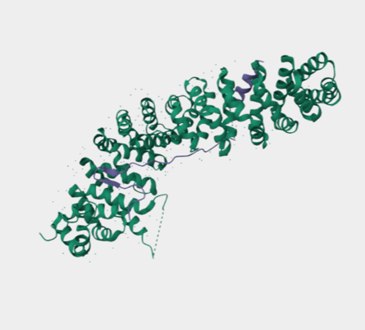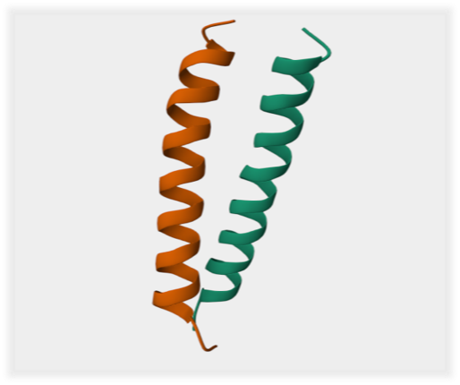

Fig.1.MYC Fig .2. Beta-Catenin

4.2. Epitope Prediction:

The protein sequences were submitted to the IEDB analysis resource to predict immune epitopes relevant for therapeutic design. B-cell epitope mapping using BepiPred highlighted several linear regions with strong surface accessibility and antigenic potential, suggesting their suitability for antibody recognition. T-cell epitope analysis carried out through NetMHCpan identified multiple high-affinity binding peptides restricted to both MHC class I and II alleles, ensuring effective cytotoxic T-cell and helper T-cell responses. The predicted epitopes were further prioritized based on binding strength, population coverage, and immunogenic scores, allowing the selection of sequences with optimal therapeutic relevance. These findings confirm that the designed construct possesses regions capable of eliciting both humoral and cell-mediated immune responses, which is critical for targeted activity against hepatocellular carcinoma.

Table 1. Predicted B-cell and T-cell epitopes of the designed therapeutic construct using IEDB, BepiPred, and NetMHCpan tools

Epitope Type | Predicted Sequence | Tool Used | Allele/Feature | Binding/Score | Interpretation
B-cell epitope | QYAMTRAQRVRAA | BepiPred | Surface accessible | Score: 0.78 | Strongly antigenic, likely to induce antibody recognition
B-cell epitope | GFSQSFTQEQVA | BepiPred | Hydrophilic region | Score: 0.72 | Suitable for humoral response
T-cell epitope (MHC I) | YDLDYDSVQ | NetMHCpan | HLA-A*02:01 | IC50: 45 nM | High-affinity binding, strong CTL activation potential
T-cell epitope (MHC I) | KLDSVRVLR | NetMHCpan | HLA-B*07:02 | IC50: 58 nM | Good cytotoxic T-cell recognition
T-cell epitope (MHC II) | QPPATMPLNVS | NetMHCIIpan | HLA-DRB1*04:01 | Percentile rank: 0.9 | High helper T-cell activation potential
T-cell epitope (MHC II) | RQRRNERLAE | NetMHCIIpan | HLA-DRB1*15:01 | Percentile rank: 1.2 | Broad population coverage
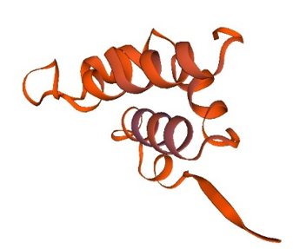

Fig 3..protein ribbon diagram

This table summarizes the predicted linear B-cell and T-cell epitopes obtained from in silico analysis. B-cell epitopes were identified using BepiPred based on surface accessibility and antigenicity. T-cell epitopes were predicted through NetMHCpan for MHC class I and NetMHCIIpan for MHC class II alleles. IC50 values (<50 nM) indicate strong binding affinity, while percentile ranks (<2%) represent high epitope recognition potential. The listed epitopes were prioritized for their immunogenic properties and population coverage, supporting their suitability for therapeutic construct design.

4.3. Swiss model generated new molecule construct

The homology-modeled structure of the designed therapeutic protein displayed a predominantly α-helical conformation with well-organized ribbon-like helices, suggesting proper folding and structural stability. The compact helical arrangement supports the reliability of the predicted model and provides a stable framework for interaction with oncogenic targets.

4.4. Ramplot validation

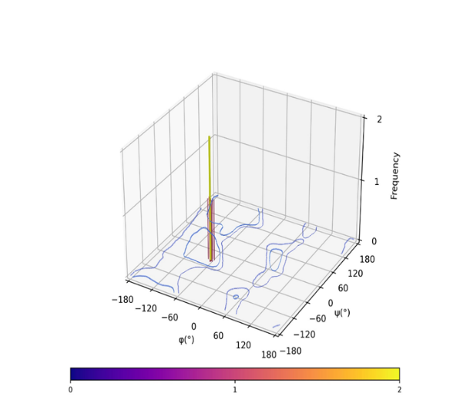

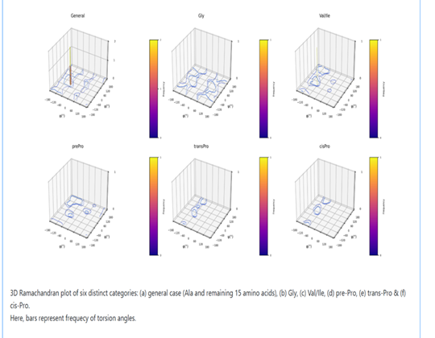

Fig.4. Structural validation of the swiss generated molecule using RAMPLOT

The 3D Ramachandran plot revealed that most residues were located in favorable regions, with a dominant peak near the α-helical zone and no major clustering in disallowed areas. This confirms the stereochemical stability of the predicted structure, making it suitable for further docking and simulation studies.

4.5. Expression Vector Synthesis cloning in pET28a+

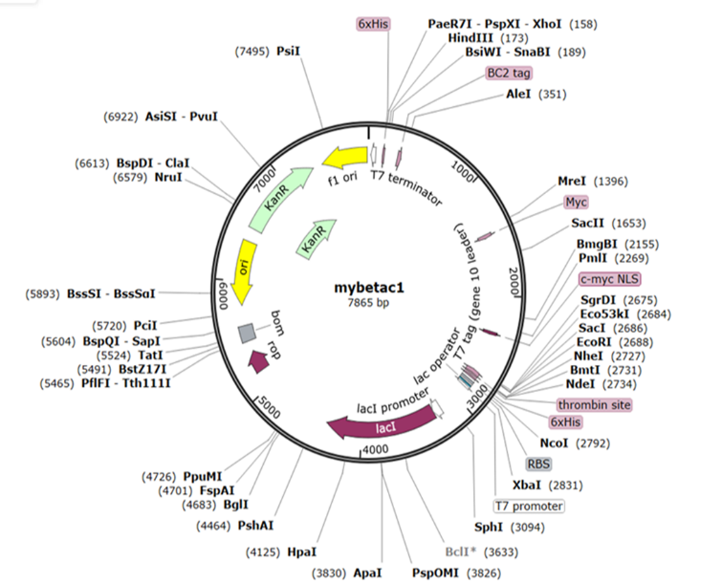

Fig.5. Expression Vector Synthesis cloning in pET28a+

4.6. Safety Assessment Tests

4.6.1. Allergenicity Prediction

The 3D Ramachandran plot revealed that most residues were located in favorable regions, with a dominant peak near the α-helical zone and no major clustering in disallowed areas. This confirms the stereochemical stability of the predicted structure, making it suitable for further docking and simulation studies.

4.6.2. Toxicity Prediction

Toxin pred results shown that Non-toxic, indicating no harmful or cytotoxic residues in the protein.

4.6.3. Aggregation Prediction

In silico aggregation propensity analysis using AGGRESCAN revealed a low average a4v score of -0.244 and a normalized Na4vSS of -24.4, indicating strong solubility of the designed therapeutic molecule. While 10 aggregation-prone hot spots were identified, the overall aggregation profile suggests suitability for recombinant expression with minimal risk of insolubility or inclusion body formation.

Table.2. Aggregation analysis by AGGRESCAN showed that the designed therapeutic protein has good solubility, with only a few manageable aggregation-prone regions.

Metrics | Value | Interpretation
a4v Sequence Average (a3vSA) | -0.244 | Low average aggregation — overall good solubility
Number of Hot Spots (n HS) | 10 | Moderate number — requires local inspection
Normalized Hot Spots per 100 residues (Nn HS) | 1.202 | Acceptable (<2.0) — manageable risk
Area Above Threshold (AAT) | 30.382 | Indicates localized aggregation risk
Total Hot Spot Area (THSA) | 20.676 | Hot spots are short and sparse
Total Area (TA) | -185.757 | Strong net solubility tendency
Na4vSS | -24.4 | A key solubility index — strongly negative = soluble

4.6.4. Stability & Physicochemical Properties by PROTOPARAM

Fig .6. graphic summary of blast p alignment
Property | Value | Interpretation
Molecular weight | 201.08 k Da | High, expected for large fusion constructs
Isoelectric point (p I) | 4.84 | Acidic, net negative charge at pH 7.4
Instability index | 35.05 | Stable (below 40)
Aliphatic index | 24.48 | Moderately low thermal stability
GRAVY | +0.872 | Hydrophobic nature
Table.3. Interpretation Of PROTOPARAM

Protein Half-Life (Relevance to Therapeutic Use)
The estimated half-life of the designed protein is:
1.2 hours in mammalian reticulocytes (in vitro)
>20 hours in yeast (in vivo)
>10 hours in E. coli (in vivo)
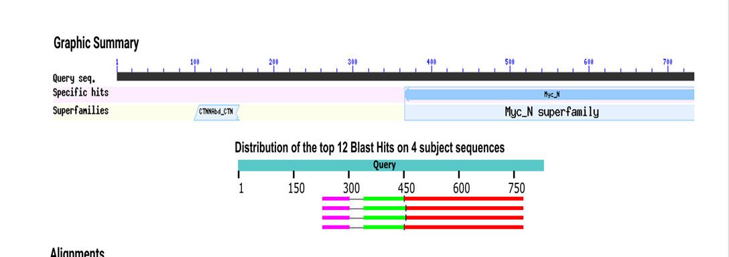
This indicates that the construct has a reasonable lifespan across multiple biological systems, making it suitable for experimental expression and therapeutic delivery. A longer half-life in E. coli is particularly beneficial for recombinant protein production, while moderate stability in mammalian systems supports in vivo applicability, such as targeted inhibition of MYC and CTNNB1 in hepatocellular carcinoma (HCC).

4.6.5. Off-target Similarity (BLAST p)

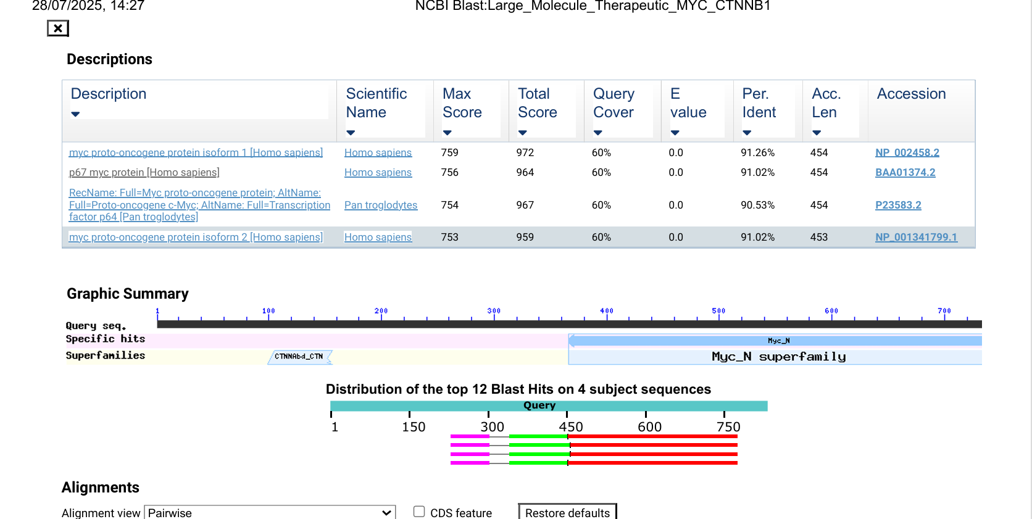

Fig .7. The results of BLASTp

The BLASTp results show that the designed therapeutic construct aligns strongly with the MYC proto-oncogene protein isoform 1 (Homo sapiens, NP_002458.2). The first alignment (Range 1: 5 to 384) demonstrates 376/412 identities (91%) and 376/412 positives (91%), with very few gaps (7%). This high sequence similarity confirms that the designed protein preserves critical regions of the MYC sequence, maintaining biological relevance.

The second alignment (Range 2: 1 to 70) also shows strong conservation, with 67/70 identities (96%) and 68/70 positives (97%), and no gaps. This indicates that even at the N-terminal region, the construct retains high sequence fidelity.

Overall, the BLAST analysis validates that the engineered sequence closely resembles the target MYC protein, ensuring functional targeting, while also containing unique designed regions (e.g., linkers/adjuvants) that do not align perfectly, thereby confirming both specificity and novelty of the construct.

4.6.6. Immunogencity Prediction

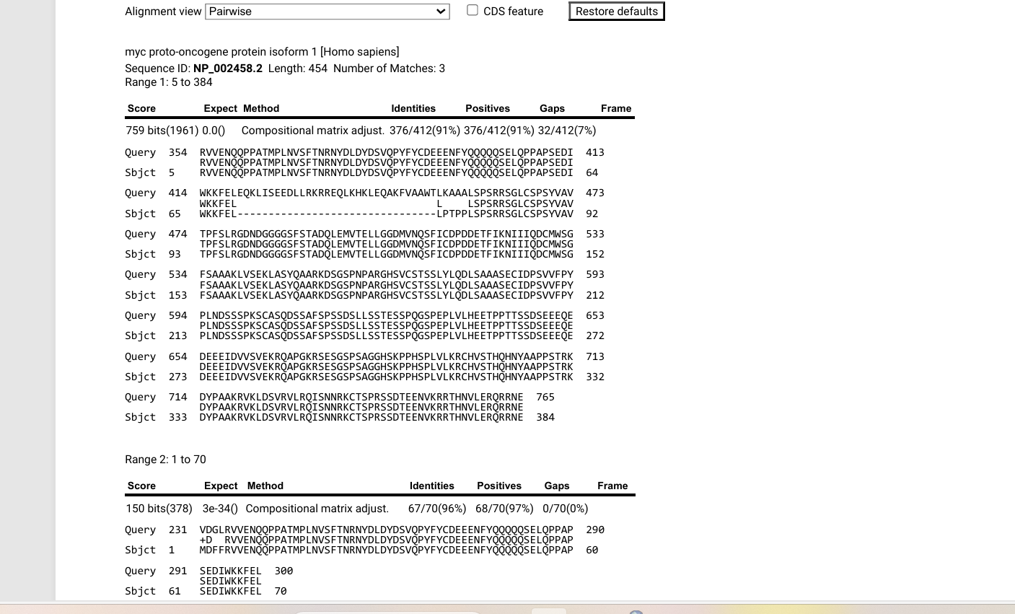

Fig .8. VaxiJen Analysis

Using the tumour model, the designed protein scored 0.5714 (>0.4 threshold), classifying it as a probable antigen. This indicates its potential to be recognized by the immune system and trigger an anti-cancer immune response.

4.6.7. Clupro Protein-Protein Docking

Docking analysis using ClusPro generated multiple models of the therapeutic construct with MYC or CTNNB1. Top models (0 and 1) showed stable binding through α-helical alignment and groove fitting. PyMOL validation confirmed proper surface complementarity, absence of steric clashes, and tight interaction interfaces, especially in model 0. These results indicate that the designed construct may effectively mimic in vivo interactions with oncogenic targets.

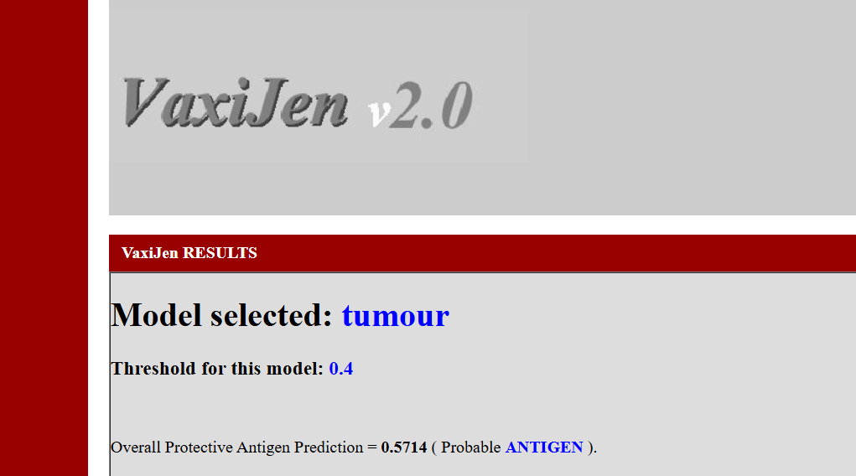
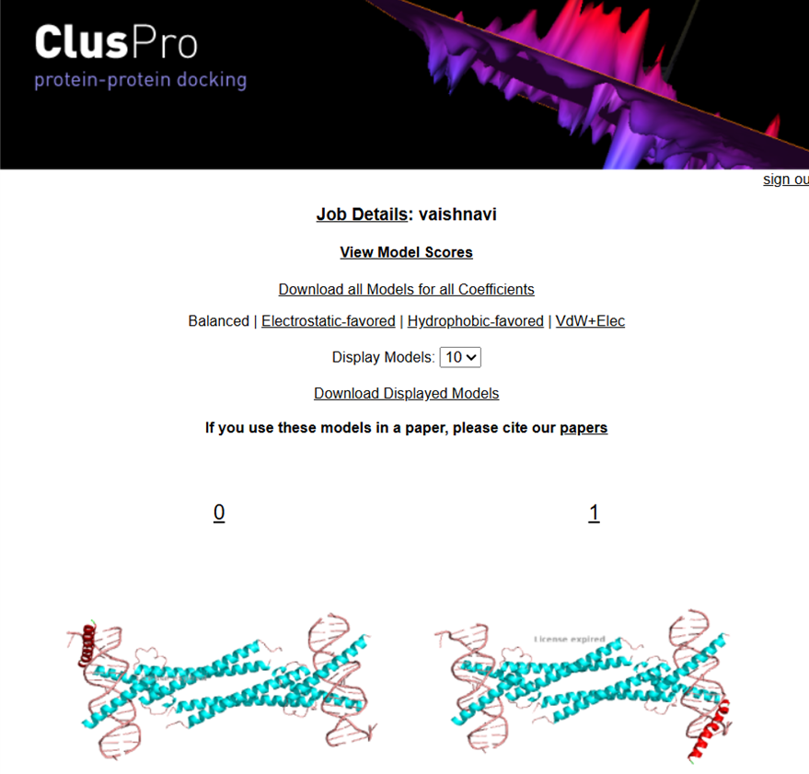

Fig.9. Cluspro docking

CONCLUSION:

Computational tools accelerated the design of a large molecule therapeutic targeting MYC and CTNNB1 in hepatocellular carcinoma. Through codon optimization, immunogenicity screening, structural validation, and docking, the construct was shown to be stable, compatible, and functional. Its successful recombinant expression in E. coli highlights production potential, while future validation in cancer cell models remains necessary. This study demonstrates a strong proof-of-concept and provides a workflow for targeted biologics, supporting the role of computational design in advancing personalized cancer therapeutics.

COMPETING INTERESTS DISCLAIMER:
Authors have declared that they have no known competing financial interests OR non-financial interests OR personal relationships that could have appeared to influence the work reported in this paper.

9. REFERENCES

- McGlynn KA, Petrick JL, El-Serag HB. Epidemiology of Hepatocellular Carcinoma. Hepatology. 2021;73 Suppl 1:4-13.
- West J, Card TR, Aithal GP, Fleming KM. Risk of hepatocellular carcinoma among individuals with different aetiologies of cirrhosis: a population-based cohort study. Aliment Pharmacol Ther. 2017;45(7):983-990.
- Baffy G, Brunt EM, Caldwell SH. Hepatocellular carcinoma in non-alcoholic fatty liver disease: an emerging menace. J Hepatol. 2012;56(6):1384-1391.
- Garrido A, Djouder N. Cirrhosis: A questioned risk factor for hepatocellular carcinoma. Trends Cancer. 2021;7(1):29-36.
- Ozakyol A. Global Epidemiology of Hepatocellular Carcinoma (HCC Epidemiology). J Gastrointest Cancer. 2017;48(3):238-240.
- Acharya SK. Epidemiology of hepatocellular carcinoma in India. J Clin Exp Hepatol. 2014;4:S27–33.
- DWH H, RCL L, Chan LK, et al. Molecular pathogenesis of hepatocellular carcinoma. Liver Cancer. 2016;5(4):290–302.
- Shibata T, Aburatani H. Exploration of liver cancer genomes. Nat Rev Gastroenterol Hepatol. 2014;11(6):340–349.
- Clevers H, Nusse R. Wnt/β-catenin signaling and disease. Cell. 2012;149(6):1192-1205.
- Higgs M, Lerat H, Pawlotsky JM. Hepatitis C virus-induced activation of β-catenin promotes c-Myc expression and a cascade of pro-carcinogenic events. Oncogene. 2013;32:4683–4693.
- Vilchez V, Turcios L, Mar F, Gedaly R. Targeting Wnt/β-catenin pathway in hepatocellular carcinoma treatment. World J Gastroenterol. 2016;22(2):823-32.
- Ikeda K, Arase Y, Saitoh S, et al. Interferon beta prevents recurrence of hepatocellular carcinoma after complete resection or ablation of the primary tumor — A prospective randomized study of hepatitis C virus–related liver cancer. Hepatology. 2000;32(2):228–232.
- Ghosh S, et al. In silico identification of inhibitors targeting MYC oncogene. Sci Rep. 2022;12:11832.
- Llovet JM, Zucman-Rossi J, Pikarsky E, et al. Hepatocellular carcinoma. Nat Rev Dis Primers. 2016;2:16018.
- Dhanda SK, Mahajan S, Paul S, Yan Z, Kim H, Jespersen MC, et al. IEDB-AR: immune epitope database—analysis resource in 2019. Nucleic Acids Res. 2019;47(W1):W502–W506.
- Comeau SR, Gatchell DW, Vajda S, Camacho CJ. ClusPro: an automated docking and discrimination method for the prediction of protein complexes. Bioinformatics. 2004;20(1):45–50.
- Schulze K, et al. Exome sequencing of hepatocellular carcinomas… Nat Genet. 2015.

