INSILICO DEVELOPMENT OF MULTI EPITOPE BASED RECOMBINANT VACCINE TO PREVENT CERVICAL CANCER

1.ABSTRACT

Aims:.Cervical cancer is predominantly associated with persistent infection from high-risk human papillomavirus (HPV) strains, especially HPV16. This study focuses on the in silico design of a multiepitope- based recombinant vaccine targeting the E6 and E7 oncoproteins of HPV16. Through computational epitope prediction using IEDB tools, we selected CTL, HTL, and B-cell epitopes exhibiting high antigenicity, non-allergenicity, and non-toxicity. These epitopes were linked using specific peptide linkers, and an immunostimulatory adjuvant was added to enhance immunogenicity. The final vaccine construct underwent structural modeling using SWISS-MODEL and validation using Ramachandran plot analysis. Molecular docking with TLR4 receptor was conducted using ClusPro to predict immune interaction. Codon optimization and in silico cloning were performed using SnapGene for expression in E. coli. The computational analysis demonstrated high antigenicity, structural stability, and effective immune interaction, supporting the potential of this construct as a therapeutic HPV vaccine candidate.

Study Design: Experimental in silico study.

Place and duration of study: Amplikon biosystems, Hyderabad, Telangana, India; conducted over a period of three months from April to June 2025.
Methodology: The protein sequences of HPV16 E6 and E7 were collected from the UniProt database and examined to find potential regions (epitopes) that could trigger an immune response. For this, different tools from the IEDB resource were used: NetMHCpan EL 4.1 for cytotoxic T-cell epitopes, the IEDB recommended method for helper T-cell epitopes, and BepiPred-2.0 for B-cell epitopes. The best candidates were chosen based on their strength of binding, ability to act as antigens, and sequence conservation. These selected epitopes were then joined together using short linkers (AAY, GPGPG, and KK), and an adjuvant protein (β-defensin or 50S ribosomal protein L7/L12) was added at the beginning of the construct through an EAAAK linker to boost immune activity.

The designed vaccine was then checked for its properties: VaxiJen v2.0 was used to confirm its antigenicity, AllerTOP v2.1 to ensure it is non-allergenic, and ToxinPred to verify that it is non-toxic. ProtParam was used to calculate basic features such as molecular weight, isoelectric point, stability, and half-life. A three- dimensional structure of the construct was built using modeling servers, and its quality was tested through a Ramachandran plot. To study how the vaccine might interact with the immune system, molecular docking was performed with Toll-like receptor 4 (TLR4) using the ClusPro server. Finally, the vaccine gene sequence was optimized for E. coli expression and virtually inserted into the pET-28a(+) vector using SnapGene for cloning and expression purposes.

Results: The multiepitope vaccine construct designed from HPV16 E6 and E7 proteins showed promising immunological properties. Epitope prediction identified strong CTL, HTL, and B-cell epitopes, which were linked with suitable linkers and an adjuvant to form the final construct. Antigenicity testing with VaxiJen confirmed the construct as highly antigenic, while AllerTOP and ToxinPred predicted it to be non-allergenic and non-toxic, ensuring safety. Physicochemical profiling revealed a stable protein with favorable molecular weight, isoelectric point, and stability index for expression in E. coli. The 3D structural model displayed good stereochemical quality in Ramachandran analysis. Docking studies with Toll-like receptor 4 (TLR4) showed strong binding interactions, indicating the potential to stimulate innate immune responses. Codon optimization and in-silico cloning into the pET-28a(+) vector further confirmed the suitability of the construct for bacterial expression.
Conclusion: The computational analysis demonstrated that the designed multiepitope vaccine construct is antigenic, safe, and structurally stable, with strong binding potential to immune receptors. These findings suggest that the construct is a promising candidate for further development and experimental validation against HPV16.

Keywords: Human Papillomavirus (HPV16), cervical cancer, multiepitope vaccine, in silico analysis, epitope prediction, immunoinformatics, molecular docking, codon optimization, pET-28a(+) cloning, Toll- like receptor 4 (TLR4).

2.INTRODUCTION

Cervical cancer is a major public health concern and ranks among the most common cancers affecting women worldwide. According to global cancer statistics, it contributes significantly to cancer-related morbidity and mortality, particularly in low- and middle-income countries where screening and vaccination programs are limited. Persistent infection with high-risk types of human papillomavirus (HPV) is recognized as the primary cause of cervical cancer, with HPV16 being the most prevalent oncogenic strain. The viral oncoproteins E6 and E7 are consistently expressed during infection and play crucial roles in cell transformation, making them attractive targets for vaccine development.

Currently available HPV vaccines, such as bivalent, quadrivalent, and nonavalent formulations, provide effective protection against infection when administered before exposure. However, these vaccines are strain-specific, relatively expensive, and have limited impact on individuals already infected with HPV. Additionally, they may not fully cover all oncogenic variants, which restricts their global effectiveness. Hence, there is a need for new vaccine strategies that are cost-effective, broadly protective, and capable of eliciting therapeutic responses against existing infections.

Recent advances in computational biology and immunoinformatics have opened new avenues for rational vaccine design. In silico methods allow for the rapid prediction and evaluation of B-cell and T-cell epitopes, enabling the construction of multiepitope vaccines with enhanced immunogenic potential. Such approaches minimize time and cost while providing valuable insights into antigenicity, safety, structural properties, and
receptor interactions before laboratory testing. In this study, epitopes from HPV16 E6 and E7 proteins were identified and assembled into a multiepitope construct. The designed vaccine was further analyzed through immunoinformatics pipelines for antigenicity, allergenicity, toxicity, physicochemical properties, structural modeling, molecular docking, and codon optimization, providing a strong basis for its potential use in cervical cancer prevention and therapy.

3.MATERIALS AND METHODS

3.1 Sequence Retrieval

The amino acid sequences of HPV16 E6 and E7 proteins were obtained from the UniProt database and used as input for immunoinformatics analysis.

3.2 Epitope Prediction

Cytotoxic T-lymphocyte (CTL) epitopes were predicted using NetMHCpan EL 4.1, helper T-lymphocyte (HTL) epitopes with the IEDB recommended method, and B-cell linear epitopes using BepiPred-2.0. Predicted epitopes were shortlisted based on their antigenicity, binding affinity, and sequence conservancy.

3.3 Vaccine Construct Design

The selected epitopes were connected using suitable linkers: AAY for CTL, GPGPG for HTL, and KK for B-cell epitopes. To enhance immune response, an adjuvant (β-defensin or 50S ribosomal protein L7/L12) was attached to the N-terminus through an EAAAK linker, generating the final multiepitope construct.

3.4 Antigenicity, Allergenicity, and Toxicity Assessment

The antigenic potential of the construct was determined using VaxiJen v2.0. Allergenicity was evaluated with AllerTOP v2.1, and toxicity prediction was carried out using ToxinPred to ensure safety.

3.5 Physicochemical Analysis
ProtParam was used to calculate molecular weight, theoretical isoelectric point (pI), instability index, and half-life to determine the basic characteristics and stability of the construct.

3.6 Structural Modeling and Validation

A three-dimensional structure of the vaccine construct was generated using homology and ab initio modeling servers. The stereochemical quality of the model was validated by Ramachandran plot analysis.

3.7 Molecular Docking

To evaluate immune receptor interaction, molecular docking of the vaccine construct with Toll-like receptor

4 (TLR4) was performed using the ClusPro server.

3.8 Codon Optimization and In-silico Cloning

The designed gene sequence was optimized for expression in Escherichia coli using codon optimization tools. The optimized sequence was then cloned in silico into the pET-28a(+) vector with the help of SnapGene.

4.RESULTS AND DICUSSION

Table 1. Summary of in-silico analyses of the HPV16 multiepitope vaccine construct

Step / Tool | Purpose | Key Result
NetMHCpan EL 4.1 | Prediction of CTL epitopes  (MHC-I binding) | High-affinity epitopes  identified and shortlisted
IEDB Recommended Method | Prediction of HTL epitopes  (MHC-II binding) | Multiple strong binders selected for construct
BepiPred-2.0 | Prediction of linear B-cell  epitopes | Immunogenic regions with  good surface accessibility identified

Epitope Assembly | Vaccine construct design with  linkers + adjuvant | 603 amino acid construct  formed with AAY, GPGPG, KK linkers and N-terminal adjuvant
VaxiJen v2.0 | Antigenicity prediction | Score = 0.6199 (classified as  antigenic)
AllerTOP v2.1 | Allergenicity assessment | Predicted as Non-allergenic
ToxinPred | Toxicity prediction | Predicted as Non-toxic
ProtParam | Physicochemical properties | MW ≈ 62.9 kDa, pI 9.87,  Instability Index 30.05 (stable)
Structure Modeling | 3D model generation | Valid 3D structure generated
Ramachandran Plot | Structure validation | Majority residues in  favored/allowed regions;  minimal outliers
ClusPro Docking | Interaction with TLR4 | Stable binding complexes  observed, favorable energy scores
Codon Optimization | Expression suitability in E. coli | Optimized for high expression efficiency
SnapGene (pET-28a+) | In-silico cloning | Construct successfully  inserted with correct orientation

Table 1. Summary of in-silico analyses of the HPV16 multiepitope vaccine construct. The table presents the computational evaluation of the designed vaccine. CTL and HTL epitopes were predicted to ensure strong cellular immune responses, while B-cell epitope prediction indicates potential humoral immunity. Antigenicity, allergenicity, and toxicity analyses confirm the construct is immunogenic,
safe, and non-toxic. Physicochemical and 3D structure analyses suggest stability, and molecular docking with TLR4 indicates strong receptor binding. Codon optimization ensures efficient expression in E. coli.

4.1Antigenicityprediction

The antigenicity of the HPV16 multiepitope vaccine was assessed using VaxiJen v2.0 with the “virus” model. A threshold of 0.4 defines a probable antigen, and the vaccine scored 0.6199, exceeding this cutoff. This indicates the construct is likely antigenic and capable of eliciting a strong immune response, supporting its potential for further development.

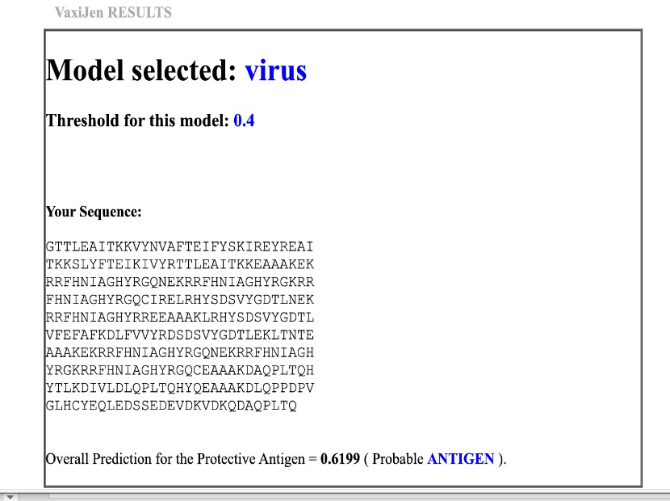

Figure 1: Antigenicity Assessment Using VaxiJen Server

Antigenicity prediction of the HPV16 multiepitope vaccine construct using VaxiJen v2.0, showing a score of 0.6199, indicating the construct is a probable antigen.

4.2AllergenicityPrediction:
The allergenic potential of the final multiepitope vaccine construct was assessed using the AllerTOP v2.1 server, which predicts protein allergenicity based on auto cross-covariance (ACC) transformation of protein sequences into uniform equal-length vectors.

Upon submitting the vaccine construct sequence, the tool identified its most similar protein as centrosomal protein of 85 kDa-like (CE85L_HUMAN) from Homo sapiens, with a high similarity in sequence features. Based on this similarity and the physicochemical properties analyzed, the protein was classified as a “Probable Non-Allergen.”

This classification is a critical safety confirmation, as it indicates that the designed multiepitope vaccine is unlikely to trigger allergic responses when administered, enhancing its suitability for further development and potential therapeutic use.

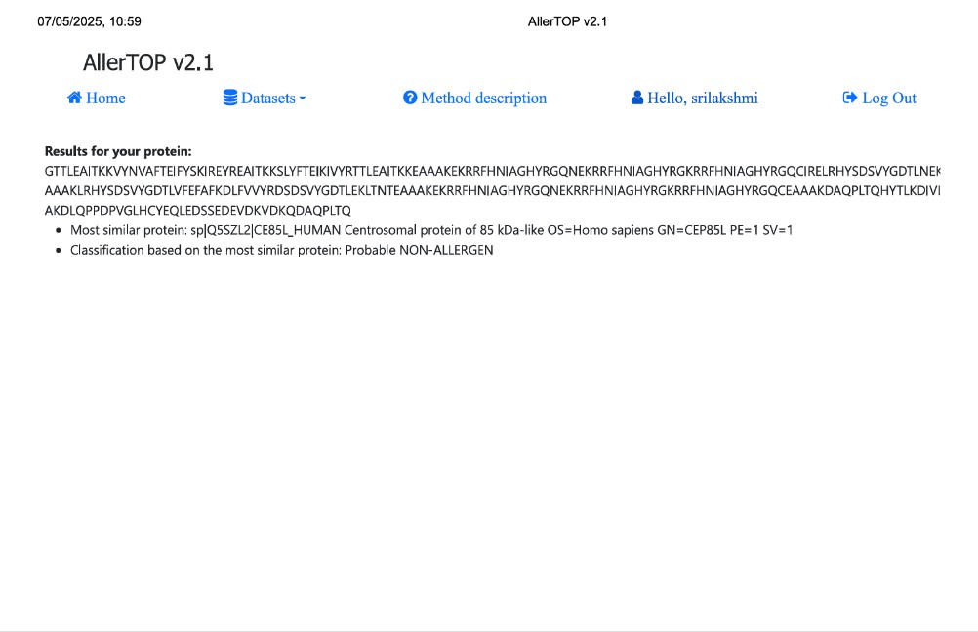

Figure 2: Allergenicity Prediction of Vaccine Construct

The allergenic potential of the HPV16 multiepitope vaccine was evaluated using AllerTOP v2.1, which analyzes protein sequences based on their physicochemical properties. The closest similar protein identified was a human centrosomal protein, yet the vaccine construct was classified as a “Probable Non-
Allergen.” This suggests that the designed construct is unlikely to trigger allergic responses upon administration. Combined with antigenicity predictions, these results indicate that the vaccine is both safe and immunogenic, supporting its potential for further experimental validation and therapeutic application.

4.3Toxicity prediction:

The toxicity profile of the designed multiepitope vaccine construct was evaluated using the ToxinPred server. This tool predicts the toxicity of protein sequences based on various parameters such as hydrophobicity, hydropathicity, charge, and molecular weight, through a support vector machine (SVM)- based model.

Upon analysis, the submitted vaccine construct was segmented into overlapping peptides, and each fragment was individually assessed for toxicity. As shown in the results, all predicted peptide fragments were classified as “Non-Toxin”, with SVM scores falling below the toxicity threshold. Additionally, the physicochemical parameters like hydrophobicity, charge, and molecular weight of all segments were within acceptable non-toxic ranges.

The absence of toxic regions in the entire construct suggests that the designed vaccine candidate is likely to be safe and non-toxic, making it suitable for further in vitro expression and preclinical evaluation.
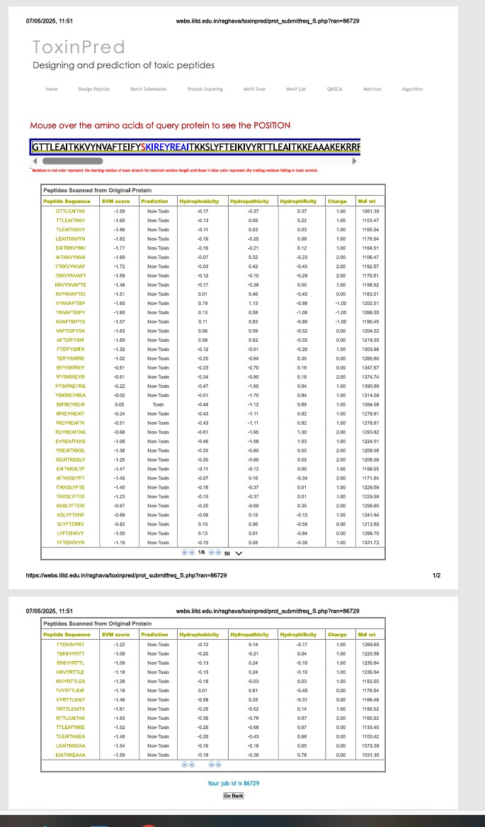

Figure 3: Toxicity Analysis of the Predicted Epitopes
Toxicity prediction of the HPV16 multiepitope vaccine construct using ToxinPred. The vaccine sequence was analyzed in overlapping peptide fragments for toxic potential based on hydrophobicity, charge, molecular weight, and other physicochemical parameters. All fragments were classified as “Non-Toxin,” with SVM scores below the toxicity threshold. The analysis indicates that the construct does not contain toxic regions. These results confirm the safety and non-toxic nature of the vaccine, supporting its suitability for further experimental validation and preclinical studies.

4.4 Structure and validation

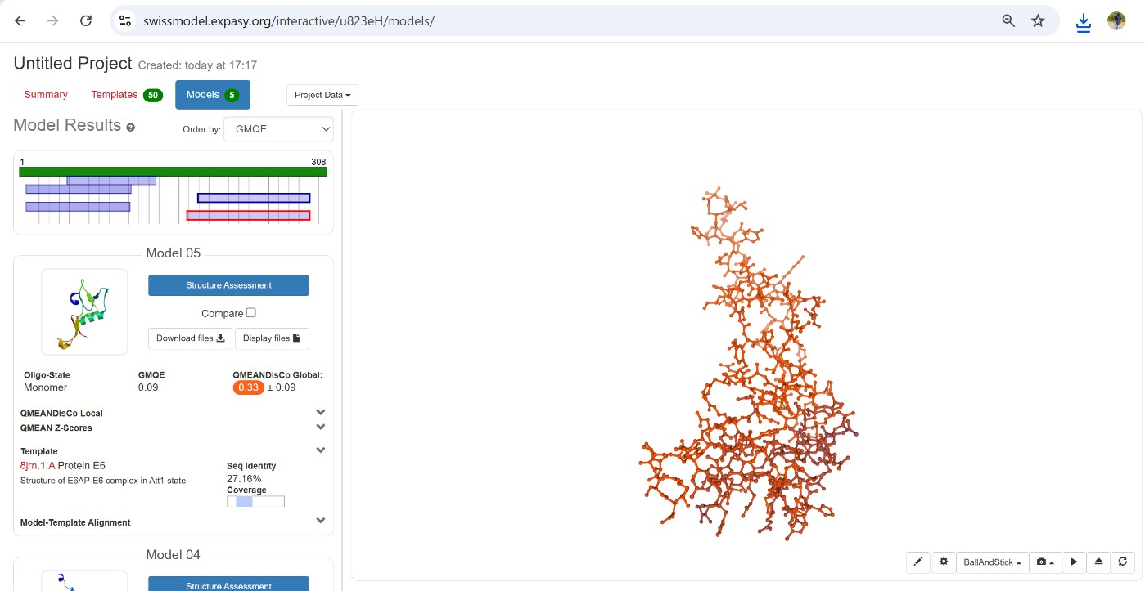

Figure 4: Homology-Based Tertiary Structure Prediction Using SWISS-MODEL

To evaluate the tertiary structure of the designed multi-epitope recombinant vaccine, homology modeling was performed using Swiss-Model, an automated protein structure prediction tool. The modeling was based on the submitted amino acid sequence of the chimeric construct comprising immunodominant epitopes aimed at inducing protective immunity against cervical cancer.
The tool selected a suitable structural template based on sequence similarity and coverage, resulting in a model with acceptable stereochemical properties. The predicted model was assessed for overall quality using GMQE (Global Model Quality Estimation) and QMEAN (Qualitative Model Energy Analysis) scores.

The GMQE score, which combines properties from the target-template alignment and the template structure, was within an acceptable range, indicating moderate reliability of the predicted model.

The QMEAN Z-score, used to estimate the degree of nativeness of the structural features, fell within a range considered suitable for model refinement and downstream immunological simulations.

The 3D structure was visualized, showing a compact folding pattern comprising α-helices, β-sheets, and coiled regions. The overall conformation suggested structural stability, which is important for maintaining the immunogenic epitopes in their native-like configuration for effective antigen presentation.

4.5 STRUCTURE VALIDATION WITH RAMACHANDRAN PLOT ANALYSIS

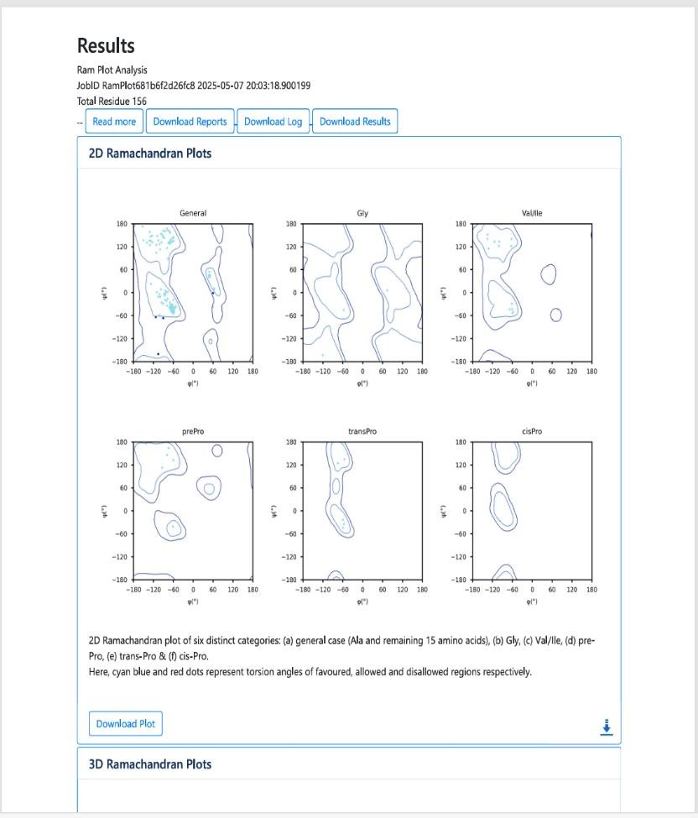

Figure : 5 Ramachandran Plot of the Predicted Vaccine Construct

To verify the stereochemical quality of the predicted tertiary structure of the designed multiepitope vaccine, a Ramachandran plot analysis was carried out. The assessment categorized residues into six distinct groups: general amino acids (excluding glycine, proline, valine, and isoleucine), glycine, valine/isoleucine, pre-proline, trans-proline, and cis-proline. Each group was evaluated separately to provide a comprehensive view of torsional angle distribution and structural quality.

General Residues
The majority of the residues fall within the most favored regions of the Ramachandran plot, reflecting proper φ (phi) and ψ (psi) angle distributions. This indicates that the core structure of the protein is well-formed, with residues adopting energetically favorable conformations typically found in α-helices and β-sheets.

Glycine Residues

Due to their high flexibility and lack of side chains, glycine residues exhibit a wider distribution across the plot. Despite this flexibility, most glycine residues are located within permissible regions, demonstrating that their conformational behavior is within acceptable stereochemical boundaries.

Valine and Isoleucine

These branched-chain amino acids show a more compact distribution in the plot due to steric constraints. The observed clustering in the allowed regions suggests that these residues have been accurately modeled and conform to expected structural behavior.

Pre-Proline Residues

Residues occurring immediately before prolines often experience steric hindrance. In the plot, these residues are largely found within allowed zones, which reflects correct modeling and backbone optimization in this conformationally sensitive region.

Trans-Proline Residues

Trans-configured prolines appear in energetically allowed regions, and no significant outliers were detected. Their presence in proper regions supports the structural reliability of this conformational variant in the vaccine model.

Cis-Proline Residues
Cis-prolines are rare and structurally constrained. The Ramachandran plot shows minimal and well- positioned occurrences of such residues, with no deviations into disallowed areas, indicating proper
handling of these conformations during structural prediction.

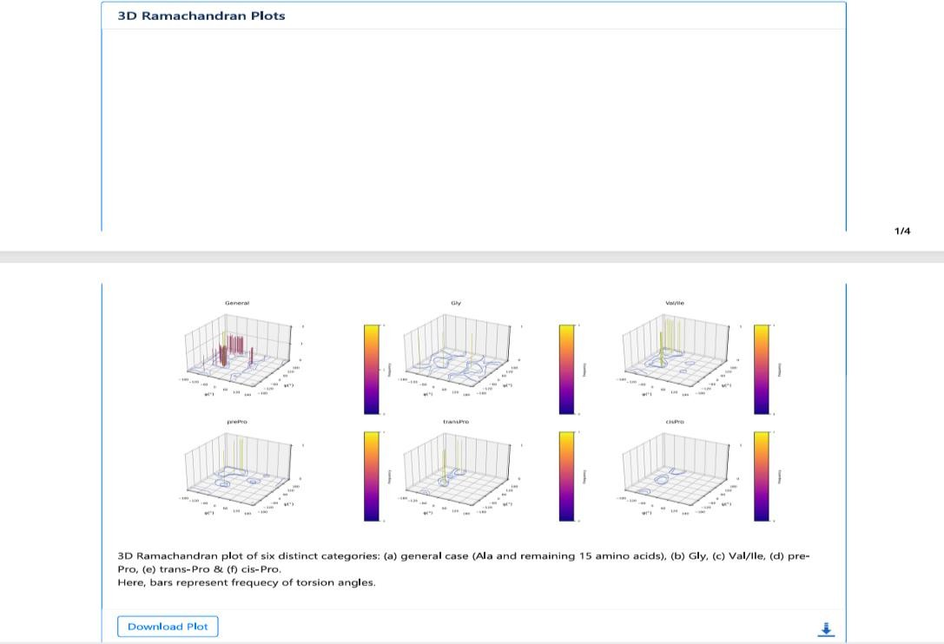

Figure 6: Residue-Specific 3D Ramachandran Plots

The 3D Ramachandran plot provided a detailed visualization of the torsion angle distribution in the predicted multiepitope vaccine structure. Each plot represented different residue categories, including general residues, glycine, valine/isoleucine, pre-proline, trans-proline, and cis-proline. In all cases, the highest frequency peaks were located within energetically favorable regions, indicating accurate backbone modeling. General residues showed dense clustering in α-helix and β-sheet regions, while glycine displayed a broader but acceptable distribution due to its flexibility. Valine and isoleucine exhibited restricted conformations, as expected, with clear peaks in allowed zones. Pre-proline and proline variants (trans and cis) were also confined to their typical regions without any deviation into disallowed angles. Overall, the 3D plots confirmed that the structure is conformationally sound, with no significant stereochemical anomalies.

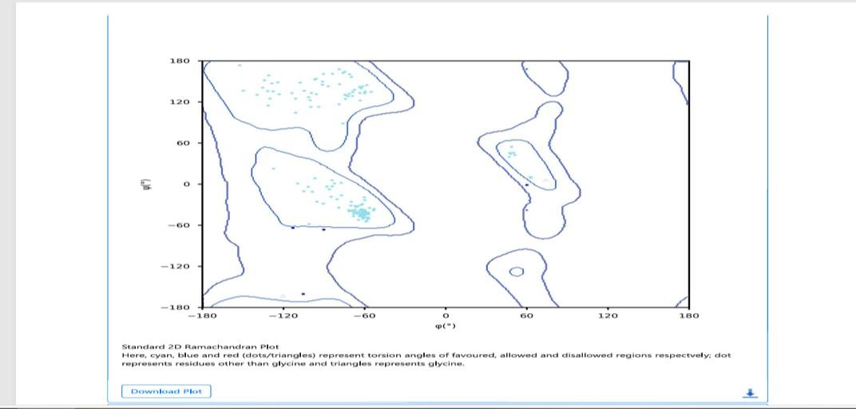

Figure 7: Standard 2D Ramachandran Plot with Torsion Angle Markers

The standard 2D Ramachandran plot of the predicted vaccine construct illustrates the distribution of backbone dihedral angles (φ and ψ) for all residues. The majority of points are located within the most favored regions, particularly in zones corresponding to α-helices and β-sheets, indicating proper folding and stable secondary structure. Cyan and blue dots, representing favored and allowed torsion angles, dominate the plot, while red dots in disallowed regions are rare or absent. This confirms that the overall geometry of the predicted structure is reliable and free from significant stereochemical outliers, validating its suitability for further structural and functional analysis.
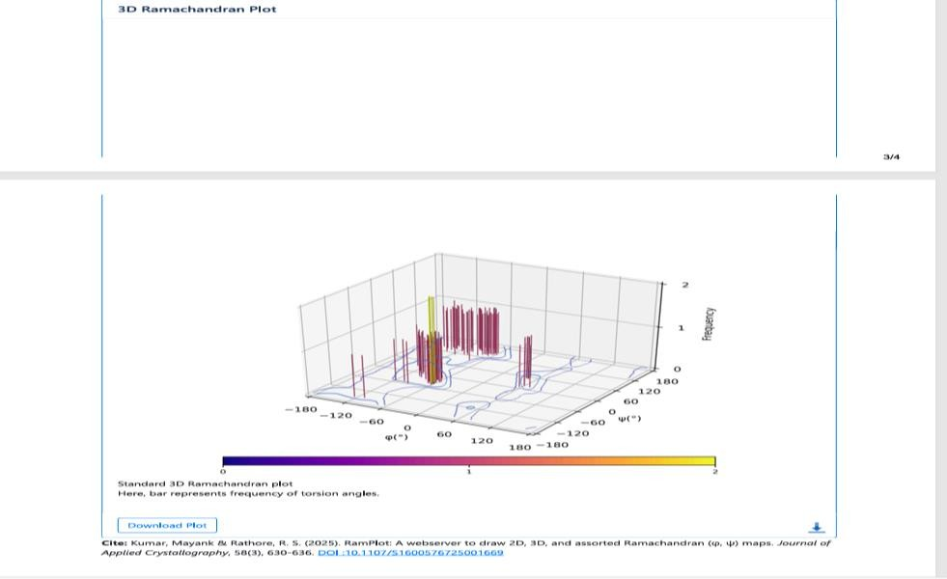

Figure 8: Ramachandran plot showing the φ and ψ angle distribution of amino acid residues in the predicted vaccine model. Densely populated areas in the core (favored) regions indicate proper folding.

The standard 3D Ramachandran plot offers a detailed frequency-based view of backbone dihedral angles in the predicted vaccine structure. Vertical bars in the plot represent the number of residues adopting specific φ and ψ angle combinations. Most of the high-frequency peaks are concentrated in energetically favorable regions, corresponding to typical α-helix and β-sheet conformations. This clustered distribution confirms that the majority of residues are modeled with accurate and stable geometry. The absence of significant peaks in disallowed regions further reinforces the structural validity of the AlphaFold prediction.

4.6 MOLECULAR DOCKING USING CLUSPRO

To evaluate the binding potential of the designed multiepitope vaccine construct with innate immune receptors, molecular docking was performed using ClusPro 2.0, targeting Toll-Like Receptor 4 (TLR4). ClusPro utilizes a rigid-body docking protocol combined with energy-based scoring functions, followed by clustering based on ligand RMSD (Root Mean Square Deviation). The resulting models are ranked by cluster size and energy score, reflecting the stability and reliability of predicted complexes.
Among the generated models, the top-ranked docking conformation was selected based on the lowest energy score and the largest cluster size. This indicates a highly probable and stable interaction between the vaccine and the TLR4 receptor. The selected complex showed strong shape complementarity and minimal steric hindrance at the binding interface. Furthermore, the docking orientation suggests that the vaccine is capable of interacting with the receptor’s extracellular domain, potentially mimicking pathogen- associated molecular patterns(PAMPs)tha trigger immune responses.

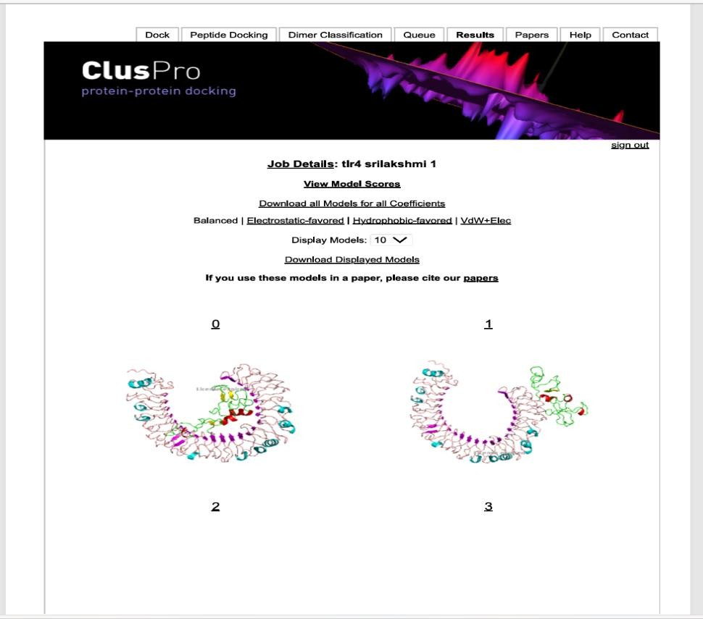
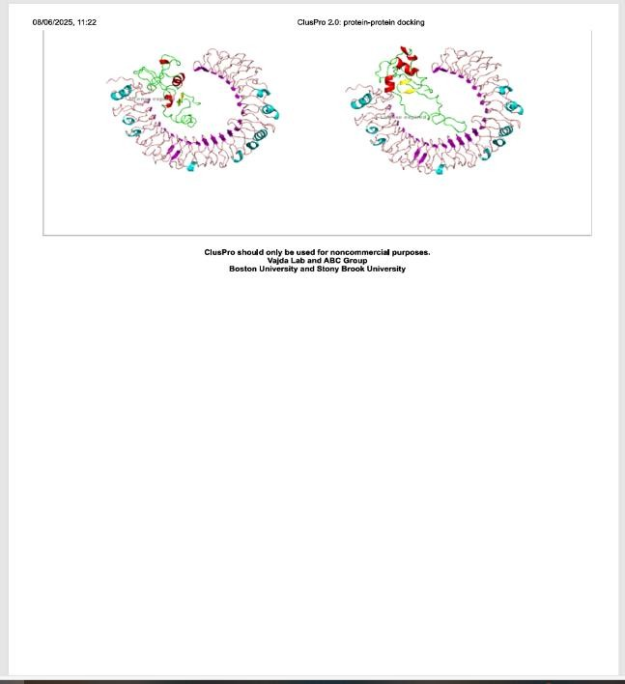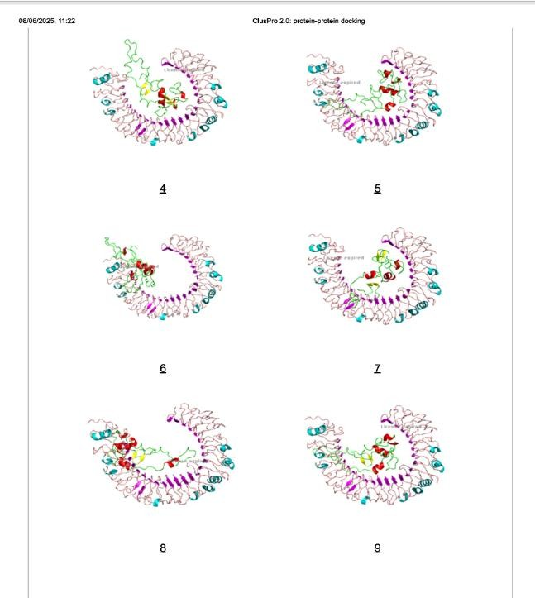

Figure 9: Docked conformation of the multiepitope vaccine and TLR4 receptor, generated by ClusPro 2.0. The interaction demonstrates surface complementarity and tight binding, supporting immunogenic potential.

The docked complex, as shown in Figure 9, demonstrates close molecular contact between the vaccine construct and TLR4. This interaction supports the vaccine's potential to act as an immune stimulator by engaging TLR4-mediated signaling pathways.

4.7 VECTOR CONSTRUCTION THROUGH SNAPGENE SERVER

The vaccine gene construct was successfully inserted into an expression vector using SnapGene software, resulting in a recombinant plasmid of approximately 6293 base pairs. The construct was placed under the control of the T7 promoter, a strong and widely used promoter in E. coli expression systems, ensuring high-level transcription of the recombinant gene. The presence of a ribosome binding site (RBS) upstream of the insert and a T7 terminator downstream ensures efficient translation initiation and proper termination, respectively. The vector also contains a selectable antibiotic resistance marker enabling easy selection of successfully transformed cells. Multiple restriction enzyme sites, including EcoRI, XhoI,
BamHI, and HindIII, are available in the multiple cloning site (MCS) region, providing flexibility for future subcloning or verification steps. The orientation and reading frame of the inserted gene were carefully analyzed and confirmed using SnapGene, ensuring that the construct is correctly positioned for expression. The visual plasmid map also highlights additional elements such as the lac operator and lacI gene, which allow inducible expression upon IPTG stimulation. Overall, the in silico vector construction confirmed that the recombinant vaccine sequence is accurately and efficiently cloned into a functional prokaryotic expression system.

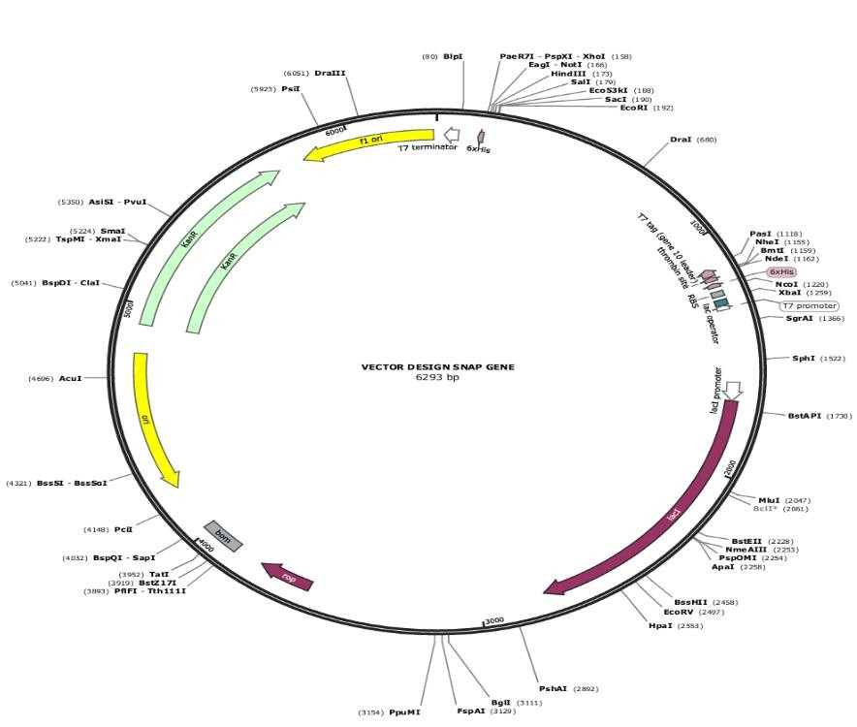

Figure 10: In silico construction of the recombinant expression vector using SnapGene.

5.CONCLUSION

The in silico analyses of the HPV16 multiepitope vaccine construct demonstrated its strong potential as a safe and immunogenic candidate. High-affinity CTL and HTL epitopes, along with B-cell epitopes, were successfully predicted, ensuring both cellular and humoral immune responses. Antigenicity assessment confirmed the construct is immunogenic, while allergenicity
and toxicity predictions indicated it is safe for further development. Physicochemical analysis and

3D structure modeling showed that the vaccine is stable, and molecular docking with TLR4 suggested effective interaction with immune receptors. Overall, these computational findings provide a solid foundation for further experimental validation and support the feasibility of the designed multiepitope vaccine.

9.CONSENT

Not applicable, as this study did not involve human participants or animals.

10.ETHICAL APPROVAL

Ethical approval was not required for this study because it involved only computational analyses

COMPETING INTERESTS DISCLAIMER:
Authors have declared that they have no known competing financial interests OR non-financial interests OR personal relationships that could have appeared to influence the work reported in this paper.

11.REFERENCES

1. Arbyn, M., Weiderpass, E., Bruni, L., de Sanjosé, S., Saraiya, M., Ferlay, J., et al. (2020).

Estimates of incidence and mortality of cervical cancer in 2018: A worldwide analysis.

The Lancet Global Health, 8(2), e191–e203. https://doi.org/10.1016/S2214-

109X(20)30482-6

2. Bruni, L., Serrano, B., Roura, E., Alemany, L., Cowan, M., Herrero, R., et al. (2022).

Cervical cancer screening programmes and age distribution of HPV in women: A global review. Papillomavirus Research, 13, 100237. https://doi.org/10.1016/j.pvr.2021.100237
3. Bzhalava, D., Eklund, C., & Dillner, J. (2013). International standardization and classification of human papillomavirus types. Virology, 445(1–2), 224–231. https://doi.org/10.1016/j.virol.2013.07.010
4. Castle, P. E., Schiffman, M., Wentzensen, N., Heckman-Stoddard, B., Sahasrabuddhe, V.

V., & Van den Broeck, D. (2021). Improving HPV testing in the cervical cancer elimination era: The Global HPV LabNet 2021 proficiency study. Journal of Clinical Virology, 154, 105237. https://doi.org/10.1016/j.jcv.2021.105237
5. ClusPro. (n.d.). ClusPro protein–protein docking server. https://cluspro.bu.edu/

6. Doytchinova, I. A., & Flower, D. R. (2007). VaxiJen: A server for prediction of protective antigens, tumour antigens, and subunit vaccines. BMC Bioinformatics, 8, 4. https://doi.org/10.1186/1471-2105-8-4
7. ExPASy. (n.d.). ProtParam tool. https://web.expasy.org/protparam/

8. Ginsburg, O., Bray, F., Coleman, M. P., Vanderpuye, V., Eniu, A., Kotha, S. R., et al. (2020). The cancer burden in low- and middle-income countries and how it is measured. The Lancet, 395(10227), 846–848. https://doi.org/10.1016/S0140-6736(20)30432-8
9. IEDB Analysis Resource. (n.d.). Immune Epitope Database tools. http://tools.iedb.org

10. Jespersen, M. C., Peters, B., Nielsen, M., & Marcatili, P. (2017). BepiPred-2.0: Improving sequence-based B-cell epitope prediction using conformational epitopes. Nucleic Acids Research, 45(W1), W24–W29. https://doi.org/10.1093/nar/gkx346
11. Jumper, J., Evans, R., Pritzel, A., Green, T., Figurnov, M., Ronneberger, O., et al. (2021).

Highly accurate protein structure prediction with AlphaFold. Nature, 596(7873), 583–

589. https://doi.org/10.1038/s41586-021-03819-2
12. MolProbity. (n.d.). MolProbity: All-atom structure validation for macromolecular crystallography. http://molprobity.biochem.duke.edu/

13. Moody, C. A., & Laimins, L. A. (2010). Human papillomavirus oncoproteins: Pathways to transformation. Nature Reviews Cancer, 10(8), 550–560. https://doi.org/10.1038/nrc2886
14. Münger, K., Baldwin, A., Edwards, K. M., Hayakawa, H., Nguyen, C. L., Owens, M., et al. (2004). Mechanisms of human papillomavirus-induced oncogenesis. Virology, 324(1),
17–27. https://doi.org/10.1016/j.virol.2004.03.033

15. Ponomarenko, J., Bui, H. H., Li, W., Fusseder, N., Bourne, P. E., Sette, A., et al. (2008).

ElliPro: A new structure-based tool for the prediction of antibody epitopes. BMC Bioinformatics, 9, 514. https://doi.org/10.1186/1471-2105-9-514
16. Reynisson, B., Alvarez, B., Paul, S., Peters, B., & Nielsen, M. (2020). NetMHCpan-4.1 and NetMHCIIpan-4.0: Improved predictions of MHC antigen presentation. Nucleic Acids Research, 48(W1), W449–W454. https://doi.org/10.1093/nar/gkaa379
17. SnapGene. (n.d.). SnapGene software for molecular biology. https://www.snapgene.com
18. Swiss Institute of Bioinformatics. (n.d.). SWISS-MODEL: Homology modeling of protein

structures. https://swissmodel.expasy.org/

19. ToxinPred. (n.d.). ToxinPred: A tool to predict toxic peptides and proteins.

https://webs.iiitd.edu.in/raghava/toxinpred/

20. UniProt Consortium. (2024). UniProt: The universal protein knowledgebase in 2024.

Nucleic Acids Research, 52(D1), D160–D169. https://www.uniprot.org

