ADVANCES IN CRISPR-CAS9 GENOME EDITING: MECHANISMS, VARIANTS, DELIVERY SYSTEMS, AND BIOMEDICAL APPLICATIONS

ABSTRACT
The CRISPR-Cas9 technology and other programmable nucleases have opened a new era in genome editing. Thanks to recent technical developments, precise and targeted DNA changes in eukaryotic cells are now within reach. Focussing on the mechanism, accuracy, and impact that CRISPR-Cas9 has had on research and biotechnology since its inception, this paper traces the evolution of the technology from zinc-finger nucleases and TALENs to CRISPR-Cas9. Originating as a bacterial defensive system, CRISPR-Cas9 has now sparked a scientific and medical revolution by allowing scientists to study, disrupt, and alter genomes with an unprecedented degree of accuracy. To guarantee targeted DNA breakage and repair—essential for the system's correct functioning—the Cas9 protein, guide RNA, and the protospacer adjacent motif (PAM) collaborate. Many issues, such as off-target effects, delivery tactics, and immunological responses, persist with CRISPR-Cas9, although the technology does provide many benefits, such as efficiency and versatility. However, new developments like the ability to modify bases and primes are broadening the scope of genome editing's potential uses and outcomes. This opens the door to possibilities for greater advancements in molecular biology and medical treatment.
Key Words: CRISPR-Cas9, Genome editing, Guide RNA, Protospacer Adjacent Motif (PAM), Off-target effects
1. INTRODUCTION
The discovery of programmable nucleases has changed the face of genome editing by making it possible to insert specific sequences of DNA into eukaryotic cells. Three generations of designed nucleases have made it possible for researchers to induce targeted double-strand breaks (DSBs) in DNA. These include zinc-finger nucleases (ZFNs), transcription activator-like effector nucleases (TALENs), and the CRISPR-Cas systems. When cells undergo DNA damage repair, their own repair machinery may insert or remove short segments from the target DNA (indels) (Cong et al., 2013; Hsu et al., 2014; Nishimasu et al., 2014). For the study of biological pathways and disease causes, this technique has become crucial since it offers a potent tool to disrupt, change, or analyse gene function (Hsu et al., 2014; Wei et al., 2020).
Mutations introduced by Cas9 were at first believed to be the result of random DNA repair mistakes. New computational and molecular methods have shown that mutations caused by Cas9 do not occur at random, but rather follow predictable patterns (Jasieniecka & Domingues, 2025; Cetin et al., 2025). Base editors and prime editors are examples of recent advancements in CRISPR-based tools that have increased the genome-editing toolkit's variety and accuracy (Chen et al., 2024; Seijas et al., 2025). Because of these advancements, the study of gene regulation and disease pathology has taken a new turn in the biological sciences. The significance of comprehending the fundamental DNA repair pathways that govern the results of genome editing technologies is highlighted by the outstanding advancements in this field. There is hope that CRISPR-Cas systems will continue to transform biomedical research and therapeutic applications as they evolve (Wei et al., 2020; Patil & Varma, 2025).

2. DISCOVERY AND EMERGENCE OF CRISPR-CAS9
CRISPR-Cas technology has revolutionized the field of molecular biology, offering scientists an unprecedented ability to target and modify specific genetic sequences within the DNA and RNA of living organisms. The CRISPR-Cas system originates from a natural bacterial defense mechanism, where bacteria capture and store fragments of viral DNA as a form of immune memory. When the same virus attacks again, the bacteria deploy the CRISPR-Cas machinery to precisely recognize and cleave the invader’s genetic material, effectively neutralizing the threat (Makarova et al., 2020; Hille et al., 2018). Since its discovery, CRISPR-Cas9 has rapidly evolved from a fascinating bacterial immune strategy into a versatile and powerful tool for genome editing. Its precision and adaptability have opened new frontiers in genetic research and biomedicine, particularly in the fight against diseases like cancer (Cong et al., 2013; Doudna & Charpentier, 2014; Hsu et al., 2014) (figure 1). Delivery hurdles, and immune responses remain significant barriers to broader therapeutic application (Fu et al., 2013; Lino et al., 2018). Nevertheless, ongoing improvements in CRISPR technology continue to drive hope for safer and more effective treatments for a range of genetic and acquired diseases (Anzalone et al., 2020; Chen et al., 2024).

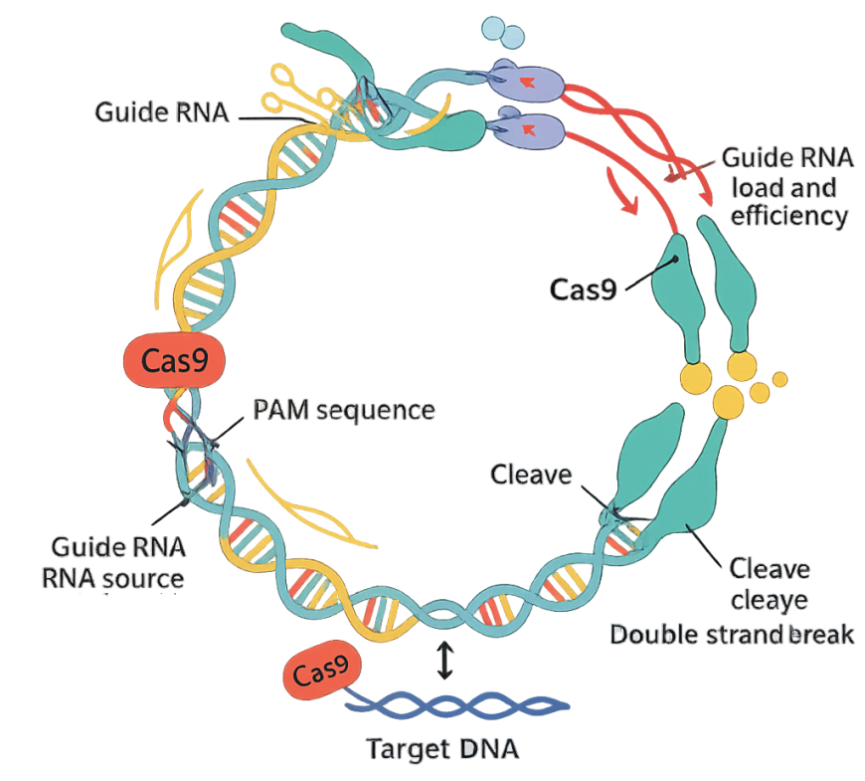
Figure 1. Bacterial Immune Defense Mechanism: A schematic illustrating how bacteria capture viral DNA, integrate it into their genome (CRISPR array), and use Cas proteins to defend against future attacks.

Importance of Cas9 in Modern Biology and Medicine
The Cas9 protein, central to the CRISPR-Cas9 system, has become a transformative tool in both biological research and medicine. Its ability to introduce precise, targeted changes in the genome has revolutionized how scientists study gene function, model diseases, and develop new therapies (Jinek et al., 2012; Komor et al., 2016).
In modern biology, Cas9 is used for a variety of genome engineering tasks, including gene knockout, gene activation, base editing, and prime editing. These techniques enable researchers to systematically investigate the roles of specific genes, unravel complex biological pathways, and conduct large-scale functional genomics studies (Shalem et al., 2014; Anzalone et al., 2020; Seijas et al., 2025). The development of advanced CRISPR-based methods, such as single-cell genomic techniques, has further expanded the possibilities for dissecting cellular diversity and gene regulation at unprecedented resolution (Chen et al., 2024). In medicine, Cas9 holds enormous promise for the treatment of genetic disorders, cancer, and infectious diseases. By correcting disease-causing mutations or disabling harmful genes, Cas9-based therapies have the potential to address the root causes of many conditions. Its potential for treating sickle cell anaemia, beta-thalassemia, and even certain forms of blindness is now being investigated in ongoing clinical studies (Frangoul et al., 2021; Gillmore et al., 2021).

Table 1. Cas9 and Related Nucleases
Nuclease | PAM Sequence | Size (kb) | Delivery Suitability | Notes | Ref
SpCas9 | NGG | ~4.2 kb | Limited by AAV size | Gold standard, widely studied | Cebrian-Serrano, A., & Davies, B. (2017)
SaCas9 | NNGRRT | ~3.2 kb | AAV-compatible | Smaller, good for in vivo use | Allemailem, K. S., Almatroodi (2023)
CjCas9 | NNNNACAC | ~2.9 kb | AAV-compatible | Compact, less studied | Gao, S., (2023)
SpCas9-NG | NG | ~4.2 kb | LNP/RNP | Broader PAM recognition | Mishra, R., Joshi, R. K. (2019)
SpRY | NRN/NYYN | ~4.2 kb | LNP/RNP | Nearly PAM-free | Walton, R. (2020)
Cas12a | 5'-TTTV-3' (V = A, C, or G) | ~3.9kb | Can be packaged into AAV vectors | T-rich PAM | University of Copenhagen, Copenhagen, Denmark. (2020)

3. AN OVERVIEW OF CRISPR-CAS SYSTEMS AND THEIR DEVELOPMENT
Originating in bacteria and archaea as a defence mechanism against viral invasion, the CRISPR-Cas system is an incredibly clever answer for microbial defence found in nature. Imagine bacteria as microscopic warriors, constantly under threat from viral attackers. Their secret weapon is the CRISPR-Cas system—a sophisticated memory bank and precision strike tool rolled into one.
How the System Works
When a virus infects a bacterium, the CRISPR machinery captures a snippet of the invader’s DNA and stores it within the bacterial genome, much like posting a “wanted” sign for future reference. If the same virus attacks again, the bacterium uses this genetic memory to recognize the invader and deploys the Cas proteins to precisely cut and destroy the viral DNA, effectively neutralizing the threat.
Components
The CRISPR-Cas system consists of two main modules:
- Adaptation Module (Memory Keepers): This part collects and stores pieces of viral DNA, creating a historical record of past infections.
- Effector Module (Attack Squad): This component recognizes and eliminates invading genetic material. While the exact evolutionary origins of this module are still being unravelled, it represents a powerful defense mechanism.
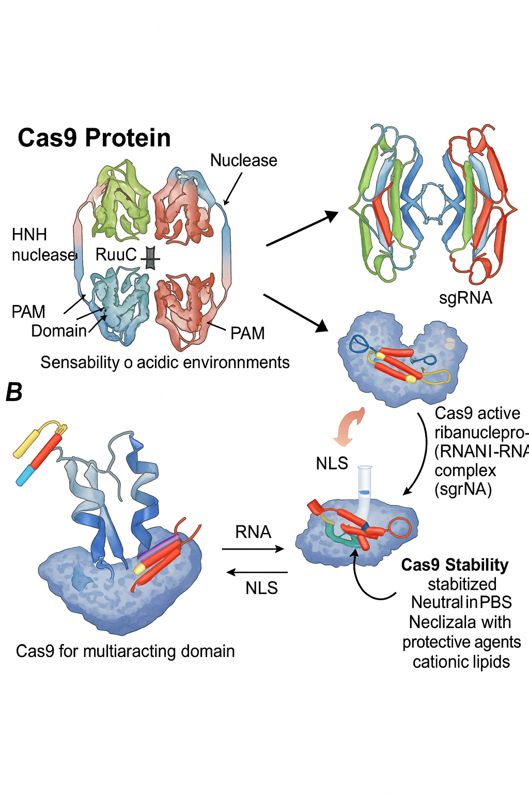
Figure 2. Working of CAS9: A schematic illustrating how CAS-9 works and
key components molecules.

Diversity and Evolution
CRISPR-Cas systems are classified into two broad classes:
Class 1: Utilizes multi-protein complexes to carry out defense functions, working as a coordinated team.
Class 2: Relies on a single, multifunctional protein (such as Cas9) to execute its tasks, making it simpler and more adaptable for genome engineering.
Recent research suggests that some bacteria may have acquired parts of the CRISPR system from ancient stress-response mechanisms, acting as an emergency shutdown to protect the colony. Intriguingly, the same mobile genetic elements that bacteria defend against have, in some cases, hijacked streamlined versions of CRISPR-Cas for their own benefit—a testament to the dynamic evolutionary arms race in the microbial world.
Scientific Significance
The evolutionary journey of CRISPR-Cas systems highlights the remarkable adaptability of microbial life. What began as a microbial immune strategy has now been harnessed by scientists as a revolutionary tool for genome editing, with profound implications for biology, medicine, and biotechnology.
4. STRUCTURE OF CAS9
Composition of Cas9 Protein
Cas9 is a large, multi-domain protein that acts as the molecular “scissors” in the CRISPR-Cas9 genome editing system. Its function depends on maintaining a precise three-dimensional structure, which is sensitive to environmental conditions. When exposed to acidic solutions, Cas9 can lose its native conformation, causing its size in solution to increase dramatically and leading to a loss of activity. This structural sensitivity presents challenges for laboratory handling and for packaging Cas9 into delivery systems like nanoparticles.
Formation of Ribonucleoprotein Complexes
Cas9 does not operate alone; it forms an active ribonucleoprotein (RNP) complex by binding to a guide RNA—typically a single-guide RNA (sgRNA) engineered for genome editing. The sgRNA provides the sequence specificity, directing Cas9 to the exact DNA target site. This partnership is essential: without the guide RNA, Cas9 cannot identify or bind to its intended DNA sequence. The formation of the RNP complex is a crucial preparatory step for efficient and accurate gene editing.
Nuclear Localization
For Cas9 to access and edit genomic DNA, it must enter the nucleus of the cell. Cas9 is equipped with nuclear localization signals (NLS), which function as molecular “address tags.” These signals guide the protein from the cytoplasm into the nucleus, ensuring that Cas9 reaches its site of action. Efficient nuclear localization is vital for successful genome editing, as it allows Cas9 to interact with chromosomal DNA.
Stability and Formulation Considerations
Maintaining the stability of Cas9 is a significant concern, especially during formulation for delivery into cells. Many standard nanoparticle preparation methods use acidic conditions, which can destabilize Cas9 and disrupt its function. To overcome this, researchers have developed gentler formulation protocols, such as using neutral buffers like phosphate-buffered saline (PBS) and incorporating protective agents like cationic lipids. These strategies help preserve the protein’s structure and activity, ensuring that Cas9 remains functional during delivery and gene editing processes.

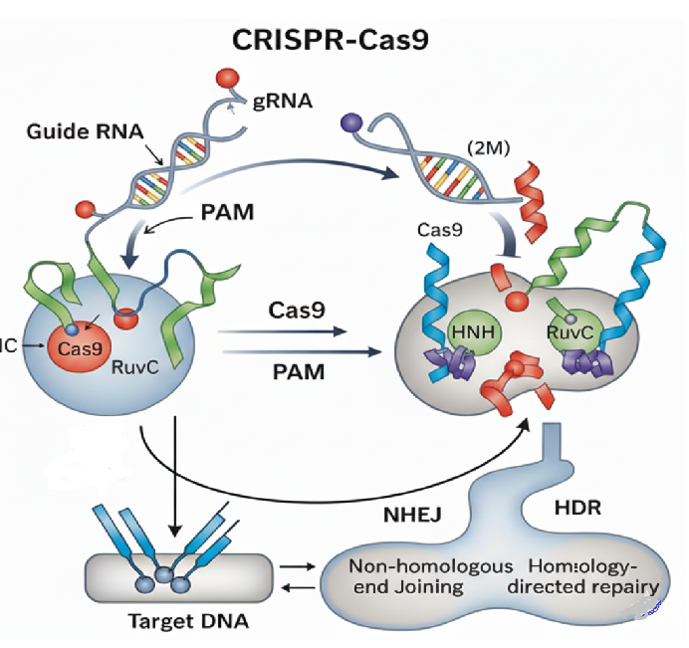
Figure 3. Structure of CAS9: A schematic illustrating how CAS-9, Composition and formation of ribonucleoprotein complexes.

5. MECHANISM OF ACTION
Target Recognition and PAM Sequence
The CRISPR-Cas9 system’s precision begins with its ability to recognize the correct DNA target. This is achieved by a partnership between the Cas9 protein and a guide RNA (usually a single-guide RNA, or sgRNA). The sgRNA contains a sequence that is complementary to the DNA region to be edited, guiding Cas9 to its destination by base pairing with the target DNA. However, Cas9 does not bind indiscriminately; it requires the presence of a short DNA motif adjacent to the target site, known as the protospacer adjacent motif (PAM). For the commonly used Streptococcus pyogenes Cas9 (SpCas9), the PAM sequence is typically “NGG.” The presence of the PAM is essential—it acts as a “landing pad” that allows Cas9 to engage and inspect the DNA for a matching sequence. Without the correct PAM, Cas9 will not bind or cut, even if the guide RNA matches the DNA perfectly.
DNA Cleavage and Activation
Once Cas9, guided by the sgRNA, locates a DNA sequence adjacent to a PAM, it binds tightly to the DNA. This binding triggers a conformational change in the Cas9 protein, activating its nuclease domains. Cas9 possesses two nuclease domains: the HNH domain, which cleaves the DNA strand complementary to the guide RNA, and the RuvC domain, which cuts the non-complementary strand. The coordinated action of these domains results in a precise double-stranded break (DSB) at the target site. This break is the critical event that initiates genome editing, as it signals the cell’s DNA repair machinery to act.
DNA Repair Following Editing
After Cas9 induces a double-stranded break, the cell’s natural DNA repair systems are recruited to fix the damage. The two primary repair pathways are:
Non-Homologous End Joining (NHEJ): This is the most common repair mechanism. It quickly rejoins the broken DNA ends but is prone to errors, often resulting in small insertions or deletions (indels) at the break site. These indels can disrupt gene function, making NHEJ useful for gene knockout experiments.
Homology-Directed Repair (HDR): If a DNA template with homology to the break site is provided, the cell can use this template to accurately repair the break. This allows for precise insertion, deletion, or correction of specific DNA sequences, enabling targeted gene modifications.
The outcome of genome editing depends on which repair pathway the cell uses. NHEJ is efficient but error-prone, while HDR is precise but less frequent in most cell types.
6. ROLE OF GUIDE RNA
Guide RNA (gRNA) is the essential navigator in the CRISPR-Cas9 genome editing system, providing the specificity that allows Cas9 to target and modify precise DNA sequences. In bacteria, the system originally used two separate RNA molecules: the CRISPR RNA (crRNA), which contains the sequence complementary to the target DNA, and the trans-activating crRNA (tracrRNA), which helps assemble the active complex. For genome engineering, scientists have combined these two molecules into a single-guide RNA (sgRNA), streamlining the process and improving efficiency.
The sgRNA acts as a molecular address label, guiding the Cas9 protein to the exact location in the genome that needs editing. It does this through complementary base pairing—matching its own sequence to a specific sequence in the target DNA. Once the sgRNA binds to Cas9, they form a ribonucleoprotein (RNP) complex that can search the genome for the matching DNA sequence.
However, perfect sequence matching is not enough for Cas9 to cut the DNA. The target site must also be adjacent to a short DNA sequence called the protospacer adjacent motif (PAM). The presence of the PAM is critical: it acts as a landing pad that enables Cas9 to bind and activate its cutting function. Without the correct PAM, even a perfectly matched guide RNA will not trigger DNA cleavage.
In summary, the guide RNA serves as both the map and the key for CRISPR-Cas9 genome editing. It determines where Cas9 will act, ensuring that DNA modifications occur only at the intended site. This remarkable specificity underlies the power and versatility of CRISPR technology in research and medicine.

Table 2. Off-Target Detection Methods
Method | Principle | Sensitivity | Advantages | Limitations | Ref
GUIDE-seq | dsODN integration at DSB | High | Detects genome-wide DSBs | Requires cell transfection | Wu, X., Scott (2014)
CIRCLE-seq | In vitro digested | Very high | No cell transfection | May not reflect | Tsai, S. Q., Nguyen  (2017)
Digenome-seq | Whole-genome sequencing after Cas9 cleavage | Moderate | Straightforward, unbiased | High sequencing depth required | Kim, D., Bae, S., (2015).
SITE-seq | Biotinylated adapters at cut sites | High | Enrichment improves signal | More complex workflow | Yan, W. X., Mirzazadeh (2017)
BLISS | Labelling of free DNA ends in fixed. | Very High | In vivo on tissues; independent of endogenous DNA repair pathways. | Technically challenging; may not capture transient off-target events. | Yan, W. X., Mirzazadeh  (2017)
GOTI | Isolation of genomic DNA from individual cells and whole-genome sequencing to identify edited loci. | High | Detects all types of genetic edits (not just DSBs); provides single-cell resolution. | Extremely expensive and labour-intensive due to single-cell sequencing. | Zuo, E., Sun, Y., Wei, W., Yuan (2020)

6. ENGINEERING OF CAS9 AND VARIANTS
Wild-Type SpCas9
The original Cas9 protein, derived from Streptococcus pyogenes (SpCas9), is the foundational tool for CRISPR-based genome editing. In its natural form, SpCas9 is guided by a specific RNA sequence to introduce precise double-stranded breaks (DSBs) in DNA at locations adjacent to an NGG protospacer adjacent motif (PAM). SpCas9’s two-lobed structure—one for DNA recognition and one for DNA cleavage—enables it to efficiently locate and cut its target. The wild-type SpCas9 is highly effective for gene knockout and modification, but its broad DNA-cutting activity can sometimes result in unintended, off-target effects.
Enhanced Cas9 Variants (eSpCas9, HypaCas9, SaCas9)
To improve the precision and versatility of genome editing, scientists have engineered several advanced Cas9 variants:
eSpCas9 and HypaCas9:
These are modified versions of SpCas9 with specific amino acid changes that reduce off-target DNA cleavage. By tweaking the protein’s interaction with the DNA backbone, these variants maintain high on-target activity while greatly minimizing unwanted cuts elsewhere in the genome. This makes them ideal for applications requiring high specificity.
SaCas9:
Sourced from Staphylococcus aureus, SaCas9 is smaller than SpCas9, making it easier to deliver into cells using viral vectors. SaCas9 also recognizes a different PAM sequence (NNGRRT), expanding the range of possible target sites for genome editing. Its compact size and distinct targeting preferences provide researchers with more flexibility in experimental design.
Nickase and Dead Cas9 (dCas9)
By introducing a single amino acid mutation (such as D10A in the RuvC domain), SpCas9 can be converted into a “nickase,” which cuts only one strand of DNA instead of both. This gentler approach reduces the risk of large-scale genomic rearrangements and can be used to promote precise gene correction via homology-directed repair. When two nickases are targeted to nearby sites on opposite DNA strands, they create staggered nicks that enhance editing accuracy while minimizing off-target effects.
Dead Cas9 (dCas9):
Further mutating both nuclease domains produces a catalytically inactive Cas9, known as “dead” Cas9 (dCas9). While dCas9 cannot cut DNA, it retains its ability to bind specific DNA sequences guided by RNA. This property makes dCas9 a versatile platform for applications beyond genome editing, such as gene regulation (CRISPR interference and activation), epigenetic modification, and live-cell imaging of genomic loci.
These engineered Cas9 variants have significantly expanded the CRISPR toolkit, enabling more precise, efficient, and versatile genome manipulation for research, biotechnology, and therapeutic development.
8. DELIVERY SYSTEMS:
The success of CRISPR/Cas9 gene editing mainly depends on the delivery systems. The delivery Systems influence the transfection efficiency, target Specificity, therapeutic potential (Lee, J. H., & Han, J. P., 2024.
Types of Delivery Systems:
Viral Systems:
The Viral vectors include Adeno associated viruses (AAV), Lenti viruses and Adeno associated Viruses. All the above vectors are very efficient to deliver genes. Not only AAVs, but also lentiviruses can encode. This makes them more effective for larger or multiple genetic payloads. These vectors integrate into the genome of the host, and this enables continuing expression of the CRISPR/Cas9 system. It is particularly helpful for applications that demand persistent gene-editing activity. The advantages of viral vectors are High efficiency, Stability in expression (in case of Lenti viruses), low immunogenicity (in case of AAVs) and the challenges are about limited cargo in case of AAVs. The novel and innovative vector systems are Self inactivating Lenti virus and novel AAVs.
Non-Viral Delivery Systems
Non-viral delivery systems are alternative for viral vectors. They are safe and versatile in delivering CRISPR/Cas9 components. The non-viral vehicle has low risk of immunogenicity and low risk of adverse reactions associated with genomic integration (Brokowski, C., & Adli, M. (2019). Lipid nanoparticles (LNPs)have the ability to protect and to encapsulate the CRISPR components, they have the ability to enhance the cellular uptake and enhance the stability against the enzymatic degradation. The structure and composition of helps in fusion with cell membrane, allowing for delivery of CRISPR/Cas9 components to the target cells. The bio reducible lipids like materials such as Cholesterol, 1,2-dioleoyl-sn-glycero-3-phosphorylethanolamine (DOPE), anionic polymers, Polyethylene glycol derived lipids are combined with LNPs in order to improve transfection efficiency upto 90% in both in vivo and in vitro (Brokowski, C., & Adli, M. (2019).
Physical Delivery Methods:
Microinjection
The delivery formats are DNA, mRNA, and protein. Applicable in case of both in vivo and invitro.The benefits are dosage controllable and direct delivery. Main limitation is that microinjection is time consuming process.
Electroporation
Like the Microinjection, the delivery formats are DNA, mRNA and protein. The benefits include easy to operate, No cargo size restriction. Only applicable in Invitro and affects the cell viability.
9. NEXT-GENERATION EDITORS:
The new genome editor delivers higher precision and control than previous gene-editing technologies. It's a basic rundown of important families and how they work. CBEs and ABEs are versatile systems for changing a specific DNA base without DSB formation. This is a big advantage compared to conventional CRISPR which uses DSBs associated with unpredictable indels.
Components
A base editor is composed of a nCas9 coupled with a deaminase enzyme. On the HQDs, the nCas9 separated the DNA, nicks one DNA strand and the deaminase converts the base within this single-stranded DNA.
CBEs (C to T):
Cytosine base editors transform C-G to T-A They contain a cytidine deaminase, which converts cytosine (C) into uracil (U). The U is then processed by the cell's repair mechanisms as a T, leading to a C: T substitution. The fused nCas9 nicks the non-edited strand, and the cell then uses the newly edited strand as a template that repairs the cut.
ABEs (A to G):
Adenine base editors induce conversion of A-T to G-C by means of an adenosine deaminase, which converts the nucleobase adenine (A) to inosine (I). Their DNA replication and repair machinery mistakenly identifies inosine as guanine (G), resulting in an A to G conversion. Off-target RNA Editing Risk: A substantial problem with the first base editors: off-target RNA editing. Deaminase enzymes such as APOBEC1 used in early CBEs are natural RNA editors. Upon expression of the base editor in a cell, the deaminase can non-specifically deaminate cytosine s or adenine s in RNA molecules in the entire transcriptome, without the need for the guide RNA. This can change the activity of thousands of proteins, which could be problematic for therapeutic use. Next generation variants such as SECURE-BE3 and SECURE-ABE have been designed with mutations to minimize this off-target RNA editing while retaining high on-target DNA activity.
Glycosylase Editors:
Glycosylase editors introduce a new type of deaminase-free tools for different base conversions. They don’t depend on deamination, avoiding the off-target risk of RNA editing.
Mechanism: Rather than deamination these editors are based on a DNA glycosylase-like domain fused to a nCas9. The glycosylase removes a particular base, creating an AP site—a sugar-phosphate backbone lacking any base.
Site-Specific Repair:
The cell’s own DNA repair system itself (the base excision repair (BER pathway, senses the AP site and repairs the lesion. With glycosylase and other mates engineered to perfection, researchers are able to program the repair pathway to install a pre-determined base at the AP site.
Applications:
This method provides a new set of base conversions, e.g. transversions (purine-pyrimidine or vice versa), unlike classical deamination-based editors. One such a GBE is a glycosylase-based guanine editor (gGBE), which may convert a G to a T or G to a C.
Prime Editing:
Prime editing is a “cut and paste” technology that provides unique capabilities for editing the genome. It can accommodate the inclusion of any of the 12 classes of single base substitutions and small indels (tens of base pairs) without generating a DSB or relying on a template donor DNA. (Li, M., Lin, Y., Cheng, Q)
Nicking Strategy:
The PE-pegRNA complex is capable of recognizing and interacting with the target DNA. The Cas9 nickase makes a cut in only one strand of the DNA, the PBS of the pegRNA pairs with the nicked strand, the RTT is used as a template for reverse transcriptase to construct the new DNA strand with the inserted edit, which “flaps out” of the original DNA. The natural repair processes to remove the original DNA strand and insert the new, edited stretch take over. In order to increase efficiency and to facilitate the wanted edition. (41)
pegRNA Design:
The system uses a unique guide RNA called pegRNA (prime-editing guide RNA). The pegRNA consists of two functional parts:
Spacer: The guide RNA sequence that locates the Cas9 nickase to the target.
RT Template (Reverse Transcriptase Template): A 3' extension containing the desired edit (e.g., new base or insertion) and a primer binding site.
Indel Profile:
The indels rate is drastically lower than that of DSB-based approaches, because we don’t make a full break in the DNA.' Still, indels are possible, especially for the PE3 system with the second nick.

Table 3. Cas9 Applications in Biomedicine
Application | Target | Outcome | Status | Ref
Sickle Cell Disease | BCL11A enhancer | Reactivate fetal Hb | Clinical trials (Vertex/CRISPR Tx) | Singh, A., Irfan, H., Fatima, E., Nazir, Z., Verma, A (2024)
Cancer Immunotherapy | PD-1 knockout in T cells | Enhanced antitumor activity | Early-phase trials | Ou, X., Ma, Q., Yin, W., Ma, X., & He, Z. (2021)
HIV Therapy | CCR5 | Knockout receptor | Proof-of-concept | Xiao, Q., Guo, D., &
Hemophilia | FVIII or FIX gene | Correct gene to restore clotting factor production | Preclinical and early-phase clinical trials | Lee, J. H., & Han, J. P. (2024).
Duchenne Muscular Dystrophy (DMD) | Dystrophin gene | Restore the gene's reading frame | Preclinical models showing promise, early-stage trials | Lee, J. H., & Han, J. P. (2024).
Cardiovascular Disease | PCSK9 gene | Inactivate gene to reduce cholesterol | Clinical trials for certain genetic forms of high cholesterol | Ou, X., Ma, Q., Yin, W., Ma, X., & He, Z. (2021)

10. SAFETY/ETHICS/REGULATION:
Gene editing brings up some significant ethical issues that our society is still addressing, particularly in the light of technologies like the CRISPR-Cas9 system. What we should and shouldn't do with this powerful ability to alter our genes is more important than scientific evidence alone. (Alsmani, S. S. & Ankara University., 2023)
The differentiation between germline and somatic editing is one of the foremost important ones we must make. To put it a different way, somatic editing involves repairing a genetic defect in the body of an individual cells, such as a gene which triggers an infection in their blood or liver, and the changes are permanent. On a genetic level, it's quite similar to normal medicine. In contrast, germline editing involves altering the DNA of the developing baby or reproductive cells. Additionally, this is where the distinction between "improving" someone's condition and "covering up a disease”.
Besides that, there are numerous ethically tricky technical challenges. There have been some unexpected adverse effects, and the technology isn't absolutely perfect. One is mosaicism, in which some cells but not altogether of them remain altered. Hence, consequence is unpredictable because somebody person could wind up with a mixture of edited and unmodified cells. Large on-target rearrangements are another problem. Here, the CRISPR tool makes the correct cut, but the cell’s natural repair mechanism malfunctions, resulting in significant, undesired DNA changes. These are challenge to identify, and their long-term impacts are unknown, analogous to unconscious landmines in the genome.
The public and scientific community must be transparent and truthful about this research. People need to get involved in the discussion and be aware of what is going on if they are to have faith in this technology. This also has to do with making sure that participants in these types of research are completely aware of the advantages and disadvantages before consenting. To ensure that this potent instrument is used for beneficial purposes and not harm, we require strict regulations and an accountability arrangement.
11. CONCLUSION
The CRISPR-Cas9 method has revolutionised genetic engineering by providing a new level of accuracy and flexibility in DNA editing. Although it first appeared as an immunological defence mechanism in bacteria, Cas9 has since developed into a very useful tool for studying gene function, disease modelling, and the discovery of novel treatment approaches. Its structure and mechanism—relying on a guide RNA for sequence specificity and the presence of a PAM sequence for target recognition—ensure that genome editing can be both targeted and efficient.
Ongoing advancements in Cas9 engineering, such as the development of enhanced variants, nickases, and catalytically inactive forms, have further expanded the system’s applications and minimized off-target effects. These innovations, coupled with improved delivery methods and computational tools, are addressing many of the challenges that initially limited the technology’s clinical potential. Despite some remaining hurdles, including delivery efficiency and immune responses, the CRISPR-Cas9 platform continues to drive breakthroughs in both basic research and medicine.
As the technology matures, it holds immense promise for treating genetic disorders, advancing personalized medicine, and deepening our understanding of biology at the molecular level. The journey of Cas9 from a microbial defense protein to a cornerstone of modern biotechnology exemplifies the power of scientific discovery and innovation.

12. LIST OF ABBREVIATIONS
ABE (Adenine Base Editor), AAV (Adeno-Associated Virus), BER (Base Excision Repair), CBE (Cytosine Base Editor), CRISPR (Clustered Regularly Interspaced Short Palindromic Repeats), CRISPRi (CRISPR Interference), CRISPRa (CRISPR Activation), Cas (CRISPR-Associated Protein), dCas9 (Dead Cas9), DSB (Double-Strand Break), gRNA (Guide RNA), HDR (Homology-Directed Repair), Indel (Insertion/Deletion Mutation), LNP (Lipid Nanoparticle), NHEJ (Non-Homologous End Joining), NLS (Nuclear Localization Signal), PAM (Protospacer Adjacent Motif), PBS (Phosphate-Buffered Saline), pegRNA (Prime Editing Guide RNA), RNP (Ribonucleoprotein), RT (Reverse Transcriptase), SaCas9 (Staphylococcus aureus Cas9), sgRNA (Single Guide RNA), SpCas9 (Streptococcus pyogenes Cas9), TALENs (Transcription Activator-Like Effector Nucleases), and ZFNs (Zinc Finger Nucleases).

REFERENCES
- Khan, M. S., Qureshi, N., Khan, R., Son, Y.-O., & Maqbool, T. (2025). CRISPR/Cas9-based therapeutics as a promising strategy for management of Alzheimer’s disease: Progress and prospects. Frontiers in Cellular Neuroscience, 19, 1578138. https://doi.org/10.3389/fncel.2025.1578138
- Navarro, C., Díaz, M. P., Duran, P., Castro, A., Díaz, A., Cano, C., Carbonell-Zabaleta, A.-K., Solano-Jimenez, D.-S., Rivera-Porras, D., Contreras-Velásquez, J. C., & Bermúdez, V. (2025). CRISPR-Cas systems: A functional perspective and innovations. International Journal of Molecular Sciences, 26(8), 3645. https://doi.org/10.3390/ijms26083645
- Hassan, Y. M., Mohamed, A. S., Hassan, Y. M., & El-Sayed, W. M. (2025). Recent developments and future directions in point-of-care next-generation CRISPR-based rapid diagnosis. Clinical and Experimental Medicine, 25, 33–48. https://doi.org/10.1007/s10238-024-01540-8
- Seijas, A., Cora, D., Novo, M., Al-Soufi, W., Sánchez, L., & Arana, Á. J. (2025). CRISPR/Cas9 delivery systems to enhance gene editing efficiency. International Journal of Molecular Sciences, 26(9), 4420. https://doi.org/10.3390/ijms26094420
- Gonzalez-Avila, L. U., Vega-López, J. M., Pelcastre-Rodríguez, L. I., Cabrero-Martínez, O. A., Hernández-Cortez, C., & Castro-Escarpulli, G. (2021). The challenge of CRISPR-Cas toward bioethics. Frontiers in Microbiology, 12, 657981. https://doi.org/10.3389/fmicb.2021.657981
- Cetin, B., Erendor, F., Eksi, Y. E., Sanlioglu, A. D., & Sanlioglu, S. (2025). Advancing CRISPR genome editing into gene therapy clinical trials: Progress and future prospects. Expert Reviews in Molecular Medicine, 27, e16, 1–33. https://doi.org/10.1017/erm.2025.10
- Jasieniecka, A., & Domingues, I. (2025). CRISPR-Cas9 and its bioinformatics tools: A systematic review. Current Issues in Molecular Biology, 47(5), 307–322. https://doi.org/10.3390/cimb47050307
- Chen, F., Chen, L., Yan, Z., Xu, J., Feng, L., He, N., Guo, M., Zhao, J., Chen, Z., Chen, H., Yao, G., & Liu, C. (2024). Recent advances of CRISPR-based genome editing for enhancing staple crops. Frontiers in Plant Science, 15, 1478398. https://doi.org/10.3389/fpls.2024.1478398.
- Brokowski, C., & Adli, M. (2019). CRISPR ethics: Moral considerations for applications of a powerful tool. Journal of Molecular Biology, 431(1), 88–101. https://doi.org/10.1016/j.jmb.2018.05.044.
- CRISPR/CAS9 delivery systems to enhance gene editing efficiency. (2025). In Int. J. Mol. Sci. (Vol. 26, p. 4420). https://doi.org/10.3390/ijms26094420.
- Nishimasu, H., Ran, F. A., Hsu, P. D., Konermann, S., Shehata, S. I., Dohmae, N., Ishitani, R., Zhang, F., & Nureki, O. (2014). Crystal Structure of Cas9 in Complex with Guide RNA and Target DNA. Cell, 156(5), 935–949. https://doi.org/10.1016/j.cell.2014.02.001.
- Hsu, P. D., Lander, E. S., & Zhang, F. (2014). Development and applications of CRISPR-CAS9 for genome engineering. Cell, 157(6), 1262–1278. https://doi.org/10.1016/j.cell.2014.05.010.
- R, P. G., & K, V. S. (2025). CRISPR/CAS9 and gene editing in Drug delivery: Emerging delivery systems for gene therapy and genome. International Journal of Drug Delivery Technology, 15(01). https://doi.org/10.25258/ijddt.15.1.46.
- Razzaq, A., Masood, A., & Institute of Molecular Biology and Biotechnology, Bahauddin Zakariya University, Multan, Pakistan. (2018). CRISPR/CAS9 system: a breakthrough in genome editing. Molecular Biology: Open Access, 7(2), 1000210. https://doi.org/10.4172/2168-9547.1000210.
- Rees, H. A., & Liu, D. R. (2018). Base editing: precision chemistry on the genome and transcriptome of living cells. Nature Reviews Genetics, 19(12), 770–788. https://doi.org/10.1038/s41576-018-0059-1.
- Hendrickson, E. A. (1 C.E.). Precise genome engineering and the CRISPR revolution (Boldly going where no technology has gone before). In BMBB Department, University of Minnesota Medical School, Minneapolis. https://three.jsc.nasa.gov/articles/CRISPR.pdf.
- Zhang, Y., & Showalter, A. M. (2020). CRISPR/CAS9 genome editing technology: a valuable tool for understanding plant cell wall biosynthesis and function. Frontiers in Plant Science, 11. https://doi.org/10.3389/fpls.2020.589517.
- https://ieeexplore.ieee.org/author/614775320328834
- Rodríguez-Rodríguez, D. R., 1, Ramírez-Solís, R., Garza-Elizondo, M. A., Garza-Rodríguez, M. D. L., Barrera-Saldaña, H. A., Universidad Autónoma de Nuevo León, Institutional core Laboratories, University of Texas Health Science center at San Antonio, Vitagénesis, SA de CV, Monterrey, & Tecnologico de Monterrey, Escuela de Medicina y ciencias de la Salud, Monterrey. (2019). Genome editing: A perspective on the application of CRISPR/Cas9 to study human diseases (Review). In INTERNATIONAL JOURNAL OF MOLECULAR MEDICINE (Vol. 43, pp. 1559–1574). https://doi.org/10.3892/ijmm.2019.4112.
- Kang, K., Song, Y., Kim, I., & Kim, T.-J. (2022). Therapeutic applications of the CRISPR-CAS system. In Bonghee Lee (Ed.), Bioengineering (Vol. 9, p. 477). https://doi.org/10.3390/bioengineering9090477.
- Alsmani, S. S. & Ankara University. (2023). ETHICAL ISSUES CONCERNED WITH CRISPR- CAS9 SYSTEM. https://www.researchgate.net/publication/374529805.
- Allemailem, K. S., Almatroodi, S. A., Almatroudi, A., Alrumaihi, F., Abdulmonem, W. A., Al-Megrin, W. a. I., Aljamaan, A. N., Rahmani, A. H., & Khan, A. A. (2023b). Recent Advances in Genome-Editing Technology with CRISPR/Cas9 Variants and Stimuli-Responsive Targeting Approaches within Tumor Cells: A Future Perspective of Cancer Management. International Journal of Molecular Sciences, 24(8), 7052. https://doi.org/10.3390/ijms24087052.
- Karp, H., Zoltek, M., Wasko, K., Vazquez, A. L., Brim, J., Ngo, W., Schepartz, A., Doudna, J. A., Department of Chemistry, University of California, Berkeley, CA 94720, United States, Innovative Genomics Institute, University of California, Berkeley, CA 94720, United States, Department of Molecular and Cell Biology, University of California, Berkeley, CA 94720, United States, California Institute for Quantitative Biosciences, University of California, Berkeley, CA 94720, United States, Gladstone Institute of Data Science and Biotechnology, Gladstone Institutes, San Francisco, CA 94158, United States, ARC Institute, Palo Alto, CA 94304, United States, Chan Zuckerberg Biohub, San Francisco, CA 94158, United States, & Howard Hughes Medical Institute, University of California, Berkeley, CA 94720, United States. (2025). Packaged delivery of CRISPR–Cas9 ribonucleoproteins accelerates genome editing. Nucleic Acid Therapeutics, gkaf105. https://doi.org/10.1093/nar/gkaf105.
- Ngo, W., Peukes, J., Baldwin, A., Xue, Z. W., Hwang, S., Stickels, R. R., Lin, Z., Satpathy, A. T., Wells, J. A., Schekman, R., Nogales, E., & Doudna, J. A. (2024). Mechanism-guided engineering of a minimal biological particle for genome editing. Proceedings of the National Academy of Sciences, 122(1). https://doi.org/10.1073/pnas.2413519121.
- Cebrian-Serrano, A., & Davies, B. (2017). CRISPR-Cas orthologues and variants: optimizing the repertoire, specificity and delivery of genome engineering tools. Mammalian Genome, 28(7–8), 247–261. https://doi.org/10.1007/s00335-017-96974.
- Gao, S., Wang, Y., Qi, T., Wei, J., Hu, Z., Liu, J., Sun, S., Liu, H., & Wang, Y. (2023). Genome editing with natural and engineered CjCas9 orthologs. Molecular Therapy, 31(4), 1177–1187. https://doi.org/10.1016/j.ymthe.2023.01.029.
- Mishra, R., Joshi, R. K., & Zhao, K. (2019). Base editing in crops: current advances, limitations and future implications. Plant Biotechnology Journal, 18(1), 20–31. https://doi.org/10.1111/pbi.13225.
- https://ieeexplore.ieee.org/author/614775320328834
- Walton, R. T., Christie, K. A., Whittaker, M. N., & Kleinstiver, B. P. (2020). Unconstrained genome targeting with near-PAMless engineered CRISPR-Cas9 variants. Science, 368(6488), 290–296. https://doi.org/10.1126/science.aba8853.
- Paul, B., Montoya, G., & Structural Molecular Biology Group, Novo Nordisk Foundation Centre for Protein Research, Faculty of Health and Medical Sciences University of Copenhagen, Copenhagen, Denmark. (2020). CRISPR-Cas12a: Functional overview and applications. In Biomedical Journal [Journal-article]. https://doi.org/10.1016/j.bj.2019.10.005.
- Tsai, S. Q., Nguyen, N. T., Malagon-Lopez, J., Topkar, V. V., Aryee, M. J., & Joung, J. K. (2017). CIRCLE-seq: a highly sensitive in vitro screen for genome-wide CRISPR–Cas9 nuclease off-targets. Nature Methods, 14(6), 607–614. https://doi.org/10.1038/nmeth.4278.
- Kim, D., Bae, S., Park, J., Kim, E., Kim, S., Yu, H. R., Hwang, J., Kim, J., & Kim, J. (2015). Digenome-seq: genome-wide profiling of CRISPR-Cas9 off-target effects in human cells. Nature Methods, 12(3), 237–243. https://doi.org/10.1038/nmeth.3284.
- Yan, W. X., Mirzazadeh, R., Garnerone, S., Scott, D., Schneider, M. W., Kallas, T., Custodio, J., Wernersson, E., Li, Y., Gao, L., Federova, Y., Zetsche, B., Zhang, F., Bienko, M., & Crosetto, N. (2017). BLISS is a versatile and quantitative method for genome-wide profiling of DNA double-strand breaks. Nature Communications, 8(1). https://doi.org/10.1038/ncomms15058.
- Zuo, E., Sun, Y., Wei, W., Yuan, T., Ying, W., Sun, H., Yuan, L., Steinmetz, L. M., Li, Y., & Yang, H. (2020). GOTI, a method to identify genome-wide off-target effects of genome editing in mouse embryos. Nature Protocols, 15(9), 3009–3029. https://doi.org/10.1038/s41596-020-0361-1.
- Wu, X., Scott, D. A., Kriz, A. J., Chiu, A. C., Hsu, P. D., Dadon, D. B., Cheng, A. W., Trevino, A. E., Konermann, S., Chen, S., Jaenisch, R., Zhang, F., & Sharp, P. A. (2014). Genome-wide binding of the CRISPR endonuclease Cas9 in mammalian cells. Nature Biotechnology, 32(7), 670–676. https://doi.org/10.1038/nbt.2889.
- Singh, A., Irfan, H., Fatima, E., Nazir, Z., Verma, A., Akilimali, A., Department of Internal Medicine, Dow University of Health Sciences, Karachi, Department of Medicine, Shaikh Khalifa Bin Zayed Al Nahyan Medical and Dental College Lahore, Department of Medicine, Services Institute of Medical Sciences, Lahore, Pakistan, Rama Medical College Hospital and Research Center, Hapur, India, Department of research, Medical Research Circle, Goma, Democratic Republic of Congo, & The Author(s). (2024). Revolutionary breakthrough: FDA approves CASGEVY, the first CRISPR/CAS9 gene therapy for sickle cell disease [Journal-article]. ANNS JOURNAL, 4555–4559. http://dx.doi.org/10.1097/MS9.002146.
- Ou, X., Ma, Q., Yin, W., Ma, X., & He, Z. (2021). CRISPR/CAS9 Gene-Editing in Cancer Immunotherapy: Promoting the present revolution in cancer therapy and exploring more. Frontiers in Cell and Developmental Biology, 9. https://doi.org/10.29070/mqdy3790.
- Xiao, Q., Guo, D., & Chen, S. (2019). Application of CRISPR/CAS9-Based gene editing in HIV-1/AIDS therapy. In Jean-Christophe Paillart (Ed.), Frontiers in Cellular and Infection Microbiology (Vol. 9, p. 69) [Journal-article]. https://doi.org/10.3389/fcimb.2019.00069.
- Lee, J. H., & Han, J. P. (2024). In vivo LNP-CRISPR Approaches for the Treatment of Hemophilia. Molecular Diagnosis & Therapy, 28(3), 239–248. https://doi.org/10.1007/s40291-024-00705-1.
- https://orcid.org/my-orcid?orcid=0000-0002-9764-6048
- https://scholar.google.com/citations?user=99wmG2IAAAAJ&hl=en
- Du, Y., Liu, Y., Hu, J., Peng, X., Liu, Z., Department of Pharmaceutics, Xiangya School of Pharmaceutical Sciences, Central South University, Changsha 410013, China, Department of Pharmaceutical Engineering, College of Chemistry and Chemical Engineering, Central South University, Changsha 410083, China, & Molecular Imaging Research Center of Central South University, Changsha 410008, China. (2023). CRISPR/Cas9 systems: Delivery technologies and biomedical applications. In Asian Journal of Pharmaceutical Sciences (Vol. 18, p. 100854).
- Li, M., Lin, Y., Cheng, Q., Wei, T., State Key Laboratory of Stem Cell and Reproductive Biology, Institute of Zoology, Chinese Academy of Sciences, Beijing, China, Key Laboratory of Organ Regeneration and Reconstruction, Institute of Zoology, Chinese Academy of Sciences, Beijing, China, Beijing Institute for Stem Cell and Regenerative Medicine, Beijing, China, University of Chinese Academy of Sciences, Beijing, China, Department of Biomedical Engineering, College of Future Technology, Peking University, Beijing, China, Beijing Advanced Center of RNA Biology, Peking University, Beijing, China, Cheng, Q., & Wei, T. (2025). Prime Editing: a revolutionary technology for precise treatment of genetic disorders [Review]. Cell Proliferation, e13808. https://doi.org/10.1111/cpr.13808.
- The Author(s). (2024). Programmable G-to-Y base editing using engineered DNA glycosylase. Life Medicine, 3, 1–3. https://academic.oup.com/lifemedi.
- Jeong, Y. K., Song, B., Bae, S., Department of Chemistry and Research Institute for Convergence of Basic Sciences, Hanyang University, Seoul 04763, South Korea, & International Research Center for Neurointelligence (WPI-IRCN), The University of Tokyo, Hongo, Bunkyo-ku, Tokyo 113-0033, Japan. (2020). Current status and challenges of DNA base editing tools. In Molecular Therapy (Vols. 28–28, Issue 9, pp. 1938–1938) [Journal-article]. The American Society of Gene and Cell Therapy. https://doi.org/10.1016/j.ymthe.2020.07.021.

***

