Determination of Lethal Dose (LD50) and Observation of Growth Performance of Gamma Irradiation for Induced Mutation in Rice

ABSTRACT
The determination of the optimum radiation dose based on its effects on crop growth attributes is essential for successful mutation breeding. This study aimed to determine the lethal dose 50 (LD50) and assess the growth performance of gamma-irradiated rice mutants of the Nepali Swarna variety. Rice seeds were exposed to gamma irradiation using Cobalt-60 (⁶⁰Co) at eleven dose levels, ranging from 100 to 600 Grays (Gy) in increments of 50 Gy, along with a non-irradiated control (T0). Key growth parameters were evaluated at different time intervals: germination percentage at 7 days, shoot length, root length, shoot fresh weight, root fresh weight, shoot dry weight, and root dry weight at 14 days, and survival percentage at 21 days. The results showed that gamma irradiation significantly influenced all growth parameters compared to the control. The LD50, based on survival percentage, was determined to be 513 Gy. Growth parameter values exhibited a linear decline with increasing radiation doses, with the most pronounced effects observed at 600 Gy. The findings suggest that 513 Gy can be considered an effective dose for inducing genetic variability in Nepali Swarna, balancing mutation induction with minimal lethal effects for subsequent generations.
Keywords: Rice, lethal dose, gamma irradiation, Radiosensitivity

1. INTRODUCTION
Rice (Oryza sativa L.) is one of the most important staple food crops, feeding more than half of the world’s population. Rice is frequently subjected to various environmental stresses, resulting in significant production losses (Ullah et al., 2024). Improving rice varieties to enhance yield, stress tolerance, and disease resistance is essential for global food security (Ullah et al. 2022). A considerable improvement has already been made by exploiting the natural variation through conventional breeding. Conventional breeding methods, while effective, can be time-consuming and limited by genetic constraints. In this context, mutation breeding has emerged as a valuable technique for inducing genetic variability and accelerating the development of improved rice varieties (Yasmine et al., 2019; Viana et al., 2019).
Gamma irradiation is widely used in mutation breeding to induce genetic mutations by altering the DNA structure of plant cells (Yasmine et al., 2019). The mutation breeding method needs preliminary data of optimum dose to result in high diversity using radiosensitivity. Radiosensitivity is a measurement tool to describe the irradiation effect for an irradiated object (Bermawie et al., 2015). However, determining the appropriate radiation dose is crucial, as excessive exposure can lead to severe damage, reduced germination, and plant mortality, while too low a dose may not induce significant genetic changes. The lethal dose 50 (LD50) refers to the radiation level at which 50% of the treated population does not survive, serving as an important benchmark for optimizing mutagenic treatments (Jency et al., 2017).
This study aims to determine the LD50 value of gamma irradiation in rice seeds and observe the subsequent effects on seed germination, seedling vigor, and overall growth performance. By evaluating these parameters, we can identify the optimal radiation dose that maximizes genetic variability while maintaining sufficient plant viability. The findings of this research will contribute to rice breeding programs by facilitating the selection of irradiation doses that enhance desirable agronomic traits, ultimately improving rice productivity and adaptability to environmental stresses.
2. MATERIAL AND METHODS
2.1 Induction of Mutants
For the present study, mature, healthy and disease-free seeds of Nepali Swarna rice was collected from Bangladesh Institute of Nuclear Agriculture (BINA), Mymensingh. The variety was irradiated with different doses of gamma radiation and its effects were studied. The moisture content of seeds was adjusted to 12% prior to irradiation. For gamma irradiation, the rice seeds were subjected to eleven different doses, viz., 100, 150, 200, 250, 300, 350, 400, 450, 500, 550, 600 Gray (Gy) emitted from 60Cobalt gamma source at BINA, Mymensingh. Irradiated seeds were then used for studies immediately after induction. Non-irradiated dry seeds were taken as control.
2.2 Radio Sensitivity Test
2.2.1 Evaluation of Seed Germination
The radio sensitivity test was conducted at the laboratory of Plant Breeding Division, BINA. Standard germination test was conducted using petri plates with moistened paper. For the procedure, 20 irradiated seeds Nepali Swarna were placed on the petri plates at room temperature for seven days, with three replications. Germination was recorded at 7 days and the percentage was calculated by the formula:
Germination%= (Number of seeds germinated/ Total number of seeds) x 100.

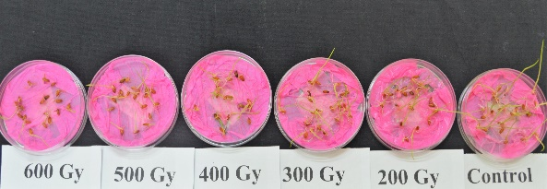
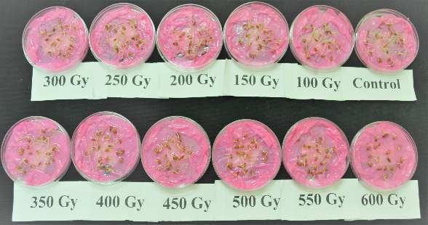
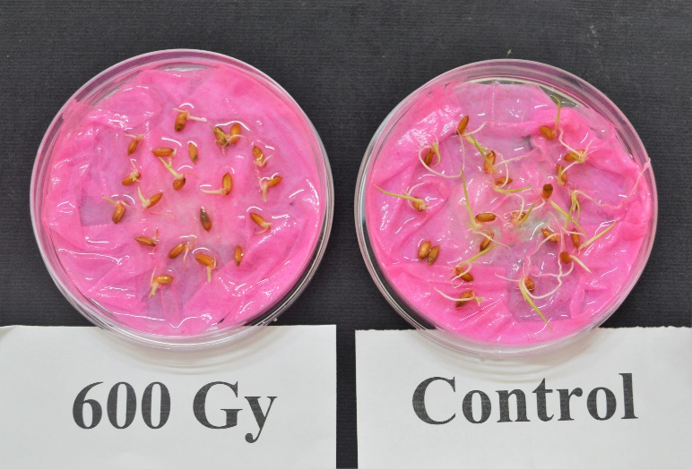
Fig. 1. Germination percentage of γ-irradiated seeds at different doses in the Nepali Swarna rice under controlled conditions

2.2.2 Growth Parameters Study in Hydroponics
For investigating the influence of gamma radiation on plant growth parameters, the pre germinated irradiated seeds were sown with non-irradiate control in hydroponic medium. Nutrient solution was supplied for proper growth and development of plants. In the solution, there was 1g Peter professional and 2.4g FeSO₄ per liter and it was maintained till data collection. Shoot length, root length, shoot fresh weight, root fresh weight, shoot dry weight and root dry weight were recorded precisely at the 14th day after sowing.
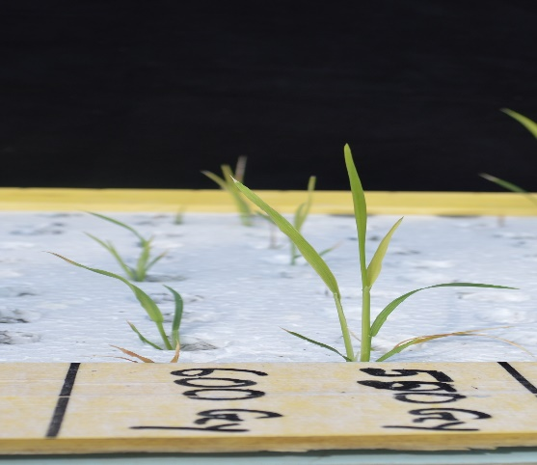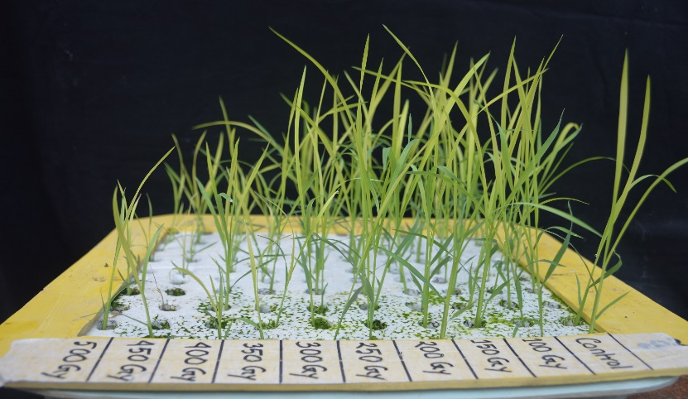
Fig.2. Seedling performance of γ rradiated seeds at different doses in the Nepali Swarna rice under hydroponics conditions

2.2.3 Survibility
The survival percentage was calculated by counting viable seedlings 21 days after sowing in portray under natural condition.
2.2.4. Statistical Analysis
This current experiment was organized based on a completely randomized Block design with three replications. Least Significant Different (LSD) test (P>0.01) was used to investigate the differences in average of all tested parameters between irradiated and non-irradiated plantlets. Therefore, statistical analysis was carried out by using R software.
For estimating the LD50, probit analysis (Finney, 1971; 1978) was conducted on the basis of survival %. The probit function is the inverse cumulative distribution function (CDF) or quantile function associated with the standard normal distribution. The procedure for determination of LD50 using probit analysis is as follows:
1) Transform the dose concentration of mutagen into log10 value.
2) Work out the mortality percentage of seeds due to treatment doses and rounded to the nearest whole number.
3) Calculate the corrected mortality percentage by using Abbott’s formula given below.
M _{observed} – M _{control}
Corrected mortality (%) = ——————————— X 100
100 - M _{control}
5) Convert the corrected values to the probit transformation.
6) Graph probit values (Y-axis) against Log10 concentration (X-axis) and draw a straight line passing through most of the plotted points, then use this line to estimate the Log10 concentration associated with a probit of 5.
7) Take antilog to the Log10 value correspond to the probit 5 and find out the LD50 for the particular mutagen under study
3. RESULT AND DISCUSSION
The study was conducted to determine the influence of gamma irradiation on Nepali Swarna rice genotype. According to the analysis of variance, gamma ray irradiation doses at the germination percentage, survival percentage and growth attributes showed highly significant differences (Table 1).
Table 1. Analysis of variance of seed germination, survivability and growth parameters due to induction of gamma radiation
Source of variation | df |  |  | Mean sum of square
Source of variation | df | %Ger | %Sur | RL (cm) | SL (cm) | RFW (g) | SFW (g) | RDW (g) | SDW (g)
Treatments | 11 | 188.57*** | 804.75*** | 14.98*** | 54.761 *** | 0.023*** | 0.436*** | 0.0005*** | 0.01267***
Error | 24 | 25.694 | 5.53 | 0.1398 | 0.202 | 0.000725 | 0.03110 | 0.0000104 | 0.0002226

*** significant at P ≤0.001; % Ger=Germination percentage, % Sur= Survival percentage, RL=Root length, SL=Shoot length, RFW=Root fresh weight, SFW=Shoot fresh weight, RDW= Root dry weight & SDW= Shoot dry weight

3.1 Determination of LD50 Dose of Mutagens
Optimum dose is the dose that cause maximum of mutation with minimum of damage to the plant and the widely accepted method to achieve the maximum mutation count is “Half Lethal Dosage” among the treated population (Vasline, 2013). In the present investigation, the LD50 values for Nepali Swarna was determined with the help of probit analysis based on the survival percentage of seedlings from the seeds treated with different doses of gamma rays (Figure 3). The results obtained for observed mortality percentage for gamma rays treated population are presented in Table 2. The result on this study exhibit that, the LD₅₀ dose for Gamma rays on Nepali Swarna was 513 Gy. It was observed that the survival of seedlings was gradually reduced with the increase doses of gamma rays. The similar results were observed in their study conducted in rice (Vasaline, 2013; Harding et al., 2012)
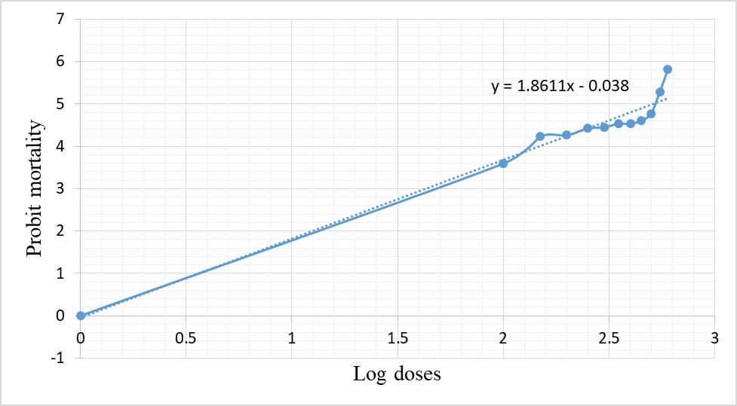
Fig. 3. Calculation of LD50 using Probit Analysis for Nepali Swarna rice genotype
Table 2. Calculation of LD50 for M1 population of Nepali Swarna treated with gamma rays using probit analysis
Gamma rays | Log₁₀ doses | Observed mortality percentage | Corrected mortality percentage | Empirical probit unit | LD₅₀ value
Control | 0 | 22 | - | - | 513
100Gy | 2 | 28 | 8 | 3.59 | 513
150Gy | 2.18 | 38 | 21 | 4.23 | 513
200Gy | 2.3 | 39 | 22 | 4.26 | 513
250Gy | 2.4 | 42 | 26 | 4.42 | 513
300Gy | 2.48 | 43 | 27 | 4.45 | 513
350Gy | 2.54 | 46 | 31 | 4.53 | 513
400Gy | 2.6 | 46 | 31 | 4.53 | 513
450Gy | 2.65 | 48 | 33 | 4.61 | 513
500Gy | 2.7 | 53 | 40 | 4.77 | 513
550Gy | 2.74 | 69 | 60 | 5.28 | 513
600Gy | 2.78 | 83 | 78 | 5.81 | 513

3.2 Percentage of Germination and Survival
The germination and survival percentage are very crucial factor for determining the viability and seedling vigor of an irradiation study respectively as it determines the extent of radiation mediated lethal effects. A significant decrease in germination % and survival % were observed with an increase in treatment doses (Figure 4). In Nepali Swarna, the highest germination% (91.67) was observed in plates treated with 0 Gy, while least germination% (66.67) was recorded in the treatment dose of 600 Gy. The decline in germination was significantly different in all the treatment doses under laboratory conditions. A decline in survival % was also recorded with an increase in dosage of gamma radiation. The lowest survival % (17.67) was recorded at the dose of 600 Gy whereas the highest survival % (78) was observed at 0 Gy. Previous studies have reported lethal effects of gamma radiation (Singh et al.,2010; Sao et al., 2020; Muhammad et al., 2021) a similar decline in seed germination, survival %. The increased mortality might be linked to tissue damage and/or alteration of vital cellular functions which inhibited the growth and lead to eventual death of the embryo. Accordingly, Ke et al., (2019) and Shimelis et al., (2019) observed, the mutagen might have an inhibitory action on plumule and radical, which would have resulted in reduced seed germination as well.
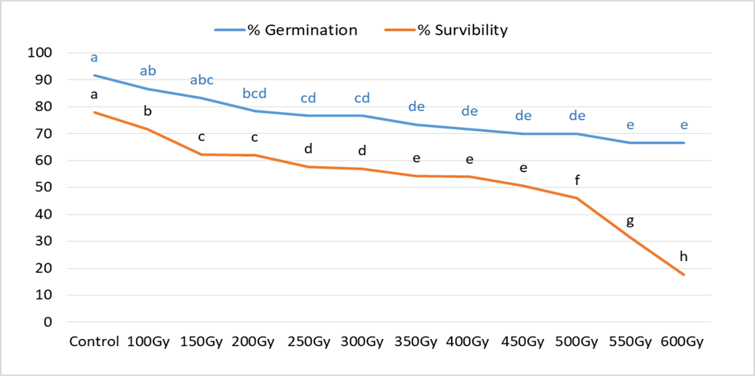
Fig. 4. %Germination and % Survival of γ-irradiated seeds at different doses in the variety Nepali Swarna under hydroponic conditions

3.3 Growth Attributes
A pragmatic reduction in growth was observed in the treatments with an increase in dose of radiation, as compared to untreated control. All the parameters, seedling length (both shoot length and root length), root fresh weight, shoot fresh weight, root dry weight and shoot dry weight were significantly reduced as compared to the untreated control (Figure 5 & 6). At the 600Gy, all the parameter showed least performance and increased gradually with a decrease in dose of radiation. Similar decline was reported in Lathyrus, where a dose of above 150 Gy resulted in decline in seedling growth, seedling dry weight and chlorophyll content (Beyaz et al., 2016). The decline in plant height might be due to chromosomal damage resulting in premature activation of protein synthesis as documented previously (Talebi et al., 2012; Jaipo et al., 2019). Previous researchers have reported the decrement in growth attributes owing to modifications in enzyme activity, enzyme degradation (Roslim et al.,2019), damage to cellular constituents and/or cellular DNA (Monica et al., 2017; Rakszegi et al., 2010).
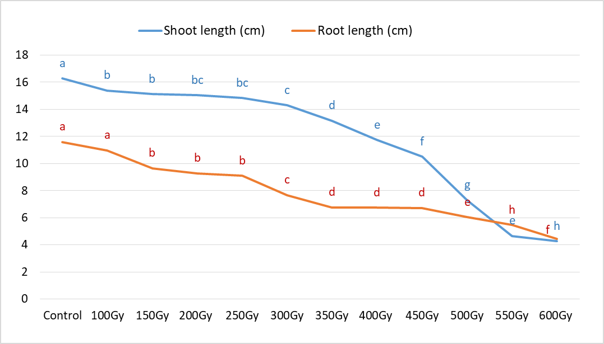
Fig. 5. Shoot length and Root length of γ-irradiated seeds at different doses in the variety Nepali Swarna under hydroponic conditions

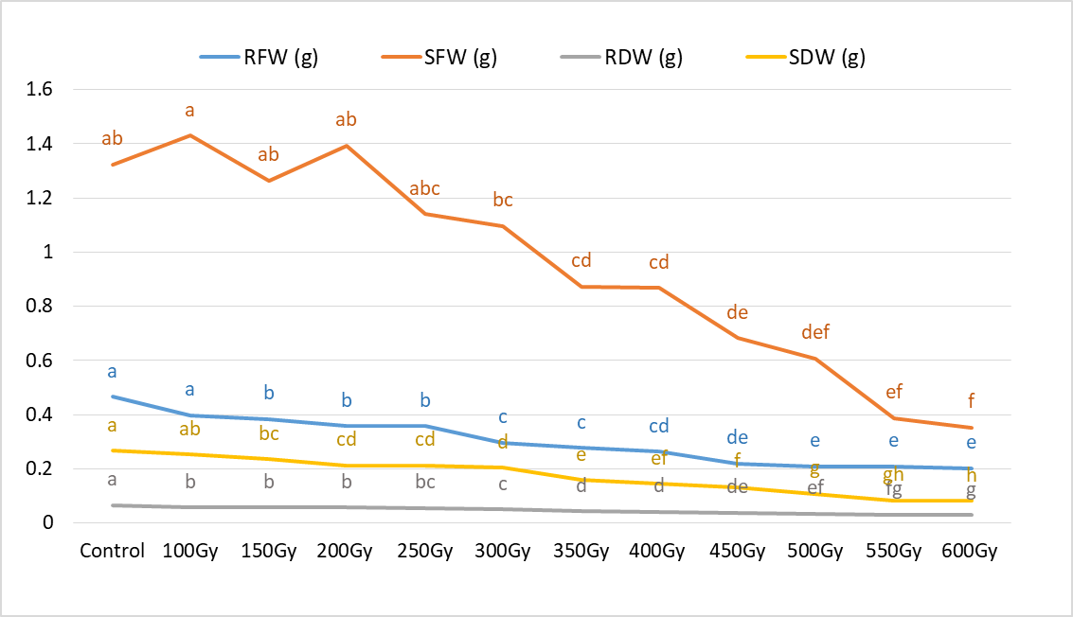
Fig. 6. RFW=Root fresh weight, SFW=Shoot fresh weight, RDW= Root dry weight & SDW= Shoot dry weight of γ-irradiated seeds at different doses in the variety Nepali Swarna under hydroponic conditions

4. CONCLUSION
This study concluded that gamma irradiation significantly affected germination, survival percentage, and seedling growth parameters of the Nepali Swarna rice variety. An increase in radiation dose led to a progressive decline in seedling growth characteristics, with complete seedling mortality observed at 600 Gy. The lethal dose 50 (LD50) was determined to be 513 Gy, which was identified as the optimal dose for inducing mutations while maintaining sufficient plant viability. This dose can be effectively utilized in mutation breeding programs for the genetic improvement of Nepali Swarna, facilitating the development of new rice variants with desirable agronomic traits.
CONFLICTS OF INTEREST
The authors declare no conflict of interest.

REFERENCES
Bermawie, N., Meilawati, N. L. W., Purwiyanti, S., & Melati, M. (2015). Pengaruh iradiasi sinar gamma (60Co) terhadap pertumbuhan dan produksi jahe putih kecil (Zingiber officinale var. a ma rum). Industrial Crops Research Journal, 21(2), 47-56.
Beyaz, R., Kahramanogullari, C. T., Yildiz, C., Darcin, E. S., & Yildiz, M. (2016). The effect of gamma radiation on seed germination and seedling growth of Lathyrus chrysanthus Boiss. under in vitro conditions. Journal of environmental radioactivity, 162, 129-133.
Finney, D. J. (1971). Probit analysis, Cambridge University Press. Cambridge, UK, 1-333.
Finney, D. J. (1978). Statistical method in biological assay (No. Ed. 3, p. 508pp).
Harding, S.S., S. D. Johnson, D. R. Taylor and C. A. a. T. M. Y. Dixon. (2012). Effect of gamma rays on seed germination, seedling height, survival percentage and tiller production in some rice varieties cultivated in Sierra Leone. American Journal of Experimental Agriculture, 2(22): 247-255.
Jaipo, N., Kosiwikul, M., Panpuang, N., & Prakrajang, K. (2019, November). Low dose gamma radiation effects on seed germination and seedling growth of cucumber and okra. In Journal of physics: Conference series (Vol. 1380, No. 1, p. 012106). IOP Publishing.
Jency, J. P., Ravikesavan, R., Sumathi, P., & Raveendran, M. (2017). Effect of chemical mutagen on germination percentage and seedling parameters in Kodomillet variety Co 3. International Journal of Chemical Studies, 5(2), 166-169.
Ke, C., Guan, W., Bu, S., Li, X., Deng, Y., Wei, Z., ... & Zheng, Y. (2019). Determination of absorption dose in chemical mutagenesis in plants. PloS one, 14(1), e0210596.
Monica, S., & Seetharaman, N. (2017). Mutagens induced chromosomal damage in Lablab purpureus (L.) Sweet var. typicus. Cytology and Genetics, 51(3), 230-237.
Muhammad, I., Rafii, M. Y., Nazli, M. H., Ramlee, S. I., Harun, A. R., & Oladosu, Y. (2021). Determination of lethal (LD) and growth reduction (GR) doses on acute and chronic gamma-irradiated Bambara groundnut [Vigna subterranea (L.) Verdc.] varieties. Journal of Radiation Research and Applied Sciences, 14(1), 133-145.
Rakszegi, M., Kisgyörgy, B. N., Tearall, K., Shewry, P. R., Láng, L., Phillips, A., & Bedő, Z. (2010). Diversity of agronomic and morphological traits in a mutant population of bread wheat studied in the Healthgrain program. Euphytica, 174(3), 409-421.
Roslim, D. I., & Fiatin, I. S. R. O. (2015). Lethal dose 50 (ld 50) of mungbean (Vigna radiata L. Wilczek) cultivar kampar. SABRAO Journal of Breeding & Genetics, 47(4).
Sao, R., P. K. Sahu, D. Sharma, G. Vishwakarma, J. P. Nair and V. C. a. D. B. K. Petwal. (2020). Comparative study of radio-sensitivity and relative biological effectiveness of gamma rays, X-rays, electron beam and proton beam in short grain aromatic rice, Indian Journal of Genetics and Plant Breeding, 80 (4): 384-394.
Shimelis, H. A., Olaolorun, B. M., Mathew, I., & Laing, M. D. (2019). Optimising the dosage of ethyl methanesulphonate mutagenesis in selected wheat genotypes. South African Journal of Plant and Soil, 36(5), 357-366.
Singh, B., & Datta, P. S. (2010). Gamma irradiation to improve plant vigour, grain development, and yield attributes of wheat. Radiation Physics and Chemistry, 79(2), 139-143.
Talebi, R., Fayaz, F., & Karami, E. (2012). Morphometric and amplified fragment length polymorphism marker analysis in some landrace wheat (Triticum aestivum) genotypes collected from north-west Iran. Exp. Biol, 10, 49-56.
Ullah, M. A., Abdullah-Zawawi, M. R., Sukiran, N. L., Uddin, M. I., Ismail, I., & Zainal, Z. (2024). In silico approach to investigate the potential HKT gene responsive to salt stress in rice. CABI Agriculture and Bioscience, 5(1), 49.
Ullah, M. A., Abdullah-Zawawi, M. R., Zainal-Abidin, R. A., Sukiran, N. L., Uddin, M. I., & Zainal, Z. (2022). A review of integrative omic approaches for understanding rice salt response mechanisms. Plants, 11(11), 1430.
Vasline, A.Y. (2013). An investigation on induced mutations in rice (Oryza sativa L.). Pl. Arch., 13 (1): 555-557
Viana, V. E., Pegoraro, C., Busanello, C., & Costa de Oliveira, A. (2019). Mutagenesis in rice: the basis for breeding a new super plant. Frontiers in plant science, 10, 1326.
Yasmine, F., Ullah, M. A., Ahmad, F., Rahman, M. A., & Harun, A. R. (2019). Effects of chronic gamma irradiation on three rice varieties. Jurnal Sains Nuklear Malaysia, 31(1), 1-10.

