Case Report

Cystic hygroma in early pregnancy: case report and literature review

ABSTRACT

Aims: To report a case of fetal cystic hygroma diagnosed in the first trimester and highlight its clinical, diagnostic, and prognostic implications in light of current.literature.
Study Design: Case report and literature review.Place and Duration of Study: Department of Gynecology and Obstetrics, Souissi Maternity Hospital, Ibn Sina University Hospital Center, Rabat, Morocco, 2024.
case presentation: We present the case of a 42-year-old nulliparous woman with a history of miscarriage and consanguinity, admitted for metrorrhagia and abdominal pain at 10 weeks of gestation. Clinical evaluation and ultrasound were performed, followed by monitoring of pregnancy outcome.
Results: Ultrasound revealed a missed miscarriage associated with a multiloculated cervical/nuchal cystic hygroma. The pregnancy ended in spontaneous abortion shortly after admission. Literature review indicates that cystic hygroma is strongly associated with chromosomal abnormalities, particularly Turner syndrome and trisomies [1–5], as well as a high risk of perinatal mortality [6–10]. Genetic testing was declined by the patient, preventing confirmation of underlying etiology.
Conclusion: Cystic hygroma is a rare but severe anomaly with a poor prognosis, often linked to chromosomal or structural abnormalities [3,7,11–13]. Early prenatal ultrasound detection and genetic testing are essential for appropriate counseling and management, particularly in resource-limited settings [14–17].

Keywords: Cystic hygroma, lymphatic malformation, nuchal translucency, chromosomal abnormalities, Turner syndrome, prenatal diagnosis, case report

1. INTRODUCTION

Cystic hygroma (CH) is a rare congenital lymphatic malformation characterized by multiloculated cystic masses, most frequently located in the cervical region [1]. It results from abnormal development of the lymphatic system and failure of communication with the venous network during embryogenesis. The reported incidence ranges from 0.3% to 2% of fetuses [2,3], with a strong association with chromosomal abnormalities, particularly Turner syndrome and trisomies [4,5]. Prognosis is generally poor, with high rates of miscarriage, perinatal death, and congenital malformations [6–8]. Early ultrasound detection and cytogenetic analysis are essential for diagnosis and counseling [9–11]. This report presents a first-trimester case of cystic hygroma and discusses its clinical, diagnostic, and prognostic implications in light of current literature [12–17].

2. CASE PRESENTATION

A 42-year-old nulliparous woman, with a history of spontaneous abortion and first-degree consanguinity, presented to the emergency department with metrorrhagia and abdominal pain. She reported three months of amenorrhea with recent minimal bleeding over five days. On examination, she was hemodynamically stable and afebrile. Gynecological assessment revealed a moderate amount of reddish intrauterine bleeding and a cervix dilated to 2 cm.
Pelvic ultrasound demonstrated a missed miscarriage corresponding to 10 weeks of gestation, associated with a multiloculated cystic cervical/nuchal hygroma [3,7]. No additional malformations were observed at that time. The patient was admitted for monitoring, and two hours later, spontaneous abortion occurred.
No genetic or cytogenetic testing could be performed, as the patient declined further investigations. Family history was unremarkable, and no teratogenic exposure was identified.

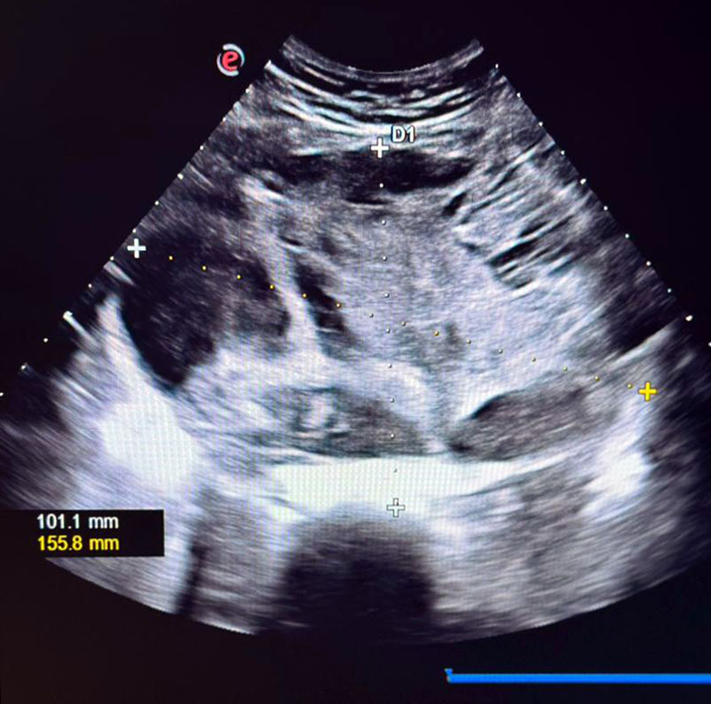
Figure 1. First-trimester ultrasound showing a multiloculated cystic cervical/nuchal mass consistent with cystic hygroma (transverse view, measurements indicated).
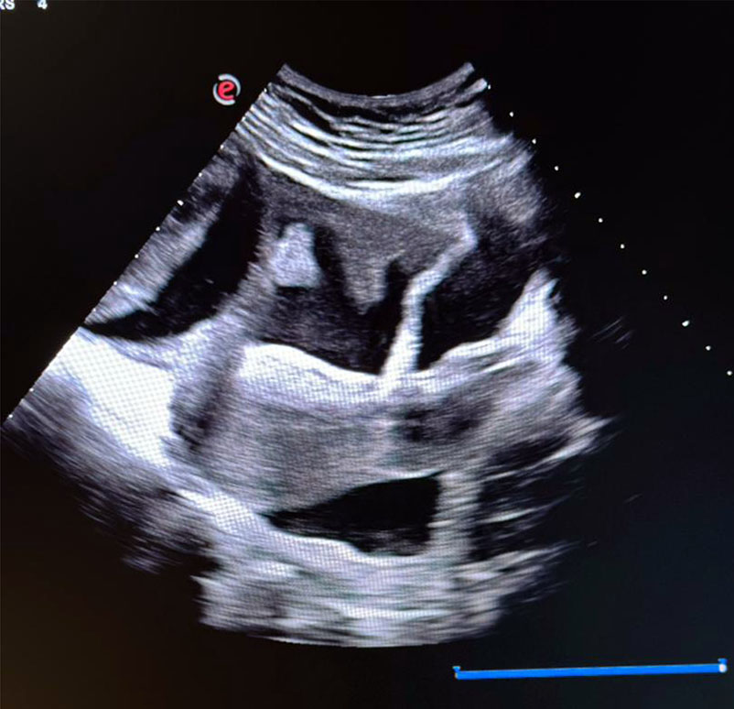
Figure 2. Sagittal ultrasound image demonstrating septated cystic hygroma extending posteriorly.

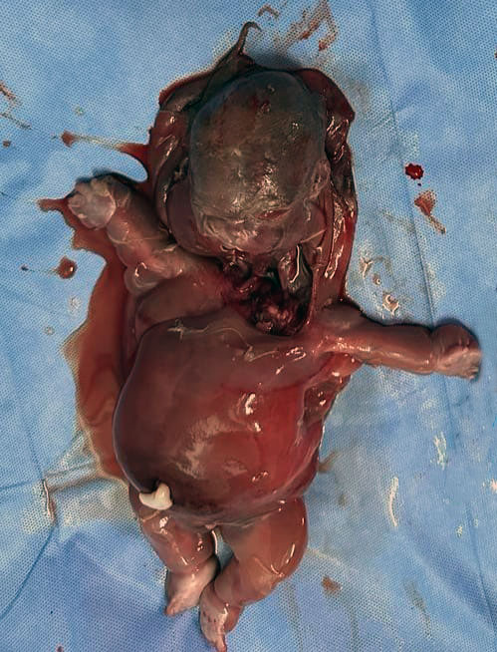
Figure 3. Post-abortion macroscopic image of the fetus with a large cervical cystic hygroma.

3. DISCUSSION

The ultrasound findings in our patient (Figure 1, Figure 2) revealed a missed miscarriage associated with a multiloculated cervical/nuchal cystic hygroma. This presentation is consistent with the echographic criteria distinguishing cystic hygroma from increased nuchal translucency [2,5,9]. The spontaneous abortion that occurred shortly after hospitalization reflects the poor prognosis generally associated with this anomaly [6,10].
Cystic hygroma is strongly linked to chromosomal abnormalities, particularly Turner syndrome and trisomies 21, 18, and 13 [3,7,12]. Reported series indicate aneuploidy in approximately 50% of cases, with additional risks of cardiac malformations and hydrops fetalis, which further worsen outcomes [8,11,13]. Although genetic testing was not performed in our case due to patient refusal, the association of maternal age, consanguinity, and early fetal loss raises strong suspicion of an underlying chromosomal or genetic disorder [14,15].
Several studies have emphasized that cystic hygroma diagnosed in the first trimester carries a significantly higher risk of adverse pregnancy outcomes compared to isolated nuchal translucency [9,12,16]. Early recognition should therefore prompt systematic karyotyping and a careful search for associated malformations. In resource-limited settings, however, access to genetic testing remains restricted, limiting comprehensive etiological evaluation and counseling [13,17].
This case illustrates the prognostic severity of cystic hygroma and highlights the need for early ultrasound screening and multidisciplinary management to optimize care and inform parental decision-making [10,15–17].

4. CONCLUSION

Cystic hygroma is a rare congenital lymphatic malformation strongly associated with chromosomal and structural abnormalities [1–4,7]. Our case illustrates its early prenatal detection and unfavorable outcome with spontaneous abortion. Early ultrasound recognition and cytogenetic assessment are crucial for accurate diagnosis and counseling [5,11,16]. Multidisciplinary management, when available, can help guide prognosis and optimize parental support, especially in resource-limited settings [14–17].

18. DEFINITIONS, ACRONYMS, ABBREVIATIONS.
19. CH: Cystic Hygroma
NT: Nuchal Translucency
US: Ultrasound
SA: Semaines d’Aménorrhée (Weeks of Amenorrhea)
CNV: Copy Number Variation
PND: Prenatal Diagnosis

CONSENT

Written informed consent was obtained from the patient’s parents for the publication of this case report and any accompanying images. A copy of the written consent is available for review by the editorial office/chief editor/editorial board members of this journal.

ETHICAL APPROVAL
Not applicable. Written informed consent for publication was obtained from the patient.

REFERENCES

1. Fonkalsrud EW. Lymphatic disorders. In: Grosfeld JL, O’Neill JA Jr, Coran JA, Fonkalsrud EW, Caldamone AA, editors. Pediatric Surgery. 6th ed. Chicago: Mosby Elsevier; 2006. p. 2137–2145.

2. Aly-Abbara. Hygroma kystique cervical [Internet]. Available from:.

3. Lajeunesse C, Stadler A, Trombert B, Varlet MN, Patural H, Prieur F, et al. Hygroma kystique découvert à l’échographie obstétricale du 1er trimestre: caractéristiques échographiques, caryotypiques et devenir de la grossesse. J Gynecol Obstet Biol Reprod. 2014; 43(6):455–462.

4. Ducarme G, Graesslin O, Alanio E, Bige V, Gaillard D, Gabriel R. Hyperclarté nucale et hygroma cervical au premier trimestre de la grossesse: diagnostic prénatal et devenir néonatal. Gynecol Obstet Fertil. 2005; 33:750–754.

5. Malone FD, Ball RH, Nyberg DA, Comstock CH, Saade GR, Berkowitz RL, et al. First trimester septated cystic hygroma: prevalence, natural history, and pediatric outcome. Obstet Gynecol. 2005; 106(2):288–294.

6. Paolino-Giacobino A, Extermann DP, Dahoun SY. Pregnancy outcome of 30 fetuses with cystic hygroma diagnosed during the first 15 weeks of gestation. Genet Couns. 2003; 14(4):413–418.

7. Gedikbasi A, Oztarhan K, Aslan G, Demirali O, Akyol A, Sargin A, et al. Multidisciplinary approach in cystic hygroma: Prenatal diagnosis, outcome, and postnatal follow-up. Pediatr Int. 2009; 51(5):670–677.

8. Scholl J, Durfee SM, Russell MA, Heard AJ, Iyer C, Alammari R, et al. First-trimester cystic hygroma: relationship of nuchal translucency thickness and outcomes. Obstet Gynecol. 2012; 120(3):551–559.

9. van Zalen-Sprock RM, van Vugt JM, van Geijn HP. First-trimester diagnosis of cystic hygroma—course and outcome. Am J Obstet Gynecol. 1992; 167(1):94–98.

10. Brumfield CG, Wenstrom KD, Davis RO, Owen J, Cosper P. Second-trimester cystic hygroma: prognosis of septated and nonseptated lesions. Obstet Gynecol. 1996; 88(6):979–982.

11. Shulman LP, Raafat NA, Mace PC, Emerson DS, Felker RE, Simpson JL, et al. Significance of septations in isolated fetal cystic hygroma detected in the first trimester. Prenat Diagn. 1994; 14(3):223–226.

12. Podobnik M, Singer Z, Podobnik-Sarkanji S, Bulić M. First trimester diagnosis of cystic hygromata using transvaginal ultrasound and cytogenetic evaluation. J Perinat Med. 1995; 23(4):283–291.

13. Schreurs L, Cokic S, Bosschieter P, Pajkrt E, Bilardo CM. First-trimester cystic hygroma colli: retrospective analysis of associated anomalies and outcomes. Eur J Obstet Gynecol Reprod Biol. 2018; 231:60–64.
14. Howarth ES, Draper ES, Budd JLS, Konje JC, Clarke M, Kurinczuk JJ. Population-based study of the outcome following the prenatal diagnosis of cystic hygroma. Prenat Diagn. 2005; 25(4):286–291.

15. Noia G, Pellegrino M, Masini L, Visconti D, Manzoni C, Chiaradia G, et al. Fetal cystic hygroma: the importance of natural history. Eur J Obstet Gynecol Reprod Biol. 2013; 170(2):407–413.

16. Malone FD, D’Alton ME, Craigo SD, Fuchs KM, Weiner S, Ecker JL, et al. Fetal cystic hygroma. Fetal Diagn Ther. 2021; 48(12):842–852.

17. Sanhal CY, Uygur D, Yildirim G, Ozgu-Erdinc AS, Yalvac S, Karaagaoglu E, et al. Mid-trimester fetal cystic hygroma: prenatal diagnosis and outcomes. Braz J Med Biol Res. 2014; 47(9):799–803.

