Case report

Intracardiac Thrombi in Children: A Five-Case Series and Literature Review

.
ABSTRACT

Aims: To report a pediatric series of intracardiac thrombi and to discuss their clinical, diagnostic, and therapeutic aspects in the light of current literature.
Study Design: Case series and literature review.
Place and Duration of Study: Department of Pediatrics, Children’s Hospital, Rabat, Morocco, 2023–2024.
Methodology: We retrospectively analyzed five pediatric patients aged 3 months to 13 years who were diagnosed with intracardiac thrombi of various etiologies. Clinical data, laboratory tests, imaging results, therapeutic strategies, and outcomes were collected from medical records.
Results: The series included five children: one adolescent with hyperhomocysteinemia complicated by a left ventricular thrombus, a premature infant with a central venous catheter and right atrial thrombus, a 7-month-old with severe heart failure and left ventricular thrombus, a teenager with Behçet’s disease and right ventricular thrombus, and an infant with protein C/S deficiency and left ventricular thrombus. Management relied mainly on anticoagulation with low-molecular-weight heparin and vitamin K antagonists, alongside etiological treatments when indicated. Outcomes were variable: two patients died, two showed favorable recovery, and one was lost to follow-up.
Conclusion: Intracardiac thrombi in children are rare but potentially fatal conditions. Early recognition using echocardiography and timely initiation of anticoagulation are essential to prevent embolic complications. Prognosis depends on underlying pathology and rapid multidisciplinary management. Preventive strategies should address modifiable risk factors such as catheterization and uncorrected coagulation disorders.

Keywords: Intracardiac thrombus; children; anticoagulation; echocardiography; hypercoagulability; congenital disorders; case series.

1. INTRODUCTION

Intracardiac thrombi are rare but serious conditions in the pediatric population, with potentially life-threatening consequences due to systemic or pulmonary embolism [1–3]. Their true prevalence remains difficult to establish, as most data come from adult cohorts and pediatric cases are reported mainly as isolated observations or small series [4,5]. Nevertheless, improvements in echocardiography and cardiac magnetic resonance imaging have enhanced the recognition of these thrombi in children [6,7].
The pathogenesis is explained by Virchow’s triad, which combines endothelial injury, blood stasis, and hypercoagulability [8,9]. In children, several predisposing factors have been identified, including congenital heart disease, dilated cardiomyopathy, systemic inflammatory disorders such as Behçet’s disease, and hematological abnormalities like protein C or S deficiency or hyperhomocysteinemia [10–13]. Iatrogenic causes, particularly central venous catheters, are also major contributors in neonates and infants [14,15].
Diagnostic confirmation relies primarily on transthoracic echocardiography, which is widely available and non-invasive [16]. Transesophageal echocardiography and cardiac MRI provide additional accuracy in evaluating thrombus size, mobility, and risk of embolization [17,18].
Management is not standardized in pediatrics and is often extrapolated from adult guidelines. Anticoagulation with unfractionated heparin, low-molecular-weight heparin, or vitamin K antagonists remains the mainstay of therapy [19,20]. Surgical thrombectomy may be considered in selected cases with large, mobile, or refractory thrombi [21]. Despite these measures, prognosis remains guarded, and mortality is high in infants with severe underlying disease [22,23].
Recent reviews stress the importance of early recognition and multidisciplinary management to improve outcomes [24–26]. The aim of this article is to present five pediatric cases of intracardiac thrombi of diverse etiologies and to discuss their clinical, diagnostic, and therapeutic implications in the light of current literature.

2. CASE PRESENTATION

Case 1. A 13-year-old boy with no significant perinatal or surgical history was referred for evaluation of asthenia, exertional dyspnea, and abdominal pain. Physical examination revealed hepatomegaly without signs of heart failure. Laboratory investigations showed elevated homocysteine (15.8 µmol/L) with normal protein C, protein S, and antithrombin III. Transthoracic echocardiography demonstrated left ventricular dysfunction with global hypokinesia and a large intraventricular thrombus. He was treated with low-molecular-weight heparin, heart failure therapy, and metabolic correction with folate and vitamins. Follow-up echocardiography after one year confirmed complete thrombus resolution.

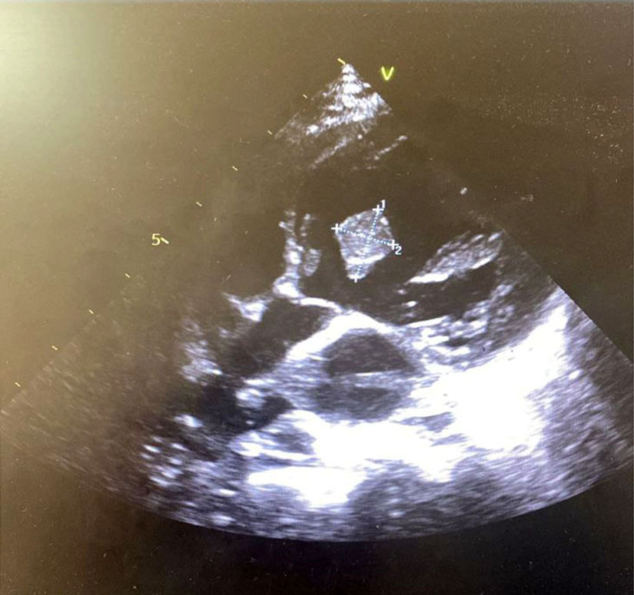
Figure 1. Transthoracic echocardiography (parasternal view) in Case 1 (13-year-old boy with hyperhomocysteinemia) showing a well-defined echogenic intracavitary mass in the left ventricle (measured at 12 mm), consistent with a thrombus..

Case 2. A 3-month-old premature infant with a history of central venous catheterization was admitted for respiratory distress and poor feeding. On examination, she was in cardiogenic shock with hypoxemia and hepatomegaly. Laboratory tests revealed leukocytosis and elevated inflammatory markers. Echocardiography confirmed a right atrial thrombus associated with dilated cardiomyopathy. Despite anticoagulation and supportive care, the patient’s condition worsened and she died.
Case 3. A 7-month-old boy, born to consanguineous parents, presented with fever, hemoptysis, and signs of heart failure. Examination revealed pulmonary congestion, gallop rhythm, and systemic hypoperfusion. D-dimer levels were elevated, while thrombophilia screening was negative. Echocardiography identified a large left ventricular thrombus with severe systolic dysfunction. He was managed with diuretics, digoxin, and low-molecular-weight heparin. Despite initial stabilization, the infant developed refractory cardiac failure and died.
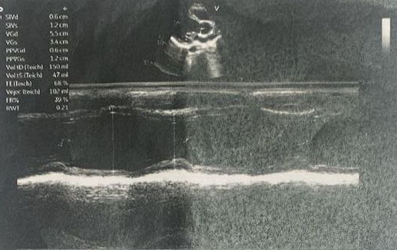

Figure 2. Transthoracic echocardiography (M-mode) in Case 3 (7-month-old infant with severe heart failure) showing left ventricular dilatation and impaired systolic function, providing a substrate for thrombus formation.

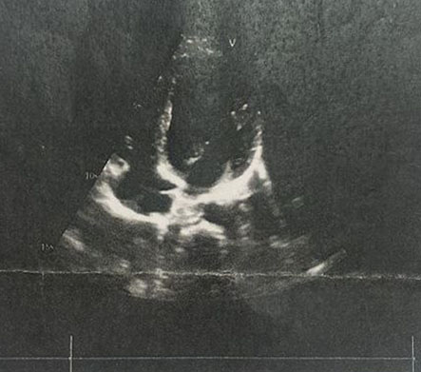
Figure 3. . Transthoracic echocardiography (apical four-chamber view) in Case 3 showing an echogenic intracavitary mass consistent with a left ventricular thrombus..

Case 4. A 13-year-old boy with a history of Behçet’s disease and poor treatment adherence presented with chest pain and bronchorrhea. Physical examination showed diminished breath sounds on the left side, while inflammatory markers were elevated. Chest CT revealed emphysema with ipsilateral collapse. Echocardiography demonstrated a right ventricular thrombus. The patient was treated with anticoagulation and immunosuppressive therapy, along with respiratory physiotherapy. Clinical condition improved with partial thrombus regression on follow-up imaging.
Case 5. A 13-month-old girl with no family history of consanguinity presented with fever, wheezing, and recurrent respiratory infections. Laboratory evaluation demonstrated decreased protein C (62%) and protein S (62%) levels with normal antithrombin III, consistent with thrombophilia. Echocardiography revealed a left ventricular thrombus. She was treated with low-molecular-weight heparin and supportive respiratory therapy. Clinical improvement was observed, but the thrombus persisted on follow-up echocardiography. The patient was subsequently lost to follow-up.

Written informed consent was obtained from the parents of all patients.

3. discussion

The five cases presented in our series illustrate the main clinical and etiological settings of intracardiac thrombi in children. The most frequent predisposing factors include coagulation disorders (hyperhomocysteinemia, protein C and S deficiency), systemic inflammatory disease (Behçet’s disease), structural or functional cardiac abnormalities (dilated cardiomyopathy, severe heart failure), and iatrogenic causes such as central venous catheterization in premature infants [1–4]. These risk factors are consistent with those described in previous pediatric cohorts, confirming the importance of Virchow’s triad—endothelial injury, stasis, and hypercoagulability—in the pathogenesis of pediatric intracardiac thrombosis [5,6].
Clinical presentation was nonspecific in our patients, ranging from respiratory distress and poor feeding in infants to chest pain or dyspnea in adolescents. Such variability has been highlighted in the literature, where intracardiac thrombi often remain clinically silent until complications such as systemic embolism or pulmonary embolism occur [7,8]. In our series, echocardiography was the cornerstone of diagnosis, allowing detection of thrombi in both atrial and ventricular locations. Transthoracic echocardiography is usually sufficient, but transesophageal echocardiography and cardiac MRI can provide additional information regarding size, mobility, and risk of embolization [9–11].
Management remains challenging in pediatrics and is largely extrapolated from adult guidelines. All our patients received anticoagulation with low-molecular-weight heparin, with or without additional supportive or disease-specific therapy. Anticoagulation is the mainstay of treatment, though vitamin K antagonists or, more recently, direct oral anticoagulants have been reported in older children [12,13]. Surgical thrombectomy has been described in cases of large, mobile, or refractory thrombi, but this option remains exceptional in children due to high operative risks [14]. In our series, outcomes were variable, with two deaths in infants, two favorable recoveries, and one patient lost to follow-up. These results reflect the severity of intracardiac thrombosis in young patients, especially when associated with hemodynamic compromise or underlying systemic disease [15,16].
Preventive strategies are essential, particularly in neonates and infants requiring central venous catheters, where careful monitoring and early removal can reduce thrombotic risk [17]. In older children, systematic screening for inherited thrombophilia should be considered when intracardiac thrombi occur in the absence of structural heart disease.
Our series adds to the limited pediatric literature by highlighting diverse etiologies and outcomes. It emphasizes the need for early diagnosis through echocardiography, systematic evaluation of underlying risk factors, and prompt initiation of anticoagulation. Multidisciplinary management involving pediatric cardiology, hematology, and critical care teams is crucial to improving prognosis.

4. Conclusion

Intracardiac thrombi in children are rare but potentially life-threatening. Echocardiography remains the cornerstone of diagnosis, particularly in settings where advanced imaging is limited. Early recognition and identification of underlying risk factors allow timely anticoagulation and targeted management. A multidisciplinary approach is essential to reduce morbidity and improve prognosis.

Consent

Written informed consent was obtained from the patient’s parents for the publication of this case report and any accompanying images. A copy of the written consent is available for review by the Editorial Office/Chief Editor/Editorial Board members of this journal.

Ethical approval
Not applicable. Written informed consent for publication was obtained from the patient’s parents.

Definitions, Acronyms, Abbreviations

CVC: Central Venous Catheter
ETT: Transthoracic Echocardiography
ETO: Transesophageal Echocardiography
HBPM / LMWH: Low-Molecular-Weight Heparin
HTAP / PH: Pulmonary Hypertension
INR: International Normalized Ratio
IT: Tricuspid Insufficiency
IM: Mitral Insufficiency
MRI: Magnetic Resonance Imaging
RCF: Fetal Heart Rate (Rythme Cardiaque Fœtal)
SD: Standard Deviation
VKA: Vitamin K Antagonist

Disclaimer (Artificial intelligence)

Author(s) hereby declare that NO generative AI technologies such as Large Language Models (ChatGPT, COPILOT, etc.) and text-to-image generators have been used during the writing or editing of this manuscript.

References

- Nield LE, Silverman ED, Smallhorn JF, Taylor GP, Benson LN, Freedom RM. Endocardial fibroelastosis and intracardiac thrombosis in children with dilated cardiomyopathy. Am J Cardiol. 1993;72(7):521-524.
- Cheung YF, Chan GC, Ha SY. Venous and arterial thromboembolism in children with acute lymphoblastic leukemia. Br J Haematol. 2000;111(3):817-823.
- Andrew M, David M, Adams M, Ali K, Anderson R, Barnard D, et al. Venous thromboembolic complications in children: first analyses of the Canadian registry of venous thromboembolic complications. Blood. 1994;83(5):1251-1257.
- Van Ommen CH, Peters M. Venous thromboembolism in childhood: state of the art. Br J Haematol. 2006;132(4):503-516.
- Monagle P, Adams M, Mahoney M, Ali K, Barnard D, Bernstein M, et al. Outcome of pediatric thromboembolic disease: a report from the Canadian Childhood Thrombophilia Registry. Pediatr Res. 2000;47(6):763-766.
- Goldenberg NA, Bernard TJ, Fullerton HJ, Gordon A, DeVeber G. Antithrombotic treatments, outcomes, and prognostic factors in childhood cerebral sinovenous thrombosis. Blood. 2009;114(24):5143-5150.
- Monagle P, Chalmers E, Chan A, DeVeber G, Kirkham F, Massicotte P, et al. Antithrombotic therapy in neonates and children: American College of Chest Physicians Evidence-Based Clinical Practice Guidelines (9th Edition). Chest. 2012;141(2 Suppl):e737S-801S.
- Albisetti M. Thrombosis in children: new developments. Curr Opin Hematol. 2007;14(5):476-482.
- Dabbous IA, Sakr FR, Chehab H, et al. Intracardiac thrombus in a child with dilated cardiomyopathy: a case report and review of the literature. Pediatr Cardiol. 2013;34(7):1758-1761.
- Van Ommen CH, Heijboer H, Büller HR, Hirasing RA, Heijmans HS, Peters M. Venous thromboembolism in childhood: a prospective two-year registry in The Netherlands. J Pediatr. 2001;139(5):676-681.
- Nowak-Göttl U, von Kries R, Göbel U. Neonatal symptomatic thromboembolism in Germany: two year survey. Arch Dis Child Fetal Neonatal Ed. 1997;76(3):F163-167.
- Rajpurkar M, Warrier I, Chitlur M, Lusher JM. Thrombosis in children: current perspectives. Haemophilia. 2002;8(1):125-135.
- Bauman ME, Massicotte MP, Barnard D. Investigational antithrombotic agents in children: a review of the current literature. Thromb Res. 2006;118(1):95-103.
- Monagle P, Newall F. Management of thrombosis in children and neonates: practical use of anticoagulants in children. Thromb Res. 2006;118(1):95-103.
- Ramaswamy P, Lytrivi ID, Yau J, Pass RH, Ko HH, Nappo L, et al. Intracardiac thrombus in children: recognition, management and clinical outcome. J Am Coll Cardiol. 2006;47(2):240-245.
- Goldenberg NA, Knapp-Clevenger R, Manco-Johnson MJ. Elevated plasma factor VIII and D-dimer levels as predictors of poor outcomes of thrombosis in children. N Engl J Med. 2004;351(11):1081-1088.
- Bhat R, Kumar R, Rao KL, et al. Right atrial thrombus in a neonate: successful management with low molecular weight heparin. Indian J Pediatr. 2009;76(7):747-749.

