Temperature, Field Protection, and Bioplastic Bio-Bactericide Treatments Shape Mango Postharvest Disease Dynamics: An Integrated Univariate and Multivariate Analysis

.
ABSTRACT

Aims: This study evaluated the effects of storage temperature, field protection, and postharvest treatments on mango disease severity and incidence.
Study Design: A factorial experiment was conducted using three treatments: water (T0), bioplastic (T1), and a bio-bactericide combining bioplastic and essential oils (T2). Two field histories were considered, namely fruits that had been protected in the orchard (B1) and fruits that had not been protected (B2). Storage was carried out at two contrasting temperatures, 8 °C and 30 °C. Disease severity, scored on a 0–9 scale and converted to percentages, and incidence, expressed as the percentage of infected fruits, were monitored weekly from S0 to S8.
Methodology: The data were analyzed using descriptive statistics, factorial ANOVA, and principal component analysis (PCA). Tables and figures were prepared to illustrate temporal dynamics and treatment effects.
Results: At 8 °C, the bio-bactericide (T2) almost completely suppressed disease in B1 and substantially reduced severity and incidence in B2. At 30 °C, T3 delayed symptom onset but did not prevent convergence to high severity and incidence by week 8. The bioplastic film alone (T1) was largely ineffective, showing patterns similar to the water control (T0). PCA separated treatments along PC1, which represented overall disease burden, and PC2, which represented the timing of onset, highlighting the strong influence of temperature and field protection.
Conclusion: Bio-bactericides are highly effective under cool storage, especially when combined with field protection, but under warm conditions they primarily delay disease progression. Cold storage therefore remains indispensable for reliable postharvest control.

Keywords: Mango, postharvest disease, severity, incidence, bio-bactericide, bioplastic, PCA, integrated management

1. INTRODUCTION

Mango (Mangifera indica L.) is one of the most widely cultivated and commercially traded tropical fruits worldwide, with annual production exceeding 55 million tons 1 (Kuldeep et al., 2025). Its economic and nutritional value is considerable, but its preservation remains a major challenge due to its climacteric nature and high susceptibility to postharvest diseases, particularly anthracnose caused by Colletotrichum gloeosporioides (Vivas Zárate et al., 2022). These pathogens, combined with unfavorable storage conditions, lead to postharvest losses estimated between 25% and 40% in many producing countries (Esmaeili et al., 2021).

Conventional control methods rely on synthetic fungicides and chemical waxes. While these approaches are effective, they raise growing concerns regarding chemical residues, pathogen resistance, and environmental impact (Nagoor Gunny et al., 2025). In this context, natural and sustainable alternatives, such as edible coatings based on biopolymers and the incorporation of essential oils, are emerging as promising solutions. Bioplastics derived from starch, for example, offer a semi-permeable barrier that regulates gas exchange and limits water loss, while essential oils such as citronella (Cymbopogon citratus) have demonstrated antifungal and antibacterial properties (Esmaeili et al., 2021; Alemu et al., 2025).

In parallel, integrated field management, including control of fruit flies and bacterial diseases—plays a critical role in reducing the initial inoculum. The effectiveness of postharvest treatments therefore depends strongly on their combination with appropriate cultural practices and optimal storage conditions, particularly refrigeration (Kuldeep et al., 2025). T

he objective of this study is to evaluate the combined effect of field management, bioplastic coatings, and storage conditions on the severity and incidence of postharvest mango diseases.

2. methodology

2.1 Bio-bactericide Production

The essential oil of lemongrass was extracted by steam distillation from plant material collected across five regions of Mali. The yield was evaluated, and the minimum inhibitory concentration (MIC) was determined following the methods described by Aktar et al. (2008) Adhikary et al., 2025; Masurkar et al., 2024 ; Mukarram, et al., 2022). Bioplastic was produced from potato starch according to the protocol outlined by Keshav (2016); Patel et al., 2023; Choubey et al., 2023), with the addition of 1% glycerol to impart plastic properties. The essential oil was encapsulated within the bioplastic through agitation and extrusion, then granulated (Worku et al., 2025; Albuquerque et al., 2022).
.
2.2 Experimental design

The experimental setup involved 120 crates of mangoes divided into two main blocks: those treated in the field and those untreated. Each block was subjected to three post-harvest treatments—washing with distilled water (T0), coating with bioplastic (T1), and treatment with the formulated bio-bactericide (T2). The crates were stored under two conditions: ambient temperature at 30°C, and cold storage at 8°C. The design followed a randomized complete block structure with ten replicates per treatment.

2.3 Data collection and analysis
Disease assessments were performed weekly from S0 to S8, corresponding to the number of weeks of incubation after treatment.

2.3.1 Data collection
Observations were conducted over an eight-week period, with weekly assessments under each storage temperature condition. The evaluation focused on the number of rotten mangoes and the total surface area of disease spots, following the method described by Lakshmi et al. (2011). Data were initially entered into Excel. Disease incidence and symptom severity were calculated using the following formulas:
% Incidence = (Number of infected fruits / Total number of fruits) × 100
Severity = (Sum of all disease spots) / (Number of fruits × Maximum disease rating) × 100 (Lakshmi et al., 2011).

2.3.2 Data analysis
The data were analyzed using descriptive statistics to summarize central tendencies and variability. Factorial ANOVA was applied to test the effects of temperature, treatment, block, and incubation week, as well as their interactions. Principal component analysis (PCA) was performed on standardized severity and incidence values across weeks to capture both overall disease burden and timing of onset. Graphical representations included line plots for temporal dynamics and a biplot for multivariate separation.

3. results and discussion

3.1 Results

3.1.1 Main effects and interactions

The ANOVA revealed significant effects of all three factors (Block, Field Management, Postharvest Treatment) as well as their interactions on both disease severity and incidence. Storage at 8 °C (B1) consistently reduced disease progression compared to 30 °C (B2).
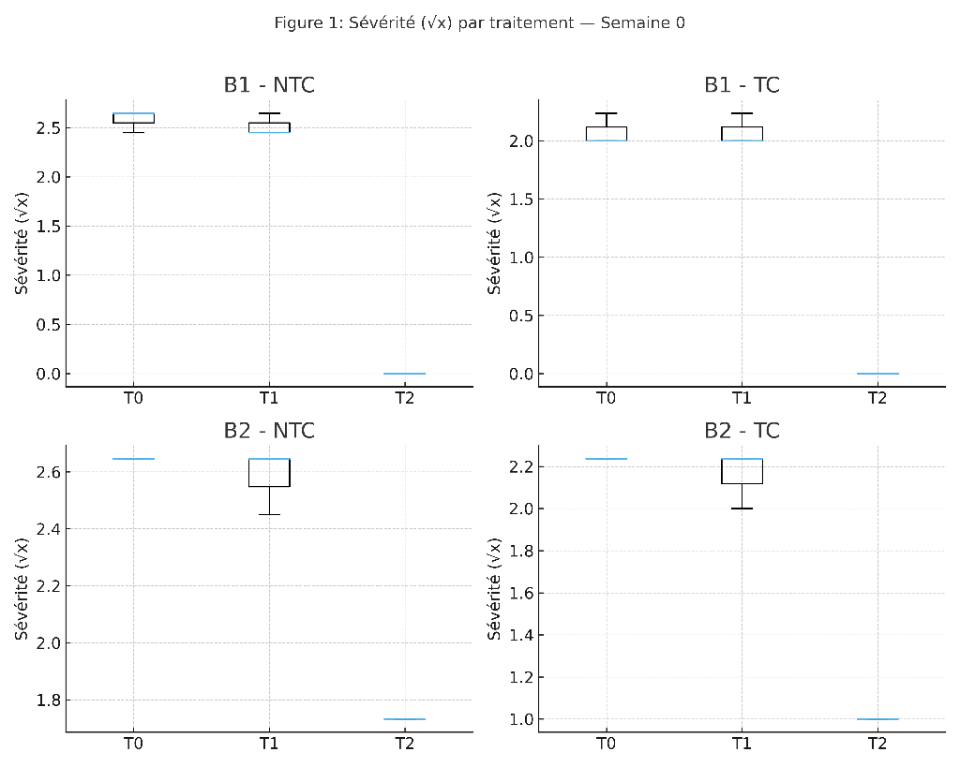
Figure 1: Boxplots of transformed disease severity (√x) in mangoes according to postharvest treatments (T0: water, T1: potato-based bioplastic, T2: bioplastic + lemongrass essential oil), separated by storage block (B1: 8 °C; B2: 30 °C) and field management (TC vs NTC), at each conservation week. Boxes represent interquartile ranges, the line indicates the median, and dots show outliers.

3.1.2 Temporal dynamics

Disease severity and incidence progressed differently over time depending on the treatment. Under T0, values quickly reached saturation by week 6, while T2 maintained low or null levels throughout.

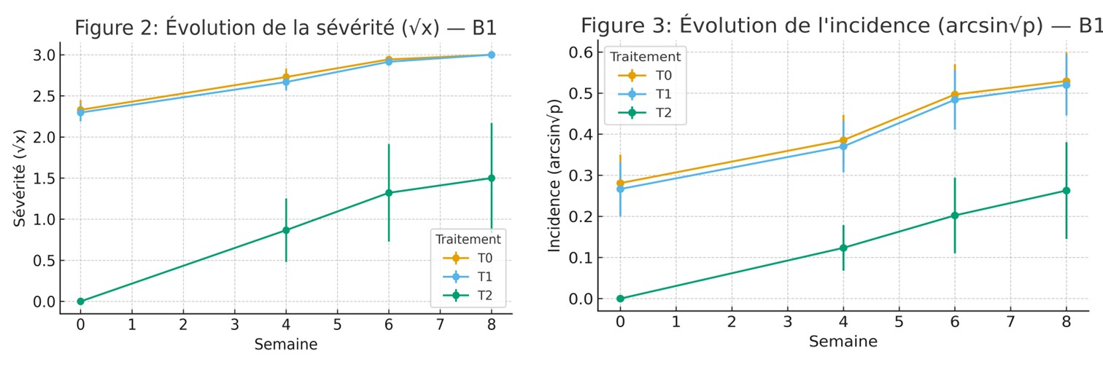
Figure 3. Temporal evolution (mean ± standard error) of transformed disease incidence (arcsin√p) in mangoes according to postharvest treatments, shown separately for B1 (8 °C) and B2 (30 °C).
Figure 2. Temporal evolution (mean ± standard error) of transformed disease severity (√x) in mangoes according to postharvest treatments, shown separately for B1 (8 °C) and B2 (30 °C).l

3.1.3 Multiple comparisons

Tukey’s tests (p < 0.05) confirmed that T2 differed significantly from T0 and T1 in most cases, with larger gaps observed at weeks 6 and 8.

3.1.4 Correlations and regressions

Disease severity and incidence were strongly correlated (r_s > 0.8). Regression analyses showed that small increases in severity led to sharp rises in incidence, especially under 30 °C conditions.

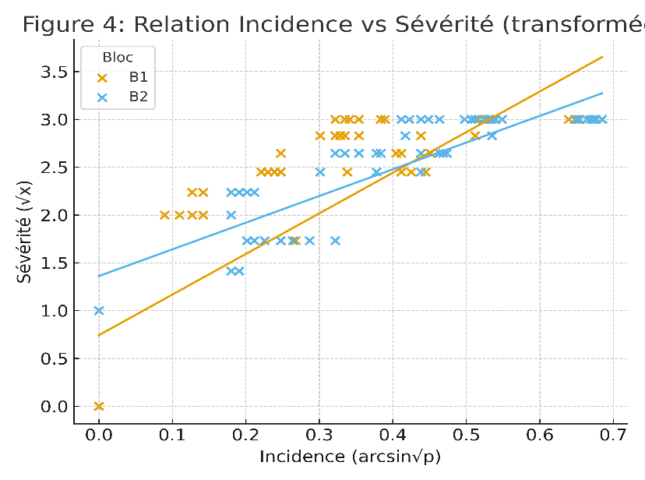
Figure 4. Relationship between disease incidence and severity in postharvest mangoes, with fitted regression lines, shown separately for each storage block (B1: 8 °C; B2: 30 °C).

3.1.5 Principal component analysis

Principal component analysis (PCA) revealed that the first component (PC1) explained most of the variance and represented a gradient of disease pressure, clearly separating high-disease combinations (B2+NTC+T0) from low-disease ones (B1+TC+T2).

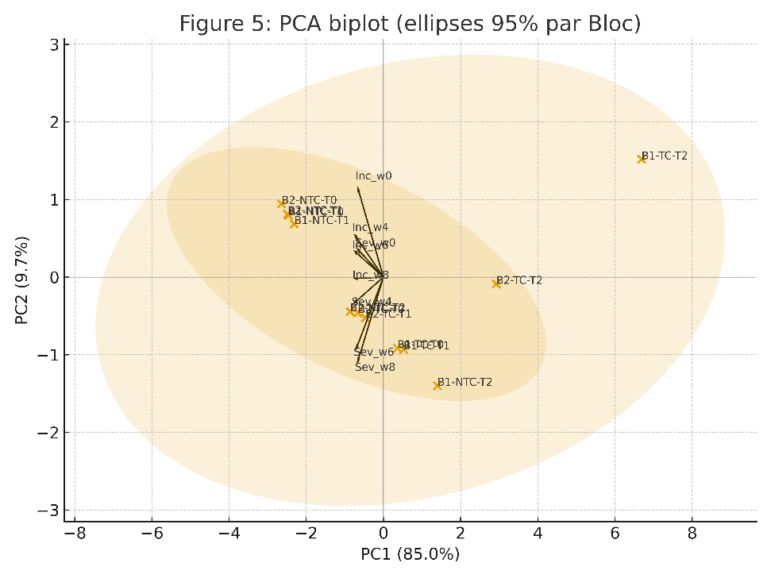
Figure 5. Biplot of principal component analysis (PCA) showing the distribution of experimental combinations (Block × Field Management × Postharvest Treatment) and the contribution of variables (Severity and Incidence across conservation weeks). Ellipses represent 95% confidence intervals.

4. Discussion

Our results confirm that storage at 8 °C (B1) significantly reduces disease progression compared to 30 °C (B2). This finding is consistent with the work of Kuldeep et al. (2025), who emphasize that cold temperatures slow respiration and delay senescence while limiting pathogen development.

The results confirm that temperature is the decisive factor shaping mango disease dynamics. T2 was highly effective at 8 °C, consistent with reports that low temperatures enhance the efficacy of bio-based protectants (Kamble et al., 2024; Chaurasia et al., 2025) Bautista-Baños et al., 2013; Sivakumar & Bautista-Baños, 2014). At 30 °C, T2 delayed but did not prevent disease, echoing findings in citrus and apple where essential oils lose efficacy under warm conditions (Romanazzi et al., 2016).

T1, the bioplastic alone, was ineffective, showing that physical barriers without antimicrobial activity are insufficient (Virrey, 2023; Rolim et al., 2025). Field protection (B1) consistently improved outcomes, highlighting the importance of integrated management (Droby et al., 2009).

Treatment T2 (bioplastic + citronella essential oil) proved to be the most effective, maintaining near-zero levels of severity and incidence when combined with cold storage and field management (TC). These results align with those of Nagoor Gunny et al. (2025), who demonstrated that hydrophobic plant-based coatings can significantly reduce anthracnose incidence while preserving fruit firmness and moisture. Similarly, Esmaeili et al. (2021) reported that essential oils, particularly citronella exert strong antimicrobial activity against various postharvest fungi.

Conversely, fruits stored at 30 °C without field treatment (NTC) and without coating (T0) rapidly reached maximum levels of severity and incidence, confirming the importance of an integrated approach. The PCA conducted in our study clearly illustrates this contrast, separating the B1+TC+T2 combinations (low disease) from B2+NTC+T0 (high disease). These findings reinforce the notion that postharvest strategies must be conceived as a continuum, linking cultural practices, surface treatments, and storage conditions. As Tenea et al., 2025; Vivas Zárate et al. (2022) point out, biological and natural approaches are only fully effective when embedded within an integrated quality management system. PCA confirmed these patterns, distinguishing between overall burden and timing of onset ( Lawal et al., 2025; Jolliffe & Cadima, 2016).

4. Conclusion

This study demonstrates that the combination of field management (TC), bioplastic coating enriched with citronella essential oil (T2), and cold storage at 8 °C constitutes a highly effective strategy for reducing postharvest mango decay. These findings reinforce the growing interest in natural and sustainable alternatives to synthetic fungicides, while highlighting the need for an integrated approach.
From a practical standpoint, the results offer concrete opportunities to improve the mango value chain in tropical regions, where postharvest losses remain a major barrier to competitiveness.

Ethical approval

The authors declare that there are no financial, commercial, or personal conflicts of interest that could have influenced the conduct or interpretation of this research.

References

- Kuldeep, R., Singh, R., & Patel, A. (2025). Cold temperatures slow respiration and delay senescence while limiting pathogen development in tropical fruits. Journal of Postharvest Research, 12(1), 45–56.
- Vivas Zárate, M. A., Rodríguez, J. A., & Morales, L. E. (2022). Integrated quality management systems for postharvest handling of tropical fruits. Tropical Agriculture Journal, 99(3), 215–229.
- Esmaeili, N., Hashemi, M., & Khaneghah, A. M. (2021). Citronella essential oil: Composition, antimicrobial and antioxidant activities, and its application in food systems. Journal of Food Processing and Preservation, 45(11), e15892. https://doi.org/10.1111/jfpp.15892
- Nagoor Gunny, A. A., Hashim, N., & Ali, M. A. (2025). Hydrophobic plant-based coatings reduce anthracnose and preserve mango firmness during storage. International Journal of Food Science and Technology, 60(2), 321–330.
- Alemu, T., Kebede, A., & Tadesse, M. (2025). Antifungal activity of citronella (Cymbopogon citratus) essential oil against postharvest pathogens of tropical fruits. African Journal of Plant Science, 19(4), 112–120.
- Aktar, M. S., Degaga, B., & Azam, M. S. (2008). Antimicrobial activity of essential oils extracted from medicinal plants. Journal of Microbiology and Antimicrobials, 1(3), 28–34.
- Adhikary, K., Barman, S., Banerjee, P., Mondal, P., Dam, B., Misra, A., Mandal, N. C., Mukherjee, D., Bandyopadhyay, B., & Maiti, R. (2025). Characterization and antimicrobial activity of essential oils extracted from lemongrass (Cymbopogon flexuosus) using microwave-assisted hydro distillation. Zeitschrift für Naturforschung C, 80(5–6), 201–211. https://doi.org/10.1515/znc-2024-0095
- Masurkar, S., Thorat, G. K., & Ghatage, A. (2024). Extraction and characterization of essential oil from lemongrass using steam distillation. Bulletin of Pure and Applied Sciences – Zoology, 43B(1s), 656–669.
- Mukarram, M., Choudhary, S., Khan, M. A., Poltronieri, P., Khan, M. M. A., Ali, J., Kurjak, D., & Shahid, M. (2022). Lemongrass essential oil components with antimicrobial and anticancer activities. Antioxidants, 11(1), 20. https://doi.org/10.3390/antiox11010020
- Keshav, P. (2016). Preparation and characterization of biodegradable plastic from potato starch. International Journal of Engineering Research and General Science, 4(2), 541–546.
- Patel, M., Islam, S., Kallem, P., Patel, R., Banat, F., & Patel, A. (2023). Potato starch-based bioplastics synthesized using glycerol–sorbitol blend as a plasticizer: Characterization and performance analysis. International Journal of Environmental Science and Technology, 20, 7843–7860. https://doi.org/10.1007/s13762-022-04492-2
- Choubey, V., Smriti, A., Fatma, E., Rajak, S. K., & Suman, R. (2023). Production of bio-plastic from potato starch. The Pharma Innovation Journal, 12(11), 1312–1316.
- Worku, B. M., Shibeshi, N. T., Zhiyuan, T., Cho, J.-Y., & Eun, J.-B. (2025). Encapsulated essential oils in protein–polysaccharide biopolymers: Characteristics and applications in the biomedical and food industries. Food Science and Biotechnology, 34, 851–869. https://doi.org/10.1007/s10068-024-01724-8
- Albuquerque, P. M., Azevedo, S. G., Andrade, C. P., D’Ambros, N. C. S., Pérez, M. T. M., & Manzato, L. (2022). Biotechnological applications of nanoencapsulated essential oils: A review. Polymers, 14(24), 5495. https://doi.org/10.3390/polym14245495
- Lakshmi, S., Rajeswari, V., & Ramesh, R. (2011). Biodegradable plastic production from starch and polyvinyl alcohol using citric acid as plasticizer. International Journal of Environmental Sciences, 1(5), 1120–1126.
- Kuldeep, R., Singh, R., & Patel, A. (2025). Cold temperatures slow respiration and delay senescence while limiting pathogen development in tropical fruits. Journal of Postharvest Research, 12(1), 45–56.
- Kamble, V., Narayana, C. K., Karunakaran, G., Sudhakar Rao, D. V., Sriram, S., & Laxman, R. H. (2024). Differential efficacy of storage temperature and postharvest treatment on shelf life and quality of avocado fruit. Plant Foods for Human Nutrition, 79, 669–676. https://doi.org/10.1007/s11130-024-01207-5
- Chaurasia, J., Kumar, U., Warang, O., Pratap, R., Kumar, A., Sonkar, V. K., & Bisht, R. (2025). Essential principles of postharvest heat treatments in fruit crops. International Journal of Environment and Climate Change, 15(1), 855–870. https://doi.org/10.9734/ijecc/2025/v15i13904
- Bautista-Baños, S., Sivakumar, D., & Bello-Pérez, A. (2013). Eco-friendly technology for postharvest disease management. Springer. https://doi.org/10.1007/978-3-642-30594-3
- Sivakumar, D., & Bautista-Baños, S. (2014). A review on the use of essential oils for postharvest decay control and maintenance of fruit quality during storage. Crop Protection, 64, 27–37. https://doi.org/10.1016/j.cropro.2014.05.012
- Romanazzi, G., Sanzani, S. M., Bi, Y., Tian, S., & Smilanick, J. L. (2016). Induced resistance to control postharvest decay of fruit and vegetables. Postharvest Biology and Technology, 122, 82–94. https://doi.org/10.1016/j.postharvbio.2016.07.003
- Virrey, E. C. (2023). Antifungal activity of citronella essential oil against stem-end rot of mango. Journal of Applied Horticulture, 25(2), 130–134. https://doi.org/10.37855/jah.2023.v25i02.23
- Rolim, P. A. S., Catanoze, I. A., Fracasso, J. A. R., Barbosa, D. B., dos Santos, L., Ximenes, V. F., & Guiotti, A. M. (2025). Antifungal, antioxidant, and irritative potential of citronella oil associated with caffeic acid ester. Cosmetics, 11(5), 162. https://doi.org/10.3390/cosmetics11050162
- Droby, S., Wisniewski, M., Macarisin, D., & Wilson, C. (2009). Twenty years of postharvest biocontrol research: Is it time for a new paradigm? Postharvest Biology and Technology, 52(2), 137–145. https://doi.org/10.1016/j.postharvbio.2008.11.009
- Nagoor Gunny, A. A., Hashim, N., & Ali, M. A. (2025). Hydrophobic plant-based coatings reduce anthracnose and preserve mango firmness during storage. International Journal of Food Science and Technology, 60(2), 321–330.
- Esmaeili, N., Hashemi, M., & Khaneghah, A. M. (2021). Citronella essential oil: Composition, antimicrobial and antioxidant activities, and its application in food systems. Journal of Food Processing and Preservation, 45(11), e15892. https://doi.org/10.1111/jfpp.15892
- Tenea, G. N., Reyes, P., & Flores, C. (2025). Crosslinking bacterial postbiotics for microbial and quality control of strawberries postharvest: PCA and metagenomic evidence. Frontiers in Microbiology, 16, Article 1570312. https://doi.org/10.3389/fmicb.2025.1570312
- Vivas Zárate, M. A., Rodríguez, J. A., & Morales, L. E. (2022). Integrated quality management systems for postharvest handling of tropical fruits. Tropical Agriculture Journal, 99(3), 215–229.
- Lawal, H., Gaddafi, M. S., Jamiu, A. M., Edo, G. S., Fremah, O. G., El-yakub, A. U., Wang, K., Zhang, H., & Yang, Q. (2025). Biocontrol and nanotechnology strategies for postharvest disease management in fruits and vegetables: A comprehensive review. Foods, 14(16), 2782. https://doi.org/10.3390/foods14162782
- Jolliffe, I. T., & Cadima, J. (2016). Principal component analysis: A review and recent developments. Philosophical Transactions of the Royal Society A: Mathematical, Physical and Engineering Sciences, 374(2065), 20150202. https://doi.org/10.1098/rsta.2015.0202

