Utilization pattern of Paddy Residue Management Techniques (PRMT) by paddy farmers in Eluru district, Andhra Pradesh
ABSTRACT
The utilization pattern of PRMT by paddy farmers was studied in Eluru district of Andhra Pradesh, which was purposively selected due to its significant contribution to paddy cultivation and residue generation. The study was conducted from oct 2024 to june 2025 to understand the adoption levels and improve sustainable residue management practices. Three mandals viz. Bhimadolu, Denduluru, and Pedapadu were selected randomly, and a total of 120 farmers were selected using a simple random sampling technique. The results revealed that little more than three-fifths (61.66%) of the paddy farmers had the medium utilization pattern followed by low (20.83%) and high (17.51%) utilization pattern of PRMT. Traditional techniques emerged as the most prominent, secured the highest index score of 73.40 followed by field techniques ranked second with a score of 62.26, whereas recent interventions ranked third with an index score of 56.94 and industrial techniques with a score of 49.65 claimed the fourth position.
Keywords: Utilization pattern, Paddy Residue Management Techniques, Paddy farmers, index score.
1. INTRODUCTION
Paddy cultivation holds a prominent place in the agricultural landscape of Andhra Pradesh, contributing significantly to food security, rural livelihoods, and the state's economy. Among the various districts, Eluru stands out as a major rice-growing region owing to its favourable agro-climatic conditions, abundant water resources, and well-established irrigation infrastructure. Paddy cultivation, while central to food security and rural livelihoods, generates substantial crop residue that poses serious challenges when not managed effectively. In many regions, the predominant practice of residue burning has led to environmental degradation, air pollution, and loss of soil fertility. To address these concerns, a range of PRMTs have been introduced, offering sustainable alternatives that promote soil health, resource efficiency, and environmental protection. However, the extent and manner of their adoption by farmers vary widely, influenced by socio-economic characteristics, awareness levels, accessibility, and infrastructural support. Understanding the utilization of PRMTs in this region is crucial for addressing the challenges posed by residue burning and for promoting sustainable farming practices. The adoption of these technologies is shaped by factors such as farmers’ socio-economic profile, awareness levels, access to resources, and availability of extension support. Hence, examining the utilization pattern of PRMTs by paddy farmers in Eluru district provides valuable insights into the existing gaps, opportunities, and constraints in residue management. The present study aims to analyze these utilization patterns to support effective policy formulation, strengthen extension strategies, and encourage environmentally sustainable practices that enhance both agricultural productivity and resource conservation.
2. MATERIALS AND METHODS
The present study was conducted using an Ex-Post Facto research design to assess the Utilization pattern of PRMT by paddy farmers in Eluru district of Andhra Pradesh. This design was chosen as the variables under investigation had already occurred and could not be manipulated by the researcher. Eluru district was purposively selected due to its significant contribution to paddy cultivation and residue generation. A simple random sampling procedure was followed, wherein three mandals i.e. Bhimadolu, Denduluru, and Pedapadu were selected randomly from the district. From each mandal, two villages were selected through simple random sampling, making a total of six villages. From each village, 20 paddy farmers were randomly chosen, resulting in a total sample of 120 respondents. Data were collected using a structured interview schedule and analyzed using an index, frequency, percentage, mean, standard deviation for meaningful interpretation.
2.1 Utilization pattern of paddy farmers:
An index was constructed to measure the utilization pattern of PRMT by paddy farmers. The utilization pattern was measured in terms of four selected indicators such as field techniques, industrial techniques, traditional techniques, recent interventions. Each indicator was further classified into its respective sub-indicators. For each sub-indicator, paddy farmers rated their level of utilization on a three-point continuum with score of 3, 2 and 1 corresponding to mostly utilized, utilized and not utilized, respectively. The average score of all paddy farmers for each sub-indicator was computed and used to determine their respective rankings based on the level of utilization. For each indicator, the total scores of farmers across its sub-indicators were averaged to obtain the overall score. This obtained score was then divided by the maximum possible score to calculate the index score, which formed the basis for assigning the final ranking.
To assess the overall utilization pattern, paddy farmers were classified into low, medium and high categories by summing their scores across all paddy residue management techniques to obtain an individual total utilization score, then mean and standard deviation of these scores were calculated to categorize. The maximum and minimum scores for the individual farmer were 84 and 28. To conclude, the data frequency and percentage were used.
3. RESULTS AND DISCUSSION :
3.1 Utilization Pattern Of PRMT By Paddy Farmers
The Table 1 and Fig.1 data consists of the overall paddy residue management techniques utilized by the paddy farmers
It is evident from the Table.1 and Fig.1 that a little more than three-fifths (61.66%) of the paddy farmers had the medium utilization pattern followed by low (20.83%) and high (17.51%) utilization pattern of PRMT.
Table 1. Distribution of paddy farmers according to the utilization pattern of PRMT (n=120)
S.No | Utilization pattern | f | %
 | Low Utilization pattern | 25 | 20.83
 | Medium Utilization pattern | 74 | 61.66
 | High Utilization pattern | 21 | 17.51
Total |  | 120 | 100.00
Mean = 46.51 |  | S.D = 3.36
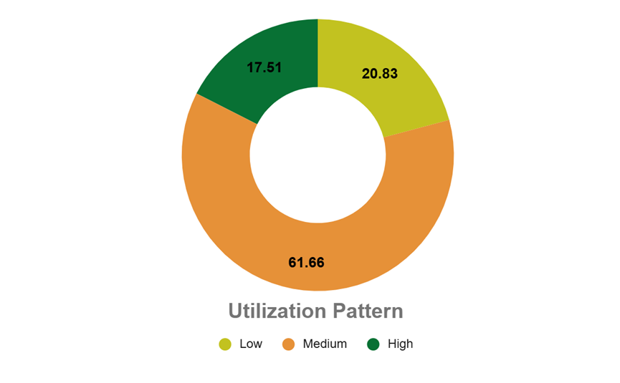
Fig. 1. Distribution of paddy farmers according to the utilization pattern of PRMT
3.2 Utilization Pattern of Field Techniques by Paddy Farmers
The field techniques utilized by the paddy farmers were ranked and furnished according to their mean scores in Table 2 and Fig.2.
The data in Table.2 and Fig.2 highlights that incorporating in field ranks first, attaining the highest mean score of 2.77, followed by burning in second place with 2.21 mean score. Composting secures the third rank recording 1.90, while mulching is positioned fourth achieving 1.80. Vermicomposting holds the fifth place with a mean score of 1.58, whereas biogas production ranks sixth, attaining 1.49 Biochar application occupies the seventh position, registering the lowest mean score of 1.30.
The order of preference for field techniques reflects how practical and accessible farmers find them in their day-to-day operations. Incorporation ranked highest, as it fits well with the machinery farmers already use and is known to improve soil health. Burning followed in second place, since it remains the fastest and cost-effective option despite its environmental drawbacks. Composting and mulching were used to a moderate extent, but their adoption is often limited by the extra labour and space they require. Vermicomposting, biogas production, and biochar application were the least preferred, mainly because many farmers lack awareness, technical know-how, and the infrastructure needed to implement these methods effectively.
Table 2. Distribution of paddy farmers according to the field techniques utilization pattern (n=120)
S.No | Field Techniques | Total Score | Mean Score | Rank
1 | Incorporating in field | 333 | 2.77 | I
2 | Burning | 266 | 2.21 | II
3 | Composting | 228 | 1.90 | III
4 | Mulching | 216 | 1.80 | IV
5 | Vermicomposting | 190 | 1.58 | V
6 | Biogas production | 179 | 1.49 | VI
7 | Biochar production | 157 | 1.30 | VII
Total Obtained Score |  | 1569 | 13.07
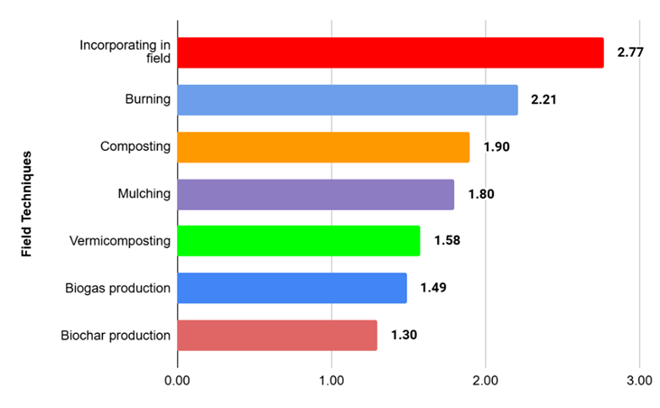
Fig. 2. Distribution of paddy farmers according to the field techniques utilization pattern

3.3. Utilization Pattern of Industrial Techniques by Paddy Farmers
The distribution of paddy farmers according to the Industrial techniques utilized were presented in the Table 3 and Fig.3.
According to the results revealed in the Table 3 and Fig.3 it was reported that within different industrial techniques, storage (silage/hay) holds the top rank, achieving the highest mean score of 2.53. Packing material follows in second place with 1.80, while mushroom cultivation secures the third position with 1.51 mean score. Paper and cardboard production ranks fourth, attaining a mean score of 1.37, whereas briquetting and biofuel industries are positioned fifth with 1.22. Electricity generating industries share the sixth rank, registering 1.21. Biomass plants occupy the seventh place, achieving 1.14, while bio-renewable industries, such as biogas and biochar holds eighth rank with the lowest mean score of 1.10.
Industrial techniques ranking order appears to be influenced by the farmers level of awareness, access to processing facilities, and perceived benefits. Storage in the form of silage or hay ranked first, likely because it serves as a practical industrial technique with direct links to livestock feed and fodder-based enterprises. Packing material and mushroom cultivation attained moderate ranks, reflecting a certain degree of awareness and adoption. In contrast, paper production and briquetting were less preferred, likely constrained by limited access and logistical challenges. The lowest ranks for electricity generation, biomass plants, and bio-renewable industries indicate minimal farmer engagement, primarily due to infrastructural limitations and weak industrial linkages. Overall, farmers favored techniques that were more practical, familiar, and locally accessible.
Table 3. Distribution of paddy farmers according to the Industrial techniques utilization pattern (n=120)
S. No. | Industrial Techniques | Total Score | Mean Score | Rank
1 | Storage (silage/hay) | 304 | 2.53 | I
2 | Packing material | 216 | 1.80 | II
3 | Mushroom cultivation | 182 | 1.51 | III
4 | Paper/ cardboard production | 165 | 1.37 | IV
5 | Briquetting and biofuel industries | 147 | 1.22 | V
6 | Electricity generating industries | 146 | 1.21 | VI
7 | Biomass plants | 137 | 1.14 | VII
8 | Bio-renewable industries like biogas, biochar | 133 | 1.10 | VIII
Total Obtained Score |  | 1430 | 11.91
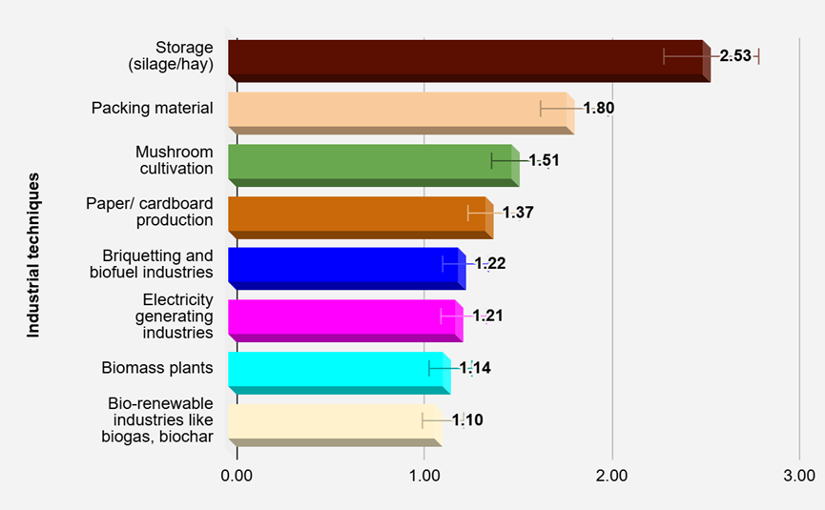
Fig.3. Distribution of paddy farmers according to the Industrial techniques utilization pattern
3.4. Utilization Pattern of Traditional Techniques by Paddy Farmers
The ranking of traditional techniques utilized by the paddy farmers were explained in the Table.4 and Fig.4
As mentioned in the Table.4 and Fig.4, it was stated that fodder holds the highest rank among traditional techniques, achieving a mean score of 2.79. In second place, roofing of poultry and cattle sheds with 2.70 mean score, while planting beds secure the third position, recording 1.66. The fourth rank is held by domestic activities, which has the lowest mean score of 1.64.
The order of preference for traditional techniques highlights their functional relevance, utility, cultural familiarity, and day-to-day relevance in farming households. Using paddy residue as fodder ranked highest, likely due to its essential role in livestock maintenance and its immediate value on mixed farms. Roofing for poultry and cattle sheds followed closely, as it offers a cost-effective and readily available material suited to rural construction needs. The use of residue for planting beds and domestic purposes ranked lower, possibly because they are limited in scale, seasonal, or serve supplementary rather than primary functions. This suggests that practices offering consistent, functional benefits tend to be prioritized.
Table.4. Distribution of paddy farmers according to the Traditional techniques utilization pattern (n=120)
S. No. | Traditional Techniques | Total Score | Mean Score | Rank
1 | Fodder | 335 | 2.79 | I
2 | Roofing of poultry and cattle sheds | 325 | 2.70 | II
3 | Planting beds | 200 | 1.66 | III
4 | Domestic activities | 197 | 1.64 | IV
Total Obtained Score |  | 1057 | 8.80
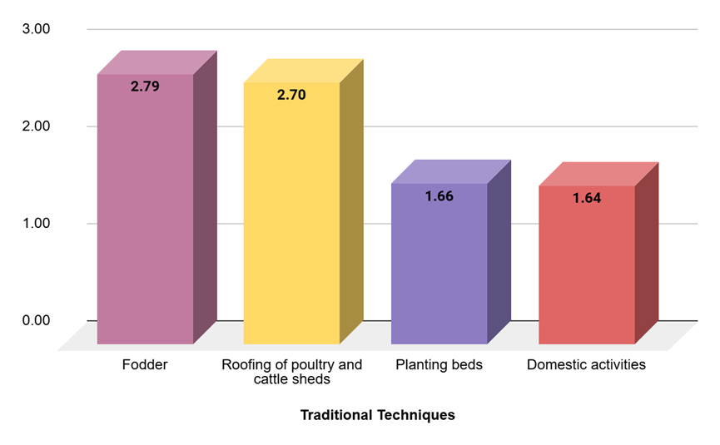
Fig.4. Distribution of paddy farmers according to the traditional techniques utilization pattern
3.5. Utilization Pattern of Recent Interventions by Paddy Farmers
The order of preference of recent interventions utilized by paddy farmers were revealed in Table.5 and Fig.5.
From the above Table 5 and Fig.5, it was furnished that among the recent interventions, the combined harvester holds the highest position, attaining a mean score of 2.65, followed by balers with a score of 1.98. Straw chopper secures the third rank, achieving a mean score of 1.67. Decomposers rank fourth, with a mean score of 1.15, whereas mulchers occupy the fifth position, attaining a mean score of 1.07, representing the lowest value among the listed interventions.
Paddy farmers ranking of recent interventions reflects their exposure, operational convenience, and institutional support. Combined harvesters ranked highest, likely due to their widespread availability and time-saving benefits during harvesting. Balers and straw choppers followed, indicating growing interest in mechanized residue handling, though their usage may be limited by cost and access. Decomposers were ranked lower, possibly due to limited awareness, delayed results, or dependence on external agencies. Mulchers received the least preference, suggesting unfamiliarity or a lack of perceived necessity. Overall, interventions that are visible, time-efficient, and integrated into routine farm operations tend to gain greater acceptance.
Table 5. Distribution of paddy farmers according to the Recent interventions utilization pattern (n=120)
S. No. | Recent interventions | Total Score | Mean Score | Rank
1 | Combined Harvester | 319 | 2.65 | I
2 | Balers | 238 | 1.98 | II
3 | Straw chopper | 201 | 1.67 | III
4 | Decomposers | 138 | 1.15 | IV
5 | Mulchers | 129 | 1.07 | V
 | Total Obtained Score | 1025 | 8.54
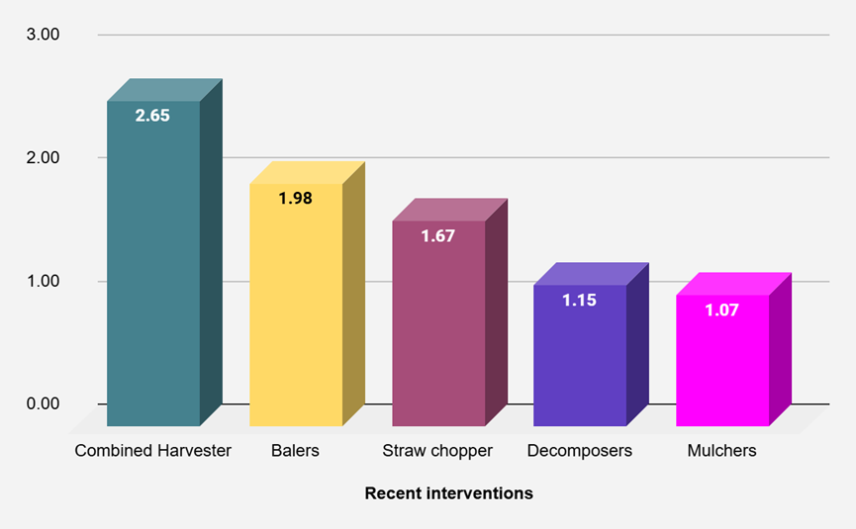
Fig.5. Distribution of paddy farmers according to the recent interventions utilization pattern
3.6. Utilization Pattern of Indicators of PRMT By Paddy Farmers
The ranking of the four indicators utilized by the paddy farmers using index score is unveiled in Table 6 and Fig.6
The evidence shown in the Table 6 and Fig.6, it was revealed that traditional techniques emerged as the most prominent, secured the highest index score of 73.40 followed by field techniques ranked second with a score of 62.26, whereas recent interventions ranked third with an index score of 56.94 and industrial techniques claimed the fourth position with a score of 49.65.
The prominence of traditional and field techniques as reflected by their highest index scores were attributed to their simplicity and cost-effectiveness. Moreover, the predominance of medium annual income among paddy farmers constraints their ability to invest in advanced technologies. Small and marginal landholdings further limit paddy residue generation, which was generally sufficient to fulfil the requirements of on-farm use and livestock feed, thereby diminishing the demand for industrial or large-scale residue management solutions. The implements employed for these two techniques are relatively simple with minimal technical skills required, which aligns well with paddy farmers capacities. In contrast, industrial techniques and recent interventions rank lower due to limited market orientation, insufficient awareness of residue utilization opportunities, and reluctance to adopt novel methods, compounded by challenges such as lack of knowledge and risk aversion. Parallel findings were observed in the results of Yadav et al. (2023), Babu (2019), Neethi and Sailaja (2013)
Table 6. Ranking of indicators of the utilization pattern of PRMTs by paddy farmers (n=120)
S.No | Indicator | Index Score | Rank
1 | Traditional techniques | 73.40 | I
2 | Field techniques | 62.26 | II
3 | Recent interventions | 56.94 | III
4 | Industrial techniques | 49.65 | IV
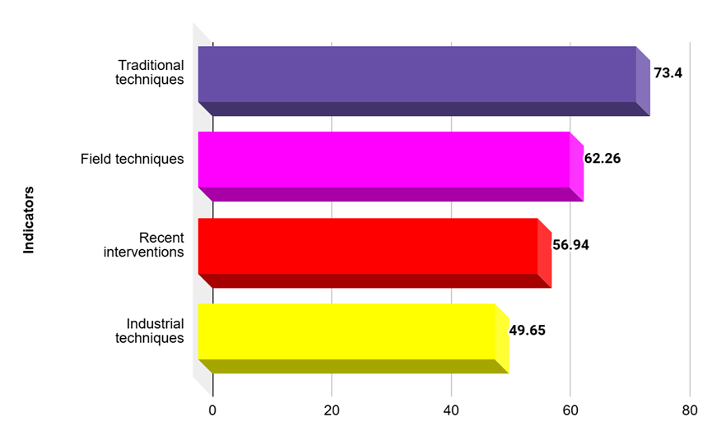
Fig.6. Distributed ranks of indictors of the utilization pattern of PRMTs by paddy farmers
CONCLUSION:
The analysis of the utilization pattern of Paddy Residue Management Technologies (PRMTs) by paddy farmers in Eluru district revealed that a majority (61.66%) exhibited medium utilization, while smaller proportions fell under low and high categories. Among the different methods, traditional techniques such as using residue for fodder and roofing materials were most prominent, reflecting their continued relevance in rural livelihoods. Field techniques like incorporating residue into the soil and burning were commonly practiced, while composting, mulching, and biochar application were less frequently adopted. Industrial techniques showed limited adoption, with storage (silage/hay) and packing material ranking higher than options like biomass plants and bio-renewable industries. Recent interventions such as the use of combine harvesters and balers found greater acceptance, whereas advanced options like decomposers and mulchers were utilized to a lesser extent. These findings highlight that while farmers continue to rely heavily on traditional and basic field practices, the gradual shift towards mechanized and industrial methods indicates emerging opportunities. However, the relatively low utilization of sustainable and advanced technologies underscores the need for capacity building, awareness creation, and support mechanisms to encourage environmentally sound and efficient residue management practices in the district.

REFERENCES
- ANAND, S. (2019). Study on use of ICT tools for crop practice in Samastipur and Katihar districts of Bihar. Ph.D. (Ag.) Thesis, Dr. Rajendra Prasad Central Agricultural University, Pusa, Samastipur.
- Babu, S. L (2019). Awareness and perception of farmers towards soil health card scheme in Rayalaseema region of Andhra Pradesh. Ph.D. (Ag.) Thesis. Acharya N.G. Ranga Agricultural University, Guntur.
- DEEP, M., KUMAR, R. M., SAHA, S. and SINGH, A. (2018). Rice-based cropping systems. Indian Farming, 68(1): 27-30.
- KADIAN, K. K. and MEENA, M. S. (2021). Reasons and awareness levels of farmers on residue burning in Indo-Gangetic plain of India: An exploratory research. Journal of AgriSearch, 8(1): 62-66.
- KAILASH, O. P. M., KUMAR, L. and SINGH, S. K. (2017). Utilization pattern of mobile phone technology (smart phone) among the farmers of Nagaur district in Rajasthan. Indian Research Journal of Extension Education, 17(4): 117-121.
- KAUSHIK, R. and SABHARWAL, K. (2021). Knowledge of farmers towards promotion of agricultural mechanization for in-situ management of crop residue scheme in Haryana. Journal of AgriSearch, 7(4): 38-42.
- KHIDIR, A. A. (2020). Awareness and use of mobile phone apps by farmers in North West Nigeria. Ph.D. Thesis, North-West University, South Africa.
- LOKESH BABU, S. (2019). Awareness and perception of farmers towards soil health card scheme in Rayalaseema region of Andhra Pradesh. Ph.D. (Ag.) Thesis, Acharya N.G. Ranga Agricultural University, Guntur.
- Neethi, B and Sailaja, A. 2013. Relationship of farmers’ profile with utilization of extension services. IOSR Journal Of Humanities And Social Science. 16: 31-37.
- Yadav, A. K., Singh, Y. K., Bishi, J. P and Patel, P. 2023. Study on socio-economic profile and constraints faced by farmers in utilization of soil health card in Surajpur district of Chhattisgarh. The Pharma Innovation Journal. 12(8S): 1066-1068.

