EVALUATION OF PHYTOCHEMICAL SCREENING AND IN-VIVO ANALGESIC ACTIVITY OF LEAVES EXTRACT OF Calotropis gigantea FROM BUTWAL LOCALITY

.
ABSTRACT

Introduction:
Calotropis gigantea (Apocynaceae) is a medicinal shrub widely used in South Asian traditional medicine for treating pain and inflammation. However, scientific validation of its analgesic properties remains limited.
Methods:
Leaves, flowers, and latex of C. gigantea were collected from Rupandehi, Nepal. The methanol leaf extract (MLE) was prepared by cold maceration and subjected to qualitative phytochemical screening. Analgesic activity was evaluated in Wistar rats using the hot plate and acetic acid-induced writhing tests. Diclofenac sodium served as the standard and saline as the control.
Results:
Phytochemical screening confirmed the presence of secondary metabolites, including alkaloids, flavonoids, tannins, saponins, and glycosides. MLE at doses of 200 and 400 mg/kg significantly (p<0.01) increased reaction latency in the hot plate test by 56.77% and 69.6%, respectively—the same doses reduced acetic acid-induced writhing by 37.76%, indicating both central and peripheral analgesic activity.
Conclusion:
The methanol leaf extract of Calotropis gigantea possesses significant analgesic potential, validating its traditional use in pain management and suggesting the presence of bioactive compounds with pharmacological relevance.

Keywords: Analgesic activity, Calotropis gigantea, Hot plate method, phytochemical screening, Pain management, Wister rats

1. INTRODUCTION
Plants contain diverse secondary metabolites such as alkaloids, steroids, tannins, and glycosides, distributed across various organs (leaves, flowers, seeds, etc.). Many of these species have long been used in folk medicine to treat different diseases; however, gaps remain in transferring indigenous knowledge between generations, along with limited information and challenges in identifying wild medicinal plants (Alsaedi & Aljeddani, 2022).
Nepal ranks 9th among the Asian countries in floral wealth, with an estimated 9,000 flowering plant species. Approximately half are considered useful and ethnobotanical, while 25-50 % are categorized as ethnomedicinal (Patel, Upadhaya & Kumar, 2021). Pain is a multifaceted subjective experience influenced by physical, psychological, and social factors. It may result from injury, disease, inflammation, or nerve damage and can significantly affect overall well-being by limiting daily activities, work performance, and social interactions. The sensation of pain involves activation of sensory neurons, transmission of signal along neural pathways, and interpretation by higher brain centers (Alorf, 2023).
Calotropis gigantea (L.) R. Br. (Apocynaceae) is a well-known tropical plant native to Asia and Africa. Commonly known as crown bloom or milkweed, it grows in diverse soils and climates and is distributed across South Asia, Southeast Asia, the Middle East, Africa, and South America. Various phytochemicals, including alkaloids, glycosides, flavonoids, saponins, tannins, and proteins, have been identified in its leaves, flowers, buds, and roots (Jamal et al., 2025). The leaves, stem, seeds, and latex of Calotropis gigantea are well known for their toxic and medicinal properties. Tropical application of its latex and leaves has been reported to reduce inflammatory and analgesic properties (Varghese, 2025).

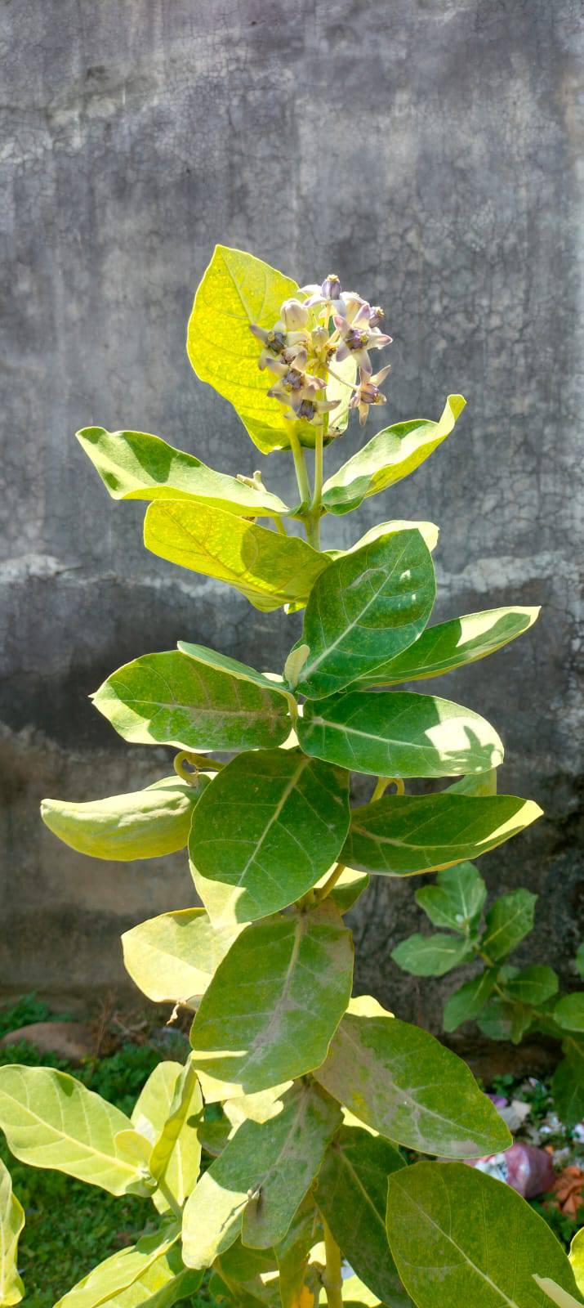

Fig. 1. Showing the C. gigantea Plant

Scientific Classification
Kingdom: Plantae
Order: Gentianales
Family: Apocynaceae
Subfamily: Asclepiadaceae
Genus: Calotropis
Species: gigantea
Common Name: Giant Milkweeds (English), Aak (Nepali), Madar (Tharu).

Mechanism of Analgesic Drugs
The stimulation of the nociceptive receptor causes pain perception. Mu, kappa, and delta receptors have been found to be involved in pain perception. They start the production of prostaglandin I, prostaglandin II, or occasionally both. Either selectively or at the CO-II receptor, analgesic medications block them. Opioids relieve pain by raising the spinal cord’s threshold level, which allows a person to tolerate more pain Patel, et al., 2016.
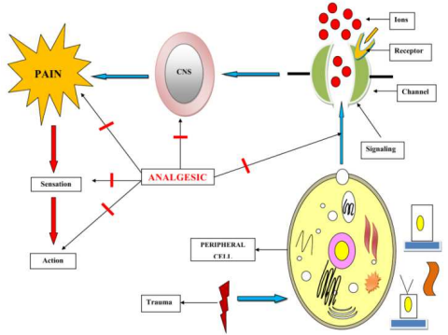
Fig. 2. Mechanism of Analgesic Activity

Rationale of the Study
There is insufficient information about the analgesic efficacy of C. gigantea leaves and latex, even though its flowers and roots have demonstrated pharmacological effects. The purpose of this study is to confirm the analgesic activity of C. gigantea leaves as a safer substitute for traditional analgesics, given their shortcoming.

Objectives
- To prepare methanol and ethyl acetate extracts of its parts.
- To conduct phytochemical screening of the extracts.
- To evaluate the in vivo analgesic activity of methanol leaf extract.

2. material and methods

2.1 Plant Materials

The selection of the plants was based on their historical applications and availability. The plant latex, leaves, and flowers were gathered from Kalikanagar, Butwal, in Nepal's Rupandehi district. Table 1 lists the parts used in the investigation, their scientific names, and the corresponding collecting times.

Table 1. Plant Details

Plant | Part used | Collection area | Collection date
C. gigantea | Leaf | Kalikanagar, Rupandehi | May, 2023
C. gigantea | Flower | Kalikanagar, Rupandehi | May, 2023
C. gigantea | Latex | Kalikanagar, Rupandehi | May, 2023

2.2 Chemicals and Drugs

In this investigation used Diclofenac (J.B. Chemicals and Pharmaceuticals Ltd.), Acetic acid, Conc. Sulfuric acid, Potassium iodide, Sodium hydroxide, Chloroform, methanol (Thermo Fischer Scientific India Pvt. Ltd.), ethyl acetate (Merck Life Science Pvt. Ltd.), and Ferric chloride (Loba Chemie Pvt. Ltd.). Almost all chemicals used in this investigation were analytical grade.

2.3 Drying
Collected plant parts were cleaned with distilled water to remove dust adhering to them. They were then naturally dried in shade at room temperature in the Pharmacognosy laboratory of Crimson College of Technology, Butwal, Nepal. The drying was carried out for 10 days. Latex of the plant was stored in a refrigerator at 4 °C until use. After complete drying, the dried leaves and flowers were hand-crushed to reduce their size. Completely dried plant materials were used for the extraction process.

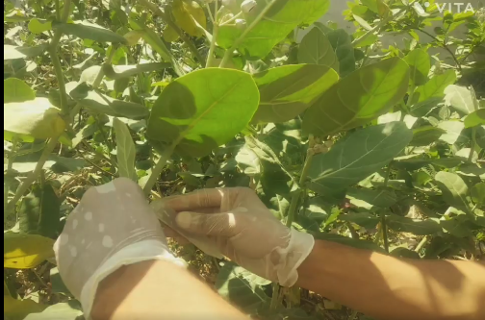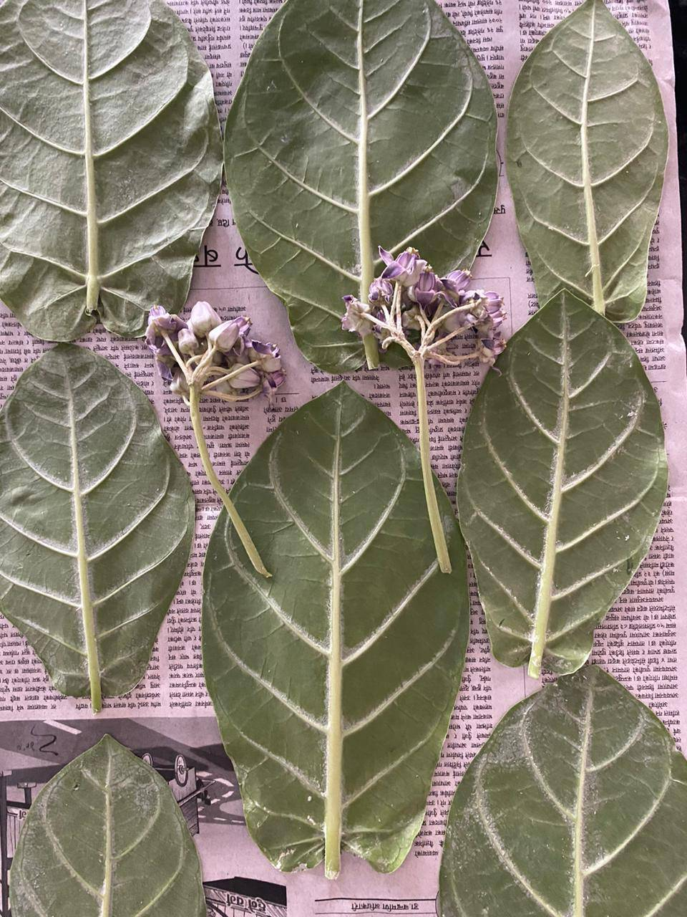

Fig. 3. Collection and Drying of Plant Samples

2.4 Extraction process

In a conical flask with periodic shaking, 150 g of powdered leaves, 25 g of flower, and 6 g of latex from C. gigantea were treated to triple cold maceration using methanol and ethyl acetate solvents in a 1:10 ratio. Six distinct extraction samples were obtained by independently extracting each plant sample in two distinct solvents. The liquids were strained and filtered following each extraction. The filtrates were combined after the extraction procedure was carried out three times. Thus, a rotary evaporator was used to evaporate the resulting filtrates until they were completely dry. The leaves, flowers, and latex extracts made of methanol and ethyl acetate were evaporated at 45 °C and 60 °C, respectively. After being analyzed, the organoleptic properties, percentage yield, colour, and odour, etc., the produced extracts were marked and kept in an airtight container until they were needed again (Bhandari et al, 2024).

2.5 Phytochemical screening

Using conventional methods, phytochemical screening was done to determine whether secondary metabolites such as alkaloids, steroids, glycosides, tannins, saponins, and flavonoids, which may have an analgesic effect, were present or absent (Neupane S et al., 2023; Sheikh JR et al., 2020, and Khanal et al., 2024),
Regents to be used for phytochemical screening;
- Hager’s Reagent: To prepare a saturated solution, 6 g of picric acid was dissolved in 100 mL of water.
- Sodium Hydroxide solution: 100 mL of distilled water was used to dissolve 20 g of NaOH.
- Dilute Sulphuric Acid solution: Distilled water was used to dilute a concentrated sulphuric acid 10 times.
- Dilute Ammonia solution: Distilled water was used to dilute a concentrated ammonia solution 10 times.
- Mayer’s Reagent: After dissolving 1.358 g of mercuric chloride in 60 mL of water and reacting with 5 g of potassium iodide treated with 10 mL of water, the final volume was 100 mL with purified water.
- 5 % FeCl₃ solution: 5 g of ferric chloride (FeCl₃) was dissolved in distilled water.

2.5.1 Phytochemical Screenings to be Performed

- Glycoside Test: 5 mL extract was mixed with the same volume of FeCl₃ and the same volume of HCl, heated for five minutes in a water bath, and then the same volume of a mixture of chloroform was added. The organic layer separates and is further diluted with ammonia solution, which shows a red color, which confirms the presence of a glycoside.
- Alkaloids Test: Extract was treated with picric acid; the appearance of yellow color indicates the presence, otherwise absence.
- Saponins Test: 0.5 g of plant extract was mixed with water and made up to 20 mL. The suspension was shaken in a graduated cylinder for 15 minutes. 2cm foam indicated the presence of saponins.
- Tannins Test: 3 mL alcoholic extract was added to 5% ferric chloride solution; the appearance of a deep blue or brownish green color indicates the presence otherwise absence.
- Steroids Test: Extract was dissolved in chloroform and concentrated sulfuric acid; the appearance of red or yellow color indicates the presence of steroids, otherwise absence.
- Flavonoids Test: Plant extract was dissolved in sodium hydroxide, giving a yellow color which turns colorless after the addition of dilute hydrochloric acid, indicating the presence of flavonoids otherwise absence.

2.6 Animals and Ethical Approval

The Wistar rats used in this study were purchased from the Natural Resources Research Institute's Department of Botany, Thapathali, Kathmandu, Nepal. In this study, Wistar rats weighing 165-185 g of either sex were employed. Standard feed and unlimited water were given to the rats on a daily basis. Throughout the trial, they were housed in hygienic cages with hardwood dust that were changed every three days and had a constant light-dark cycle of 12-12 hours. Animals were given time to get used to the lab environment before the investigation. All procedures about animal care, handling, and experimental protocols were completed in accordance with Nepal’s approved ethical guidelines (Pandey, J et al., 2020).

2.7 Acute Toxicity Test

An acute toxicity test was performed according to the OECD (Organization for Economic Co-operation and Development) guideline 425/2008. Fasted female rats were used for the toxicity study. First, a sighting study was performed to determine the starting dose, in which a single female rat was given 2000 mg/kg of the extract as a single dose by oral gavage. Since no death was observed within 24 hours, an additional four rats were recruited for the extract treatment at the same dose. The animals were observed continuously in the first 4 hours with 30 30-minute intervals and then for 14 consecutive days with an interval of 24 hours for the general signs and symptoms of toxicities. These signs and symptoms include changes in skin, eyes, mucous membranes, somatomotor activity, behavioral pattern, salivation, diarrhea, weight loss, tremor, convulsions, lethargy, paralysis, food and water intake, and mortality. Based on the results of the acute toxicity test, three treatment doses of the extract were chosen: a middle dose, which was one-tenth of the maximum dose obtained during the acute toxicity study; a low dose, which was half of the middle dose; and a high dose, which was twice the middle dose. Middle and high dose of treatment was used in the study (OECD, 2008).

2.8 In Vivo Analgesic Activity

C. gigantea leaf extract was evaluated for analgesic activity in rats using the hot plate and acetic acid-induced writhing method (Alemu A. et al, 2018; Arifin W.N. & Zahiruddin W.M., 2017) with slight modification.

2.8.1 Hot Plate Method

Experimental animals of both sexes were chosen at random and divided into four groups, each of which contained four Wistar rats for the control, standard, and test sample groups (200 mg/kg and 400 mg/kg).

Group A: Control group-Received particular treatment (Normal saline (N/S), 10 mL/g, p.o.).
Group B: Standard drugs-Received a solution of Diclofenac sodium (9 mg/kg, p.o.).
Group C: Test drug-Received MLE (Calotropis gigantea extract) at the doses of 200 mg/kg, p.o
Group D: Test drug-Received MLE (Calotropis gigantea extract) at the doses of 400 mg/kg, p.o.

The animals were placed on Eddy’s hot plate, which maintained a steady temperature of 55 ± 0.5 °C, and fed through a feeding tube. Animals that licked their forepaws or hindpaws or leaped before and after the sample was administered for 0, 30, 60, 90, and 120 minutes had their reaction times recorded.
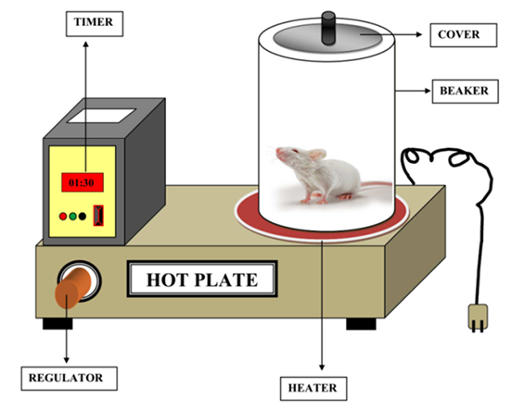
Fig. 4. Explanatory Diagram of Hot Plate Analgesiometer

According to (Yimer, T., Birru, 2020), the percentage increase in reaction time or pain threshold inhibition was determined using the relation;

2.7.2 Acetic Acid Induced Writhing Method

As previously mentioned, four groups of four Wistar rats each were created.

Group A: Control group-received Normal saline, 10 mL/kg p.o.
Group B: Standard drug-received a solution of Diclofenac sodium 9 mg/kg, p.o.
Group C: Test drug-received MLE (Calotropis gigantea extract) at the dose 200 mg/kg, p.o
Group D: Test drug-received MLE (Calotropis gigantea extract) at the dose 400 mg/kg, p.o..
A 0.5 % acetic acid solution was injected intraperitoneally around 30 minutes after normal saline, Diclofenac, and MLE samples were delivered. Lastly, for 25 minutes, the number of writhes was recorded.

The following formula was used to determine the percentage protection against writhing, which was used as an indicator of analgesia.
2.8 Statistical analysis

All results were expressed as Mean ± Standard deviation. The mean value was calculated using Microsoft Excel. The test sample was compared with the standard drug and control by one-way analysis of variance (ANOVA) followed by Tukey’s post hoc test using SPSS software trial version.

3. results and discussion

3.1 Extractive yield

The Table below displays the results of the calculation of the ethyl acetate and methanol extraction yield of C. gigantea leaves, flowers, and latex using the provided equation (Pandey J. and others, 2020).
Table 2. Yield Value of Different Extracts
Scientific Name | Solvents | Parts Used | Sample | Weight of crude sample (g) | Weight of Dry Extracts (g) | Yield value (%)
C. gigantea | Methanol | Leaf | MLE | 150 | 14 | 9.33%
C. gigantea | Methanol | Flower | MFE | 25 | 2.05 | 8.2%
C. gigantea | Methanol | Latex | MLAE | 6 | 0.08 | 1.33%
C. gigantea | Ethyl acetate | Leaf | EALE | 150 | 9 | 6%
C. gigantea | Ethyl acetate | Flower | EAFE | 25 | 1.78 | 7.12%
C. gigantea | Ethyl acetate | Latex | EALAE | 6 | 0.2 | 3.33%

3.2 Phytochemical analysis
The methanol and ethyl acetate extracts of C. gigantea leaves, latex, and flowers were used in a variety of phytochemical experiments. To check the existence of several active principles or phytochemical elements, such as steroids, alkaloids, glycosides, flavonoids, tannins, and saponins, they were exposed to phytochemical analysis displayed in the table below.

Table 3. Phytochemical Screening of C. gigantea Leaf, Latex, and Flower
Solvents | Plant parts | Alkaloids | Flavonoids | Tannins | Saponins | Glycosides | Steroids
Methanol | Leaf | + | - | + | + | + | ±
Methanol | Flower | + | - | + | + | ± | +
Methanol | Latex | ± | + | - | - | + | +
Ethyl acetate | Leaf | + | ± | ± | - | + | -
Ethyl acetate | Flower | ± | - | + | - | ± | ±
Ethyl acetate | Latex | ± | - | - | + | + | ±

‘+’ = strongly presence, ‘-’= absence and ‘±’ = moderately presence

3.3 Acute Toxicity Test

Within 24 hours and 14 days of observation, there were no noticeable behavioral abnormalities, toxic effects, or fatalities in the acute oral toxicity test of MLE extract of C. gigantea at the limit dose of 2000 mg/kg. According to OECD 425/2008 guidelines, the oral LD₅₀ of crude MLE in rats is therefore higher than 2000 mg/kg. Thus, the outcomes imply that the extract is safe Alemu et al., 2018.

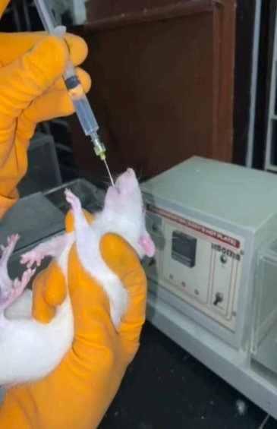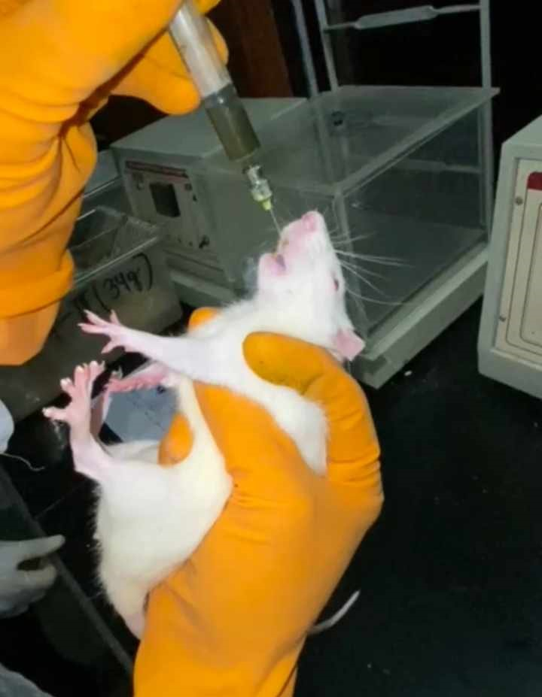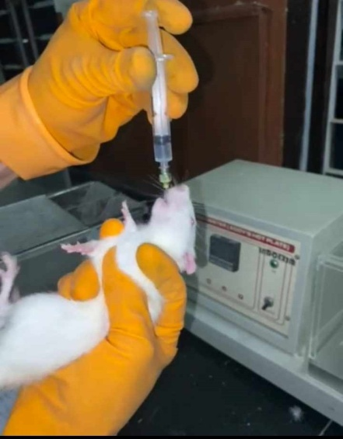
Fig. 5. Administration of N.S., Standard Drug, and MLE to Rats

3.4 Analgesic activity

3.4.1 Hot plate method

In our study, the MLE extract had its maximal effect at 120 minutes and significantly (p < 0.01) delayed the rats' reaction times to hotplate thermal stimulation at all dose levels. At 120 minutes, the greatest analgesic efficacy of MLE 400 and Diclofenac is almost similar. At the 120-minute mark, the percentage inhibition of 200 and 400 mg/kg of MLE was 56.76 % and 69.50 %, respectively, in a dose-dependent manner. An intergroup comparison revealed that 400 mg/kg and 200 mg/kg responded to hot plate thermal stimulation significantly more slowly (p<0.01), while 9 mg/kg of diclofenac had a strong analgesic effect when compared to 400 mg/kg (p<0.01), and Figure 2 displayed the delay period’s percentage elongation.

Table 4. Effect of MLE of C. gigantea on Hotplate Test in Rats (Mean Latency Time After Drug/ Extract Administration in Sec.)

Groups | Treatment | O min. | 30 min. | 60 min. | 90 min. | 120 min.
A | N/S | 34±2.45 | 34 ± 2.58 | 34.25 ± 3.3 | 35.5 ± 2.08 | 36.75 ± 1.25
B | Diclofenac | 39.25± 2.22 | 64.5 ±2.65 | 93.75±2.87 | 114.75±3.4 | 138.25±2.5
C | MLE  (200 mg/kg) | 35.5±2.51 | 52.25±6.29 | 64.25±1.71 | 69.25±2.22 | 85±3.55
D | MLE  (400 mg/kg) | 36±3.16 | 57.25±4.34 | 84.25±3.30 | 96.25±3.5 | 120.5±4.203

Fig. 6. Graph Showing the Percentage Increase in Latency of Paw Licking in Rats After 30, 60, 90, and 120 Minutes of Standard and MLE Administration
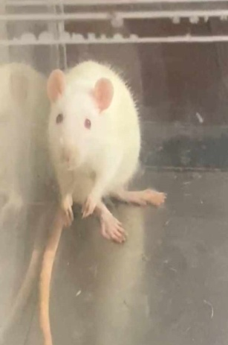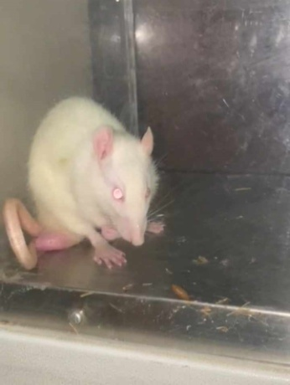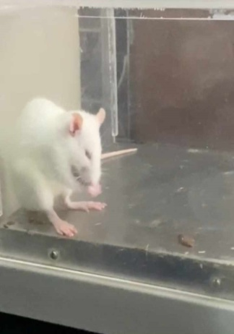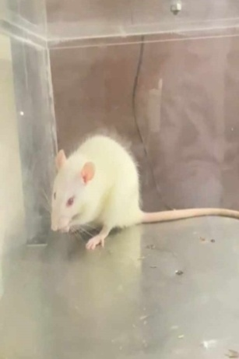

Fig. 7. Paw Licking Response after N/S, Diclofenac, MLE administration in Rats in the Hot Plate Test

3.4.2 Acetic Acid-Induced Writhing Method

In this study, results show that when compared to the control group, the MLE (200 and 400 mg/kg) and the reference drug diclofenac 9 mg/kg significantly (p<0.01) decreased writhing in rats. The number of writhings decreased from 47 ± 1.83 in the control group to 17.5 ± 1.29 at the dose of MLE 400 mg/kg, which decreased from 47 ± 1.83 to 13.5 ± 1.29 in the standard drug. The analgesic effect of diclofenac was greater than that of MLE 200 mg/kg and 400 mg/kg. Nonetheless, the analgesic efficacy of MLE 400 mg/kg is similar to that of diclofenac.

Table 5. Effect of MLE of C. gigantea on Acetic Acid-Induced Writhing Test in Rats

Groups | Treatment | Dose | No. of writhing | Percentage protection against writhing (%)
A | N/S | 10 mL/kg b.w. | 47 ± 1.83 | -
B | Diclofenac | 9 mg/kg b.w. | 13.5 ± 1.29 | 71.28
C | MLE | 200 mg/kg b.w. | 29.25 ± 0.96 | 37.76
D | MLE | 400 mg/kg b.w. | 17.5 ± 1.29 | 62.77

The percentage inhibition of writhing for different treatment groups is shown in Fig. 3 below.

Fig. 8. Showing the Percentage Inhibition of Writhing in Rats in Different Treatment Groups
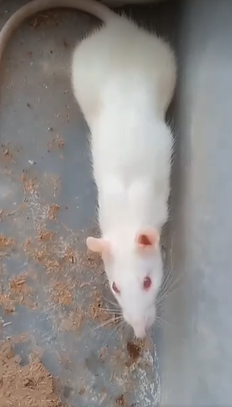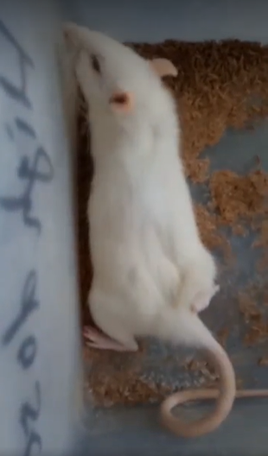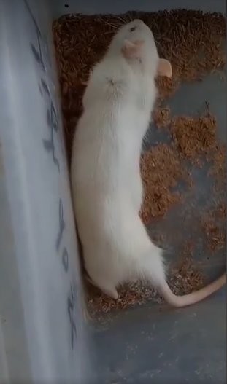

Fig. 9. Writhing Response in Rats after Acetic Acid Administration in the Acetic Acid-Induced Writhing Test

4. DISCUSSION

Pain and Inflammation are common physiological responses to tissue injury, and analgesics act through peripheral or central mechanisms. In this study, the methanol leaf extract of Calotropis gigantea exhibited significant analgesic activity in both central and peripheral models. The extract increased latency in the hot plate test, indicating central analgesic effects, likely by modulating nociceptive responses to thermal stimuli (Alemu et al., 2018). Additionally, the extract inhibited acetic acid-induced writhing, suggesting peripheral analgesic activity through interference with nociceptor activation and prostaglandin-mediated pathways (Alemu et al., 2018).

Similarly, previous studies have reported that the alcoholic extract of C. gigantea flowers exhibits analgesic activity in preclinical models. Oral administration of the extract significantly reduced the incidence of writhing and paw-licking time. These effects were evaluated using the acetic acid-induced writhing test and the hot plate method (Mandal, 2023).

Phytochemical analysis revealed the presence of alkaloids, flavonoids, saponins, and tannins, compounds reported to contribute to analgesic and anti-inflammatory activity by inhibiting enzymes in the arachidonic acid pathway and prostaglandin synthesis (Ahmadiani et al., 2000; Choi et al, 2005). These constituents likely underlie the observed analgesic effects. Beyond analgesic, C. gigantea has demonstrated wound healing, anti-diarrheal, mosquito repellent, anticonvulsant, sedative, and muscle relaxant activities in previous studies, highlighting its broad pharmacological potential (Alafnan et al., 2021; Dhivya & Manimegalai, 2013; Rahman et al., 2012). The leaf extract, in particular, appears to be a promising source of bioactive compounds with central and peripheral analgesic properties.

5. Conclusion

In conclusion, the present study has demonstrated the analgesic potential of MLE of C. gigantea in rats. The MLE of C. gigantea was able to inhibit pain sensation in rats in dose dose-dependent manner. The mechanism of pain inhibition by MLE of C. gigantea might be related to the presence of phytochemicals and bioactive compounds in the plant. According to the results of our study, the MLE of C. gigantea can help prevent pain and serve as a valuable bioresource for developing a readily available herbal formulation that is more effective in treating pain. Further study is necessary for the investigation of the precise mechanism at the molecular level. Our results provide scientific justification for the use of these plant parts in traditional medicine for the treatment of various diseases, particularly as analgesics.

6. RECOMMENDATION
1. Analgesic activity of the latex of C. gigantea can be conducted, as no previous studies on the latex have been done.
2. Research work on the stem bark and fruits can also be conducted.
3. Further, research can be conducted to isolate the chemical responsible for analgesic activity and study the mechanism of action.
DATA AVAILABILITY STATEMENT
All the data generated during this study were statistically analyzed and are presented in the figures and tables. The dataset could be available upon reasonable request from the corresponding author.

COMPETING INTERESTS DISCLAIMER:
Authors have declared that they have no known competing financial interests OR non-financial interests OR personal relationships that could have appeared to influence the work reported in this paper.

References

Ahmadiani, A., Moghaddam, H. F., & Jafari, S. (2000). Antinociceptive and anti-inflammatory effects of the methanol extract of Cissus polyantha roots. Journal of Ethnopharmacology, 71(1–2), 93–98. https://doi.org/10.1016/S0378-8741(00)00235-1
Alafnan, A. H., Al-Sheddi, E. S., & Al-Oqail, M. M. (2021). Phytochemical, antioxidant, and antimicrobial activities of Calotropis gigantea (L.) Dryand leaves. Saudi Journal of Biological Sciences, 28(2), 1185–1192. https://doi.org/10.1016/j.sjbs.2020.10.027
Alemu A. et al. (2018). Analgesic and Anti-inflammatory Effects of 80% Methanol Extract of Leonotis ocymifolia (Burm. F.) Iwarsson Leaves in Rodent Models, Hindawi: 1-8.
Alemu, A., Tamiru, W., Nedi, T., & Shibeshi, W. (2018). Analgesic and anti-inflammatory effects of 80% methanol extract of Leonotis ocymifolia (Burm.f.) Iwarsson leaves in rodent models. Evidence-Based Complementary and Alternative Medicine, 2018. https://doi.org/10.1155/2018/1614793
Alorf, N. M. (2023). Pharmacological methods of pain management: Narrative review of medication used. International Journal of General Medicine, 16, 3247–3256. https://doi.org/10.2147/IJGM.S414073
Alsaedi, S., & Aljeddani, G. (2022). Phytochemical analysis and bioactivity screening of primary and secondary metabolic products of medicinal plants in the valleys of Medina Region, Saudi Arabia. Advances in Biological Chemistry, 12(4), 135–152. https://doi.org/10.4236/abc.2022.124009.
Arifin W.N. and Zahiruddin W.M. (2017), Sample Size Calculation in Animal Studies Using the resource Equation Approach, The Malaysian Journal of Medical Sciences, 24(5): 101-105.
Bhandari, A., Aryal, A., Bashyal, D., Giri, J., & Gyawali, M. (2024). Comparative in vitro study on phytochemical profile, antioxidants, and antimicrobial activities of Pogostemon benghalensis leaves and stem from two different geographical regions in Lumbini Province of Nepal. Journal of Medicinal Plants Research, 18(7), 95–106. https://doi.org/10.5897/JMPR2024.7352
Choi, J. H., Lee, H. S., & Lee, S. H. (2005). Anti-inflammatory and analgesic effects of saponins from Panax ginseng roots. Journal of Ethnopharmacology, 96(3), 441–448. https://doi.org/10.1016/j.jep.2004.11.027
Dhivya, R., & Manimegalai, K. (2013). Preliminary phytochemical screening and GC-MS profiling of ethanolic flower extract of Calotropis gigantea Linn. International Journal of Scientific and Research Publications, 3(3), 1–5. Retrieved from http://www.ijsrp.org/research-paper-0313/ijsrp-p1791.pdf
Jamal, A., Arif, A., Kiran, S., Shahid, M. N., & Hossain, M. B. (2025). Phytochemical investigations and pharmacological potential of organic extracts of Calotropis gigantea L. leaves. Scientifica, 2025. https://doi.org/10.1155/sci5/1669969
Khanal, S., & Bhandari, A. (2024). Formulation and physicochemical evaluation of polyherbal toothpaste using domestic medicinal plants. International Journal of Pharmaceutical Sciences, 2(7), 962–975. https://doi.org/10.5281/zenodo.12738905
Mandal, S. (2023). Calotropis gigantea: A brief study on phytochemical and pharmacological profile. Asian Journal of Pharmaceutical Research, 13(1), 34–40. https://doi.org/10.52711/2231-5691.2023.00006
Neupane S. et al. (2023) Total Phenolic and Flavonoid Contents, and Preliminary Antioxidant, Xanthine Oxidase Inhibitory and Antibacterial Activities of Fruits of Lapsi (Choerospondias axillaris Roxb.), an Underutilized Wild Fruit of Nepal, Applied Sciences, 13: 1-20.
OECD. (2008). OECD test no. 425: Acute oral toxicity: Up-and-down procedure. OECD Publishing.
Pandey, J et al. (2020). Analgesic activity of bark and leaves of Ficus religiosa L. from Nepal, International Journal of Pharmacy and Pharmaceutical Sciences; 12 (7): 32-35.
Patel, B. P., Upadhaya, A., & Kumar, S. (2021). Conservation, cultivation and sustainable utilization of lesser-known plants in Nepal. In Lesser known plants: Conservation, management and utilization (pp. 193–227). Walnut Publication.
Patel, P. K., Sahu, J., & Chandel, S. S. (2016). A detailed review on nociceptive models for the screening of analgesic activity in experimental animals. International Journal of Neurologic Physical Therapy, 2(6), 44–50. https://doi.org/10.11648/j.ijnpt.20160206.11a
Rahman, M. M., Sultana, S., & Islam, M. R. (2012). Antioxidant and antimicrobial activities of Calotropis gigantea (L.) Dryand leaves. Asian Pacific Journal of Tropical Biomedicine, 2(6), 455–459. https://doi.org/10.1016/S2221-1691(12)60104-3
Sheikh JR and Patil Mk (2020) Qualitative test for preliminary phytochemical screening: An overview, International Journal of Chemical Studies, 8(2): 603-308.
Varghese, V. (2025). Anti-inflammatory potential of Calotropis gigantea leaf using in silico techniques. Plant Science Today. Advance online publication. https://doi.org/10.14719/pst.3631
Yimer, T., Birru, E. M., Adugna, M., Geta, M., & Emiru, Y. K. (2020). Evaluation of analgesic and anti-inflammatory activities of 80% methanol root extract of Echinops kebericho M. (Asteraceae). Journal of Inflammation Research, 13, 647–658. https://doi.org/10.2147/JIR.S267154

