Assessing Digital Literacy and e-Readiness among Undergraduate Students Engaged in Online Learning

Abstract
The education sector in India has faced tremendous changes ever since the digital revolution took place. The most prevalent educational system underwent a paradigm shift from traditional to technology driven teaching. e-learning platforms were launched and they became popular over time. e-learning connects the eminent academicians and learners from different parts of the world. Various institutes around the globe were utilising e-learning to educate and train their students and employees. The present study was conducted using exploratory research design. Data was collected by using structured schedule from 150 students using simple random sampling procedure. The statistical tools used for analysis and interpretation of the data were frequency and percentage, class interval, T-test and correlation.
The profile characteristics of students indicated that more than two thirds (72.66%) of the respondents were female, belonged to 20 to 25 years of age group (52.66%), equal number of respondents from UG 2nd year and UG 3rd year (75%). Sixty per cent of the students belonged to rural background. More than two-fifths of the student’s parental occupation was agriculture (41.33%). Most of the students (94.00%) had knowledge on usage of learning apps followed by usage of digital devices (91%), submission of online assignment (86.66%). Majority (98.66%) of the students possessed smartphone. Most of the students (82%) frequently used smartphone. More than two thirds (70%) of students were using mobile hotspots for internet connection. Majority (97.33%) of the students had competences of how to join in the meeting followed by mute and unmute the audio (96.66%), remain chatting an reply in chat box (96.00%). More than two-fifths (43.33%) of the students were satisfied with quality of teaching. Fifty per cent of the students had medium level of e-readiness (50.66%).There was no significant differences between the e-readiness and area of the students. There was a positive relationship between the digital literacy, competencies of online learning and possession of electronic devices with e-readiness of the students.
Key words: e-learning, digital literacy, online competencies
Introduction
The e-learning covers a wide set of application and processes including computer based earning, web-based learning virtual classroom and digital collaboration (Hambrecht WR, 2007). e-readiness is becoming widely accepted as substitute for online learning and web based-learning and involves the use of all the electronic medium like e-mail, e-journal, e-book and so on. Earlier online technology and gadgets were used for only entertainment purposes, but now they are used even for productive purposes. Everything is digitalized now, where teacher and students started meeting online on digital platforms for educational purpose. Previously, very few people used to learn from online lectures, but it became a compulsion now. The educational institutions charted out the time tables for synchronous online education where in the teacher and students come online at a predetermined time and date in a video conference application. Numerous online learning platforms now provide both free and paid access to their services in response to high demand.

Ministry of Human Resource Development (MHRD), GOI; UGC and its Inter University Centres (IUCs), Information and Library Network (INFLIBNET) and Consortium for Educational Communication (CEC) started several ICT initiatives in the form of digital platforms like SWAYAM, Swayam Prabha, e-PG Pathshala which can be accessed by the teachers, students and researchers in all Universities and Colleges for broadening their horizon of learning. Therefore, it was maintaining a consistency in educational quality by providing them to a large group of students. It offers the ability to share material in all kinds of formats such as videos, slideshows, word documents, and PDFs. Conducting webinars, synchronous online classes and communicating with professors using chat and non-synchronous tools like social media groups allow learners to keep in touch and discuss course-related matters creating a sense of community.
Review of literature
Bhuasiri et al. (2012) conducted a study on “Critical success factors for e- learning”. Data was collected from 76 responses by using the Delphi method and Analytic Hierarchy Process. The results revealed that (54.00%) of the respondents completed master degree and the remaining (46.00%) completed doctorate degree. The success factors for e-learning such as technology awareness, motivation, and changing learners behaviour were prerequisites for successful e-learning implementations.
Madhumita (2016) conducted a study on “e-learning among the post graduate students”. Data was collected from 120 respondents across institutes of Agricultural Sciences, Banaras Hindu University by using questionnaire. The results found that majority of the students were from urban background (69.16%) and the remaining 30.84 per cent were from rural background. Most of the students were from rural areas so they did not possess their own electronic gadgets so they had negative perception towards the e-learning.
Ullah et al. (2017) conducted a study on “Students attitude towards online learning”. Data was collected from 83 undergraduate students from university of Peshawar district. The results found that nearly three-fourths of the respondents agreed (74.70%) that slow computer and poor internet connections discouraged to use online learning. The findings of the study show no significant relationship between students‟ interest in computer, usefulness of computer to students and easiness in using online learning at undergraduate level. The study concluded that they had negative attitude towards online learning.
Dhas (2017) conducted a study on “Attitude of college students towards e- learning” The results revealed that three-fourths of respondents belonged to rural (75.00%) and remaining 25.00 per cent belonged to urban. The study highlighted that both rural and urban students had positive attitude towards e-learnng.
Perdana et al. (2019) conducted a study on “Assessing students digital literacy skill in senior high school Yogyakarta”. Data was collected from 193 students. The results showed that the digital literacy skill of all students was deficient. There was a significant difference in students‟ digital literacy skills based on educational level.
Razzaghi and Azziman (2019) conducted a study on “Attitudes of faculty members towards using e-learning”. Data was collected from 334 faculty members from Shahid Beheshti University of Medical Sciences by questionnaires. The results revealed that 57.75 per cent of the male respondents and remaining 42.25 per cent were female respondents. The study highlighted that both male and female had positive attitude of faculty towards e-learning.
Anusha (2019) conducted a study on “Perception of university students regarding e-learning”. Data was collected form 200 respondents of Punjab Agricultural University, Ludhiana. The results showed that more than half of the students were observed in the age group of 21-24 years (51.00%) followed by less than 20 years (38.50%) and more than 25 years (10.50%) age group. The study concluded that 21-24 years age group of students had positive perception towards e-learning.
Surahman and Sulthoni (2020) conducted a study on “Student Satisfaction toward quality of online learning”. Data was collected from 244 respondents from 26 universities by using questionnaire. The results found that (60.00%) of the respondents were satisfied with online learning and (40.00%) were dissatisfied with network issues, unclear material and lack of constructive feedback on students work. The students were satisfied with the ease of using video conferencing applications, and other obstacles.
Baticulon et al. (2021) conducted a study on “Barriers to online learning”. Data was collected from 3670 medical students by using questionnaire. The results showed that 98.00% of the respondents had access to internet and expressed that net connectivity was not a problem for online learning.
Muthuprasad et al. (2021) conducted a study on “Students perception and preference for online education in India”. Data was collected from 307 students from agricultural college .The results concluded that majority of the respondents used mobile data pack (85.67%) followed by Wi-Fi (11.40%) and LAN (2.93%) for online education. Most of the students were using the mobile data pack for online classes.
Tohara et al. (2021) conducted a study on “Exploring digital literacy strategies for students with special educational needs in the digital age”. The findings showed that the digital literacy skills model consists of cognitive skills, technology and ethics as basic guidelines to explore digital literacy teaching and learning strategies for SNS. The study revealed that the digital literacy skills model was able to improve the teaching and learning strategies needed for SNS in the digital environment.
Khojah et al. (2021) conducted a study on Student’s perception towards e- learning during covid-19 pandemic in India. Data was collected from 184 university students of National Capital Territory, Delhi by using questionnaire. The majority of the respondents (84.78 %) belonged to the age-group of 19-29 years, followed by 30-39 years (8.70%) and below 18 years (4.89%), 1.00 per cent 40-49 years and 50-59 years (0.54%). The study also revealed that 19-29 years students had positive perception towards e-learning and thus acceptance of this new learning system.
Muthuprasad et al. (2021) conducted a study on “Students perception and preference for online education in India”. Data was collected from 307 students from agricultural college. The results showed that more than half of the respondents used smart phone (57.98%) followed by laptop (35.83%), tablet (4.89%) and less than one per cent use desktop for online education. The study revealed that students from rural area were comfortable with smartphone for online education.

Methodology

SAMPLING PROCEDURE
The state of Andhra Pradesh was selected for the study. Further, the researcher hails from the same state. Four constituent colleges of the faculty of Agricultural Engineering and Technology and college of faculty of community science of ANGRAU were included for the study. Thirty students from each selected college who have completed 2 years of the undergraduate study and exposed to online classes were selected for the study using simple random sampling method. A sample 150 students were selected randomly for the study.
Results and Discussion
Profile of students involved in online learning

Age
On the basis of chronological age, the students were classified into three categories namely 15 to 19 years, 20 to 25 years and 26 to 30 years. The results are presented in Table 1. and Figure 1.

Table 1. Distribution of students according to their age
(n=150)
S.No | Age | Frequency | Percentage%
1 | 15 to19 Years | 59 | 39.33
2 | 20 to 25Years | 79 | 52.67
3 | 26 to 30Years | 12 | 8.00
Total |  | 150 | 100.00
The results from the above Table1 indicated that more than half of the students belonged to 20 to 25 years of age group (52.67%), followed by 15 to 19 years of age group (39.33%) and 26 to 30 years of age group (8.00%). The sample covered all the age groups. The findings showed that majority of the respondents belonged to 20 to 25 years age group, who had shown more interest towards the online learning. The results were in line with findings Suri and Sharma (2013).
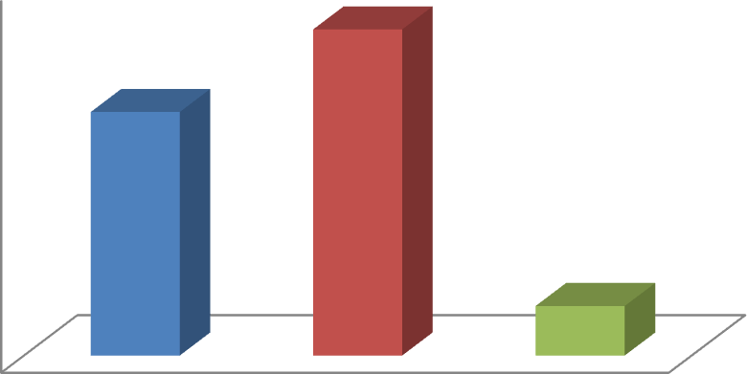
60
50
40
30
20
10
0
Age
52.67
39.33
8
15 -19 years 20 -25 years 26-30 years

Fig. 1. Distribution of students according to their age
- Gender
It is the range of socially constructed characteristics pertaining to and differentiating between masculinity and femininity, it was categorized as male or female. The results are presented in Table 2

Table 2. Distribution of students according to their gender
(n=150)
S.No | Gender | Frequency | Percentage%
1 | Female | 109 | 72.67
2 | Male | 41 | 27.33
Total |  | 150 | 100.00

From the above Table 2. it was observed that more than fifty per cent of the respondents (72.67%) were female and 27.33 per cent were male respondents. The findings indicated that the female students were more as compared to male students. The admission of female students in the university was double than that of male students. The results were in line with findings Khojah et.al. (2021), Ayoob and Malik (2020).

Education
It was operationalized as the year of degree pursuing by the students. It was classified into two categories as 2nd year and 3rd year. The results are presented in Table 3.

Table 3. Distribution of students according to their education qualification
(n=150)
S.No | Education | Frequency | Percentage%
1 | B.sc and B.Tech  2nd year | 75 | 50.00
2 | B.sc and B.Tech 3rd  year | 75 | 50.00
Total |  | 150 | 100.00
The Table 3. indicated that equal number of respondents were taken 2nd year and 3rd year (75%).

Background
It was operationally defined as the place from where the respondent hails. It was classified into two categories as rural and urban. The results are presented in Table 4.

Table 4. Distribution of students according to their background
(n=150)
S.No | Background | Frequency | Percentage%
1 | Rural | 90 | 60.00
2 | Urban | 60 | 40.00
Total |  | 150 | 100.00

It was observed from the Table 4.that three-fifths of the students (60%) belonged to rural background and remaining 40 per cent of the students belonged to urban background. The above findings could be due to the reason that, in the admission process there is preference for the children of farmers under farmers quota. The results clearly indicated that greater proportion of the rural families preferred agricultural education for their children. Moreover, the major profession of the people dwelling in rural areas is agriculture and allied activities. Hence due to the inclination towards agriculture-based profession, parents might have opted agriculture education for their children. Further it could be added that student’s personal interest towards their parent’s profession might be the reasons for more students preferring agricultural courses from rural backgrounds. These findings were in line with Muthuprasad et.al. (2021).

Type of Family

It was operationally defined as number of pairs of couples and their children living together, it was categorized based on blood relations living together viz., nuclear and joint. The results are presented in Table 5.

Table 5. Distribution of students according to their type of family
(n=150)
S.No | Type of family | Frequency | Percentage%
1 | Nuclear | 126 | 84.00
2 | Joint | 24 | 16.00
Total |  | 150 | 100.00
The Table 5. revealed that large majority of the students belonged to nuclear family (84%) and remaining 16 per cent belonged to joint family. Living in nuclear families is the trend of current era. The probable reasons for disintegration of joint families into nuclear families might be due to over population, problem of accommodation, family quarrels, impact of western culture, education, urbanisation, industrialisation etc. These findings were in line with Khojah et. al. (2021).

Parental occupation
It was operationalized as an activity in which a respondent’s parents were engaged for their livelihood, it was categorized into five namely, Government sector, Private sector, Agriculture, Business and Others. The results are presented in Table 6 and Figure 2.

Table 6. Distribution of students according to their parental occupation
(n=150)
S.No | Parental occupation | Frequency | Percentage%
1 | Government sector | 24 | 16.00
2 | Private sector | 16 | 10.67
3 | Agriculture | 62 | 41.33
4 | Business | 21 | 14.00
5 | Others | 27 | 18.00
Total |  | 150 | 100.00
It was found from the Table 6. that more than two-fifths of the student’s parental occupation was agriculture (41.33%), followed by others (18.00%), government sector (16%), business (14%) and private sector (10.67%). The results showed that greater proportion of students’ parental occupation was agriculture. Other occupation included artisans, pottery makers and craftsmen etc.

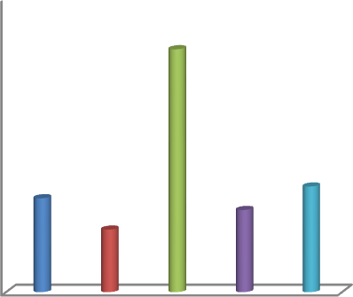
Other
Fig 2. Parental Occupation
0
Business
10
14
10.66
Agriculture
18
16
20
30
Government sector
Private sector
40
41.33
50

- e-readiness of students for online learning
Digital literacy
Digital literacy refers ability to use a range of technologies tools and other media on various digital platforms. The results are presented in Table 7 and Figure 3.

Table 7. Distribution of Students based on their digital literacy
(n=150)
S.No | Digital literacy | Frequency | Percentage%
1 | Usage of digital devices | 137 | 91.33
2 | Usage of learning apps | 141 | 94.00
3 | Submission of online assignment | 130 | 86.66
4 | Resolving the technical problems | 86 | 57.33
5 | Usage of options of online learning platforms | 95 | 63.33

*Multiple responses
From the results in the Table 7. it can be observed that majority of the students (94.00%) had knowledge on usage of learning apps, followed by usage of digital devices (91%), submission of online assignment (86.66%). More than three- fifths of the students had knowledge on usage options of online learning platforms (63.33%) and resolving the technical problems (57.33%). The students expressed that they were using power point, word document, pdf content and other learning apps for doing their assignment, group work and workshop etc.Hence due to this students got exposure towards learning apps, learning platforms as well as usage of digital devices like computer, laptop and smartphone etc. This basic exposure towards the use of apps, software and devices helped the students to gain skill and increase the digital literacy among students. The results were in accordance with Shopova (2014) who stated that students had improving digital literacy and their skills in using ICTs for the learning process.

Percentage


Fig.3. Distribution of student’s digital literacy
100
90
80
70
60
50
40
30
20
10
0
91.33
94
86.66
Usage of digital devices
57.33
63.33
Usage of learning apps
Submission of online assignment
Resolving the technical problems
Usage of options of online learning

- Possession of electronic devices

Response from the students on possession of electronic devices owned in terms of laptop, smartphone, tablets Office computer, personal computer was obtained and the results are presented in Table 8 and Figure 4.

Table 8. Distribution of students according to possession of electronic devices

(n=150)
S.No | Electronic Devices | Frequency | Percentage%
1 | Laptop | 65 | 43.33
2 | Smartphone | 148 | 98.66
3 | Tablets | 35 | 23.33
4 | Personal computer | 35 | 23.33
*Multiple responses

It was observed from the Table 8. that large majority of the students possessed smartphone (98.66%), whereas 45.33 per cent of the students possessed the laptop, followed by equal proportion of 23.33 per cent possessed the tablet and personal computer. These findings clearly indicate that almost all the students possessed and used smartphone, because of its easiness and having features of user friendly and economically affordable. So most of the students preferred smartphones. The findings were similar with Baticulon et.al. (2021) and Muthuprasad et.al. (2021)

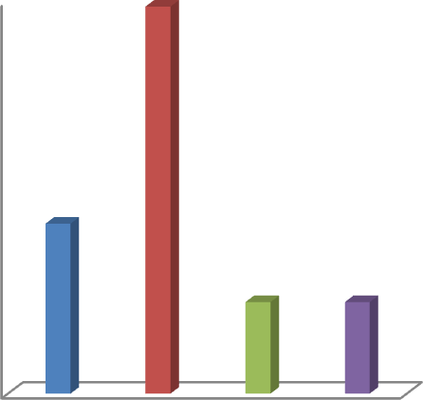
Fig 4. Distribution of students according to possession of electronic
100
98.66
80

60
43.33
40
23.33 23.33
Laptop Smartphone Tablets
Personal computer
20

0
Devices
Percentage
devices
- Frequency of using electronic devices for online learning
It was operationally defined as the degree to which the respondent used the electronic device namely laptop, Smartphone, Tablets, office computer and Personal computer for online teaching. The results are presented in Table 9 and Figure 5.

Table 9. Utilisation of electronic device for online learning by students
(n=150)
S.No | Electronic device | Frequency of utilisation
S.No | Electronic device | Frequently | Rarely | Never
S.No | Electronic device | f (%) | f (%) | f (%)
1 | Laptop | 7  (4.66) | 73  (48.67) | 70  (46.67)
2 | Smartphone | 123  (82.00) | 26  (17.33) | 1  (0.67)
3 | Tablets | 2  (1.33) | 35  (23.33) | 113  (75.34)
4 | Personal computer | 5  (3.33) | 29  (19.33) | 116  (77.34)
The Table 9. revealed that majority of the students frequently used smartphone (82%), followed by rarely (17.33%) and less than one per cent never used smartphone. About 48.67 per cent rarely used the laptop, followed by never (46.67%) and frequently used laptop (4.66%). While 77.34 per cent never used the personal computer, followed by rarely (19.33%) and frequently used personal computer (3.33%). A large proportion of students never used the tablets (75.34%), followed by rarely (23.33%) and frequently used tablets (1.33%). The reason why most of the used smartphones because students could access the learning process at any time and from anywhere by downloading assignments and uploading completed assignments.
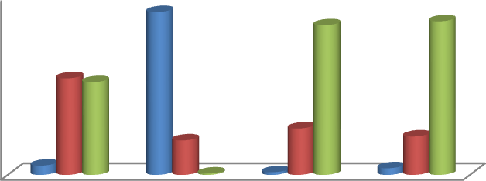

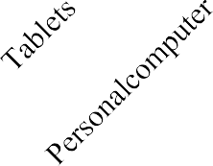
Utilisation of electronic device
90
80
70
60
50
40
30
20
10
0
Frequently
Rarely

Never

Fig. 5 Utilization of electronic device for online learning by students
- Types of internet connection used for online learning
It was operationally defined as the degree to which the student used the internet connection used for online teaching namely Wi-Fi, Mobile Hotspots, Local Area Network. The results are presented in Table 10 and Figure 6.

Table 10. Distribution of students according to types of internet connection used for online teaching
(n=150)
S.No | Types of internet connections | Frequency | Percentage%
1 | Wi-Fi | 72 | 48.00
2 | Mobile Hotspots | 105 | 70.00
3 | Local area network | 79 | 52.66
*Multiple responses

It was observed from the Table 10. that more than half of the students were using mobile hotspots (70%) for internet connection, followed by local area network (52.66%) and Wi-Fi (48%). Because most of the students were from rural areas they did not have proper internet connection facilities for online learning. So students depend onthe mobile hotspots for online classes. The results were in conformity with the results of Hasan and Khan (2020).

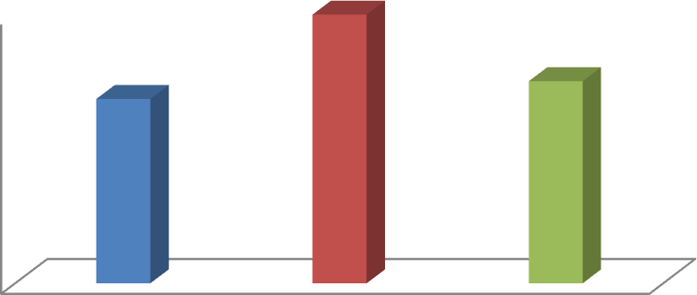
70
70
60
50
40
30
20
10
0
48
52.66
Wi-Fi Mobile hotspots Local area network

Percentage

Fig. 6. Distribution of students according to types of internet connection used for online learning
- Online learning competencies of students
Competency was operationalized as the ability of the student to make use of different features of a videoconferencing application and handle online class. The results are presented in Table 11.

Table 11. Distribution of students according to their competencies in online learning
(n=150)
S.No | Competencies | Frequency | Percentage %
1 | Basic knowledge on operating  devices | 141 | 94.00
2 | Joining the meeting | 146 | 97.33
3 | Mute and unmute the audio | 145 | 96.66
4 | Mute and unmute my video | 142 | 94.66
5 | Chat and reply in chat box | 144 | 96.00
6 | Sharing of videos, animations  etc. | 123 | 82.00
7 | Operating different  applications during online classes | 113 | 75.33
8 | Aware of tools in settings of  online application | 106 | 70.66
9 | Sending reply with symbols | 136 | 90.66
10 | Sharing invite link to others  during the class | 136 | 90.66
11 | Raise hand for doubts | 142 | 94.66
*Multiple responses

The above Table11. indicated that majority of the students had competency how to joining the meeting (97.33%), followed by mute and unmute the audio (96.66%), remain chatting an reply in chat box (96.00%), an equal proportion of students (94.00%) had competency like mute and unmute the video and raise hand for doubts and knowledge on operating devices. While 90.66 per cent of the students know how to reply with symbols and sharing inviting link to friends when class is going on followed by sharing of videos and animations (82%), operating applications in online classes (75.33%) and aware of every tool in setting of online application (70.66%).
Most of the students were aware of how to join the meeting, mute & unmute audio and video while the class was going they did chat and reply in chat box, raising hand for doubts. Because of the experience they gained knowledge during pandemic. These findings were similar with Azimi (2013) students improve the technological skill for e-learning with training.

e-readiness of students for online learning
e-readiness was operationally defined as the preparedness of teachers to participate in the electronic world for teaching the students online. The results are presented in Table 12 and Figure 7.

Table 12. e-readiness of students towards the online learning
(n=150)
S.No | Category | Frequency | Percentage%
1 | High | 71 | 47.33
2 | Medium | 76 | 50.67
3 | Low | 3 | 2.00
It was observed from the above Table 12. that majority of the students had medium level of e-readiness (50.67%), followed by (47.33%) high level and (2%) Low level of e- readiness.
The findings revealed that most of the students had medium level of e-readiness towards the online learning. Because the reason due to lack of uninterrupted power supply and internet connectivity. To have high level of e-readiness towards the online learning students possess their own electronic gadgets and proficient in digital skill, digital learning platforms. They must have good infrastructure facilities with internet connectivity. The findings were similar with Rodriguez et. al. (2008) who stated the students had comfort with technology and motivation were the related to perceived quality and satisfaction towards e-learning.

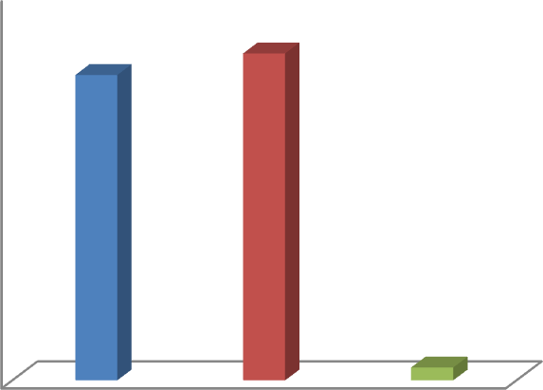
e-readiness
0
2
10
Low
20
Medium
30
High
50

40
50.67
47.33
60

Percentage

Fig.7 e-readiness of students towards the online learning
13 Difference between rural and urban students based on e-readiness
Table 13. Mean differences between e-readiness of students based on locality

(n=150)
S.No | Dependent variable | Area | Mean ± S.D | t-value
1 | e-readiness | Urban | 2.50±0.55 | 1.303^{NS}
1 | e-readiness | Rural | 2.38±0.52 | 1.303^{NS}
*Non- significant at 0.01 level of probability
The results presented in the above Table 13 indicated that there was a no significant difference between the urban and rural students on e-readiness for online learning. However urban students scored better than the rural counterpart. Interestingly all the students had good exposure towards usage of electronic gadgets, participation in online class, workshops, seminars, competition, utilising ICT tools and technologies for gathering information and attending online classes. There was no much difference between rural and urban students. This due to improvement and development of rural areas in terms of internet connectivity, possession of electronic devices in each home, awareness regarding handling electronic gadgets and innovative technologies. These findings were smiliar with konwar (2017) who stated that both rural and urban students possess high attitude towards e-learning but urban students have slightly higher attitude towards e-learning than rural students.

14. Relationship between the selected profile characteristics and e-readiness of the students
(n=30)
S.No | Independent variable | r-value
1 | Digital literacy | 0.41**
2 | Competencies of electronic  learning | 0.46**
3 | Possession of electronic devices | 0.21*
** Significant at 0.01 level of probability
*Significant at 0.05 level of probability
It was observed from the Table 14. that the computed coefficient of correlation ‘r’ value of digital literacy, and competencies of online learning was found to be positively significant at 0.01 level of probability, while possession of electronic devices was found to be positively significant at 0.05 level of probability. Therefore, it could be inferred that there was a positive and significant relationship between independent variable and e-readiness of the students. The student who had better digital literacy such as usage of digital devices like computer, smartphone, tablets, laptop, online learning apps, solving technical problems, usage of online learning platform. So this would bring about significant improvement in the e-readiness. And also the students who had good online learning competencies like knowledge on operating devices, usage of online learning platforms and participants in online learning classes that helps students to have better e-readiness. The students who possessed their own electronic gadgets like laptop, smartphone and tablets had knowledge in operating electronic gadgets that helps students to have better e-readiness towards the online learning. These findings were similar with Soni (2016) who stated that possession of ICT tools and devices were positively correlated to extent of using digital platforms for educational purpose.
Teaching learning strategy for effective online education
A strategy in this study was evolved to implement the teaching and learning for effective online education without any deviation.
- The nature of content and infrastructure were the major determinants for smooth conduct of online classes. The course instructor should spend quality time to design the content which should be well structured, concise, interactive and relevant. Students must be provided with online class recording such that content can be accessed at any time based on their convenience. This recording will be beneficial for students who missed or did not understand any part of the lecture.
- Minimum technical requirements such as internet connectivity, devices and software requirements should be fulfilled for optimal learning experience.
- Basic knowledge on handling computer and digital literacy need to be imparted to the students for effective learning.
- Online learning engagement strategies such as participating in collaborative group work, having students facilitate presentations and discussions, sharing resources actively, creating course assignments with hands on components should be included for providing positive learner experiences.
- Communication between students and teachers is crucial. Teachers should pay closer attention to their vocal pitch and tone when teaching online. Teachers should be aware of the significance of keeping a low voice and honing vocal pitch.
- To ensure attentiveness, a large lecture can be broken up into smaller lectures or discussions. Less than 30-minute materials should be prepared by the teaching staff for online classes. This can be accomplished by breaking up a lengthy presentation into several shorter lectures. This will support learners' ability to pay attention and maintain their focus in online class.
- In order to improve student learning abilities in online classes, teachers should pose challenging questions to the students. These procedures will assist students to develop superior learning skills and will guarantee that they are more attentive in online sessions.
- Interaction between learners is crucial for online learning since it increases student engagement. Planning activities that increase engagement is crucial to avoiding potential boredom and isolation among online students in the learning environment. Web-based tools like forums, chat sessions, blogs, wikis, group projects, and peer evaluation can be used to encourage student interaction in online courses for active learning as well as to boost engagement.
- The use of multiple student-instructor communication channels may be highly related to student engagement. Mini videos and screen casting are techniques to increase learner to instructor interaction. The instructor can use various features in synchronous sessions to interact with students such as polls, whiteboard, text, or audio and video chat.
- Student friendly software can be used in order to obtain the maximum benefit of online learning and to make online learning comfortable.
- Online learning may be continue to be incorporated through a blended mode which will enable better preparedness for the adoption of online learning in future crisis situations.

Conclusion:
To make teaching and learning effective in online education the content of the course should be well structured, concise, interactive and relevant. Various features can be used in synchronous sessions to interact with students such as polls, whiteboard, text, or audio and video chat. To ensure attentiveness of the students, a large lecture can be broken up into smaller lectures or discussions. Less than 30-minute materials should be prepared by the teaching staff for online classes.

COMPETING INTERESTS DISCLAIMER:
Authors have declared that they have no known competing financial interests OR non-financial interests OR personal relationships that could have appeared to influence the work reported in this paper.

References
Anusha. 2019. A study on perception of university students regarding e-learning. M. Sc (Ag.) Thesis. Punjab Agricultural University, Ludhiana.
Baticulon, R. E., Sy, J. J., Alberto, N. R. I., Baron, M. B. C., Mabulay, R. E. C., Rizada,L. G. T and Reyes, J. C. B. 2021. Barriers to online learning in the time of COVID-19: A national survey of medical students in the Philippines. Medical science educator. 31(2): 615-626.

Bhuasiri, W., Xaymoungkhou, O., Zo, H., Rho, J. J and Ciganek, A. P. 2012. Critical success factors for e-learning in developing countries: A comparative analysis between ICT experts and faculty. Computers & Education. 58 (2): 843–855.
Dhas, J.S., 2017. Attitude of college students towards e-learning. International emerging science and Technology. 4.
Khojah, M., Vivek, Khan, M.A., Nabi, M.K and Tahir, M. 2021. Students’ Perception towards E-Learning during COVID-19 Pandemic in India: An Empirical Study. Sustainability 2021. 13 (1): 57.
Madhumita. 2016. A study on e-learning among the Post Graduate students of Banaras Hindu University. M. Sc (Ag.) Thesis. Banaras Hindu University, Varanasi, India.
Muthuprasad. T., Aditya, K. S., Aiswarya, S and and Jha, G. K. 2021 Students’ Perception and Preference for Online Education in India during COVID -19 Pandemic. Social Sciences & Humanities Open. 3 (1): 00101.
Perdana, R., Yani, R., Jumadi, J. and Rosana, D., 2019. Assessing students’ digital literacy skill in senior high school Yogyakarta. JPI (Jurnal Pendidikan Indonesia). 8(2):169-177.
Razzaghi, A., Delavar Pour Moghaddam H and Akbarilakeh, M. 2019. Attitudes of faculty members towards using e-learning. Research and Development in Medical Education. 8 (1): 12-19.
Surahman, E and Sulthoni. 2020. Student Satisfaction toward Quality of Online Learning in Indonesian Higher Education During the Covid-19 Pandemic. 6th International Conference on Education and Technology (ICET). 120-125.
Tohara, A.J.T., 2021. Exploring Digital Literacy Strategies for Students with Special Educational Needs in the Digital Age. Turkish Journal of Computer and Mathematics Education .12(9): 3345-3358.
Ullah, O., Khan, W. and Khan, A. 2017. Students’ Attitude towards Online Learning at Tertiary Level. Peshawar University Teachers Association Science Journal. 25 (1-2): 3-82.

