Leveraging Anthropocene Indian disasters with Python

ABSTRACT
The work encompasses the analysis and visualisation of the patterns, impact, and trends of disasters for 124years in India. The anthropogenic, tectonic, stratification and climate change impacts are frequently causing disasters like floods, cyclones, droughts, earthquakes, epidemics and chemical disasters. To better understand these events and their consequences, a dataset comprising records of 783 disaster incidents was analysed using Python. The languages Python and Q-GIS/RS were used to analyse and visualise libraries like Pandas, NumPy, Matplotlib, Seaborn, and Plotly. The involved processes are data cleaning, exploratory data analysis, and developing visual insights to highlight disaster-prone regions and high-impact periods. The results reveal that climate change-induced disasters like floods, droughts and cyclones are recurrent, apocalyptic and detrimental. Indian states like Odisha, Gujarat, Jammu and Kashmir are more vulnerable to geo-meteorological disasters. The analysis results compel management authorities to stress disaster preparedness, resource planning, infrastructure development, and risk reduction instead of relief-oriented approaches. To establish the real-world applicability of Python as a geospatially versatile tool to plan for addressing critical socio-economic challenges. The future projections shall comply with Sustainable Development Goal 11.5, comprising Sustainable Cities and Communities, specifically in target 11.5, SDG 13 (Climate Action).
Keywords: Disasters, Spatial Data Infrastructures, Stochastic modelling, DRR, Python, SDGs
INTRODUCTION
The geographical setting of the peninsula in the globe, India, is ranked among the top ten countries with the most disasters occurring. The tropical housing, along with juxtaposing the North Indian Ocean (NIO) and the mighty Himalayas, made India the hub for many devastating disasters. The common disasters in the country are tropical storms, floods, drought, landslides, earthquakes, cloud bursts, mud flows, wildfires, sinkholes, avalanches and many others. The climate change (CC) impacts have exacerbated extreme weather events during the Anthropocene epoch in India, being driven by natural and climatic forces (Neelakantan et al, 2019^{[1]}, Ulal et al., 2023^{[2]}, Mishra et al., 2023[^{3]}, Cvetković et al, 2024^{[4]}).
Globally India, the 7th largest Agri-based country in the world, and the second most populous, home to over 1.464 billion (with growth rate 0.89%) housed between young Himalayas and the gulfs of Indian Ocean, diverse geography with mountainous ranges Eastern and western Ghats Belt Hills (EGBH and WGBH), northern plains, deccan and peninsular plateau, coasts (11099km) wet and deserts with, divergent changing climates, biodiversity, and rich natural resources SOI data, Climate risk country Profile, India; World ban. Key issues are climate Vagaries, equitable resources management, and sustainable environmental growth, adequate employment, redressal of environmental issues like soil/forest degradation, poor air quality and groundwater usage, etc. The escalated population grounds significant and irreversible impacts on the environment and Ecosystem (Tal et al, 2025^{[5]})
Indonesia is shifting 10million from Jakarta city to Nusantara (Archipelago) due to coastal submergence @25cm/year (Maheng et al., 2021^{[6]}). India is the hub of all forms of natural disasters that have an impact. On average, main disasters comprise floods/erosion (12%), droughts (68% of total CCA), NIO Cyclones/ Storms about 5700km out of 7516km coast, earthquakes (58.6%), and landslides (15% of hill ranges), affecting 27 out of 36 States. The Himalayan ranges and the eastern states in India are disaster-prone, mainly earthquakes (India recorded 159 earthquakes with tremors >4 on the Richter scale from November 2024 to February 2025). Annual heat waves (central, northern, and western India). Urban local bodies (ULBs) of 5161 are also susceptible to urban flooding, with 5,161 Urban Local Bodies 12.6% of land area (0.42 MKm² ) excluding snow-covered surfaces, prone to landslides, and affected. (Mishra et al, 2020^{[7]}, GSI data ^{[08]}, NDMA course materials 18-29, Aug, 2025^{[9]}, Fuady et al, 2025^{[10]} ).
The World has glacial and deglacial epochs (even at the Poles) in cycles at about 100,000-, 41,000- and 23,000-year intervals as per the Milankovitch cycles based on the earth’s eccentricity (orbital shape), Obliquity (axial shift), and precision, i.e. insolation distributed over the earth’s surface through ages. The 21st century (Milankovitch cycle) is at the interface of the 6th mass extinction, one among such deglaciation epochs (Karanjit A., 2025^{[11],} Anderson, 2025^{[12]}).
Table 1: Human evolution, natural social stratification with CC and ISM change in India
Date (YBP) | Epochs | Period | Major happenings | Climate change effects
82000-42000 | Pleistocene | Mid Palaeolithic period | Homosapiens in South Africa grew (Kalahari) | Terrible CC, humans migrated to India as hunter-gatherers. Extreme cold; Younger Dryas.
42000- 12000 | Pleistocene | Upper Palaeolithic period | Severe CC rate, Human-shifts, Fire use; Hunter-gatherers. | Ruined human population; cave life and paintings, from nomadic hunter-gatherer to habitations.
12000-10800 | Pleistocene-Holocene, transition | Younger dryas | SST warmed, 5 to 10⁰C | Microlith sites (M.P) Bhimbetka, Hunsgi, Caves, Narmada Valley, Kaladgi R., Mehergarh
10800-7200 | Pre-Holocene | Greenlandian | ISM rise, warm climate, Rise MSLR, | Still Glacier growth, high floods, Farms start, surge in Navigation
7200-4200 | Mid Holocene | Newgrippian | Mini Ice Age, cool climate; Agriculture flourished, | ISM strong, Indus Valley civilisation, Chilika Lagoon formation, Aryan in North
4200 - 75 | Post Holocene | Meghalayan (medieval max^{m} warm period, | Little Ice Age (3300-2200), Global warming, Bronze Age | Megafauna extinct, central society, trades expanded, men civilised, Industrial age
075- till date | Pre-Anthropocene | Golden spoon period | Erratic ISM, Global warming, and climate extremes like droughts and floods | More people, less food, land and forests loss, urban spread along coasts, more migration, 6th Mass extinction, and human activities.
YBP: years before present; CC: climate Change; MSLR: Mean Sea Level Rise; ISM: Indian summer monsoon, MP: Madhya Pradesh; SST: Sea Surface Temperature
Sources: Mishra et al, (2018)^{[13]}, Sharma et al, (2021)^{[14]}, Mishra SP., (2022)^{[15]},
About large/small or localised/widespread fourteen famines occurred from the 12th century to the 17th century, fought in the Indian sub-continent, which are less reported. (Thilagavathy et al, 2024^{[16]}). The mounting frequency, magnitude, varieties, spatial distribution and severity of these disasters are mostly attributed to natural, geological, lithological, structural and anthropogenic factors. CC bearings, rapid urbanisation impacts, and environmental deterioration have made Indians added vulnerabilities that warrant the nation’s focus on disaster preparedness, management and mitigation (Richer et al, 2022^{[17]}). From India’s independence (emergence of Anthropocene epoch), less stress was laid on prepared activities and long-term resilient strategic plan implementations till 2005. Later, India strengthened its disaster management strategies by spatial data management, capacity building and resource mobilisation (Ghawana et al., 2021^{[18]})
Literature Review:
The Internal Displacement Monitoring Centre (IDMC) reports that the weather-related disasters compel 21.8 million people on average to become oustees annually. The climate-migrants in India have surged sporadically (Haque et al, 2020,^{[19]} Gupta et al, 2025^{[20]}).
The frequency, magnitude and severity of natural disasters necessitate more open-source disaster intelligence (OSDI) for real time appropriate disaster response, and insitu model studies and according comprehensive disaster monitoring, management action plans Balakrishna et al., 2024^{[21]}, Sufi et al., 2025,^{[22]} ] Systematic analysis and mapping of building damages, health risks due to disaster can be done using Internet of things (IOT), (Leong et al, 2025^{[23]}), Machine Learning (ML) (Rajapasakha et al, 2024^{[24]}, Artificial Intelligence (AI) methodology, (David et al., 2024^{[25]}), Artificial neural Network (ANN) as the parameters extreme rainfall (Kagabo et al, 2024) ^{[26}], Floods (Heideri et al, 2025^{[27]}, Alkaabi et al, 2025^{[28]})
The detection of cataclysmic extreme weather, natural disasters, and anthropogenic catastrophes, the resulting environmental and ecosystem degradation of land by utilising AI, ANN, ML, and DL, etc methodologies (Shiv Kumar et al, 2007^{[29}], IPCC 6th AR 2023^{[30]}, Van-Excel et al., 2025. ^{[31]})
The Internet of Things (IoT), Machine Learning technologies, and Artificial Intelligence (AI) have emerged as an innovative skill that enables easy and systematic real-time data collection and analysis. Judicious strategic plans for encountering disasters can strengthen Risk, safety, response, and emergency management of disasters. The disaster analysis by using Python is one among the efficient tools that includes data analysis and modelling, development of algorithms and data visualisation (Wang et al, 2025^{[32]})
About 59% of the area in India is susceptible to earthquakes. India recorded 159 earthquake tremors of magnitude 4.0 from Nov. 2024 to Feb. 2025, with the latest being a in Delhi on 17th February (Santosh et al, 2025^{[33]}), large fires 12506 in 2022-23 and 11306 in 2023-24 in Wayanad landslide (2024) in Kerala. The 251 deaths underscore the distressing human and economic toll of such events. Similarly, the 2023 Joshimath subsidence in Uttarakhand and the 2022 Manipur landslides warrant addressing landslide hazard, exacerbated by climate change (CC), heavy rainfall, and infrastructure development (Zhao et al, 2025^{[34]}), contributing towards Real-Time Data Collection and Processing (Nguyen et al., 2021.
From the above review it is found that there is a gap between study of complexity in various disasters which are inter related and underreported like storm -rainfall -flood, landslide/dam break and flash floods, Earth quake – Tsunami – coastal floods and human destruction by pandemics etc.. the others are improper The Crisis Preparedness Gap Analysis (CPGA) is the gap in policy making and disaster preparedness etc. Research areas in disaster analysis in big data management in addressing various challenges like the use of AI, ML, ANN and Python are actively progressing, but are insignificant.
Objectives: The Present work is conducted with the following objectives:
- Recognising long-term disaster trends, geospatial geologic stratification, and identifying high-impact years and frequencies, for better strategic planning and inter-relationships between them.
- Offer data-driven support to real-time studies for the government agencies, NGOs, and researchers in designing effective disaster risk reduction strategies.
- Promote the use of programming and data science (particularly Python) in solving real-world societal challenges.
- Finding the Interrelation between disasters and the trend analysis of various disasters in India
Methodologies
The Python and GIS and RS methods are used to generate charts, graphs, and interactive visualisations, bringing clarity to complex historical data and disclosing the valuable trends, region specificity, to inculcate management strategies, early warning systems, etc.
Data Acquisition: The data set is structured in a tabular format with multiple columns, each capturing specific details about the disaster event. The 124 years data (1900-2024) comprising of 783 disasters and of 17 attributes is gathered from site Kaggle titled: "Indian Disaster Dataset, It serves as the primary data of India for performing exploratory analysis and visualization using Python under csv (Comma-Separated Values) (Link -ii) The Key Attributes used in the Dataset are Disaster Subgroup (geological, meteorological etc.) and Disaster location, Type, fatalities. Area affected and timing, along with the specific type of disaster in India (e.g., Flood, Earthquake, Epidemic). Insured Damages and Reconstruction Costs.
The various charts prepared are distribution of Disasters by Type in India (Donut chart), Time Series Analysis - Disasters Over the Years (Bar Chart, Line Chart), Most Frequent Types of Disasters (Bar Chart), Total Damage Over the Years, Total Death Over the Years (line graph), Economic loss vs Deaths (bubble chart) and heat map of Deaths by Year and Disaster Type. The tools used in the work are pandas (to load and manipulate the dataset), numpy ( numerical operations), and matplotlib. pyplot (to create line, bar, and scatter plots), seaborn (for heatmaps and aesthetic graphs), and Plotly Express (for interactive charts).
System Configuration
The system required for the use of tools and the configuration of the system used are in Table 2.
Table 2: Minimum Requirements for Similar Projects and the present work done using Python
Gadgets | Minimum Necessity | The present system is used
Processor: | Intel i3 or AMD Ryzen 3 | Intel Core i7-10750H CPU @ 2.60GHz
Processor RAM: | 4 GB (8 GB for large dataset) | 16.0 GB
Storage: | 500 MB – 1 GB of free space | 512 GB SSD (SK Hynix HFS512GD9TNI)
OS: | Windows 10/11, macOS/Linux | 512 GB SSD (SK Hynix HFS512GD9TNI)
Python Version: | Python 3.7 or higher | Operating System: Windows 10, 64-bit
Required Libraries: | Pandas – for data manipulation | System Type: x64 - based processor 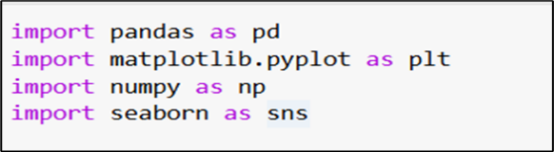
 | numpy – for numerical operations
 | matplotlib, seaborn, plotly – for visualisations | Tools Used: Jupyter Notebook, Google Colab.

Data Preprocessing
Based on our dataset, the important processes are Importing and Loading Data: - The Dataset was imported from Kaggle in CSV format and loaded using pandas for manipulation and analysis. Understanding the Structure: - Contains 783 records and 25 columns, including disaster type, location, date, magnitude, death toll, and economic damage.
Dropping Irrelevant Columns: Example: ‘Unnamed: 3’ column is empty, needs removal. Handling Missing Values: Many columns have missing values, like - Location – 50 missing, Total Deaths – 66 missing, Total Damage – over 580 missing. - Drop columns with excessive nulls (like Unnamed: 3, Latitude, Longitude). They are fill/ignore based on relevance(e.g., leave damage fields blank for plotting, or use 0). Converting to a Data series: Convert date-related columns (Start Year, Start Month, etc.) to datetime. Renaming and Cleaning Columns: Clean long column names (e.g., 'Total Damage, adjusted ('000 US$)' → Adjusted Damage).Removing Duplicates and repetitions: Check for and drop the duplicate records to avoid skewed results. Filtering Data: Focus analysis only on major disaster types for clarity (e.g., Earthquake, Flood, Cyclone).

Data Visualisation: Created insightful charts using matplotlib, seaborn, and Plotly. They are Doughnut Chart – Distribution of disaster types; Line/Bar Charts – Year-wise disaster trends and deaths. Bubble Chart – Comparison of deaths vs. economic loss; Heatmap – Deaths by year and disaster type; Bar Chart – Most frequent disasters.

Insight Generation: In data analysis, the interpreted visual outputs to find key patterns are (i) Floods and cyclones are most frequent. (ii) Economic losses and deaths vary per disaster type. States like Odisha, Bihar, and Assam are highly vulnerable.
Limitations of the Study: The various limitation for the research are (i) Limited to Historical Data: The analysis is based only on past disaster data and does not include real-time data or forecasting models, (ii) Data Incompleteness: Some disaster records may have missing or inconsistent values (e.g., exact economic losses, death counts), which could affect the accuracy of certain visualizations, (iii) No Predictive Analysis: The study focuses on trend analysis and visualization but does not employ predictive models (e.g., machine learning) to forecast future disasters, (iv) Generalized Insights: Regional and local factors such as infrastructure, population density, and disaster response efficiency are not deeply analyzed.(v) Data Source Reliability: The dataset is collected from public or secondary sources, which may have reporting gaps or discrepancies over decades, (vi) Static Visualizations in Some Cases: Although some charts (like bubble charts and heatmaps) provide strong insights, real-time interactive dashboards are not implemented in the final version, (VII) Lack of Integration with Geographic Mapping Tools; While the project includes heatmaps and visualizations, detailed geospatial analysis using GIS or satellite data is not included.
Disasters in India during Anthropocene:
Anomalies in the sun-earth geometry, tectonic activities, sea surface temperatures, Himalayan climatic activities, Indian summer monsoon (ISM), El-Nino Southerly Oscillation (ENSO) and positioning of ITCZ invite different natural disasters like floods, earthquakes, landslides, biological disasters, and cyclones, which are devastating and apocalyptic. At present, the disaster data from 1900 to 2024 has been collected from various sources and has been analysed using Python tools. The historic disasters pre-Anthropocene epoch (before 1950).
Climate change vs. disasters: Present-day Climate change in India is associated with Temperature, Precipitation, Change, Sea Level rise, and Extreme events. They may be natural earth systems or Anthropogenic, reflected by geo-hazards, intense cyclone activities both in the Bay of Bengal and Arabian Sea, shrinking/ shrinking and subsidence of deltas, cloud bursts, Heat waves, Glacier Lake overflows, mudflows, landslides, urban floods, frequent earthquakes, etc. In the 21st century, the cloud bursts, coastal erosion, intense cyclonic storms and land subsidence have become frequent. The status of decadal disasters impacted India is in Table 3.

Table 3: Decadal Natural disasters numbers, deaths and types in India in the 20th century in Anthropocene
Year Range | Major Disaster Types (Disaster count) | Major Areas Affected | Total Deaths (approx.) | Economic Loss/Impact
1901–1910 | Drought, Epidemic (Bubonic plague)(2) | Central & Western India (Maharashtra, Gujarat) | 13,20,000 dead | Kangra EQ Alaria/cholera epidemics, Bengal- Odisha
19 t1 1920 | Spanish Flu (H₁N₁ Flu), cyclone, Flood (5) | All zones in India (earthquakes, epidemics, cyclones) | deaths: 2,500,300 | 1.5% decline in GDP and a 2.1% drop in consumption;1918-19 pandemic (17–18 mi)
1921–1930 | Epidemic;( plague) ,Flood, Cyclone(8) | All India (urban centres like Bombay, Calcutta) | 725043 deaths | Epidemic and cyclones-
1931-1940 | Earthquake, cyclone (6) |  | 62009 | Cyclone 4nos, Earthquake (3nos)
1941–1950 | Drought/ Famine, EQ, Flood, Cyclone (13) | The Bengal, Bihar drought is apocalyptic. | 1,500,000 | Cyclone Gujarat, Odisha, WB, LS in Assam, in 1944 &1948
1951-1960 | EQ, Heat wave, flood, land slide (30) | Panjab, Odisha, Tiruchi, MP, UP, Bihar, Kuchh, Gujarat; Bhuj, Kandla | 5500  (aprox) | Bengal famine, Cyclone WB., )
1961–1970 | Drought, Flood, EQ, HW, Epidemic, LS, Cyclone (44), | North India, Bihar, UP. | 1,550,000 | Affected: 967,051, all over India, cold waves, heat waves, ground movement, Koyana
1971–1980 | Cyclone, Flood, cold wave, HW, Epidemic, HW, LS(102) | Andhra Pradesh, Odisha, Bihar, CS slammed TN, AP | ≈442169 | 1,000,000 affected, Landslide in Kinnaur, Kashmir, HP, DS; AP cyclone, Flood in Gnges
1981–1990 | Cyclones, Bhopal Gas Manmade), heat / cold wave, drought, LS, Bacterial diseases(111) | Andhra Pradesh, Madhya Pradesh (Bhopal), WB, bacterial diseases in Delhi, Haryana, UP, Rajasthan | ≈40140 | 1,500,000, Forest fire in J&K, LS in Kachhar Assam, Flash flood Ladakh, CW, in NE region killed 290, HW deaths 450
1991–2000 | Earthquakes, Cyclones, Floods, subsidence (115) | Latur (Maharashtra), Odisha, Assam | ≈49990 | 2,000,000, flood in odisha; Subsidence in Killari Haegaon , Super cyclone Paradip ,, Heat waves, Avalanche, JE etc.
2001–2009 | Gujarat Earthquake (2001), Tsunami (2004), Heat waves, Cold waves, Major disaster events are (64Nos) | Gujarat, Tamil Nadu, Andaman–Nicobar; IO Tsunami death >10672 and missing >5711 (BBC News) | ≈56844 | 15,000,000; Gujarat EQ:20000 deaths; Heavy rain, Floods (Whole India ), Bihar Gopalganj, Odisha (2008), Flash flood Karnatak, drought (R-sthan), HW AP and MP, Cold waves HP; UP & MP,
2010–2019 | Cyclone Phailin, Hudhud, Fani, Bulbul, Kashmir, Kerala Floods (2013, 2018) (161) | Odisha, Kerala, U-khand, flash flood is the destroyer, heavy Phailin, Hudhud, Phani with rain and floods | ≈221771 | 8,000,000 affected, debris flash Flood at Kedar Nath, HW, and LS Kasmir, U-Khand flash floods, and Adilabad heat waves are the major Killers.
2020–2024 | Cyclone Amphan (2020), COVID-19 Pandemic (62) | West Bengal, All India | > 533000 | Affected > 4500000; Major killer Covid 19,(>53400), Hyderabad floods
EQ: Earthquake; LS: Land slide, Heatwave: HW; Corona Virus: COVID-19; WB: West Bengal; UP: Uttar Pradesh; MP: Madhya Pradesh; WB: West Bengal, HP: Himachal Pradesh; AP: Andhra Pradesh; TN: Tamil Nadu ; DS: Dust storm ; U-Khond : Uttarakhand, JE :Japanese encephalitis,

Source: Barro et al, 2020^{36]}, Mishra SP. 2022^{[37]}, Jha et al, 2022^{[38]}, EM DATA CRED-2024^{[39]}, Nagmani et al, 2024^{[40]}, Gupta -2025^{[41]}, https://www.worldometers.info/faq/, Joshi et al. 2025^{[42]}.

SDIs and DRR:
In present-day machine learning days, data analysis and visualisation have become essential tools for understanding complex real-world problems. The Spatial Data Infrastructures (SDIs) of the disaster are necessitated for Disaster Risk Reduction (DRR) through various modern technologies like Artificial Intelligence (AI), Artificial Neural Network (ANN), PYTHON, Machine Learning (ML) algorithms used for analysis and provide in-time appropriate predictions for proper Disaster Risk Reductions (DRRs) through metadata. The SDI and DRR are done with an aim that Human resources are the data providers, analysts and data users. The accuracy in the data should be timely, accurate and easy to use. Present thought on natural disasters, based on historical data analysis that helps to reveal vital trends, detect high-risk areas, and assess the scale of damage caused over time. This enables governments, researchers, and policymakers to make informed decisions regarding disaster preparedness, risk management, and resource allocation.
Python
Python is a common choice for data scientists, a widely used programming language. It is the most versatile/ efficient tool for non-computer science data analysts. Big data handling through metadata is known to computer analysts; they have less deep scientific knowledge that offers analysis of real-world problems. Python is an easy, flexible, and sophisticated tool for analysing complex, interrelated disaster data that allows a multi-dimensional analysis of disasters across time and space. The data scientist, other than a software designer, uses Python tools like pandas, polars, numpy, keras, sklearn, statsmodels, scipy, pyspark, etc., from the Python libraries that cover specific data-science-related tasks. The Python language is used in ML, AI, ANN and Data Science as they are Simple, Consistent, free, Easy to learn/read and use. They offer platform independence to run the code anywhere, including Windows, Mac OS X, UNIX, and Linux (Hiremath et al, 2023^{[43]}, Riyantoko et al, 2025^{[44]})
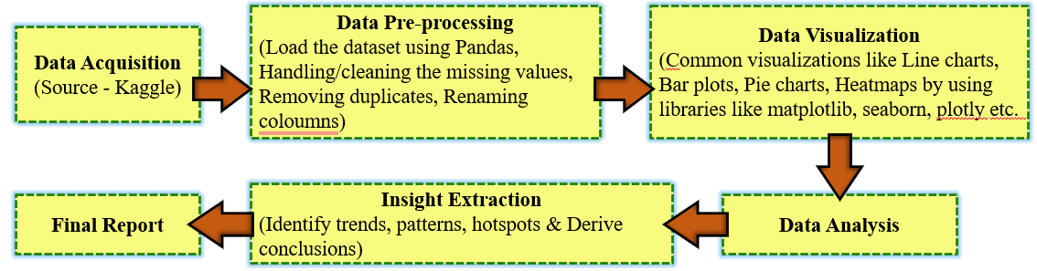
Fig 1: The flow chart for use analysing big data on disaster India by using python tools
Present search needs the use of historical data, which can be used effectively for informed decision-making and to strengthen disaster management from relief-oriented disaster redressal to systems in India. Through detailed visualisations and statistical analysis, we highlight the need for data-driven approaches in responding to and preparing for future natural calamities (Rawat et al, 2024^{[45]}) (Fig. 1)
Need for the Study
India’s vulnerability to natural disasters has made disaster preparedness and management a national priority. Over the years, events such as floods, cyclones, earthquakes, and droughts have repeatedly caused massive human and economic losses. However, without structured analysis, understanding long-term patterns and regional risk levels remains difficult. Python is a convenient tool available in libraries for hands-on practice to identify trend patterns, correlations, and anomalies, for manipulating data that supports decision-making and predictions.

RESULTS AND DISCUSSION
After the collection of data, preparing time series, processing them, various charts are created, and their interpretations are:
- Distribution Of Disaster Types in India in Donut Chart
The above Donut chart provides insight into a visual representation of the frequency of various natural and biological disasters in India. The floods are the most common disaster type, followed by storms, which together account for 70% of all disasters, the majority of the disaster incidents recorded (in Fig. 2). these Pie or annular chart (Donut Chart) representation from disaster data (Pajankar et al, 2022^{[46}) The types of disaster are epidemics (8.8%) of total, heat waves, extreme temperatures (8.2%), and landslides (mass movement - wet) (7.4%) also contribute significantly to the overall distribution. Disasters like earthquakes (3.4%), droughts (2.0%). Wildfires (<1%) appear less frequently but can still have severe impacts when they occur.
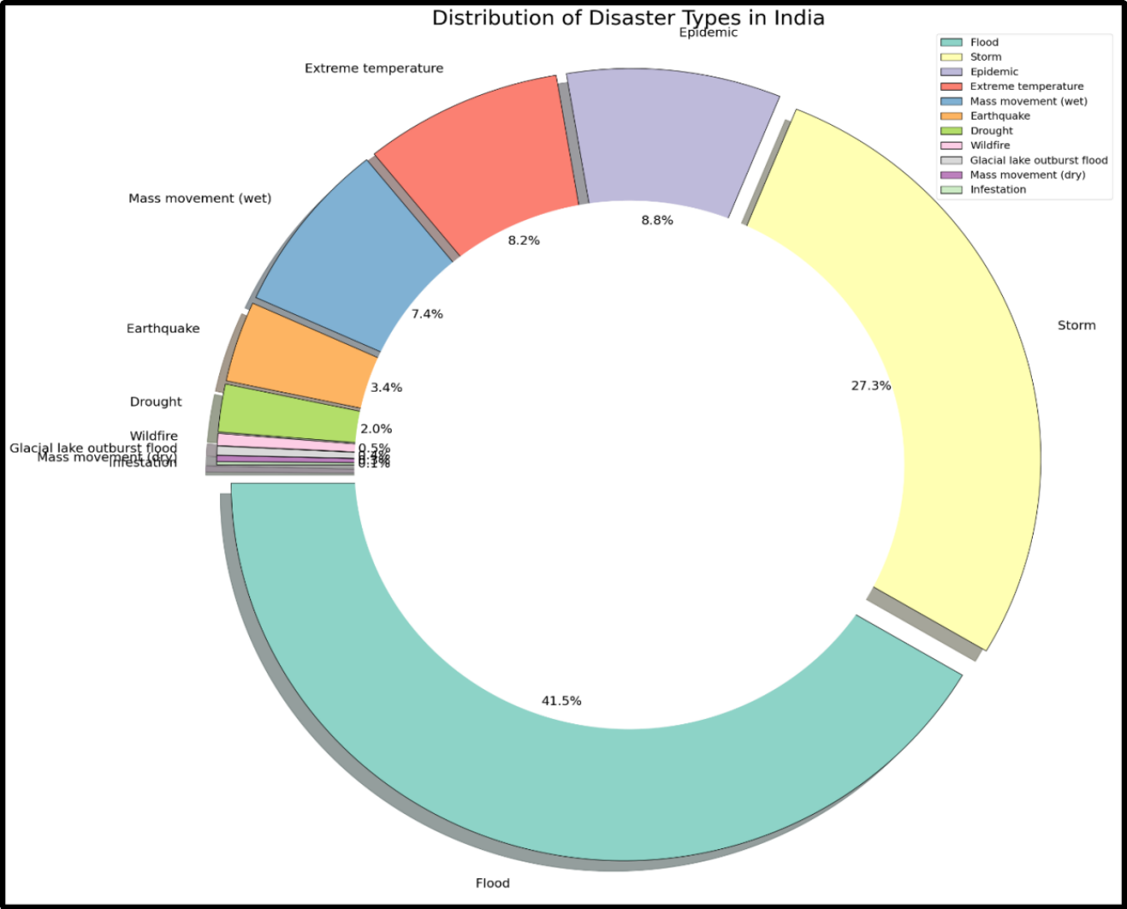
Fig 2: The Doughnut Chart prepared from disaster data using handy Python tools
The key observations from the Donut Chart, which provides information about the distribution of disaster types in India, are in Table 4:
Table 4: Donut Chart showing the distribution of disaster types in India (data 124 years)
Disaster Type | Share (% ) | Insights
Flood | 41.5% | 🔵 Most common disaster type in India
Storm | 27.3% | 🌪️ Second most frequent
Epidemic | 8.8% | 🦠 Significantly common
Extreme Temperature | 8.2% | 🌡️ High relevance, likely heatwaves
Mass Movement Wet) | 7.4% | ⛰️ Landslides and related events
Earthquake | 3.4% | 🌍 Less frequent, but high impact usually
Drought | 2.0% | 🌾 Still relevant, but less reported
Others (Wildfire, etc.) | <1% | 🔥 Very rare
The chart helps in quickly identifying high-risk disaster types and provides insight into which hazards require the most attention in terms of preparedness and mitigation strategies. The Minor disasters include Drought (2.0%), Wildfires (0.5%), and Glacial Lake outbursts, cloud bursts, flash floods, Mass movement (dry), and droughts, each contributing less than 0.5% (Bajic et al, 2022^{[47]}, https://www.geeksforgeeks.org/python/donut-chart-using-matplotlib-in-python/).
Number of Disasters/Year in Bar and Line Chart
The annual frequency of disasters has been exhibited in Bar charts/line charts. Inferences drawn from the charts are shown in Fig. 3 (a-b).
a.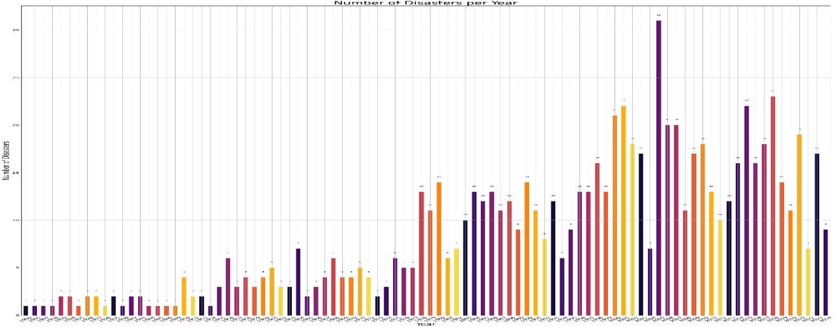
b.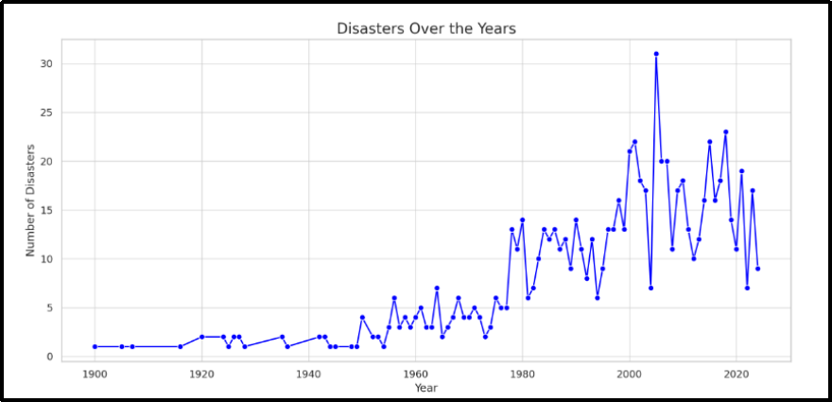
Fig 3 (a-b): Bar charts/line charts prepared from the charts prepared using Python tools
Spatial Observations: Early 20th Century (1900–1950):.From the bar and the line chart, it is inferred that very few disasters were recorded each year, often between 1 and 3. It may be due to limited record-keeping and less frequent formal reporting mechanisms.
Mid to Late 20th Century (1950–2000): There is a noticeable rise in disaster counts starting around the 1970s with increased urbanisation and mineralisation (example: The cloud burst, Glacier Lake overflow, Mud flow, Coastal and Urban floods, landslides, sinkholes, etc.). The monitoring and documentation are available in a data series.
The recent millennium, Post-2000 Period Peaks observed, especially around the early 2000s (e.g., 2001), with the disaster count exceeding even up to 30 in some years. There were 2 or three disasters in past, and their impacts were promptly disseminated due to the use of Satellite imagery becoming common as the federal institution placed importance on zero fatalities due to disasters in India.
Recent Years (2010–2024): Moderate fluctuation in disaster frequency in India, resulting in a reduction to 10–20 disasters annually. The statistics indicate a reduction in ongoing vulnerabilities and strict adherence to strategic planning, Understanding Risk, Inter-Agency Coordination, and investing in DRR (through Structural or non-structural Measures, Capacity Development, proper monitoring and adhering to mitigation plans.
India has faced a sharp increase in frequency, amplitude, and intensity of some disasters over the past five decades. These warrants growing need for disaster preparedness, climate resilience, early warning systems, Mitigation (prevention and risk reduction), Preparedness, Response and Recovery (both short-term and long-term). This rising trend is driven by a mix of Environmental factors: climate change, rising MSL, and extreme weather. Social and economic changes: urbanisation, deforestation, population growth. The strategy can be ameliorated by Technological and institutional improvements: better disaster reporting, recording and inculcating participatory disaster management.
Frequency of a disaster: The most frequent type of disasters per year in a bar graph in India
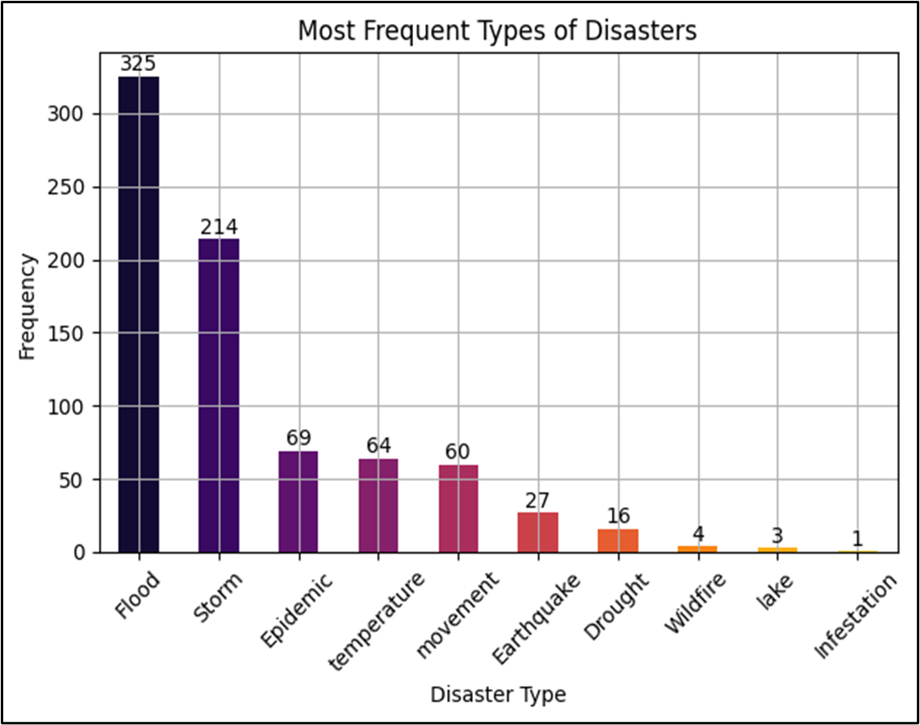
Fig. 4: The frequency of divergent type disasters in India for the study period.
Top-ranked disasters with high frequency observed for the top 3 Disaster Types are (Fig. 4):
- Top-ranked disasters: Flood (325 occurrences) – Most frequent, reflecting India's vulnerability to monsoonal and riverine flooding. Storm (214 occurrences) – Likely includes cyclones, especially from the Bay of Bengal. Epidemic (69 occurrences): A significant but smaller share, possibly linked to post-disaster conditions and health infrastructure.
- Mid-frequency Disasters: Temperature extremes (64) and Geological movement (60) (likely landslides or avalanches). Earthquakes (27) – Lower in frequency but typically high in impact.
- Less Frequent Disasters: Drought (16) – Surprisingly low in count; may be due to reporting definitions. Wildfire (4), Lake-related disasters (3), and Infestation (1) – Very rare events.
The findings are highlighted in the chart, which highlights that hydro-meteorological disasters (Floods and Storms) dominate India’s disaster profile. This suggests the country is highly vulnerable to extreme weather events, exacerbated by climate change, poor land use planning, and unplanned urbanisation. Medium-frequency events like epidemics and extreme temperatures indicate growing climate-health linkages. Although less frequent, earthquakes and droughts still demand attention due to their severe consequences.
Total Damages over the Years in a Line Chart
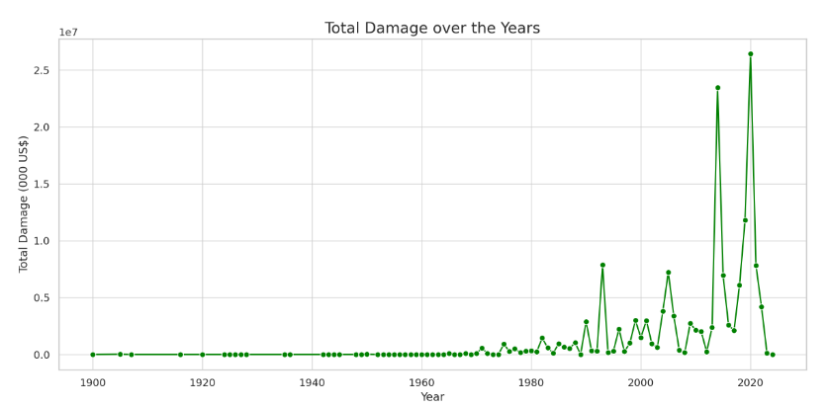
Fig 5: The graph uses green lines with circular markers to plot damage in USD/ per year.
Key observations from the line graph of the economic damages occurred due to the disaster’s impact, shown in Fig. 5, are: From the 1900s to 1970s: The Damage levels were very low or negligible. Possible reasons: lower reporting accuracy, fewer large-scale disasters, or less economic infrastructure at risk. ii. From Post-1980 1990:There is a gradual increase in reported damages that starts to appear due to better reporting mechanisms, urban expansion, and higher economic exposure. From the 1990s to 2000s: Sharp spikes begin to emerge, reflecting severe disasters with significant economic impact. This includes major events like the 1999 Odisha Cyclone, 2001 Gujarat Earthquake, etc., From the 2010s to 2020s: Steep spikes in damage, especially around 2018 and 2020, reaching peaks over 25 million USD (Fig. 5).
Indicates more frequent and intense disasters affecting critical infrastructure and urban zones. Increase in total damage from natural disasters, especially after the 1980s, peaking after 2010 — indicating that natural disasters are becoming more costly, likely due to increased urbanisation, climate change, and higher asset exposure. Economic loss peaked post-2010, indicating growing disaster impact or urban exposure. Earlier years show minimal or no reported damage, likely due to poor data or low infrastructure. It warrants the need for better DRR and resilience planning.
Fatalities By Years In Line Chart
The key inferences of fatalities occurred due to natural disasters are in (Fig. 6): The high peaks in early years (1900–1960). The massive death tolls in years like 1918–1920: due to the Spanish flu pandemic and famines, 1943: Possibly reflecting the Bengal famine, which caused over a million deaths, 1965: Another notable peak, perhaps from a major drought or epidemic. During the post-1970s period, there was a dramatic decline in deaths, staying consistently below 100,000 per year, which reflects improvements in disaster response, healthcare, early warning systems, and infrastructure resilience. Finally, during recent decades (2000–2025), the fatalities remained low and stable, indicating better disaster mitigation efforts despite more frequent disasters (Fig. 6).
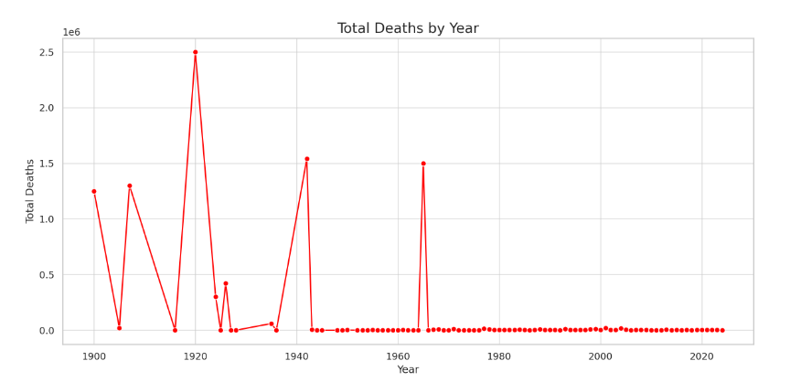
Fig 6: The key inferences of fatalities occurred due to natural disasters (1900-2024)
In summation, the early 1900s to 1940s had a very high death toll, especially in 1918 (Spanish Flu pandemic) and in 1942, likely due to epidemics and famines. In the pre-independence period (post-1950), deaths from disasters declined significantly, which indicates the nation's response to better healthcare, warning systems, and disaster management. From 2000 onward, deaths remained consistently low, showing improved preparedness and response. Despite frequent disasters, modern measures have greatly reduced fatalities during disasters except the -19 period.
  - Total Deaths and Damages In a Bubble Chart
A bubble chart is a multiple pie chart which are difficult to analyse and interpret, especially when comparing adjacent pies. The total deaths and damages in the bubble chart are shown in Fig. 7.
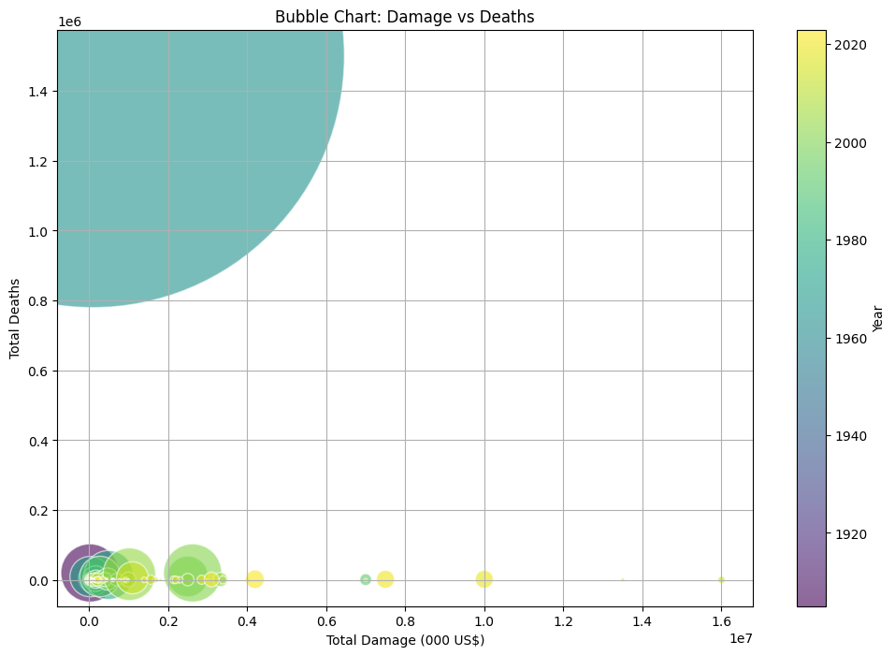
Fig 7: The deaths vs. damages in a bubble chart in Python from the year 1900 to 2024
The key findings from the bubble chart obtained from the time series data show that High Deaths and low Damage occurred during the early 20th century. The largest bubble on the top-left of the chart represents a disaster with over 1.5 million deaths but relatively low economic damage. During that period, economic infrastructure was limited, but disaster response systems were poor, leading to a massive loss of life. Low Deaths, High Damage (Recent Disasters)More recent events, shown as yellow-coloured bubbles, are positioned farther to the right, indicating very high financial damage (up to $16 billion or more), but in recent days, after 2005, the disasters caused fewer deaths. It suggests improvements in technology, early warning systems, and emergency response activities and has saved lives, though at a high economic cost due to dense urban infrastructure. Large numbers of bubbles indicate that they are clustered in the lower-left quadrant of the chart, represent disasters with limited deaths and lower damage, suggesting they were either less severe or well-managed.
Total Deaths by Year and Disaster Types in Heat Map
The total deaths and the disaster type in India from 1900 to 2024 are in Figure 8
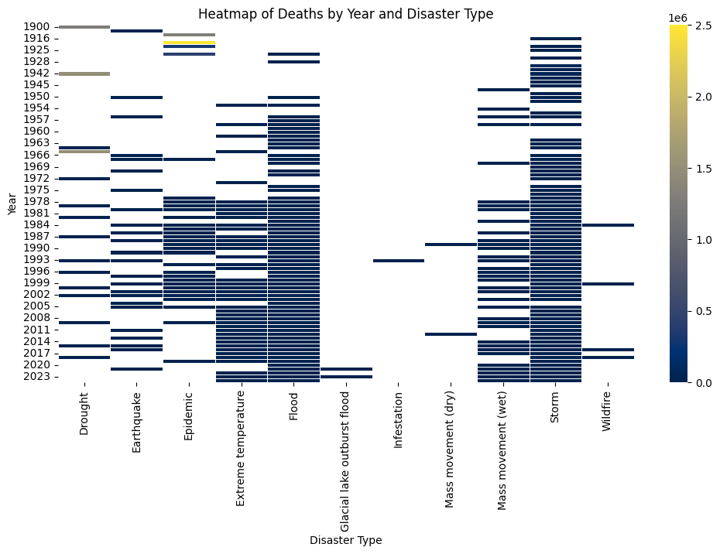
Fig 8: The fatalities shown by a Heat map against the type of disaster in India, 1900- 2024.
The key observations are that the major deadly events shown in yellow bands in the Epidemic and Earthquake columns during the early 1900s and 1940s suggest huge death tolls (millions) for historical pandemics or famines. Floods and Storms: Repeatedly show deaths across many years — especially from the 1960s onward — indicating they are recurring and deadly events. In recent Years from 2000 onwards, deaths have been more distributed, with events seen across multiple disaster types, but no single massive fatal event, indicating improved disaster mitigation and response. Disasters like Infestation, Mass Movement (Dry), and Wildfire are relatively less deadly over the years, based on this data.

The important findings are:
Improved Disaster Response Over Time: Despite the frequent occurrence of disasters like floods and storms, the absence of extreme death tolls in recent decades suggests a significant decrease due to appropriate Disaster Preparedness, Forecasting Systems, Medical Response, and maintaining a Responsibility Matrix for Preparedness and Response
Shift in Disaster Risk Patterns: The early 20th century was dominated by health-related disasters (epidemics and pandemics), while recent decades show an increase in climate-related disasters like extreme temperatures, indicating a shift from biological to environmental threats. Persistent Vulnerability to Floods and Storms: These two types of disasters remain consistently deadly, highlighting a continued vulnerability, especially in flood-prone and coastal regions. Emerging Risk from Climate Change: The rise in deaths due to extreme temperatures after the 1980s signals the growing impact of climate change, requiring urgent adaptation strategies. Disaster-Specific Risk: The intensity and type of disasters differ across time periods, implying that disaster risk is influenced by socio-economic, environmental, and technological changes.
Stochastic Modelling:
Many a stochastic analysis for fatalities by disasters in India is conducted, starting from Various regression plots such as linear, Polynomial for Years vs death, and model comparisons, Moran’s diagram predicted vs. actual, and the graphs are in Fig. 9 (a-g)
a.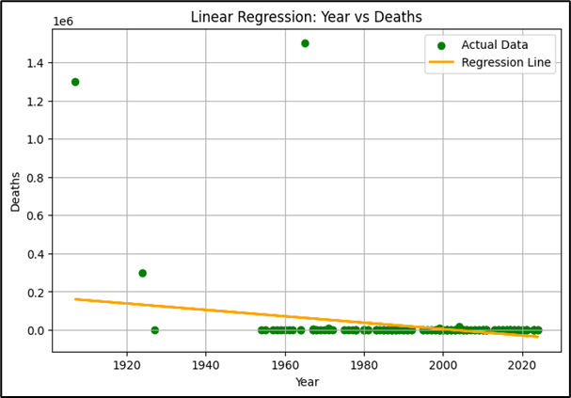b.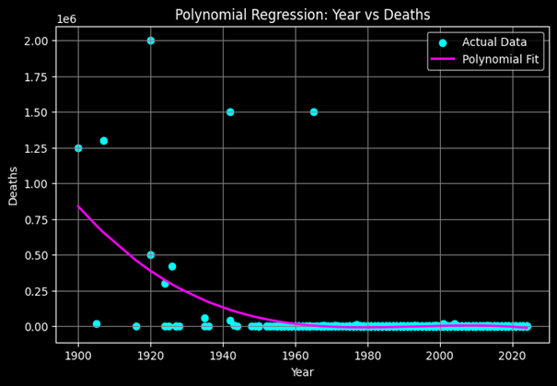
c.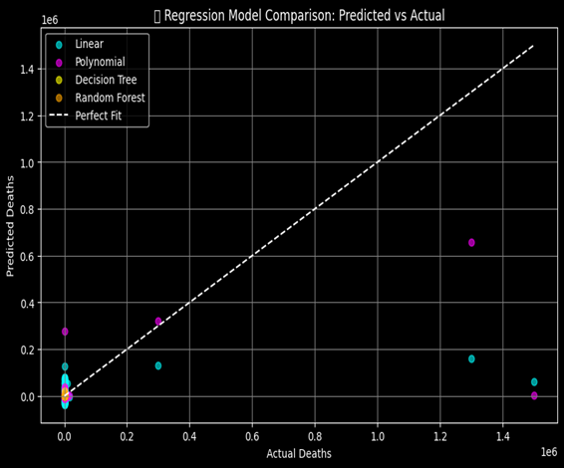 d.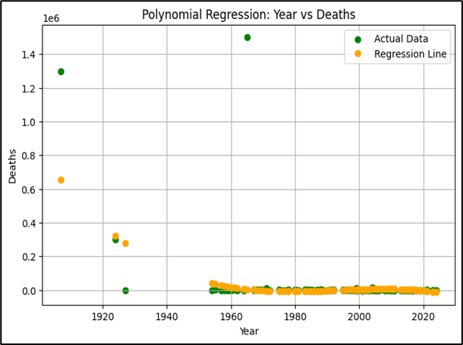
e.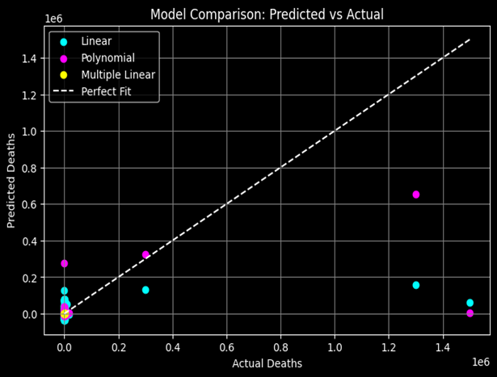f.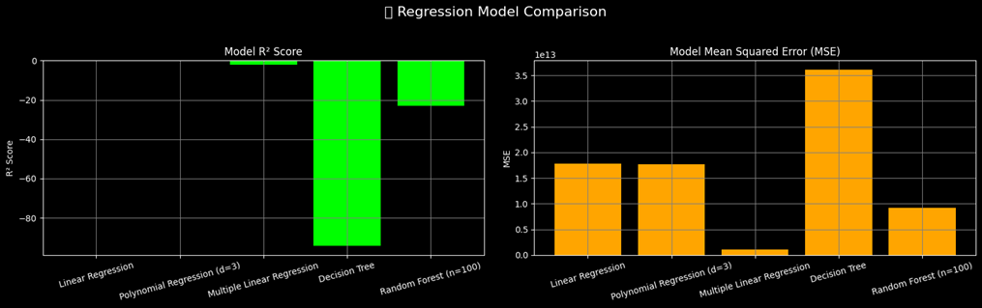
Fig 9(a-g): Various regression plots, such as linear, Polynomial for Years vs death, and model comparisons, Regression model comparisons
Moran’s scatter plot: A Moran Scatter Plot is a graphical tool used in spatial statistics to visualise the relationship between the value of a variable at a location and the average value of the same variable in its neighbouring locations (spatial lag). (Fig. 10).
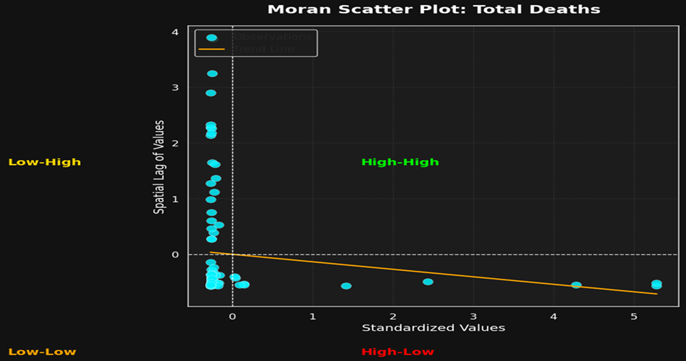
Fig 10: Moran’s scatter diagram for disaster deaths in India (predicted vs. actual)
The present case shows that a Moran Scatter Plot is a graphical tool used in spatial statistics to visualise the relationship between the value of a variable at a location and the average value of the same variable in its neighbouring locations (spatial lag). Present case show that · Most dots are in the Low-Low quadrant indicating many disasters in India had low deaths and they are associated with low fatalities and are small impact events). · A few dots are in the High-Low quadrant pointing towards: Some disasters had very high deaths, but they happened in regions where nearby disasters had much fewer deaths like (Example: 2004 Tsunami or 1999 Odisha Cyclone).
High Actual – High Predicted (High–High): When the actual deaths are very high, the model also predicts high deaths. But the predicted values are usually lower than the actual (dots fall below the red line). This means the model captures the trend but underestimates the true scale.
Low Actual – High Predicted (Low–High): If actual deaths are small, but the model predicts a large number. The model is not making big mistakes in this way.· The orange line’s slope (Moran’s I) is slightly negative → this means there is no big cluster of deadly disasters. Instead, deadly ones are isolated events.
The choropleth Map of deaths: A Choropleth map of India, where each state is shaded according to the total number of deaths recorded. The darker the shade of red, the higher the number of deaths (Fig. 11). The State-wise Observations are: (1)Uttar Pradesh (darkest red): Clearly, the state with the highest total deaths, crossing 3500 deaths, indicates either very high population exposure or multiple large disaster events like floods and cold waves. (2) Punjab, Andhra Pradesh, West Bengal, Jharkhand, Assam (moderately dark shades). These states also report significant numbers of deaths (1000–2500 range). Their intermediate colour intensity shows they were heavily affected, but not as extreme as Uttar Pradesh. (3) Madhya Pradesh, Bihar, Telangana, Tamil Nadu, Karnataka (light orange shades). These states recorded moderate death counts (500–1000 range) due to floods and cyclones. Still notable, but lower compared to the highly affected regions. (4)Majority of central, western, and southern states (Maharashtra, Gujarat, Kerala, Odisha, Chhattisgarh, Rajasthan, etc.): Shown in light beige/cream colour, meaning fewer than ~500 deaths in the dataset, indicating lower reported impact or better resilience/response to cyclones, heavy rain and floods. (5) Union Territories (Andaman & Nicobar, Lakshadweep, etc.) are shown in near white, meaning very few or negligible deaths. (6). Northern and North Eastern states of India (Uttarakhand, Bihar, West Bengal, and seven states of Assam): Heavier mortality burden due to earthquakes, urbanisation, frequent floods, heavy rain, and poor healthcare access. (7) Southern India (Andhra Pradesh, Tamil Nadu, Telangana) for Moderate mortality, perhaps linked to cyclones, floods, or health crises. Western/Central India (Rajasthan, Gujarat, Maharashtra, Madhya Pradesh): Comparatively lower mortality reported, as seen by lighter shades.
Discussion:
According to Government statistics, India is in the midst of a boiling disaster. About 59% of India is susceptible to earthquakes (Record of 159 damaging earthquakes from Nov. 2024 to Feb. 2025). https://www.pib.gov.in/PressReleasePage.aspx?PRID=2113875. India has 733 deaths from Heat waves in 2024, a total affected by floods 7million, (EMDAT Report 2024). Above 85% of nations' terrestrial area is prone to multiple natural hazards (Deshpande et al., 2022^{[48]}).

Interconnectivity of disasters: Various disasters, and their drivers, are linked (like cyclones with coastal erosion, heavy rainfall and floods) and stimulate each other. A particular disaster that occurred in an area/sector can activate or trigger another disaster in the same place or elsewhere. The interconnectivity drivers are the GHG emissions, changes in the earth science system and global claim for resources, etc., which may grow and intensify in future. Disaster risks are to be reduced by keeping vulnerability at the heart of solutions and making changes through participation. Considering the connectivity, the disaster managers should plan for their DRR policies for building resilience.
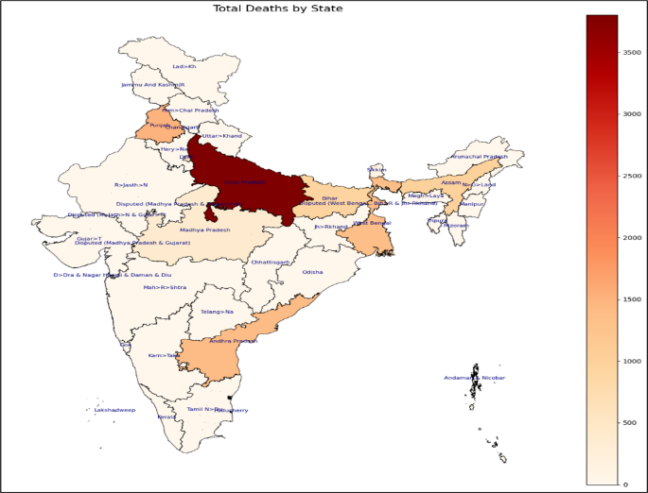b. 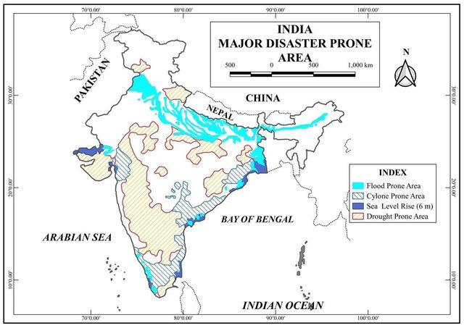
Fig 11: (a)The disaster death map yearly death map of India 1900-2024 (b) The disaster-prone area 2001-2021 (Source modified: Mondal et al, 2023)
Future Threats:
Mass movement (both dry and wet), subsidence, and flash floods have become rising threats in the 21st century. Himalayan and Siwalik range landslides cover 30% the global mass movement as they are the youngest formation, during monsoon days (August). In the rest of India, like the Nilgiris range (western ghats), Avalanches Valley, and other NE states, and peninsular Hill ranges are prone to landslides, debris flow and flash floods from lakes in glaciers.
Fighting disasters:
India should master basic DRR Principles and conduct Holistic Risk Assessment & Proactive Planning: Apply methodologies for comprehensive Hazard, Risk, Vulnerability, and Capacity Assessments (HRVCA) across various hazards, and formulate robust preparedness and mitigation strategies, including Early Warning Systems. It is pertinent that India should Integrate Climate Change Adaptation & Risk Financing in broader development planning and policy, foster gender-sensitive and inclusive approaches, and leverage technology for effective disaster management.
The Disaster Management (Amendment) Act, 2025, heralds a cutting-edge in India’s approach to disasters. Shifting from a relief-centric model to a proactive and participatory holistic model, strategic plans are to emphasise modern innovative technologies with zero casualties. The institutions are to be empowered, leveraging Python-based monitoring and engaging communities, for Participatory Disaster Management (Disaster Management (Amendment) Act, 2025^{[49]}).
CONCLUSIONS
The multifaceted disasters are analysed and visualised with 124years of historical data of natural disasters in India using Python. Through the use of powerful data analysis libraries such as Pandas, Matplotlib, Seaborn, and Plotly. The key insights were derived from the dataset. The analysis revealed that floods and storms are the most frequent and impactful disasters in India, particularly in certain vulnerable regions.
By creating various charts like donut charts, line graphs, bar charts, heatmaps, and bubble charts, the study provided a clear understanding of the distribution, frequency, and consequences of disasters over time. The visual insights helped in identifying trends, such as an increase in climate-related disasters in recent years and the correlation between economic losses and death tolls. The study reveals that Python can be an effective tool for interpreting real-world data and aiding in data-driven decision-making for disaster preparedness and risk management than stochastic modelling.
The analysis throws light to disaster type, pattern, to disaster management authorities to stress upon disaster preparedness, resource planning, infrastructure development, and risk reduction and establish the real-world applicability of Python in solving critical societal challenges using data, future projections and complying to Sustainable Development Goal 11.5 comprising Sustainable Cities and Communities, specifically in target 11.5, SDG 13 (Climate Action).
The future scope of research is to have a Regional-Level Analysis for more detailed regional or state-wise analysis to understand local vulnerabilities. Analysis is to be carried out on ML or Python Models: Predictive models can be developed to forecast future disaster risks based on historical trends and climate patterns. Real-Time Data Integration: Incorporating real-time disaster data can enhance the project’s relevance for emergency response. Socio-Economic Impact Study: The project can be extended to study how disasters affect livelihoods, infrastructure, and long-term development. Interactive Dashboards: Creating interactive dashboards using tools like Dash or Tableau can make the insights more accessible to decision-makers and the public.

COMPETING INTERESTS DISCLAIMER:
Authors have declared that they have no known competing financial interests OR non-financial interests OR personal relationships that could have appeared to influence the work reported in this paper.

REFERENCES
1. Neelakantan, R. Geo-environment and related Disasters—A Geo-spatial Approach. J. Environ. Nanotechnol. 2019, 8, 1–5.
2. Ulal, S.; Saha, S.; Gupta, S.; Karmakar, D. Hazard risk evaluation of COVID-19: A case study. Int. J. Disaster Risk Management. 2023, 5, 81–101.
3. Mishra SP., Chakraborty T., 2023, Land Subsidence; Future Apocalyptic Geo-Hazard Triggered by Anthropocene Activities. Technische Sicherheit , 23, 10, 2023, 1- 27
4. Cvetković, V. M., Renner, R., Aleksova, B., & Lukić, T. (2024). Geospatial and Temporal Patterns of Natural and Man-Made (Technological) Disasters (1900–2024): Insights from Different Socio-Economic and Demographic Perspectives. Applied Sciences, 14(18), 8129. https://doi.org/10.3390/app14188129.
5. Tal, A. (2025). The Environmental Impacts of Overpopulation. Encyclopedia, 5(2), 45. https://doi.org/10.3390/encyclopedia5020045
6. Maheng, D., Pathirana, A., & Zevenbergen, C. (2021). A Preliminary Study on the Impact of Landscape Pattern Changes Due to Urbanisation: Case Study of Jakarta, Indonesia. Land, 10(2), 218. https://doi.org/10.3390/land10020218
7. Mishra S. P., Sethi K. C., Siddique M., 2020, Emerging threats during Anthropocene as urban Flooding of Bhubaneswar city, India, Water and Energy Int., CBIP, ND, 63, 46-58
8. GSI data, NDMA (CoDRR- 14), (2025). One-day workshop, Slopes & Solutions: Unleashing 3Ms for 3Rs in Landslide Risk Resilience. Geological Survey of India (GSI).
9. NDMA, 2025. National Institute of Disaster Management (NIDM), Two-week Residential Course. 18- 29 August, 2025. https://nidm.gov.in
10. Fuady, M., Buraida, Kevin, M. A., Farrel, M. R., & Triaputri, A. (2025). Enhancing Urban Resilience: Opportunities and Challenges in Adapting to Natural Disasters in Indonesian Cities. Sustainability, 17(4), 1632. https://doi.org/10.3390/su17041632
11. Karanjit, R.; Pally, R.; Samadi, S. (2023). FloodIMG: Flood image Database system. Data Brief 2023, 48, 109164.
12. Anderson K. (2025). The influence of Milankovitch cycles on climate. https://greenly. earth/en-gb/blog/ecology-news/the-influence-of-milankovitch-cycles-on-climate
13. Mishra S. P., Mishra S. K., 2018, The Cataclysm of Geo-Bio-Climate in Short-Lived Holocene and in Anthropocene epochs: A Critical Review, International Journal of Science and Research (IJSR) Vol. 7(9), PP-1445 – 1462, DOI: 10.21275/ART20191537
14. Sharma A, Ghosh D, Divekar N, Gore M, Gochhait S, Shireshi SS. (2021) Comparing the socio-economic implications of the 1918 Spanish flu and the COVID-19 pandemic in India: A systematic review of literature. Int Soc Sci J. Nov;71(Suppl 1):23-36. doi: 10.1111/issj 12266.
15. Mishra S.P., 2022, Catastrophism and Uniformitarianism in Decision Making of Meghalayan Age in East India, IJECC, 12(4):19-3, DOI: 10.9734/IJECC/2022/v12i430652
16. Thilagavathy S. (2024). An Overview of the Great Famine of 1876-1878. Bodhi International Journal of Research in Humanities, Arts and Science. 8(2), 160-163.
17. Ritchier, H., Rosado, P., Max R. (2022) - “Natural Disasters” Published online at Our World in Data.org. Retrieved from: 'https://ourworldindata.org/natural-disasters' [Online Resource]
18. Ghawana, T., Pashova, L., Zlatanova, S. (2021). Geospatial data utilisation in national disaster management frameworks and the priorities of multilateral disaster management frameworks: case studies of India and Bulgaria. ISPRS Int. J. of Geo-Information, 10(9), 610. https://doi.org/10.3390/ijgi10090610
19. Haque, R.; Parr, N.; Muhidin, S. Climate-Related Displacement, Impoverishment and Healthcare Accessibility in Mainland Bangladesh. Asian Popul. Stud. 2020, 16, 220–239.
20. Gupta, D., Kumar, P., Okano, N., & Sharma, M. (2025). Climate-Induced Migration in India and Bangladesh: A Systematic Review of Drivers, Impacts, and Adaptation Mechanisms. Climate, 13(4), 81. https://doi.org/10.3390/cli13040081
21. Balakrishnan, V.; Shi, Z.; Law, C.; Lim, R.; Teh, L.; Fan, Y.; Periasamy, J. A Comprehensive Analysis of Transformer-Deep Neural Network Models in Twitter Disaster Detection. Mathematics 2022, 10, 4664
22. Sufi, F., & Alsulami, M. (2025). AI-Driven Global Disaster Intelligence from News Media. Mathematics, 13(7), 1083. https://doi.org/10.3390/math13071083
23. Leong, W. (2025). Internet of Things for Enhancing Public Safety, Disaster Response, and Emergency Management. Engineering Proceedings, 92(1), 61. https://doi.org/10.3390/engproc2025092061
24. Rajapaksha, D., Siriwardana, C., Ruparathna, R., Maqsood, T., Setunge, S., Rajapakse, L., De Silva, S. (2024). Systematic Mapping of Global Research on Disaster Damage Estimation for Buildings: A Machine Learning-Aided Study. Buildings, 14(6), 1864. https://doi.org/10.3390/buildings14061864
25. David, A.O.; Ndambuki, J.M.; Muloiwa, M.; Kupolati, W.K.; Snyman, J. (2024) A Review of the Application of Artificial Intelligence in Climate Change-Induced Flooding—Susceptibility & Management Tech. 5, 1185–1198. https://doi.org/10.3390/civileng5040058
26. Kagabo, J., Kattel, G. R., Kazora, J., Shangwe, C. N., & Habiyakare, F. (2024). Application of Machine Learning Algorithms in Predicting Extreme Rainfall Events in Rwanda. Atmosphere, 15(6), 691. https://doi.org/10.3390/atmos15060691
27. Heidari, E., Samadi, V., & Khan, A. A. (2025). Leveraging Recurrent Neural Networks for Flood Prediction and Assessment. Hydrology, 12(4), 90. https://doi.org/10.3390/hydrology12040090
28. Alkaabi, K., Sarfraz, U., Al Darmaki, S. (2025). A Deep Learning Framework for Flash-Flood-Runoff Prediction: Integrating CNN-RNN with Neural Ordinary Differential Equations (ODEs). Water, 17(9), 1283. https://doi.org/10.3390/w17091283
29. Sivakumar, M. V. (2007). Interactions between climate and desertification. Agricultural and forest meteorology, 142(2-4), 143-155.
30. Intergovernmental_Panel_On_Climate_Change(IPCC). Climate Change 2021—The Physical Science Basis: Working Group I Contribution to the Sixth Assessment Report of the Intergovernmental Panel on Climate Change; Cambridge University Press: Cambridge, UK, 2023.
31. Van Exel, K., Sherchan, S., & Liu, S. (2025). Optimising Deep Learning Models for Climate-Related Natural Disaster Detection from UAV Images and Remote Sensing Data. Journal of Imaging, 11(2), 32. https://doi.org/10.3390/jimaging11020032
32. Wang, M., Wang-Chien Lee, Na Liu, Qiang Fu, Fujun Wan, Ge Yu. (2025). A Data-Driven Deep Learning Framework for Prediction of Traffic Crashes at Road Intersections" Applied Sciences 15, no. 2: 752. https://doi.org/10.3390/app15020752
33. Santosh Ku., Angral S., Lakaria K. (2025). Making India More Disaster-Resilient. Govt. Proactive Measures for Earthquake Safety Ministry of Earth Sciences, 1-6, 21st Mar., 2025.
34. Zhao, W., Li, Y., Huang, Y., Li, G., Ma, F., Zhang, J., Wang, M., Zhao, Y., Chen, G., Meng, X., Guo, F., & Yue, D. (2025). An Integrated Approach for Emergency Response and Long-Term Prevention for Rainfall-Induced Landslide Clusters. Remote Sensing, 17(14), 2406. https://doi.org/10.3390/rs17142406
35. Nguyen, David N., Yuichiro Usuda, and Fumihiko Imamura. 2024. Gaps in and Opportunities for Disaster Risk Reduction in Urban Areas Through International Standardisation of Smart Community Infrastructure" Sustainability 16, no. 21: 9586. https://doi.org/10.3390/su16219586
36. Barro, RJ., UrsúaJF., Weng J., 2020. Social and Economic Impacts of the 1918 Influenza Epidemic, The digest, https://www.nber.org/digest/may20/social-and-economic-impacts-1918-influenza-epidemic,
37. Mishra, S. P., Samal, A. (2022). Anthropocene Bearing on Snow-Avalanche Disasters over the West Indian Himalayas: An Appraisal. International Journal of Environment and Climate Change, 12(10), 74-92. https://doi.org/10.9734/ijecc/2022/v12i1030772
38. Jha P, Deshmukh Y, Tumbe C, Suraweera W, Bhowmick A, Sharma S, Novosad P, …(2022) COVID mortality in India: National survey data and health facility deaths. Science. 11;375(6581):667-671. doi: 10.1126/science.abm5154.
39. EM-DAT, CRED / UCLouvain (2024) – with major processing by Our World in Data. “Number of recorded natural disaster events – EM-DAT” [dataset]. EM-DAT, CRED / UC Louvain, “Natural disasters”. https://archive.ourworldindata.org/20250903-083611/ grapher/number-of-natural-disaster-events.html (archived on September 3, 2025).
40. Nagamani, K., Mishra, A. K., Meer, M. S., & Das, J. (2024). Understanding flash flooding in the Himalayan Region: A case study. Scientific Reports, 14, 7060. https://doi.org/10.1038/s41598-024-53535-w
41. Gupta, H.K., 2025. The Great 26 December 2004Tsunami. Habitable Planet1(1&2), 34–42Habitable Planet, DOI: 10.63335/j.hp.2025.0004.
42. Joshi S., Subramanian SS, 2025, Landslide and dam studies in Uttarakhanda, IIT Roorkee, 199-207,
43. Hiremath, S., Shetty, E., Prakash, A. J., Sahoo, S. P., Patro, K. K., Rajesh, K. N. V. P. S., & Pławiak, P. (2023). A New Approach to Data Analysis Using Machine Learning for Cybersecurity. Big Data and Cognitive Computing, 7(4), 176. https://doi.org/10.3390/bdcc7040176
44. Riyantoko, P. A., Funabiki, N., Brata, K. C., Mentari, M., Damaliana, A. T., & Prasetya, D. A. (2025). A Fundamental Statistics Self-Learning Method with Python Programming for Data Science Implementations. Information, 16(7), 607. https://doi.org/10.3390/info16070607
45. Rawat, A., Witt, E., Roumyeh, M., & Lill, I. (2024). Advanced Digital Technologies in the Post-Disaster Reconstruction Process—A Review Leveraging Small Language Models. Buildings, 14(11), 3367. https://doi.org/10.3390/buildings14113367
46. Pajankar, A. (2022). Pie and Polar Charts. In: Hands-on Matplotlib. Apress, Berkeley, CA. https://doi.org/10.1007/978-1-4842-7410-1_9
47. Bajić, F., & Job, J. (2022). Data Extraction of Circular-Shaped and Grid-like Chart Images. Journal of Imaging, 8(5), 136. https://doi.org/10.3390/jimaging8050136
48. Deshpande RS. Disaster management in India: Are we fully equipped? J Soc Econ Dev. 2022;24(Suppl 1):242-281. doi: 10.1007/s40847-022-00225-w.
49. Government of India (2025). India becomes a global leader in disaster management. Disaster Management (Amendment) Act, 2025. Vigilant India, 24, 16-31 Mar., 2025

