Original Research Article
Anti-Coccidial Effect of N-Hexane Fraction of Cashew (Anacardium occidentale) Nut Shell Extract on Eimeria Tenella Infection in Broiler Chickens

Abstract
Avian coccidiosis for many years has been a disease of major economic importance in the poultry industry worldwide. The anti-coccidial effect of n-hexane fraction of cashew nut shell (CNS) extract on Eimeria tenella infection in broiler chickens was studied. Median lethal dose (LD₅₀) was used to determine the toxicity of the extract and to establish the dose for the in vivo studies. The chicks (2 weeks old) were grouped into five groups (A-E) of five chicks each; A: Normal control group (uninfected and untreated, only feed and water), B: Infected with 5000 sporulaed E. tenella oocysts and untreated, C: Infected and treated with 1.5% Amprolium®, D: Infected and treated with n-hexane fraction (750mg/kg), E: Infected and treated with n-hexane fraction (1500mg/kg). Preparative TLC, GC-MS and FTIR were used to further purify and determine active ingredient in the fraction. The median lethal dose (LD₅₀) was found to be >5000mg/kg body weight. There was a significant (p<0.05) increase in body weight of the chicks in group A (368.2±54.2g), C (417.00±42.8g), D (387.4±35.8g) and E (427.4±35.8g) at 7 days post infection with E. tenella oocysts when compared with group B (222.8±48.0g). The oocyst per gram (OPG) in the caecum of group B was significantly (p<0.05) higher (394120.0±115414) than what was found in group A (23.0±07.2), C (101±66.1), D (10149±6656.1) and E (2249.3±232.1). The gross lesion scores of +3 and +1 were recorded for groups B and C respectively. Further fractionation revealed four sub-fractions (A₁, A₂, A₃ and A₄) in which sub-fraction A₂ showed the highest inhibitory activity against sporulated E. tenella oocysts based on the percentage oocysts lysis of 91.5% and the remaining unlysed oocysts (8.5%) which were found to be unviable. Based on GC-MS and FTIR spectroscopy, the active compound in sub-fraction A₂ of the CNS n-hexane fraction maybe 2-(5-bromopentyl)- 7,9-Diethyl-2,4-bis(dimethylamino) -10-imino-8-thio-1,7,9-triazaspiro [4.5]-1,3-decadiene-6,8-dione. This finding suggested that, the compounds present in the active fraction A of CNS extract possess anticoccidial effect against E. tenella infection in broiler chicks.
Key words: Avian coccidiosis, Eimeria tenella, N-hexane fraction, Anti-coccidiosis.
INTRODUCTION
Avian coccidiosis is the commonest and economically most important parasitic disease affecting poultry production worldwide (Shirley et al., 2005; Olanrewaju and Agbor, 2014; Jadhav and Nikham, 2014; Mona, et al., 2015; Gensa, 2018). It is caused by the single cell, intracellular protozoan parasite of the genus Eimeria, (Williams, 2005; McDougald, 2008; Gensa, 2018). The disease is characterized by bleeding, hemorrhagic lesion development, high morbidity and mortality and reduced weight gain (Bera, et al., 2010). Heavily infected animals that show severe clinical signs and coccidiostat resistance are causing important economic losses (Hamid et al., 2018). Clinical signs are associated with tissue destruction from the release of the merozoites and mature oocysts from the mucosal surface during the last generations of merogony and throughout gametogony (Gensa, 2018).
About eleven different species of Eimeria have been recognized in chickens, of which Eimeria brunette, Eimeria maxima, Eimeria necatrix, Eimeria tenella are the most pathogenic; while Eimeria acervulina, Eimeria mitis, Eimeria mivati, Eimeria praecox and Eimeria hagani are the less pathogenic (Alberta, 2007; Patrick and Mgbere, 2010; Lai et al., 2011; Gensa, 2018). Eimeria is highly species-specific and multiply in the intestinal tract, causing tissue damage that result in haemorrhagic enteritis, loss of blood and death (Geetha and Palanivel, 2018). Each of the eleven species known to infect chicken has a special predilection site in the intestine/caecum to complete its life cycle (Deplazes et al., 2006; Gensa, 2018). Caecal coccidiosis caused by E. tenella may produce bloody droppings and anemia that is often followed by death (Muazu et al., 2008; Ali et al., 2014).
Global costs to the poultry industry as a result of avian coccidiosis exceed $2 billion annually (Fornace et al., 2013). It was also estimated that the economic losses due to the disease was about $ 450 million with additional US $ 100 million due to medication in the United States alone (Maikai et al., 2007). In Nigeria where poultry farming is less developed, the disease is more serious and causes heavy economic losses in millions of Naira annually (Balarabe and Obeta, 2015). High cost of control of coccidiosis makes it one of the most expensive parasitic diseases encountered in the poultry industry in Nigeria (Maikai et al., 2007; Fornace et al., 2013).
Diagnosis of coccidiosis in chicken is best accomplished by postmortem examination of representative number of birds. The type and locations of lesions in the gut indicate the species of Eimeria (Gensa, 2018). A diagnostic characteristic is based on presence of clusters of large schizonts of E. tenella in the ceca (McDougald and Fitz-Coy, 2008).
The search for anticoccidial drugs and vaccines against avian coccidiosis has led to the isolation and characterization of different fungal extracts, plant extracts, and probiotics with anticoccidial potential (Quiroz-Castañeda, 2018). Medicinal strategies for Eimeria control involved the use of Amprolium® along with ionophores in higher doses. Moreover, live attenuated or un-attenuated vaccine strains can also be used for the control of coccidiosis. Anti-coccidials can be further categorized into ionophores and synthetic chemicals. Ionophores interfere with ion transfer through plasma membrane of the parasite which led to death of the parasite and synthetic drugs interfere with biochemical pathways of the parasite. However, massive introduction of anticoccidial drugs in different combinations led to the development of resistance in the poultry birds (Chapman, 2000; Chapman et al., 2002; Chapman et al., 2005). Herbals and botanicals are now being used as alternative strategy to control coccidiosis which are cheaper, effective and safer when compared with attenuated vaccines. As such no resistance has been detected against them yet (Quiroz-Castañeda, 2018).
This study, involves the determination of anti-coccidial effect of n-hexane fraction of CNS pentane extract on Eimeria tenella infection in broiler chickens based on the established preliminary in vitro inhibitory activity against sporulated and unsporulated Eimeria tenella oocysts. This may provide best alternative toward curbing the menace of avian coccidiosis.

MATERIALS AND METHODS
Parasite (Eimeria tenella)
Sporulated Eimeria tenella oocysts (25,000 counts) were obtained from Department of Veterinary Parasitology and Entomology, Ahmadu Bello University Zaria, Kaduna State of Nigeria. Two weeks old broiler chicks (5) were individually inoculated with 5000 sporulated Eimeria tenella oocysts in order to amplify sufficient oocysts for the studies. The infected birds were sacrificed 7 days post inoculation and the caeca were collected at post-mortem for the harvest of Eimeria tenella oocysts.
Caecal Harvest of the Propagated Oocysts
The harvested caeca were carefully cut open longitudinally and placed on a glass plate to minimize the likelihood of losing any material. By holding the edge of each caecum, a glass microscope slide was used to carefully scrape the caecal contents and placed into a beaker containing phosphate buffer saline (PBS). Thereafter, the scrapings were homogenized using a glass rod in a beaker and 1.5% (w/v) trypsin was added to the homogenate (to break down any connective tissue) and the mixture was incubated in a water bath at 41ºC for 45 minutes. The trypsin treated homogenate, was strained through a double layer of muslin cloth into a centrifuge tubes and centrifuged at 750 x g for 12 minutes. The supernatant was poured off and the washing and centrifugation were repeated three times as described by Shirley (1995).
Preparation of N-Hexane Fraction
N-hexane fraction was obtained by column chromatographic fractionation of crude CNS pentane extract. The CNS pentane extract (10ml) was loaded into a 3 cm x 60 cm column, pac
ked with 60 x120 mesh size silica gel (stationary phase). The mobile solvents n-hexane and ethyl acetate were allowed to flow down the column at different ratios (100%Hex, 9: 1Hex.Et, 1:1Hex.Et, and 100%Et). The compounds in the mixture have different interaction with stationary phase (silica gel), and mobile phase, thereby flow along the mobile phase at different time intervals. Thirty-eight fractions were collected and pooled together based on their retention factor (Rf) value and six pooled fractions (A, B, C, D, E and F) were obtained. The pooled fraction A known as N-hexane fraction was used in this study.
Collection of Chicks and Grouping
A total of fifty (50) day old broiler chicks were obtained from a commercial hatchery (Zartech Limited, Ibadan). The birds were monitored for 14 days under strict biosecurity measures in cage in the Department of Pharmacology and Therapeutics, Ahmadu Bello University, Zaria, Nigeria. During the brooding period, fecal samples were collected from the experimental birds and analyzed for the presence of oocysts using a simple floatation technique every 3 days. The chicks were fed with grower mash from Vital Feeds Company and water ad libitum. At two weeks of age, the chicks were grouped into five groups (A to E) of five birds each. A: Normal control group (uninfected and untreated, only feed and water), B: Infected with 5000 sporulaed E. tenella oocysts and untreated, C: Infected and treated with 1.5% Amprolium®, D: Infected and treated with n-hexane fraction (750mg/kg), E: Infected and treated with n-hexane fraction (1500mg/kg).
Median Lethal Dose (LD₅₀) Determination
Median Lethal Dose (LD₅₀) of n-hexane fraction of CNS extract was investigated using Lorke’s method (1983). This method has two phases (1 and 2).
Phase 1: This phase required nine chicks which were divided into three groups of three chicks each. Each group of chicks was administered different doses (10, 100, 1000 mg/kg) of fraction A. The chicks were observed for 24 hours to monitor their behavioral toxicity signs as well as mortality.
Phase 2: This phase involved three chicks, which were distributed into three groups of one chick each. The chicks were administered higher doses (1600, 2900, and 5000 mg/kg) of fraction A orally and then observed for behavior changes as well as mortality for 24 hours.
Therefore, LD₅₀ =√ D_{0 x} D₁₀₀.
D₀ = Highest dose that gave no mortality,
D₁₀₀ = Lowest dose that produced mortality.

Determination of Oocysts per Gram (OPG)
After one week of infection and treatment, the caeca of the broiler chicks were harvested and opened by giving longitudinal incision. Two grams of the faecal content of each caecum was collected and examined microscopically for identification of Eimeria tenella oocysts (Soulsby, 1982).

Determination of Caecal Lesion Score
Postmortem examination was conducted on the dead chicks for the presence of gross lesions which were consistent with coccidiosis. The ceca section of the GIT was removed, washed and opened with a small scissor. Fecal contents were removed and the mucosa washed. Lesions were noted, recorded and assigned with scores from 1 to 4 using the criteria described by Conway and McKenzie (2007).
Statistical Analysis
The data were analyzed by the analysis of variance using SPSS version 20. The results were expressed as mean ± standard deviation. The differences between the various means were compared using the Duncan Multiple Range Test. P values less than 0.05 were considered significant.
RESULTS AND DISCUSSION
The result of median lethal dose (LD₅₀) of n-hexane fraction of cashew nut shell (CNS) as presented in Table 1 showed zero mortality in any of the test groups even at high dose of 5000mg/kg body weight. This is expected because CNS extracted by cold maceration using pentane has lesser toxicity due to the small amount of cardol and cardanol constituents which are responsible for it toxicity (Pimentel et al., 2009). Application of heat in extraction of CNS extract resulted in decarboxylation and subsequent production of cardol and cardanol (Pimentel et al., 2009), and in this study, heat not applied in the extraction process.

Table 1: Median lethal dosage (LD₅₀) of n-hexane fraction of Anacardium occidentales nut shell extract in two weeks old chicks.
PHASES | EXTRACT DOSE (mg/kg body weight) | MORTALITY
I | 10 | 0/3
 | 100 | 0/3
 | 1000 | 0/3
II | 1600 | 0/1
 | 2900 | 0/1
 | 5000 | 0/1
Number of deaths per group = 0, Number of chicks per group = 3 and 1.
LD₅₀ > 5000mg/kg body weight.

The relative weight of the broiler chicks infected and treated with n-hexane fraction of the CNS extract at 750mg/kg and 1500mg/kg (417.0±42.8g and 387.4±35.8g respectively) and also infected and treated with 1.5% Amprolium® (427.4±35.8g) were found to be significantly (p<0.05) higher when compared with infected untreated groups (222.8±48.0g) as presented in Table 2. This is consistent with the report of Fetterer and Allen (2001) that coccidiosis is often accompanied by decreased body weight and reduced muscular mass as compared to uninfected control. There was no significant difference (p<0.05) groups infected and treated 1.5% Amprolium and also infected and treated with n-hexane fraction of CNS extract at both concentrations (750mg/kg and 1500mg/kg).The pathophysiological effect of E. tenella that causes cecal coccidiosis on the chicks is different from intestinal coccidiosis because of the significant blood loss that occurs during the acute phase of the infection (Witlock and Fetterer, 1982).

Table 2: Effect of N-hexane fraction of CNS extract on weight gain by the chicks for seven days
GROUPS | INITIAL  WEIGHT | DAY1 | DAY2 | WEIGHT  DAY3 | GAIN(g)  DAY4 | DAY5 | DAY6 | DAY7
A | 227.8±29.7^{C} | 278.2±28.4^{C} | 301.0±28.4^{C} | 332.2±29.3^{C} | 346.6±31.9^{b} | 377.6±32.3ª | 389.2±52.6ª | 368.2±54.2^{ab}
B | 236.8±17.1^{c} | 288.8±17.0^{c} | 316.6±21.7^{c} | 251.0±26.5^{c} | 251.4±34.6^{c} | 246.8±60.0^{c} | 239.0±61.9^{c} | 222.8±48.0^{c}
C | 240.2±14.1^{c} | 277.8±27.0^{c} | 301.0±19.9^{bc} | 342.0±20.0^{b} | 391.0±26.7^{b} | 414.2±34.7ª | 416.6±44.9ª | 417.0±42.8ª
D | 237.0±50.0^{c} | 282.6±71.7^{c} | 306.0±68.9^{bc} | 330.0±73.1^{b} | 329.0±57.8^{bc} | 343.0±74.9^{abc} | 360.0±74.4^{ab} | 387.4±35.8ª
E | 281.0±36.4^{c} | 306.8±31.8^{c} | 322.8±25.8^{c} | 347.6±28.3^{b} | 368.6±33.5^{b} | 377.2±36.4ª | 386.2±20.4ª | 427.4±35.8ª
Values are expressed as M ± SD (n=3) Superscript ^{b and c} means significant (P < 0.05). Values with the same super script mean no significant (P < 0.05) difference and different super script means significant (P < 0.05) difference. A: Normal control group, B: Infected untreated group, C: Infected and treated with Amprolium (1.5g/100ml), D: Infected and treated with Fraction A (750mg/kg), E: Infected and treated with Fraction A (1500mg/kg).

The result of oocysts per gram (OPG) of this study as presented in Table 3 showed significantly (p<0.05) high amount of E. tenella oocysts per gram in the ceca of the infected untreated group when compared with both infected and treated with n-hexane fraction of the CNS extract and standard drug Amprolium®. This showed severity of damage as a result of the infection by this parasite in the infected untreated group and also ameliorative effect of n-hexane fraction against the infection (cecal coccidiosis) in the infected and treated groups. However, this confirmed the claim that plant extracts such as CNS extract may provide readily available and affordable source of effective drug against E. tenella infection in broiler chickens.

Table 3: Effects of n-hexane fraction of CNS extract on oocysts per gram (OPG) of the chicks after 7 days.
TREATMENT/  EFFECT |  |  | GROUPS
TREATMENT/  EFFECT | A | B | C | D | E
OOCYSTS PER GRAMS | 23.0±07.2^{d} | 394120.0±114414ª | 101.0±66.1^{c} | 10149.0±6656^{b} | 2249.3±232.1^{b}
Values are expressed as M ± SD (n=3) Superscript ^{b and c} means significant (P > 0.05). Values with the same superscript means no significant (P > 0.05) difference and different superscript means significant (P <0.05) difference. A: Normal control group, B: Infected untreated group, C: Infected and treated with Amprolium (1.5g/100ml), D: Infected and treated with Fraction A (750mg/kg), and E: Infected and treated with Fraction A (1500mg/kg).

Lesion scoring is an interpretation based on macroscopic visible lesions caused by Eimeria sp following a scoring system of 0-4 by Johnson and Reid, (1970). Eimeria tenella affect ceca of the chicks and because of its deep development in the mucosa and subsequent wide spread damage with distinct gross lesions and loss of blood in the faeces; it is easily recognized also by farmers (De gussem, 2005). The result of the lesion score of this study were in agreement with the number of oocysts per gram (OPG), where infected untreated group showed severity of coccidial infection in the ceca with lesion score of +3 (plate 1B). However, lesion scoring of normal control (0; plate 1A), infected and treated with standard drug Amprolium® (+1; plate 1C) and fraction A (+2; plate 1D) further proved the ameliorative effect of n-hexane fraction of the CNS extract.
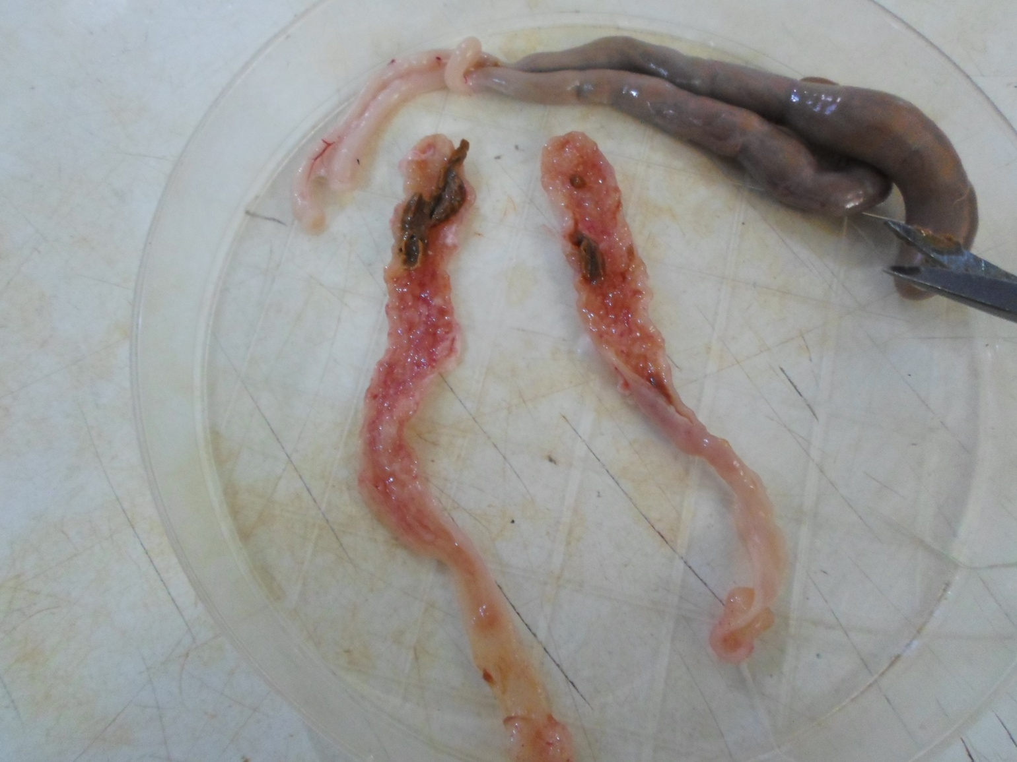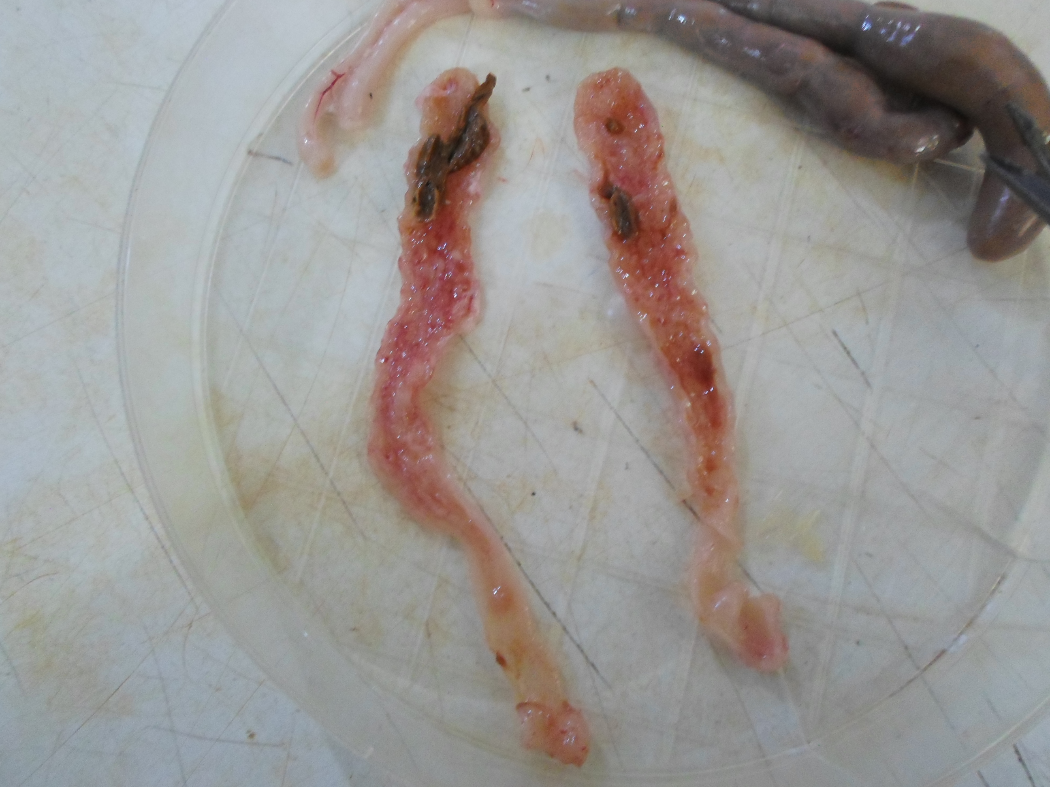
1B
1A
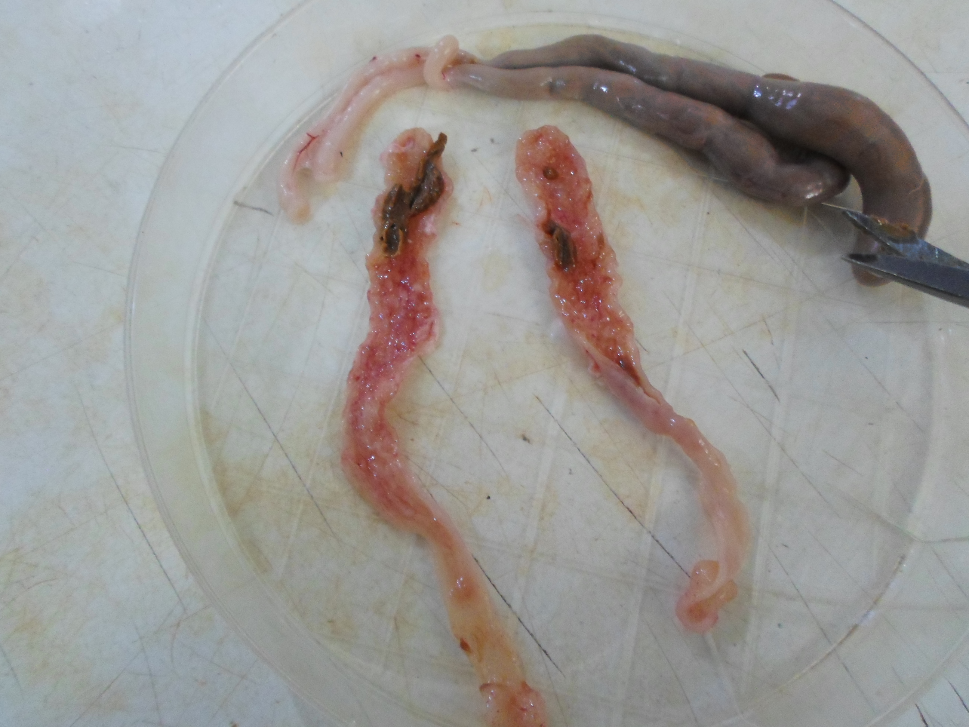
1D
1C
Plate 1: Descriptive lesions in E. tenella and Effect of fraction A. 1A: Normal control group shows 0 gross lesion.
1B: Infected untreated group with highly damaged cecum. 1C: Infected and treated with Amprolium (1.5g/100ml)
1D: Infected and treated with Fraction A (750mg/kg and 1500mg/kg). Technigue: Johnson and Reid, 1970 technigue of lesion scoring (Conway and McKenzie, 1991).

Further purification of the active n-hexane fraction by thin layer chromatography (TLC) revealed four sub fractions (A₁, A₂, A₃ and A₄) and sub fraction A₂ gives the highest yield of 30% (Table 4). The individual components of n-hexane fraction (sub-fraction A₁, A₂, A₃ and A₄) obtained possessed different activities against sporulated E. tenella oocysts based on percentage oocysts lyses and viability of the remaining unlysed oocysts. The result showed that sub-fraction A₂ has the highest activity with percentage lysis of 91.5% and the remaining 8.5% were not viable (Table 5). Therefore, sub fraction A₂ could be responsible for the in vivo anti-coccidial properties of n-hexane fraction of the CNS extract of Anacardium occidentale.

Table 4: Percentage yield of sub fractions recovered from n-hexane fraction
S/N | SUB-FRACTION A | YIELD (%)
1 | A₁ | 20
2 | A₂ | 30
3 | A₃ | 10
4 | A₄ | 10

Table 5: Effect of n-hexane sub-fractions of the CNS extract against sporulated E. tenella oocysts through Viability test.
Sub fractions | Initial  number  of oocysts | Exposure periods (hours)  2 4 6 8 10 12  % Unlysed Oocysts and Viability
A1 | 110 | 100.0 | 100.0 | 98.9 | 90.0 | 81.5 | 60.0
A2 | 110 | 100.0 | 73.9 | 50.3 | 34.6 | 20.0 | 8.5*
A3 | 110 | 100.0 | 100.0 | 100.0 | 100.0 | 100.0 | 93.3
A4 | 110 | 100.0 | 100.0 | 100.0 | 100.0 | 100.0 | 100.0
50%Tween 80 | 110 | 100.0 | 100.0 | 100.0 | 100.0 | 100.0 | 100.0
2.5% k₂Cr₂O₂ | 110 | 100.0 | 100.0 | 100.0 | 100.0 | 100.0 | 100.0
1.5%Amprolium® | 110 | 100.0 | 100.0 | 100.0 | 100.0 | 100.0 | 73.3
Superscript ⁽*⁾ means sporulated E. tenella oocysts not viable.

Infrared spectra of the isolated active sub-fraction A₂ bands, of the CNS extract from Figure 1 showed different functional groups which correspond to reference wave numbers (Table 7). Based on the interpretation of the main FTIR absorption bands of this most active sub-fraction A₂, the O-H bending band at 730.6cm⁻¹ from the output of the IR spectra is that of an alcohol. This fall within the range reported by Asensio et al. (2009) that O-H bend occurs at frequency range of 650-770cm⁻¹ when absorbed infrared spectra. The C-H aromatic stretching band at 905.7cm⁻¹ from the output of the IR spectra is that of C-H. This corresponds with the reports of Iliharco and Britode Barros (2000), Verleye et al., (2001) and Guidelli et al., (2011).
The C-O stretch at 1207.1cm⁻¹ from the FTIR spectra of the most active sub-fraction of the CNS extract is within the range reported by chem.libretexts (2014) that C-O stretch occurs at frequency range of 1210-1163cm⁻¹. The carboxylic stretching from the IR spectra with wave number of 1379.1cm⁻¹ fall within range reported by Chem.libretexts (2014) with frequency range of 1440-1395cm⁻¹. Moreover, C=N stretching from the IR spectra with wave number of 1647.51cm⁻¹ is that of Imine. This result corresponds to the range (1690-1640cm⁻¹) reported by Chem.libretexts (2014). Also, the alkene (C=C) functional group stretched at 1606.5cm⁻¹ from the output of the IR spectra which is within the range reported by Chem.libretexts (2014).
Based on the GC-MS chromatogram output (Table 6), the FTIR absorption bands and the nature of effect by the absorbed spectra, it is suggested the active compound in the sub fraction A₂ was; 2-(5-bromopentyl)- 7,9-Diethyl-2,4-bis(dimethylamino)-10-imino-8-thio-1,7,9-triazaspiro [4.5]-1,3-decadiene-6,8-dione.

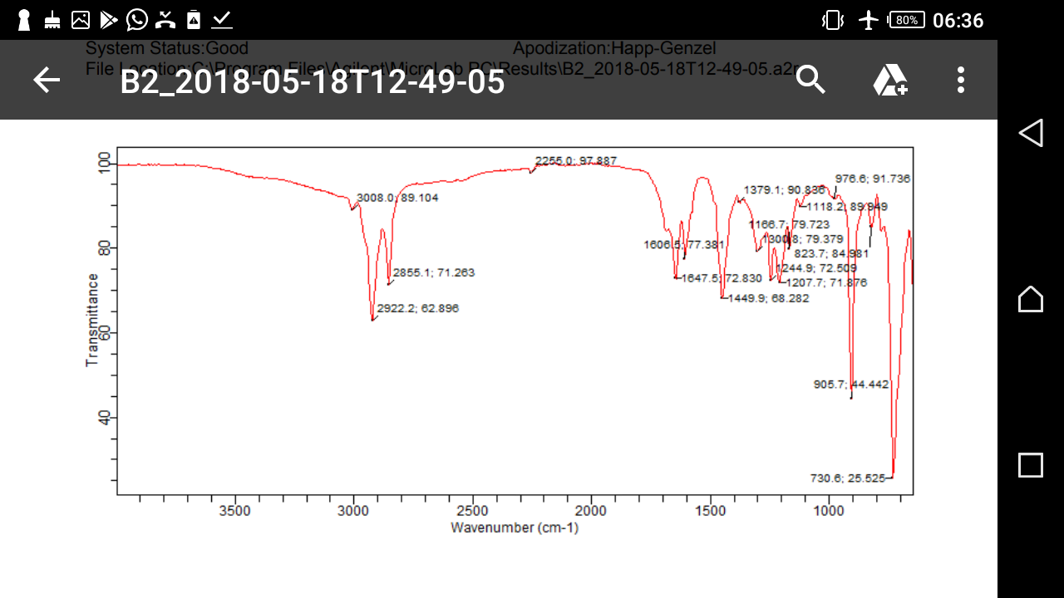Figure 1: FTIR spectra of the most active sub-fraction (A₂) of CNS extract of Anacardium occidentales.

Table 6: Abbreviated mass spectra of the active compound (n-Hexane sub-fraction) recovered from CNS extract of Anacardium occidentales.
%AREA QUALITY | LIBRARY (COMPOUND)
97.23 9 | 2-(5-bromopentyl)- 7,9-Diethyl-2,4-bis(dimethylamino) -10-imino-8-thio-1,7,9-triazaspiro [4.5]-1,3-decadiene-6,8-dione
 | 1,3-Dioxolane
 | 1-Butaneboronic acid

Table 7. Frequency ranges for the FTIR output of the most active sub-fraction (A₂) of the CNS extract
Wave Number (cm⁻¹) | Nature | Reference frequency ranges(cm⁻¹)
730.6 | C-CI Stretch | 850-550
905.7 | C=C Bend | 905-915
1207.0 | C-O Stretch | 1210-1163
1379.1 | O-H Bend | 1440-1395
1606.5 | N-H Bend | 1650-1580
1647.5 | C=N Stretch | 1690-1640

Conclusion
The in vivo anticoccidial effect of the n-hexane fraction of CNS pentane extract against E. tenella infection in broiler chicks has been ascertained in this study. The active component of the n-hexane fraction of CNS extract characterized using GC-MS and FTIR spectroscopy could be an alternative source of effective drug against Eimeria tenella infection in broiler chickens. This information will help in the management of caecal coccidiosis.
Ethical Approval
All experimental procedures involving animals were conducted in accordance with the ethical guidelines for animal research of Ahmadu Bello University, Zaria, Nigeria, and were approved by the Institutional Animal Care and Use Committee (Approval No: ABU-CAUC/2016/142].

References
Alberta, G. (2007). Coccidiosis in Chickens. Agriculture and Food. Roping the web. Pp 1-2. http://www.alberta. chicken coccidiosis.gov.12/25/2008.
Ali, H., Naqvi, F., and Tariq, N. (2014). Prevalence of Coccidiosis and its Association with Risk Factors in Poultry of Quetta, Pakistan. Asian Journal of Applied Sciences, 2(4): 554-558.
Balarabe R.M and Obeta S.S. (2015). An Overview of the Prevalence of Avian Coccidiosis in Poultry Production and Its Economic Importance in Nigeria. Veterinary research international. 3(3): 35-45.
Bera, A.K., Bhattacharya, D., Pan, D., Manna, B., Bandyopadhyay, S. and Das, S.K. (2010). Effect of Heat Killed Mycobacterium phlei on Body Weight Gain and Management of Caecal Coccidiosis in Broiler Chickens. Research in Veterinary Science, 89: 196-199.
Chapman HD (2000) Practical use of vaccines for the control of coccidiosis in the chicken. World’s Poultry Science Journal 56: 7-20.
Chapman HD, Cherry TE, Danforth HD, Richards G, Shirley MW, et al. (2002) Sustainable coccidiosis control in poultry production: The role of live vaccines. Int J Parasitol 32(5): 617-629.
Chapman HDB, Roberts MW, Shirley, Williams RB (2005) Guidelines for evaluating the efficacy and safety of live anticoccidial vaccines and obtaining approval for their use in chickens and turkeys. Avian Pathol 34(4): 279-290.
Conway, D.P. and McKenzie, M.E. (2007). Poultry Coccidiosis Diagnostic and Testing Procedures. 3rd ed. Ames, IA, USA: Blackwell Publishing. pp. 7–9.
De gussem, M. (2005). Coccidiosis control in poultry: importance of the quality of anticoccidial
premixes. Proceedings of the IXth International Coccidiosis Conference, Foz do Iguassu, September 19-23, 2005.
Deplazes P., Eckert J., Mathis A., Samson-Himmelstjerna G. and Zahner H. (2006). Parasitology in veterinary medicine. Wageningen Academic Publisher. Wageningen, Netherland, 2006.
Fetterer R.H and Allen P.C (2001). Eimeria tenella Infection in Chickens: Effect on Plasma and Muscule 3-Methylhistidine. Poultry science. 80:1549-1553.
Fornace, K.M., Clark, E.L., Macdonald, S.E., Namangala, B., Karimuribo, E., Awuni, J.A., Thieme, O., Blake, D.P. and Rushton, J. (2013). Occurrence of Eimeria species Parasites on Small-Scale Commercial Chicken Farms in Africa and Indication of Economic Profitability. Journal. Pone. 8(12): 1-8.
Geetha M., and Palanivel K. M. (2018). A review on coccidiosis. International Journal of Current Microbiology and Applied Sciences. 7(6): 2319-7706.

Gensa U. (2018). Review on poultry coccidiosis. College of agriculture and veterinary medicine school of veterinary medicine. jimma, Ethiopia. https://www.academia.edu
Hamid P. H., Kristianingrum Y. P., Wardhana A. H., Prastowo S., and Ribeiro da Silva L. M. (2018). Chicken Coccidiosis in Central Java, Indonesia: A Recent Update. Veterinary Medicine International. Volume 2018, Article ID 8515812, 7 pages https://doi.org/10.1155/2018/8515812.
Jadhav, B.N and Nikam, S.V (2014). Study of Seasonal Incidence of Chicken Coccidiosis in Gangapur and Vaijapur Tehsil of Aurangabad District in Maharashtra. International Journal of Applied Science-Research and Review.1(3): 093-097.
Johnson, J. and Reid, W.M. (1970) Anticoccidial drugs: lesion scoring techniques in battery and floor pen experiments with chickens. Experimental Parasitology 28: 30-36.
Lai, L., Bumstead, J., Liu, Y., Garnett, J., Campanero-Rhodes, M.A., Blake, D.P. and Matthews, S. (2011). The Role of Sialyl Glycan Recognition in Host Tissue Tropism of the Avian Parasite Eimeria tenella. PLoS Pathogen, 7(10): e1002296.
Lorke D. (1983). A new approach to practical acute toxicity testing. Archive of Toxicology. 1983 Dec; 54 (4):275-87.
Maikai, V.A., Makeri, H.K., Adeiza, A.A. and Maikai, B.V. (2007). Preliminary Studies of Anticoccidial Effect of Mahogany (Khaya senegalensis) and African Locust Bean Tree (Parkia biglobosa) Aqueous Bark Extracts on Chicken Infected with Coccidia. Savannah Journal of Agriculture, 2: 43-45.
McDougald, L.R. and Fitz-Coy, S.H. (2008). Coccidiosis, In: Saif, Y.M., A.M. Fadly, J.R. Glisson, L.R. McDougald, L.K.Nolan and D.E. Swayne, (ed.), Diseases of poultry, 12th edn., Blackwell publishing professional, Ames, Iowa, USA. pp. 1069-1085.
Mona A. M. K., Abulqasim I. A. and Sumaia M. A. A. (2015). Isolation and morphological identification of Eimeria tenella from Khartoum State (Sudan). Journal of applied and industrial science. 3(5): 177-181.
Muazu, A., Masdooq, A.A., Ngbede, J., Salihu, A.F., Haruna, G., Habu, A.K., Sati, M.N. and Jamilu, H. (2008). Prevalence and Identification of Species of Eimeria Causing Coccidiosis in Poultry within Vom, Plateau State, Nigeria. International Journal of Poultry Sciences, 7(9): 917-918.
Olanrewaju, C. A. and Agbor, R. Y. (2014). Prevalence of coccidiosis among poultry birds slaughtered at gwagwalada main market, Abuja, FCT. Nigeria. The International Journal of Engineering and Science.3(1); 41-45.
Patrick, O.U. and Mgbere, M. (2010). Effects of Components of Melia azadirachta on Coccidia Infections in Broilers in Calabar, Nigeria. International Journal of Poultry Sciences, 9 (10): 931-934.
Pimentel, M. F., De- Lima, D.P., Martins, L.R., Beatriz, A., Santaella, S.T. and Costa- Lotufo, L. V. (2009). Eco Toxicological Analysis of Cashew Nut Industry Effluents, Specifically Two of its Major Phenolic Components Cardol and Cardanol. Pan-America Journal of Aquatic Sciences. 4(3): 363 – 368
Quiroz-Castañeda R. E. (2018). Avian Coccidiosis, New Strategies of Treatment, Farm Animals Diseases, Recent Omic Trends and New Strategies of Treatment. https://www.intechopen.com/books/farm-animals-diseases-recent-omic-trends-and-new-strategies-of-treatment/avian-coccidiosis-new-strategies-of-treatment
Shirley, M W., Smith, A. L., and Tomley, F. M. (2005). The biology of avian Eimeria with an emphasis on their control by vaccination. Advances in Parasitology. 60; 285-330.
Soulsby, E., (1982). Helminths, Arthropods and Protozoans of Domesticated Animals. 7th Ed., Bailliere Tindall, London, UK.
Williams, R.B. (2005). Intercurrent coccidiosis and necrotic enteritis of chickens: Rational, integrated di sease management by maintenance of gut integrity. Journal of Avian Pathology. 34: 159–180.

