A DIAGNOSTIC STUDY TO CONTROL PACKAGING WEIGHT VARIABILITY IN CHILLI POWDER MANUFACTURING USING STATISTICAL PROCESS CONTROL

ABSTRACT
In the food processing industries, weight variation in the net product content is frequently noticed, particularly in the case of spices (Chilli Powder). Because it has a direct impact on customer satisfaction and brand reputation, excessive weight variation in spice packing, either above or below the legal minimum weight, is a serious concern. This weight fluctuation is a possible waste that could result in different product quality, higher production costs, and worse profitability. Product weight variations during packaging are still a major issue due to human error, machine calibration, raw material variability, environmental variables, and standard operating procedures. Chilli powder is fine and sticky, thus the auger filler nozzle can affect weight variations in packaging. A poorly sized or residue-clogged nozzle might inhibit chili powder flow, resulting in irregular fills. Proper nozzle design and regular cleaning reduce these difficulties and will help the chilli industry standardize products, cut waste, and compete globally.
Quality is essential in any productive industry, including manufacturing and services. Several techniques have been consolidated to analyze the standardization of production process quality. The research method included data collection, statistical analysis and process control to evaluate packing machine component changes. A large sample size was employed to measure spice packet weight before and after change to ensure statistical significance. Descriptive statistics, a two-sample t-test, and variance tests (F-test and Levene's test) assessed mean weight and variability. SPC used X-bar and R charts to monitor how stable the process was, set control limits, and calculate process capability (Cp and Cpk) based on the set specifications. These tools helped check how effective the component change was. Before changing the component, there were 38 outliers on the X-bar chart and 5 on the R chart. After making the change, outliers on both charts were very few and insignificant. This study recommends modifying the auger filler nozzle to help lower packing weight variation.
Keywords: Weight Variation, Spice packaging, Component change, t-test, Process capacity

- Introduction
A significant category of agricultural products, spices are thought to be essential for cooking and flavoring meals. Additionally, various spices and spice-related items are utilized for cosmetic, fragrance, and medical purposes. Referred to as the "Land of Spices," India cultivates a wide range of spices in vast quantities. The nation grows over sixty-three different types of spices, including pepper (the King of Spices), cardamom (the Queen of Spices), ginger, turmeric, coriander, cumin, and many more.
Humanitarians have long used spices as a herbal cure to stave against illness and maintain their physical and emotional well-being. In addition to using herbal medicines, Ayurveda is utilized to preserve, flavor, and color food (Gidwani et al., 2022). Spices that have particular qualities because of a special volatile oil or molecule they contain include whole or ground spices, spice blends, purees, air-dried products, and essential oils (Siruguri& Bhat 2015; Kumar et al., 2024). Their fundamental processing and packaging features have received little attention despite this massive production. The importing nations have strict safety and hygienic requirements, which can vary from one nation to another. However, the presence of poisons, pesticide residues, and biological infestations always worry the regulatory bodies more. Due to inadequate packaging, a number of shipments failed to arrive. Therefore, it is reasonable to assume that appropriate functional packaging will be crucial to preserving the quality of spices throughout storage and transit (Indriramma, 2004).

  - Role of Packaging in Spice Manufacturing
Enclosing food to prevent physical, chemical, or biological contamination or tampering is known as packaging. Even after the production process is complete, packaging is essential to maintaining the benefits of food processing. It guarantees that food items can be securely transported over long distances from their place of production and will still be safe and nutritious when eaten. Food packaging's main goal is to protect food against external elements such as air, moisture, ultraviolet radiation, and microbial and chemical hazards (Pruthi et al., 1962). Because different spices have different and particular packaging needs, packing spices is a more complex undertaking than packaging other products. To prolong the storage life of multiple spice categories, like whole seeds (celery, fennel, cumin, and fenugreek), ground or powdered spices, blended seasonings (curry powders and masalas), essential oils and oleoresins, and through diverse distribution networks, appropriate packaging materials must be designed and developed. To eliminate inferior materials, impurities, and foreign objects during the production and final packaging processes, continuous quality control should be put in place. Following defined operational standards and national or regional regulations established by the producing and consuming countries, processed plant materials must be packed in clean, dry containers such as boxes, sacks, bags, or other suitable packaging (Ramanathan et al., 1974; Ammaan et al., 2024).

Because it ensures efficiency and consistency throughout production, storage, and distribution, packaging is essential to the manufacturing of spices. By maintaining freshness, avoiding contamination, and protecting spices from air, light, and moisture—all of which can deteriorate flavor, aroma, and color—it safeguards the product's quality. Precise portioning is made possible by modern packaging techniques, which guarantee constant weight and volume in each unit. This is essential for both regulatory compliance and upholding consumer confidence. While automated filling and sealing systems improve operating efficiency by decreasing manual errors and lowering material waste, advanced technologies like vacuum sealing and multilayer films increase shelf life. By guaranteeing durability during transportation and maximizing storage space through standardized designs, packaging also makes logistics easier. Additionally, it promotes branding by offering convenience features like resealable pouches, portion management, and clear labeling. As the spice sector develops, manufacturers are able to satisfy environmental targets while upholding strict quality, consistency, and cost-effectiveness criteria thanks to advancements in sustainable materials and intelligent packaging.

  - Importance of Consistent Product Weight
    - Accuracy and Consistency- Crucial in Quality Assurance
Any company that wishes to preserve client happiness and guarantee the highest standards of product quality must prioritize quality assurance. Two essential components of quality assurance that have a direct bearing on consumer satisfaction and brand reputation are accuracy and consistency. In terms of accuracy, check weighing is essential for confirming that the consumer is receiving the right quantity of product. Any departure from the recommended weight, whether it be for a manufactured component, a pharmaceutical pill, or a packaged food item, may result in unhappy customers and possible legal problems. Businesses may make sure that every product leaving their plant satisfies the necessary weight criteria by incorporating check weighing into the quality control procedure. In quality assurance, consistency is just as crucial. Consumers anticipate consistency from the goods they buy, and any deviations may cause them to lose faith and allegiance. By detecting any discrepancies in product weight, check weighing enables businesses to address and fix the problem before it affects the customer. This helps preserve brand reputation and competitiveness in the market in addition to guaranteeing client happiness. In conclusion, as accuracy and consistency have a direct bearing on consumer happiness, brand reputation, and legal compliance, they are essential components of quality assurance. Check weighing is a crucial procedure in quality control procedures since it is a dependable way to guarantee product weight correctness and consistency.
1.2.2. Advantages of Using Check Taking Quality Assurance into Account
Businesses in a variety of industries can benefit greatly from the use of check weighing in quality assurance procedures. Among the main benefits are:
1. Increased customer satisfaction: Businesses can satisfy customer expectations and increase satisfaction by making sure that products weigh accurately and consistently. Consumers appreciate getting the right quantity of goods, and check weighing contributes to their loyalty and trust.
2. Improved brand reputation: A positive brand image is a result of consistent product weight. Customers come to identify the brand with dependability and quality when they often receive products that weigh the anticipated amount. This sets the business apart from rivals and enhances its reputation in the marketplace.
3. Cost savings: Check weighing reduces waste and streamlines production, which lowers costs. Early detection of underweight or overweight products helps businesses avoid needless costs related to rework, product returns, or legal problems.
4. Regulation adherence: A lot of industries have stringent rules about product weight, particularly in the food and beverage and pharmaceutical industries. By ensuring adherence to these rules, check weighing lowers the possibility of fines or recalls.
5. Process improvement: Businesses can find any discrepancies or deviations and implement corrective measures by integrating check weighing into quality control procedures. Errors are reduced, manufacturing is optimized, and efficiency is increased through this ongoing development.
To sum up, there are a number of advantages of incorporating check weighing into quality assurance procedures, such as increased customer satisfaction, better brand recognition, cost savings, regulatory compliance, and process enhancement. Because of these benefits, check weighing is a crucial procedure for businesses in all sectors who want to succeed in quality control and provide their clients with outstanding products.

  - Factors Causing packaging variations in spice manufacturing
A vast range of elements, including human capabilities, machinery, materials, procedures, control methods, and environmental circumstances, affect the correct and efficient manufacture of items. Every one of these elements is essential to maintaining constant quality and reducing mistakes in production procedures.
1.3.1. Human Factors (Man):
Insufficient Instruction and Carelessness: Appropriate training courses are necessary to reduce mistakes and improve operator proficiency. According to Smith & Jones in Manufacturing Practices, 2020, a worker that has received proper training greatly increases output consistency. Insufficient training may result in operational errors, decreased productivity, and possible safety hazards. Frequent evaluations and refresher courses help fill up knowledge gaps and strengthen best practices.
-Workload Stress: Overburdening workers often results in increased error rates.Levels of stress affect concentration, efficiency, and decision-making. Stress and decreased productivity are linked, according to the Industrial Management Journal, 2019, which also emphasizes the necessity of balanced workloads, ergonomic upgrades, and mental health care in industrial settings.

1.3.2. Machine Equipment Factors:
Calibration Problems & Malfunctions: As required by ISO 9001 requirements for quality control, weighing and filling equipment must be calibrated on a regular basis to maintain accuracy. Inconsistent weights due to improper calibration can cause regulatory non-compliance and customer unhappiness. Regular inspections guarantee that machines operate within reasonable tolerance ranges.
Upkeep Timetables: According to the Maintenance Engineering Handbook, preventive maintenance lowers machine-induced mistakes and downtime (Higgins & Mobley, 2015). By anticipating possible problems before they arise, a systematic maintenance plan can increase operational dependability and extend the life of equipment.
1.3.3. Raw Material Factors (Material):
Moisture Content: The accuracy and consistency of product weights are impacted by variations in moisture content. In order to guarantee consistent raw material conditions, environmental control is crucial, according to the Journal of Food Engineering, 2018. Standards compliance and product quality are preserved by keeping an eye on and managing the moisture content of raw materials.
The distribution of particle sizes: Products with unequal weight distribution may result from non-uniform grinding. Controlling the particle size distribution during raw material preparation guarantees improved consistency in manufacturing results, according to research published in Powder Technology by Kim et al., 2019.
1.3.4. Process Factors (Method):
Inconsistent Filling Techniques: Weight variations are sometimes caused by variability in manual filling procedures. According to Packaging Technology Today, 2021, automated filling methods increase manufacturing productivity and decrease human error. Additionally, automation guarantees consistency and adherence to industry norms.
SOP Compliance: Manufacturing uniformity is guaranteed when Standard Operating Procedures (SOPs) are followed. Well-defined SOPs improve quality control and lower process variability, which builds consumer trust, according to the FDA's Good Manufacturing Practices for Food Processing, 2020.
1.3.5. Control Factors (Measurement):
Inaccurate Scales: Weighing scales must be calibrated often to prevent inaccurate data. The significance of preserving accuracy through routine inspections and recalibration of measurement instruments is emphasized in Quality Control in Manufacturing Processes, 2018.
Keeping an eye on frequency: Frequent weight checks during production aid in the early detection of disparities, averting more serious problems. In order to guarantee consistency in quality and adherence to safety laws, ISO 22000 standards promote systematic monitoring.
1.3.6. External Factors (Environmental):
Humidity and Temperature: Variations in temperature and humidity, for example, can modify the moisture content of materials, which can impact weight and uniformity of the final product. The Food Quality Journal, 2020 emphasizes how crucial it is to regulate these factors in order to preserve consistent manufacturing results.
Contamination and Dust: Operational errors brought on by contamination are reduced in a clean and well-maintained environment. The importance of cleanliness in lowering errors and increasing overall productivity is emphasized in the Lean Manufacturing Guidelines, 2021.

  - Precautions and Solutions to Minimize Weight Variation
A thorough approach that addresses both operational factors and environmental conditions is essential to reduce weight variation in packaging processes. Because wear and tear can cause disparities over time, it is imperative to regularly calibrate the weighing system to ensure correct dosing. Maintaining accuracy and adherence to quality standards can be facilitated by scheduling routine calibration checks using certified weights. Enhancing the flow characteristics of spices is also essential. Powder flow may be managed and problems like clumping or bridging, which frequently result in uneven filling, can be avoided with the use of vibratory feeders or auger systems.
Another important component is environmental control. Changes in spice density and moisture absorption can be avoided by keeping the producing area's temperature and humidity constant. Air conditioners, dehumidifiers, and environmental sensors can all help achieve this. Additionally, a more consistent filling process is ensured by modifying machine settings to correspond with the unique properties of the spice being packaged, such as particle size and moisture content. Fast and efficient machine adjustments are made possible by test runs and documentation of the ideal parameters for various items.
Equipment maintenance and regular monitoring are also essential. Examining parts including the machine mechanisms, bag alignment, and sealing system aids in spotting possible problems before they have an impact on output. Schedules for preventive maintenance that are based on industry best practices help preserve operational effectiveness and minimize downtime. Automated check weighers can be deployed to continuously verify package weights throughout production, improving quality control. This reduces waste and enhances product uniformity by enabling the real-time identification and rectification of weight anomalies.
Finally, adequate operator training is essential. Operators should possess the information and abilities necessary to efficiently control and keep an eye on machine settings. Frequent training sessions covering quality standards, troubleshooting, and machine operations guarantee that the equipment is used within ideal bounds. Manufacturers may increase weight consistency, cut down on material waste, and uphold high standards of quality in their production processes by putting these safety measures and solutions into practice.

- Research Methodology
  - Data Collection
To evaluate the impact of the component change in the packaging machine, weight measurements of spice packages were collected both before and after the modification. The pre-modification measurements (baseline data) were gathered to establish a reference point for comparison. Following the implementation of the component change, post-modification weight measurements (post-change data) were collected under similar operating conditions.
In both cases, a sufficiently large sample size was ensured to achieve statistical significance, thereby enabling reliable and robust comparisons. The sample size determination considered factors such as the expected variation in package weights and the desired confidence level for the statistical analysis. This approach ensures that any observed differences between the baseline and post-change datasets can be attributed to the component change with high confidence.

  - Statistical Analysis of Package Weights
To assess the impact of the component change on the weight of spice packages, a structured statistical analysis was performed on the pre-change (baseline) and post-change datasets. The following steps were implemented:
    - Comparison of Means and variance
The average (𝑥̅) and standard deviation (σ) of the package weights were calculated for both the baseline and post-change datasets. These descriptive statistics help to understand the central values and the distribution of data within each dataset.
To assess whether the component change had a significant impact on the mean package weight, a two-sample t-test was performed.
A p-value was computed to evaluate whether the difference in means was statistically significant, with a threshold significance level (α) set at 0.05. This methodology follows best practices described in statistical texts such as Howell, 2013.
To examine if the component change helped lower the variability in package weights, the variances of the baseline and post-change datasets were analyzed using both an F-test and Levene’s test. Levene’s test was applied to check for equality of variances. The test utilizes the absolute deviations from group means to evaluate the null hypothesis of equal variances (Levene, 1960).
Both tests provide complementary insights into whether the component change reduced weight variability. Statistical significance for these tests was also evaluated at the α=0.05 level.
2.2.2. Statistical Process Control (SPC)
According to Montgomery (2009), the goal of Statistical Process Control (SPC) is to identify nonconformities that might disrupt a process, ultimately preventing the production of defective units of a given product. To achieve this, he explains that control charts can be employed to define process capability by estimating key parameters that directly influence the process under review and by supporting process improvement through minimizing inherent variability.
Furthermore, Lins (1993) states that SPC can be applied using a control chart by following these steps:
a) select the characteristic to be measured;
b) measure this characteristic at regular intervals during sequential steps;
c) calculate the mean and range of the collected samples;
d) plot these values on the control chart;
e) check whether the process remains under control.
By following these steps, it becomes possible to track process performance and observe its variability, as highlighted by Martini and Drei (2019).
Using X-bar and R charts for process capability analysis enables the evaluation of a process over a period by collecting sample data. These samples help determine the mean and range of the process, from which control limits are established to identify potential variations. When data points fall outside these control limits, it indicates that the process is out of control.
Montgomery (2009) outlines the procedure to construct X-bar and R charts as follows:
a) calculate the mean (𝑥̅) and range (R) for each sample observation;
b) determine the overall average of all sample means and ranges, taking into account the sample size;
c) establish control limits for both the 𝑥̅ and R charts.
Additionally, process capability can be evaluated in two ways based on the control limits to understand how well the process performs and to assess the quality of produced items. The first metric, Cp, measures the width of the process variation relative to the specification limits and considers only process variability. The second, Cpk, assesses how centered the process mean is within the specification limits, reflecting both variability and process centering, as noted by Silveira (2014).
    - Calculation of control limits
Having arranged the samples, it was necessary to calculate the limits of control of them, using the norms of the quality chart X-bar and R. For this, it was necessary to obtain some variables related to this quality charts. Thus:
- The variable m indicates the total number of samples selected, which in this case is m = 50;
- The variable n denotes the number of observations within each sample;
- The mean of the X-bar chart was determined by calculating the simple arithmetic average,
which involves summing all X-bar values and dividing by the total number of samples m. Thus,
Mean ( ̅)= $\frac{Σ x̅}{m}$
• The R-bar is calculated as the simple arithmetic average of all range values by summing the individual R values and dividing by the total number of samples m. Thus,
R̅ = $\frac{ΣR}{m}$
To determine the upper (UCL) and lower (LCL) control limits for both the X-bar and R charts, it was also necessary to define specific constants. These constants are associated with the number of observations per sample n used in this study and are provided in Table 3. Accordingly, for a sample size of 5, we have:
• The constant A2 is required to calculate the upper and lower limits for X-bar. With A2 = 0.577, the limits are given by the formulas:
UCL= Mean (𝑥̅) + A₂ * R̅
LCL= Mean (𝑥̅) – A₂ * R̅
• Lastly, the constants D3 and D4 are applied to establish the control limits for the R chart. With D3 = 0 and D4 = 2.114, we have:
𝑈𝐶𝐿 = 𝐷4 ∗ R̅
𝐿𝐶𝐿 = 𝐷3 ∗ R̅
It is important to note that SPSS software automatically computes these values to determine if the process remains within control limits.
    - Process Capability Analysis (Cp)
Using the calculated control limits, it became necessary to determine the process capability of the RU based on the recorded grades. To do this, two key control parameters were first computed:
• The Standard Deviation (𝜎), obtained by dividing the R-bar by d2, where d2 is a constant dependent on the sample size n. In this case, with d2 = 2.326, we have:
𝜎= $\frac{ R̅}{d2}$
• Additionally, the Specification Limits were required, which were defined by the person responsible for managing the RU. This person established the control range of grades between 6 (Lower Specification Limit – LSL) and 8 (Upper Specification Limit – USL), with a target value of 7. Using this data, the Cp of the RU was then calculated as follows:
c_{p}= $\frac{USL-LSL}{6σ }$
Since the resulting Cp value falls between 0 and 1, it indicates that the process variation exceeds the specified specification limits, meaning the process, by definition, is not capable.
    - Process Capacity Index (Cpk)
Since Cp only reflects the potential process capability and does not capture the actual alignment of the process results with the specification limits, it becomes necessary to calculate Cpk to address this limitation. To compute Cpk, two intermediate values must first be determined: the Upper Production Capacity (UPC) and the Lower Production Capacity (LPC). These are calculated using the following formulas:
UPC = $\frac{USL-(x̅̅̅)}{3σ }$

LPC= $\frac{(X̅̅)-LSL}{3σ }$

With UPC and LPC duly calculated, it is possible to find the value of Cpk, which is given by the formula:
𝐶𝑝𝑘 = 𝑚𝑖𝑛 (𝑈𝑃𝐶, 𝐿𝑃𝐶) (Martino &Drei, 2019).

- Data Analysis
The mean values for the weight of chili powder before replacement (199.29) and after replacement (200.02) did not differ significantly. However, the standard deviations showed a substantial difference, with 5.06 before replacement and 1.67 after replacement.
To confirm this significant variance difference, Levene’s test was conducted, resulting in an F-statistic of 130.605 and a p-value of 0.000 (p < 0.05). This suggests that the assumption of equal variances is violated, meaning the standard deviations are significantly different.
Additionally, a t-test for Equality of Means was conducted to check for a significant difference in the mean weights. For both cases—equal variances assumed and equal variances not assumed—the p-values were 0.093, suggesting that there is no statistically significant difference in the mean weight of chili powder before and after replacement.
To investigate weight variation in chili powder before and after replacement, control charts (specifically X̅ and R charts) were developed to identify outliers contributing to the significant difference in standard deviations.
The data comprising of 50 observations was taken in the form of triplet and for the first time, the average $({\overline{X}}_{1}, {\overline{X}}_{2}, …)$ and range $(R_{1}, R_{2}, …)$ was computed for each of the triplet and then, the overall average $\left(\overline{\overline{X}}\right)$ and range $(\overline{R})$ were calculated.
Limits can be established around the sample means using the following relationships for $\overline{X}$ and R charts, which illustrate the amount of variance that can be anticipated for a specific sample size. These expected limits are referred as upper control limit (UCL) and lower control limit (LCL).
3.1. $\overline{X}$ Chart: This chart is used to monitor process mean by plotting sample means to control the mean value of a variable.
The X - bar chart for 50 observations taken in the triplet form (for before replacement) is given below:
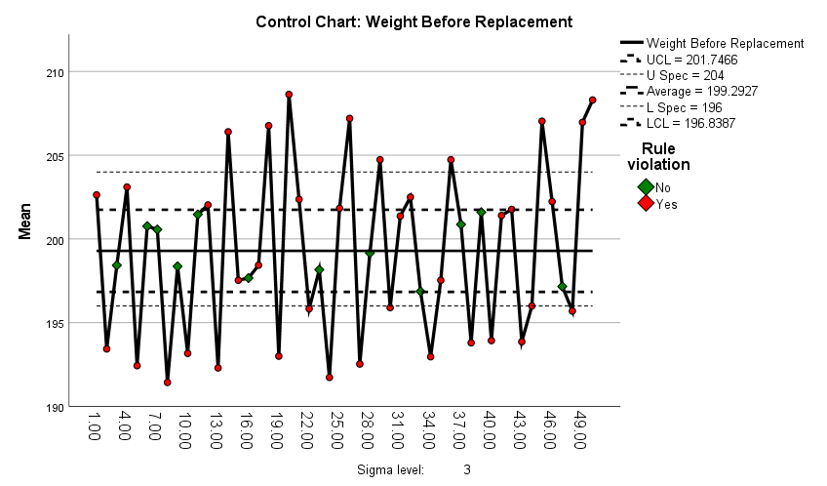
Figure 1. $\overline{\text{X}}$Chart for Weight Before Replacement
The outliers observed from the above control chart are given in the following table –
Table 1. Rule Violations for X-bar
Unit | Violations for Points | Frequency
1, 4, 12, 14, 18, 20, 21, 25, 26, 29, 32, 36, 42, 45, 46, 49, 50 | Greater than +3 sigma | 17
2, 5, 8, 10, 13, 19, 22, 24, 27, 30, 34, 38, 40, 43, 44, 48 | Less than -3 sigma | 16
12, 14, 20, 21, 26, 31, 32, 41, 42, 46, 50 | 2 points out of the last 3 above +2 sigma | 11
10, 15, 24, 34, 35, 40, 44, 48 | 2 points out of the last 3 below -2 sigma | 8
17, 19 | 4 points out of the last 5 below -1 sigma | 2

The X-bar control chart for 50 observations (taken in triplet form) shows significant rule violations, indicating that the process is not under statistical control. A total of 38 points violates control rules, which highlights substantial process instability. Specifically:

17 points exceed the +3-sigma limit, and 16 points fall below the -3-sigma limit, indicating extreme deviations from the process mean.Further violations include 11 points where 2 out of the last 3 observations are above +2 sigma and 8 points where 2 out of the last 3 observations are below -2 sigma, suggesting a persistent pattern of variation.Additionally, 2 instances of 4 out of the last 5 points falling below -1 sigma further confirm systematic instability.

The process average is 199.27, which is less than the expected average, reflecting a downward shift in performance. The presence of 38 outliers indicates significant variation among the sets of triplets, and the process is influenced by assignable causes rather than random variation. This confirms that the statistical process is not under control and requires immediate investigation and corrective actions to identify and eliminate the sources of variation.

  - Range (R) Chart: This chart indicates changes in process variability by plotting sample ranges to control the variability of a variable.

The R chart for 50 observations taken in the triplet form (for before replacement) is given below:
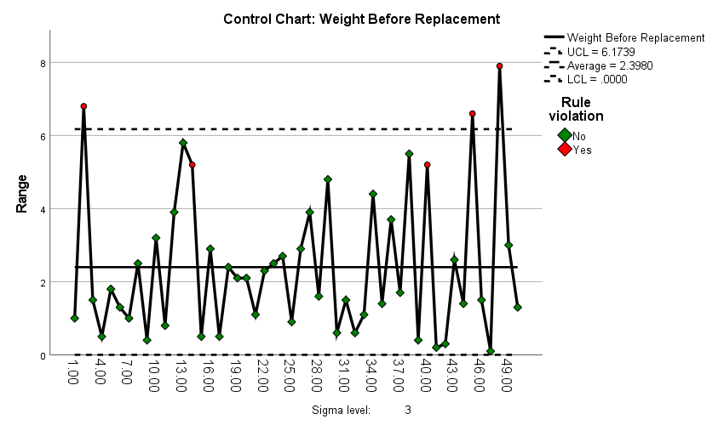
Figure 2. Range Chart for Weight Before Replacement

The outliers detected from the above R control chart are given in the following table –

Table 2. Rule Violations for Range
Unit | Violations for Points | Frequency
2, 45, 48 | Greater than +3 sigma | 3
14, 40 | 2 points out of the last 3 above +2 sigma | 2

The R (Range) chart for 50 observations taken in triplet form indicates that the process is not under statistical control. Although the actual range is 8 (USL = 204, LSL = 196), the observed range from the control chart is significantly lower at 2.398, which is far less than the expected range. This discrepancy suggests restricted variation that is inconsistent with the process limits.
Additionally, 5 points violate control rules, confirming the presence of assignable causes that are driving the process out of control. These assignable causes are responsible for the inconsistencies in the observed ranges and indicate that the process is not stable or predictable. Immediate corrective actions are necessary to identify and address the sources of this variation to bring the process back into control.

  - Process Capability Index (Cp):Cp refers to the potential capability of the process which measures the performance of the process when there is the absence of assignable causes. The implications of the process capability index (Cp) are as follows. An increase in tolerance spread leads to a higher Cp, indicating a more capable process. When Cp > 1, the process is capable, meaning variation is minimal, and defects are theoretically absent. At Cp = 1, the process just meets specifications, with defects likely, especially if the process is not centered. When Cp < 1, the process is incapable, as variation exceeds specifications, resulting in defective items. In practice, perfect centering is unattainable, and assignable causes cannot be entirely eliminated. To ensure quality, coefficients greater than 1 are preferred, with a Cp of 1.33 generally considered suitable for maintaining a capable and reliable process in chili powder production.

3.4. Process Capability Index (Cpk): It reflects the actual capability of the process. Cpk is defined as a one-sided process capability index (PCI) that relates to the specification limit closest to the process mean. This index accounts for the centering or offset of the process, so Cpk measures both the process variation relative to the allowable specifications and the position of the process average.
A higher Cpk value signifies fewer defects. For two-sided specifications, both Cp and Cpk are used to evaluate process capability. Cpk specifically compares the smallest distance from the process mean to either specification limit against half of the process spread. When the process mean is perfectly centered, Cp and Cpk become equal. The interpretation of Cpk is as follows: Cpk greater than 1 shows that the process meets the required specifications; Cpk less than 1 means the process mean falls outside the limits. A Cpk between 1 and 1.33 suggests a marginally capable process, while a Cpk of 2 indicates a highly capable process. In practice, industries often target a minimum Cpk of 1.33, with an ideal goal of reaching 2.

The statistical measures (indices) for process capability (for weight after replacement) are provided in the table below:
List 1 Process Statistics
Capability Indices | CP | 0.941
Capability Indices | CpL | 0.775
Capability Indices | CpU | 1.108
Capability Indices | CpK | 0.775

The Cp value measures the overall process capability, indicating how well the process can fit within the specified limits (LSL = 196, USL = 204). A Cp of 0.941 is less than the desired benchmark of 1.33 (or higher), suggesting that the process is not capable of consistently producing results within the specification limits. This indicates that the process spread (variation) is too large relative to the specification range.

CpL (0.775) measures the process capability towards the lower specification limit (LSL = 196). A CpL below 1.0 indicates that the process has a higher likelihood of producing values below the lower limit, reflecting poor performance on this side. CpU (1.108) measures the process capability towards the upper specification limit (USL = 204). A CpU above 1.0 indicates better performance towards the upper limit, meaning the process is less likely to produce values exceeding the upper limit. Together, these indices show asymmetry in the process performance: the lower limit is more problematic than the upper limit.

The Cpk index considers both the process mean and the variability, reflecting the process's capability to meet both the lower and upper specification limits. A Cpk of 0.775 indicates that the process is not centered and is closer to violating the lower limit. Since Cpk is lower than 1.0, this confirms that the process is incapable of consistently meeting specifications.
Overall, the process capability indices suggest that the process is not capable of producing consistent results within the specified limits (196 to 204). The spread of the process variation exceeds the specification range, and there is a tendency for the process to drift towards the lower specification limit (LSL = 196), which is a concern. Improving the process performance will require reducing variability and re-centering the process mean closer to the midpoint of the specification range.

In the further process, we will construct the variable control charts for the wight of chilli powder after replacement.
The X - bar chart for 50 observations taken in the triplet form (for after replacement) is given below:

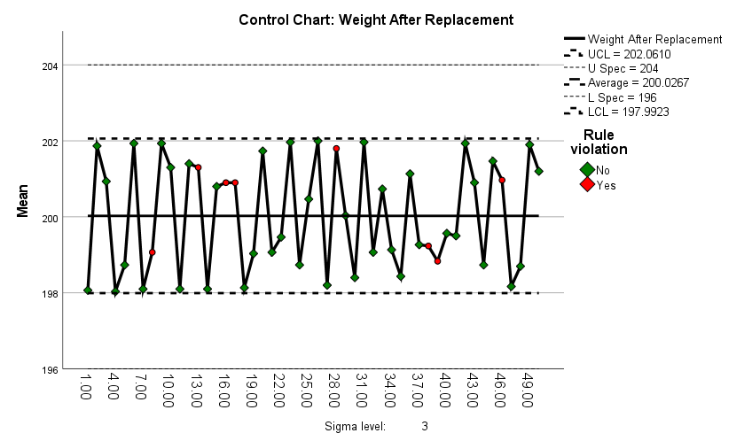
Figure 3. $\overline{\text{X}}$Chart for Weight After Replacement
The outliers observed from the above control chart are given in the following table –

Table 3. Rule Violations for X-bar
Unit | Violations for Points | Frequency
13, 16, 17, 46 | 4 points out of the last 5 above +1 sigma | 4
8,38, 39 | 4 points out of the last 5 below -1 sigma | 3
28 | 2 points out of the last 3 above +2 sigma | 1

The X-bar chart for 50 observations taken in triplet form after replacing the machine component shows significant improvement in process stability. The process average has increased to 200.026 (compared to 199.27 before replacement), bringing it closer to the target mean.

Out of the 50 observations, there are only 8 outliers, a considerable reduction from the 38 violations observed before replacement. Importantly, there are no violations for points greater than +3 sigma or less than -3 sigma, indicating that extreme deviations have been eliminated. The observed rule violations include:

4 instances where 4 out of the last 5 points are above +1 sigma.
3 instances where 4 out of the last 5 points are below -1 sigma.
1 instance where 2 out of the last 3 points are above +2 sigma.

The absence of extreme outliers and the reduction in overall violations indicate that the process variability has been significantly reduced. The process is now much more stable and closer to being under statistical control. The improvement in the process average and consistency highlights the positive impact of replacing the machine component. Continued monitoring is recommended to maintain this improved performance.

The R chart for 50 observations taken in the triplet form (for after replacement) is given below:
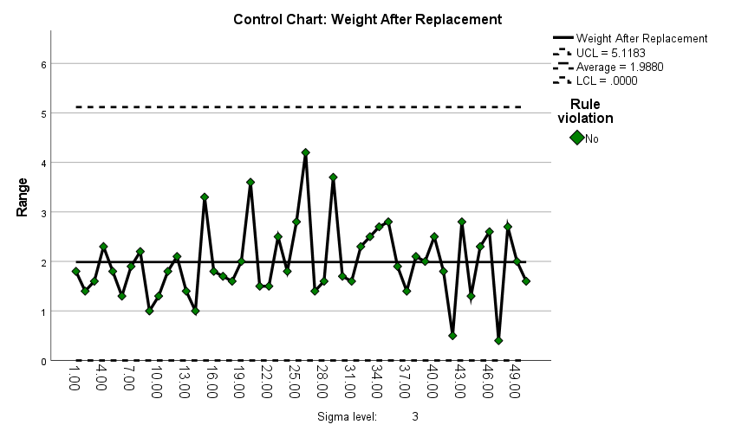
Figure 4. Range Chart for Weight After Replacement

The R (Range) chart for 50 observations taken in triplet form after replacing the machine component shows a clear improvement in process control. The observed range has reduced to 1.98 (compared to 2.398 before replacement), which is still significantly lower than the actual range of 8 (USL = 204, LSL = 196).

Notably, no points violate control rules, and there are no outliers in the range chart. This indicates that the variability in the process has been further minimized, and the process is now stable and well-controlled. The absence of outliers and rule violations reflects that the assignable causes contributing to process instability have been effectively eliminated. The reduction in range variability demonstrates the positive impact of replacing the machine component, leading to a more consistent and predictable process.

The statistical measures (indices) for process capability (for weight after replacement) are provided in the table below:
List 2 Process Statistics
Capability Indices | CP | 1.135
Capability Indices | CpL | 1.143
Capability Indices | CpU | 1.128
Capability Indices | CpK | 1.128

The Cp value measures the overall process capability, indicating how well the process variation fits within the specification limits (LSL = 196, USL = 204). A Cp of 1.135 is greater than 1.0, suggesting that the process variability has improved and now fits more comfortably within the specification limits. However, it is still slightly below the industry benchmark of 1.33, which is often considered desirable for a capable process.

CpL (1.143) measures the process capability towards the lower specification limit (LSL = 196). A CpL greater than 1.0 indicates that the process performs well in avoiding values below the lower limit. CpU (1.128) measures the process capability towards the upper specification limit (USL = 204). A CpU greater than 1.0 shows that the process also performs well in avoiding values exceeding the upper limit. The closeness of CpL and CpU values indicates that the process is well-balanced, with no significant skewness or asymmetry towards either specification limit.

The Cpk index reflects the actual process capability, considering both the process mean and variability relative to the specification limits. A Cpk of 1.128 suggests that the process is capable and well-centered, with sufficient room to meet both lower and upper specification limits. While still slightly below the ideal value of 1.33, it demonstrates significant improvement compared to the previous state.

After replacing the machine component, the process capability has significantly improved. The indices (Cp, CpL, CpU, and Cpk) are all above 1.0, indicating that the process is capable of producing outputs consistently within the specification limits (LSL = 196, USL = 204). The process is now more balanced and stable, with reduced variability. To achieve the ideal benchmark of 1.33 or higher, further refinements may be needed, but overall, the replacement has resulted in a much more reliable and capable process.

- Conclusion
The overall conclusion for weight variation in chilli powder before and after replacement is as follows:

4.1. Comparison of mean and standard deviation for Before and After Replacement
While the mean weights of chili powder before (199.29) and after replacement (200.02) did not differ significantly (p = 0.093), the standard deviations showed a robust and statistically significant reduction (5.06 to 1.67), as confirmed by Levene's Test (p = 0.000). This indicates that the replacement improved process consistency by reducing variability, even though the mean weight remained stable.

  - Comparison of Control Charts Before and After Replacement
The comparison of the X-bar chart and Range chart before and after replacing the machine component highlights significant improvements in process stability and control.
X-bar Chart: Before replacement, the process average was 199.27, with 38 outliers, including extreme deviations beyond +3 sigma and -3 sigma, indicating substantial variation and the presence of assignable causes. After replacement, the process average improved to 200.026, with only 8 outliers and no violations for points beyond +3 sigma or -3 sigma, reflecting reduced variation and better process stability.
Range Chart: Before replacement, the observed range was 2.398, and 5 points violated control rules, confirming the presence of assignable causes and an unstable process. After replacement, the range further reduced to 1.98, with no violations of control rules and no outliers, demonstrating that the assignable causes were eliminated, and the process variability was minimized.

  - Comparison of Process Capability Before and After Replacement
The comparison of process capability indices before and after the replacement of the machine component shows a significant improvement in process performance. Before replacement, the process capability (Cp = 0.941, Cpk = 0.775) indicated excessive variability and poor control, with a higher risk of outputs falling below the lower specification limit (CpL = 0.775). After replacement, the overall process capability improved (Cp = 1.135, Cpk = 1.128), demonstrating reduced variability and better alignment with the specification limits (LSL = 196, USL = 204). Both CpL (1.143) and CpU (1.128) show the process is now balanced and well-controlled. While further refinements can be made to achieve the ideal benchmark of 1.33, the replacement has successfully made the process capable of consistently meeting specifications.
Finally, the replacement improved process control and reduced variance but introduced a situation of underfilling due to insufficient process capability and centering.

COMPETING INTERESTS DISCLAIMER:
Authors have declared that they have no known competing financial interests OR non-financial interests OR personal relationships that could have appeared to influence the work reported in this paper.

- References
Ammaan, M., Panjavarnam, G., Sudha, R., Anuradha, P. (2024). AN OVERVIEW OF PACKAGING TECHNOLOGIES FOR SEED SPICES: A REVIEW. Plant Archives, 24 (2), 725-730.
FDA (2020). Good Manufacturing Practices for Food Processing. U.S. Food & Drug Administration.
Gidwani, B., Bhattacharya, R., Shukla, S.S., Pandey, R.K. (2022). Indian spices: past, present and future challenges as the engine for bio‐enhancement of drugs: impact of COVID‐19. Journal of the Science of Food and Agriculture, 102(8), pp.3065-3077.
Higgins, L. R., Mobley, R. K. (2015). Maintenance Engineering Handbook. McGraw-Hill Education.
Howell, D. C. (2013). Statistical Methods for Psychology (8th ed.). Cengage Learning.
Indiramma, A. R. (2004). Packaging aspects of spices and spice products. Plastics in food packaging. Mysore, India: Food Packaging Technology Department, Central Food Technological Research Institute.
ISO (2005). ISO 9001 Standards for Quality Control. International Organization for Standardization.
ISO(2018). ISO 22000 Standards for Food Safety Management Systems. International Organization for Standardization.
Kim, S., Park, J., Lee, H. (2019). Article on particle size distribution. Powder Technology.
Kumar, V., Raj, R., Verma, P., Garza-Reyes, J.A., Shah, B. (2024). Assessing risk and sustainability factors in spice supply chain management. Operations Management Research, 17(1),233-252.
Lean Manufacturing Guidelines (2021). Guidelines on cleanliness and defect reduction.
Levene, H. (1960). "Robust Tests for Equality of Variances." In Contributions to Probability and Statistics, edited by I. Olkinet al., 278–292. Stanford University Press.
Lins, B. F. (1993). Ferramentasbásicas da qualidade. Ciência da Informação, 22(2).
Martino, D. P., Drei, S. M. (2019). Using Control Charts X-Bar And R To Analyze The Quality Of A Restaurant At A Federal University. XXXIX Encontro Nacional De Engenharia De Producao.
Montgomery, D. C. (2007). Introduction to statistical quality control. John Wiley & Sons.
Montgomery, D. C. (2017). Design and Analysis of Experiments (9th ed.). Wiley.
Packaging Technology Today, 2021. Article on automated filling systems.
Pruthi, Y. S., Ramu, S. D., Jayaramen, A. (1962). Studies on the chemical composition and sortion isotherms of spices. Spice Rok, Nat’lecon, 10.
Quality Control in Manufacturing Processes (2018). Article on weighing scale calibration.
Ramanathan, P.K., Rao P.N.S. (1974). Equipment needs of the spice industry. Proc. Smp.: “Spice Indus: tries - Dev. Prospects”. 82.
SILVEIRA, Cristiano Bertulucci. Cp e Cpk – Índices de capacidade de um processo. Citisystems, 2014. Disponívelem: Acessadoem 6 de fevereiro de 2019.
Siruguri, V., Bhat, R.V. (2015). Assessing intake of spices by pattern of spice use, frequency of consumption and portion size of spices consumed from routinely prepared dishes in southern India. Nutrition journal, 14, pp.1-9.
Smith, J., Jones, L. (2020). Manufacturing Practices.
The Food Quality Journal (2020). Article on temperature and humidity control.
The Industrial Management Journal (2019). Article on stress and productivity.
The Journal of Food Engineering (2018). Article on environmental control and raw materials.

