Original Research Article

Perception of consumers about impact of E-waste (Electronic Waste) disposal on environment in Hyderabad city

Abstract
Growth in the IT and communication sectors has enhanced the usage of the electronic product exponentially world-wide. Faster upgradation and development of new electronic product is forcing consumers to purchase latest ones by discarding old electronic products is driving the ever-increasing production of electronic waste (e-waste) to the solid waste stream which contains hazardous components leading to a threat of deterioration in environmental conditions and mankind.
With a view to minimize environmental impacts, collection schemes for e-waste management and awareness on its safe disposal, maximum re-use, recovery and recycling of valuable materials are being implemented. So, a study has been conducted to assess the perception of consumers on e-waste management. Random sampling method has been used for the purpose of gathering responses from 120 consumers of Hyderabad. The findings indicated that with the rise in general information respondents tend to purchase or replace more electronic items which leads to more E-waste generation. An inference was drawn from the results which showed that the socio-demographic profile characteristics were in positive association with the perception level of the respondents. Further, data suggests that there was an immediate need to develop the sense of awareness about proper disposal of discarded e-waste amongst consumers.
Keywords:-E-waste, Perception, Consumers, Management
Introduction
The Electronics industry is the world’s largest and fastest growing manufacturing industry. Recent policy changes in India have led to an influx of leading multinational companies to set up electronics’ manufacturing facilities and research and development (R&D) centres for hardware and software. This has no doubt helped the Indian economy to grow faster and fuelled increase in the consumption rate ofelectrical and electronic equipment (EEE) both by institutional users and households. Along with the economic growth, shortened product life cycle due to rapid progression of technology and availability of electronic goods in the market has increased temptation of consumers to replace their household electronic items with newer models for various reasons. Then its effect is a higher rate of obsolescence, which is leading to growing piles of e-waste.
Most of the e-waste generated in the country comes from television sets, computer display monitors, and refrigerators. According to a study by the Department of Environment on e-waste generation in 2016 stated that desktop computers (31%) and television sets (30%), refrigerators (16%) and washing machines (10%) were among the most important electronic gadgets discarded which are termed as waste. However, experts argue that mobile phones, liquid-crystal display (LCD) televisions, and laptop computers will constitute large volumes of e-waste in the future.
The e-waste comprises of discarded television, computers, mother boards, mobile phones, pen drives, cathode ray tubes, printed circuit boards, air conditioners, refrigerators, compact discs and plasma television. E-waste is most hazardous component of waste other than waste and it contains many elements of hazardous chemicals like polyvinyl chloride (PVC), Nonylphenol, Polybrominated-diphenyl ethers, polychlorinated-biphenyls copper, Triphenyl-phosphate, Chromium-VI, Barium, Beryllium, Phosphor and lead, mercury, arsenic, cadmium, manganese, cobalt, gold, and iron. These chemicals create water pollution, land pollution, air pollution and are also hazardous to human health.
With reference to the above environmental hazards, the proper management of disposal of e-waste is a high alarming issue for government and stakeholder agencies. Moreover e-waste is increasing even in rural areas now-a-days as there is an increase in electronic literacy. Hence the present study is proposed to study the perception towards health hazards caused due to e-waste, environmental problems forming out of improper disposal of e-waste, unhygienic practices of disposal and proper legislative policies, framework and guidelines on e-waste management in the country.

Review of literature
Joy and Chandrasekhar (2017) explored the quantities of e-waste generated and the level of households` awareness towards e-waste recycling through a self-structured questionnaire. The findings of this study also lead to implications for the theory-deficient of e-waste recycling literature and policy recommendations for policy makers to enhance household e-waste recycling response rate.

Ohajinwa et al. (2017) conducted a cross-sectional study to assess the knowledge, attitude and practices associated with professional health risk for proper disposal of e-waste workers on comparison to a control group in the informal sector in Nigeria. A questionnaire was used to obtain data in which the results led to the health risk awareness level of the e-waste workers was significantly lower compared with their counterparts in the same informal sector. Furthermore with increasing knowledge of the workers risky practices reduces.

Sivathanu (2016) attempted the exploratory factor analysis technique to identify the awareness factors contributing to the user's preference for the proper disposal of e-waste. The
findings proved that main factors affecting to the user’s preferences during the disposal of e-waste were awareness of toxic effects on human health, awareness of environmental hazards, and awareness of proper disposal of e-waste, awareness of e-waste management by various stakeholders and awareness of convenience of recycling.

Saritha et al. (2015) identified the various sources and reasons for e-waste generation, in addition to addition to acknowledging the knowledge perception of the consumers towards disposal of e-waste management. This research aimed to induce an awareness of sustainability practices and sustainability issues in the management of E-waste, especially waste related to personal computers (PCs) and mobile phones. From the results, it was concluded that the majority (90%) of the public was ignorant about e-waste and its issues; hence, there is a strong requirement for giving knowledge on awareness about the increasing hazard potential of E-waste..

Kwatra (2014) aimed to gauge the awareness levels and practices of people regarding e-waste management and design of customized awareness programmes for addressing this concern more effectively. From the results, it was found that most respondents were totally unaware about correct ways of its recycling and management. An important analysis of the study was that nearly about 26% people replace their daily usable major electronic goods like
refrigerators, grinders, computer sets and music systems within the first half decade of purchase. Discarding products within their period of shelf-life had led to enhanced generation of e-wastes.

Akhtar et al. (2014) emphasized to ascertain household awareness, knowledge and riskperception of e-waste and its impact on attitudes and recycling behaviours in Kuala Lumpur. The results showed that three factors, such as, personal awareness, behavioral knowledge and risk perception of contaminous e-waste management had powerful and significant influence on attitudes towards e-waste management. Furthermore, attitudes towards e-waste management have a positive influence on recycling behavior. This research study gives the crystal clear insights to policy makers for which they may take appropriate steps to raise recycling behavior among consumers of households in Kuala Lumpur.

Methodology
The study aimed to obtain information about the perceptions levels and disposal methods of e- waste as practiced by the consumers of Hyderabad city. A self-administered questionnaire was designed to obtain information with respect to the above-mentioned parameters. Random sampling method has been used for the purpose of gathering responses from 120 consumers (respondents) of Hyderabad. Data has been analyzed using Microsoft Excel by applying different methods like averages, percentages and figures.

Results and Discussion

Education of consumers:
The result clearly showed that majority of the respondents 53.33% had graduation degree followed by 28.33% of the respondents had intermediate or diploma degree. Nearly 10.83% of the respondents had high school certificate and few of the respondents 7.5% had middle school certificate.
Anusree and Balasubramanian (2019) evaluated that about 60% of respondent’s education level had either graduate or post graduate, 27% had high school to higher school, 10% were higher educated (> post graduate), and 3% were primary to middle.
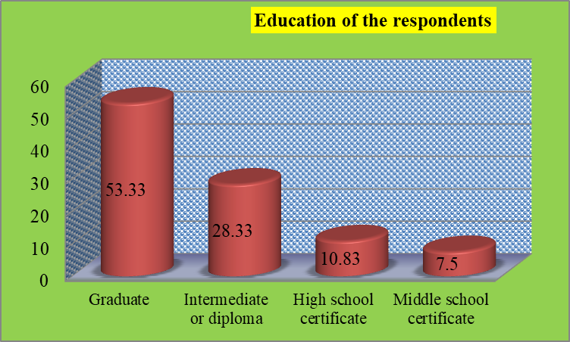
Figure 1. Distribution of respondents according to their education

Socio-economic class of consumers:
The data described that nearly 14.17% of the respondents had upper class followed by majority of the respondents 35.83% had upper middle class, 32.5% of the respondents had lower middle class and 17.5% of the respondents had upper lower class.
Azodo et al. (2017) studied that in all, 12 per cent of the respondents represented the upper class (annual income above 15 lakhs), 36 per cent of the respondents represented under upper middle class (5-15 lakhs per annum) and 24 per cent of the respondents represented as lower middle class (annual income below 5 lakhs) and rest of the respondents 28 per cent represented under upper lower class.

Figure 2. Distribution of respondents according to their socio-economic class

Disposal methods of electronic products of the consumers:
The data analysed that majority of the respondents 51.67% sold the electronic products to scrap dealer while about 25.83% of the respondents returned to seller in exchange for a new product followed by 13.33% of the respondents stored it in the house and a few 9.17% of the respondents donated to friends, relatives, schools or charitable institutions.
Mahat et al. (2019) studied that the majority of respondents practised the ewaste disposal method of selling them as used appliances 25%. The second most chosen practice was to switch it with a new one 20%, followed by the third method which was sending it to the recycling centre 17%. The fourth method was keeping them in a store/outdoors 11%, the fifth method was donating them to charities, schools or others 9%, the sixth method being throwing them out with other trash 8%, the seventh method was giving them to friends or relatives 5%, and the last and least practised method was selling them to classic/old item collectors 5%.

Figure 3. Distribution of respondents according to their disposal methods of electronic products

Condition of electronic products while replacement:
The result indicated that more than half of the respondents 57.5% replaced their existing electronic products when it was unrepairable since the repairing cost was too high whereas about 33.33% of the respondents replaced their existing electronic products when it can be repaired and fixed followed by 9.17% of the respondents replaced their existing electronic products when it was working.
Edumadze et al. (2013) stated that majority of the households 51 per cent replaced their existing electronic products when it was unrepairable since the repairing cost was too high. Companies should manufacture accessories with low cost replaceable product accessories. It will reduce the disposal of electronic products as e-waste. Among the households, 37 per cent of the households replaced their existing electronic products when it can be repaired and fixed while 12 per cent of the households replaced their existing electronic products when it was working.
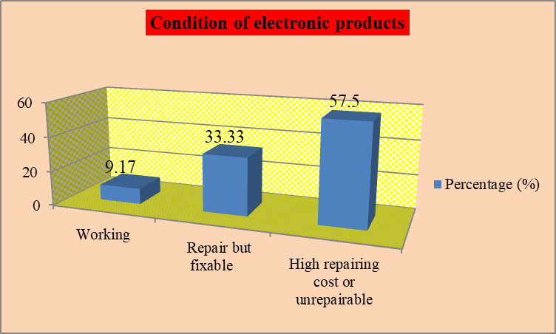

Figure 4. Distribution of respondents according to the condition of electronic products while replacement

Responsibility in the collection and disposal of e-waste:
It can be demonstrated that majority of the respondents 45.83% said that the responsibility of e-waste should be taken up by the government and 30% of the respondents said that the responsibility of e-waste should be taken up by the producers or manufacturers whereas rest of the respondents 24.17% opted for the responsibility of consumers or ones’ own fault in the collection and disposal of e-waste.
Saritha et al. (2015) explained that among the respondents, 34.6% and 34.4% of the respondents claimed that the responsibility of e-waste should be taken up by government and manufacturers respectively and rest of the respondents 31% of the respondents claimed the responsibility of consumers in the collection and disposal of e-waste.

Figure 5. Distribution of respondents according to the responsibility in the collection and disposal of e-waste

Obstacles to e-waste recycling:
It can be explained that majority of the respondents 35.83% opted for lack of convenience in recycling, while 30.83% of the respondents opted for lack of awareness in recycling, 18.33% of the respondents opted for the lack of cost in recycling and 15% of the respondents opted that they did not found it secure to recycle e-waste.
Saritha et al. (2015) stated that among participants, 40.4% of the respondents attributed a lack of convenience as one of the hurdles for recycling, while 23.6% of the respondents admitted a lack of awareness about e-waste recycling, 22% of the respondents highlighted the cost of doing so and 14% of the respondents stated that they did not found it secure to recycle e-waste.

Figure 6. Distribution of respondents according to the obstacles to e-waste recycling

Status of equipment after it is disposed in the garbage bin:
The result indicated that majority of the respondents 40.83% thought that their discarded equipment are re-sold as it was in the second-hand market while 28.33% of the respondents thought that valuable and non-valuable products are extracted. About 17.5% of the respondents thought that their equipment’s are recycled whereas 13.33% of the respondents thought that their product was sent for landfilling.
Bhatia et al. (2019) emphasized that about 50% of the total consumers thought that their discarded products are reused as it was in the second-hand market. Only 25% of the consumer responded that E-waste was segregated for valuable and non-valuable products. Valuable products are recovered are again sell to the second-hand market which acts as a resource. About 15% of the consumers thought that their e-devices are recycled properly. Rest of the respondents 10% thought that their product was left for landfilling.

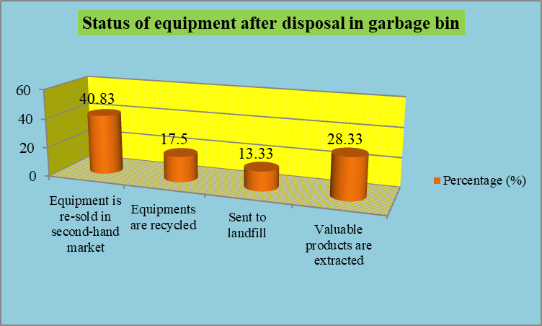

Figure 7. Distribution of respondents according to the status of equipment after it is disposed in the garbage bin

- Suggestions for the methods of E-waste management practices at household level
Suggestions are the ideas how one should perform to achieve something. To optimize the use of available electronic products, integration of both informal and formal stake holders and potential for the environmentally sound management (ESM) of E-waste at household level, few suggestions are comprehended below:
4.5.1 Role of end-users or consumers- The aspirational mind-sets of public needs to be changed for effective use of the products over the period of maximum useful life or donate to others. Prolonging the shelf life of the electronic product through repair needs to be considered as an alternative to disposal. Purchase of required electronic product rather than unnecessary products, organizing the electronic product for different uses, taking the obsolete electronics back to the store, learning about local recycling options and acquiring proper knowledge and education can be practised by the households. Environmental consciousness among people should be developed through organizing rallies, workshops and awareness campaigns by the use of mass media to highlight the need to manage E-waste. The 3Rs strategy namely Reduce; Reuse and Recycle should be motivated among the users of electronic gadgets which would minimize E-waste generation.
4.5.2 Role of government and authorities- There is a need to develop baseline data which would benefit policy makers in initiating suitable legislations. Impetus needs to be given for effective national E-waste management policy framework. The E-waste collection should be emphasized by creating local, urban, district level, and state level collection points and recycling units so that the maximum amount of E-waste may be collected for proper E-waste disposal. To attract people for voluntarily disposal, the monetary benefits should be given to the people concerned for the ill-effects and diseases of E-waste caused to them and their family by arranging workshops in their local language at grass root level. Collaborating with the industry, refer methods adopted by other countries and strict vigilance of unorganized sector are other areas to be focused for E-waste disposal. So going in accordance with the environmental sustainability it is thus extremely important that policy of E-waste disposal and regulatory aspects should be stringent as well as rational.
4.5.3 Responsibility of recyclers, collectors and scrap dealers- The registered recyclers’ representative should train the local collectors of formal and informal sectors about the E-waste and its detrimental effects on human beings and abiotic components of ecosystem by conducting seminars and workshops with the help of doctors. Using the potential of local collectors and fix the rates item-wise which are to be given to the user after receipt of items concerned and its collection charges upto collection point should be laid down properly. Setting of the door-to-door for E-waste collection service, its storage and further packaging mechanism in the locality should be emphasized with the help of formal and informal collectors. The segregation of the various equipment, components and packaging by pasting slip with all details need to be done on local informal stations and dispatch it to the registered formal recyclers. After recycling, refurbishment and decontamination procedure, the rest of the material is disposed of either through incineration or secured landfilling. Reward, tax incentives and reprimand schemes for performance and non-compliance of E-waste management for scrap dealers should be implemented.
4.5.4 Electronic product design specifications to be done by producers or manufactures - There is a need to gradually eliminate or phase out harmful substances used in the manufacture of electronic gadgets. Restriction on the use of Hazardous Substances (RoHS) compliance and maximize use of renewable materials has to be made mandatory for all electronic gadgets. Manufacturing process of electronic products that result in waste minimization and the judicious use of electronic components need to be encouraged. The crossed out wheelie/wheeled bin symbol should be more prominently displayed on gadgets. Special bins with crossed out wheelie symbol should be placed at public locations in the city such as shopping malls and parks for encouraging voluntary disposal of E-waste. Viability and implementation of recycling with take-back product scheme, extended producer responsibility (EPR) monitoring and penalty clauses that makes producers responsible for end of life (EOL) gadgets. The higher % of exchanges indicated that the old products reach the dealers or manufacturers which may help in the EPR policy implementation. Advance Disposal Fee (ADF) and Advance Recycling Fee (ARF) also can be framed as alternatives for E-waste management.

9. Chi-square test statistics analysis between independent and dependent variables-the general information characteristics and perception on E-waste management
In order to study the relationship between the general information characteristics and perception on E-waste management activities of the rural and urban respondents, chi-square test ‘X2’ values were computed and values were presented in the below tables.
The relationship between the scores of general information characteristics and overall mean scores of the likert scales of various statements on perception level of E-waste management activities of the rural and urban respondents obtained were tested by relevant null and alternate hypothesis.
Null hypothesis: There will be no significant relationship between the scores of general information characteristics of the respondents i.e. age, place of living, education, occupation, income and scores of perception on E-waste management activities. Indicated by Ho.
The degree of freedom (d.f.) for the chi-square was calculated 6 for all except place of living i.e.2
Significance level: 5 per cent or 0.05.
Total no. of respondents, n= 120.
Table 1. Association between general information and perception of the respondents
Age | 5  (SA) |  | 4  (A) |  | 3  (N) |  |  |  |  |  | 2  (D) |  | 1  (SD) |  |  | Total
60-50 | - |  | - |  | 4 |  |  |  |  |  | 7 |  | - |  |  | 11
50-40 | - |  | 12 |  | 2 |  |  |  |  |  | 23 |  | - |  |  | 37
40-30 | - |  | 18 |  | 5 |  |  |  |  |  | 16 |  | - |  |  | 39
30-20 | - |  | 19 |  | 1 |  |  |  |  |  | 13 |  | - |  |  | 33
Total | - |  | 49 |  | 12 |  |  |  |  |  | 59 |  | - |  |  | 120
X² tabulated value = 12.592 |  |  |  |  |  |  |  | X² calculated value = 20.91
Place of living |  | 5  (SA) |  | 4  (A) |  | 3  (N) |  |  |  | 2  (D) |  |  | 1  (SD) |  | Total
Rural |  | - |  | 18 |  | 5 |  |  |  | 37 |  |  | - |  | 60
Urban |  | - |  | 31 |  | 7 |  |  |  | 22 |  |  | - |  | 60
Total |  | - |  | 49 |  | 12 |  |  |  | 59 |  |  | - |  | 120
X² tabulated value = 5.991 |  |  |  |  |  |  |  | X² calculated value = 7.60
Education |  | 5  (SA) |  | 4  (A) |  |  | 3  (N) |  |  | 2  (D) |  |  | 1  (SD) |  | Total
Graduate |  | - |  | 26 |  |  | 3 |  |  | 35 |  |  | - |  | 64
Intermediate or diploma |  | - |  | 17 |  |  | 6 |  |  | 11 |  |  | - |  | 34
High school certificate |  | - |  | 6 |  |  | 2 |  |  | 5 |  |  | - |  | 13
Middle school certificate |  | - |  | 0 |  |  | 1 |  |  | 8 |  |  | - |  | 9
Total |  | - |  | 49 |  |  | 12 |  |  | 59 |  |  | - |  | 120
X² tabulated value =12.592 |  |  |  |  |  |  |  | X² calculated value = 14.19
Occupation |  | 5  (SA) |  | 4  (A) |  |  | 3  (N) |  |  | 2  (D) |  |  | 1  (SD) |  | Total
Professionals |  | - |  | 21 |  |  | - |  |  | 35 |  |  | - |  | 56
Technicians and Associate Professionals |  | - |  | 12 |  |  | 4 |  |  | 4 |  |  | - |  | 20
Elementary Occupation |  | - |  | 10 |  |  | 6 |  |  | 15 |  |  | - |  | 31
Unemployed |  | - |  | 6 |  |  | 2 |  |  | 5 |  |  | - |  | 13
Total |  | - |  | 49 |  |  | 12 |  |  | 59 |  |  | - |  | 120
X² tabulated value = 12.592 |  |  |  |  |  |  |  | X² calculated value = 19.08
Income |  | 5  (SA) |  | 4  (A) |  |  | 3  (N) |  | 2  (D) |  |  | 1  (SD) |  | Total
≥ 78,063 |  | - |  | 5 |  |  | - |  | 8 |  |  | - |  | 13
39,033–78,062 |  | - |  | 24 |  |  | 9 |  | 14 |  |  | - |  | 47
29,200 –39,032 |  | - |  | 13 |  |  | - |  | 23 |  |  | - |  | 36
19,516–29,199 |  | - |  | 7 |  |  | 3 |  | 14 |  |  | - |  | 24
Total |  | - |  | 49 |  |  | 12 |  | 59 |  |  | - |  | 120
X² tabulated value = 12.592 |  |  |  |  |  |  |  | X² calculated value = 17.20
Note: Respondents were asked to report on a 5 point continuum scale i.e. strongly agree (5), agree (4), neutral (3), disagree (2) and strongly disagree (1).

It was observed that the chi-square test of perception on e-waste management with regards to each of the general information of the respondents was more than the individual table value of ‘X^{2’} at 5 per cent level of significance. Hence, the null hypothesis was rejected and alternate hypothesis was accepted. Therefore, it was inferred that there was a positive and significant relationship between the general information of the respondents and perception levels. This implies that when general information of the respondents increases, the perception on e-waste management also increases.
Srimathi et al. (2019) explained that age was found to have significant relationships with desired awareness on e-waste disposal strategy. The results of the model provided that the coefficient of age was significant at 5% for selling as used commodity.
Ohajinwa et al. (2017) found that the significant effects of the location on the mean scores could be caused by the fact that each geographic location was dominated by one major ethnic group (this was highly correlated with location) which in turn influences their attitude/believes and practices of e-waste. The location effect suggests that any health intervention should consider ethnicity and location.
Okoye and Odoh (2014) emphasized the fact that from the chi square analysis, the calculated value was 79.1428. The Table value at 0.05 confidence level and 15 degrees of freedom the chi square value was 24.996. Hence it was found that the calculated value was higher than the table value. Therefore, null hypothesis, Ho was rejected and the alternative hypothesis was accepted. It was proved that there was significant association between the educational qualification and the awareness on e-waste disposal methods followed by the households.
Oomman (2014) found that the mean knowledge, attitude and practice scores across the three job designations in their job position on e-waste management were significantly different (F (2497) = 88.261, p = 0.000, 2 = 0.262); explaining 26.2% of the variation. The mean practice scores of the participants were: repairers 4.6 ± 1.35, dismantlers 5.8 ± 1.63, and butchers 6.73 ± 1.6. This implies that the butchers had a safer work practice compared to the e-waste workers. Overall, only 32% of the e-waste workers (repairers 16%, dismantlers 50%) compared to 70% of the butchers had a total score of >5 and were categorized as having a safe practice. The mean attitude scores across the three job designations were significantly different (F (2497) = 8.878, p = 0.000, 2 = 0.034; explaining 3.4% of the variation). The mean attitude scores of the participants were: repairers 3.0 ± 1.1, dismantlers 3.6 ± 1.7, and butchers 3.7 ± 1.7; reflecting that the butchers had a better attitude towards their health in relation to their jobs.
The possible explanation for this was that higher income earners as observed by Kumar (2017) are already used to paying for the disposal of their household waste through the door-to-door services and so find no problem in paying for sustainable disposal of their e-waste. The coefficient of income of respondents was also observed significant at 1% to have a strong positive influence on the preferred choice of e-waste disposal strategy. This suggests that higher income earners were more likely to choose other disposal strategies to selling the e-waste as scrap for its management. Such analysis implied that a fee for sustainable disposal of e-waste was being charged to the high income group of consumers.
CONCLUSIONS
The rapid growth of ICT, frequent innovations and technological changes are resulting in shorter life span of existing EEE at an alarming rate. It contains hazardous substances that may negatively impact and affect the whole biotic ecosystem if not properly managed. At the same time, advanced and effective E-waste management is a great challenge for governments of many countries.
A significant attention is to be laid in developing information management systems for defining what contributes to E-waste, generation and management. Increasing efforts are urgently required on improvement of the current practices such as collection schemes and management practices to reduce the illegal trade of E-waste and also to protect the habitat. Reducing the amount of toxic substances in EEE will also have a positive effect in dealing with the specific E-waste streams since it will support the prevention process.
Hence, there is a requirement to incorporate the informal and formal sector together in order to collect different obsolete EEE separately, effectively treat and dispose as well as divert it from conventional landfills and open burning when crude and unscientific methods are applied for recovery of useful components thus minimizing public health and environmental impacts. The competent authorities should be reluctant to establish mechanisms for handling and treatment of E-waste. Enhancing information campaigns, capacity building and awareness is needed to promote environmental friendly E-waste management activities.

REFERENCES
Anusree, P.S and Balasubramanian, P. 2019. Awareness and Disposal Practices of E-waste with Reference to Household Users in Kochi City. International Journal of Recent Technology and Engineering. 8(154): 293-299.
Azodo, A. P., Ogban, P. U and Okpor, J. 2017. Knowledge and Awareness Implication on E- Waste Management among Nigerian Collegiate. Journal of Applied Sciences and Environmental Management. 21(6): 1035-1040.
Akhtar, R., Masud, M. M and Afroz, R. 2014. Household Perception and Recycling Behaviour on Electronic Waste Management: A Case Study of Kuala-Lumpur, Malaysia. Malaysian Journal of Science. 33(1): 32-41.
Bhatia, A., Kiran, C and Kapoor, M. 2019. A Study on Awareness of Consumers towards E- Waste Management in the City of Jaipur. Journal of Management. 6(2): 200-208.
Edumadze, J. K. E., Cudjoe, F and Edumadze, G. E. 2013. An evaluation of the awareness and knowledge of students of University of Cape Coast on e-waste.Journal of Basic and Applied Sciences. 1(1): 75-103.
Joy, A. M. T and Chrandrasekar, K. S. 2017.Perceptions of Consumers on E-waste Management in Tamilnadu.International Journal of Engineering Technology Science and Research. 4(9): 363-370.
Kumar, R. 2017. Youths’ Perspective: Awareness and Attitude towards E-Waste Management. Asian Journal of Multidisciplinary Studies. 5(7): 190-199.
Kwatra, S., Pandey, S and Sharma, S. 2014. Understanding Public Knowledge and Awareness on E-waste in an Urban Setting in India- A Case Study for Delhi. Management of Environmental Quality: An International Journal. 25(6): 752- 765.
Mahat, H., Hashim, M., Nayan, N., Saleh, Y and Norkhaidi, S. B. 2019. E-waste disposal awareness among the Malaysian community.Knowledge Management & E-Learning: An International Journal. 11(3): 393–408.
Ohajinwa, M.C., Bodegom, V.M.P., Vijver, G.M and Peijnenburg, M.G.J.W. 2017. Health Risks Awareness of Electronic waste Workers in the Informal Sector in Nigeria. International Journal of Environmental Research and Public Health. 14 (911): 1-16.
Okoye, A and Odoh, C. 2014. Assessment of the Level of Awareness of E-Waste Management and Concern for the Environment amongst the Populace in Onitsha, Southeastern Nigeria. Journal of Environmental Protection. 5(10): 120-134.
Oomman, U. P. 2014. A Survey of Consumer Behaviour towards E- Waste Management in the City of Mumbai.International Journal of Research in Applied, Natural and Social Sciences. 2(8): 1-10.
Srimathi, H., Krishnamoorthy, A and Dharshini, S. 2019. E-Waste Management and Awareness.International Journal of Scientific and Technology Research. 8(11):2627- 2631.
Sivathanu, B. 2016. User`s Perspective: Knowledge and Attitude towards E-Waste. International Journal of Applied Environmental Sciences. 11 (2): 413-423.
Saritha, V., Kumar, K. A. S and Srikanth, V. N. 2015. Consumer Attitudes and Perceptions on Electronic waste: An assessment. Pollution. 1(1): 31-43.
https://en.wikipedia.org/wiki/SEC_Classification

