Exploring the Drivers of AI Tool Usage in Agricultural Education in Andhra Pradesh

Abstract
The Fourth Industrial Revolution has positioned Artificial Intelligence (AI) as a transformative technology across sectors, including agriculture and education. In agricultural education, AI tools are increasingly utilized to enhance learning outcomes, support research and data analysis, and prepare students for agri-tech-driven ecosystems. This study aimed to assess the attitudes of B.Sc. (Hons.) Agriculture students toward AI-driven tools, focusing on perceived ease of use, usefulness, digital confidence, and concerns related to career development, practical applications, and trust in AI accuracy. A descriptive research design using the survey method was employed among students of Vignan Institute of Agriculture and Technology (VIAT), affiliated with VFSTR University, Vadlamudi, Andhra Pradesh. From a population of 443 students across four academic years, a proportionate stratified random sample of 180 students was drawn. Data were analysed to determine the mean scores and ranks of factors influencing AI tool usage. Results revealed that easy access to updated knowledge (Mean = 3.66, Rank I) and enhanced learning efficiency (Mean = 3.56, Rank II) were the most influential factors motivating AI adoption. Other factors, including research and data analysis, and improved communication and presentation skills, also contributed positively, whereas aspects such as real-world usefulness, curriculum integration, career relevance, practical field applications, and trust in AI accuracy were less influential. These findings suggest that students prioritize immediate academic benefits over long-term career or practical applications. The study underscores the need for institutional support to enhance adoption in underutilized areas through curriculum integration, practical assignments, and digital confidence building. Understanding students’ attitudes toward AI can guide policymakers, curriculum developers, and educational technologists in creating AI-integrated learning environments that are pedagogically effective and contextually relevant for agricultural education.
Keywords: Artificial Intelligence, Agricultural Education, Student Attitudes, AI Adoption, Digital Learning, Higher Education

Introduction
The Fourth Industrial Revolution has ushered in a transformative era, placing Artificial Intelligence (AI) at the forefront of technological innovation across various sectors, including agriculture and education. In the realm of education, AI-driven tools are revolutionizing traditional teaching methodologies by fostering personalized, adaptive, and immersive learning experiences. This paradigm shift is particularly evident in agricultural education, where AI applications are enhancing learning outcomes, supporting informed decision-making, and preparing students for agri-tech-driven ecosystems. According to the World Economic Forum, the global AI in education market is projected to grow from $5.18 billion in 2024 to $112.3 billion by 2034, reflecting a compound annual growth rate (CAGR) of approximately 31.2%
This growth is indicative of the increasing integration of AI technologies in educational settings, encompassing areas such as automated content delivery, intelligent tutoring systems, performance analytics, and chatbot-assisted learning. In the context of agricultural sciences, AI offers a paradigm shift not only in research and extension but also in pedagogy. Intelligent systems that simulate field scenarios, visualize data from precision farming, or analyze agronomic patterns are being integrated into classrooms and virtual platforms. A study by UNESCO reported that AI-enhanced learning systems improved conceptual understanding and knowledge retention in agricultural and life sciences by over 30% when compared to traditional lecture-based teaching
The Indian higher education system, including agricultural education, is rapidly adapting to this transformation. The Indian Council of Agricultural Research (ICAR), through its National Agricultural Education Policy (NAEP 2020), emphasizes the integration of digital technologies including AI, machine learning, and data analytics to build the capacities of future agricultural professionals. As per ICAR's 2023 report, over 70% of agricultural universities in India have initiated steps toward digital learning platforms and smart classroom initiatives, many of which involve AI-enabled components such as automated assessments, virtual practicals, and adaptive learning platforms.
India’s National Education Policy (NEP 2020) also underscores the use of emerging technologies, including AI, to improve quality, inclusivity, and student-centric learning. The Ministry of Education’s AI for All campaign (2021) promotes AI literacy among students, including those from non-engineering backgrounds like agriculture. In a nationwide survey conducted by NITI Aayog and CBSE (2022), nearly 64% of students expressed willingness to engage with AI tools in their education if proper training and infrastructure were provided. However, the study also highlighted disparities in access and a general lack of awareness among rural students and those from non-technical disciplines.
Despite the institutional push and technological readiness, the success of AI integration in agricultural education ultimately depends on the attitudinal disposition of students—their acceptance, adaptability, perceived usefulness, and concerns regarding these tools. Literature indicates that technology adoption in education is significantly influenced by user attitude and digital confidence. In the Indian context, agricultural students often come from rural or semi-urban backgrounds, where digital exposure varies significantly, and their receptiveness to AI tools may be influenced by various socio-educational factors.
Recent studies point to both enthusiasm and apprehension among agricultural students. For instance, Kumar and Bansal (2023) found that while 58% of students from three agricultural universities in North India viewed AI tools as useful for understanding complex agronomic concepts, nearly 30% reported challenges in accessing or using such tools effectively. Similarly, Patil et al. (2022) noted that students’ confidence in using AI tools increased with prior exposure to ICT-based learning environments, highlighting the role of digital readiness.
The use of AI in agricultural education is still in a nascent stage in India, and there is limited empirical evidence on how students perceive and interact with these technologies. While most studies focus on teacher preparedness or institutional infrastructure, student-centric attitudinal assessments remain underexplored. Understanding students’ perspectives is essential for designing need-based AI interventions, ensuring equitable access, and minimizing resistance to digital change.
Therefore, this study was undertaken to assess the attitudes of students toward AI-driven tools in agricultural education, with a focus on dimensions such as perceived ease of use, perceived usefulness, digital confidence, and concerns related to technological substitution or data privacy. The findings are expected to provide actionable insights for policymakers, curriculum developers, and educational technologists in designing AI-integrated learning environments that are pedagogically effective and contextually relevant to Indian agricultural students.

Material and Methods

1. Research Design
The present study employed a descriptive research design using the survey method to assess the attitudes of students toward the use of AI-driven tools in agricultural education. This design was considered suitable as it facilitates the collection of standardized information from a large population to analyze perceptions, attitudes, and opinions on educational innovations.

Study Area and Population
The study was conducted at Vignan Institute of Agriculture and Technology (VIAT), affiliated with VFSTR University, located in Vadlamudi, Guntur District, Andhra Pradesh. The total population of the study comprised 443 B.Sc. (Hons.) Agriculture students enrolled across all four academic years during the academic year 2024–25.

Table 1 . Study Area and Population
Year | Section | No. of Students
I Year | A | 57
I Year | B | 49
II Year | A | 63
II Year | B | 49
III Year | A | 66
III Year | B | 78
IV Year | A | 54
IV Year | B | 27
Total |  | 443

Sampling Method and Sample Size
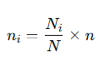
A proportionate stratified random sampling technique was used to ensure that the sample accurately reflected the composition of the population across all classes and sections. From the total population of 443 students, a sample of 180 students was drawn using proportionate allocation as per the formula:

Where:
- n_{i}= Sample size from stratum (section)
- N_{i}​ = Population of the stratum (section)
- N = Total population (443)
- n = Total sample size (180)
stratified proportionate sample allocation for your population of 443 students with percentage representation for each stratum.

Table 2 Proportionate Allocation Table
Year - Section | Population (Nᵢ) | Population % | Allocated Sample (nᵢ) | Sample %
I Year A | 57 | 12.87% | 23 | 12.78%
I Year B | 49 | 11.06% | 20 | 11.11%
II Year A | 63 | 14.22% | 26 | 14.44%
II Year B | 49 | 11.06% | 20 | 11.11%
III Year A | 66 | 14.90% | 27 | 15.00%
III Year B | 78 | 17.61% | 32 | 17.78%
IV Year A | 54 | 12.19% | 22 | 12.22%
IV Year B | 27 | 6.09% | 10 | 5.56%
Total | 443 | 100.00% | 180 | 100.00%

Result and Discussions

Table 3: Factors influencing on AI tool Usage among Agriculture Graduates
S. No. | Factors Influencing AI Tool Usage | Mean Score | Rank
 | Easy Access to Updated Knowledge | 3.66 | I
 | Enhanced Learning Efficiency | 3.56 | II
 | Research and Data Analysis | 3.43 | III
 | Improved Communication and Presentation Skills | 3.39 | IV
 | Real-World Usefulness | 2.95 | V
 | Personality and Career Development | 2.84 | VI
 | Practical Applications in Field Work | 2.65 | VII
 | Career Relevance | 2.56 | VIII
 | Curriculum Integration | 2.40 | IX
 | Trust in AI Accuracy | 2.15 | X
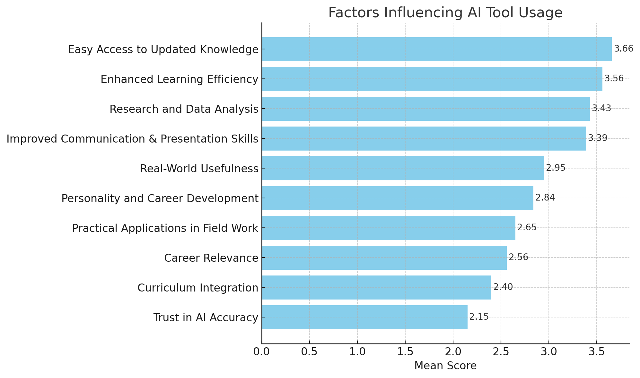

Fig. 1: Factors affecting AI tools usage by Agriculture Graduates
The table presents the factors influencing the usage of AI tools among students, ranked according to their mean scores. The findings highlight both the perceived benefits and limitations of AI tool adoption in an educational context.
Easy Access to Updated Knowledge (Mean = 3.66, Rank I) emerges as the most influential factor, indicating that students primarily value AI tools for their ability to provide instant, up-to-date information. This aligns with research by Dwivedi et al. (2021), which emphasizes that access to current knowledge is a key driver for technology adoption in learning environments.
Enhanced Learning Efficiency (Mean = 3.56, Rank II) is ranked second, showing that students perceive AI tools as mechanisms to streamline learning, improve understanding, and reduce the time required for completing academic tasks. Holmes et al. (2019) support this, noting that AI can personalize learning pathways and enhance cognitive engagement, leading to more effective educational outcomes.
Research and Data Analysis (Mean = 3.43, Rank III) is another significant factor, reflecting students’ reliance on AI tools to process large datasets, analyze trends, and support research activities. Luckin et al. (2016) highlight the role of AI in facilitating data-driven decision-making, which enhances academic and professional research skills.
Improved Communication and Presentation Skills (Mean = 3.39, Rank IV) indicates that students also value AI for enhancing their soft skills, including organizing ideas, preparing reports, and delivering presentations. This underscores AI’s utility beyond mere content acquisition, extending into the development of transferable skills (Zawacki-Richter et al., 2019).
In contrast, factors such as Real-World Usefulness (Mean = 2.95, Rank V), Personality and Career Development (2.84, Rank VI), Practical Applications in Field Work (2.65, Rank VII), and Career Relevance (2.56, Rank VIII) received relatively lower scores. This suggests that while students acknowledge AI’s potential for practical and career-related applications, these aspects are not immediate motivators for AI usage. Chen et al. (2020) argue that limited integration of AI in real-world tasks and insufficient guidance on career-oriented applications may reduce perceived relevance.
Curriculum Integration (Mean = 2.40, Rank IX) is also ranked low, reflecting that AI tools are not yet deeply embedded into formal coursework. This is consistent with studies indicating that adoption improves when AI is systematically integrated into teaching and learning frameworks (Holmes et al., 2019).
Finally, Trust in AI Accuracy (Mean = 2.15, Rank X) is the least influential factor, suggesting that concerns about the reliability and correctness of AI outputs may act as barriers to usage. McKnight et al. (2011) highlight that trust is critical in technology adoption; if users doubt AI’s accuracy, they may limit its use despite recognizing its potential benefits.
The results indicate a clear preference for AI tools that provide immediate academic benefits, such as knowledge access and efficiency enhancement, over long-term or career-oriented benefits. To increase adoption in underutilized areas—such as field applications, curriculum integration, and career development—educational institutions should provide structured training, integrate AI into practical assignments, and build confidence in AI reliability.
Conclusion
The study reveals that students primarily use AI tools for immediate academic benefits, such as accessing updated knowledge and improving learning efficiency. While research, communication, and practical skills also motivate usage, factors like career relevance, curriculum integration, field applications, and trust in AI accuracy have less influence, indicating areas needing institutional support.
Overall, AI adoption is strongest for knowledge acquisition and learning efficiency, but its potential for career development, real-world applications, and integration into the curriculum remains underutilized. Educational institutions should prioritize embedding AI in coursework, promoting practical applications, and fostering trust to fully leverage AI’s benefits in higher education.
References
Brynjolfsson, E., and McAfee, A. (2017). Machine, Platform, Crowd: Harnessing Our Digital Future.
Chen, L., Chen, P., and Lin, Z. (2020). Artificial Intelligence in Education: A Review. Computers and Education, 147, 103778.
Davis, F. D. (1989). Perceived usefulness, perceived ease of use, and user acceptance of information technology. MIS Quarterly, 13(3), 319–340.
Dwivedi, Y. K., et al. (2021). Artificial Intelligence (AI): Multidisciplinary perspectives on emerging challenges, opportunities, and agenda for research, practice and policy. International Journal of Information Management, 57, 101994.
Holmes, W., Bialik, M., and Fadel, C. (2019). Artificial Intelligence in Education: Promises and Implications for Teaching and Learning.
Indian Council of Agricultural Research (ICAR). (2023). Digital Initiatives in Agricultural Education in India.
Kumar, R., and Bansal, S. (2023). Perception of agricultural students toward AI-based learning tools in North India. Journal of Agricultural Education and Extension, 29(2), 101–115.
Luckin, R., et al. (2016). Intelligence Unleashed: An Argument for AI in Education.
McKnight, D. H., Choudhury, V., and Kacmar, C. (2011). Trust in Technology: Development of a Measurement Instrument.
Ministry of Education. (2021). AI for All Campaign. Government of India.
Patil, A., Sharma, P., and Rao, V. (2022). Digital readiness and AI adoption among agricultural students. Indian Journal of Agricultural Education, 58(1), 45–60.
UNESCO. (2022). AI in Education: Transforming Teaching and Learning in Life Sciences. Paris: UNESCO.
Venkatesh, V., and Bala, H. (2008). Technology Acceptance Model 3 and a Research Agenda on Interventions. Decision Sciences, 39(2), 273–315.
World Economic Forum. (2023). Global AI in Education Report. Geneva: WEF.
Zawacki-Richter, O., (2019). Systematic Review of Research on Artificial Intelligence Applications in Higher Education – Where are the Educators?

