Geo-Spatial Assessment of Accuracy of Satellite Based Topographic Mapin Aba North Using Ground Referenced Data: A Case Study of Ogbonnaya Onu Polytechnic Aba. Abia State, Nigeria

Abstract
Accurate geospatial data is fundernental to reliable decision making for sustainable physical development on earth surface. Improvements in satellite technology have facilitated capturing of geometrically precise images of the earth’s surface. In this study evaluation of the horizontal and vertical accuracies of google earth satellite imagery and SRTM of 90m resolution has been carried out in absolute and relativesenses to investigate their reliability for topographic mapping requiring high level of accuracy.Detail and contour maps of the study site were produced using ground data capture with DGPS and digital level respectively, software used are ArcGIS10.5 and suffer 11. Accuracy of the satellite dataset were investigated Visually by comparison between ground and satellite-based maps and statistically using root mean square as evaluation metrics. The statistical evaluation analysis was carried out using 36 well dispersed and randomly selectedreal world planimetric control points and 50 vertical ground control point (GCP) which has been harmonized to the same horizontal and verticaldatum with the corresponding values extracted from the satellite datasets.The relative comparison revealed that the detail map from the satellite data represented the ground data very well. In terms of contour maps,some similarities were observed between the SRTM and ground-based maps, but the level of conformity was not good enough for engineering projects requiring high accuracy. Absoluteaccuracy assessment in Easting,Northing, 2D plane and height yielded root mean square error value of 0.039011751, 0.04554514, 0.059969and1.78731642 respectively.Correlation coefficient revealed valuesof 999997857, 0.999999354 and 0.5471. In eastings, northings, and height. These values attest that google earth imagery is effective for detail mapping requiring high accuracy, while SRTM also producedgood result but requires further refinement to render it fit for topographic mapping requiring high level of accuracy.

KEY WODS; SRTM, ASTER GDEM, Terrain, Elevation.

1.0Introduction
Maps serve as the end point of surveying and play a crucial role in fostering a comprehensive understanding of the environment. The process of mapping and visualizing topographical details is important in comprehending and effectively managing the physical surroundings. New possibilities for mapping have been opened due to the availability of High-Resolution Satellite Imageries (Nzelibe et al 2020). In recent times remote sensing has increasingly become a means of capturing Geo-spatial data for input into a digital database especially when a large area is involved. Remote sensing can be defined as a means of gathering information about a distance object without physical contact. Onyeka (2007) noted that remote sensing embraces all techniques by which information is gathered about a target by a device separated from it by some distance. In remote sensing, the sensors are not in direct contact with the objects or events being observed. The information needs a physical carrier to travel from the objects or events to the sensors through an intervening medium.
In contemporary times different remote sensing data with varied spatial and temporal resolutions are available freely which can be further processed into maps. Among these data is google earth satellite imagery andShuttle Radar Topography Mission digital elevation model (SRTM-DEM). Google Earth (GE)provides the most accurate and available global high-resolution imagery covering nearly the entire land surface of the earth and has been found useful in many applications. A comprehensive list of applications of GE in scientific projects can be found in Pulighe et al. (2015). Google Earth software gives access to satellite and aerial images, ocean bathymetry, and other geospatial data (Mohammad et al 2017).
However, despite its numerous advantages, the positional accuracies of GE imagery have not been officially published or validated (jing et al 2020; Becek and Ibrahim, 2011). GE images are collection of satellite images with world-wide coverage, aerial photos from local or national mapping agencies, and orthophoto collections in Geoportals and therefore, do not have an identical spatial resolution or positional accuracy over the globe (Scollar 2013). Tian et a (2017) showed that more accurate and reliable assessment results can be obtained by choosing the appropriate evaluation method of geometric positioning accuracy. The traditional ground measurement method though,difficult to be utilized to verify the accuracyof remote sensing data over a large area is the most accurate method of investigating the accuracy of satellite data within a small geographical area.
Shuttle Radar Topography Mission DEM (SRTM DEM) is among the post-processed elevation datasets that are frequently used for a wide range of applications due to its near-global coverage [Sarra et al 2015].SRTM captured radar datasets for 11 days between February 11 and 22, 2000 which yielded a digital elevation model (DEM) with coverage between 60⁰ north of latitude and 56⁰ south of latitude [ASTER DEM TEAM 2019]. The mission of the SRTM wasa united effort between the National Aeronautics and Space Administration (NASA) of the United States, the German Aerospace Center, the Italian Space Agency, and the National Geospatial-Intelligence Agency (NGA) and covered about 80% of the earth surface [Hensleyet al 2001;Smith 2013].
It yielded digital elevation dataset on 3 arc-second, and I arc second grid horizontal spatial resolutions. The 3arc second version was made available to the public while the 1 arc second version which was only made available for USA has been released to the public in 2014.(Vijith et al 2015). Theoriginal SRTM elevations datum was WGS84 ellipsoid and then the EGM96 geoid separation values were added to transform heights relative to the geoid for all the released products. The reported global absolute horizontal and vertical accuracies are given as equal to 20 meters (circular error at 90% confidence) and 16 meters (linear error at 90% confidence). However, it must be known that varied accuracies have been obtained by different researchers in different regions of the globe and the data has numerous geospatial applications.
Notwithstanding the wealth of advantages of these digital datasets, one of their limitations is presence of errors arising from different sources which must be reduced to minimum before processing to maps. Based on this accuracy assessment of a particular data is necessary to determine its suitability for a particular purpose. Accuracy assessment or validation is a significant step in the processing of remote sensing data. It establishes the value of the resulting informationto a user. Productive utilization of geodata is only possible if the quality of the data is known. Therefore, this study attempted to investigate thehorizontal accuracy of google earth satellite imagery and vertical accuracy of SRTM-DEM of 3 arc seconds resolution using ground referenced data.

1.1 Objectives of this study
The objectives of this study are:
To map the study area using ground data and satellite data (GE and SRTM) and compare the products
To Investigate horizontal absolute accuracy of google earth imagery in the study are
To investigate absolute vertical accuracy of SRTM-90m in the study area

1.2 Description of the study area
The study area is Ogbonnaya Onu Polytechnic formally known as Abia State Polytechnic Aba. It is located in Aba North L.G.A. of Abia State – Nigeria, West Africa. Geographically, the study area is located between latitude 5⁰ 06’N and 5°07’N and between longitude 7⁰ 21’E and 7° 23. Figure 1 is the location map of the study area.

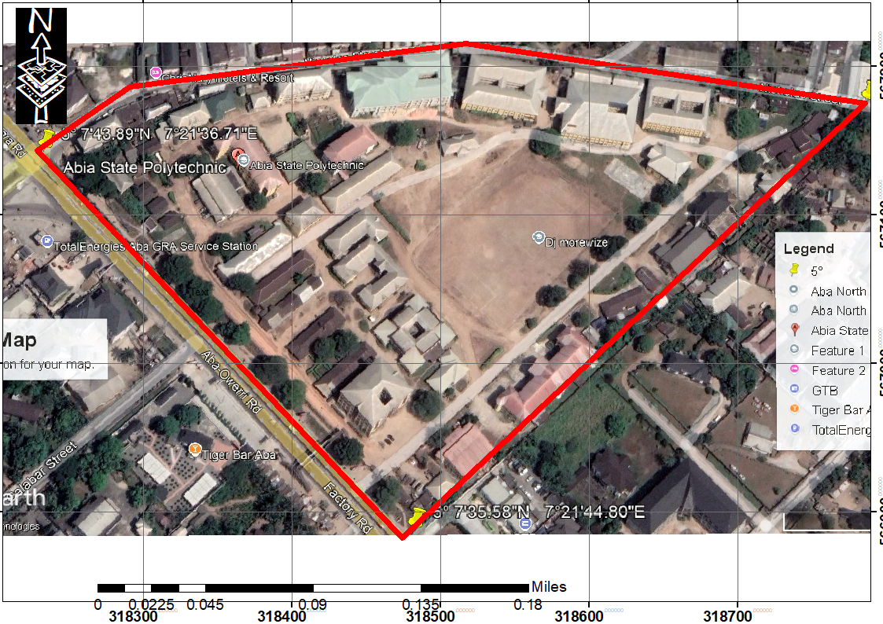

Figure 1 Location map

METHODOLOGY

The procedure for this study basically involves acquisition of google earth satellite imagery, georeferencing, feature extraction, downloading of SRTM from United state geological survey (USGS) site, projection and production of contours.A field survey was carried out using a Differential Global Positioning System (DGPS) to acquire coordinates ofground features and a digital level was utilized for ground levelling operation.Evaluations of positional accuracy based on common points on ground,GE and SRTM using Root Mean Square Error (RMSE) and coefficient of correlation was also carried out
DATA CAPTURE
Google Earth (GE) is a virtual globe software developed by Google. The imagery of GE is not a single data source, but satellite imagery Integration with aerial photography data.It integrates Worldview, Quick bird, Landsat and SPOT5 in one. In this study GE imagery of the study area was downloaded freely using google earth software. The mission of the SRTM was conducted in cooperation between the National Aeronautics and Space Administration (NASA) of the United States, the German Aerospace Center, the Italian Space Agency, and the National GeospatialIntelligence Agency (NGA) and covered about 80% of the earth surface (Hensley et al., 2001, Smith and Sandwell, 2003).SRTM DEM of 3-arcsecond (30-m) which is being made publicly available through, the United States Geological Survey's EarthExplorer site was utilized for this study. The elevation raster was downloaded from (http://earthexplorer.usgs.gov). Fielddata utilized was captured using Differential Global positioning System (DGPS) and digital level instrument.
DATA PROCESSING
In the present study data acquisition and processing was carried out in phases. In the first phase, Differential Global Positioning System (DGPS) configured in UTM zone 32N WGS84 projected datum was utilized to acquire coordinates of the boundary points and detailing of all features within the study site. Well dispersed Ground Control Points (GCPs) of identified image positions were also collected for geo-referencing. After geo-referencing, theboundary and details were extracted via onscreen digitization. The coordinates of corresponding datasets (details and boundary line) captured from DGPS were added as events in ArcGIS10.5. The added details were superimposed on the satellite data derived map after on-screen digitization for visual comparison (see figure5).
To evaluate absolute accuracy of GE satellite imagery, 36 well spread image control points (ICP) were carefully selectedover the study area comprising of distinct point features conducive for high precision measurement in the GE. The corresponding GCPs were surveyed using conventional surveying techniques with DGPS and overlaid (see figure2). The horizontal positional accuracy of GE was analyzed by comparing the two-dimensional coordinates of the selected DGPS points with their coordinates measured in GE using root mean square error (RMSE)represented in equation 1, 2 and 3 as evaluation metrics(see table 1 and 3)
The second phase involved elevation comparison. Elevation values of the two sources of data (ground and SRTM) should be harmonized in a commonvertical datum before comparison is said to be reliable. To actualize this, static mode DGPS coordinate of a point within a long-time open space in the study area was captured and added as event to the SRTM of the study area which has been masked to actual boundary limit in GIS window. Progressively, SRTM elevation of the point was extracted and used as reference (benchmark) for the ground levellingoperation covering the study area and DGPS was used to coordinate the grid nodes of all the staff positions. To further refine the SRTM, its raster file was converted to spot heightmap using ‘‘covert raster to point’’ tool in ArcGIS window and digitizedbuilding featureswere overlaid on the sport height map. In so doing the elevation values covered by the buildings were identified and filtered out because they do not represent bare ground elevation but that of canopies. Linear interpolation was carried on the modified map in GIS window to close the gaps created by removal of canopy elevations. The interpolated file was reconverted to raster file using ‘‘convert point to raster’’ module of ArcGIS10.5.
Progressively, the ground level data was converted to raster file and interpolated to the same pixel number and sizes equivalence to those of refinedSRTM. Both raster files were independently used to generate contour mapsfor visual assessment (see figure 6 and 7).To evaluate absolute accuracy,50 randomly and well dispersed selected ground reference points were captured and overlaid as events on the SRTM. Their corresponding elevation values from the SRTM were extracted for comparative assessment using RMSE (see table 2 and 4).

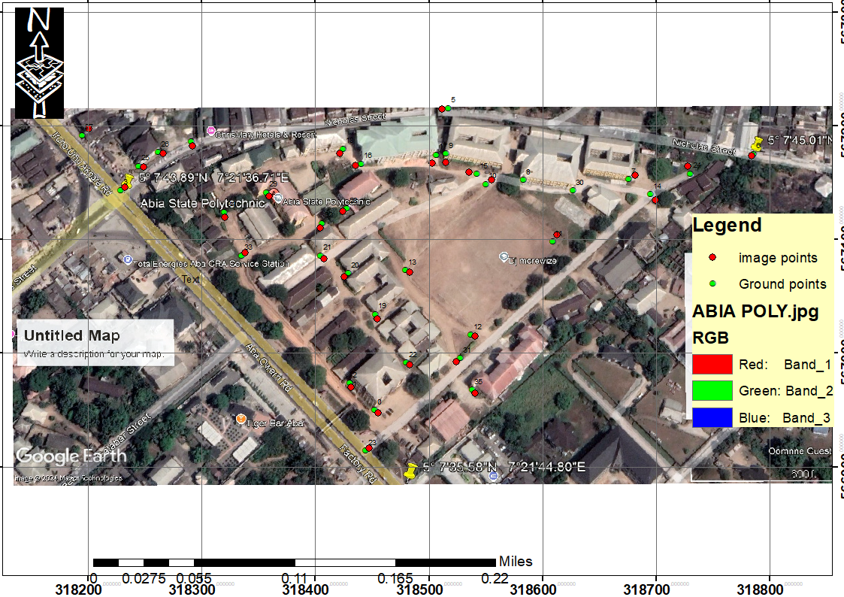
Figure 2 image of study area, portraying differences in GCP and SCP

Table 1 Coordinate differences
POINTS | GROUND (N) | MAP (N) | DIFFERENCE | GROUND ( E) | MAP (E) | DIFFERENCE
1 | 566950.112 | 566950.121 | -0.009 | 318452.324 | 318452.333 | -0.009
2 | 566974.212 | 566974.200 | 0.012 | 318431.002 | 318431.102 | -0.1
3 | 566974.243 | 566974.211 | 0.032 | 318431.043 | 318431.000 | 0.043
4 | 567143.121 | 567143.113 | 0.008 | 318228.032 | 318228.012 | 0.02
5 | 567186.234 | 567186.232 | 0.002 | 318291.565 | 318291.577 | -0.012
6 | 567215.222 | 567215.221 | 0.001 | 318517.231 | 318517.203 | 0.028
7 | 567175.331 | 567175.305 | 0.026 | 318786.332 | 318786.361 | -0.029
8 | 567153.212 | 567153.222 | -0.01 | 318676.221 | 318676.202 | 0.019
9 | 567152.222 | 567152.200 | 0.022 | 318583.334 | 318583.401 | -0.067
10 | 567175.022 | 567175.098 | -0.076 | 318515.232 | 318515.112 | 0.12
11 | 567148.032 | 567148.100 | -0.068 | 318550.221 | 318550.201 | 0.02
12 | 567098.004 | 567098.024 | -0.02 | 318609.322 | 318609.311 | 0.011
13 | 567016.008 | 567016.012 | -0.004 | 318537.121 | 318537.099 | 0.022
14 | 567073.282 | 567073.209 | 0.073 | 318479.223 | 318479.112 | 0.111
15 | 567139.333 | 567139.335 | -0.002 | 318695.332 | 318695.321 | 0.011
16 | 567157.255 | 567157.201 | 0.054 | 318542.355 | 318542.363 | -0.008
17 | 567166.323 | 567166.311 | 0.012 | 318440.211 | 318440.222 | -0.011
18 | 567174.004 | 567174.112 | -0.108 | 318506.032 | 318506.121 | -0.089
19 | 567179.026 | 567179.023 | 0.003 | 318424.033 | 318424.007 | 0.026
20 | 567034.112 | 567034.102 | 0.01 | 318453.343 | 318453.312 | 0.031
21 | 567070.032 | 567070.077 | -0.045 | 318429.332 | 318429.345 | -0.013
22 | 567085.033 | 567085.073 | -0.04 | 318405.122 | 318405.171 | -0.049
23 | 566991.042 | 566991.04 | 0.002 | 318480.121 | 318480.109 | 0.012
24 | 566914.009 | 566914.021 | -0.012 | 318444.244 | 318444.212 | 0.032
25 | 567158.232 | 567158.202 | 0.03 | 318730.131 | 318730.201 | -0.07
26 | 567164.212 | 567164.219 | -0.007 | 318245.333 | 318245.326 | 0.007
27 | 567176.044 | 567176.104 | -0.06 | 318262.443 | 318262.409 | 0.034
28 | 567191.023 | 567191.029 | -0.006 | 318195.233 | 318195.277 | -0.044
29 | 567127.044 | 567127.088 | -0.044 | 318428.121 | 318428.104 | 0.017
30 | 567141.066 | 567141.101 | -0.035 | 318357.333 | 318357.331 | 0.002
31 | 567143.003 | 567143.079 | -0.076 | 318627.344 | 318627.310 | 0.034
32 | 566995.077 | 566995.024 | 0.053 | 318528.354 | 318528.304 | 0.05
33 | 567114.022 | 567114.012 | 0.01 | 318406.333 | 318406.361 | -0.028
34 | 567085.343 | 567085.323 | 0.02 | 318335.556 | 318335.572 | -0.016
35 | 567124.322 | 567124.302 | 0.02 | 318320.222 | 318320.223 | -0.001
36 | 566967.353 | 566967.368 | -0.015 | 318538.344 | 318538.307 | 0.037
MEAN | 567103.6435 | 567103.6504 | -0.0068611 | 318468.9743 | 318468.9704 | 0.004

Table 2Elevation differences
POINTS | EASTINGS | NORTHINGS | GROUND (H_{G}) | SRTM (H_{S}) | H_{G}- H_{S} | (H_{G}- H_{S} )²
1 | 318310.8722 | 567113.4025 | 63.843 | 64.461 | -0.618 | 0.381924
2 | 318339.3983 | 567119.4535 | 63.732 | 65.546 | -1.814 | 3.290596
3 | 318360.1445 | 567122.0468 | 63.851 | 67.772 | -3.921 | 15.374241
4 | 318388.6706 | 567125.5045 | 63.208 | 67.922 | -4.714 | 22.221796
5 | 318416.3322 | 567128.0978 | 64.22 | 68.215 | -3.995 | 15.960025
6 | 318450.0449 | 567129.8266 | 64.562 | 68.343 | -3.781 | 14.295961
7 | 318485.4864 | 567133.2843 | 65.215 | 67.738 | -2.523 | 6.365529
8 | 318520.9279 | 567133.2843 | 65.347 | 66.989 | -1.642 | 2.696164
9 | 318557.2338 | 567134.1487 | 64.572 | 66.223 | -1.651 | 2.725801
10 | 318596.133 | 567132.4199 | 64.938 | 66.434 | -1.496 | 2.238016
11 | 318628.1168 | 567130.691 | 64.974 | 66.652 | -1.678 | 2.815684
12 | 318669.6092 | 567127.2333 | 65.293 | 66.197 | -0.904 | 0.817216
13 | 318708.5084 | 567120.3179 | 65.68 | 66.128 | -0.448 | 0.200704
14 | 318741.3566 | 567115.9958 | 65.796 | 66.2404 | -0.4444 | 0.19749136
15 | 318322.9742 | 567071.0456 | 65.04 | 63.664 | 1.376 | 1.893376
16 | 318352.3647 | 567074.5033 | 67.116 | 68.768 | -1.652 | 2.729104
17 | 318385.2129 | 567076.2322 | 69.08 | 70.901 | -1.821 | 3.316041
18 | 318422.3832 | 567081.4187 | 68.877 | 70.164 | -1.287 | 1.656369
19 | 318461.2824 | 567081.4187 | 67.282 | 68.4901 | -1.2081 | 1.45950561
20 | 318497.5883 | 567085.7409 | 66.395 | 67.888 | -1.493 | 2.229049
21 | 318536.4875 | 567085.7409 | 65.201 | 66.878 | -1.677 | 2.812329
22 | 318567.6069 | 567087.4697 | 64.662 | 66.235 | -1.573 | 2.474329
23 | 318597.8618 | 567087.4697 | 65.086 | 66.48 | -1.394 | 1.943236
24 | 318633.3033 | 567087.4697 | 65.402 | 67.188 | -1.786 | 3.189796
25 | 318666.1515 | 567089.1986 | 65.463 | 66.478 | -1.015 | 1.030225
26 | 318707.644 | 567086.6053 | 65.585 | 66.255 | -0.67 | 0.4489
27 | 318361.8734 | 567002.7559 | 64.58 | 63.127 | 1.453 | 2.111209
28 | 318410.2813 | 567005.3492 | 65.357 | 65.109 | 0.248 | 0.061504
29 | 318460.418 | 567006.2136 | 63.779 | 65.721 | -1.942 | 3.771364
30 | 318497.5883 | 567008.8069 | 63.989 | 65.064 | -1.075 | 1.155625
31 | 318528.7077 | 567009.6713 | 64.875 | 65.371 | -0.496 | 0.246016
32 | 318565.878 | 567010.5357 | 66.497 | 65.135 | 1.362 | 1.855044
33 | 318603.0484 | 567011.4002 | 66.685 | 66.131 | 0.554 | 0.306916
34 | 318644.5409 | 567016.5867 | 66.656 | 66.401 | 0.255 | 0.065025
35 | 318401.637 | 566947.4326 | 63.395 | 60.939 | 2.456 | 6.031936
36 | 318444.8583 | 566954.348 | 63.495 | 61.142 | 2.353 | 5.536609
37 | 318482.8931 | 566954.348 | 64.498 | 62.516 | 1.982 | 3.928324
38 | 318519.199 | 566956.9413 | 64.227 | 62.937 | 1.29 | 1.6641
39 | 318559.8271 | 566959.5346 | 65.009 | 65.568 | -0.559 | 0.312481
40 | 318591.8108 | 566960.399 | 65.983 | 65.678 | 0.305 | 0.093025
41 | 318424.9765 | 566916.3132 | 63.111 | 60.488 | 2.623 | 6.880129
42 | 318462.1469 | 566919.771 | 62.95 | 61.625 | 1.325 | 1.755625
43 | 318491.5374 | 566919.771 | 63.079 | 62.676 | 0.403 | 0.162409
44 | 318520.9279 | 566920.6354 | 62.254 | 63.814 | -1.56 | 2.4336
45 | 318547.7251 | 566920.6354 | 62.977 | 64.294 | -1.317 | 1.734489
46 | 318455.2314 | 566886.0583 | 62.195 | 61.431 | 0.764 | 0.583696
47 | 318478.571 | 566885.1939 | 62.259 | 61.982 | 0.277 | 0.076729
48 | 318507.9615 | 566886.9227 | 61.922 | 62.654 | -0.732 | 0.535824
49 | 318484.6219 | 566871.3631 | 62.355 | 63.088 | -0.733 | 0.537289
50 | 318483.7575 | 566857.5322 | 63.253 | 61.381 | 1.872 | 3.504384

3.2.1 Comparison of detail maps
Relative accuracy evaluation was made by visual assessment of similarities between the mapping products obtain using ground acquired data and GE data. Figure 3 is the detail map of the study area from google earth imagery. Figure4is the detail map derived from the ground data. figure5 is an overlay analysis of ground base map (yellow-colored features) on GE generated map. This analysis revealed little shift between the two maps

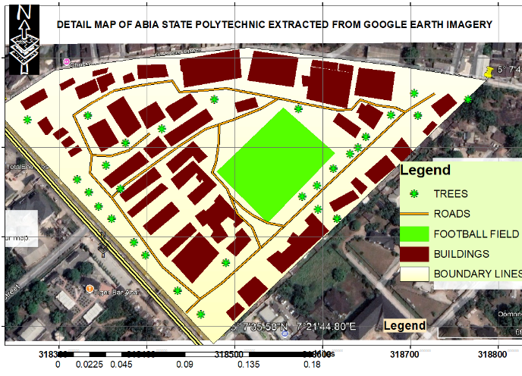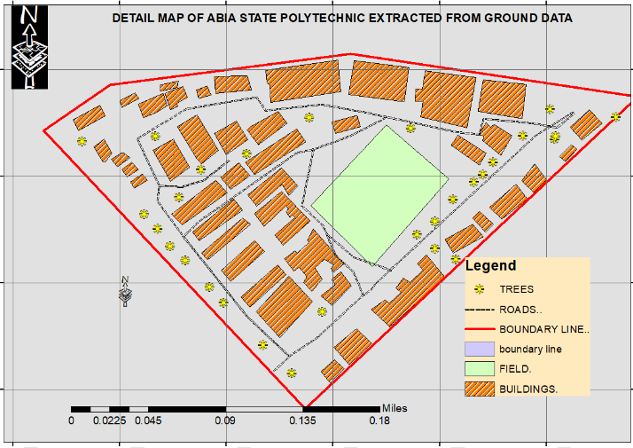Figure3Detail map of the study area from satellite data Figure4 Detail map of the study area from Ground data
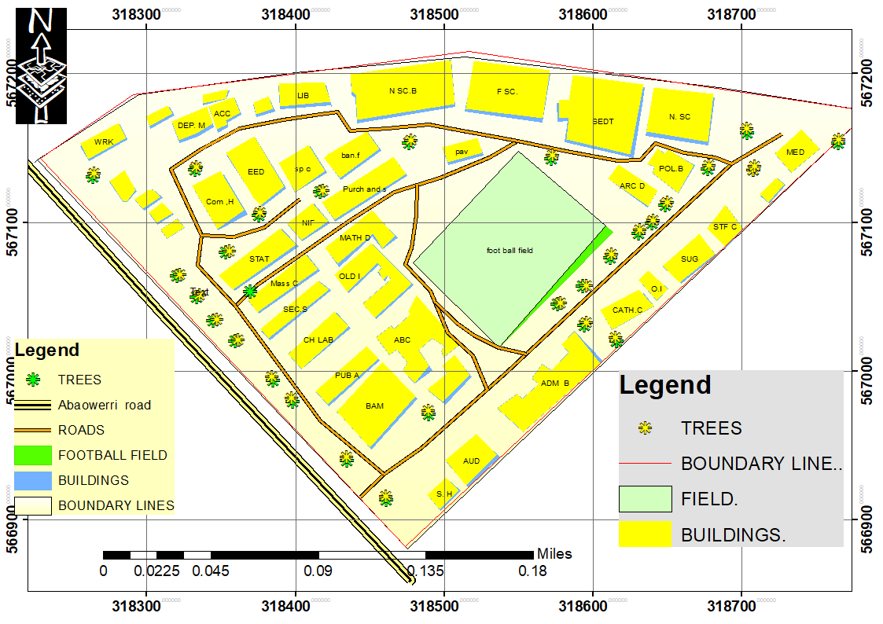
Figure5overlay analysis of satellite data and ground data-based maps

3.2.1 Comparison of terrain surfaces
Relative comparison in variation of heights between satellite DEM (SRTM) and ground-based heights was made by considering the contour pattern and 3-D models generated from the two sources of data. Figure 6 is the contour generated using ground-based data, figure 7 is contour map generated from SRTM.Figures 8 and 9 are 3-D surfaces generatedby ground data and SRTM respectively.

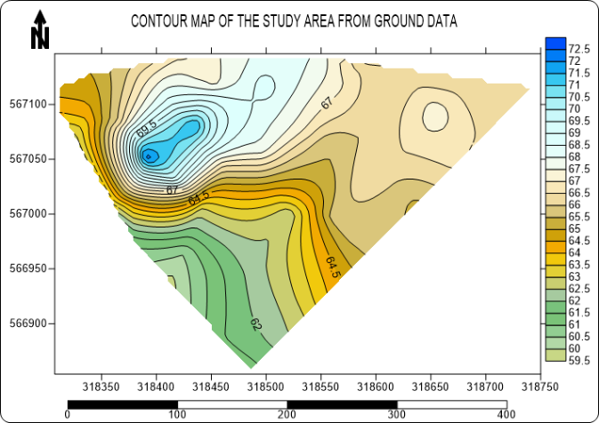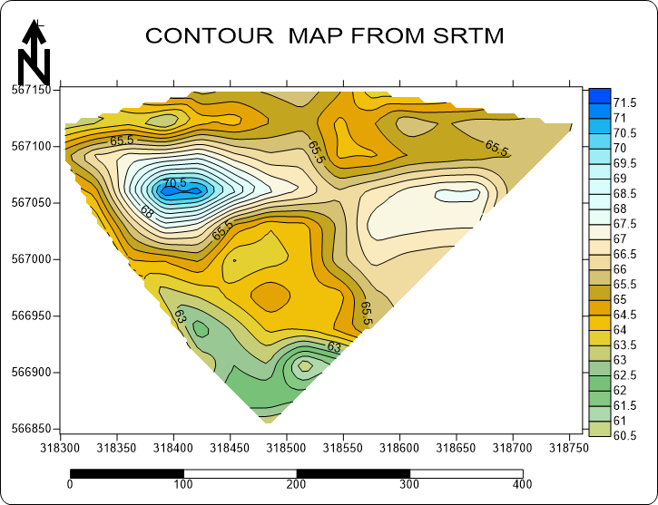
Figure 6 Contour map of the study area from ground data Figure7 Contour map of the study area from satellite data

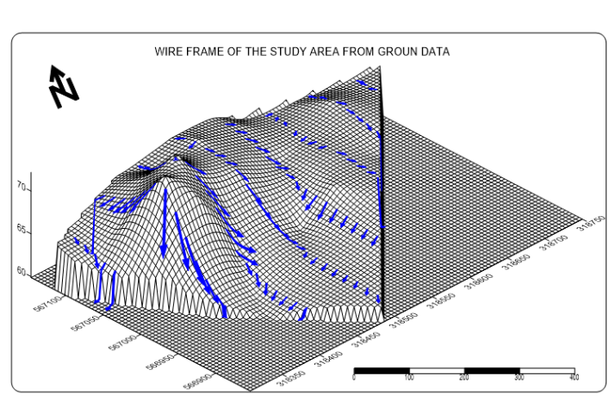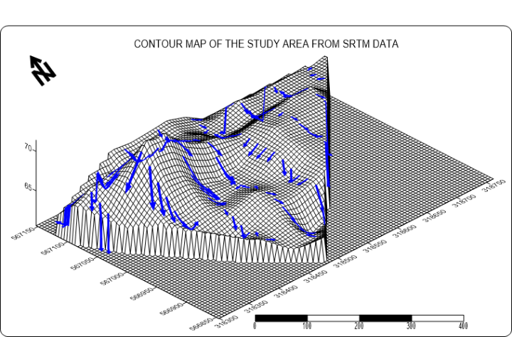

Figure 83-D model of the study area from ground data Figure9 3-D model of the study area from ground data

ACCURACY ASSESSMENT

3.1 Absolute accuracy assessment
One of the standards by which Accuracy of a map is determined is Root-Mean-Square-Error (RMSE). RMSE serves to aggregate the discrepancies between the ground reference data and their equivalent from the satellite data into a single measure of predictive power while correlation analysis evaluatesthe level of linear correlation between the ground and satellitedata. Table 1 andtable 2arerespectively absolute position and height comparison of GCP and corresponding ICP of 36 well dispersed planimetric points and spot height of 50 points scattered within the study area whiletable3 and 4 are the summary of accuracy assessment. Root mean square was computed using equation1, 2, 3 and 4 while correlation analysis has been carried out using excel software.

Table3 Absolute accuracy metrics derived from the 36planimetric checkpoints
Statistics | N_{G} | N_{S} | N_{G} - N_{S} | E_{G} | E_{S} | E_{G} -E_{S} | 2D RMSE
Mean | 567103.6435 | 567103.6504 | -0.0068611 | 318468.9743 | 318468.9704 | 0.004
RMSE | 0.0390 |  |  | 0.0455 |  |  | 0.059969
R² | 0.999997857 |  |  | 0.999999354

Table4 Absolute accuracy metrics derived from the 50 height checkpoints
Statistics | H_{G} | H_{S} | H_{G} - H_{S}
mean | 64.716 | 65.37043 | -0.65443
RMSE | 1.78731642
R² | 0.5471

$RMSEx=[ \sum_{n=1}^{n}{{\left({East}_{GCP}-{East }_{SCP}\right)}^{2}}$ /N ]^{1/2} (1)
$RMSEy=[ \sum_{n=1}^{n}{{\left({North}_{GCP}-{North }_{SCP}\right)}^{2}}$ /N ]^{1/2} (2)
𝑅𝑀𝑆𝐸_{2𝐷}=[(𝑅𝑀𝑆𝐸_{𝑥})²+(𝑅𝑀𝑆𝐸_{𝑦})²]^{1/2} (3)

$RMSE=√[∑(Zg-Zs)^{2}/N]$ (4 )
Where GCPs are horizontal control points on the ground, SCPs are corresponding control points from the satellite data. Z_{g}and Z_{s} are height of ground control points and that of corresponding points from the satellite data

Discussion of result
Thecoordinates of GCPs and ICPs plotted on the image map in figure 2revealed little discrepancesbetweenthe locational coordinates. This is corroborated by the high level of resemblance between the GE data (figure3) andground data (figure4) based maps and further validated by little shifts observed from overlay analysis of the two maps (figure5).Table1 statisticallyrevealed that these discrepancesare small in magnitude and randomly distributed, with positive and negative values approximately equally distributed. This indicates the absence ofsystematic errors and blunders in the 36 ICPs used in evaluating the GE imagery. The results in table 3 show that the two sets of coordinates are close.The analysis of the result shows a RMSE value of 0.0455m in the easting coordinate, 0.0390m in the northing coordinates and 0.059969m in 2D planes. Analysis of result also revealed a high level of correlation between GCPs and ICPs with R²recording a value of 0.999997857and 0.999999354 in the northing and easting respectively (see table3). These statistics indicate that the ICPs are good estimates of their real-world values therefore attest that GE imagery is effectivefor detailmapping thatrequires high accuracy in the study area.

Contour is one of the oldest methods of terrain surface assessment. In this format, topographical slope, undulations and general surface are interpreted based on the density of spatial cluster of contour lines. Figures 6 and 7 are respectively surface contour patterns of the study area generated by ground data and by SRTM DEM. A cursory study of the two maps revealed certain level of resemblance in terms of general surface direction of inclination. But within the surface SRTM basedcontour Map revealed high level of undulating surface when compared to the smoother ground data-based map. The ground data map revealed elevation range of 59.5m to 73m above mean sea level as against elevation range of 60.5 to 72m recorded by SRTM. This was further validated by the corresponding 3-D surface models generated from the two data sources. The 3-D models revealed certain level of similarity and a remarkable level of differences. Controlling surface flow is fundamental need for surface analysis. Based on this surface flow models (blue vectors) generated from the two data sources which were superimposed on the corresponding3-D surfaces and the flow pattern further corroborated the former results. Statistical results drawn from elevation differencing (table 2) using equation 4revealed a root mean square error of value 1.78731642. Further statistical analysis revealed mean surface elevation difference of 0.65443m and correlation coefficient (R²) of 0.5471.

CONCLUSSION
Satellite datasets are very important data sources for several remote sensing and geospatial applications; however, it is important to analyze their accuracy to determine their suitability for a particular geospatial application. This research provided evaluation of GE satellite imagery and 3-arc seconds resolution SRTM for topographical mapping requiring high accuracyusing ground data as reference.Relative assessments were carried out in terms ofvisual similarities between mapping products derived from the two sources of data while absolute assessment was carried out usingstatistical accuracy metrics. The detail maps produced using satellite data showed little deviations in relative and absolute manner with high level conformity when compared with ground data-based map. However, the SRTM in relative sense revealed certain level of similarities and may be considered good when used to show general surface situations in terms of general surface direction of slope but the relative and absolute conformity was considered not good enough for engineering projects requiring high accuracy.

COMPETING INTERESTS DISCLAIMER:
Authors have declared that they have no known competing financial interests OR non-financial interests OR personal relationships that could have appeared to influence the work reported in this paper.

References
Becek, K., Ibrahim, K. 2011). On the positional accuracy of Googleearth imagery. Paper presented in FIG Working Marrakech, Morocco,18-22 May 2011
ASTER GDEM Validation Team (2009) ASTER Global DEM Validation: Summary Report. 28 p. METI &NASA .http://www.viewfinderpanoramas.org/GDEM/ASTER_GDEM_Validation_Summary_Report_ _FINAL _for_Posting_06-28-09[1].pdf
Nzelibe, I. U., Tata, H. and Nnamani, O. J (2020) Geometric Accuracy Assessment of Digital Map Derived from QuickBird High Resolution Satellite Imagery. FUTY Journal of the Environment. 14 ( 3) pp 73 – 83
Hensley, S., Munjy, R. and Rosen, P., , In Interferometric Synthetic Aperture Radar (IFSAR), Digital Elevation Model Technologies and Applications: The DEM User’s Manual, D. Maune (Ed.), 2001; 143–206 (Bethesda, MD: American Society for Photogrammetry and Remote Sensing
Jing Gu, Jixian Zhang, Haitao Zhao, Chang Li, Jin Zhou, Hongjing Tu, Ying Zhao (2020) Horizontal Accuracy Assessment of Google Earth Data Over Typical Regions of Asia, The International Archives of the Photogrammetry, Remote Sensing and Spatial Information Sciences, Volume XLIII-B3-2020, 2020 XXIV ISPRS Congress (2020 edition)
Mohammad Ali GOUDARZI, René Jr. LANDRY (2017) Assessing Horizontal Positional Accuracy of Google Earth Imagery InThe City Of Montreal, Canada, Geodesy and Cartography, 43(2): 56–65
Onyeka E.C (2007). Geoinformatics in environmental mornitoring, Enugu: San Press LTD
Pulighe, G.; Baiocchi, V.; Lupia, F. (2015). Horizontal accuracy assessment of very high-resolution Google Earth images in the city of Rome, Italy, International Journal of Digital Earth 9(4): 342–362. https://doi.org/10.1080/17538947.2015.1031716
Scollar, I. (2013). Google Earth: improving mapping accuracy. AARG news 47: 19–27.
Sarra Ouerghi, Ranya Fadlalla AbdallaElsheikh, Hammadi Achour Samir Bouazi (2015) Evaluation and Validation of Recent Freely- Available ASTER-GDEM V.2, SRTM V.4.1 and the DEM Derived from Topographical Map over SW Grombalia (Test Area) in Northeast of Tunisia. Journal of Geographic Information System 2015;.7 (3)
Smith B., Sandwell D. Accuracy and resolution of shuttle radar topography mission data, Geophys. Res. Lett., 30 2003; doi: :10.1029/2002GL016643
Tian, G., Huang, Q., He, H., & Xia, Z. (2017). Analysis on geometric positioning accuracy evaluation of remote sensing satellite image." Spacecr. Recovery Remote Sens 38 pp 106-112.
Vijith. H, Seling. LW, Dodge-Wan, D (2015). Comparison and Suitability of SRTM and ASTER Digital Elevation Data for Terrain Analysis and Geomorphometric Parameters: Case Study of Sungai Patah Sub watershed Baram River, Sarawak, Malaysia.Environmental Research, Engineering and Management. 71(3); 23-35

