Interaction effect of Crop Rotation and Diversification on Soil Health and Productivity — A Review

Abstract
Crop diversification and crop rotation are pillar practices of sustainable farming, counteracting the ecological and productivity problems of monocultures. Rotation brings in temporal diversity through disruption of pest and disease cycles, organic matter turnover, and nutrient dynamics, while diversification using intercropping, relay cropping, cover cropping, or agroforestry adds spatial and functional diversity, use efficiency of resources, and stability. When combined, these measures produce synergistic advantages that are greater than the sum of their separate impacts. Functional complementarity within crops increases nutrient and water uptake, diverse organic inputs accumulate soil organic carbon and stabilize soil aggregates, and greater habitat heterogeneity promotes favorable microbial communities and natural pest control. Experimental results reveal diversified rotations to enhance soil physical, chemical, and biological attributes, reinforce microbial processes, and promote yield stability under climatic stress. Even with these benefits, adoption is still limited by socioeconomic factors, labor needs, and a lack of region-specific evidence. Gaps in the research involve long-term, multi-site trials, mechanistic experiments connecting crop traits to microbial processes, and economic evaluation of trade-offs. Practitioner advice stresses beginning with small-scale adoption, focusing on legumes and cover crops, tracking soil health indicators, and combining with conservation agriculture practices. In general, the interactive use of diversification and crop rotation is central to constructing robust agroecosystems that ensure productivity, minimize input reliance, and support climate change adaptation and international sustainability efforts.
1. Introduction
Crop rotation, which refers to the temporal rotation of diverse crops on the same unit of land, and crop diversification, involving the combination of more than one crop species in space and/or time (e.g., intercropping, relay cropping, cover cropping, and agroforestry), are identified as foundation practices of sustainable agriculture. Both approaches solve the inherent problems of intensive monoculture systems of the present day that tend to lead to land degradation, nutrient imbalance, pest and disease accumulation, and yield variability (Fan, et al., 2025).
Although each practice has been widely researched alone, it is their interactive effects that offer the most hope for developing resilient agroecosystems. Rotations offer temporal diversity that breaks cycles of pests, enhances the turnover of soil organic matter, and increases nutrient dynamics, while diversification by way of spatial or functional inclusion of crops improves ecological niches, raises resource-use efficiency, and promotes above- and below-ground diversity (Hernández-Ochoa et al., 2022). Together, these practices can produce synergistic effects, such as diversified rotations involving legumes, cover crops, or deep-rooted plants enhance soil aggregation, promote microbial activity, and buffer climatic instability more than plain cereal–cereal rotations (Sharma, et al., 2021).
The significance of these interactions is highlighted in the context of global sustainability objectives and climate change adaptation. Healthy soils with greater organic carbon, balanced cycling of nutrients, and strong microbial communities are not only more productive but also sequester carbon, store water, and minimize reliance on external chemical additions. In addition, diversified rotation diversification systems have been demonstrated to stabilize yields when faced with climatic stress, lower greenhouse gas emissions, and enhance ecosystem services like pollination and natural pest control (Gómez-Macpherson et al., 2024).
Crop diversification is essential in improving productivity, soil health, and ecosystem services through improving spatial and temporal diversity by the use of practices like intercropping and crop rotation (Li, et al., 2024). Within various crop groups, legumes are usually favored in diversification because they have the capacity to fix nitrogen from the atmosphere using symbiotic relationships and provide organic inputs. All these activities have a positive impact on the soil microbial population, enhance soil fertility, and increase crop yield (Jia, et al., 2024). Notwithstanding these well-known advantages, the specific mechanisms by which crop diversification with legumes affect biological processes in the soil and drive the enhancement of soil functions, ecosystem services, and aggregate productivity are still subject to uncertainty (Ditzler, et al., 2021).
Crop diversification and rotation are central tenets of sustainable agricultural systems. Through the change of crop type over time through rotation and combining several crops at a single time through diversification methods like intercropping, agroforestry, or mixed systems, these processes play an important role in rejuvenating soil fertility, avoiding degradation, and improving stress resistance against environmental and biotic stresses. Their combined impact is manifest on physical, chemical, and biological aspects of soil health, which collectively support long-term productivity and general ecosystem stability (Hufnagel, et al., 2024).
Rotations and diverse systems largely enhance structure and aggregation of soil through the inclusion of crop species with differing root structures and organic residue inputs. Fibrous-rooted cereals aggregate surface soils well, whereas deep-rooted legumes and perennials form macropores to promote gas exchange and root penetration (Shah, et al., 2021). These operations improve tilth, increase porosity, reduce bulk density, and improve soil aggregation. Besides, crop diversification minimizes soil erosion hazards through the maintenance of year-round ground cover by the application of cover crops, green manures, and intercrops, which prevent wind and water erosion, especially in sloping and marginal areas. Crop residue retention forms a protective mulch cover that reduces splash erosion and surface runoff. In addition, diversified rotation leads to better water dynamics through higher infiltration rates and water-holding capacity as a result of increased soil organic matter (Liang et al., 2023). Cereal crops with large root systems create biopores that favor deeper penetration of water, an issue of specific interest in rainfed cropping systems where water supply is the most limiting factor to crop growth.
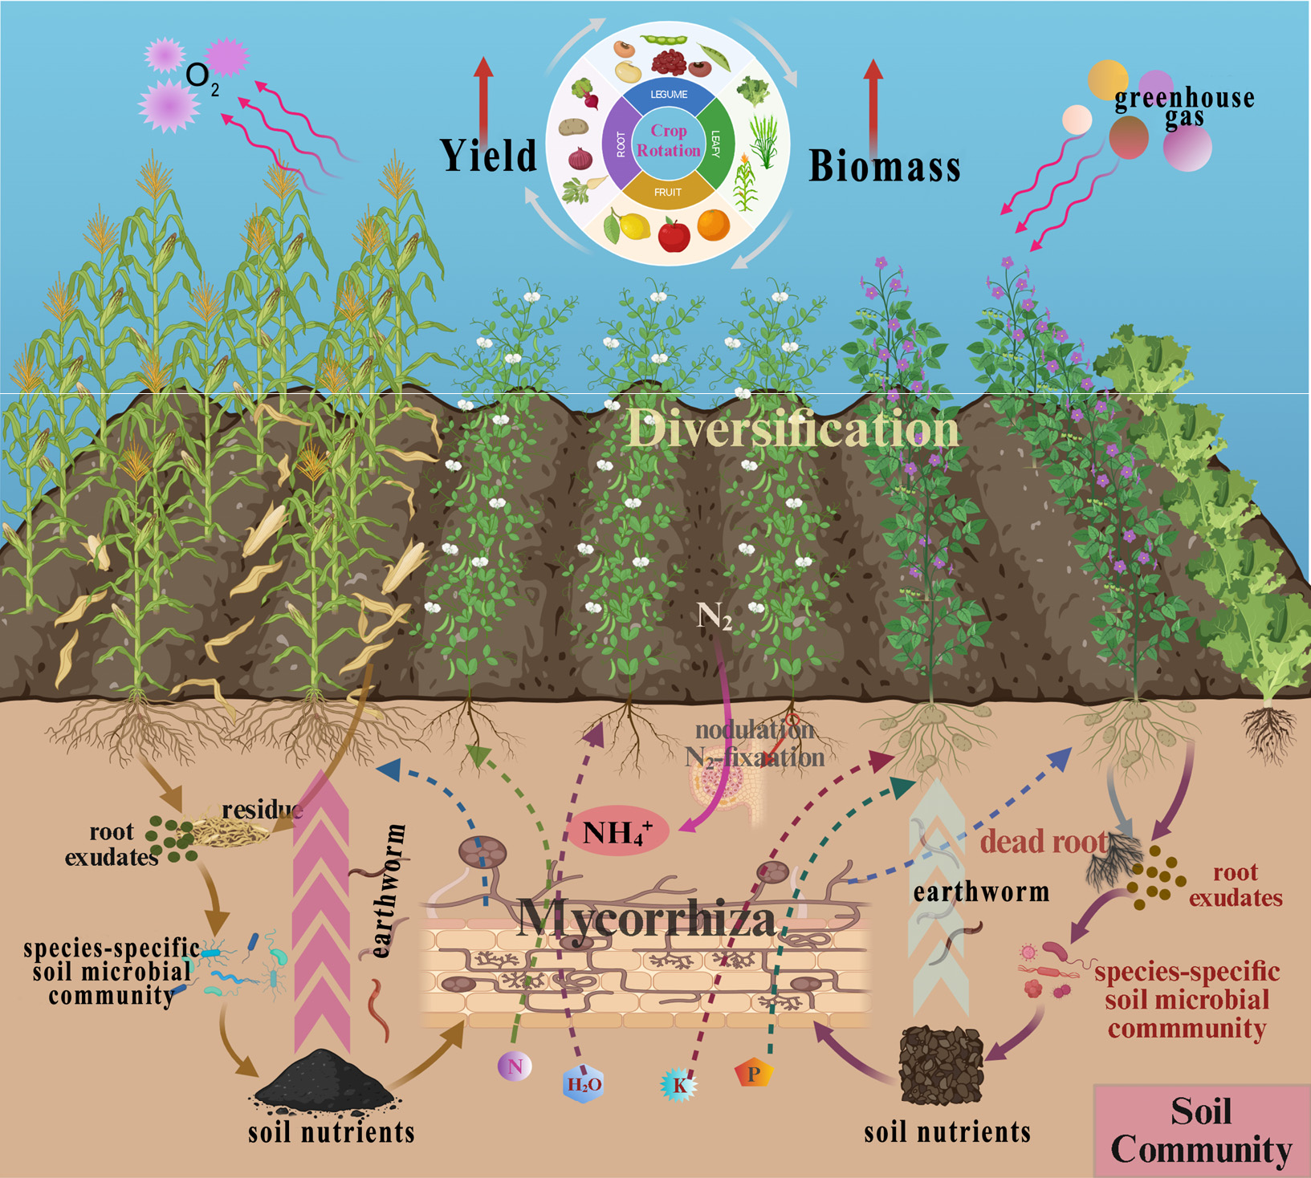

(Source, Zou et al., 2024)
Figure 1. Conceptual diagram of crop rotation and diversification (CRD) as a strategy for promoting sustainable agriculture
Crop diversification and rotation have a significant effect on soil chemical fertility through enhanced nutrient cycling and availability. The incorporation of legumes adds biologically fixed nitrogen to the soil, decreasing synthetic fertilizer reliance while increasing nutrient-use efficiency. Perennial deep-rooted crops like sunflower, pigeon pea, and safflower also complement nutrient dynamics by bringing subsoil layers into nutrient cycling and redistributing the recovered nutrients into the upper profile, thus benefiting the following shallow-rooted crops like cereals and vegetables (Zhang, et al., 2024). Integration of crop diversity also ensures a constant supply of organic matter by residues, root exudates, and green manures, which as a whole enhance soil carbon sequestration.
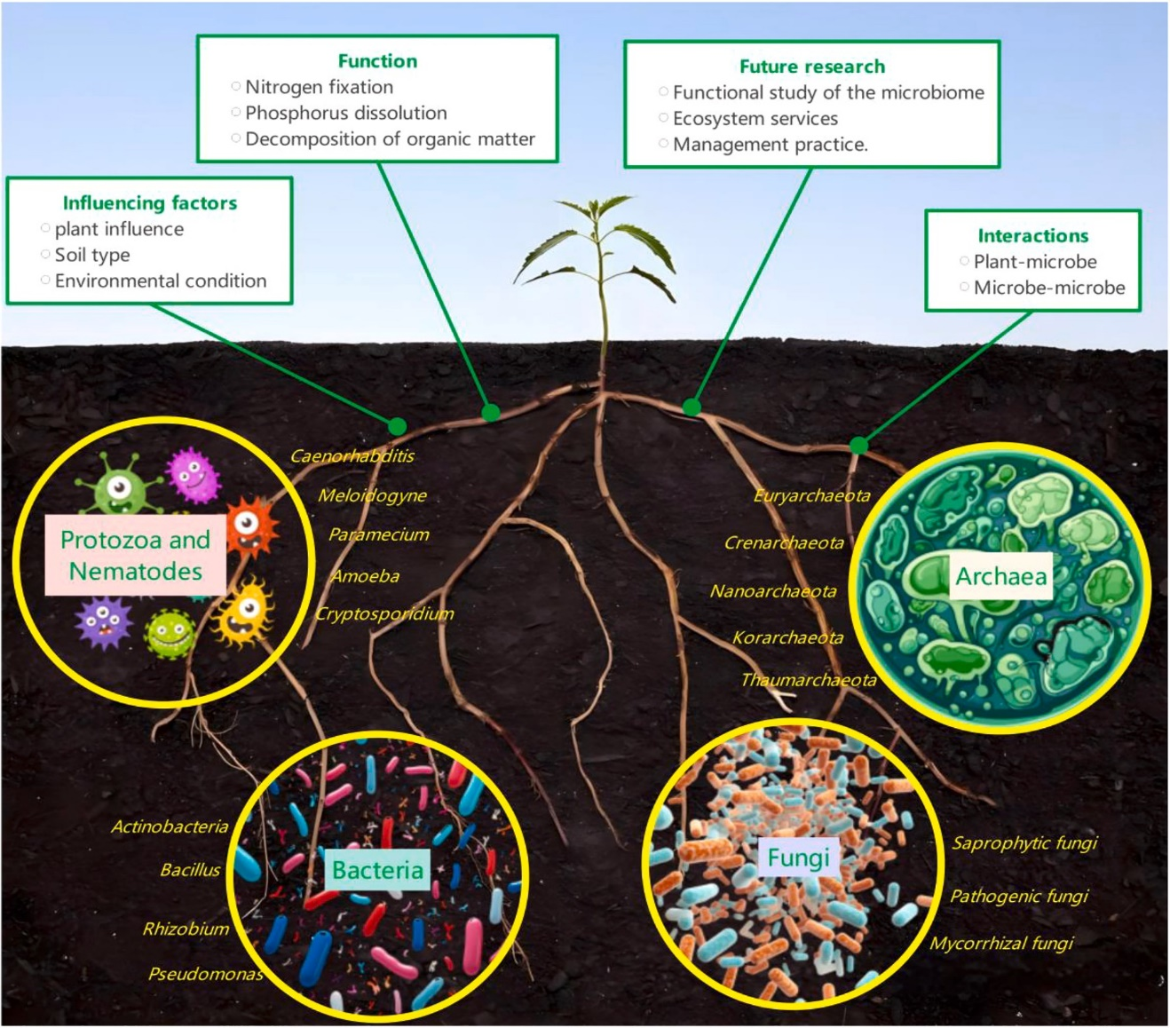
High soil organic carbon not only plays a central role in fertility but also an important mechanism for climate change mitigation. In addition, the addition of diverse crop species promotes a well-balanced nutrient matrix (Khan, et al., 2024): legumes add nitrogen content, cereals give carbonous residues, and oilseeds offer sulfur-containing materials. Such an equal nutrient input avoids soil nutrient loss and assists in minimizing the hazard of acidification and salinity accumulation that usually follows repeated monocropping regimes (Belete, and Yadete, 2023).
(Source, Xing et al., 2025)
Fig. 2. Rhizosphere microbial composition is a key determinant of plant growth and soil health.

The biological aspect of soil health also gains considerably with crop rotation and diversification. Varied rotations enrich microbial communities within rhizospheres, promoting the growth of desirable organisms like rhizobia, mycorrhizal fungi, and phosphorus-solubilizing bacteria. This augmented microbial richness reinforces essential soil processes such as nutrient mineralization, organic residue decomposition, and pathogen suppression in the soil. Diversity in rotation also avoids pathogenic microbe dominance, thus keeping a microbial ecosystem in equilibrium. Likewise, fauna in soil like earthworms, nematodes, and collembola prosper under systems with constant input of organic matter (Pareek, 2013). For example, earthworm densities are greater in diversified legume–cereal rotations owing to good food supply and soil conditions and their activity facilitates nutrient cycling and aggregate formation in the soil by burrowing and grazing. Crop rotations also promote pest and disease suppression by breaking the life cycles of soil-borne diseases and pests. For instance, alternation of cereals with non-host broadleaf crops drastically minimizes the prevalence of take-all disease in wheat. Moreover, spatial diversification strategies like intercropping water down host presence and hence decrease inoculum density and pest pressure (Ratnadass et al., 2012).
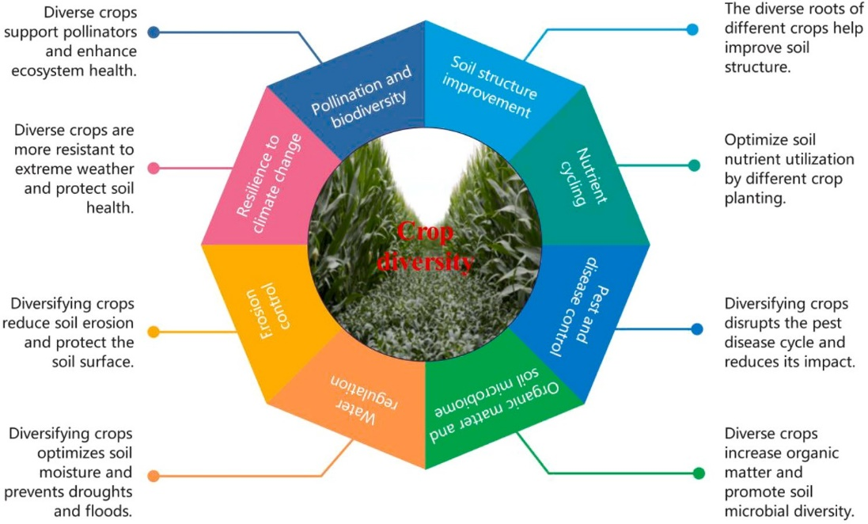
(Source, Xing et al., 2025)
Fig. 3. Ecological service effects of crop diversity on soil health.
The overall enhancement of soil physical, chemical, and biological characteristics offered by crop rotation and diversification provide long-term ecosystem services that are essential for sustainable agriculture. Improved soil health provides a more stable and larger long-term crop output at the same time as decreasing dependency on expensive outside inputs like fertilizers and pesticides. Such systems further contribute to climate resilience by insulating against rainfall and temperature variability, improving the physical properties of soil water, sequestering carbon, and retaining nutrient supplies, hence decreasing susceptibility to drought, floods, and heat stress. In addition, increased soil organic carbon is a greenhouse gas mitigation strategy through the sequestration of carbon for long periods, while legume inclusion in rotations lowers nitrous oxide emissions as a result of decreased fertilizer use (Hazra, 2001). Crop diversification at the landscape and field levels conserves biodiversity through habitat provision of beneficial soil organisms, pollinators, and natural enemies of insects. Lastly, the ecological functions of diversified cropping systems also involve decreasing environmental degradation by limiting erosion, nutrient losses, and chemical reliance, hence reducing risks of water pollution, soil acidification, and salinization (Sharma et al., 2021).

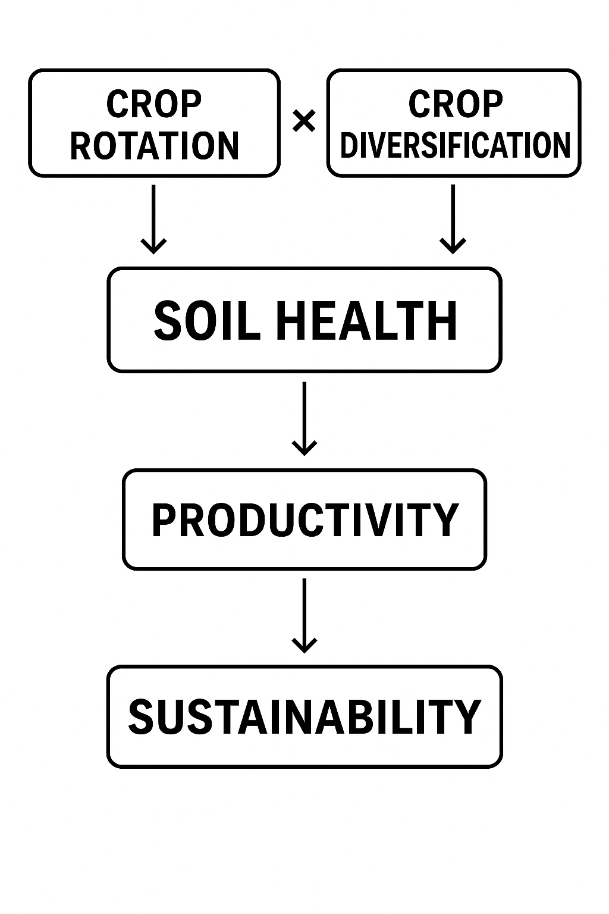
Fig.- 4. Pattern of crop rotation and diversification
2. Determinants of Diversified Crop Rotation Adoption
Various studies indicated that land fragmentation has been identified as one of the significant factors affecting the adoption of diversified crop rotation (DCR). Fragmentation restricts optimal resource allocation, raises the cost of production, and causes suboptimal utilization of factor inputs. Fragmentation also causes extra travel time losses, wasted spaces within field boundaries, restricted surveillance, and avoidance of using standardized equipment. Such challenges impede agricultural growth and lower the viability of restructuring programs aimed at alleviating such inefficiencies. Additionally, the incentive to increase productivity on farmland by smallholders through expanding area is weak, and unwillingness to diversify crops stems from low yields of some species, decreasing landholdings owing to population pressure, and natural resource depletion (Mekuria, and Mekonnen, 2018).
As per, farmers with many small plots of land are more likely to adopt fewer new technologies, resort to monocropping, and try to reduce travel distances among plots. In contrast, a rise in total farm size promotes diversification of crops using rotation, lowers cost per unit of production, and increases adoption interest. However, diffusion of knowledge (cultivation information, technical expertise, and adoption methods) and intervention efficacy (e.g., enhanced production and economic yield) are still essential but unexplored topics. Large knowledge gaps exist in training and extension programs that would make DCR's large-scale adoption possible (Mesfin, et al., 2011).
Uncertainty in market conditions, unstable outputs, erratic availability of inputs, and low farmer consciousness add to the complexity of adoption in low-income countries. These differences render DCR's diffusion, adoption potential, and profitability strongly context-dependent (Ridier, et al.,2021) Besides, agriculture-related risks and uncertainties, especially the mismatch between farmer decision-making and subsequent realization of profits, deter diversification. Several other socio-economic variables, such as the availability of crop insurance, farmers' previous experience with new technologies, financial status, and even decision-maker age, also strongly affect adoption. All these factors should be taken into account carefully while developing policies, strategies, and extension programs for encouragements of crop diversification at scale (Avemegah, et al., 2024).
Monoculture
Multistorey cropping
Multiple livelihood options
Economic benefits
Boost financial and economic status
High production
Agriculture system
Diversified crop rotation

Sociocultural benefits
Social assets
Cultural and other intangible assets
Other ecological values
Ecosystem benefits
Agrobiodiversity conservation
Improved soil health
(Source, Shah et al., 2021)
Figure 5. Diagrammatic representation of the importance of DCR for food security and soil health management.
Conceptual Framework: How Rotation × Diversification Interact
Crop rotation and diversification interact best when interpreted through ecological principles and soil–plant–microbe feedbacks. Combined, they produce functional complementarity, break pest and disease cycles, and maintain soil physical, chemical, and biological processes (Kelly, and ILBERY, 1995).
Functional Complementarity in Resource Use
Various crops have differing rooting depths, canopy structures, nutrient requirements, and residue characteristics. When these are rotated or mixed, such as cereals and legumes, shallow-rooted crops and deep-rooted ones, or rapid-growing annuals and perennials, rotations and diversification complement each other to enhance water and nutrient capture, especially nitrogen, phosphorus, and micronutrients (Zimmerer, and Vanek, 2016). They minimize inter-annual nutrient mining risk by spreading nutrient requirement over time and ensuring long-term availability of resources to soil organisms, resulting in wider and more stable biota of the soil. For example, rotation of maize with soybean and the use of cover crops maximizes nitrogen cycling efficiency and minimizes the need for fertilizers, while deep-rooted crops like sunflower or pigeon pea enhance recovery of nutrients in the subsoil (Paut, et al., 2020).
Interruption of Pest and Disease Cycles
Spatial diversification and temporal rotation create heterogeneity that disrupts the life cycles of monophagous pests and pathogens. Decreased continuity of the host decreases inoculum pressure, whereas elevated habitat heterogeneity strengthens natural enemies. In cereal cropping, rotation retards the carry-over of diseases like Fusarium spp., while the incorporation of legumes represses nematode populations by means of non-host effects. As with intercropping with aromatic or trap crops, insect pest accumulation can be repressed. Combined, rotation and diversification serve as an ecological barrier that minimizes the use of synthetic pesticides (Li et al., 2021).
Varied Organic Inputs and Carbon Cycling
Another critical means of interaction occurs through the heterogeneity of residues into the soil. Rotations and diversified systems add litter with varying carbon-to-nitrogen ratios, lignin, and polyphenol levels. The heterogeneity leads to a wider diversity of decomposer communities, promotes complementary decomposition processes with both rapid and slow turnover pools, and builds soil organic matter fractions that stabilize nutrients and increase soil structure. The persistent incorporation of varied residues enhances soil carbon sequestration capacity and enhances long-term nutrient retention (Hufnagel, et al., 2020).
Soil Physical Advantages
Rotating crop varieties with contrasting rooting structures also alters physical structure in soil. Rooted crops produce biopores, disrupt sealed layers like plough pans, and enhance water permeability. Dense fibrous-rooted plants stabilize aggregates and avert erosion, and cover crops and green manures establish surface cover that minimizes raindrop impact and surface sealing. In the long run, this heterogeneity improves porosity, decreases bulk density, enhances aggregate stability, and increases water-holding capacity and forms a sturdy physical basis for sustained productivity (Bodner, et al., 2021).
Microbial and Biochemical Interactions
Plant diversity strongly affects rhizosphere microbial communities such as bacteria, fungi, and arbuscular mycorrhizal fungi (AMF). Diversified root exudates deliver sources of energy to a broad number of microbes, whereas useful symbionts like nitrogen-fixing rhizobia and phosphorus-mobilizing mycorrhizae flourish in diversified systems. These conditions enhance soil enzyme activities that accelerate nutrient mineralization rates, and they facilitate functional redundancy of microbial guilds that enhances the stability of soil processes under environmental stress like drought or heat (Wang, et al., 2021).
Feedback Loops and Emergent Properties
The preceding pathways are extremely interactive and collectively create positive feedback loops. For instance, enhanced microbial diversity enhances decomposition of varied residues, and this enhances nutrient availability for the following crops. Increased nutrient cycling enhances vigorous plant growth that recycles more organic matter into the soil, and increased soil structure favors increased microbial activity and root penetration, further enhancing system resilience. These feedbacks create emergent benefits exceeding the impacts of rotation or diversification independently, leading to improved yield stability, lowered reliance on external inputs, and lasting soil health improvements.
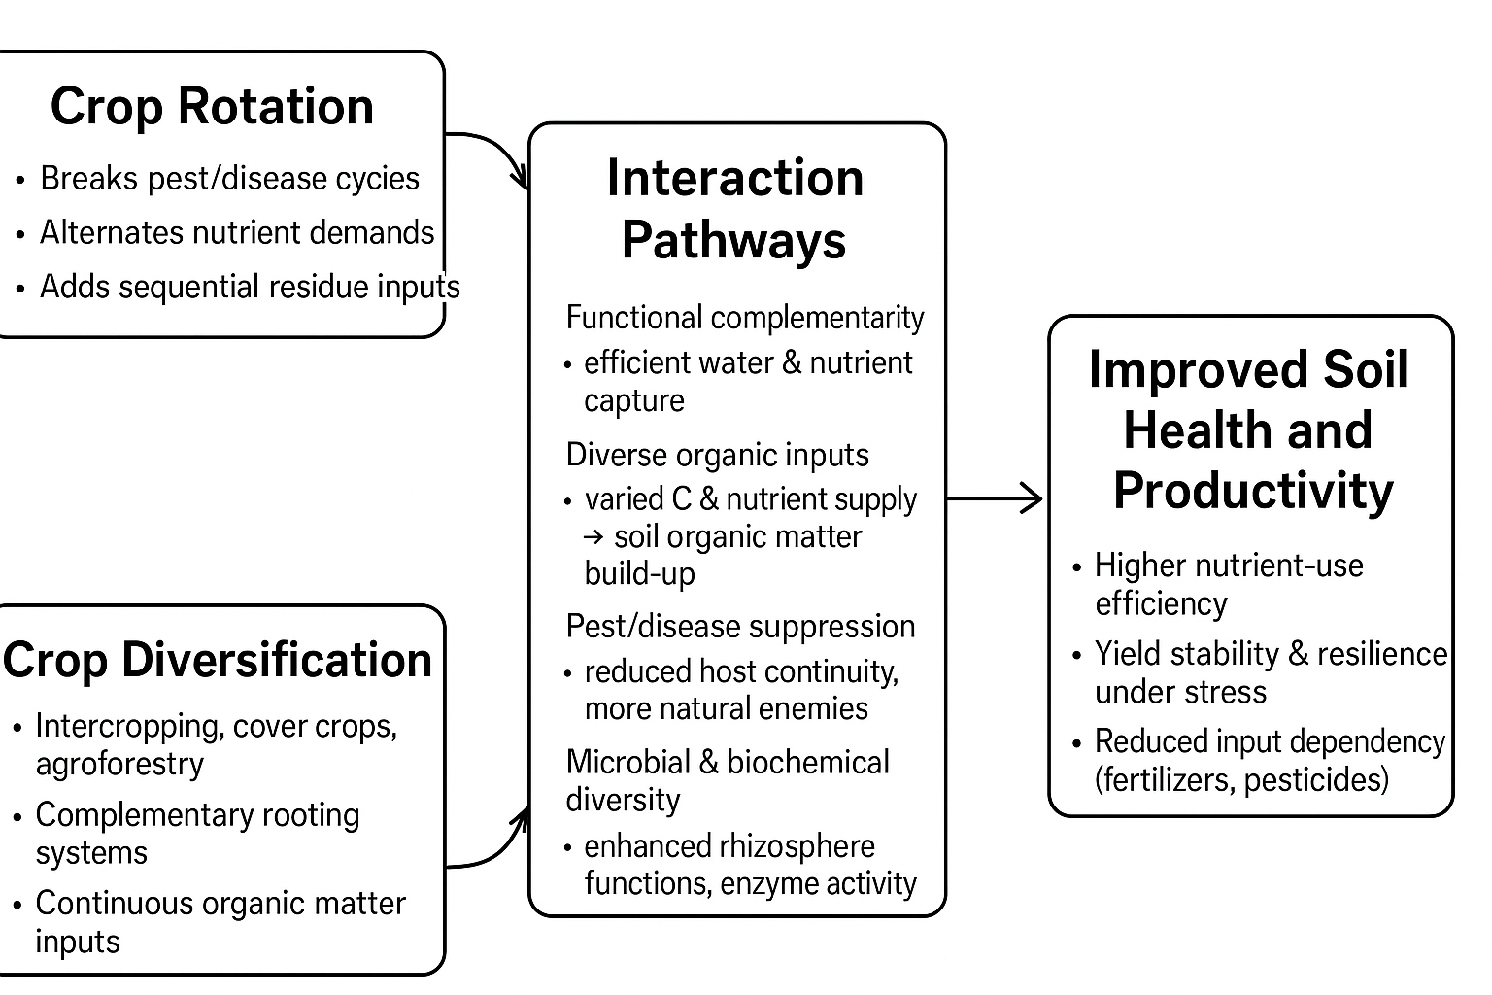
Fig.-6- Pathways of Crop rotation and diversification
Impacts on Soil Physical, Chemical, and Biological Properties
Soil Physical Properties
Crop diversification and rotation have a significant impact on soil physical properties. Incorporating high-root-biomass crops, deep-rooted crops, and cover crops in rotation systems favors the production of root-derived binding agents and fungal hyphal proliferation, which collectively increase the stability of soil aggregates and enhance structural integrity. Such varied sequences also reduce surface crusting and compaction, favoring the growth of roots. Intercrops with differences in root architecture still enhance macroporosity and both infiltration and water-retention capacity. These benefits result in increased soil resistance to droughts and an improved physical crop-growing environment (Delgado, and Gomez, 2024).
Soil Chemical Properties
The chemical attributes of the soil are also significantly enhanced in diversified rotations. Legume-based cover crop systems are likely to build soil organic carbon (SOC) through greater returns of biomass and less fallow. Crop residue quality, especially its carbon-to-nitrogen ratio, is a key factor in SOC stabilization and the creation of long-term carbon pools. Legume addition enhances nutrient cycling through the contribution of biologically fixed nitrogen to the next crop. In addition, diversified sequences that involve combinations of species and different residue qualities minimize nutrient leaching and enhance nutrient retention. Crop diversification also indirectly enhances phosphorus availability by promoting higher colonization and activity of mycorrhizal fungi, which immobilize otherwise unavailable soil P (Maiti, et al., 2011).
Soil Biological Properties
Soil biological processes are probably the most sensitive to crop rotation and diversification. Rotations that involve several functional groups promote higher microbial richness and functional gene diversity, such as genes for carbon and nitrogen cycling. Intercropping and perennial cover crop presence maintain rhizosphere activity year-round and have an active microbial community even without cash crops. Some crop rotations also benefit the formation of vigorous mycorrhizal networks and microbial consortia, improving nutrient acquisition and plant growth by the next crop. Notably, diversified systems tend to foster the establishment of disease-suppressive soils, wherein microbial populations suppress soilborne pathogens through resource competition, antibiosis, or induced systemic resistance of host plants (Zhang et al., 2020).
Impact on Productivity and Crop Yield
Yield and Yield Stability
Diversified rotations and intercropping systems generally enhance crop productivity compared with monoculture systems, particularly when assessed over the medium to long term. Numerous comparative studies demonstrate that mean yields are higher in diversified systems due to improved soil fertility, better nutrient cycling, and reduced pest and disease pressures. Beyond yield levels, diversification also contributes significantly to yield stability. By distributing production risk between various species and by increasing the resilience of the system to environmental shocks like drought, flooding, and pest and disease episodes, diversified rotations minimize inter-annual yield variability. Another key advantage is in nutrient-use efficiency. Diverse systems tend to realize greater nitrogen-use efficiency (NUE) and phosphorus-use efficiency (PUE) due to the matching of nutrient supply and demand, enhanced biological nitrogen fixation by legumes, and increased mobilization of nutrients by mycorrhizal associations. Therefore, these combined impacts lead to higher and more consistent productivity and reduced dependence on external inputs (Ogundari, 2013).
Quality and Market Impacts
Besides impacting yields, rotation and diversification plans also have an impact on crop quality and market access. Crop quality characteristics such as cereal protein, root and fruit sugar content, and micronutrient levels tend to increase when the rotation involves legumes or deep-rooted species that bring about otherwise inaccessible nutrients. For instance, legumes add biologically fixed nitrogen that can improve the protein quality of ensuing cereals, whereas deep-rooted varieties like pigeon pea or sunflower can enhance micronutrient access for ensuing crops. In addition to these physiological gains, diversification presents farmers with possibilities to diversify products as well as markets. Through the production of several species or crops per system, farmers are able to diversify market risks, meet consumer demand for diversified products, and enhance farm profitability overall. Therefore, diversification increases not just the ecological sustainability but also the economic viability of crop production (Beillouin, et al., 2021).
Advantages of Diversified Crop Rotation on Soil Health
Diversified crop rotation (DCR) is generally acclaimed as a pillar of sustainable agriculture because it can sustain and improve the health of the soil. By incorporating crops that have different rooting depths, nutrient requirements, growth forms, and residue characteristics, DCR enhances the structure, fertility, and microbial life of the soil while also enhancing the resilience to climatic and biological stresses at the same time. The holistic advantages of DCR on soil health can be classified under physical, chemical, and biological enhancements, as well as ecosystem and long-term sustainability benefits (Bhaduri, et al., 2022).
Physical Benefits
Rotations with diversification play a great role in enhancing physical soil properties. Various root architectures exert complementary impacts on the soil: the surface-rooted cereals aggregate surface soil particles, whereas deep-rooted legumes and oilseeds form channels to enhance aeration and water flow. This action improves soil aggregation, porosity, compaction reduction, and tilth, hence giving the roots a good environment for growth. The use of cover crops and high-canopy species also gives a protective cover over the soil surface, minimizing the risk of water and wind erosion. The surface residues of crops left on the surface serve as mulch, which protects the soil from raindrop impact and surface runoff. In addition, diversified rotations enhance soil organic matter content, which has a vital function to enhance water dynamics by augmenting infiltration, raising water-holding capacity, and lowering evaporative losses. This is especially essential in rainfed systems where water limitation is a productivity constraint (Ijaz, et al., 2019).
Chemical Benefits
Soil chemical fertility is enhanced under diversified crop rotations through enhanced nutrient cycling and availability. Leguminous crops grown in rotations are responsible for fixing atmospheric nitrogen by symbiosis with rhizobia, thus lowering reliance on synthetic nitrogen fertilizers and making nitrogen available as soon and easily as it is needed by the next crop. Inclusion of residues with different carbon-to-nitrogen (C:N) ratios brings about SOC accumulation in the soil, which increases cation exchange capacity, nutrient storage, and long-term fertility. Perennial crops like pigeon pea or safflower bring nutrients from subsoil horizons and redistribute them to the upper layers, with these nutrients being available to shallow-rooted crops during subsequent seasons. Diversified rotations, in this manner, ensure a balanced nutrient content, avoiding nutrient deficiency, reducing soil acidification, and enhancing soil buffering capacity (Beillouin, et al., 2021).
Biological Benefits
Biological characteristics of the soil are significantly improved with diversified rotations. A greater diversity of crops promotes microbial diversity in the rhizosphere, promoting the growth of beneficial organisms like mycorrhizal fungi, nitrogen-fixing microbes, and phosphate-solubilizing microbes. These microcommunities catalyze important processes like organic matter decomposition, nutrient mineralization, and natural suppression of soil-borne pathogens. Likewise, soil fauna like earthworms, nematodes, and collembola are benefited by the higher organic matter and residue input that is attendant on DCR. Their feeding and burrowing contribute further to aggregation, soil aeration, and nutrient cycling. Rotations also serve as a good method of disease and pest control through breaking of the life cycle of insect pests and soil-borne diseases. For example, switching host crops with non-host crops minimizes inoculum accumulation in the soil and thus decreases disease pressure as well as chemical pesticide dependence (Kremen, and Miles, 2012).
Ecosystem and Long-Term Benefits
The collective enhancements of soil physical, chemical, and biological well-being under multiple cropping rotations are reflected in the greater ecosystem services and sustainable agriculture over the long term. Such soils with greater organic matter content and improved structure are more resistant to climate stresses like droughts, floods, and extreme temperature variations and thus stabilize crop yields under varying climatic conditions. Enhanced fertility and natural pest control minimize the use of synthetic fertilizers and pesticides, reducing the cost of production while limiting environmental pollution from agrochemicals. Over the long term, diversified rotations preserve sustainable productivity through soil fertility conservation, improved biodiversity, carbon sequestration, and erosion, salinization, and acidification degradation risk avoidance. DCR, therefore, not only maintains current crop production but also enhances ecosystem stability and resilience, and is an important practice to apply for regenerative and climate-resilient agriculture.
Dynamics of Soil Microbiome in Crop Rotation and Diversification
Crop rotation and diversification significantly impact the structure, diversity, and functionality of microbial communities in the soil. Various crops exude different root exudates and residues that influence rhizosphere populations of microbes. Such microbial dynamic turnover is a key driver of nutrient cycling, soil aggregation, and pathogen suppression (Yang, et al., 2023).
Microbial diversity and shifts in communities
Rotations involving legumes, cereals, and root crops promote varied microbial niches and thus increase both bacterial and fungal richness. Diversified systems tend to enhance beneficial microbes like Rhizobium, Azotobacter, and arbuscular mycorrhizal fungi (AMF), leading to enhanced nutrient uptake and plant stability. Monocropping tends to lower microbial diversity and promote a rise in host-specific pathogens (Shu, and Huang, 2022).
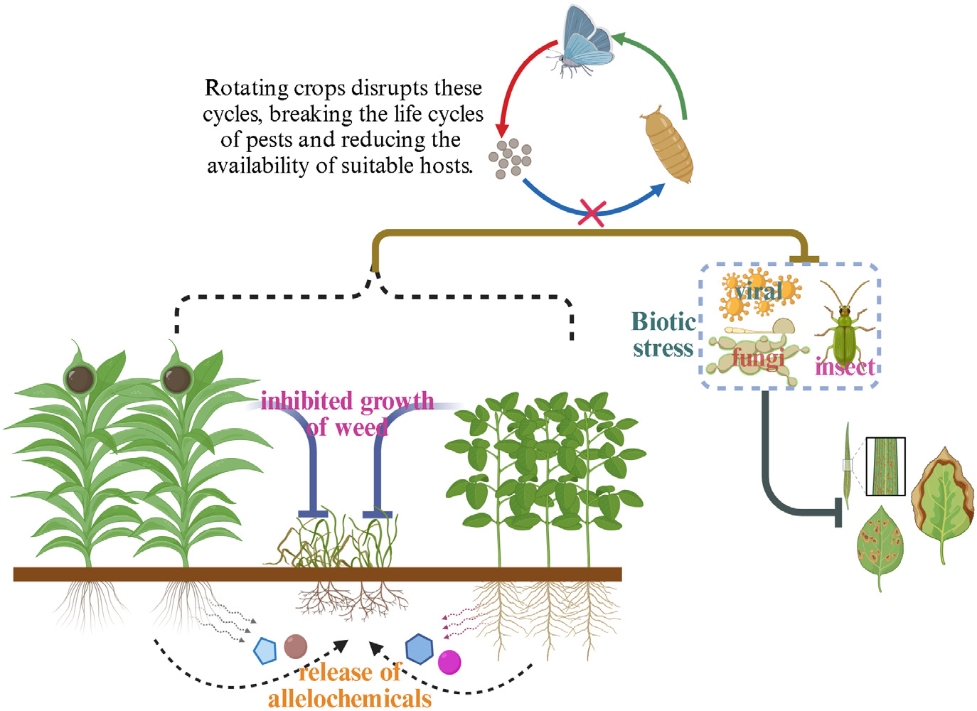

(Source, Zou et al., 2024)
Figure 7. Conceptual diagram of crop rotation and diversification (CRD) for managing pests and diseases while suppressing weed germination and growth.
Functional benefits
The agronomic advantages of crop rotation and diversification are most strongly associated with microbial action. Microorganisms in the soil control important processes of nutrient cycling such as nitrogen mineralization, solubilization of phosphorus, and mobilization of micronutrients. Microorganisms also stabilize fungal hyphae and microbial polysaccharides, improving soil structure to enhance porosity and water-holding capacity. In addition, rotated diversification interrupts pathogen life cycles and encourages beneficial microbial antagonists like Trichoderma and Pseudomonas spp., which serve to minimize the frequency of soil-borne diseases. (Liu, et al., 2023).
Trade-offs and limitations
Even with these advantages, some trade-offs and restraints must be recognized. The beneficial impacts of microbial enrichment can take years to accrue, especially in soils with compromised biological activity. Also, some crop residues have the potential to lead to pathogen accumulation; for instance, repeated cultivation of maize tends to favor the growth of Fusarium spp., which underscores the importance of balanced rotation planning. In addition, intensive tillage procedures that accompany some rotation schemes tend to alter microbial habitats, hence somewhat neutralizing biodiversity benefits.
Realistic Rotation and Diversification Strategies
Realistic crop rotation and diversification strategies should be informed by design principles that balance both crop productivity and soil health. One of the fundamental principles is having multiple functional groups, including cereals, legumes, oilseeds, and both shallow-rooted and deep-rooted species, in sequences to have maximum use efficiency of resources. The incorporation of cover crops among cash crops serves to sustain living roots, minimize soil erosion, and introduce organic biomass into the system. There is also a need for residue management; a balance in residue quality is essential to prevent immobilization of nitrogen, which can be attained by following high-carbon residues with legumes or the use of starter nitrogen. Of equal significance is the requirement to disrupt pest and disease cycles by not repeating the host crops and adding trap or non-host varieties. Lastly, successful design needs to be responsive to local limitations, e.g., soil, climate, market access, and labor, so that the system is both pragmatic and remunerative (Van Oijen, and Douma, 2000).
Exemplary instances of these approaches are seen in various settings. In a temperate cereals system, a common sequence would be wheat followed by a legume like pea or bean, next a cover crop like vetch or rye, and lastly barley. In a tropical smallholder context, a good sequence would consist of maize followed by cowpea intercrop, next groundnut, and ending with a fallow phase with a quick-growing cover crop like mucuna. On mixed farms incorporating livestock, rotation may include a cereal crop, then a legume offering soil fertility value and forage, then a perennial pasture or forage period, followed by a return to cereal cropping.
Example Sequences
- Temperate cereal systems: Wheat → legume (pea/bean) → cover crop (vetch/rye) → barley.
- Tropical smallholder systems: Maize → cowpea intercrop → groundnut → fallow with fast-growing cover (mucuna).
- Mixed farms with livestock: Cereal → legume that provides forage → perennial pasture/forage → cereal.
Region-Specific Examples (India)
- Rice–pulse system: Rice (kharif) → lentil/chickpea (rabi) → short-duration mungbean (summer).
- Maize-based rotation: Maize (kharif) → potato/pea (rabi) → fodder crop or short-duration pulse (summer).
- Oilseed diversification: Soybean (kharif) → wheat (rabi) → mungbean (summer).
- Sugarcane intercropping system: Sugarcane (18 months) intercropped with soybean/groundnut in the early stages → followed by a pulse or fodder crop.
- Horticultural integration: Maize (kharif) → onion/garlic (rabi) → leafy vegetables or mungbean (summer).

Table-1. Comparison of Monocropping and Diversified Crop Rotations
Aspect | Monocropping | Diversified Rotations / Intercropping
Soil Fertility | Continuous nutrient mining; higher dependence on synthetic fertilizers. | Improves nutrient cycling (legumes fix N, deep-rooted crops recover subsoil nutrients).
Soil Organic Matter (SOM) | Declines over time due to uniform residues. | Builds SOM through diverse residue quality and cover crop biomass.
Pest & Disease Pressure | High, due to continuous host presence; requires more pesticides. | Disrupts pest/pathogen cycles; increases beneficial organisms.
Soil Physical Properties | Risk of compaction and reduced aggregate stability. | Improves porosity, aggregation, and water-holding capacity.
Microbial Diversity | Low, with dominance of host-specific microbes and pathogens. | High, with functional redundancy, enhanced AMF, and beneficial microbes.
Yield (Short-term) | Often higher initially due to specialization and input use. | May be slightly lower in the short term due to competition and complexity.
Yield (Long-term) | Declines due to soil degradation and pest buildup. | More stable over years; resilience to drought, pests, and climate variability.
Nutrient-Use Efficiency | Low efficiency; high leaching and wastage. | Higher NUE/PUE due to synchronized supply-demand and biological N fixation.
Labor & Management | Simple, less labor-intensive. | Requires more knowledge, planning, and sometimes more labor.
Profitability | Short-term profits possible with marketable monocrops. | Long-term profitability higher due to reduced input costs and diversified market opportunities.
Environmental Impact | Greater pollution risk (fertilizer runoff, pesticide use). | Lower environmental footprint; contributes to carbon sequestration and biodiversity.

Case Studies and Empirical Evidence
Empirical research on various agroecosystems continually shows diversified sequences of crops and intercropping arrangements augment soil health and productivity compared to monoculture. Diversified systems build up soil organic carbon (SOC) and microbial biomass due to higher and more diverse organic inputs, along with maintaining more functionally diverse microbial communities. Numerous studies document lower frequency and severity of soilborne diseases in diversified rotations, primarily because pest–pathogen cycles are interrupted and disease-suppressive microbial communities are enhanced. Long-term field trials have demonstrated that the incorporation of legumes enhances biological nitrogen fixation, thus minimizing the need for synthetic nitrogen fertilizer and increasing crop performance in following years. Moreover, diversified systems tend to have higher stability of yield under changing climatic conditions, and offer a measure of protection against drought, heat, and outbreaks of pests. Outcomes are never uniform; responses are influenced by soil type, climatic conditions, crop species, and management practices. This emphasizes the role of local adaptation, site-specific cropping sequence design, and long-term observation to intercept the cumulative effects of rotation × diversification practices.
Knowledge Gaps and Research Priorities
Despite the evidence of benefits from crop rotation and diversification, there are still knowledge gaps critical to their adoption and optimization at larger scales. Long-term, multi-site experiments are urgently needed that specifically address the interactive effects of rotation and diversification between contrasting soils, climates, and farming systems. Mechanistic research connecting crop functional traits root exudation patterns and litter chemistry to changes in microbial community structure and processes of nutrient cycling is underinvestigated. Economic assessments considering labor requirements, market access, and risk management are needed to assess trade-offs and offer practical suggestions for farmers. The creation of model frameworks and decision-support systems can facilitate the planning of optimized cropping sequences tailored to regional environments and balancing productivity, environmental integrity, and profitability. Lastly, social, institutional, and policy research covering adoption challenges, extension approaches, and incentive systems is necessary to bridge scientific knowledge and farmer practice and push large-scale transitions to diversified, resilient agroecosystems.
Practitioner Recommendations
Practical implementation of diversification and crop rotation can be done by beginning with small scale, where farmers experiment with diversified rotations on a part of their farm to learn before expanding. Highest priority should be given to the use of legumes and cover crops, as they make the largest contribution to soil nitrogen and soil organic carbon (SOC) development. Farmers are invited to track soil health indicators—organic matter levels, water infiltration, compaction, and simple biological surrogates—annually to gauge progress and inform management changes. Combining frequent pest scouting with planned crop rotation reduces host crop continuity and represses disease pressure. Furthermore, the rewards of diversification are highest when used in conjunction with conservation agriculture strategies, like minimum tillage and retaining crop residues, that collectively strengthen soil structure, water use efficiency, and biological processes.
Conclusions
Crop rotation and crop diversification, both utilized together, create strong and durable increases in soil health and agricultural yield. Their interaction, especially when structured in terms of complementary plant functional traits and fit for local agroecological conditions, generates synergistic effects such as increased SOC accumulation, augmented nutrient cycling, higher microbial diversity and functioning, minimized pest and disease pressure, and increased yield stability. Notably, these effects accumulate over time and necessitate regular management, customized approaches, and localized adjustment. Long-term, integrated research is indispensable to comprehensively document the cumulative effects of these practices. In the end, rotation and diversification are foundation approaches to establishing robust, sustainable agroecosystems that minimize input reliance with the promotion of food security and environmental health.
Reference

Avemegah, E., Bennett, E. A., Ulrich-Schad, J. D., Wang, T., Eaton, W. M., Sieverding, H. L., ... & Clay, D. E. (2024). Understanding farmers’ adoption of diversified crop rotations in South Dakota, USA: an examination of the roles of sense of place and social responsibility. Agroecology and Sustainable Food Systems, 48(7), 934-960.
Beillouin, D., Ben‐Ari, T., Malézieux, E., Seufert, V., & Makowski, D. (2021). Positive but variable effects of crop diversification on biodiversity and ecosystem services. Global change biology, 27(19), 4697-4710.
Belete, T., & Yadete, E. (2023). Effect of mono cropping on soil health and fertility management for sustainable agriculture practices: A review. Plant Sci, 11, 192-197.
Bhaduri, D., Sihi, D., Bhowmik, A., Verma, B. C., Munda, S., & Dari, B. (2022). A review on effective soil health bio-indicators for ecosystem restoration and sustainability. Frontiers in Microbiology, 13, 938481.
Bodner, G., Mentler, A., & Keiblinger, K. (2021). Plant roots for sustainable soil structure management in cropping systems. The root systems in sustainable agricultural intensification, 45-90.
Delgado, A., & Gómez, J. A. (2024). The soil: Physical, chemical, and biological properties. In Principles of agronomy for sustainable agriculture (pp. 15-30). Cham: Springer International Publishing.
Ditzler, L., van Apeldoorn, D. F., Pellegrini, F., Antichi, D., Bàrberi, P., & Rossing, W. A. (2021). Current research on the ecosystem service potential of legume inclusive cropping systems in Europe. A review. Agronomy for Sustainable Development, 41(2), 26.
Fan, H., Miao, R., Guo, C., Bao, X., He, W., Sun, Y., & Zhao, C. (2025). Research on the effect of diversified cropping on crop quality: A review. Agriculture, 15(5), 456.
Gómez-Macpherson, H., Villalobos, F. J., & Fereres, E. (2024). Cropping and farming systems. In Principles of Agronomy for Sustainable Agriculture (pp. 549-559). Cham: Springer International Publishing.
Hazra, C. R. (2001). Crop diversification in India. Crop diversification in the Asia-Pacific Region.(Minas K. Papademetriou and Frank J. DentEds.). Food and Agriculture Organization ofthe United Nations. Regional Office for Asiaand the Pacific, Bangkok, Thailand, 32-50.
Hernández-Ochoa, I. M., Gaiser, T., Kersebaum, K. C., Webber, H., Seidel, S. J., Grahmann, K., & Ewert, F. (2022). Model-based design of crop diversification through new field arrangements in spatially heterogeneous landscapes. A review: Model-based design of crop diversification through new field arrangements in spatially heterogeneous landscapes. A review. Agronomy for Sustainable Development, 42(4), 74.
Hufnagel, J., Reckling, M., & Ewert, F. (2020). Diverse approaches to crop diversification in agricultural research. A review. Agronomy for Sustainable Development, 40(2), 14.
Ijaz, M., Nawaz, A., Ul-Allah, S., Rizwan, M. S., Ullah, A., Hussain, M., ... & Ahmad, S. (2019). Crop diversification and food security. In Agronomic crops: volume 1: production technologies (pp. 607-621). Singapore: Springer Singapore.
Jia, J., Zhang, J., Li, Y., Xie, M., Wang, G., & Zhang, J. (2024). Land use intensity constrains the positive relationship between soil microbial diversity and multifunctionality. Plant and Soil, 503(1), 141-154.
Kelly, C. E., & ILBERY, B. W. (1995). Defining and examining rural diversification: a framework for analysis. Tijdschrift voor economische en sociale geografie, 86(2), 177-185.
Khan, M. T., Aleinikovienė, J., & Butkevičienė, L. M. (2024). Innovative organic fertilizers and cover crops: Perspectives for sustainable agriculture in the era of climate change and organic agriculture. Agronomy, 14(12), 2871.
Kremen, C., & Miles, A. (2012). Ecosystem services in biologically diversified versus conventional farming systems: benefits, externalities, and trade-offs. Ecology and society, 17(4).
Li, J., Huang, L., Zhang, J., Coulter, J. A., Li, L., & Gan, Y. (2019). Diversifying crop rotation improves system robustness. Agronomy for Sustainable Development, 39(4), 38.
Li, R., He, Z., He, P., Yang, R., Ma, D., Li, Y., ... & Zhang, Z. (2025). Crop diversification improves productivity and soil health by regulating fungal diversity. Soil and Tillage Research, 252, 106628.
Liang, Z., Xu, Z., Cheng, J., Ma, B., Cong, W. F., Zhang, C., ... & Groot, J. C. (2023). Designing diversified crop rotations to advance sustainability: A method and an application. Sustainable Production and Consumption, 40, 532-544.
Liu, B., Schroeder, J., Ahnemann, H., Poeplau, C., & Tebbe, C. C. (2023). Crop diversification improves the diversity and network structure of the prokaryotic soil microbiome at conventional nitrogen fertilization. Plant and Soil, 489(1), 259-276.
Maiti, D., Toppo, N. N., & Variar, M. (2011). Integration of crop rotation and arbuscular mycorrhiza (AM) inoculum application for enhancing AM activity to improve phosphorus nutrition and yield of upland rice (Oryza sativa L.). Mycorrhiza, 21(8), 659-667.
Mekuria, W., & Mekonnen, K. (2018). Determinants of crop–livestock diversification in the mixed farming systems: evidence from central highlands of Ethiopia. Agriculture & Food Security, 7(1), 1-15.
Mesfin, W., Fufa, B., & Haji, J. (2011). Pattern, trend and determinants of crop diversification: empirical evidence from smallholders in eastern Ethiopia. Journal of Economics and Sustainable Development, 2(8), 78-89.
Ogundari, K. (2013). Crop diversification and technical efficiency in food crop production: A study of peasant farmers in Nigeria. International Journal of Social Economics, 40(3), 267-287.
Pareek, N. (2013). The Role of Soil Microfauna in Maintaining Soil Health. CENTRE OF ADVANCED FACULTY TRAINING IN PLANT PATHOLOGY.
Paut, R., Sabatier, R., & Tchamitchian, M. (2020). Modelling crop diversification and association effects in agricultural systems. Agriculture, Ecosystems & Environment, 288, 106711.
Ratnadass, A., Fernandes, P., Avelino, J., & Habib, R. (2012). Plant species diversity for sustainable management of crop pests and diseases in agroecosystems: a review. Agronomy for sustainable development, 32(1), 273-303.
Ridier, A., Roussy, C., & Chaib, K. (2021). Adoption of crop diversification by specialized grain farmers in south-western France: evidence from a choice-modelling experiment. Review of Agricultural, Food and Environmental Studies, 102(3), 265-283.
Shah, K. K., Modi, B., Pandey, H. P., Subedi, A., Aryal, G., Pandey, M., & Shrestha, J. (2021). Diversified crop rotation: an approach for sustainable agriculture production. Advances in Agriculture, 2021(1), 8924087.
Sharma, G., Shrestha, S., Kunwar, S., & Tseng, T. M. (2021). Crop diversification for improved weed management: A review. Agriculture, 11(5), 461.
Shu, W. S., & Huang, L. N. (2022). Microbial diversity in extreme environments. Nature Reviews Microbiology, 20(4), 219-235.
Van Oijen, A., & Douma, S. (2000). Diversification strategy and the roles of the centre. Long Range Planning, 33(4), 560-578.
Wang, J., Wang, J., He, J. Z., Zhu, Y. G., Qiao, N. H., & Ge, Y. (2021). Arbuscular mycorrhizal fungi and plant diversity drive restoration of nitrogen‐cycling microbial communities. Molecular Ecology, 30(16), 4133-4146.
Xing, Y., Wang, X., & Mustafa, A. (2025). Exploring the link between soil health and crop productivity. Ecotoxicology and environmental safety, 289, 117703.
Yang, X., Hu, H. W., Yang, G. W., Cui, Z. L., & Chen, Y. L. (2023). Crop rotational diversity enhances soil microbiome network complexity and multifunctionality. Geoderma, 436, 116562.
Zhang, J., Van Der Heijden, M. G., Zhang, F., & Bender, S. F. (2020). Soil biodiversity and crop diversification are vital components of healthy soils and agricultural sustainability. Frontiers of Agricultural Science and Engineering, 7(3), 236.
Zhang, W., Liang, Y., Wang, W., & Chen, F. (2024). Long-term effects of crop rotation on soil fertility and nutrient cycling: Methodology and impact analysis. Geographical Research Bulletin, 3, 282-285.
Zimmerer, K. S., & Vanek, S. J. (2016). Toward the integrated framework analysis of linkages among agrobiodiversity, livelihood diversification, ecological systems, and sustainability amid global change. Land, 5(2), 10..
Zou, Y., Liu, Z., Chen, Y., Wang, Y., & Feng, S. (2024). Crop rotation and diversification in China: Enhancing sustainable agriculture and resilience. Agriculture, 14(9), 1465.

