Assessment of Body Weight and Organ (Liver and Kidney) Histopathology of Albino Rats fed with Aqueous Extract of Fermented seeds of Prosopis africana and Orlistat

.
ABSTRACT

Aims: The present study aims to assess the body weight and organ histopathology of albino rats fed with aqueous extract of fermented seeds of Prosopis africana and orlistat.

Study design: The design of the study entails monitoring the effect of aqueous extract of fermented seeds of Prosopis africana in rats both in acute toxicity (24hrs) study and chronic toxicity study (for twenty-one days)
Place and Duration of Study: Biochemistry laboratory, Department of Biochemistry, University of Nigeria Nsukka. Between December 2023 and October 2024.
Methodology: Acute toxicity test was done using Lorke’s method. Twenty (20) adult Wistar albino rats were used for this study. The animals were acclimatized for two weeks, fed on rat pellets and allowed free access to clean water ad libitum. The animals were grouped into five groups, designated as groups I – V. Group I served as the control group that received distilled water (5 ml/kg). Groups II, III and IV were given 50, 100 and 200 mg/kg body weight of the extract respectively while group V were given 12.5 mg/kg body weight of Orlistat. The weights of the experimental subject were checked using an electronic weighing balance for twenty-one days. Histopathological examination of hepatocytes and kidney cells of the wistar albino rats was done.
Results: Result of the acute toxicity study (LD₅₀) test, showed that there was no mortality or any significant change in the behavior of the mice that received 5000 mg/kg of the plant extract after 24h. The effect of aqueous extract of fermented seeds of Prosopis africana on body weight of the animals showed that the body weight of animals in groups 2, 3, and 4 fed with 50mg/kg, 100mg/kg and 200mg/kg respectively, reduced significantly (p < 0.05) in the first week of measurements compared to the standard drug orlistat, while an increase in the body weight was observed in animals in groups 2, 3 and 4 compared to the animals in the control group 1. Histopathological investigations clearly showed that aqueous extract of fermented seeds of Prosopis africana caused no significant adverse changes in the organs like kidney and liver.
Conclusion: The result showed that aqueous extract of fermented seeds of Prosopis africana (okpeye) did not significantly alter liver or kidney weights compared to the normal saline control group or to the group treated with orlistat.

Keyword: Fermented foods, Prosopis africana, Body weight, Organ weight, Orlistat

1. INTRODUCTION

Prosopis africana is a flowering plant species of the genus Prosopis found in Africa, and its common names include African mesquite and iron tree (Oluwafemi et al., 2021). Seeds of Prosopis africana are fermented and used in Nigeria to prepare daddawa, also known as okpeye (Akpata and Ani 2023). Fermentation occurs in a moist solid state, typically through chance inoculation with various species of microorganisms, resulting in extensive hydrolysis of protein and carbohydrate components (Tiwari et al., 2023). Prosopis africana is a leguminous tree and one of the species of the genus Prosopis (Ravhuhali et al., 2021). It is one of the lesser-known leguminous seed crops used as a food condiment in Nigeria (Asiru, 2024). Prosopis africana thrives well in the Savannah region of Nigeria, although there is no record of the yield of annual production (Houètchégnon et al., 2015). Prosopis africana seeds are rich in proteins and contain both essential and non-essential amino acids in quantities comparable with some animal proteins and common legumes (Igwe et al., 2012). Good nutrition, a balanced diet, and regular physical activity are foundations of good health (Yel et al., 2024). Good nutrition is the cornerstone for the strong immune system, disease prevention, and a better health (Shao et al., 2021). The liver is the largest solid organ, the largest gland, and one of the most important organs that acts as the center of nutrient metabolism and metabolite excretion (Hassani, 2022). Its main function is to control the flow and safety of substances absorbed by the digestive system before they enter the systemic circulation (Hassani, 2022). The liver has numerous functions best grouped into secretion of bile, metabolism of bilirubin, vascular and hematologic functions, metabolism of nutrients, metabolic detoxification and storage of minerals and vitamins (Ozougwu, 2017). The liver receives portal blood enriched with nutrients absorbed by the intestine from the splanchnic circulation via the portal vein (Yang, 2020). The kidneys are responsible for several vital functions, including electrolyte and volume regulation, excretion of waste products, acid-base balance, synthesis of hormones such as erythropoietin, and metabolism of low molecular weight proteins (Li & Wu, 2020). The kidney is a structurally complex organ essential for human survival since its embryonic development, every cell in the renal parenchyma is highly specialized in maintaining electrolyte, volume, and waste homeostasis (Li & Wu 2020). Histology is the microscopic study of animal and plant cells and tissues through staining and sectioning and examining them under a microscope (electron or light microscope) (Dibal, 2022). There are various methods used to study tissue characteristics and microscopic structures of the cells (Liu et al., 2023). Histological studies are used in forensic investigations, autopsy, diagnosis and in education (Cirielli et al., 2021). In addition, histology is used extensively in medicine, especially in the study of diseased tissues to aid treatment (Sabino and Wiederhold 2022). Obesity is a global epidemic that is irrefutable & a serious health issue due to its several comorbidities, including cancer, type II diabetes & cardiovascular illness (Soonmin et al., 2023). The Recent estimates suggest that a Body Mass Index (BMI) over 25kg/m2 is responsible for 60% of male and 77% of female cases of type 2 diabetes mellitus worldwide. According to the World Health Organization, there are four major categories for adult BMI, including underweight (<18.5 kg/m2), healthy weight (18.5 – 24.9 kg/m2), overweight (25– 29.9 kg/m2) and obese (>30 kg/m2) (Zarei et al., 2014). Prosopis africana has been used as a food condiment, however there is no enough information on effect of the fermented seeds of Prosospis africana on body weight and organ histopathology, Thus, there is a need to explore for a calorie deficit food condiment in the diet.

2. material and methods

2.1 Plant Materials:
Prosopis africana seeds were collected from its natural habitat, in Nsukka, Enugu State, Nigeria, identified and documented by a botanist, Alfred Ozioko at Bioresource and Development Conservative Programme (BDCP), Nsukka, Nigeria.
2.2 Traditional fermentation of the Prosopis africana seeds:
The seeds of Prosopis africana were boiled for up to six hours, and allowed to cool to room temperature, the seed coats were removed by pressing between fingertips. These coats were later decanted along with the washing water, leaving the clean seed cotyledons. The clean cotyledons were boiled for another 2hours, this allowed the seeds to become soft, reduced bitterness and made them easy for fermentation. The cotyledons were later drained through sieve and wrapped with paw-paw leaves. The wrapped cotyledons were put in clean bowls covered with the same leaves for a period of four days (for fermentation to take place). After fermentation, the resultant product, which was brown in colour, was okpeye, a strong-smelling mass of sticky cotyledons covered by a whitish mucilaginous film produced during fermentation (Ogunshe et al., 2007). The fermented seeds were ground in a mortar into a smooth paste. The okpeye was made into ball of 3-5 diameter, arranged in trays and dried for 1-2 days under the sun. The product became dark after sun drying.
2.3 Preparation of the aqueous extract of fermented Prosopis africana seeds:
The extraction was done by soaking the fermented Prosopis africana seed in water in the ratio of 1:5 for 24 hours at room temperature (26-28ºC). The macerate was filtered using Whatman No. 1 Filter paper in water bath at a temperature of 60ºC to concentrate in order to obtain a crude paste-like extract, which was weighed and stored in an air-tight plastic (EDTA) container, then stored in the refrigerator (4ºC) and used for the study.
2.3.1 Experimental Animals:
Swiss albino mice (18-32 g) and adult Wistar rats (130-145 g) of either sex obtained from the animal house of the Faculty of Biological Sciences, University of Nigeria, Nsukka were used. They were housed in metal steel cages and acclimatized for seven days prior to the commencement of the experiment. They were given free access to water and fed with growers’ mash (Niger Feeds, Nigeria) bought from the local market.
2.4 Acute toxicity study:
The acute toxicity test of the aqueous extract of fermented Prosopis africana seeds was carried out by the method of Lorke (1983) to define the range of lethal dose and safe dose for the extract. A total of eighteen (18) albino mice were used for the study. The test involved two phases. In phase one, the animals were grouped into three (3) groups of three mice each and were given 10, 100 and 1000 mg/kg body weight of the extract, respectively and in the second phase, 1600, 2900 and 5000 mg/kg body weight of the extract were administered to the groups, respectively. The administration of the extract was done orally using intubation tube. The animals were then observed for toxic symptoms such as nervousness, dullness, incoordination, or death for 24 h.

2.5 Determination of Body Weight
Twenty (20) adult Wistar albino rats were used for this study. The animals were kept in rat cages and maintained under standard laboratory conditions. The animals were acclimatized for two weeks, fed on rat pellets and allowed free access to clean water ad libitum. The animals were grouped into five, designated as groups I – V. Group I served as the control group that received distilled water (5 ml/kg). Groups II, III and IV were given 50, 100 and 200 mg/kg body weight of the extract, respectively while group V were given 12.5 mg/kg body weight of orlistat. The weights of the experimental subject were checked using an electronic weighing balance. The weight of the rats were monitored before, during and after the experiment for twenty-one (21) days, to know whether the combination of the extracts have an effect in the body weight of the experimental rats during the treatment period.

2.5.1 Experimental Design
Twenty (20) Wistar albino rats were used for the study. They were divided into five (5) groups of four (4) rats each and treated as follows:
Group 1: Received 5 ml/kg of normal saline
Group 2: Received 50 mg/kg extract
Group 3: Received 100 mg/kg extract
Group 4: Received 200 mg/kg extract
Group 5: Received 12.5 mg/kg orlistat

2.6 Relative Organ Weight
Organs such as heart, liver, kidney, lungs and brain were excised and observed for physical signs of abrasions, weighed and relative organ weight (ROW) calculated as follows (Akhtar et al., 2009).
$$ROW=\frac{Absolute Organ Weight}{Body Weight of Rat on Sacrifice day(g)}$$

2.7 Histopathological Examination of Organs
Histopathological examination of hepatocytes and kidney cells of the Wistar albino rats was done using the method of Drury et al. (1967).

2.8 Statistical Analysis
The data obtained from the study were analyzed using IBM Statistical Product and Service Solutions (SPSS) version 22, and the results were expressed as mean ± standard deviation of triplicate measurements. Significant differences in the means were established by one–way analysis of variance (ANOVA), and the results were subjected to the Post Hoc multiple comparison test. Mean Values with p ≤ 0.05 were considered statistically significant.

3. results and discussion

3.1 Median Lethal Dose of Aqueous Extract of Fermented Seeds of Prosopis africana (Okpeye)
Treatment of the animals with doses up to 5000 mg/kg body weight did not cause any death within 24 h of administration as shown in Table 1.

Table 1: Non – Lethality of Median Dose of Aqueous Extract of Fermented Seeds of Prosopis africana (Okpeye)
PHASE I | Dose mg/kg body weight | Mortality
Group 1 | 10 | 0/3
Group 2 | 100 | 0/3
Group 3 | 1000 | 0/3
PHASE II
Group 1 | 1600 | 0/3
Group 2 | 2900 | 0/3
Group 3 | 5000 | 0/3
Values are mean ± standard deviation(n=3)

  - Effects of Administration of Aqueous Extract of Fermented Seeds of Prosopis africana (Okpeye) on Body weight of Rats Measured Weekly for Twenty-One (21) Days
Initial weight: The initial weight before the commencement of treatment in Table 2 shows that the body weight of the animals increased significantly (p < 0.05) in groups 2, 3, and 4 animals fed with 50 mg/kg body weight of the extract (132 g), 100 mg/kg body weight of the extract (133 g) and 200 mg/kg body weight of the extract (135 g) respectively, compared with the body weight of the animals in the control group 1, fed with normal saline (119 g). There was also a significant decrease (p < 0.05) in the body weight of the animals in groups 3, 4 and 2 compared to the body weight of the animals treated with the standard drug (orlistat 12.5mg/kg) in group 5. The result also shows that the body weight of the animals in group 5 significantly (p < 0.05) increased with respect to the control group 1 (animals fed with normal saline).

1st week weight (g): At first week measurements, the Table 2 shows that the body weight of the animals increased significantly (p < 0.05) in groups 2, 3, 4 animals fed with 50 mg/kg body extract (158 g), 100 mg/kg body weight of the extract (151 g) and 200 mg/kg body weight of the extract (154 g) respectively, compared with the body weight of the animals in the control group 1 fed with normal saline which had (137 g). The Table shows that there was a decrease in the body weight of the animals in groups 2, 3 and 4 compared to the body weight (169 g) of the animals treated with the standard drug (orlistat 12.5 mg) in group 5. The Table also shows that the body weight (169 g) of the animals in group 5 significantly increased compared to the animals in the control group 1 (normal saline).

2nd week weight (g): At second week, the Table 2 shows that the body weight of the animals fed with extract increased significantly (p < 0.05) in groups 2, 3 and 4 at 50 mg/kg extract (173 g), 100 mg/kg body weight extract (166 g) and 200 mg/kg body weight extract (175 g) respectively compared to the control group 1 which was fed with normal saline (163 g). There was also a significant increase (p < 0.05) in the body weight of the animals treated with the standard drug orlistat 12.5 mg/kg (180 g) compared with the animals in the control group fed with normal saline.

3rd week weight(g): Table 2 shows that the body weight of the animals fed with the extract increased significantly (p < 0.05) in groups 2 and 4 which was administered 50 mg/kg body weight of the extract (179 g) and 200 mg/kg body weight of the extract (173 g) respectively, compared to the animals in the control group fed with normal saline (166 g). The body weight of the animals in group 2 fed with 100 mg/kg body weight of the extract had same body weight as that of the animals in the control group.There was a significant increase (p < 0.05) in the body weight of the animals treated with the standard drug orlistat 12.5 mg/kg (179 g) compared to the animals in the control group fed with normal saline (166 g).
Table 2: Effects of aqueous extract of fermented seeds of Prosopis africana (okpeye) on body weight of rats measured weekly for twenty-one (21) days
Groups | Treatments
 |  | Initial Weight (g) | Weight (g)  Week 1 | Weight (g)  Week 2 | Weight (g)  Week 3
1 | 0.5 ml/kg  normal saline | 119.00±25.25ª | 137.54±20.33ª | 162.86±14.18ª | 165.66±12.08ª
2 | 50 mg/kg Extract | 132.23±29.15^{a,b} | 158.45±33.89ª | 198.25±50.28ª | 204.03±44.78ª
3 | 100 mg/kg Extract | 132.98±12.91^{a,b} | 150.65±16.83ª | 165.72±18.23ª | 165.83±20.26ª
4 | 200 mg/kg Extract | 135.20±6.38^{a,b} | 154.43±10.32ª | 175.47±7.68ª | 172.76±9.93ª
5 | Orlistat 12.5 mg/kg | 154.88±20.02^{b} | 168.58±12.65ª | 180.01±7.27ª | 178.78±7.92ª
Values are expressed as mean±SEM (n = 5 rat); The control group received 0.5 ml/kg normal saline. Means with same letter are not significantly different from each other (p > 0.05).

3.3 Effects of Administration of Aqueous Extract of Fermented Seeds of Prosopis africana (Okpeye) on Relative Organ Weights (Liver and Kidney)
Table 3 shows that the relative liver weight of the animals fed with 50 mg/kg body weight of the extract (4.26) and 100 mg/kg body weight of the extract (4.43) and 200 mg/kg body weight of the extract (4.66) in groups 2, 3 and 4 respectively increased non-significantly (p > 0.05) with respect to the animals fed with normal saline in the control group 1 (4.28). The result also shows that the relative liver weight of the animals fed 100 mg/kg body weight of the extract (4.43) and 200 mg/kg body weight of the extract (4.66) in groups 3 and 4 respectively, increased non-significantly compared to the relative liver weight of the animals fed with the standard drug (orlistat 12.5 mg/kg). There was a non-significant decrease in the relative liver weight of the animals fed 50 mg/kg body weight of the extract (4.26) in group 2 compared with relative liver weight of the animals fed with the standard drug (orlistat 12.5 mg/kg) in group 5. There was also a non-significant (p > 0.05) increase in the relative liver weight of the animals in group 5 fed with standard drug (orlistat 12.5 mg/kg) compared with the relative liver weight of the animals in group 1.

Table 3 also shows that the relative kidney weight of the animals fed 50 mg/kg body weight of the extract (0.7567), 100 mg/kg body weight of the extract (0.7467) and 200 mg/kg body weight of the extract in groups 2, 3 and 4 respectively, decreased non-significantly (p > 0.05) with respect to the relative kidney weight of the animals fed normal saline in the control group 1 and group 5 animals fed the standard drug (orlistat 12.5 mg/kg). However, the relative kidney weight of the animals fed standard drug (orlistat 12.5 mg/kg) increased non-significantly (p > 0.05) compared to the animals in the control group 1.

Table 3: Effects of Aqueous Extract of Fermented Seeds of Prosopis africana (Okpeye) on Relative Organ Weights (Liver and Kidney)
Groups | Treatments | Organ | Weight
 |  | Liver (g) | Kidney (g)
1 | 0.5 ml/kg  normal saline | 4.28±0.32 | 0.79±0.05
2 | 50 mg/kg Extract | 4.26±0.12 | 0.76±0.02
3 | 100 mg/kg Extract | 4.43±0.18 | 0.75±0.07
4 | 200 mg/kg Extract | 4.66±0.59 | 0.75±0.06
5 | Orlistat 12.5 mg/kg | 4.36±0.55 | 0.83±0.02

Values are expressed as mean ± SEM (n = 5); Control group received 0.5 ml/kg normal saline. Means with same letter are not significantly different from each other (p > 0.05).

3.4 Effects of Administration of Aqueous Extract of Fermented Seeds of Prosopis africana (Okpeye) on Histopathological Changes in Liver
Sections of the liver collected from all the experimental animals did not show any deviation from the normal hepatic histo-architecture. The histological sections showed normal hepatic lobules with normal hepatocytes arranged in radiating chords around the central veins. The chords were separated by hepatic sinusoids occasionally filled with red blood cells (not abnormal). At the periphery of the hepatic sinusoids, normal hepatic triads (hepatic artery, hepatic vein, bile duct) and its surrounding connective tissues were observed.

- THE LIVER (Group 1)
Effect of administration of aqueous extract of fermented seeds of Prosopis africana on the histology of the liver in group 1 animals

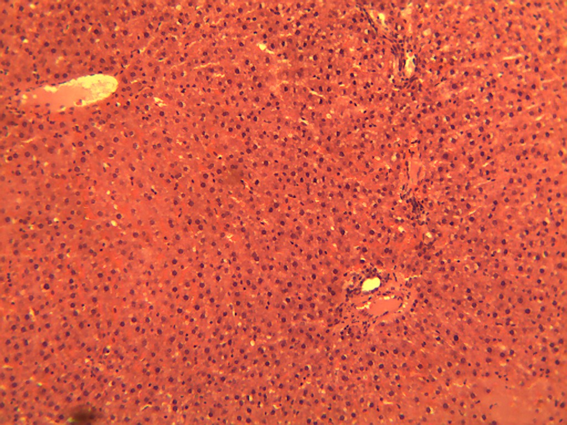
V
P
P
Plate 1: Photomicrograph of the liver from animals in group 1 (0.5 ml/kg normal saline) showing the normal hepatic histo-architecture. It shows hepatic chords around the central vein (V), radiating towards the portal areas (P). H & E x 100.

- THE LIVER (Group 2)
Effect of administration of aqueous extract of fermented seeds of Prosopis africana on the histology of the liver in group 2 animals.
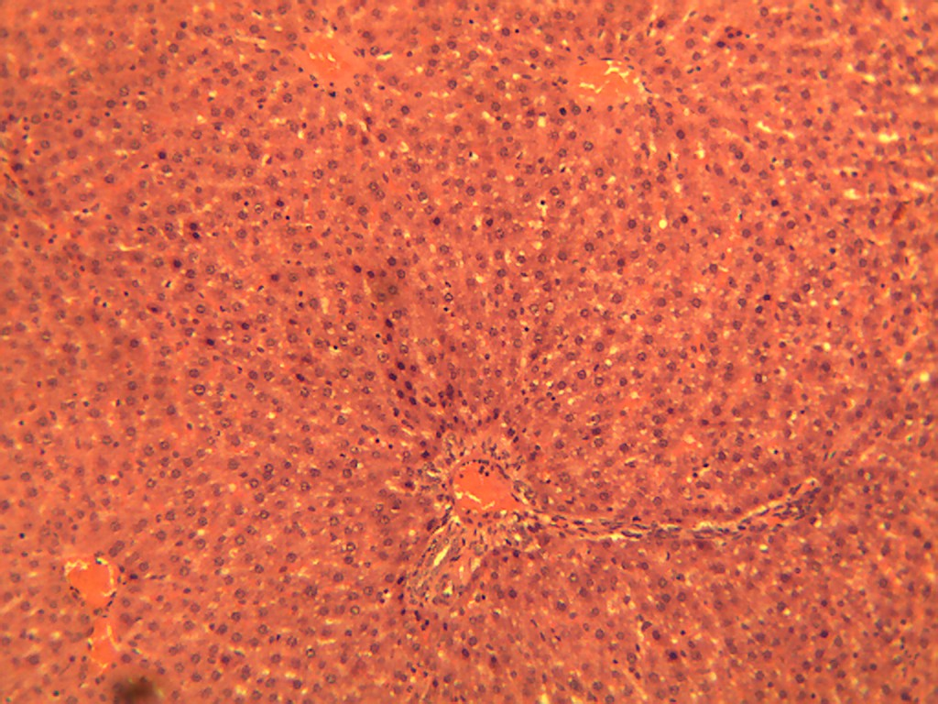
V
P
V
V
Plate 2. Photomicrograph of the liver from animals in group 2 (50 mg/kg extract) showing the normal hepatic histo-architecture. It shows hepatic chords around the central vein (V), radiating towards the portal areas (P). H & E x 100.

- THE LIVER (Group 3)
Effect of administration of aqueous extract of fermented seeds of Prosopis africana on the histology of the liver in group 3 animals.

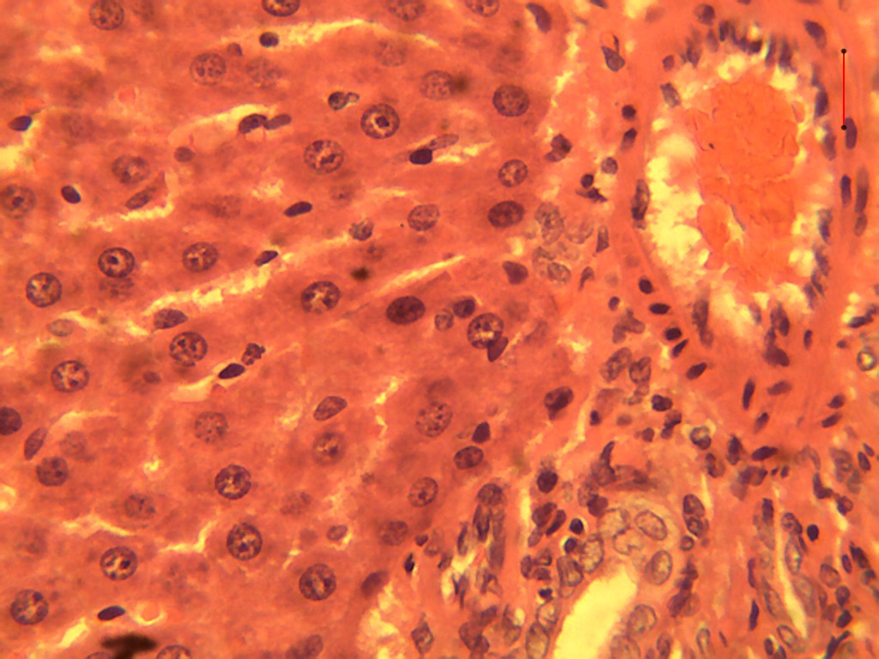
V
B
B
A
Plate 3. A photomicrograph of the liver from the animals in group 3 (100 mg/kg extract) showing the normal hepatic histo-architecture of the mammalian liver. The hepatocytes are arranged in chords (white arrow). Hepatic sinusoids (black arrow). Note the Portal area which consists of the portal triad [hepatic artery (A), hepatic vein (V) and the bile duct (B)]. H & E x 400.

- THE LIVER (Group 4)
Effect of administration of aqueous extract of fermented seeds of Prosopis africana on the histology of the liver in group 4 animals

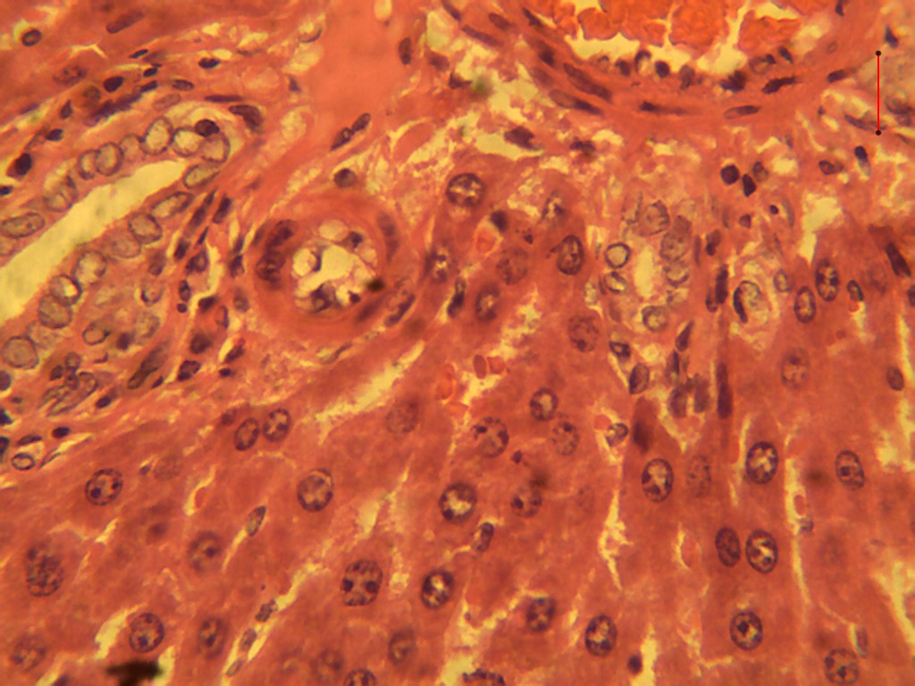Plate 4. A photomicrograph of the liver from group 4 animals (200 mg/kg extract), showing the normal hepatic histo-architecture of the mammalian liver. The hepatocytes are arranged in chords (white arrow). Hepatic sinusoids (black arrow). Note the portal area which consists of the portal triad [hepatic artery (A), hepatic vein (V) and the bile duct (B)]. H & E x 400.
V
A
B
B

- THE LIVER (Group 5)
Effect of administration of aqueous extract of fermented seeds of Prosopis africana on the histology of the liver in group 5 animals

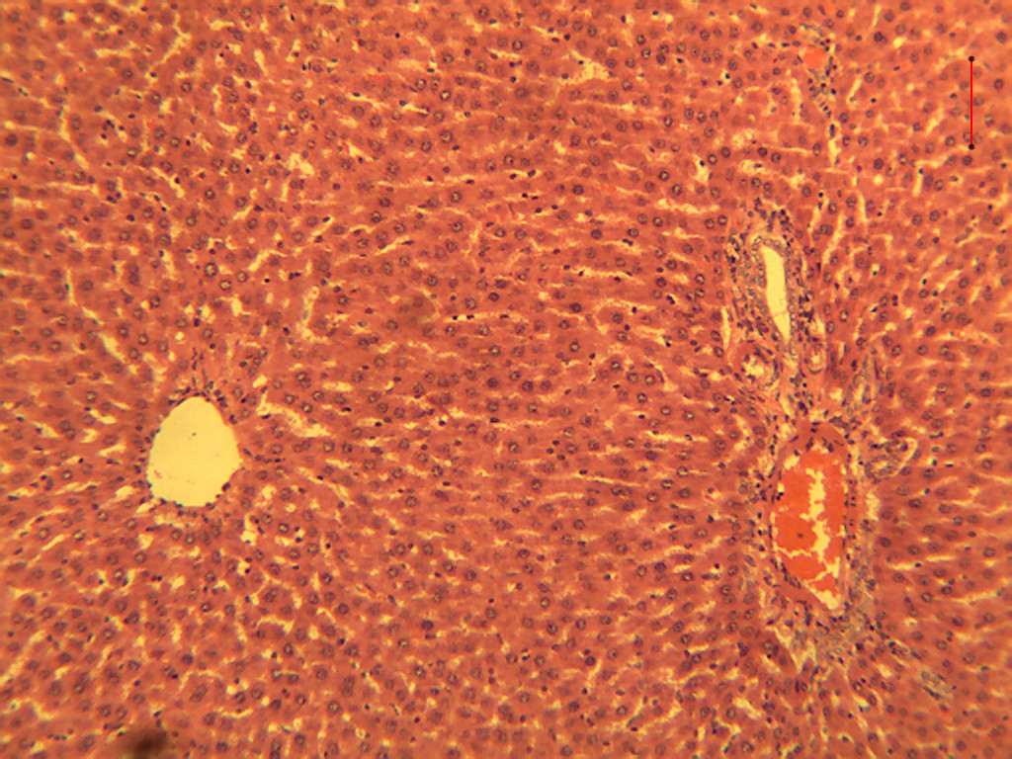
V
Plate 5. Photomicrograph of the liver from animals in group 5 (orlistat 12.5 mg/kg) showing the normal hepatic histo-architecture. The plate shows hepatic chords around the central vein (V), radiating towards the portal areas. Hepatic artery (black arrow); Hepatic vein (white arrow); Bile duct (blue arrow). H & E x 100.

3.5 Effects of Administration of Aqueous Extract of Fermented Seeds of Prosopis africana (Okpeye) on Histopathological changes in Kidney
Sections of the kidney collected from group 1 experimental animals at the end of the study period did not show any change from the normal mammalian renal histo-architecture in all the groups. The sections showed normal glomeruli in their Bowman’s capsules, embedded in a sea of normal renal tubules (proximal convoluted tubules, distal convoluted tubules, pars recta and collecting ducts) and renal interstitium.

- THE KIDNEY (Group 1)
Effect of administration of aqueous extract of fermented seeds of Prosopis africana on the histology of the kidney in group 1 animals

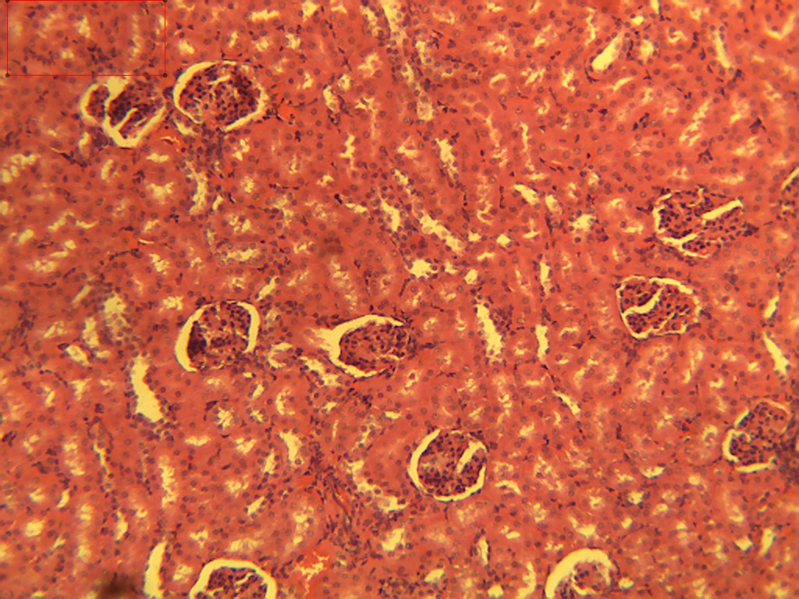
G
G
G
Plate 6. A photomicrograph of the kidney from the Group 1 animals (0.5 ml/kg normal saline) showing the normal renal histo-architecture. Glomerulus (G); Renal tubules (arrow). H & E x 100.

- THE KIDNEY (Group 2)
Effect of administration of aqueous extract of fermented seeds of Prosopis africana on the histology of the kidney in group 2 animals

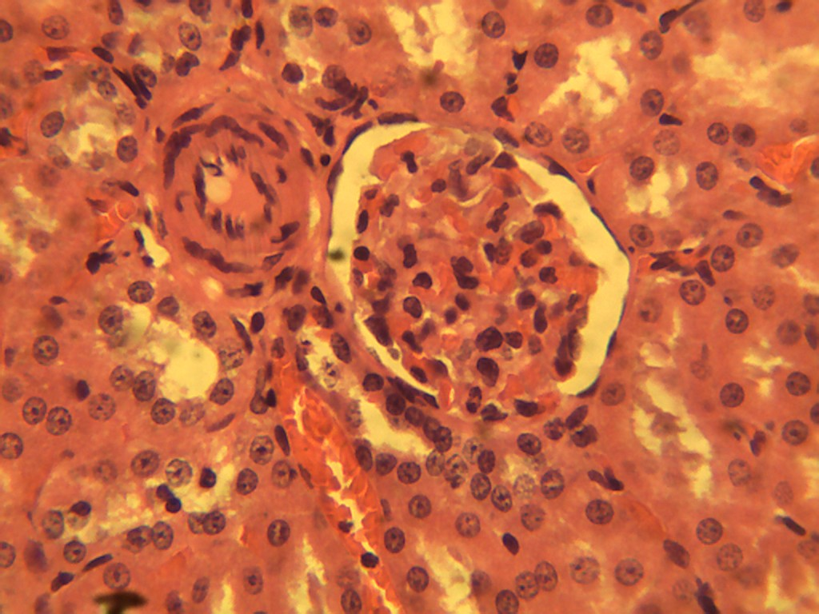
G
Plate 7. Photomicrograph of the kidney from the animals in group 2 (50 mg/kg extract)showing the normal renal histo-architecture. Glomerulus (G); Renal tubules (arrow); Bowman’s capsule (white arrow). H & E x 400.

- THE KIDNEY (Group 3)
Effect of administration of aqueous extract of fermented seeds of Prosopis africana on the histology of the kidney in group 3 animals

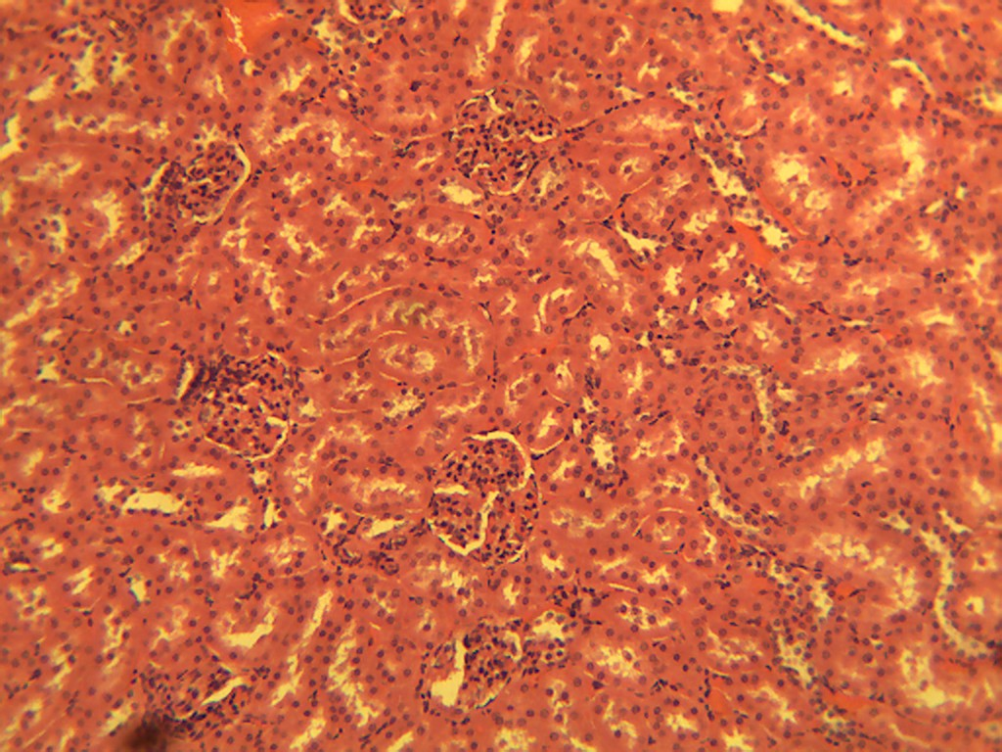
G
G
G
G
Plate 8. Photomicrograph of the kidney from the animals in group 3 (100 mg/kg extract) showing the normal renal histo-architecture. Glomerulus in Bowman’s capsules (G); Renal tubules (arrow);. H & E x 100.

- THE KIDNEY (Group 4)
Effect of administration of aqueous extract of fermented seeds of Prosopis africana on the histology of the kidney in group 4 animals

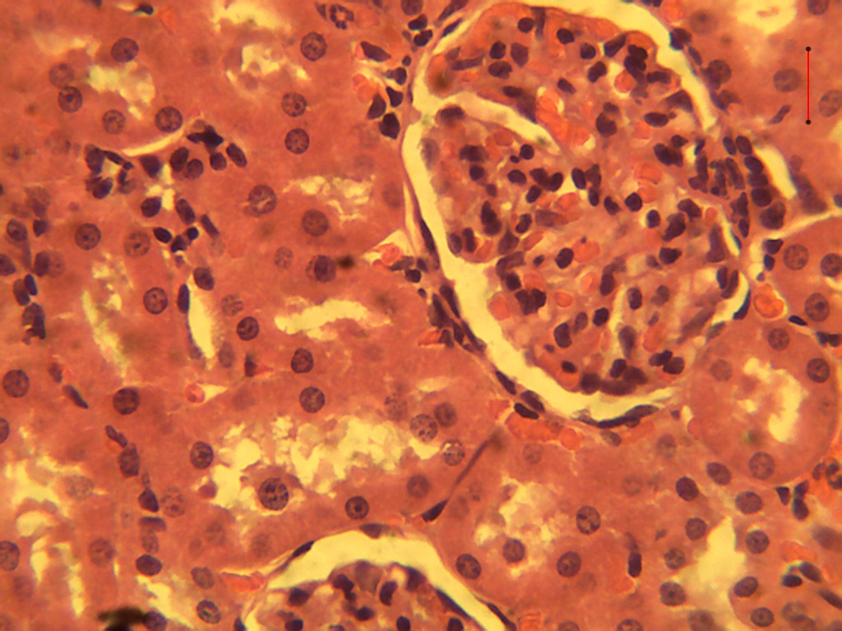
G
Plate 9. Photomicrograph of the kidney from the animals in group 4 (200 mg/kg extract) showing normal renal histo-architecture. Glomerulus (G); Renal tubules (arrow); Bowman’s capsule (white arrow). H & E x 400.

- THE KIDNEY (Group 5)
Effect of administration of aqueous extract of fermented seeds of Prosopis africana on the histology of the kidney in group 5 animals
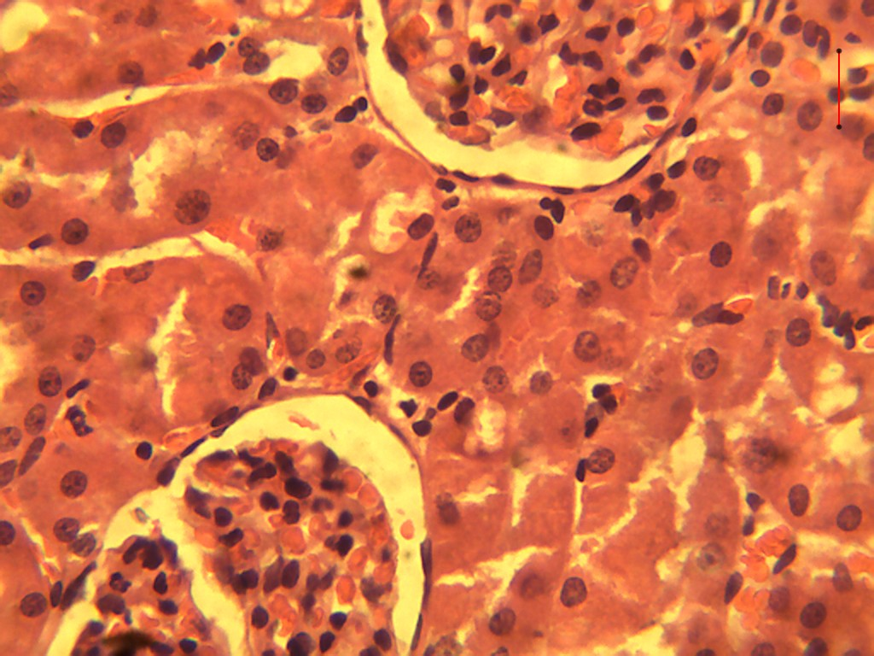
G
G
Plate 10. Photomicrograph of the kidney from group 5 (orlistat 12.5 mg/kg) showing the normal structures of the renal histo-architecture. Glomerulus (G); Renal tubules (arrow); Bowman’s capsule (white arrow). H & E x 400.

Discussion

The aim of this study was to assess the body weight and organ weight of albino rats fed with aqueous extract of fermented seeds of Prosopis africana and orlistat. Prosopis africana seeds are used in animal feed as fodder and in human food as a food condiment as Okpeye in Nigeria (Modesty et al., 2021). The result of the acute toxicity study (LD₅₀) test showed that there was no mortality or any significant change in the behavior of the mice that received 5000 mg/kg of the plant extract after 24h. This shows a high margin of safety. The extract is safe at a dose of 5000 mg/kg. Preclinical toxicity testing is one of the basic screenings required to generate important information about the potential damage of agents or new compounds to humans and is of utmost importance in drug development processes (Gupta et al, 2022). The United States Food and Drug Administration mentioned that the screening of new molecules for pharmacological activity and toxicity on animals is essential, as this reveals similar incidence of occurrence and severity in humans (Avila et al., 2020). From the result of the acute toxicity test, the extract showed that there was no mortality or any significant change in the behavior of the mice recorded up to the dose of 5000 mg/kg after 24 h toxicity test. Obesity is a global epidemic that is irrefutable & a serious health issue due to its several comorbidities including cancer, type II diabetes & cardiovascular illness (Soonmin et al., 2023). The effect of aqueous extract of fermented seeds of Prosopis africana on body weight of the animals showed that the body weight of animals in groups 2, 3, and 4 fed with 50mg/kg, 100mg/kg and 200mg/kg respectively, reduced significantly (p < 0.05) in the first week of measurements compared to the standard drug orlistat, while an increase in the body weight was observed in animals in groups 2, 3 and 4 compared to the animals in the control group 1. At the second week, the body weight of the animals at 50 mg/kg and 200 mg/kg increased significantly (p < 0.05) compared to the control group 1. Phytogenics are substances that come from plants such as spices, herbs, essential oils and other plant extracts. (Singh and Gaikwad 2020). Phytogenics have been utilized for countless years for both traditional uses and for their unique abilities as natural treatments (Alagbe et al., 2023). Among other biological actions, phytogenic substances have antioxidant, antibacterial, antifungal, antiviral, hepato-protective, and immune-stimulatory amongst others (Alagbe, 2022, Singh et al., 2021).
It was observed at the third week, that the body weight of animals at 50mg/kg showed a significant (p < 0.05) increase compared to animals in the control group 1. In this study, the improved body weight gain at the third week in the experimental rats fed with aqueous extract of fermented seeds of Prosopis africana may be as a result of extended days of feeding, as well as due to the activities of the constituents of these phytogenics that may be found in plant extracts.

Orlistat prevents hydrolysis of the dietary triglycerides (Carrière et al., 2001). The calorie deficit caused by decreased fat absorption is thought to be the main mechanism by which orlistat causes weight loss (Subramaniyan & Hanim, 2025). In this study, orlistat served as a positive control group. However, It was observed that the body weight of the animals treated with 12.5mg/kg orlistat increased significantly (p < 0.05) compared to the animals fed with 50, 100, and 200mg/kg body weight of extract at the first, second and third week. This result shows that fermented seeds of Prosopis africana extract if incorporated in the diet, may not increase the calorie intake.

Internal organ weight changes are sensitive and indicative marker for the first sign of toxicity when exposed to toxic substance (Taychaworaditsakul et al., 2024). This result showed a non-significant (p > 0.05) increase in the relative liver weight of animals in groups 2 ,3 and 4 which was dose dependent with respect to the control group. The increase in liver weight likely reflects enzyme adaptive hypertrophy and may not be as a result of toxicity. Report has shown that the protective and ameliorative effect of extract of Prosopis africana could be attributed to flavonoids and alkaloids in the extract and that Prosopis africana seeds extract are effective in regeneration of damaged liver cells by averting enzyme leakage into the bloodstream (Elijah et al., 2018).The result also showed that the relative liver weight of the animals fed with 100 mg/kg (4.43) and 200mg/kg extract (4.66) in groups 3 and 4 respectively, increased compared to the relative liver weight of the animals fed with the standard drug (12.5 mg/kg orlistat).
There was a slight increase in the relative liver weight of the animals fed with 200 mg/kg extract (4.66) in group 4 compared with relative liver weight of the animals fed with the standard drug (12.5 mg/kg orlistat) in group 5. The result also showed that there was a slight increase in the relative liver weight of the animals in group 5 fed with standard drug (orlistat 12.5 mg/kg) compared with the relative liver weight of the animals in group 1 fed with normal saline. The result also showed that the relative kidney weight of the animals fed with 50 mg/kg extract (0.7567), 100 mg/kg extract (0.7467) and 200 mg/kg extract in groups 2, 3 and 4 respectively, decreased non-significantly (p > 0.05) with respect to the relative kidney weight of the animals fed with normal saline in the control group 1 and group 5 animals fed with the standard drug (orlistat 12.5 mg/kg). However, the relative kidney weight of the animals fed with standard drug (orlistat 12.5 mg/kg) increased non-significantly (p > 0.05) compared to the animals in the control group 1. Orlistat is a chemically synthesized derivative of lipstatin which exerts its therapeutic activity in the lumen of the stomach and small intestine by forming a covalent bond with the active serine residue site of gastric and pancreatic lipases (Subramaniyan and Hanim, 2025). Pathological processes frequently involve the body’s normal responses to abnormal environmental influences. Such harmful peripheral influences as pathogenic microorganisms, trauma, dietary deficiencies and hereditary factors acting alone or in multifarious interaction with environmental factors cause diseases. A variety of environmental chemicals, industrial pollutants, and food additives have been implicated as causing harmful effects. Most food additives act either as preservatives, or enhancer of palatability (Awuchi et al., 2020). Histopathological investigations clearly demonstrates that aqueous extract of fermented seeds of Prosopis africana caused no significant adverse changes in the organs like kidney and liver. Abnormalities were also not observed in the organs at a dose of 50, 100, 200 mg/kg extract and 12.5 mg/kg orlistat respectively, compared to the animals in control group I. Histopathological sections of the liver in the control group and aqueous extract of fermented seeds of Prosopis africana treated groups at dosages of 50, 100 and 200 mg/kg extract showed normal lobular architecture. The portal tracts, hepatocytes, central veins, sinusoids are found to be normal. No evidence of toxic signs observed, as there is no inflammation, fatty change on fibrosis. Sections from kidney of control group 1 and aqueous extract of fermented seeds of Prosopis africana treated groups at different dosages of 50, 100, and 200 mg/kg extract showed normal cortex and medulla. The cortex showed normal glomeruli. The interstitium and distal convoluted tubules are found to be normal. No inflammation or tubular necrosis was observed. Obode et al (2020) reported that the extract of fermented seeds of Prosopis africana did not cause any adverse effect on both the liver and the kidney.

4. Conclusion

The experimental findings showed that the extract of fermented seeds of Prosopis africana did not cause any adverse effect on both the liver and the kidney. This suggest that the extract could also be used to formulate a calorie deficit condiment in the diet. Incorporation of fermented seeds of Prosopis africana in the diet sparingly, may not increase the body weight. However, if the food condiment is incorporated in the diet for a longer period of time, it might increase the body weight.

Ethical approval (where ever applicable)

All authors involved in this research hereby declare that "Principles of laboratory animal care" (NIH publication No. 85-23, revised 1985) were followed, as well as specific national laws where applicable. All experiments have been examined and approved by the appropriate ethics committee”

COMPETING INTERESTS DISCLAIMER:
Authors have declared that they have no known competing financial interests OR non-financial interests OR personal relationships that could have appeared to influence the work reported in this paper.

Disclaimer (Artificial intelligence)
Option 1:
Author(s) hereby declare that NO generative AI technologies such as Large Language Models (ChatGPT, COPILOT, etc.) and text-to-image generators have been used during the writing or editing of this manuscript.
Option 2:
Author(s) hereby declare that generative AI technologies such as Large Language Models, etc. have been used during the writing or editing of manuscripts. This explanation will include the name, version, model, and source of the generative AI technology and as well as all input prompts provided to the generative AI technology
Details of the AI usage are given below:
1.
2.
3.

References

[1] Oluwafemi, R. A., Agubosi, O. C. P., and Alagbe, J. O. (2021) "Proximate, minerals, vitamins and amino acid composition of Prosopis africana (African mesquite) seed oil." Asian J Adv Res, 4(1), 1011-1017.
[2] Akpata, E. I., & Ani, O. N. (2023). Evaluation of anti-inflammatory and antiulcer effects of aqueous extract of fermented seeds of Prosopis africana (okpeye) in albino rats in FANS 1st annual conference: microcrystalline cellulose from oil bean pod; extraction and characterization, 146-155.
[3] Tiwari, M., Dhingani, R., Goyal, N., Joshi, B. & Prasad, R.V. (2023). Solid‐state fermentation. Microbes in the Food Industry, 355-392.
[4] Ravhuhali, K. E., Mudau, H. S., Moyo, B., Hawu, O., & Msiza, N. H. (2021). Prosopis species—an invasive species and a potential source of browse for livestock in semi-arid areas of South Africa. Sustainability, 13(13), 7369.
[5] Asiru, R. A. (2024). Physicochemical and sensory properties of fermented Prosopis africana seeds: physicochemical and sensory. Indonesian Journal of Health Sciences Research and Development, 6(2), 1-11.
[6] Houètchégnon, T., Gbèmavo, D. S. J. C., Ouinsavi, C. A. I. N., & Sokpon, N. (2015). Structural Characterization of Prosopis africana Populations (Guill., Perrott., and Rich.) Taub in Benin. International Journal of Forestry Research, 1, 101373.
[7]Igwe, C. U., Ojiako, O. A. Anugweje, K. C. Nwaogu, L. A. and Ujowundu, C. O. (2012). Amino acid profile of raw and locally processed seeds of Prosopis africana and Ricinus communis: potential antidotes to protein malnutrition. Functional Foods in Health and Disease, 2(4): 107-119

[8]Yel, K., Şencan, D., Güzel, S., & Erkılıç, A. O. (2024). Physical activity, nutrition, and healthy living. International Journal of Health, Exercise, and Sport Sciences, 1(3), 15-28.
[9]Shao, T., Verma, H. K., Pande, B., Costanzo, V., Ye, W., Cai, Y., & Bhaskar, L. V. K. S. (2021). Physical activity and nutritional influence on immune function: an important strategy to improve immunity and health status. Frontiers in Physiology, 12, 751374.

[10]Hassani, M. (2022). Liver structure, function and its interrelationships with other organs: a review. Int J Dent Med Sci Res, 4(1), 88-92.
[11]Ozougwu, J. C. (2017). Physiology of the liver. International Journal of Research in Pharmacy and Biosciences, 4(8), 13-24.
[12]Yang, L. L. (2020). Anatomy and physiology of the liver. In Anesthesia for Hepatico-Pancreatic-Biliary Surgery and Transplantation (pp. 15-40). Cham: Springer International Publishing.
[13] Li, X., Zheng, S., & Wu, G. (2020). Amino acid metabolism in the kidneys: nutritional and physiological significance. Amino Acids in Nutrition and Health: Amino acids in systems function and health, 71-95.
[14]Dibal, N. I., Garba, S. H., & Jacks, T. W. (2022). Histological stains and their application in teaching and research. Asian Journal of Health Sciences, 8(2), ID43-ID43.
[15] Liu, S., Yu, J. M., Gan, Y. C., Qiu, X. Z., Gao, Z. C., Wang, H., & Hou, H. H. (2023). Biomimetic natural biomaterials for tissue engineering and regenerative medicine: new biosynthesis methods, recent advances, and emerging applications. Military Medical Research, 10(1), 16.
[16]Cirielli, V., Bortolotti, F., Cima, L., De Battisti, Z., Del Balzo, G., De Salvia, A., & Brunelli, M. (2021). Consultation between forensic and clinical pathologists for histopathology examination after forensic autopsy. Medicine, Science and the Law, 61(1l), 25-35.
[17]Sabino, R., & Wiederhold, N. (2022). Diagnosis from tissue: histology and identification. Journal of Fungi, 8(5), 505.
[18]Soonmin, H., Akram, M., Laila, U. & Khalil, M. I. (2023). Nutrition and Obesity; review. International Journal of Frontline Research in Chemistry and Pharmacy, 2(1): 001 – 004
[19]Zarei, F., Taib, M. & Zarei, M. (2014). Nutrition and weight management knowledge, dietary intake and body weight staus in Iranian postgraduate students in Universiti Putra Malaysia. Pakistan Journal of Nutrition, 13(6): 351-358.
[20]Ogunshe, A.A.O., Omotosho, M.O. and Ayanshina, A.D.V. (2007). Microbial studies and biochemical characteristics of controlled fermented Afiyo-a Nigerian fermented food condiment from Prosopis africana (Guill and Perr.) Taub. Pakistan Journal of Nutrition, 6: 620- 627.

[21]Lorke, D. (1983). A new approach to practical acute toxicity testing. Archives of Toxicology, 53: 275-289.
[22]Akhtar, N., Srivastava, M. K. & Raizada, R. B. (2009). Assessment of Chlorpyrifos toxicity on certain organs in rat rattus norvegicus. Journal of Environmental Biology, 30(6): 1047 – 1052.
[23]Drury, R. A., Wallington, A. and Cameroun, S. R. (1967). Carleton’s Histological Techniques. 4th Edn. Oxford University Press, New York. pp 279 – 280.

[24]Modesty, G., Brice. K., Brice, A., Aymard, A. & Rene, D. (2021) Literature review on Prosopis africana and the use of essential oils as preservatives. IOSR Journal of Environmental Science, Toxicology and Food Technology. 15(10): 27-34
[25] Gupta, R., Polaka, S., Rajpoot, K., Tekade, M., Sharma, M. C., & Tekade, R. K. (2022). Importance of toxicity testing in drug discovery and research. Pharmacokinetics and toxicokinetic considerations (pp. 117-144).
[26] Avila, A. M., Bebenek, I., Bonzo, J. A., Bourcier, T., Bruno, K. L. D., Carlson, D. B.,Elayan, I., Harrouk, W., Lee, S.L., Mendrick, D. L., Merrill, J. C., Peretz, J., Place, E., Saulnier, M., Wange, R. L., Yao, J., Zhao, D., & Brown, P. C. (2020). An FDA/CDER perspective on nonclinical testing strategies: Classical toxicology approaches and new approach methodologies (NAMs). Regulatory Toxicology and Pharmacology, 114, 104662.
[27] Alagbe, J. O., Agubosi, O.C.P., & Oluwafemi, R. A. (2023). Effects of dietary supplementation of Prosopis africana (African mesquite) essential oil on the growth performance, nutrient retention and oxidative stress indices of broiler chicken. Discovery 59:1-10
[28]Alagbe, J. O. (2022). Prosopis africana (African mesquite) oil as an alternative to antibiotic feed additives on broiler chickens diets: Performance and nutrient retention. Discovery; 58 (314):134-142
[29]Singh, J., & Gaikwad, D. S. (2020). Phytogenic feed additives in animal nutrition. In Natural bioactive products in sustainable agriculture. Singapore: Springer Singapore. Pp273-289
[30]Carrière, F., Renou, C., Ransac, S., Lopez, V., De Caro, J., Ferrato, F., & Laugier, R. (2001). Inhibition of gastrointestinal lipolysis by Orlistat during digestion of test meals in healthy volunteers. American Journal of Physiology-Gastrointestinal and Liver Physiology, 281(1), G16-G28.
[31]Subramaniyan, V., & Hanim, Y. U. (2025). Role of pancreatic lipase inhibition in obesity treatment: Mechanisms and challenges towards current insights and future directions. International Journal of Obesity, 1-15.
[32]Taychaworaditsakul, W., Saenjum, C., Lumjuan, N., Chawansuntati, K., Sawong, S., Jaijoy, K., ... & Sireeratawong, S. (2024). Safety of oral Carica papaya L. leaf 10% ethanolic extract for acute and chronic toxicity tests in sprague dawley rats. Toxics, 12(3), 198.
[33]Elijah, J. P., Anosike, J. C., Okpashi, V. E and Nwodo, O. F. C. (2019) Paracetamol-induced liver damage and effect of Prosopis Africana seeds extract on liver marker enzymes of wistar albino rats. Parkistan Journal of Scientific and Industrial Research Series B: Biological Sciences. 62B (3) 164 – 171
[34]Awuchi, C. G., Twinomuhwezi, H., Igwe, V. S., & Amagwula, I. O. (2020). Food additives and food preservatives for domestic and industrial food applications. Journal of Animal Health, 2(1), 1-16.
[35] Obode, O. C., Adebayo, A. H., Omonhinmin, C. A., & Yakubu, O. F. (2020). A systematic review of medicinal plants used in Nigeria for hypertension management. International Journal of Pharmaceutical Research, 12(4). 1-46

