Original Research Article
Faculty Readiness and Perceptions of AI in Commerce Education: Evidence from Chhatrapati Sambhajinagar City,India

Abstract:
This research paper focuses on the role of AI in commerce education, particularly examining faculty perceptions and readiness in colleges across Chhatrapati Sambhajinagar City. The study reveals that many commerce faculty members are not yet prepared to integrate AI tools into their teaching practices. A sample of 56 faculty members was selected based on their willingness to respond to the questionnaire. The findings show that 80% of faculty members are beginners in AI proficiency, while 89% express a strong interest in AI training to enhance their teaching and learning processes. ChatGPT is the most widely used AI tool, with 61% of faculty members utilizing it, surpassing other tools like Perplexity, Coursera, and Grammarly. The results of the Chi-Square test indicate no statistically significant relationship between teaching experience and the preference for AI tool usage. The study also highlights several challenges, including concerns over data manipulation, misappropriation, authenticity, and security. Some teachers express fears of job replacement due to AI, but they also recognize its advantages, such as automating administrative tasks, improving research and data analysis, aiding in content creation and lecture planning, and enhancing personalized student learning. Extending beyond the teacher’s availability with their students but continuing to deliver on the teacher’s intent. (Miguel A. Cardona, Ed. D. and Roberto J. Rodriguez, 2023). Overall, AI offers significant benefits to the teaching and learning process, from curriculum design to implementation. It is evident that AI technology will create numerous opportunities and profoundly shape the future of education.
Keywords: Artificial Intelligence, Commerce Education, Teacher Proficiency, AI tools and technology
Introduction:
AI is rapidly transforming various sectors of society, including marketing, finance, healthcare, insurance, and tourism. Among the most promising areas for AI integration is education, where the technology has the potential to revolutionize teaching and learning. AI can offer advanced software, systems, methodologies, and models to enhance educational practices (Ahmat Gocen & Fatih Aydemir, 2020). It is reshaping key aspects of education, from curriculum design and course delivery to content creation and distribution (Muhammad Tahir, Farha Deeba Hassan, Mudasir Rahim Shagoo, 2024).
In the classroom, teachers play a central role, but their teaching methods must also adapt to be effective. When teachers are equipped with AI tools, they can enhance presentations, conduct research more efficiently, and better monitor student progress. For example, AI-powered tools like the Perplexity tool can assist teachers in research, saving both time and resources. Additionally, AI enables more personalized interactions between teachers and students, optimizing both the curriculum and individual learning experiences (Bidisha Borchetia & Mridula Hazarika, 2024).
The success of AI in education hinges largely on the preparedness and confidence of teachers. For AI to be truly effective, teachers need to be both willing and ready to embrace these tools. Building teacher confidence in AI’s relevance and utility is crucial, as it empowers them to integrate AI into their teaching practices. Teachers should feel confident in using AI, not only in their classrooms but also as part of their curriculum, helping students better understand the technology and its social implications (Musa Adekunle, Ismaila Temitayo, Owolabi Paul, Kahinde D, Solomon, 2022). This broader adoption of AI aims to improve access to education, enhance teaching and learning processes, and strengthen educational outcomes (Garcia-Chitiva, M. P.; Valdés Ramirez, D.; Zavala, G.; Vázquez-Villegas). AI is also transforming educational administration, streamlining tasks such as curriculum management, student support, and resource allocation by automating repetitive functions, offering personalized guidance, and providing data-driven insights. Tools like AI-powered ChatGPT have become invaluable for students, assisting them with assignments and learning tasks. This highlights the need for educators to adapt their assessment strategies and foster AI literacy to ensure that both students and teachers are equipped for the future of education (Ezequiel Molina, Cristobal Cobo, Jasmine Pineda, & Helena Rovner, 2024).
Literature Review:
The AI guide book proposed the activities of specific areas of artificial intelligence. The subject areas and activities are practical applications, reinforcement learning, search algorithms, neural networks, AI ethics and philosophy. These subject areas are significant to be familiar with AI. It helps to get practical enough to do all possible activities. (AI in Education, 2019). Artificial intelligence has many benefits rather than its drawbacks in education and schools. In the study of (Ahmat Gocen and Fatih Admire, 2020), while teachers see AI in the education is beneficial, but academicians seem to agree less with this idea and focus on more negative aspects. Educational institutions are updating their course curriculum to confirm that learners are getting skills required for rapidly evolving future workplace, with changes occurring across the board in every instructional division, from childhood education. Contemporary AI technologies are having substantial impact on education system. We are in the beginning stage of organizing holistic approach of AI in education. It can lead to create a well-organized policy, plan in education. Therefore, AI industries collaborate with other sectors when beginning the development of framework (Sonya Yeprem, 2022). AI is applied to examine enormous quantities of data to find trends and insights that might guide to create new education policies and plans. The way AI is transforming how students learn and how a teacher should teach is having an immense effect on higher education in India. AI is crucial in education system to ensure high quality education. It has begun to transform how teachers and students interact with each other, from providing customized learning experiences to curriculum optimization (Bidisha Borchetia and Mridula Hazarika, 2024). It is crucial to address any barriers that may impede the successful integration of AI tools into curriculum design. Faculty needs adequate training and support to enhance their confidence in using AI technology. Colleges can develop mentorship programs to bridge the knowledge gap and encourage faculty of all ages to embrace AI in their teaching (Dr. Rakhi Gulati, 2024). Shaping the attitude and behavior of faculty are essential towards AI. Dynamic surroundings faculty engagement with AI has significance to get good results in education. Such insights would reflect to educational policymakers, administrators and practitioners seeking to harness the full potential of AI technologies in teaching and learning context. The collaboration between faculty, administrators, technologists and ethicists to navigate the complex ethical, pedagogical and practical considerations associated with AI adoption in higher education. (Nevárez Montes J and Elizondo-Garcia J, 2025).
Objectives:
1. To explore the current status of AI integration in teaching, pedagogical and ethical concerns.
2. To identify AI technologies and tools being implemented in educational settings for personalized learning, student engagement and other administrative work.
3. To find out the AI tools used by commerce teachers and analyze their perception and readiness to cope with AI.
4. To study the need and importance of AI training, to be more proficient in teaching profession.
5. To analyse the positive and negative impact of AI on education sector including teachers, students, educational institutions etc.
Scope:
Artificial intelligence has impacted on teachers as well as students. The AI tools and technology embraced educational institution to prepare and execute effective curriculum. In Chhatrapati Sambhajinagar City, teachers have challenges to cope with AI tools and technology. By using AI tools, a teacher can be more dynamic, specific and innovative. The scope includes use of AI in education, significance of AI training, challenges faced by teachers during its use and opportunities in AI. The research is based on primary data with some recent literatures, policy reports, and examples of practical implementations. Emphasis is given to AI tools, teacher’s experience and social context that influence AI usage in education. Teachers would do impressive research work and impactful presentation with the help of AI, even they can do their all academic or official work through AI. AI can create such a good connection between teachers and students through curricular and co-curricular activities. AI is assisting all framework or activities relevant to education like formation of policies and plans about curriculum.
Limitations:
This research study has several limitations. First, it relies on primary data, and due to the use of convenient sampling methods, there is a possibility of errors in data validation. As a result, the sample size may not fully represent the entire population. Additionally, secondary data sources, such as published literature and reports, might not capture the real-time challenges associated with AI implementation. Second, the study is geographically limited to Chhatrapati Sambhajinagar City, which may not fully reflect the diversity of the broader district due to variations in available data. Third, regional differences in infrastructure, policy, and cultural attitudes toward AI may limit the ability to generalize the findings. Finally, the study does not probe into the technical aspects of AI systems or software performance, instead focusing on the educational outcomes and trends.
Statement of the problem:
AI is one of the most popular and in-demand technologies today, and it is on the verge to bring about significant changes in education, transforming traditional systems. Chhatrapati Sambhajinagar, with its predominantly rural background, presents unique challenges. Many students and teachers come from rural areas where the language of instruction, particularly for commerce subjects, is often local. This cultural and linguistic shift requires time and effort to adapt to the integration of AI into both the curriculum and co-curricular activities.
Awareness and familiarity with AI remain limited, with many teachers, especially those with more experience, struggling to adjust to AI tools. As a result, they face challenges in effectively utilizing AI applications. Tools such as ChatGPT, Grammarly, and Perplexity are essential for enhancing teaching, yet teachers need time to master these tools and integrate them into their workflow. AI proficiency significantly impacts a teacher’s classroom performance and overall contributions to the institution. Despite these challenges, teachers cannot afford to ignore the role of AI in their profession. However, limited access to AI training resources and insufficient infrastructure further complicate their ability to effectively work with these technologies.

Hypotheses:
H₀ There is no significant relationship between popular AI tools and teaching experience of teachers.
H₁ There is a significant relationship between popular AI tools and teaching experience of teachers.
Methodology:
The present research adopts a descriptive research method aimed at investigating the use of AI tools in teaching and learning pedagogy among commerce faculty members. The study explores faculty perceptions, their readiness to integrate AI tools into the commerce curriculum, and the broader impact of AI on the teaching and learning process. Data was collected via an online Google Forms survey, which was distributed to a sizable sample within a specific timeframe, aligning with the study's objectives and constraints. Participants were selected using a convenience sampling method, targeting only commerce faculty members from 13 traditional colleges in Chhatrapati Sambhajinagar City. A total of 56 faculty members were chosen based on their willingness to complete the questionnaire. The survey consisted of a structured questionnaire divided into four sections: Demographic Profile, AI Familiarity and Usage, Proficiency and Attitudes, and Perceived Benefits and Challenges. It included Likert-scale items to measure faculty beliefs, confidence levels, and the perceived impact of AI integration on the curriculum. The collected data is presented in tabular form and analyzed using simple averages, percentages, correlations, and regression techniques. The analysis leads to the interpretation of the study's key findings.

Results and Findings: Demographic Profile
Figure 1: Age Distribution
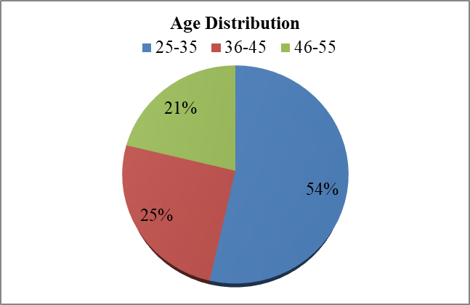
Source: Filed data
The study revealed that the majority of participants, 54%, fall within the 25 to 35 age group. This younger cohort of educators demonstrates a strong curiosity about AI and its applications in education. The other age groups—36 to 45 and 46 to 55—account for 25% and 21% of the participants, respectively. Regardless of age, a teacher's eagerness to understand the importance and value of AI in today’s educational landscape is crucial to their effectiveness. As we know, learning is a lifelong process, and a great teacher has the capacity to absorb and integrate new knowledge at any stage of their career, at any time, and from anywhere. (Figure 1)

Figure 2: Gender Distribution
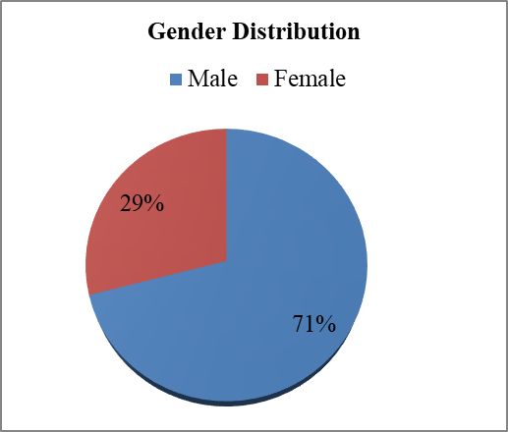
Source: Filed data
The chart reveals that more than 71% of the participants are male, compared to 29% female participants. In Chhatrapati Sambhajinagar, the majority of college teachers are male. However, regardless of gender, all educators in the teaching profession must adapt to AI tools and technology in order to work more efficiently and effectively. AI offers a wide range of platforms and opportunities, benefiting everyone across society, particularly in the field of education. (Figure 2)

Figure 3: Educational Qualifications
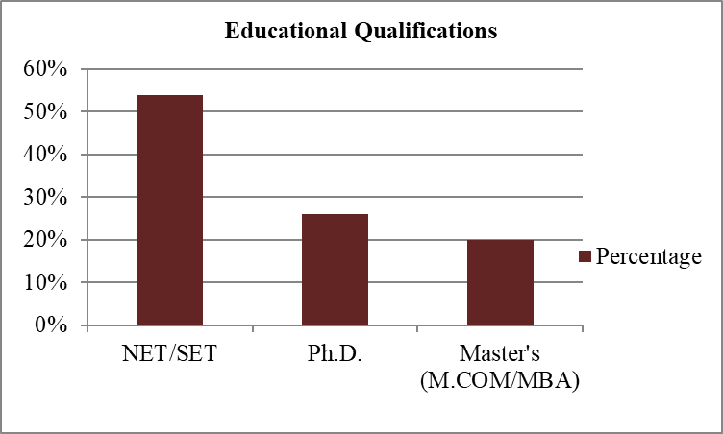
Source: Filed data
The survey shows that 54% of teachers have qualified for NET/SET, while 26% have completed their research and been awarded a Ph.D. Additionally, 20% of teachers hold an M.Com/MBA, and it appears many of them are preparing for NET/SET exams or pursuing their Ph.D. AI can play a significant role in assessing and enhancing knowledge. By leveraging AI tools, teachers can create optimal learning platforms for their students. With the aid of technology, educators can become more professional, dynamic, and efficient, adopting innovative teaching methods that improve the overall learning experience. (Figure 3)
Table 1: Teaching Experience
Frequency | Midpoint | Number | Percentage
0-5 years | 2.5 | 2 | 4%
6-10 years | 8 | 3 | 5%
11-15 years | 13 | 49 | 88%
16-20 years | 18 | 2 | 3%
More than 20 years | 22 (assumed) | 0 | 0%
Average Mean | 12.5 Years
Source: Field Data
Figure 4: Teaching Experience
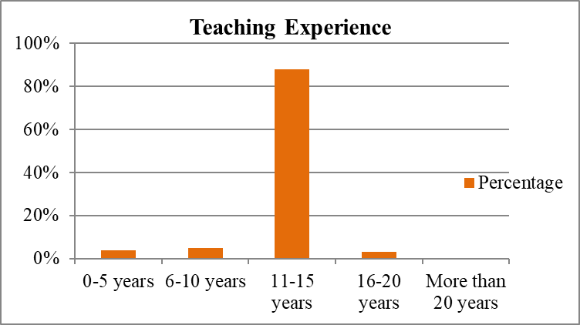
Source: Filed data
The survey results indicate that the workforce is predominantly composed of mid-career professionals, with an average (mean) experience of 12.5 years. A more balanced distribution of experience is crucial for long-term sustainability, growth, and innovation. Teachers with 11-15 years of experience represent the largest group, accounting for 88%, while those in the 6-10 years range make up 5%, and those with 0-5 years of experience constitute 4%. Only 3% of teachers have 16-20 years of experience. While experienced teachers bring valuable knowledge, they must also become proficient with AI technology to enhance class presentations and manage administrative tasks effectively. Students tend to have higher expectations from more experienced teachers, and administrators also assign them greater responsibilities due to their expertise. Thus, it is essential for all educators, especially those with extensive experience, to gain a command over AI tools in order to perform both academic and administrative duties efficiently. (Table 1 and Figure 4)

Figure 5: Familiarity with AI
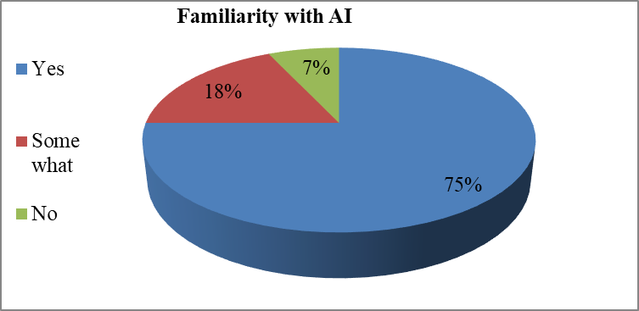
Source: Filed data
The figure above indicates that most participants (75%) are familiar with AI, followed by 18% who have some familiarity, and 7% who are unfamiliar with AI. A lack of familiarity with AI may hinder both the performance and growth of teachers, as it is increasingly difficult to thrive in the teaching profession without it. Teachers who are familiar with AI have the opportunity to continually learn and develop professionally. Familiarity with AI boosts confidence and encourages teachers to move forward with new approaches. Embracing AI fosters the acquisition of fresh ideas, which ultimately leads to more effective teaching practices. (Figure 5)

Figure 6: Use of AI Tools
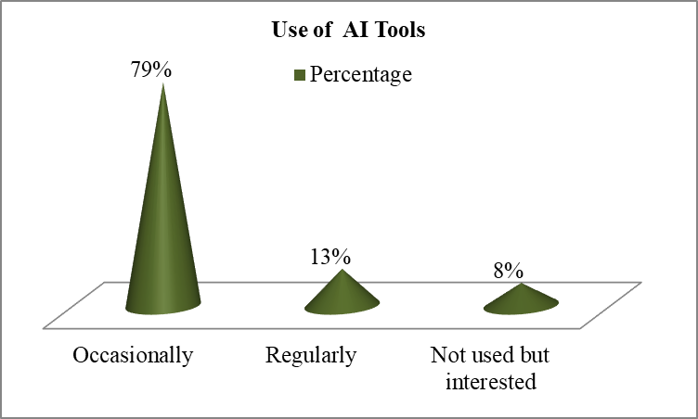
Source: Filed data
The data on AI tool usage indicates that 79% of teachers use AI tools occasionally, while only 13% regularly integrate AI into their curriculum and other educational tasks. A reluctance or fear of using AI could hinder a teacher's ability to meet the demands of modern education. It is becoming clear that a teacher who embraces AI will have a distinct advantage over one who does not. Even highly educated and talented teachers who show little interest in using AI (8%) are likely to face significant challenges in the teaching profession moving forward. (Figure 6)
Table 2: Most Popular AI Tools
Tool | Number | Percentage | Weighted Mean
ChatGPT | 34 | 61% | 1
Grammarly | 9 | 16% | 2
All AI tools | 8 | 14% | 3
Perplexity | 3 | 5% | 4
Coursera | 2 | 4% | 5
Weighted Mean |  |  | 1.75
Source: Filed data

Figure 7: Most Popular AI Tools
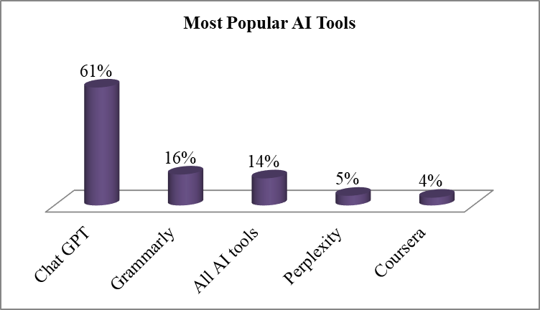
Source: Filed data
Our study reveals that average users tend to prefer top-ranked AI tools, with ChatGPT being the most popular, widely used across various professions. The weighted mean rank of 1.75 indicates a preference for diversifying the use of strong AI tools to enhance overall digital productivity. Tools like ChatGPT and GPT-4 are reshaping the academic landscape, influencing the future of teaching and assessment (Jorg Von Garrel & Jana Mayer, 2023). Grammarly is known to only 9 teachers (16%), followed by Perplexity (5%) and Coursera (4%). A small group of teachers (14%) believe that all AI tools are equally popular. Grammarly is particularly useful for improving English language skills, while Perplexity supports research development. Today, AI tools are gaining popularity, helping educators streamline curriculum implementation, such as creating Power Point presentations, drafting subject notes, and composing proposals or letters in a fraction of the time. (Table 2 and Figure 7)

Figure 8: Proficiency and Attitudes:
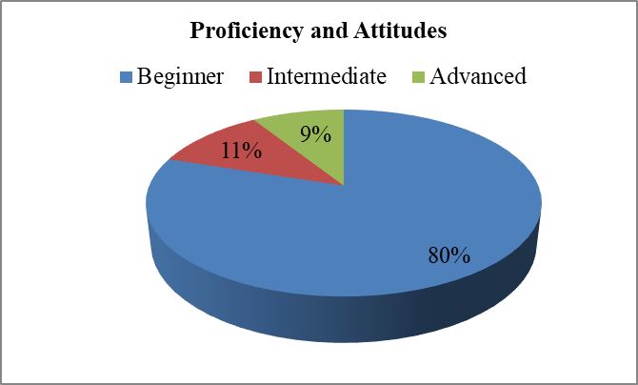
Source: Filed data
The data indicates that 80% of participants are beginners in AI proficiency, followed by 11% at the intermediate level and 9% at the advanced level. Both beginners and intermediates have the opportunity to expand their knowledge and skills in AI, while advanced users have already mastered AI tools and are reaping the benefits. Proficiency in AI is achieved through consistent practice, and even basic literacy in AI is becoming increasingly important. While some fear that the rapid rise of AI could disrupt teaching and learning, research and discussions emphasize the need for educators to gain proficiency in AI tools to remain competitive in their professions. As the cornerstone of society, teachers play a pivotal role in shaping students' development; therefore, they must transcend the boundaries of AI to fully harness its potential. (Figure 8)
Table 3: Beliefs about AI Enhancing Commerce Education
Frequency | Number | Percentage | Mean Value
Strongly Agree | 27 | 48% | 5
Agree | 22 | 39% | 4
Neutral | 7 | 13% | 3
Disagree | 0 | 0% | 2
Mean Value |  |  | 4.36
Source: Filed data
Figure 9: Beliefs about AI Enhancing Commerce Education
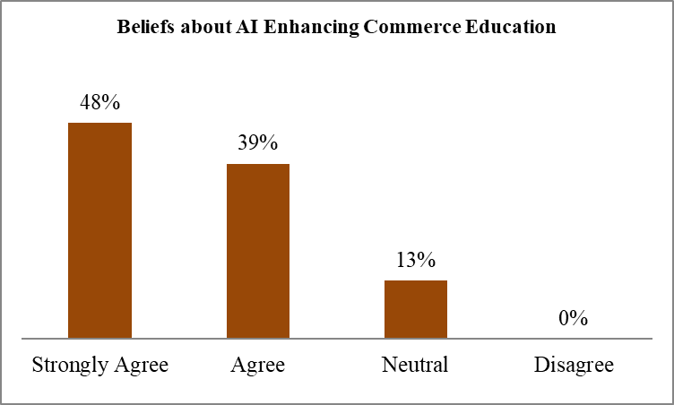
Source: Filed data
The survey results clearly indicate strong agreement, with a mean score of 4.36, reflecting that the majority of participants are supportive and satisfied, with no negative sentiments. Specifically, 48% of respondents strongly agreed that AI can enhance commerce education, while 39% agreed and 13% were neutral. AI offers numerous platforms that allow both teachers and students to improve their skills and the quality of their work. Teachers can analyze research data and derive insights through tools like Claude AI, while students can create PowerPoint presentations with the help of ChatGPT. Notably, no respondents disagreed with the statement that AI can enhance commerce education, demonstrating a remarkable openness to technological integration. This suggests that teachers, students, and other educational stakeholders recognize the significance of AI in both the education system and daily life. (Table 3 and Figure 9)

Figure 10: Interest in AI Training
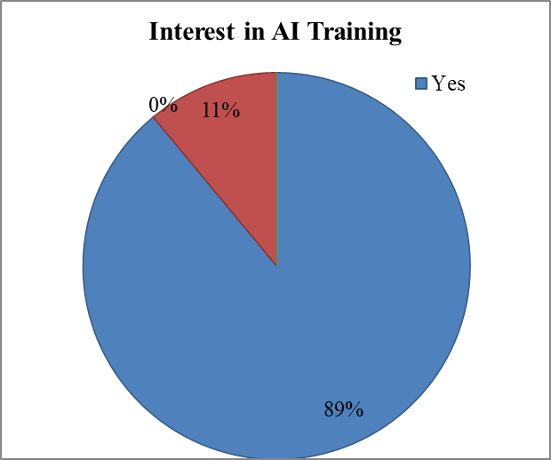
Source: Filed data
AI training offers numerous opportunities, ranging from curriculum design to its execution. As curricula evolve in response to innovation, technology, and industry and societal needs, teachers must stay updated and proficient with these advancements. AI training is poised to bring a transformative shift to the future of education. The figure above shows that a significant majority of teachers (89%) are interested in AI training, while the remaining 11% are undecided. This indicates a strong awareness of AI among educators, coupled with a clear desire to enhance their skills through training. Teachers are not intimidated by AI; rather, they are eager to learn how to use AI tools, recognizing the immense value they bring to modern education. (Figure 10)

Figure 11: Perceived Benefits and Challenges
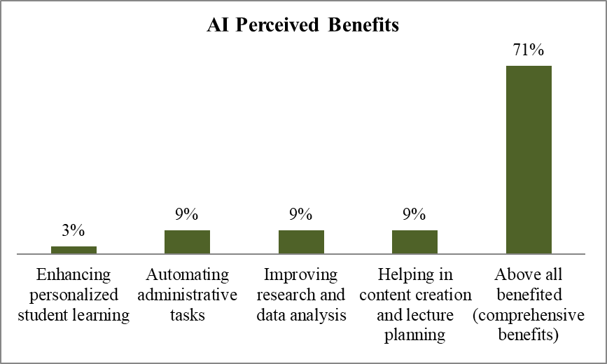
Source: Filed data
Commerce education, recognizing its advantages across multiple dimensions rather than in isolated areas. Other benefits include automating administrative tasks (9%), improving research and data analysis (9%), assisting with content creation and lecture planning (9%), and enhancing personalized student learning (3%). These benefits are equally significant for facilitating multitasking in the education process (Figure 11). AI-powered capabilities, such as speech recognition, can increase support for students with disabilities, multilingual learners, and others who benefit from greater adaptability and personalization in digital learning tools. Educators are exploring how AI can enhance lesson creation, as well as how it aids in selecting, adapting, and improving materials for their lessons (Report-Office of Educational Technology, 2023).
Table 4: AI Implementation Challenges
Challenge | Number | Percentage | Weighted Mean
Lack of proper training | 15 | 27% | 3
Fear of AI replacing teachers | 3 | 5% | 2
Ethical concerns (plagiarism, misinformation) | 2 | 4% | 1
All of the above (comprehensive challenges) | 36 | 64% | 4
Weighted Mean |  |  | 3.52
Source: Filed data
Figure 12: AI Implementation Challenges
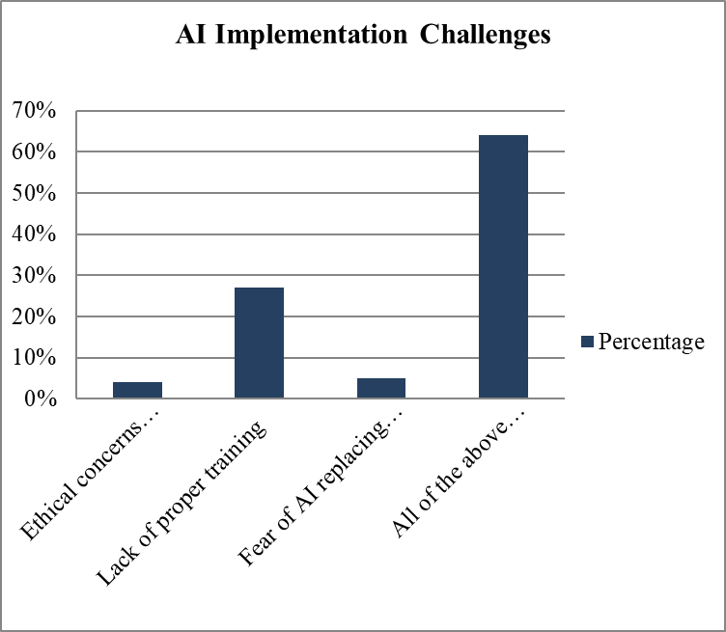
Source: Filed data
The survey results show a weighted mean of 3.52, indicating that most respondents face multiple challenges related to AI. While AI offers many benefits, it also presents challenges, such as the lack of proper training for teachers, concerns over AI replacing educators, and ethical issues like plagiarism and misinformation. Collectively, these challenges account for 64% of the responses. The lack of proper training is considered one of the biggest hurdles; once teachers receive adequate training, their ability to effectively use AI tools is greatly enhanced. These challenges can be mitigated through targeted AI training and development. Additionally, AI must be supported by well-established ethical policies and robust security measures to alleviate public concerns (Table 4 and Figure 12). While it is difficult to predict whether AI will replace teaching jobs, job security will ultimately depend on government policies, rules, and regulations. Ethical concerns and cybersecurity will also become increasingly important, as we are engaging with systems that are vastly more powerful and capable than we are (World Economic Forum, 2016).
Table 5: Hypotheses Tested by using Chi-Square Test
H₀There is no significant relationship between popular AI tools and teaching experience of teachers.
H₁ There is significant relationship between popular AI tools and teaching experience of teachers.
AI Tools | ChatGPT | Grammarly | All AI tools | Perplexity | Coursera | Total
Age group
Experience
0-5 years | 1 | 1 | 0 | 0 | 0 | 2
6-10 years | 1 | 1 | 0 | 0 | 0 | 2
11-15 years | 30 | 7 | 7 | 3 | 2 | 49
16-20 years | 2 | 0 | 1 | 0 | 0 | 3
More than 20 years | 0 | 0 | 0 | 0 | 0 | 0
Total | 34 | 9 | 8 | 3 | 2 | 56
Total X² = 5.7005
Degrees of freedom
df = (r-1) (c-1) = (4-1) (5-1) = 3x4 = 12
Critical value at α = 0.05
From chi square distribution table:
X²_{critical} (df = 12, α = 0.05) = 21.026
Calculated X² = 5.7005
CriticalX²= 21.026
Since X²_{Calculated}< X²_{Critical}, we fail to reject H₀ hence we accepted H₀ and rejected H₁
At the 0.05 significance level, there is no statistically significant relationship between teaching experience and preferred AI tools usage.
Discussion:
AI is rapidly expanding across the globe and revolutionizing various sectors, with education being no exception. It is driving significant changes in the education system, including curriculum design, student engagement in co-curricular activities, and student monitoring. AI provides instant solutions to challenges that arise during curriculum implementation and has the potential to address many issues in education. Experts believe that AI will eliminate existing problems in the system, leading to improved performance. However, it is not a one-size-fits-all solution that guarantees perfect outcomes. The transformative power of AI in education has led the Indian government to incorporate AI technology into the National Education Policy (NEP-2020). AI tools offer benefits for both teachers and students. With AI, teachers can conduct classes more effectively, prepare presentations, and work on research projects. AI is also fostering innovative teaching and learning strategies and is being integrated into various educational settings (Bidisha Borchetia & Mridula Hazarika, 2024). The impact of AI on education is profound, addressing emerging issues across multiple domains. AI’s cognitive algorithms support skills such as creative synthesis, evaluation, analysis, application, understanding, and memory. Similarly, in the psychomotor domain, AI aids in activities like origination, adaptation, and complex responses. It’s clear that AI is modernizing education by introducing new disciplines and updating traditional ones, including interdisciplinary approaches (Wayne Holmes, 2019; Maya Bialik & Charles Fedel).
A teacher is the backbone of society and a key pillar in shaping the future of the nation. The data reveals that only 13% of teachers are currently incorporating AI into their daily teaching tasks. It is essential for teachers to be proficient in AI tools, as they play a crucial role in enhancing their own knowledge and skills. As the saying goes, “Teaching is a profession that teaches all other professions,” making it clear that teachers cannot thrive in today’s education system without embracing AI. When we examine teachers' experience, it’s evident that experienced educators must master AI tools to meet students’ needs. Experienced teachers are highly sought after in reputable institutions, and all stakeholders expect them to be at the forefront of educational advancements. AI training for teachers is, therefore, critical to the future of education. A significant 89% of teachers have expressed interest in AI training, eager to perfect their use of AI tools. This reflects the readiness of teachers, who are not fearful of AI but instead are positive and motivated to learn, recognizing the value and importance of AI in modern education. The results also show that 48% of participants believe AI enhances commerce education. AI offers numerous platforms that help both teachers and students improve their skills and productivity. By using tools like ChatGPT, Grammarly, Perplexity, and Coursera, teachers can engage their students more effectively and work more efficiently. AI tools such as Claude AI also enable teachers to analyze research data and gain valuable insights. ChatGPT, in particular, is widely used across various fields, with 61% of participants incorporating it into their work.
AI has a positive impact on education, contributing to sustainable learning outcomes and the career growth of students. Key factors influencing students’ attitudes toward AI include social, technological, and organizational factors. It is crucial to raise awareness about AI to maximize its benefits. AI is already shaping our lives through various applications and technologies, offering guidance on how these tools can be effectively utilized (Dr. K. Ravishankar & Dr. K. Logasakthi, 2023). While AI presents numerous opportunities, it also poses certain challenges. One significant issue is balancing human and AI decision-making—who remains in control when there is tension between the two? Another challenge is ensuring AI tools make teachers’ jobs easier without increasing surveillance. Achieving a trustworthy AI that improves the teaching experience will be difficult if it results in higher surveillance of educators. Furthermore, responding to students' strengths while safeguarding their privacy is a challenge, as AI-enabled systems require more personal data (Miguel A. Cardona, Ed.D., & Roberto J. Rodriguez, May 2023). Our research highlights several challenges, including inadequate teacher training, fears of AI replacing teachers, and ethical concerns such as plagiarism and misinformation, which together account for 64% of the challenges reported. AI is revolutionizing the education system, but with these transformations come significant hurdles that need to be addressed. Despite its many benefits, AI raises concerns about data security, confidentiality, and potential job displacement. Ethical issues also include data privacy, the lack of inclusion and equity for students from diverse backgrounds, and the diminished "human touch" in education. Addressing these challenges is not easy (Muhammad Tahir, Farha Deeba Hassan, & Mudasir Rahim Shagoo, 2024). However, these challenges can be mitigated through clear AI regulations, robust cybersecurity measures, and an inclusive implementation strategy. It is recommended that AI adoption in education be tailored to the varying levels of awareness, readiness, and ethical concerns among faculty members (Patrick T. S. Harris, 2024).
Conclusions:
AI is one of the most transformative and in-demand practices in today’s education system. It offers numerous benefits that can help create a more effective and dynamic educational environment. The study indicates that AI has broad and comprehensive benefits for commerce education, with 71% of participants recognizing its advantages. These benefits include automating administrative tasks, improving research and data analysis, and assisting in content creation and lecture planning. Rather than being confined to specific areas, AI impacts multiple dimensions of the educational process. From curriculum planning to implementation, AI enhances the entire workflow, creating a seamless connection between course preparation and delivery. With the aid of AI tools, teachers can engage students in a wide range of curricular and co-curricular activities. Notably, 89% of teachers are interested in AI training to become more proficient and professional. AI tools are gaining popularity rapidly, with ChatGPT leading at 61%, followed by Grammarly, Perplexity, and Coursera. Although AI is driving significant change in education, it is essential to ensure strong security measures and ethical policies to protect data privacy. There are concerns about misrepresentation, data manipulation, and the theft of research data, highlighting the need for structured AI guidelines and strict usage policies. Therefore, it is crucial to consider the pedagogical, psychological, and sociological impacts—both positive and negative—and ensure that the entire process is legally sound to avoid potential harm (Ahmat Gocen & Fatih Aydemir, 2020).
Scope for Future Research Agenda: This research follows a descriptive research methodology. The researcher has the opportunity to conduct comparative studies between government and private colleges, or between general and private institutions. Future research could explore curriculum integration and skills gap analysis, implement AI training modules in selected colleges, and assess the impact on faculty attitudes and student outcomes. From a cultural perspective, it would be valuable to investigate how local education cultures influence AI readiness and to propose strategies for tailored adoption. Additional research could focus on AI applications in fields like finance, marketing, analytics, and the ethical use of AI in business.
Disclaimer (Artificial intelligence)
Author(s) hereby declare that generative AI technologies such as Large Language Models, etc. have been used during the writing or editing of manuscripts. This explanation will include the name, version, model, and source of the generative AI technology and as well as all input prompts provided to the generative AI technology
Details of the AI usage are given below:
The author(s) hereby declare that AI technology, specifically the ChatGPT-5 model, was utilized during the manuscript editing process. The free-tier version of ChatGPT-5 was employed for data editing across all stages.
References:
1. Ezequiel Molina, Cristobal Cobo, Jasmine Pineda, and Helena Rovner, (March to June 2024), AI revolution in education, what you need to know, Digital Innovations in education Brief N. 1º, Report of International Bank for Reconstruction and Development(IBRD)/The World Bank.
2. Garcia-Chitiva, M. P.; Valdés Ramirez, D.; Zavala, G.; Vázquez-Villegas, P. (2024), Readiness of the Student Community for Using Artificial Intelligence in Higher Education. In: 10th International Conference on Higher Education Advances (HEAd’24). Valencia, 18-21 June 2024. https://doi.org/10.4995/HEAd24.2024.17286
3. Musa Adekunle, IsmailaTemitayo, Owolabi Paul, Kahinde D, Solomon, (2022), Elsevier www.sciencedirect.com/journal/computers-and-education-artificial-intelligencehttps://doi.org/10.1016/j.caeai.2022.100099
4. Ahmat Gocen and Fatih Aydemir (2020), Artificial Intelligence in Education and School, Scienedo, Research on Education and Media, Vol 12 (1), ISSN: 2037- 0830, DOI- 10.2478/rem-2020-0003.
5. AI in Education, (2019), A Practical Guide for Teachers and Young People, Department of AI, University of Malta, visit http://creativecommons.org/licenses/by-nc-sa/4.0/
6. Wayne Holmes, (2019) Maya Bialik and Charles Fedel Artificial Intelligence in Education, Promises and Implications for Teaching and Learning, Centre for Curriculum Redesign, ISBN-13: 978-1-794-29730-0.
7. Miguel A. Cardona, Ed. D. and Roberto J. Rodriguez (May 2023), Artificial Intelligence and the future of Teaching and Learning, Insights and Recommendations, Office of educational technology, https://tech.ed.gov.
8. BidishaBorchetia and Mridula Hazarika, (2024), Artificial Intelligence in Education: An Overview, Journal of Emerging Technologies and Innovative Research (JETIR), Vol. 11(2), ISSN- 2349-5162.
9. Muhammad Tahir, FarhaDeeba Hassan, Mudasir Rahim Shagoo, (2024), Role of Artificial Intelligence in Education: A Conceptual Review, World Journal of Advanced Research and Reviews, 22 (1), ISSN – 2581-9615. DOI: https://doi.org/10.30574/wjarr.2024.22.1.1217
10. Sonya Yeprem, (2022), STS research paper, A research paper submitted to the department of engineering and society, University of Virginia, Charlottesville, Virginia
11. Dr. K. Ravishankar, Dr. K. Logasakthi, 2023, Impact of Artificial Intelligence on student’s sustainable education and career development using extended TOE Framework, Korea Review of International Studies, ISSN-1226-4741, Vol. 16 (6).
12. Dr. Rakhi Gulati, (2024), A study on the faculty perception regarding the use of Artificial Intelligence in commerce education, International Journal of Advance Research and Innovation, ISSN – 2347-3258, Vol. 12 (2), DOI: https://doi.org/10.69996/ijari.2024007
13. Nevárez Montes J and Elizondo-Garcia J (2025), faculty acceptance and use of generative artificial intelligence in their practice, Front. Educ. 10:1427450. DOI: 10.3389/feduc.2025.1427450.
14. https://www.socscistatistics.com/tests/chisquare2/default2.aspx
15. Jorg Von Garrel and Jana Mayer, (2023), Artificial Intelligence in Studies – Use of Chat GPT and AI Based Tools Among Students in Germany, Humanities and Social Science Communications, Open Access, DOI – https://doi.org/10.1057/s41599-023-02304-7
16. Report-Office of Educational Technology, (2023), Artificial Intelligence and The Future of Teaching and Learning-Insights and RecommendationsWebsite – https://tech.ed.gov
17. World Economic Forum, (2016), Emerging Technologies-Top 9 Ethical Issues in Artificial intelligence, https://www.weforum.org
18. Mondal, Debdas (2025), AI in Education: A Global Perspective On Classroom Transformation, Available at https://www.ssrn.com/
19. Patrick T. S. Harris, (2024), Faculty Perspectives Toward Artificial Intelligence In Higher Education, Middle Georgia State University, USG, Available at https://www.ssrn.com/

