Hexagonal Shaped 4-Port MIMO Filtering Antenna with High Gain & Low Mutual Coupling for Multiuser Applications

ABSTRACT

This research presents an advanced 4-port multiple-input multiple-output (MIMO) antenna designed to address the rigorous requirements of 5G/6G, ultra-wideband (UWB), and Internet of Things (IoT) applications. The antenna features four hexagonal-shaped radiating elements interfaced with 50 Ω microstrip feed lines, arranged rotationally to achieve orthogonal polarization, effectively minimizing mutual coupling and enhancing MIMO diversity for superior system performance. Fabricated on a compact 60 x 60 mm² FR4 substrate, the design incorporates a filtenna architecture, integrating antenna and filter functionalities to eliminate switching components like PIN diodes, which often disrupt radiation patterns due to biasing circuits. A defected ground structure (DGS) further improves inter-element isolation and frequency selectivity, ensuring high performance within a minimal footprint. Designed and simulated using Ansys HFSS, the antenna was validated through fabrication and testing with an Agilent N5247A Vector Network Analyzer, with electromagnetic characterization conducted in an anechoic chamber across 1-20 GHz. It delivers a wideband impedance bandwidth of 6.7 GHz (17.50-24.20 GHz) with a return loss (S₁₁) better than -20 dB, alongside inter-element isolation exceeding -20 dB. Performance metrics include a peak gain of 7 dBi, omnidirectional radiation patterns, low Total Active Reflection Coefficient (TARC), minimal Envelope Correlation Coefficient (ECC), high Diversity Gain (DG), and negligible Channel Capacity Loss (CCL). Time-domain analysis confirms its suitability for UWB applications, showcasing low distortion and robust signal fidelity. The antenna’s applications are profound for mm-Wave 5G/6G networks, enabling high-data-rate, low-latency communications in dense urban environments through MIMO’s channel hardening and favorable propagation properties. For UWB, it supports precision ranging and high-bandwidth IoT networks, such as smart cities and industrial automation. Its compact design is ideal for handheld devices, base stations, and embedded systems, addressing miniaturization challenges. The research’s significance lies in overcoming mutual coupling and spectral interference through innovative filtenna and DGS integration, enhancing spectral efficiency and scalability for next-generation networks. By providing a compact, high-performance solution validated through rigorous simulation and experimental protocols, this work sets a benchmark for MIMO antenna designs, driving advancements in massive MIMO and beyond-5G systems.

Keywords: MIMO, UWB, mutual coupling, TARC, ECC, DG, CCL, Filtenna, LHCP, RHCP

INTRODUCTION
“Electronics and wireless communication system have developed significantly over past decades. The increasing popularity of wireless connectivity demands integration of mobile devices that operates at different standards evolving towards multi-functionality. This leads to the need of miniaturized, more reliable integrated wireless system. In this context, integration of the entire antenna structure on a single substrate is the vision for future wireless system. Therefore, several planar integrated antennas have been addressed in literature” [1]-[9]. “Most of these cases include incorporation of several switching components in the antenna structure where, the switching elements such as PIN diodes, varactor diodes and MEMs etc. are basically integrated into the radiating surface of the antenna. However, such integration techniques may affect the radiation behavior of antenna as they lead to extensive care during the design process due to biasing circuit. At the same time, antennas and filters are considered as the largest key component of integrated wireless system” [10]-[11]. Owing to such facts, one of the effective solutions for this challenging issue is the implementation of filtenna.
Multiple-input- multiple-output (MIMO) is considered another technology utilized in communication systems. In MIMO systems, several antennas are used in the transmitting and receiving ends to enhance the data rate and signal quality without increasing the bandwidth and the power of the transmission.
Meanwhile, “the current wireless technologies have faced the challenges of multipath fading caused by reflection and refraction of the communication link. To mitigate such challenges MIMO configuration system with filtenna have been implemented with good inter port isolation. Such system results very low envelope correlation coefficient, which in turn improves the efficiency and reliability of communication link especially under fading environment”. [12]-[16]. “The major issue in multiport antenna system is the excellent inter-port isolation, so the antenna element should be placed more than half wavelength. As in typical mobile phone or laptops antennas are distributed around the periphery of device, so maintaining half wavelength does not support always for practical feasibility. In such cases of closely spaced antenna elements, the relative position to each other and ground affects a lot to the radiation behavior. Keeping into eye such issues some recent papers reported in literature in respect of relative distance of different antenna elements” [17]-[23].
In [17] a “3D metamaterial structure is employed to achieve an isolation of 18 dB with inter element antenna array spacing of 0.13λ. But the total electrical dimension of the substrate was 60 x 60 mm2 and operated from 2.35 GHz to 2.45 GHz. To mitigate the mutual coupling an antenna interference cancellation chip was proposed in literature [18] operating near 2.4 GHz with isolation more than 15 dB. Similarly, a multilayered EBG is proposed in literature [19] for isolation improvement at operating frequency of 2.55 GHz”. In [20] a scalable filtering multiple-input–multiple-output (MIMO) antenna based on a shared substrate integrated waveguide (SIW) is proposed. Half-mode SIWs are cascaded as the last-stage radiators. Then, two filtering-independent beams are obtained to achieve the space diversity characteristic. Because of the orthogonal modes, the two filtering beams of the two directions can also be scaled to work in different bandwidths, different working frequencies and patterns. The demonstrated filtering MIMO antenna in this literature has −10 dB impedance bandwidth from 9.94 GHz to 10.09 GHz, and the isolations are better than 20 dB. In [21] a compact millimeter-wave (mm-wave) dual-band filtering patch antenna is presented. It is fed by a new multi-null resonator, composed of a single-layer substrate integrated waveguide (SIW) cavity-backed slot. This multi-null resonator can produce two resonant modes and three radiation nulls. With the load of a radiating patch, another radiation null can be generated between the two operating bands. In addition, the radiating patch produces two patch modes by introducing an H-shaped slot and four shorting pins. Therefore, a second-order bandpass filtering response is obtained for each operating band. Owing to this new multi-null resonator, two controllable radiation nulls are realized beside each band, showing high-frequency selectivity and an out-of-band suppression level of more than 18 dB. The antenna prototype, with only two substrate layers, has antenna gains of 8 and 7.5 dBi in the 28- and 39-GHz bands. Furthermore, the dual-band filtering patch antenna is extended to a 2×2 multiple input/multiple output (MIMO) antenna and the isolations between any two-antenna elements are higher than 20 dB for the two passbands. In [22], a broadband microstrip patch array filtenna based on array decoupling surface (ADS) structure is proposed. The ADS unit comprises a split-ring resonator housing a patch resonator. Positioned above the array antenna, the ADS structure serves to eliminate coupled waves, thereby enhancing isolation and generating transmission zeros beyond the operational bandwidth to improve out-of-band suppression. The operational principle of the ADS structure is elucidated through equivalent circuits and electromagnetic simulation. The proposed configuration is implemented in a 1 × 2 patch array featuring “X”-shaped slot feeding. In [23], “a two-port MIMO filtenna with center frequency and bandwidth tunability is introduced by integrating a tunable filter into the feeding section of a monopole antenna. The tunable filter is constructed by a dual-mode square loop resonator having four varactor diodes. The 10-dB bandwidth of the designed MIMO filtenna can be tuned from 340 to 690 MHz at the highest center frequency, while the center frequency is tuned between 3.4 and 3.93 GHz. Within the tuning range, the maximum peak gain varies between 1.6 and 4 dBi in the electromagnetic (EM) simulations. Isolation between the outputs of the MIMO filtenna was measured as better than -20 dB and envelope correlation coefficient (EEC) was observed as less than 0.001. Diversity gain (DG) and mean effective gain (MEG) were obtained as close to 10 and less than 3 dB, respectively. Moreover, radiation efficiency of the proposed MIMO filtenna was obtained between 60% and 72%”.

“UWB technology is the prospective applicant for wireless communication ever since the FCC (Federal Communication Commission) approved band of 3.1 to 10.6 GHz (unlicensed frequency band) for some UWB devices applications” [24]. Definitions of the minimum bandwidth of an UWB signal vary; while the European Telecommunication Standards Institute (ETSI) defines in [25] a minimum bandwidth of 50 MHz, the Federal Communications Commission (FCC) specifies a minimum instantaneous bandwidth of 500 MHz [24] in a frequency range from 3.1 to 10.6 GHz. Because of this large frequency span, UWB devices can operate in the same RF spectrum as many other wireless communication technologies including WiMAX™, Wi–Fi, satellite communications, etc. “MIMO technology can boost the capacity of the channel with the use of many antennas, which create the effectiveness of the antennas in overpopulated zones by giving high efficiency and data rates in Gigabits/s [26]. Additionally, the technique of MIMO can effectively utilize the inter-element coupling and also correlation of antenna is minimum. The utilization of more than one antenna in a device brings minimum spacing between the elements and results in very less isolation” [27]. “The bandwidth impedance of monopole printed antenna by the length of the ground. And cutting slots of different structures and sizes on the back of ground can substitute the distribution of surface current of a monopole antenna which can alter the impedance bandwidth. This kind of slotted geometry of the ground plane is called the DGS” [28], [29]. In any MIMO; “mutual coupling is a major requirement. Many researches have been done to diminish the mutual coupling. By utilizing the slots in the defected ground structure, the mutual coupling and channel capacity can be boosted in MIMO system” [30]. “DGS is utilized to maximize the impedance bandwidth and these types of antennas are energized by the co-axial probe” [31], [32]. To acquire wide bandwidth impedance, a patch with a radiator of circular-shape which is coupled with reformed ground plane was utilized. This radiator does not radiate so as to approach each other directly, which gives high quality isolation.
UWB technology is suitable for application scenarios where communication needs to be carried out at a smaller distance because of its weak power and the multipath signal reception problem. So, MIMO technology integrated with filter would help to increase the channel capacity and fix the multipath signal reception problem.
For the above stated problems, this paper suggested a 4-port UWB MIMO filtenna without using decoupling structures. A 50 Ω microstrip feed line is utilized to feed the four hexagonal shape radiator antennas. The isolation is enhanced by adding the elements in a perpendicular arrangement to achieve isolation higher than 20 dB between elements for the desired band of 15.43-23.60 GHz. The simulation of the antenna is carried out using Ansys HFSS software and for VNA testing Agilent N5247A: A.09.90.02 is used. For electromagnetic measurement and characterization, the antenna was tested in anechoic chamber range 1GHz to 20 GHz. The antenna has a size of 60 x 60 mm². The antenna has omnidirectional patterns with a peak gain of >6 dB. The results of the diversity performance of the MIMO are ECC < 0.01, DG >10 within the operating bands. Finally, from the tested results in the form of S-parameters and radiation patterns, it can be claimed that the suggested antenna can be operated in UWB communications.

The contributions of this research work for MIMO systems, underscores their transformative impact on 5G and 6G networks. The detailed analysis of MIMO’s channel hardening and favorable propagation properties highlights its potential to scale network capacity in dense urban environments. The design and analysis of the final 4-port UWB MIMO filtering antenna with a hexagonal shape is aimed at addressing the evolving demands of wireless communication systems. Traditional antenna designs often incorporate switching components like PIN diodes and varactor diodes, which can disrupt radiation behavior due to biasing circuits. To overcome this, the research work incorporates a filtenna, a combination of an antenna and a filter, integrated into a single substrate to enhance performance without compromising radiation characteristics.
By tackling challenges such as mutual coupling and imperfect channel state information, this study provides practical solutions for compact MIMO suitable for futuristics wireless mobile communication (mm-5G/6G), UWB and IoT applications. The integration of MIMO designs with filter and DGS architecture offers a synergistic approach, enabling efficient antenna arrays that maximize spectral efficiency while minimizing physical footprint.
The research article presented herewith has been addressed in three sections namely Methodology, Results & Discussions and Conclusion. In the methodology section the single port, dual port and four port structures in order of their design order have been discussed in detail. In the result section the MIMO parameters such as reflection coefficients, VSWR, Gain, Radiation pattern, TARC, CCL, ECC and DG along with LHCP, RHCP are discussed in detail. The conclusion section emphasizes on the applications and utilities of the design for wireless communication.
METHODOLOGY

ANTENNA CONFIGURATION AND DESIGN

Single Port Hexagonal Patch Antenna
The development process of the antenna involves changing the radiator shape and ground length to match the UWB technology requirement, such as wide bandwidth, small size, and simple design as shown in Fig.1 (antenna 1). The S₁₁ simulated results are carried out to obtain the proposed structure, as shown in Fig.2. The antenna has an impedance bandwidth spanning from 9.35-21.09 GHz with S₁₁ lower than -10 dB, as seen in Fig.2. To improve the antenna bandwidth, a hexagonal shaped radiator with slot is utilized as depicted in Fig.3 (antenna 2) with the same length as the ground plane as of antenna 1. The second antenna design has an impedance bandwidth spanning from 9.35-21.26 GHz with S₁₁ lower than -20 dB. But the S₁₁ increases from -22 dB to -44 dB with the insertion of slot in the center of the patch as clear from Fig.2 and Fig.4. On comparison we can see the hexagonal antenna with slot has a better S₁₁ and narrow bandwidth suitable for UWB applications.
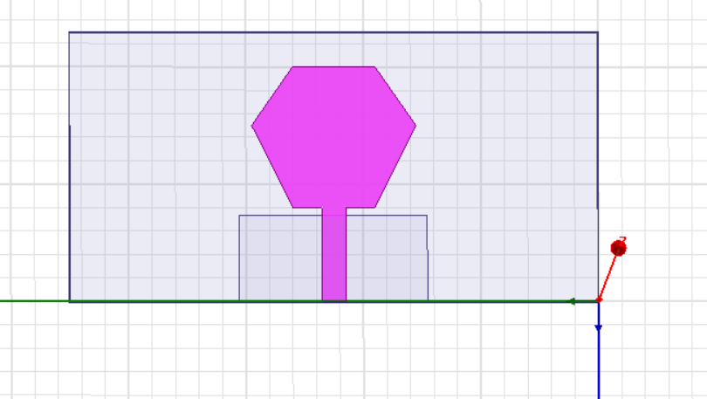
Fig.1. Hexagonal Microstrip Patch Antenna
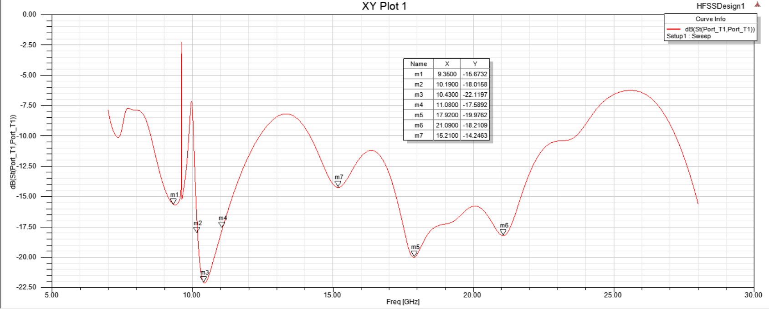
Fig.2. S11 plot for Hexagonal Microstrip Patch Antenna
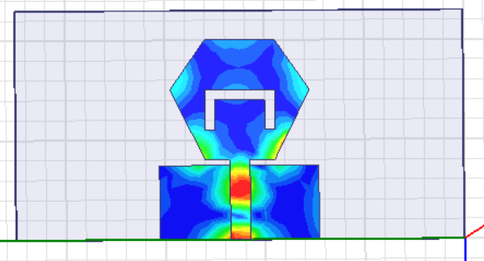
Fig.3. Hexagonal Microstrip Patch Antenna with Slot
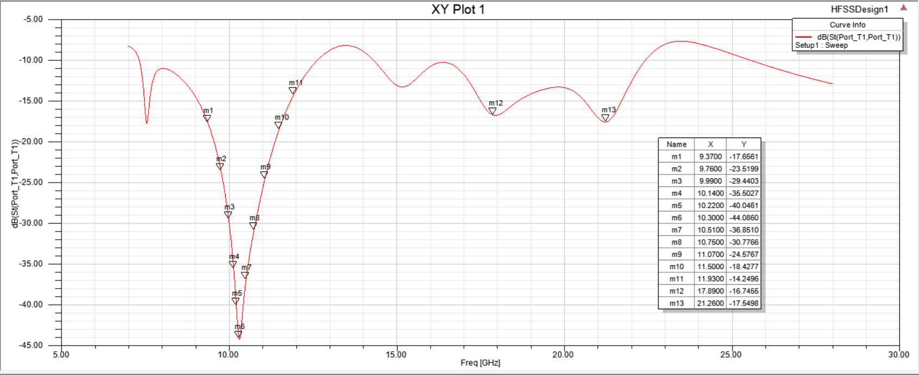
Fig.4. S11 for Hexagonal Microstrip Patch Antenna with Slot
The reason for taking hexagonal shape has been discussed in detailed manner. Table.1 shows five different shapes of polygons unit cell designed in the same substrate of fast Film TM-27 [33]. The simulation results show different bandwidth percentage for each polygon unit cell shape. The hexagon unit cell AMC (with 6-edges) shows the good bandwidth percentage compared to others. Different shapes of patch and its design and performance efficiencies are listed in Table.1, the hexagon shape will be used for further modification. The full patch hexagon AMC is modified by introducing slots into the shape.
Table 1: Bandwidth coverage for different shapes of unit cell polygon
AMC unit cell | Shape | Band Width
Tetragon |  | 77%
Hexagon | 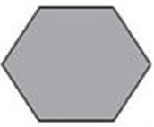 | 104%
Octagon | 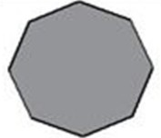 | 121%
Decagon | 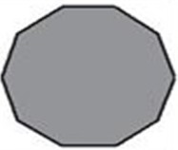 | 98%
Dodecagon | 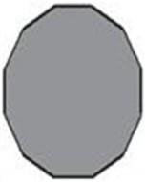 | 97%

To design the antenna to operate at the resonant frequency of 14.25 GHz, the value of the radiator radius is calculated based on the cavity model to excite the dominant mode TM110 as Eq. (1)[33]. Where, fr, εr, and h are the resonant frequency, dielectric constant, and the thickness of the substrate, respectively. Also, to increase the gain, the patch with a slot is employed as shown in Fig.3.
$R= \frac{F}{(1+ \frac{2h}{πFεr}(ln⁡(\frac{πF}{ 2h })+1.7726))}$ (1)

The antenna structure parameters such as hexagonal patch side (s), hexagonal patch diameter (D), ground length (L_{g}), ground width (W_{g}), slot width (W_{s}), slot length (L_{s}), feed length (F_{L}) and feed width (F_{w}) are illustrated below in Table.2 and the design is shown in Fig. 5.
Table.2. Single Hexagonal Patch Antenna parameters
Parameter Name | Parameter value (in mm)
s | 7
D | 14
L_{g} | 7
W_{g} | 8
W_{s} | 1
L_{s} | 4
F_{L} | 8
F_{w} | 2

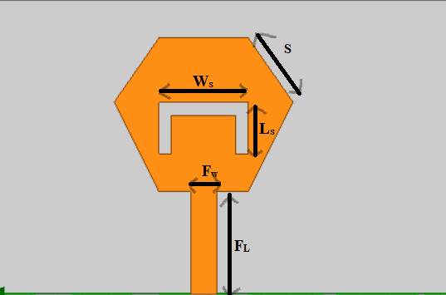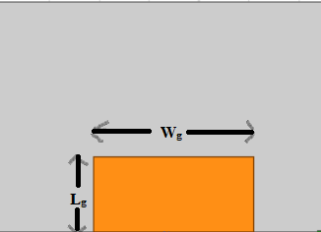
- (b)
Fig.5. (a) Front Layer of Patch Antenna with a slot & (b) Back Layer of Antenna

Dual Port Hexagonal MIMO Patch Antenna
To convert the single port to the two ports, the two ports with two configurations side by side and orthogonal orientations with the same edge-to-edge distance of 7 mm between elements. The side-by-side arrangement is illustrated in Fig.6 and the orthogonal orientation is presented in Fig.9. The S₁₁ for the side by side 2-port MIMO antenna on simulation exhibited a wide band of 15 GHz ranging from 9.58-24.60 GHz as shown in Fig7. The Radiation pattern for the E-plane of the 2 port MIMO antenna is shown in Fig. 8. The S₁₁ for orthogonal or perpendicular arrangement is shown in Fig.10, for which the passband range is 10-25 GHz.
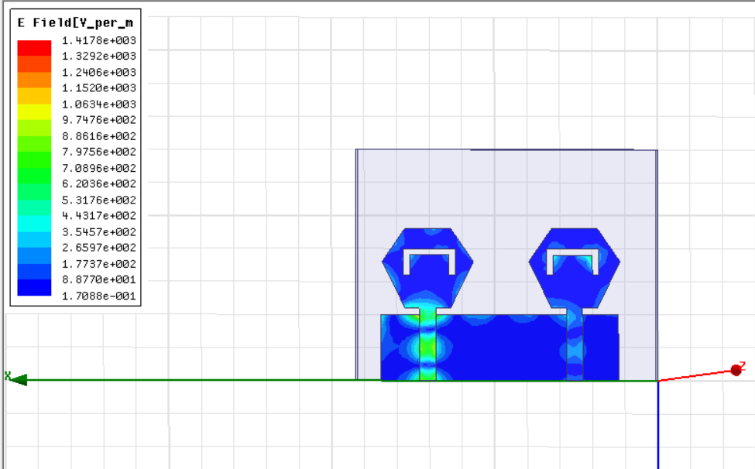
Fig.6. Hexagonal MIMO Patch Antenna placed side by side
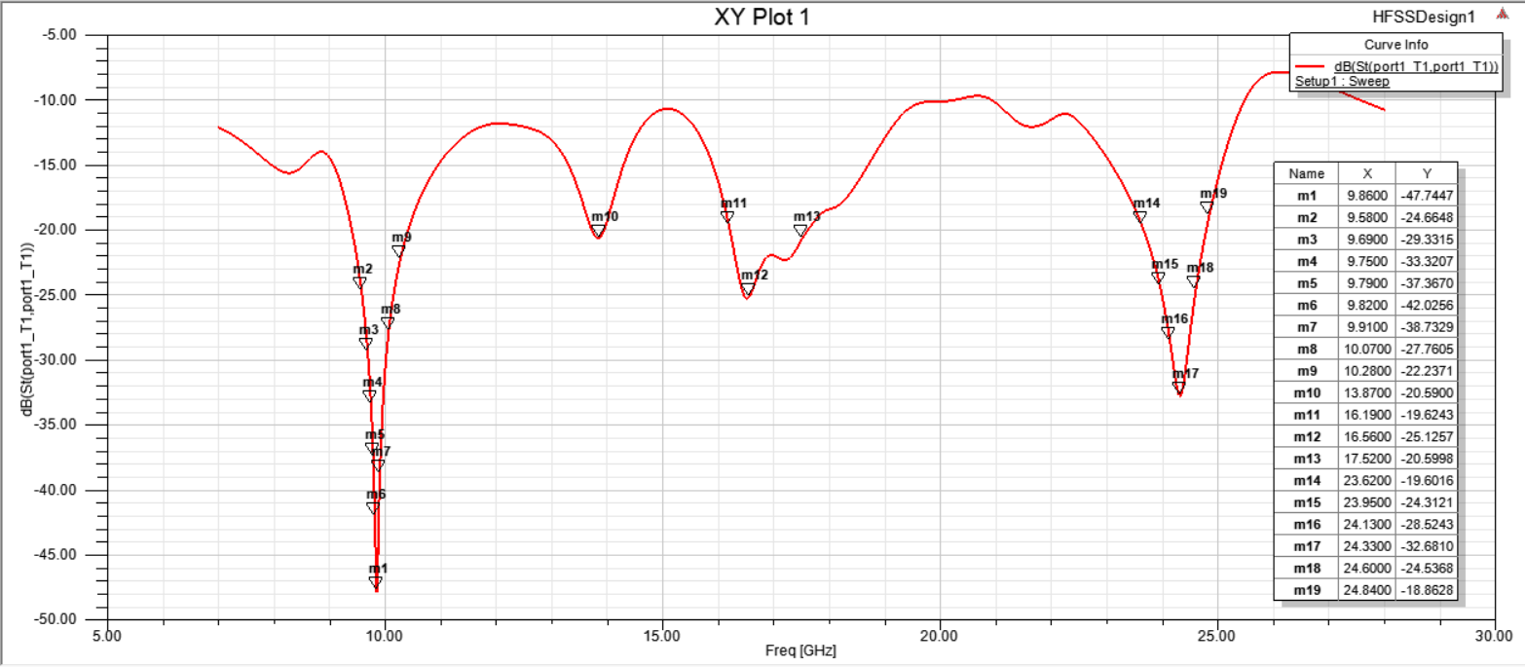
Fig.7. S₁₁ for 2-port MIMO antenna placed side-by-side.
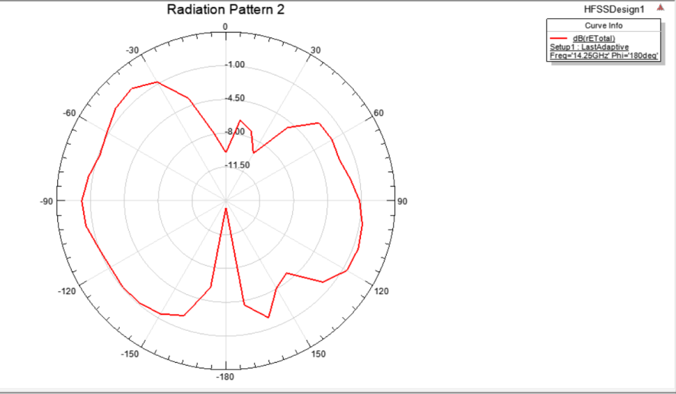
Fig.8. E-plane Radiation pattern for 2-port MIMO antenna placed side-by-side.
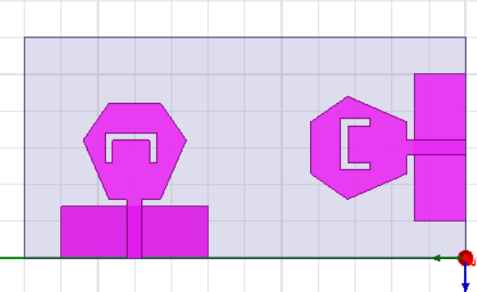
Fig.9. Hexagonal MIMO Patch Antenna placed orthogonally
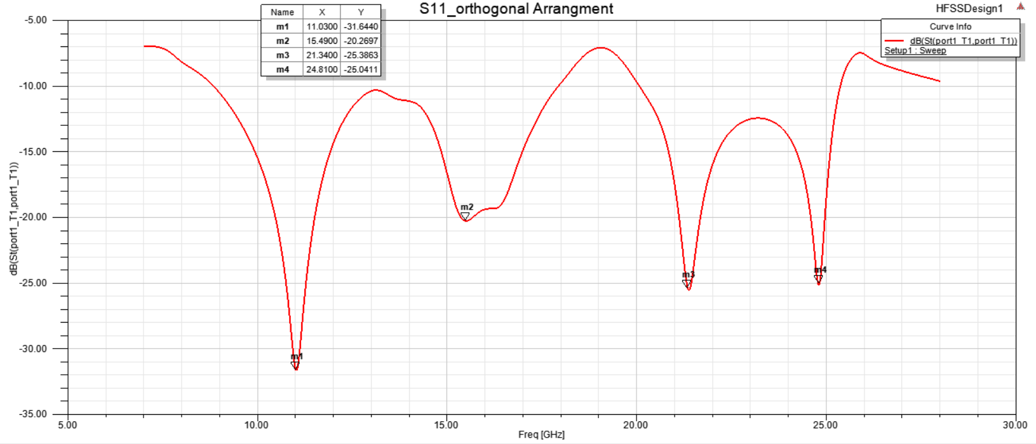
Fig.10. S₁₁ for 2-port MIMO antenna placed orthogonally.
The side-by side arrangement although giving a low reflection coefficient had inter-element radiation which reduces the gain. Thus, the orthogonal orientation has been used rather than the side-by-side configuration. The mutual coupling is enhanced by using the orthogonal orientation without adding extra structures. So, the orthogonal orientation is utilized in the final four ports MIMO antenna.

4-Port MIMO Patch Antenna
The single and the two ports MIMO antenna discussed in the previous sections is arranged to achieve and realize the proposed 4 ports MIMO antenna with 60 mm x60 mm as shown in Fig.11. The antenna in port 1 has an orthogonal orientation with the antenna on port 2, and port 4, and has the same orientation but in opposite direction to the antenna in port 3. This arrangement is utilized to produce the polarization diversity which in turn increases the isolation between elements. The antenna is designed and simulated on HFSS software using FR₄ substrate. The simulated result of S11 are extracted using HFSS for port 1 are only presented in Fig.13, because of the symmetry property, the other three ports have the similar results.
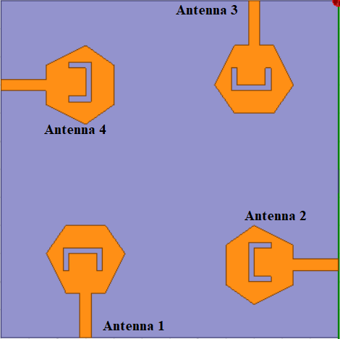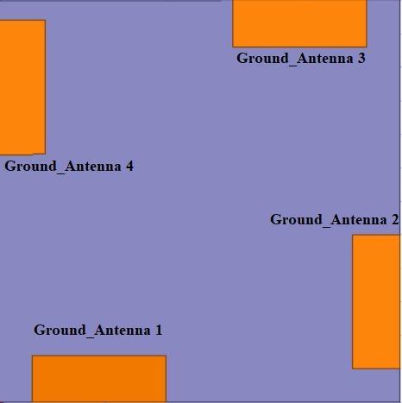
- (b)
Fig.11. 4-Port MIMO Patch Antenna (a) Top layer and (b) Bottom layer
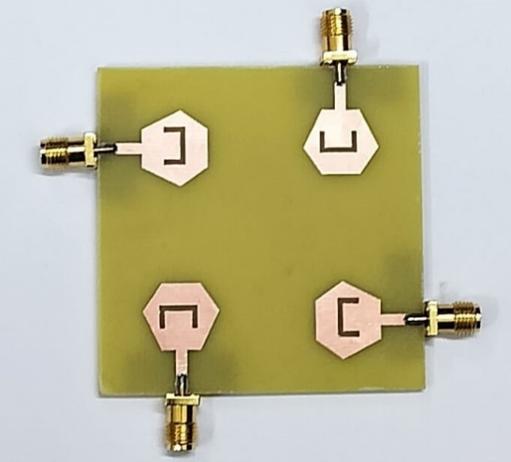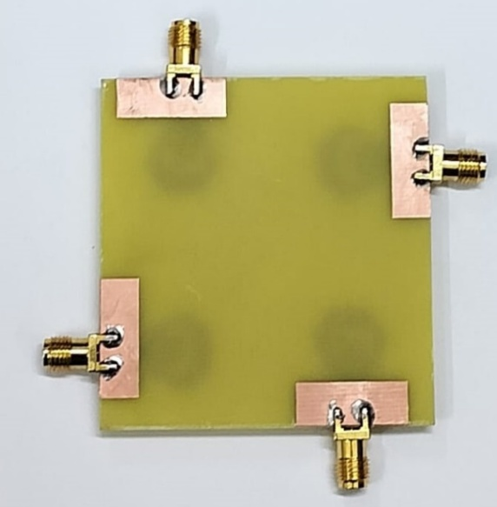
- (b)
Fig.12. Fabricated prototype of 4-Port MIMO Patch Antenna (a) Top layer and (b) Bottom layer
The fabricated prototype of the 4-port MIMO antenna is illustrated in Fig.12. The Patch structure is fabricated on FR₄ substrate.

Results and Discussion
Fig.13. illustrates the proposed 4-port MIMO antenna results at port 1. It is noticed that the simulated results are operated from (103.44%) 15.8–21.5 GHz with S11≤ -20 dB. The antenna is measured using 2 ports Agilent N5247A: A.09.90.02 VNA from port 1 because of the symmetry property, also all the other three ports have similar results. Fig.14 shows the measurement procedure and in Fig.15 the measured S₁₁ is presented. The simulated isolation results at port 1 (S21, S31, S41) are shown in Fig.16, Fig.18 and Fig.19. It is seen that the S21, S31 and S41 have values lower than 20 dB. Also, the results have good matching between simulated and measured S₂₁ them with the small shift as shown in Fig.16 and 17.
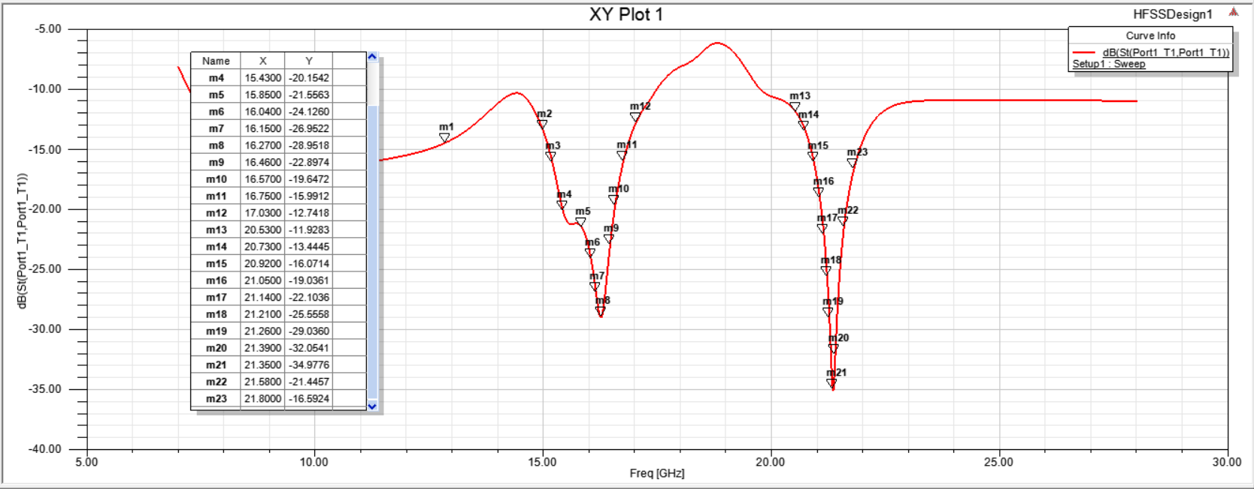
Fig. 13. S₁₁ for 4-port MIMO Patch Antenna
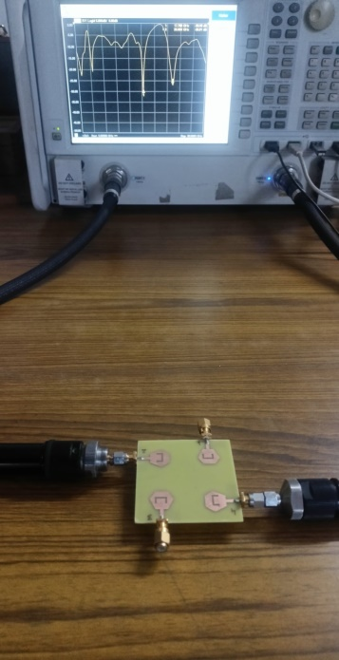
Fig.14. Measurement process using VNA
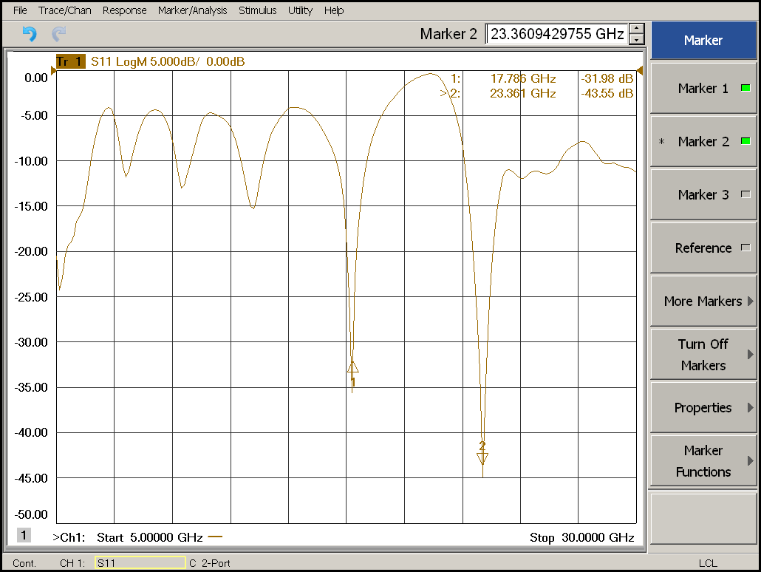
Fig. 15. S₁₁ for 4-port MIMO Patch Antenna obtained through VNA
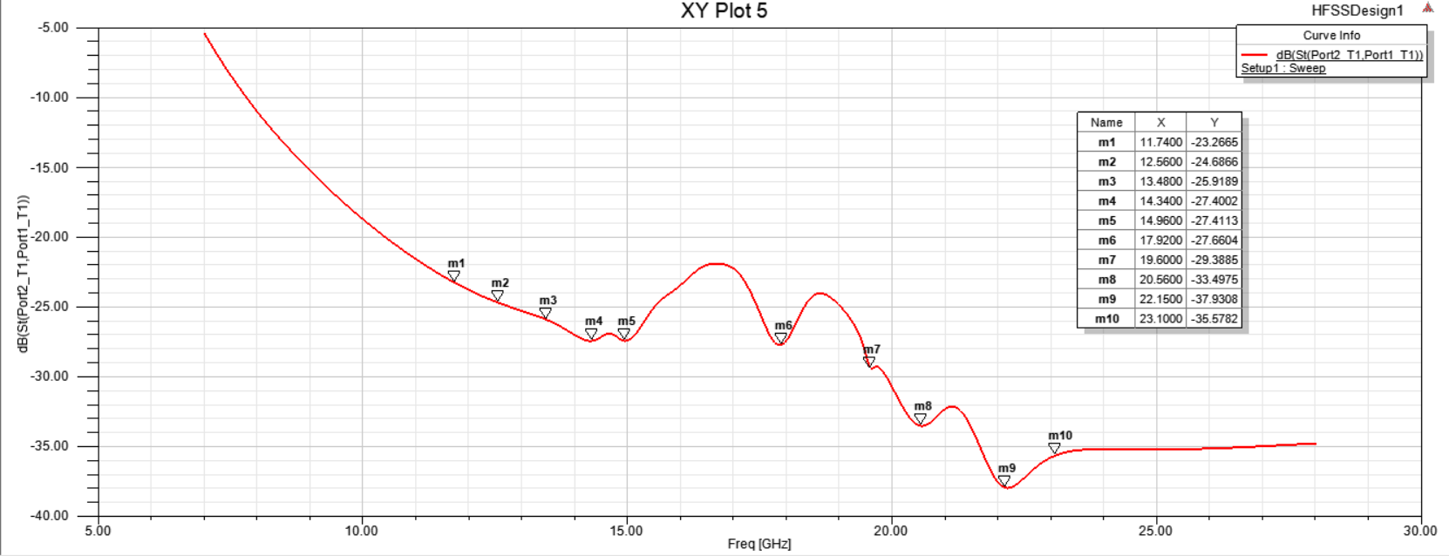
Fig. 16. Simulated S₂₁ for 4-port MIMO Patch Antenna
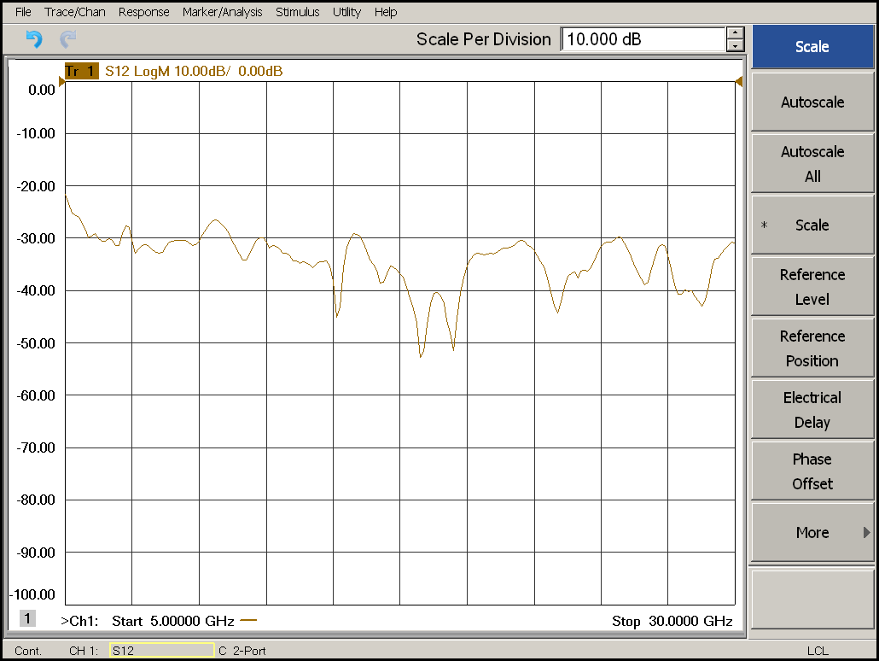
Fig. 17. Measured S₂₁ for 4-port MIMO Patch Antenna
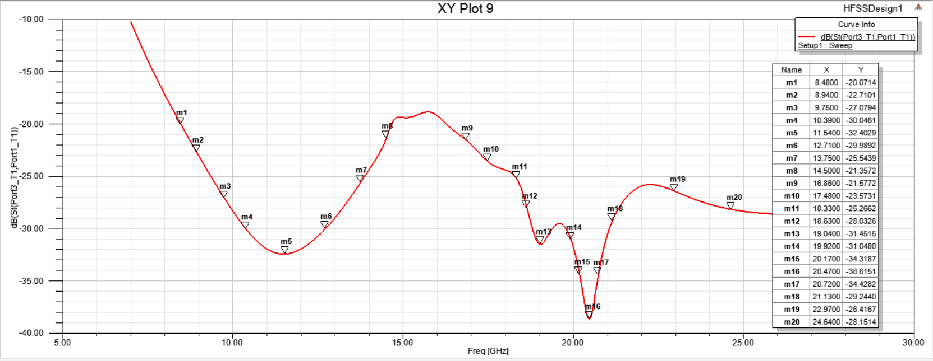
Fig. 18. S₃₁ for 4-port MIMO Patch Antenna
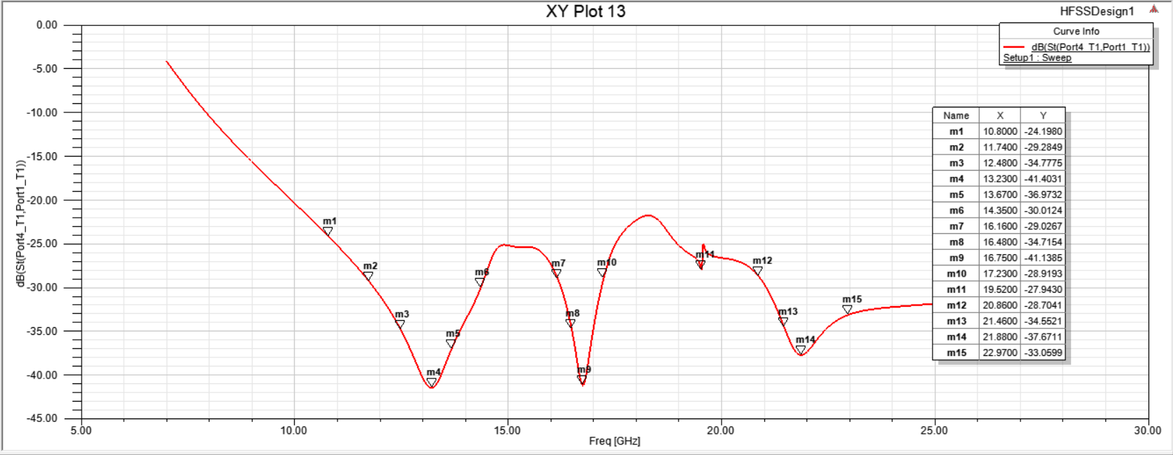
Fig.19. S₄₁ for 4-port MIMO Patch Antenna
The measured outcomes as shown in Fig.15, show that the antenna almost matched the simulated impedance spanning from 17.5 to 24.2 GHz. There is a shift from the resonant frequencies of 16.25GHz and 21.35 GHz to 17.786 GHz and 23.361 GHz respectively due to the fabrication and SMA connector losses. The frequency shift is about 2GHz but the bandwidth range is increased from 5.7 GHz to 6.7GHz. The results have good matching between them with minor shift, not effecting the overall isolation among the patch arrangements.
The simulated current distributions of the hexagonal MIMO antenna at 16.27 GHz and 21.35 GHz at four ports are shown in Fig.20. The current is concentrated around the hexagonal patch proving that the antenna radiated at these two frequency bands. Also, the current is confined around the antenna with a very small amount of current dissipated to the other ports which confirm the high isolation between ports.
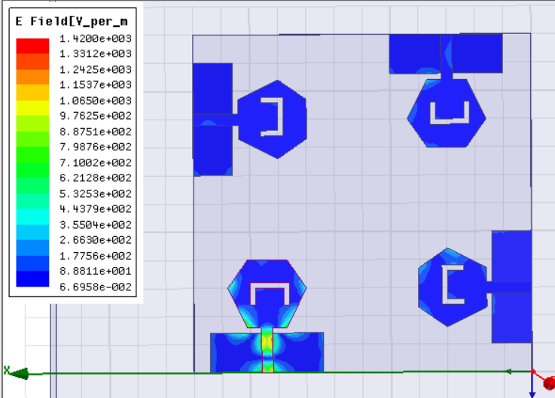
Fig.20. Current distribution of 4-port MIMO Antenna

The radiation pattern simulation results at 16.27 GHz and 21.35 GHz for port1 are illustrated in Fig.21, Fig.22, Fig.24 and Fig.25 to validate the diversity of the patterns. When the suggested port 1 is excited the remaining three ports are connected to 50 Ω loads. Also, from Fig.15 and Fig.17 it is seen that the 90° phase difference between the ports is achieved to confirm the polarization diversity which in turn enhances the MIMO system.
The proposed MIMO antenna simulated radiation patterns and peak gain are depicted in Fig.21 and Fig.22 for 16.27 GHz, the measured peak gains and radiation pattern for 16.27 GHz are illustrated in Fig.23.The simulated and measured results are in agreement.
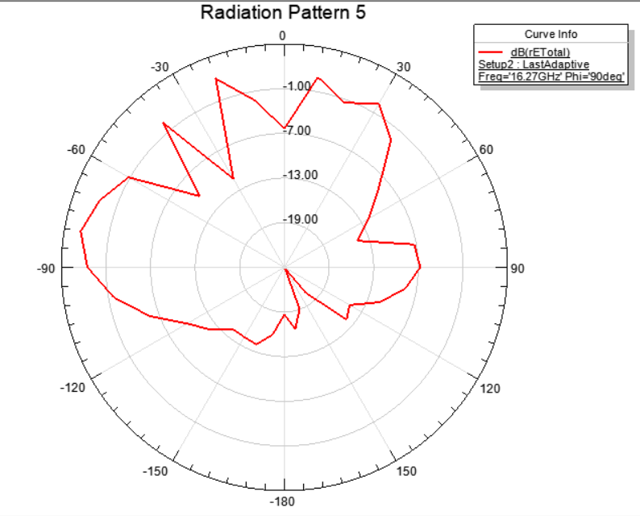
Fig. 21. H-Plane radiation off 4-port MIMO at 16.27 GHz
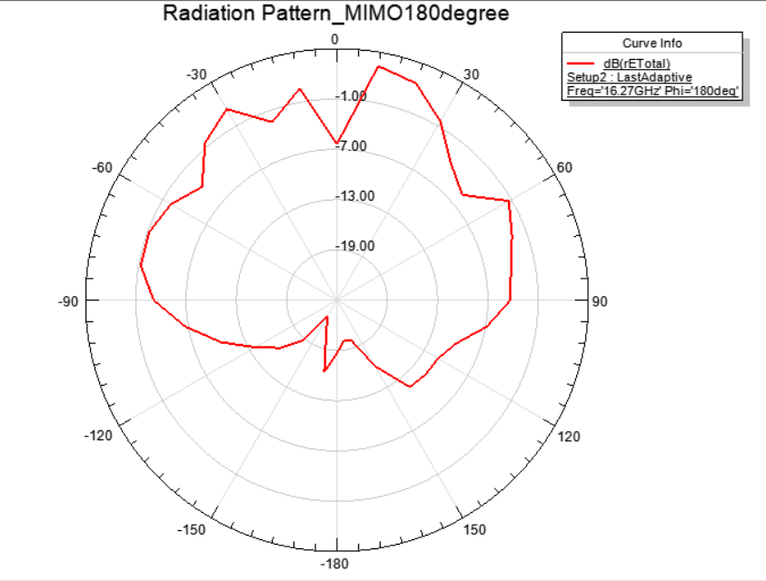
Fig. 22. E-Plane radiation of 4-port MIMO at 16.27 GHz

Fig. 23. Measured E-Plane & H-Plane radiation of 4-port MIMO at 16.27 GHz (co & cross)
The proposed MIMO antenna’s simulated radiation patterns and peak gain are depicted in Fig.24 and Fig.25 for 21.35 GHz, the measured peak gains and radiation pattern for 21.35 GHz are illustrated in Fig.26.The simulated and measured results are in agreement.

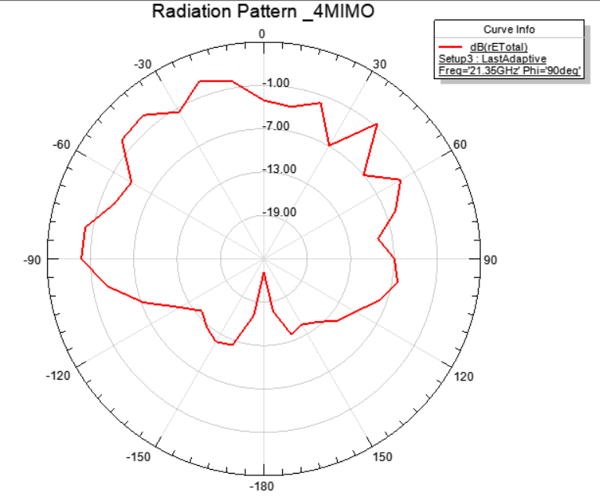
Fig. 24. H-Plane radiation of 4-port MIMO at 21.35 GHz

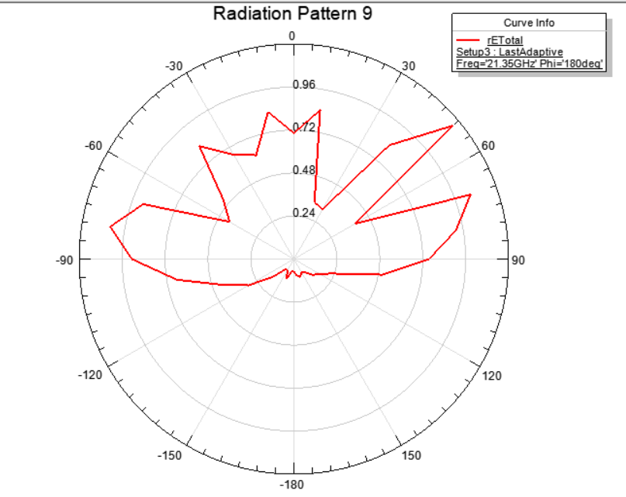
Fig.25. E-Plane radiation of 4-port MIMO at 21.35 GHz

Fig.26. Measured E-Plane & H-Plane radiation of 4-port MIMO at 21.35 GHz (co & cross)
The radiation pattern results of E and H-plane both co and cross at 8.39 GHz for port2 is illustrated in Fig.27 (linear plot) and Fig.28 (polar plot) to validate the diversity of the patterns and multi-output characteristic of MIMO type patch antenna.

Fig.27. Measured E-Plane & H-Plane radiation of 4-port MIMO at 8.39 GHz at Port2 (co & cross)

Fig.28. Measured E-Plane & H-Plane radiation of 4-port MIMO at 8.39 GHz at Port2
The simulated and measured peak gain total of the MIMO antenna at port 1 are presented in Fig.29 and Fig.30. The simulated results show that the antenna has peak gain extended from 2.9 to 7.1 dBi within the operated frequency bands. The measured results show peak gain extends from 1.7 to 9.5 dBi with in the operated frequency band, proving antenna’s utility in UWB applications.
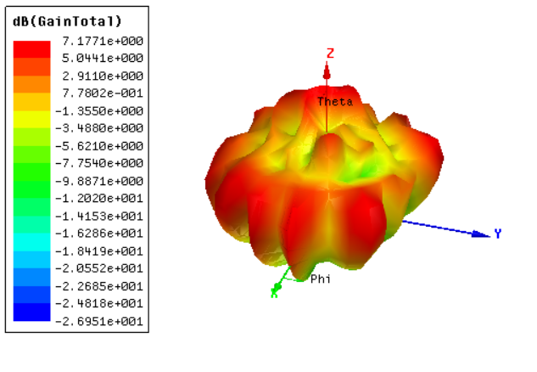
Fig.29. Total Gain of 4-port MIMO Antenna

Fig. 30. 4-port MIMO antenna peak gain results on measurement from Anechoic Chamber
The antenna directivity total, spherical polarization ratio, RHCP and LHCP of the MIMO antenna at port 1 are presented in Fig.31, Fig.32, Fig.33 and Fig.34. Right-Hand Circular Polarization (RHCP) and Left-Hand Circular Polarization (LHCP) antennas both transmit radio waves that rotate as they travel, but in opposite directions: RHCP rotates clockwise, and LHCP rotates counter-clockwise. RHCP antenna's electric field rotates clockwise, while an LHCP antenna's electric field rotates counter-clockwise as it moves forward. RHCP is often the standard in GPS systems, while LHCP might be used for alternate channel systems or in situations where you want to avoid a potential overlap with another system using RHCP. Clearly the findings for my design show that the 4-port MIMO is a LHCP and thus suitable for wireless communication in dense environments. From Fig.31, the results show that the antenna has radiation efficiency extended from 77% to 95% and total efficiency ranging from 70% to 90% within the operated frequency bands. The reduction of the total efficiency especially at higher frequency band is due to the FR4 lossy substrate.
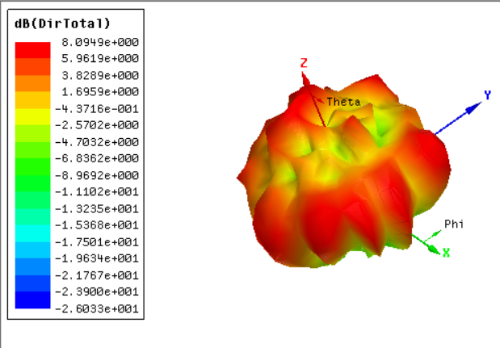
Fig. 31. Radiation Efficiency and Directivity of 4-port MIMO Antenna
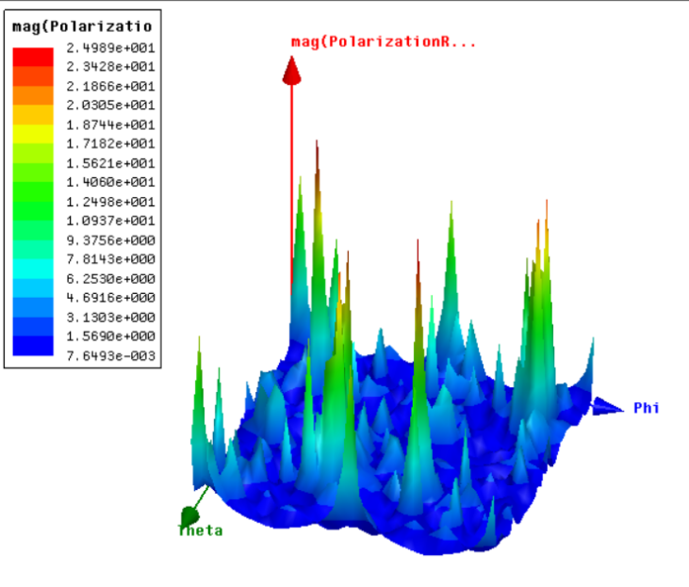
Fig. 32. Spherical Polarization Ratio of the 4-port MIMO Antenna
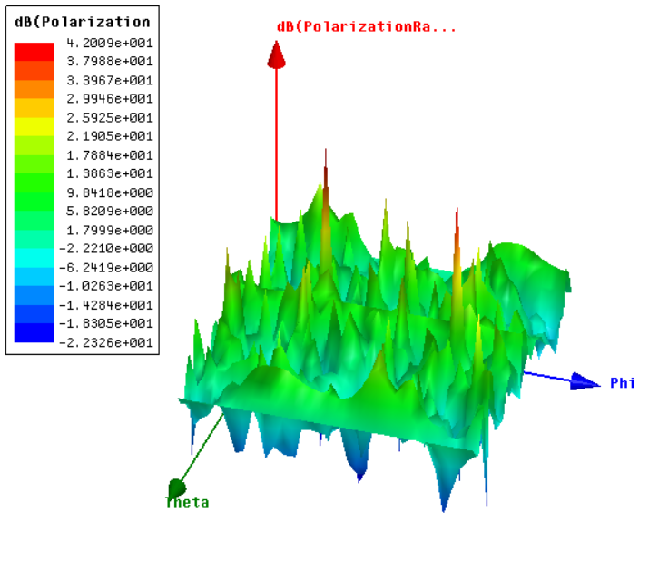
Fig.33. LHCP for 4-port MIMO Antenna
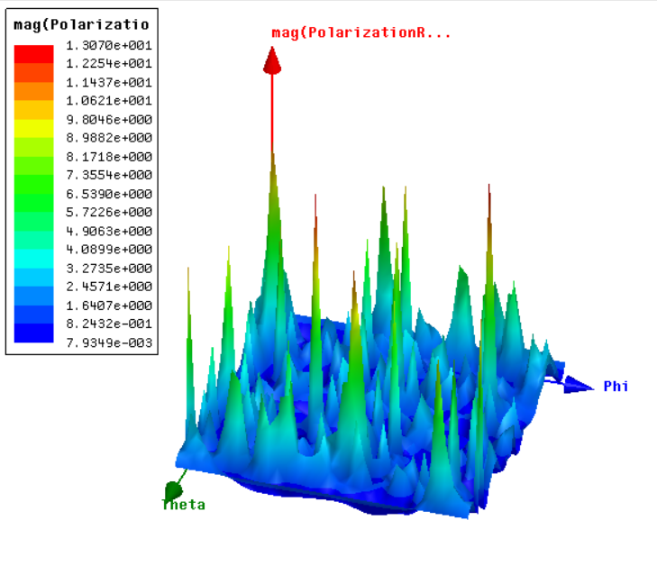
Fig.34. RHCP for 4-port MIMO Antenna
The ECC and DG are two parameters to measure the MIMO performance. ECC states how multiple radiating elements in MIMO systems are independent in their radiation pattern. The practically acceptable limit of ECC must be ˂ 0.5. The ECC measures the relationship between antenna elements in the MIMO system. ECC can be calculated from Eq. (2) [34]-[36].
ECC = |S₁₁*S₁₂+S₂₁*S₂₂|²/(1-|S₁₁|²-|S₂₁|²) (1-|S₂₂|²-|S₁₂|²) (2)
Fig.35 shows the ECC at port 1. It is noticed that the ECC ˂ 0.45 within the band of interest. Diversity gain indicates the quality and reliability of a MIMO antenna in wireless systems. Hence, DG of the MIMO antenna must be high (≈ 10 dB) within the acceptable frequency band. DG is connected with the ECC and is calculated from Eq. (3) [34]-[36].
DG=10$\sqrt{1-{(ECC)}^{2}}$ (3)
Fig.36 illustrates the DG, where for the band of interest, the value of 9.95 dB is achieved. The Total Active Reflection Coefficient (TARC) is the ratio of the reflected power and the incident power, and it is expected that all the power should be accepted by the antenna. Therefore, ideally the TARC value for the MIMO antenna should be zero.Fig.37 illustrates the TARC for MIMO system which is less than 0dB for the band of interest, as can calculated from Eq. (4).
$Г=\frac{√\sum_{i=1}^{N}{|bi|2}}{√\sum_{i=1}^{N}{|ai|}2}$ (4)
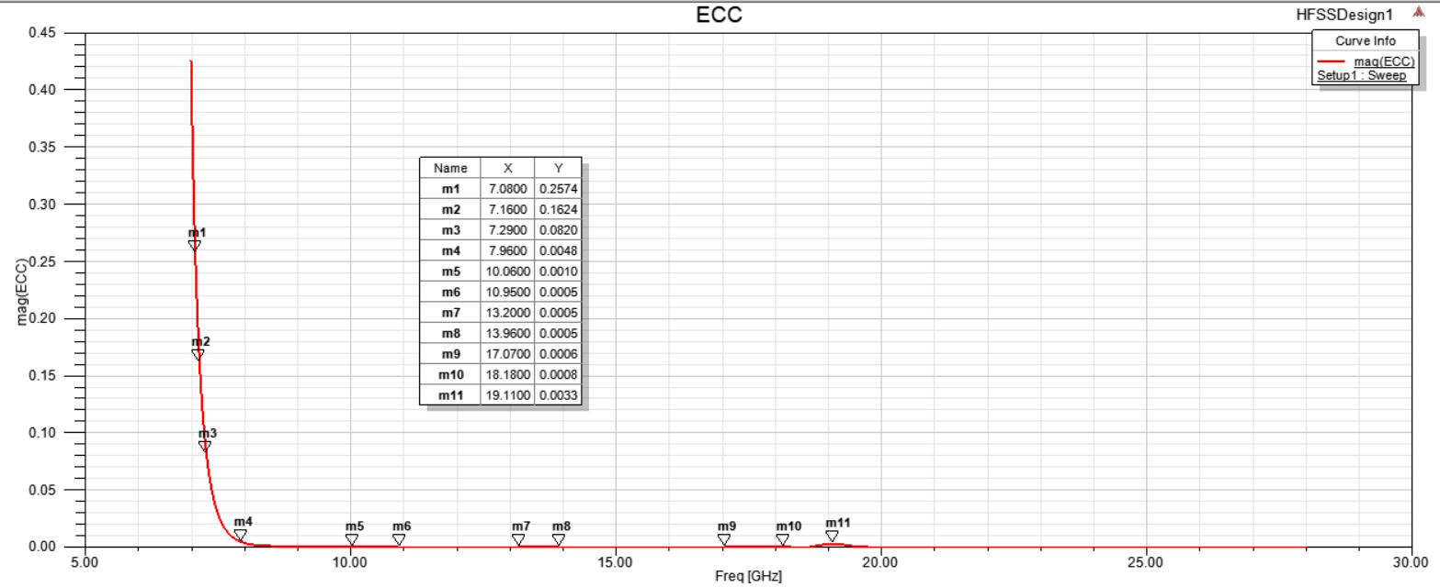
Fig.35. ECC for 4-port MIMO Patch Antenna
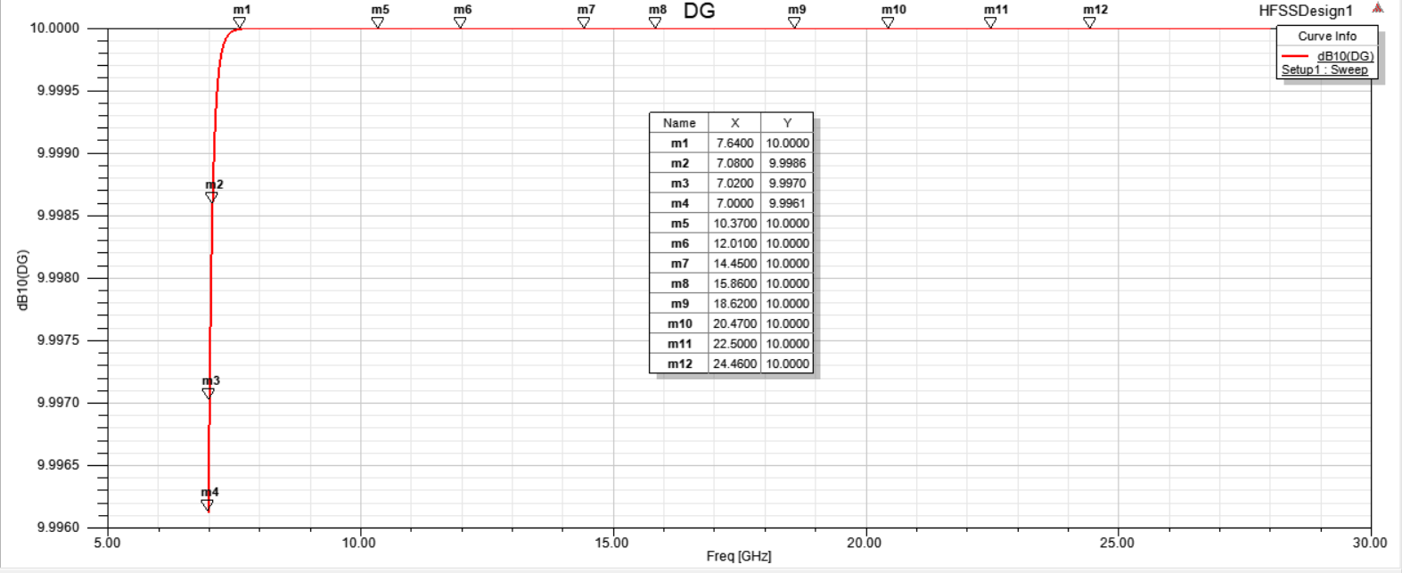
Fig.36. DG for 4-port MIMO Patch Antenna

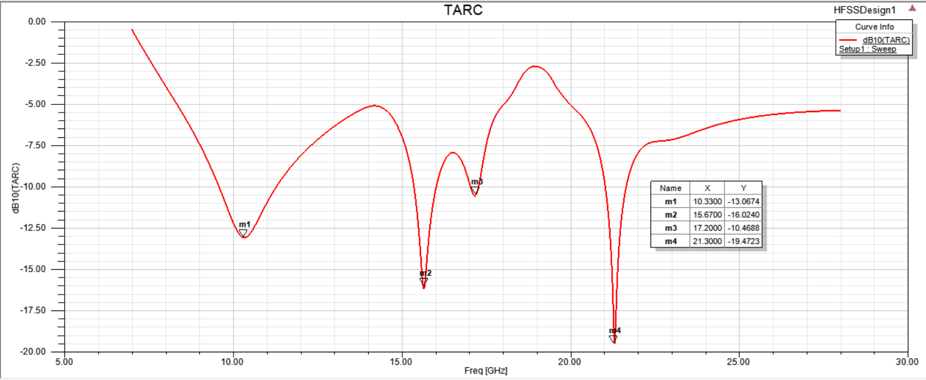
Fig.37. TARC for 4-port MIMO Patch Antenna
From the results in Fig.35 and Fig.36, it is noticed that the proposed antenna has good MIMO results which make our antenna suitable for MIMO for filtration characteristics and diversity systems for UWB communication applications.
The Voltage Standing Wave Ratio (VSWR) indicates the mismatching between the antenna and transmission line. Large VSWR means more mismatching between the antenna and transmission line. The total simulated VSWR for all the 4 ports and VSWR for port 1 is presented in Fig.38 and Fig.39. The standing wave ratio for the all the ports combined in less than 1.5 and for port 1 it is less than 0.9, which is good for a MIMO system. Fig.40 presents the measured VSWR for port 1, the standing wave ratio is less than 1 for all the peak resonating frequencies.
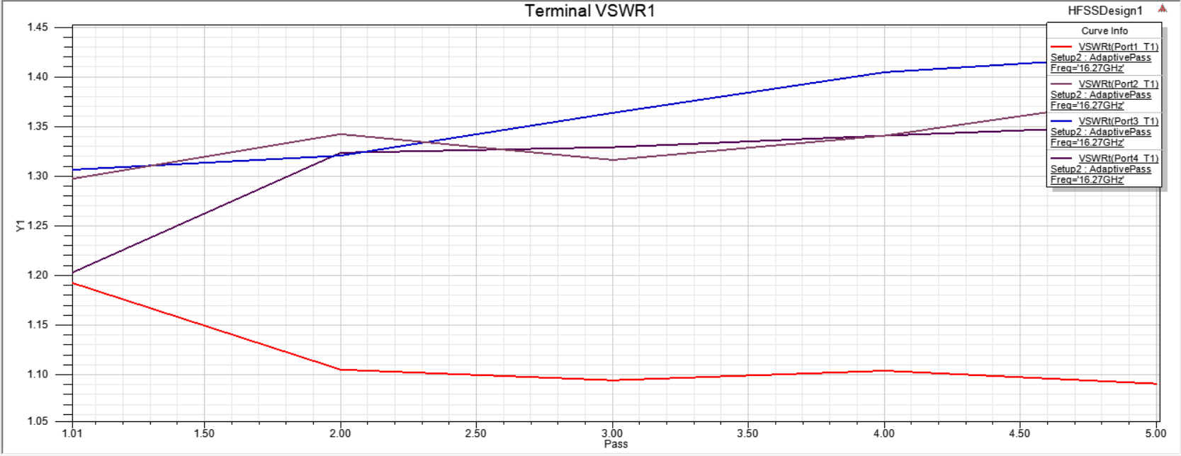
Fig.38. VSWR for all the four ports of the MIMO Antenna
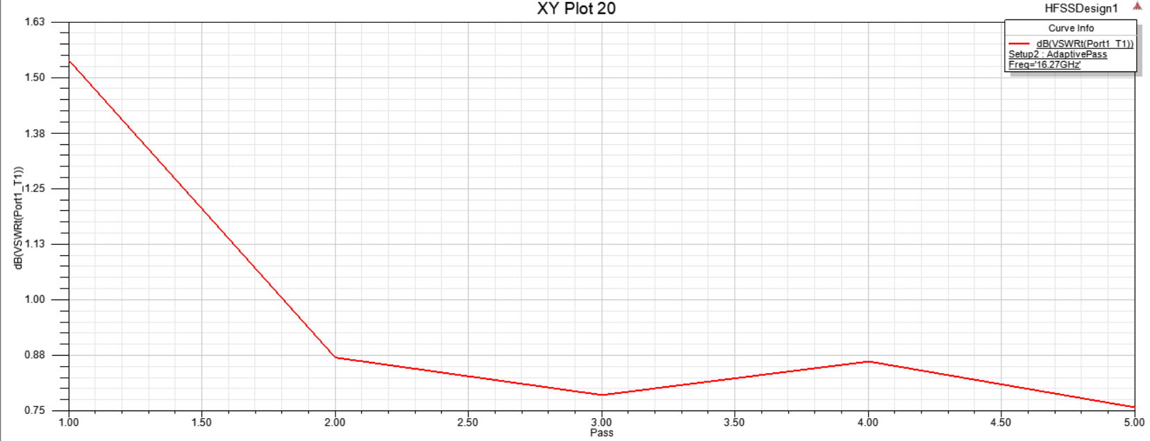
Fig.39. VSWR for port 1 of the MIMO Antenna
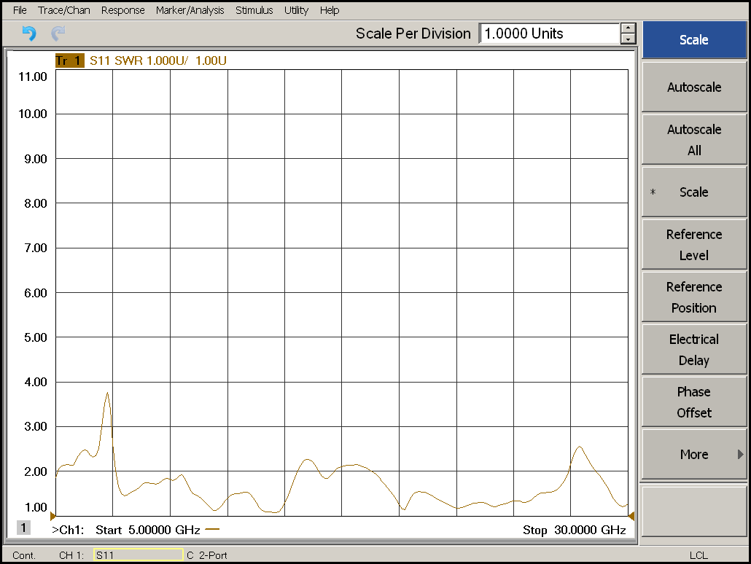
Fig.40. The Measured VSWR for port 1 of the MIMO Antenna
The antenna is compared with the existing MIMO antennas from the literature in Table.3. It is observed that the antenna has a low profile, wide bandwidth, 4-port configuration, high gain, low mutual coupling without using a complex decoupling structure, and low ECC value that qualifies the antenna for its use in UWB MIMO Filtenna applications.
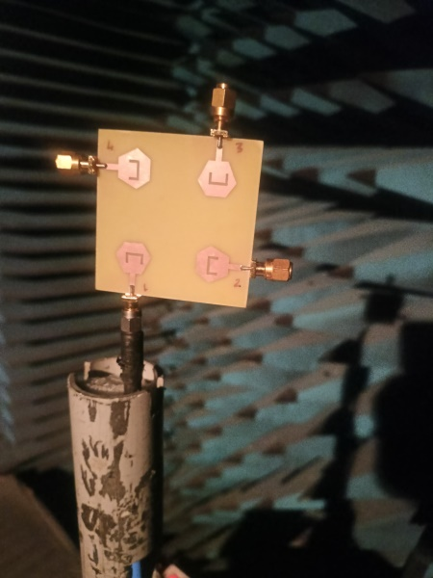
Fig.41. Image of 4-port MIMO being tested in Anechoic Chamber
Table.3: Comparison between our suggested work and other selected designs
S.No. | Reference | Size (mm³) | ε_{r}/thickness (in mm) | B.W (in GHz) | No. of antennas | Gain (dBi) | Efficiency (⁒) | Isolation (dB) | ECC/DG
1 | [6] | 40 x 30 | 4.4/1.6 | 3.20-5.85 | 4 | 3.5 | 85 | >17.5 | <0.15/9.9
2 | [11] | 42 x 42 | 4.4/1.6 | 3.2-12 | 4 | 4 | 80 | ≥17 | 0.01/9.96
3 | [12] | 45.5 x 33 | 3.55/1.5 | 3-12 | 2 | 4 | 75-90 | ≥20 | 0.09/low
4 | [13] | 66 x 36 | 3.38/0.813 | 2.6-12.5 | 2 | 4 | Not mentioned | ≥20 | 0.001/9.97
5 | [15] | 45 x 45 | 4.4/1.6 | 2-10.6 | 4 | 3 | Not mentioned | ≥17 | 0.005/low
6 | [16] | 38 x 38 | 3.2/0.762 | 3-15 | 4 | 3.5 | 65-79 | ≥20 | <0.5/low
7 | [17] | 81 x 87 | 4.4/1.6 | 3.03-10.74 | 4 | 5 | 60-87 | ≥20 | 0.1/low
8 | [19] | 48 x 52 | 4.4/1.6 | 2.7-11 | 4 | 3.5 | 80 | ≥20 | 0.0004/9.85
9 | [33] | 26 x 55 | 4.4/1.6 | 3.1-12.3 | 4 | 2.5 | Not mentioned | >20 | <0.5/low
10 | [37] | 62.5 x 60.5 | 4.4/1.6 | 3.5-11 | 4 | 4 | 70-90 | >20 | <0.01/9.5
11 | My work | 60 x 60 | 4.4/1.6 | 9.35-21.26 | 4 | 7-8 | 85-95 | ≥20 | <0.1/9.9

CONCLUSION
A four-port MIMO antenna for UWB Filtering operation has been presented in this paper. The suggested antenna element, as the initial design, is first designed and simulated using HFSS. After that, 2 ports (both side-by-side and orthogonal arrangement) and 4 ports MIMO antenna with perpendicular arrangement has been designed, simulated and discussed. The radiation patterns, peak gain, and MIMO performance characteristics such as TARC, ECC and DG have been illustrated and discussed. The suggested antenna has been worked at a frequency band extending from 9.35 to 21.26 GHz with S11 more than -20 dB, 4 dBi isolation between ports, and peak gain of upto 9 dBi. The response of the antenna is terms of radiation patterns in E and H-Plane has been discussed to validate the suggested antenna to operate in wideband and filteration applications. Finally, the proposed antenna has been compared with other antennas, and the results show that the suggested antenna can be used in both as Filtenna and in UWB communication.

Disclaimer (Artificial intelligence)
Author(s) hereby declare that NO generative AI technologies such as Large Language Models (ChatGPT, COPILOT, etc.) and text-to-image generators have been used during the writing or editing of this manuscript.

REFERENCES
- I. Messaoudene, T. A. Denidni, and A. Benghalia, “Experimental investigations of ultra-wide-band antenna integrated with dielectric resonator antenna for cognitive radio applications,” Prog. Electromagnetics. Res., vol. 45, pp. 33–42, 2013.
- S. Pahadsingh and S. Sahu, “A two port UWB-dual narrowband antennas for cognitive radios”, Microwave and Optical Technology Letters, Wiley, Vol, 58, No, 8, August 2016.
- S. Pahadsingh and S. Sahu, “Planar UWB Integrated with Multi narrowband Cylindrical Dielectric Resonator Antenna for Cognitive radio Application”, Int. J. Electron. Commun. AEU, Vol.74, pp.150- 157, 2017.
- A. H. Ramadan, J. Costantine, Y. Tawk, C.G. Christodoulou, and K. Y. Kabalan, “Frequency-tunable and pattern diversity antennas for cognitive radio applications,” Int. J. Antennas Propag., vol. 20, No.14, p. 638-627, 2014.
- E. Erfani, J. Nourinia, C. Ghobadi, M. Niroo-Jazi, and T. A. Denidni, “Design and implementation of an integrated UWB/reconfigurable-slot antenna for cognitive radio applications,” IEEE Antennas wireless Propag. Lett., vol. 11, pp. 77–80, 2012.
- J. F. Li, Q. X. Chu, Z. H. Li, and X. X. Xia, “Compact dual band notched UWB MIMO antenna with high isolation,” IEEE Trans. Antennas Propag., vol. 61, no. 9, pp. 4759–4766, Sep. 2013.
- Y. Li, W. Li, and Q. Ye, “A Reconfigurable Triple-Notch-Band Antenna Integrated with Defected Micro-strip Structure Band-Stop Filter for Ultra-Wideband Cognitive Radio Applications” International Journal of Antennas and Propagation, vol.2013, pp 1-13, 2013.
- Y. Li, W. Li, and Q. Ye, “A Reconfigurable Wide Slot Antenna Integrated with SIRS for UWB/Multiband Communication Applications”, Microwave and Optical Technology Letters, vol. 55, No.1, pp 52-55, 2013.
- Y. Li, W. Li, W. Yu, “A Switchable UWB Slot Antenna using SIS-HSIR and SIS-SIR for Multi-Mode Wireless Communications Applications”, ACES Journal, vol. 27, No.4, pp.340-351, 2012.
- A. Rahman, A. R. Ali, S. Amari, and A. S. Omar, “Design of high frequency RC active filters using passive compensation methods,” IEEE International Symposium on Circuits and Systems, 1988.
- N.S Bhuvana, S.K. Menon, “OLR- Filtenna for WiFi Application” Progress in Electromagnetic Research Symposium (PIERS), pp. 1968-1971, Aug. 2016.
- B. P. Chacko, G. Augustin, T. A. Denidni, “Uniplanar slot antenna for Ultrawideband Polarization Diversity Applications”, IEEE Antennas and Wireless Propag. Lett., vol.12, pp. 88-91, 2013.
- S. F. Rosian, M. R. Kamarudin, M. H. Jamaluddin, “An MIMO F shaped Dielectric Resonator Antenna for 4G Applications”, Microwave and Optical Technology Letters, vol. 57, no.12, pp. 2931- 2936, 2015.
- A. H. Ramdan, K.Y. Kabalan, J. Costantine, Y. Tawk, C. G. Christodoulou, “A Tunable Filtenna for Cognitive Radio Applications”, 9th European conference on Antennas and Propagation (EuCAP) 2015.
- A. H. Ramadan, J. Costantine, M. Al-Husseini, K. Y. Kabalan, Y. Tawk, and C. G. Christodoulou, “Tunable Filter-Antennas for Cognitive Radio Applications,” Progress in Electromagnetics Research B, vol. 57, pp. 253-265, 2014.
- A. H. Ramadan, J. Costantine, Y. Tawk, M. Al-Husseini, C. G. Christodoulou, and K. Y. Kabalan, “A research vision on cognitive radio filter antennas,", The 8th European Conference on Antennas and Propagation (EuCAP’14), The Hague, The Netherlands, pp. 3654 -3656, 6-1, 2014.
- K. Yu, Y. Li, X. Liu, “Mutual coupling reduction of MIMO antenna array using 3_d Novel metamaterial structure”, ACES Journal, vol. 33, No.7, pp.758-763, 2018.
- Luyu Zhao, Feng Liu, Xiumei Shen, Guodong Jing, Yuanming Cai, and Yingsong Li, “A High Pass Antenna Interference Cancellation Chip for Mutual Coupling Reduction of Antennas in Contagious Frequency Bands”, IEEE ACESS, pp.1-9, 2018.
- Tao Jiang, Tianqi Jiao, Yingsong Li, “A Low Mutual Coupling MIMO Antenna Using Periodic Multi-Layered Electromagnetic Band Gap Structures” ACES Journal, vol.33, No. 3, pp. 305-311, 2018.
- Y. C. Li, K. L. Chu, T. -Z. Zhang and Q. Xue, "A Scalable Filtering MIMO Antenna with Space Diversity Based on Shared SIW Cavities," in IEEE Antennas and Wireless Propagation Letters, vol. 24, no. 7, pp. 1769-1773, July 2025, doi: 10.1109/LAWP.2025.3546501.
- X. Yin, P. F. Hu, K. W. Leung, Y. M. Pan, N. Yang and K. Lu, "Millimeter-Wave Dual-Band Filtering Patch Antenna and MIMO Array Using Multinull Resonator," in IEEE Transactions on Antennas and Propagation, vol. 72, no. 9, pp. 6897-6907, Sept. 2024, doi: 10.1109/TAP.2024.3430814.
- X. W. Dai, W. H. Hu, H. P. Ruan, W. Yu, H. Hong and G. Q. Luo, "Microstrip Patch Array Filtenna Based on Array Decoupling Surface Structure," in IEEE Antennas and Wireless Propagation Letters, vol. 24, no. 7, pp. 1999-2003, July 2025, doi: 10.1109/LAWP.2025.3554510.
- A. Türkeli, A. Kürşad Görür, Y. Altuncu and A. Görür, "A New Two-Port MIMO Filtenna With Tunable Bandwidth and Center Frequency," in IEEE Access, vol. 12, pp. 181544-181552, 2024, doi: 10.1109/ACCESS.2024.3509513.
- “Federal Communications Commission Revision of Part 15 of the Commission’s Rules regarding Ultra- Wideband Transmission System from 3.1 to 10.6 GHz in federal Communications Commission Washington, DC: ET Docket, pp. 98-153, FCC, 2002.
- Electromagnetic compatibility and Radio spectrum Matters (ERM); Ultra-Wide-Band (UWB) technologies for communication purposes; Harmonized EN covering the essential requirements of article 3.2 of the R&TTE Directive. European Telecommunications Standards Institute (ETSI), December 2007.
- Kaiser, T; Zheng, F; Dimitrov, E “An Overview of ultrawide-band systems with MIMO”. Proceedings, IEEE, 97, 285-312,2009.
- Sipal D, Abegaonkar MP, Koul SK “Compact band-notched UWB antenna for MIMO applications in portable wireless devices” Microwave optical Technology Letters., 58: 1390-1394, 2016.
- John M, Ammann MJ, “Optimization of impedance bandwidth for the printed rectangular monopole antenna”, Microwave optical technology Letters, 47(2):153-154, 2005.
- Khandelwal MK, Kanaujia BK, Kumar S, “Defected ground structure: fundamentals, analysis and applications in modern wireless trends.” Int J Antennas Propag., 2017:2018527, 2017.
- Srivastava Gunjan, Mohan Akhilesh “Compact MIMO slot antenna for UWB applications” IEEE Antenna Wireless Propagation Letters, 15: 1057-60, Oct 2016.
- Kumar C, Guha D, “Defected ground structure (DGS)-integrated rectangular microstrip patch for improved polarization purity with impedance bandwidth”, IET Microwave Antennas Propag., 8(8); 589-596, 2014.
- Baudha S, Yadav MV, “A novel design of a planar antenna with modified patch and defective ground plane for ultra-wideband applications.” Microwave Optical technology Letters, 61:1320- 1327, 2019.
- D. Sharmila, M.Puranchandra Rao, P.S.V. Subbarao and S. Nagkishore Bhavanam, “Design, Simulation and Fabrication of Multiband Antenna using HFSS”, IJRTE, vol.8, No. 2, 2019.
- Desai, A., Palandoken, M., Kulkarni, J., Byun, G., Nguyen, T. K. (2021). Wideband flexible/transparent connected-ground MIMO antennas for Sub-6 GHz 5G and WLAN applications. IEEE Access, 9, 147003– 147015. DOI 10.1109/ACCESS.2021.3123366.
- Ibrahim, A. A., Ali, W. A. (2021). High gain, wideband and low mutual coupling AMC-based millimeter wave MIMO antenna for 5G NR networks. AEU-International Journal of Electronics and Communications, 142, 153990. DOI 10.1016/j.aeue.2021.153990.
- Desai, A., Kulkarni, J., Kamruzzaman, M. M., Hubálovský, Sˇ., Hsu, H. T. et al. (2022). Interconnected CPW Fed flexible 4-port MIMO antenna for UWB, X, and Ku band applications. IEEE Access, 10, 57641– 57654. DOI 10.1109/ACCESS.2022.3179005.
- Mahmoud A. Abdelghany, Mohamed Fathy Abo Sree, Arpan Desai and Ahmed A. Ibrahim, “4-Port Octagonal Shaped MIMO Antenna with Low Mutual Coupling for UWB Applications”, Computer Modelling in Engineering & Sciences, DOI: 10.32604/cmes.2023.023643, Sept. 2023.

