Antiradical, Antioxydant and Antimicrobial Properties of Essential Oil of Eucalyptus Tereticornis Used in the Treatment of Respiratory Diseases in Togo: A Phytochemical Study Approach

ABSTRACT

Introduction
Traditional medicine has seen a resurgence of attention and interest worldwide. Eucalyptus tereticornis is a medicinal plant belonging to the Myrtaceae family. This study was initiated to assess the therapeutic potential of Eucalyptus tereticornis essential oil.
Methods
The essential oil was obtained by steam distillation and analyzed by GC/MS. Refractive index was assessed in accordance with ISO 280 (1998). Antiradical activity was assessed by the DPPH free radical scavenging method, while antioxidant activity was assessed by the FRAP test. Antimicrobial activity was assessed using the plate microdilution method coupled with nutrient agar spreading.
Results
Essential oil yield was 0.75%. The refractive index was 1.475 ± 0.004. Thirty-three compounds, representing 99.09% of the oil, were identified in the EO. The major constituents are α-Pinene (55.72%), β-Pinene (16.73%), O-Cymene (7.40%), Eucalyptol (5.45%), β- terpineol acetate (2.69%) and Aromadendrene (1.99%). Anti-free radical activity was estimated at 4.11 ± 0.01 µg EAA/g EO and antioxidant activity at 0.60 ± 0.11 mg EAA/g EO. The antimicrobial activity results show that Eucalyptus tereticornis essential oil has antibacterial activity against all the different micro-organisms selected.
Conclusion
The results of this study justify the traditional use of this plant against respiratory illnesses, and encourage research into new natural molecules with antioxidant and antibacterial properties, with a view to investing them in the pharmaceutical, cosmetics and food industries.

Key words: Eucalyptus tereticornis, essential oil, Antioxidant activity, Antiradical activity, Antimicrobial activity
INTODUCTION

The use of traditional medicine has gained renewed attention and interest worldwide [1]. In Africa, WHO estimates that 80 % of the population uses traditional medicine to meet their health needs [2]. In Togo, this figure is estimated at between 60 and 80% [3].
Eucalyptus is the popular name of many species of the genus Eucalyptus (Myrtaceae) with the origin in Australia and a worldwide distribution. There are a great number of species of eucalyptus trees yielding essential oils with different characteristics. Although their pharmacological or toxicological properties have not been thoroughly investigated, infusions or decoctions of Eucalyptus plants are traditionally used in the treatment of respiratory diseases. [4] Eucalyptus is an evergreen tall tree first discovered from Australia and Tasmania. Eucalyptus belongs to the Myrtaceae family under which there are 900 species and subspecies present. After Acacia it is the largest genera. In more than 90 countries it is grown today. The oil extract from the different parts of the plant (leaves, fruits, buds and bark) shows antibacterial, antiseptic, antioxidant, anti-inflammatory, anticancer activity. Due to presence of these properties this is used for treatment of respiratory disease, common cold, influenza, sinus and congestion. The widely used species is E. globulus due to its various propose of uses like perfume, cosmetics, food, beverages, aromatherapy, and phytotherapy [5]. The essential oil of Eucalyptus tereticornis is considered medicinal, characterized by its high cineole content. It is therefore widely used to relieve coughs, colds, sore throats and other symptoms of the upper respiratory tract [6].
In order to make the most of its natural resources, we felt it important to study the therapeutic potential of Eucalyptus tereticornis essential oil. Specifically, we will analyze the chemical composition of Eucalyptus tereticornis essential oil, determine its antioxidant and free radical scavenging activities, and evaluate its antibacterial activity.

MATERIALS AND METHODS

Plant material : Dried leaves of Eucalyptus tereticornis

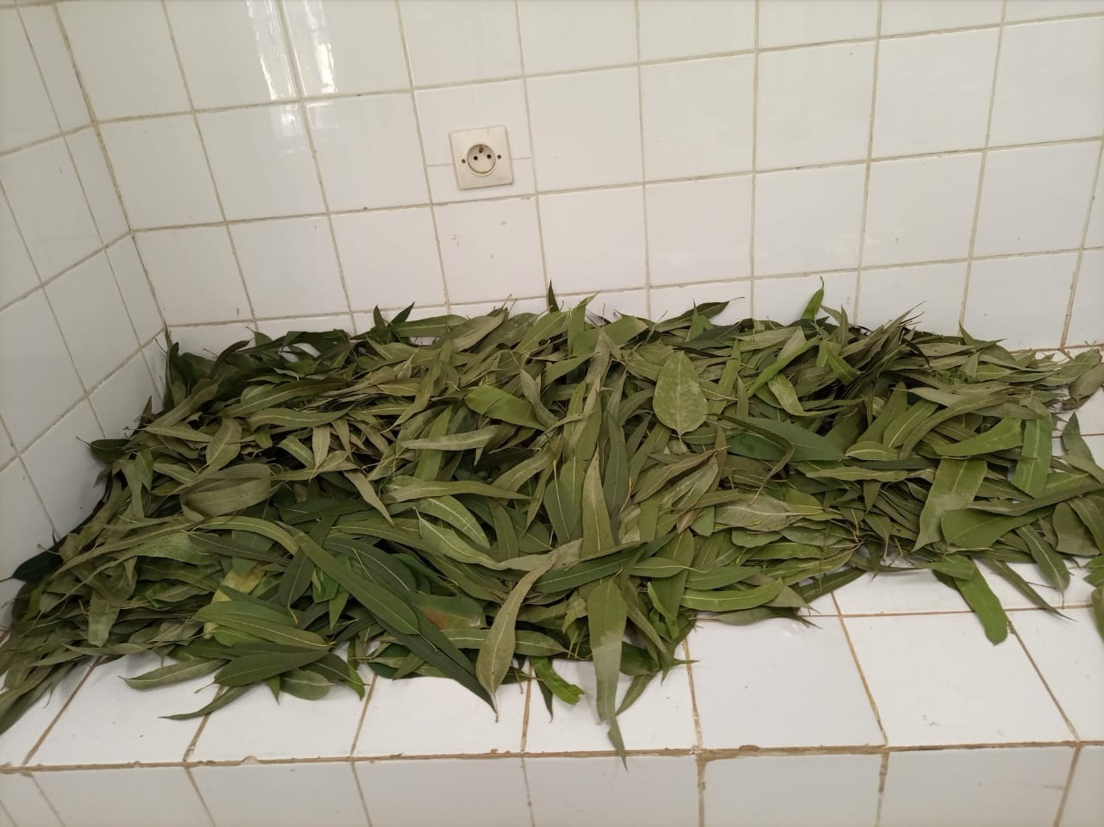
Plate 1: Dried leaves of Eucalyptus tereticornis

The leaves of Eucalyptus tereticornis were harvested in January 2022 and identified at the herbarium of the University of Lomé under the number TOGO 15869 then dried between 18 and 20°C in the Laboratory

Essential oil extraction

500g of dried leaves were placed in a still and then placed above a 5L heating mantle containing water. The water vapor thus produced passes through the raw material. The essential oil, mixed with the water vapor, rises towards a condenser. This mixture is then cooled and collected in the essential oil container which previously contained water. After condensation and liquefaction, the oil above the water (immiscible) is separated. After extraction, the essential oil obtained volume was measured and then stored in a tightly stoppered glass bottle and protected from light and then stored in the freezer until its use.
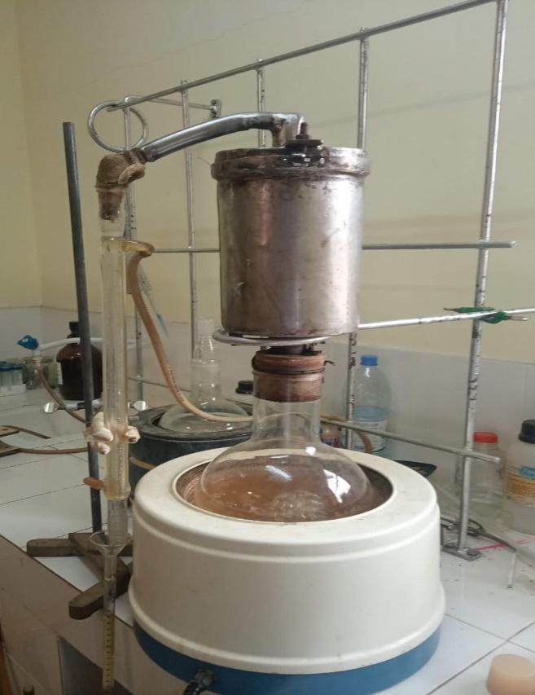
Plate 2: Essential oil extraction device by steam entrainment

The essential oil yield
The essential oil yield was estimated based on the mass of essential oil obtained and the mass of dry plant matter. It is expressed as a percentage and calculated using the following formula:

$$RHE=\frac{MHE}{MVS}X 100$$
RHE : Essential oil yield (%)
MHE : Mass of essential oil (g)
MVS : Mass of dry plant matter (g)

Determination of the Refractive Index

Measurements are performed using an Abbé "AZZOTA" refractometer. The quality standard for refractometry used to adjust the refractometer is distilled water. When the measurement is performed at a temperature other than 20°C, the correction to 20°C is made using the following formula:

I 20 = I T + 0.00045(T-20°C)

I 20: index at 20°C
IT: index at room temperature
T: room temperature

Analysis of essential oil chemical composition

The chemical composition of the essential oil was determined using the Gas Chromatography/Mass Spectrometry (GC/MS) analysis technique. Analysis of the chemical composition of the EO was carried out using a Thermo SCIENTIFIC TRACE 1300 gas chromatograph coupled to a Thermo SCIENTIFIC ISQ QD mass spectrophotometer. The oven was programmed at an initial temperature of 45°C for 5 minutes, then reduced to 155°C at a rate of 2°C/min maintained for 2 minutes, before being raised again to 250°C at a rate of
5°C/min maintained for 9 minutes. Detection was performed in split mode without splitting. The injection temperature was set at 200°C. The ion source temperature was set at 230°C and the transfer temperature at 250°C. Mass spectrum data were acquired in SCAN mode in the 40-
550 m/z range. Compound identification was based on comparison of the mass spectrum
obtained for each compound with those of mass spectra in a database available in the analysis system [7].

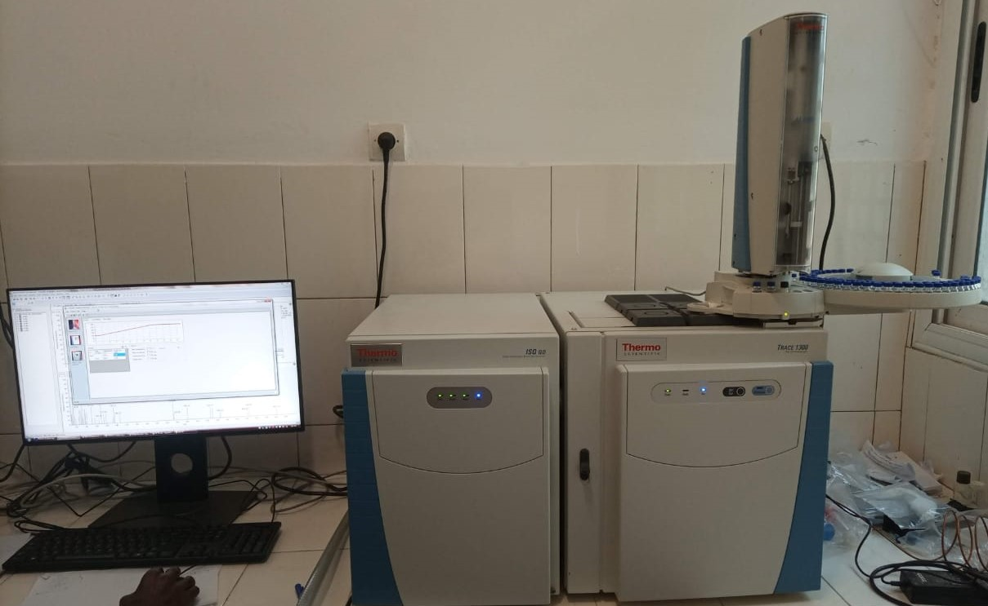
Plate 3: GC/MS analysis: Thermo SCIENTIFIC TRACE1300, coupled with a Thermo SCIENTIFIC ISQ QD mass spectrometer

Assessment of biological activities

Evaluating the anti-free radical activity of essential oils

The free radical scavenging activity of Eucalyptus tereticornis essential oil was assessed using

the DPPH● free radical scavenging method [8].

Principle of the DPPH● radical trapping method

2,2-diphenyl-1-picrylhydrazyl (proton scavenger) is a free radical, stable over time and widely used to assess the free radical scavenging activity of any compound [9], [10]. This radical in solution is colored violet. In the presence of a proton donor, the DPPH● radical is reduced by forming a stable molecular bond (Figure 1). The reduced product shows a yellowish color. Absorbance is measured using a UV-Visible spectrophotometer at a wavelength of 517 nm. The decrease in color intensity of the solution is proportional to the quantity of free radical scavengers present in the reaction medium. The anti- free radical activity of our EO was compared with that of ascorbic acid used as a reference antioxidant.

Fig 1-Principle of the DPPH● radical trapping method

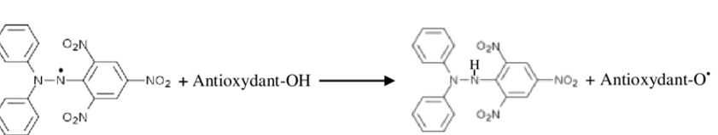
DPPH Free radical(purpe) DPPH-H reduced form (yellow)

How it works

From a stock solution of ascorbic acid (1 mg/mL), dilutions were made to plot the calibration curve. To 3 mL of DPPH● reagent in a test tube, 100 µL of ascorbic acid solution was added. The mixture was vortexed and the optical density was read on the spectrophotometer after 15 minutes of incubation. The calibration curve was thus produced. For the test samples, the DPPH● reagent (3 mL) and the HE solution to be tested (100 µL) with a titre of 15.06 mg/µL were mixed in the same proportions as for the standard curve. The optical density was read with a spectrophotometer after 15 minutes incubation at a wavelength of 517 nm.

Assessing the antioxidant activity of essential oils

The antioxidant activity of Eucalyptus tereticornis essential oil was measured using the FRAP (Ferric reducing-antioxidant power) test following the protocol described by [11].

FRAP test principle

The FRAP test is based on the reduction of ferric ion to iron (II) salt by antioxidants, resulting in the formation of the blue color [12].

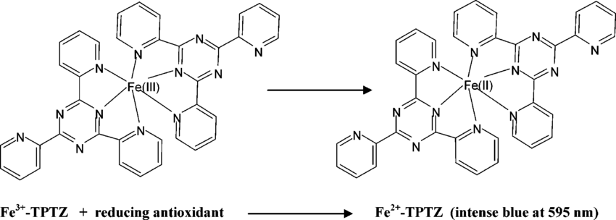

Fig 2-The FRAP test

How it works

Dilutions of a stock solution of ascorbic acid (1 mg/mL) were made to plot the calibration curve. To 3 mL FRAP reagent introduced into a test tube, 300 µL distilled water and 100 µL ascorbic acid solution were added. The mixture was vortexed and the optical density was read after 5 minutes incubation using the UV-Visible spectrophotometer. A calibration curve was thus produced. For the samples to be tested, FRAP reagent (3 mL), distilled water (300 µL) and the HE solution to be tested (100 µL), at a concentration of 100 mg/mL, were mixed in the same proportions as for the standard curve. Optical density was read after 5 minutes incubation at a wavelength of 593 nm.

Assessment of antibacterial activity

Antibacterial tests were carried out using the microdilution method on 96-well plates [13].

Bacterial strains studied

Antibacterial tests were carried out on four clinical strains and four reference strains. Clinical strains were isolated from respiratory tract samples. These were the following four strains: Staphylococcus aureus, Streptococcus spp, Klebsiella pneumoniae and Escherichia coli. The four reference strains used are : Staphylococcus aureus ATCC 29213, Klebsiella pneumoniae Lot 7000 920, Escherichia coli ATCC 25922 and Streptococcus pneumoniae ATCC 49619.

Stump processing

Pure culture isolation of each strain was performed on nutrient agar.

Sterility test

A 100 µL volume of essential oil was spread on the nutrient agar and incubated at 37°C for 24 hours. As the essential oil showed no microbial growth, it was considered sterile.

Preparation of bacterial inoculum

A microbial suspension equivalent to the 0.5 Mc Farland standard (108 CFU/mL) was prepared from an 18 to 24 hours old bacterial culture on nutrient agar.

Preparation of the stock solution

To facilitate miscibility of the essential oil in the liquid medium, Tween 20 was used at a ratio of 90% essential oil to 10% Tween 20 [14]. Tween served as a dispersant for the essential oil in water. It was miscible with both oil and water. The oil was then diluted to generate a 2-fold dilution.

Antibacterial testing

Determination of minimum inhibitory concentration (MIC)

Microplates (Greiner bio-one) with 96 wells, divided into 8 rows of 12 columns, were used. Four successive dilutions of order 2 were made from the essential oil stock solution with MH broth in four columns of the microplate. Concentrations of 100%, 50%, 25%, 12.5% and 6.25% were prepared. The volume of extract per well was 100 µL, to which was added 100 µL of bacterial inoculum. Controls were made. The sixth column was reserved for Tween 20 diluted to 10% in MH broth as a negative control. The seventh column was reserved for the positive control antibiotic, gentamicin injection 40 mg/mL. In the eighth column, 100 µL of MH broth was placed in six wells. This was used to check for possible contamination of the culture medium. The remaining six wells in the eighth column, containing 100 µL of MH broth and
100 µL of inoculum, were used to check the quality of growth of the bacterial strain. The test was carried out in an aseptic environment. Each test was performed in duplicate for each bacterial strain and repeated twice. Plates were then covered and incubated in an oven at 37°C for 18 to 24 hours. The MIC of the essential oil was determined after 18 to 24 hours of incubation, from the first well of the range free of bacterial growth visible to the naked eye. The MIC therefore corresponded to the concentration of the well containing the lowest concentration of extract showing no visible growth to the naked eye.

Determination of minimum bactericidal concentration (MBC)

The minimum bactericidal concentration (MBC) is the concentration that kills 99.99% of the bacterial inoculum. It was determined by spreading 100 µL of wells with a concentration greater than or equal to the MIC on nutrient agar. The bactericidal or bacteriostatic effect was determined by the BMC/MIC ratio. If the BMC/MIC ratio = 1 to 2, the effect was bactericidal and it was bacteriostatic, if the BMC/MIC ratio = 4 to 16 [15].

RESULTS AND DISCUSSION

Extraction yield of Eucalyptus tereticornis EO

In this study, the extraction yield of Eucalyptus tereticornis essential oil from dry leaves was
0.75%. This result is lower than that obtained by [16] i.e. 1.21% for fresh Eucalyptus tereticornis leaves. Our yield is lower than that of [17], which was 1.20% for Eucalyptus globulus, and that [18], which was 1.80% for Eucalyptus citriodora. On the other hand, our result is higher than that found by [19], which was 0.58% for Eucalyptus tereticornis extracted by hydrodistillation. This disparity in essential oil extraction yields could be attributed to the different nature of the species studied, and to a number of factors such as the stage of plant growth, the pedoclimatic and edaphic conditions of the region where the plants are grown, and the extraction technique applied [20].

Refractive index of Eucalyptus tereticornis essential oil

The refractive index of the Eucalyptus tereticornis EO studied in the present work is presented in Table 1, in comparison with the AFNOR standard [21].
Table 1: Refractive index of Eucalyptus tereticornis essential oil

Parameter | Eucalyptus tereticornis EO | AFNOR reference
Refractive index | 1,475 ± 0,004 | 1,460-1,476

According to Table 1, the refractive index at 20°C of our Eucalyptus tereticornis essential oil is

1.475 ± 0.004. This value falls within the range established by the AFNOR standard. The value of the refractive index is considered to be one of the purity criteria for an essential oil. This value depends on the temperature at which the analysis is carried out [22]. For essential oils, the refractive index value also depends on their chemical composition, essentially the content of monoterpenes and oxygenated derivatives. Thus, a high monoterpene content corresponds to an EO with a high refractive index [23].

Chemical composition of Eucalyptus tereticornis essential oil (EO)

The data compiled in Table 2 show the results of GC/MS analysis of the chemical composition of Eucalyptus tereticornis dry leaf essential oil. According to Table 3, at least thirty-three compounds were identified in the EO of Eucalyptus tereticornis, each with a content greater than or equal to 0.02%. These thirty-three compounds have a content corresponding to 99.09% of the cumulative concentrations of all the various constituents of the essential oil.
Table 2: The various constituents identified in our essential oil extracted from the dried leaves of Eucalyptus tereticornis with their percentage

N° RT Compounds % Area

Monoterpenes

1 11.34 α-Pinene 55.72
2 13.94 β-Pinene 16.73
3 15.09 β-Myrcene 0.29
4 15.75 α-phellandrene 3.91
5 17.10 o-Cymene 7.40
6 17.47 Eucalyptol 5.45
7 19.42 γ-Terpinene 0.37
8 21.42 α-Terpinolene 0.20
9 23.09 β-Fenchol 0.13
10 23.67 exo-2,7,7-Triméthylbicyclo[2.2.1]heptan-2-ol 0.02
11 24.76 Trans-pinocarveol 0.14
12 25.37 β-Linalool, 0.04
13 26.39 α-Pinocarvone 0.06
14 26.68 Borneol 0.15
15 27.48 Terpinen-4-ol 0.43
16 28.45 α-Terpineol 0.77
17 28.92 Myrtenol 0.04
18 29.22 Cis-sabinol 0.08
19 32.22 p-Menth-1(7)-én-2-one 0.05
20 32.70 5-Isopropényl-2-méthyl-7- oxabicyclo[4.1.0]heptan-2-ol
0.11
Total 92.09
Sesquiterpenes
21 42.60 α-Gurjunene 0.11
22 43.14 Cis-β-Caryophyllene 0.77
23 44.34 (+)-Aromadendrene 1.99
24 45.21 α-Humulene 0.09
25 47.80 Alloaromadendrene 0.15
26 51.53 Epiglobulol 0.15
27 51.92 (+)- Viridiflorol 0.05
28 52.93 (+)- Lédol 0.79
29 53.97 (+)- Rosifoliol 0.05
Total 4.15
Unclassified compounds
30 12.24 n-Heptane 0.08
31 17.36 β-terpineol acetate 2.69
32 30.45 1,3,3-Trimethylbicyclo[2.2.1]hept-2-yl acetate 0.05
33 54.78 12-Oxatricyclo[4.4.3.0(1,6) ]tridécane-3,11-dione 0.03
Total 2.85
Total compounds identified in EO 99.09
As can be seen, the essential oil of Eucalyptus tereticornis leaves studied in the present work consisted mainly of α-Pinene (55.72%), β-Pinene (16.73%), O-Cymene (7.40%), Eucalyptol (5.45%), β-terpineol acetate (2.69%) and Aromadendrene (1.99%), giving a total concentration of 89.98%. This oil differs in chemical composition from that extracted from leaves of the same species by [24], whose major constituents were Para-cimene (31.14%), β - Phellandrene (9.77%), Spathulenol (8.13%), γ-Terpinene (7.03%), α -Phellandrene (6.78%), 1,8 cineole (5.35%) and that extracted from leaves of the same species studied by [25], whose major constituents were trans-trans Farnesol (58.51%), trans-cis Farnesol (12.56%), cis-cis Farnesol (8.42%) and β-Pinene (7.83%). The differences in results indicate the presence of three different Eucalyptus tereticornis chemotypes, including the Farnesol and Para-cymene chemotypes found in Benin and the α-Pinene chemotype found in Togo. It has been reported that variability between the HE chemical compositions of different chemotypes of the same species, as is the case here, may be due to intrinsic factors (genetics and subspecies) or extrinsic factors such as the geographical origin of the species (climate and soil) or the extraction method [26].

Anti-free radical and antioxidant activity of Eucalyptus tereticornis EO

Table 3 shows the results of the evaluation of the anti-free radical and antioxidant activities of

Eucalyptus tereticornis essential oil.

Table 3: Anti-free radical and antioxidant activity of Eucalyptus tereticornis essential oil

 | Anti-free radical activity | Antioxidant activity
Eucalyptus tereticornis EO | 4.11 ± 0.01 µg EAA/g HE | 0.60 ± 0.11 mg EAA/g HE

The results presented in Table 3 show that the Eucalyptus tereticornis essential oil studied in the present study has an antiradical activity estimated at 4.11 ± 0.01 µg EAA/g EO and an antioxidant activity estimated at 0.60 ± 0.11 mg EAA/g EO. The existence of pinenes (α-Pinene and β-Pinene) in the essential oil extract is therefore consistent with the anti-free radical and antioxidant activities highlighted in this work. Indeed, it has been sufficiently demonstrated that β-Pinenes possess antiradical properties [27]. The work of [28] and [29] had shown that pinenes possess remarkable antioxidant
properties. Earlier results by [16] also demonstrated the antioxidant activity of Eucalyptus tereticornis essential oil.

Antibacterial activity of Eucalyptus tereticornis essential oil

The results obtained after evaluating the antibacterial activity of Eucalyptus tereticornis essential oil are shown in Table 4.

Table 4: Minimum inhibitory concentration (MIC) and minimum bactericidal concentration

(MBC) of the essential oil of Eucalyptus tereticornis studied in the present work.

Bacterial strains | MIC (%) | CMB (%) | Activities
Gram-positive bacteria
Staphylococcus aureus  Staphylococcus aureus ATCC 29213 | 25 (¼)  25 (¼) | 25 (¼)  25 (¼) | Bactericide  Bactericide
Streptococcus spp  Streptococcus pneumoniae ATCC 49619 | 25 (¼)  25 (¼) | 25 (¼)  25 (¼) | Bactericide  Bactericide
Gram-negative bacteria  Klebsiella pneumoniae | 25 (¼) | 50 (½) | Bactericide
Klebsiella pneumoniae Lot 7000 920  Escherichia coli | 25 (¼)  25 (¼) | 50 (½)  25 (¼) | Bactericide  Bactericide
Escherichia coli ATCC 25922 | - | - | No activity
Legend: (-) no effect
The results obtained using the microdilution | technique | on 96-well | plates showed that
Eucalyptus tereticornis essential oil possessed antibacterial activity against all the different micro-organisms selected up to ¼ dilution (25%), with the exception of the reference strain Escherichia coli ATCC 25922, which showed no sensitivity in relation to the dose applied. This antibacterial activity would then be justified thanks to the presence of α-Pinene and β-Pinene, which are compounds recognized as endowed with antimicrobial properties [28], [30]. However, bacterial susceptibility is indeed either Gram-independent [31], or dependent on the essential oils used [32]. Indeed, it has been shown that the sensitivity of microorganisms can vary according to the germ tested, since an essential oil can be bactericidal towards certain strains, bacteriostatic towards others, or have no effect at all [33]. The mechanism of action of essential oils is therefore essentially linked to bacterial wall structure and membrane permeability. In general, an essential oil exerts its antimicrobial power by interfering with the bacterial lipid bilayer
thanks to its hydrophobic property, resulting in: increased permeability and subsequent loss of cellular constituents; acidification of the bacterial interior, blocking cellular energy production and synthesis of structural components; destruction of genetic material, leading to bacterial death [34]. On the other hand, Gram-negative bacteria are more resistant than Gram-positive ones, due to structural differences in their outer membranes [35]. The action of EOs would cause permeability of the bacterial membrane leading to the loss of cytoplasmic content[36]. Previous studies on the essential oil of Eucalyptus tereticornis revealed antimicrobial activity and indicated a similarity with the results obtained in the present work [24].

CONCLUSION

The present work was devoted to analyzing the chemical composition, determining the antioxidant and free radical scavenging activities, and then evaluating the antibacterial activity of the essential oil extracted from the leaves of Eucalyptus tereticornis. Analysis of the chemical composition shows that Eucalyptus tereticornis essence contains α-Pinene, β-Pinene, O- Cymene, Eucalyptol, β-terpineol acetate and Aromadendrene as its main compounds. Eucalyptus tereticornis essential oil showed weak antioxidant and free radical scavenging activities and interesting bactericidal activity against Staphylococcus aureus strains, Staphylococcus aureus ATCC 29213, Streptococcus spp, Streptococcus pneumoniae ATCC
49619, Klebsiella pneumoniae, Klebsiella pneumoniae Lot 7000 920 and Escherichia coli, but had no activity on the reference strain Escherichia coli ATCC 25922.

Disclaimer (Artificial intelligence)
Authors hereby declare that NO generative Artificial intelligence (AI) technologies such as Large Language Models (ChatGPT, COPILOT, etc.) and text-to-image generators have been used during the writing or editing of this manuscript.

REFERENCES

[1] World Health Organization (2003). Traditional Medicine. Fact Sheet 135.

[2] World Health Organization. WHO Strategy for Traditional Medicine for 2002-2005, (2002) Geneva: World Health Organization.

[3] Agody K, Bakoma B, Batawila K, Wala K, Dourma M, Pereki H, Dimobe K, Bassene H, Akpagana K. (2019). Contribution to the census of medicinal plants in Togo: the case of the maritime region. Eur. Sci. J. ESJ, vol. 15, no. 24, pp. 329-345.

[4] Francisco JB. Limaa, Teresinha S. Britoa, Walter BS. Freirea, Roberta C. Costaa, Maria I. Linharesa, Francisca CF. Sousaa, Saad Lahloub, JoséH. Leal-Cardosob, Armênio A. Santosa, Pedro JC. Magalhães (2010). The essential oil of Eucalyptus tereticornis, and its constituents α-and β-pinene, potentiate acetylcholine-induced contraction sin isolated rattrachea. Fitoterapia 81 (2010) 649–655

[5] Khursheed Ahmad Ansari. (2017). Ethnomedical uses of Eucalyptus: A review. Journal of Medicinal Plants Studies 2017; 5(1): 298-301
[6] Lima FJB, Brito TS, Freire WBS, Costa RC, Linhares MI, Sousa FCF. (2010) The essential oil of Eucalyptus tereticornis, and its constituents α- and β-pinene, potentiate acetylcholine-induced contractions in isolated rat trachea. Fitoterapia. vol. 81, no. 6, p. 649‑655.

[7] Santana HT, Trindade FTT, RG S, Silva AAE, Militão J, & Facundo VA. (2015) Essential oils of leaves of Piper species display larvicidal activity against the dengue vector, Aedes aegypti (Diptera: Culicidae). Rev. Arm. Plantas Med..vol. 17, no. 1, p. 105-111.

[8] Avlessi F, Dangou J, Wotto VD, Alitonou GA, Sohounhloue DK, & Menut C. (2004) Antioxidant properties of the essential oil of Clausena anisata (Wild) Hook leaves. Comptes Rendus Chim.. vol. 7, no. 10‑11, p. 1057-1061.

[9] Cotelle N, Bernier J-L, Catteau J-P, Pommery J, Wallet J-C, & Gaydou EM. (1996) Antioxidant properties of hydroxy-flavones. Free Radic. Biol. Med..vol. 20, no. 1, p. 35-43.

[10] Trouillas P, Calliste C-A, Allais D-P, Simon A, Marfak A, Delage C, & Duroux J-L. (2003) Antioxidant, anti-inflammatory and antiproliferative properties of sixteen water plant extracts used in the Limousin countryside as herbal teas. Food Chem.. vol. 80, no. 3, p. 399-407.

[11] Agbodan KA, Dotse K, & Koumaglo KH. . (2014) Antioxidant activities of essential oils from three aromatic plants acclimated to Togo. Int. J. Biol. Chem. Sci. vol. 8, no. 3, pp. 1103-1110.

[12] Ou B, Hampsch-Woodill M, & Prior RL. (2001) Development and Validation of an Improved Oxygen Radical Absorbance Capacity Assay Using Fluorescein as the Fluorescent Probe. J. Agric. Food Chem.. vol. 49, no. 10, pp. 4619-4626, doi: 10.1021/jf010586o.

[13] NCCLS C. (2002). Performance standards for antimicrobial susceptibility testing. Twelfth Information Supplement 22,

[14] Oussou KR, Yolou S, Boti JB, Guessennd KN, Kanko C, Ahibo C, & Casanova J. (2008) Chemical study and antidiarrheal activity of essential oils from two aromatic plants in the Ivorian pharmacopoeia. Eur. J. Sci. Res., vol. 24, no. 1, pp. 94-103.

[15] El Amri J, Elbadaoui K, Zair T, Bouharb H, Chakir S, & Alaoui TI. (2014). Study of the antibacterial activity of essential oils of Teucrium capitatium L and Silene vulgaris extract on different strains tested. J. Appl. Biosci., vol. 82, pp. 7481-7492.

[16] Shalinder K, Harminder PS, Daizy RB, & Ravinder KK. (2011). Chemical characterization, antioxidant and antifungal activity of essential oil from Eucalyptus tereticornis. J.Med. Plant Res. flight. 5, no. 19, p. 4788‑4793.

[17] Rao RV, Shashikala S, Sreevani P, Kothiyal V, Sarma CR, & Lal P. (2002). Within tree variation in anatomical properties of some clones of Eucalyptus tereticornis Sm. Wood Sci. Technol. flight. 36, no. 3, p. 271‑285, doi: 10.1007/s00226-002-0139-3.

[18] Singh HP, Kaur S, Negi K, Kumari S, Saini V, Batish DR, & Kohli RK. (2012). Assessment of in vitro antioxidant activity of essential oil of Eucalyptus citriodora (lemon-scented Eucalypt; Myrtaceae) and its major constituents. LWT-Food Sci. Technol. flight. 48, no. 2, p. 237-241.

[19] Zafar Iqbal ZI, Imtiaz Hussain IH, Hussain A, & MY Ashraf M.Y. (2003). Genetic variability to essential oil contents and composition in five species of Eucalyptus.

[20] Ben Ammar R, Kilani S, Bouhlel I, Skandrani I, Naffeti A, (2007) Boubaker J Antibacterial and cytotoxic activities of extracts from (Tunisian)Rhamnus alaternus (Rhamnaceae), Ann. Microbiol.. vol. 57, no. 3, p. 453, doi: 10.1007/BF03175089.

[21] AFNOR (2000). Essential Oils, Monograph Relating to Essential Oils, Volume 2, Vols 1 and 2
[22] Novidzro KM, Wokpor K, Fagla BA, Koudou vo K, Dotse K, Osseyi E, & Koumaglo KH. (2019). Study of some physicochemical parameters and analysis of mineral elements, chlorophyll pigments, and carotenoids in Griffonia simplicifolia seed oil. Int. J. Biol. Chem. Sci. vol. 13, no. 4, pp. 2360-2373.

[23] Boukhatem MN, Hamaidi MS, Saidi F, & Hakim Y. (2010). Extraction, composition, and physicochemical properties of the essential oil of Rose Geranium (Pelargonium graveolens L.) grown in the Mitidja plain (Algeria). (1)(2) Abstractv. Nat. Technol. vol. 2, no. 2, pp. 37-45.

[24] Alitonou G, Avlessi F, Wotto VD, Ahoussi E, Dangou J, & Sohounhloué DC. (2004). Chemical composition, antimicrobial properties, and activity on ticks of the essential oil of Eucalyptus tereticornis Sm. Comptes Rendus Chim. vol. 7, no. 10-11, pp. 1051-1055.

[25] Sohounhloue DK, Dangou J, Gnomhossou B, Garneau F-X, Gagnon H, & Jean F-I. (1996). Leaf Oils of Three Eucalyptus Species from Benin: E. torelliana F. Muell., E. citriodora Hook, and E. tereticornis Smith J. Essent. Oil Res. flight. 8, no. 1, p. 111-113, doi: 10.1080/10412905.1996.9700571.

[26] Özcan MM, Chalchat JC. (2008). Chemical composition and antifungal activity of rosemary (Rosmarinus officinalis L.) oil from Turkey”, Int. J. Food Sci. Nutr. 2008. vol. 59, no. 7‑8, p. 691-698, Jan. doi: 10.1080/09637480701777944.

[27] Mercier B, Prost J, & Prost M. (2009). Turpentine essential oil and its most volatile part (α- and β-pinenes): A literature review, Int. J. Occup. Med. Environ. Health vol. 22, no. 4, pp. 331-342.

[28] Salehi B, Upadhyay S, Erdogan Orhan I, Kumar Jugran A, LD Jayaweera S, A & Dias D. (2019). Therapeutic potential of α- and β-pinene: A miracle gift of nature, Biomolecules. vol. 9, no. 11, p. 738.

[29] Weston-Green K, Clunas H, and Jimenez-Naranjo C. (2021). A review of the potential use of pinene and linalool as terpene-based medicines for brain health: discovering novel therapeutics in the flavors and fragrances of cannabis, Front. Psychiatry vol. 12, p. 583211, 2021.

[30] Yang H, Woo J, Pae AN, Um MY, Cho N-C, Park KD. (2016). α-Pinene, a major constituent of pine tree oils, enhances non-rapid eye movement sleep in mice through GABAA-benzodiazepine receptors, Mol. Pharmacol. flight. 90, no. 5, p. 530‑539.

[31] Dorman HD. & Deans S.G. (2000). Antimicrobial agents from plants: antibacterial activity of plant volatile oils, J. Appl. Microbiol. flight. 88, no. 2, p. 308-316.

[32] Deans SG, & Ritchie G. (1987). Antibacterial properties of plant essential oils, Int. J. Food Microbiol. Vol. 5, No. 2, pp. 165-180.

[33] Hermal C. (1993). Bacteriostatic activity of seven essential oil emulsions and two combinations of essential oil emulsions.

[34] Caillet S. & Lacroix M. (2007). Essential oils: their antimicrobial properties and their potential applications in food. INRS-Inst. Armand-Frappier RESALA Vol. 1, No. 8.

[35] Burt S. (2004). Essential oils: their antibacterial properties and potential applications in foods—a review. Int. J. Food Microbiol. Vol. 94, no. 3, p. 223‑253.

[36] Elodie G. (2010). Molécules antibactériennes issues d’huiles essentielles : séparation, identification et mode d’action. Thèse présentée pour l’obtention du grade de Docteur de l’Université de Corse le 6 decembre 2010. Mention : Biochimie - Biologie moléculaire

