Original Research Article

Phytochemical profiling and anti-MRSA activity of extracts from Moringa oleifera Lam. and Senna occidentalis (L.) Link cultivated under organic conditions

.
ABSTRACT

The emergence of antibiotic-resistant bacterial strains, particularly Methicillin-Resistant Staphylococcus aureus (MRSA), is a major threat to global public health. In this context, medicinal plants represent a promising alternative for the discovery of new antimicrobial agents. The aim of this study was to explore the phytochemical profile and assess the antibacterial activity of extracts in solvents of different polarity from Moringa oleifera (leaves, bark, flowers) and Senna occidentalis (leaves, bark, seeds, pods) against clinical strains, including 10 MRSA strains, 4 methicillin-sensitive Staphylococcus aureus (MSSA) strains, and an ATCC 25923 strain for quality control The extracts were obtained by maceration in water, ethanol (70 %) and dichloromethane, followed by concentration in a rotary evaporator. Phytochemical screening was carried out using conventional chemical reactions in a tube, enabling the presence of secondary metabolites such as flavonoids, tannins, alkaloids, saponins, sterols, triterpenes, anthocyanosides, coumarins and reducing compounds to be identified. Assessment of the antimicrobial activity, using disk diffusion and broth dilution methods, revealed that M. oleifera flower extract exhibited marked antibacterial activity, with an inhibition zone of more than 10 mm and a bactericidal effect with a MBC/MIC ratio ≤ 4. In comparison, S. occidentalis showed more modest activity. These results suggest that M. oleifera extracts could be an effective natural alternative in the treatment of infections caused by resistant strains of staphylococci.

Keywords: Moringa oleifera, Senna occidentalis, MRSA, antibacterial activity, phytochemical screening, secondary metabolites.

1. INTRODUCTION

For several decades, antibiotics have been a fundamental pillar in the fighting against bacterial infections. However, the excessive, inappropriate and unregulated use of these molecules has led to an alarming increase in bacterial resistance, particularly in strains such as methicillin-resistant Staphylococcus aureus (MRSA), which is now recognised as a global public health problem (WHO, 2023 ; Mohammed et al., 2025). Bacterial multi-resistance considerably limits the available therapeutic options, putting many conventional treatment strategies at risk (Ejikeugwu et al., 2023). Faced with this impasse, the search for new sources of antimicrobial molecules is intensifying, and medicinal plants are emerging as a promising alternative. Rich in secondary metabolites (alkaloids, flavonoids, tannins, saponins, etc.), these natural resources have demonstrated significant antimicrobial activity, including against resistant bacteria (Alqahtani et al., 2022; Batiha et al., 2020). Their accessibility, low cost and traditional use make them ideal candidates, particularly in resource-limited settings where modern healthcare is not widely available. In traditional African pharmacopoeia, plants play a central role in the treatment of many ailments. However, their scientific exploitation often remains limited by empirical methods and extraction focused solely on water-soluble compounds (Kamagaté et al., 2014). Yet the polarity of solvents strongly influences the chemical profile of extracts and, consequently, their biological activity. By integrating modern tools for extraction, phytochemical screening and microbiological evaluation, their therapeutic potential can be fully exploited (Panigrahi et al., 2015). In this context, Moringa oleifera and Senna occidentalis stand out as two plant species of major interest. M. oleifera, nicknamed the 'miracle tree', is recognised for its nutritional, antioxidant, anti-inflammatory and antimicrobial properties, which have been widely documented in the scientific literature (Batiha et al., 2020). It is used for both the prevention and treatment of various diseases. For its part, S. occidentalis, a perennial plant in the Fabaceae family, is used in traditional African medicine to treat skin, digestive and respiratory infections, due to the diversity of its bioactive compounds (Panigrahi et al., 2015). Both plants are locally available and can be grown under organic conditions, reinforcing their value as sustainable and environmentally friendly alternatives to conventional antibiotics. Therefore, in the present study, we undertook an in-depth investigation of the phytochemical profile and antibacterial potential of M. oleifera and S. occidentalis against multidrug-resistant strains of Staphylococcus aureus, focusing on extracts obtained with solvents of different polarities. The aim of this work is to contribute to the identification of new therapeutic approaches based on local plant biodiversity.

2. material and methods

2.1. Plant material
Moringa oleifera and Senna occidentalis plants used in this study were harvested at Bissiri, and the various analyses were carried out in Ouagadougou (Figure 1). Both plants (Figure 2) were grown using organic methods, guaranteeing the absence of pesticides and chemical fertilizers, which is crucial for preserving the quality and purity of the active compounds (Amanze et al., 2020). The organs harvested for M. oleifera included leaves, stem bark and flowers, while for S. occidentalis, leaves, stem bark, seeds and seed capsules were collected. After harvesting, the plant parts were carefully cleaned, dried in the shade (at room temperature for one week) to preserve heat-sensitive compounds, then ground into a fine powder using a mechanical grinder. The powder obtained was stored in airtight containers at room temperature, protected from light and humidity, until use.
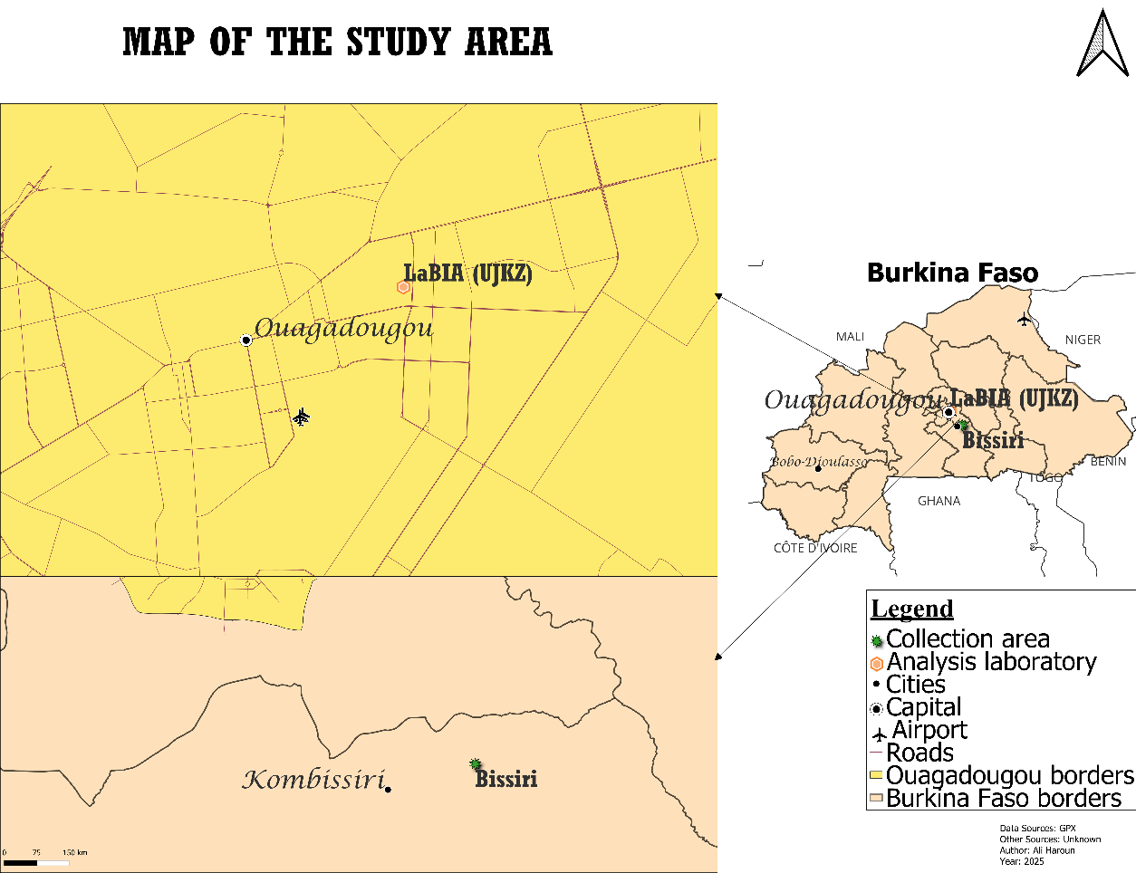
Fig. 1 : Harvesting site and study area for M. oleifera and S. occidentalis samples
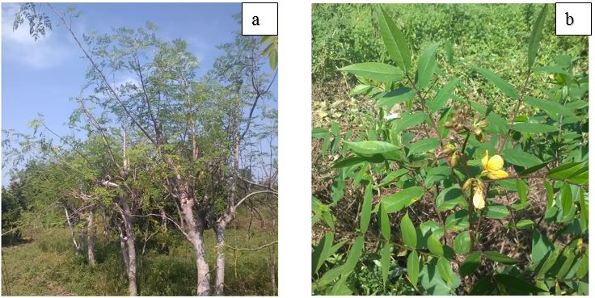
Fig. 2 : Moringa oleifera (a) and Senna occidentalis (b)
2.1.1. Preparation of crude extracts
To maximise extraction of the active compounds, three solvents of different polarity were used: water, ethanol and dichloromethane. For each solvent, 2.5 g of powder was macerated in 25 mL of solvent for 24 hours in a cool place. The extracts were filtered on cotton wool and then on 3 mm Whatman paper. The ethanolic and dichloromethane extracts were concentrated in the oven, while the aqueous extracts were freeze-dried to preserve the heat-sensitive compounds. All extracts were stored at 4°C prior to microbiological testing (Dai et al., 2020).
2.1.2. Qualitative phytochemical screening
The concentrated extracts were subjected to a series of specific chemical tests in tubes, enabling the qualitative detection of different classes of secondary compounds, according to protocols validated and updated by several recent studies (Harborne, 1998 ; Vijayakumar et al., 2012 ; Souza et al., 2020). These tests are based on the ability of phytochemical compounds to react with specific reagents, producing characteristic colourations or precipitates.
Sterols and triterpenes: Detected by the Liebermann-Burchard reaction, which produces a reddish-brown or purplish ring at the interface and a green or violet coloration in the upper layer, indicating the presence of these lipophilic compounds.
Cardenolides: Revealed by a red coloration after the addition of dinitrobenzoic acid and 1N KOH, a test used to detect cardiotonic glycosides.
Anthracenes: Revealed by the Borntrager reaction, detected by the appearance of a red supernatant in the presence of 5% KOH, characteristic of anthracenosides.
Coumarins: Detected by blue or green fluorescence under UV light at 254 and 366 nm after addition of ammonia, the classic method for identifying these phenolic compounds.
Flavonoids: Identified by the cyanidin test (Shibata reaction), where the formation of a red or orange coloration after the addition of magnesium and concentrated hydrochloric acid indicates the presence of flavonoids.
Anthocyanosides: Revealed by the red colour obtained after heating acidified ethanolic extracts in n-butanol, indicating the presence of anthocyanic pigments.
Phenolic compounds (tannins): Indicated by a green (catechol-type tannins) or intense blue (pyrogallol-type tannins) colouration after addition of ferric chloride, a well-known reaction in phytochemistry.
Saponins: Detected by the formation of a persistent foam of at least 1 cm after vigorous shaking, characteristic of these amphiphilic glycosides.
Alkaloids: Detected by the Dragendorff and Mayer-Valser reactions, which lead to the formation of coloured precipitates (orange-yellow or opalescent), indicating the presence of basic alkaloids.
Reducing compounds: Revealed by a brick-red precipitate after reaction with Fehling's reagent, indicating the presence of reducing sugars and other compounds with reducing functional groups.
These qualitative tests are an essential step in guiding subsequent biochemical and pharmacological analyses, by identifying the major classes of secondary metabolites likely to explain the biological activity observed.
2.2. Evaluation of antibacterial activity
2.2.1. Bacteriological material
Methicillin-resistant Staphylococcus aureus (MRSA) was isolated in different laboratories in the city of Ouagadougou. Strains were identified using API STAPH (Analytical Profile Index) galleries, a reliable biochemical method that allows precise determination of bacterial genus and species. Methicillin resistance was confirmed by a cefoxitin sensitivity test in accordance with international standards recommended by the Antibiogram Committee of the Société Française de Microbiologie. The reference strain S. aureus ATCC 25923 was used as a control in all experimental procedures to ensure the quality and reproducibility of the results (EUCAST/CA-SFM, 2024).
2.2.2. Disc diffusion test
Neutral sterile discs were impregnated with the extracts to be tested and then placed on Mueller-Hinton agar plates inoculated by flooding with MRSA bacterial suspensions standardised to 10⁶ CFU/mL. After pre-incubation at room temperature for 30 minutes to allow diffusion, the plates were incubated at 37°C for 24 to 48 hours. Inhibition diameters around the discs were measured with a caliper and interpreted according to EUCAST/CA-SFM (2024) recommendations.
2.2.3. Determination of minimum inhibitory concentration (MIC) and minimum bactericidal concentration (MBC)
The liquid dilution method was used to determine MIC and MBC. Extracts were tested at concentrations ranging from 0.625 to 20 mg/mL. Each tube containing the extract was inoculated with 0.1 mL of a bacterial suspension standardised to 10⁶ CFU/mL. After incubation at 37°C for 18 to 24 hours, the MIC was determined as the minimum concentration showing no visible growth. For the BMC, cultures from tubes with no growth were plated on Mueller-Hinton agar. The MBC corresponds to the lowest concentration that kills at least 99.99 % of bacteria (EUCAST/CA-SFM, 2024).
2.3. Statistical analysis
Experimental data were expressed as means ± standard deviation. A one-way analysis of variance (ANOVA) was performed to assess the impact of bacterial phenotypes (sensitive or resistant) on the antibacterial activity of the extracts. Differences were considered significant at a p-value < 0.05. All statistical analyses were performed using GraphPad Prism 5 software.

3. results and discussion
3.1. Results
3.1.1. Phytochemical composition
Qualitative analysis by phytochemical screening revealed a significant diversity of chemical groups in Moringa oleifera and Senna occidentalis extracts, with notable variations depending on the plant organ, the nature of the extract and the solubility of the metabolites.
The Table 1 shows that S. occidentalis contains a higher diversity of compounds than M. oleifera. Flavonoids, tannins, alkaloids, saponins, anthracenosides and reducing compounds were found in both plants, although some (emodols, coumarins, anthracenosides) are specific to S. occidentalis.
Table 1. Results of the chemical characterization of M. oleifera and S. occidentalis.
Chemical group | SOC | SOG | SOL | SOE | MOE | MOF | MOL
Sterols/triterpenes (aglycones) | + | + | + | + | + | + | +/-
Emodols | +/- | + | +/- | + | - | - | -
Coumarins | - | + | - | - | - | - | -
Aglycone flavones | - | - | - | +/- | - | +/- | +/-
Basic alkaloids | - | + | - | + | +/- | - | -
Sterols/triterpenes (glycosides) | + | + | + | + | +/- | + | +
Flavone glycosides | - | - | + | +/- | - | + | +
Anthracenosides | + | + | +/- | + | - | - | -
Coumarins (hydrolysed) | + | - | + | - | - | - | -
Tannins (phenols) | + | + | ++ | + | - | ++ | ++
Saponins | + | + | + | +/- | +/- | +/- | -
Alkaloids (salts) | - | + | - | + | + | - | -
Anthocyanosides | - | - | - | + | + | + | -
Reducing compounds | + | + | + | + | +/- | + | +
Legend: + = presence; (-) = absent; +/- = tracks; SOC = Senna occidentalis (SO) shells; SOG = seeds of SO; SOL = SO sheets; SOE = SO bark; MOE = MO bark; MOF = Flowers of MO; MOL = Sheets of MO.
3.1.2. The heat map of secondary metabolites per extract
The heatmap shows the comparative distribution of phytochemical groups in the different extracts of Senna occidentalis and Moringa oleifera. It shows: A high concentration of tannins in MOL, MOF and SOL (dark blue areas); A marked presence of anthracenosides and sterol glycosides in S. occidentalis extracts. Flavonoids (glycosides and aglycones) were more abundant in floral and leaf extracts of M. oleifera.
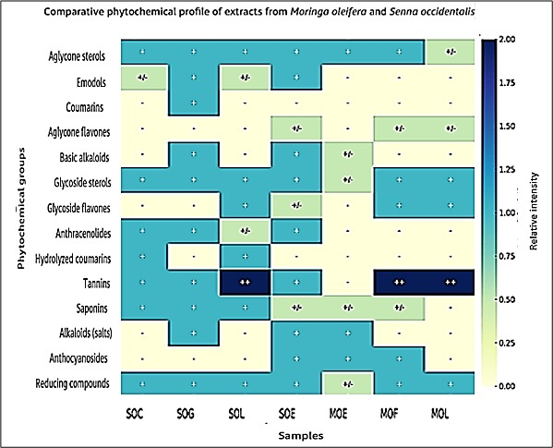
Fig. 3 : Heat map of phytochemical groups in extracts of M. oleifera and S. occidentalis.
3.1.3. Antibacterial activity
3.1.3.1. Evaluation of the anti-MRSA activity of extracts
In this study, extracts from different parts of M. oleifera (leaves, bark and flowers) and S. occidentalis (leaves, bark, seeds and seed capsules) were tested against susceptible and resistant strains of S. aureus. These strains are associated with suppurative (mainly) and urinary tract infections. Only one strain is of vaginal origin. Fifteen strains of S. aureus were involved in this study. Four were methicillin-susceptible (MSSA), ten were MRSA and one was a reference strain (ATCC 25923; MSSA). Cefoxitin discs (30 µg) were used to detect methicillin-resistant isolates. Methicillin resistance was established when an inhibition diameter < 27 mm was obtained (EUCAST/CA-SFM, 2024). The strains collected are presented in Tables 2.
Table 2. Strain phenotypes and nature of samples
Strain | S5 | S14 | S16 | S43 | R4 | R20 | R23 | R26 | R28 | R29 | R32 | R39 | R40 | R41
Nature | Pus | Pus | Pus | Pus | Pus | Pus | Pus | Pus | Pus | ECBU | EV | Pus | ECBU | Pus
Age | 9 | 66 | 52 | 42 | 24 | 52 | 28 | 48 | 64 | 24 | 37 | 86 | 25 | 3
Sex | F | F | F | M | F | F | M | F | M | M | F | F | M | F
S: Susceptible; R: Resistant; ECBU: Urine Cytobacteriological Examination; EV: Vaginal Swab; F: Female; M: Male.
To compare the activities of the extracts, cefoxitin disks (30 µg) were used as the reference antibiotic.
Extracts from the different solvents showed variable activities for water and ethanol. No activity was detected with dichloromethane on any of the strains. Table 3 shows the intrinsic activity of the aqueous extracts on the different strains.
Table 3. Diameters of the zones of inhibition of aqueous extracts of M. oleifera and S. occidentalis
Strains |  | Aqueous extracts
Strains | Cefox | MOL | MOE | MOF | SOL | SOE | SOC | SOG
ATCC | 26.67 ± 1.78 | 7.33 ± 0.58 | 9.33 ± 0.58 | 8.33 ± 0.58 | 7.33 ± 0.58 | 8.33 ± 0.58 | 7.33 ± 0.58 | 8.50 ± 0.71
S5 | 11.33 ± 0.58 | 7.33 ± 0.58 | 7.33 ± 0.58 | 7.33 ± 0.58 | 7.33 ± 0.58 | 7.33 ± 0.58 | 7.33 ± 0.58 | 7.33 ± 0.58
S14 | 10.67 ± 4.16 | 6.33 ± 0.57 | 6.33 ± 0.57 | 6.33 ± 0.57 | 6.33 ± 0.57 | 6.33 ± 0.57 | 6.33 ± 0.57 | 6.33 ± 0.57
S16 | 10.67 ± 4.16 | 6.33 ± 0.57 | 7.33 ± 0.57 | 6.33 ± 0.57 | 6.33 ± 0.57 | 7.33 ± 0.58 | 6.33 ± 0.57 | 6.5 ± 0.71
S43 | 11.00 ± 4.36 | 6.33 ± 0.58 | 8.33 ± 0.57 | 7.33 ± 0.57 | 7.33 ± 0.57 | 7.33 ± 0.57 | 7.33 ± 0.57 | 7.33 ± 0.57
R4 | 8.33 ± 2.08 | 7.67 ± 0.58 | 7.67 ± 0.58 | 7.67 ± 0.58 | 7.67 ± 0.58 | 6.67 ± 0.58 | 7.67 ± 0.58 | 7.67 ± 0.58
R20 | 6.00 ± 0.00 | 7.33 ± 0.57 | 7.33 ± 0.58 | 7.33 ± 0.57 | 7.33 ± 0.57 | 6.33 ± 0.57 | 7.33 ±0.57 | 7.33 ± 0.57
R23 | 7.67 ± 2.88 | 7.67 ± 0.57 | 7.67 ± 0.57 | 7.67 ± 0.57 | 7.67 ± 0.57 | 6.67 ± 0.57 | 7.67 ± 0.57 | 7.67 ± 0.57
R26 | 8.33 ± 2.08 | 6.33 ± 0.57 | 6.33 ± 0.57 | 6,33 ± 0.58 | 6.33 ± 0.57 | 6.33 ± 0.57 | 6.33 ± 0.57 | 6.33 ± 0.57
R28 | 7.33 ± 2.31 | 7.33 ± 0.57 | 9.33 ± 0.57 | 8.33 ± 0.57 | 7.33 ± 0.57 | 8.33 ± 0.57 | 7.33 ± 0.57 | 8.33 ± 0.57
R29 | 6.00 ± 0.00 | 8.33 ± 0.57 | 8.33 ± 0.57 | 8.33 ± 0.57 | 8.33 ± 0.57 | 8.33 ± 0.57 | 6.33 ± 0.57 | 8.33 ± 0.57
R32 | 8.67 ± 0.57 | 8.33 ± 0.57 | 8.33 ± 0.57 | 8.33 ± 0.57 | 8.33 ± 0.57 | 7.33 ± 0.57 | 7.33 ± 0.57 | 8.33 ± 0.57
R39 | 8.67 ± 4.62 | 8.33 ± 0.57 | 8.33 ± 0.57 | 8.33 ± 0.57 | 8.33 ± 0.57 | 8.33 ± 0.57 | 7.33 ± 0.57 | 7.33 ± 0.57
R40 | 6.00 ± 0.00 | 6.33 ± 0.57 | 6.33 ± 0.57 | 6.33 ± 0.57 | 6.33 ± 0.57 | 6.33 ± 0.57 | 6.33 ± 0.57 | 6.33 ± 0.57
R41 | 6.00 ± 0.00 | 6.33 ± 0.57 | 8.33 ± 0.57 | 6.33 ± 0.57 | 8.33 ± 0.57 | 9.33 ± 0.57 | 6.33 ± 0.57 | 8.33 ± 0.57
MOL : M. oleifera leaves; MOE : M. oleifera bark; MOF : M. oleifera flowers; SOL : S. occidentalis leaves; SOE : S. occidentalis bark; SOC : S. occidentalis shell; SOG : S. occidentalis seeds; S : sensitive; R : resistant; Cefox : cefoxitin; ATCC : American Type Culture Collection
The results obtained show that the ethanolic extracts of Moringa oleifera (in particular the MOF extract) exert the strongest antibacterial activity in vitro against the strains tested, with maximum inhibition zones greater than 10 mm, particularly on the standard ATCC strain. This activity is clearly more marked than that observed for the other extracts (MOL, MOE, SOL, SOE, SOC, SOG), whose inhibition zones generally oscillate between 6 and 9 mm, suggesting a lesser efficacy (table 4).
Table 4. Diameters of inhibition zones of ethanolic extracts of M. oleifera and S. occidentalis
Strain |  | Ethanolic extracts
Strain | Cefox | MOL | MOE | MOF | SOL | SOE | SOC | SOG
ATCC | 27.76 ± 3.05 | 11.33 ± 0.57 | 7.67 ± 0.58 | 13.67 ± 0.57 | 8.33 ± 0.58 | 8.33 ± 0.57 | 8.33 ± 0.58 | 8.67 ± 0.57
S5 | 11.33 ± 0.57 | 8.00 ± 1.00 | 6.00 ± 0.00 | 12.33 ± 1.16 | 7.33 ± 0.57 | 7.33 ± 0.57 | 7.33 ± 0.58 | 7.33± 0.58
S14 | 10.67 ± 4.16 | 8.67 ± 0.57 | 6.00 ± 0.00 | 11.33 ± 1.16 | 6.33 ± 0.58 | 6.33 ± 0.57 | 6.33 ± 0.57 | 6.33± 0.58
S16 | 10.67 ± 4.16 | 8.00 ± 0.00 | 6.00 ± 0.00 | 10.67 ± 0.58 | 6.33 ± 0.58 | 7.33 ± 0.58 | 6.33 ± 0.57 | 6.33 ± 0.57
S43 | 11.00 ± 4.36 | 8.67 ± 0.58 | 6.33 ± 0.57 | 10.67 ± 0.57 | 7.33 ± 0.57 | 7.33 ± 0.58 | 7.33 ± 0.57 | 7.33 ± 0.57
R4 | 8.33 ± 2.08 | 9.67 ± 1.16 | 6.67 ± 0.57 | 9.67 ± 0.57 | 7.33 ± 0.58 | 7.33 ± 0.57 | 7.33 ± 0.58 | 7.67 ± 058
R20 | 6.00 ± 0.00 | 8.33 ± 0.57 | 6.67 ± 0.58 | 9.67 ± 0.58 | 7.33 ± 0.57 | 6.33 ± 0.58 | 7.33 ± 0.57 | 7.33 ± 0.58
R23 | 7.67 ± 2.89 | 7.67 ± 0.58 | 6.00 ± 0.00 | 11.00 ± 1.00 | 7.67 ± 0.57 | 6.67 ± 0.58 | 7.67 ± 0.58 | 7.67 ± 0.57
R26 | 8.33 ± 2.08 | 8.00 ± 0.00 | 6.67 ± 0.57 | 10.33 ± 1.16 | 6.33 ± 0.58 | 6.33 ± 0.58 | 6.33 ± 0.57 | 6.33 ± 057
R28 | 7.33 ± 2.31 | 7.67 ± 0.57 | 6.33 ± 0.58 | 10.33 ± 0.58 | 7.33 ± 0.57 | 8.33 ± 0.57 | 7.33 ± 0.57 | 833 ± 0.57
R29 | 6.00 ± 0.00 | 8.67 ± 2.08 | 6.00 ± 0.00 | 13.00 ± 1.00 | 8.33 ± 0.57 | 8.33 ± 0.57 | 6.33 ± 0.578 | 8.33 ± 0.58
R32 | 8.67 ± 0.57 | 10.00 ± 0.00 | 6.00 ± 0.00 | 12.00 ± 0.00 | 8.33 ± 0.58 | 7.33 ± 0.58 | 7.33 ± 0.57 | 8.33 ± 0.58
R39 | 8.67 ± 4.62 | 8.00 ± 1.00 | 6.67 ± 0.57 | 10.67 ± 0.57 | 8.33 ± 0.58 | 8.33 ± 0.57 | 7.33 ± 0.58 | 7.33 ± 0.58
R40 | 6.00 ± 0.00 | 10.00 ± 1.00 | 6.67 ± 0.57 | 12.00 ± 2.00 | 6.33 ± 0.57 | 6.33 ± 0.57 | 6.33 ± 0.58 | 6.33 ± 0.58
R41 | 6.00 ± 0.00 | 7.67 ± 0.58 | 6.33 ± 0.57 | 10.0 ± 1.00 | 8.33 ± 0.58 | 9.33 ± 0.57 | 6.33 ± 0.57 | 8.33 ± 0.58
MOL: M. oleifera leaves; MOE: M. oleifera bark; MOF: M. oleifera flowers; SOL: S. occidentalis leaves; SOE: S. occidentalis bark; SOC: S. occidentalis shell; SOG: S. occidentalis seeds; S: susceptible; R: resistant; Cefox: cefoxitin; ATCC: American Type Culture Collection.
3.1.3.2. Intrinsic activity of aqueous extracts of M. oleifera and S. occidentalis leaves
Evaluation of the antibacterial activity of aqueous extracts of Moringa oleifera (MOL) and Senna occidentalis (SOL) against several clinical bacterial strains revealed variable efficacy depending on the extract and the target strain. The tests were carried out using the Mueller-Hinton agar diffusion method, with measurement of the inhibition halos around the extract-impregnated discs. (Figure 4)
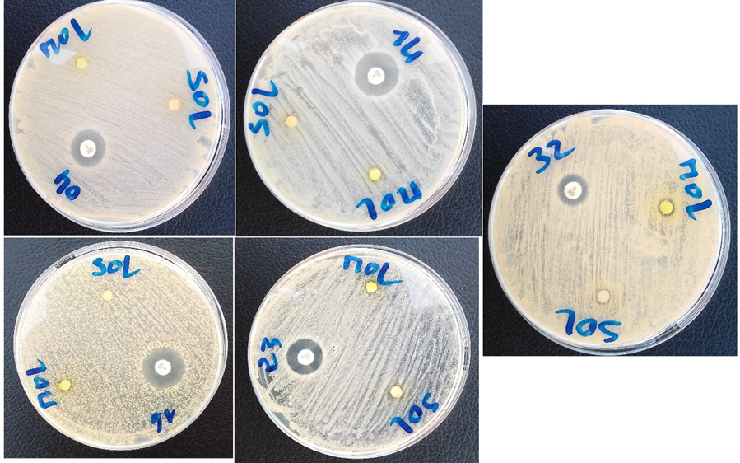
Fig. 4. Intrinsic activity of aqueous extracts of M. oleifera and S. occidentalis leaves
3.1.3.3. Intrinsic activity of ethanolic extracts of total organs of M. oleifera and S. occidentalis
These images (Figure 5) show the results of bacterial inhibition tests, which reveal the variable antimicrobial activity of the different plant extracts tested against different strains of MRSA. The discs in the centre are cefoxitin discs, and the numbers correspond to the strain numbers.
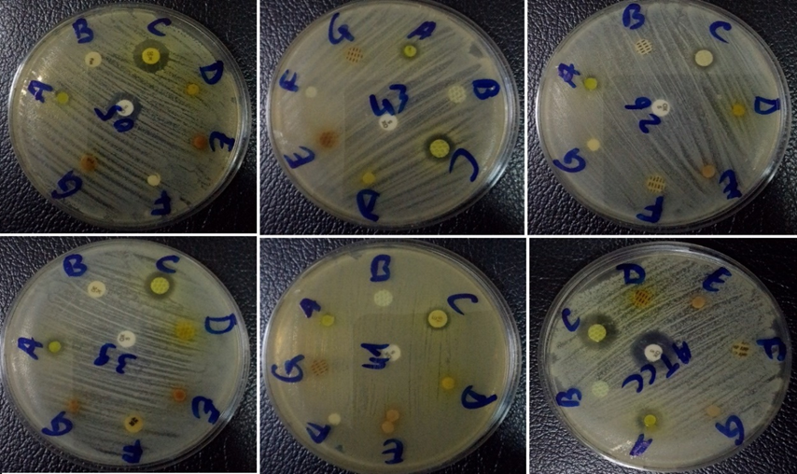
Legends: A = MOL; B = MOE; C = MOF; D = SOL; E = SOE; F = SOC; G = SOG
Fig. 5. Intrinsic activity of ethanolic extracts of total organs of M. oleifera and S. occidentalis
3.1.3.4. Evaluation of the minimum inhibitory concentration (MIC) and minimum bactericidal concentration (MBC) of active extracts
Analysis of the data revealed significant antimicrobial activity of the extracts tested against Staphylococcus aureus strains, including the ATCC reference strain and several methicillin-resistant clinical isolates (MRSA). The minimum inhibitory concentrations (MICs) observed range from 1.25 mg/mL to 5 mg/mL, while the minimum bactericidal concentrations (MBCs) range from 5 mg/mL to 10 mg/mL. The MBC/MIC ratio is a crucial indicator for characterising the type of antibacterial action: a MBC/MIC ratio ≤ 4 suggests a bactericidal effect; a ratio > 4 would indicate a bacteriostatic effect. According to this classification, all the strains tested have a bactericidal profile, although isolates S5, S14 and S16 show borderline efficacy (MBC/MIC = 4.0) (Table 5).
Table 5. Ethanolic extracts of M. oleifera and S. occidentalis MIC and BMC against S. aureus strains
Strain | MIC (mg/mL | MBC (mg/mL | MBC/MIC
ATCC | 2.5 | 5.0 | 2.0
S5 | 1.25 | 5.0 | 4.0
S14 | 1.25 | 5.0 | 4.0
S16 | 1.25 | 5.0 | 4.0
S43 | 2.5 | 5.0 | 2.0
R4 | 5.0 | 5.0 | 1.0
R20 | 5.0 | 5.0 | 1.0
R23 | 5.0 | 10.0 | 2.0
R26 | 5.0 | 10.0 | 2.0
R28 | 5.0 | 5.0 | 1.0
R29 | 5.0 | 5.0 | 1.0
R32 | 5.0 | 10.0 | 2.0
R39 | 5.0 | 10.0 | 2.0
R40 | 5.0 | 5.0 | 1.0
R41 | 5.0 | 10.0 | 2.0
3.2. Discussion
Qualitative analysis of extracts from Moringa oleifera and Senna occidentalis revealed a significant diversity of chemical compounds. These compounds varied based on the plant part and the type of solvent used for extraction.
- The dichloromethane fraction was rich in lipophilic compounds such as sterols and triterpenes.
- The hydroalcoholic fraction contained glycosylated forms of sterols and triterpenes, as well as a high concentration of anthracenosides in S. occidentalis.
- The non-hydrolyzed fraction showed a strong presence of tannins in M. oleifera leaves and saponins in S. occidentalis.
This rich combination of compounds suggests significant therapeutic potential, particularly for antioxidant, antimicrobial, and anti-inflammatory activities.
Although the results show an interesting antibacterial activity of Moringa oleifera extracts, it remains moderate compared to the standard antibiotic used as a positive control. This difference highlights the need to concentrate or purify the active fractions to improve efficacy. In addition, synergy tests with conventional antibiotics could be considered, as suggested in the studies by Lacmata et al., (2012).
The results obtained suggest that some of the plant extracts tested possess significant antibacterial activity, comparable to the reference antibiotics used as positive controls. This indicates the probable presence of bioactive secondary metabolites such as flavonoids, tannins, saponins, triterpenes and alkaloids, widely recognised for their antimicrobial properties (Cowan, 1999 ; Barros et al., 2011 ; Vijayakumar et al., 2012).
For extracts with low efficacy, this can be explained by: a low concentration of bioactive compounds, poor diffusion in the agar medium (linked to the chemical nature or molecular size), or a lack of intrinsic activity against this specific strain. The presence of large halos around the standard discs confirms the sensitivity of the strain to the reference treatment, and enables the microbiological test to be validated.
Evaluation of the antibacterial activity of the extracts tested against the various strains of Staphylococcus aureus, including multi-drug resistant clinical strains, enabled the minimum inhibitory concentrations (MIC), minimum bactericidal concentrations (MBC) and MBC/MIC ratio to be determined. The results show marked antibacterial activity, although this varies from strain to strain.
MIC values ranged from 1.25 to 5.0 mg/mL, indicating inhibition of bacterial growth at relatively low concentrations, particularly in sensitive strains S5, S14 and S16 (MIC = 1.25 mg/mL). The MBC ranged from 5.0 to 10.0 mg/mL, reflecting the concentration required to completely eliminate viable bacterial cells. The MBC/MIC ratio is used to distinguish the bactericidal effect (MBC/MIC ≤ 4) from the bacteriostatic effect (MBC/MIC > 4), as recommended by Balouiri et al., (2016).
All strains analysed in this study show a MBC/MIC ratio ≤ 4, indicating an overall bactericidal activity of the extract. The ATCC reference strain shows a ratio of 2.0, highlighting a clear bactericidal effect. Similarly, the resistant clinical strains R4, R20, R28, R29 and R40 showed a ratio of 1.0, reflecting strong bactericidal efficacy of the extract despite their resistant nature. In contrast, isolates S5, S14 and S16, although highly susceptible (MIC = 1.25 mg/mL), showed a MBC/MIC ratio of 4.0, suggesting a more moderate or borderline bactericidal effect, often observed in plant-based extracts (Ríos & Recio, 2005; Saiqali et al., 2024).
Strains R23, R26, R32, R39 and R41 show a ratio of 2.0, which remains within the range of a bactericidal effect. The elevation of BMCs to 10 mg/mL in these cases may be attributed to more developed intracellular resistance mechanisms in these hospital strains, including bacterial wall thickening or overexpression of efflux pumps (Piddock, 2006).
These results are consistent with the existing literature on Moringa oleifera and Senna occidentalis extracts. Several studies have reported significant antibacterial activities of these African medicinal plants on multidrug-resistant strains. For example, Saiqali et al., (2024) observed MICs of between 1.25 and 10 mg/mL against methicillin-resistant strains of S. aureus. These authors also reported BMC/MIC ratios of less than 4 for ethanolic extracts of Moringa oleifera leaves, confirming their bactericidal effect.
Furthermore, Ríos & Recio, (2005) proposed that extracts with a MIC of less than 8 mg/Ml could be considered antibacterially active, a threshold met by all the extracts tested in the present study. In addition, Mwamatope et al., (2020) showed that certain species of Senna and Moringa contain bioactive compounds such as flavonoids, tannins and triterpenes that can act by disrupting the bacterial cytoplasmic membrane, thus explaining their bactericidal effect.
The traditional use of these plants in the treatment of skin, respiratory and digestive infections in several African countries is therefore scientifically justified. Their extracts could represent a credible natural alternative to conventional antibiotics, especially in view of the emergence of multi-resistant strains (WHO, 2021).
4. Conclusion
This study revealed a wide range of phytochemical compounds in Moringa oleifera and Senna occidentalis extracts, depending on the plant organs and solvents used. The results show a high presence of sterols/triterpenes, flavonoids, tannins, anthracenosides and saponins, confirming the medicinal potential of these two species widely used in traditional African medicine. Senna occidentalis has been found to be particularly rich in anthracenosides, emodols and alkaloids, notably in its leaves, pods and seeds. Moringa oleifera is characterised by a high concentration of flavonoids, glycosylated sterols and tannins, particularly in the leaves and flowers. These bioactive metabolites give these plants potential antioxidant, antimicrobial and anti-inflammatory properties, hence their interest in combating resistant infections, such as those caused by methicillin-resistant Staphylococcus aureus (MRSA). The results obtained justify further studies in chromatography, spectroscopy and biological assays for the isolation, quantification and pharmacological evaluation of the active ingredients.

COMPETING INTERESTS DISCLAIMER:
Authors have declared that they have no known competing financial interests OR non-financial interests OR personal relationships that could have appeared to influence the work reported in this paper.

Author(s) hereby declare that NO generative AI technologies such as Large Language Models (ChatGPT, COPILOT, etc.) and text-to-image generators have been used during the writing or editing of this manuscript.

References
Alqahtani, Y. S., Bahafi, A., Mirajkar, K. K., Basavaraju, R. R., Mitra, S., Shailaja, S., More, S. S., Muddapur, U. M., Khan, A. A., Sudarshan, P. R., & Shaikh, I. A. (2022). In Vitro Antibacterial Activity of Green Synthesized Silver Nanoparticles Using Mangifera indica Aqueous Leaf Extract against Multidrug-Resistant Pathogens. Antibiotics, 11(11). https://doi.org/10.3390/antibiotics11111503
Amanze, E. K., Nwankpa, U. D., Udekwu, C., Ogbonna, H. N., Nwokafor, C. V, & Udensi, C. (2020). Antibacterial Activity of Moringa oleifera Root Bark Extract against Some Pathogenic Organisms. Asian Journal of Immunology, 4(3), 21–27.
Balouiri, M., Sadiki, M., & Ibnsouda, S. K. (2016). Methods for in vitro evaluating antimicrobial activity: A review. Journal of Pharmaceutical Analysis, 6(2), 71–79. https://doi.org/10.1016/j.jpha.2015.11.005
Barros, L., Carvalho, A. M., & Ferreira, I. C. F. R. (2011). Exotic fruits as a source of important phytochemicals : Improving the traditional use of Rosa canina fruits in Portugal. FRIN, 44(7), 2233–2236. https://doi.org/10.1016/j.foodres.2010.10.005
Batiha, G. E. S., Beshbishy, A. M., El-Mleeh, A., Abdel-Daim, M. M., & Devkota, H. P. (2020). Traditional uses, bioactive chemical constituents, and pharmacological and toxicological activities of Glycyrrhiza glabra L. (fabaceae). In Biomolecules (Vol. 10, Issue 3, pp. 1–19). https://doi.org/10.3390/biom10030352
Dai, J., Han, R., Xu, Y., Li, N., Wang, J., & Dan, W. (2020). Recent progress of antibacterial natural products: Future antibiotics candidates. Bioorganic Chemistry, 101. https://doi.org/10.1016/j.bioorg.2020.103922
EUCAST/CA-SFM. (2024). Recommandations 2024 – Interprétation des antibiogrammes. Société Française de Microbiologie. https://www.sfm-microbiologie.org
Cowan, M. M. (1999). Plant products as antimicrobial agents. CLINICAL MICROBIOLOGY REVIEWS, 12(4), 564–582. https://doi.org/10.3109/9781420019919-17
Ejikeugwu, C., Eze, P., & Orji, J. (2023). Antimicrobial resistance crisis: Exploring plant-based solutions. Journal of Herbal Medicine, 39, 100569. 10.20944/preprints202309.0110.v1
Harborne J.B. Phytochemical methods (1998): A guide to modern techniques of plant analysis; Springer, Third ed., London; 320p. ISBN-10: 0412572702. ISBN-13:978-0412572708
Kamagaté, M., Koffi, C., Kouamé, N. M., Akoubet, A., Yao, N. A. R., & Die-Kakou, H. M. (2014). Ethnobotany, phytochemistry, pharmacology and toxicology profiles of Cassia siamea Lam. The Journal of Phytopharmacology, 3(1), 57–76. https://doi.org/10.31254/phyto.2014.3109
Lacmata, S. T., Kuete, V., Dzoyem, J. P., Tankeo, S. B., Teke, G. N., Kuiate, J. R., & Pages, J. M. (2012). Antibacterial activities of selected cameroonian plants and their synergistic effects with antibiotics against bacteria expressing MDR phenotypes. Evidence-Based Complementary and Alternative Medicine, 2012. https://doi.org/10.1155/2012/623723
Mohammed, M. M., Isa, M. A., Abubakar, M. B., Dikwa, A. S. B., & Kappo, A. P. (2025). Molecular detection of mecA gene from methicillin-resistant Staphylococcus aureus isolated from clinical and environmental samples and its potential inhibition by phytochemicals using in vitro and in silico approach. In Silico Pharmacology, 13(1), 1–25. https://doi.org/10.1007/s40203-024-00297-y
Mwamatope, B., Tembo, D., Chikowe, I., Kampira, E., & Nyirenda, C. (2020). Total phenolic contents and antioxidant activity of Senna singueana, Melia azedarach, Moringa oleifera and Lannea discolor herbal plants. Scientific African, 9, e00481. https://doi.org/10.1016/j.sciaf.2020.e00481
Panigrahi, G. K., Ch, R., Mudiam, M. K. R., Vashishtha, V. M., Raisuddin, S., & Das, M. (2015). Activity-Guided Chemo Toxic Profiling of Cassia occidentalis (CO) seeds: Detection of Toxic Compounds in Body Fluids of CO-Exposed Patients and Experimental Rats. Chemical Research in Toxicology, 28(6), 1120–1132. https://doi.org/10.1021/acs.chemrestox.5b00056
Ríos, J. L., & Recio, M. C. (2005). Medicinal plants and antimicrobial activity. Journal of Ethnopharmacology, 100(1–2), 80–84. https://doi.org/10.1016/j.jep.2005.04.025
Saiqali, M. Al, Jamil, K., Samreen, R., & Reddy, A. V. (2024). Exploitation of Phytochemical Extracts of Moringa oleifera as Antimicrobial Agent against Human Pathogenic Bacteria. Saudi Journal of Pathology and Microbiology, 9(06), 130–138. https://doi.org/10.36348/sjpm.2024.v09i06.003
Souza, A. D. O., Bessa, D. H. R. F., Fernandes, C. C., Pereira, P. S., Martins, C. H. G., & Miranda, M. L. D. (2020). Phytochemical screening of extracts from Spiranthera odoratissima a. St.-hil. (Rutaceae) leaves and their in vitro antioxidant and anti-listeria monocytogenes activities. Acta Scientiarum - Biological Sciences, 42, 1–10. https://doi.org/10.4025/actascibiolsci.v42i1.51881
Vijayakumar, A., Duraipandiyan, V., Jeyaraj, B., Agastian, P., Raj, M. K., & Ignacimuthu, S. (2012). Phytochemical analysis and in vitro antimicrobial activity of Illicium griffithii Hook. f. & Thoms extracts. Asian Pacific Journal of Tropical Disease, 2(3), 190–199. https://doi.org/10.1016/S2222-1808(12)60045-0
World Health Organization (WHO). (2021). Global priority list of antibiotic-resistant bacteria to guide research, discovery, and development of new antibiotics. https://www.who.int/publications/i/item/WHO-EMP-IAU-2017.12
World Health Organization (WHO). (2023). Global research on antimicrobial resistance. Geneva: WHO. https://www.who.int/publications/i/item/9789240062703

