Original Research Article
Microbiological Characteristics of Food Sold in Schools in N'Djamena (Chad): Case of Sandwiches, Alelés and Danwakhé

.
ABSTRACT

Aims: To contribute to knowledge of the health quality of food sold near schools in N'Djamena, Chad, in order to ensure that students have healthy food.
Study design: Cross-sectional descriptive study based on analyses of collected samples and interpretations of the results.
Place and Duration of Study: The study was carried out from January 2023 to December 2024 in five (5) districts of the city of N'Djamena in Chad.
Methodology: Microbiological analyses were carried out on samples through standard methods in microbiology. A total of 79 samples were taken, divided between Sandwiches (37), Danwakhé (25) and Alelés (17). The germs counted were total mesophilic aerobic flora (FAMT), total coliforms, yeasts and molds, Staphylococcus and Escherichia coli
Results: The results revealed that for sandwiches, 81.2% and 88.9% to 100% of the samples analyzed were non-compliant with respect to total aerobic mesophilic flora and total coliforms respectively. For E. coli, 68.8% of the standard sandwich samples were non-compliant and 100% of the peanut sauce and eggplant sandwich samples were highly loaded with staphylococci as well as yeasts and molds. Analysis of the Danwakhé samples showed non-compliant results for all germs with high percentages particularly for coliforms (86%) followed by staphylococci (76%). In the Alelés, these are also the germs that are regularly found in samples with non-compliance rates of 62.5% and 75% respectively for staphylococci and yeasts and molds.
Conclusion: The presence of these germs in non-compliant proportions in Sandwiches, Danwakhé and Alelés sold near schools constitutes a significant health hazard that deserves awareness among stakeholders in order to offer young students healthy foods to guarantee their health.

Keywords: Health quality, germs, Sandwiches, Danwakhé, Alelés, students, schools, N’Djamena
1. INTRODUCTION

School food sales, like street food, provide a source of income for many households in Africa, especially in developing countries (Gnélé et al., 2022). In Chad and particularly in N'Djamena, foods such as Sandwiches (with several fillings), Danwakhé (small balls of millet or wheat flour dough), Alelés (processed beans) and many others (dried and unripe green mangoes, juice, dried fruits, boiled potatoes or in the form of fries and doughnuts) are sold like street foods around schools in other countries (Vido et al., 2018; Naibe Maimangyang, 2019). The sale of these foods around schools represents a source of income for many households (Gnélé et al., 2022). The majority of actors operating in this sector are women who use it as a means to cover their children's school fees (Yaou et al., 2024). Food sold in public places such as schools allows students to eat on site and increase their academic performance (Critch, 2020). Most vendors have not received any training in good hygiene and manufacturing practices. Food is therefore exposed to the open air or under trees on unsuitable supports (Naibe Maimangyang, 2019). These forms of sale expose food to contamination by various germs impacting health quality and to food poisoning among children who find it an alternative to easily feed themselves depending on their income (Baba-Moussa et al., 2006). In schools, these poisonings are mainly caused by Salmonella spp., Staphylococcus aureus and Clostridium perfringens (Randriamalala et al., 2019). Cases of E. coli, Campylobacter and Shigella infections have also been reported (Lezzar et al., 2019). Studies conducted in Burkina Faso, Ghana and Nigeria have clearly revealed that street food is sold in inappropriate environments which represent real vectors of contamination (Mayoré et al., 2023). In Chad, very little data exists on the microbiological quality of food sold in schools. Research activities have provided data on street foods (cereal, processed meat and fish sectors) in the cities of N'Djamena and Abéché without specifically studying their microbiological quality in these schools (Tidjani et al., 2016; Gamane et al., 2017; Logténé et al., 2020; Mahamat et al., 2025). The objective of our study was to contribute to improving the health quality of the most consumed foods in schools in the city of N'Djamena.

2. material and methods

2.1 Location of the study and Sampling

2.1.1 Location and period of study

The descriptive study was conducted in schools in five (5) districts of the city of N'Djamena. This included both public and private schools. During the surveys, samples of food sold near the schools were collected from identified vendors. Figure 1 shows the study location in the districts of the city of N'Djamena.

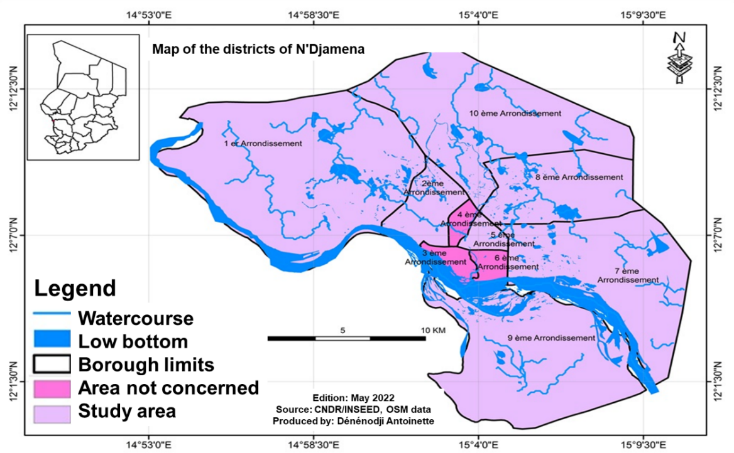

Fig. 1. Study location map

2.1.2 Sampling

A total of seventy-nine (79) samples were collected, divided between sandwiches (37), Danwakhé (25), and Alelés (17). These samples were collected from several vendors in the various selected schools and packaged in sterile bags for microbiological analysis. Table I summarizes the different types of sandwiches, Danwakhé, and Alelés along with their descriptions.

Table 1. Description of samples

Foods | Types | Descriptions
Sandwiches | Standard | Bread with an omelet filling
Sandwiches | Kanda | Bread with a fish filling
Sandwiches | Eggplant sauce | Bread spread with eggplant broth
Sandwiches | Peanut sauce | Bread spread with peanut paste preparation
Sandwiches | Meat | Bread with a minced meat filling
Danwakhé | Small boiled balls of millet or wheat flour dough
Alelés | Processed beans

2.2 Microbiological Analysis

Microbiological analysis was performed at the Food Quality Control Center (CECOQDA) in Chad and at the Food Science and Nutrition Research Laboratory (LaRSAN) at the University of N'Djamena. Sample preparation, stock suspensions, and decimal dilutions were carried out in accordance with ISO 11133 (2014). Thus 10 g of each sample was dissolved in 90 ml of peptone water which was used to carry out the different dilutions.

2.2.1 Detection and Enumeration of Germs

2.2.1.1 Total Mesophilic Aerobic Flora

The total mesophilic aerobic flora (FAMT) was enumerated according to ISO 4833-1 (2013). It consisted of double-layer inoculation onto Plat Count Agar (PCA) medium and incubation at 30°C for 48 hours.

2.2.1.2 Total Coliforms

Total coliforms (TC) were counted according to ISO 4832-2 (2006) on Eosin Methylene Blue (EMB) agar. A 0.1 ml inoculum was inoculated onto the plates, then the plates were incubated at 37°C for 24 hours. Colonies were characterized by their purple and reddish color with a halo.

2.2.1.3 Escherichia coli

Escherichia coli (E. coli) was counted according to ISO 16649-2 (2001). The dilution was inoculated onto TBX medium, and the Petri dishes were incubated at 44°C for 24 hours. The greenish-blue colonies were counted.

2.2.1.3 Staphylococcus

Staphylococcus were enumerated according to ISO 16888-1(99) 2(2018) on Chapman medium, after inoculation and incubation at 37°C for 24 hours. Golden yellow colonies with a slight halo were retained.

2.2.1.4 Yeasts and Molds

Yeasts and molds were counted on Sabouraud chloramphenicol agar according to ISO 7954-1988. Plates were incubated at 30°C for 3 to 5 days after inoculation. Milky-colored colonies (tending toward white) and varying in shape for yeasts and filamentous molds of various colors were retained.

2.1.1 Data Processing

Data entry was performed using Microsoft Office (Excel 2016) to create tables and figures. Image visibility was improved using Paint version 5.1.9.

3. results and discussion

3.1 Results

3.1.1 Microbiological Characteristics of Sandwiches

3.1.1.1 Microbial Loads

Table 2 presents the values of minimum and maximum microbial loads of the germs counted. The total mesophilic aerobic flora showed a maximum load of 1.6x10⁷ CFU/g in the standard sandwich and 1.5x10³ CFU/g as the minimum value in the same food with meat filling. For total coliforms, the loads varied from less than 10 CFU/g to more than 1.5x10⁵ CFU/g recorded in the meat and standard sandwiches respectively. Escherichia coli was counted with minimum microbial loads less than 10 CFU/g in all sandwiches. On the other hand, maximum values (>1.5x10⁵ CFU/g) were observed in standard and peanut sauce sandwiches. The maximum Staphylococcus loads were recorded in standard and Kanda sandwiches, with values above 1.5 x 10⁵ CFU/g. For yeasts and molds, values above 1.5x10⁵ CFU/g were also revealed in standard and peanut sauce sandwiches.

Table 2. Microbiological characteristics of sandwiches

Food/Standards | Germs (CFU/g)
Food/Standards | FAMT |  | Total Coliforms |  | E. coli |  | Staphylococcus |  | L&M
Food/Standards | Min | Max | Min | Max | Min | Max | Min | Max | Min | Max
Standard | 1.5x10³ | 1.6x10⁷ | <10 | >1.5x10⁵ | <10 | >1.5x10⁵ | 10 | >1.5x10⁵ | 10 | >1.5x10⁵
Kanda | 2.2x10⁴ | 4.6x10⁴ | 2.7x10² | 3.4x10² | <10 | <10 | 8x10³ | >1.5x10⁵ | <10 | 4x10³
Eggplant sauce | 5.8x10³ | 6x10³ | 4.5x10³ | 4.5x10³ | <10 | <10 | <10 | 4x10³ | 1.5x10¹ | 2.5x10³
Meat | 1.5x10³ | 2x10³ | <10 | <10 | <10 | <10 | 1.2x10³ | 2.8x10³ | 2x10¹ | 1.9x10³
Peanut sauce | 2.5x 10⁵ | 2.5x10⁵ | 9.6x10³ | >1.5x10⁵ | <10 | >1.5xx10⁵ | 2x10³ | 9.8x10⁴ | 8x10³ | >1.5x10⁵
Standards (FCD, 2022) | <10⁵ |  | <10 |  | <10² |  | <10² |  | <10³
Legend: FAMT: Total mesophilic aerobic flora; L&M: Yeasts and molds; Min: Minimum; Max: Maximum

3.1.1.2 Sandwich Compliance Analysis

The results of the total mesophilic aerobic flora count showed total satisfaction rates (100%) only for sandwiches with eggplant sauce and meat fillings. Compliance was questioned in the Standard, Kanda, and peanut sauce sandwich samples (88.90% to 100% of samples were unsatisfactory). Figure 2 illustrates the compliance rates by sandwich type.

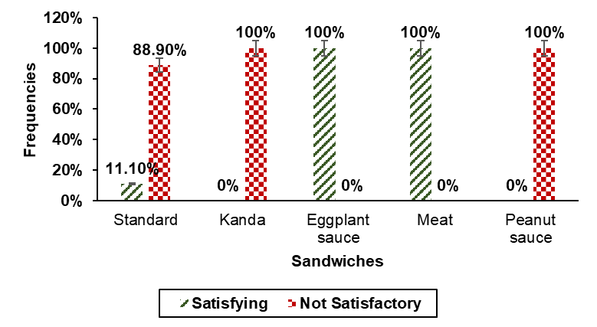

Fig. 2. Compliance of sandwiches types with Total mesophilic aerobic flora

Figure 3 shows that the highest dissatisfaction rates are observed in sandwiches with peanut sauce filling (50%), standard (81.20%) and with eggplant sauce (100%) regarding total coliforms. As for the Kanda and meat types, satisfaction was 100% for these same germs counted.

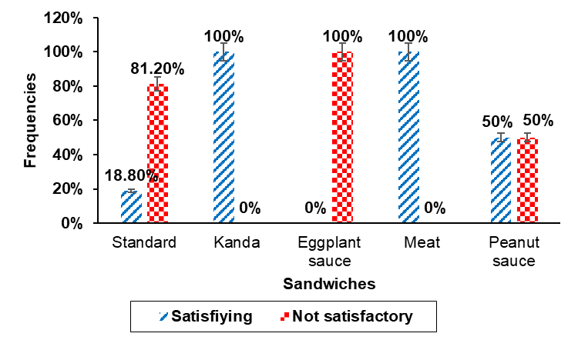

Fig. 3. Compliance of sandwich types with respect to total coliforms

For Escherichia coli, the standard and peanut sauce sandwiches showed unsatisfactory results with respective frequencies of 68.80% and 50% of the samples. Satisfaction was 100% for the Kanda, eggplant sauce and meat types (Figure 4).

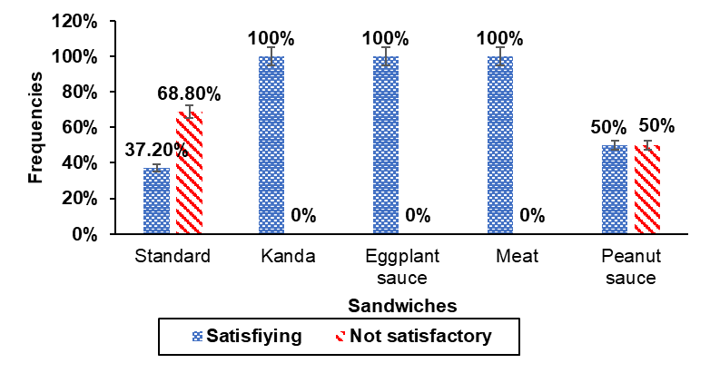

Fig. 4. Compliance of sandwich types with respect to Escherichia Coli

Figure 5 shows dissatisfaction rates ranging from 50 to 100% for meat, standard, eggplant, and peanut sauce sandwiches. Only the meat sandwich showed a 100% compliance rate among the samples collected.

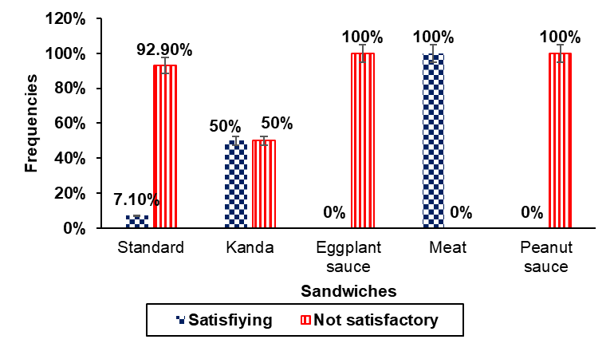

Fig. 5. Compliance of sandwich types with respect to Staphylococcus

The most notable dissatisfaction rates regarding the microbial load of yeasts and molds are observed with standard type sandwiches, with eggplant and peanut sauce filling with respective values of 85.70%, 100% and 100% (Figure 6).
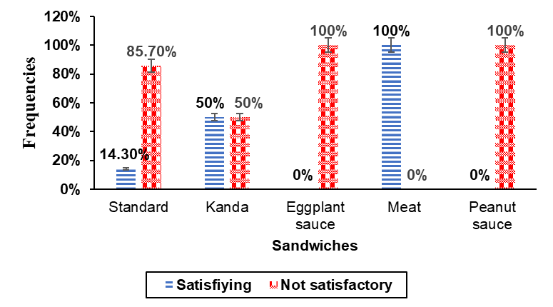

Fig. 6. Compliance of sandwich types with respect to Yeast and Molds

3.1.2 Microbiological Characteristics of Danwakhé and Alelés

3.1.2.1 Microbial Loads

The highest microbial loads of total mesophilic aerobic flora (FAMT) and total coliforms in Danwakhé and Alelés have the same values, which are 3x10⁶ CFU/g and 1.5x10⁶ CFU/g, respectively. Escherichia coli in Alelés has a higher value of 1.5x10³ CFU/g and higher than 1.5x10³ CFU/g in Danwakhé. For Staphylococcus, maximum loads of 1.5x10⁴ CFU/g and 1.3x10⁴ CFU/g were noted in Danwakhé and Alelés, respectively. As for yeasts and molds, the maximum microbial loads were 1.5x10⁴ CFU/g in Danwakhé and 1.5x10⁵ CFU/g in Alelés (Table 3).

Table 3. Microbiological characteristics of Danwakhé and Alelés

Foods/Standards | Germs (CFU/g)
Foods/Standards | FAMT |  | Total coliforms |  | E. coli |  | Staphylococcus |  | L&M
Foods/Standards | Min | Max | Min | Max | Min | Max | Min | Max | Min | Max
Danwaké | 5. 10¹ | 3.10⁶ | 10 | 1,5.10⁵ | 10 | >1,5.10⁴ | 10 | 1,5.10⁴ | 100 | 1,5.10⁴
Alelés | 1,5.10³ | 3.10⁶ | 10 | 1,5.10⁵ | 10 | 1,5.10⁵ | 10 | 1,3.10⁴ | 10 | 1,5.10⁵
Standards (FCD,2022) | <10⁵ |  | <10 |  | <10² |  | <10² |  | <10³
Legend: FAMT: Total mesophilic aerobic flora; L&M: Yeasts and molds; Min: Minimum; Max: Maximum; E. coli: Escherichia coil

3.1.2.2 Danwakhé and Alelés Compliance Analysis

Total coliforms, Staphylococcus, and Escherichia coli were the microorganisms that characterized the non-compliance of the Danwakhé samples, with respective dissatisfaction rates of 86%, 81%, and 76%. Considering all the organisms counted, the dissatisfaction rates were greater than 50% (Figure 7).

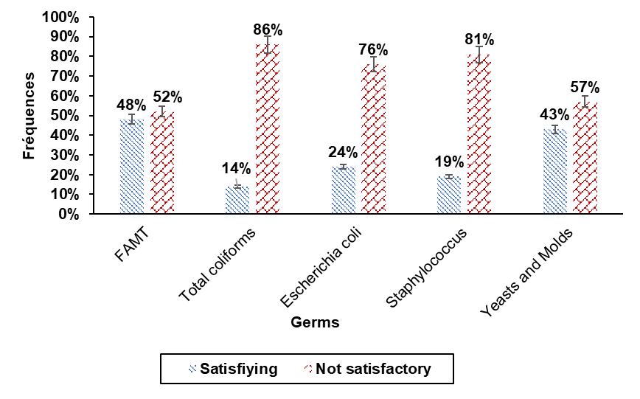

Fig. 7. Compliance of Danwakhé for all germs counted
Legend: FAMT: Total mesophilic aerobic flora

Figure 8 reveals satisfaction rates (compliance) evaluated at 84.60%, 75% and 55.60% concerning respectively the enumeration of Total mesophilic aerobic flora (FAMT), yeasts and molds of Escherichia coli. For total coliforms and Staphylococcus, the level of dissatisfaction was more remarkable with respective frequencies of 62.50% and 75%.

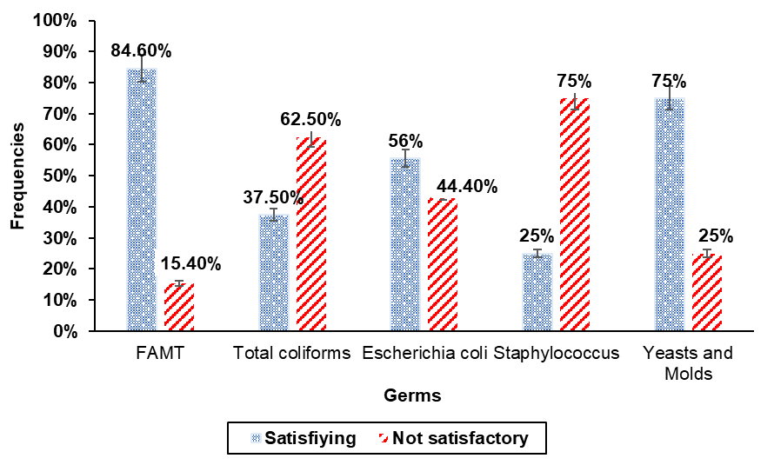

Fig. 8. Compliance of Alelés for all germs counted
Legend: FAMT: Total mesophilic aerobic flora

3.2 Discussion

3.2.1 Unsanitary Conditions and Quality Defects

The results of microbiological analyses revealed non-compliant sandwich, Danwakhé and Alelés samples, with frequencies approaching 100% for some samples regarding the total mesophilic aerobic flora (FAMT) count. Micha et al. (2018) linked the uncontrolled presence of global flora to inadequate handling during processing and the lack of cleaning and disinfection of production equipment. Yeasts and molds were also found in irregular concentrations in these same foods. These results can be explained by the fact that the majority of sellers are women who have not received any training on production and sales hygiene rules (Dossou et al., 2018; Yaou et al., 2024). Added to this is the unsanitary conditions of the equipment and sales areas which can carry all sorts of germs into street food in general (Baba-Moussa et al., 2006; Vido et al., 2018). These foods are produced in households, sometimes crossing streets with inconvenient means of transport to schools for marketing. Microbial contamination can also occur and affect the safety of food (sandwich, Danwakhé and Alelés) through several factors such as prolonged exposure to air, bare soil, harmful insects and flies (Koné et al., 2020; Yaou et al., 2024). Dossou et al. (2018) highlighted the importance of sales conditions in preserving food safety. The work of Maiwore et al. (2018) also highlighted the abundance of FAMT in fermented milk, resulting from an unsanitary environment and production equipment. The non-compliant concentration of mesophilic aerobic flora in foods sold in public places measures the level of alteration of the product and affecting its marketable quality. This can cause economic losses for the sector's stakeholders. In spoiled sandwiches, Danwakhé and Alelés, other potentially pathogenic microorganisms causing food poisoning could be included among the germs described as spoilage flora (Aouadhi et al., 2024). The study also revealed differences in microbial load and compliance rates depending on the foods and sandwich fillings. This observation seems logical because each germ is specific to the nature of the food and some of its physicochemical parameters.

3.2.2 Risks of Toxi-Infection in Schools

The data showed very high total coliforms loads in sandwiches, Danwakhé, and Alelés sold around schools, with very remarkable levels of non-compliance for some samples (100% unsatisfactory). Analyses of other foods prepared in Mali revealed a much lower non-compliance rate, at 26.66% for these same germs (Samaké et al., 2024). Also, the predominance of Escherichia coli was noted in several samples with non-compliance rates above 50%. Similar studies carried out in Ivory Coast also revealed the presence in samples of Attiéké (fermented cassava couscous) sold near roads and primary education establishments (Anoman et al., 2018). The study of Yaou et al. (2024) showed that 65% of food samples collected in school settings contained E. coli beyond limits. His work highlighted the non-compliance of Staphylococcus in 100% of samples collected in the same sales environments which is almost similar to our results on the non-compliance of Staphylococcus (100%) in sandwiches, Danwakhé and Alelés. The presence of these coliforms, Escherichia coli and Staphylococcus beyond the limits is an indicator of breaches of hygiene rules resulting in the absence of precautions in the maintenance of production equipment, packaging, storage environments and sales of the targeted foodstuffs sold near roads and public places (Guignard, 2021). The predominance of Escherichia coli is particularly perceived as an indicator of fecal contamination (Lezzar et al., 2019). This prevalence could be the cause of intestinal and gastric disorders (gastroenteritis) in young children in establishments (Abdoulaye et al., 2020). Certain pathogenicity and antibiotic resistance genes have been identified in E. coli strains isolated from community environments, posing a problem in the fight against infection by this bacterium (Guindo et al., 2022; Hounkpe, 2025). Some strains of Escherichia coli produce toxins (Shiga toxins) that cause numerous disorders, the most common of which is diarrhea (90.2%) reported by Noftall et al. (2019). Food poisoning due to Staphylococcus aureus is generally caused by the ingestion of food containing the heat-stable enterotoxins of these germs (Lezzar et al., 2019). Some molds present in food can produce mycotoxins depending on their species (case of aflatoxins produced by Aspergillus flavus) if their predominance continues in the materials used for the preparation of sandwiches, Danwakhé and Alelés sold to young schoolchildren.

4. Conclusion

Microbiological analysis revealed very high levels of contamination for all the germs counted in all the target foods in our study. This made it possible to identify the varying degrees of non-compliance for each food based on the flora tested. This study highlighted the breaches of hygiene rules for the preparation, transportation, and sale of the most popular foods sold near schools in the city of N'Djamena by stakeholders who, according to previously collected data, have not received any training in best practices. Selling food in unsafe conditions could pose a risk of foodborne illnesses that could be harmful to children. It is therefore necessary to raise awareness and organize awareness campaigns aimed at the perpetrators (sellers) to ensure food safety for students. Also, analyses for the search for other germs of the genera Salmonella, Shigella and Bacillus are possible, as well as their biochemical, molecular characterization and from the point of view of resistance to antibiotics.

DISCLAIMER (ARTIFICIAL INTELLIGENCE)

Author(s) hereby declares that NO generative AI technologies such as Large Language Models (ChatGPT, COPILOT, etc) and text-to-image generators have been used during writing or editing of this manuscript

References

Abdoulaye, O., Abdoulaye, I., Maiga, D. A., Kourna, M., Harouna Amadou, M. L., Doutchi, M., Bahari, K. D., Biraima, A., Amadou, O., & Illa, M. (2020). Prevalence of Escherichia Coli Virulence Genes in Acute Gastroenteritis in Children in Niamey. Health Sciences and Disease, 21(7). http://www.hsd-fmsb.org/

Anoman, A. T., Koussemon, M., Kouassi, K. I., & Assi, Y. A. (2018). Microbiological Quality of Garba, a Street Food in Côte d'Ivoire. International Journal of Biological and Chemical Sciences, 12(5), 2258‑2265. https://dx.doi.org/10.4314/ijbcs.v12i5.26

Aouadhi, C., Trakhna, F., & Maaroufi, A. (2024). Prevalence of pathogenic bacteria in dairy products. Journal of the Faculty of Sciences of Bizerte XXII, 209‑218.

Baba-Moussa, L., Bokossa, Y. I., Baba-Moussa, F., Ahissou, H., Adeoti, Z., Yehouenou, B., Mamadou, A., Toukourou, F., & Sanni, A. (2006). Study of the possibilities of contamination of street food in Benin: Case of the city of Cotonou. Journal of Scientific Research of the University of Lomé, 8, 149‑156.

Critch, J. N. (2020). School nutrition : Support for providing healthy food and beverage choices in schools. Paediatrics & Child Health, 25(1), 33‑38.

Dossou, B. R., Nassaya, S., Karou, D. S., Soncy, K., Kagni-Dossou, M., Anani, K., & Ameyapoh, Y. (2018). Assessment of the Safety of Prepared Meals Sold Along the Streets of the City of Kara, Togo. Journal of Scientific Research of the University of Lomé, 20(3), 79‑88.

Gamane, K. A., Micha, J. C., & Tidjani, A. (2017). Quality Assurance Approach in the Processed Fish Production Sector in Chad. Scientific and Technical Journal of Forestry and Environment of the Congo Basin. Scientific and Technical Journal of Forestry and Environment of the Congo Basin, 7, 53‑64.

Gnélé, B. D. L. C., Ouassa, P., Vissin, E. W., & Gibigaye, M. (2022). Food Contamination Factors in Street Restaurants in the Municipality of Abomey-Calavi in Southern Benin, West Africa. International Journal of Progressive Sciences and Technologies, Vol. 41 (1), pp. 93-105. https://doi.org/10.52155/IJPSAT.V41.1.5674

Guignard, A. (2021). Overview of the Main Biological and Related Foodborne Hazards. Bulletin of the French Veterinary Academy, 174(1), 271-285. https://doi.org/10.3406/bavf.2021.70966

Guindo, I., Dicko, A. A., Konaté, I., Sacko, K., Abdou, M., Dao, S., & Bougoudogo, F. (2022). Pathogenicity Factors and Antibiotic Resistance of Escherichia Coli Strains Isolated from Diarrheal Children Aged 0 to 59 Months in Community Settings in Bamako. Health Sciences and Disease, 23(5). file:///C:/Users/User/Downloads/010+ao+ibrahema+atb+diarhee+bko%20(1).pdf

Hounkpe, C. E. (2025). Characterization of pathogenic microorganisms isolated from food of animal origin consumed in schools and from swabs from the hands of operators in the Mono department (Benin) and control measures. Thesis, University of Liège (Belgium); 165p.https://orbi.uliege.be/bitstream/2268/335142/1/Th%C3%A8se%20Eustache_Dfinal.pdf

Koné, S., Samaké, M., Camara, M. A., Maiga, O. S., Koné, A. Z., Maïga, A. M., Sangaré, S., Coulibaly, M., Sangaré, C. T. O., & Maïga, F. (2020). Evaluation of the microbiological and chemical quality of bread and flour used to make bread in Bamako bakeries. Malian Journal of Science and Technology, 1(23), 4-11. file:///C:/Users/User/Downloads/rmstpub-4-11-pp-evaluation-qualit-pain%20(1).pdf

Lezzar, A., Kaoueche, O., Achat, A., Laouar, H., Benkhemissa, M., Bentchouala, C., & Benlabed, K. (2019). Collective foodborne illness. Algerian Journal of Medicine, 27(4), 94-98. file:///C:/Users/User/Downloads/les-toxi-infections-alimentaires-collectives%20(2).pdf

Logténé, Y. M., Tellah, M., Bechir, A. B., & Nayo, A. (2020). Characterization of the pig sector in the towns of Pala and Moundou in the savannah zone of southwest Chad. Journal of Livestock and Veterinary Medicine in Tropical Countries, 73(1), 3-10. file:///C:/Users/User/Downloads/dbastia,+310+MOPATE+(1)+73,+2020+WEB%20(2).pdf

Mahamat, M. I., Edwige, S. T. R., Oumar, D. A., Bechir, M., François, T., Donatien, K., & Aly, S. (2025). Technological Characterization and Socioeconomic Significance of Djir, a Fermented Cereal Flour Consumed in Chad. Microbiology Research Journal International, 35(9), 9-27. DOI: https://doi.org/10.9734/mrji/2025/v35i91618

Maiwore, J., Baane, M. P., Ngoune, L. T., Fadila, J. A., Yero, M. Y., & Montet, D. (2018). Microbiological and Physicochemical Quality of Fermented Milks Consumed in Maroua (Cameroon). International Journal of Biological and Chemical Sciences, 12(3), 1234-1246. DOI: https://dx.doi.org/10.4314/ijbcs.v12i3.13

Mayoré, A. D., Bodering, A., Bako, E., Bessimbaye, N., Gandolo, R., Tidjani, A., & Barro, N. (2023). Serotype and genotyping of Salmonella sp. Isolated from street foods in N’Djamena, Chad. International Journal of Biological and Chemical Sciences, 17(6), 2170-2180. DOI: https://dx.doi.org/10

Micha’º, J. C., Kaffine, A. G., & Tidjani, A. (2018). Hygienic quality of fish processed and marketed in Chad. Tropicultura, 36, 649‑657.

Naibe Maimangyang, S. (2019). Assessment of food quality in schools in the city of N'Djamena in Chad. https://umontreal.scholaris.ca/items/8b1db03b-a584-478d-b9b4-ade005505e3f

Noftall, K., Taylor, M., Hoang, L., & Galanis, E. (2019). Shiga toxin-producing Escherichia coli in British Columbia, 2011–2017: Analysis to inform exclusion guidelines. Canada Communicable Disease Report, 45(9), 261‑267. https://doi.org/10.14745/ccdr.v45i09a03f

Randriamalala, N. C., Rafalimino, H. N., Andrianjafinoro, T. H., Rakotonirina, F. P., Rabarijaona, H. S. N., Pamphile, M., Rakoto, A. S., Ralison, F., Rasoamananjara, J., & Ramaroson, J. (2019). Hygiene practices and food microbiology in food stalls in Ankatso. Malagasy online odontostomatology journal ISSN, 47‑59. http://madarevues.recherches.gov.mg/IMG/pdf/5_pratiques_d_hygiene_et_microbiologie_des_denrees_alimentaires_dans_les_gargotes_a_ankatso.pdf

Samake, S., Souleyemene, D., Ousmane, D., Aminata, S., Adama, K., Aminata, F., Nanourou, D., Rokiatou, F., Sogna, D. A. O., & Lalia, S. (2024). Prevalence of total coliforms, coagulase-positive Staphylococcus aureus and Salmonella spp. in prepared foods analyzed at the National Health Laboratory (Mali) in 2022. MSAS 2024, 221. https://hal.science/hal-05042851/document#page=230

Tidjani, F. S., Hamadi, A., Chandra, A., Pillay, P., & Ndtoungou, A. (2016). Optimization of standalone microgrid considering active damping technique and smart power management using fuzzy logic supervisor. IEEE Transactions on Smart Grid, 8(1), 475‑484.

Vido, M. J., Le, K., Hartsough, E. J., & Aplin, A. E. (2018). BRAF splice variant resistance to RAF inhibitor requires enhanced MEK association. Cell reports, 25(6), 1501‑1510. URL: http://dx.doi.org/10.19044/esj.2018.v14n33p251

Yaou, C., Ali, M. A., Lewamy, M., & Sadou, H. (2024). Microbiological quality control of street food sold in schools in Niamey (Niger). International Journal of Biological and Chemical Sciences, 18(3), 938‑949.

