DEVELOPMENT AND STORAGE STUDY OF FLAVOUR BLENDED MULBERRY LEAF POWDER
ABSTRACT
Mulberry (Morus spp.) leaves are nutrient-dense, containing proteins, flavonoids, phenolics, and 1-deoxynojirimycin (DNJ) with strong health benefits. The study aimed to develop Flavour blended mulberry leaf powder (FBMLP) to improve taste, acceptability and storage stability. Fresh leaves (Victory-1 variety) were shade-dried, powdered, and blended with ginger, jeera(cumin) and pudina(mint) at varying levels (0.4 g, 0.6 g, 0.8 g). Sensory evaluation by a 21-semi-trained panel using 20-point hedonic scale showed that the 0.6 g blend (T2) achieved the highest scores for flavour, aroma and overall acceptability. Storage studies at room temperature for 45 days showed no fungal growth or E. coli, and bacterial load remained very low. FBMLP consistently showed lower microbial counts than control, indicating better microbial stability. Thus, flavour blending enhanced both sensory quality and storage safety of mulberry herbal tea powder, making it a promising functional beverage.
Key words: Mulberry leaf powder, Flavour blending, Sensory evaluation, Storage stability, Herbal tea
Introduction:
Mulberry (Morus spp.), is a versatile and fast-growing deciduous plant from the Moraceae family, thrives in diverse climatic condition, ranging from tropical to temperate regions, showcasing its remarkable adaptability. it is primarily cultivated for silk cocoon production, providing the exclusive diet for the silkworm Bombyx mori and supporting the silk industry, its significance extends much further. Known as "Kalpavriksha," a mythical wish-fulfilling tree, for its numerous applications. Its leaves and fruits are packed with rich nutrients and antioxidants, making them valuable in food and traditional medicine. They are also used as livestock fodder. The plant’s roots and bark possess medicinal properties, while its leaves contribute to preventing soil erosion and enhancing soil fertility as green manure. Beyond these uses, mulberry serves in the production of natural dyes, paper, and various culinary dishes, highlighting its broad utility in agriculture, industry and everyday life (krishna et al.,2015)
Mulberry leaves are a powerhouse of nutrients and bioactive compounds, making them invaluable in both nutrition and medicine. On a dry weight basis, they contain high-quality proteins (15.31% to 30.91%), fats (2.09% to 7.92%), crude fiber (9.9% to 13.85%), neutral dietary fiber (27.6% to 43.6%), and ash (11.3% to 17.24%). The leaves are also rich in essential vitamins and minerals, with ascorbic acid (100200 mg/100g), beta-carotene (8.44-13.13 mg/100g), iron (19-50 mg/100g), calcium (786.662,726.66 mg/100g), phosphorus (970 mg/100g) and magnesium (720 mg/100g) being notably abundant (Adeduntan and Oyerinde, 2010).

Mulberry is an important medicinal plant, known for its rich source of bioactive compounds such as flavonoids, phenolics, and dietary fiber, along with its strong antioxidant properties. These components impart mulberry with potent health benefits, making it effective in combating various diseases. Studies highlight its strong impact against diabetes, cardiovascular diseases and viral infections due to its ability to modulate biological activities and enhance immune response (Afzal et al., 2021). This combination of nutritional and medicinal properties underscores the mulberry's importance as both a food and a therapeutic resource.
The leaves also contain 1-deoxynojirimycin (DNJ), a polyhydroxylated alkaloid beneficial for consumption as a tea, present in concentrations ranging from 0.28 mg/g to 3.88 mg/g (Asano et al., 2001). Carbohydrates are another key component, including total soluble carbohydrates (3.1 g/100 g fresh weight), reducing sugars (1.5 g/100 g fw), monosaccharides like fructose and glucose (0.3 g/100 g fw) and sucrose (1.1 g/100 g fw) (Dimitrova et al., 2015). These compounds make mulberry leaves beneficial for managing diabetes, cardiovascular health and other diseases. They are traditionally used to treat various ailments and are valued for their potentiality as a dietary supplement and medicinal resource.
Mulberry leaves offer a potent solution to the nutritional deficiencies prevalent in India, such as vitamin A deficiency, protein-energy malnutrition and anaemia. Rich in high-quality proteins and essential nutrients, mulberry leaves serve as an affordable alternative to traditional protein sources like eggs, milk, meat and fish, that are often too costly or inadequately produced. In South Korea and China, mulberry leaves are already well combined into the food industry. They are used in a broad range of products such as noodles, bread, biscuits, cakes, yogurt, salads and even ice cream, to enhance dietary protein intake (Chowdary et al., 2009). By incorporating mulberry leaf powder into these foods, these countries effectively utilize this nutrient-dense plant to combat malnutrition and dietary deficiencies, offering a sustainable and economical approach to improving public health
In India, mulberry leaves are increasingly being used in various culinary preparations. Fresh, healthy mulberry leaves and tender twigs are used to create dishes such as leaf pakoda and vada. Additionally, processed mulberry leaf powder is incorporated into traditional foods like chapathi, idly, dosa, and paratha, as well as bakery items like cakes and biscuits (Chowdary et al., 2009). This incorporation enhances the nutritional value of these foods, helps address dietary deficiencies, and contributes to public health in a sustainable and cost-effective manner.
Nutritional benefit of mulberry tea
Rich in minerals, vitamins, dietary fiber, amino acids, phytosterols, flavonoids and other valuable components, mulberry leaves offer a variety of biological benefits. Their high nutritional content makes them a popular choice as functional foods, commonly incorporated into herbal teas, juices, and other beverages (Dugo et al.,2009).
Mulberry leaves contain compounds that naturally aid in lowering blood pressure and controlling blood sugar levels. They are also rich in various vitamins and minerals, offering additional health benefits for all Seri tea drinkers. Naowaboot et al. (2009) reported that mulberry (Morus alba L.) leaf extracts exhibit antihyperglycemic, antioxidant, and antiglycation activities.
Fractions of mulberry leaf extract with higher concentrations of phenolic and flavonoid compounds have shown stronger antioxidant properties (Iqbal et al., 2012; Flaczyk et al., 2013). Compared to the petiole, ripe fruit, unripe fruit and stem, mulberry leaf extract possesses the highest antioxidant activity, particularly in DPPH and H2O2 radical scavenging (Lim et al., 2019). Mulberry leaves contents high levels of iron (Fe). The iron content in mulberry leaves around 119.3 to 241.8 mg/kg (Salcedo et al., 2015).
Health is a precious thing that requires consistent care and attention. The rising cost of modern medicine has prompted many consumers to explore alternative ways to maintain their well-being. This has given rise to a growing health trend known as "back to nature." One notable effect of this shift is the increasing popularity of herbal teas. Unlike traditional tea, herbal tea refers to any beverage made from plants other than Camellia sinensis, the tea plant.
Herbal teas, more accurately known as tisanes, are infusions made from a variety of dried leaves, seeds, grasses, nuts, barks, fruits, flowers, or other plant elements that contribute to their flavor and health benefits. Unlike traditional teas, tisanes are caffeine-free, offering a delicious and easy-to-drink option. They can be composed of a single herb or a blend of ingredients, often crafted to serve specific purposes, such as promoting relaxation, rejuvenation, or providing relief from certain conditions. (Manikant et al., 2023).
Shelf life of any product shows its ability for being stored for a definite period of time without any deteriorating effects on its quality parameters. Storage life of developed products indirectly shows the market life of the product. Pallavi R et al. (2020)
Shelf life is the recommended maximum time for which products are fresh. Shelf life is an important property of any food and is of interest to everyone in the food chain from producer to consumer products can be stored during which the defined quality of a specified proportion of the goods remains acceptable under expected conditions of distribution, storage and display. Factors affecting shelf life include micro-biological, chemical and biochemical changes during storage. Most food products rely on their particular packaging to achieve their expected shelf-life. The principal roles of food packaging are to protect food products from outside influences and damage to content of the food and to provide consumers with ingredient and nutritional information. (Priya and.Shanthini, 2019)
II Material and Methods:
In this chapter, the material and methods adopted for various experiments in the present study “Development of Mulberry Herbal Tea with Different Flavours” was carried out at the Department of Sericulture, UAS, GKVK, Bengaluru in collaboration with Department of food science and nutrition, CoA, UAS, GKVK, Bengaluru during the year 2023-2024. This paper deals with the methods and approaches followed to accomplish the best accepted flavoured mulberry herbal tea with consumer acceptability and working out the economics of the best accepted flavoured mulberry herbal tea.
Procurement of raw material
The fresh, tender mulberry leaves (V1or Victory-1) were collected from the Mulberry Garden, Department of Sericulture, University of Agricultural Sciences, GKVK, Bangaluru, located in the Northern part of Bangalore between Latitude; 13⁰05’ North and Longitude: 77⁰34’ East Altitude: 924 m (above mean sea level), land area: 1380 acres. The maximum and minimum temperature was about 29.6 and 18.5 ⁰C, respectively.
Processing of mulberry leaves for preparation of mulberry herbal tea with different flavours
Generally, the tender mulberry leaves were harvested from the top of the branches in the early morning and immediately transferred into a zip-pouch for moisture retention. The collected mulberry leaves were manually separated and the leaves were washed in tap water to remove extraneous matter and spread those leaves on a clean cloth. The mulberry leaves were dried in the shade until they became crisp. Then dried leaves were ground into small pieces and stored.
Flavour blended mulberry herbal tea
Flavour blended mulberry herbal tea was prepared with three best accepted flavors ginger, jeera(cumin) and pudina(mint) and using mulberry tea powder 4g constant in all treatments, combination of ginger, jeera and pudina at 0.4, 0.6 and 0.8g, respectively and compared with control for sensory parameters (Table: 1)
Table 1 : Analysis of the Ingredients of flavour-blended mulberry herbal tea
Sl.No. | Ingredients (g) | I | II | III | Control
1 | Ginger | 0.4 | 0.6 | 0.8 | -
2 | Jeera | 0.4 | 0.6 | 0.8 | -
3 | Pudina | 0.4 | 0.6 | 0.8 | -
4 | Mulberry leaf | 4 | 4 | 4 | 4
5 | Water | 250ml | 250ml | 250ml | 250ml
4 | Honey | 3ml | 3ml | 3ml | 3ml

Shelf life study of the developed flavour blended mulberry leaf powder
Flavour blended mulberry leaf powder was packed in airtight PET containers and stored at room temperature for 15, 30 and 45 days. A airtight PET containers were filled on the day of preparation for conducting microbial studies.
The stored samples were analyzed for organoleptic characteristics and microbial load on the initial day, 15th day, 30th day and 45th day of storage
III. Results and Discussion:
- Sensory evaluation of flavour blended mulberry herbal tea
The mulberry herbal tea was prepared by using mulberry leaf tea powder with 4g and ginger, pudina(mint) and jeera(cumin) (blended) with 0.4g, 0.6g and 0.8g respectively. Products were subjected to sensory evaluation by 21 semi trained panel members using 20-point hedonic scale and the results are presented in (Table 1)

The tea with 4g mulberry leaf tea powder and 0.6g of ginger, pudina(mint) and jeera(cumin) powder each was the best accepted among formulations attributed with higher composite sensory score for all the sensory attributes to the other level of incorporation with mean score of 1.74,1.74, 1.77, 1.76, 0.97, 0.91, 1.42, 1.12, 1.89, 1.38 and 14.73 and control had 1.69, 1.76, 1.21, 1.26, 0.83, 0.97, 1.27, 0.51, 0.99, 1.09 and 11.61 for appearance, colour, aroma, bouquet, acidity, sweetness, body, astringency, flavour, quality and overall acceptability respectively expect sweetness and colour which had high score in control (Table 2)

There was significant difference between the variations flavour blended mulberry herbal tea for sensory attributes like appearance, colour, aroma, bouquet, body, astringency, quality and overall acceptability, whereas, acidity and sweetness showed a non-significant difference at 5 per cent level of significance among the variations.

Ubashana et al. (2020) combined moringa, amla, ginger, celery, and sweet basil to create a herbal tea based on curry leaves. The combination of 50% curry leaves, 20% amla, 10% moringa and dry ginger, and 50% celery and sweet basil had the best overall acceptance, according to an organoleptic study This suggests that curry leaf- based herbal tea could serve as an alternative to commercial green tea with diverse health benefits.
The results align with study reported by Brut, (2004) were essential oils (EOs) show strong antibacterial activity against pathogens like Listeria, Salmonella, E. coli O157:H7, and Staphylococcus aureus, with MICs ranging from 0.05–5 μl/ml in vitro. Higher concentrations (0.5–20 μl/g) are required in foods due to complex matrices. Their action is mainly through disrupting bacterial membranes, enhanced under low pH, temperature, and oxygen. Synergistic effects between EO components and mild preservation methods improve efficacy, though sensory impacts must be managed carefully.

Table 2: Mean sensory scores of flavour blended mulberry herbal tea
Treatments | SENSORY PARAMETERS
Treatments | Appearances | Colour | Aroma | Bouquet | Acidity | Sweetness | Body | Astringency | Flavour | Quality | OAA
Control | 1.69±0.46 | 1.76±0.43 | 1.21±0.46 | 1.26±0.43 | 0.83±0.35 | 0.97±0.40 | 1.27±0.48 | 0.51±0.19 | 0.99±0.20 | 1.09±0.24 | 11.61±3.68
T₁ | 1.73±0.38 | 1.74±0.35 | 1.50±0.46 | 1.49±0.38 | 0.96±0.15 | 0.96±0.15 | 1.10±0.20 | 0.85±0.21 | 1.16±0.26 | 1.01±0.06 | 12.57±2.89
T₂ | 1.74±0.26 | 1.74±0.25 | 1.77±0.27 | 1.76±0.31 | 0.97±0.40 | 0.91±0.19 | 1.42±0.21 | 1.12±0.36 | 1.89±0.14 | 1.38±0.39 | 14.73±2.5
T₃ | 1.04±0.22 | 0.90±0.18 | 1.08±0.29 | 0.93±1.55 | 0.71±0.40 | 0.75±0.37 | 0.85±0.22 | 0.53±0.26 | 0.99±0.06 | 1.01±0.06 | 8.33±1.16
F value | * | * | * | * | NS | NS | * | * | * | * | *
Sem± | 0.08 | 0.07 | 0.08 | 0.07 | 0.08 | 0.06 | 0.06 | 0.06 | 0.04 | 0.05 | 0.62
CD at 5% | 0.21 | 0.20 | 0.24 | 0.21 | - | - | 0.18 | 0.17 | 0.11 | 0.14 | 1.73
*Significance, NS- Non significant at 5 per cent level, Control – Mulberry leaf tea powder (4g), T₁- Mulberry leaf tea powder 4g + 0.4g ginger, pudina and jeera respectively, T₂ - Mulberry leaves powder 4g + 0.6 ginger, pudina and jeera respectively, T₃ - Mulberry leaves powder 4g + 0.8g ginger, pudina and jeera respectively

The results revealed that 0.6g of ginger, pudina(mint) and jeera(cumin) (T2) incorporation to mulberry tea scored higher than control expect colour and sweetness. Ginger likely contributes a warm, spicy aroma and flavour, jeera adds a subtle earthy and nutty profile, and pudina provides a refreshing and cooling effect. These combined flavours and aromas may lead to a more balanced and appealing sensory profile, making T2 more preferable to the control in terms of taste and aroma, even though the differences are not statistically significant.

B. Storage studies on flavour blended mulberry leaf powder:
Table 3. Microbial population of flavour blended mulberry leaf powder different intervals of storage
Sample | Storage period (Days) | Total bacterial count (×105 cfu/g) | Fungi  (×103 cfu/g) | E. coli  (×102 cfu/g)
Control | Initial | Nil | Nil | Nil
Control | 15 | Nil | Nil | Nil
Control | 30 | 0.67 | Nil | Nil
 | 45 | 0.69 | Nil | Nil
FBMLP | Initial | Nil | Nil | Nil
FBMLP | 15 | Nil | Nil | Nil
FBMLP | 30 | 0.53 | Nil | Nil
 | 45 | 0.58 | Nil | Nil

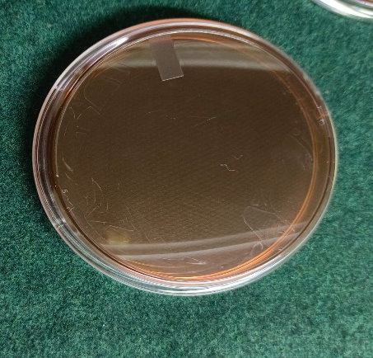
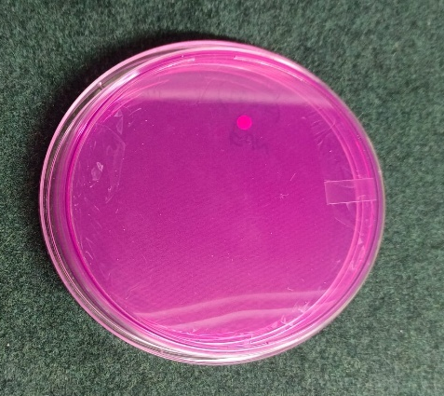
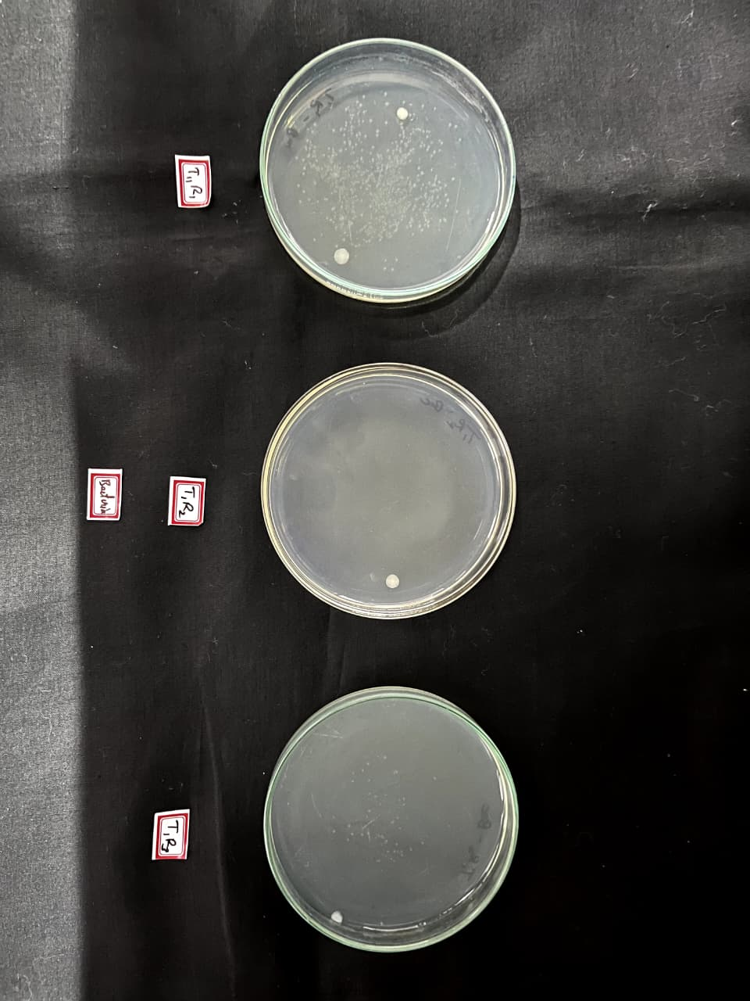
Fungi (×103 cfu/g)

Total bacterial count (×105 cfu/g)

E. coli (×102 cfu/g)

Fig 1. Represents microbial load of total bacterial count (×105 cfu/g), Fungi (×103 cfu/g), E. coli (×102 cfu/g) of flavour blended mulberry leaf powder

During food storage, E. coli serves as an indicator of contamination and usually remains absent in properly dried and sealed products. Bacteria may survive in low numbers but rarely multiply unless moisture enters, while spores can persist for long periods. Fungi are the main storage concern, as they can grow even at low moisture, causing spoilage, off-flavors, and harmful mycotoxins. Thus, maintaining low humidity and airtight packaging is essential for safe storage.
Both Control and FBMLP showed no fungal growth or E. coli throughout storage. Only a slight increase in bacterial count was observed after 30 days, which remained very low and within safe limits.
The microbial analysis of Control and Flavour Blended Mulberry Leaf Powder (FBMLP) during storage (0–45 days) revealed that: that no fungal growth or E. coli was detected in any sample throughout the storage period, indicating hygienic processing and safe storage conditions. The total bacterial count remained nil up to 15 days in both control and FBMLP samples. A slight bacterial load developed after 30 days, with 0.67 × 10⁵ cfu/g in the control and 0.53 × 10⁵ cfu/g in FBMLP, which increased only marginally by the 45th day to 0.69 × 10⁵ cfu/g and 0.58 × 10⁵ cfu/g, respectively. (Table 2, Fig 1). Notably, the bacterial load was consistently lower in FBMLP than in the control, suggesting that blending mulberry leaf powder contributed to better microbial stability. Overall, the microbial counts remained well within acceptable limits for dry herbal powders, ensuring the product’s safety for up to 45 days of storage at room temperature.
The results align with study reported by Kumar et al. (2020) found that molds, lactic acid bacteria, yeasts and E coli were not detected in moringa leaf powder throughout the storage period irrespective of the drying methods. However, aerobic plate count was higher in shade dried samples throughout the storage period.
The results align with study reported by Pallavi R et al. (2020 found that incorporation of herbs like kasuri methi, curry leaves and spinach enhanced the nutritional and sensory qualities of paneer. Herb-added paneer, especially with kasuri methi and spinach, showed better storage stability up to 30 days compared to curry leaf paneer, which lasted 25 days. Overall, the study demonstrated that potherbs can improve both the acceptability and shelf life of paneer under refrigerated conditions.

Conclusion:
The development of flavour blended mulberry leaf powder (FBMLP) demonstrated that incorporation of ginger, jeera and pudina at optimized levels (0.6 g) significantly enhanced sensory attributes and consumer acceptability. Storage studies confirmed its microbial safety and stability for 45 days under ambient conditions, with negligible bacterial load and absence of fungal and E. coli contamination. Thus, FBMLP offers a stable, safe, and palatable functional beverage with added nutritional and health benefits, indicating strong potential for commercial utilization.
DISCLAIMER (ARTIFICIAL INTELLIGENCE):
Author(s) hereby declares that NO generative AI technologies such as large language models (ChatGPT, COPILOT, etc) and text-to-image generators have been used during writing or editing of manuscripts.

References:
Adeduntan, S.A. And Oyerinde, A.S., 2010, Evaluation of Nutritional And Antinutritional Characteristics of Obeche (Triplochition Scleroxylon) And Several Mulberry (Morus Alba) Leaves. Afr. J. Biochem.Res., 4 (7): 175-178.
Afzal, F., Khalid, W., Asif, M. N., Jabeen, A., Jha, R.P., Khalid, M.Z., Fizza, C., Aziz, A., Akram, R., Bashir, A. And Younas, S., 2021, Role of Mulberry Leaves in Human Nutrition. Act. Sci. Nutr., 5 (3): 43-50
Asano, N., Yamashita, T., Yasuda, K., Ikeda, K., Kizu, H., Kameda, Y., Kato, A., Nash, R., Lee, H., And Ryu, K., 2001, Polyhydroxylated Alkaloids Isolated from Mulberry Trees (Morus Alba L.) and Silkworms (Bombyx Mori L.). J. Agric. Food Chem., 49 (10): 4208–4213.
Burt, S. (2004). Essential oils: their antibacterial properties and possible applications in foods—a review. International Journal of Food Microbiology, 94 (3): 223–253. https://doi.org/10.1016/j.ijfoodmicro.2004.03.022
Chowdary, N. B., Mala V. Rajan and Dandin, S.B., 2009, Mulberry The Wonder Plant. Indian Silk, 4 (4): 8-10.
Dimitrova, M.P., Petkova, N.T., Denev, P.P., And Aleksieva, I.N., 2015, Carbohydrate Composition and Antioxidant Activity of Certain Morus Species. Int. J. Pharmacogn. Phytochem. Res., 7 (3): 621-628
Dugo, P., Donato, P., Cacciola, F., Germano, M., Rapisarda, A., Mondello, L.,2009, Characterization of the Polyphenolic Fraction of Morus Alba Leaves Extracts By Hplc Coupled To A Hybrid It-Tof Ms System. J. Sep. Sci., 32 (10): 3627-3634.
Flaczyk, E., Kobus-Cisowska, J., Rzeor, M., Korczak, J., Remiszewski, M., Korbas, E., Buchowski, M., 2013, Chemical Characterization and Antioxidative Properties of Polish Variety of Morus Alba L. Leaf Aqueous Extracts from The Laboratory and Pilot-Scale Processes. Agric. Sci., 4 (5): 141–147.
Iqbal, S., Younas, U., Sirajuddin, K.W., Chan, R.A., Sarfraz, Uddin, M.K.,2012, Proximate Composition and Antioxidant Potential of Leaves From Three Varieties Of Mulberry (Morus Spp.): A Comparative Study. Int J Molsci., 13 (6): 6651-6664.
Krishna, V.A., Sujathamma, P., Savithri, G. and Vijaya, T., 2015, MulBerry: The Fruit of Heaven’s Choice. Hort Flora Res. Spectr, 4: 82-85.
Kumar, P.C., Sethuraman, B., Azeez, S. And Kozhummal, R., 2020, Effect of Drying Methods and Storage on Bioactive Compounds of Moringa Oliefera Leaf Powder. Ijcs, 8 (4): 1406-1410.
Manikant, S. V. V., Srihari, D. And Salomi Suneetha, D.R., 2023, Blended Tulsi Drumstick Herbal Tea: Quality and Organoleptic Properties. J. Pharma. Innov., 12 (3): 19-23.
Pallavi R, Rashmi HS and Devaki CS. (2020). Development, Evaluation and Storage Studies of Flavour Enriched Herbs-Based Paneer. Arch. Nutr. Public Health. 2 (3): 2-8
A.Priya and P.Shanthini, 2019, Formulation of Oregano Leaves Powder Incorporated Kuchi Murukku and Evaluation of Storage Stability. Int. J. Res. Anal. Rev., 6(1): 204-209
Ubashana, M. Mohanalakshmi, N. Shoba and P. Vennila, 2020, Development and Assessment of Functional Properties of Curry Leaf Based Herbal Tea. Int. J. Curr. Microbiol. App. Sci., 9 (11): 3148-3156.

