Spatial distribution of anthracnose disease incidence in major chilli growing areas of Telangana, India

ABSTRACT

A roving survey was conducted for three consecutive years during kharif, 2022-23, kharif, 2023-24 and kharif, 2024-25 in major chilli growing areas of Telangana in five districts namely Warangal, Khammam, Mahabubabad, Badradri kothagudem and Hanamkonda covering 48 mandals and 87 villages. The study revealed variations in per cent disease incidence in the fields surveyed. During three years, among the districts surveyed, maximum mean Per cent disease incidence was recorded in Khammam district and minimum mean Per cent disease incidence was recorded in Badradri kothagudem district. During the three years of study, the Per cent disease incidence ranged from 2.60 – 45.40. Highest per cent disease incidence of 45.40 was recorded in Mamahadhapur village of Duggondi mandal of Warangal district during 2024 - 25 and lowest per cent disease incidence of 2.60 was recorded in Pasaragonda village of Damera mandal of Hanamkonda district during Kharif, 2023-24. The variations in disease incidence was mainly due to, Variety/Hybrid grown, plant protection and agronomic practices adopted and climatic factors etc.

Keywords: Survey, Chilli, Fruit rot and Per cent disease incidence

- Introduction:

“Chilli is the most important ingredient in many different cuisines around the world as it adds pungency, taste, flavor and color to the dishes in daily life. Indian chilli is considered to be world famous for two important commercial qualities namely, its colour and pungency levels” (Venkata et al., 2018). In Telangana, chilli crop is mostly affected with Fusarium wilt followed by anthracnose and Choanophora blight. Among these anthracnose causes die back at early stages of the crop and fruit rot at later stages which directly reduces the market value of the fruits results in low income to the farmers.

India is the largest exporter of chilli and its products (Geetha and Selvarani, 2017), however, anthracnose disease causes an estimated annual loss of 29.5%, corresponding to 491.67 million US$ (Garg et al., 2014). Anthracnose of chilli caused by Colletotrichum spp. has resulted in up to 50 per cent yield losses owing to pre- and post-harvest fruit rot in India (Pakdeevaraporn et al., 2005).
“In 2024-25, Telangana ranked third in chilli area and second in chilli production and productivity with 3.80 lakh acres, 6.89 lakh tonnes and 1813 kg per acre respectively. Chilli area and production in Telangana account for 17% and 26% of all India area and production respectively. The major chilli growing districts are Khammam, Mahabubabad, Gadwal, Jayashankar Bhupalapally and Badradri Kothagudem” (Chilli Outlook, May, 2025, PJTAU).

Conducting surveys for recording the incidence of disease is a crucial step in the management of disease which provides essential information on pathogen identification, disease prevalence, intensity and associated crop losses. This knowledge forms the basis for implementing effective control measures, minimizing disease impacts, and ensuring sustainable crop production.

- Material and Methods:

2.1 Description of surveyed areas:

Intensive roving survey was conducted for three consecutive years during kharif, 2022-23, Kharif, 2023-24 and Kharif, 2024-25 in major chilli growing areas of Telangana in five districts namely Warangal, Khammam, Mahabubabad, Badradri kothagudem and Hanamkonda during main cropping season.

  - Sampling procedures and sample unit:

The survey was carried out from vegetative to fruiting stage in August to January months during Kharif, 2022-23, Kharif, 2023-24 and Kharif, 2024-25. A total of 87 villages covering 48 mandals were assessed. The chilli fields were randomly sampled at intervals of 5-10 km along the main and feeder roads. In each field, five quadrats (1 m² each) 5-10 m apart were sampled by moving diagonally across each field in an ‘X’ pattern.

The data on biophysical factors like preceding crops, cropping systems, plant density, sowing time, growth stage, crop residue management, weeding practice, fertilizer application, source of seed and crop varieties was also collected.

2.3 Disease assessment:

Per cent disease incidence of anthracnose/dieback/fruit rot of chilli observed in most of the fields of the villages during survey (Figure 1) was recorded. Based on infected and total no. of fruits per plant, disease incidence was calculated (Thori, 2012).

$$Per cent disease incidence= \frac{Number of infected fruits}{Total number of fruits evaluated} X 100$$

- RESULTS:

All chilli fields assessed during the current survey were infected by chilli anthracnose, however, the per cent disease incidence varied among districts.

3.1 Survey for incidence of anthracnose disease in major chilli growing areas of Telangana during Kharif, 2022-23 (Chandini et al., 2018)

Survey was conducted in five districts namely, Warangal, Khammam, Mahabubabad, Badradri kothagudem and Hanamkonda covering 16 mandals and 24 villages during Kharif, 2022-23 (Figure 2).

Among the five districts surveyed, mean Per cent disease incidence ranged from 7.89 to 38.30. Maximum mean Per cent disease incidence of 38.30 was recorded in Khammam district, followed by Mahabubabad, Warangal and Hanamkonda with 21.06, 13.02 and 11.40 respectively whereas minimum mean Per cent disease incidence was recorded in Badradri kothagudem district with 7.89.

Among the different mandals surveyed in Telangana, the Per cent disease incidence ranged from 3.60 to 40.80. Highest incidence (40.80) was recorded in Konijarla mandal of Khammam district while least incidence (3.60) was observed in Julurupadu mandal of Badradri kothagudem district.

Among the villages surveyed in five districts, the Per cent disease incidence ranged from 3.60 to 40.80. Highest per cent disease incidence of 40.80 was recorded in Chalaparthy village of Duggondi mandal of Warangal district and Bottlakunta village of Konijarla mandal of Khammam district and lowest per cent disease incidence of 3.60 was recorded in Kommugudem village of Julurupadu mandal of Badradri Kothagudem district (Table 1 and Figure 5).

3.2 Survey for incidence of anthracnose disease in major chilli growing areas of Telangana during Kharif, 2023-24 (Chandini et al., 2018)

Survey was conducted in six districts namely, Warangal, Khammam, Mahabubabad, Badradri kothagudem, Hanamkonda and Jangoan covering 16 mandals and 27 villages (Figure 3).

Among the five districts surveyed, mean Per cent disease incidence ranged from 7.85 to 22.42. Maximum mean Per cent disease incidence of 22.42 was recorded in Khammam district, followed by Mahabubabad, Hanamkonda and Warangal with 15.96, 15.16 and 9.38 respectively whereas minimum mean Per cent disease incidence was recorded in Badradri kothagudem district with 7.85.

Among the different mandals surveyed in Telangana, the Per cent disease incidence ranged from 4.80 to 25.20. Highest incidence (25.20) was recorded in Karepalli mandal of Khammam district while least incidence (4.80) was observed in Nallabelly mandal of Warangal district.

Among the villages surveyed, the Per cent disease incidence ranged from 2.60 to 25.20. Highest per cent disease incidence of 25.20 was recorded in Pinjaramadugu village of Karepalli mandal of Khammam district and lowest per cent disease incidence of 2.60 was recorded in Pasaragonda village of Damera mandal of Hanamkonda district (Table 2 and Figure 6).

3.3 Survey for incidence of anthracnose disease in major chilli growing areas of Telangana during Kharif, 2024-25 (Chandini et al., 2018)

Survey was conducted in four districts namely, Warangal, Khammam, Mahabubabad and Hanamkonda covering 16 mandals and 36 villages during Kharif, 2024-25 (Figure 4).

Among the five districts surveyed, mean Per cent disease index ranged from 8.15 to 19.61. Maximum mean Per cent disease incidence of 19.61 was recorded in Khammam district, followed by Hanamkonda, Mahabubabad and Warangal with 10.80, 14.04 and 14.55 respectively whereas minimum mean Per cent disease incidence was recorded in Badradri kothagudem district with 8.15.
Among the different mandals surveyed in Telangana, the Per cent disease incidence ranged from 6.40 to 23.70. Highest incidence (23.70) was recorded in Khammam mandal of Khammam district while least incidence (6.40) was observed in Kothagudem mandal of Badradri Kothagudem district.
Among the villages surveyed, the Per cent disease incidence ranged from 4.20 to 45.40. Highest per cent disease incidence of 45.40 was recorded in Mamahadhapur village of Duggondi mandal of Warangal district and lowest per cent disease incidence of 4.20 was recorded in Keshavapatnam village of Kesamudrum mandal of Mahabubabad district (Table 3 and Figure 7).

- DISCUSSION:

“Chilli anthracnose was found widely distributed in all surveyed districts of major chilli growing areas of Telangana and was prevalent in all the fields assessed during the survey. In India, a calculated loss of 10–54 has been reported in yield of the crop due to the anthracnose disease” (Lakshmesha et al., 2005; Ramachandran and Rathnamma, 2006). “The loss is high owing to the post and pre harvest involvement of the pathogen causing a loss of 10–80 of the marketable yield of chilli fruits” (Than et al., 2008).

During the current assessment, “chilli anthracnose incidence varied among five districts. This could be related to differences in agroecology resulting in weather variations among districts. The relationships among rainfall intensity, duration and crop geometry and the dispersal of inoculum possibly lead to different levels of disease severity” (Dodd et al., 1992).

Chandini et al. (2022) reported “highest disease incidence in Pinapaka village of Khammam area (89.0) and minimum per cent disease incidence in Erraguntapadu of Sathupalli (10.0) during a roving survey conducted in erstwhile Khammam district i.e. Khammam, Sathupally and Bhadrachalam of Telangana” while Chowdary et al. (2024) reported “per cent disease severity ranged from 8.13 to 38.66 in major chilli growing areas of Andhra Pradesh and Tamil Nadu during 2019 – 2020”. Kavya et al. (2024) reported highest anthracnose incidence was recorded in chilli cultivar, tomato (Chapata) collected from Nagarajpalle village, Nallabelli mandal of Warangal district with 72.34 per cent. However, irrespective of the cultivars, the average disease ranged from 25-29 in Khammam district and 15- 18 in Warangal district from major chilli growing areas of Telangana, in Khammam (Konijerala, Wyra mandals) and Warangal (Nallabelli mandal) districts in Kharif chilli crop.

Venkata et al., (2018) reported “highest (54.63) mean per cent incidence in Warangal district while the lowest (35.54) incidence in Rangareddy district of Telangana”. Among the different mandals, highest incidence (56.76) was recorded in Zaffergadh mandal of Warangal district in a range of 58.80 (Thidugu village) to 51.80 (Sagaram village) while least incidence (32.80) was observed in Maheshwaram mandal of Rangareddy district within a range of 29.60 (Maheswaram village) to 37.50 (Kollapadkal village).

In the present study, “most of the fields with higher anthracnose intensity were found in the districts of Khammam and Mahabubabad. This report could be partly related to soil infestation by Colletotrichum spp. and wide use of susceptible cultivars year after year in the studied areas and also these districts have maximum Per cent area under chilli cultivation in Telangana. This practice might lead to the build-up and survival of inocula of the pathogen. Colletotrichum species naturally produce micro-sclerotia to allow dormancy in the soil during the winter or when subjected to stressful conditions, and these micro- sclerotia can survive for many years” (Pring et al., 1995).

During survey it was also noticed that, now -a -days, some of the farmers are incorporating the stubbles after harvest of the crop through rotavators in the same field, this might also may be the reason for increasing of fruit rot year after year. “Diseased fruit acts as a source of inoculum, allowing the disease to spread from plant to plant within the field” (Roberts et al., 2001). “It may survive up to 18 months in crop debris, on the soil surface, in alternate hosts and in infected seeds” (Tesso et al. 2012). In contrast, many farmers in the surveyed areas are removing crop residue and this could have played an important role in chilli anthracnose management in the fields with less incidence.

During survey, “maximum incidence was recorded in fields sown with previously saved seed (seed recycling) in case of varieties grown like Chapata, LCA -334 etc. Colletotrichum species can survive in and on seeds as acervuli and micro-sclerotia” (Pernezny et al., 2003).

Throughout the surveyed areas, “high disease intensity was observed in poorly weeded fields. Weed infestation reduces circulation of air under the crop canopy, which leads to increased leaf-wetness. This could increase humidity between the plants and higher possibility of conidial germination of the pathogen and subsequent development of anthracnose. The presence of high weed infestation could promote the development of the disease and also reduce crop vigor through competition for available resources, a situation that has been reported for different host-pathogen systems” (Zewde et al. 2007; Sahile et al. 2008).

Chilli crop is mainly cultivated in light and red soils where irrigation is given at 15 days interval. This might increase the relative humidity between the plants which favours the disease development. Leite and Nicholson (1993) reported that in “the development of most Colletotrichum spp. free water plays a favorable role”. “Conidia germinate in thin films of water on the leaf surface, develop germ tubes and appresoria, and penetrate the epidermis” (Thakur et al. 2007). In addition, “the lesions increase in number and coalesce to cover most of the leaf area under high humidity” (Casela et al. 1997).

The growth stage also has profound influence on disease incidences. In the study it is observed that, the disease intensity was severe at fruiting and harvesting stage (more on red chilli when compared with the green chilli) than at vegetative and flowering stages of the crop. This may be due to crop senescence where the pathogen can easily penetrate and developin the foliage, loss of rigidity in plant due to maturity. In contrast, Ko et al.2005 found that “ripe pepper fruits (Capsicum annuum) were resistant to Colletotrichum gloeosporioides, while unripe, mature fruits were more susceptible”. Similarly, Oh et al. 1998 and Kim et al. 1999 observed “a greater prevalence of appressorium and infection hypha development on unripe fruit compared to ripe fruit”. Some researchers (Wilson et al., 1990; Prusky et al., 2000; Chillet et al., 2007; Moral et al., 2008) emphasized that “physiological changes (changes in pH and cell wall composition, decrease in fruit firmness, and increased soluble sugars and secondary metabolites) during the ripening stage could increase the chili pepper’s susceptibility to Colletotrichum spp. Infection”.

During the survey period, it was observed that, the low disease incidence was recorded on hybrids than varieties. However, the land race called Chapata was recorded highest per cent disease incidence of 80. Chilli crop was grown as only sole crop, there was no inter crop or mixed cropping was followed by the farmers. “Cropping system is known to contribute to disease pressure in a positive or a negative way” (Agrios 2005).

Management of disease is not possible using only chemical spray. Farmers should definitely follow integrated disease management in case of anthracnose of chilli. Bailey (1987) and Agrios (2005) recommended “integrated management techniques, as no single specific management program could eliminate chilli anthracnose”. “Effective control of Colletotrichum diseases usually involves the use of a combination of cultural control, biological control, chemical control and intrinsic resistance” (Wharton and Diéguez- Uribeondo, 2004).

- CONCLUSION:

The study indicated that chilli anthracnose is widely distributed and is a major threat to crop in major chilli growing areas of Telangana. Chilli anthracnose levels varied with districts. The variation is mainly depended on weather conditions, Variety/Hybrid grown, Soil type, Plant protection and agronomic measures taken by the farmer. Seed recycling of varieties was observed as one of the most important factors for high anthracnose intensity in most of the studied areas. Thus, healthy seed or seed treated with an appropriate fungicide, coupled with disease resistance could be helpful to avoid or reduce losses from chilli anthracnose. Monocropping of chilli years together on the same field, no intercropping and incorporation of crop residue through rotavator in the same field was also observed as important factor for the high incidence of disease in most of the fields surveyed. The fields with high disease incidence as no proper weed management, pest management which also served as the source for the incidence and spread of the disease. These differences could play important role in developing effective and economically sound management strategies of the disease. The study suggested that removal of crop residues, Seed treatment, intercropping, crop rotation, weed and pest management can serve important in managing the disease.

ACKNOWLEDGEMENTS

The first author acknowledge the facilities provided by Regional Agricultural Research Station, Warangal for conducting survey.
Disclaimer (Artificial intelligence)
Option 1:
Author(s) hereby declare that NO generative AI technologies such as Large Language Models (ChatGPT, COPILOT, etc.) and text-to-image generators have been used during the writing or editing of this manuscript.
Option 2:
Author(s) hereby declare that generative AI technologies such as Large Language Models, etc. have been used during the writing or editing of manuscripts. This explanation will include the name, version, model, and source of the generative AI technology and as well as all input prompts provided to the generative AI technology
Details of the AI usage are given below:
1.
2.
3.

REFERENCES

- Agrios, G.N. 2005. Plant Pathology, 5th Ed. Academic Press, San Diego, p.922.

- Bailey, J.A. 1987. Phytoalexins: A Genetic View of Their Significance. In: Day, P.R., Jellis, G.J. (Eds.), Genetics and Plant Pathogenesis. Blackwell, Oxford, p.13-26.

- Casela CR, Pinto N, Oliveira E, Ferreira AS. 1997. Diseases of sorghum. In: Zambolim L, Okay FXR, editors. Plant disease control. Minas Gerais, Brazil: Federal University of Vic¸osa; pp. 1025–1064.

- Chandini, A., Kumar, J. H., Devi, G. U., Kumar, K. R. and Pushpavalli, S. N. C. V. L. 2022. Survey and collection of isolates of Colletotrichum capsici from different chilli growing areas of erstwhile Khammam district. The Pharma Innovation. 11(7): 2393-2399.

- Chillet, M. Hubert, O. and de Bellaire, L.D.L.2007. Relationship between physiological age, ripening and susceptibility of banana to wound anthracnose. Crop Prot., 26:1078–1082.

- Chilli Outlook, May, 2025, PJTAU.
https://www.pjtau.edu.in/files/AgriMkt/2025/May/chilli-May-2025.pdf

- Chowdary, G. B. S. and SRK, R. 2024. Survey, pathogenicity and characterization of different Colletotrichum spp. associated with Chilli anthracnose. ESS Open Archive eprints, 174, 17446953.

- Dodd, J.C., Estrada, A. and Jeger, M.J. 1992. Epidemiology of Colletotrichum Gloeosporioides in the Tropics. In: Bailey, J.A., Jeger, M.J. (Eds.), Colletotrichum: Biology, Pathology and Control. CAB International, Wallingford, p.308-325.

- Garg, R., Loganathan, M., Saha, S. and Roy, B.K. 2014. Chilli anthracnose: a review of causal organism, resistance source and mapping of gene. Microbial Diversity and Biotechnology in Food Security. 589-610.

- Geetha, R. and Selvarani, K. 2017. A study of chilli production and export from India. International Journal of Advance Research. 3 (2): 205-210.

- Kavya et al., 2024. Chilli anthracnose: Survey for the incidence and characterization of Colletotrichum spp. isolates in Telangana state. The Pharma Innovation. 24: 344-355.

- Kim, K.D. Oh, B.J. and Yang, J. 1999.Differential interactions of a Colletotrichum gloeosporioides isolate with green and red pepper fruits. Phytoparasitica, 27: 1–10.

- Ko, M.K. Jeon, W.B. Kim, K.S. Lee, H.H. Seo, H.H. Kim, Y.S. and Oh, B.J. 2005. A Colletotrichum gloeosporioides induced esterase gene of non-climacteric pepper (Capsicum annuum) fruit during ripening plays a role is resistance against fungal infection. Plant Mol. Biol., 58, 529–541.

- Lakshmesha, K., Lakshmidevi, K., Aradhya, N. and Mallikarjuna, S.2005. Changes in pectinase and cellulose activity of Colletotrichum capsici mutants and their effect on anthracnose disease on Capsicum fruit. Arch.Phytopathol. PlantProt. 38:267-279.

- Leite, B and Nicholson, R.L. 1993. A volatile self-inhibitor from Colletotrichum graminicola. Mycologia. 85(6):945–951.

- Moral, J. Bouhmidi, K. and Trapero, A. 2008. Influence of fruit maturity, cultivar susceptibility, and inoculation method on infection of olive fruit by Colletotrichum acutatum. Plant Dis., 92: 1421–1426.
- Oh, B.J. Kim, K.D. and Kim, Y.S.1998. A microscopic characterization of the infection of green and red pepper fruits by an isolate of Colletotrichum gloeosporioides. J. Phytopathol. 146: 301–303.

- Pakdeevaraporn, P., Wasee, S., Taylor, P.W.J. and Mongkolporn, O. 2005. Inheritance of resistance to anthracnose caused by Colletotrichum capsici in Capsicum. Plant Breeding. 124 (2): 206–208.

- Pernezny, K., Roberts, P.D., Murphy, J.F. and Goldberg, N.P. 2003. Compendium of Pepper Diseases. The American Phytopathological Society, St. Paul, Minnedota, p.73.

- Pring, R.J., Nash, C., Zakaria, M. and Bailey, J.A., 1995. Infection process and host range of Colletotrichum capsici. Physiological and Molecular Plant Pathology, 46(2): 137-152.

- Prusky, D. Koblier, I. Ardi, R. Beno-Moalem, D. Yakoby, N. and Keen, N. 2000.Resistance mechanisms of subtropical fruits to Colletotrichum gloeosporioides. In Colletotrichum: Host Specificity, Pathology, and Host-Pathogen Interaction; American Phytopathological Society. 232–244.

- Ramachandran, N. and Rathnamma, K. 2006.“Colletotrichum acutatum—a new addition to the species of chilli anthracnose pathogen in India,” in Paper presented at the Annual Meeting and Symposium of Indian Phytopathological Society, Central Plantation Crops Research Institute (Kasarago).

- Roberts, P.D., Pernezny, K. and Kucharek, T.A., 2001. Anthracnose caused by Colletotrichum sp. on pepper. Journal of University of Florida/Institute of Food and Agricultural Sciences.

- Sahile, S, Ahmed, S, Fininsa, C, Abang, M.M. and Sakhuja, P.K. 2008. Survey of chocolate spot (Botrytis fabae) disease of faba bean (Vicia faba L.) and assessment of factors influencing disease epidemics in northern Ethiopia. Crop Prot. 27(11):1457–1463.

- Tesso, T., Perumal, R., Little, C., Adeyanju, A., Radwan, G., Prom, L., Magill, C. 2012. Sorghum pathology and biotechnology- a fungal disease perspective: Part II Anthracnose, stalk rot, and downy mildew. Eur J Plant Sci Biotechnol. 6:31–44.

- Thakur, R.P., Reddy, B.V. and Mathur, K. 2007. Screening techniques for sorghum diseases. Information: Bulletin No.76, Andhra Pradesh, India: International Crops. Research Institute for the Semi-Arid Tropics; pp. 92.

- Than, P.P., Jeewon, R., Hyde, K.D., Pongsupasamit, S., Mongkolporn, O., and Taylor, P.W.J. 2008.Characterization and pathogenicity of Colletotrichum species associated with anthracnose disease on chilli (Capsicum spp.) in Thailand. Plant Pathol. 57, 562 -572

- Venkata Ramesh, K., R. Sarada Jayalakshmi Devi, K. Gopal, B. K. M. Lakshmi, T. Murali Krishna and Ravindra Reddy, B. 2018. Survey for the Incidence of Chilli Anthracnose and Fruit Rot Disease in Major Chilli Growing Areas of Telangana, India. Int.J.Curr.Microbiol.App.Sci. 7(03): 3795-3803.

- Wharton, P.S. and Diéguez-Uribeondo, J. 2004. The biology of Colletotrichum acutatum. Anales del Jardin Botanico de Madrid. 61:3-22.

- Wilson, L. Madden, L. and Ellis, M.1990. Influence of temperature and wetness duration on infection of immature and mature strawberry fruit by Colletotrichum acutatum. Phytopathology. 80:111–116.

- Zewde, T, Fininsa, C, Sakhuja, P.K. and Ahmed, S. 2007. Association of white rot (Sclerotium cepivorum) of garlic with environmental factors and cultural practices in the North Shewa highlands of Ethiopia. Crop Prot. 26 (10):1566–1573.

- Venkata Ramesh, K., R. Sarada Jayalakshmi Devi, K. Gopal, B. K. M. Lakshmi, T. Murali Krishna and Ravindra Reddy, B. 2018. Assessment of Chilli Anthracnose and Fruit Rot in Major Chilli Growing Areas of Andhra Pradesh State, India. Int.J.Curr.Microbiol.App.Sci. 7(03): 3789-3794. doi: https://doi.org/10.20546/ijcmas.2018.703.439

Table 1: Incidence of chilli anthracnose in major chilli growing areas of Telangana during Kharif, 2022-23

District |  | Mandal |  | Village | GPF Coordinates |  | Soil type |  | Hybrid/  Variety | Per cent disease incidence |  | Mean Per cent disease incidence of mandal
 |  |  |  | Village | Longitude | Latitude
Warangal |  | Geesugonda |  | Kommala | 79.7703341  79.7733783 | 17.952656  17.9588328 | Black soil |  | Yashawini  SVHA 2222  One rod,  Shark-1  Chapata etc | 10.40 |  | 10.40
 |  | Duggondi |  | Nachinepally | 79.78801  79.788574 | 17.972965  17.968456 | Light soil |  | Yashawini  SVHA 2222  One rod,  Shark-1  Chapata etc | 20.60 |  | 22.26
 |  |  |  | Chalaparthy | 79.834558 | 17.956917 | Black soil |  | Yashawini  SVHA 2222  One rod,  Shark-1  Chapata etc | 40.80 |  | 22.26
 |  |  |  | Mahammadhapur | 79.83997 | 17.981943 | Black soil |  | Yashawini  SVHA 2222  One rod,  Shark-1  Chapata etc | 5.40 |  | 22.26
 |  | Narsampeta |  | Dasaripally | 79.860964 | 17.994349 | Black soil |  | Yashawini  SVHA 2222  One rod,  Shark-1  Chapata etc | 6.40 |  | 6.40
Mean Per cent disease incidence of district |  |  |  |  |  |  |  |  |  |  |  | 13.02
Hanumakonda |  | Damera |  | Pulkurthy | 79.6679481  79.6679353  79.6598228  79.6602075 | 18.1008945  18.101011  18.1204137  18.1214371 | Black soil |  | Yashawini, Yagnesya, Esha,  US-341,  Chapata etc | 8.40 |  | 11.40
 |  |  |  | Pasaragonda | 79.6679353  79.6672091 | 18.101011  18.100602 | Black soil |  | Yashawini, Yagnesya, Esha,  US-341,  Chapata etc | 5.40 |  | 11.40
 |  |  |  | Kogilvai | 79.6096549  79.6078976 | 18.1121893  18.112031 | Black soil Sandy loam |  | Yashawini, Yagnesya, Esha,  US-341,  Chapata etc | 20.40 |  | 11.40
Mean Per cent disease incidence of district |  |  |  |  |  |  |  |  |  |  |  | 11.40
Khammam |  | Konijarla |  | Bottlakunta | 80.2684474  80.2721418  80.2721703  80.2772281  80.2772399 | 17.1989219  17.1999433  17.197721  17.1919114  17.192139 | Red soil | Little star  Vikki vijay  Yashawini  Vikky  Vasundara etc |  | 40.80 |  | 40.80
 |  | Khammam |  | Khammam | 80.2772281 | 17.1919114 | Red soil |  |  | 35.80 |  | 35.80
Mean Per cent disease incidence of district |  |  |  |  |  |  |  |  |  |  |  | 38.30
Mahabubabad |  | Garla |  | Gorla charla | 80.1119381  80.1122214  80.111704  80.1110874 | 17.4544312  17.4544491  17.4546022  17.4545585 | Red soil |  | SVHA 2222  Yashawini  Vignesh  Vikar  Tejitha  Shark-1etc | 38.40 |  | 38.40
 |  | Kuravi |  | Somlathanda | 80.0313396 | 17.6830649 | Red soil/  Light soil |  | SVHA 2222  Yashawini  Vignesh  Vikar  Tejitha  Shark-1etc | 10.00 |  | 10.00
 |  | Gudur |  | Sandrelagudem | 80.0498249 | 17.6699317 | Red soil/  Light soil |  | SVHA 2222  Yashawini  Vignesh  Vikar  Tejitha  Shark-1etc | 14.80 |  | 14.80
Mean Per cent disease incidence of district |  |  |  |  |  |  |  |  |  |  |  | 21.06
Badradri Kothagudem | Yellandu |  | Komraram |  | 80.2657587 | 17.7027288 | Red soil/  Light soil |  | Tejaswini,  Yashawini, SVHA 2222  Shark-1  Vasundara  Red rise  Kalash  Wonder hot  Esha  Krishna  US-341etc |  | 5.60 | 8.93
Badradri Kothagudem |  |  | Masivagu |  | 80.273497 | 17.669462 |  |  |  |  | 10.40 | 8.93
Badradri Kothagudem |  |  | Yellapuram thanda |  | 80.290458 | 17.709496 |  |  |  |  | 10.80 | 8.93
Badradri Kothagudem | Kothagudem |  | Mamidigudem |  | 80.3074805 | 17.6739978 |  |  |  |  | 12.40 | 9.4
Badradri Kothagudem |  |  | Appaigudem |  | 80.283868 | 17.520074 |  |  |  |  | 6.40 | 9.4
Badradri Kothagudem | Pinapaka |  | Veerapuram |  | 80.263428 | 17.703068 |  |  |  |  | 4.60 | 4.7
Badradri Kothagudem |  |  | Karapalle |  | 80.272 | 17.5096 |  |  |  |  | 4.80 | 4.7
Badradri Kothagudem | Julurupadu |  | Kommugudem |  | 80.273497 | 17.669462 |  |  |  |  | 3.60 | 3.60
Badradri Kothagudem | Gundala |  | Manik kyaram |  | 80.273439 | 17.712638 |  |  |  |  | 10.60 | 10.60
Badradri Kothagudem | Singareni |  | Bhagyanagar thanda |  | 80.300177 | 17.53828 |  |  |  |  | 12.60 | 12.60
Badradri Kothagudem | Tulsiya thanda |  | Chunchupalli |  | 80.283868 | 17.520074 |  |  |  |  | 5.40 | 5.40
Mean Per cent disease incidence of district |  |  |  |  |  |  |  |  |  |  |  | 7.89

Table 2: Incidence of chilli anthracnose in major chilli growing areas of Telangana during Kharif, 2023-24

District | Mandal |  | Village | GPF Coordinates |  |  | Soil type | Hybrid/  Variety | Per cent disease incidence | Mean Per cent disease incidence of mandal
District |  |  | Village | Longitude | Latitude
Warangal | Geesugonda |  | Machapur | 79.7657732  79.7807055 | 17.9503402  17.9547741 |  | Red soil | Yashawini  SVHA 2222  One rod,  Shark-1  Chapata etc | 15.80 | 14.00
Warangal |  |  | Vishwanathpur | 79.7703341  79.7734833 | 17.952656  17.958607 |  | Red soil | Yashawini  SVHA 2222  One rod,  Shark-1  Chapata etc | 12.20 | 14.00
Warangal | Narsampet |  | Narsampet | 79.8552396 | 17.936294 |  | Black soil | Yashawini  SVHA 2222  One rod,  Shark-1  Chapata etc | 5.50 | 5.95
Warangal |  |  | Akulthanda | 79.8940955 | 18.0193994 |  | Black soil | Yashawini  SVHA 2222  One rod,  Shark-1  Chapata etc | 6.40 | 5.95
Warangal | Parkal |  | Kowkonda | 79.654596 | 18.12713 |  | Black soil | Yashawini  SVHA 2222  One rod,  Shark-1  Chapata etc | 8.50 | 8.50
Warangal | Nallabelly |  | Nagarajpalle | 79.8100553 | 17.990869 |  | Black soil | Yashawini  SVHA 2222  One rod,  Shark-1  Chapata etc | 4.80 | 4.80
Warangal | Sangem |  | Sangem | 79.7926155 | 17.8553222 |  | Sandy loam | Yashawini  SVHA 2222  One rod,  Shark-1  Chapata etc | 14.50 | 15.45
Warangal |  |  | Gandhi nagar | 79.7092897 | 17.87144662 |  | Black soil | Yashawini  SVHA 2222  One rod,  Shark-1  Chapata etc | 16.40 | 15.45
Warangal | Wardhannapet |  | Ponkal | 79.7963203 | 17.9784987 |  | Black soil | Yashawini  SVHA 2222  One rod,  Shark-1  Chapata etc | 7.60 | 7.60
Mean Per cent disease incidence of district |  |  |  |  |  |  |  |  |  | 9.38
Hanumakonda |  | Damera | Kogilvai | 79.608283  79.608461  79.60811  79.609665  79.6096151 | 18.11224  18.112948  18.114432  18.1128191  18.1122866 | Black soil |  | Yashawini, Yagnesya, Esha,  US-341,  Chapata etc | 32.40 | 15.16
 |  | Damera | Pulkurthy | 79.663165  79.668008 | 18.104273  18.099219 | Black soil |  | Yashawini, Yagnesya, Esha,  US-341,  Chapata etc | 10.50 | 15.16
 |  | Damera | Pasaragonda | 79.6587969 | 18.12115 | Black soil |  | Yashawini, Yagnesya, Esha,  US-341,  Chapata etc | 2.60 | 15.16
Mean Per cent disease incidence of district |  |  |  |  |  |  |  |  |  | 15.16

Khammam | Karepalli |  | Pinjaramadugu |  |  | 80.283393 | 17.473206 | Black soil |  | Tejaswini,  SVHA 2222, Red hot, Kalash,  Red rise, Yashawini, Shark-1, Blaze etc |  | 25.20 | 25.20
Khammam | Khammam |  | Gudurupadu |  |  | 80.083699 | 17.307915 | Red Soil |  |  |  | 20.60 | 20.56
Khammam |  |  | Valaya thanda |  |  | 80.074128 | 17.342076 |  |  |  |  | 22.50 | 20.56
Khammam |  |  | Khammam |  |  | 80.078632 | 17.571042 |  |  |  |  | 18.60 | 20.56
Khammam | Konijerla |  | Yatham kunta |  |  | 80.2721418 | 17.1999433 | Black soil |  |  |  | 21.50 | 21.50
Mean Per cent disease incidence of district |  |  |  |  |  |  |  |  |  |  |  |  | 22.42
Mahabubabad |  | Kesamudrum |  | Kesamudrum |  | 80.000768  80.00076  80.100768 | 17.771682  17.771738  17.671682 | Red soil |  |  | Shark-1, SVHA 2222,  Priya 999, Yashaswini, Vasundara Red hot, Mega hot, Kalash etc | 16.50 | 16.50
 |  | Gudur |  | Kongaragidda |  | 80.021856 | 17.731102 | Red soil |  |  |  | 13.60 | 13.60
 |  | Mahabubabad |  | Khambhalapalle |  | 80.054006  80.053643 | 17.66845  17.66902 | Red soil/  Light soil |  |  |  | 12.20 | 13.35
 |  |  |  | Mahububabad |  | 80.033128  80.078612  80.0483802  80.0052458 | 17.682242  17.571025  17.9201992  17.9243393 |  |  |  |  | 14.50 | 13.35
 |  | Dornakal |  | Uyyalawada |  | 80.1110874 | 17.4545585 | Black soil |  |  |  | 20.40 | 20.40
Mean Per cent disease incidence of district |  |  |  |  |  |  |  |  |  |  |  |  | 15.96
Badradri Kothagudem |  | Yellandu | Usirikayalapally |  | 80.328922 |  | 17.535922 | Red soil/ Light soil | Tejaswini, US-341,Yashawini SVHA 2222, Shark-1, Red rise Vasundara etc |  |  | 12.50 | 10.10
 |  | Yellandu | Kondaigudem |  | 80.246943 |  | 17.409526 | Red soil/ Light soil |  |  |  | 8.90 | 10.10
 |  | Yellandu | Rompedu |  | 80.2657587 |  | 17.7027288 | Red soil/ Light soil |  |  |  | 6.40 | 10.10
 |  | Yellandu | Yellandu |  | 80.3074805 |  | 17.6739978 | Red soil/ Light soil |  |  |  | 12.60 | 10.10
 |  | Julurupada | Kommugudem |  | 80.300363 |  | 17.483378 | Red soil |  |  |  | 5.60 | 5.60
Mean Per cent disease incidence of district |  |  |  |  |  |  |  |  |  |  |  |  | 7.85

Table 3: Incidence of chilli anthracnose in major chilli growing areas of Telangana during Kharif, 2024-25
District |  | Mandal | Village |  |  | GPF Coordinates |  |  |  |  | Soil type |  | Hybrid/  Variety |  | Per cent disease incidence |  | Mean Per cent disease incidence of mandal
 |  | Mandal |  |  |  | Longitude |  |  |  | Latitude
Warangal |  | Geesugonda | Kommala |  |  | 79.76087 |  |  |  | 17.950682 | Black soil |  | Yashaswini,  SVHA 2222, Blaze,  Red rise Wonder hot, US -341, Shark-1, Esha gold, Mega hot, Tejaswini, Chapata etc |  | 8.20 |  | 11.24
 |  | Geesugonda | Brahmanapally |  |  | 79.989728 |  |  |  | 17.782835 | Sandy loam |  |  |  | 14.80
 |  | Geesugonda | Mogilicherla |  |  | 79.997766 |  |  |  | 17.5415 | Black soil |  |  |  | 6.40
 |  | Geesugonda | Elukurthy haveli |  |  | 79.744601  79.744752  79.744772  79.743541  79.74386  79.745771 |  |  |  | 17.981754  17.98183  17.981841  17.996377  17.982319  17.992936 | Red soil |  |  |  | 20.60
 |  | Geesugonda | Girnibavi |  |  | 79.806385 |  |  |  | 17.953328 | Black soil |  |  |  | 6.20
 |  | Khanapur | Budharaopeta |  |  | 79.979591 |  |  |  | 17.872701 | Sandy loam |  |  |  | 15.40 |  | 15.40
 |  | Narsampeta | Laknepally |  |  | 79.836733 |  |  |  | 17.942769 | Sandy loam |  |  |  | 22.80 |  | 17.80
 |  | Narsampeta | Narsampeta |  |  | 79.887129  79.887129 |  |  |  | 17.92305  17.923205 | Black soil |  |  |  | 12.80
 |  | Duggondi | Mamahadhapur |  |  | 79.865208 |  |  |  | 18.002908 | Black soil |  |  |  | 45.40 |  | 22.10
 |  | Duggondi | Mallampally |  |  | 79.828286  79.844331  79.844312 |  |  |  | 18.023857  18.002338  18.002212 | Black soil |  |  |  | 9.40
 |  | Duggondi | Lenkalapally |  |  | 79.83672 |  |  |  | 18.028076 | Red soil |  |  |  | 14.20
 |  | Duggondi | Duggondi |  |  | 79.807086 |  |  |  | 18.024735 | Black soil |  |  |  | 19.40
 |  | Nallabelly | Ramteertham |  |  | 79.873979  79.875912  79.874433  79.875912 |  |  |  | 18.063095  18.062396  18.063103  18.062396 | Red soil |  |  |  | 8.20 |  | 8.20
 |  | Warangal | Gopalapuram |  |  | 79.816892 |  |  |  | 18.024155 | Black soil |  |  |  | 12.60 |  | 12.60
Mean Per cent disease incidence of district |  |  |  |  |  |  |  |  |  |  |  |  |  |  |  |  | 14.55
Hanumakonda |  | Damera |  |  | Kogilvai |  | 79.611431 |  | 18.109057 |  |  | Red soil |  | Yashaswini  Esha 5129, Shark-1  Wonder hot etc |  | 20.40 |  | 10.80
 |  |  |  |  | Pasaragonda |  | 79.6679453 |  | 18.101025 |  |  | Black soil |  |  |  | 5.60 |  | 10.80
 |  |  |  |  | Pulkurthy |  | 79.6602145 |  | 18.1214251 |  |  | Black soil |  |  |  | 6.40 |  | 10.80
Mean Per cent disease incidence of district |  |  |  |  |  |  |  |  |  |  |  |  |  |  |  | 10.80 |  | 10.80
Khammam | Thirumalayapalem |  |  |  | Medidapally |  |  | 79.954984 | 17.343537 |  |  | Black soil |  | Tejaswini,  SVHA 2222, Red hot, Kalash,  Red rise,  Yashawini, Shark-1 etc |  | 14.60 |  | 15.53
Khammam |  |  |  |  | Dhammaigudem |  |  | 79.979795 | 17.316749 |  |  | Black soil |  |  |  | 21.40 |  | 15.53
Khammam |  |  |  |  | Pindiprolu |  |  | 80.013303 | 17.322457 |  |  | Black soil |  |  |  | 10.60 |  | 15.53
Khammam | Khammam |  |  |  | Chinthapalli |  |  | 80.051052 | 17.284268 |  |  | Red soil |  |  |  | 26.80 |  | 23.70
Khammam |  |  |  |  | Khammam |  |  | 80.078028  79.86011  80.078461 | 17.335179  17.420692  17.3314 |  |  | Red soil |  |  |  | 20.60 |  | 23.70
Mean Per cent disease incidence of district |  |  |  |  |  |  |  |  |  |  |  |  |  |  |  |  |  | 19.61
Mahabubabad |  | Kuravi |  | Nallela |  |  | 80.024077 |  | 17.484041 |  |  | Sandy loam |  | Shark-1, SVHA 2222, Priya 999, Yashaswini, Vasundara Red hot, Mega hot, Kalash etc |  | 22.40 |  | 18.60
 |  |  |  | Upparagudem |  |  | 80.025837 |  | 17.441458 |  |  | Red soil |  |  |  | 14.80 |  | 18.60
 |  | Kesamudrum |  | Pocharam |  |  | 79.973998 |  | 17.877536 |  |  | Sandy loam |  |  |  | 20.20 |  | 12.20
 |  |  |  | Keshavapatnam |  |  | 79.957915 |  | 17.831692 |  |  | Sandy loam |  |  |  | 4.20 |  | 12.20
 |  | Gudur |  | Kongaragidda |  |  | 80.023275  80.026769 |  | 17.722721  17.696194 |  |  | Black soil |  |  |  | 16.40 |  | 12.40
 |  |  |  | Macharla |  |  | 79.992174  79.992174 |  | 17.781497  17.781497 |  |  | Sandy loam |  |  |  | 5.40 |  | 12.40
 |  |  |  | Apparajpalle |  |  | 79.998465 |  | 17.72182 |  |  | Black soil |  |  |  | 12.60 |  | 12.40
 |  |  |  | Gudur |  |  | 79.968754 |  | 17.800783 |  |  | Black soil |  |  |  | 15.20 |  | 12.40
 |  | Mahabubabad |  | Bethole |  |  | 79.999958 |  | 17.545376 |  |  | Red soil |  |  |  | 12.60 |  | 12.90
 |  |  |  | Kotha Redyala |  |  | 80.029215 |  | 17.673274 |  |  | Red soil |  |  |  | 13.20 |  | 12.90
Mean Per cent disease incidence of district |  |  |  |  |  |  |  |  |  |  |  |  |  |  |  |  |  | 14.04
Badradri Kothagudem |  | Yellandu | Yellandu |  |  |  | 80.3074750 |  | 17.6739602 |  |  | Red soil/  Light soil |  | Shark-1, Vasundara  Tejaswini, Yashawini, SVHA 2222, Red rise etc |  | 5.50 |  | 6.55
 |  | Yellandu | Masivagu |  |  |  | 80.273520 |  | 17.669340 |  |  |  |  |  |  | 7.60 |  | 6.55
 |  | Pinapaka | Karepalle |  |  |  | 80.283393 |  | 17.473206 |  |  |  |  |  |  | 11.50 |  | 11.50
 |  | Kothagudem | Mamidigudem |  |  |  | 80.3074742 |  | 17.6739720 |  |  |  |  |  |  | 6.40 |  | 6.40
Mean Per cent disease incidence of district |  |  |  |  |  |  |  |  |  |  |  |  |  |  |  |  |  | 8.15

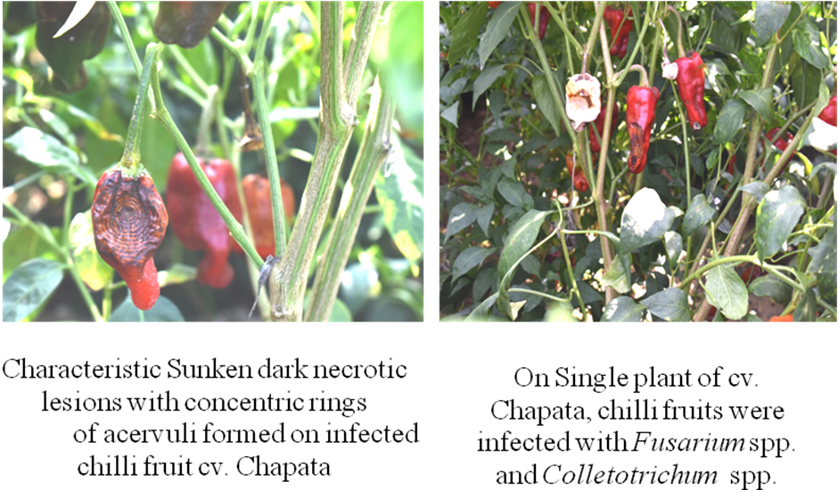
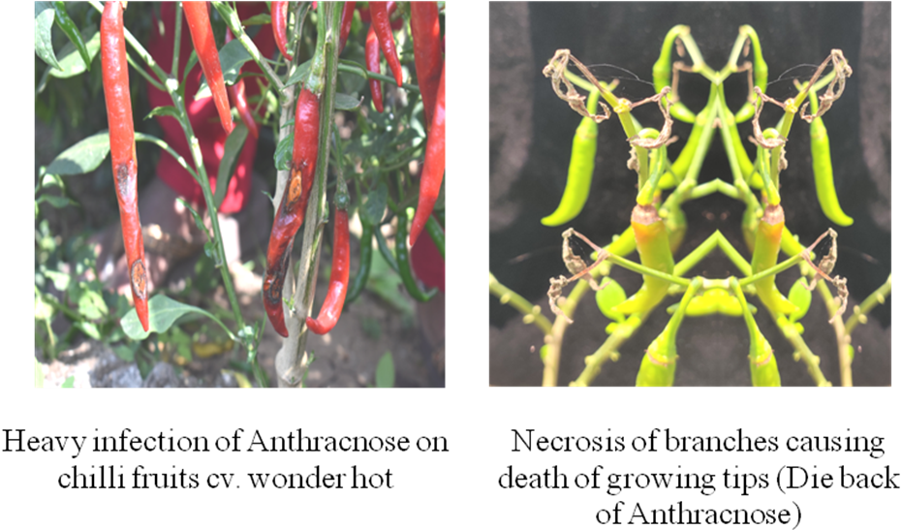

Figure 1: Disease symptoms of fruit rot observed during field visits on different hybrids/varieties grown by farmers during survey

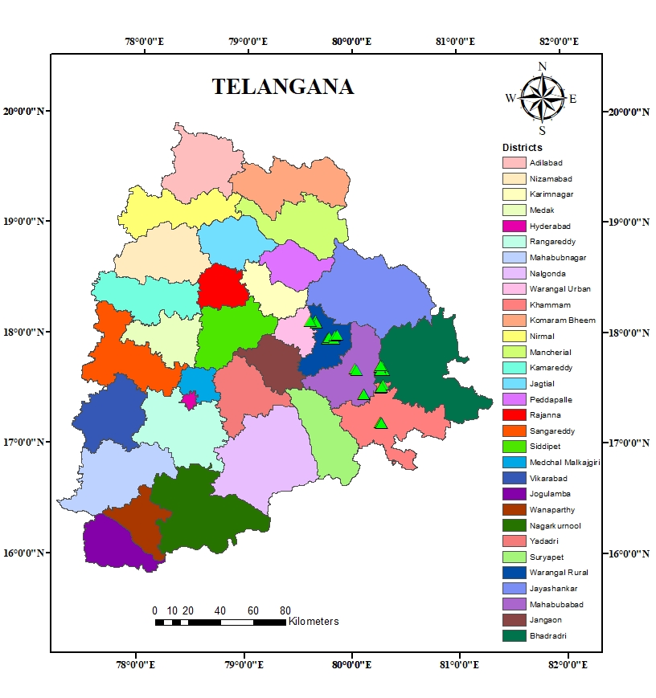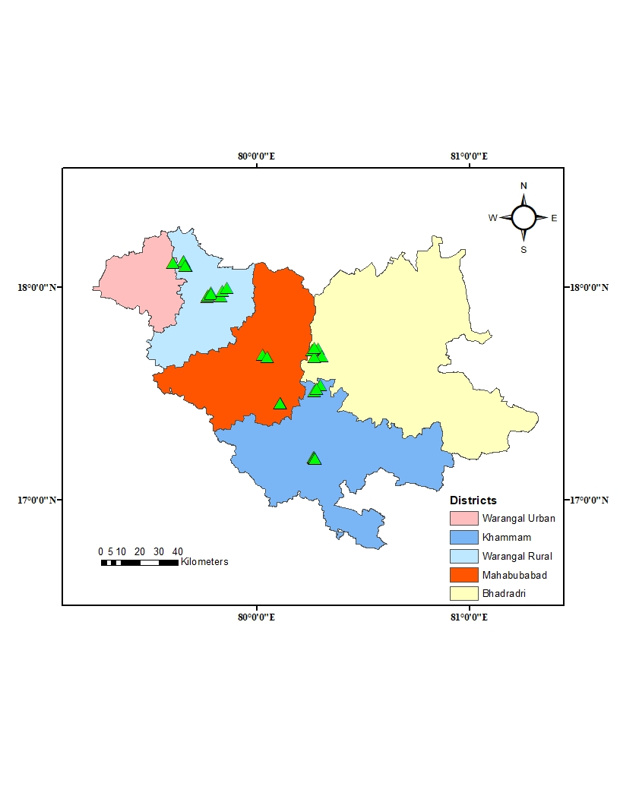

Figure 2: Spatial distribution maps of surveyed locations with chilli anthracnose incidence in major chilli growing areas of Telangana during 2022-23.

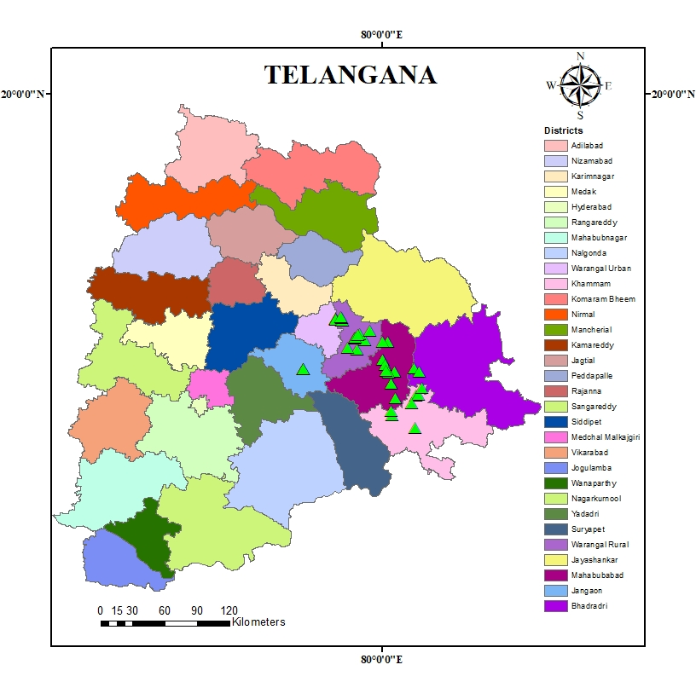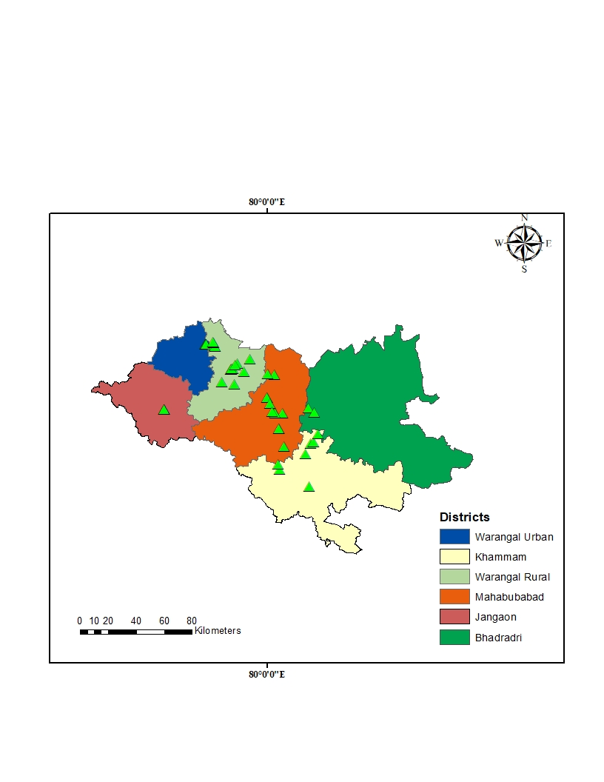

Figure 3: Spatial distribution maps of surveyed locations with chilli anthracnose incidence in major chilli growing areas of Telangana during 2023-24.

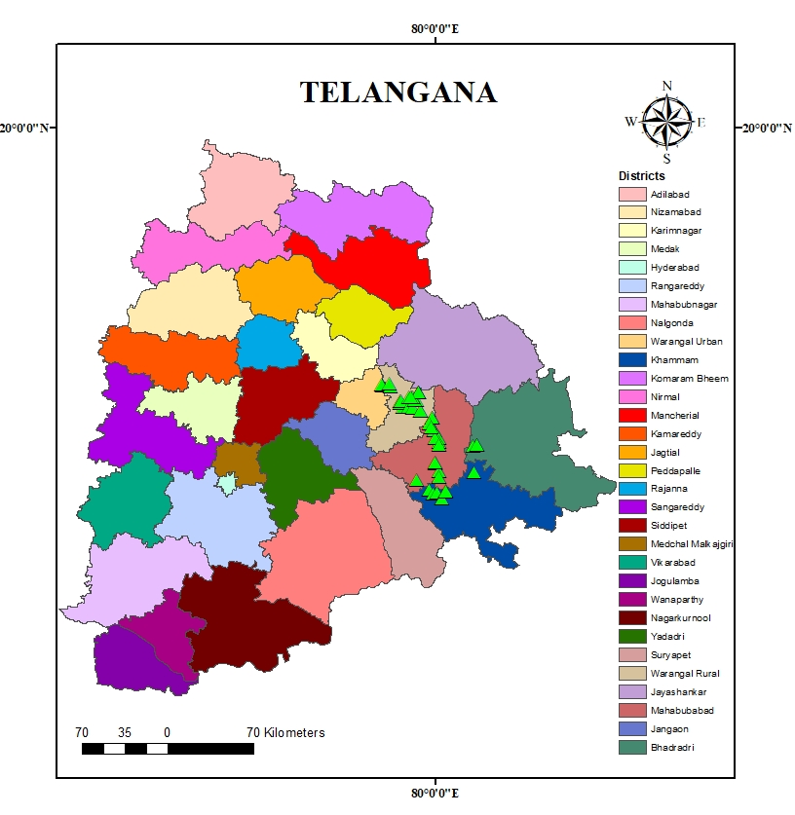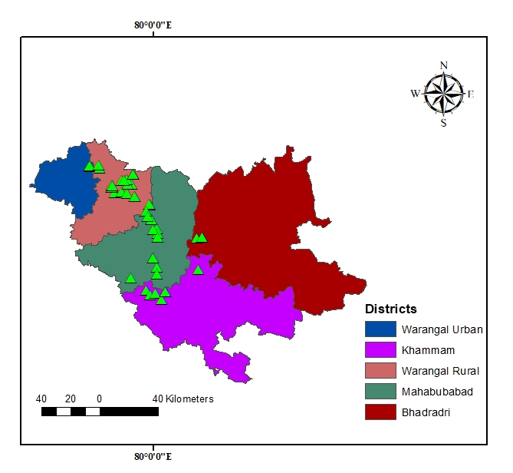
Figure 4: Spatial distribution maps of surveyed locations with chilli anthracnose incidence in major chilli growing areas of Telangana during 2024-25.

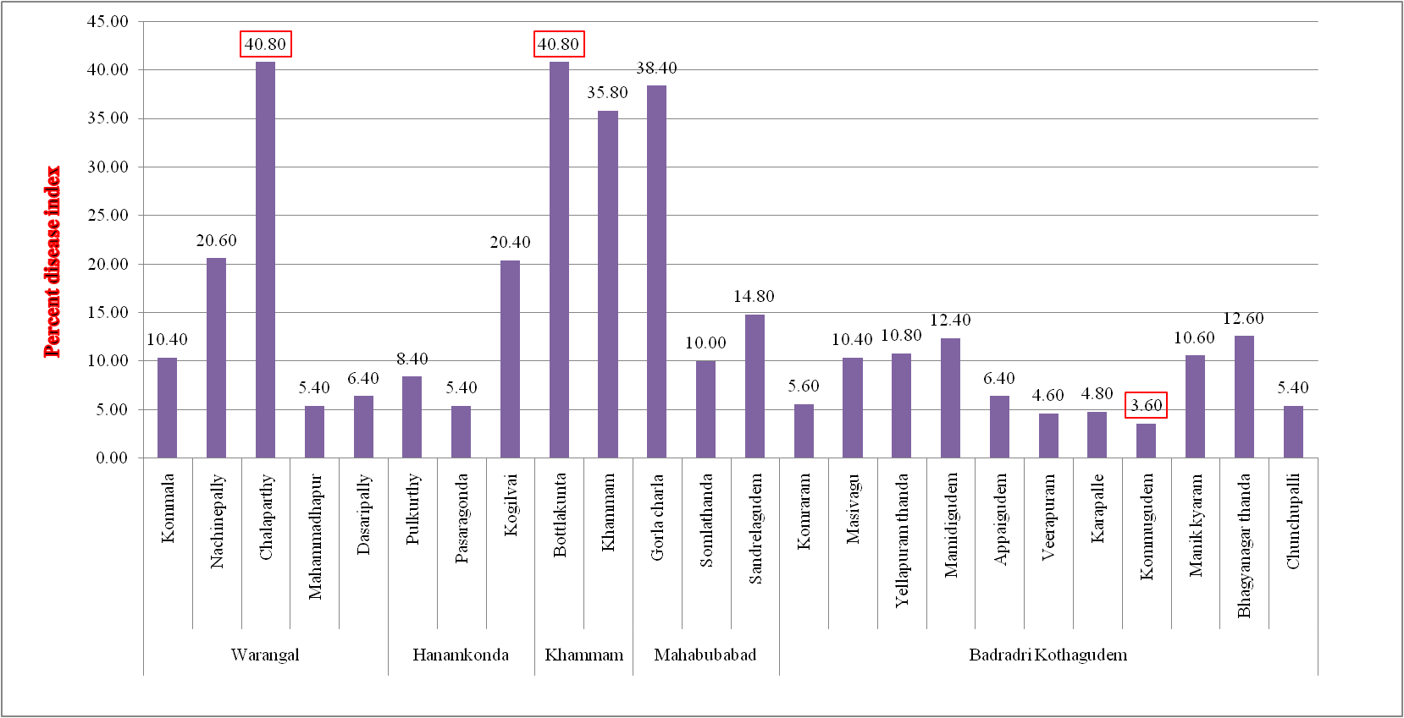

Figure 5: Incidence of Chilli anthracnose in mandals of major chilli growing areas Telangana state during Kharif, 2022-23.

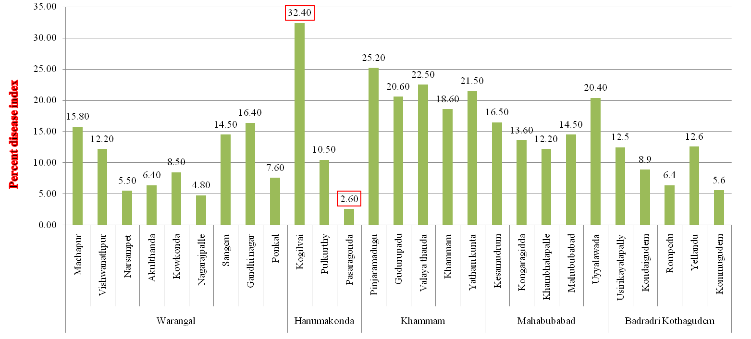

Figure 6: Incidence of Chilli anthracnose in mandals of major chilli growing areas Telangana state during Kharif, 2023-24.

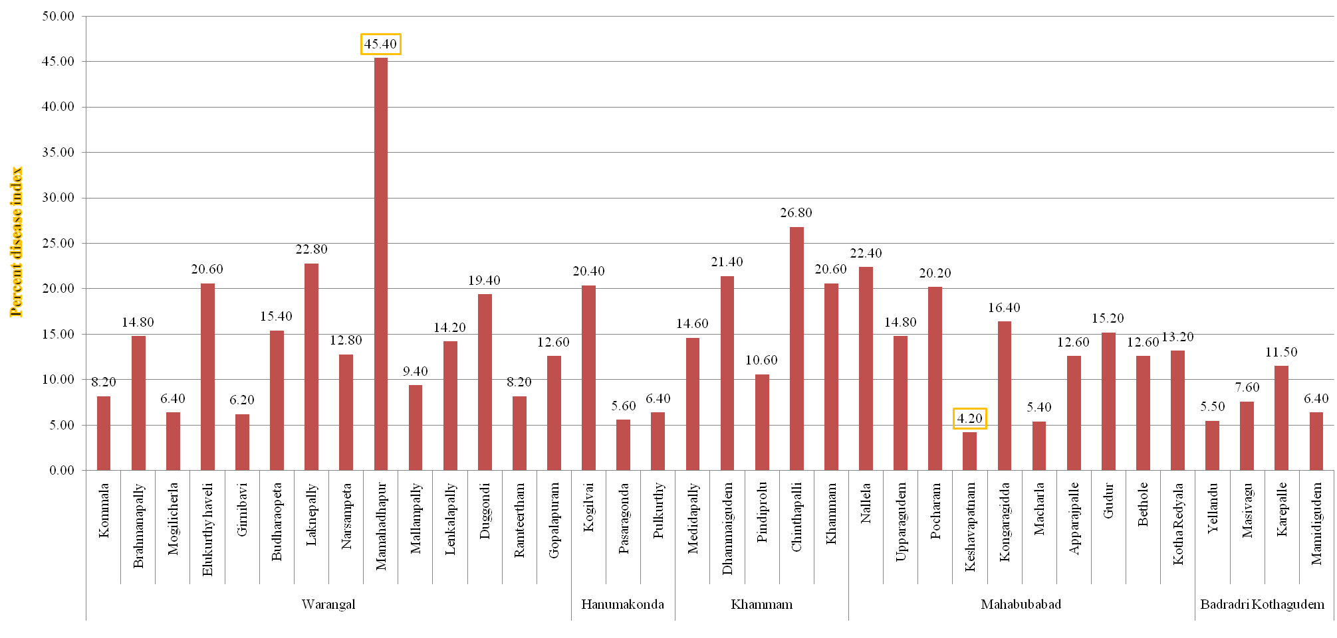
Figure 7: Incidence of Chilli anthracnose in mandals of major chilli growing areas Telangana state during Kharif, 2024-25.

