Short Research Article

First record of Vespa basalis attacked on Pear (Pyrus communis) fruits in Himachal Pradesh, India

.
ABSTRACT

Wasps are integral to maintaining ecological balance. However, their specific impact as fruit pests in India has not been well documented. This study aimed to investigate the feeding behavior of Vespa basalis (Black bellied hornet) on ripe pears (Pyrus communis) through a field survey conducted in the village of Shahpur in the Kangra district, a mid hill region of Himachal Pradesh, India, during the pear harvest in August 2025. Researchers randomly selected 50 ripe fruits of pears from five trees and observed them at three distinct time intervals: 09:00-11:00 h, 12:00-14:00 h, and 15:00-17:00 h. Feeding indicators, such as puncture marks and tissue scraping, were photographed. The study revealed significant variations in feeding intensity throughout the day, with 24% of the fruits exhibiting damage at midday (12:00-14:00 h), (χ² = 12.88, df = 2, p = .0016) compared to 2% in the morning (09:00-11:00 h) and 6% in the evening (15:00-17:00 h). Observations of two to four wasps per fruit suggests that chemical signals may influence resource utilization. A significant observation was that the wasps initially targeted the ripest portion of the fruit for feeding. As the number of wasps increased and their feeding activity intensified, substantial damage to the fruit ensued. This damage compromises fruit integrity, accelerates microbial decay, and significantly reduces market value, despite its limited occurrence. This study provides the first scientific evidence that V. basalis acts as a direct pest of ripe pears, thereby expanding its ecological role beyond predation. The findings underscore the importance of integrated orchard management strategies, such as attractant-based trapping, sanitation, protective coverings, and timely harvesting, to protect fruit quality and reduce economic losses without over-relying on chemical control.

Keywords: Vespa wasp; pear orchards; fruit feeding; mid hills; Himachal Pradesh; integrated pest management; Himalayan fruit pests; vespa basalis

1. INTRODUCTION

Pear is a major horticultural commercial crop in India, primarily grown in Himachal Pradesh, Jammu and Kashmir, Uttarakhand. India ranks ninth globally in terms of pear production, being the third most cultivated temperate fruit (Singh, 2024; Sawant et al., 2021). Predatory wasps regulate the populations of harmful insects in warm, humid climates (Verma et al., 2023). The genus Vespa, a diverse group within the Vespinae subfamily of the Vespidae family in the Hymenoptera order, encompasses 22 species of eusocial wasps that predominantly thrive in Asia. These predatory insects, known as hornets, are not just inhabitants of their ecosystems; they are vital players in maintaining ecological balance. Adult wasps typically exhibit black or brown coloration, often highlighted by significant yellow or white markings. In the case of Vespa and other social wasps, adult females progressively nourish the larvae with chewed-up insects, although they occasionally rely on glandular secretions. Conversely, in solitary wasp species, larvae generally prey on the caterpillars of other insects (Nguyen et al., 2006 ; Smith-Pardo et al., 2020; Kumar & Sharma, 2014).

In India, more than 12 species of predatory wasps have been recognized for their role in biological pest control. Beyond predation, these wasps consume tree bark to fulfill their nutritional needs, in that way they pose a risk to stone fruit orchards (Sharma et al., 2024). Hornets belonging to the genus Vespa (Hymenoptera: Vespidae) are notable predators that annually establish moderate to large colonies of eusocial insects. This flexibility in resource use, along with several biological characteristics contribute to the successful colonization of non-native environments. In temperate regions, reproductive females initiate nest construction following a period of diapause (Matsuura, 1991). Hornets are excellent predators in their native environment. However, certain species have become well-known for their unintended introduction into non-native ecosystems, where they prey on species that have not developed defenses (Matsuura, 1991; Cappa et al., 2021). In addition to their invasive capacity, the nests of Vespa species are characterized by complex nesting biology. Their colonies can be substantial, accommodating over 1,000 workers, although they typically consist of several hundred (Archer, 2008). These wasps exhibit a range of color patterns that vary by region of the body. Earlier researchers have identified numerous subspecies based solely on these color patterns, yet such traits often transition gradually across different regions, complicating reliable taxonomic classification (Nguyen et al., 2006; Perrard et al., 2014).

Species of the genus Vespa predominantly prey on social Hymenoptera, with a particular emphasis on the Western honey bee, Apis mellifera, thereby posing substantial economic challenges to the apiculture industry (Monceau et al., 2014; Requier et al., 2023). In addition to their ecological importance, wasps have economic value in regions where humans consume insects. For instance, over 2000 insect species, including wasps, are consumed globally by various ethnic groups. In the northeastern states of India, wasps are a traditional dietary staple, offering essential nutrients such as proteins, vitamins, and minerals. However, despite these nutritional advantages, wasp consumption is constrained by challenges related to storage and packaging (FAO, 2021; Thangjam et al., 2020; Mozhui et al., 2020). Given the ecological and economic importance of Vespa species, it is essential to comprehend their interactions with commercial crops, such as pears. These wasps play a pivotal role in regulating pest populations; however, their predatory behavior, nesting practices, and bark-feeding activities can pose a threat to pear orchards. Although their contribution to biological control is acknowledged, there is a paucity of research quantifying their specific impact on pear fruits in the temperate regions of India. This study aimed to address this gap by evaluating the presence, foraging patterns, and potential damage inflicted by predatory wasps on pear fruits in Himachal Pradesh. By elucidating the relationship between Vespa populations and pear fruit health, our findings will support sustainable orchard management and inform the development of broader strategies that integrate ecological wasp control with crop productivity.

2. materialS and methods

During the pear harvesting season in August, observations were conducted in the village of Shahpur, located in the Kangra district of Himachal Pradesh (Fig. 2), India (32.2197° N, 76.1728° E, altitude 657 m). Local farmers reported the presence of certain wasps on ripe pear fruits. Consequently, a field survey was initiated to investigate and document their direct feeding behavior on ripe pears. A total of 50 ripe fruits were randomly selected from five different trees and arranged in piles to assess feeding damage. This arrangement facilitated thorough monitoring and easy photographic documentation of the wasps as they fed on the fruit. This study primarily focused on the first report of wasps directly feeding on pear fruits, rather than the extent of critical damage caused. Consequently, a single sample was used to examine both feeding behavior and resultant damage. Digital photographs were taken using a mobile camera with a 70 mm focal length, f/5.6 aperture, and a shutter speed of 1/101s. Feeding damage was identified by signs such as fresh puncture marks and tissue scraping, which resulted in bite holes in the fruits (Fig. 4a). The number of damaged fruits was documented, and the infestation rate was determined using the following formula:

$$Infestation \left(\%\right)= \frac{Number of damaged fruits }{Total number of fruits examined } ×100$$

This calculation was performed for each time interval (09:00-11:00 h, 12:00-14:00 h, 15:00-17:00 h). The percentage of infestation was quantified by entering the collected data into Microsoft Excel for further analysis. Temporal variation in damage rates was confirmed using chi-square analysis to test for significant differences across time intervals. In August 2025, the survey was conducted in the aforementioned village at three distinct intervals: 9:00-11:00 h, 12:00-14:00 h, and 15:00-17:00 h. Wasps engaged in feeding were captured using a hand net and preserved in 70% ethanol for further analysis. These specimens were subsequently examined under a stereo microscope and identified as Vespa basalis Smith (Fig. 3) (Hymenoptera: Vespidae) by analyzing their external morphological characteristics, in accordance with the identification keys of Carpenter and Kojima (1997). Additionally, species identification was corroborated using the NBAIR Vespidae database. Voucher specimens were labeled as SSR-AD-2025-08-SH-01, SSR-AD-2025-08-SH-02, SSR-AD-2025-08-SH-03 and SSR-AD-2025-08-SH-04 (Shahpur) and have been deposited in the insect collections at CSKHPKV, Palampur for future reference upon request.

3. results and discussion

The direct ingestion of ripe pear fruits by Vespa basalis in the mid-hills region of Himachal Pradesh, India, represents the inaugural reported instance of this behavior in the area. Previous research in the northwestern Himalayas has demonstrated that wasps engage in several activities, including hive predation, feeding on bark, and exploiting pre-existing wounds in fruits inflicted by birds. The study revealed that these wasps, particularly Vespa basalis, consume ripe pears by directly consuming them, resulting in clearly apparent puncture wounds and abraded tissue areas on the fruit. Also a key observation includes that within very short period (approximately 10 minutes), wasps started congregating and intensity of feeding was increased drastically. This voracious feeding of this wasp shows a novelty in its behavior by contrasting with its predatory nature. This damage not only renders the fruits physically unpleasant but also facilitates the entry of microbes, resulting in post-harvest degradation. Consequently, orchardists experience substantial economic consequences due to the swift depreciation of the market value of damaged fruits, regardless of the small level of the damage. Wasps always choose ripe fruits, according to the study. Additionally, the fruit's most developed part was fed first. Photographic evidence substantiates the assertions concerning the behavior in question, while also highlighting the novelty of these findings. This work addresses the critical knowledge gap identified in prior studies by presenting concrete data.
In the Ladakh region of India, the codling moth (Cydia pomonella), an invasive pest from Pakistan and Afghanistan, causes damage exceeding 70% to apple and pear crops (Pawar et al., 1980; Zaki, 1999; Hussain et al., 2015). Other significant pests affecting pear crops in India include pear psylla (Cacopsylla pyricola) and the San Jose scale (Quadraspidiotus perniciosus). Historically, wasps have not been identified as pests of pear fruits. This study documents the observation of Vespa basalis feeding on ripe pears, thereby identifying it as a fruit pest. This finding suggests that V. basalis could potentially become a significant pest for pears in the future and may already be causing fruit damage under favorable environmental conditions. The temporal pattern of this novel feeding was quantified and confirmed through chi-square analysis, revealing 2% damage in morning observations (09:00–11:00 h), 24% at midday (12:00–14:00 h), and 6% in the evening (15:00–17:00 h). This variation was statistically significant (χ² = 12.88, df = 2, p = .0016), with peak activity during warmer midday hours when wasps congregate rapidly on ripe fruits.
Table 1. Temporal variation in feeding damage by Vespa basalis on pear fruits
Interval | Sample Size (n) | Damaged (n) | Undamaged (n) | Expected Damaged | χ²ᵢ (Damaged) | p-value (Individual) | Interpretation
09:00–11:00 | 50 | 1 | 49 | 5.33 | 3.52 | .0606 | Lower than expected damage
12:00–14:00 | 50 | 12 | 38 | 5.33 | 8.33 | .0039 | Significantly higher than expected damage
15:00–17:00 | 50 | 3 | 47 | 5.33 | 1.02 | .3123 | Slightly lower than expected damage
χ²ᵢ = chi-square contribution per interval; df = degrees of freedom; p = probability value.

3.1 Direct feeding behavior of wasps on pear fruits

Field observations indicated that the wasps frequently congregated in groups of two to four individuals per fruit, which suggests that conspecific attraction or chemical cues released during the feeding process may facilitate congregation. Rapid feeding activity was observed during the warm midday hours, particularly from 12:00-14:00 h. Out of 50 fruits (100%) examined, 12 (24%) were damaged during this time period. When contrasted with the other two intervals, it is significantly high as compared to 2% in the 9:00-11:00 h and 6% in the 15:00-17:00 h intervals respectively (Fig. 1). The timing of this event coincides with hot environmental conditions, such as higher temperatures in the surrounding environment and dry periods. It has been determined that this particular time period is the most destructive time for wasps. Scraping the skin and creating irregular bite holes results in the release of fruit sap. This mechanism facilitates a continuous release of sugary liquid, attracting not only one individual, also multiple individuals to feed simultaneously (Fig. 4b). This self-reinforcing process implies that once feeding begins, damage can spread quickly due to attacks from more individuals. It is clear from this behavior that wasps are not only opportunistic feeders, but they also have the potential to act as pests in pear orchards when the environmental conditions are particularly favorable. Interestingly, this direct fruit feeding behavior of wasps contradicts previous studies conducted in this mid-hills region. Therefore, the current study broadens the ecological role of Vespa basalis by revealing its potential to act as a pest in commercial pear orchards.
3.2 Preference of Vespa basalis for fully ripened pear fruits
Field observations confirmed that Vespa basalis had a distinct preference for fully grown pear fruits, while young pears remained largely unscathed. Among the studied samples, damaged fruits consistently exhibited a higher degree of maturity compared to their undamaged counterparts. This indicates that the ripening phase is essential for attracting wasps and facilitating feeding. The weaker outer layers and elevated sugar concentrations in fully matured fruits likely reduce feeding deterrents and provide enhanced energy benefits, making them more vulnerable than less mature fruits. Feeding activity often initiated on the most developed regions of the fruit surface, where tissue deterioration is most evident, resulting in localised harm that quickly escalates with subsequent wasp visits. This preference negatively affects market-ready fruits, leading to substantial quality and value decline at harvest, therefore categorising V. basalis as a pest of direct economic importance in pear orchards.
3.3 Implications for Orchard management

This study has two significant implications. First, orchardists must acknowledge Vespa basalis as a pest in pear cultivation because of its direct consumption of vital fruit tissues. Second, adopting integrated pest management strategies is essential to minimize the damage caused by Vespa basalis and to reduce the risk of it developing into a significant pest in the future. Given their ecological benefits and the potential for chemical residues on fruits, reliance on insecticides is neither optimal nor sustainable in the long term. Instead, more selective methods are recommended, such as attractant-based trapping, fermented bait formulations, and habitat manipulation through orchard sanitation, including the removal of fallen or overripe fruits. Harvesting in the morning can also reduce exposure to wasp activity, which peaks in the afternoon. Additional strategies include the use of bait fruits or sugar and honey based traps, along with regionally validated devices, such as the Palampur trap. To minimize direct feeding damage, protective coverings on ripening fruits, such as paper bags, mesh sleeves, and biodegradable wraps, can be utilized. Collectively, these strategies can enhance fruit quality, reduce economic losses, and provide sustainable alternatives to the use of chemical control.

3.4 Ecological repercussions and emerging pest status

The observation of Vespa basalis feeding directly on pear fruits signifies an ecological alteration in its foraging behavior. This species, formerly acknowledged as an insect predator and a natural pest regulator, is increasingly displaying characteristics of an emerging fruit pest. This duality in ecological roles indicates that climatic changes, like rising temperatures and altered flowering-fruiting patterns, may be prompting behavioral adjustments in wasp populations. The advent of direct fruit-feeding behavior in V. basalis signifies that orchard ecosystems are under novel and developing challenges. This change is significant as it contests the traditional categorisation of wasps exclusively as beneficial insects, hence requiring a reassessment of their function as a predator or as a developing pest in pear. Identifying this unusual behavior is crucial for formulating proactive monitoring initiatives, predicting additional insect outbreaks, and comprehending the long-term ecological ramifications in Himalayan fruit production environments.
3.5 Limitations of the study

This research presents the inaugural scientific account of Vespa basalis consuming ripe pear fruits in Himachal Pradesh, marking a groundbreaking finding that reveals a previously overlooked ecological aspect and establishes a clear standard for future studies. By emphasizing behavioral observation over comprehensive incidence data, it creates an undeniable foundational record with a notable efficiency. The targeted sample (n=50 fruits from five trees) and the single-location, single-season approach (Shahpur village, August 2025) were intentionally designed to accurately capture this novel phenomenon and provide clear and actionable insights. These aspects, rather than being limitations, encourage further exploration, such as multi-orchard studies, to celebrate and disseminate this initial evidence, reinforcing the significance of V. basalis in sustainable orchard practices.

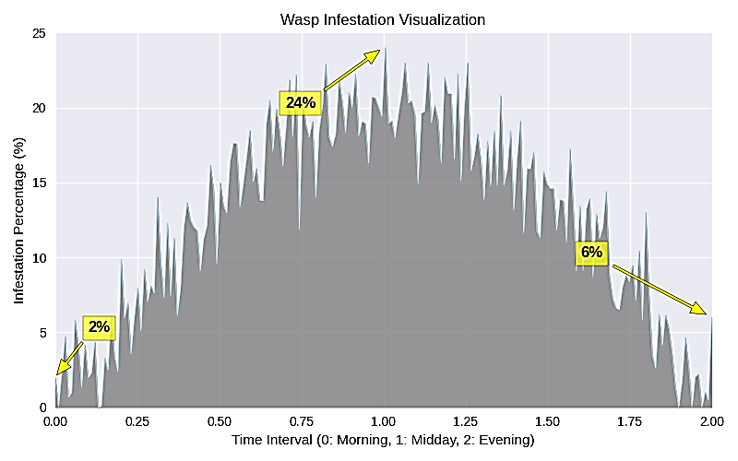

Fig. 1. Percentage of pear fruits damaged by Vespa basalis at different time intervals: morning (09:00–11:00 h) - 2%, midday (12:00–14:00 h) - 24%, and evening (15:00–17:00 h) - 6%.

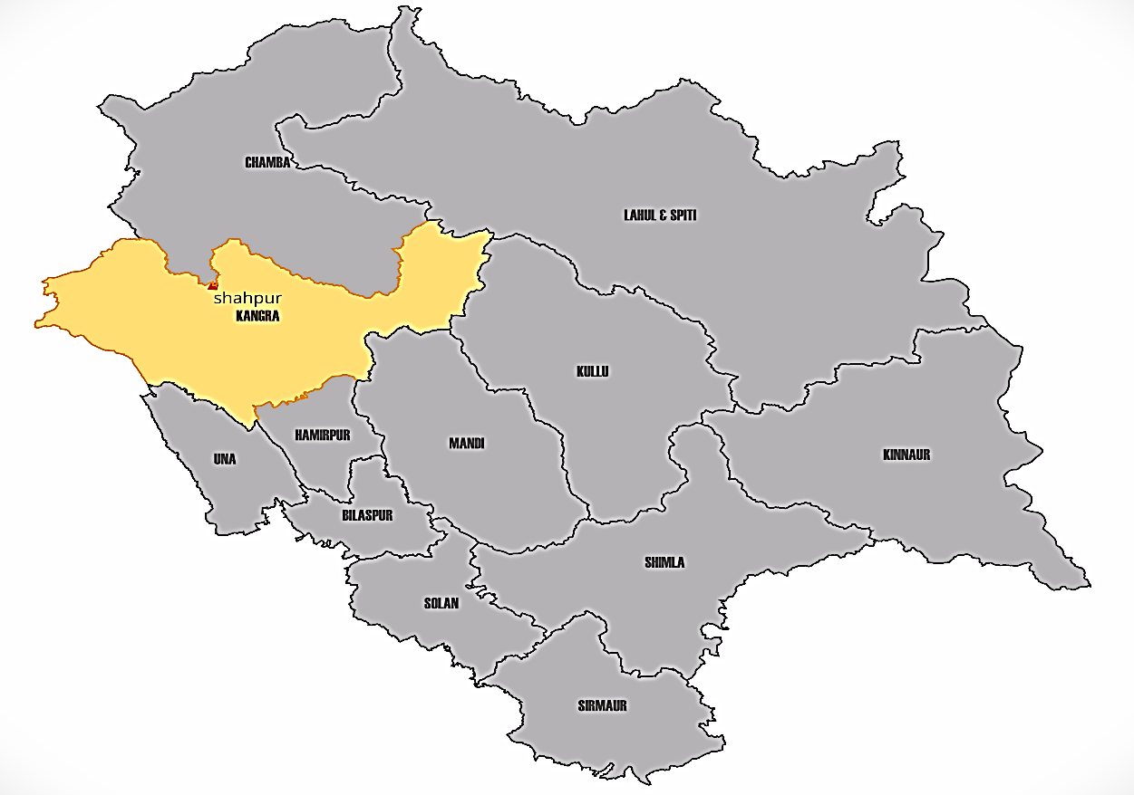

Fig. 2. Geographical location of the study site. Map of Himachal Pradesh highlighting Kangra district and Shahpur village where field observations on Vespa basalis feeding on pear fruits were conducted.

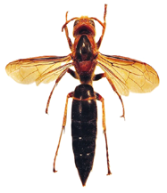
Fig. 3. Adult Vespa basalis (worker)

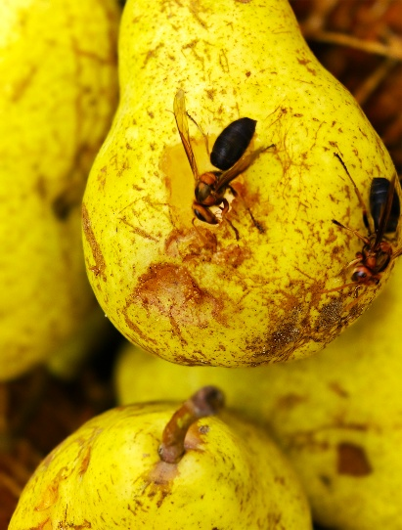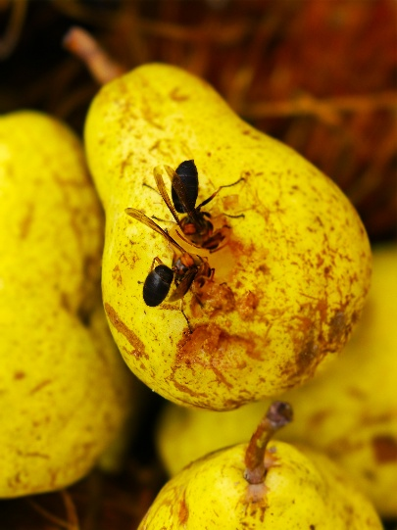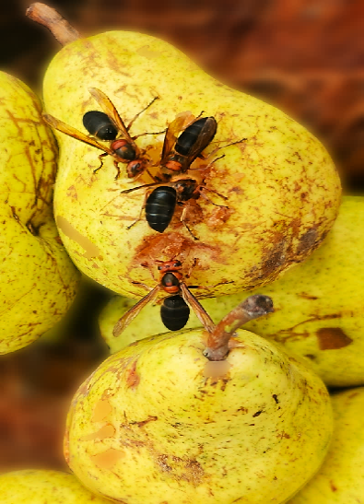
Fig. 4b. Congregation of wasps during feeding
Fig. 4a. Wasps feeding on ripe pear fruits

4. Conclusion

This study documents the first recorded instance of Vespa basalis directly feeding on ripe pear fruits in Himachal Pradesh, India. The peak feeding activity was observed around midday, resulting in 24% of the fruit being damaged, which was significantly higher than the damage observed in the morning and evening. Although the level of damage was moderate, it notably reduced the market value by accelerating spoilage and affecting fruit quality. This study revealed that V. basalis, previously recognized primarily as a beneficial predator, can also function as a direct pest on pear fruits. These findings underscore the necessity of integrated orchard management strategies, such as utilizing attractant-based traps, maintaining orchard cleanliness, employing protective coverings, and ensuring timely harvesting, to minimize economic losses while maintaining ecological balance.

Disclaimer (Artificial intelligence)

Author(s) hereby declare that NO generative AI technologies such as Large Language Models (ChatGPT, COPILOT, etc.) and text-to-image generators have been used during the writing or editing of this manuscript.

REFERENCES

Archer, M. E. (2008). Taxonomy, distribution and nesting biology of species of the genera Provespa Ashmead and Vespa Linnaeus (Hymenoptera: Vespidae). Entomologist’s Monthly Magazine, 144(1), 69–101.

Cappa, F., Cini, A., Bortolotti, L., Poidatz, J., & Cervo, R. (2021). Hornets and honey bees: A coevolutionary arms race between ancient adaptations and new invasive threats. Insects, 12(11), 1037. https://doi.org/10.3390/insects12111037

Carpenter, J. M., & Kojima, J. (1997). Checklist of the species in the subfamily Vespinae (Insecta: Hymenoptera: Vespidae). Natural History Bulletin of Ibaraki University, 1, 51–92.
Food and Agriculture Organization. (2021). Looking at edible insects from a food safety perspective: Challenges and opportunities for the sector. FAO. https://doi.org/10.4060/cb4094en

Hussain, B., Ahmad, B., & Sheikh, B. (2015). Monitoring and mass trapping of codling moth, Cydia pomonella, by the use of pheromone-baited traps in Kargil, Ladakh, India. International Journal of Fruit Science, 1, 1–9. https://doi.org/10.1080/15538362.2013.819207

Kumar, P. G., & Sharma, G. (2014). Taxonomic studies on vespid wasps (Vespidae: Vespoidea: Hymenoptera: Insecta) of Rajasthan, India with six new records from the state. Journal on New Biological Reports, 3(3), 240–258.

Matsuura, M. (1991). Vespa and Provespa. In K. G. Ross & R. W. Matthews (Eds.), The social biology of wasps (pp. 232–262). Cornell University Press, NY: Ithaca.

Monceau, K., Bonnard, O., & Thiéry, D. (2014). Vespa velutina: A new invasive predator of honeybees in Europe. Journal of Pest Science, 87(1), 1–16. https://doi.org/10.1007/s10340-013-0537-3

Mozhui, L., Kakati, L. N., Kiewhuo, P., & Changkija, S. (2020). Traditional knowledge of the utilization of edible insects in Nagaland, North-East India. Foods, 9(7), 852. https://doi.org/10.3390/foods9070852

Nguyen, L. T. P., Saito, F., Kojima, J., & Carpenter, J. M. (2006). Vespidae of Viet Nam (Insecta: Hymenoptera) 2. Taxonomic notes on Vespinae. Zoological Science, 23(1), 95–104. https://doi.org/10.2108/zsj.23.95

Pawar, A. D., Tuhan, N. C., Balasubramaniam, S., & Parry, M. (1980). Biological control of codling moth in Ladakh. Indian Journal of Plant Protection, 8(2), 189–191.

Perrard, A., Arca, M., Rome, Q., & Carpenter, J. M. (2014). Geographic variation of melanisation patterns in a hornet species: Genetic differences, climatic pressures or aposematic constraints? PLoS ONE, 9(4), e94162. https://doi.org/10.1371/journal.pone.0094162

Requier, F., Fournier, A., Pointeau, S., Rome, Q., & Courchamp, F. (2023). Economic costs of the invasive yellow-legged hornet on honey bees. Science of the Total Environment, 898, 165576. https://doi.org/10.1016/j.scitotenv.2023.165576

Sawant, S., Choi, E., Song, J., & Seo, H.-J. (2021). Pear production trends and characteristics of important pests in India. Journal of the Korean Society of International Agriculture, 33(3), 265–269. https://doi.org/10.12719/KSIA.2021.33.3.265

Sharma, S. K., Chatterjee, D., & Shivani. (2024). First report on the bark feeding wasp species on lowland apple and stone fruit trees of Himachal Pradesh, India. Journal of Scientific Research and Reports, 30(11), 1057–1063. https://doi.org/10.9734/jsrr/2024/v30i112632

Singh, S. (2024). Growth trends and instability in area, production, and productivity of fruit crops in Himachal Pradesh. International Journal for Multidisciplinary Research (IJFMR), 6(4), 1–10.

Smith-Pardo, A. H., Carpenter, J. M., & Kimsey, L. (2020). The diversity of hornets in the genus Vespa (Hymenoptera: Vespidae; Vespinae), their importance and interceptions in the United States. Insect Systematics and Diversity, 4(1), 1–27. https://doi.org/10.1093/isd/ixaa006

Thangjam, R., Kadam, V., Ningthoujam, K., & Sorokhaibam, M. (2020). A review on edible insects and their utilization in Northeastern Himalaya. Journal of Entomology and Zoology Studies, 8(3), 1309–1318.

Verma, R. C., Waseem, M. A., Sharma, N., Bharathi, K., Singh, S., Anto Rashwin, A., et al. (2023). The role of insects in ecosystems, an in-depth review of entomological research. International Journal of Environment and Climate Change, 13(10), 4340–4348.

Zaki, F. A. (1999). Incidence and biology of codling moth, Cydia pomonella L., in Ladakh (Jammu and Kashmir). Applied Biological Research, 1, 75–78.

