Efficacy of fungicides against powdery mildew in Luffa cylindrica under field and in vitro conditions

ABSTRACT
A field and laboratory study were conducted in Kharif 2024 to evaluate the efficacy of various fungicides against powdery mildew (Erysiphe cichoracearum) in sponge gourd (Luffa cylindrica). The experiment involved eight treatments, including both chemical fungicides and a control, applied as foliar sprays in a randomized block design with three replications. Disease severity was assessed using the 0 to 9 disease rating scale, and the effectiveness of treatments were determined by measuring mean per cent disease severity, per cent disease control, and area under the disease progress curve values. Among the tested fungicides, Azoxystrobin 11% w/w + Tebuconazole 18.3% at 0.15% (T₃) and Kresoxim methyl 18% + Mancozeb 54% WP at 0.2% (T₆) provided the greatest reduction in disease severity (12.28% and 15.18%), highest disease control (66.23% and 59.51%), and the lowest AUDPC values (311.10 and 531.15). In vitro evaluations supported these results, with T₃ and T₆ exhibiting the lowest disease severity ratings and maximum resistance in leaf disc assays. In contrast, the control plot (water spray) showed maximum disease progression and severity. The study concludes that Azoxystrobin 11% w/w + Tebuconazole 18.3% and Kresoxim methyl 18% + Mancozeb 54% WP are highly effective for managing powdery mildew in sponge gourd under both field and laboratory conditions, offering promising options for integrated disease management strategies.
Keywords: Erysiphe cichoracearum, sponge gourd, powdery mildew, per cent disease control, AUDPC, leaf disc bioassay.

INTRODUCTION
Powdery mildew, caused by the airborne fungi Erysiphe cichoracearum and Sphaerotheca fuliginea (the latter being the anamorphic stage), is a widespread and destructive disease affecting cucurbits in both field and greenhouse settings. In India, sponge gourd is cultivated in an area of 7.21 lakh ha with a production of 12.87 lakh tonnes. The productivity of this crop is 10.52 tonnes per hectare (Anon., 2022). Powdery mildew can result in an yield loss of 30–50%, particularly after fruit set and in densely planted fields. The yield loss is proportional to the severity of the disease and the length of time that plants have been infected (Mossler and Nesheim, 2005). The disease initially appears as white, talc-like patches on the undersides of older leaves, with conidia spreading rapidly via wind to adjacent foliage. As infection progresses, these patches merge, covering entire leaf surfaces, leading to yellowing, necrosis, and premature leaf drop. This reduces photosynthetic capacity, stunts plant growth, and impairs fruit development, compromising both yield and quality. Optimal conditions for powdery mildew include temperatures around 35 degrees Celsius (35°C) and relative humidity above 70 per cent (70%), with heavy dew enhancing severity, though excessive leaf wetness may inhibit fungal growth (Ali et al., 2013). Management strategies include cultural practices such as planting resistant or tolerant varieties and ensuring adequate spacing for aeration and sunlight exposure. It can be effectively managed with both protective and systemic fungicides. Sulphur formulations (wettable sulphur 0.2% or dusting sulphur 20–25 kg/ha) are economical and widely used, while triazoles (hexaconazole, propiconazole) and strobilurins (azoxystrobin, trifloxystrobin, or their combination with tebuconazole) have shown high efficacy. Hence, the present investigation was carried out to assess the effectiveness of various fungicides in controlling powdery mildew of sponge gourd.

MATERIALS AND METHODS
A field experiment was conducted during kharif 2024 to evaluate the efficacy of fungicides against powdery mildew of sponge gourd. Seeds of cv. Phule Prajakta were sown on 15 August 2024 at a spacing of 150 × 100 cm, and the crop was raised using standard agronomic practices. Fungicidal treatments were initiated at the first appearance of disease symptoms, followed by two subsequent sprays at 10-day intervals. The experiment was laid out in Randomized Block Design (RBD) with three replications and eight treatments. A total of three sprays were given at 10 days interval. The details of the treatments are presented in Table 1.

Table 1. Fungicides/chemicals and their concentrations used in different treatments

Treatments | Fungicides/chemicals | Conc. (%)
T1 | Carbendazim 12%+ Mancozeb 63% | 0.15
T2 | Azoxystrobin 4.8% w/w + Chlorothalonil 40% w/w SC | 0.6
T3 | Azoxystrobin 11% w/w + Tebuconazole 18.3 | 0.15
T4 | Aureofungin 46.25 w/w SP | 0.005
T5 | Copper sulphate 47.15 + Mancozeb 30% WDG | 0.5
T6 | Kresoxim methyl 18% +Mancozeb 54% WP | 0.2
T7 | Potassium salt of Phosphoeric acid | 0.4
T8 | Control (water spray) | -
*T= Treatment; T1 To T8 represent the different fungicide treatments evaluated against downy mildew of sponge gourd
Observations on powdery mildew intensity were taken at the initial appearance of the disease. Subsequent assessments were made one day prior to the first and second sprays, and 15 days after the third spray. For recording disease intensity, three plants were randomly selected and tagged in each replication. From each tagged plant, three leaves (one each from the lower, middle, and upper canopy) were assessed. Disease severity was recorded using the 0–9 disease rating scale proposed by Mayee and Datar (1986) as shown in table 2.

Table 2. Disease rating scale (0-9) for assessing powdery mildew severity in sponge gourd (Mayee and Datar,1986)
Grade | Description | Reaction
0 | No symptom on leaves | Immune (I)
1 | Small scattered specks covering 1% or less leaf area. | Highly Resistant (HR)
3 | Small lesions covering 1 to 10% leaf area | Resistant (R)
5 | Lesions enlarged covering 11 to 25 % leaf area | Moderately Resistant (MR)
7 | Lesions coalesce to form big patches covering 26 to 50 % leaf area. | Susceptible (S)
9 | Big patches covering 51% or more of leaf area and defoliation occur. | Highly Susceptible (HS)
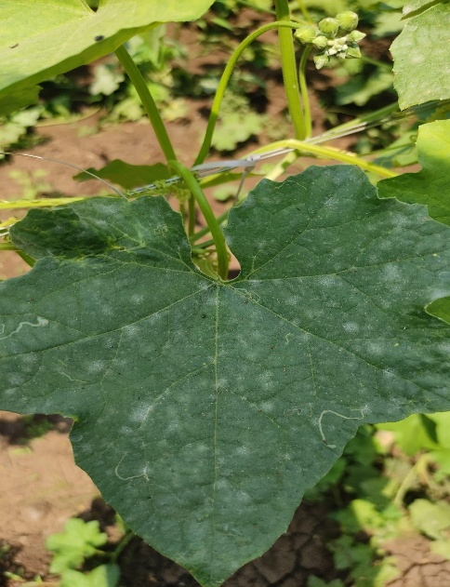
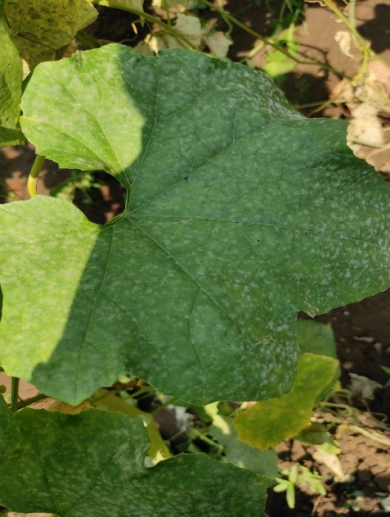

Plate 1: Symptoms of powdery mildew on leaves of sponge gourd

Further, per cent disease intensity (PDI) and its reduction over control (PDC) and area under disease progress curve were calculated by applying the following formulae Wheeler (1969)

Per cent Disease Index (PDI) by using 0-9 scale
PDI (Per cent Disease Index) = ∑ (Numerical Ratings​) ×100
(Number of Plants Assessed×Maximum Rating
Per cent disease reduction over control (PDC)
PDC (%) = (Disease severity in treatment – Disease severity in control) X 100
Disease severity in control

Area Under Disease Progress Curve (AUDPC)
AUDPC = Σ (Xi+Xi+1)/2(Xi + Xi+1) / 2(Xi+Xi+1)/2 × Di, for i = 1 to K–1

Where, Xi = Per cent disease index (PDI) at the end of the ith week.

K = number of successive evaluations of powdery mildew.

D = days interval between two observationsWhere, Xi = Per cent disease index (PDI) at the end of the i^{th} week.
K = number of successive evaluations of powdery mildew.
D = days interval between two observations.
Apparent rate of infection
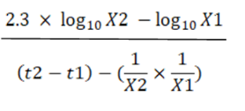
Rate of disease spread=

Where, r = apparent rate of infection/ spread
X1 = PDI (Per cent disease intensity/index) at time t1
X2 = PDI (Per cent disease intensity/index) at time t2
t2-t1 = time interval in days between the two consecutive observations

Collection of inoculum of powdery mildew (Erysiphe cichoracearum) on sponge gourd
Powdery mildew infected sponge gourd leaf samples were collected from the field. To obtain a representative sample, lesions, from thirty to forty leaves was cut out with a scissor and placed in zip lock bags lined with wet blotting paper for transport to the laboratory. Sporulation was induced by incubating the leaves overnight in a humid chamber under darkness. For fungicide susceptibility assay, these sporangia were used as inoculum. When fresh sporulation was visible the sporangia was collected by washing in sterilized water.
Determination of fungicide sensitivity using leaf disc bioassay
The leaf disc bioassay method was used for determining sensitivity of powdery mildew (E. cichoracearum) of sponge gourd against fungicides/chemicals. The sporangia produced on infected leaves was collected using sterile distilled water with the help of brush and adjusted to a concentration of 50,000 mL/l by the use of a haemocytometer.
Sponge gourd was grown in field separately and plants were kept free of powdery mildew by the application of sulfur. No fungicide specific for powdery mildew control was sprayed on the plants. Fully expanded young leaves from the shoot tip was used for the bio-assays. Leaf disc of 15 mm diameter were cut from the healthy leaves. Twenty-four-well plates was taken and one leaf disc was placed upside down in individual wells. Each fungicide concentration was applied on four leaf discs with a camel hair brush. The treatment details are given in table 3.
Table 3. Treatment details:
Tr.No. | Fungicides/chemicals | Conc.(%)
T1 | Carbendazim 12%+ Mancozeb 63% | 0.15
T2 | Azoxystrobin 4.8% w/w + Chlorothalonil 40% w/w SC | 0.6
T3 | Azoxystrobin 11% w/w + Tebuconazole 18.3 | 0.15
T4 | Aureofungin 46.25 w/w SP | 0.005
T5 | Copper sulphate 47.15 + Mancozeb 30% WDG | 1
T6 | Kresoxim methyl 18% +Mancozeb 54% WP | 0.3
T7 | Potassium salt of Phosphoeric acid | 0.4
T8 | Control (water spray) | -
*T= Treatment; T1 To T8 represent the different fungicide treatments evaluated against downy mildew of sponge gourd
After 24 hrs each leaf disc was inoculated by placing 50 µl of Erysiphe cichoracearum inoculum and plates were incubated overnight at 22 ± 2⁰C, in darkness, to allow infection. The drop was removed next morning from the leaf discs by using a pipette and the plates were further incubated at 22⁰C with interchanging periods of 12 hours light and darkness.
After 7-8 days of incubation, each leaf disc was observed under 20 × magnifications stereo microscope and scored using the scale, where
0= no visible symptoms
1= infection but no sporulation
2= little sporulation, lesion size smaller than droplet size,
3= sporulation, lesion size same as droplet size
4= sporulation, lesion size larger than droplet size

Positive test was considered when the average rating in control leaf disc was >3. The minimum inhibitory concentration (MIC) is defined as the concentration at which the average rating was < 2 (Giraud et al., 2013).
RESULTS AND DISCUSSION
Effect of Treatments on the Disease Intensity of Powdery mildew on sponge gourd
Evaluating the effectiveness of different treatments for controlling Powdery Mildew (Erysiphe cichoracearum) in sponge gourd during the Kharif 2024 season involved measuring mean per cent disease severity and per cent disease control. The results, presented in Table 4, demonstrate the varying effects of fungicidal and chemical treatments.
Table 4. Impact of treatments on per cent disease severity and per cent disease control for powdery mildew (Erysiphe cichoracearum) in sponge gourd (Kharif 2024).
Tr.No. | Treatments | Conc.(%) | Mean Per cent disease severity
T₁ | Carbendazim 12%+ Mancozeb 63% | 0.15 | 19.21  (25.86)
T₂ | Azoxystrobin 4.8% w/w + Chlorothalonil 40% w/w SC | 0.6 | 18.76  (25.48)
T₃ | Azoxystrobin 11% w/w + Tebuconazole 18.3 | 0.15 | 12.28  (20.41)
T₄ | Aureofungin 46.25 w/w SP | 0.005 | 31.51  (34.07)
T₅ | Copper sulphate 47.15 + Mancozeb 30% WDG | 0.5 | 27.14  (31.18)
T₆ | Kresoxim methyl 18% +Mancozeb 54% WP | 0.2 | 15.18  (22.74)
T₇ | Potassium salt of Phosphoric acid | 0.4 | 29.50  (32.72)
T₈ | Control (water spray) |  | 38.18  (38.00)
 | S.E. (m) ± |  | 1.25
 | CD (5%) |  | 3.79
*Figures in parentheses are arcsine transformed values *T= Treatment; T1 To T8 represent the different fungicide treatments evaluated against downy mildew of sponge gourd
Fig. 1 Effect of treatments on per cent disease control on powdery mildew in sponge gourd

The data in table 4 reveals significant variations in disease severity across the treatments. Fig. 1 shows the effect of treatments on per cent disease control. The control treatment (T₈, water spray) exhibited the highest mean per cent disease severity at 38.18%, with no disease control (0.00%), indicating the natural progression of powdery mildew without intervention. Among the chemical treatments, T₃ (Azoxystrobin 11% w/w + Tebuconazole 18.3% @ 0.15%) and T₆ (Kresoxim methyl 18% + Mancozeb 54% WP @ 0.2%) performed best, reducing disease severity to 12.28% and 15.18%, respectively, and achieving the highest disease control at 66.23% and 59.51%. Other treatments, including T₁ (Carbendazim 12% + Mancozeb 63% @ 0.15%), T₄ (Aureofungin 46.25 w/w SP @ 0.05%), T₅ (Copper sulphate 47.15 + Mancozeb 30% WDG @ 0.5%), and T₇ (Potassium salt of Phosphoric acid @ 0.4%), resulted in disease severities ranging from 19.21% to 31.51%, with control per centages between 14.73% and 48.62%. Statistical measures (S.E. (m) ± 1.25, CD (5%) 3.79) confirm the reliability of these findings, with significant differences observed among treatments. T₃, which has the lowest disease severity is on par with the subsequent superior treatment T₆ (Kresoxim methyl 18% + Mancozeb 54% WP @ 0.2%).
These findings are consistent with those reported by Kumar and Sharma (2020), who evaluated fungicides for powdery mildew (Leveillula taurica) management in chilli. Similarly, Yasmin, et al. (2008) evaluated the fungicides in vivo viz., Wettable Sulphur 80% WP @ 0.2%, Carbendazim 50% WP @ 0.1%, and Metalaxyl 8% + Mancozeb 64% WP @ 0.25% to manage powdery mildew of sweet gourd, at two different locations. Furthermore, Anand et al. (2008), evaluated Azoxystrobin at various doses (31.25, 62.50 & 125 g a.i./ha), Mancozeb 75% WP @ 1 kg/ha, and Carbendazim 50% WP @ 500 g/ha to manage cucumber powdery mildew (Erysiphe cichoracearum).
AUDPC analysis of Powdery Mildew control in sponge gourd across treatments
As shown in Table 2, the AUDPC values exhibited a wide range, reflecting the diverse impact of the eight treatments (T₁ to T₈) on powdery mildew. The control treatment recorded the highest AUDPC value of 901.55, indicating the most extensive disease progression due to the absence of any intervention. In contrast, treatments T₃ and T₆ demonstrated the lowest AUDPC values, at 311.10 and 531.35 respectively. These results suggest that T₃, applied at a 0.15% concentration, and T₆, at 0.2%, were highly effective in curbing disease development by consistently suppressing powdery mildew growth across the observation period of 10 days after each of the three sprays.
Table 5. Effect of different fungicidal treatments on AUDPC of Powdery mildew in
sponge gourd
Tr.  No. | Conc. (%) | PDI before first spray | PDI after |  |  | Mean | AUDPC | PDC
Tr.  No. | Conc. (%) | PDI before first spray | 10 days after 1st spray | 10 days after 2nd spray | 10 days after 3rd spray | Mean | AUDPC | PDC
T₁ | 0.15 | 1.81  (7.73) | 14.97  (22.76) | 19.77  (26.33) | 22.90  (28.50 | 19.21 | 470.95 | 48.62
T₂ | 0.6 | 1.83  (7.77) | 14.27  (22.12) | 18.43  (25.42) | 23.57  (28.90) | 18.76 | 454.00 | 50.25
T₃ | 0.15 | 1.73  (7.56) | 11.33  (19.66) | 12.33  (20.50) | 13.17  (21.07) | 12.28 | 311.10 | 66.23
T₄ | 0.005 | 1.88  (7.88) | 26.30  (30.81) | 32.43  (34.71) | 35.80  (36.69) | 31.51 | 798.70 | 14.73
T₅ | 0.5 | 1.74  (7.58) | 19.83  (26.40) | 24.50  (29.66) | 37.10  (37.48) | 27.14 | 637.50 | 28.99
T₆ | 0.2 | 1.92  (7.96) | 12.00  (20.19) | 14.77  (22.60) | 18.77  (25.44) | 15.18 | 531.15 | 59.51
T₇ | 0.4 | 1.79  (7.69) | 22.03  (27.99) | 26.60  (31.05) | 39.87  (39.13) | 29.50 | 688.60 | 22.56
T₈ | - | 1.78  (7.67) | 27.07  (31.29) | 36.93  (37.40) | 50.53  (45.30) | 38.18 | 901.55 | 0.00
S.E. (m) ± |  | 0.01 | 0.94 | 1.06 | 1.74
CD at 5% |  | 0.032 | 2.86 | 3.23 | 5.28
*Figures in parentheses are arcsine transformed values *T= Treatment; T1 To T8 represent the different fungicide treatments evaluated against downy mildew of sponge gourd
Analysis of Infection Rate and PDI Progression of Powdery mildew in Sponge Gourd Under Different Fungicidal Treatments
The results of the study, as presented in Table 3, demonstrate significant variations in the infection rates of powdery mildew in sponge gourd across different treatment intervals, highlighting the efficacy of various treatments. Treatment T₃ (Azoxystrobin 11% + Tebuconazole 18.3% at 0.15%) exhibited the lowest infection rates of 0.660, 0.317 and 0.167 from the initial observation to the 10-20 day and 20-30 day periods, respectively, with its PDI increasing only from 1.73 to 13.17, indicating robust disease control. In contrast, T₆ (Kresoxim methyl 18% + Mancozeb 54% WP at 0.2%) showed moderate efficacy with rates of 1.108, 0.377 and 0.300, and a PDI rise from 1.92 to 19.77. Treatments T₄ and T₇ displayed higher infection rates (2.442, 0.613, 0.337 for T₄; 2.024, 0.457, 1.317 for T₇) and larger PDI increases (1.88 to 35.80 for T₄; 1.79 to 39.87 for T₇), suggesting limited control. The untreated control (T₈) recorded the highest rates (4.229, 0.553, 1.593) and a PDI surge from 1.78 to 65.53, underscoring rapid disease progression without intervention. These findings highlight T₃ as the most effective treatment, followed by T₆, for managing powdery mildew in sponge gourd.
Similar experiment was conducted in okra at Mahatma Phule Krishi Vidyapeeth, Rahuri, by Waychal et al. (2018). They evaluated 20 genotypes against Erysiphe cichoracearum. The study measured both AUDPC and the apparent infection rate (r), and pinpointed genotypes GK-IV-2-2-3 and Hissar Unnat as having the lowest AUDPC and infection rates.

Table 6. Effect of different Fungicidal treatments on PDI and infection rate of Powdery mildew in sponge gourd
*Figures in parentheses are arcsine transformed values *T= Treatment; T1 To T8 represent the different fungicide treatments evaluated against downy mildew of sponge gourd
Tr.No. | Treatment | Conc. (%) | PDI before first spray | PDI after |  |  | ‘r’ (from disease appearance to 1st obs. after spray) | ‘r’  (10-20 days) | ‘r’ (20-30 days)
 |  |  |  | 10 days after 1st spray | 10 days after 2nd spray | 10 days after 3rd spray | ‘r’ (from disease appearance to 1st obs. after spray) | ‘r’  (10-20 days) | ‘r’ (20-30 days)
T₁ | Carbendazim 12%+ Mancozeb 63% | 0.15 | 1.81  (7.73) | 14.97  (22.76) | 19.77  (26.33) | 22.90  (28.50 | 1.316 | 0.480 | 0.313
T₂ | Azoxystrobin 4.8% w/w + Chlorothalonil 40% w/w SC | 0.6 | 1.83  (7.77) | 14.27  (22.12) | 18.43  (25.42) | 23.57  (28.90) | 1.244 | 0.416 | 0.514
T₃ | Azoxystrobin 11% w/w + Tebuconazole 18.3 | 0.15 | 1.73  (7.56) | 11.33  (19.66) | 12.33  (20.50) | 13.17  (21.07) | 0.958 | 0.100 | 0.084
T₄ | Aureofungin 46.25 w/w SP | 0.005 | 1.88  (7.88) | 26.30  (30.81) | 32.43  (34.71) | 35.80  (36.69) | 2.442 | 0.613 | 0.337
T₅ | Copper sulphate 47.15 + Mancozeb 30% WDG | 0.5 | 1.74  (7.58) | 19.83  (26.40) | 24.50  (29.66) | 37.10  (37.48) | 2.466 | 0.326 | 0.744
T₆ | Kresoxim methyl 18% +Mancozeb 54% WP | 0.2 | 1.92  (7.96) | 12.00  (20.19) | 14.77  (22.60) | 18.77  (25.44) | 1.099 | 0.186 | 0.400
T₇ | Potassium salt of Phosphoric acid | 0.4 | 1.79  (7.69) | 22.03  (27.99) | 26.60  (31.05) | 39.87  (39.13) | 2.024 | 0.457 | 1.327
T₈ | Control (water spray) |  | 1.78  (7.67) | 27.07  (31.29) | 36.93  (37.40) | 50.53  (45.30) | 2.529 | 0.986 | 1.360
S.E. (m) ± |  |  | 0.01 | 0.94 | 1.06 | 1.74
CD at 5% |  |  | 0.032 | 2.86 | 3.23 | 5.28
Management of Powdery Mildew with Fungicides/Chemicals in vitro
To evaluate the efficacy of various fungicides and chemicals against powdery mildew an investigation was conducted under in vitro conditions. The study assessed different treatments, the resulting disease severity (measured on a 0-4 scale), and the plant's response to the applied treatments. The findings are presented in Table 7.
Table 7. Management of Powdery Mildew with Fungicides/Chemicals in vitro
Tr.No. | Treatments | Conc. (%) | MIC | Reaction
T₁ | Carbendazim 12%+ Mancozeb 63% | 0.15 | 2 | MR
T₂ | Azoxystrobin 4.8% w/w + Chlorothalonil 40% w/w SC | 0.6 | 2 | MR
T₃ | Azoxystrobin 11% w/w + Tebuconazole 18.3 | 0.15 | 1 | R
T₄ | Aureofungin 46.25 w/w SP | 0.005 | 2.6 | S
T₅ | Copper sulphate 47.15 + Mancozeb 30% WDG | 1.00 | 3 | S
T₆ | Kresoxim methyl 18% +Mancozeb 54% WP | 0.3 | 1.33 | MR
T₇ | Potassium salt of Phosphoric acid | 0.4 | 3.33 | HS
T₈ | Control (water spray) |  | 3.66 | HS
MR=Moderately Resistant, R=Resistant, S=Susceptible, HS=Highly Susceptible
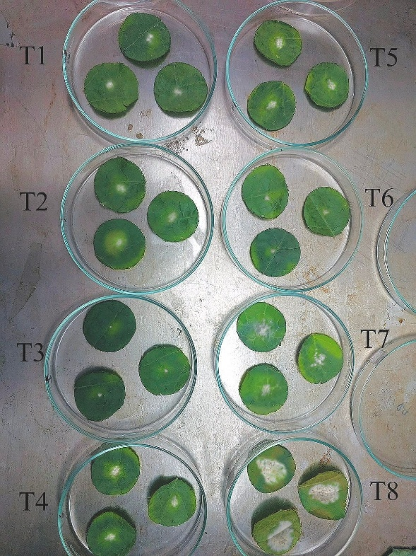

Plate 2. Management of Powdery mildew with fungicides/chemicals in in vitro conditions.
Treatments T₃ (0.15%) and T₆ (0.30%) had the lowest disease severities (1.00 and 1.33) indicating high fungicidal effectiveness. In contrast, T₄, T₅, T₇, and the control T₈ had weak responses and higher severities (2.60 to 3.66), indicating poor control. Higher concentrations like T₅ (1.00%) and T₇ (0.40%) increased severities (3.00 and 3.33), suggesting reduced effectiveness. The untreated T₈ reached the highest severity (3.66), stressing the need for treatment. Concentrations of 0.15% to 0.30% seem best for improving control.
These results are in conformity to the findings of several earlier workers. The fungicides viz., Carbendazim 12%+ Mancozeb 63%, Azoxystrobin 4.8% w/w + Chlorothalonil 40% w/w SC, Azoxystrobin 11% w/w + Tebuconazole 18.3, Aureofungin 46.25 w/w SP, Copper sulphate 47.15 + Mancozeb 30% WDG, Kresoxim methyl 18% +Mancozeb 54% WP and Potassium salt of Phosphoeric acid at their recommended field dosages were reported effective and economical for the management of powdery mildews of various crop hosts in in vitro condition such as Ghule et al.(2020), Reuveni, M. (2001), Suryawanshi et al.(2023) and Sawant (2023) on grapes.
CONCLUSION
The study concluded that Azoxystrobin 11% w/w + Tebuconazole 18.3% and Kresoxim methyl 18% + Mancozeb 54% WP were the most effective fungicides for managing powdery mildew in sponge gourd under both field and laboratory conditions. These treatments significantly reduced disease severity and progression, improved yield, and offer promising options for integrated disease management strategies in sponge gourd cultivation.
Disclaimer (Artificial intelligence)
Author(s) hereby declare that NO generative AI technologies such as Large Language Models (ChatGPT, COPILOT, etc.) and text-to-image generators have been used during the writing or editing of this manuscript.
REFERENCES
Ali, M., et al. (2013). Environmental factors affecting powdery mildew development. Plant Pathology Journal, 12(3), 45–52.
Anonymous (2022). Area, production and productivity of vegetable in India. www.nhb.gov.in.
Anand, T., Chandrasekaran, A., Kuttalam, S. P., Senthilraja, G., Raguchander, T., & Samiyappan, R. (2008). Effectiveness of azoxystrobin in the control of Erysiphe cichoracearum and Pseudoperonospora cubensis on cucumber. Journal of Plant Protection Research, 48(2), 183–191.
Ghule, M. R., Sawant, S. S., & Patil, V. C. (2020). Resistance of Plasmopara viticola to multiple fungicides in vineyards of Maharashtra, India. Journal of Environmental Biology, 41(5), 1023–1032.
Giraud, C., et al. (2013). Resistance of Plasmopara viticola to multiple fungicides in vineyards of Maharashtra, India. Journal of Environmental Biology, 41(5), 1023–1032.
Kumar, D., & Sharma, R. (2020). Evaluation of fungicides, botanical and organic amendments for management of chilli powdery mildew caused by Leveillula taurica under field conditions. The Pharma Innovation Journal, 9(4), 2271–2275.
Mayee, C. D., & Datar, V. V. (1986). Phytopathometry, Technical Bulletin-1 (Special Bulletin-3). Marathwada Agricultural University, Parbhani, Maharashtra, India, 95 pp.
Mossler, M.A. and Nesheim, O.N. 2005. Florida Crop/Pest Management Profile: Squash. Electronic Data Information Source of UF/IFAS Extension (EDIS). CIR 1265.
Reuveni, M. (2001). Efficacy of trifloxystrobin (Flint), a new strobilurin fungicide, in controlling powdery mildews on apple, mango, nectarine, and rust on prune. Crop Protection, 20(6), 553–559.
Sawant, I. S. (2023). Microbes in management of fungal diseases of grape. Grape Insight, 60, 59–67.
Suryawanshi, K. T., Sawant, S. D., & Sawant, I. S. (2023). Management strategies for zero fungicides residue in grapes. International Journal of Current Microbiology and Applied Sciences, 12(07), 192–203.
Waychal, G. U., Game, B. C., & Jagtap, S. D. (2018). Evaluation of fungicides for management of powdery mildew disease of okra (Abelmoschus esculentus Moench). International Journal of Chemical Studies, 6(2), 325–327.
Wheeler, B. E. J. (1969). An Introduction to Plant Disease. John Wiley and Sons Ltd., London, 301 pp.
Yasmin, A., Akter, N., Haque, M. M., & Rahman, M. M. (2008). Management of powdery mildew disease of sweet gourd through fungicidal spray. Journal of Agricultural Research, 33(4), 13–21.

