Rice Yield Assessment in Nalgonda: A Comparative Study of APSIM and Semi-Physical Models with Remote Sensing Integration

ABSTRACT
Precise estimates of crop yields are crucial for planning and predicting future food supplies and ensuring that the production resources are allocated appropriately. This study demonstrated two approaches: the assimilation of remote sensing with the APSIM model and a semi-physical approach for the spatial rice yield estimation of Nalgonda district, Telangana, during Kharif 2021. APSIM-ORYZA simulated field-level crop production using fundamental input parameters such as soil, weather, and crop management data. The spatial mean yield of the model showed 4925 kg/ha. The semi-physical approach calculated the net primary product using the periodical photosynthetically active radiation (PAR), fraction of absorbed photosynthetically active radiation (FAPAR), crop stress and maximum radiation use efficiency (RUE). The resultant spatial rice yield of the semi-physical approach revealed an average of 4426 kg/ha. In comparison, the government statistics for the Nalgonda district exhibited an average yield of 5026 kg/ha. The crop model showed a deviation of 2% while the semi-physical approach showed 11% from the reported yield. According to the evaluation with observed yields at the field points, the APSIM model correlated linearly with R² = 0.79, and the root mean square error (RMSE) of 504 kg/ha and SPM showed R² of 0.76 and an RMSE of 807 kg/ha. These findings suggest that while both approaches hold potential, the APSIM model provided more accurate spatial rice yield estimation.

Keywords: Crop Simulation Model, Agricultural Production Systems Simulator (APSIM), Remote Sensing, Semi Physical Model, Yield estimation, FAPAR

1. INTRODUCTION

Accurate yield estimation serves as a fundamental element in aiding the optimisation of resource allocation, management decisions, and policy formulation (Awad, 2019; Gumma et al., 2024). Rice, a staple food for more than half of the world's population, plays a critical role in global food security (Schneider & Asch, 2020). Nalgonda district, situated in the southern part of India, exemplifies such a region where rice cultivation is both a livelihood necessity and a challenge due to its diverse agro-climatic conditions. Improving rice yield predictions in Nalgonda is crucial for sustainable agriculture. It helps in managing agricultural resources efficiently to ensure sustained food supplies for future demands.
In India, traditional methods of crop yield estimation based on ground-based field visits and reports are often limited by high costs, time constraints, and incomplete data, leading to inaccuracies (Jha, Kumar, Dubey, & Pandey, 2022). To address these limitations, remote sensing using satellite data presents a promising alternative by enabling accurate and timely crop assessments over large geographic areas (Khanal, Kc, Fulton, Shearer, & Ozkan, 2020). Satellite imagery provides synoptic, cost-effective, and frequent observations that facilitate the monitoring of surface features and agricultural activities (Ali et al., 2022). Moreover, remote sensing enables the tracking of crop phenology through the computation of vegetation indices—such as the Normalized Difference Vegetation Index (NDVI)—which is strongly correlated with the Leaf Area Index (LAI), a key indicator of crop health and biomass (Atzberger, 2013).
Crop simulation models have been developed through the integration of data from agrometeorology, soil, crop physiology, and management, using a set of mathematical equations to predict growth, development, and yield (Pazhanivelan et al., 2022). These models can successfully simulate potential crop growth and characteristics and provide real-time vegetation cover status (Huang et al., 2019). Many studies have taken up the integration of remote sensing and crop simulation models like ORYZA (Setiyono et al., 2018); WOFOST (Guo et al., 2012); DSSAT (Son, Chen, Chen, Chang, & Chiang, 2016); SIMRIW (Maki, Sekiguchi, Homma, Hirooka, & Oki, 2017); GEPIC (Muslim, Romshoo, & Rather, 2015) for the prediction of rice yield. The Agricultural Production Systems Simulator (APSIM) is a widely recognized software application that employs multiple sub-models to simulate crop growth, soil processes, and management options under varying climatic conditions (Hao et al., 2021). The APSIM-ORYZA model, a part of the APSIM framework, is based on the original ORYZA2000 model and enables the modelling of rice metabolism, including photosynthesis, phonological development, and productivity, using the APSIM modules for water, nitrogen, and other soil processes and management issues (Amarasingha et al., 2015). This feature allows for the examination of continuous cropping systems, carry-over effects, and field management options.
Semi Physical model balances complexity and computational efficiency, making it especially valuable in scenarios where data may be incomplete or noisy. SPMs offer a practical approach to capturing the essential dynamics of crop growth, such as photosynthesis, nutrient uptake, and water use, while still accommodating large-scale applications through integration with remote sensing technologies. They require fewer data inputs than fully physical models, reducing the barrier to entry for users without extensive technical backgrounds. This technique combines various parameters such as Photosynthetically Active Radiation (PAR), Fraction of Photosynthetically Active Radiation (FAPAR), Radiation use efficiency (RUE), harvest index, and Crop stress factors to estimate crop yield with accuracy. Previous studies that have dealt with the semi-physical model for rice yield estimation include (Pazhanivelan et al., 2022); (Jha et al., 2022); (Dwivedi, Saxena, & Ray, 2019). This paper presents a comparative analysis of the two methodologies — the APSIM model and a semi-physical modelling approach in conjunction with remote sensing to estimate rice yield in the Nalgonda district.

2. material and methods

Study area
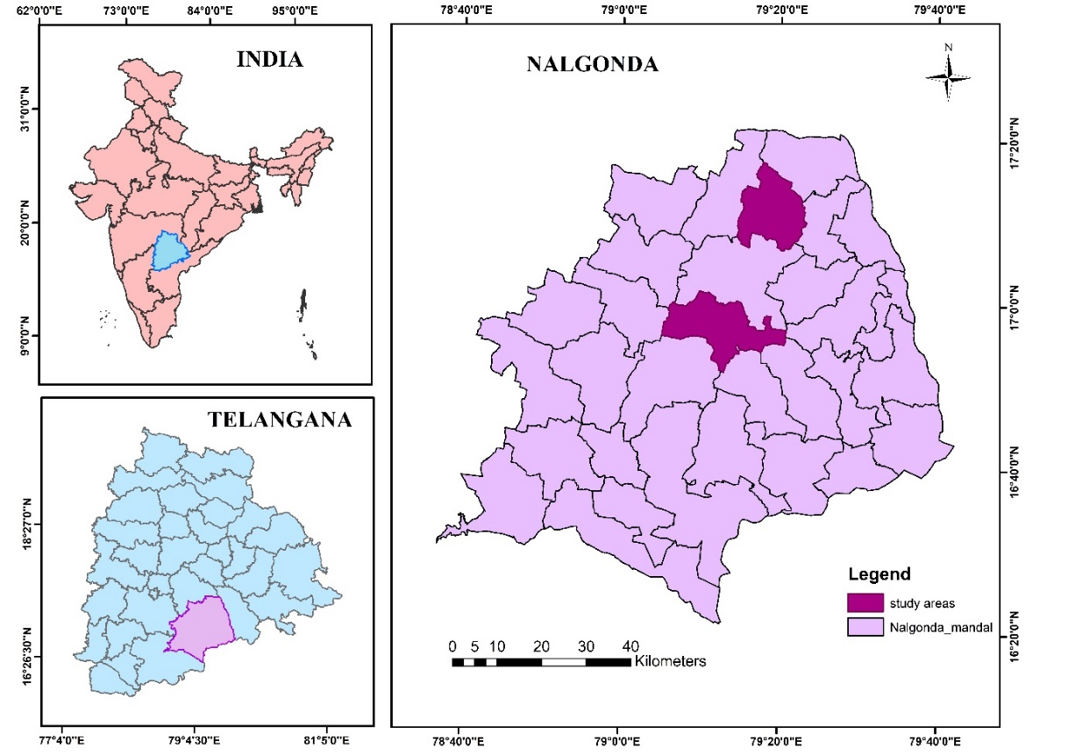
Nalgonda district, situated in the southern part of Telangana, lies between latitudes 16º25' N and 17º50' N and longitudes 78º40' E and 80º05' E. The district experiences a tropical wet and dry climate, with an average annual temperature of 30.22 °C and an average annual rainfall of approximately 105 mm. The region's soil profile comprises alluvial, alkaline, black, and red soils. During the Kharif season, major crops cultivated include rice, cotton, bajra, green gram, red gram, castor, sesame, jowar, and groundnut. For this study, two representative paddy-growing villages—Telakantigudem and Mallaram—from Kanagal and Kattangoor mandals, respectively, were selected based on the previous season’s rice crop distribution, along with soil and rainfall data (Fig. 1). The study area captures contrasting agro-ecological conditions:

Fig. 1. Study area map representing the selected villages in the Nalgonda district
Kanagal mandal receives relatively higher rainfall and features vertisol soils, while Kattangoor mandal experiences lower rainfall and is characterized by alfisol soils.
Mapping of Rice growing areas in Nalgonda district
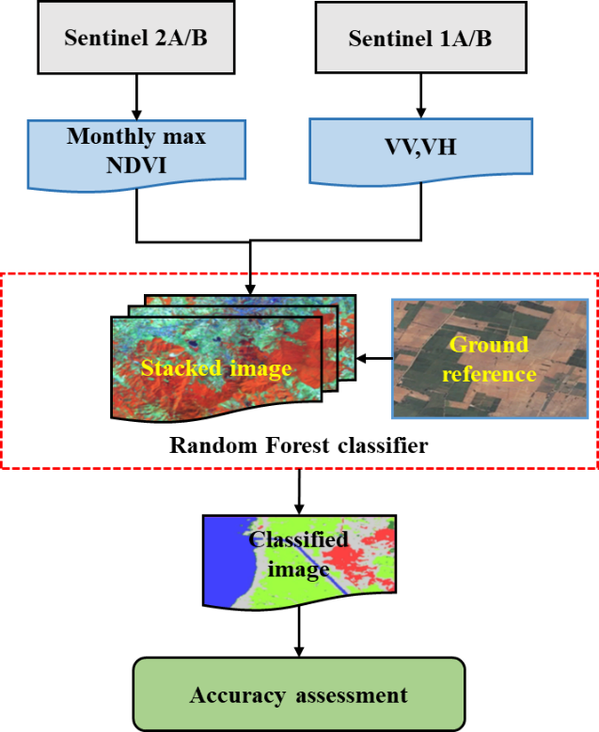
Sentinel-1 and Sentinel-2 are utilised in conjunction for mapping, as Sentinel-1 supplies Synthetic Aperture Radar (SAR) data, which is advantageous for monitoring vegetation structure and soil moisture irrespective of weather conditions or daylight, while Sentinel-2 provides high-resolution optical imagery across multiple spectral bands, facilitating the use of indices such as NDVI (Normalised Difference Vegetation Index) to evaluate plant vigour and distinguish between different crops. The method employed for classifying rice cultivation regions is illustrated in Fig. 2. GEE was used to analyse and classify Sentinel-2 and Sentinel-1 data due to its cloud computing capabilities, which diminish the necessity for users to possess hardware and software resources. The Sentinel-1 dataset on Google Earth
Fig. 2. Methodology for rice area mapping using GEE
Engine (GEE) offers dual-polarization C-band Synthetic Aperture Radar (SAR) data, comprising calibrated and ortho-corrected Ground Range Detected (GRD) images. Data from Sentinel-1, comprising both vertical-vertical (VV) and vertical-horizontal (VH) polarisation, were combined with the monthly maximum Normalised Difference Vegetation Index (NDVI) from Sentinel-2 to produce a composite image. A supervised classification was then performed using a random forest classifier, trained on 160 ground reference points enhancing the accuracy of crop growing area identification.
Yield estimation integrating remote sensing using the APSIM model
In APSIM v 7.10, the APSIM-ORYZA model simulates the growth and development of rice crop on a daily basis. All input data files, such as meteorological data, soil data, cultivar data, and crop management data, were generated by extracting them from a variety of sources (Table 1). The model was executed for Kharif transplanted rice for the 20 treatments with different management practices as represented in Appendix A.
Table 1: Input data and their variables for simulation model (APSIM-ORYZA)
Input data | Variables | Source
Site data | Longitude (East or West), latitude (North or South) and altitude (m). | Ground truth data
Weather data | Solar radiation (MJm⁻²), daily maximum and minimum temperature (°C), annual average ambient temperature (T_{av}, °C) and annual amplitude in mean monthly temperature (amp, °C). | Automatic Weather  Station
Soil data | Soil pH, soil organic carbon, soil texture, coarse fragments, CEC, bulk density, field capacity, wilting point and texture. | ISRIC2.0  (https://www.isric.org)
Crop data | Cultivar | Collected from the farmers
Management data | Fertiliser application rate (e.g., N, P, K), irrigation date and amount, cropping calendar (e.g., sowing and harvesting times), plant population, transplanting date, and row spacing. | Data collection from farmers

Validation of the model was done by comparing the simulated yield to the observed yield in the fields. The methodology for yield estimation using remote sensing products and simulation model is shown in Fig. 3. NDVI values extracted from Sentinel-2 images for the growing season were utilized to generate a spatial LAI based yield map from simulated LAI values by applying the regression analysis. 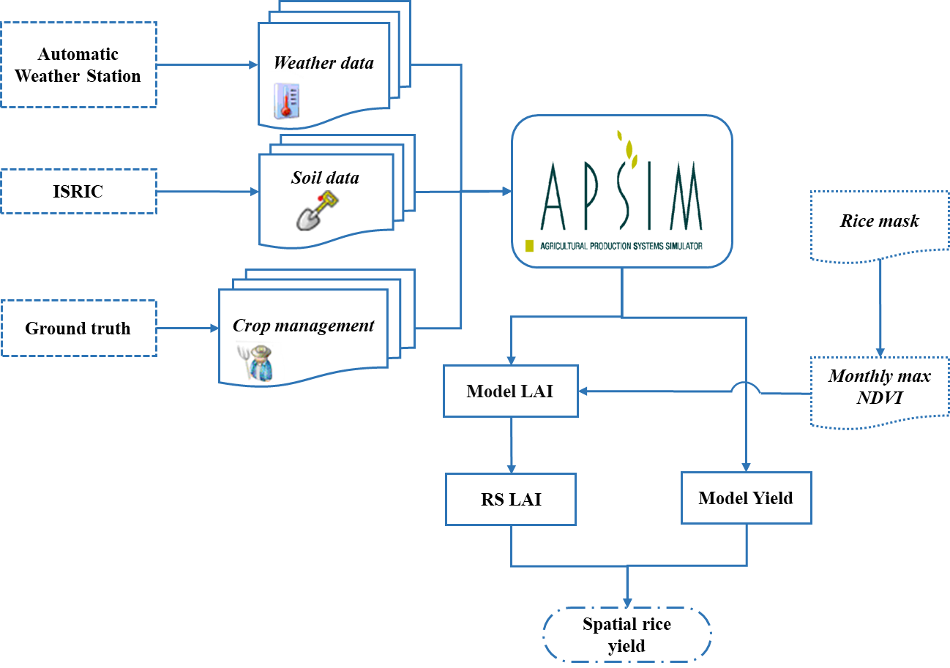Fig. 3. Schematic diagram of the estimation of rice yield by integration of remote sensing data with the simulation model

Yield estimation using Semi-Physical Model
The semi-physical approach was used in this study to estimate yield by monitoring daily plant biomass growth from development to maturity, based on the influence of photosynthetically active radiation (PAR) and fraction of PAR absorbed (FAPAR) by the crop canopy (dela Torre et al., 2021). The physiological parameters, PAR and FAPAR, can help to assess the real-time information of the crop growing condition at any stage of the crop (Leolini et al., 2023). The influence of crop stress was considered for computing NPP. The methodology used for the semi-physical model is presented in Fig. 4.
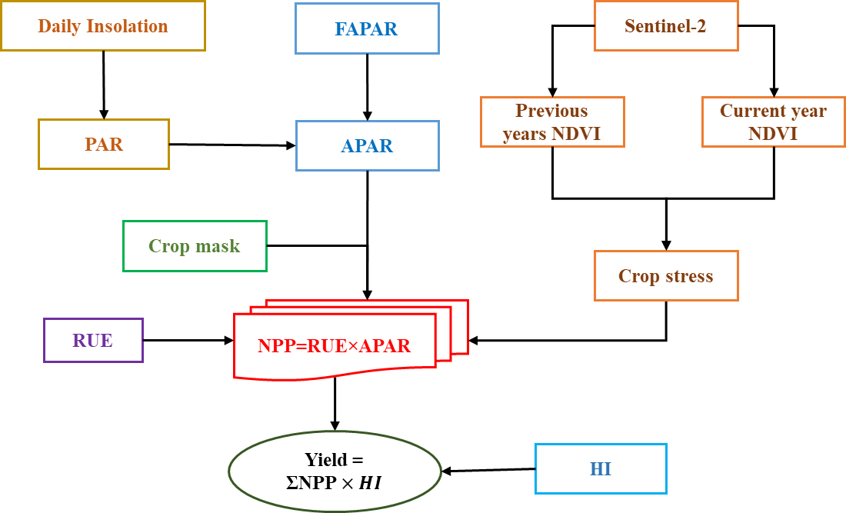
Fig. 4. Flowchart for the methodology of yield estimation by SPM
Photosynthetically Active Radiation (PAR) was estimated using daily insolation data from the INSAT-3D satellite, downloaded from the MOSDAC at 1 km resolution for the growing period of June 2021 to October 2021. The 10-day sum of daily insolation was calculated, assuming that 50% of the total insolation contributes to PAR (Akitsu et al., 2022). FAPAR (Fraction of Absorbed Photosynthetically Active Radiation) was obtained from Sentinel-3 OLCI data as 10-day composites at 300 m resolution from the Copernicus website (http://land.copernicus.eu/global/), and a scale factor of 1/250 was applied. Net Primary Productivity (NPP) was calculated at 10-day intervals using inputs such as PAR, fAPAR, crop stress, and maximum radiation use efficiency, at a spatial resolution of 300 m. Crop stress was assessed using NDVI and NDWI derived from Sentinel-2 imagery by comparing the current season’s maximum values with the average maximum values from the previous two years. Areas exhibiting a significant decline were identified as stressed, potentially due to factors such as water scarcity, nutrient deficiencies, pest infestations, diseases, or adverse climatic conditions.
The Net Primary Product (NPP) was computed as
NPP = APAR× RUE × Crop stress (1)
Where, NPP = Net Primary Productivity (gm-2d−1); PAR = photosynthetically active radiation (MJm−2d−1); APAR= absorbed PAR (dimensionless); RUE = Radiation-use efficiency of absorbed PAR (gMJ−1).
RUE = Biomass / PAR (2)
The economic grain yield is determined as
Grain Yield = ∑NPP×HI (3)
Where Harvest Index (H.I) is computed from the model simulated data.
HI= (Grain yield) / (Biological yield)×100 (4)
From the obtained spatial yield, the field points were applied to it and the yield for the particular fields was extracted.

3. results and discussion

Rice Area Classification
The spatial distribution of rice crops in Nalgonda district during the Kharif season of 2021 was delineated using supervised classification based on the Random Forest (RF) algorithm. The classified output, presented in Fig. 5, estimated the rice-growing area to be approximately 1.55 lakh hectares (L ha). This estimate is in close agreement with the official government-reported area of 1.8 L ha, reflecting a minimal deviation of -0.16%, thereby validating the robustness of the classification approach.

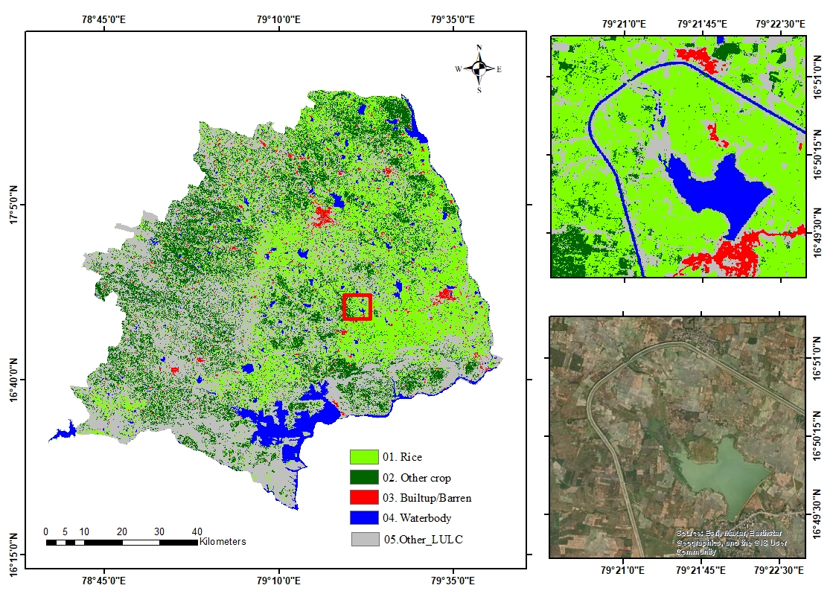
Fig. 5. Spatial distribution of rice cultivation in Nalgonda district

The classified map clearly highlights rice cultivation as predominant in the eastern and central parts of the district, especially within the command areas of the Nagarjuna Sagar canal system and regions with dependable irrigation, primarily sourced from the Krishna river.
Conversely, the western regions of the district exhibited sparse rice coverage due to limited
access to irrigation infrastructure.
Accuracy assessment
To assess the reliability of the classification results, an accuracy assessment was conducted using a confusion matrix based on ground truth validation data. The Random Forest classifier achieved a high overall accuracy of 92.5%, along with a Kappa coefficient of 0.894, indicating strong agreement between the classified and reference datasets. Table 2 summarizes the user’s and producer’s accuracies for each land use/land cover (LULC) class. The rice class achieved a user’s accuracy of 97.8% and a producer’s accuracy of 90.2%, reflecting high classification precision.
Table 2. Confusion matrix showing classification accuracy in Nalgonda district
Classified data | Rice | Other crop | Waterbody | Builtup | Other  LULC | Totals | Users  Accuracy  (%)
Rice | 46 | 1 | 0 | 0 | 0 | 47 | 97.8
Other crop | 0 | 12 | 0 | 0 | 1 | 13 | 92.3
Waterbody | 0 | 0 | 11 | 0 | 0 | 11 | 100
Builtup | 0 | 0 | 0 | 8 | 0 | 8 | 100
Other LULC | 5 | 0 | 0 | 1 | 21 | 27 | 77.7
Totals | 51 | 13 | 11 | 9 | 22 | 106
Producers  accuracy  (%) | 90.2 | 92.3 | 100 | 88.8 | 95.4
Overall accuracy (OA) |  |  | 92.5%
Kappa coefficient |  |  | 0.894

Other major LULC classes, such as waterbodies and built-up areas, were classified with 100% accuracy. However, minor misclassifications occurred, especially between rice fields and certain vegetative cover types like shrubs, due to spectral similarity in specific zones. The results highlight the effectiveness of combining multi-temporal satellite data and machine learning techniques for large-scale rice area mapping. The accuracy levels observed indicate that this approach is suitable for operational crop monitoring and agricultural planning at the district level.
Yield estimation using APSIM
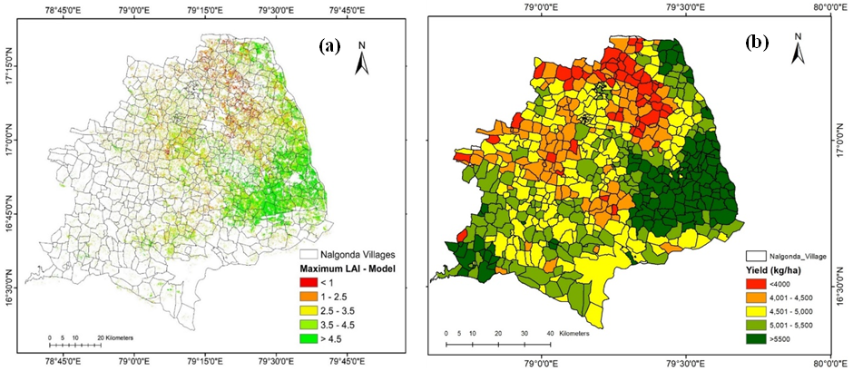
APSIM-ORYZA was used to simulate the rice yields for the field points with the input data collected from different sources. The simulated yield for the fields has been expanded to the whole study area by integrating remote sensing data. In this study, remotely sensed LAI values were spatially assimilated with the APSIM model. A regression analysis was used to generate remotely sensed LAI from sentinel-2 images, with the simulated LAI from the APSIM model at the spatial level derived from the monitoring fields as an explanatory variable for spatial yield estimation.
Fig. 6. Spatial distribution of (a) Remote sensing-based LAI; (b) Simulated rice yield of the APSIM model

By integrating remote sensing with the APSIM-ORYZA model, a rice yield map (Fig. 6) was generated for the study area, resulting in a mean rice yield of 4925 kg/ha. When compared to the government-reported (telangana.gov.in./) yield of 5024 kg/ha mean yield, the model underestimated the yield by 2%. Sarkar et al., 2023 stated that Satisfactory model performance was found with likewise estimates of RMSE for hybrid rice grain and biomass yield within the experimental uncertainty limit for calibration and validation dataset
Semi Physical Model
Crop stress map: Based on the values, threshold was set to classify areas as stressed and healthy. Thresholds 1, 0.8, 0.6, and 0.4 represent the areas of no stress, mild stress, moderate stress and severe stress, respectively. The crop stress map (Fig. 7) highlights areas within the Nalgonda district where values have significantly declined, indicating potential crop stress in rice-growing regions. However, a larger proportion of rice-cultivated areas exhibit no or only mild stress, suggesting generally healthy crop conditions. This can be attributed to the availability of adequate water and favourable temperatures throughout the growing season in the Nalgonda district for Kharif, 2021.
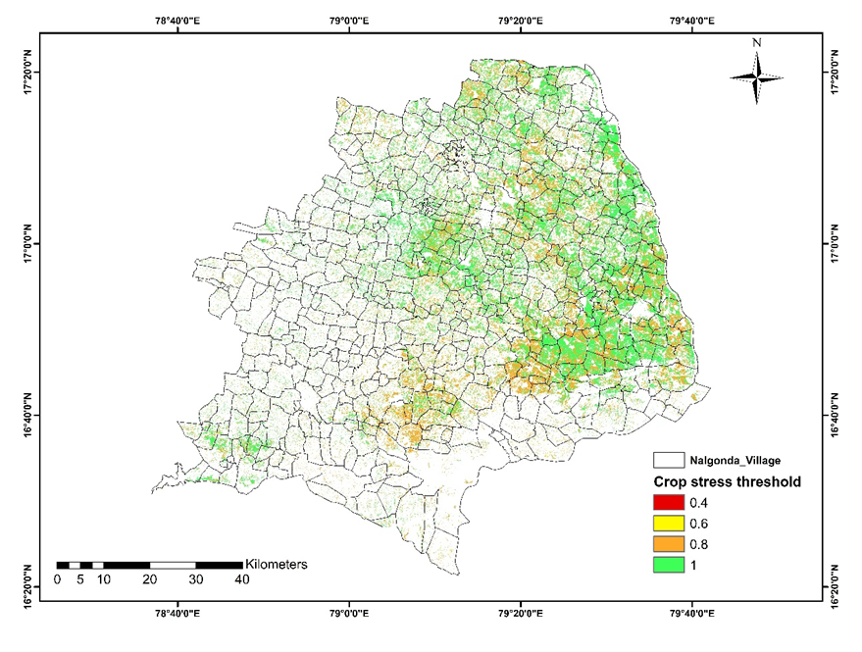
Fig. 7. Crop stress map of rice growing areas in Nalgonda district
Yield estimation using Semi physical model
Net Primary Product has been computed over the growing period at an interval of 10 days using the computed radiation use efficiency of 2.0 and crop stress threshold. The 10-day periodic data of APAR is integrated for the whole crop season for the study area using a kharif rice crop mask. Grain yield was computed from total NPP using the harvest index as 0.5. The distributed yield map is shown in Fig. 8. It shows the regions of high yield and low yield. The estimated grain yield for the whole district was 4426 kg/ha, which is 11% less than the reported yield (5024 kg/ha). Previous studies like Dwivedi et al. (2019) recorded a 3.94% underestimation in state-level rice yield estimation, whereas Jha et al. (2022) indicated an 8.7% overestimation compared to the reported yield, attributing the yield variability to inaccuracies in sowing and harvesting dates.

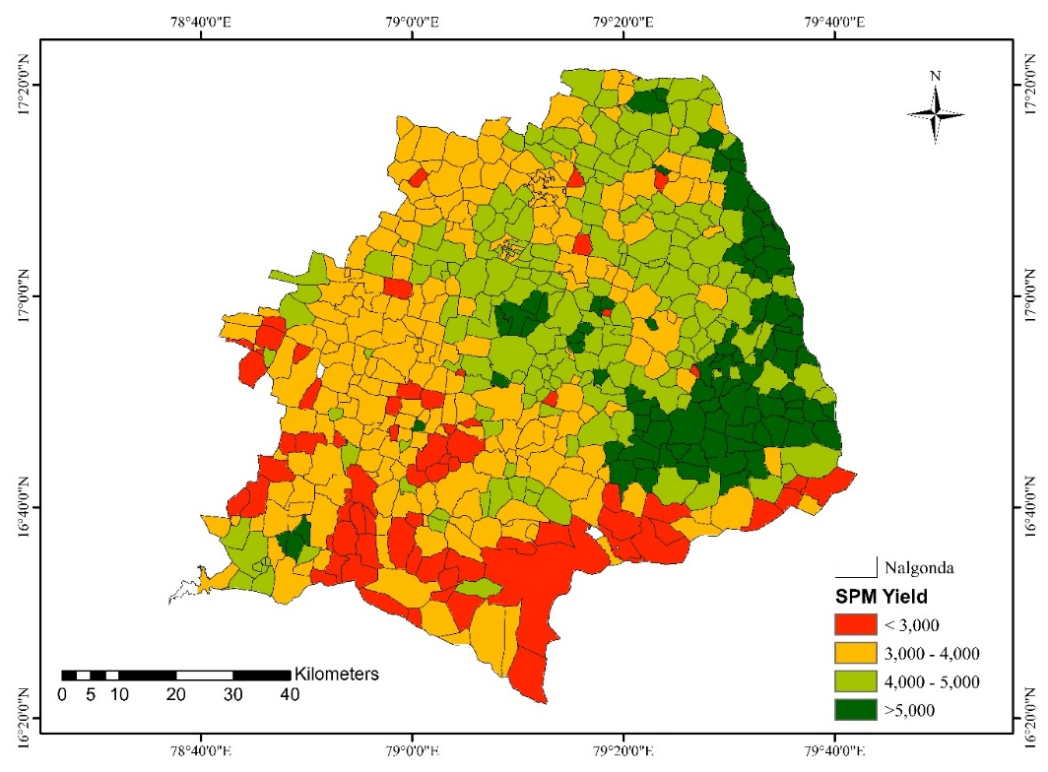
.Fig. 8. Spatial distribution of yield using the SPM model for the Nalgonda district
Comparison of Spatial Yield Estimation Techniques
The APSIM model, with an RMSE of 504 kg/ha, has the highest mean R² value of 0.79 out of the two yield estimating techniques (Fig. 9). The disparity of the simulated yield of the APSIM model can be that the model oversimplifies real-world scenarios. The Telangana varieties' photoperiod sensitivity couldn't be calibrated due to a lack of data, so default values were used, causing a disparity. To estimate yields accurately by a crop model, calibrating photoperiod sensitivity features is necessary. Sarkar et al., 2023 reported satisfactory model performance, with comparable RMSE estimates for hybrid rice grain and biomass yield using APSIM model.
The semi-physical approach resulted in an R² value of 0.76 and an RMSE of 807 kg/ha. The high RMSE for rice yield estimation was the result of the underestimation of rice crop yield using the SPM model as compared to the observed yield at field points. The parameters used in a semi-physical model are based on generalized conditions, which means that they may not accurately represent the local conditions. Moreover, the model's operating scale does not match the granularity of the observed data, leading to discrepancies when compared to field-specific yields as the SPM operates on a larger or more generalized scale, as it might not effectively capture local variations. As a result, ecological impacts such as soil degradation and changes in local biodiversity may be underestimated. Additionally, variations in agricultural practices, such as differences in planting, irrigation, fertilizer application, and harvesting, can influence yields but are not precisely represented in the Semi physical model. Due to differences in the variety, using the same harvest index for the entire district may not be accurate. Table 3 highlights the key differences between the APSIM crop model and the semi-physical model for spatial rice yield estimation. Pazhanivelan et al. (2022) demonstrated that remote sensing products integrated with a crop growth model achieved the greatest mean R² value of 0.86, in contrast to a semi-physical method which yielded a R² value of 0.78. APSIM model offers higher accuracy and the ability to simulate crop responses under different climate scenarios, requiring detailed input data and is computationally more intensive. In contrast, the semi-physical model is easy to implement and scale across larger areas using remote sensing data, but may be less accurate under variable field conditions.
Fig. 9. Comparison of SPM and APSIM estimated yields against Observed yields
Table 3: Comparison of APSIM Crop Model and Semi-Physical Model for Spatial Rice Yield Estimation
Feature | APSIM Crop Model | Semi-Physical Model
Accuracy (well-calibrated) | High | Moderate to High
Spatial scalability | Medium (needs replication) | High
Data requirement | High | Moderate
Remote sensing integration | Possible via data assimilation | Directly uses RS
Sensitivity to input quality | High | Medium
Use in climate/change scenarios | Yes | Limited
Ease of use for mapping | Complex | Simple

4. Conclusion

This study estimated rice yield for the Nalgonda district using a crop simulation model (APSIM) and Semi Physical model (SPM). The APSIM model was executed with the weather, soil, genetic and crop management data. The model showed an R² of 0.79 and an RMSE of 504 kg/ha. When LAI based spatial yield map was generated, it showed a mean yield of 4924 kg/ha of yield underestimating by 2% with the reported yields i.e. 5024 kg/ha. The Semi physical model showed an R² of 0.76 and an RMSE of 807 kg/ha when validated with the observed yields recorded in the field points. The spatial mean yield of the district by SPM showed 4426 kg/ha, deviating by -11% from the reported yields. These results indicate that while both modeling approaches are suitable for spatial rice yield estimation, the APSIM model demonstrated higher accuracy, especially when integrated with remote sensing, making it more effective from field to regional scale. To ensure reliable results, it's best to use a combination of data and models that take into account local variations and agricultural practices.

Disclaimer (Artificial Intelligence)
Authors hereby declare that no generative AI technologies such as Large Language Models (ChatGPT, COPILOT,etc) and text to image generators have been used during the writing or editing of this manuscript.

References

Akitsu, T. K., Nasahara, K. N., Ijima, O., Hirose, Y., Ide, R., Takagi, K., & Kume, A. (2022). The variability and seasonality in the ratio of photosynthetically active radiation to solar radiation: A simple empirical model of the ratio. International journal of applied earth observation and geoinformation, 108, 102724.
Ali, A. M., Abouelghar, M., Belal, A., Saleh, N., Yones, M., Selim, A. I. Maginan, S. (2022). Crop yield prediction using multi sensors remote sensing. The Egyptian Journal of Remote Sensing and Space Science, 25(3), 711-716.
Amarasingha, R., Suriyagoda, L., Marambe, B., Gaydon, D., Galagedara, L., Punyawardena, R. Howden, M. (2015). Simulation of crop and water productivity for rice (Oryza sativa L.) using APSIM under diverse agro-climatic conditions and water management techniques in Sri Lanka. Agricultural water management, 160, 132-143.
Atzberger, C. (2013). Advances in remote sensing of agriculture: Context description, existing operational monitoring systems and major information needs. Remote Sensing, 5(2), 949-981.
Awad, M. M. (2019). Toward precision in crop yield estimation using remote sensing and optimization techniques. Agriculture, 9(3), 54.
dela Torre, D.M.G., Gao, J. and Macinnis-Ng, C., 2021. Remote sensing-based estimation of rice yields using various models: A critical review. Geo-Spatial Information Science, 24(4), pp.580-603.
Dwivedi, M., Saxena, S., & Ray, S. (2019). Assessment of rice biomass production and yield using semi-physical approach and remotely sensed data. The International Archives of the Photogrammetry, Remote Sensing and Spatial Information Sciences, 42, 217-222.
Gumma, M. K., Nukala, R. M., Panjala, P., Bellam, P. K., Gajjala, S., Dubey, S. K.Deevi, K. C. (2024). Optimizing Crop Yield Estimation through Geospatial Technology: A Comparative Analysis of a Semi-Physical Model, Crop Simulation, and Machine Learning Algorithms. AgriEngineering, 6(1), 786-802.
Guo, J., Wang, Q., Zheng, T., Li, X., Shi, J., & Zhu, J. (2012). Estimation of rice yield based on integration remote sensing information and crop model. Paper presented at the Remote Sensing and Modeling of Ecosystems for Sustainability IX.
Hao, S., Ryu, D., Western, A., Perry, E., Bogena, H., & Franssen, H. J. H. (2021). Performance of a wheat yield prediction model and factors influencing the performance: A review and meta-analysis. Agricultural systems, 194, 103278.
Huang, J., Gómez-Dans, J. L., Huang, H., Ma, H., Wu, Q., Lewis, P. E., . . . Wu, Y. (2019). Assimilation of remote sensing into crop growth models: Current status and perspectives. Agricultural and Forest Meteorology, 276, 107609.
Jha, M. N., Kumar, A., Dubey, S., & Pandey, A. (2022). Yield estimation of rice crop using semi-physical approach and remotely sensed data Geospatial Technologies for Resources Planning and Management (pp. 331-349): Springer.
Khanal, S., Kc, K., Fulton, J. P., Shearer, S., & Ozkan, E. (2020). Remote sensing in agriculture—accomplishments, limitations, and opportunities. Remote Sensing, 12(22), 3783.
Leolini, L., Bregaglio, S., Ginaldi, F., Costafreda-Aumedes, S., Di Gennaro, S., Matese, A. Bajocco, S. (2023). Use of remote sensing-derived fPAR data in a grapevine simulation model for estimating vine biomass accumulation and yield variability at sub-field level. Precision Agriculture, 24(2), 705-726.
Maki, M., Sekiguchi, K., Homma, K., Hirooka, Y., & Oki, K. (2017). Estimation of rice yield by SIMRIW-RS, a model that integrates remote sensing data into a crop growth model. Journal of Agricultural Meteorology, 73(1), 2-8.
Muslim, M., Romshoo, S. A., & Rather, A. (2015). Paddy crop yield estimation in Kashmir Himalayan rice bowl using remote sensing and simulation model. Environmental monitoring and assessment, 187, 1-12.
Pazhanivelan, S., Geethalakshmi, V., Tamilmounika, R., Sudarmanian, N., Kaliaperumal, R., Ramalingam, K.Quicho, E. D. (2022). Spatial rice yield estimation using multiple linear regression analysis, semi-physical approach and assimilating SAR satellite derived products with DSSAT crop simulation model. Agronomy, 12(9), 2008.
Sarkar, S., Ray, K., Garai, S., Banerjee, H., Haldar, K. and Nayak, J., 2023. Modelling nitrogen management in hybrid rice for coastal ecosystem of West Bengal, India. PeerJ, 11, p.e14903.
Schneider, P., & Asch, F. (2020). Rice production and food security in Asian Mega deltas—A review on characteristics, vulnerabilities and agricultural adaptation options to cope with climate change. Journal of Agronomy and Crop Science, 206(4), 491-503.
Setiyono, T. D., Quicho, E. D., Gatti, L., Campos-Taberner, M., Busetto, L., Collivignarelli, F. Holecz, F. (2018). Spatial rice yield estimation based on MODIS and Sentinel-1 SAR data and ORYZA crop growth model. Remote Sensing, 10(2), 293.
Son, N., Chen, C., Chen, C., Chang, L., & Chiang, S. (2016). Rice yield estimation through assimilating satellite data into a crop simumlation model. The International Archives of the Photogrammetry, Remote Sensing and Spatial Information Sciences, 41, 993-996.

APPENDIX

Appendix-A. Crop Management Data Collected From The Farmers To Execute In The Model
Field ID | Mandal | Village | Variety | DOT | Nitrogen applied (kg/ha) | Observed yield (kg/ha)
T1 | Kanagal | Thelikantegudem | MTU 1153 | 27/07/2021 | 127 | 6500
T2 | Kanagal | Thelikantegudem | MTU 1010 | 30/07/2021 | 160 | 5500
T3 | Kanagal | Thelikantegudem | MTU 1010 | 24/07/2021 | 128 | 6000
T4 | Kanagal | Thelikantegudem | MTU 1010 | 03/08/2021 | 160 | 3600
T5 | Kanagal | Thelikantegudem | MTU 1010 | 01/08/2021 | 120 | 5300
T6 | Kanagal | Thelikantegudem | MTU 1010 | 24/07/2021 | 122 | 5800
T7 | Kanagal | Thelikantegudem | KNM 118 | 30/07/2021 | 108 | 4500
T8 | Kanagal | Thelikantegudem | MTU 1010 | 30/07/2021 | 108 | 4600
T9 | Kanagal | Thelikantegudem | MTU 1010 | 30/07/2021 | 124 | 5100
T10 | Kanagal | Thelikantegudem | BPT 5204 | 24/07/2021 | 140 | 6300
M1 | Kattangoor | Mallaram | MTU 1010 | 25/07/2021 | 127 | 4400
M2 | Kattangoor | Mallaram | IR 64 | 27/07/2021 | 115 | 5930
M3 | Kattangoor | Mallaram | JGL 24423 | 24/07/2021 | 180 | 4600
M4 | Kattangoor | Mallaram | BPT 5204 | 20/07/2021 | 130 | 4400
M5 | Kattangoor | Mallaram | MTU 1010 | 24/07/2021 | 100 | 4500
M6 | Kattangoor | Mallaram | RNR 15048 | 04/08/2021 | 160 | 3800
M7 | Kattangoor | Mallaram | MTU 1010 | 03/08/2021 | 160 | 4100
M8 | Kattangoor | Mallaram | MTU 1010 | 27/08/2021 | 130 | 3600
M9 | Kattangoor | Mallaram | BPT 5204 | 09/08/2021 | 122 | 3600
M10 | Kattangoor | Mallaram | BPT 5204 | 24/08/2021 | 130 | 3650

