Short Research Article

Host range of Bacteriophage Filtrates from Soil Targeting Xanthomonas vasicola pv. musacearum

ABSTRACT

Background: Xanthomonas vasicola pv. musacearum is a gram-negative bacterium that causes Banana Xanthomonas Wilt (BXW), a disease that severely affects banana crops. This results in reduced banana production, affects food security and the livelihoods of smallholder farmers. Conventional control measures, including burying, burning infected banana plants, farm tool sterilisation or use of clean planting material, have shown limited success due to poor adoption and resource limitations. Despite the use of conventional management practices, the disease remains widespread and continues to affect banana plantations.
Aim: The study aims to determine the host range of bacteriophage filtrates isolated from soils surrounding BXW-infected plants.

Methods: Xanthomonas vasicola pv. musacearum was isolated from exudates of infected BXW-banana plant pseudostems and cultured on agar containing yeast extract, peptone, glucose, cephalexin and cycloheximide (YPGA-CC). The bacterial strains were confirmed using the polymerase chain reaction.
Soil samples were collected from three banana gardens affected by BXW. The soil-derived bacteriophage filtrates were enriched using double-strength YPG broth, while the host range was determined using the spot assay technique.

Results: Bacterial isolates obtained from the exudates of the infected banana plants formed yellowish mucoid colonies on YGPA-CC plates. Xanthomonas vasicola pv. musacearum strains were confirmed by PCR, which yielded a band of approximately 398 base pairs on agarose gel. The host range was between 81% and 86% when tested on 21 Xanthomonas vasicola pv. musacearum strains. No plaque formation was detected on non-Xanthomonas bacterial strains. The clear plaques observed on Xanthomonas vasicola pv. Musacearum lawns indicate successful lytic infection of the bacteriophage filtrates against the bacteria.

Conclusions: The bacteriophage filtrates isolated from soil surrounding BXW-infected banana plants exhibited a broad host range against Xanthomonas vasicola pv. musacearum strains. These findings highlight their potential as biocontrol agents for managing Banana Xanthomonas Wilt. To advance their application, further studies are required to isolate individual phage types from the filtrates and characterise them for potential use as biocontrol agents.

Keywords: Bacteriophages, Bacteriophages filtrates, Host range, Soil, Xanthomonas vasicola pv. musacearum, Banana Xanthomonas Wilt

INTRODUCTION
Xanthomonas vasicola pv. musacearum is responsible for the widespread Banana Xanthomonas Wilt in banana cultivation regions across the globe. Biocontrol measures for disease management remain limited amidst increasing antimicrobial resistance and unsustainable conventional agricultural practices (Nakayinga et al., 2024). It is the bacterium responsible for Banana Xanthomonas Wilt (BXW), a disease that causes substantial yield losses in bananas and poses a major threat to food security in East and Central Africa (1, 2). Conventional control measures, including burying, burning infected banana plants, farm tool sterilisation or use of clean planting material, have shown limited success due to poor adoption and resource limitations (3, 4). Without effective control measures, BXW risks driving the banana crop toward extinction. Therefore, there is a need for alternative management strategies to combat the disease.

Bacteriophages (Phages) are viruses that infect and kill bacteria via lytic or lysogenic pathways (5) and have emerged as promising biocontrol agents due to their selectivity and specificity. Bacteriophages infect and replicate inside a bacterial host as well as serve as natural bio-control agents. Phages were once viewed as nuisances that caused fermentation failures with cheese-making and other industrial processes, which led to economic losses, but phages are now increasingly being observed as being promising antimicrobials that can fight against spoilage and pathogenic bacteria (Ranveer et al., 2024; Jia et al., 2023). Given their potential as alternatives to conventional management strategies, this study investigates the host range of soil-derived bacteriophage filtrates against Xanthomonas vasicola pv. musacearum (Xvm). The findings will guide future studies on the identification of phage types for the development of biocontrol agents targeting Xvm.

Host range studies using phage filtrates against phytopathogens were first reported by (6), who evaluated the lytic activity of phage filtrates (I-XX) against twenty-nine Xanthomonas trifolii cultures. They observed a variable host range, with lysis rates ranging from 3 % to 69 % across the tested cultures. A cocktail comprising filtrates IV, VIII, XVII, and XIX lysed all twenty-nine cultures. Both single and cocktail filtrates exhibited specificity, showing no lytic activity against other Xanthomonas species or unrelated bacterial genera.

Subsequent studies investigated the host range of phage isolates and reported considerable variability. The author (7) isolated phages from paddy soil infected with Xanthomonas oryzae pv. oryzae (Xoo), the causative agent of bacterial leaf blight in rice. Fifteen phages (Xoo-sp1 to Xoo-sp15) showed a host range of 90 % (9/10 Xoo strains). In another study, phages Pg176, Pg177, and Pg181, isolated from Xanthomonas phaseoli-infected soil, which causes common blight in beans, exhibited host ranges of 88 % (14/16), 44 % (7/16), and 56 % (9/16), respectively (8). Host range determination is a key step in selecting phage candidates for biocontrol applications. Phages with broad host ranges are generally preferred for biocontrol applications, as they offer the advantage of targeting bacterial strains of the same species (9, 10, 11). The study aims to determine the host range of bacteriophage filtrates isolated from soils surrounding BXW-infected plants.

MATERIAL AND METHODS
Sample collection
Soil samples (500 g each) were collected from a depth of 10 cm around the root zones of banana plants exhibiting symptoms of Banana Xanthomonas Wilt (BXW) in three infected gardens located inNama Sub-county, Mukono District. Each soil sample was placed in a clean, labelled Ziploc bag and transported to the laboratory for phage detection and host range evaluation. The GPS coordinates of the sampling sites were: 0.416543° N, 32.757152° E; 0.415974° N, 32.757130° E and 0.416788° N, 32.757837° E. Purposive sampling was employed for soil sample collection, and this activity took place in February 2023. Three soil samples were collected from each of the three BXW-infected gardens, totalling nine samples. The samples were then subjected to an enrichment process, and while lytic activity was determined using the spot assay technique.

Bacterial strains used in host range assays were either freshly isolated from BXW-infected pseudostems or retrieved from existing laboratory archives. Isolation of bacteria from the pseudostems was performed following the protocol described by (12).

Isolation and verification of Xanthomonas vasicola pv. musacearum
Bacteria isolation followed a modified version of the method of (12). Briefly, banana pseudostems showing BXW symptoms were cut with a sterile machete, placed in labelled rubber bags, and transported to the laboratory. A 100 µL of exudate from the pseudostem was mixed with 400 µL of sterile double-distilled water, diluted 10-fold, and spread onto YPGA-CC plates (1% Yeast extract, 1% Peptone, 1% Glucose, 1.5% Agar, 100 mg/L Cephalexin, 150 mg/L Cycloheximide). The agar plates were incubated at 28 °C for 96 hours with shaking at 100 rpm.

Molecular analysis was done using PCR using Xvm-specific primers F1 (5′-TTACAACACCGTTCAATGCCGATGG-3′) and R2 (5′-TGTACTGACTTCCTGCACGATATCCAG-3′) that target the GspD gene (13). Amplification of this region yields a product size of approximately 398 base pairs (bp). The PCR reaction mixture at a total volume of 20 µL comprised 10 µL of 1 x One Taq master mix (New England Bio Labs, UK), 1 µL each of 10 uM forward (FI) and reverse (R2) primers, 2 µL of 200 ng template DNA, and 6 µL nuclease-free sterile water. The reaction mixture was subjected to 35 amplification cycles with the following steps: initial denaturation at 95 ºC for 2 min, denaturation at 95 ºC for 30 s, annealing at 58 ºC for 30 s, extension at 72 ºC for 30 s and final extension at 72 ºC for 5 min. The amplified PCR products were separated into distinct bands using gel electrophoresis at 100 V for 60 min, and the resulting bands were visualised under a UV transilluminator.

Soil sample enrichment
Phages targeting Xvm were isolated using an enrichment method described by (14), with minor modifications. Briefly, 500 g of pooled soil samples collected from three BXW-infected gardens were mixed with 200 mL of single-strength YPG broth containing 5 mM CaCl₂. The mixture was incubated at 28 °C for an hour with shaking at 100 rpm. Next, 200 mL of double-strength YPG broth was added to the mixture and incubated for an additional hour at 28 °C with shaking at 100 rpm. Thereafter, 1 mL of early log phase Xvm cultures (OD₆₀₀ of 0.3) was added to the mixture and incubated for three weeks at 28 ºC with shaking at 100 rpm. After this, the mixture was centrifuged at 10,000 x g for 10 min, and the supernatant was filtered and sterilised using a 0.45 µM membrane filter. The filtrate was stored at 4 ºC for spot and host range analysis.

Detection of lysis
The spot assay method described by (15) was employed to detect lysis in the filtrate.
During this procedure, 100 µL of Xvm cultures grown to an OD₆₀₀ value of 0.3 were mixed with 5 mL of 0.7 % YPG molten soft agar, supplemented with 5 mM CaCl₂ and poured onto agar media with the same concentration of calcium chloride. The plate was gently swirled to evenly distribute the soft agar and left to solidify. A volume of 10 µL of the phage filtrate was spotted onto the solidified soft agar, left to dry, and the plates were incubated at 28 °C overnight with shaking at 100 rpm. After incubation, the agar plates were examined for the presence of plaques in the spotted areas.

Host range of the filtrates
To determine the host range of the phages, the spot assay method was employed and conducted as described earlier. A total of 21 Ugandan Xvm strains and 5 non- Xvm were tested against phages in the soil sample, and the host range percentages were calculated. As a negative control, 10 µL of sterile SM buffer was added to each Xvm overlay. Agar plates were visually examined for the presence of plaques where the soil sample was added. Positive results showed clearance, while negative results showed no clearance.

RESULTS AND DISCUSSION

Phenotypic and molecular verification of Xanthomonas vasicola pv. musacearum
Banana plants infected with BXW showed typical symptoms, including yellowing and wilting of young leaves (Figure 1A). These symptoms are consistent with those initially described by (16) in Ethiopia and later reported in Uganda by (17). The pathogen invades vascular tissues and disrupts water and nutrient transport, resulting in wilting (18,19).

On YPGA-CC medium, the bacterial isolates formed yellow, mucoid, and convex colonies with smooth edges (Figure 1B), consistent with descriptions of (20). These colony characteristics are typical of Xanthomonas species. The yellow pigmentation is attributed to the production of xanthomonadin, a membrane-bound pigment that provides protection against photodamage and reactive oxygen species (21, 22). The mucoid appearance is due to extracellular polysaccharide production, which contributes to virulence, adhesion, and biofilm formation (23). Of the bacterial isolates obtained, twenty-one strains were confirmed as Xvm by PCR, yielding an amplicon of approximately 398 base pairs (bp) on agarose gel (Figure 1C). The observed band size corresponds to the gene encoding the secretion pathway protein D (GspD), as previously reported by (13).

B
A
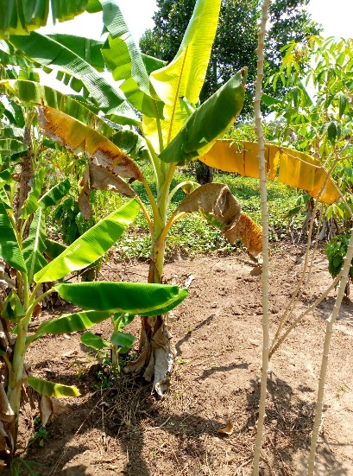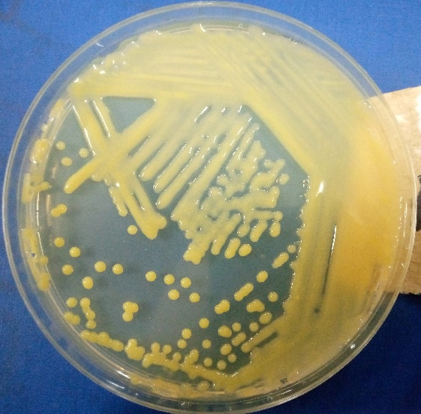
7
6
5
4
3
2
1
C
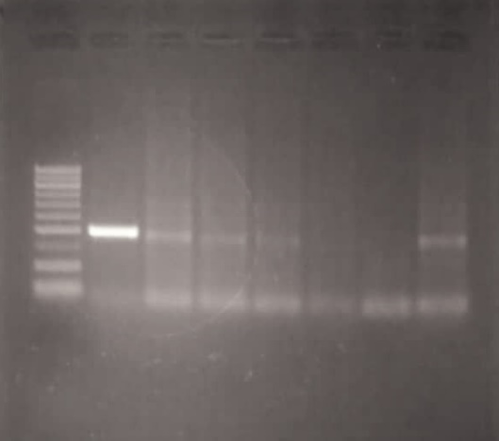
L
398 bp
100 bp
400 bp
1000 bp
Figure 1. A banana plant infected with BXW, phenotypic and molecular verification of Xvm. (A) The leaves of the banana plant are yellow and wilted, typical symptoms of BXW. (B) Bacteria isolates with yellowish, mucoid and convex colonies are characteristic of Xvm on YPGA-CC agar plate. (C) Agarose gel showing bands corresponding to 398 base pairs (bp) of the Xvm secretion pathway protein D. Lane L: 1000 bp ladder, Lane 1-7: U40L2, P1, L, P0, P2, P4, BS17-6. bp stands for base pair.

Detection of lysis
The filtrates produced clear, well-defined plaques on Xvm lawns of strains BS17-5, BS17-6, Xvm1-4, and BS8b2 (Figure 2). The plaques were designated as pBS17-5, pBS17-6, pXvm1-4 and pBS8b2 (Table 1). The formation of clear plaques indicates lytic infection, which begins when phages attach to bacterial receptors, inject their genome, replicate within the host and ultimately cause cell lysis to release progeny phages (24). Similar observations were reported by (25), who described the formation of clear plaques on Xvm lawns following infection with phage Kintu.
D
C
B
A
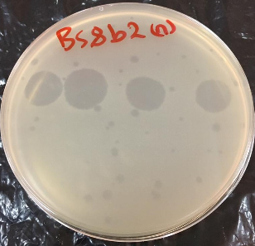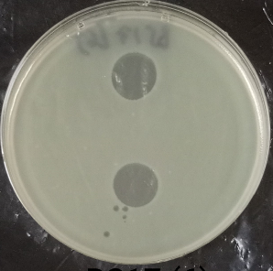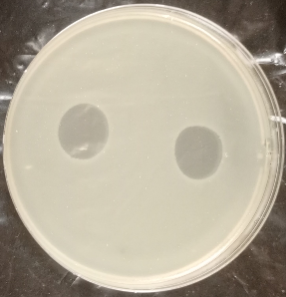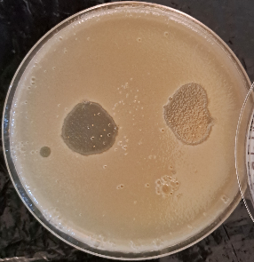
Figure 2. YPG Agar plate showing plaques by the spot assay. A-D: Formation of plaques on lawns of BS8b2, BS17-5, BS17-6 and Xvm1-4.
Table 1 the lytic activity of soil-derived phage filtrate
Xvm strain | Lytic activity of soil-derived phage filtrate | Phage suspected | Lab name given to phage
BS17-5 | + | Yes | pBS17-5
BS17-6 | + | Yes | pBS17-6
Xvm1-4 | + | Yes | pXvm1-4
BS8b2 | + | Yes | pBS8b2
+ indicates lysis of filtrate derived from the soil

Host range of filtrates against Xvm strains

The host range of the filtrates was assessed using the spot test assay on 21 Xvm and 5 non-Xvm strains, revealing lytic activity ranging from 81 % to 86 %. Specifically, filtrates pBS17-5, pBS17-6, and pXvm1-4 lysed 86 % (18 out of 21) of Xvm strains, while pBS8b2 infected 81 % (17 out of 21) of the tested Xvm strains (Table 2). These findings indicate that the soil-derived filtrates contain phages capable of infecting and lysing a broad spectrum of Xvm strains. However, none of the filtrates lysed strains U09L3b or Ooze 3b, suggesting the possible absence of suitable phage receptors in these isolates (26, 27, 28).

Importantly, none of the filtrates exhibited lytic activity against the non-Xvm strains, including Klebsiella pneumoniae, Enterococcus faecalis, Escherichia coli, Staphylococcus aureus, and Bacillus species, confirming the specificity of the phages to Xvm. This host specificity is desirable for phage-based biocontrol, as it minimises mistargeting of beneficial plant microbiota and humans (29).

The host range percentages observed in this study are comparable to those reported for phages P1- P26, which lysed up to 88 % of Xanthomonas arboricola pv. juglandis strains (30, 31). These findings contribute to the growing body of evidence supporting the presence of Xanthomonas-specific phages and confirm their potential use in disease management.

Table 2 the host range of phages lytic against Xvm strains.

 | Phage sample
Xvm strains | pBS17-5 | pBS17-6 | pXvm1-4 | pBS8b2
BS17-5 | + | + | + | +
BS17-6 | + | + | + | +
Xvm1-4 | + | + | + | +
BS8b2 | + | + | + | +
Xvm9-7 | + | + | + | +
S33A | + | + | + | +
U09L3b | - | - | - | -
BCC278 | + | + | + | +
U40L2 | - | - | + | -
Ooze 3b | - | - | - | -
XK₁ | + | + | - | -
P0 | + | + | + | +
P1 | + | + | + | +
P3 | + | + | + | +
P5 | + | + | + | +
L1 | + | + | + | +
E3 | + | + | + | +
E3-1 | + | + | + | +
6 | + | + | + | +
B₁T₁KX₁ | + | + | + | +
KB₁ | + | + | + | +
Klebsiella pneumonia | - | - | - | -
Enterococcus faecalis | - | - | - | -
Escherichia coli | - | - | - | -
Staphylococcus aureus | - | - | - | -
Bacillus spp | - | - | - | -
Percentage lysis | 86% | 86% | 86% | 81%

(+) indicates the presence of lysis, while (-) indicates the absence of lysis

CONCLUSION
Filtrates obtained from soil samples collected around BXW-infected plants lysed 81 % to 86 % of twenty-one Xanthomonas vasicola pv. musacearum strains, as evidenced by the formation of clear plaques on Xvm lawns. No lysis was observed against non-Xanthomonas strains, indicating that the filtrates are specific to Xvm. This study therefore recommends further identification, characterisation of phage types and their potential for BXW biocontrol.

CONSENT
This is not applicable

ETHICAL APPROVAL
This is not applicable since animals and humans are not involved.
Abbreviations:
Xvm: Xanthomonas vasicola pv. musacearum, Banana Xathomonas Wilt, pv: pathovar, g: grams, GPS: Global Positioning System, N: North, E: East, µL: microliters, YPGA-CC: Yeast, Peptone, Glucose, Agar,
Cephalexin, Cycloheximide, %: Percentage, mg/L: Milligrams per Liter, ºC: degrees centigrade, rpm: rotations per minute, F: Forward, R: Reward, bp: base pairs, µM: Micromolar, min: Minutes, s: Seconds, V: Voltage, mL: milliliters, CaCl₂: Calcium chloride, OD: Optical density, mm: millimeter.

Disclaimer (Artificial intelligence)

Option 1:

Author(s) hereby declare that NO generative AI technologies such as Large Language Models (ChatGPT, COPILOT, etc.) and text-to-image generators have been used during the writing or editing of this manuscript.

Option 2:

Author(s) hereby declare that generative AI technologies such as Large Language Models, etc. have been used during the writing or editing of manuscripts. This explanation will include the name, version, model, and source of the generative AI technology and as well as all input prompts provided to the generative AI technology

Details of the AI usage are given below:
1.
2.
3.

REFERENCES
- Kubiriba J, Erima R, Tugume A, Tinzaara W, & Tushemereirwe W. Changing dynamics in the spread and management of banana Xanthomonas wilt disease in Uganda over two decades. Phytobiomes Journal. 2023;7(1), 29-41. https://doi.org/10.1094/PBIOMES-06-22-0038-RVW
- Geberewold AZ. (2019). Review on impact of banana bacterial wilt (Xanthomonas campestris pv. musacerum) in East and Central Africa. Cogent Food & Agriculture. 2019;5(1);1586075. https://doi.org/10.1080/23311932.2019.1586075
- Blomme G, Mpiira S, Ssemakadde R, & Mukasa, H. (2005). Controlling banana Xanthomonas wilt through de-budding. Info Musa. 2005;14(1);46.
- Kubiriba J, & Tushemereirwe W. Approaches for the control of banana Xanthomonas wilt in East and Central Africa. African Journal of Plant Science. 2014; 8(8): 398–404. https://doi.org/10.5897/AJPS2013.1106
- d’Hérelle F. Sur un microbe invisible antagoniste des bacilles dysentérique. Académie des Sciences Paris. 1917;165:373-375. https://doi.org/10.1016/j.resmic.2007.07.005
- James N, Roslycky EB. Specificity of bacterial virus for Xanthomonas trifolii. Canadian Journal of Microbiology. 1956;2(1):6-11. https://doi.org/10.1139/m56-002
- Dong Z, Xing S, Liu J, Tang X, Ruan L, Sun M, Tong Y, Peng D. Isolation and characterization of a novel phage Xoo-sp2 that infects Xanthomonas oryzae pv. oryzae. Journal General Virology. 2018;99(10):1453-62. https://doi.org/10.10.1099/jgv.0.001133
- Sutton MD, Wallen VR. Phage types of Xanthomonas phaseoli isolated from beans. Canadian Journal of Botany. 1967;45(2):267-80.
- Gayder S, Parcey M, Castle AJ, Svircev AM. Host range of bacteriophages against a world-wide collection of Erwinia amylovora determined using a quantitative PCR assay. Viruses. 2019;11(10):910. https://doi:10.3390/v11100910.
- Liu M, Hu R, Xia M, He X, Jin Y. Novel broad-spectrum bacteriophages against Xanthomonas oryzae and their biocontrol potential in rice bacterial diseases. Environmental Microbiol. 2023;25(11):2075-2087. https://doi.org/10.1111/1462-2920.16447
- Nawaz A, Zafar S, Shahzadi M, Bukhari SMAUS, Khan N, Shah AA et al. Bacteriophages: An overview of the control strategies against phytopathogens. Egyptian Journal of Biological Pest Control. 2023;33 (108). https://doi.org/10.1186/s41938-023-00751-7
- Tripathi L, Tripathi JN, Tushemereirwe WK, & Bandyopadhyay R. Development of a semi-selective medium for isolation of Xanthomonas campestris pv. musacearum from banana plants. European Journal of Plant Pathology. 2007;117(2):177-186. https://doi.org/10.1007/s10658-006-9083-7
- Adriko J, Aritua V, Mortensen CN, Tushemereirwe WK, Kubiriba J, & Lund OS. Multiplex PCR for specific and robust detection of Xanthomonas campestris pv. musacearum in pure culture and infected plant material. Plant Pathology. 2012;61(3):489-497. https://doi.org/10.1111/j.1365-3059.2011.02534.x
- van Twest R, Kropinski AM. Bacteriophage enrichment from water and soil. In: Clokie MRJ, Kropinski AM, editors. Methods in Molecular Biology. 2009;501:15-21. https://doi.org/10.1007/978-1-60327-164-6_2
- Wommack KE, Williamson KE, Helton RR, Bench SR, Winget DM. Methods for the isolation of viruses from environmental samples. In: Clokie MRJ, Kropinski AM, editors. Bacteriophages: Methods and Protocols. Volume 1: Isolation, Characterization, and Interactions. Totowa (NJ): Humana Press; 2009. p. 3-14.
- Yirgou D, Bradbury JF. Bacterial wilt of enset (Ensete ventricosum) incited by Xanthomonas musacearum sp. n. Phytopathology. 1968;58:111-2.
- Tushemereirwe W, Kangire A, Ssekiwoko F, Offord LC, Crozier J, Boa E, et al. First report of Xanthomonas campestris pv. musacearum on banana in Uganda. Plant Pathology. 2004;53(6):802. https://doi.org/10.1111/j.1365-3059.2004.01090.x
- Nakato V, Mahuku G, Coutinho T. Xanthomonas campestris pv. musacearum: A major constraint to banana, plantain and enset production in Central and East Africa over the past decade. Molecular Plant Pathology. 2018;19(3):525-536. https://doi.org/10.1111/mpp.12578
- An SQ, Potnis N, Dow M, Vorhölter FJ, He YQ, Becker A, Teper D, Li Y, Wang N, Bleris L, Tang JL. Mechanistic insights into host adaptation, virulence and epidemiology of the phytopathogen Xanthomonas. FEMS Microbiology. Rev. 2019;44(1):1-32. https://doi.org/10.1093/femsre/fuz024
- Ssekiwoko F, Taligoola HK, Tushemereirwe W. Xanthomonas campestris pv. musacearum host range in Uganda. African Crop Science Journal. 2006;14(2):111-120. https://doi.org/10.4314/acsj.v14i2.27917
- Rajagopal L, Sundari CS, Balasubramanian D, Sonti RV. The bacterial pigment xanthomonadin offers protection against photodamage. Federation of European Biochemical Societies Letters. 1997;415:125-128. https://doi.org/10.1016/s0014-5793(97)01109-5
- Poplawsky AR, Urban SC, Chun W. Biological role of xanthomonadin pigments in Xanthomonas campestris pv. campestris. Appl Environ Microbiol. 2000;66(12):5123-7. https://doi.org/10.1128/AEM.66.12.5123-5127.2000.
- Dharmapuri S, Sonti RV. A transposon insertion in the gumC gene of Xanthomonas oryzae pv. oryzae leads to loss of extracellular polysaccharide production and virulence. FEMS Microbiology Letter. 1999;179(1):53-9. https://doi:10.1111/j.1574-6968.1999.tb08704.x
- Clokie MRJ, Kropinski A, editors. Bacteriophages: Methods and Protocols. Volume 1: Isolation, characterization, and interactions. 1st ed. USA: Humana Press, Springer Protocols; 2009.
- Nakayinga R, Ntulume I, Wagemans J, et al. Isolation, characterization and genome analysis of the orphan phage Kintu infecting Xanthomonas vasicola pv. musacearum. BMC Microbiology. 2024;24:482. https://doi:10.1186/s12866-024-03629-2.

- Lindberg AA. Bacteriophage receptors. Annual Review of Microbiology. 1973;27:205-41. https://doi:10.1146/annurev.mi.27.100173.001225.
- Zhao XN, Cui YJ, Yan YF, Du ZM, Tan YF, Yang HY, Bi YJ, Zhang PP, Zhou L, Zhou DS, et al. Outer membrane proteins Ail and OmpF of Yersinia pestis are involved in the adsorption of T7-related bacteriophage Yep-phi. Journal Virology. 2013;87(22):12260-9. https://doi:10.1128/JVI.01948-13.
- Zhang M, Qian J, Xu X, Ahmed T, Yang Y, Yan C, Elsharkawy MM, Hassan MM, Alorabi JA, Chen J, Li B. Resistance of Xanthomonas oryzae pv. oryzae to lytic phage X2 by spontaneous mutation of lipopolysaccharide synthesis-related glycosyltransferase. Viruses. 2022;14(5):1088. https://doi:10.3390/v14051088.
- Debray R, Conover A, Koskella B. Phages indirectly maintain tomato plant pathogen defense through regulation of the commensal microbiome. ISME Communications. 2025;5(1). https://doi.org/10.1093/ismeco/ycaf065
- Romero-Suarez S, Jordan B, Heinemann JA. Isolation and characterization of bacteriophages infecting Xanthomonas arboricola pv. juglandis, the causal agent of walnut blight disease. World Journal of Microbiology and Biotechnology. 2012;28(5):1917-27. https://doi:10.1007/s11274-011-0992-z.
- Nakayinga R, Makumi A, Tumuhaise V, Tinzaara W. Xanthomonas bacteriophages: a review of their biology and biocontrol applications in agriculture. BMC Microbiology. 2021;21:291. https://doi:10.1186/s12866-021-02351-7.
- Nakayinga, R., Ntulume, I., Wagemans, J., Vallino, M., Kanaabi, R., Kajubi, A., & Kwetegyeka, J. (2024). Isolation, characterization and genome analysis of the orphan phage Kintu infecting Xanthomonas vasicola pv. musacearum. Bmc Microbiology, 24(1), 482.

Ranveer, S. A., Dasriya, V., Ahmad, M. F., Dhillon, H. S., Samtiya, M., Shama, E., ... & Puniya, A. K. (2024). Positive and negative aspects of bacteriophages and their immense role in the food chain. npj Science of Food, 8(1), 1.

Jia, H. J., Jia, P. P., Yin, S., Bu, L. K., Yang, G., & Pei, D. S. (2023). Engineering bacteriophages for enhanced host range and efficacy: insights from bacteriophage-bacteria interactions. Frontiers in microbiology, 14, 1172635.

