EFFECT OF DIFFERENT EDIBLE DYES ON FLOWER QUALITY AND
VASE LIFE OF TINTED TUBEROSE (Polianthes tuberosa L.)

Abstract

The experiment was carried out during July 2025 at Laboratory, Department of Horticulture, Naini Agricultural Institute, Sam Higginbottom University of Agriculture, Technology and Sciences, Prayagraj (U.P.) in Completely Randomized Design This study tested three edible dyes (Apple Green, Lemon Yellow, Orange Red) at 3, 4 and 5% concentrations, combined with a standard vase solution, to evaluate color intensity and vase life of tuberose spikes. Lower dye concentrations (3%) generally produced the longest vase life (best T2, T5, T8), while 5% concentrations produced the deepest colour but reduced longevity. Overall, 3% Lemon Yellow Dye Solution produced the best balance between colour and vase life under the tested conditions. The treatment T2 (3% Lemon Yellow Dye Solution) reported significantly better performance in vase life (11.67 days) and it was at par with T5 (11.57), T8 (11.33) and T1 (11.00). The highest colour intensity was shown by all the 5% concentration containing dye solutions among all the 10 treatments which were T10 (5% Apple Green Dye Solution), T7 (5% Orange Red Dye Solution) and T4 (5% Lemon Yellow Dye Solution).

Keywords: Different edible dyes, Color intensities, Vase life, CRD, Tinted tuberose.

Introduction

Tuberose (Polianthes tuberosa L.) or Double Pearl Tuberose popularly known as Rajanigandha, Nishigandha, Gul-e-Shabu is a perennial plant belonging to family Amaryllidaceae, originated from Mexico. It is a highly valued ornamental flower known for its pleasant fragrance and aesthetic appeal. In floriculture, enhancing the visual appearance of flowers through tinting has become a popular practice, particularly to meet market demands for novel colors. Tuberose is grown as an ornamental bulbous plant, for extraction of perfumes and also for extraction of oil. Tuberose is a hardy, perennial plant having fragrant waxy white flowers. The tuberose spikes

are useful as cut flowers in vase decoration and bouquets, while individual florets are used for making veni, garland, button-holes or crown, the last named ornament is used during marriage or other religious ceremonies. Tuberose is grown for beds, borders and pots.

Flowers have always attracted people with their natural colour and elegance but sometimes due to limitations, there is less variability in colour in some flowers and tuberose is one of them which results in low market value. In order to exploit its economic potential in flower trade, variability may be introduced in white coloured flowers by tinting the spikes with edible dye (Sudha Patil and Harshal Patil, 2008). The value addition techniques like colouring of white flowers, flower dehydration, flower processing, advances in flower arrangement etc. can add value up to 5 to 10 times (Mekala et al., 2012).
Edible dyes, derived from natural or edible-grade synthetic sources, offer a safer and environmentally friendly alternative to synthetic chemical dyes traditionally used in flower tinting. The application of edible dyes on tuberose aims not only to diversify flower color options but also to maintain post-harvest quality, shelf life, and consumer safety. Tinting enhances aesthetic beauty of fresh and dry flowers as single colour limits the flower's acceptability and reduces the market value (Chougala et al.,2016). Hence, this study aimed to identify the edible dye and concentration that best balance colour intensity and vase life of tuberose spikes.

Methods and Materials

The present experiment was carried out at the Laboratory, Department of Horticulture, Sam Higginbottom University of Agriculture, Technology and Sciences, Prayagraj (U.P.) during July 2025. There were a total number of 10 treatments viz. T1 = Control; T2–T4 = Lemon Yellow (3, 4, 5%); T5–T7 = Apple Green (3, 4, 5%); T8–T10 = Orange Red (3, 4, 5%) respectively with vase solution containing Sucrose (2%) + 8-HQC (200 ppm) + Citric acid (20 ppm) were used uniformly in all the treatments Each treatment had three replications with n = 3 spikes per replication (total n = 9 per treatment; overall 90 spikes). The experiment was conducted in Completely Randomized Design (CRD) with three replications. All the spikes were harvested at the same maturity stage i.e. when the first pair of flowers in the spike is fully open were harvested from the research field of National Botanical Research Institute.

Method of tinting
Spikes were cut to a uniform length of 30 cm above the last fully opened basal floret and re-cut at a 45° angle before treatment and treated with the pulsing solution (Sucrose 20% + 8-HQS 400 ppm + Citric acid 0.25%) for 18 hrs (Sinha. M. S., et al, 2025). Weightage of edible dyes for tinting was done by Digital Analytical Weighing Balance (±0.01 g, Model Sky-4450). Spikes were treated in the dye solution for 5 hours, dye concentrations are (3%, 4% and 5%) w/v in distilled water. Solutions were prepared fresh and the pH measured (initial pH = 7). Spikes were dipped vertically in 100 mL of dye solution per spike, without stirring. Solutions were discarded after each replication and then tinted tuberose spikes were transferred to a holding vase solution of Sucrose 2% + 8-HQC 200 ppm + Citric acid 20 ppm for the study of the vase life in their respective beakers.
The observations recorded were time taken for colour uptake (hr), colour (using RHS colour chart), colour intensity (Chromometer), vase life (days).
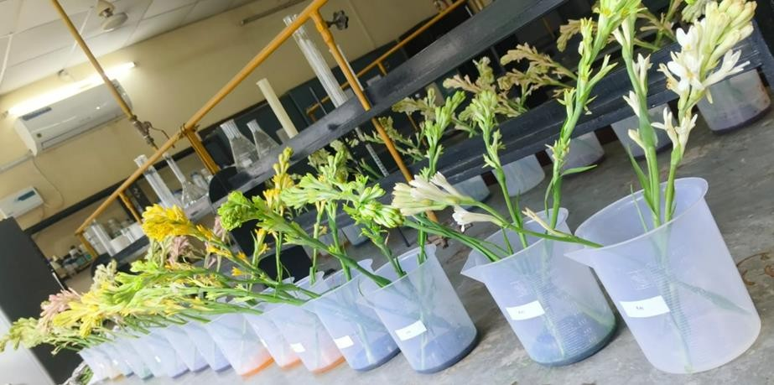

Plate 1 Overall view of the experiment

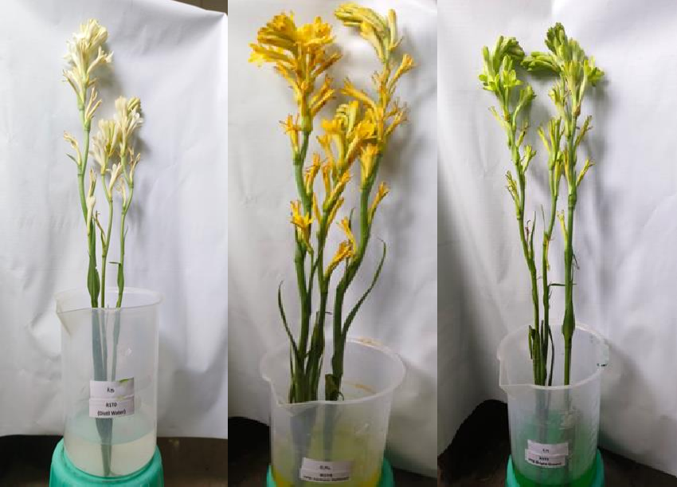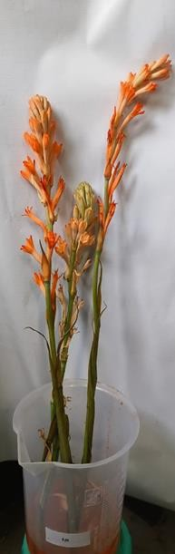
Plate 2 : T1–Control, T2–Lemon Yellow, T5–Apple Green, T8–Orange Red Tinted tuberose flowers with different treatments
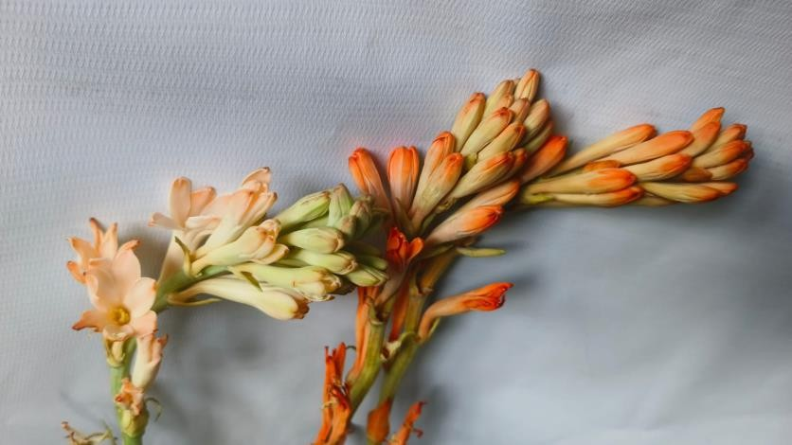
Plate 3 : Blooming florets of tinted tuberose

Results and Discussions

Colour intensity as per RHS (Royal Horticultural Society) colour chart

The sensory evaluation for colour using RHS colour chart was done after tinting spikes for 5 hours with different edible dyes has been done by recording each colour code for all the treatments and presented in Table1. Observations were made at 25 ± 2 °C, 60 ± 5% RH, and under a 12 hours photoperiod with 250 lux light intensity (Sinha. M. S., et al, 2025). The colour of spike in T1 (Control) was recorded as White 155D. The highest colour intensity in Orange

Red was shown by T10 (5% Orange Red Dye Solution). In Apple Green, highest colour intensity was shown by T7 (5% Apple Green Dye Solution). In Lemon Yellow, highest colour intensity was shown by T4 (5% Lemon Yellow Dye Solution). The colour intensity changes in different dyes as different dyes show different colour intensity may be because of its different reaction. This may be due to more absorption of dye to the petals through the vascular system along with water or dye uptake (Sambandamurthy and Appavu,1980). It was also observed that the colour intensity was more at the periphery of the petals. This may be due to accumulation of dyes at the stomata as the water soluble dyes gradually transpired from the stomata, leaving impermeable solid dye at the base of the stomata. Hence, providing much intense colour at the periphery of petals (Dhaduk and Naik, 2003).

Table1: Effect of edible dyes on colour intensity of tinted tuberose spikes

COLOUR INTENSITY
TREATMENTS | COLOUR CODE
T1 Control (without tinting) | 155D
T2 3% Lemon Yellow Dye Solution | 30B
T3 4% Lemon Yellow Dye Solution | 30D
T4 5% Lemon Yellow Dye Solution | 30C
T5 3% Apple Green Dye Solution | 142B
T6 4% Apple Green Dye Solution | 142A
T7 5% Apple Green Dye Solution | 142C
T8 3% Orange Red Dye Solution | 7A

T9 4% Orange Red Dye Solution | 7C
T10 5% Orange Red Dye Solution | 7B
Vase life (days)

Vase life is the period during which a cut flower remains in a presentable/acceptable form in the vase. The vase life of tuberose spikes was recorded from the time it was placed in water in the vase till 50% of fresh open florets had withered off. The data on vase life of all the treatments were recorded and significant differences were observed. The statistically analyzed data is presented in Table2. The tuberose spikes were treated with edible dyes (3%, 4% and 5%) of different edible dyes (Lemon Yellow, Apple Green and Orange Red) in combination with vase solution such as Sucrose (2%), Citric acid (20 ppm) and 8-HQC (200 ppm) to enhance vase life. Among all the treatments, significantly the maximum vase life of (11.67 days) was observed in T2 and it was at par with T5 (11.57 days), T8 (11.33 days) and T1 (11.00 days) while, minimum vase life was observed in T10 (8.67 days). Treating the flowers with sucrose, improves the effect of cytokinins in delaying senescence of cut flowers by reducing the ethylene action, which ultimately increases the self-life of cut flowers. Thus, results are in confirmation with Suresh et al., 2009. Sucrose also has a great value in prolonging vase life, promoting opening and improving colour and size of petals. Therefore, treating the cut flowers with sucrose increases the availability of respiratory substrate, also delays the hydrolysis of structural cell components and decreases ethylene production and sensitivity. Similar views have been reported by Pun et al. (2005); Da Silva, (2003); Donoghue et al. (2002) and Mayak et al. (1973). Carbohydrate or sucrose is the main substrate for respiration. Cut flowers after detachment from the plants lack edible, hormone and water supply and they solely depend upon the stored edible material. Supply of exogenous edible material like sucrose is beneficial for longevity of flowers as sucrose is the best readymade carbohydrate for flowers. It supplies much needed substrates for respiration and increases vase life. (Donoghue et al., 2002; Dorn, 1999 and Kumar, 2003). Exogenous sucrose likely supplied respiratory substrate, which may have delayed senescence. High dye concentration reduces vase life due to osmotic stress and blockage.

Table2: Effect of edible dyes and vase solution on vase life of tuberose spikes.

TREATMENTS | MEAN VASE LIFE  ( days )
T1 Control (without tinting) | 11.00
T2 3% Lemon Yellow Dye Solution | 11.67
T3 4% Lemon Yellow Dye Solution | 8.67
T4 5% Lemon Yellow Dye Solution | 10.00
T5 3% Apple Green Dye Solution | 11.57
T6 4% Apple Green Dye Solution | 9.67
T7 5% Apple Green Dye Solution | 9.67
T8 3% Orange Red Dye Solution | 11.33
T9 4% Orange Red Dye Solution | 9.33
T10 5% Orange Red Dye Solution | 8.67
F-test | S
S.E. (d)± | 0.451
CD (5%) | 1.126
C.V. | 5.292
ANOVA: F (2, 6) = 24.364, P < 0.01.

Note: Vase solution containing Sucrose (2%) + 8-HQC (200 ppm) + Citric acid (20 ppm) were used uniformly in all the treatments.

Conclusion

It is concluded from the present experiment that 10 different treatments under study showed significant differences in both the parameters observed. The treatment T2 (3% Lemon Yellow Dye Solution) reported significantly better performance in vase life (11.67 days) and it was at par with T5 (11.57), T8 (11.33) and T1 (11.00). The highest colour intensity was shown by all the 5%

concentration containing dye solutions among all the 10 treatments which were T10 (5% Orange Red Dye Solution), T7 (5% Apple Green Dye Solution) and T4 (5% Lemon Yellow Dye Solution).Under the conditions tested, 3% Lemon Yellow produced the best compromise between colour and vase life when combined with a vase solution of 2% sucrose + 200 ppm 8-HQC + 20 ppm citric acid. Higher dye concentrations improved colour depth but reduced vase life. For commercial tinting of tuberose, we recommend 3% dye concentrations and testing on other cultivars before large-scale adoption. The higher concentration of edible dyes produces high intensity of colors on spikes but the vase life decreases in case of higher concentration of edible dye and the higher vase life is seen in lower concentration of edible dyes.

Disclaimer (Artificial intelligence)
Option 1:
Author(s) hereby declare that NO generative AI technologies such as Large Language Models (ChatGPT, COPILOT, etc) and text-to-image generators have been used during writing or editing of manuscripts.
Option 2:
Author(s) hereby declare that generative AI technologies such as Large Language Models, etc have been used during writing or editing of manuscripts. This explanation will include the name, version, model, and source of the generative AI technology and as well as all input prompts provided to the generative AI technology
Details of the AI usage are given below:
1.
2.
3.

References

- Baidya, B. K., & Chakrabarty, S. (2020). Increasing vase life of tinted spikes of Polianthes tuberosa. International Journal of Current Microbiology and Applied Sciences, 9(8), 1807– 1816.
(TITLE PROPERLY NOT MATCH)

- Chougala, S., Naik, B. H., Mathapati, S., Savita, K. H., & Shivakumar. (2016). Effect of tinting on florets drop of cut tuberose spikes. International Journal of Current Research, 8, 27206– 27208.

- Kaur, G., et al. (2023). To study the effect of tinting and vase solution on vase life of Tuberose (Polianthes tuberosa L.) cv. Prajwal. The Pharma Innovation Journal, 12(10), 276–279.

- Kumar, H., et al. (2023). Effect of varying levels of pH and edible dyes on tinting and vase life of tuberose cut flowers. International Journal of Plant & Soil Science, 35(4), 1–8.

- Kumari, M. S., Dhua, R.S., Tiwari, P. K. and Tiwari, D. (2025). Effect of pre-storage pulsing on the vase life of Tuberose (Polianthes tuberosa L.) cv. Calcutta Double. International Journal of Research in Agronomy, 8(6): 317-321.

- Kumari, S., & Deb, P. (2018). Effect of tinting on value addition of tuberose (Polianthes tuberosa L.) cv. Prajwal. International Journal of Bio-resource and Stress Management, 9(3), 314–322.

- Kumari, S., Raghupati, D., Sarika, K., & Deb, P. (2018). Value addition of tuberose cv. Calcutta Double cut flowers by colouring with edible dyes. Chemical Science Reviews and Letters, 7(25),158–164.

- Patil, P., et al. (2023). Tinting process in tuberose (Polianthes tuberosa L.) spikes — a review of dyes and techniques. The Pharma Innovation Journal, 12(10), 40–44.

- Prasanth, P., Ramesh, T., & Nirosha, R. (2020). Tinting efficiency of various food dyes in colour development and vase life of tuberose. International Journal of Current Microbiology and Applied Sciences, 9(9), 1545–1551. (title properly not match)

- Safeena, S. A., Thangam, M., & Singh, N. P. (2016). Value addition of tuberose spikes by tinting with different edible dyes. Asian Journal of Research in Biological and Pharmaceutical Sciences, 4(3), 89–98. (title properly not match)

- The Pharma Innovation Journal Editorial. (2024). Effect of different preservatives on shelf life of cut tuberose (Sucrose, Citric Acid, AgNO₃). The Pharma Innovation Journal, 13(12).

- Yadav, R., et al. (2022). Effect of tinting methods with various food dyes on vase life and colour retention of tuberose. The Pharma Innovation Journal, 11(5), 239–243.

