Design and Development of a Cost-Effective Ridge Maker cum Seed Sower

Abstract
In modern agriculture, it is crucial to achieve accurate seed placement while reducing manual labor to enhance both productivity and sustainability. This initiative introduces the Ridge Maker Cum Seed Sower, an affordable and energy-efficient device designed specifically for small to medium-sized farming enterprises. This innovative machine merges two essential agricultural tasks, creating furrows and sowing seeds into a single cohesive unit. The system operates using a 12V DC motor (60 RPM) and is equipped with a solar panel for battery charging, thereby promoting sustainability through the use of renewable energy sources. A chain drive mechanism links the ground wheel directly to the seed dispensing system, ensuring that seed release is perfectly timed with the distance travelled. This design guarantees uniform seed spacing of 8 cm, irrespective of variations in speed. Additionally, the machine is equipped with a furrow opener positioned either in front of or beneath the seed dropping mechanism, allowing it to form planting rows as it advances. The implementation of mechanical transmission through a chain drive enhances reliability while simplifying the electronic control systems. By combining solar energy with mechanical accuracy, this project presents a sustainable and effective approach to precision farming. It minimises seed loss, decreases labor needs, and lessens reliance on fossil fuels, thereby fostering eco-friendly agricultural methods. Future enhancements may include automation through microcontrollers and the ability to adjust seed spacing for compatibility with various crops.
Keywords: Seed Sowing Machine, Row Maker, Solar Powered Agriculture, Precision Farming.

- Introduction
Agriculture is a cornerstone of the Indian economy, with a significant portion of the population depending on it for their livelihoods. In rural regions of India, traditional farming techniques, such as manual seed sowing and ridge formation, remain widely used. While these age-old methods are deeply rooted in the culture, they are often labor-intensive, time-consuming, and inconsistent, leading to inefficient use of resources and lower crop yields. To address these challenges, this project presents the Ridge Maker Cum Seed Sower—a compact, semi-automated, solar-powered agricultural tool that simultaneously creates ridges and plants seeds at consistent intervals. The device is powered by a 12V DC motor operating at 60 RPM and utilizes a chain drive mechanism to synchronize the seed dropping process with the wheel's rotation. A solar panel system charges the battery, enabling operation in remote or off-grid agricultural areas, thereby enhancing its practicality and sustainability. It is specifically designed for sowing crops such as groundnut, maize, soybean, and chickpea, all of which require precise seed spacing and benefit from ridge planting. Groundnut is cultivated in states like Gujarat, Andhra Pradesh, Tamil Nadu, and Karnataka, where ridging enhances aeration and drainage. Maize is grown in Bihar, Karnataka, Andhra Pradesh, and Madhya Pradesh, where consistent spacing is essential for uniform growth. Soybean, a vital crop in Madhya Pradesh and Maharashtra, flourishes in ridged rows to prevent waterlogging. Chickpea, found in Madhya Pradesh, Rajasthan, Uttar Pradesh, and Maharashtra, benefits from well-spaced planting that promotes healthy root development. Traditionally, the manual process of sowing and ridge-making on one acre takes about 8–10 hours and requires several laborers. In contrast, the Ridge Maker Cum Seed Sower can accomplish this task in roughly 2–3 hours with just one operator. Additionally, the machine is calibrated to ensure an 8 cm seed spacing, improving uniformity in crop stands.
2.Literature Review
Sartape et al. (2025) introduced a solar-powered seed spraying machine that significantly reduces reliance on fossil fuels while promoting eco-friendly farming practices^{[1]}. Building on this, Pranil et al. (2015) developed a solar-powered seed sowing machine designed for enhanced mobility and operational simplicity in rural farming conditions^{[2]}. Similarly, Elayadevan et al. (2020) focused on automation by fabricating a solar seed sowing machine that performed automatic seed metering using renewable energy^{[3]}. In regions with undulating terrain like Rwanda, Sankaranarayanan and Nzamwitakuze (2013) proposed a push-type seed drill for maize, which proved simple and cost-effective but lacked motorized assistance or power augmentation. Enhancing technological integration, Senthilnathan et al^{[4]}. (2018) implemented IoT in seed sowing machines, allowing for improved automation and remote control features that can be adapted to Indian agricultural machinery^{[5]}. The use of intelligent systems was advanced by Javidan and Mohammadzamani (2018), who developed a solar-powered seed sowing robot with row detection technology, offering high accuracy but with increased complexity and cost^{[6]}. Joshi et al. (2021) and Marode et al. (2013) addressed multi-seed sowing systems, facilitating flexibility in crop cultivation, although these systems did not incorporate ridge formation or solar power^{[7]}. Further development in actuation methods is seen in the work of Ekad et al. (2019), who employed pneumatic mechanisms for automatic seed sowing. However, their designs required constant air pressure, making field application challenging^{[8]}. Kumar et al. (2021) used SolidWorks and ANSYS for virtual simulation and analysis of automatic sowing machines, which supported optimal mechanical design but lacked real-world energy integration^{[9]}. Manually operated sowing machines continue to hold relevance for low-cost farming. Patel et al. (2017) and Kyada & Patel (2014) developed manually operated sowing tools that were affordable but limited in efficiency and uniformity^{[10]}. Kadam et al. (2018) addressed this by combining manual operation with solar power, ensuring better consistency and reduced labor^{[11]}. Other studies, like Dharmik et al. (2015) explored agribots for sowing, emphasizing automation and real-time feedback^{[12]}, while Ramesh and Girishkumar (2014) offered a comprehensive overview of traditional seed sowing equipment, identifying key inefficiencies in spacing and depth control^{[13]}. Gite and Yadav (2015) examined the status of agricultural mechanization in India, stressing the importance of appropriate technology for smallholder farmers^{[14]}. Singh (2013) further demonstrated the effectiveness of solar-powered agricultural machines, reinforcing the benefits of renewable energy in this domain^{[15]}. Design optimization and multipurpose functionality were key concerns in works by Yadav et al. (2019) and Kannan et al. (2014), who proposed multipurpose equipment for sowing, fertilizing, and ridging. These designs serve as precursors to the Ridge Maker Cum Seed Sower, integrating multiple operations in one pass^{[16]}.
3.Methodology
3.1.Design and Fabrication of the Solar-Powered Seed Sowing Machine
The approach taken in the creation of the Solar-Powered Ridge Maker Cum Seed Sower involved a methodical design, construction, and integration of components aimed at achieving sustainable and efficient sowing for small-scale agricultural practices. This machine is engineered to execute two main functions concurrently, forming ridges and sowing seeds utilizing solar energy as its power source. The frame is made from mild steel, featuring essential structural dimensions of 28 inches (71.12 cm) in width at the front, 24 inches (60.96 cm) at the rear, and a vertical height of 10.63 inches (27 cm), which provides a stable yet lightweight foundation. The primary frame supports all critical components, including the seed hopper, motor assembly, ridger blade, and wheels. The seed hopper, constructed from 1 mm thick sheet metal, measures 6 × 8 inches (15.24 × 20.32 cm) with a height of 8 inches (20.32 cm), offering an approximate capacity of 6.3 liters. It delivers seeds to the metering mechanism, which is driven by a chain connected to the ground wheel, ensuring that seeds are dropped at an 8 cm interval. This mechanism maintains consistency in seed distribution, regardless of variations in terrain speed or movement. A 12V DC motor operating at 60 RPM, powered by a solar panel and supported by a rechargeable 12V battery, drives both the wheel and the seed metering system, enabling autonomous operation without the need for external fuel. Lightweight and durable materials were chosen to guarantee portability and resilience in the field, while ergonomic features such as optimal handle positioning and balanced weight distribution were integrated for ease of use. Ground wheels were added to enhance traction and mobility over tilled soil, while also aiding in the power transmission to the seed mechanism. The ridger component, positioned at the front of the machine, is designed to effectively cut and lift soil, creating ridges that are ideal for crops like groundnut, which thrive in well-ridged and aerated planting conditions.

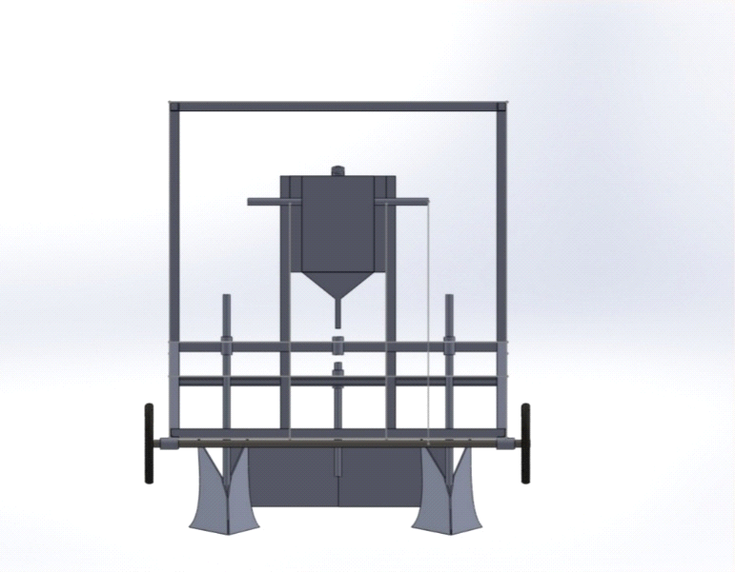 | 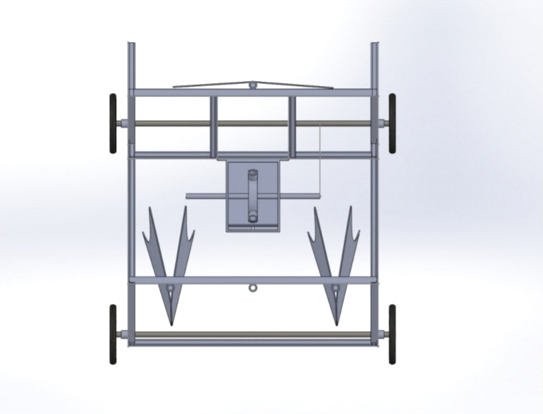
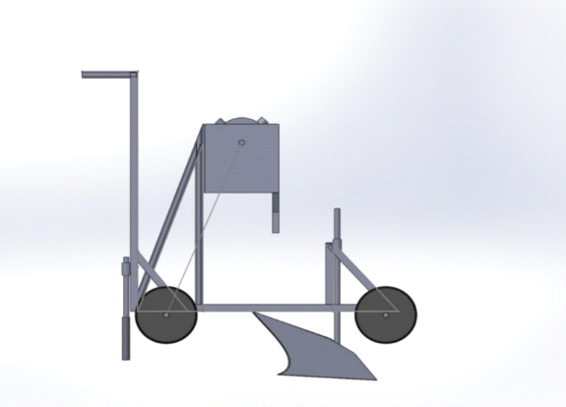 | 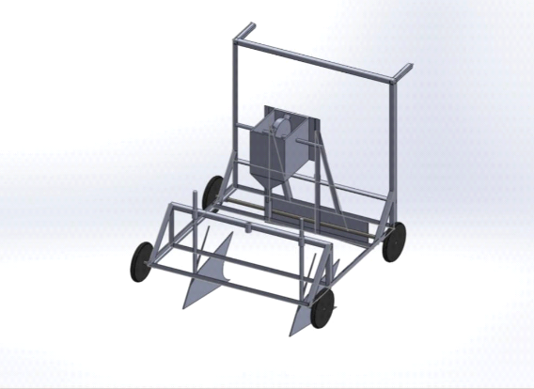

Fig. 1. Different views of ridger
3.2.Principle of Operation
The solar-powered seed sowing machine utilizes renewable energy and advanced automation to minimize manual labor while improving the precision of farming practices. At its heart lies a solar panel that captures sunlight and converts it into electrical energy using photovoltaic technology. This energy is stored in a rechargeable battery, which guarantees dependable operation even during low light or overcast conditions. The stored energy powers a 12V DC motor, enabling both the movement of the machine and the activation of the seed metering system, which is engineered to distribute seeds at uniform intervals. The seed hopper, measuring 6 x 8 inches with a height of 8 inches, supplies seeds to a rotating or oscillating metering disc or chute, depending on the specific design. As the machine traverses the field, the motor's power is allocated between the mobility system and the seed dispensing mechanism, ensuring coordinated operation. Seeds are released at regular intervals, such as every 8 cm, into the prepared soil. The depth at which seeds are placed is determined by the design of the seed outlet and the height of the frame, which is crucial for creating optimal germination conditions. The system can function efficiently for several hours, depending on the battery's capacity and the amount of solar exposure, making it ideal for small to medium-sized farms. Furthermore, its dependence on solar energy renders the machine environmentally friendly and cost-effective in the long run, reducing reliance on fossil fuels. This approach not only fosters sustainable farming practices but also improves the accuracy and consistency of sowing compared to traditional manual methods.
3.3. Experimental Procedure
A practical evaluation phase was implemented to determine the machine's operational efficiency and performance in actual agricultural environments. The main objective of this phase was to assess the machine's capability to fulfill operational standards while functioning in a setting that closely resembles its intended application. A variety of assessment criteria were established to ensure a thorough understanding of the machine's performance under real-world conditions. These criteria included: Efficiency: This metric indicates the ratio of actual sowing completed compared to the expected sowing performance. The machine's efficiency is a vital indicator that demonstrates how well its real-world output corresponds with anticipated performance levels. The efficiency percentage is crucial for evaluating the machine's overall effectiveness in maximizing its sowing capabilities during operational hours. Quantity of Seeds Sown (Numbers): This criterion measures the total number of seeds planted within a specific timeframe. The machine's capacity to distribute seeds at the required rate is fundamental to its effectiveness, and this measure provided direct insight into the machine's output during the testing phase. It also acts as a benchmark for assessing how well the machine manages and distributes seeds across the land designated for sowing. Area Coverage (Acres): This metric assesses the amount of land covered by the machine within a specified duration. Area coverage is a critical parameter for evaluating how efficiently the machine can complete the sowing task over extensive agricultural land. The larger the area covered during the 10-hour test, the more productive the machine is deemed to be. The field test was conducted over a continuous 10-hour period, allowing the machine to operate in a way that closely simulated real-world, sustained usage. Throughout this period, data was collected at regular intervals, specifically on an hourly basis, providing a comprehensive analysis of performance over time.
4.Result and Discussion
4.1. Stress Analysis
The Von Mises stress analysis under the same 250 N load shows a peak stress of around 38.3 MPa. This stress concentration appears near the joint areas and sharp internal curves common hotspots in agricultural implement design. However, considering the yield strength of the material (172 MPa for mild steel or similar alloy), the ridger demonstrates a high safety margin, affirming its structural soundness for continuous operation in ploughed soil.
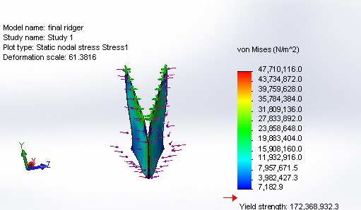
Fig. 4.1. Static nodel stress analysis of ridger
4.2 Strain Analysis
Under a uniformly applied load of 250 N, the static strain analysis of the ridger reveals a maximum equivalent strain of approximately 1.22 × 10⁻⁴. The strain is primarily concentrated along the upper curved edges of the blades, indicating localized deformation in areas subjected to higher bending and soil resistance. The magnitude of strain remains well within the elastic limit of the material, suggesting that the structure can withstand typical field forces without risk of fatigue or permanent deformation.
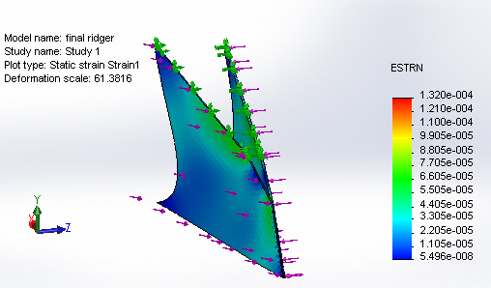

Fig. 4.2. Static strain analysis of ridger
4.3 Displacement Analysis
The static displacement plot indicates a maximum deflection of 0.573 mm, primarily at the free edges of the ridger wings. This small displacement proves the robustness of the design, especially under moderate field conditions such as groundnut cultivation. The minimal deformation ensures effective soil penetration and ridge formation without loss of alignment or functional efficiency.
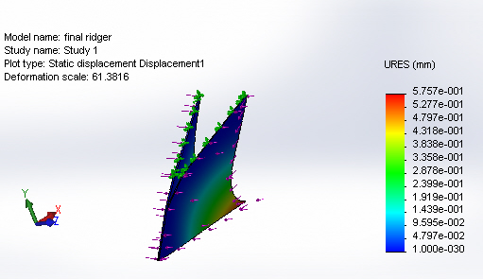
Fig. 4.3. Static displacement analysis of ridger
4.1.Efficiency Evaluation Over Time
Efficiency demonstrated a gradual increase during the testing period. It began at zero but rose significantly as the machine stabilized, reflecting optimal use of power and mechanical components over time.
Table 4.1.1. Efficiency Over Time
Time in Hours | Efficiency (%)
0 | 0.00
1 | 44.37
2 | 47.34
3 | 48.67
4 | 49.21
5 | 52.46
Fig. 4.4. Efficiency of the machine
4.2 Quantity of Seeds Sown Over Time
The number of seeds sown was recorded every hour, showing minor fluctuations but generally maintaining an increasing trend.
Table 4.21. Quantity of Seeds Sown Over Time
Time in Hours | Groundnut  (kg) | Maize  (kg) | Soybean  (kg) | Chickpea  (kg)
0 | 0 | 0 | 0 | 0
1 | 106 | 97 | 125 | 107
2 | 152 | 138 | 163 | 146
3 | 144 | 125 | 137 | 154
4 | 178 | 159 | 164 | 131
5 | 182 | 175 | 135 | 146
6 | 180 | 149 | 124 | 149
7 | 179 | 150 | 141 | 135
8 | 175 | 124 | 149 | 135
9 | 167 | 142 | 158 | 160
10 | 187 | 166 | 123 | 148

Fig. 4.5. Seed sowing output
4.3 Area Coverage Over Time
Area coverage increased almost linearly with time, demonstrating the machine’s consistency in ground movement and sowing capability.
Table 3. Area Coverage Over Time.
Time in Hours | Area covered (Acres)
0 | 0
1 | 0.07
2 | 0.17
3 | 0.27
4 | 0.31
5 | 0.49
6 | 0.51
7 | 0.68
8 | 0.79
9 | 0.86
 | 0.99
Fig. 4.6 Time-Based Acreage Coverage by Ridge Maker Cum Seed Sower

4.4.Seed Placement Accuracy
The performance of the Ridge Maker cum Seed Sower in terms of seed placement accuracy was evaluated against the theoretical spacing of 8 cm. Field observations revealed that the actual spacing varied within a narrow range of 7.7–8.3 cm, indicating high precision of the metering system. The calculated placement accuracy averaged 98.6 per cent, with most deviations occurring only due to soil irregularities. This demonstrates that the machine successfully maintains uniform spacing, ensuring proper germination and crop stand establishment. Compared to traditional manual sowing, where deviations of up to 2–3 cm are common, the machine shows a significant improvement in seed distribution uniformity.

Fig. 4.7. Seed placing accuracy

4.5.Ridge Formation Quality
The quality of ridge formation was assessed based on ridge height, uniformity, and soil firming across multiple test runs. The actual ridge height closely matched the ideal of 10 cm, with recorded values ranging between 9.8 and 10.5 cm. The uniformity score, measured on a scale of 1–10, consistently remained between 8 and 9, confirming the machine’s reliability in forming well-structured ridges. The average ridge formation quality was found to be 96.8 percent, which is adequate for crops such as groundnut and maize that require well-defined ridges for optimum growth. The results indicate that the ridger blade and soil handling system are effective in maintaining both consistency and structural stability of ridges during continuous operation.
Table.4.5.1. Ridge formation Quality
Trial | Ridge Height (cm) | Ridge width (cm) | Ride Uniformity (Qualitative) | Soil compaction at ridge shoulder (kPa)
1 | 10.2 | 31 | Good (Even) | 150
2 | 9.8 | 29 | Good | 160
3 | 10.5 | 30 | Very good | 145
4 | 10 | 32 | Good | 155
5 | 9.6 | 30 | Fair | 148

4.6.Cost of Operation
The operational cost of the Ridge Maker cum Seed Sower was compared with traditional manual methods for one acre of field preparation. Manual ridge formation and seed sowing typically require 4 laborers working for 8–10 hours, amounting to a cost of Rs.2800–3200 per acre. In contrast, the machine required only one operator and completed the task in 2–3 hours, reducing the cost to Rs.850–1100 per acre This represents a cost reduction of approximately 65 per cent, along with significant savings in time and labor. The adoption of this machine, therefore, not only enhances field efficiency but also provides considerable economic benefits to small and medium-scale farmers.
5.Conclusion
The Ridge Maker Cum Seed Sower introduced in this study offers an innovative solution designed to enhance agricultural efficiency and sustainability, especially for small to medium-sized farmers. By combining ridge formation and seed sowing capabilities into one machine, it provides a streamlined, time-efficient, and labour-saving alternative to conventional farming practices. This machine operates on a solar-powered 12V motor system, highlighting its environmentally friendly design. It significantly decreases the need for manual labor and reduces operational time by an impressive 40–50% compared to traditional manual methods, making it a revolutionary tool for farming communities with limited resources. At the heart of its functionality is a chain-driven seed metering system that guarantees accurate seed placement at consistent intervals of 8 cm. This precision improves crop establishment, encourages uniform growth, and reduces seed loss. The dual functionality of ridge formation and seed sowing is especially advantageous for crops that flourish in ridged soil conditions. Field trials with crops such as groundnut, maize, soybean, and chickpea have shown the machine’s reliability and versatility in various agricultural contexts. Among these, groundnut proved to be the most suitable due to its specific agronomic needs. Groundnut farming greatly benefits from well-formed ridges, which improve soil aeration, drainage, and pod development below the soil surface. The Ridge Maker Cum Seed Sower effectively fulfils these needs by producing evenly spaced and well-defined ridges. Furthermore, its precise seed placement aligns with the ideal conditions required for groundnut germination and growth. The machine’s efficiency is further enhanced in the loose, ploughed soil commonly found in groundnut fields, which reduces the draft force needed for operation. This feature alleviates the burden on the motor while simultaneously improving the system's overall energy efficiency. Groundnut, a significant crop in regions like Gujarat, Tamil Nadu, and Andhra Pradesh known for smallholder farming and elevated labor costs, benefits from the Ridge Maker Cum Seed Sower, which offers a scalable and low-maintenance solution designed for these farmers. By minimizing reliance on manual labor, decreasing operational expenses, and enhancing productivity, this machine makes a strong case for widespread use. Additionally, its solar-powered design supports sustainable agricultural practices, positioning it as an environmentally friendly option for contemporary farming. In conclusion, the Ridge Maker Cum Seed Sower effectively meets its design goals, providing a highly efficient, cost-effective, and sustainable solution for groundnut-focused agriculture. Its potential for broader application in smallholder farming systems highlights its significance as a practical tool for boosting agricultural productivity while mitigating environmental impact.
6.References
- Sartape, S. N., Pathan, H. Y., Patil, S. S., Mane, A. B., & Pawar, V. T. (2025). Solar powered seed spraying machine. Journal of Mechanical Robotics, 10(1).
- Pranil, V. S., Wandhare, A., Sontakke, A., Patil, B., & Bawanwade, R. (2015). Solar powered seed sowing machine. Global Journal of Advanced Research, 2(4), 712–717.
- Elayadevan, E., Girish, S., & Uthappan, K. (2020). Design and fabrication of automatic solar seed sowing machine. International Research Journal on Advanced Science Hub, 2(6), 131–135.
- Sankaranarayanan, M., & Nzamwitakuze, A. (2013). Development of a push type seed drill for sowing maize in Rwanda.
- Senthilnathan, N., Gupta, S., Pureha, K., & Verma, S. (2018). Fabrication and automation of seed sowing machine using IoT. International Journal of Mechanical Engineering and Technology, 9(4), 903–912.
- Ahmad, F., & Sultan, M. (2021). Technology in agriculture.
- Javidan, S. M., & Mohammadzamani, D. (2018). Design and development of solar powered seed sowing robot with row detection technology.
- Joshi, P., Gupta, S. S., Shukla, A. K., & Gautam, S. S. (2021). Design and implementation of multi seed sowing machine. In Advances in Engineering Design: Select Proceedings of FLAME 2020.
- Ekad, A. B., Salunke, S. N., Gawde, S. B., Said, A. K., & Suryawanshi, G. L. (2019). Design and development of pneumatically operated automatic seed sowing machine.
- Kumar, G., Singh, R., Kumar, P., & Shrivastava, Y. (2021). Design and analysis of an automatic seed sowing machine using SolidWorks and ANSYS tools. In Advances in Engineering Design: Select Proceedings of FLAME 2020.
- Kadam, A., Chavan, M., & Shinde, R. (2018). Design and fabrication of solar operated seed sowing machine. International Research Journal of Engineering and Technology (IRJET), 5(4), 4532–4535.
- Patel, M., Patel, K., & Patel, P. (2017). Design and development of manually operated seed sowing machine. International Journal of Advance Engineering and Research Development, 4(5), 563–567.
- Dharmik, P., Rathod, A., & Patil, N. (2015). Automated seed sowing agribot. International Journal of Research in Engineering and Technology, 4(3), 2321–7308.
- Gite, L. P., & Yadav, B. G. (2015). Agricultural mechanization in India. Agricultural Engineering Today, 39(4), 15–21.
- Singh, G. (2013). Development and performance evaluation of solar-powered agricultural machinery. Agricultural Engineering International: CIGR Journal, 15(2), 23–30.
- Yadav, A., Kumar, A., & Thakur, A. (2019). A review paper on design and development of multipurpose agricultural equipment. International Journal of Scientific Development and Research (IJSDR), 4(11), 271–275.
- Marode, R. V., Tayade, G. P., & Agrawal, S. K. (2013). Design and implementation of multi seed sowing machine. International Journal of Mechanical Engineering and Robotics Research, 2(4), 2278–0149.
- Ramesh, D., & Girishkumar, H. P. (2014). Agriculture seed sowing equipments. International Journal of Science, Engineering and Technology Research, 3(7), 2278–7798.
- Kannan, A., Esakkiraja, K., & Thimmarayan, S. (2014). Design modifications in multipurpose sowing machine. International Journal of Mechanical Engineering and Technology, 5(2), 97–105.
- Kyada, A. R., & Patel, D. B. (2014). Design and development of manually operated seed planter machine. Proceedings of the 5th International & 26th All India Manufacturing Technology, Design and Research Conference (AIMTDR 2014), IIT Guwahati, Assam, India.

