Original Research Article
Determinants of attitude of sugarcane growers towards sugarcane cultivation: Evidence from South Gujarat
ABSTRACT

Aim: The study aimed to ascertain the relationship of profile of sugarcane growers with their attitude toward sugarcane crop cultivation
Research design: Ex-post facto research design was adopted.
Place and Duration of the study: The present study was conducted in the South Gujarat region of Gujarat state during 2023-25.
Methodology: Bharuch, Tapi and Surat districts were purposively selected as they have maximum area under sugarcane cultivation in the South Gujarat. In the next step, multistage random sampling was employed. Two talukas from each district, four villages from each taluka and ten sugarcane growers from each village were selected randomly resulting in a total sample size of 240 respondents. Data were collected through personal interview method using structured and pre-tested interview schedule. Appropriate techniques and scales were used for the measurement of variables and the data were analysed using Pearson’s correlation and stepwise regression in IBM SPSS Statistics (Version 29).
Results: Education, experience in farming, extension contact, extension participation, mass media exposure, information seeking behaviour, use of ICT for farming, social media utilization and change proneness had positive and significant correlation with attitude towards sugarcane cultivation at 1% level of significance whereas, social participation, credit orientation, scientific orientation, risk orientation and management orientation had positive and significant correlation at 5% level of significance. Stepwise regression analysis showed that social media utilization, mass media exposure, experience in farming, education, information seeking behaviour, credit orientation, extension participation, extension contact, use of ICT for farming and scientific orientation were accounting influence on attitude towards sugarcane cultivation and together accounted 41.20 per cent variation in attitude towards sugarcane cultivation.
Conclusion: Strengthening the factors significantly influencing attitude towards sugarcane cultivation help the extension agencies and policy makers design effective interventions to promote sustainable cultivation practices.

Keywords: Attitude, sugarcane cultivation, sugarcane growers, correlation, stepwise regression, South Gujarat

- INTRODUCTION

Sugarcane (Saccharum officinarum) is a crop of strategic importance in India, linking millions of sugarcane growers to the nation’s agro-industrial network and contributing substantially to economic growth of our nation and rural prosperity. It is an important commercial crop with 57.40 lakh hectare under cultivation, 4,531.58 lakh tonnes production and yield of 78,953 kg/ha during 2023-24 (Anonymous, 2025). India has the largest area under sugarcane cultivation in the world and holds second position in terms of global sugarcane production (Anonymous, 2024a). Gujarat is a prominent sugarcane producing state in India, with 2.02 lakh ha of area under cultivation, 14.48 million tonnes of production and 71.62 t/ha of productivity during 2023-24 (Anonymous, 2024b). In South Gujarat, sugarcane occupies a significant position due to its favourable agro climatic conditions, well established cooperative sugar mills and strong market linkages. Beyond its economic value, sugarcane cultivation also plays a vital role in employment generation and allied industries such as bio-energy, sugar and jaggery production. The sugarcane growers in India face several challenges. Dineshappa (2019) stated that “the basic problem confronting the cane growers is to meet the high cost of cultivation. This problem is aggravated by the unreasonable statutory price paid for the cane by the sugar mills.

However, the sustainability and profitability of sugarcane cultivation are not only influenced by physical and economic factors but also by the attitude of sugarcane growers towards sugarcane cultivation. According to Allport, (1935), “attitude is a mental and neutral state of readiness, organized through experience, exerting a directive or dynamic influence upon the individual’s response to all objects and situations with which it is related”. Sakuntala and Thanigasalam (2020) identified that sugarcane growers had negative attitude about production, harvesting, marketing and financial aspects except, soil fertility, labour availability for production and manure availability in private market. Attitude positively influences the adoption of sugarcane cultivation practices (Kumar et al., 2018). This implies that favourable attitude leads to better adoption of cultivation practices among sugarcane growers. Adoption of Best Crop Management Practices (BCMPs) is vital for enhancing sugarcane yields and ensuring a consistent supply of high quality raw materials for processing, therefore, understanding the factors influencing the adoption decisions by smallholder sugarcane farmers is essential for effective promotion strategies (Pato et al., 2024). Knowledge about sugarcane cultivation and adoption of technological advancements are crucial for enhancing crop production and ensuring the acceptability of innovative practices among farmers (Bhairagond, et al., 2024).

Attitude formation and attitude change are two important features at the core of social psychology (Srivastava and Rojhe, 2021). Attitudes are pivotal because it predict and shapes behaviour, especially when they are strongly embedded in an individual core values or are linked to social allegiances (Johnson et al. 2022). Attitude formation can be described as a function of prior beliefs and information (Young and Zeimer, 2024). Attitudes are formed as a result of personal experience, learning, social and cultural factors (Cherry, 2024). Some attitudes are mostly based on beliefs, while some are based on feelings, and behaviours but strong attitudes are important as we hold them with confidence, we do not change them very much, and we use them often to guide our actions (Jhangiani and Tarry, 2022). Attitude of an individual is shaped by a combination of several factors including personal, socio-economic, communication and psychological characteristics. Therefore, understanding these determinants is crucial for designing targeted extension strategies, policy interventions and support services that encourage a positive attitude towards sugarcane cultivation.

In this context, the present study seeks to ascertain the relationship between the profile of sugarcane growers and their attitude towards sugarcane cultivation. By providing empirical evidence, the findings aim to guide extension agencies, policy makers, researchers and other stakeholders in strengthening the engagement of sugarcane growers, improving adoption of recommended practices, and enhancing the overall productivity of sugarcane sector.

- OBJECTIVE

To ascertain the relationship of profile of sugarcane growers with their attitude toward sugarcane crop cultivation

- METHODOLOGY

The present study was conducted in South Gujarat region of Gujarat state during the year 2023-25 by employing Ex-post facto research design. Ex-post facto means what is done afterward and refers to those studies which investigate possible cause-and-effect relationships by observing an existing condition or state of affairs and searching back in the time of possible causal factors. Ex-post-facto research design is worthy to be applied when the independent variables have already acted upon (Kerlinger, 1976). Two sampling methods were adopted for the study. First, purposive sampling technique was used for the selection of districts. Bharuch, Surat and Tapi districts were purposively selected as these districts were having maximum area under sugarcane cultivation in South Gujarat. Second, the multistage random sampling technique was employed for the selection of talukas, villages and respondents. In first stage, two talukas from each selected district were selected randomly. In second stage, four villages from each taluka were selected randomly. In the final stage, 10 sugarcane growers were selected randomly from each village. Thus, the total sample size comprised 240 respondents. The schematic representation of sampling procedure is presented in Fig.1.

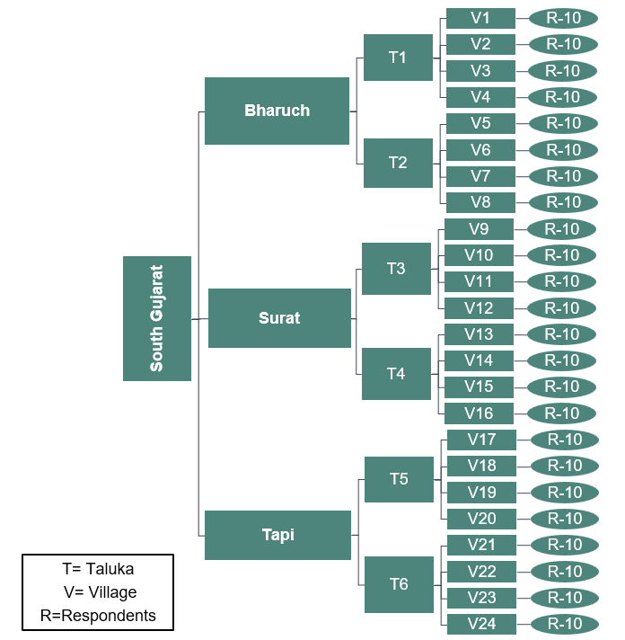
Fig.1. Diagrammatic representation of sampling procedure

In light of the objectives of the study, attitude towards sugarcane cultivation was selected as the dependent variable and variables including age, education, experience in farming, family size, occupation other than farming, social participation, extension contact, extension participation, cosmopoliteness, group cohesiveness, annual income, area under sugarcane cultivation, farm resource possession, land holding, credit orientation, mass media exposure, information seeking behavior, use of ICT for farming, social media utilization, negotiation skills, scientific orientation, risk orientation, management orientation, change proneness and decision making ability were selected as independent variables. For measuring the dependent and independent variables appropriate measuring techniques/scales developed by other scientists were used. In the case of variables for which appropriate measuring tools are not available, were measured by pretested structured schedule. The tentative model depicted in Fig. 2 shows that 25 independent variables of the sugarcane growers might be having a relationship with their attitude towards sugarcane cultivation.

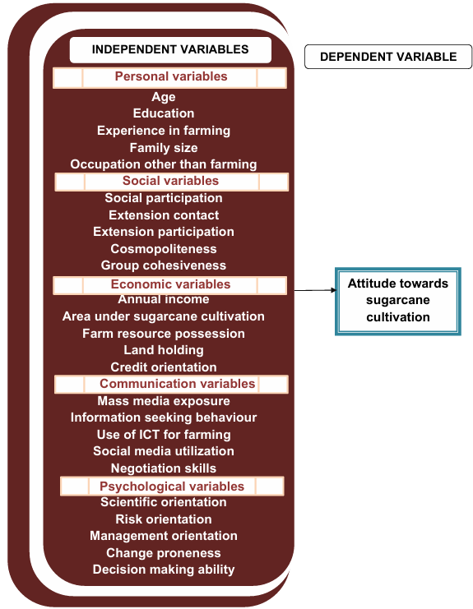
Fig. 2. Conceptual model showing the relationship of independent and dependent variables

The null hypothesis framed was as follows:
Null hypothesis(H₀): There is no relationship between the profile of sugarcane growers and their attitude towards sugarcane cultivation

A structured and pre-tested interview schedule was used to collect the data through personal interview method. The data collected were tabulated and analysed using appropriate statistical tools - Pearson’s correlation and stepwise regression analysis using IBM SPSS Statistics (Version 29). For visualisation of results, correlation heat map and model improvement graph of step wise regression were generated using Python (Version 3.13.3) in Jupyter Notebook.

- RESULTS AND DISCUSSION

4.1 Relationship between profile of sugarcane growers and their attitude towards sugarcane cultivation

The relationship between the profile of the sugarcane growers and their attitude towards sugarcane cultivation was examined by computing Pearson Correlation Coefficient. The results are presented in the Table 1. The correlation heat map shown in Fig. 3 provides a visual representation of strength and direction of these relationships and the empirical model shown in Fig. 4. summarizes significant and non-significant relationships between the independent variables and dependent variable.

Table 1: Relationship between the profile of sugarcane growers and their attitude towards sugarcane cultivation
(n=240)
Sr. No. | Independent Variables | Coefficient of correlation (r)
 | - Personal variables
1. | Age | -0.006 ^{NS}
2. | Education | 0.219**
3. | Experience in farming | 0.175**
4. | Family size | -0.002 ^{NS}
5. | Occupation other than farming | -0.006 ^{NS}
 | - Social variables
6. | Social participation | 0.162*
7. | Extension contact | 0.198**
8. | Extension participation | 0.203**
9. | Cosmopoliteness | 0.041 ^{NS}
10. | Group cohesiveness | -0.046 ^{NS}
 | - Economic variables
11. | Annual income | -0.003 ^{NS}
12. | Area under sugarcane cultivation | 0.053 ^{NS}
13. | Farm resource possession | 0.019 ^{NS}
14. | Land holding | 0.093 ^{NS}
15. | Credit orientation | 0.143*
 | - Communication variables
16. | Mass media exposure | 0.257**
17. | Information seeking behaviour | 0.185**
18. | Use of ICT for farming | 0.243**
19. | Social media utilization | 0.271**
20. | Negotiation skills | -0.027 ^{NS}
 | - Psychological variables
21. | Scientific orientation | 0.163*
22. | Risk orientation | 0.143*
23. | Management orientation | 0.134*
24. | Change proneness | 0.170**
25. | Decision making ability | -0.062 ^{NS}
**Significant at 0.01 level of probability *Significant at 0.05 level of probability
NS = Non significant

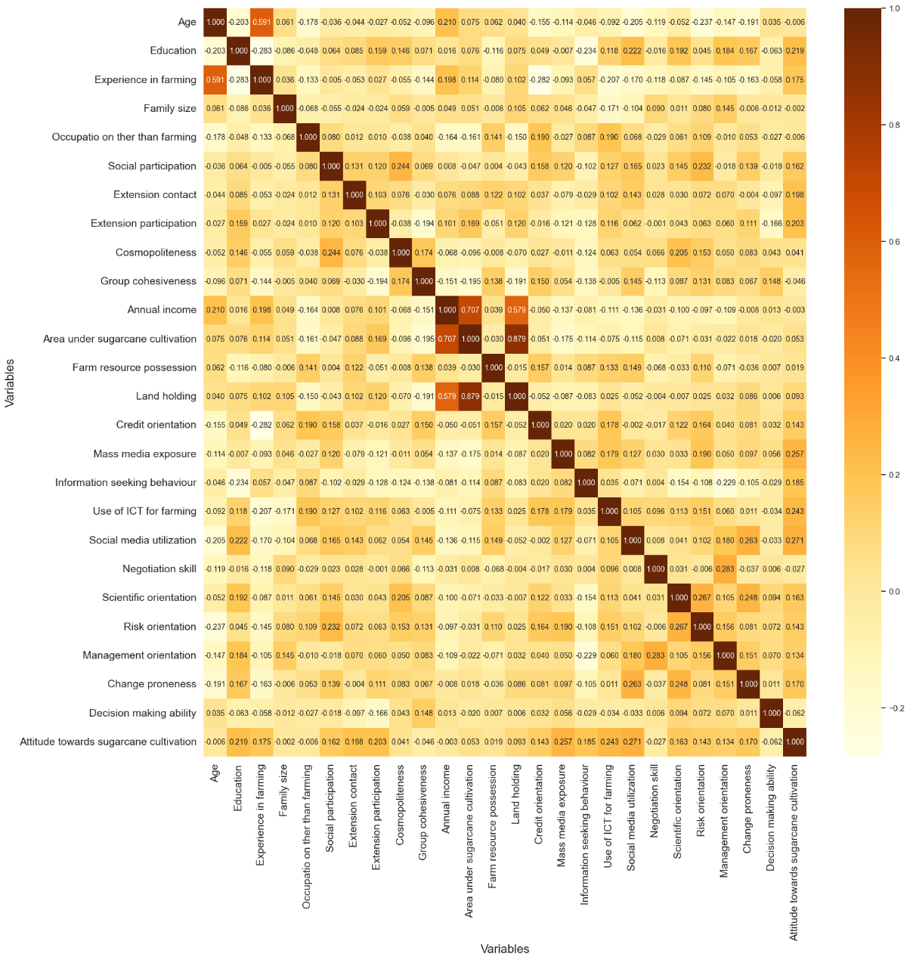
Fig.3. Correlation heat map showing relationship between profile of sugarcane growers with their attitude towards sugarcane cultivation
4.1.1 Personal variables and attitude towards sugarcane cultivation

The results presented in Table 1, Fig.3 and Fig.4 Indicates that, among personal variables education (r=0.219**) and experience in farming (r=0.175**) were positively and significantly correlated with attitude towards sugarcane cultivation at 1% level of significance whereas, age (r=-0.006^{NS}), family size (r=-0.002^{NS}) and occupation other than farming (r=-0.006^{NS}) had non significant correlation with attitude towards sugarcane cultivation. These findings are consistent with Archana (2021) who reported that education had positive and significant correlation with attitude towards sugarcane cultivation and age had no significant correlation. Similarly, Islam et al. (2022) found that education was positively and significantly correlated with attitude towards sunflower cultivation while, age and family size had no significant correlation. Study in rapeseed-mustard by Kumar et al. (2020) reported that education and experience was positively and significantly associated with attitude towards rapeseed-mustard cultivation whereas family size and occupation had no significant association.

4.1.2 Social variables and attitude towards sugarcane cultivation

It is evident from Table 1, Fig.3 and Fig.4 that, out of the five social variables, two variables namely, extension contact (r=0.198**) and extension participation (r=0.203**) had positive and significant correlation with attitude towards sugarcane cultivation at 1% level of significance while, social participation (r=0.162*) had positive and significant correlation with attitude towards sugarcane cultivation at 5% level of significance. On the other hand, cosmopoliteness (r=-0.041^{NS}) and group cohesiveness (r= -0.046^{NS}) had non significant correlation with attitude towards sugarcane cultivation. Similar results were reported by Archana (2021) and Kumar (2020) where extension contact had positive and significant correlation with attitude towards sugarcane cultivation and rapeseed-mustard cultivation, respectively.

4.1.3 Economic variables and attitude towards sugarcane cultivation

The correlation coefficients in Table 1, Fig.3 and Fig.4 reveals that credit orientation (r=0.143*) had had positive and significant correlation with attitude towards sugarcane cultivation at 5% level of significance. Other economic variables namely, annual
income (r= -0.003^{NS}), area under sugarcane cultivation (r=-0.053^{NS}), farm resource possession (r= 0.019^{NS}) and land holding (r=0.093^{NS}) had no significant correlation with attitude towards sugarcane cultivation. The findings aligns with Nikam et al. (2015), Kumar (2020) and Archana (2021) that land holding had no significant association with attitude towards grape cultivation, rapeseed-mustard cultivation and sugarcane cultivation, respectively.

4.1.4 Communication variables and attitude towards sugarcane cultivation

A careful examination of Table 1, Fig.3 and Fig.4 shows that among communication variables, mass media exposure (r=0.257**), information seeking behaviour (r=0.185**), use of ICT for farming (r=0.243**) and social media utilization (r=0.271**) had positive and significant correlation with attitude towards sugarcane cultivation at 1% level of significance. Only, negotiation skills (r= -0.027^{NS}) had no significant correlation with attitude towards sugarcane cultivation. The results are in line with the previous research in sugarcane (Archana, 2021) where mass media utilization had positive and significant association with attitude towards sugarcane cultivation. Islam et al., 2022 highlighted that use of communication media was positively and significantly correlated with attitude towards sunflower cultivation

4.1.5 Psychological variables and attitude towards sugarcane cultivation

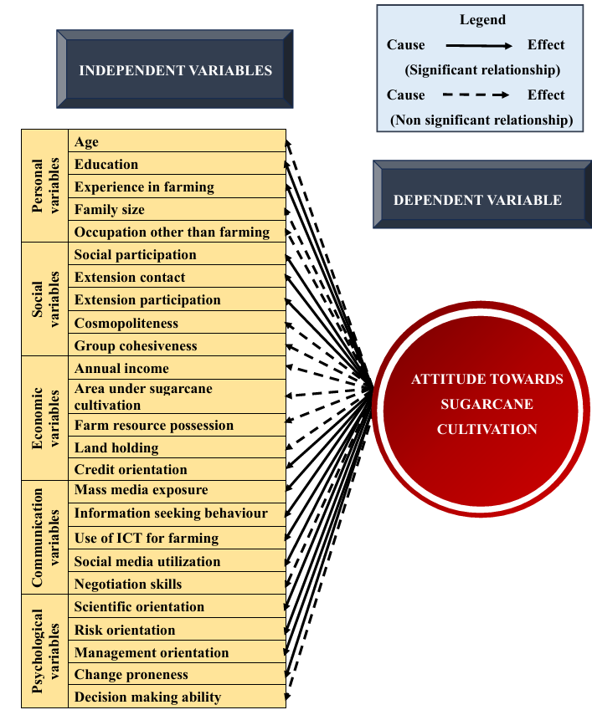
The results in Table 1, Fig.3 and Fig.4 indicates that four psychological variables viz; scientific orientation (r=0.163*), risk orientation (r=0.143*), management orientation (r=0.134*), and change proneness (r=0.170*) had positive and significant correlation with attitude towards sugarcane cultivation at 5% level of significance. While, decision making ability (r= -0.062^{NS}) had no significant correlation with attitude towards sugarcane cultivation. The findings align with previous research conducted by Archana (2021) where scientific orientation, management orientation and risk orientation had positive and significant relationship with attitude towards sugarcane cultivation and decision making ability had no significant relationship. Rathod (2014) reported that scientific orientation had positive and significant correlation with attitude towards capsicum cultivation.

Fig. 4. Empirical model showing relationship between the profile of sugarcane growers and their attitude towards sugarcane cultivation
4.2 Stepwise regression analysis of independent variables and attitude towards sugarcane cultivation

The results of stepwise regression analysis with 25 independent variables and attitude towards sugarcane cultivation are presented in Table 2. The Fig.2 shows how well the stepwise regression model explains the variation in the dependent variable (attitude towards sugarcane cultivation) as significant predictors are added step by step, with the increase in adjusted R² indicating improvement in model fit at each step.

Table 2: Stepwise multiple regression analysis of independent variables and attitude towards sugarcane growers
(n=240)
Sr. No. | Independent variables | Partial regression coefficient (b) | Standard error | Multiple Correlation Coefficient ‘R’ | Adjusted R²
 | (Constant) | -111.257 | 9.652 | 0.661 | 0.412
1. | Social media utilization (X₁₉) | 0.854** | 0.206 | 0.661 | 0.412
2. | Mass media exposure (X₁₆) | 0.768** | 0.161 | 0.661 | 0.412
3. | Experience in farming (X₃) | 0.663** | 0.094 | 0.661 | 0.412
4. | Education (X₂) | 2.604** | 0.567 | 0.661 | 0.412
5. | Information seeking behavior (X₁₇) | 0.663** | 0.130 | 0.661 | 0.412
6. | Credit orientation (X₁₅) | 0.434** | 0.121 | 0.661 | 0.412
7. | Extension participation (X₈) | 0.566** | 0.173 | 0.661 | 0.412
8. | Extension contact (X₇) | 0.903** | 0.302 | 0.661 | 0.412
9. | Use of ICT for farming (X₁₈) | 0.325** | 0.128 | 0.661 | 0.412
10 | Scientific orientation (X₂₁) | 0.357** | 0.152 | 0.661 | 0.412
**Significant at 0.01 level probability

The data presented in Table 2 reveals that out of 25 independent variables, ten variables namely viz. social media utilization (0.854**), mass media exposure (0.768**), experience in farming (0.663**), education (2.604**), information seeking behavior (0.663**), credit orientation (0.434**), extension participation (0.566**), extension contact (0.903**), use of ICT for farming (0.325**) and scientific orientation (0.357**) were accounting influence on attitude towards sugarcane cultivation.

These ten independent variables together accounted 41.20 per cent variation in attitude towards sugarcane cultivation.

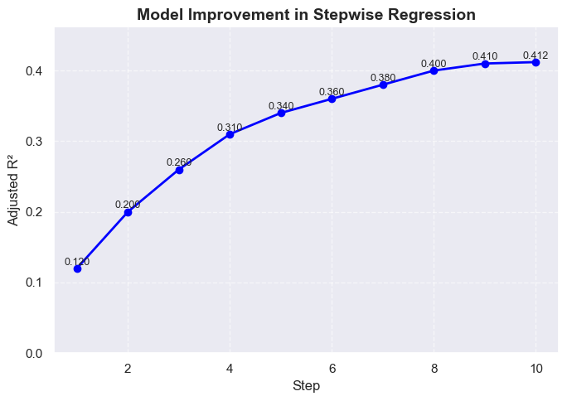
Fig.5. Improvement in Adjusted R² across stepwise regression stages

By following the model, result of stepwise regression analysis is as;
Y = a +b₁₉X₁₉+b₁₆X₁₆ + b₃X₃ + b₂X₂ + b₁₇X₁₇+b₁₅X₁₅+b₈X₈ + b₇X₇ + b₁₈X₁₈ + b₂₁X₂₁

Where
Y = Attitude towards sugarcane cultivation
a = the intercept i.e., -111.257
b₁₉ = Coefficient of partial regression of Y₁ on X₁₉ i.e. 0.854
b₁₆ = Coefficient of partial regression of Y₁ on X₁₆ i.e. 0.768
b₃ = Coefficient of partial regression of Y₁ on X₃ i.e. 0.633
b₂ = Coefficient of partial regression of Y₁ on X₂ i.e. 0.567
b₁₇ = Coefficient of partial regression of Y₁ on X₁₇ i.e. 0.130
b₁₅ = Coefficient of partial regression of Y₁ on X₁₅ i.e. 0.121
b₈ = Coefficient of partial regression of Y₁ on X₈ i.e. 0.722
b₇ = Coefficient of partial regression of Y₁ on X₇ i.e. 0.173
b₁₈ = Coefficient of partial regression of Y₁ on X₁₈ i.e. 0.302
b₂₁ = Coefficient of partial regression of Y₁ on X₂₁ i.e. 0.152
X₁₉ = Social media utilization
X₁₆ = Mass media exposure
X₃ = Experience in farming
X₂ = Education
X₁₇ = Information seeking behaviour
X₁₅ = Credit orientation
X₈ = Extension participation
X₇ = Extension contact
X₁₈ = Use of ICT for farming
X₂₁ = Scientific orientation

Therefore, the fitted equation would be as:
Y= -111.257+(0.854)X₁₉+(0.768)X₁₆+(0.663)X₃+(2.604)X₂+(0.663)X₁₇+(0.434)X₁₅+ (0.566)X₈+(0.903)X₇+(0.325)X₁₈+ (0.357)X₂₁

- CONCLUSION

From the findings of the study, it is evident that out of 25 independent variables, nine variables - education, experience in farming, extension contact, extension participation, mass media exposure, information seeking behaviour, use of ICT for farming, social media utilization and change proneness had positive and significant correlation with attitude towards sugarcane cultivation at 1% level of significance whereas, social participation, credit orientation, scientific orientation, risk orientation and management orientation had positive and significant correlation with attitude towards sugarcane cultivation at 5% level of significance. Furthermore, the independent variables namely, social media utilization, mass media exposure, experience in farming, education, information seeking behaviour, credit orientation, extension participation, extension contact, use of ICT for farming and scientific orientation significantly contributed to attitude towards sugarcane cultivation. Extension agencies, policymakers, and agricultural educators should focus on strengthening these determinants/attributes to foster more favourable attitude towards sugarcane cultivation, ultimately leading to better adoption of recommended practices and improved productivity.

DISCLAIMER (ARTIFICIAL INTELLIGENCE)

Author(s) hereby declare that no generative AI technologies such as Large Language Models (ChatGPT, COPILOT, etc.) and text-to-image generators have been used during the writing or editing of this manuscript.

REFERENCES

Allport, G. W. (1935). Attitudes. In C. Murchison (Ed.), A handbook of social psychology. (pp.798–844), Worcester, MA: Clark University Press.
Anonymous (2024a). Sugarcane production in India: Cultivation, distribution & Importance. https://www.nextias.com/blog/sugarcane/
Anonymous. (2024b). State wise area of sugarcane in country during 2019-20 to 2023 -24.https://sugarcane.dac.gov.in/schemes/StatewiseAPYofSugarcane2019-20to2023-24.pdf
Anonymous. (2025). Annual report (2024-25), Department of Agriculture and Farmers, Ministry of Agriculture & Farmers Welfare, Government of India Welfare, New Delhi, p. 04. https://agriwelfare.gov.in/Documents/AR_Eng_2024_25.pdf
Archana, K. (2021). Prospects of sugarcane cultivation for jaggery - A critical analysis. Thesis Ph.D., Acharya N.G. Ranga Agricultural University, Guntur.
Bhairagond, G. S., Nagesha, G., Kumar, V. R. Jagdish, H. M., & Meghana, N. (2024). Personal, socio-economic and psychological characteristics of sugarcane growers in Vijayapura district of Karnataka. International Journal of Agriculture Extension and Social Development, 7(4), 270-274. https://doi.org/10.33545/26180723.2024.v7.i4d.537
Cherry, K. (2024). Attitude in Psychology—Definition, Formation, and How They Change. Verywell Mind. https://www.verywellmind.com/attitudes-how-they-form-change-shape-behavior-2795897
Dineshappa, S. (2019). Problems and prospects for sugarcane growers in India: A sociological study. International Journal of Humanities and Social Science Invention, 8(3), 51-57.
Jhangiani, R., & Tarry, H. (2022). Principles of social psychology (1st International H5P Ed.), Kwantlen Polytechnic University, BC campus.
Johnson, B., Martinez-Berman, L., & Curley, C. (2022). Formation of attitudes: How people (wittingly or unwittingly) develop their viewpoints. Oxford Research Encyclopedia of Psychology.
https://oxfordre.com/psychology/view/10.1093/acrefore/9780190236557.001.0001/acrefore-9780190236557-e-812
Kerlinger, F. N. (1976). Foundation of behavioural research. New Delhi: Surjeet Publications.
Kumar, A., Jahanara, & Bose, D. K. (2018). Knowledge and attitude of the respondents towards sugarcane cultivation practices in Khumbi Block of Lakhimpur Kheri District of Uttar Pradesh. International Journal of Research Culture Society, 2(1), 399-402.
Kumar, R., Slalitha, P. S., Nain, M. S., Peshin, R., Gupta, S. K., & Sharma, B. C. (2020). Farmers’ attitude towards rapeseed-mustard (Brassica campestris) cultivation in Jammu. Indian Journal of Agricultural Sciences, 90(3), 597–600. https://doi.org/10.56093/ijas.v90i3.101494
Nikam, V. R., Singh, P., & Chahal, V. P. (2015). Attitude of farmers towards grape cultivation and export. Indian Journal of Agricultural Sciences, 85(4), 592-595. https://doi.org/10.56093/ijas.v85i4.47952
Pato, I. D., Osewe, M., & Han, J. (2024). Effects of perceived effectiveness in contract farming on adoption of best crop management practices among sugarcane farmers in Tanzania. Frontiers in Sustainable Food System, 8, 1-13. https://doi.org/10.3389/fsufs.2024.1442301
Rathod, D. M. (2014). Development of scale to measure the attitude of farmers towards capsicum cultivation. Thesis M.Sc. (Agri.), Anand Agricultural University, Anand.
Sakuntala, K. & Thanigasalam, G. (2020). Sugarcane growers attitude towards sugarcane production and marketing, Dharmapuri district, Tamil Nadu, India. International Journal of Psychosocial Rehabilitation, 24(5), 9121-9131.
Srivastava, S., & Rojhe, K. C. (2021). Attitude formation and attitude change: A social psychological perspective. In B. Christiansen & H. C. Chandan (Eds.), Handbook of research on applied social psychology in multiculturalism (pp. 1-28). Hershey, PA: IGI Global. https://doi.org/10.4018/978-1-7998-6960-3.ch001
Young, C., & Ziemer, K. (2024). Attitude formation at the individual level. In Polls, pollsters, and public opinion: A guide for decision-makers (pp. 25-37). Cambridge: Cambridge University Press. https://doi.org/10.1017/9781108855310.004

