INFLUENCE OF GROWTH SUBSTRATE IN ROOTING ABILITY OF PYRETHRUM (CHRYSANTHEMUM CINERARIIFOLIUM) STEM CUTTINGS
Original Research Article
Abstract
Pyrethrum (Chrysanthemum cinerariifolium) is an important cash crop valued for its natural insecticidal properties. Kenya’s production, once the world's highest, declined due to policy and market challenges but rebounded to 1,680 tons in 2023, supported by government and private sector interventions This study evaluated the rooting performance of pyrethrum (Chrysanthemum cinerariifolium) stem cuttings across different growth substrates and auxin hormone treatments to optimize propagation protocols for seedling production. Four substrates (soil, soil:sand, manure:sand, cocopeat:sand) and two indole-3-butyric acid (IBA) formulations (0.6% powder and 4.5% solution) were tested using a split plot design. Results showed that the cocopeat:sand substrate combined with 0.6% IBA powder produced the highest rooting frequency, root number, and length. No rooting occurred without hormone treatments. The study recommends using cocopeat:sand with IBA powder for efficient large-scale pyrethrum propagation under controlled conditions. This protocol supports sustainable seedling production and future breeding efforts for this important natural insecticide crop.
Key words; Pyrethrum, Growth substrate, PGR, Rooting
Introduction
Pyrethrum (Chrysanthemum cinerariaefolium) has been a major cash crop in several countries of the world. However, production declined sharply due to policies, market, and management challenges including diseases and pest (Liu et al., (2023). In recent years, Kenya’s pyrethrum production has shown recovery after completely going down from the highest producer in the world, to no production at all. Production of dry pyrethrum flowers increased from 941.9 tonnes in 2022 to 1,680 tonnes in 2023, mainly due to government interventions such as seedling distribution, improved agronomic training, and better post-harvest handling. However, in 2024, production slightly declined to 1,634 tonnes, attributed to erratic weather, seedling distribution challenges, and reduced farmer participation (Economic Survey 2025). This revival has led to very high demand for planting material, that has led to the need to come up with fast means of providing clean planting materials to the farmers. The crop is valued for its natural insecticidal properties and its eco-friendly profile, natural pyrethrins degrade rapidly in the environment, reducing chemical residues and minimizing ecological impact. Pyrethrins are naturally found insecticides obtained from dried pyrethrum daisy flowers, and the market is showing strong growth due to increased demand for hygienic and environmentally friendly products in Europe and the US, with a forecasted CAGR of 5.68% in Europe and 6.5% globally through 2032-2033. The natural origin and degradability make pyrethrins preferred over conventional insecticides, boosting demand and value for dry flowers used for extraction. (European Pyrethrum Market Report, July 2025).According Kenya National Bureau of Statistics (2024): National Agriculture Production Report. Kenya, as a major pyrethrum producer, supplies significant amounts of dried flowers for pyrethrin extraction, with much of the refined extract exported to the US and Europe. There is strong global demand for organic pyrethrum products, which supports the increasing value of dried flowers as raw material for pyrethrin extracts. The industry faces challenges such as policy inconsistencies, weather variability, and logistical setbacks. However, increasing global demand for natural insecticides and ongoing government support present significant opportunities for growth and export earnings. The renewed interest in pyrethrum is driven by the need for sustainable pest control solutions that address the environmental and health risks associated with synthetic pesticides. Integrating pyrethrum into agricultural systems supports the UN’s environmental conservation agenda while providing a valuable source of income for farmers. Pyrethrum is primarily propagated vegetatively, either by splitting established plants or by rooting stem cuttings. While seed propagation is possible, vegetative methods are preferred as they preserve the desirable genetic traits of elite mother plants, ensuring uniformity and vigor in new plantings (Chauhan et al., (2021). The success of vegetative propagation depends on several factors, including: Rooting hormone concentration; growth substrate; environmental conditions and cutting selection. Plant growth hormones particularly IBA has been found to effectively promote rooting in cuttings (Ullaha et al., (2023). This research study was conducted to evaluate the efficiency of different types of substrates in root initiation of pyrethrum (Chrysanthemum cinerariifolium) stem cuttings hence optimizing a propagation protocol for pyrethrum.

Materials and methods
Study Area
The study was conducted at the Department of Agriculture and Biotechnology of The University of Eldoret, Uasin Gishu County, Kenya. The latitude and longitude of this county are approximately: Latitude: 0° 31' 0" N (or 0.5167° N in decimal) Longitude: 35° 17' 0" E (or 35.2833° E), with an altitude ranging from about 1,800 to 2,200 meters above sea level. The county is characterized by a diversity of soil types, influenced by its plateau landscape, volcanic geology, and varying elevation. The dominant Soil types include: Ferralsols; Nitisols; Gleysols; Luvisols, Acrisols, Cambisols, and Regosols. The area features a subtropical highland climate, with moderate to cool temperatures year-round, ranges between 7°C and 29°C throughout the year. More specifically, the mean annual temperature is about 17.3°C (63.2°F), with average daily highs around 23.8°C (74.9°F) and lows around 11.5°C (52.7°F) The region receives an average annual rainfall of approximately 1,150 mm, with one long rainy season spanning from March to September, peaking in March and August. Relative humidity is moderate, and the climate supports both agricultural and urban activities (Uasin Gishu County Integrated Development Plan (CIDP), 2023–2027, (2023).
Plant Material
Stem cuttings were collected from mature Chrysanthemum cinerariifolium plants that had been established in the university field since September 2022 from tissue culture plants. The propagation material consisted of stems cuttings from average 4-month-old plants, randomly selected from mother plants exhibiting desirable traits such as disease resistance, high vigor, and uniform flowering. The stems from which the cuttings were made were harvested when they were at vegetative stage. Each cutting measured approximately 2–3 cm in length and was mainly from the youngest part of each stem from which the tip was cut off. These cuttings were cleaned with running water and dipped in 50% ethanol to sterilize from any pathogens.

Treatments
The experiment was set out as a split plot with the substrate type as the main plot, while the hormone treatment was the split plot. Four different growth substrates were used. The first was soil only, the second mix was sand: soil, with the third as manure: sand, and the last as cocopeat: sand with all mixtures at a ratio of 1:1. The mixtures were well blended together. The stem cuttings were treated using one of 2 growth hormones, either in powder or solution form, while the last one was left untreated with any growth hormone. To prepare the first growth hormone, Osho rootex rooting hormone was used with a concentration of 0.6% of IBA. Another set-up was prepared where IBA solution at a concentration of 4.5% (IBA powder was dissolved in pure ethanol and topped up with distilled water to obtain 4.5% of IBA). For the control treatment, no rooting hormone was used. Trays with cells were filled with each of the growth media substrate and compressed to create a compact substrate. The basal cuttings were dipped into 0.6% powder IBA. Another set of stem cuttings were soaked in IBA overnight to allow IBA solution absorption. All the treatments were replicated four times with 30 cuttings per plot. The cuttings were kept in a greenhouse with maintained temperatures of between 26-280C with misting being done for 30 seconds after every 30 minutes, creating a humidity of 75-78%.
Experimental Design
A split plot randomized complete block design was used with four replications comprising of 15 cuttings per plot where each of the 4 treatments were split into two IBA concentrations each in solution form and in powder form and a third split as cuttings with no hormone application, as shown in Table 1. The cuttings were first planted in plastic celled trays of 5 cm diameter each and 11 by 20 cells per tray. After 6 weeks when the stem cuttings had established roots at their best, a transplant was carried out from the tray cells into pots to encourage more root growth. According Zhang et al., (2017). a split plot complete randomized design (CRD) with four replications is a common and powerful experimental design used extensively in agricultural and horticultural research. This design is particularly suited when there are two factors where one is more difficult or costly to vary than the other. The study also explained that, using four replications increases the reliability of the experiment by reducing the impact of random variation and improving the accuracy of treatment effect estimation. The CRD component within the split plot design controls for variability among replicates.

Table 1: Description of substrate and PGR applied to Chrysanthemum cinerariifolium for rooting test
Soil types | Substrate | Four Split plot (hormone treatment of cuttings
T1 | Soil | IBA at 0.6% in powder form,  0.6% solution,  4.5% IBA powder  4.5% IBA solution, no hormone
T2 | Soil + sand
T3 | Manure+ sand | For each substrate
T4 | Coco peat+ sand

Data collection and statistical analysis
At six-week stage, the number of rooted cuttings, number of roots per cuttings, root length per cutting, number of dieback on stems cuttings and number of non-rooted cuttings was recorded. The plantlets which had not died were transplanted out in the pots which were 15 cm in diameter and depth of 10 cm. All data collected were square root transformed before being analyzed using Analysis of Variance (ANOVA) in statistical package. Differences between treatment means were separated using the least significant difference (LSD) test at 5% probability level.
Results and Discussion
Six weeks after the establishment of the stem cuttings, data was collected on number of roots and the length of the roots, percentage of the die back, the rooted cuttings and the non-rooted cuttings as shown in Tables 2 and 3 and Figures 1 and 2 below. Getting to find out the best composition of rooting substrate for pyrethrum will help in preparing seedlings for farmers effectively and efficiently. Soil is the most common and first line choice of substrate. However, it is necessary to test other substrates and mixtures to optimize seedling preparation. In this study, there was significant differences in the rooting with the 4 different types of substrates. The addition or lack of it also brought up further differences that were significant. There was no rooting observed on the control plots, where no hormone was added, irrespective of the type of substrate used. This indicates that substrate alone will not lead to effective rooting of pyrethrum cuttings. There was a significant difference in the rooting percentage across all the treatments. Stem cuttings treated with 0.6% IBA in powder form gave the highest rooting percentage as compared to the stem cuttings dipped overnight in 4.5% IBA solution. This could be as a result of slow absorption of the IBA solution.
Effect of growth substrate and PGR form on survival and rooting ability of Chrysanthemum cinerariifolium
The findings by Ullaha et al., (2023) while studying on assessing the impact of indole-3-butyric acid (IBA) on rooting efficiency in carnation (Dianthus caryophyllus l.) reported that IBA effectively promotes rooting in cuttings. Table 2 in this study shows the effects of different substrates combined with two forms of indole-3-butyric acid (IBA) hormone treatments (0.6% powder and 4.5% solution) on the rooting ability of Chrysanthemum cinerariifolium stem cuttings, specifically measuring rooted cuttings, non-rooted cuttings, and stem dieback. The cocopeat:sand substrate with 0.6% IBA powder had the highest number of rooted cuttings (28.25), significantly surpassing all other treatments. This indicates excellent suitability of this substrate-hormone combination for promoting root initiation. The soil substrate had the second lowest rooting with 9.00 rooted cuttings under 0.6% IBA powder and only 4.25 under 4.5% IBA solution, highlighting poor rooting in soil alone. Manure:sand substrate performed poorly, especially under 0.6% IBA powder, with just 3.00 rooted cuttings, the lowest in that hormone group. Across substrates, the 0.6% IBA powder form generally led to more rooted cuttings than the 4.5% IBA solution, suggesting greater effectiveness at the lower concentration and/or in powder form. The highest numbers of non-rooted cuttings were recorded with the manure:sand substrate (23.67 under 0.6% IBA powder), indicating this substrate inhibits rooting. The cocopeat:sand substrate had the fewest non-rooted cuttings (3.50 under 0.6% IBA powder), reflecting its superior rooting environment. Generally, non-rooted cutting numbers were higher in the 4.5% IBA solution treatments than in the corresponding powder treatments, indicating less rooting success with the solution form. Stem dieback was lowest in the cocopeat:sand substrate (3.00 with 0.6% IBA powder), which correlates with higher survival and vigor of cuttings in this environment. The soil substrate showed the highest dieback (12.50 with 0.6% IBA powder), suggesting stress likely caused by poor aeration or compactness. Powder hormone treatments tended to have slightly lower dieback rates compared to the higher concentration solution treatments. The data demonstrates that the best rooting performance and lowest dieback in pyrethrum stem cuttings occur with the cocopeat:sand substrate paired with 0.6% IBA powder. This substrate likely offers better aeration, moisture retention, and nutrient exchange, while the 0.6% IBA powder provides a more effective hormone delivery for root initiation. In contrast, manure:sand and soil substrates, especially in the absence of optimal hormone application, tend to inhibit rooting and increase cutting mortality. The results support recommending the use of cocopeat:sand mixed substrate with low-concentration IBA powder for efficient and reliable large-scale pyrethrum propagation.
Multiple horticultural studies, including those by Kumar et al., (2021)., have consistently reported improved rooting percentages with IBA treatment in diverse species such as chrysanthemum, rose, and others. This corroborates its wide applicability in vegetative propagation. The observations on the positive effect of cocopeat and sand mixtures on aeration and root development agree with Modi and Soni (2024) on study of effect of groth hormones on in-vitro propagation. Mixtures of sand with 10-20% cocopeat significantly improved rooting and root development in the varieties tested. The improved aeration and moisture retention provided by cocopeat combined with the drainage and structure from sand creates an ideal rooting environment that supports root initiation and growth. This mixture enhances root quality and vigor compared to using sand or cocopeat alone. The poor rooting on manure substrates concurs with Adugna et al., (2015), study on the effects of cattle and sheep manure application on grapevine rooting indicated that excessive manure doses negatively affected rooting and shoot performance. High salt content and altered soil pH due to manure decomposition were suggested as potential causes for inhibited root formation and growth in cuttings. The drawbacks of callus formation under stress and poor rooting in dense soil are supported by Yu et al. (2017), study on callus culture in Pinus radiata found that while callus tissue can differentiate into nodules containing xylem, cambium, and phloem, the vascular tissue produced in callus often lacks the proper polarity and organization necessary for efficient nutrient conduction. This disorganized vascular differentiation limits the establishment of functional vascular connections crucial for root and shoot nutrient transport, hampering effective root development.
Table 2: Effect of different substrates and PGR Form on rooting ability of Chrysanthemum cinerariifolium
Substrate | Rooted cuttings |  | Non rooted cuttings |  | Stem Die back
 | 0.6% IBA Powder | 4.5% IBA Solution | 0.6% IBA Powder | 4.5% IBA Solution | 0.6% IBA Powder | 4.5% IBA Solution
Soil | 9.00 b | 4.250 a | 13.50 c | 17.75 b | 12.500 c | 13.00 b
Soil: sand | 13.00 c | 8.750 b | 11.25 b | 13.75 a | 10.750 bc | 12.50 b
Manure: sand | 3.00 a | 4.250 a | 23.67 d | 17.75 b | 9.750 b | 13.00 b
Cocopeat: sand | 28.25 d | 16.000 c | 3.50 a | 11.50 a | 3.000 a | 8.00 a

Effect of growth substrate and PGR form on number and length of Chrysanthemum cinerariifolium
Table 2 presents the effect of different growth substrates and plant growth regulator (PGR) forms on the number and length of roots in Chrysanthemum cinerariifolium stem cuttings. The cocopeat:sand substrate with 0.6% IBA powder treatment produced the highest mean number of roots (13.294), significantly more than all other substrate-PGR combinations, demonstrating its superiority for root proliferation. The soil:sand substrate with 0.6% IBA powder was the second-best, producing 7.875 roots on average, which is considerably higher than soil or manure-based substrates under similar treatment. Both soil and manure:sand substrates had the lowest numbers of roots with 0.6% IBA powder (3.562 and 2.125, respectively), indicating less favorable rooting environments. Interestingly, the 4.5% IBA solution generally induced fewer roots than the 0.6% powder form across substrates, but manure:sand showed a slightly higher number with the solution (3.867) than with powder. The longest roots were observed in the cocopeat: sand substrate with 0.6% IBA powder (5.412 cm), suggesting that this combination not only promoted numerous roots but also supported better root elongation. The soil: sand mixture with 0.6% IBA powder also allowed relatively longer roots (3.150 cm), though much shorter than the cocopeat:sand mix. Soil and manure:sand substrates under 0.6% IBA powder produced the shortest root lengths (2.587 cm and 1.819 cm, respectively). Again, root length was longer under the 0.6% powder form compared to 4.5% IBA solution across most substrates, affirming that powder form at lower concentration is more effective in promoting both root number and growth. The results clearly establish the cocopeat:sand substrate combined with 0.6% IBA powder as the optimal condition for maximizing both the number and length of roots in pyrethrum stem cuttings. This can be attributed to the superior aeration, moisture retention, and nutrient availability properties of cocopeat and sand, creating a conducive environment for root initiation and elongation. The lower concentration IBA powder likely provides a sustained release of auxin, enhancing root formation more effectively than the higher concentration IBA solution. The poor root development in soil and manure-based substrates likely results from compactness, poor aeration, or inhibitory chemical properties, which hamper root growth and elongation. Overall, this data supports the recommendation for using cocopeat:sand with low concentration IBA powder to achieve efficient and robust rooting, essential for large-scale propagation of pyrethrum. This supports recommendations for propagation protocols using cocopeat:sand substrates combined with low-concentration IBA powder to maximize root proliferation and growth for effective vegetative propagation of pyrethrum.
These results confirm that substrate physical properties such as aeration and texture are pivotal for effective root formation and growth, with cocopeat’s high porosity and moisture retention combined with sand creating optimal conditions, consistent with findings by Mabizela et al. (2017). These developments facilitate the breeding of high-pyrethrin-yielding varieties and support the expansion of sustainable pyrethrum production systems.
Effects of growth media properties on root development and nutrient uptake in plants. Reported that, substrate aeration and texture fundamentally shape the rooting environment and the combination of cocopeat’s porosity and moisture retention with sand’s coarseness offers an ideal physical substrate for root formation and growth, ensuring healthy, efficient propagation of plants such as Chrysanthemum cinerariifolium. The superiority of the 0.6% IBA powder over the 4.5% solution form aligns with literature suggesting that lower concentrations and powder hormone formulations facilitate a more sustained, effective auxin release, critical for adventitious rooting (Hartmann et al., 2011). The poor rooting performance in soil and manure-containing substrates supports observations by Adugna et al. (2015), who reported that manure decomposition products and soil compaction negatively affect root initiation and elongation due to adverse chemical or physical conditions.
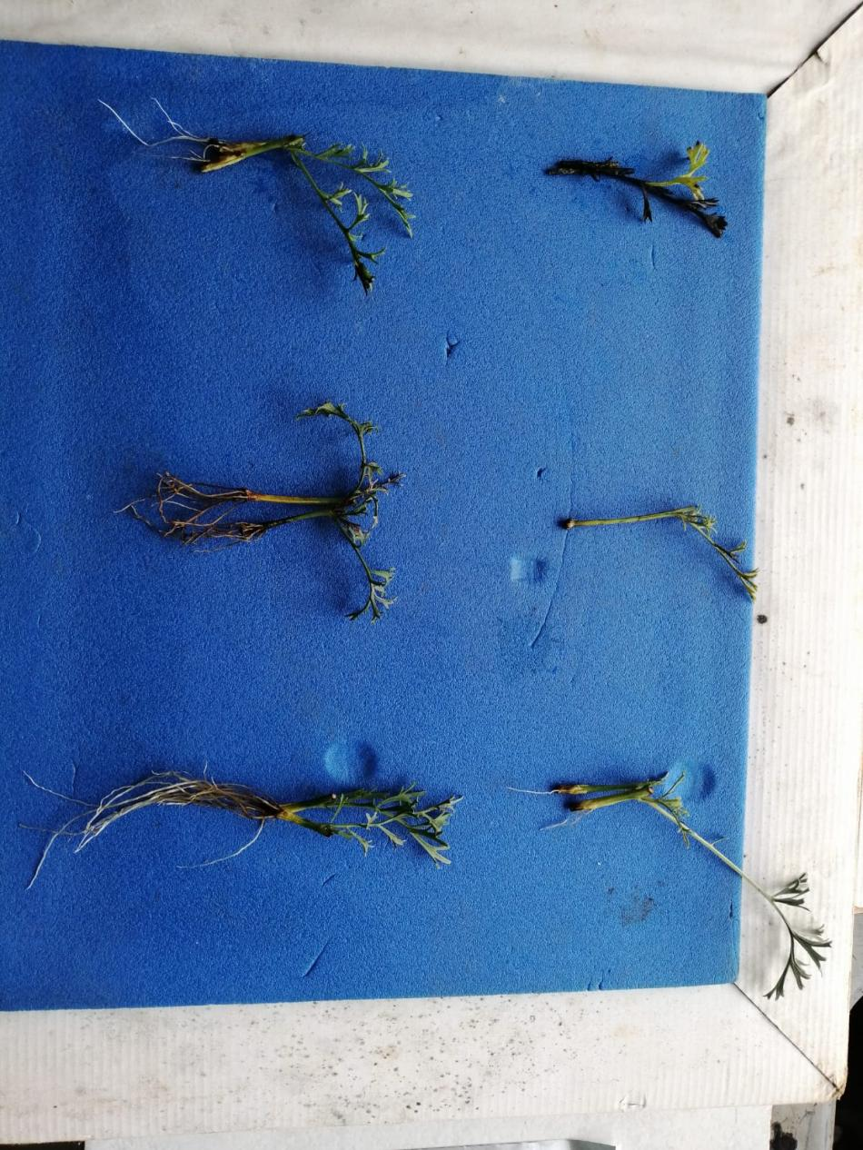
F
C
B
E
D
A
Figure 1: A) Dieback of the stem cuttings B) Non rooted cuttings which developed a callus at the base of the cutting C) Stem cuttings obtained from manure: sand D) Stem cuttings obtained from soil E) Stem cuttings obtained from soil: sand F) Stem cuttings obtained from cocopeat: sand

The pictures below show the stages of the micro propagation. From the initiation stage i, to the development of a whole plant, viii.
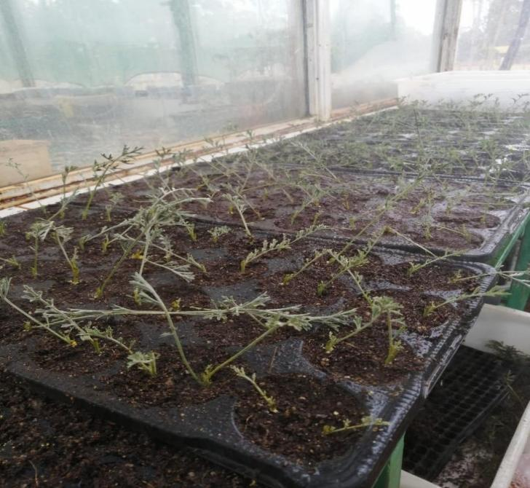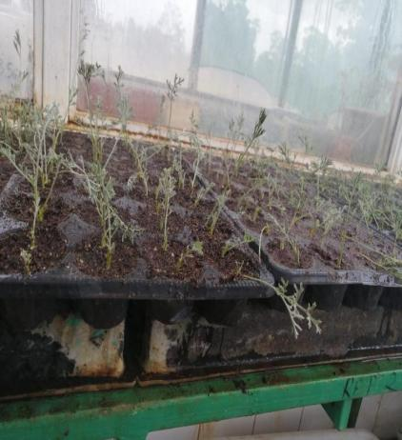
ii
i

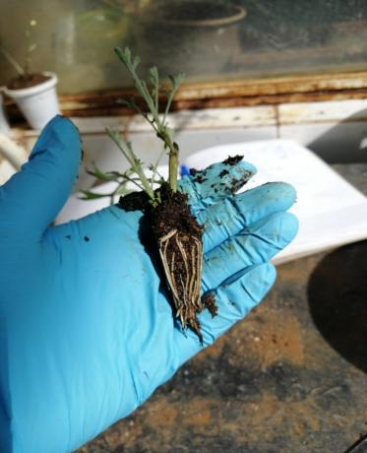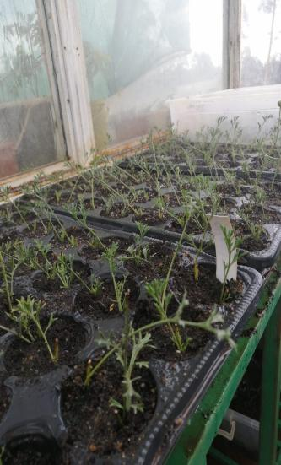
iv
iii

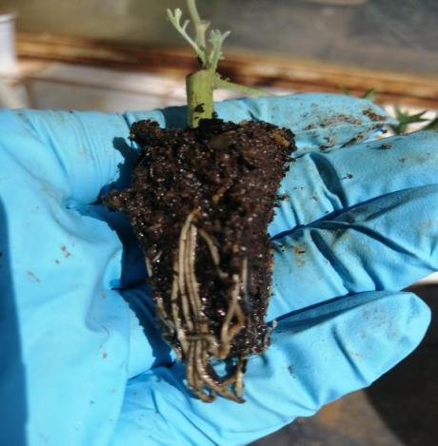 v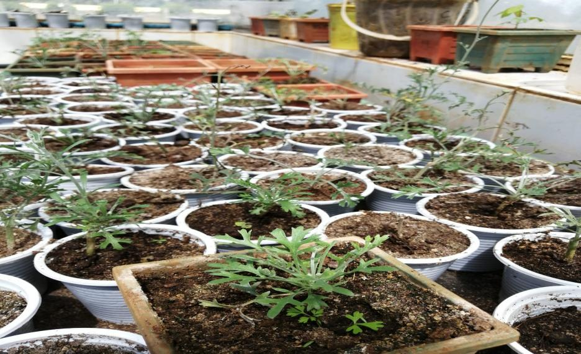
vi
V
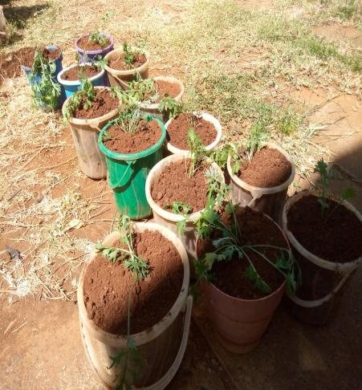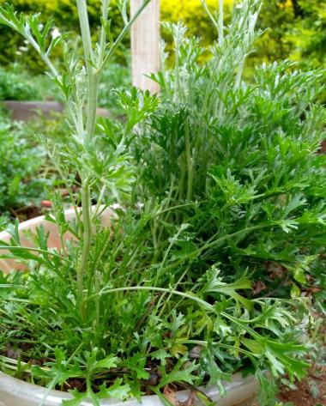
viii
viii
Fig. 2. Show the stages of the micro propagation. From the initiation stage i, to the development of a whole plant, viii

Conclusion and recommendation
The research study provides an optimized propagation protocol for pyrethrum (Chrysanthemum cinerariifolium) stem cuttings. Propagation with a combination of cocopeat: sand at ratio 1:1 and IBA powder at 0.6% was found to be the most effective to influence rooting. It is also recommended that the stem cuttings be maintained at optimum growth conditions of 26-280C. Frequent misting of 30 seconds after 30 minutes is encouraged to create relative humidity of 75-80%. Frequent misting should be incorporated with good drainage system for aeration.
Acknowledgement
This work was carried out at the University of Eldoret lab, Kenya and part funding was from the University. The technical staff were of great help. The Kentegra pyrethrum company provided the plant materials for the study and part of the funding.

REFERENCES
Adugna, M., Assefa, T., & Tesfaye, B. (2015). Effects of growth media on rooting and growth
performance of vegetative cuttings of some ornamental plants. African Journal of
Agricultural Research, 10(13), 1564–1573. https://doi.org/10.5897/AJAR2014.8890
Chauhan Aanchal, Deepa Sharma, Rajeev Kumar, Kumari Shiwani and Neha Sharma., (2021).
Methods of Propagation in Vegetable Crops. Recent trends in propagation of forest and
horticultural crops. Taran publications. ISBN 978-81-947336-4-5
Hartmann, H. T., Kester, D. E., Davies, F. T., & Geneve, R. L. (2011). Plant Propagation:
Principles and Practices (8th ed.). Prentice Hall.
Kenya National Bureau of Statistic (KNBS), (2024). National Agriculture Production Report.
Modi G, Soni RK. (2024). Analyzing the impact of growth hormones on in vitro propagation of Anacyclus pyrethrum. AGBIR.2024;40(4):1226-1228.
Kumar, M., Chaudhary, V., & Sirohi, U. (2021). Plant growth regulators and their implication in
ornamental horticulture: an overview. International Journal of Agriculture, Environment
and Biotechnology, 14(3), 417-445.
Liu Y, Vaghefi N, Ades PK, Idnurm A, Ahmed A, Taylor PW. Globisporangium and Pythium
species associated with yield decline of Pyrethrum (Tanacetum cinerariifolium) in
Australia. Plants. 2023 Mar 17;12(6):1361.
Mabizela et al. (2017). Effects of growth media properties on root development and nutrient
uptake in plants.
Uasin Gishu County Integrated Development Plan (CIDP), 2023–2027, (2023) .
Ullaha, R., Chachar, M., Rasoolb, A., Khanc, A., Ahmeda, Z., Ahmeda, S., & Hakroa, R. A
(2023). Assessing the impact of indole-3-butyric acid (iba) on rooting efficiency in
carnation (dianthus caryophyllus l.) propagation under protected conditions
Yu J, Liu W, Liu J, Qin P and Xu L (2017) Auxin Control of Root Organogenesis from
Callus in Tissue Culture. Front. Plant Sci. 8:1385. doi: 10.3389/fpls.2017.01385
Zhang, J., Hou, J., Yang, Y., Zeng, Q., Wu, L., Li, F., & Ma, J. (2017). Numerical and statistical
analyzing of the effect of operating parameters on syngas yield fluctuation in entrained
flow coal gasification using split-plot design. Energy & Fuels, 31(6), 5870-5881.
Disclaimer (Artificial intelligence)
Author(s) hereby declare that NO generative AI technologies such as Large Language Models (ChatGPT, COPILOT, etc.) and text-to-image generators have been used during the writing or editing of this manuscript.

