Neuroprotective and Antidepressant-like Effects of Gladiolus aequinoctialis (Irideaceae) Ethanolic Extract in Wistar Rats

.
ABSTRACT
Aims: Depression causes wide changes in the brain and blood parameters. This study investigated the effect of the ethanol extract of Gladiolus aequinoctialis (G. aequinoctialis) in regulation of hormones and neurotransmiiters balance in depressed Wistar rats.
Methodology: Depression was evaluated using sucrose and force swim tests. None depressed adult Wistar rats were depressed using CUMS (deprivation of water, food, dark cycle and congested) for over 6 weeks. They were grouped into group of 5 rats and treated with extract at different doses (25, 50, 100 mg/kg), 5 ml/kg of distilled water (Negative control) and 1 mg/kg of diazepam (positive control) for 38 days. After treatment, the motor activities were evaluated and animals were sacrificed. Brain tissue was examined through histological examination as well as brain levels of dopamine (DA), norepinephrine (NE) and serotonin (5-HT), and serum levels of, ACTH (adrenocorticotropic hormone), CRH (cortocotropin releasing hormone) and CORT (corticosterone) were evaluated using ELISA kits. The analysis of variance (ANOVA) followed by the Student-Newman-Keuls test was performed to establish the difference between groups at p<0.05.
Results: Results indicated that the extract of G. aequinoctialis caused a significant increase in sucrose intake and reduction in immobility time in swimming test, motor coordination, locomotive behavior compared to the negative control (p<0.05). Extract also reduced the brain levels of DA, NE and 5-HT in depressed animals compared to non-treated. Moreover, extract significantly (p<0.05) lowered serum levels of ACTH, CRH and CORT in depressed animals. Furthermore, the extract prevented the neuropathological alteration in the hippocampus, amygdala, gyrus and cortex compared to depressed animals.
Conclusion: This study therefore demonstrated that the consumption of the ethanolic fraction of G. aequinoctialis by preventing the disruption of motor activities, changes in levels of DA, NE, 5-HT ACTH, CRH and CORT in depressed rats , demonstrated it is a promising phytomedecine for the management of depression.

Keywords: Depression, Gladiolus aequinoctalis, Behavior, neurotransmitters, hormones
1. INTRODUCTION
Depression is a mental illness that affects both mental and physical health, contributing to a significant global burden of neurological diseases and disability (World Health Organization, 2021). It is characterized by a persistent loss of interest or pleasure in activities, sleep disturbances, low mood, fatigue, and even suicidal ideation (Ferrari et al., 2022). Depression impairs emotional and cognitive functioning, reducing quality of life and productivity. Moreover, individuals with major depressive disorder (MDD) face an increased risk of developing comorbidities such as cardiovascular disease, metabolic syndrome, and obesity, all of which contribute to elevated morbidity and mortality (Penninx et al, 2018). The World Health Organization estimates that over 300 million people globally suffer from depression, making it one of the leading causes of disability worldwide (World Health Organization, 2021).
In countries like Cameroon, neuropsychiatric disorders account for around 6.1% of the total disease burden, with depression being among the top contributors (Global Burden of Disease Collaborative Network, 2020). Neurochemical imbalances involving serotonin (5-HT), norepinephrine, and dopamine are commonly observed in patients with depression (Pittenger & Duman, 2020). The pathophysiology of depression includes dysregulation of the hypothalamic-pituitary-adrenal (HPA) axis, glucocorticoid receptor resistance, and chronic neuroinflammation—leading to structural and functional impairments in the brain (Zhang et al., 2023). While traditional antidepressants like milnacipran, a serotonin-norepinephrine reuptake inhibitor (SNRI), are used in treatment, their efficacy varies by dose, and relapse rates remain high (Cipriani et al., 2018).
Several newer agents, including selective 5-HT1A receptor agonists, have shown promise, but their antidepressant efficacy in clinical trials has been limited (Smith et al., 2023). Likewise, nefazodone, a 5-HT2 receptor antagonist, has shown only modest benefits. Despite the availability of various antidepressants, treatment-resistant depression and recurrence remain significant issues—warranting the search for novel therapeutic molecules. In this context, Gladiolus aequinoctalis, a perennial herb from the Iridaceae family (commonly called titamutoh in Bafut, Cameroon), is of particular ethnobotanical interest. Other species such as Gladiolus dalenii are traditionally used in Cameroonian folk medicine to manage conditions like schizophrenia, seizures, and headaches. Aqueous extracts of G. dalenii have shown anticonvulsant and sedative effects in mice, likely through modulation of the GABAergic system (Ngoupaye et al., 2013). Furthermore, studies suggest G. dalenii exerts antidepressant-like effects in epilepsy-induced depressive models, potentially via BDNF upregulation and HPA axis restoration (Fotsing et al., 2017). However, G. aequinoctalis remains under-researched despite belonging to the same genus and potentially sharing phytochemical profiles. Further exploration of its pharmacological properties could provide a novel approach to depression treatment. In a preliminary studies, the ethanolic extract showed that is very rich in compounds such as phenols, saponins and flavonoids, which are known for their antioxidant and neuroprotective effects. Therefore, in this study, we examined the behavioral, anti-inflammatory and hormonal regulatory effects of ethanolic extract of G. aequinoctalis in depressed rats.

2. material and methods
2.1. Plant collection and extraction
A specimen of G. aequinoctialis was harvested in Bambili (Latitude 5º 59’ 0’’ N; Longitude 10º 15’ 0’’ E) in Tubah subdivision, Mezam Division, North West region, Cameroon during the month of September 2024. The specimen was taken to the National Herbarium at Yaounde for identification and authentication. G. aequinoctialis was authenticated in comparison with the specimen collected by Letouzey R 8624 of the National Herberuim (No: 17902SRFCam). The corms of G. aequinoctialis were therefore harvested, washed in water to remove dust and mud and was dried under ambient air for a month. The corms were grounded using a blender to get the powder form. The powder (200g) was macerated in 2 liters of 95%v/v ethanol with constant shaking for 72hours and was filtered using Whatman filter paper No 1. The filtrate was evaporated to dryness in an oven at 35ºC for 72hours. A dry matter representing the ethanol extract of 6.2g was obtained and kept at 4ºC. The extract yield of 3.1% was obtained using the following formula.
$Percentage yield= \frac{weight of extract obtained}{weight of plant material used}$ × 100

2.2. Experimental animals
Wistar female rats (150 ± 10 g) were obtained from the Animal house in the University of Yaounde I, Cameroon. Rats were raised in the animal house and kept under room temperature with a 12 hours /12 hours’ light-dark cycle. The animals were caged in plastic basins of dimension (48.5 cm × 33.5 cm × 22.5 cm) and fed with an appropriate diet at their pleasure on fresh standard pellets of 15kg of corn flour, 2.5kg of powdered dry fish, 1.5g of bone, 1g of wheat and multivitamins) and were given tap water. Animals were acclimatized for 2 weeks and they were handled according to the Cameroon National Veterinary Laboratory guideline (No 003/19 CCS/MINEPIA/RD-NW/DDME/SSV). The protocol was approved the Scientific Committee of the Biological Sciences.
2.3 Selection of none depressed rats
- Sucrose preference test
The sucrose preference test is use to assess anhedonia and the Sucrose preference test was carried out following the protocol described by Gong et al., 2024. Animals were placed into one per cage throughout this test duration and were presented two bottles simultaneously in the home cage, one containing a 100% w/v sucrose solution, and other containing standard drinking water (100mL/kg) during 48h training session. To prevent the preference to position, the location of the two bottles were varied during this period. After 18h period of water deprivation, test session was conducted. The amount of liquid remaining in each bottle will be measured at the end of the testing period. The sucrose preference (SP) score was expressed as percentage of total liquid intake using to the following equation:
$$SP= \frac{SI}{SI+WI} x 100$$
Where, SI = sucrose intake in grams and WI = water intake in grams.
Animals consumed with SP high than 65% were considered none depressed and selected for the study (swimming test).
- Force swim test.
Forced swim test was performed as previously reported in various studies (Liu, et al., 2024). One day prior to the test, each rat were preselected by placing in a clear plastic tank (45 cm x 35 cm x 60 cm) containing water (24 ± 0.5⁰C) up to the level 30 cm for 15 min. Twenty-four hours later, they were again placed in tank with the water and the total immobility period within a 5 mins was recorded as immobility scores (in sec). A rat was judged to be immobile when its hind legs were no longer moving and the rat was hunched forward (a floating position). The immobility time was recorded by an observer who was blind to the treatment. Hence, mobile animals were therefore selected for the experiment.
2.4. Grouping, treatment and induction of depression
After the rats were acclimatized and tested for depression, 36 female Wistar rats were divided into six different groups of 6 rats each (n=6). Excluding the group taken as Normal group, the different groups of animals were therefore treated and exposed to stressors (induction of depression) for 38 days. Depression was induced using cumulative unpredictable mild stress (CUMS) method by exposing the rats to four stressors (congestion, water deprivation, food deprivation and dark cycle) at random order (Zhao et al., 2024). Animals were congested by placing them 6 per cage instead of the usual one per cage and were subjected to 24-hour water deprivation, 24-hour food deprivation, 12-hour dark cycle and 24-hour congestion, with all the stimuli administered at random a day (by alternating the time of the stressors).
Treatment was done orally using an orapharygeal cannula and Diazepam (1mg/kg) was used as reference drug (Ma et al., 2024). The solid extract was diluted with in distilled water at different concentration. The various groups were treated as follows:
- Normal group (NrGrp): received 10mg/kg of distill water only
- Negative group (NgGrp): received 10mg/kg of distill water and were subjected to depression
- Positive group (PsGrp): received 1mg/kg of diazepam and were subjected to depression
- Group 4 (25EE): received 25mg/kg of ethanol extract (EE) of Gladiolus aequinoctialis (G. aeq) and were subjected to depression
- Group 5 (50EE): received 50mg/kg of ethanol extract (EE) of Gladiolus aequinoctialis (G. aeq) and were subjected to depression
- Group 6 (100EE): received 100mg/kg of ethanol extract (EE) of Gladiolus aequinoctialis (G. aeq) and were subjected to depression
After the 38 days of treatment, the behavioral tests were carried out to assess anti-depressive and motor activities. Animals were sacrificed to collect bio specimens for analysis.
2.5. Sacrifice and collection of samples
After treatment, rats were fasted overnight and were sacrificed by cervical dislocation. Venous blood was collected in each rat into heparinized tubes and centrifuged at 3000 rpm for 15 mins to obtain serum (stored for 3 days in the freezer at -20ºC) before use for the analysis of hormones. Brain was also collected for histological analysis and to assess the neurotransmitter levels. To prepare the homogenate for neurotransmitters analysis, brain was removed put on ice, weighed and homogenized in 0.1 M phosphate buffer (pH 7.4) at 5%. The homogenates were centrifuged at 10,000 g for 15 min and aliquots of supernatants was separated and used for the analysis of neurotransmitters. For histological analysis, the whole brain was put in 10% formalin.
2.6. Y-Maze Test
The Y-maze test was carried out to assess the spatial working memory and the test was conducted according to the protocol describe by Eduviere et al. (2015). The Y-maze apparatus consists of a chamber with three arms labeled A, B, and C, symmetrically separated at 120°. Each rat was placed in arm A of the Y-mazea pparatus and allowed to explore all three arms for 5 minutes. Frequency of arm entries and alternations (consecutive navigations through the three arms, that is, ABC, CAB, or BCA but not BAB or ABA) was assessed in this test (Eduviere et al., 2015). The maze was cleaned with70%ethanolaftereachtestto remove residual odor. The percentage (%) of correct alternations (an index of memory performance) was calculated as follows:
(F₂) $\% Alternation=\frac{total number of alternation}{Number of visits-2} X 100$
2.7 Open-field test
The open-ﬁeld was tested to assess both exploratory behavior and locomotor activity according to the protocol described by Chen et al. (2019). The test consists of a box made from gray wood measuring 40cm × 40cm × 45cm. One rat was placed at the center of the device and allows to freely exploring the arena. The number of rearing, crossing, grooming, and the time spent at the center was recorded over a 5minutes period for each animal. At the end of each observation, the rat was returned to its home cage, and the device cleaned with 70% ethanol
2.8. Beam walking test (BWT)
Motor coordination was tested using the beam walking test in a wood strip (20-mm diameter) as described by Gonzalez-Usano et al. (2014). Briefly, mice had to cross a 1-m long wooden stick located approximately 1 m above the ground and observers counted the number of slips committed by the animals, the total distance travelled and the number of turns of the animal for 5 min. The number of foot faults (slips) served as a measure of incoordination.
2.9. Brain neurotransmitter and hormone levels analysis
Competitive ELISA was used to quantify the level of neurotransmitters namely: NE, DA, and 5-HT in brain homogenate and serum levels of hormones: CRH, CORT and ACTH. This assay employs the competitive ELISA principle in which the microplate is precoated with antibody specific for each of the test parameters. The assay was carried out according to the procedure and instructions of the manufacturer of the specific kits for neurotransmitter (ELISA Kits obtained from Elascience, USA). 50ul of each standard or samples were added into appropriate microplate wells and immediately Biotin-detection antibody work solution. The plate was seal and incubates at 37ºC for 45 minutes. The solution was discarded and washes 3 times. After, 0.1 ml of HRP¬Streptavidin conjugate working solution was added to each well. The plate was covered and incubated for 30mins at 37ºC. The solution was discarded and the wells were washed 5 times and 90ul of TMB substrate were added into each well, covered and incubate at 37ºC in dark within 15-30 min and observed for color change. 50ul of stop solution were added to each well and the result was read at 450nm within 20 minutes immediately using ELISA URIT 660 machine. The intensity of the color is measured in proportion to the amount NE, DA, 5-HT CORT, CRH and ACTH were express as pg/mL using the standard curve.
2.10. Histological examination
The brain tissue was fixed in 10% formalin for one week, washed in running tap water for 24 h and dehydrated in ascending series of ethanol (50–90 %), followed by absolute alcohol. The samples were cleared in xylene and immersed in a mixture of xylene and paraffin at 60ºC. The tissue was transferred to pure paraffin wax of the melting point 58°C and then mounted in blocks and left at 4°C. The paraffin blocks were sectioned on a microtome at thickness of 5 μm and mounted on clean glass slides and left in the oven at 40°C to dryness. The slides were deparaffinized in xylene and then immersed in descending series of ethanol (90–98%). The ordinary hematoxylin and eosin stain were used to stain the slides (Paxinos & Watson, 2007).
2.11. Statistical analysis
Data obtained in this study was entered in Micro soft Excel 2016 sheets and statistically analyzed using the graph pad Prism 9.0. The analysis of variance (ANOVA) followed by the Student-Newman-Keuls test was performed to establish the difference between groups. Differences between comparable sets of results was considered significant when p <0.05. All data are to be represented in charts and in tables as mean ± standard error (mean ± SE).

3. results and discussion

Results

3.1. Effect anti-anhedonia of the ethanol extract of Gladiolus aequinoctialis in CUMS-induced rat depression model
As illustrated by Figure 1, the sucrose consumption increased in depressed animals after 35 days of the induction of depression compared to the sucrose consumption before induction of depression (p<0.001). The consumption of sucrose by the normal animals, and the animals submitted to daily depressed stimulus but receiving the diazepam and the extract (25, 50 and 100 mg/kg) do not change significantly after the 35 days of experiment (p > 0.05).
Figure 1: Sucrose consumption by animals before and after induction and treatment with the ethanol extract of Gladiolus aequinoctalis or diazepam. Values represent Mean ± SD of 6 rats per group. *p>0.05 indicate no difference and ***p<0.001 indicates significant difference compared to depressive control or negative group (NegPg).
3.2 The effect of ethanol extract of G. aequinoctialis in depressive behavior (force swim) in CUMS-induced rat depression model
Results (Figure 2) showed there was significant difference (p<0.05) in the immobility period of normal animal compared to animals to which depressed stimuli were applied for 35 days. The immobility period was lower in the depressed animals compared to the normal animals. Comparing the animals that received the extract or diazepam during the period of the application of the depressed stimuli, the results showed that the immobility period significantly increased in animals treated with the extract of G. aequinoctalis at 50 mg/kg followed by dose 100mg/kg, 25mg/kg (p<0.05) and animals treated with diazepam (p<0.001).
Figure 2: Force swim of rat treated with the ethanol extract of Gladiolus aequinoctalis of female wistar rats subjected to depression. Values represent Mean ± SD of 6 rats per group. ^{b}p<0.01; ^{c}p<0.001 indicate difference compared to depressed group. NrGrp: Normal group. NegGrp: Negative group. PsGrp: Positive group.
3.3 The effect of ethanol extract of G. aequinoctialis in motor coordination and balance (beam walking) in CUMS-induced rat depression model
The results in Table 1 represent the effect of the treatment of G. aequinoctialis on motor coordination and balance assess using beam walking on depressed rats. These results show a significant increase (p<0.001) in the distance travelled by rats that were not subjected to depression compared to those that were subjected to depression without. Animals that received G. aequinoctialis treatment (25mg/kg, 50mg/kg 100mg/kg) showed an increased (p<0.001) in the distance travelled compared to those treated only with distill water and were depressed. Furthermore, they were a significant decrease in the number of pauses, foot-slip and number of turns observed in animals in the normal control group compared to the negative control where there was a significant increased. A decreased in the number of pauses foot-slip and number of turns was also observed in animals treated with G. aequinoctialis (25, 50 and 100 mg/kg) compared to the negative control group which shows an increased number of paused, foot-slip and number of turns.

3.4. The effect of ethanol extract of G. aequinoctialis on exploration and locomotor behaviour (open file test) in CUMS-induced rat depression model
The results in Table 2 represents the effect of the treatment of G. aequinoctialis on exploration and locomotor activity, these results show a significant increase (p<0.001) in the distance travelled by rats that received just distill water and were not subjected to depression compared to those that were subjected to depression that shows a significant decreased in the distance traveled. Animals that received G. aequinoctialis treatment (25mg/kg, 50mg/kg 100mg/kg) showed an increased (p<0.001) in the distance travelled compared to those treated only with distill water and were depressed to depression. Furthermore, they were a significant decrease (p<0.01) in the duration of grooming, time speed in the center square and the number of grooming in animals treated only with distill water compared to the negative control group that shows a significant increased (p<0.001) in the during of grooming, time speed in the center square and the number of grooming. Also, a decreased in the duration of grooming, time speed in the center square and the number of grooming in animals were observed in animal treated with G. aequinoctialis (25mg/kg, 50mg/kg 100mg/kg) compared to the negative control group which shows an increased number in the during of grooming, time speed in the center square and the number of grooming of animals that were subjected to depression.

Table 1: Coordination behavior on beam walking following the treatment with the ethanol extract of Gladiolus aequinoctalis and diazepam in the depressed Wistar rats.
Parameters | NrGp | NeGp | PsGp | EE25 mg/kg | EE50 mg/kg | EE100 mg/kg | ANOVA sig.
Distance (cm) | 1602±191.1^{c} | 273.3±16.87 | 1430±260.1^{b} | 1052±197.7ª | 1358±208.2ª | 605±5.0 | P<0.001
Number of turns | 3.50±0.34^{c} | 15.67±0.49 | 3.50±0.50^{c} | 3.333±0.33^{c} | 2.50±0.22^{b} | 1.667±0.33^{b} | P<0.001
Foot slips | 0.833±0.16^{c} | 5.667±0.42 | 1.83±0.40^{c} | 1.333±0.21^{c} | 1.5±0.22^{b} | 1.333±0.21^{c} | P<0.001
Pauses (s) | 2±0.365^{c} | 8.5±0.428 | 2.5±0.22^{c} | 1.333±0.210^{c} | 1.33±0.21^{c} | 1.333±0.21^{c} | P<0.001
Values represent Mean ±SEM of 6 rats per group. ªp<0.05; ^{b}p<0.01; ^{c}p<0.001 indicate difference compared to depressed group. NrGrp: Normal group. NegGrp: Negative group. PsGrp: Positive group. EE25, EE50, and EE100 mg/kg are groups receiving doses of ethanol extract.

Table 2: Exploratory behaviors on open field following the treatment with the ethanol extract of Gladiolus aequinoctialis and diazepam in the depressed wistar rats.
Parameters | NrGp | NeGp | PsGp | EE25 mg/kg | EE50 mg/kg | EE100 mg/kg | ANOVA sig.
Distance (cm) | 1408±10.12^{c} | 720.3±12.17 | 1403±9.34^{c} | 1094±9.44^{c} | 1303±10.88^{c} | 1127±63.49^{c} | p<0.001
Number of square entries | 87.67±0.71^{c} | 44.83±0.6 | 87.5±0.56^{c} | 69.33±0.61^{c} | 82.1±0.73^{c} | 66.33±3.74^{c} | p<0.001
Grooming | 1.333±0.33^{c} | 8.50±1.18 | 1.16±0.16^{c} | 2.0±0.16^{c} | 1.16±0.17^{b} | 1.333±0.21^{c} | p<0.001
Duration of grooming | 3.167±0.31^{c} | 8.67±0.84 | 2.83±0.16^{c} | 2.5±0.5^{c} | 2.83±0.65^{c} | 2.167±0.54^{c} | p<0.001
Time in square | 1.67±0.21^{b} | 6.83±1.54 | 0.67±0.42^{c} | 1.0±0.63c | 1.67±1.05^{b} | 1.67±1.05^{b} | p<0.001
Values represent Mean ±SEM of 6 rats per group. ªp<0.05; ^{b}p<0.01; ^{c}p<0.001 indicate difference compared to depressed group. NrGrp: Normal group. NegGrp: Negative group. PsGrp: Positive group. EE25, EE50, and EE100 mg/kg are groups receiving doses of ethanol extract.

3.5. Effect of ethanolic extract of G. aequinoctialis against CUMS-induced hyperactivity of HPA axis and hypersecretion of neurotransmitters in CUMS-induced rat depression model
As shown in (Table 3) the serum level of serotonin showed significant difference (p<0.05) in the normal animals that received only distilled water when compared to animals that were not treated but were subjected to depression. Compared to negative group significant difference was observed in animals that were treated with the plant extract at the doses 25mg/kg (p<0.05), 50mg/kg (p<0.01) and 100mg/kg (p<0.001).
In comparison to the depressed animals, the serum level of noradrenaline observed, shows no significant difference (p<0.05) in the normal group when compared to animal that were subjected to depression. Animals that were treated with the plant extract (25mg/kg, 50mg/kg, 100mg/kg) promote the secretion of noradrenaline when compared to the depressed group that did not receive treatment (p<0.001, p<0.5, p<0.01) respectively.
It was observed that there was a significant difference in the serum level of dopamine in the normal group when compared with the depressed group that did not receive treatment (p<0.001). On the other hand, group treated with the extract (50mg/kg, 100mg/kg) increase the serum level of dopamine when compared to the depressed animals that did not receive treatment (p<0.001). There was no significant difference with the group treated with 25mg/kg of G. aequinoctialis compared to the depressed animals that were not treated (p<0.05).

Table 3: Serotonin, norepinephrine and dopamine levels following the administration of ethanolic extract of G. aequinoctialis in CUMS-induced rat depression model rats
 | 5-HT (ng/g tissue) | NE(ng/g tissue) | DA (ng/g tissue)
NrGp | 1.21±0.17ª | 1.13±0.10ª | 1.87±0.13^{c}
NeGp | 0.47±0.11 | 0.36±0.11 | 0.63±0.17
PsGp | 1.55±0.26ª | 0.46±0.11 | 1.82±0.08^{c}
EE 25 mg/kg | 1.60±0.45^{b} | 1.29±0.27 | 0.56±0.17^{ns}
EE 50 mg/kg | 1.89±0.45^{c} | 1.70±0.27^{b} | 1.94±0.10^{c}
EE100 mg/kg | 1.89±0.39^{c} | 1.38±0.26ª | 2.11±0.22^{c}
ANOVA Sig. | F_{(5,24)}= 2.535; P<0.560 | F_{(5,24)}=7; P<0.002 | F_{(5,24)}=20.30; P<0.001
Valus represent Mean ± SD serum level of 5-HT, NE, and DA of 6 rats per group. ªp<0.05; ^{b}p<0.01; ^{c}p<0.001 indicate difference compared to depressed group. NrGrp: Normal group. NegGrp: Negative group. PsGrp: Positive group. EE25, EE50, and EE100 mg/kg are groups receiving doses of ethanol extract.
3.6. The effect of the ethanol extract of Gladiolus aequinoctialis on the brain level of corticosterone in CUMS-induced rat depression model
There is a significant increase in serum level of corticosterone (Figure 3) in the depressed animals when compared to the normal group that were not subjected to depression (P<0.001). Administration of the ethanol extract of Gladiolus aequinoctialis prevented the increased of the serum level of corticosterone compared to the depressed animals that received no treatment (P<0.001). There is no statistical difference between the group of animals treated with the extract at the doses 50mg/kg and 100mg/kg compared to the normal group (p<0.001).

.
Figure 3 Variation of serum level of corticosterone following the treatment with the ethanol extract of Gladiolus aequinoctalis and diazepam in the depressed Wistar rats. Valus represent Mean ± SE of 6 rats per group. ªp<0.05; ^{b}p<0.01; ^{c}p<0.001 indicate difference compared to depressed group. NrGrp: Normal group. NegGrp: Negative group. PsGrp: Positive group.
3.7. The effect of the ethanol extract of Gladiolus aequinoctialis on the serum level of ACTH in CUMS-induced rat depression model
There is a significant increase in serum level ACTH (Figure 4) in the depressed animals when compared to the normal group that were not subjected to depression (P<0.001). Administration of the ethanol extract of Gladiolus aequinoctialis prevented the increased of the serum level ACTH compared to the depressed animals that received no treatment (P<0.001). There is no statistical difference between the group of animals treated with the extract at the doses 50mg/kg and 100mg/kg compared to the normal group (p<0.001).
Figure 4: Variation of serum level of adrenocorticotropic hormone following the treatment with the ethanol extract of Gladiolus aequinoctalis and diazepam in the depressed wistar rats. Valus represent Mean ± SEM of 6 rats per group. ªp<0.05; ^{b}p<0.01; ^{c}p<0.001 indicate difference compared to depressed group. NrGrp: Normal group. NegGrp: Negative group. PsGrp: Positive group.
3.8. The effect of the ethanol extract of Gladiolus aequinoctialis on the serum level of CRH in CUMS-induced rat depression model
There is a significant increase in serum level CRH (Figure 5) in the depressed animals when compared to the normal group that were not subjected to depression (P<0.001). Administration of the ethanol extract of Gladiolus aequinoctialis prevented the increased of the serum level CRH compared to the depressed animals that received no treatment (P<0.001). There is no statistical difference between the group of animals treated with the extract at the doses 50mg/kg and 100mg/kg compared to the normal group (p<0.001).

Figure 5: Variation of serum level of cortocotropin releasing hormone following the treatment with the ethanol extract of Gladiolus aequinoctalis and diazepam in the depressed wistar rats. Valus represent Mean ± SEM of 6 rats per group. ªp<0.05; ^{b}p<0.01; ^{c}p<0.001 indicate difference compared to depressed group. NrGrp: Normal group. NegGrp: Negative group. PsGrp: Positive group.
3.9. Effect of ethanol extract of G. aequinoctialis on CA1, CA3, Gyrus, amygdala, hippocampal and cortex structure in CUMS-induced rat depression model
Figure 6 showed the effects of treatment with ethanol extract of extract of G. aequinoctialis on the structure of the hippocampus and cortex. The figure shows that G. aequinoctialis induced hyperchromatic nuclei, neuronal cytolysis, neuronal dispersion and edema in CA1, CA3, gyrus and cortex compared with normal animals. extract at different doses corrected these alterations by preventing the formation of hyperchromatic nuclei, neuronal cytolysis and neuronal dispersion of oedema in the CA3, CA1, gyrus regions, compared with sick animals treated with distilled water.

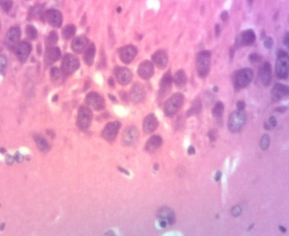
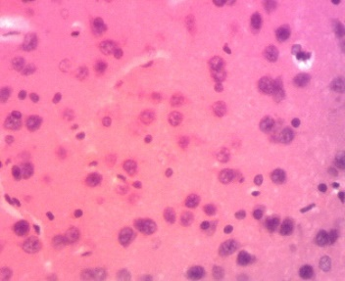
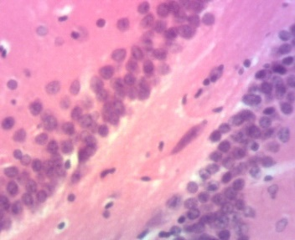
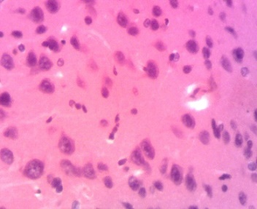
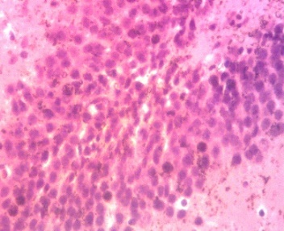
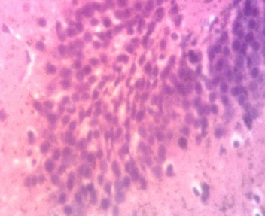
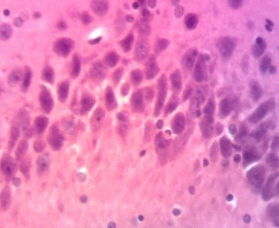
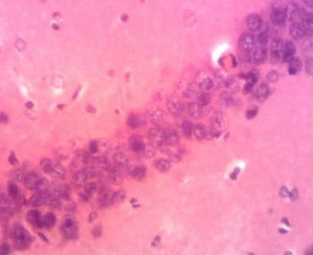
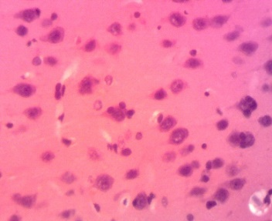
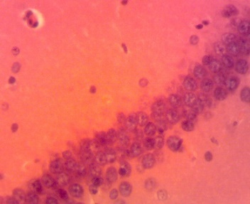
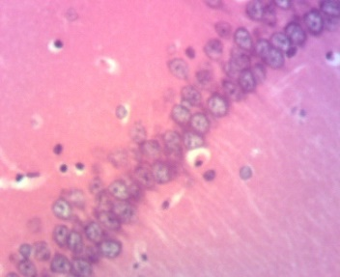
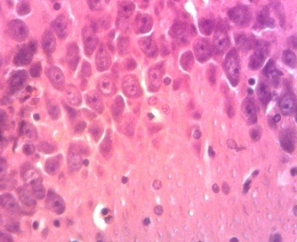
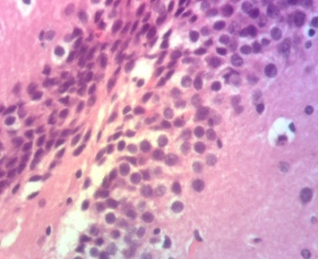
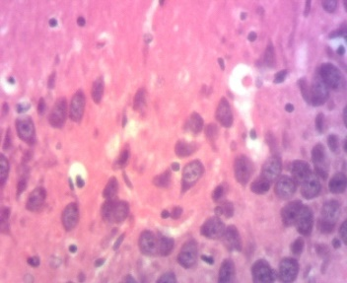
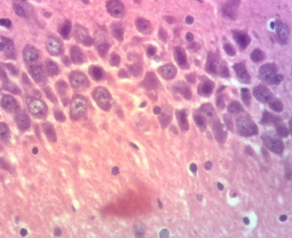
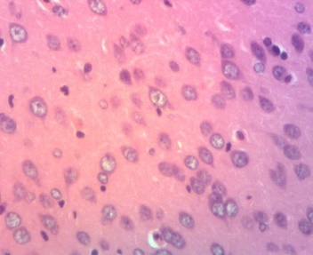
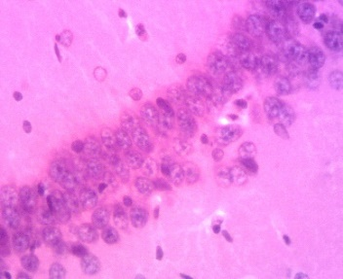
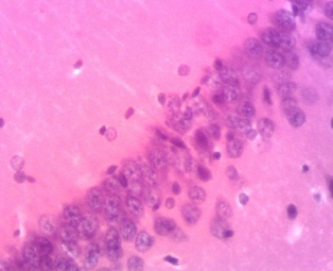
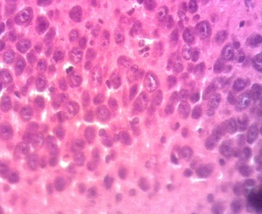
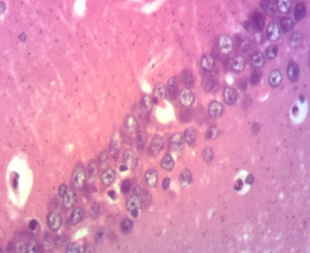
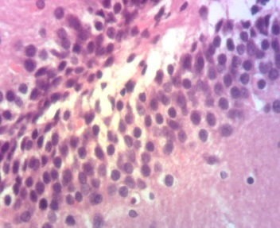
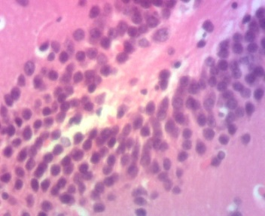
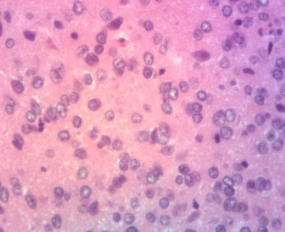
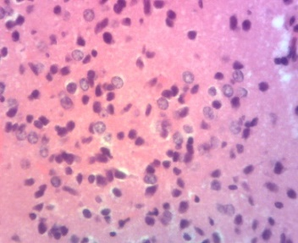
Cn
NC
Nh
Ce
Hn
NL
Nn
Hn
Nn
Nn
Nn
Gc
Mc
Pc
Gyrus dente
CA3
CA1
Cortex
DW
Neg C
O
REF
O

E25
O
E50
E100
Nc
Hn
Hn

Figure 6: Microscopic images of the hippocampal area and the cortex from the different studied groups and neuroprotective outcomes after treatment with different doses of G. aequinoctialis. Nn: Normal neuron. O: Oligodendrocyte. On: Oligodendrocyte necrosis. NL: Neuronal loss. Hn: Hyperchromatic nucleus. Pn: Neuronal loss. Gc: Granular cell layer. Pc: Polymorphic cell layer. Mc = Molecular layer; Nd = Neuronal degeneration.

Discussions
This study aimed at evaluating the effects of the ethanol extract of G. aequinoctialis in prevention of changes in behavior, neurotransmitters and hormones concentrations and brain tissue in depressed Wistar rats. G. aequinoctialis is commonly used to treat neurological diseases and it used at low doses according the traditional healers in Cameroon. The preliminary study of ethanol extract of G. aequinoctialis also demonstrated that the extract is toxic at high doses. In this study, the Lethal dose 50 (LD50) was found to be 329.58 mg/kg, with a concentration inducing hemolysis in 50% of rat erythrocyte population (HC50) and concentration inducing 50% of rat peritoneal murine cells of 53.8 mg/ml and 145.2 mg.ml respectively. Phytochemical analysis of G. aequinoctialis extract revealed the presence of various bioactive compounds, including phenols, flavonoids, saponins, and tannins. Quantitative analysis demonstrated that ethanol was the most effective solvent in extracting the highest concentrations of these phytoconstituents. This can be attributed to ethanol's intermediate polarity, which enhances the solubility of non-polar compounds, making it suitable for extracting a wide range of secondary metabolites. Compounds such as phenols, saponins and flavonoids highly found in ethanol extract of this plant, are known for their antioxidant and neuroprotective properties (Sani et al., 2024). The results align with findings from similar studies on medicinal plants where ethanol extracts often yield the highest concentrations of key bioactive constituents (Kumar et al., 2019; Singh & Singh, 2021). For instance, Gladiolus dalenii, a related species, also demonstrated higher antioxidant and antimicrobial activity in ethanol extracts, correlating with higher phenolic and flavonoid content (Fotsing et al., 2017).
Animals exposed to depressive factors showed a significant decrease in sucrose intake, likely due to stressful experiences that favor the development of depression (Boyle et al., 2023). This development can lead to weight loss and reduced sucrose consumption (Sttrkalva et al., 2007). A decrease in sucrose consumption is a putative marker of anhedonia (Willner, 2017), which is a primary feature in the chronic mild stress (CMS) depression model (Henningsen et al., 2019). Anhedonia, a core symptom of depression, along with alterations in locomotor activity and weight loss, reflect depression-like effects in CMS-treated rats (Agnieszka et al., 2024). Animals that received the extract and exposed to stressors sowed a high sucrose preference, demonstrating the antidepressant activities of the extract.
The Forced Swim Test (FST) is widely used to evaluate depressive behavior. In this study, depression increased the immobility period, indicating reduced coping behavior in the vehicle group, suggesting that depressive stress impairs behavioral responses in animals. The immobility time aligns with findings from chronic mild stress models, reflecting behavioral despair (Crowley et al., 2021). The antidepressant-like effect of the extract, shown by reduced immobility, suggests a restorative effect on stress-induced behavioral changes, comparable to anxiolytic or antidepressant agents (Zhou et al., 2020). Oxidative stress plays a significant role in neurological and neuropsychiatric disorders including depression (Saljo et al., 2022). Similar findings were reported by Szczesny et al. (2019) and Kada et al. (2022), where stressed rats showed increased immobility and decreased swimming time. The antidepressant-like effects are likely attributed to flavonoids, saponins, and phenols, known to modulate neurotransmitter systems including serotonin, dopamine, and GABA (Xu et al., 2021). Flavonoids, in particular, inhibit monoamine oxidase (MAO), reduce oxidative stress, and enhance cognition (Pannue et al., 2022).
Locomotor and motor deficiencies assessed by the Beam Walking test showed that depressed animals had decreased distance traveled and increased slips and pauses compared to controls, consistent with previous reports indicating that stress impairs motor coordination and balance (Kada et al., 2022; Wang et al., 2023). The ethanol extract of G. aequinoctialis alleviated these motor deficits, suggesting the presence of neuroprotective bioactive compounds (Fotsing et al., 2017). The Open Field Test (OFT) results showed decreased center square entries, lines crossed, and distance traveled in depressed rats, alongside increased anxiety-related parameters (Kada et al., 2022). Treatment with G. aequinoctialis extract prevented these effects, indicating anxiolytic and stress-suppressing properties (Fotsing et al., 2017).
Serotonin levels did not differ significantly between control and CUMS-exposed groups nor following extract treatment, suggesting the extract may not affect serotonergic transmission under chronic stress (Chen et al., 2023). Noradrenaline levels, however, were markedly reduced in untreated depressed rats and significantly elevated by extract doses of 50 mg/kg and 100 mg/kg (p < 0.05), implying a noradrenergic mechanism possibly through MAO inhibition or enhanced NE synthesis. Similar effects have been observed with traditional formulations such as Suanzaorenhehuan decoction (Qiuxia et al., 2017) and Caesalpinia pulcherrima extract (Li et al., 2023). Dopamine levels were also significantly restored by the extract, suggesting dopaminergic pathway involvement consistent with flavonoid-rich extracts from Apocynum venetum (Zhang et al., 2016). This selective upregulation of NE and DA, without changes in serotonin, points to a mechanism involving MAO-A/B inhibition or neurotransmitter transporter blockade (Reddy et al., 2024).
Corticosterone, a key stress hormone regulating energy and immune responses, was significantly elevated in depressed animals, consistent with HPA axis dysregulation in depression (Pariante & Lightman, 2008; Liu et al., 2023). Treatment with the ethanol extract of G. aequinoctialis at 50 and 100 mg/kg prevented corticosterone elevation, suggesting modulation of HPA axis activity (Nájera et al., 2024). These effects likely stem from flavonoids and phenolics with antioxidant and neuroprotective actions (Liu et al., 2024). Similar corticosterone-lowering effects have been observed with other plant extracts in depression models (Chen et al., 2021; Fotsing et al., 2017).
Elevated ACTH levels observed in depressed animals confirm chronic stress-induced HPA axis overactivity (Herman et al., 2016). Administration of G. aequinoctialis extract significantly normalized ACTH levels, possibly via flavonoid and polyphenol-mediated suppression of CRH release and oxidative stress reduction (Nájera et al., 2024).
Neuropathological changes in the hippocampus and cortex, including hyperchromatic nuclei and neuronal cytolysis, were consistent with depression-related neuronal damage (McEwen, 2007; Duman & Aghajanian, 2012). These histopathological changes were reversed by G. aequinoctialis extract, indicating neuroprotective and neurorestorative effects likely mediated by antioxidant and anti-inflammatory mechanisms (Bhatt et al., 2015; Zhou et al., 2019). Preservation of neuronal integrity is critical for cognitive and emotional function and supports improved behavioral outcomes (Wang et al., 2020).

4. Conclusion

This study therefore demonstrated that the consumption of the ethanolic fraction of G. aequinoctialis by preventing the disruption of motor activities, changes in levels of DA, NE, 5-HT ACTH, CRH and CORT in depressed rats, demonstrated it is a promising phytomedecine for the management of depression. The ethanolic fraction is found rich in flavonoids, saponins or alkaloids, therefore, further studies that can permit the characterization of the various types of those compounds will be important for the research of new therapeutic molecules.
Ethical consideration
Animals were were handled according to the Cameroon National Veterinary Laboratory guideline (No 003/19 CCS/MINEPIA/RD-NW/DDME/SSV). The protocol was approved the Scientific Committee of the Biological Sciences.

Disclaimer (Artificial intelligence)
Author(s) hereby declare that NO generative AI technologies such as Large Language Models (ChatGPT, COPILOT, etc.) and text-to-image generators have been used during the writing or editing of this manuscript.

References

Cipriani, A., Furukawa, T.A., Salanti, G., Chaimani, A., Atkinson, L.Z., Ogawa, Y., Leucht, S., Ruhe, H.G., Turner, E.H., Higgins, J.P., Egger, M., Takeshima, N., Hayasaka, Y., Imai, H., Shinohara, K., Tajika, A., Ioannidis, J.P., Geddes, J.R., (2018). Comparative efficacy and acceptability of 21 antidepressant drugs for the acute treatment of adults with major depressive disorder: a systematic review and network meta-analysis. Lancet 391 (10128), 1357–1366.
Ferrari, A.J., Charlson, F.J., Norman, R.E., Patten, S.B., Freedman, G., Murray, C.J.L., Vos, T., Whiteford, H.A., (2022). Burden of depressive disorders by country, sex, age, and year: findings from the Global Burden of Disease Study. Lancet Psychiatry 9 (3), 223–235.
Fotsing D, Ngoupaye GT, Ouafo AC, Njapdounke SKJ, Kenneth YA and Ngo Bum E (2017) Effects of Gladiolus dalenii on the Stress-Induced Behavioral, Neurochemical, and Reproductive Changes in Rats. Front. Pharmacol. 8:685. doi: 10.3389/fphar.2017.00685
Global Burden of Disease Collaborative Network, (2020). Global Burden of Disease Study 2019 (GBD 2019) Results. Institute for Health Metrics and Evaluation (IHME). Available at: https://vizhub.healthdata.org/gbd-results/
Ngoupaye, G.T., Fodouop, C.T., Wouatsa, N.A.V., Kamanyi, A., (2013). Antidepressant-like effects of Gladiolus dalenii aqueous extract in epileptic mice. J. Ethnopharmacol. 209, 89–97. http://www.biomedcentral.com/1472-6882/13/272
Penninx, B.W.J.H., Lange, S.M.M., (2018). Metabolic syndrome in depression: mechanisms, pathophysiology, and treatment considerations. Lancet Psychiatry 8(7), 620–631
Pittenger, C., Duman, R.S., (2020). Stress, depression, and neuroplasticity: a convergence of mechanisms. Nat. Rev. Neurosci. 21(3), 186–195.
Smith A. L. W., Harmer C. J., Cowen P. J., Murphy S. E. (2023) The Serotonin 1A (5-HT₁A) Receptor as a Pharmacological Target in Depression. CNS Drugs. A recent and insightful overview of how targeting 5-HT₁A receptors may advance pharmacological treatment strategies.
World Health Organization, (2021). Depression – Key facts. World Health Organization. Available at: https://www.who.int/news-room/fact-sheets/detail/depression
Zhang, J., Yao, W., Hashimoto, K., (2023). Inflammation-induced neurobiological mechanisms in depression. Prog. Neuropsychopharmacol. Biol. Psychiatry 121, 110658.
Qiuxia, Z., xinlong, M., yilong, Y., hui, Z., yali, W., xiaoquan, Y., lei, W., jiahui, C., & haiyan, Z. (2017). JIEYUANSHEN DECOCTION EXERTS ANTIDEPRESSANT EFFECTS ON DEPRESSIVE RAT MODEL VIA REGULATING HPA AXIS AND THE LEVEL OF AMINO ACIDS NEUROTRANSMITTER. African Journal of Traditional, Complementary and Alternative Medicines, 14(2), 33–46. https://doi.org/10.21010/ajtcam.v14i2.5
Liu F, Bai Q, Tang W, Zhang S, Guo Y, Pan S, Ma X, Yang Y, Fan H. (. 2024 ). Antioxidants in neuropsychiatric disorder prevention: neuroprotection, synaptic regulation, microglia modulation, and neurotrophic effects. Front Neurosci. 2024 Dec 5;18:1505153. doi: 10.3389/fnins.2024.1505153. PMID: 39703344; PMCID: PMC11655488
Ai Z, Cheng AF, Yu YT, Yu LJ, Jin W. (2014). Antidepressant-like behavioral, anatomical, and biochemical effects of petroleum ether extract from maca (Lepidium meyenii) in mice exposed to chronic unpredictable mild stress. J Med Food. 2014 May;17(5):535-42. doi: 10.1089/jmf.2013.2950. Epub 2014 Apr 14. PMID: 24730393; PMCID: PMC4025608.
Sinem Gencturk1 · Gunes Unal. (2024). Rodent tests of depression and anxiety: Construct validityand translational relevance Vol.:(0123456789)Cognitive, Affective, & Behavioral Neuroscience (2024) 24:191–224. https://doi.org/10.3758/s13415-024-01171-2
Fotsing D, Ngoupaye GT, Ouafo AC, Njapdounke SKJ, Kenneth YA and Ngo Bum E (2017) Effects of Gladiolus dalenii on the Stress-Induced Behavioral, Neurochemical, and Reproductive Changes in Rats. Front. Pharmacol. 8:685. doi: 10.3389/fphar.2017.00685
Strekalova T, Spanagel R, Bartsch D, Henn FA, Gass P. (2007) Stress-induced anhedonia in mice is associated with deficits in forced swimming and exploration. Neuropsychopharmacology. 2004 Nov;29(11):2007-17. doi: 10.1038/sj.npp.1300532. PMID: 15266352.
Ngoupaye, G.T., Fodouop, C.T., Kamanyi, A., (2013). Anticonvulsant activity of Gladiolus dalenii in mice: role of GABAA modulation. Epilepsy Behav. 28(3), 386–391. https://doi.org/10.1016/j.yebeh.2013.06.014
Agnieszka Pałucha-Poniewiera, Bartosz Bobula, Anna Rafało-Ulińska, Katarzyna Kaczorowska (2024). Depression-like effects induced by chronic unpredictable mild stress in mice are rapidly reversed by a partial negative allosteric modulator of mGlu5 receptor, M-5MPEP. Psychopharmacology (2025) 242:1259–1273. https://doi.org/10.1007/s00213-024-06724-4.
Herman, J.P., McKlveen, J.M., Ghosal, S., Kopp, B., Wulsin, A., Makinson, R., & Myers, B. (2016). Regulation of the hypothalamic-pituitary-adrenocortical stress response. Comprehensive Physiology, 6(2), 603–621. https://doi.org/10.1002/cphy.c150015
Kada AS, Nantia EA, Chin FJ, Manfo FPT, Vijayakumar N, Nchinda JT, Atsamo AD, Momordica foetida (Cucurbitaceae) prevents behavioral impairment, motor incoordination and brain oxidative stress induced by subchronic exposure to Parastar pesticide formulation, Journal of Drug Delivery and Therapeutics. 2022; 12(3-S):44-50 DOI: http://dx.doi.org/10.22270/jddt.v12i3-s.5368.
Saljo Simon, Sedhulakshmi K, Jerin Joseph, Dhanya George. (2022). Optimization of extraction parameters of bioactive components from Moringa oleifera leaves using Taguchi method. Biomass Conversion and Biorefinery, № 13, p. 11973-11982. https://doi.org/10.1007/s13399-021-02276-1
Behr GA, Moreira JC, Frey BN. (2012). Preclinical and clinical evidence of antioxidant effects of antidepressant agents: implications for the pathophysiology of major depressive disorder. Oxid Med Cell Longev. 2012;2012:609421. doi: 10.1155/2012/609421. Epub 2012 May 27. PMID: 22693652; PMCID: PMC3368202. https://doi.org/10.1155/2012/609421.
Boyle CC, Bower JE, Eisenberger NI, Irwin MR. (2023). Stress to inflammation and anhedonia: Mechanistic insights from preclinical and clinical models. Neurosci Biobehav Rev. 2023 Sep;152:105307. doi: 10.1016/j.neubiorev.2023.105307. Epub 2023 Jul 6. PMID: 37419230; PMCID: PMC12273880.
Dinesh Dhingra and Deepak. Lamba (2021). Brazilian Journal of Pharmaceutical Sciences (online edition, Vol. 57). DOI: https://doi.org/10.1590/s2175-97902020000418891
Li Q, Qu FL, Gao Y, Jiang YP, Rahman K, Lee KH, Han T, Qin LP. Piper sarmentosum Roxb. produces antidepressant-like effects in rodents, associated with activation of the CREB-BDNF-ERK signaling pathway and reversal of HPA axis hyperactivity. J Ethnopharmacol. 2017 Mar 6;199:9-19. doi: 10.1016/j.jep.2017.01.037. Epub 2017 Jan 23. PMID: https://doi.org/10.1016/j.jep.2017.01.037
McEwen, B.S. (2007). Physiology and neurobiology of stress and adaptation: Central role of the brain. Physiological Reviews, 87(3),873–904. https://doi.org/10.1152/physrev.00041.2006
Pannu, A.; Sharma, P.C.; Thakur, V.K.; Goyal, R.K. (2021). Emerging Role of Flavonoids as the Treatment of Depression. Biomolecules, 2021, 11, 1825. https://doi.org/10.3390/biom11121825
Chen L, Wang X, Zhang Y, Zhong H, Wang C, Gao P and Li B (2021) Daidzein Alleviates Hypothalamic-Pituitary-Adrenal Axis Hyperactivity, Ameliorates Depression-Like Behavior, and Partly Rectifies Circulating Cytokine Imbalance in Two Rodent Models of Depression. Front. Behav. Neurosci. 15:671864. doi: 10.3389/fnbeh.2021.671864
Pariante, C.M., & Lightman, S.L. (2008). The HPA axis in major depression: Classical theories and new developments. Trends in Neurosciences, 31(9), 464–468. https://doi.org/10.1016/j.tins.2008.06.006
Chirayu D. Pandya, Kristy R. Howell, Anilkumar Pillai. (2012). Antioxidants as potential therapeutics for neuropsychiatric disorders. Prog Neuropsychopharmacol Biol Psychiatry. 2013 Oct 1;46:214-23. doi: 10.1016/j.pnpbp.2012.10.017. Epub 2012 Nov 2. PMID: 23123357; PMCID: PMC3615047.
Reddy K, Stafford GI and Makunga NP (2024) Skeletons in the closet? Using a bibliometric lens to visualise phytochemical and pharmacological activities linked to Sceletium, a mood enhancer. Front. Plant Sci. 15:1268101. doi: 10.3389/fpls.2024.1268101.
Sani Buhari, Surayya Lawan Idris, Binta Muhammad Saidu, Namadina M.M, Aisha Muhammad Galalain, Mardiyya Auwal Yakasai, Aisha Tijjani, Mujittafa Lawan, Ladan Wada Hayatu, Hamisu Abba, Taufiq Kyari Mazadu, Hadiza Rabiu Isihak, Hassan Muhammad Ibrahim (2024).Biological Sciences (Vol. 4, Issue 1, 2024: March). https://doi.org/10.55006/biolsciences.2024.4101
Eman A. Mohammed; Ismat G. Abdalla; Mohammed A. Alfawaz; Mohammed A. Mohammed; Salah A. Al Maiman; Magdi A. Osman; Abu ElGasim A. Yagoub; Amro B. Hassan (2022) Effects of Extraction Solvents on the Total Phenolic Content, Total Flavonoid Content, and Antioxidant Activity in the Aerial Part of Root Vegetables. Agriculture (MDPI):
https://doi.org/10.3390/agriculture12111820
Yang CH, Huang CC, Hsu KS. Behavioral stress modifies hippocampal synaptic plasticity through corticosterone-induced sustained extracellular signal-regulated kinase/mitogen-activated protein kinase activation. J Neurosci. 2004 Dec 8;24(49):11029-34. doi: 10.1523/JNEUROSCI.3968-04.2004. PMID: 15590919; PMCID: PMC6730281. https://doi.org/10.1523/JNEUROSCI.3968-04.2004
Nájera-Maldonado, J.M.; Salazar, R.; Alvarez-Fitz, P.; Acevedo-Quiroz, M.; Flores-Alfaro, E.; Hernández-Sotelo, D.; Espinoza-Rojo, M.; Ramírez, M. Phenolic Compounds of Therapeutic Interest in Neuroprotection. J. Xenobiot. 2024, 14, 227–246. https://doi.org/10.3390/jox14010014.
Zhang, M.-W., Zhang, S.-F., Li, Z.-H., & Han, F. (2016). 7,8-Dihydroxyflavone reverses the depressive symptoms in mouse chronic mild stress. Neuroscience Letters, 635, 33–38. https://doi.org/10.1016/j.neulet.2016.10.035
Willner, P. (2017). The chronic mild stress (CMS) model of depression: History, evaluation and usage. Neurobiology of Stress, 6, 78–93. https://doi.org/10.1016/j.ynstr.2016.08.002
Zhang, M. W., Zhang, S. F., Li, Z. H., and Han, F. (2016). “7,8-Dihydroxyflavone reverses the depressive symptoms in mouse chronic mild stress.” Neuroscience Letters, 635, 33–38. doi:10.1016/j.neulet.2016.10.035
Wang, X., Zhang, Y., & Li, H. (2020). Neuroprotective roles of flavonoids in depression and neurodegenerative diseases. Neurochemistry International, 136, 104708. https://doi.org/10.1016/j.neuint.2020.104708.

