Optimization of green extraction of oil from black chia seed using supercritical CO2 and study of its in-vitro antioxidant characteristics

Abstract
- Chia (Salvia hispanica L.) is an emerging oilseed crop renowned for its rich nutritional profile and diverse health-promoting properties. Black chia seed oil (BCO) is particularly valued for its high content of omega-3 fatty acids and bioactive compounds, making it a promising functional ingredient. Supercritical fluid extraction (SFE) using liquid CO₂ is preferred over conventional extraction methods, as it preserves thermolabile omega-3 fatty acids and bioactive compounds due to SFE’s controlled conditions. Therefore, optimizing the SFE process for BCO is essential to maximize yield and maintain oil quality. The extraction process was optimized using RSM with a specific focus on variables
- such as oil yield (%), iodine value (gI2/100g), and total phenolic content (TPC) (mg GAE/100g), having
- extraction independent variables: extraction pressure (X1), extraction time (X2), and CO2 flow rate (X3).
- A backpropagation-trained ANN has been utilized for optimal configuration prediction of each RSM response. Data
- analysis reported extraction pressure and CO2 flow rate as key factors. Optimal conditions were: 400
- bar pressure, 3.24 h extraction time, and 18.24 g/min CO2 flow rate. These parameters showed a 28.96
- % oil yield, an iodine value of 213.78 g I2/100g, and a TPC value of 3.563 mg GAE/100g. The oil sample obtained
- with optimized extraction conditions was further characterized for in vitro antioxidant activities based on DPPH radical scavenging assay (64.91%), ferric reducing antioxidant power (FRAP) assay (411.78 µgAAE/g), and other assays
- collectively showed the potent antioxidant properties of black chia seed oil, suggesting its potential health benefits in reducing oxidative stress and enhancing overall well-being. The substantial presence of polyunsaturated fatty acids (PUFAs) and antioxidant content in black chia seed oil underscores its potential as a valuable natural resource suitable for various applications in food, cosmetics, and pharmaceuticals.

- Keywords: Chia seed oil; Omega-3 fatty acid; Antioxidants; Supercritical fluid extraction; Response
- surface methodology; Artificial neural network; Predictive modelling

1. Introduction

- Health and well-being are becoming priorities for modern consumers, shifting away from less
- nutritious or economically driven food choices. This trend is evident as products with enhanced
- nutritional profiles gain popularity. Consumers increasingly prefer foods rich in essential nutrients like
- omega-3 and omega-6 fatty acids, histidine, isoleucine, leucine, methionine, tocopherols, polyphenols,
- and dietary fiber (Aljobair, 2022). This shift towards healthier eating habits is driven by growing
- nutritional awareness and the demand for well-being-promoting items. Consequently, the industry is
- expanding its range of health-oriented products to meet these evolving consumer preferences.
- Chia (Salvia hispanica L.), originates from west-central Mexico to northern Guatemala. Once
- vital to the Aztecs, it is now a globally cultivated summer annual in China, India, Australia, and tropical
- regions (Abdulrashed et al., 2016; Labanca et al., 2017; Teng et al., 2018). Chia seeds are rich in
- essential fatty acids, amino acids, antioxidants, dietary fiber, and other nutrients such as minerals and
- vitamins, containing about 25-38% oil (Infoport, 2020). Approximately 70-80% of Chia seed oil is
- unsaturated fat, with high PUFA offering health benefits like preventing cardiovascular diseases and
- Alzheimer's (Moraes et al., 2019). Chia seed oil is also rich in tocopherols and phytosterols, with minor
- amounts of polyphenols, carotenoids, and squalene (Grzegorz Dąbrowski et al., 2017).
- Various stages from cultivation to oil seed processing can reduce the amount of essential fatty
- acids, antioxidants, and other nutrients in oil due to different conditions and processing steps of oil
- seeds. Various methods of oil extraction such as screw press, cold press (Rokosik et al., 2020), solvent
- extraction, Soxhlet (Villanueva-Bermejo et al., 2019) and other assisted technologies such as
- ultrasound (Fernandes et al., 2019a), microwave (Mortazavi et al., 2023), enzymes, etc. (Sharma et al.,
- 2002) were used to extract oil from different oil seeds. These methods expose oil to heat, pressure, or
- solvents, potentially altering its composition and reducing beneficial compounds. Hence, selecting the
- right extraction method is vital for maintaining the oil's nutritional quality. Supercritical fluid extraction
- (SFE) represents advanced techniques in oil extraction, offering distinct advantages. SFE, particularly
- utilizing carbon dioxide (CO2) as a supercritical fluid, is renowned for its ability to extract high-purity
- compounds without degradation, ensuring superior product quality. Compared to other supercritical
- fluids like ethane, propane, and water, CO2 is preferred due to its safety, non-flammability, and cost-
- effectiveness. Operating under mild critical conditions (73.7 bar, 31.8°C), CO2 effectively recovers oil
- from chia seeds while preventing oxidation and preserving bioactive compounds (Marchetto and Aziz,
- 2014). The SFE has been used for chia seed oil extraction, focusing on key variables such as pressure,

- temperature, extraction time, and particle size of the seed. Optimal conditions for SFE have been
- explored, highlighting pressure and temperature as critical factors influencing oil quality. However,
- comprehensive studies optimizing these parameters specifically for chia seed oil extraction are limited
- (Ahangari et al., 2021). Only a few studies have been reported on the extraction of chia seed oil using
- SFE, which includes parameters like pressure, time, and temperature (Ishak et al., 2021;Ixtaina et al.,
- 2010a). Research indicates that CO2 flow rate, along with extraction time and pressure, significantly
- impacts both oil yield and quality. Addressing these variables through systematic optimization could
- enhance the efficiency and quality of chia seed oil extraction using SFE. Further investigation is
- warranted to fully understand and refine these parameters, thereby maximizing the yield of high-quality
- chia seed oil while preserving its beneficial compounds.
- Various factors influence the efficiency of extraction processes, and evaluating each factor
- individually can be both time-consuming and costly. Therefore, process optimization approaches such
- as Response Surface Methodology (RSM) and Artificial Neural Networks (ANN) are necessary to
- optimize extraction processes effectively. RSM is a valuable tool for assessing the impact of
- independent variables on the outcomes of extraction processes (Almeida et al., 2008). It employs
- statistical and mathematical techniques to ascertain the relationship between independent and
- response variables, known for its efficiency in saving time during experimental work (Bas, 2007). On
- the other hand, ANN optimization is a computational framework that utilizes non-linear multivariate
- analysis to evaluate responses within the experimental domain (Selin et al., 2017). It relies on training
- examples to conduct the project and doesn't require prior knowledge of the correlation between targeted
- responses (Huang et al., 2017). RSM's prediction efficiency diminishes when confronted with non-linear
- relationships between variables, whereas ANN serves as an alternative system for intricate non-linear
- multivariate modeling (Yu et al., 2019).
- The present study focuses on improving oil extraction efficiency and quality using the supercritical
- fluid extraction (SFE) method from black chia seed. Optimization of the oil extraction process involved
- three independent variables such as pressure, extraction time and solvent (CO2) flow rate. The
- dependent variables such as oil yield, iodine value and total phenolic content were examined for efficient
- oil extraction using SFE. The response surface methodology was used for the optimization of the SFE
- process for oil extraction. Additionally, a comparative analysis is conducted using artificial neural
- network (ANN) fitting to evaluate the effectiveness of the optimization.

2. Materials and methods
- 2.1 Materials
- The black Chia seeds were procured from a commercial supplier from Nutriplanet Foods Private
- Limited Bangalore India. The Folin-Ciocalteu reagent (from Loba Chemie, India), sodium carbonate,
- gallic acid, and methanol were sourced from Merck, Germany. Ethanol solvent of analytical grade (AR)
- was obtained from Fisher Scientific, UK, and ultrapure water was acquired from the Milli-Q purification
- system (Millipore, France). All remaining chemicals of analytical grade were utilized for subsequent
- analysis.

2.2 Sample preparation

- Chia seeds were manually cleaned to remove extraneous matter, including dust, empty seeds,
- and straw from threshed seeds. Before oil extraction, the seeds were ground using a coffee grinder with
- specifications of 300 W power, 220 V voltage, and 50 Hz frequency. To prevent heating and degradation
- of the oil components, the grinding was limited to a 10-second interval with a total grinding time of 60
- seconds. The ground chia seeds were passed through a 44 BSS (0.35 mm) mesh sieve. The sieved
- samples were packed in plastic pouches and stored refrigerated until the oil extraction.

2.3 Oil extraction using supercritical fluid extraction (SFE) system

- The black chia seed (100g sample in each run) oil extraction was conducted using a pilot-scale

- Supercritical Fluid Extraction (SFE) system, specifically the SFE 1000 system from Waters Corporation, Milford, USA. The system
- includes several key components: a pump connected to a circulating chiller (FL601), a CO2 pump
- (P50X), an inline heater, an extraction vessel surrounded by a heating jacket with a maximum capacity
- of 500 ml, a back pressure regulator, and a collection vessel, also surrounded by a heating jacket to
- collect the extract. Additionally, a CO2 flow rate controller is used to monitor the gas flow rate during
- extraction. All these components are integrated into a controller system and operated using Chrom
- Scope IE software. In the optimization study, the seed particle size (0.35 mm) and extraction
- temperature (50 ֯C) was maintained consistently across all experiments, based on preliminary findings.
- The other parameters of the SFE system, including pressure, extraction time, and CO2 flow rate, were
- varied within the studied ranges for the purpose of optimization. The following equation is used to
- calculate the oil yield extracted by the SFE system: -

117
𝑜𝑖𝑙 𝑦𝑖𝑒𝑙𝑑 (%) = W𝑒𝑖𝑔ℎ𝑡 𝑜𝑓 𝑡ℎ𝑒 𝑒𝑥𝑡𝑟𝑎𝑐𝑡𝑒𝑑 𝑜𝑖𝑙 ∗ 100 (1)
W𝑒𝑖𝑔ℎ𝑡 𝑜𝑓 𝑡ℎ𝑒 𝑠𝑒𝑒𝑑 𝑠𝑎𝑚𝑝𝑙𝑒

2.4 Experiment design

- 2.4.1 Response Surface Methodology

- In the present work, response surface methodology (RSM) was used to study the effects of three
- independent parameters such as pressure, extraction time, and CO2 flow rate on oil yield (%), iodine
- value (g I2/100g), and total phenolic content (mg GAE/100g) in the extraction process. The extraction
- temperature (50°C) and seed particle size (0.35 mm) were kept constant throughout the experiments.
- The independent parameters, designated as X1, X2, and X3, represent the pressure, extraction time,
- and CO2 flow rate of the SFE process, respectively. These parameters were tested at three coded
- levels: -1, 0, and +1, corresponding to pressures of 300, 350, and 400 bar; time of 3, 4, and 5 hours;
- and CO2 flow rates of 10, 15, and 20 g/min, as given in Table 1. The central composite design (CCD)
- was employed as the experimental method within RSM, developing model equations to represent the
- response surface. CCD proposed 20 experiments, encompassing combinations of three different
- parameters: eight factorial points, six axial points, and six central points. The central points were
- repeated six times to assess the repeatability of the method. All the runs were examined using the
- software Design-expert 7.0.10 (Statease Inc., Minneapolis, USA) for statistical analysis of variance, regression coefficients and regression
- equations. The response variables were fitted to the second-order polynomial model as given in
- Equation:

135 𝑌 = 𝛽0 + 𝛽1𝑋1 + 𝛽2𝑋2 + 𝛽3𝑋3 + 𝛽11𝑋² + 𝛽22𝑋² + 𝛽33𝑋² + 𝛽12𝑋1𝑋2 + 𝛽13𝑋1𝑋3 + 𝛽23𝑋2𝑋3
1 2 3

- In the model, Y represents the predicted response variable, with β0 as the intercept, β1, β2 and
- β3 as linear coefficients, β11, β22, β33 as quadratic coefficients, and β12, β13, β23, as interaction coefficients
- for X1, X2, X3, respectively. Experiments were conducted in triplicate, presenting outcomes as means.
- Statistical analysis employed analysis of variance (ANOVA) at a significance level of p < 0.05. Model
- adequacy was assessed through the coefficient of determination (R2) and p-values for model and lack-
- of-fit testing. The paired t-test was conducted to compare predicted and experimental values, validating
- the model's efficacy.

2.4.2 Artificial Neural Network Modelling

- An Artificial Neural Network (ANN) was applied to predict the relationship between input variables
- (X1-pressure, X2- extraction time and X3-CO2 flow rate) and output variables (yield, iodine value and
- TPC) using data from a Response Surface Methodology (RSM) experiment. Fig. 1 represents the
- schematic diagram of the ANN model. The dataset was divided into 70% for training, 15% for validation,
- and 15% for testing. The training utilized the Levenberg-Marquardt algorithm. The ANN architecture
- involved a three-layer structure: an input layer with three variables, a hidden layer with ten neurons,
- and an output layer with three response variables. Nonlinear activation functions in the hidden layer
- facilitated output generation by processing weighted inputs to individual neurons. Employing a trial-and-
- error approach, the optimal number of hidden neurons (ranging from 1 to 15) was determined based on
- minimizing Mean Squared Error (MSE) and maximizing the determination coefficient (R2). MATLAB
- R2024a's Neural Network Toolbox facilitated the construction of the feed-forward ANN model. The
- evaluation relied on the highest R2 and lowest MSE to validate and assess model performance, aiming
- to minimize deviations between experimental and predicted values.

2.5 Oil analysis

- 2.5.1 Iodine value (IV)

- The iodine value of the extracted oil was determined as per the procedure described by (Haile
- et al., 2019). Initially, 0.15 -0.6 g of sample was taken in a clean dry 250 ml conical flask. 10 ml of
- carbon tetrachloride was added to the sample along with 25 ml wij’s solution (9g iodine and 8g iodine trichloride in 600 ml glacial acetic acid). Mix the above mixture
- carefully and store it in the dark for 30 min. After the incubation period, 15 ml of 10% potassium iodide
- solution was added and the whole mixture was diluted using 100 mi distilled water. Titrate the mixture
- using 0.1 N sodium thiosulfate solution using the starch indicator. The iodine value was calculated using
- the following equation: -

166
𝐼𝑜𝑑𝑖𝑛𝑒 𝑣𝑎𝑙𝑢𝑒 =
(𝐵 − 𝑆) × 𝑛𝑜𝑟𝑚𝑎𝑙𝑖𝑡𝑦 𝑜𝑓 𝑠𝑜𝑑𝑖𝑢𝑚 𝑡ℎ𝑖𝑜𝑠𝑢𝑙𝑓𝑎𝑡𝑒 × 12.69
(2)
𝑚

Where: -
- B – titration value for blank (ml)
- S – titration value for sample (ml)
- m – weight of the sample (g)

2.5.2 Total phenolic content (TPC)

- The total phenolic content was determined by the Folin–Ciocalteu spectrophotometric method
- described by (Hatamian et al., 2020), with some modification. A quantity of 1 g of oil was combined with
- 10 mL of a mixture consisting of ethanol, water, and hydrochloric acid in a ratio of 80:19:1, and this
- combination was allowed to react at room temperature for a duration of 2 h in the dark. Subsequently,
- the resulting mixture was subjected to centrifugation at a speed of 3000 rpm for a period of 15 min. A
- volume of 1 mL of the obtained extract was then mixed with 5 mL of Folin-Ciocalteous reagent at a
- concentration of 0.2N, along with 4 mL of a solution of sodium carbonate at a strength of 7.5%. Incubate
- the mixture for 90 min in the dark at ambient temperature. Finally, the absorbance of the prepared
- samples were determined using a spectrophotometer (Cole Parmar, UV2100PU), specifically at a
- wavelength of 765 nm. The total phenolic content was calculated using a standard curve for gallic acid
- and reported as (mg GAE/100g), or gallic acid equivalent.

2.5.3 Antioxidant activities

- 2.4.3.1 DPPH radical scavenging assay

- The DPPH free radical-scavenging assay of Chia seed oil was investigated as per the procedure
- described by (Ishak et al., 2021), with minor modifications. Chia seed oil (0.2 mL) was thoroughly
- blended with methanol (10 mL) for a duration of 1 min employing a vortex. Subsequently, the above
- mixture was subjected to centrifugation at a rate of 4000 rpm for a duration of 5 min. Following this, 0.6
- mL of the resultant supernatant was mixed with 2 mL of a 0.1 mmol/l DPPH solution in methanol. The
- amalgamation was subsequently placed in a light-free location for a duration of 60 min. Subsequently,
- the absorbance of the amalgamation was gauged utilizing a UV–visible spectrophotometer (Cole
- Parmar, UV2100PU) at a wavelength of 517 nm.
- The percentage inhibition of DPPH radical by Chia seed oil was calculated by the following:

194
𝐷𝑃𝑃𝐻 𝑓𝑟𝑒𝑒 𝑟𝑎𝑑𝑖𝑐𝑎𝑙 𝑠𝑐𝑎𝑣𝑒𝑛𝑔𝑖𝑛𝑔 (%) =
(𝐴1 − 𝐴2)
× 100 (3)
𝐴1

- where, A1 = Absorbance of control and A2 = Absorbance of sample

2.5.3.2 Ferric reducing antioxidant power assay (FRAP)

- The determination of FRAP of each extract was assessed by the procedure described by (Dib et
- al., 2021), with minor modifications. A stock solution was prepared by combining 25 mL of acetate buffer
- (30 mM; pH 3.6), 2.5 mL of a 2,4,6-Tripyridyl-s-triazine (TPTZ) solution (10 mM) in 40 mM hydrochloric

- acid, and 2.5 mL of a ferric chloride solution (20 mM). Subsequently, an aliquot of 150 μL was mixed
- with 2.85 mL of the stock solution and incubated in darkness for a duration of 30 min. The measurement
- of the absorbance of each sample was conducted at 595 nm using a blank solution that consisted of
- methanol in place of the sample with an equal volume. Ascorbic acid was employed as the standard
- and was determined as μg ascorbic acid equivalent (AAE) per gram of sample.

2.5.3.3 ABTS radical scavenging assay

- The ABTS radical scavenging capacity assay for black chia seed oil was conducted following a
- modified procedure based on (Akbari et al., 2019). Initially, stock solutions of 7 mM ABTS and 2.45 mM
- potassium persulfate (K2S2O8) was prepared by dissolving the compounds in distilled water. Equal
- quantities of these stock solutions were mixed to create a working solution and left to rest in the dark at
- room temperature for 12–16 hours. A fresh working solution was then prepared by diluting 1 mL of the
- ABTS solution in 60 mL of methanol, achieving a constant absorbance of 0.700 ± 0.02 at 734 nm, as
- measured by a UV–vis Spectrophotometer (Cole Parmar, UV2100PU). Subsequently, 150 µL of black
- chia seed oil extract was mixed with 2.85 mL of the ABTS solution and incubated in the dark for 2 hours
- before measuring the absorbance at 734 nm. In place of the sample, methanol was used to prepare
- the control. The free radical scavenging activity of the oil was calculated using the following equation:

216
𝐴𝐵𝑇𝑆 𝑟𝑎𝑑𝑖𝑐𝑎𝑙 𝑠𝑐𝑎𝑣𝑒𝑛𝑔𝑖𝑛𝑔 𝑎𝑠𝑠𝑎𝑦(%) =
𝐴1 − 𝐴2
× 100 (4)
𝐴1

- Where: A1- Absorbance of control and A2- Absorbance of sample

2.5.3.4 Hydrogen peroxide scavenging activity (HPSA)

- The hydrogen peroxide scavenging assay was conducted following the procedure described by
- (Elmastas et al., 2012). A 43 mM solution of H2O2 was prepared in a 0.1 M phosphate buffer with a pH
- of 7.4. Clove oil, at a concentration of 15 µg/mL, was added to 3.4 mL of the phosphate buffer. Then,
- 0.6 mL of the 43 mM H2O2 solution was mixed with the black chia seed oil-phosphate buffer mixture.
- The absorbance of the resulting reaction mixture was measured at 230 nm. A blank solution, containing
- only the phosphate buffer without H2O2, was used as the control. The percentage of H2O2 scavenging
- of black chia seed oil was calculated using the following equation:

226
𝐻2𝑂2 𝑠𝑐𝑎𝑣𝑒𝑛𝑔𝑖𝑛𝑔 𝑒𝑓𝑓𝑒𝑐𝑡 (%) =
𝐴1 − 𝐴2
× 100
𝐴1

- Where : A1 is the absorbance of the control and A2 is the absorbance in the presence of the
- sample.

2.5.3.5 Phosphomolybdinum assay (PMA)

- The phosphomolybdate assay was employed to determine the antioxidant activity of black chai
- seed oil, following the method described by (Khan et al., 2012). In this procedure, 0.3 ml of the prepared
- oil extract sample was mixed with 3 ml of a reagent solution composed of sulfuric acid (0.6 M), sodium
- phosphate (28 mM), and ammonium molybdate (4 mM). The mixture was then incubated in a water
- bath at 95°C for 90 minutes. After allowing the mixture to cool to room temperature, the absorbance
- was measured at 695 nm against a blank containing 0.3 ml of methanol instead of the extract. The total
- antioxidant capacity was expressed as ascorbic acid equivalents.

237

2.6 Statistical analysis
- The tests were conducted in triplicate, and the results are presented as mean ± standard
- deviation (SD), and as mean for yield, iodine value and total phenolic content. A significance level of p
- < 0.05 was used for statistical analysis. Design-expert 7.0.10 (Statease Inc., Minneapolis, USA) was
- employed for data analysis. Analysis of variance (ANOVA) was utilized to identify significant terms in
- the model, including regression coefficients for linear, quadratic, and interaction terms.
- 3 Results and discussion
- 3.1 Optimization of SFE parameters and model analysis
- 3.1.1 RSM modelling
- In the present study, a central composite design (CCD) was utilized to optimize the extraction of
- black chia seed oil, focusing on three critical variables: extraction pressure, time, and CO2 flow rate.
- The experimental setup involved 20 different experimental combinations conducted under varied
- conditions. Table 2 shows the observed mean values for oil yield, iodine value, and total phenolic
- content (TPC) of black chia seed oil. Data analysis employed a second-order polynomial equation to
- model to represent the relationship between extraction variables and responses. The effectiveness of
- the model was rigorously assessed through analysis of variance (ANOVA) and determination of the
- coefficient of determination (R2), confirming statistical significance at a 95% confidence level (p < 0.05),
- as given in Table 3. The findings indicated significant quadratic effects of extraction pressure, time, and

- CO2 flow rate on oil yield, iodine value and TPC of black chia seed oil. Specifically, all three variables
- demonstrated quadratic relationships with iodine value and TPC. In terms of linear effects, extraction
- pressure, time, and CO2 flow rate individually exerted significant influences (p < 0.05) on both oil yield
- and TPC. Moreover, notable interaction effects among extraction parameters were observed.
- Interactions such as pressure-time, pressure-CO2 flow rate, and time-CO2 flow rate significantly
- influenced all three response variables. To validate the model, a lack of fit test was conducted, and the
- results are given in Table 4. The non-significant lack of fit for all three responses indicated that the
- model accurately represented the experimental data, affirming its robustness in predicting extraction
- outcomes. Additionally, high coefficients of multiple regression (R2) values (0.9823 for oil yield, 0.9886
- for iodine value, and 0.9757 for TPC) underscored strong correlations between the responses and
- independent variables. Overall, these findings underscore the efficacy of CCD in optimizing chia seed
- oil extraction parameters of the SFE process. They emphasize the intricate relationships among
- extraction variables and highlight the importance of systematic experimental design and statistical
- analysis in achieving desirable product characteristics efficiently. The study's comprehensive approach
- not only enhances understanding of the extraction process but also provides valuable insights into
- maximizing the yield and quality of chia seed oil through controlled experimentation and robust
- optimization techniques.

3.2 Effect of extraction conditions on oil yield

- The developed regression model aims to represent the relationship between the oil yield of black
- chia seed and key extraction parameters: extraction pressure (X₁), extraction time (X₂), and CO₂ flow
- rate (X₃). The highest oil yield (33.96%) was observed at extraction pressure (400 bar), time (5 h) and
- CO2 flow rate (20 g/min), while the lowest oil yield (12.92%) was observed at 300 bar pressure, 3 h
- extraction time and 10 g/min CO2 flow rate. The oil extraction parameters were investigated using a
- second-order polynomial analysis as given in Table 3. The relationship between the oil yield as well as
- extraction parameters with the coefficient of determination (R2 =0.9823) of the obtained model is shown
- in the following regression equation:
282 𝑶𝒊𝒍 𝒚𝒊𝒆𝒍𝒅 = 24.78 + 4.33 𝑋1 + 2.97 𝑋2 + 3.25𝑋3 − 0.2262 𝑋1𝑋2 + 0.2038 𝑋1𝑋3 − 0.1412𝑋2𝑋3
283 + 0.1441 𝑋² + 0.0791𝑋² − 1.39𝑋²
1 2 3
284 The coefficients (4.33, 2.97, 3.25, -0.2262, 0.2038, -0.1412, 0.1441, 0.0791, -1.39) from the
- regression analysis indicate the quantitative impacts of extraction pressure, time, and CO₂ flow rate on

- oil yield. Positive coefficients (4.33, 2.97, 3.25, 0.2038, 0.1441, 0.0791) show that increasing these
- parameters significantly boosts oil yield. Conversely, negative coefficients (-0.2262, -0.1412, -1.39)
- reflect the complex interactions and non-linear relationships affecting yield. ANOVA analysis (Table 4)
- affirms the model's statistical significance, indicating a close alignment between predicted and observed
- oil yields. Experimental oil yield values (Table 2) further validate the model's practical effectiveness.
- This regression model quantifies extraction parameters' individual and interactive effects and provides
- a reliable framework for optimizing the black chia seed oil extraction process, maximizing yield under
- controlled conditions.
- The surface plots shown in Fig. 2 (a1, b1 and c1) highlight a notable trend in oil yield that an
- increase in extraction pressure, extraction time, and CO2 flow rate significantly increases the oil yield.
- This observation underscores the critical influence of these parameters on the efficiency of oil extraction
- processes. Moreover, Fig. 2(a1) showed that increasing the operating pressure from 300 to 400 bar
- enhances the extraction yield (19 – 33%) of black chia seed at a constant CO2 flow rate with an increase
- in the extraction time. This finding underscores the fundamental importance of operating pressure as
- an elementary factor affecting oil yield (Mohammadpour et al., 2019). Higher pressures during
- extraction generally enhance oil yield by increasing the density and solvation strength of CO2 at its
- supercritical point (Soh and Lee, 2019). Consequently, optimizing extraction pressure is crucial to
- balance the benefits of enhanced solvation strength with maintaining effective mass transfer for
- maximizing oil yield (Belwal et al., 2016). Fig. 2(b1) indicates that extraction pressure and CO2 flow rate
- directly impact the oil yield. Results (Table 2) showed that increasing extraction pressure and CO2 flow
- rate significantly increases the oil yield. The influence of extraction parameters such as time and CO2
- flow rate on oil yield was examined, as shown in Fig. 2(c1). It was observed that increasing the CO2
- flow rate under constant extraction time led to higher oil yield, indicating improved mass transfer
- efficiency independent of applied pressure. Furthermore, a study done on chia seed oil extraction using
- SFE showed that an increase in extraction pressure and temperature showed an increase in oil yield
- (Fernandes et al., 2019a). Another study using SFE for oil extraction showed that constant extraction
- time with an increase in extraction pressure showed a significant increase in oil yield (Mazurek et al.,
- 2022). The impact of extraction time is directly shown in the results of the present study that an increase
- in extraction time at constant pressure and CO2 flow rate drastically increases the oil yield. These
- findings underscore the significance of accurate modification and fine-tuning of extraction conditions in

- the SFE-CO2 process. This reinforces how crucial a role these factors play in the productivity and
- effectiveness of CO2-based oil extraction techniques.

3.3 Effect of extraction conditions on iodine value

- The mean values of iodine value (g I2/100g) of black chia seed oil of 20 different oil extraction
- conditions for SFE are given in Table 2. A high iodine value (215.62 g I2/100g) was observed at 300
- bar pressure, 3 h extraction time and 20 g/min CO2 flow rate, while the lowest iodine value (208.45 g
- I2/100g) was observed at 400 bar, 5 h extraction time and 10 g/min CO2 flow rate. The iodine value was
- higher with a high CO2 flow rate and low extraction time at constant extraction temperature (50 ֯C). The
- extraction pressure, time and CO2 flow rate significantly affect the iodine value of extracted oil using
- SFE as shown by regression analysis given in Table 3. The multiple regression equation for iodine
- value is described below:
- 𝑰𝒐𝒅𝒊𝒏𝒆 𝒗𝒂𝒍𝒖𝒆 = 214.53 − 0.8180𝑋1 − 1.75𝑋2 + 1.11𝑋3 − 0.2037𝑋1𝑋2 − 0.5962 𝑋1𝑋3 + 0.9488𝑋2𝑋3
328 − 0.4791𝑋² − 1.08𝑋² − 0.4291𝑋²
1 2 3

- The regression model showed that the regression coefficient for extraction time (1.11) and CO2
- flow rate (0.9488) positively impact oil's iodine value. However, negative coefficients of the linear,
- interaction, and quadratic terms (-0.8180, -1.75, -0.2037, -0.5962, -0.4791, -1.08, -0.4291) highlight
- complex interactions and non-linear effects. These negative values suggest that certain interactions
- and squared terms can diminish the iodine value, underscoring the need to consider these factors in
- optimizing the extraction process. A study suggests oil extraction using SFE at constant pressure and
- temperature for a longer extraction time significantly decreases the iodine value (Ixtaina et al., 2011).
- The ANOVA results (Table 4) validate the model's statistical significance by showing a close match
- between predicted and observed iodine values. This accuracy demonstrates the model's ability to
- process experimental data effectively. Additionally, the experimentally observed iodine levels (Table 2)
- confirm the model's practical application, supporting its usefulness in optimizing the iodine value in
- black chia seed oil extraction. The regression model provides a robust basis for enhancing chia seed
- oil extraction by precisely analyzing the effects of various parameters on the iodine value, enabling
- targeted modifications to maximize PUFA content.

- The iodine value of the oil increases with higher extraction pressure, time, and CO2 flow rate
- initially, as shown in Fig. 3 (a2, b2, c2). However, it significantly decreases if the extraction time exceeds

- a certain limit, highlighting the critical impact of these factors on oil extraction effectiveness. Fig. 3 (a2)
- indicates that increasing the CO2 flow rate and pressure from 300 to 400 bar significantly improves the
- oil's iodine value. However, prolonged extraction at constant temperature decreases the iodine value,
- a trend also observed in SFE studies on chia seed oil extraction reported by (Ixtaina et al., 2011). The
- basic mechanism is linked to the density and solvation power of CO2, which increases as the extraction
- pressure reaches its supercritical point. The extraction process is made more efficient by this increased
- density and solvation power. As a result, increased extraction pressure and duration at constant
- temperature directly impact the iodine value of oil. Fig. 3 (b2) shows that increasing extraction pressure
- and CO₂ flow rate significantly raises the iodine value. However, prolonged extraction at constant
- temperature leads to a decrease in iodine value, as extended oil exposure causes oxidation, which
- lowers the iodine value (Ixtaina et al., 2011). The influence of extraction parameters such as extraction
- time and CO2 flow rate on oil iodine value was examined, as depicted in Fig. 3(c2). It was observed that
- increasing the CO2 flow rate under constant extraction time led to higher iodine value, indicating
- improved mass transfer efficiency independent of applied pressure. A study on chia seed oil extraction
- using SFE at 250 bar pressure, 40 ֯C and 60 min showed an iodine value of 179.85 g I2/ 100g
- (Fernandes et al., 2019b), which suggests that an increase in the pressure directly increases in iodine
- value but an increase in the extraction time and temperature significantly reduces it. The impact of
- extraction time is directly shown in the results of the present study that an increase in extraction time at
- constant pressure and CO2 flow rate significantly decreases the iodine value of extracted oil.

3.4 Effect of extraction conditions on total phenolic content

- The mean values of the total phenolic content (TPC) (mg GAE/100g) of 20 different extraction
- conditions using SFE are given in Table 2. The high TPC value of 3.584 mg GAE/100g was obtained at
- an extraction pressure of 400 bar, time 3 h and CO2 flow rate of 20 g/min, while the lower TPC value of
- 2.741 mg GAE/100g was obtained at 300 bar, 5 h and 10 g/min, respectively. The shorter extraction time
- showed a significantly higher TPC value compared to the longer extraction time at constant pressure
- and CO2 flow rate. The regression analysis given in Table 3 showed that all three independent variables
- significantly affect the TPC value. The multiple regression equation for iodine value is described below:

372 𝑇𝑃𝐶 = 32.49 + 1.09𝑋1 − 1.40𝑋2 + 1.89𝑋3 + 0.2337𝑋1𝑋2 + 0.2962𝑋1𝑋3 + 0.3012𝑋2𝑋3 + 0.2341𝑋²
1
373 + 0.2241𝑋² − 1.07𝑋²
2 3

374 The regression analysis quantified the effects of linear, interaction, and quadratic terms on TPC
375 values with coefficients (1.09, -1.40, 1.89, 0.2337, 0.2962, 0.3012, 0.2341, 0.2241, -1.07). These
- coefficients indicate how TPC values change with variations in independent variables. Positive
- coefficients (4.33, 2.97, 3.25, 0.2038, 0.1441, 0.0791) suggest that increasing pressure, time, and CO2
- flow rate significantly increases TPC values. Conversely, negative coefficients for interaction and
- quadratic terms (-0.2262, -0.1412, -1.39) reveal complex interactions and non-linear correlations that
- negatively impact the TPC value of the extracted oil. The ANOVA analysis (Table 4) validated the
- model's statistical significance, which showed that the variations in the oil TPC value closely matched
- the predictions of the regression equation. This shows how well the model collects and analyses
- experimental data. Furthermore, the experimentally determined TPC values (Table 2) highlight the
- model’s efficacy in optimizing the extraction of black chia seed oil. In addition to analyzing the individual
- and combined effects of the independent variables on the TPC values, the regression model offers a
- strong basis for optimizing TPC value under controlled conditions.
- Fig. 4 (a3, b3, and c3) shows the effect of extraction variables on TPC value. The results indicate
- that the TPC value increases with an increase in independent variables, but when the extraction
- temperature remains constant, an extended extraction time considerably lowers the oil's TPC value.
- Fig. 4 (a3) shows that an increase in the extraction pressure along with extraction time significantly
- increases the TPC value. A study on chia seed oil extraction using SFE at 270 bar pressure at 70 ֯C
- showed that an increase in the extraction time from 1 h (12.3 mg/kg) to 5 h (8.9 mg/kg) significantly
- decreased the TPC value (Dąbrowski et al., 2018). Fig. 4(b3) shows the relationship between CO2 flow
- rate and extraction pressure on TPC value. The TPC value significantly increases with higher extraction
- pressure and increased CO2 flow rate. Conversely, the TPC value decreases with longer extraction
- times at a constant temperature. This reduction is attributed to the degradation of heat-sensitive
- bioactive compounds due to prolonged exposure. According to a study on the extraction of chia seed
- oil using SFE, a decrease in the TPC value is correlated with an increase in extraction pressure at a
- constant temperature (Guindani et al., 2016). Fig. 4(c3) showed that increasing the CO₂ flow rate at a
- constant extraction time raised the Total Phenolic Content (TPC) value. A higher CO₂ flow rate
- enhanced the contact time between solute and solvent, improving mass transfer and extraction
- efficiency, thus increasing TPC. However, it also shortened the solvent's residence time in each cycle,
- reducing interaction time with the solute and overall extraction efficiency. Consequently, while a higher

- CO₂ flow rate increases mass transfer and efficiency initially, it may lead to diminishing returns if the
- residence time becomes too short. Previous research has demonstrated similar findings, mainly that a
- drop in the TPC value of extracted oil occurs when the extraction pressure is raised while maintaining
- a constant temperature (Guindani et al., 2016;Ixtaina et al., 2011).

3.5 Model verification and process optimization

- After developing response models for oil yield, iodine value, and TPC value, optimization
- identified the optimal parameters: 400 bar extraction pressure, 3.24 hours extraction time, and 18.24
- g/min CO2 flow rate. Under these conditions, the experimental values were: oil yield 28.96%, iodine
- value 213.78 g I2/100g, and TPC value 3.563 mg GAE/100g, closely matching the predicted values. A
- comparison of these values, validated by a paired t-test, revealed non-significant differences (p<0.05)
- in oil yield, iodine value, and TPC value, demonstrating the model's reliability. The close alignment
- between the predicted and experimental values indicates that the regression model accurately captures
- ,the optimized parameters, despite slight deviations from the experimental results. Fig. 6 represents the desirability values graph among the independent variables, with the values ranging from 0.91 to 0.95, showing a high level of overall optimization and indicating that the selected input variable combinations showed highly desirable outcomes across all responses. This consistency
- underscores the model's robustness and reliability in predicting the response variables even when
- variations occur. A study on chia seed oil extraction reported optimal conditions for supercritical carbon
- dioxide extraction: an extraction pressure of 450 bar and an extraction time of 4 h showed similar oil
- yield (Ixtaina et al., 2010b).

3.5.1 ANN modelling

- Artificial Neural Networks (ANNs) are advanced tools for optimization and simulation, known for
- their strong predictive and estimation capabilities. Numerous studies have shown that ANNs offer
- superior prediction accuracy compared to Response Surface Methodology (RSM) (Alara et al., 2018).
- The black chia seed oil extraction yield, iodine value, and TPC value model were trained using a
- multilayer feed-forward neural network with an error back-propagation learning algorithm to optimize
- the weights and biases. The ANN model includes an input layer with independent variables (pressure
- X1, extraction time X2, and CO2 flow rate X3), multiple hidden layers for data processing, and an output
- layer with dependent variables (oil yield, iodine value, and TPC value). Each layer contains multiple
- neurons that translate the inputs into outputs for improved prediction accuracy (Kashyap et al., 2020).
- The effectiveness of the ANN network model depends on the number of neurons present in each hidden
- layer. The best network was selected based on the maximum determination of coefficient (R2) and

- minimum mean square error (MSE) by training different feed-forward networks of the various topologies,
- which depends on the number of hidden neurons in each layer (Wang et al., 2008). The central
- composite design's 20 runs were split into training (14), validation (3), and testing (3) sets. Using the
- Levenberg–Marquardt algorithm, the optimal ANN model for oil yield, iodine value, and TPC had ten
- hidden layer neurons. This configuration achieved a minimal MSE of 0.10 and a maximum R² value of
- 0.9862. As shown in Fig. 5, each observation point aligns closely with the linear trend, demonstrating
- the ANN model's accurate predictive ability for both variables. A significant coefficient of determination
- (R² = 0.9862) indicates a strong correlation between the predicted and experimental data, confirming
- the model's high accuracy. The most appropriate ANN configuration for this problem is a feedforward
- neural network with three input nodes, one hidden layer with ten nodes, and three output nodes.

3.5.2 Comparative assessment of optimization techniques

- The predictive and evaluative performance of the RSM and ANN models is assessed using
- coefficient of determination (R²) and mean squared error (MSE). The coefficient of determination
- indicates the fit of the model, while a lower MSE reflects better prediction accuracy. Predicted response
- values from both models are given in Table 5. Fig. 5 shows the coefficient of determination values for
- predicted oil yield, iodine value, and TPC from RSM and ANN models against experimental values. The
- close alignment of predicted values with the regression line highlights the high accuracy and reliability
- of both models in predicting experimental values. The close alignment between predicted and
- experimental values demonstrate the high precision and reliability of both models. The regression
- coefficients for the ANN model were 0.9679 for oil yield, 0.9862 for iodine value, and 0.9798 for TPC,
- while the RSM values were 0.9823, 0.9886, and 0.9757, respectively, highlighting the strong predictive
- ability and accuracy of both models. Similar results were obtained in various studies using RSM (Ishak
- et al., 2021; Ixtaina et al., 2011; Ixtaina et al., 2010b). A study was done on bitter apple fruit seed oil
- extraction using a supercritical fluid extraction system compared extraction study using RSM and ANN
- and showed similar results (Chouaibi et al., 2020). The ANN effectively evaluates the multiple
- responses in a single run independently from the experimental design, which is better than that of RSM
- (Dadgar et al., 2015). Table 6 presents the experimental and predicted values of the RSM and ANN
- models for the dependent variables under optimal extraction conditions. The results indicate that the
- ANN design is more dependable and accurate for optimizing the SFE process when it comes to
- prediction accuracy and matching the model with desired outputs.

3.6. Antioxidant activity analysis

- The antioxidant activity of black chia seed oil is evaluated using several methods (Table 7),

- including the DPPH radical scavenging assay, Ferric reducing antioxidant power assay (FRAP), ABTS
- radical scavenging assay, hydrogen peroxide scavenging activity (HPSA), and the phosphomolybdinum
- assay (PMA). The DPPH assay indicates a moderate to high antioxidant capacity, with black chia seed
- oil showing a scavenging activity of 64.91%. Another study found a 54.0% DPPH value for cold-pressed
- chia seed oil after roasting treatment (Özcan et al., 2019). These results suggest that the oil effectively
- neutralizes free radicals, potentially reducing oxidative stress in biological systems. The FRAP and
- ABTS values were determined to be 411.78 and 172.79 µg AAE/g. This reduction potential is a direct
- measure of the antioxidant power of the oil, with higher values indicating greater antioxidant activity. A
- comprehensive study by (Labanca et al., 2017) on chia seed oil from South America and Europe
- assessed its antioxidant activity using FRAP and ABTS assays showed similar FRAP and ABTS assay
- values of 405.71 μmol TE/g and 166 μmol TE/g, respectively. These results highlight chia seed oil's
- potential health benefits, particularly in protecting cells and tissues from oxidative damage, due to its
- notable antioxidant properties. A 25.10% inhibition of hydrogen peroxide scavenging activity (HPSA)
- shows that black chia seed oil has a significant ability to neutralize H2O2. The lower HPSA of 22.9%
- inhibition of clove oil reported by (Elmastaset al., 2012) indicates potent antioxidants, capable of
- mitigating oxidative stress. Given these properties, black chia seed oil shows promising potential for
- therapeutic applications in the treatment of diseases associated with oxidative stress, such as
- cardiovascular diseases, neurodegenerative disorders, and certain types of cancer. Additionally, a
- phosphomolybdenum assay (PMBA) value of 2.31 µg AAE/g indicates good antioxidant activity in black
- chia seed oil. This antioxidant capacity (PMBA) shows that it is on par with or even better than many
- commonly used oils in terms of antioxidant potential. Together, these results provide comprehensive
- insights into the antioxidant potential of black chia seed oil, supporting its applications in health, food,
- and cosmetics research.

4. Conclusion

- The optimization of supercritical fluid extraction (SFE) of oil from black chia seeds was
- investigated using Response Surface Methodology (RSM) and Artificial Neural Networks (ANN). The
- study focused on the impact of three key variables—pressure, extraction time, and CO₂ flow rate—on

- oil yield, iodine value, and total phenolic content (TPC). These factors were selected due to their
- significant influence on extraction efficiency and oil quality. Factorial ANOVA revealed that pressure
- had the most substantial effect on all dependent variables, followed by extraction time and CO₂ flow
- rate. The results showed that increasing extraction pressure initially boosted oil yield, but beyond a
- certain threshold, further pressure increases did not enhance yield, suggesting an optimal pressure
- point. While extraction time and CO₂ flow rate also influenced the outcomes, their impact was less
- pronounced compared to pressure. Linear and quadratic models were developed to predict the
- dependent variables, with experimental values closely matching the predicted values, indicating the
- accuracy of the models. The optimal conditions for SFE were identified as a pressure of 400 bar,
- extraction time of 3.24 hours, and CO₂ flow rate of 18.24 g/min, yielding oil at 28.96%, iodine value of
- 213.78 g I₂/100g, and TPC of 3.563 mg GAE/100g. Evaluation of RSM and ANN models using mean
- square error (MSE) and coefficient of determination (R²) revealed that the ANN model outperformed
- RSM in predictive accuracy, suggesting its superior suitability for optimizing the SFE process, especially
- with limited datasets. High antioxidant activity of chia seed oil suggests its potential to prevent oxidative stress and related chronic diseases, making it valuable for health supplements, functional foods, and skincare products.

- Research ethics: No research has been done involving huma and animal subjects.

Disclaimer (Artificial intelligence)
Option 1:
Author(s) hereby declare that No generative AI technologies such as Large Language Models (ChatGPT, COPILOT, etc.) and text-to-image generators have been used during the writing or editing of this manuscript.

5. References

- Abdulrashed, R., Gazem, A., Puneeth, H.R., Madhu, C.S., Sharada, A.C., 2016. Physicochemical
- Properties and in Vitro Anti-Inflammatory Effects of Indian Chia (Salvia Hispanica L.) Seed Oil. IOSR J.
- Pharm. Biol. Sci. (IOSR-JPBS 11, 1–08. https://doi.org/10.9790/3008-1102040108

- Ahangari, H., King, J.W., Ehsani, A., Yousefi, M., 2021. Supercritical fluid extraction of seed oils – A
- short review of current trends. Trends Food Sci. Technol. 111, 249–260.
- https://doi.org/10.1016/j.tifs.2021.02.066
- Akbari, S., Abdurahman, N.H., Yunus, R.M., Alara, O.R., Abayomi, O.O., 2019. Extraction,
- characterization and antioxidant activity of fenugreek (Trigonella-Foenum Graecum) seed oil.
- Mater. Sci. Energy Technol. 2, 349–355. https://doi.org/10.1016/j.mset.2018.12.001
- Alara, O.R., Abdurahman, N.H., Afolabi, H.K., Olalere, O.A., 2018. Efficient extraction of antioxidants
- from Vernonia cinerea leaves: Comparing response surface methodology and artificial neural
- network. Beni-Suef Univ. J. Basic Appl. Sci. 7 (2018) 276–285.
- https://doi.org/10.1016/j.bjbas.2018.03.007
- Aljobair, M.O., 2022. Effect of Chia Seed as Egg Replacer on Quality, Nutritional Value, and Sensory
- Acceptability of Sponge Cake. J. Food Qual. 2022. https://doi.org/10.1155/2022/9673074
- Almeida, M., Erthal, R., Padua, E., Silveira, L., Am, L., 2008. Talanta Response surface methodology
- (RSM) as a tool for optimization in analytical chemistry. Talanta, 76, 965–977.
- https://doi.org/10.1016/j.talanta.2008.05.019
- Baş, D., & Boyacı, İ. H. (2007). Modeling and optimization I: Usability of response surface
- methodology. Journal of food engineering, 78(3), 836-845.
- https://doi.org/10.1016/j.jfoodeng.2005.11.024
- Belwal, T., Dhyani, P., Bhatt, I. D., Rawal, R. S., & Pande, V. (2016). Optimization extraction conditions
- for improving phenolic content and antioxidant activity in Berberis asiatica fruits using response
- surface methodology (RSM). Food chemistry, 207, 115-124.
- https://doi.org/10.1016/j.foodchem.2016.03.081
- Chouaibi, M., Rigane, K., Ferrari, G., 2020. Extraction of Citrullus colocynthis L. seed oil by supercritical
- carbon dioxide process using response surface methodology (RSM) and artificial neural network
- (ANN) approaches. Ind. Crops Prod. 158. https://doi.org/10.1016/j.indcrop.2020.113002
- Dąbrowski, G., Konopka, I., Czaplicki, S., 2018. Supercritical CO2 extraction in chia oils production:
- impact of process duration and co-solvent addition. Food Sci. Biotechnology 27, 677–686.
- https://doi.org/10.1007/s10068-018-0316-2
- Dadgar, M., Hosseini Varkiyani, S.M., Merati, A.A., 2015. Comparison between artificial neural network
- and response surface methodology in the prediction of the parameters of heat set polypropylene
- yarns. J. Text. Inst. 106, 417–430. https://doi.org/10.1080/00405000.2014.924656
- Dib, H., Seladji, M., Bencheikh, F.Z., Faradji, M., Benammar, C., Belarbi, M., 2021. Phytochemical
- Screening and Antioxidant Activity of Salvia hispanica. J. Pharm. Res. Int. 33, 167–174.
- https://doi.org/10.9734/jpri/2021/v33i41a32314
- Elmastas, M., Aboul-enein, H.Y., 2012. Antioxidant activity of clove oil – A powerful antioxidant
- source. Arabian Journal of Chemistry, 5(4), 489-499.
- https://doi.org/10.1016/j.arabjc.2010.09.016
- Fernandes, S.S., Tonato, D., Mazutti, M.A., de Abreu, B.R., da Costa Cabrera, D., D’Oca, C.D.R.M.,
- Prentice-Hernández, C., Salas-Mellado, M. de las M., 2019b. Yield and quality of chia oil
- extracted via different methods. J. Food Eng. 262, 200–208.
- https://doi.org/10.1016/j.jfoodeng.2019.06.019

- Grzegorz Dąbrowski, Iwona Konopka1, S.C. and M.T., 2017. Composition and oxidative stability of oil
- from Salvia hispanica L. seeds in relation to extraction method. European Journal of Lipid
- Science and Technology, 119(5), 1600209. https://doi.org/10.1002/ejlt.201600209
- Guindani, C., Podestá, R., Block, J.M., Rossi, M.J., Mezzomo, N., Ferreira, S.R.S., 2016. Valorization
- of chia (Salvia hispanica) seed cake by means of supercritical fluid extraction. J. Supercritical.
- Fluids 112, 67–75. https://doi.org/10.1016/j.supflu.2016.02.010
- Haile, M., Duguma, H. T., Chameno, G., & Kuyu, C. G. (2019). Effects of location and extraction solvent
- on physicochemical properties of Moringa stenopetala seed oil. Heliyon, 5(11).
- https://doi.org/10.1016/j.heliyon.2019.e02781
- Hatamian, M., Noshad, M., Abdanan-Mehdizadeh, S., Barzegar, H., 2020. Effect of roasting treatment
- on functional and antioxidant properties of chia seed flours. NFS J. 21, 1–8.
- https://doi.org/10.1016/j.nfs.2020.07.004
- Huang, S. M., Kuo, C. H., Chen, C. A., Liu, Y. C., & Shieh, C. J. (2017). RSM and ANN modeling-based
- optimization approach for the development of ultrasound-assisted liposome encapsulation of
- piceid. Ultrasonics Sonochemistry, 36, 112-122. https://doi.org/10.1016/j.ultsonch.2016.11.016
- Infoport, P., 2020. Effect of extraction solvents on the oxidative stability of chia seed (Salvia hispanica
- L.) oil stored at different storage temperatures. Food Research, 4(6), 2103-2113.
581 https://doi.org/10.26656/fr.2017.4(6).259
- Ishak, I., Hussain, N., Coorey, R., Ghani, M.A., 2021. Optimization and characterization of chia seed
- (Salvia hispanica L.) oil extraction using supercritical carbon dioxide. J. CO2 Util. 45, 101430.
- https://doi.org/10.1016/j.jcou.2020.101430
- Ixtaina, V. Y., Mattea, F., Cardarelli, D. A., Mattea, M. A., Nolasco, S. M., & Tomás, M. C. (2011).
- Supercritical carbon dioxide extraction and characterization of Argentinean chia seed oil. Journal
- of the American Oil Chemists' Society, 88, 289-298. https://doi.org/10.1007/s11746-010-1670-2
- Ixtaina, V.Y., Vega, A., Nolasco, S.M., Tomás, M.C., Gimeno, M., Bárzana, E., Tecante, A., 2010a.
- Supercritical carbon dioxide extraction of oil from Mexican chia seed (Salvia hispanica L.):
- Characterization and process optimization. J. Supercritical Fluids 55, 192–199.
- https://doi.org/10.1016/j.supflu.2010.06.003
- Ixtaina, V.Y., Vega, A., Nolasco, S.M., Tomás, M.C., Gimeno, M., Bárzana, E., Tecante, A., 2010b.
- Supercritical carbon dioxide extraction of oil from Mexican chia seed (Salvia hispanica L.):
- Characterization and process optimization. J. Supercritical. Fluids 55, 192–199.
- https://doi.org/10.1016/j.supflu.2010.06.003
- Kashyap, P., Riar, C. S., & Jindal, N. (2021). Optimization of ultrasound assisted extraction of
- polyphenols from Meghalayan cherry fruit (Prunus nepalensis) using response surface
- methodology (RSM) and artificial neural network (ANN) approach. Journal of Food Measurement
- and Characterization, 15, 119-133.https://doi.org/10.1007/s11694-020-00611-0
- Khan, R.A., Khan, M.R., Sahreen, S., Ahmed, M., 2012. Assessment of flavonoid contents and in vitro
- antioxidant activity of Launaea procumbens. Chem. Cent. J. 6, 1–11.
- https://doi.org/10.1186/1752-153X-6-43
- Labanca, R. A., Svelander, C., Eliasson, L., de Araújo, R. L. B., Ahrné, L., & Alminger, M. (2017).
- Supercritical carbon dioxide extraction and conventional extraction of chia seed oils: chemical
- composition and lipid oxidation. International Journal of Research, 04, 563–572.
- http://hdl.handle.net/1843/39557
- Marchetto, F., & Aziz, A. A. (2014). A review of supercritical fluid extraction technology and
- application. Jurnal Teknologi, 69(6). https://doi.org/10.11113/jt.v69.3235

- Mazurek, B., Wójciak, M., Kostrzewa, D., & Kondracka, M. (2022). Modeling and optimization of the
- isolation of blackcurrant and black cumin seeds oils using supercritical fluid
- extraction. Molecules, 27(24), 8921. https://doi.org/10.3390/molecules27248921
- Mohammadpour, H., Sadrameli, S.M., Eslami, F., Asoodeh, A., 2019. Optimization of ultrasound-
- assisted extraction of Moringa peregrina oil with response surface methodology and comparison
- with Soxhlet method. Ind. Crops Prod. 131, 106–116.
- https://doi.org/10.1016/j.indcrop.2019.01.030
- Moraes, G.S. de O., Ferreira, M. de A., Guim, A., Tabosa, J.N., Chagas, J.C.C., Almeira, M. de P.,
- 2019. Chia oil supplementation changes body composition and activates the insulin signaling
- cascade in the skeletal muscle tissue of obese animals. Livest. Sci. 221, 133–138.
- https://doi.org/10.1016/j.nut.2018.08.011
- Mortazavi, P., Azadmard-Damirchi, S., Piravi-Vanak, Z., Ahmadi, O., Anarjan, N., Martinez, F.,
- Jafarizadeh-Malmiri, H., 2023. Microwave-accelerated pretreatment technique in green
- extraction of oil and bioactive compounds from camelina seeds: Effectiveness and
- characterization. Green Process. Synth. 12. https://doi.org/10.1515/gps-2023-0101
- M.O. Aljobair, Effect of Chia Seed as Egg Replacer on Quality, Nutritional Value, and Sensory
- Acceptability of Sponge Cake, J. Food Qual. 2022 (2022). https://doi.org/10.1155/2022/9673074.
- Özcan, M.M., Al-Juhaimi, F.Y., Ahmed, I.A.M., Osman, M.A., Gassem, M.A., 2019. Effect of soxhlet
- and cold press extractions on the physicochemical characteristics of roasted and non-roasted
- chia seed oils. J. Food Meas. Charact. 13, 648–655. https://doi.org/10.1007/s11694-018-9977-z
- Şahin, S., Samli, R., Tan, A. S. B., Barba, F. J., Chemat, F., Cravotto, G., & Lorenzo, J. M. (2017).
- Solvent-free microwave-assisted extraction of polyphenols from olive tree leaves: Antioxidant
- and antimicrobial properties. Molecules, 22(7), 1056.
- https://doi.org/10.3390/molecules22071056
- Rokosik, E., Dwiecki, K., & Siger, A. (2020). Nutritional quality and phytochemical contents of cold-
- pressed oil obtained from chia, milk thistle, nigella, and white and black poppy seeds. Grasas y
- Aceites, 71(3), e368-e368. https://doi.org/10.3989/GYA.0679191
- Sharma, A., Khare, S.K., Gupta, M.N., 2002. Enzyme-assisted aqueous extraction of peanut oil.
637 JAOCS, J. Am. Oil Chem. Soc. 79, 215–218. https://doi.org/10.1007/s11746-002-0463-0
- Soh, S. H., Agarwal, S., Jain, A., Lee, L. Y., Chin, S. K., & Jayaraman, S. (2019). Mathematical modeling
- of mass transfer in supercritical fluid extraction of patchouli oil. Engineering Reports, 1(4),
- e12051. https://doi.org/10.1002/eng2.12051
- Teng, J., Hu, X., Wang, M., Tao, N., 2018. Fabrication of chia (Salvia hispanica L.) seed oil
- nanoemulsions using different emulsifiers. J. Food Process. Preserv. 42, 1–9.
- https://doi.org/10.1111/jfpp.13416
- Villanueva-Bermejo, D., Calvo, M. V., Castro-Gómez, P., Fornari, T., Fontecha, J., 2019. Production of
- omega 3-rich oils from underutilized chia seeds. Comparison between supercritical fluid and
- pressurized liquid extraction methods. Food Res. Int. 115, 400–407.
- https://doi.org/10.1016/j.foodres.2018.10.085
- Wang, L., Yang, B., Wang, R., Du, X., 2008. Extraction of pepsin-soluble collagen from grass carp
- (Ctenopharyngodon idella) skin using an artificial neural network. Food Chem. 111, 683–686.
- https://doi.org/10.1016/j.foodchem.2008.04.037
- Yu, H. C., Huang, S. M., Lin, W. M., Kuo, C. H., & Shieh, C. J. (2019). Comparison of artificial neural
- networks and response surface methodology towards an efficient ultrasound-assisted extraction
- of chlorogenic acid from Lonicera japonica. Molecules, 24(12), 2304.
- https://doi.org/10.3390/molecules24122304
655

656
657
658
659
660 Table 1. Factors and levels for the experimental design

Factors | Low (-1) | Medium (0) | High (+1)
Pressure | 300 | 350 | 400
(X1, bar)
Extraction time | 3 | 4 | 5
(X2, hours)
CO2 flow rate | 10 | 15 | 20
(X3, g/min)
661
662
663
664
665
666
667
668
669
670
671
672
673
674
675
676
677
678
679
680
681
682

683
684 | Table-2. Central composite design with experimental data of oil yield, iodine value and
685 | total phenolic content of black chia seed oil
 | Runs SC-CO2 conditions Observed value

Pressure (bar) | Time (h) | CO2 flow rate (g/min) | Yield (%) | Iodine value  (g I2 /100g) | Total phenolic content (mg GAE/100g)
1. -1 | -1 | +1 | 19.12 | 215.62 | 3.381
2. 0 | 0 | 0 | 26.95 | 214.85 | 3.254
3. 0 | 0 | 0 | 24.08 | 214.56 | 3.247
4. 0 | +1 | 0 | 28.05 | 211.46 | 3.118
5. 0 | 0 | 0 | 24.57 | 214.62 | 3.167
6. 0 | 0 | -1 | 19.97 | 212.78 | 2.968
7. -1 | +1 | +1 | 25.21 | 214.59 | 3.078
8. +1 | -1 | +1 | 28.86 | 213.37 | 3.584
9. +1 | 0 | 0 | 28.98 | 213.01 | 3.346
10. 0 | -1 | 0 | 21.81 | 215.04 | 3.436
11. -1 | 0 | 0 | 21.01 | 214.71 | 3.210
12. +1 | -1 | -1 | 21.76 | 214.09 | 3.249
13. -1 | +1 | -1 | 19.49 | 209.13 | 2.741
14. 0 | 0 | 0 | 24.02 | 214.91 | 3.270
15. 0 | 0 | +1 | 26.96 | 215.03 | 3.328
16. +1 | +1 | +1 | 33.96 | 211.22 | 3.468
17. -1 | -1 | -1 | 12.92 | 214.26 | 3.071
18. +1 | +1 | -1 | 27.51 | 208.45 | 2.919
19. 0 | 0 | 0 | 24.85 | 214.92 | 3.249
20. 0 | 0 | 0 | 23.96 | 214.14 | 3.281
686
687
688
689
690
691
692
693
694
695
696
697
698

699 Table 3. Regression coefficients of quadratic model for yield, iodine value and total
700 phenolic contents (TPC) of black chia seed oil
 | Parameters | Term | Regression  coefficient | Standard error | p-value
 | Yield model | β0 | 24.78 | 0.2885 | < 0.0001
 |  | β1 | 4.33 | 0.2654 | < 0.0001
 |  | β2 | 2.97 | 0.2654 | < 0.0001
 |  | β3 | 3.25 | 0.2654 | < 0.0001
 |  | β11 | 0.1441 | 0.5060 | 0.7816
 |  | β22 | 0.0791 | 0.5060 | 0.8789
 |  | β33 | -1.39 | 0.5060 | 0.0209
 |  | β12 | -0.2262 | 0.2967 | 0.4633
 |  | β13 | 0.2038 | 0.2967 | 0.5078
 |  | β23 | -0.1412 | 0.2967 | 0.6442
 | Iodine model | β0 | 214.53 | 0.1012 | < 0.0001
 |  | β1 | -0.8180 | 0.0931 | < 0.0001
 |  | β2 | -1.75 | 0.0931 | < 0.0001
 |  | β3 | 1.11 | 0.0931 | < 0.0001
 |  | β11 | -0.4791 | 0.1775 | 0.0224
 |  | β22 | -1.08 | 0.1775 | 0.0001
 |  | β33 | -0.4291 | 0.1775 | 0.0362
 |  | β12 | -0.2037 | 0.1041 | 0.0788
 |  | β13 | -0.5962 | 0.1041 | 0.0002
 |  | β23 | 0.9488 | 0.1041 | < 0.0001
 | TPC model | β0 | 32.49 | 0.1460 | < 0.0001
 |  | β1 | 1.09 | 0.1343 | < 0.0001
 |  | β2 | -1.40 | 0.1343 | < 0.0001
 |  | β3 | 1.89 | 0.1343 | < 0.0001
 |  | β11 | 0.2341 | 0.2561 | 0.3822
 |  | β22 | 0.2241 | 0.2561 | 0.4021
 |  | β33 | -1.07 | 0.2561 | 0.0019
 |  | β12 | 0.2337 | 0.1502 | 0.1506
 |  | β13 | 0.2962 | 0.1502 | 0.0768
 |  | β23 | 0.3012 | 0.1502 | 0.0726
701
702
703
704
705
706
707
708
709
710
711
712
713
714
715
716

717 Table 4. Analysis of variance (ANOVA) of quadratic model for yield, iodine value and
718 the total phenolic content (TPC) of black chia seed oil
 | Source of variation | Sum of  square | Degree of  freedom | Mean  square | F value | P value
 | Yield (R² =0.9823)
 | Regression | 390.39 | 9 | 43.38 | 61.60 | <0.0001
 | Residual | 7.04 | 10 | 0.704
 | Lack of fit | 0.554 | 5 | 0.110
 | Pure error | 6.49 | 5 | 1.30 | 0.085 | 0.9913
 | Total | 397.43 | 19
 | Iodine value (R²=0.9886)
 | Model regression | 75.25 | 9 | 8.35 | 96.47 | <0.0001
 | Residual | 0.866 | 10 | 0.086
 | Lack of fit | 0.418 | 5 | 0.083 | 0.934 | 0.5285
 | Pure error | 0.447 | 5 | 0.089
 | Total  TPC (R²=0.9757) | 76.12 | 19
 | Model regression | 77.50 | 9 | 8.06 | 67.64 | <0.0001
 | Residual | 1.80 | 10 | 0.180
 | Lack of fit | 0.9935 | 5 | 0.1987 | 0.359 | 0.8571
 | Pure error | 0.810 | 5 | 0.1621
 | Total | 74.31 | 19
719
720
721
722
723
724
725
726
727
728
729
730
731
732
733
734
735
736
737
738
739

740 Table 5. The predicted value of RSM and ANN for oil yield, iodine value and total
741 phenolic content (TPC) of black chia seed oil using supercritical fluid extraction

Runs SC-CO2 conditions Predicted values

RSM ANN
Pressure | Time | CO2 | Yield | Iodine | Total | Yield | Iodine | Total
(bar) | (h) | flow | (%) | value | phenolic | (%) | value | phenolic
 |  | rate |  | (g I2 | content |  | (g I2 | content
 |  | (g/min) |  | /g) | (mg |  | /g) | (mg
 |  |  |  |  | GAE/100g) |  |  | GAE/100g)
1. -1 | -1 | +1 | 19.27 | 215.67 | 3.372 | 19.13 | 215.61 | 3.392
2. 0 | 0 | 0 | 24.78 | 214.53 | 3.249 | 24.47 | 214.63 | 3.241
3. 0 | 0 | 0 | 24.78 | 214.53 | 3.249 | 24.47 | 214.63 | 3.241
4. 0 | +1 | 0 | 27.84 | 211.7 | 3.131 | 26.93 | 212.49 | 3.125
5. 0 | 0 | 0 | 24.78 | 214.53 | 3.249 | 24.47 | 214.63 | 3.241
6. 0 | 0 | -1 | 20.15 | 212.99 | 2.953 | 21.76 | 213.40 | 2.969
7. -1 | +1 | +1 | 25.39 | 214.47 | 3.106 | 22.93 | 213.44 | 3.366
8. +1 | -1 | +1 | 28.79 | 213.25 | 3.601 | 22.82 | 213.61 | 3.446
9. +1 | 0 | 0 | 29.26 | 213.24 | 3.381 | 29.35 | 213.53 | 3.339
10. 0 | -1 | 0 | 21.89 | 215.2 | 3.411 | 22.18 | 215.35 | 3.434
11. -1 | 0 | 0 | 20.6 | 214.87 | 3.164 | 20.45 | 214.27 | 3.206
12. +1 | -1 | -1 | 21.61 | 214.11 | 3.224 | 20.17 | 214.28 | 3.185
13. -1 | +1 | -1 | 19.59 | 209.15 | 2.727 | 19.24 | 209.18 | 2.736
14. 0 | 0 | 0 | 24.78 | 214.53 | 3.249 | 24.47 | 214.63 | 3.241
15. 0 | 0 | +1 | 26.64 | 215.22 | 3.331 | 28.42 | 213.68 | 3.061
16. +1 | +1 | +1 | 34.01 | 211.23 | 3.429 | 33.38 | 212.25 | 3.061
17. -1 | -1 | -1 | 12.9 | 214.15 | 3.113 | 15.71 | 214.44 | 3.067
18. +1 | +1 | -1 | 27.39 | 208.3 | 2.931 | 27.39 | 211.03 | 2.882
19. 0 | 0 | 0 | 24.78 | 214.53 | 3.249 | 24.47 | 214.63 | 3.241
20. 0 | 0 | 0 | 24.78 | 214.53 | 3.249 | 24.47 | 214.63 | 3.241
742
743
744
745
746
747
748
749
750
751
752
753

754 Table 6. Experimental and predicted values (RSM and ANN) for oil yield, iodine value
755 and total phenolic content (TPC) value at optimal condition

Parameters Experimental value RSM predicted
value
ANN predicted value

Oil yield (%) 27.83 28.96 28.73

Iodine value (g I2/100g)
213.37 213.78 213.64

TPC (mg GAE/100g) 3.572 3.563 3.558

756
757
758
759
760
761
762
763
764
765
766
767
768
769
770
771
772
773
774
775
776
777
778
779

780 Table 7. Antioxidant activities assay values of black chia seed oil at optimum extraction
781 conditions

Parameters | Black chia seed oil
DPPH radical scavenging assay | 64.91±2.009
(% inhibition)
Ferric reducing antioxidant power assay | 411.78±0.864
(µg AAE/g)
ABTS radical scavenging assay | 172.79±0.225
(µmol AAE/g)
Hydrogen peroxide scavenging activity | 25.10±0.374
(% inhibition)
Phospho-molybdenum assay | 2.31±0.058
(µg AAE/g)
782
783
784
785
786
787
788
789
790
791
792
793
794
795
796
797
798
799
800
801
802
803
804

805
823
824
825
826
827
828
829
830
831
832
833
834
835
836
837
838
839
840
841

N1
I
n d e p e n d e n
t
Pressure
N2
V
a r i a b l e
s
Oil
Yield
N3
N4
Extraction
time
N5
Iodine
value
N6
N7

N8
CO2 flow
rate
N9
TPC
value
R
e s p o n s e
s
N10
Figure 1
Output Layer
Hidden Layer
Input Layer
Schematic Diagram of ANN model
843
842
844 Figure 1. The architecture of the artificial neural network adopted for the optimization of the oil
808 extraction process using a supercritical fluid extraction system
845
846
847
848
849
850
851
852
853
854
855
856
857

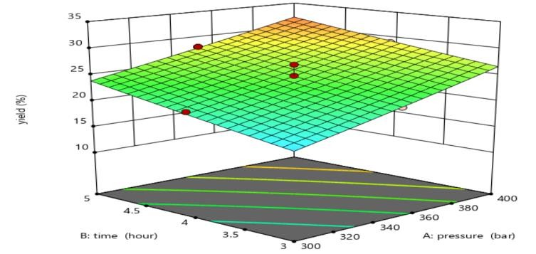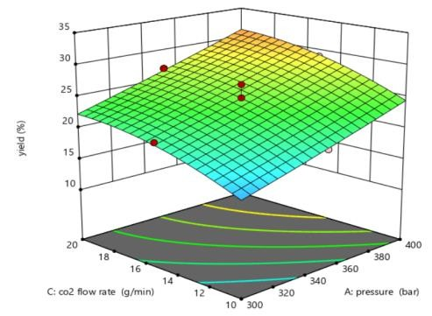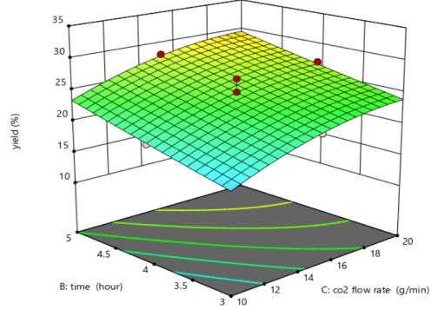
a1
b1
c1
Figure 2
864
- Figure 2. Plots of interaction effect on oil yield from black chia seed oil as a function of significant
858
859
860
861
862
863
- interactions between factors: a1 pressure and time; b1 pressure and CO2 flow rate; c1 CO2 flow
- rate and time.

866
867
868
869
870
871
872
873
874
875
876
877
878
879
880
881
882
883
884
885
886
887
888

889
890
891
892
893
894
895
896
897
 | 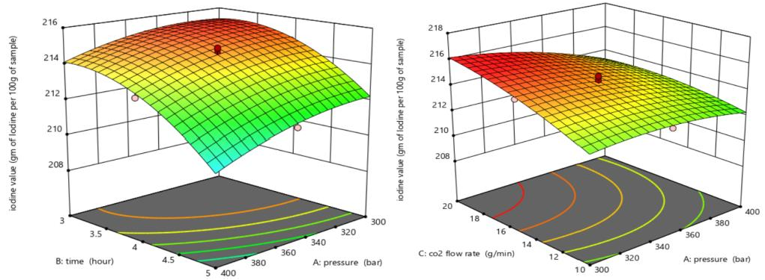  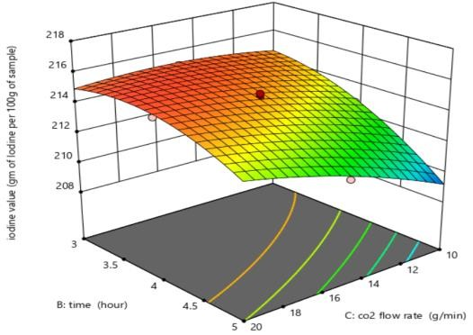  a2 | b2 | c2
 |  | Figure 3
898 | Figure 3. Plots of interaction effect on iodine value of black chia seed oil as a function of significant  interactions between factors: a2 pressure and time; b2 pressure and CO2 flow rate; c2 CO2 flow  rate and time
899
900
901
902
903
904
905
906
907
908
909
910
911
912
913
914
915
916
917
918
919

920
921
922
923
924
925
926
927
928
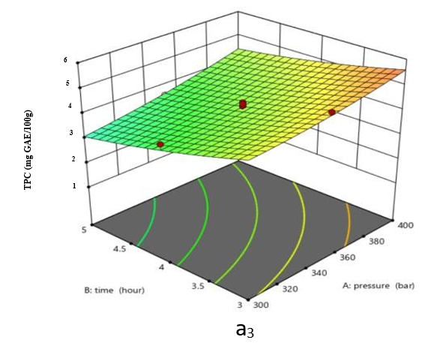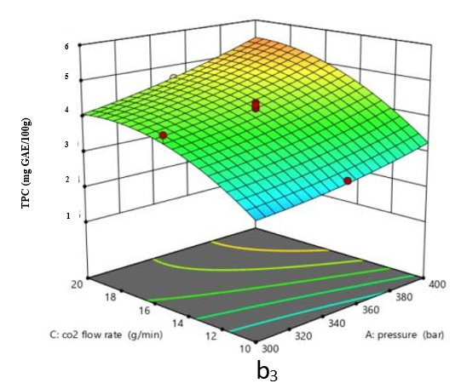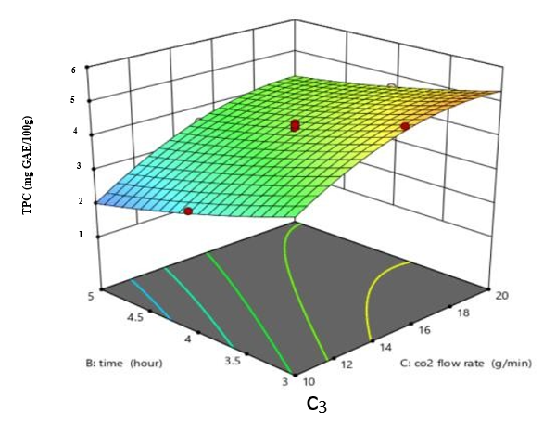
Figure 4
929
930 Figure 4. Plots of interaction effect on total phenolic content of black chia seed oil as a function of
significant interactions between factors: a3 pressure and time; b3 pressure and CO2 flow rate;
c3 CO2 flow rate and time

931
932
933
934
935
936
937
938
939
940
941
942
943
944
945
946
947
948
949
950

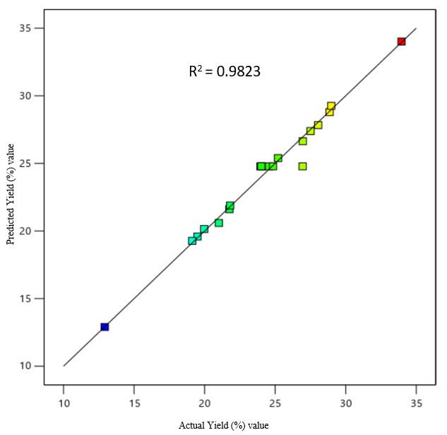
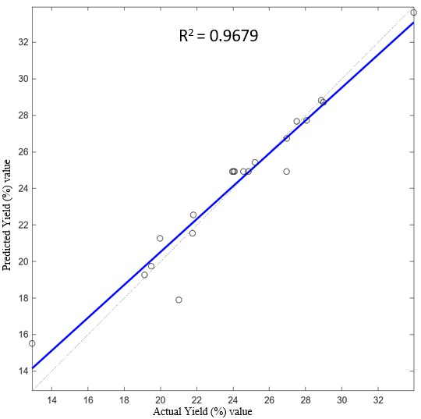
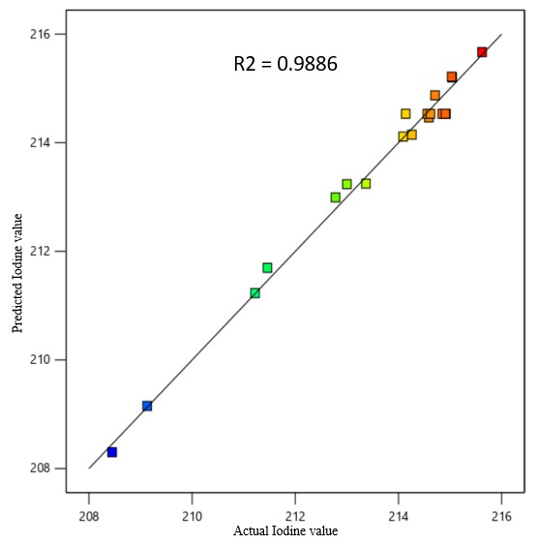
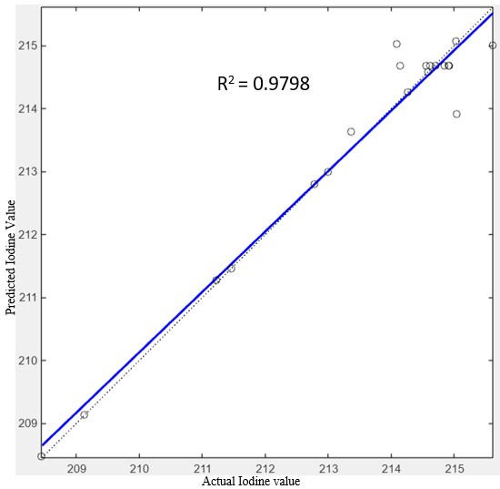
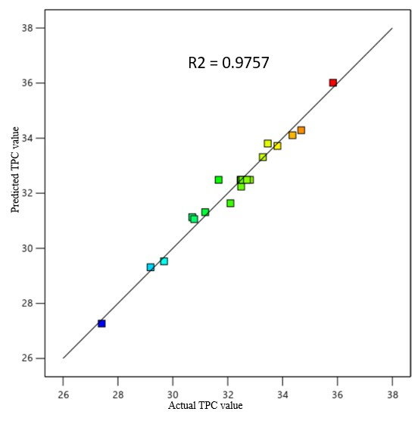
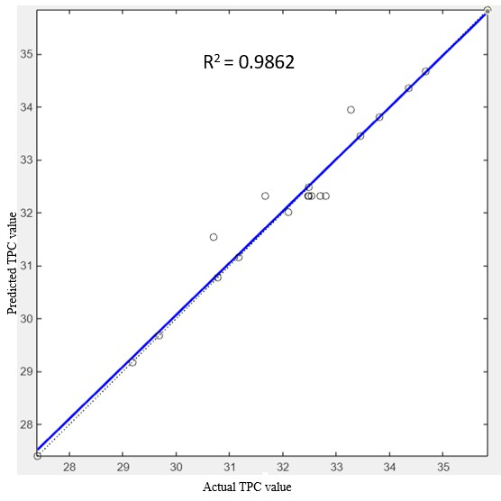
951
952
953
954
955
956
957
958
959
960
961
962
963
964
965
966
967
968
969
970
971
972
973
974
975
976
977
978
979
980
981

34

a1 b1

a2 b2

a3 b3
Figure 5- The coefficient of determination (R2) between actual and predicted data of yield, iodine value and total phenolic content of black chia seed oil was determined by RSM (a1, a2 and a3) and ANN (b1, b2 and b3).
ANN (b1, b2 and b3).

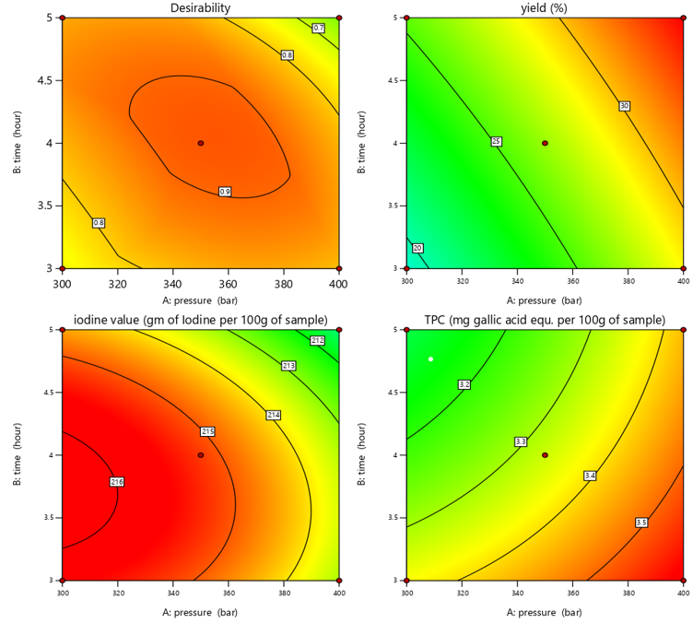
a₁
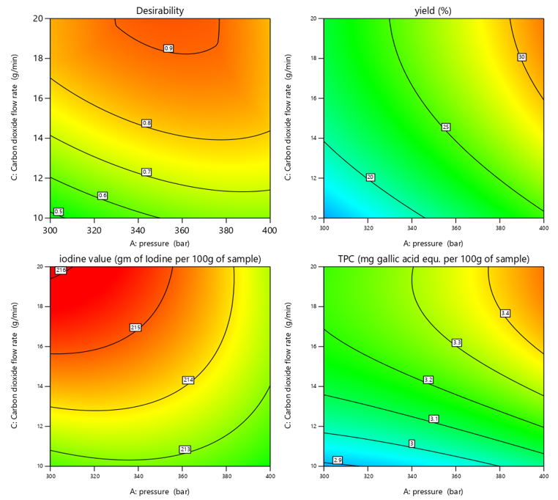
a₂

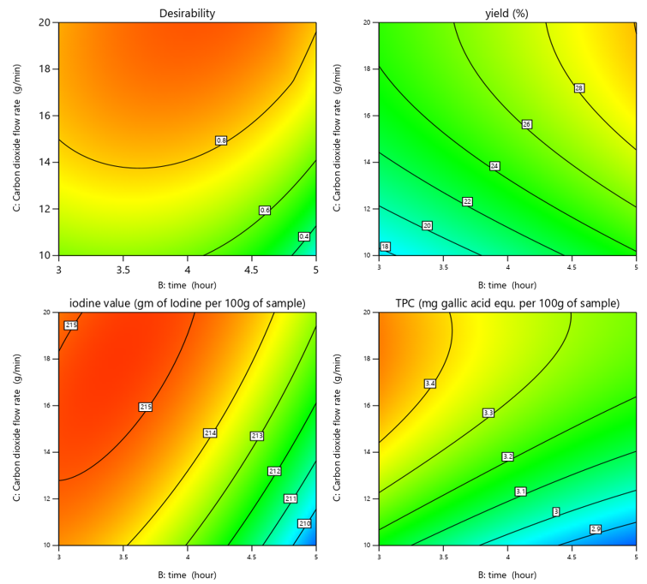
Figure 6- Desirability values plot between independent variables, a₁: pressure and time; a2: pressure and carbon dioxide flow rate; a3: time and carbon dioxide flow rate for yield, iodine value and TPC
a₃

