Original Research Article

Fraction-Dependent Redox Modulation by Tapinanthus globiferus Leaf Extracts parasitizing Psidum guajava in Drosophila melanogaster

ABSTRACT

Tapinanthus globiferus, a hemiparasitic mistletoe extensively used in African ethnomedicine, was evaluated for its redox-modulatory and cytotoxic properties using Drosophila melanogaster under non-stressed physiological conditions. Methanolic crude extract and solvent-partitioned fractions (butanol, methanol, ethyl acetate) from leaves parasitizing Psidium guajava were administered via diet supplementation (1.0 mg/10 g) for 10 days. Survival analysis revealed enhanced longevity in flies treated with the butanol (77%) and methanol (63.3%) fractions, while the crude extract significantly reduced survival (43.6%). Biochemical assays indicated pro-oxidant activity in the crude and ethyl acetate fractions, evidenced by elevated hydrogen peroxide and protein carbonyl levels (p ≤ 0.0001, p = 0.008), and antioxidant effects in the butanol and methanol fractions, marked by reduced malondialdehyde and nitric oxide levels (p < 0.05). Glutathione depletion was observed in the crude extract group (p = 0.002), while GST activity and total thiol levels remained unchanged. Gene expression analysis showed upregulation of CNC (Nrf2 homolog) by the methanol fraction (p = 0.05) and downregulation by the ethyl acetate fraction (p = 0.0006), with no significant change in SOD1 expression. The crude extract exhibited the highest cytotoxicity in MTT assays. These findings highlight the fraction-dependent redox behavior of T. globiferus, supporting the therapeutic potential of its butanol and methanol fractions while cautioning against the use of unrefined extracts due to potential pro-oxidant and cytotoxic effects.

Keywords: Tapinanthus globiferus, oxidative stress, antioxidant, pro-oxidant, Drosophila melanogaster, cytotoxicity, polyphenols

1. INTRODUCTION
Oxidative stress occurs in cells due to an imbalance between the production of reactive species—such as Reactive Oxygen Species (ROS), Reactive Nitrogen Species (RNS), and Reactive Sulphur Species (RSS)—and the antioxidant system, leading to cellular damage. This imbalance is implicated in diseases like cancer, cardiovascular disorders, diabetes, and neurodegenerative conditions. Plants, known for their antioxidative properties, are widely used in traditional medicine, particularly in Asia and Africa, to treat oxidative-stress-related diseases (Achika et al., 2023; Yadav et al., 2024; Zhong & Zhou, 2013). Herbal medicines are considered safe and effective reservoirs of bioactive compounds with therapeutic potential (Yu et al., 2021). Plants enhance antioxidant enzyme activities, thereby supporting the antioxidant system (Abeyrathne et al., 2022). Growing evidence highlights their role in preventing and managing oxidative stress-related conditions, prompting their integration into modern medicine (Serafini & Peluso, 2016). The rising use of plant-based antioxidants in dietary supplements and functional foods underscores their potential health benefits (Dixit et al., 2023).
Tapinanthus globiferus, a hemiparasitic plant native to West and East Tropical Africa, commonly grows on vascular trees like guava (Psidium guajava). Known as African mistletoe, It is commonly known as African mistletoe, belonging to the Loranthaceae family and is native to West Tropical Africa, up to East Africa (Botanikks, 2024). It is widely used in Nigeria for its medicinal properties, referred to as Kauchi in Hausa, afomo onishana in Yoruba, and Osisi/Okwumaosa in Igbo. Although often regarded as a parasitic epiphyte that reduces host economic value, it is a prominent herb in folklore medicine due to its therapeutic potential (Wang et al., 2022). The leaves of T. globiferus contain bioactive phytochemicals such as steroids, flavonoids, and phenolics, contributing to its antioxidant properties (Jeremiah et al., 2019). It is traditionally used for its anti-inflammatory and arthritis-protective effects (Raceline et al., 2019) and exhibits potential antidepressant properties, as demonstrated by reduced immobility in Swiss mice during tail suspension tests (Umar et al., 2021).
The survival of T. globiferus depends on nutrients and water from the host via specialized structures called haustoria, with host-dependent variations in its secondary metabolites and phytochemical content (Muche et al., 2022; Wang et al., 2022), which may be responsible for its application for treatment of diseases. For example, T. globiferus obtained from Albizia lebbeck showed greater antioxidative properties compared to those from Azadirachta indica (Oseni et al., 2022). Additionally, extracts from guava hosts displayed superior in vitro antioxidative activities compared to Moringa oleifera and Vernonia amygdalina (Oche et al., 2019). Host-specific applications include T. globiferus from Persea americana, which is used to treat inflammation and joint pain (Raceline et al., 2019). Based on anecdotal reports, guava-hosted T. globiferus is used in cancer treatment in Northern Nigeria. Despite its medicinal potential, non-standardized, prolonged or high-dose use of T. globiferus could cause adverse effects, including kidney and liver damage, as shown in histological studies on Swiss mice (Abedo et al., 2019). Studying these effects can reveal its intrinsic antioxidant or pro-oxidant activities, reduce confounding factors, and provide insights for safe applications and toxicological risks (Rajashekar, 2023).
This study aims to investigate the intrinsic antioxidant and pro-oxidant properties, as well as the bioactive components of the methanolic crude extract and solvent-derived fractions (butanol, methanol, and ethyl acetate) of Tapinanthus globiferus leaves from guava (Psidium guajava) host. The investigations were carried by assessing the impact of these extracts on key oxidative stress markers, including thiols, hydrogen peroxide, nitric oxide, GST activity, glutathione, MDA, and protein carbonyl levels and by identifying the bioactive components present in the plant using High-Performance Liquid Chromatography with Diode Array Detector (HPLC-DAD). Using Drosophila melanogaster as a model, the study evaluates survival outcomes and key oxidative stress markers under non-stressed conditions to elucidate the therapeutic potential and toxicological risks associated with these extracts. This study uniquely explores the baseline bioactivity of T. globiferus to inform its potential therapeutic applications while minimizing risks associated with oxidative imbalances.

2. MATERIALS AND METHODS

2.1 Equipment
The equipment used for the study were standardized.

2.2 Chemicals and Reagents
The chemicals used for the study were commercially obtained and were of analytical grade.

2.3 Experimental Flies

The mixed sex of Canton-S strain of Drosophila melanogaster which were no older than 3 days were used for the study. The flies were bred on a medium comprising cornmeal with 1% w/v brewer's yeast, 1% w/v agar and 0.08% v/w nipagin at constant temperature and humidity (25 °C; 60-70% relative humidity) under 12 h dark/light cycle conditions, at the Drosophila Laboratory, Department of Biochemistry, College of Medicine, University of Ibadan, Oyo State, Nigeria. The flies were obtained from the Federal University of Santa Maria in Brazil, which were originally obtained from the National Stock Centre in Bowling Green, Oklahoma, in the United States of America. The number of flies used were approximately 50 flies per vial, in 5 replicates per group.

The experimental flies used for the study were grouped as indicated in Table 1.

Table 1
Treatment Groups
Group | Description
Group 1 | Positive Control (Distilled water)
Group 2 | Exposed to methanolic crude extract
Group 3 | Exposed to butanol fraction
Group 4 | Exposed to methanol fraction
Group 5 | Exposed to ethyl acetate fraction
(n = 5 vials per group; 50 flies/vial).

2.4 Plant Samples
For the study, fresh leaf samples of Tapinanthus globiferus Lam on Psidium guajava host in Alheri, (on Latitude: 9.92000 E° and Longitude: 8.89000 N°) located in Jos North L.G.A of Plateau State Nigeria was used for the research. The samples for the study were obtained in March during the dry season. The whole plant was authenticated at Federal College of Forestry, Jos, Plateau State, Nigeria and deposited with the voucher number FHJ284, at the herbarium of the college. The leaves were removed from the stem and washed thoroughly under clean running water and allowed to dry in a well-ventilated room afterwards the samples were pulverized. The plant name has been checked with https://wfoplantlist.org/taxon/wfo-0000413254-2024-12?page=1

2.5 Extraction and Fractionation of Tapinanthus globiferus Leaf
The crude extract of Tapinanthus globiferus leaf was obtained using maceration method using 70% methanol. 500g of the plant powder was soaked in 1000 mL of 70% methanol and allowed to soak for seventy-two (72) hours. This was followed by filtration using filter paper to separate the unbounded phenolics from the plant extract. The filtrate was decanted into a glass beaker and allowed to evaporate. The extract was concentrated at 60 °C in an oven to obtain the dried crude extract. Vacuum Liquid Chromatography (VLC) was used to fractionate the crude extract using butanol, ethyl acetate and methanol solvents.
2.6 Dose Selection of Tapinanthus globiferus Crude Extract and Fractions and their effect on markers of oxidative stress
The crude extract and fractions were dissolved in distilled water before their administration to the flies. To select the concentration of the test samples to be used for the study, the flies were exposed to different concentrations of the crude extract and the butanol, ethyl acetate and methanol fractions (0, 0.5, 1.0 and 2.0 mg/10 g diet). The mode of exposure was via diet supplementation, by adding the weighed test samples to 10 g of the diet. The flies were divided into 5 experimental groups of 5 replicates with 50 flies per vial. The flies were subjected to 14-day survival analysis, with their diets changed at least twice per week. The rate of survival of the groups treated with the crude extract was compared with the fractions and positive control group treated with only distilled water.
The concentration of 1.0 mg/10 g diet was selected for further studies based on preliminary survival assays, ensuring non-lethal yet biologically relevant exposure levels. The 10-day exposure period aligns with established protocols for assessing chronic effects in Drosophila melanogaster. To evaluate the effect of the crude extract and the fractions on markers of oxidative stress the diet of the flies was supplemented with the selected concentrations for 10 days, after which the flies were homogenized and the markers of oxidative stress were assayed for.

2.7 Preparation of fly samples for biochemical assays
All flies were anaesthetized using carbon dioxide, weighed and homogenized using the ratio 1:10 – filed/volume (µL) in 0.1 M potassium phosphate buffer of pH 7.4, and centrifuged at 4,000 g for 10 min at 4 °C. The supernatants obtained were used to determine the following biochemical parameters: Total Thiol level, hydrogen peroxide (H₂O₂) level, Reduced Glutathione (GSH) level, Nitric Oxide, Lipid peroxidation, Protein carbonyl and gene expression.
2.8 Effect of Tapinanthus globiferus Crude Extract and Fractions on Survival Rate and Biochemical Markers of Oxidative Stress
Flies were exposed to the different doses (0, 0.5, 1.0, and 2.0 mg/10 g diet) for the 14-day survival analysis. The flies were observed for survival using the method described by Abolaji et al. (2019). The daily death rate of the flies was recorded, and the Kaplan-Meier survival method was used to assess the rate of survival of the flies exposed to sodium arsenite in contrast to the positive group that had not been exposed to arsenite.
Biochemical Analysis of Oxidative Stress Markers
Protein Determination
Lowry’s method was used to determine protein concentration. The protein concentration of the various sample was determined using modified Lowry method as described by Everette et al. (2010).
Total Thiol Determination
The total thiol level was analysed based on the method of Ellman (1959).
Glutathione-S-transferase activity
Glutathione-S-transferase activity was evaluated using the method described by Habig and Jakoby (1981).
Hydrogen peroxide generation
Hydrogen peroxide level was measured according to the method described by Wolff (1994).
Determination of reduced glutathione concentration
The method described by Beutler et al. (1963) was used to assess the level of reduced glutathione (GSH).
Nitric oxide generation
Nitric oxide concentration was analysed using Greiss method as described by Johnson et al. (2021).
Protein carbonyl concentration
The protein carbonyls was evaluated as described by Wehr and Levine (2013).
Acetylcholinesterase activity
Acetylcholinesterase activity was assayed using the method of Ellman et al. (1961).
Cell Viability (MTT Assay)
The fly homogenate was incubated in MTT dye for 4 hours at 37 °C. Afterwards the insoluble formazan crystals were solubilized using dimethyl Sulfoxide (DMSO) by shaking the mixture. Then the absorbance was read using a microplate reader at wavelength 570nm. The result was expressed, relative to the control, as percentage.
2.9 Effect of Tapinanthus globiferus Fractions on Gene Expressions
The effect of Tapinanthus globiferus fractions on CNC and SOD1 genes was carried using mRNA expression kits. Extraction of mRNA was carried out using the Quick-RNA™ MiniPrep Plus Kit and cDNA was synthesized using the ProtoScript II First Strand cDNA Synthesis Kit according to the protocols of the manufacturer. Quantitative real-time PCR was carried out to evaluate the expression of the identified gene of the flies. RNA isolation and extraction was carried out rapidly under ice to prevent degradation by RNase. The primers used are presented in table 2:
Table 2 Primers Sequence
Genes | Sequence
CNC | F 5’ CGCCAACGAGGTGGAAATCG 3’  R 5’ CGCCTCCTGGTCCAAACTGA 3’
SOD1 | F 5’ CATCGGGTGCGGCGTTATT 3’  R 5’ AATAACGCCGCACCCGATG 3’
Statistical Analysis
The data was statistically analysed using GraphPad Prism Software, San Diego, CA, USA, version 9.5.1. The results were presented as mean + standard deviation (SD). Tukey's post hoc test was used to assess significant differences, whereas the statistical significance of the survival rate was determined using the log-rank (Mantel-Cox) test. Level of significance was accepted at p < 0.05, with n = 50 per group.

Hydrogen Peroxide (H₂O₂) indicates reactive oxygen species (ROS) production and oxidative stress. Malondialdehyde (MDA) is an indicator of lipid peroxidation and membrane damage caused by oxidative stress. Protein Carbonyls measures oxidative modification of proteins, indicating cellular protein damage. Total Thiols and Reduced Glutathione (GSH) assess antioxidant capacity and redox buffering potential. Glutathione-S-Transferase (GST) Activity evaluates detoxification enzyme function and oxidative byproduct neutralization. Nitric Oxide balances its role as a signalling molecule and a potential pro-oxidant under excessive production. Drosophila melanogaster on the other hand shares oxidative stress response mechanisms with humans, ensuring biological relevance. Its sequenced genome and advanced genetic tools enable detailed mechanistic studies, as well as facilitates large-scale, statistically robust experiments at low cost. It has a rapid lifecycle, which allows observation of long-term effects within a short timeframe and presents fewer ethical concerns and supports high-throughput studies.
By combining these oxidative stress markers and the advantages of Drosophila melanogaster as a model organism, this study ensures a comprehensive and biologically relevant assessment of the effects of Tapinanthus globiferus leaf crude extract and fractions.

3 RESULTS
3.1 Survival rate of Drosophila melanogaster exposed to crude extract of Tapinanthus globiferus leaf samples
The result shown in Fig. 1 shows that there was a significant difference in the survival rate of the D. melanogaster treated with different concentrations (0.5, 1.0, and 2.0 mg/g diet) of the crude extract of T. globiferus leaf compared with the control (p = 0.001). The highest survival was observed in the group treated with 0.5 mg/10 g diet of the crude extract, with 54% probability of survival, followed by the 1.0 mg/10 g diet with 43.6% probability of survival.

3.2 Survival rate of Drosophila melanogaster exposed to Butanol fraction of Tapinanthus globiferus leaf samples

The effect of different concentrations of the butanol fraction from T. globiferus leaf on the survival of D. melanogaster is illustrated in Fig. 2. The results showed no significant difference in the survival rate of the flies exposed to the butanol fraction (p = 0.944) compared to the control group. Notably, the group treated with a 0.5 mg/10 g diet of the butanol fraction had a survival probability of 79%, while the group treated with a 1 mg/10 g diet had a survival probability of 77%. This indicates that the survival rate for the group receiving the 1.0 mg/g diet increased by 22% compared to the control group.

3.3 Survival rate of Drosophila melanogaster exposed to methanol fraction of Tapinanthus globiferus leaf samples
The results presented in Fig. 3 show that varying concentrations of the methanol fraction from T. globiferus leaf did not significantly impact the survival rate of D. melanogaster when compared to the control group (p = 0.530). Notably, the group that received a diet containing 1 mg/g of the methanol fraction experienced a 10% increase in survival rate. By day 14, the survival probability was 63.3%, compared to 54% for the control group.
3.4 Survival rate of Drosophila melanogaster exposed to ethyl acetate fraction of Tapinanthus globiferus leaf samples
The results in Fig. 4 indicate that varying concentrations of the ethyl acetate fraction from T. globiferus leaf did not significantly reduce the survival rate of the flies compared to the control group (p = 0.414). The group that received a diet containing 2 mg/10 g diet of the ethyl acetate fraction exhibited the highest survival probability at 61%, reflecting a 7% increase in survival.
In comparing the survival rates of the crude extracts to the three fractions, it was observed that the three fractions had higher survival rates by day 14 (see Fig. 5). The crude extract exhibited a higher death rate compared to both the positive control groups and the three fractions. Generally, butanol fraction showed higher survival rate compared to the crude extract and other fractions. The concentrations and fractions used in this study were chosen based on their ability to extend the lifespan of the flies. Among all three fractions, a concentration of 1.0 mg /10 g of diet was selected, as all fractions demonstrated improved survival rates compared to the unexposed flies and those supplemented with the crude extract of Tapinanthus globiferus.
us
3.5 Effects of the crude extract and fractions of Tapinanthus globiferus on markers of oxidative stress in Drosophila melanogaster
Following the survival rate outcome, 1.0 mg/10 g diet was the concentration selected to evaluate the effect of the crude extract and three fractions on markers of oxidative stress.

Effect of the crude extract and fractions of Tapinanthus globiferus on acetylcholinesterase activity

In Fig. 6a, it was observed that the flies treated with the butanol fraction exhibited a significant increase in acetylcholinesterase (AChE) activity (p = 0.0037) compared to the positive control (unexposed). Likewise, the methanol fraction also led to a significant increase in AChE activity (p < 0.0001). However, there was no significant difference in AChE activity levels observed in the crude fraction (p = 0.076) and the ethyl acetate fraction (p = 0.083) when compared to the positive control.

Effect of the crude extract and fractions of Tapinanthus globiferus on total thiols
The graph in Fig. 6b illustrates the impact of the crude extract and fractions of Tapinanthus globiferus on TSH levels in the flies. The results show that thiol levels increased in the groups exposed to the fractions. However, there was no significant increase observed in any group when compared to the positive control.

Effect of the crude extract and fractions of Tapinanthus globiferus on hydrogen peroxide generation

Hydrogen peroxide is produced in excess during oxidative stress and, at moderate levels, functions as a signalling molecule. The results observed in Fig. 6c indicate that both the crude extracts (p = 0.0001) and the ethyl acetate fraction (p < 0.0001) significantly increased the release of H₂O₂. In contrast, the butanol and methanol fractions showed no significant change.

Effect of the crude extract and fractions of Tapinanthus globiferus on nitric oxide generation

Increased levels of nitric oxide (NO) indicate oxidative stress. NO is typically produced by the action of nitric oxide synthase. As shown in Fig. 6d, the NO levels in the groups treated with butanol fraction were significantly lower (p = 0.025) compared to the control group. In contrast, the methanol and ethyl acetate fractions did not show a significant difference in nitric oxide levels compared to the control (p = 0.22 and p = 0.12, respectively). Additionally, there was an insignificant increase in NO levels in the group exposed to the crude extract (p = 0.69).

Effect of the crude extract and fractions of Tapinanthus globiferus on GST activity

The presence of a xenobiotic leads to an increase in GST activity, as it plays a crucial role in detoxifying these compounds or molecules. According to the graph in Fig. 6e, there were no significant differences in GST activity among the three fractions and the crude extract.

Effect of the crude extract and fractions of Tapinanthus globiferus on reduced glutathione level

Reduced glutathione (GSH) serves as the substrate for the glutathione S-transferase (GST) enzyme, playing a crucial role in the detoxification process. The GST enzyme conjugates GSH with various compounds or molecules, which makes them water-soluble and easier to excrete. As shown in Fig. 6f, there was no significant difference in GSH levels among the fractions when compared to the control group. However, a significant decline in GSH levels was observed in the group exposed to the crude extract (p = 0.002).

Effect of Tapinanthus globiferus on lipid peroxidation

Lipid peroxidation occurs when free radicals react with polyunsaturated fatty acids found in cell membranes. The results shown in Fig. 6g indicate a significant decrease in the concentration of malondialdehyde in both the butanol fraction (p = 0.0212) and the methanol fraction (p = 0.004) when compared to the positive control.

Effect of Tapinanthus globiferus on protein carbonyl generation

Proteins in cells can be oxidized by free radicals, resulting in the formation of protein carbonyls. According to the results shown in Fig. 6h, there was significant difference (p = 0.008) in the concentration of protein carbonyls between the ethyl acetate group and the positive control.

3.6 Effect of Tapinanthus globiferus on gene expression

Plants have been reported to have modulatory effects on gene expression. The impact of different leaf fractions from Tapinanthus globiferus on the mRNA expression SOD1, and CNC is illustrated in Fig. 7. SOD1 expression was not affected by any of the fractions. However, the methanol fraction significantly overexpressed CNC (p = 0.05), while the ethyl acetate fraction significantly downregulated it (p = 0.0006).

3.7 Effect of Tapinanthus globiferus on cell viability

The result in Fig. 8 shows the effect of Tapinanthus globiferus on the viability of the cells. Cell viability assay measured the healthy state of the cells after treatment with the test samples. With the positive control assumed to have 100 % cell viability, the crude extract had 49.74 + 7.7 % viability, butanol fraction had 60.64 + 1.77 %, methanol fraction had 68.22 + 2.23 % and ethyl acetate fraction had 66.62 + 1.40 % cell viability.

3.8 Effect of Tapinanthus globiferus on the climbing ability
Fig. 9 shows the effect of T. globiferus fractions on the climbing ability of the flies. The result shows that only the groups treated with the methanol fraction had significant decrease in the climbing ability (64.4 + 1.92 %) compared with the positive control (76. 67+ 3.35 %), with p = 0.039.

4 DISCUSSION

This study provides a comprehensive evaluation of the redox-modulatory effects of methanolic crude extract and solvent-partitioned fractions (butanol, methanol, and ethyl acetate) of Tapinanthus globiferus leaves parasitizing guava (Psidium guajava) on key oxidative stress markers, survival, gene expression, and cell viability in Drosophila melanogaster. Unlike previous investigations that focused on stressed conditions or specific bioactivities, this study assessed the baseline biochemical response in a non-stressed model, thereby elucidating the intrinsic redox properties of the plant extracts.

4.1 Fraction-Dependent Modulation of Oxidative Stress
The butanol and methanol fractions exhibited the most significant antioxidant effects. The butanol fraction reduced nitric oxide (NO) and malondialdehyde (MDA) levels, while enhancing fly survival. These findings suggest that compounds extracted by butanol possess potent antioxidant properties, possibly through modulation of nitric oxide synthase pathways or radical scavenging activity.
Similarly, the methanol fraction significantly reduced lipid peroxidation and upregulated CNC gene expression—homologous to mammalian Nrf2. CNC/Nrf2 is a key regulator of the antioxidant response, and its upregulation enhances the transcription of cytoprotective genes (Loboda et al., 2016; Wadowski et al., 2024). The ability of the methanol fraction to activate this pathway suggests therapeutic potential in managing oxidative stress-related disorders.

In contrast, the ethyl acetate fraction and the crude methanolic extract showed pro-oxidant tendencies, as evidenced by increased hydrogen peroxide (H₂O₂) and protein carbonyl levels. This pro-oxidant behavior could be attributed to the presence of specific polyphenols that undergo redox cycling. These findings are supported by Rajashekar (Rajashekar, 2023) and Veskoukis et al. (2012), who reported that polyphenols can exhibit pro-oxidant effects under certain conditions, particularly at high concentrations or in the presence of transition metals.

The different solvents used in extracting these compounds can affect the composition of the extracted compounds, which in turn affects their biological activities, including their impact on markers of oxidative stress (Bitwell et al., 2023).

4.2 Antioxidant Enzyme Activity and Redox Homeostasis

The decrease in reduced glutathione (GSH) observed in the crude extract group implies an increased requirement for detoxification or ROS neutralization, suggesting the presence of electrophilic or redox-active compounds in the crude matrix. This observation aligns with reports by Potęga (2022), who highlighted GSH depletion as a consequence of conjugation reactions during detoxification. Notably, neither total thiol levels nor glutathione-S-transferase (GST) activity were significantly affected across all groups. This suggests that the redox buffering systems were not overwhelmed under the exposure conditions used. A stable thiol pool and unaltered GST activity under non-stress conditions reflect the flies' ability to maintain redox homeostasis (Dawood Shah et al., 2020; Jan et al., 2018). It also implies that the fractions do not significantly interfere with phase II detoxification pathways at the tested concentrations.

Increased protein carbonyl level suggests the presence of prooxidants in the ethyl acetate fraction. This does not rule out the presence of antioxidants, because polyphenolic compounds—frequently abundant in plant extracts—can function as antioxidants under specific conditions. However, when administered in isolation or at elevated concentrations, these compounds may exhibit prooxidant activity, such as protein oxidation, potentially causing oxidative damage even in the absence of induced stress due to their redox state (Veskoukis et al., 2012).

4.3 Gene Expression and Neuromodulatory Activity
At the molecular level, SOD1 expression remained unchanged, whereas CNC expression was significantly modulated. The methanol fraction upregulated CNC expression, reinforcing its antioxidant profile, while the ethyl acetate fraction downregulated CNC, supporting its observed pro-oxidant and potentially cytotoxic effects. These observations are consistent with previous studies demonstrating that activation of CNC/Nrf2 reduces oxidative stress and promotes cell survival (Dewanjee et al., 2024; Hammad et al., 2023).

In terms of neurophysiological impact, only the methanol fraction significantly reduced climbing ability, suggesting potential neuromodulatory effects. Abolaji et al. (2019) previously reported that phytochemicals may impair neuromotor function in Drosophila, especially when associated with redox imbalances.

4.4 Cytotoxicity
The cytotoxicity observed in the crude extract and ethyl acetate fraction, as reflected by reduced cell viability, highlights the importance of fractionation to isolate bioactive constituents and minimize toxicity. The butanol and methanol fractions demonstrated relatively higher cell viability, which correlates with their antioxidant profiles. These findings are supported by Adegbaju et al. (2020) who reported cytotoxic effects of crude plant extracts, suggesting potential application in conditions requiring inhibition of cell proliferation, such as cancer.

4.5 Comparative Context and Implications
The findings of this study are in agreement with the dual-role hypothesis of polyphenols, which can act as antioxidants or pro-oxidants depending on their concentration, redox state, and cellular context (Andrés et al., 2023). For instance, Serreli and Deiana (2023), demonstrated how dietary polyphenols modulate nitric oxide synthase and reduce oxidative stress in mammalian systems—paralleling our observations with the butanol fraction.

Furthermore, the use of Drosophila melanogaster as a model offers translational value, given its conserved oxidative stress pathways, cost-effectiveness, and suitability for high-throughput in vivo screening(Abolaji et al., 2019). The alignment of our data with prior rodent and cell-based studies underscores the model’s reliability for preclinical evaluations of plant-derived compounds.

5. CONCLUSION
This study demonstrates that Tapinanthus globiferus exhibits fraction-dependent redox activity under non-stressed conditions in Drosophila melanogaster. The butanol and methanol fractions possess antioxidant potential, with minimal cytotoxicity and enhanced survival outcomes, while the crude extract and ethyl acetate fraction exhibit pro-oxidant and cytotoxic characteristics. These effects are closely linked to their phytochemical composition, particularly the presence of polyphenolic compounds. The modulation of CNC gene expression further underscores the mechanistic basis for these activities.

Future research could focus on dose-response analysis, isolation of individual bioactive compounds, and validation in mammalian models to establish therapeutic potential and safety profiles. Additionally, quantifying phytochemicals across fractions may aid in standardizing T. globiferus preparations for medicinal use.

DECLARATION OF COMPETING INTEREST
The authors declare that they have no known competing financial interests or personal relationships that could have appeared to influence the work reported in this paper.

DECLARATION OF GENERATIVE AI AND AI-ASSISTED TECHNOLOGIES IN THE WRITING PROCESS
During the preparation of this work the author(s) used Grammarly and ChatGPT in order to check for grammar. After using this tool/service, the author(s) reviewed and edited the content as needed and take(s) full responsibility for the content of the publication.
Details of the AI usage are given below:
- ChatGPT, Version-GPT-4o, source - Open AI
- COPILOT, version GPT-4-turbo, source - Microsoft
- Grammarly, v 1.2.152.1646, source - Grammarly inc.
- Input prompts: Identify and correct grammatic errors.

REFERENCES
Abedo, A., Abdullahi, R., Shettima, F., Muhammed, I., Tasie, H., Tamba, C., Tamba, Z., Ogar, M., Enoh, E., & Abedo, O. (2019). Toxicity Analysis of Tapinantus Globiferus in Swiss Albino Mice. IOSR J Pharm Biol Sci, 14, 360-370.
Abeyrathne, E. D. N. S., Nam, K., Huang, X., & Ahn, D. U. (2022). Plant-and animal-based antioxidants’ structure, efficacy, mechanisms, and applications: A review. Antioxidants, 11(5), 1025.
Abolaji, A. O., Ajala, V. O., Adigun, J. O., Adedara, I. A., Kinyi, H. W., & Farombi, E. O. (2019). Protective role of resveratrol, a natural polyphenol, in sodium fluoride-induced toxicity in Drosophila melanogaster. Experimental Biology and Medicine (Maywood), 244(18), 1688-1694. https://doi.org/10.1177/1535370219890334
Achika, J., Yusuf, A., Ayo, R., & Liman, D. (2023). Flavonoids from Nigerian indigenous medicinal plants and their bioactivities: a review. Phytomedicine plus, 3(2), 100405.
Adegbaju, O. D., Otunola, G. A., & Afolayan, A. J. (2020). Anti-inflammatory and cytotoxic evaluation of extracts from the flowering stage of Celosia argentea. BMC Complementary Medicine and Therapies, 20(1), 152. https://doi.org/10.1186/s12906-020-02941-4
Andrés, C. M. C., Pérez de la Lastra, J. M., Juan, C. A., Plou, F. J., & Pérez-Lebeña, E. (2023). Polyphenols as Antioxidant/Pro-Oxidant Compounds and Donors of Reducing Species: Relationship with Human Antioxidant Metabolism. Processes, 11(9), 2771. https://www.mdpi.com/2227-9717/11/9/2771
Beutler, E., Duron, O., & Kelly, B. M. (1963). Improved method for the determination of blood glutathione. Journal of Laboratory and Clinical Medicine, 61, 882-888.
Bitwell, C., Indra, S. S., Luke, C., & Kakoma, M. K. (2023). A review of modern and conventional extraction techniques and their applications for extracting phytochemicals from plants. Scientific African, 19, e01585. https://doi.org/https://doi.org/10.1016/j.sciaf.2023.e01585
Botanikks. (2024). Tapinanthus Globiferus (a.rich.) Tiegh. https://www.botanikks.com/plants/tapinanthus-globiferus-arich-tiegh/667789/1
Dawood Shah, M., Seelan Sathiya Seelan, J., & Iqbal, M. (2020). Phytochemical investigation and antioxidant activities of methanol extract, methanol fractions and essential oil of Dillenia suffruticosa leaves. Arabian Journal of Chemistry, 13(9), 7170-7182. https://doi.org/https://doi.org/10.1016/j.arabjc.2020.07.022
Dewanjee, S., Bhattacharya, H., Bhattacharyya, C., Chakraborty, P., Fleishman, J., Alexiou, A., Papadakis, M., & Jha, S. K. (2024). Nrf2/Keap1/ARE regulation by plant secondary metabolites: a new horizon in brain tumor management. Cell Communication and Signaling, 22(1), 497. https://doi.org/10.1186/s12964-024-01878-2
Dixit, V., Joseph Kamal, S. W., Bajrang Chole, P., Dayal, D., Chaubey, K. K., Pal, A. K., Xavier, J., Manjunath, B., & Bachheti, R. K. (2023). Functional foods: exploring the health benefits of bioactive compounds from plant and animal sources. Journal of food quality, 2023(1), 5546753.
Ellman, G. L. (1959). Tissue sulfhydryl groups. Archives of biochemistry and biophysics, 82(1), 70-77.
Everette, J. D., Bryant, Q. M., Green, A. M., Abbey, Y. A., Wangila, G. W., & Walker, R. B. (2010). Thorough study of reactivity of various compound classes toward the Folin− Ciocalteu reagent. Journal of agricultural and food chemistry, 58(14), 8139-8144.
Hammad, M., Raftari, M., Cesário, R., Salma, R., Godoy, P., Emami, S. N., & Haghdoost, S. (2023). Roles of Oxidative Stress and Nrf2 Signaling in Pathogenic and Non-Pathogenic Cells: A Possible General Mechanism of Resistance to Therapy. Antioxidants, 12(7), 1371. https://www.mdpi.com/2076-3921/12/7/1371
Jan, N., Majeed, U., Andrabi, K. I., & John, R. (2018). Cold stress modulates osmolytes and antioxidant system in Calendula officinalis. Acta Physiologiae Plantarum, 40(4), 73. https://doi.org/10.1007/s11738-018-2649-0
Jeremiah, C., Katsayal, U. A., Nuhu, A., Anafi, S. B., Ibrahim, M. A., & Nuhu, H. D. (2019). Phytochemical Screening and Anti-Inflammatory Studies of Tapinanthus globiferus (A. Rich) Teigh. Leaves Three Extracts. Pharmaceutical Sciences, 25(2), 124-131.
Johnson, T. O., Adegboyega, A. E., Adeyemi, O. E., Okonkwo, F. O., Ejembi, S. A., Oche, J.-R. I., Oluwarotimi, E. A., Bashar, F., Johnson, G. I., & Adeyemi, O. S. (2021). Computer-Aided Identification of Bioactive compounds of Azadirachta indica (Neem) with Potential activity against SARS-CoV-2 main protease. BMC Plant Biology.
Loboda, A., Damulewicz, M., Pyza, E., Jozkowicz, A., & Dulak, J. (2016). Role of Nrf2/HO-1 system in development, oxidative stress response and diseases: an evolutionarily conserved mechanism. Cellular and Molecular Life Sciences, 73(17), 3221-3247. https://doi.org/10.1007/s00018-016-2223-0
Muche, M., Muasya, A. M., & Tsegay, B. A. (2022). Biology and resource acquisition of mistletoes, and the defense responses of host plants. Ecological Processes, 11(1), 24.
Oche, J., Johnson, T. O., Akinsanmi, A. O., Jaryum, K. H., & Francis, T. (2019). In vitro Antioxidant activity and inhibition of Fe 2+ and SNP lipid peroxidation of African mistletoes (Tapinanthus globiferus) from three selected host plants in Jos Plateau state Nigeria. J. App. Life Sci. int, 20(4), 1-10.
Oseni, F., Ibrahim, S., Ahmad, H., Abubakar, M., & Abbas, S. (2022). Phytochemicals in methanolic leaf extracts of Tapinanthus globiferous from Azadirachta indica and Albizia lebbeck: A comparative analysis of some pharmacological potentials. Bayero Journal of Pure and Applied Sciences, 13(1), 223-229.
Potęga, A. (2022). Glutathione-mediated conjugation of anticancer drugs: an overview of reaction mechanisms and biological significance for drug detoxification and bioactivation. Molecules, 27(16), 5252.
Raceline, G. K., Aubin, N. K. B., Jaures, T. N. M., Ducos, Y. F., Florence, N. T., Desire, D. D. P., Théophile, D., & Véronique, P. B. (2019). Anti-inflammatory potential of Tapinanthus globiferus (Loranthaceae) leaves as an alternative treatment against arthritis. The Journal of Phytopharmacology, 8(3), 96-103.
Rajashekar, C. B. (2023). Dual role of plant phenolic compounds as antioxidants and prooxidants. American Journal of Plant Sciences, 14(1), 15-28.
Serafini, M., & Peluso, I. (2016). Functional foods for health: the interrelated antioxidant and anti-inflammatory role of fruits, vegetables, herbs, spices and cocoa in humans. Current pharmaceutical design, 22(44), 6701-6715.
Serreli, G., & Deiana, M. (2023). Role of Dietary Polyphenols in the Activity and Expression of Nitric Oxide Synthases: A Review. Antioxidants, 12(1), 147. https://www.mdpi.com/2076-3921/12/1/147
Umar, A., M. Garba, M., Aishatu, S., & N. Mohammed, D. (2021). Antidepressant Activity of Methanol Extract of Tapinanthus globiferus (A. Rich) Tiegh in Swiss Mice: doi.org/10.26538/tjnpr/v5i12.13. Tropical Journal of Natural Product Research (TJNPR), 5(12), 2123-2126. https://tjnpr.org/index.php/home/article/view/257
Veskoukis, A. S., Tsatsakis, A. M., & Kouretas, D. (2012). Dietary oxidative stress and antioxidant defense with an emphasis on plant extract administration. Cell Stress and Chaperones, 17(1), 11-21. https://doi.org/10.1007/s12192-011-0293-3
Wadowski, P., Juszczak, M., & Woźniak, K. (2024). NRF2 Modulators of Plant Origin and Their Ability to Overcome Multidrug Resistance in Cancers. International Journal of Molecular Sciences, 25(21), 11500. https://www.mdpi.com/1422-0067/25/21/11500
Wang, L., Kong, D., Tian, J., Zhao, W., Chen, Y., An, Y., Liu, X., Wang, F., Cai, F., & Sun, X. (2022). Tapinanthus species: A review of botany and biology, secondary metabolites, ethnomedical uses, current pharmacology and toxicology. Journal of Ethnopharmacology, 296, 115462.
Wolff, S. P. (1994). [18] Ferrous ion oxidation in presence of ferric ion indicator xylenol orange for measurement of hydroperoxides. In Methods in enzymology (Vol. 233, pp. 182-189). Elsevier.
Yadav, N., Singh Chandel, S., Venkatachalam, T., & Fathima, S. N. (2024). Herbal Medicine Formulation, standardization, and Commercialization challenges and sustainable strategies for improvement. In Herbal Medicine Phytochemistry: Applications and Trends (pp. 1769-1795). Springer.
Yu, M., Gouvinhas, I., Rocha, J., & Barros, A. I. (2021). Phytochemical and antioxidant analysis of medicinal and food plants towards bioactive food and pharmaceutical resources. Scientific reports, 11(1), 10041.
Zhong, R.-z., & Zhou, D.-w. (2013). Oxidative Stress and Role of Natural Plant Derived Antioxidants in Animal Reproduction. Journal of Integrative Agriculture, 12(10), 1826-1838. https://doi.org/https://doi.org/10.1016/S2095-3119(13)60412-8

LIST OF ABBREVATIONS
ROS: Reactive Oxygen Species
RNS: Reactive Nitrogen Species
RSS: Reactive Sulphur Species
H₂O₂: Hydrogen Peroxide
NO: Nitric Oxide
MDA: Malondialdehyde
GSH: Reduced Glutathione
GST: Glutathione-S-Transferase
TSH: Total Thiol
AChE: Acetylcholinesterase
CNC: Cap ‘n’ Collar
SOD1: Superoxide Dismutase 1
MTT: 3-(4,5-dimethylthiazol-2-yl)-2,5-diphenyltetrazolium bromide

a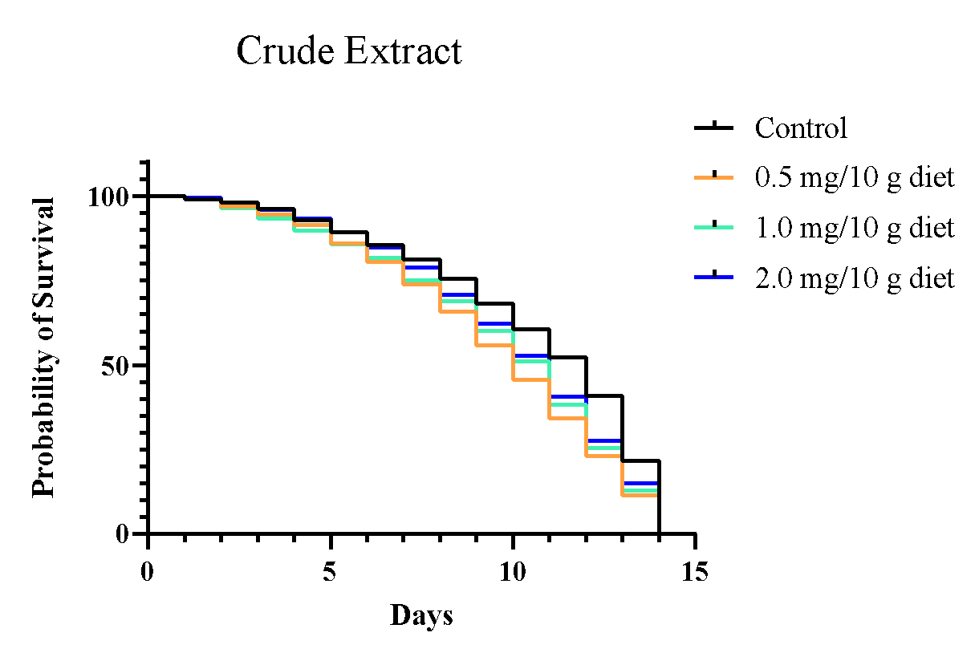 b 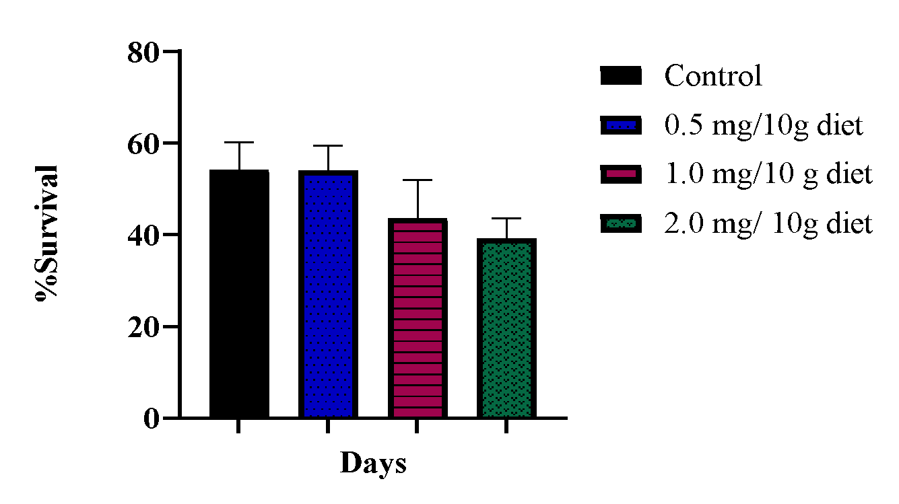

Fig. 1 (a) Probability of survival (b) Survival Rate of Flies Exposed to varying Concentration of crude extract of T. globiferus leaf

a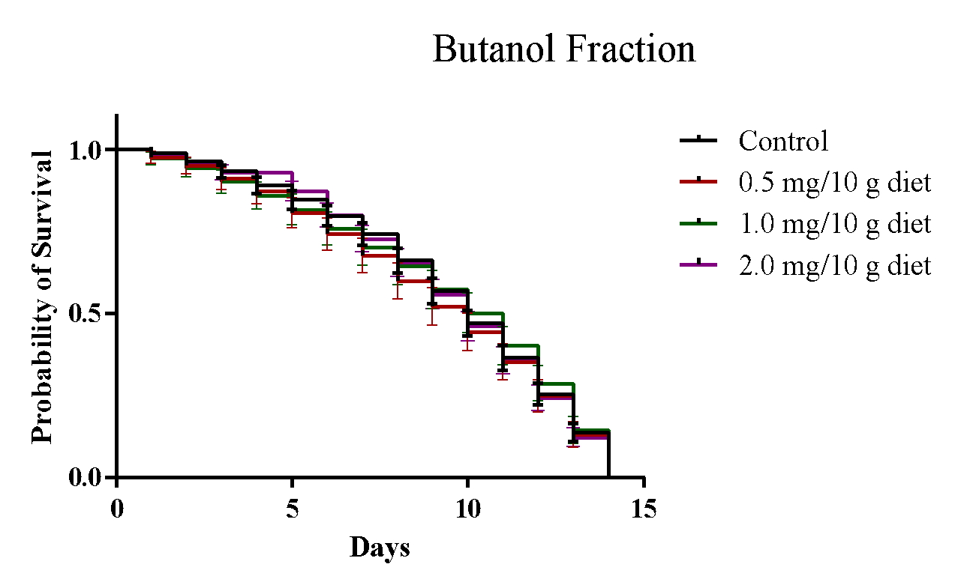b 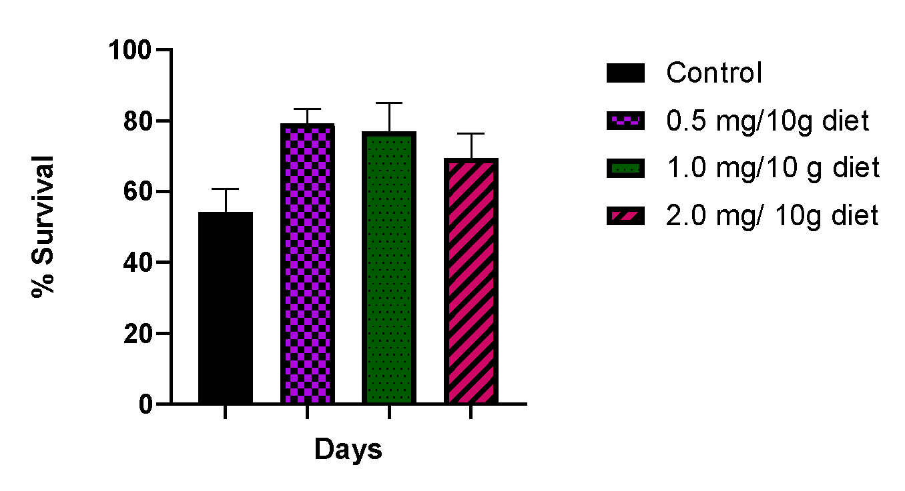

Fig. 2 (a) Probability of survival (b) Survival Rate of Flies Exposed to varied Concentration of Butanol Fraction of T. globiferus Leaves

a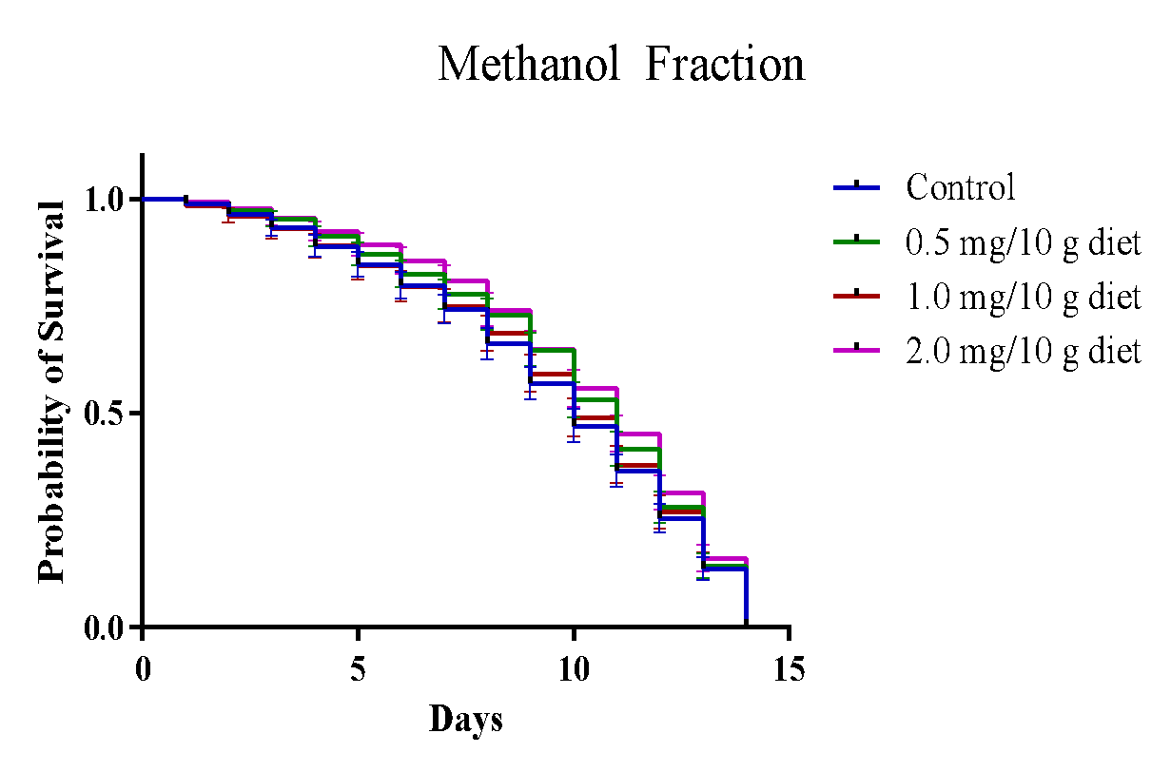 b 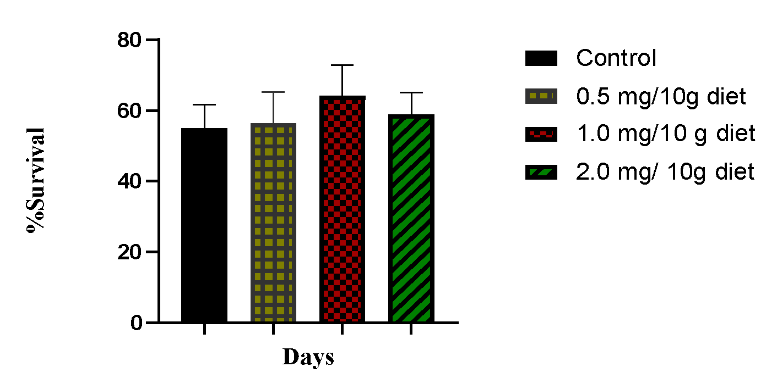

Fig. 3 (a) Probability of survival (b) Survival Rate of Flies Exposed to varied Concentration of Methanol Fraction of T.globiferus Leaves

a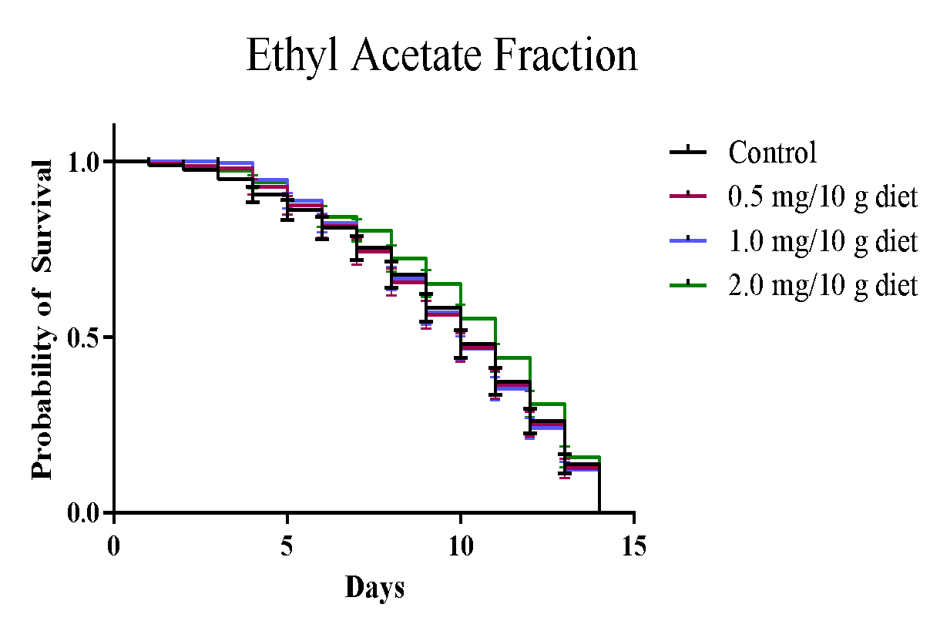 b 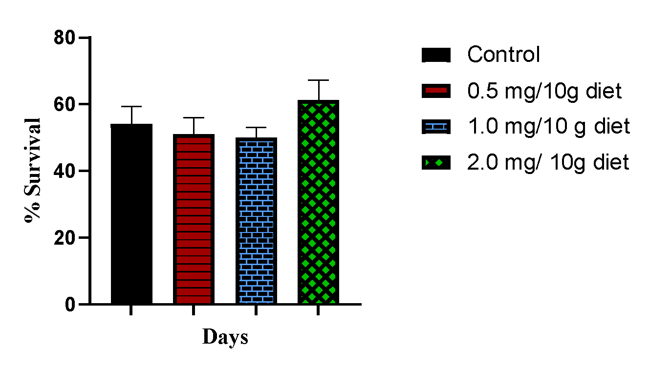

Fig. 4 (a) Probability of survival (b) Survival Rate of Flies Exposed to varied Concentration of Ethyl Acetate Fraction of T.globiferus Leaves

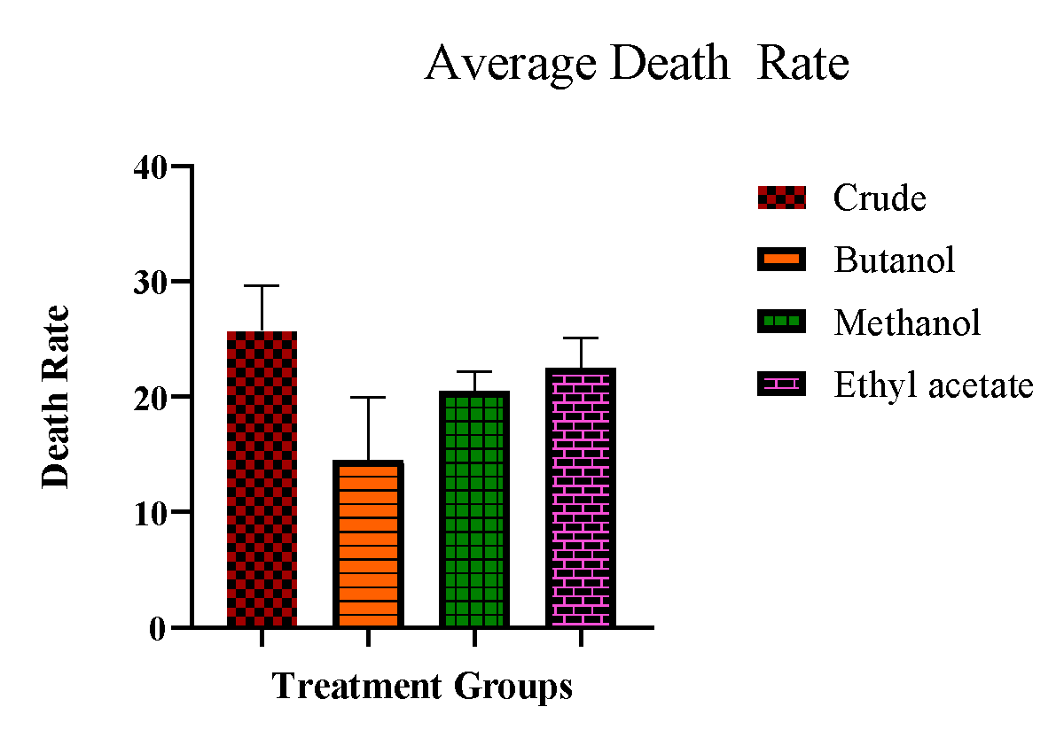
Fig. 5 Average Death rate of Crude extract and Fractions of Tapinanthus globiferus

a 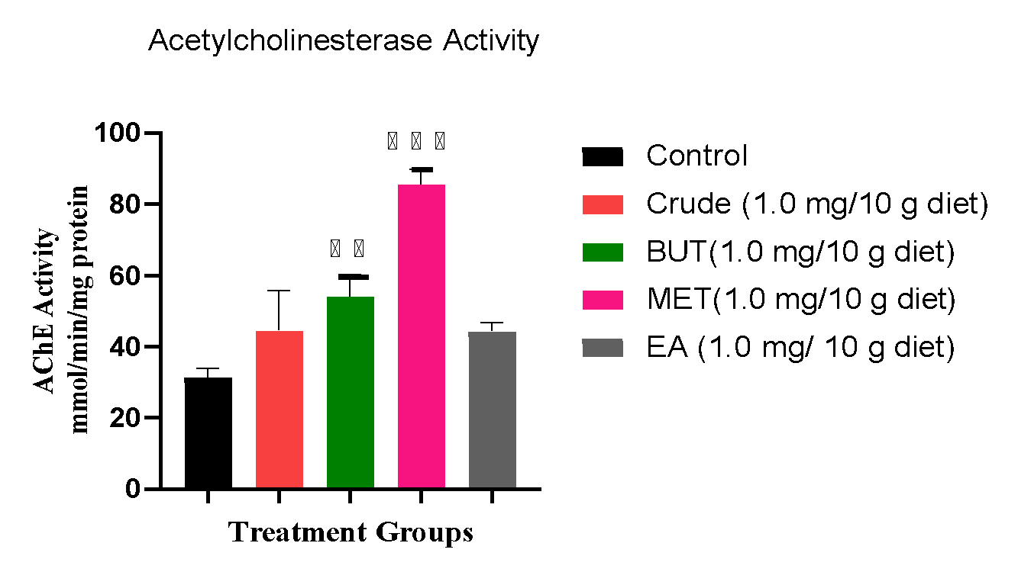b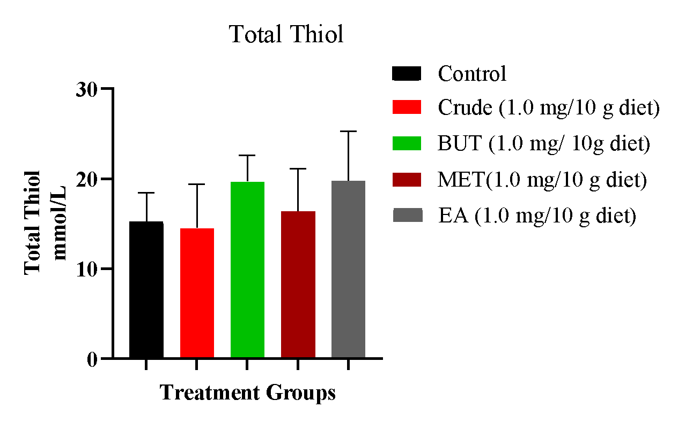
c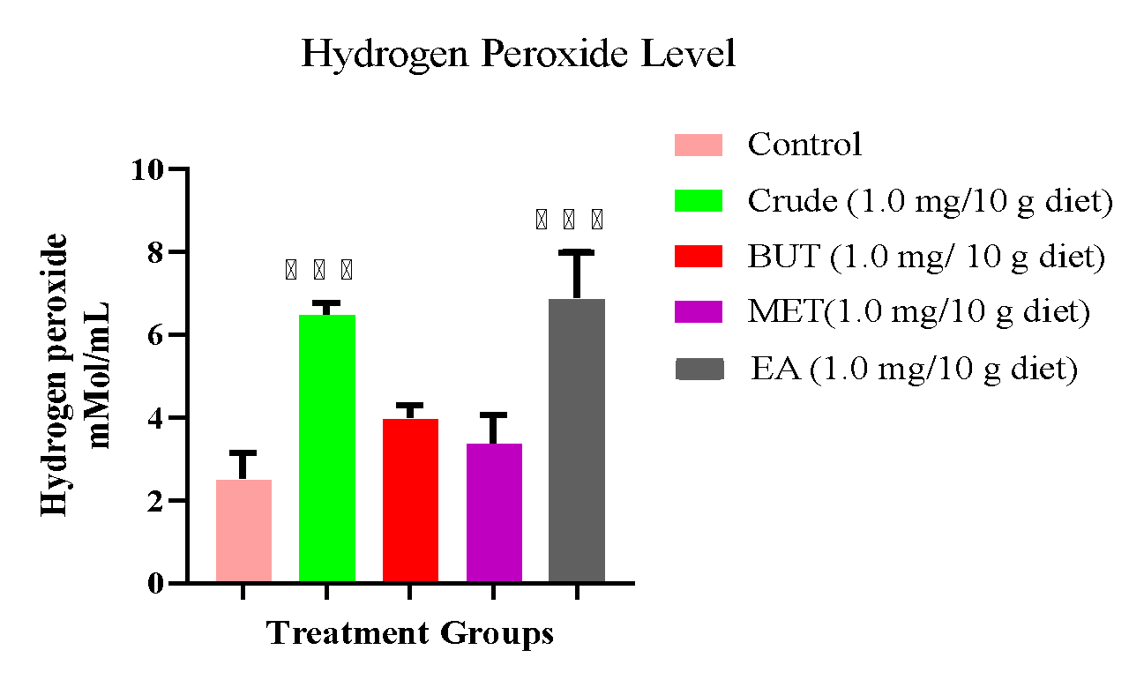d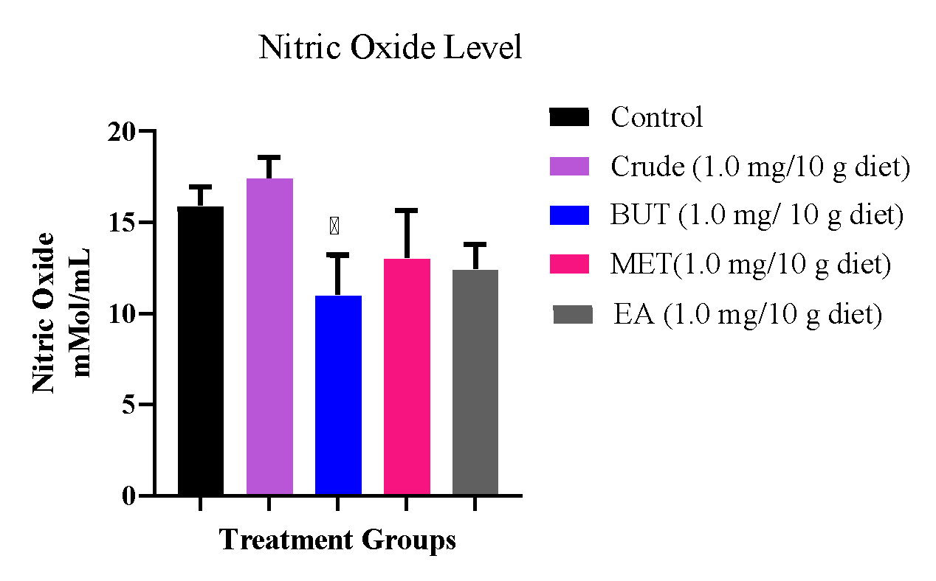

e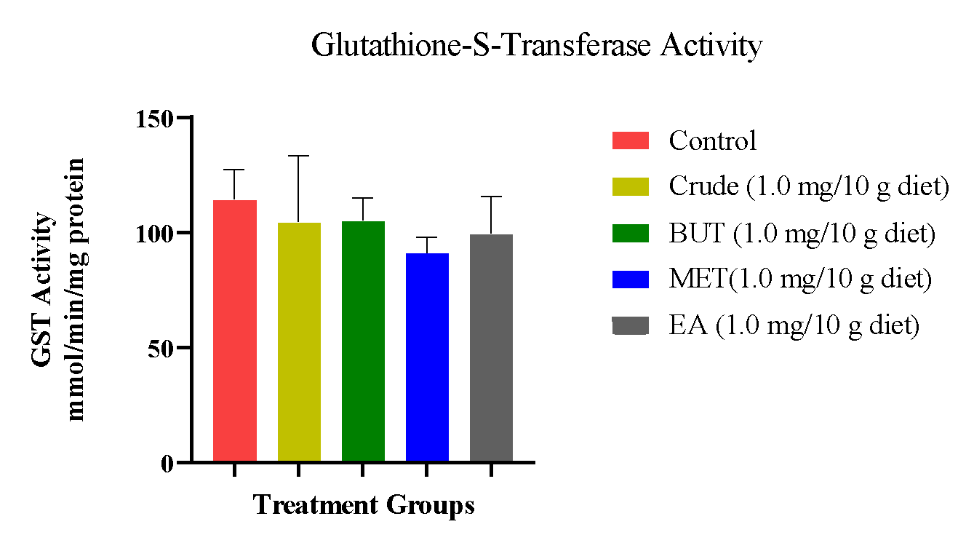f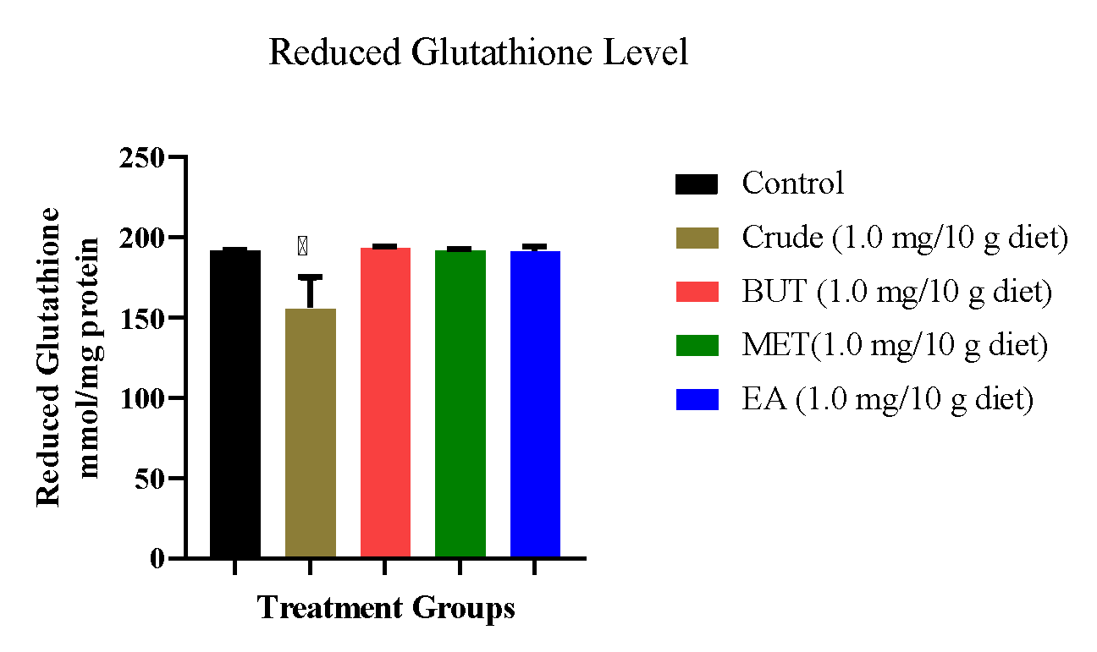

g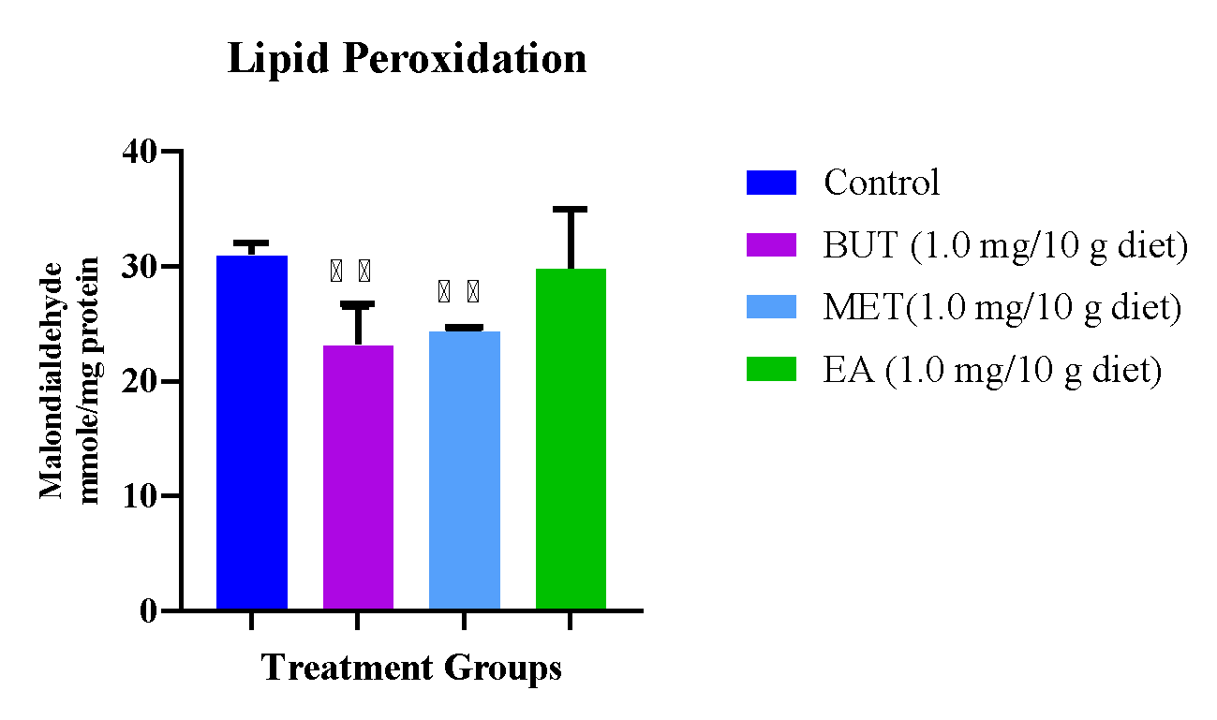h 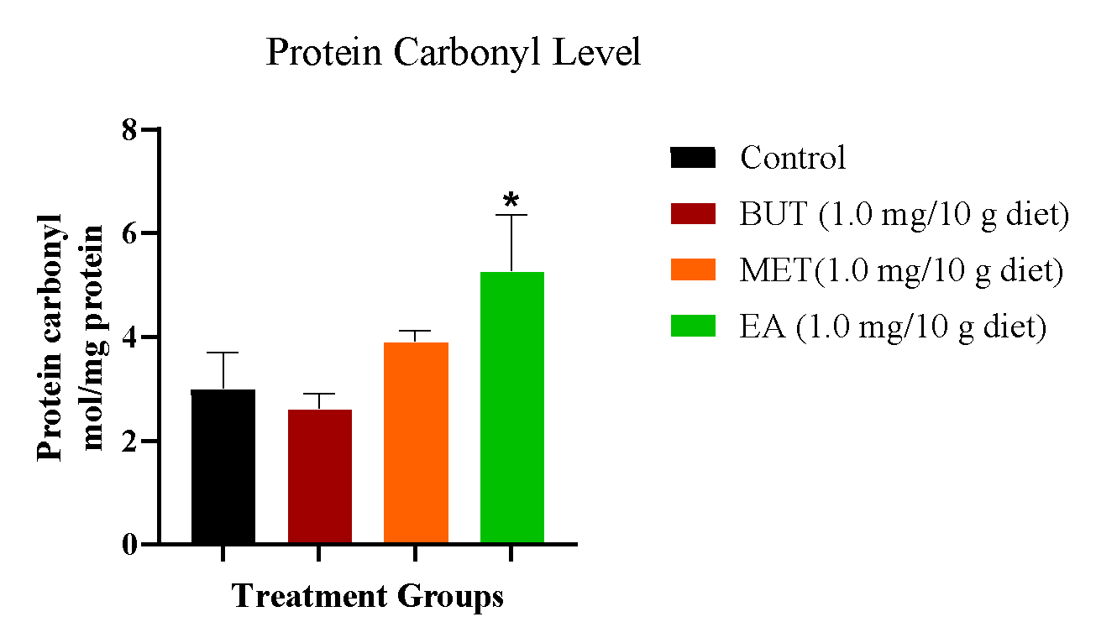
Fig. 6 Effect of Tapinanthus globiferus leaf Fractions on markers of oxidative stress in Drosophila melanogaster (a) acetylcholinesterase (b) total thiol (c) hydrogen peroxide level (d) nitric oxide level (e) GST Activity (f) reduced glutathione level (g) lipid peroxidation (h) Protein carbonyl level
Each value indicates mean ± SD of three independent three replicate experiments
*** Significant difference at p ≤ 0.05 compared with positive control

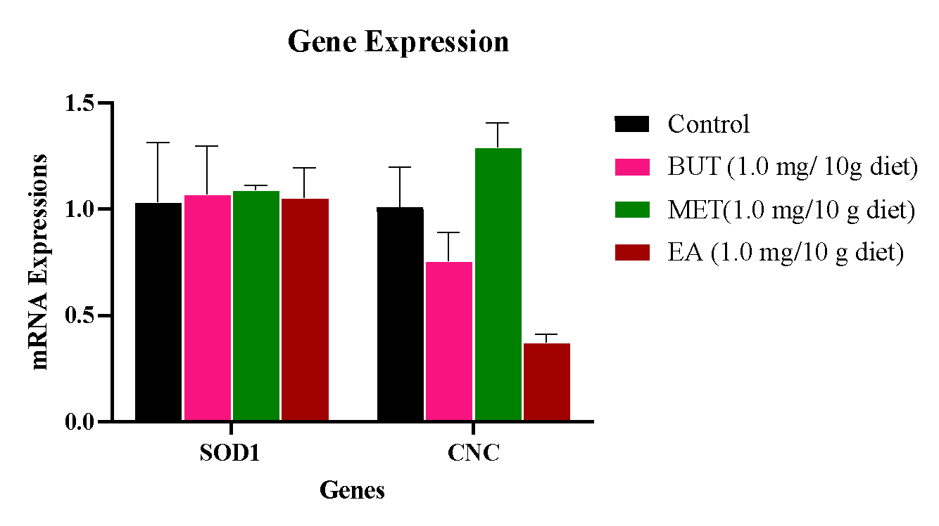
Fig. 7 Effect of Tapinanthus globiferus leaf Fractions on gene expressions in Drosophila melanogaster
Each value indicates mean ± SD of three independent three replicate experiments

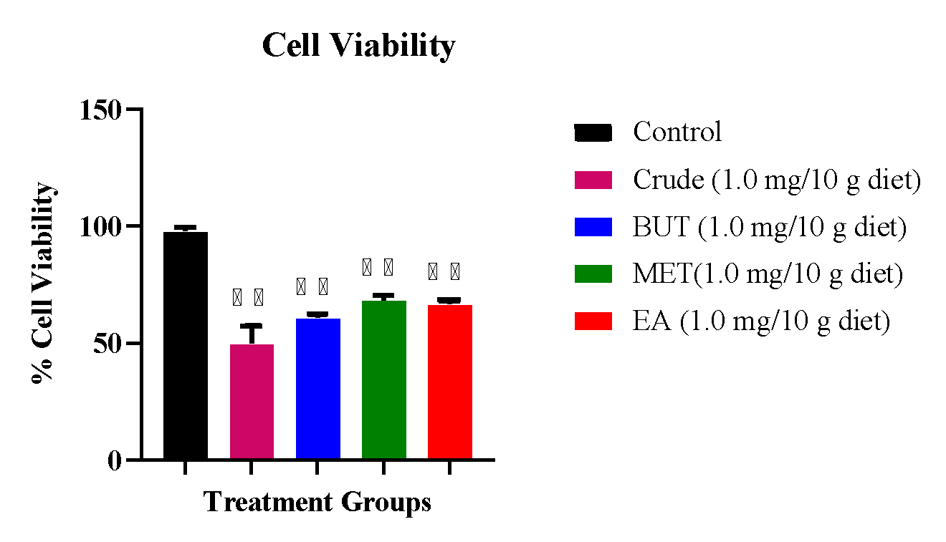
Fig. 8 Effect of Tapinanthus globiferus leaf Fractions on cell viability in Drosophila melanogaster
Each value indicates mean ± SD of three independent three replicate experiments
*** Significant difference at p ≤ 0.05 compared with positive control

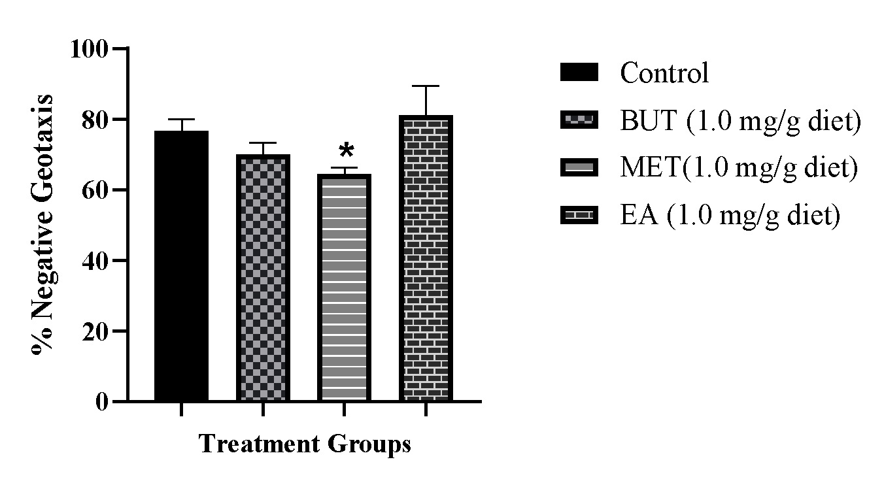
Fig. 9 Effect of Tapinanthus globiferus leaf Fractions on the climbing ability of Drosophila melanogaster
Each value indicates mean ± SD of three independent three replicate experiments

